Fairfax Water Resources

Estimating Urban Flood Susceptibility, Historical Flooding Extent, and Land Cover Change in Fairfax County, Virginia to Aid in Flood Mitigation Planning

 **Technical Paper**

Final – April 2nd, 2021

Kaitlynn Hietpas (Project Lead)

Egla Ochoa-Madrid

Ebony Williams

Olivia Spencer

***Advisor:***

Dr. Kenton Ross, NASA Langley Research Center (Science Advisor)

# 1. Abstract

Between 2000 and 2020, Fairfax County, Virginia experienced extreme weather events that caused severe flooding and degradation of roads, businesses, and other public property. A single flood event on July 8th, 2019 resulted in $14.8 million in damages. These flood events routinely impact the community, often resulting in power outages, school closures, and downed trees. The Fairfax County Department of Public Works and Environmental Services partnered with DEVELOP to explore how remotely sensed data could be integrated to support its current flood mitigation efforts. This project used environmental factors such as elevation, slope, and topographic wetness index from Earth observation derived data to map flood susceptibility. We utilized Landsat 5 Thematic Mapper (TM), Landsat 7 Enhanced Thematic Mapper Plus (ETM+), Landsat 8 Operational Land Imager (OLI), Sentinel-1 C-Band Synthetic Aperture Radar (C-SAR), and Sentinel-2 Multispectral Instrument (MSI) to map historic flooding events in Fairfax County. These maps will support flood management practices for the Fairfax County Department of Public Works and Environmental Services through the integration of remotely sensed data. Our results show that developed areas in the county are more susceptible to flooding, coinciding with analysis of flood factors, which indicated that imperviousness and tree canopy were the most influential drivers in flood susceptibility. Other results show that using Earth observations to map historical flooding is limited in urban areas due to false positives from SAR imagery between water and shadows. Further research is necessary to evolve the historical flood mapping technique if Earth observations are to be incorporated in future historical flood analysis.

**Key Terms**

Remote sensing, historic flood mapping, Landsat 5 TM, Landsat 8 OLI, random forest classification

# 2. Introduction

***2.1 Background Information***

Changes to a local hydrologic cycle caused by urbanization decrease infiltration and evapotranspiration rates and lead to increased runoff (Di Salvo, 2018). This, along with severe storms and rising temperatures driven by global climate change, has caused increasingly frequent and intense flood events in many places around the world (Yamazaki, 2018; Madakumbura et al., 2019; [Kinoshita](https://apps-webofknowledge-com.ezproxy.library.wisc.edu/OutboundService.do?SID=7A8kdyN7wtesQLvOMR2&mode=rrcAuthorRecordService&action=go&product=WOS&lang=en_US&daisIds=4901247) et al., 2018). The United States alone has seen a significant increase in financial losses due to floods. According to a testimony at a congressional hearing on federal flood maps, the cost of floods in the 1980s averaged to about $4 billion a year. This cost increased to $17 billion per year between 2010 and 2018 (*An examination of Federal Flood Maps in a Changing Climate*, 2020*).*

Fairfax County, located in northern Virginia (Figure 1), is one such site that has noticed the growing price tag from flooding due to extreme weather events. The area is characterized by a combination of urban, suburban, and rural territories and is home to 1,170,000 residents (Economic, Demographic and Statistical Research Department of Management and Budget, 2019). In recent years, they have experienced all-time high levels of flooding. Some areas have even experienced water levels above seven feet. Flash flooding in Fairfax County in 2019 alone generated over $14 million worth of damages to property, residences, and buildings. These damages arose from just a single event on July 8th when a month’s worth of rain fell in the span of one hour (Smith, 2019).

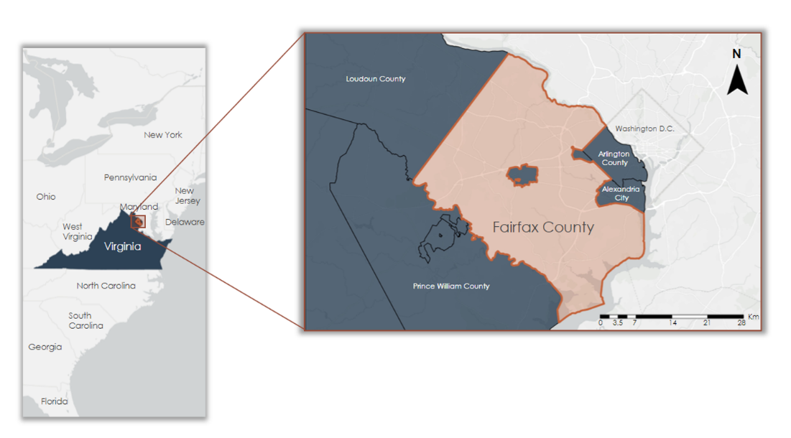

*Figure 1:* Location Map of Fairfax County, Virginia

In order to prepare for the possibility of future large-scale floods, a better understanding of historical flood trends, flood susceptibility, and changes in urban tree canopy and impervious surface cover is required. As impervious surfaces become more widespread and tree canopy decreases in a developing area, flooding may become more prevalent. Because of this, understanding how these land cover types have changed over time can provide insight into how they are impacting localized flooding events. In part, this project aimed to create maps to show these changes over the past two decades. Additionally, this project served as a feasibility study to determine if past flooding events could be identified and mapped through the use of Earth observations. These observations were used to create historical flood maps and the results served as a baseline for how to improve upon flood mapping of past events.

A variety of flood control and mitigation strategies can reduce the damage caused by floods; however, it can be difficult to determine which strategies to use and where to implement them. Flood susceptibility mapping is one way to identify areas at risk of flooding (Shafizadeh-Moghadam et al., 2018) and can help inform decisions on where flood control measures would be most effective. By combining factors related to hydrology, topography, and land cover and determining their relative importance through the use of random forest (RF), this project creates a flood susceptibility map to identify areas of Fairfax County most likely to flood.

***2.2 Project Partners & Objectives***

As of 2020, our project partners at the Fairfax County Department of Public Works and Environmental Services were interested in mitigating damage due to increased flooding events and providing targeted responses for county residents. The Department relied on a reactive approach based on citizen-reported flood complaints, previously collected data, expert knowledge, and flood condition assessments to inform their decision-making. This project aimed to supplement current department practices by providing county-wide flood analysis to help transition their mitigative responses from reactive to proactive. The results of this study will help our partner organization identify areas that are most susceptible to flooding and areas with a high concentration of impervious surface. Furthermore, the Department will utilize results to target specific flood-prone areas in need of preemptive mitigation. The primary goals of this project were to utilize Earth observations to map areas susceptible to flooding and to determine the feasibility of using Earth observations in identifying past inundation events to assess flood frequency. In addition, this project sought to analyze how land cover change over time contributed to flooding events within the county.

# 3. Methodology

***3.1 Data Acquisition***

For creating impervious surface and urban tree canopy change maps, our team downloaded percent imperviousness and land cover data from the National Land Cover Database (NLCD). The specific datasets used can be found in Table 1. In addition to data obtained for the land cover change maps, eight different parameters were selected and procured for the susceptibility model (Table 2 and Appendix A). These were slope, elevation, topographic wetness index (TWI), height above nearest drainage (HAND), imperviousness, tree canopy, distance to water (DTW), saturated hydraulic conductivity (KSAT), and soil drainage.

Table 1

*Datasets used in urban tree canopy and impervious surface change maps*

|  |  |  |  |  |
| --- | --- | --- | --- | --- |
| **Dataset** | **Description & Use** | **Dates** | **Source** | **Spatial Resolution** |
| National Land Cover Database: Land Cover | Used to create urban tree canopy change map | 2001, 2016 | USGS: Earth Resources Observation and Science Center | 30 m |
| National Land Cover Database: Percent Developed Imperviousness | Used to create impervious surface change maps | 2001, 2016 | USGS: Earth Resources Observation and Science Center | 30 m |

Table 2

*Datasets used in flood susceptibility map*

|  |  |  |  |  |
| --- | --- | --- | --- | --- |
| **Dataset** | **Description & Use** | **Dates** | **Source** | **Spatial Resolution** |
| Citizen Reported Flood Complaints | Used as flood inventory training sample in susceptibility map | 2008, 2011 | Fairfax County | Vector Data |
| National Land Cover Database: Imperviousness and Urban Tree Canopy | Used to create imperviousness and urban tree canopy layers used in random forest and static flood susceptibility map | 2008, 2011 | USGS: Earth Resources Observation and Science Center | 30 m |
| Digital Elevation Model | Used to calculate elevation, slope, and TWI | 2012, 2018 | USGS National Elevation Dataset | 30 m |
| Global HAND | Used to extract 30 m HAND data | 2000 | Google Earth Engine Webapp | 30 m |
| National Hydrography Dataset | Used to calculate distance to water | 2020 | USGS | Vector Data |

Elevation and slope are important variables when considering flooding as they dictate general water flow directions and the speed of surface flow. TWI provides robustness to the susceptibility model, as it influences runoff flow direction and accumulation (Ballerine, 2017). The digital elevation model (DEM) obtained from the USGS National Elevation Dataset was used to derive elevation, slope, and TWI. Distance to water accounts for the drainage networks within the county and was acquired through the National Hydrography Dataset. HAND is a drainage normalized version of a DEM and gives the vertical distance between each cell and its corresponding drainage point (Nobre et al., 2011). This variable was acquired from the Global HAND Google Earth Engine Webapp at a 30 m resolution.

Impervious surfaces and tree canopy are also important factors to consider when assessing flooding in an urban area as they influence water runoff and infiltration. These variables were accessed through the NLCD. We utilized the same percent imperviousness layer in the susceptibility model as this was used for land cover change. We also used the NLCD Urban Tree Canopy dataset for flood susceptibility mapping, but this layer was not used in the land cover change maps as it was not available in 2001, which was necessary for assessing change.

KSAT is a measure of how fast water infiltrates into soil in millimeters per second; these infiltration rates dictate the amount of runoff that will occur during intense rainfall. A soil depth of 200 cm was chosen to calculate KSAT values, as this depth encompasses most of the soil horizon allowing for an accurate calculation of soil properties. Soil drainage is a qualitative measure of how well a soil transmits water. The USDA Soil Web Survey was used to access both of these variables as csv files, as well as general Virginia soil data as a shapefile to use for processing KSAT and soil drainage.

To acquire data for the historical flood maps, our team first searched for satellite imagery (Table 3) surrounding nine prominent flooding events that the county experienced (Appendix B, Table B1). To do this, our team chose to utilize the Hydrologic Remote Sensing Analysis for Floods (HYDRAFloods; Markert et al., 2020). Using this toolkit in a Jupyter notebook, our team searched for radar and optical scenes surrounding each flood. The HYDRAFloods toolkit currently does not have Landsat 5 TM built in, so for the 2003 to 2011 storm events, imagery was searched for in Google Earth Engine. Only three storm events (July 8th, 2019, August 1st, 2018, and January 22nd, 2016) had usable imagery before and after the flood, so our team acquired applicable radar and optical scenes for each of these three events.

Table 3

*Earth observations used for historical flood mapping.*

|  |  |  |
| --- | --- | --- |
| **Satellites & Sensors** | **Description & Use** | **Dates** |
| Sentinel-2 Multispectral Instrument (MSI) | Surface reflectance data were used to map historical flooding events | 2015 - 2020 |
| Sentinel-1 C-Band Synthetic Aperture Radar (C-SAR) | Backscatter data were used to map historical flooding events | 2014 - 2020 |
| Landsat 7 Enhanced Thematic Mapper Plus (ETM+) | Surface reflectance data were used to map historical flooding events | 2000 - 2012 |
| Landsat 8 Operational Land Imager (OLI) | Surface reflectance data were used to map historical flooding events | 2013 - 2020 |

***3.2 Data Processing***

All collected data layers for the susceptibility map and land cover change maps were first brought into ArcGIS Pro 2.7, clipped to the Fairfax County border, and projected to NAD 1983 (2011) State Plane Virginia North (meters). For the land cover change maps, the imperviousness percent layers did not require further processing, but the land cover layer was reclassified to create an urban tree canopy layer. We reclassified the following land cover designations as tree canopy: deciduous forest, evergreen forest, and mixed forest. All other land cover classes were lumped together to designate areas without tree canopy.

In addition, our team also curated susceptibility map layers from acquired data using ArcGIS Pro 2.7. These included percent imperviousness, urban tree canopy, elevation, slope, TWI, HAND, KSAT, soil drainage, and distance to water. Each layer was resampled to 30m2 cell resolution for statistical analysis and mapping purposes. No further processing was required for percent imperviousness, tree canopy, elevation, or HAND layers. Distance to water was calculated using the Euclidean Distance tool and stream and river feature classes from the National Hydrography Dataset. Slope and TWI were derived from the DEM. To obtain slope, we used the Slope tool from the Spatial Analyst toolbox. For TWI, we used the Raster Calculator and various Spatial Analyst tools including Flow Direction, Flow Accumulation, and Slope.

For soil-related variables, we joined the KSAT csv file to the Virginia soil shapefile in ArcGIS Pro 2.7 to connect the soil type with its respective KSAT value. This layer was then classified into five sections of KSAT values: 0.8 – 4.9, 4.9 – 9.0, 9.0 – 15.5, 15.5 – 29.5, and 29.5 – 72.3. Following a similar workflow, we then joined the soil drainage csv file with the Virginia soil shapefile to connect the soil type with its respective drainage type. This layer was then classified into five sections of drainage type: very poorly drained, poorly drained, somewhat poorly drained, moderately well drained, and well drained. The resulting KSAT and soil drainage layers showed missing values in various places in our study area, predominantly where impervious surfaces were (i.e., heavily developed areas, major roads, buildings, etc.). These gaps would limit the extent of our final susceptibility map to only areas containing values for KSAT and soil drainage, so we discarded these variables from our analysis.

In addition to preparing raster variables for our susceptibility map, we also prepared a dataset containing known flood locations to train a random forest classifier. To create this, our team utilized a dataset provided by our partner containing over 15,000-point locations of citizen-reported flood complaints from 1987 through 2021. Based on known storm events between 2003 and 2019 (Appendix B, Table B1) our team temporally filtered the flood complaint data to include time periods surrounding known storm events including the day of the event and five days following. This allowed for more certainty that the flood complaints were storm-related. Additionally, our team filtered the dataset to only include complaints seeming most pertinent to rain and storm events based on caller descriptions of the reported floods.

In addition to filtering flood presence data, we also generated a pseudo-absence layer to use in conjunction with presence points in susceptibility mapping. To do this, we first created one-kilometer buffers around all flood complaint locations and used the Erase tool in ArcGIS Pro to subtract the buffers from our study area. This left us with a polygon containing areas where flood complaints never occurred. Using the Generate Random Points tool, we then randomly placed points in the erased polygon to designate pseudo-absence points. Having both presence and pseudo-absence points represented in the study area, we then merged the two layers to create one single layer with presence points having a value of one assigned and pseudo-absence points having a value of zero (Figure 2). The last step before moving into creating a random forest classifier involved using the Extract Multi Values to points tool to create a table where each row represented presence or pseudo-absence points and each column contained values for each of our seven predictor rasters. We then generated two random subsets of the table in RStudio, with one being used to train the classifier and the second used for validation purposes.

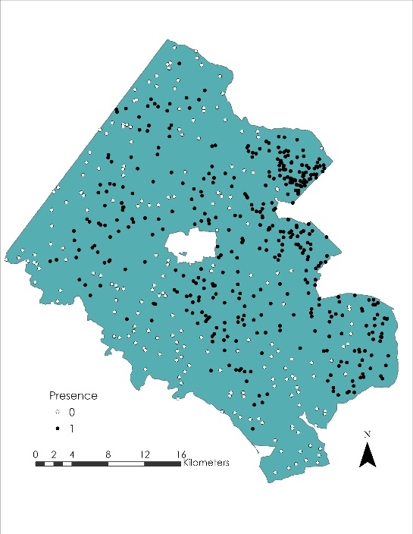

*Figure 2*: Flood presence and pseudo-absence points used to train our random forest classifier.

Data processing for the historical flood maps included applying pre-processing algorithms to satellite scenes for the 2016, 2018, and 2019 events to improve the image quality. For radar imagery, terrain flattening and speckle filters were applied to reduce noise from the terrain and atmosphere. For optical imagery, a modified difference normalized water index was added to enhance water features. Additionally, an illumination correction algorithm was applied to correct terrain effects for optical imagery but did not work because the algorithm contains bugs. After the imagery was pre-processed, the Edge Otsu surface water mapping algorithm, which uses a thresholding technique, was applied to identify existing water found in the before and after flood images. Our team chose to use the Edge Otsu algorithm because of its high-performance accuracy in applying it to radiometric terrain corrected imagery (Markert et al., 2020). The before flood imagery was mosaicked into a single image and the after-flood imagery was mosaicked into a single image. These two mosaicked images were then combined into one image to show all areas of identified surface water.

***3.3 Data Analysis***

To map change in impervious surfaces and tree canopy, our team used the Raster Calculator tool from the spatial analyst toolbox in ArcGIS Pro 2.7 to subtract the 2001 layers from their corresponding 2016 layers. The resulting maps can be found in Figure 4 in section 4.1.1. From these maps, we calculated the percent of land changed by dividing the number of cells showing gain or loss by the total number of cells in the map. To further quantify impervious surface change, we created equal interval bins of imperviousness percent change and calculated how many cells fell within each range of change. This allowed us to gain a deeper understanding of how impervious surfaces changed in the study area (Figure 3).

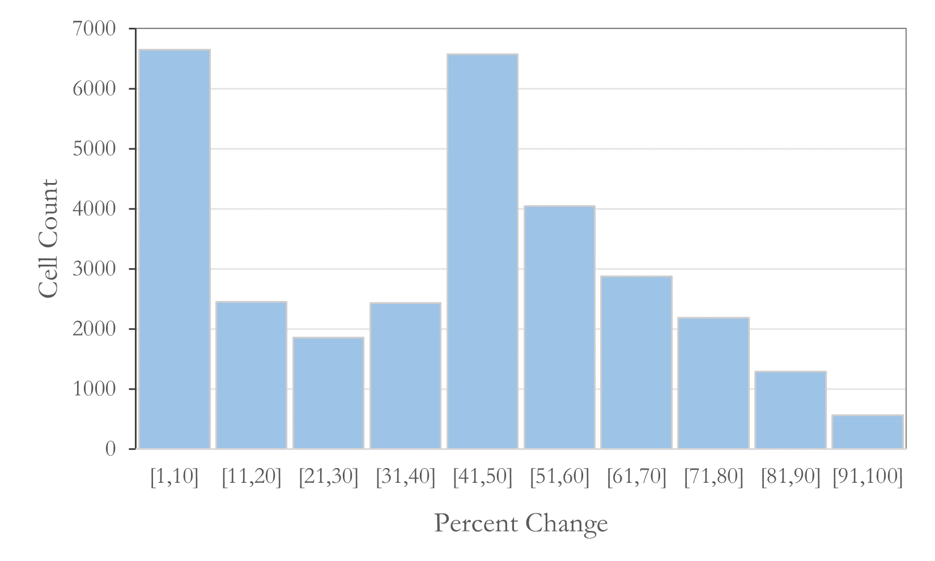

*Figure 3:* Histogram showing number of cells in each decile of imperviousness percent

Using the flood location training samples and flood susceptibility criteria, our team utilized the randomForest library in RStudio to create a prediction surface of flood susceptibility and generate importance values for each predictor variable used in the model (Appendix A, Figure A2). Random forest, a machine learning algorithm, takes input training samples and explanatory variables to train a classifier by generating numerous decision trees. In our case, we used flood complaint locations and pseudo-absence points with extracted values of each of our seven explanatory variables at each point. After inputting our data, we ran multiple variations of the tool with differing numbers of decision trees and variables included within each tree. After testing these variations, we settled on a robust classifier that ran 1,000 decision trees and used five random predictor variables in each tree. Using this finalized classifier, we generated a predictive raster surface showing the probability of flooding across our study area by applying it to our seven predictor raster layers. We produced two main outputs from utilizing this tool including a table of variable importance to provide insight into the most predictive variables of flooding and a prediction surface map layer to highlight areas that are most susceptible to flood.

To create the final historical flood map, the after-flood image was combined with the mosaicked images to show the flood waters. In total, there were five resulting flood maps from the 2016, 2018, and 2019 storm events (Appendix B, Figures B1 & B2). Each of these maps was visualized on the GEE map and analyzed to see where the Edge Otsu algorithm identified flood and existing water. Along with classifying flooding near bodies of existing water, highly paved surfaces such as the Dulles International Airport were also often classified as floods and existing water. This misclassification is common with radar satellite imagery and is due to smooth asphalt surfaces having a similar specular reflection as water. As a comparison metric, our team used a sump dataset, which consists of areas that are likely to collect water due to depressions in the landscape, to display areas of overlap between the flood maps and the sumps. Our team exported the five flood maps in the NAD 1983 projection and brought these tiffs into ArcGIS Pro 2.7 to display areas of overlap using the Intersect tool. As another comparison metric, our team also used the Intersect tool to identify any areas of overlap between the five flood maps. This intersection yielded no results, so our team intersected the 2019 Sentinel-1 and Sentinel-2, and the 2018 Sentinel-1 flood maps.

# 4. Results & Discussion

***4.1 Analysis of Results***

*4.1.1 Land Cover Change Maps*

In quantifying land cover change over time, we found that 2.1% of land in Fairfax County experienced a decrease in tree canopy from 2001 to 2016 period and 0.2% had a gain. For impervious surfaces, 3.7% of the county had some percentage of growth in impervious surfaces and 0% had a decrease. A deeper look into how imperviousness changes through time showed most change was either minimal, falling between 1% and 10% increase, or moderate with percent change ranging from 41% to 50% (Figure 3). A visual inspection of our static change maps (Figure 4) showed that areas experiencing a gain in impervious surfaces also had a loss in tree canopy. While we saw general alignment in imperviousness gain and tree canopy loss, it is important to note that the methodology in deriving these maps varied slightly due to data availability. Because of this, we cannot assume correlation.

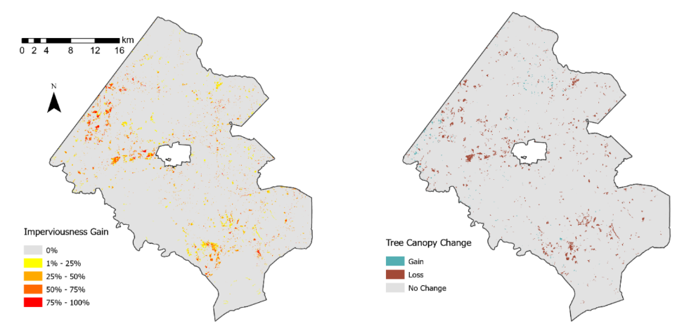

*Figure 4*: Static land cover change maps with imperviousness percent change on the left and tree canopy change on the right.

*4.1.2 Flood Susceptibility*

In training and selecting a random forest classifier, we also gained information on the importance of each of our seven explanatory variables by calculating the mean decrease accuracy value. This measure assesses how much accuracy the classification loses when excluding any one particular variable. A high value suggests that a given variable is important in the model, where a low value suggests little importance. We found tree canopy and imperviousness to be the most important variables in our output, with mean decrease accuracy values being near 60 and all other variables falling below 29 (Appendix A, Figure A3). Given the suburban and urban landscape of Fairfax County and flood reports coming from areas in which people live, these results make sense.

Generation of our final flood susceptibility map showed a wide range in variation of flood risk across the study area (Figure 5). A closer look into the southern portion of the county highlights this variation. There is a general trend of the eastern portion of the county showing more areas that are highly susceptible than the western portion. Having found imperviousness and tree canopy to be the driving factors in predicting flood risk in our study, those factors had a great influence on this static map. Areas with both high imperviousness and low tree canopy show up as being highly susceptible. The other explanatory variables also played a role in the generation of this map, though not as heavily. Because we trained our random forest classifier on citizen-reported data, our results are limited to areas where residents live, generating some inherent bias. Areas in which there are no inhabitants might still see flooding, but it is not reported in the same way as floods occurring where people live. While we aimed to investigate flood susceptibility in Fairfax County, this map should be considered a probability of citizen flood complaint rather than a true susceptibility map.

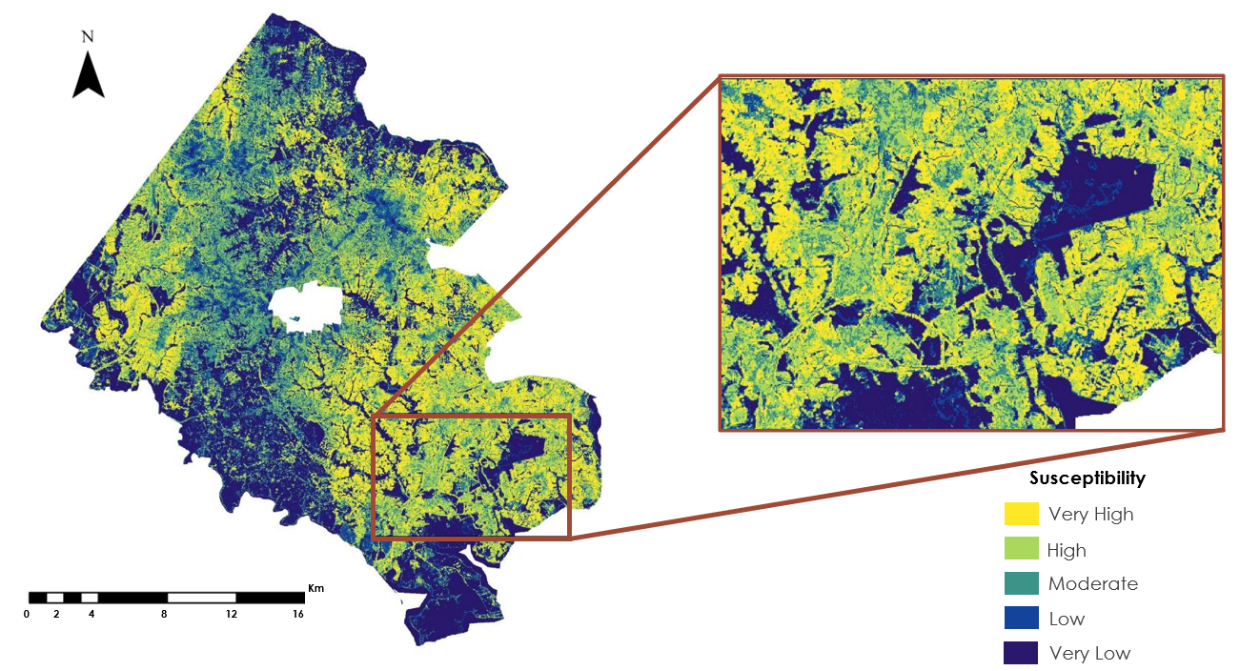

*Figure 5*: Static Flood Susceptibility Map generated using the random forest classifier.

After creating our random forest classifier and static flood susceptibility map, we ran a cross-validation in R using the validation dataset created before training the model. This allowed us to test the accuracy and precision of our model in predicting floods based on known locations. In running this analysis, we created a confusion matrix that allowed us to calculate model performance measures. We found the model to have a high accuracy rate of 0.79 and a precision rate of 0.77. With this, our classifier also had a low error rate of 0.21. The model also performed better with predicting presence points than pseudo-absence. This may be in part to bias introduced in generating our own pseudo-absence points. We recognize that these validation measures apply only to available flood complaint data used in the study and may possess inherent bias because of this.

*4.1.3 Historical Flood Mapping*

The July 8th, 2019 flood map (Figure 6) had recorded the most flooding locations out of all of the five flood maps. Sentinel-1 imagery identified more historical flooding events than Sentinel-2 imagery. This is also evident in the 2018 flood map (Appendix B, Figure B1), where Sentinel-1 outperformed the Landsat 8 optical imagery in identifying floods. This may indicate that radar imagery is better at recording small-scale flooding events, but due to the misclassification of roads as water features, this may not be a completely accurate indication. Validation data, such as road flooding locations, need to be incorporated to assess the accuracy of the algorithms correctly identifying flooding on or alongside roads.

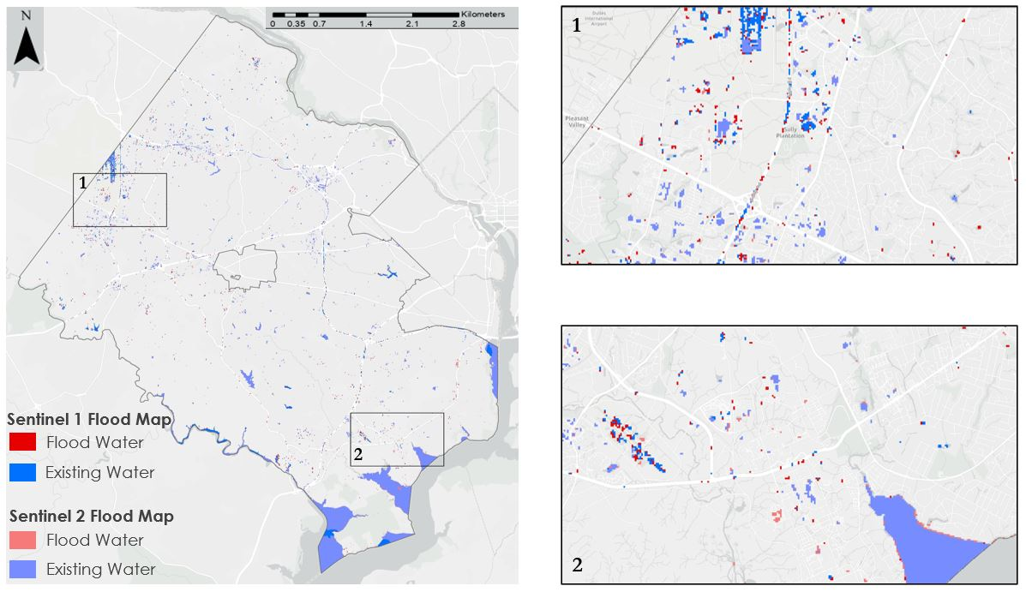

*Figure 6:* Sentinel-1 and Sentinel-2 Historical Flood Maps for the July 8th, 2019 storm event

In completing the intersection of the 2019 Sentinel-1 and Sentinel-2, and the 2018 Sentinel-1 flood maps with the sump layer, there were 16 locations of overlap. Additionally, our team intersected the 2018 Landsat 8 and 2016 Landsat 7 flood maps and there was only one area of overlap, due to the extremely low numbers in identified floods for each map. No conclusive results can be drawn from these intersections due to the lack of resulting flood maps and uncertainty with the accuracy of identified floods. Because of this, we were unable to determine flood frequency within Fairfax County with this study.

***4.2 Limitations & Assumptions***

Although our team was able to deliver products that met our partner's interests, the results were limited by general data unavailability. Our team relied on NLCD data, which are only updated on a five-year basis, and the most recent year of available data is 2016. This meant that the most accurate analyses that we could provide would need to coincide with the years of updated data. The land cover change maps were therefore limited to the year 2016, which meant a narrow timeline for analysis that is nearly four years before our project started. Additionally, the flood complaint data introduced inherent bias to the susceptibility model, which limits the accuracy of our results to predict actual locations of a flood. The flood complaint reports are called in by residents of the county who experience flooding at or near their homes. There is no guarantee that the data is completely representative of where flooding actually occurs in the county. Some residents may be unaware that they can report a flood, and less developed areas may see fewer reported events even if floods are occurring. In this way, the flood complaint data assume that flooding occurs only at those locations and nowhere else.

***4.3 Future Work***

To strengthen the reliability and expand on the effectiveness of the project maps, there are six main avenues that our team foresees as future paths of exploration. First, future teams could expand the training points used in the random forest classifier by incorporating NOAA storm complaints. This would aid in correcting the bias introduced by relying solely on citizen flood reporting and the randomly generated absence points. Second, other hydrological influences like soil data could be added when compiling the susceptibility factors. To add the KSAT data, our team recommends supplementing the gaps with an average of the surrounding values. Third, future teams could consider classifying and updating land cover change maps from 2020 imagery to create up-to-date susceptibility models rather than waiting five years for updated NLCD data. Fourth, the misclassification of roads and buildings in the historical flood mapping could be improved by applying alternative water mapping algorithms. This could include other algorithms available through the HYDRAFloods toolkit or by implementing a Normalized Difference Fraction Index. Fifth, additional reference scenes of the area before and after storm events could provide a clearer depiction of normal conditions. In this way, determining the change brought on by a storm event could be more evident. Finally, our team would also like to note that urban areas prove to be particularly difficult for remote sensing, and future teams are encouraged to explore the radar imagery provided by the upcoming NASA-ISRO SAR Mission (NISAR).

# 5. Conclusions

Our partners at the Fairfax County Department of Public Works and Environmental Services were interested in learning how NASA Earth observations could aid in transitioning their flood mitigation strategies from a reactive to a proactive approach. They were particularly interested in understanding how such tools could be used to assess the impact of major storm events and the current state of flood risks across the county. To meet these interests, our team utilized satellite imagery, land cover data, and hydrological data to create a set of products outlining different flood-related insights. These included tree canopy and impervious surface change maps, a flood susceptibility map, and a set of five historical flood maps for prominent storm events. Our assessment of the surface change maps indicates that growing imperviousness and a subsequent loss of tree canopy has the potential to increase flood risk in the county. This is of particular relevance since we also determined that tree canopy and imperviousness were the strongest predictors for flooding in our susceptibility model. Consequently, our team concluded that because the susceptibility model was trained on flood complaint points rather than *in situ* or remotely sensed flood event data, the model is more suitable for predicting the probability of flood complaint locations.

Our preliminary results and conclusions illustrate general pitfalls of remote sensing in urban areas, but they also showcase the potential that remote sensing techniques have for flood management. Our partners will be able to learn from these techniques so that they can replicate and incorporate results with updated information. In this way, we successfully provided partners with insights into how NASA Earth observations could be utilized at their county level.

# 6. Acknowledgments

The Fairfax Water Resources Team would like to thank our partners Catie Torgersen, Yeoanny Venetsanos, Chip Galloway, Saurabh Raje, and Laurel Shultzaberger at the Fairfax County Department of Public Works and Environmental Services for their contributions, interest, and excitement in our project. We’d also like to thank our Center Fellow Adriana Le Compte, our Science Advisor Dr. Kenton Ross, and Kel Markert with the SERVIR program for their guidance and support throughout the term.

This material contains modified Copernicus Sentinel data (2018, 2019), processed by ESA.

Any opinions, findings, and conclusions or recommendations expressed in this material are those of the author(s) and do not necessarily reflect the views of the National Aeronautics and Space Administration.

This material is based upon work supported by NASA through contract NNL16AA05C.

# 

# 7. Glossary

**DTW** –Distance to water

**Earth Observations** – Satellites and sensors that collect information about the Earth’s physical, chemical, and biological systems over space and time

**Edge Otsu** – Algorithm that uses a thresholding technique to create a bimodal image of water and no water

**HAND** – Value that indicates the vertical distance from a surface cell and its respective outlet-to-the-drainage cell

**ISRO** – The Indian Space Research Organization

**KSAT** –Saturated hydraulic conductivity, a measure of how fast water infiltrates into soil in millimeters per second

**NISAR** – NASA-ISRO SAR Mission (NISAR) – joint mission between NASA and ISRO to launch in 2022

**Random Forest Classification** – Machine learning algorithm that uses decision trees to make a prediction

**TWI** – Topographic Wetness Index; defined at a certain point in the catchment as the upslope area per unit contour length divided by the local gradient

# 8. References

*An Examination of Federal Flood Maps in a Changing Climate*. 116th Cong. (2020). (testimony of Michael Grimm). <https://www.congress.gov/event/116th-congress/house-event/110578>

Ballerine, C. (2017). Topographic Wetness Index urban flooding awareness act action support. Illinois State Water Survey. <https://www.isws.illinois.edu/pubdoc/CR/ISWSCR2017-02.pdf>

Brophy, T., Coleman, W., Garik, A., Peters, W. (2020). *Charles River Watershed Water Resources: Assessing Flood Vulnerability to Assist High Water Intervention and Urban Planning Programs in the Charles River Watershed*. DEVELOP.

Di Salvo, C., Pennica, F., Ciotoli, G., & Cavinato, G.P. (2018). A GIS-based procedure for preliminary mapping of pluvial flood risk at metropolitan scale. *Environmental Modeling and Software, 107, 64-84.* https://doi.org/10.1016/j.envsoft.2018.05.020

Douglas Moran, C. (2019, July 30). Flash Flooding Damage in Fairfax County Costing Millions For Repairs. Retrieved April 01, 2021, Retrieved from <https://www.tysonsreporter.com/2019/07/30/flash-flooding-damage-in-fairfax-county-costing-millions-for-repairs/>

Economic, Demographic and Statistical Research Department of Management and Budget, 2019. *Demographic Reports 2019 Fairfax County, Virginia*. Retrieved from <https://www.fairfaxcounty.gov/demographics/sites/demographics/files/assets/demographicreports/fullrpt.pdf>

Fairfax County. (September 14, 2020). *LiDAR Digital Terrain Model-2018*. Fairfax County LiDAR. <https://lidar-fairfaxcountygis.opendata.arcgis.com/datasets/2fb71d2fc56c41dd81d3fca662e82ff7?geometry=-78.207%2C38.453%2C-76.377%2C39.202&showData=true>. (February 18, 2021)

[Kinoshita, Y](https://apps-webofknowledge-com.ezproxy.library.wisc.edu/OutboundService.do?SID=7A8kdyN7wtesQLvOMR2&mode=rrcAuthorRecordService&action=go&product=WOS&lang=en_US&daisIds=4901247)., [Tanoue, M](https://apps-webofknowledge-com.ezproxy.library.wisc.edu/OutboundService.do?SID=7A8kdyN7wtesQLvOMR2&mode=rrcAuthorRecordService&action=go&product=WOS&lang=en_US&daisIds=3176602)., [Watanabe, S](https://apps-webofknowledge-com.ezproxy.library.wisc.edu/OutboundService.do?SID=7A8kdyN7wtesQLvOMR2&mode=rrcAuthorRecordService&action=go&product=WOS&lang=en_US&daisIds=36287870)., Hirabayashi, Y. (2018). Quantifying the effect of autonomous adaptation to global river flood projections: Application to future flood risk assessments. *Environmental Research Letters, 13*(1), 014006.

# [Madakumbura, G.D](https://apps-webofknowledge-com.ezproxy.library.wisc.edu/OutboundService.do?SID=7A8kdyN7wtesQLvOMR2&mode=rrcAuthorRecordService&action=go&product=WOS&lang=en_US&daisIds=29782557)., [Kim, H](https://apps-webofknowledge-com.ezproxy.library.wisc.edu/OutboundService.do?SID=7A8kdyN7wtesQLvOMR2&mode=rrcAuthorRecordService&action=go&product=WOS&lang=en_US&daisIds=1224193)., [Utsumi, N](https://apps-webofknowledge-com.ezproxy.library.wisc.edu/OutboundService.do?SID=7A8kdyN7wtesQLvOMR2&mode=rrcAuthorRecordService&action=go&product=WOS&lang=en_US&daisIds=3563628)., [Shiogama, H](https://apps-webofknowledge-com.ezproxy.library.wisc.edu/OutboundService.do?SID=7A8kdyN7wtesQLvOMR2&mode=rrcAuthorRecordService&action=go&product=WOS&lang=en_US&daisIds=388695)., [Fischer, E.M](https://apps-webofknowledge-com.ezproxy.library.wisc.edu/OutboundService.do?SID=7A8kdyN7wtesQLvOMR2&mode=rrcAuthorRecordService&action=go&product=WOS&lang=en_US&daisIds=602086)., [Seland, O](https://apps-webofknowledge-com.ezproxy.library.wisc.edu/OutboundService.do?SID=7A8kdyN7wtesQLvOMR2&mode=rrcAuthorRecordService&action=go&product=WOS&lang=en_US&daisIds=733442)., … [Oki, T](https://apps-webofknowledge-com.ezproxy.library.wisc.edu/OutboundService.do?SID=7A8kdyN7wtesQLvOMR2&mode=rrcAuthorRecordService&action=go&product=WOS&lang=en_US&daisIds=10332). (2019). Event-to-event intensification of the hydrologic cycle from 1.5 °C to a 2 °C warmer world. S*cientific Reports, 9, 3483.*

Markert, K.N., Markert, A.M., Mayer, T., Nauman, C., Haag, A., Poortinga, A., Bhandari, B., Thwal N.S., Kunlamai, T., Chishtie, F., Kwant, M., Phongsapan, K., Clinton, N., Towashiraporn, P., Saah, D. (2020). Comparing Sentinel-1 Surface Water Mapping Algorithms and Radiometric Terrain Correction Processing in Southeast Asia Utilizing Google Earth Engine. *Remote Sensing, 12,* 2469.<https://doi.org/10.3390/rs12152469>

Multi-Resolution Land Characteristics Consortium. (Updated January 2019). *NLCD 2016 Land Cover Conterminous United States.* <https://www.mrlc.gov/data/nlcd-2016-land-cover-conus>

Multi-Resolution Land Characteristics Consortium. (Updated January 2019). *NLCD 2011 Land Cover Conterminous United States.* <https://www.mrlc.gov/data/nlcd-2011-land-cover-conus>

Multi-Resolution Land Characteristics Consortium. (Updated January 2019). *NLCD 2008 Land Cover Conterminous United States.* <https://www.mrlc.gov/data/nlcd-2008-land-cover-conus>

Multi-Resolution Land Characteristics Consortium. (Updated January 2019). *NLCD 2001 Land Cover Conterminous United States.* <https://www.mrlc.gov/data/nlcd-2001-land-cover-conus>

Nobre, A.D., Cuartas, L.A., Hodnett, M., Renno, C.D., Rodrigues, G., Silveira, A., … Saleska, A. (2011). Height Above the Nearest Drainage – a hydrologically relevant new terrain model. *Journal of Hydrology, 404, 13-29.* https://doi.org/10.1016/j.jhydrol.2011.03.051

Roopnarine, R., Opadeyi, J., Eudoxie, G., Thong G., Edwards, E. (2018). GIS-based Flood Susceptibility and Risk Mapping Trinidad Using Weight Factor Modeling. *Caribbean Journal of Earth Science*, *49*, 1-9. Retrieved from: <https://www.researchgate.net/publication/326925603_GIS-based_Flood_Susceptibility_and_Risk_Mapping_Trinidad_Using_Weight_Factor_Modeling>

Shafizadeh-Moghadam, H., Valavi, R., Shahabi, H., Chapi, K., & Shirzadi, A. (2018). Novel forecasting approaches using combination of machine learning and statistical models for flood susceptibility mapping. *Journal of Environmental Management, 217*, 1-11. https://doi.org/10.1016/j.jenvman.2018.03.089

Smith, M. (2019, August 1). *Northern Virginia could qualify for federal aid after July flash flooding*. WTOP News. <https://wtop.com/virginia/2019/08/nova-could-qualify-for-federal-aid-after-july-flash-flooding/>

U.S. Geological Survey Earth Resources Observation and Science Center. (2020, October 20). *Landsat 7 ETM+ Level-2 Surface Reflectance (SR) Science Product.* U.S. Geological Survey. <https://doi.org/10.5066/F7Q52MNK>

U.S. Geological Survey Earth Resources Observation and Science Center. (2020, October 20). *Landsat 8 OLI Level-2 Surface Reflectance (SR) Science Product*. U.S. Geological Survey. [https://doi.org/10.5066/f78s4mzj](https://doi.org/10.1371/journal.pone.0087852)

Yamazaki, D., Watanabe, S., & Hirabayashi, Y. (2018) Global Flood Fisk Modeling and Projections of Climate Change Impacts. *In Global Flood Hazard: Applications in Modeling, Mapping, and Forecasting, 233,* 185-203. https://doi.org/10.1002/9781119217886.ch11

# 9. Appendices

*Appendix A: Flood Susceptibility Factors*

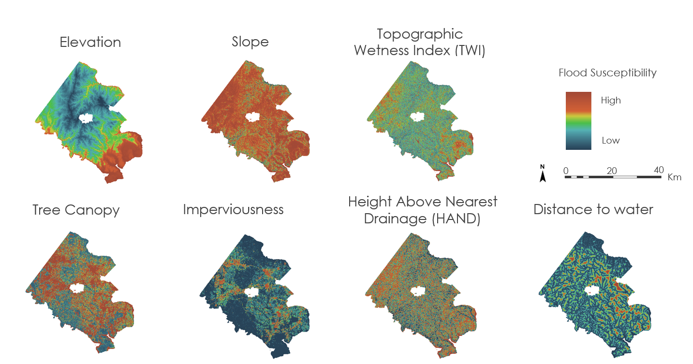

*Figure A1:* Final Explanatory variables for the Susceptibility model overlayed Fairfax County, Virginia

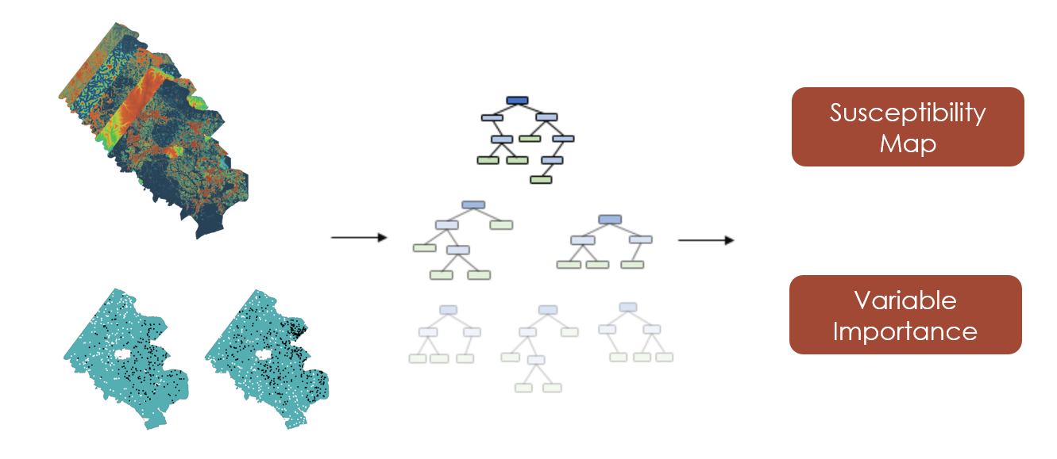

*Figure A2*: Illustration on the workflow process of producing the Flood Susceptibility Map. On top left are stacked flood factors and on the bottom left are the presence and absence points displayed over Fairfax County.

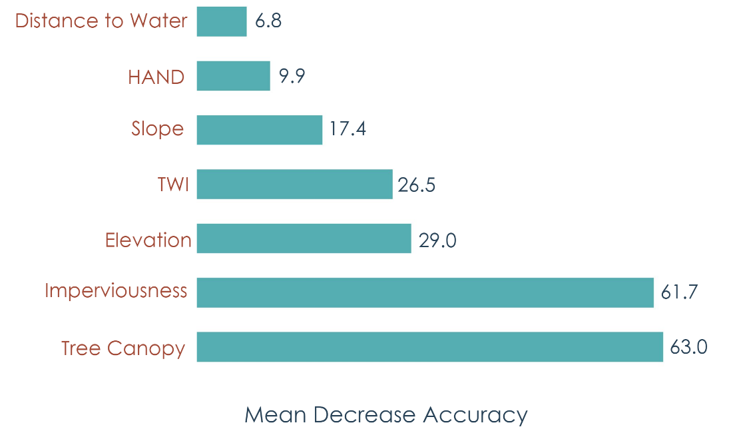

*Figure A3*: Variable Importance for the Flood Susceptibility Model

***Appendix B:*** *Historical Flood Mapping*

*Table B1*: Storm Events during the study period

|  |  |  |  |  |  |
| --- | --- | --- | --- | --- | --- |
| Date (year, month, day) | Event | Sentinel-1 Imagery Available? | Sentinel-2 Clear Imagery Available? | Landsat 8 Clear Imagery Available? | Landsat 7 Clear Imagery Available? |
| 2019-07-08 | July 8th rainfall | Yes | Yes | No | Yes - limited |
| 2018-08-01 | August 1st rainfall | Yes | No | Yes | Yes - limited |
| 2016-01-22 | Winter Storm Jonas | No | No | No | Yes - limited |
| 2012-10-29 | Hurricane Sandy | No | No | No | Yes - limited |
| 2011-09-06 | Tropical Storm Lee | No | No | No | No |
| 2011-08-27 | Hurricane Irene | No | No | No | No |
| 2010-02-05 | North American Blizzard | No | No | No | No |
| 2008-09-06 | Tropical Storm Hanna | No | No | No | No |
| 2003-09-18 | Hurricane Isabel | No | No | No | No |

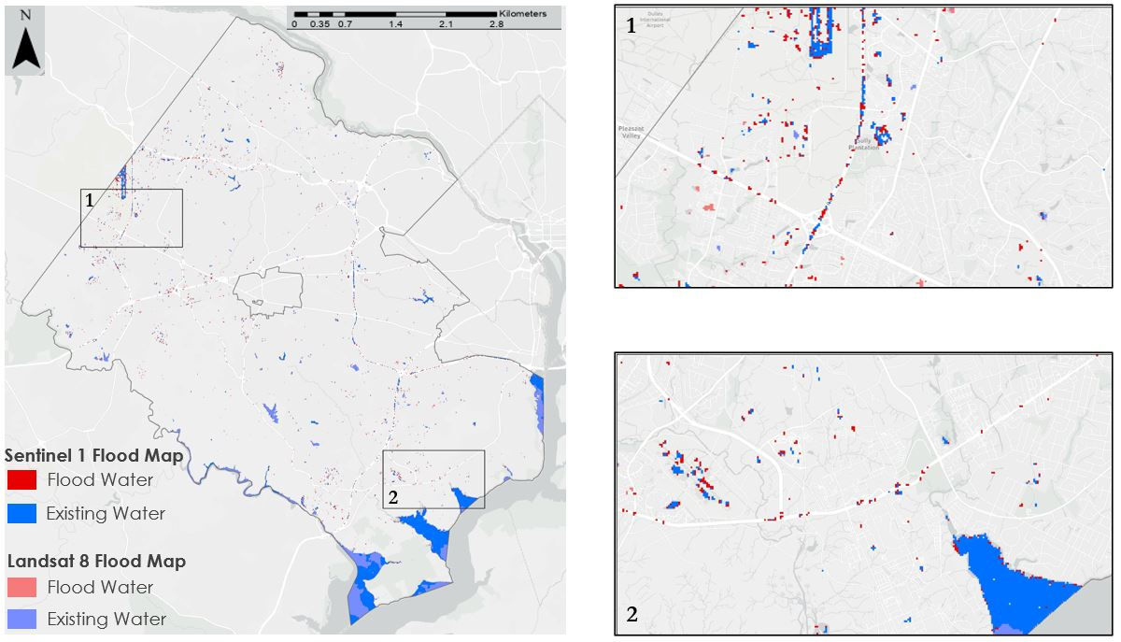

*Figure B1*: Sentinel-1 and Landsat 8 Flood Maps for the August 1st, 2018 Flooding Event

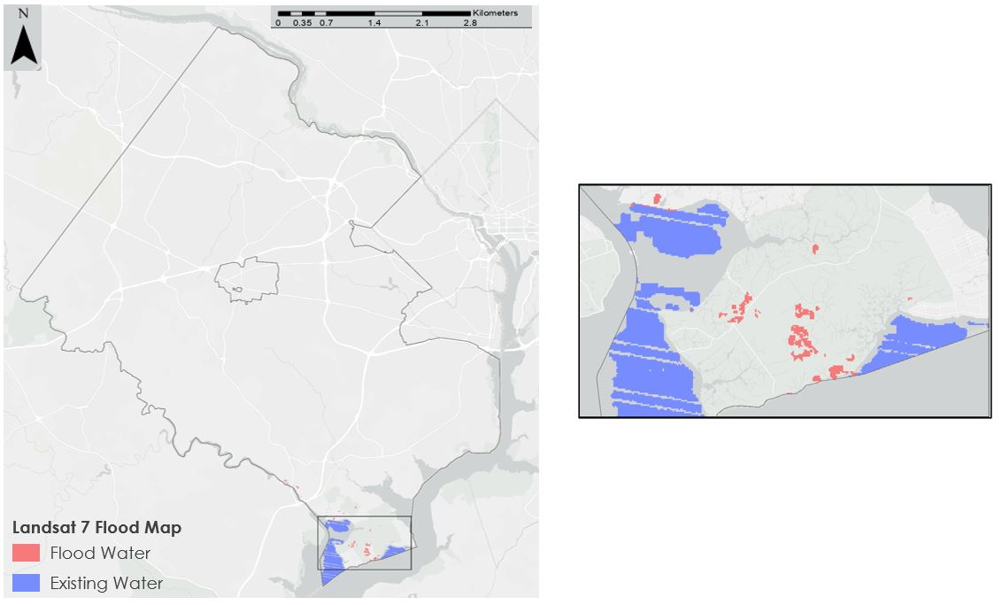

*Figure B2*: Landsat 7 Flood Map for the January 22nd, 2016 Flooding Event