**NASA DEVELOP National Program**

NASA Langley Research Center

**Summer 2015**

**Short Title: Arizona Health & Air Quality**

**Subtitle:** Enhancing Extreme Heat Health-Related Intervention and Preparedness Activities Using Remote Sensing Analysis of Daily Surface Temperature Variation Between Extreme Heat Days

**VPS Title:** Beat the Heat: Surface Temperature Flux in the Valley of the Sun

**Project Team & Partners**

**Project Team:**

Amy Stuyvesant (Project Lead), amy.stuyvesant@nasa.gov

Geordi Alm

Rocky Garcia

Emma Baghel

April Rascon

Bernardo Gracia

**Advisors & Mentors:**

Dr. David Hondula (Arizona State University)

Dr. Kenton Ross (NASA DEVELOP National Program)

**Partner Organizations**

Arizona Department of Health Services (ADHS), End-User and Boundary Organization, POC: Matthew Roach

Arizona State University, Environmental Remote Sensing and Informatics Lab, End-User, POC: Billie L. Turner II

Arizona State University, Center for Policy Informatics, End-User, POC: Erik W. Johnston

**Project Details**

**Applied Sciences National Applications Addressed:**Health & Air Quality

**Study Area:** Maricopa County, AZ

**Study Period:** May – September months from 2005 – 2014

**Earth Observations & Parameters**

Landsat 8 OLI, TIRS - Visible, NIR, and panchromatic bands

Aqua, MODIS - Land surface temperature

Terra, ASTER - Visible and NIR bands

**Ancillary Datasets Utilized**

* Maricopa County Health Department (MCDPH) map datasets - Locations of heat relief network cooling centers
* Arizona State University (ASU)’s GIS spatial data repository - Land use classification shapefiles, county boundaries, county digital elevation model
* U.S. Census Bureau TIGER datasets - Census tract shapefiles with demographic attributes
* ASU’s Urban Vulnerability to Climate Change project map dataset - Maricopa County heat vulnerability maps
* MCDPH and David Hondula’s dissertation research map datasets - Maps of spatial variability in heat-health outcomes
* MCDPH, ASU, and Arizona Department of Health Services interviews, surveys, and observations CASPER dataset - Responses from summer 2014 cooling center evaluation
* NOAA National Centers for Environmental Information (NCEI) (Formerly National Climatic Data Centers) teleconnection dataset - Teleconnection indices
* Multi-Resolution Land Characteristics Consortium National Land Cover Dataset - 2011 impervious surface estimates
* MesoWest’s Automated Weather Observation Network dataset - Ground-based meteorological observations

**Software Utilized**

ArcGIS - Map creation of land surface temperature census tract averages, survey data map creation, and final imagery creation

Qualtrics- Survey and interview development and response recording

RStudio - Statistical analysis of surface temperature averages from MODIS raster files and census tract shapefiles

ENVI – MODIS, Landsat, and ASTER imagery processing and classification

**Project Overview**

Human exposure to excessive heat, especially in cities, accounts for more fatalities in the United States than any other weather hazard. Elevated vulnerability of the poor, homeless, elderly, and ethnic minorities highlights the necessity for understanding these spatial discrepancies in order to enact effective and meaningful change. Remote sensing helped produce visual aids outlining seasonal hot spots, communities at higher risk, and overall zones of greatest incidence. This will provide information regarding appropriate locations for cooling centers and assist officials in delivering proper aid.

**Abstract**

Extreme heat causes more human fatalities in the United States than any other natural disaster, elevating the concern of heat-related mortality. Maricopa County, Arizona is specifically known for its high heat index and is the leading megapolitan area in the U.S. for population growth and urbanization. As Phoenix expands, the increase in urban strictures raises nighttime temperatures and induces a positive feedback loop, creating an urban heat island (UHI) effect. Individuals at higher risk are unequally distributed, leaving the poor, homeless, non-native English speakers, elderly, and socially isolated vulnerable to heat events. While this is a devastating incidence, it can be prevented. The Arizona Department of Health Services and the Phoenix Heat Relief Network, among others, are working to create more effectively placed cooling centers and heat warning systems to aid those with the highest exposure. Using NASA Earth observation technology from Landsat 8, Aqua (MODIS), and Terra (ASTER) satellites (sensors) the daily spatial and temperature variability within the UHI was quantified over the summer seasons of 2005 – 2014. A series of One-way Analysis of Variance revealed significant differences between daily surface temperature averages of the hottest 30% of census tracts within a single season. Visual analyses displayed shifts of where and how consistently the top 30% occur. These results provided detailed information regarding nuances within the UHI effect and will allow pertinent recommendations regarding the health department’s adaptive capacity. They also hold essential components for future policy regarding appropriate locations for cooling centers and efficient warning systems.

**Community Concerns**

* Extreme heat is a chronic health hazard and is expected to become more dangerous with time and individuals’ vulnerability. Civilians most affected include those without air conditioning or proper insulation, those with low income, newcomers, homeless, minorities, and socially isolated.
* Expanding urban landscapes with impervious surfaces slow down cooling rates at nighttime, resulting in an urban heat island (UHI) effect. Area types most affected are dependent on housing type, location and distance from the nearby UHI(s), land cover type, and crime rate. Knowing this information can show the optimal locations of new cooling centers and warning message deployment.

**Current Management Practices & Policies**

There are currently no state laws with regard to heat surveillance or heat monitoring policies in Arizona. Consequently, there are no guidelines for governing entities to follow in such situations. While laws do not explicitly cover heat surveillance or heat monitoring, the Federal Health Insurance Portability and Accountability Act (HIPAA), where Public Health is an exempt entity, does allow for data collection regarding relevant fatalities. This allows the Maricopa County Department of Public Health (MCDPH) to obtain information on a patient without violating the patient’s confidentiality. MCDPH primarily collects data through preliminary reports of death from the office of the medical examiner and by obtaining death certificates from the MCDPH office of Vital Registration. This data is then classified into heat-caused and heat-related deaths, and is evaluated to obtain the demographics of heat related deaths and the risk factors for mortality in order to inform relief efforts. Presently, policy formation does not employ information gathered from NASA Earth observations.

**Decision Support Tools & Benefits**

|  |  |  |
| --- | --- | --- |
| **End-Product** | **Earth Observations Used** | **Benefit & Impact** |
| Remotely Sensed Climatology of Maricopa County Surface Temperatures on Extreme Heat Days | Aqua MODIS | Suitable candidate communities for improved heat warning messages and cooling station locations |
| Maps of heat duration and recurrence (including definitions based on temp and temp-humidity metrics) | Landsat 8 OLI/TIRS, Aqua MODIS, Terra ASTER | Understanding how/when UHI varies and how various urban landscapes affect seasonal variations in surface temperature |
| Revised heat vulnerability maps | Landsat 8 OLI/TIRS, Aqua MODIS, Terra ASTER | Updated knowledge of socio-economic reasons for vulnerability locations and densities |

**Project Imagery**

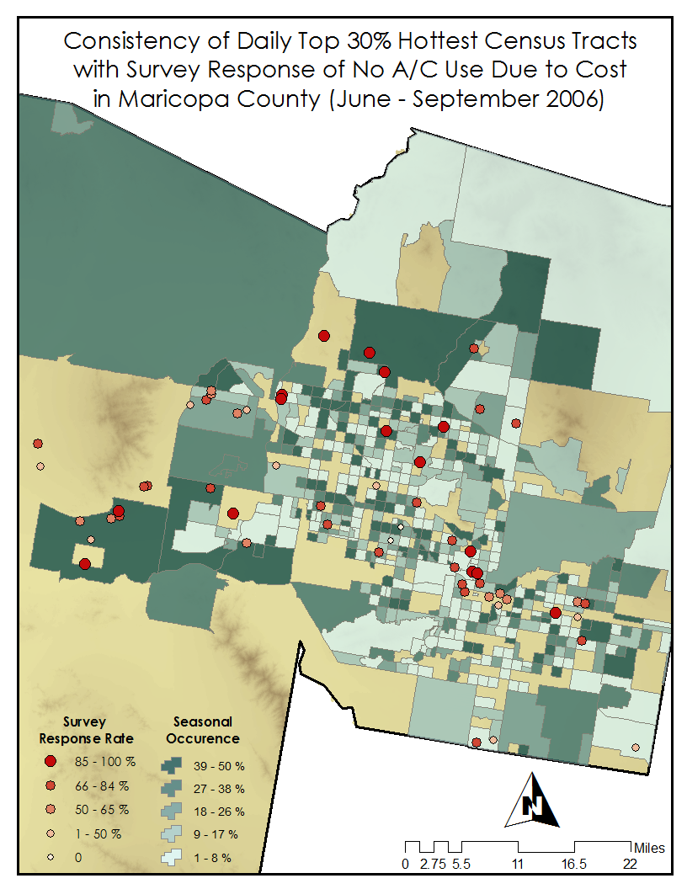

**Caption:** Hottest 30% daily surface temperature averages per census tract mapped by percent occurrence throughout season. Points represent survey responses where participant doesn’t use A/C due to cost.

**Image:** FinalImage07092015.PNG