InVEST Urban Development
Incorporating Earth Observation Data into the Integrated Valuation of Ecosystem Services and Tradeoffs (InVEST) Urban Flood Risk Mitigation Model Python API


Technical Report
March 30th, 2023

Son Do (Project Lead)
Jessica Besnier

Advisors:
Dr. Venkataraman Lakshmi, University of Virginia (Science Advisor)
Dr. Kenton Ross, NASA Langley Research Center (Science Advisor)

Fellow:
Caroline Williams (Pop-Up Project Fellow)

Abstract
Urban flooding poses as one of the biggest issues for cities today as its impacts are amplified by both climate change and urbanization. The Natural Capital Project’s Integrated Valuation of Ecosystem Services and Tradeoffs (InVEST) Urban Flood Risk Mitigation (UFRM) model, which benefits from its simplicity and robustness, is commonly used in NASA DEVELOP projects for disaster mitigation, urban planning, and environmental justice issues. While the InVEST UFRM model was able to produce the surface water runoff and retention map sufficient for the scopes of past projects, the model’s accuracy and spatial variability need improvement. Since the current InVEST UFRM model employs constant rainfall depth for all pixels in the area of interest (AOI), the model suffers from inaccurately estimating rainfall depth, runoff volume, and flood depth. Therefore, we adapted the model so that satellite-based precipitation raster datasets (i.e., Integrated Multi-satellitE Retrievals for Global Precipitation Measurement [GPM IMERG]) can be used instead of a single constant value. We simulated the flood events on August 21st and August 22nd, 2017, in Wyandotte County, Kansas using both our modified and the original InVEST UFRM model and then compared the results after incorporating rainfall raster into the model. Areas with developed land on the land use map predicted moderate to high flood volume in the original volume regardless of the actual amount of precipitation. The modified model considered the rainfall depth’s spatial variation achieving less overestimation of flood runoff and volume at low-to-moderate rainfall area.

Key Terms
Urban flooding, flood damage assessment, remote sensing, flood modeling, hydrological extremes, natural hazards

2. Introduction
2.1 Background Information
Floods are among the world’s costliest and deadliest natural disasters. According to the World Disasters Report (2012), flooding events accounted for more than 55% of all natural disasters and affected over 1.1 billion people around the world from 2002-2011. Urban flooding is defined as floodwater accumulation resulting from an influx of stormwater which exceeds the drainage system capacity to move water out of built-up areas (National Academies of Sciences, Engineering, and Medicine, 2019). Urban flooding poses as one of the biggest issues for cities today as its impacts are amplified by both climate change and urbanization. Climate change exacerbates the proportion of the population exposed to floods (Tellman et al., 2021), while urbanization leads to higher peak flow rate of runoff due to the modification from permeable to impervious land and insufficient drainage infrastructure (Quagliolo et al., 2021). Not only does urban flooding cause widespread damage, but it also poses health risks, such as epidemic outbreaks, contaminating drinking water, and destroying ecosystems (Chen et al., 2015).

Due to the significant impacts and severity of urban flooding, many urban flood models, ranging from simple numerical simulations to complicated hydrodynamics models, have been developed and extensively studied by the scientific community (Qi et al., 2021; Luo et al., 2022). Emerging technologies and urban flood models have begun to explore 2D and 3D simulations to gain better insight into previously overlooked parameters such as parked cars, water entering buildings, and construction (Mignot et al., 2019). However, such models require intensive data and computational power, which are often unavailable. The Natural Capital Project’s Integrated Valuation of Ecosystem Services and Tradeoffs (InVEST) Urban Flood Risk Mitigation (UFRM) model, which benefits from its simplicity and robustness, is more suited for situations where there is limited available data. This model is also beneficial for determining preliminary and rapid results for early urban planning and flood mitigation phases.

The model was previously applied in Italy (Quagliolo et al., 2021), India (Kadaverugu et al., 2021), and several NASA DEVELOP projects (Tango et al., 2021; Castillo et al., 2022). Through all of these case studies, while InVEST UFRM model was able to produce the surface water runoff and retention map sufficient for the scopes of past projects, the model accuracy and spatial variability need improvement. Since the current InVEST UFRM model employs constant rainfall depth for all pixels in the area of interest (AOI), the model suffers from inaccurately estimating rainfall depth, runoff volume, and flood depth. Indeed, rainfall data has a major impact on the model results, as indicated by previous sensitivity analysis run on the InVEST UFRM model by Quagliolo et al. (2021), which resulted in a 40% increase in rainfall depth doubling the resulting runoff volume. Therefore, we are adapting the model so that satellite-based precipitation raster datasets can be used instead of a single constant value. This integration will improve the model accuracy and spatial variability. We chose to include precipitation data from Integrated Multi-satellitE Retrievals for Global Precipitation Measurement (GPM IMERG).

Like the DEVELOP 2022 Kansas City Disasters project, we chose Wyandotte County in Kansas City, Kansas as the AOI as seen in Figure 1. We simulated the flood events on August 21st and August 22nd, 2017, using both our modified and the original InVEST UFRM model and then compared the results after incorporating a rainfall raster into the model.

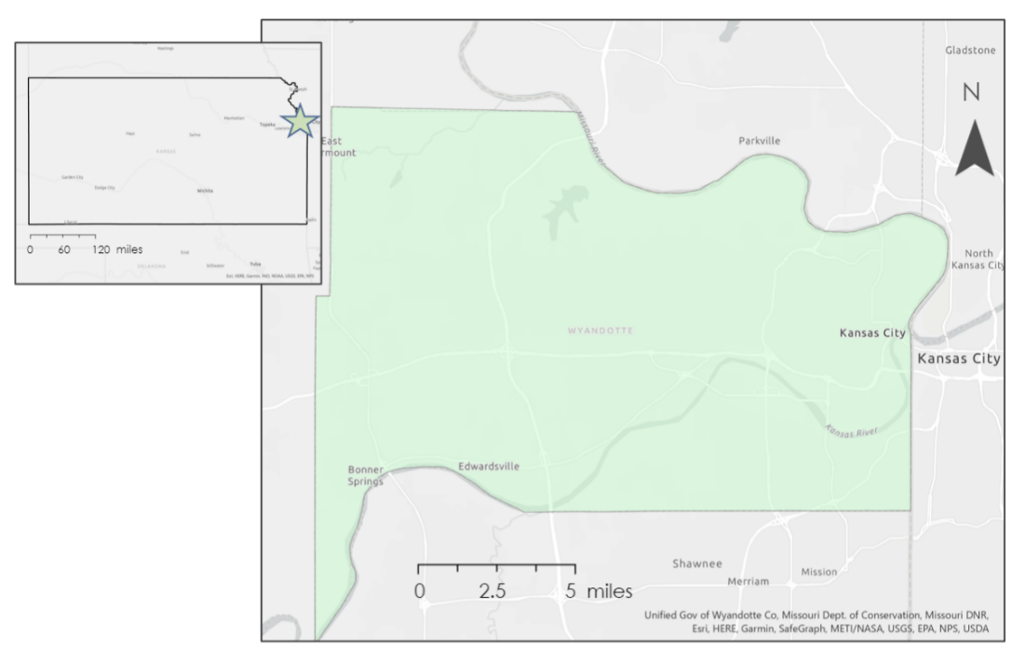
Figure 1. Wyandotte County, KA – the Area of Interest for the analysis.

2.2 Objectives
This tech and innovation project focused on integrating Earth observation (EO) data into the InVEST Urban Flood Risk Mitigation model for future DEVELOP projects. With the inclusion of the spatial variability of rainfall data into this model, we aimed to enhance the model's current capabilities and outputs by improving its surface water runoff & retention maps and potential building damage estimation. To illustrate the benefits of incorporating rainfall raster into the model, we tested our modified InVEST UFRM model over the same study area and period (Kansas City, Kansas, 2010 – 2021) as a previous DEVELOP urban flood study (Castillo et al., 2022). We compared the results from the old and new models to validate the necessity of a rainfall raster input for the InVEST UFRM model. Finally, we prepared a well-documented internal script along with detailed tutorials to assist future DEVELOP participants and partners with ease of use for the new model.

3. Methodology
3.1 Data Acquisition
We acquired the required remote sensing datasets for the InVEST UFRM model for the study area (Wyandotte County – Kansas City) which include: a singular rainfall depth value, a land cover raster, a soil hydrological classification group raster, and a biophysical table containing the empirical Soil Conservation Service–Curve Number (SCS – CN) that helps estimate the direct surface runoff from rainfall for different soil and land cover type classes (NRCS-USDA, 2004). Additionally, building footprint shapefiles with infrastructure category and damage loss information can potentially be used for estimating the potential building damage due to the flood volume and runoff retention across the watershed. Precipitation raster data over the area of interest during flood events were also acquired, as we aimed to incorporate rainfall depth rasters into the model. For this project scope, we didn’t consider the building damage assessment of the model and only focused on the flood runoff & retention calculation from the InVEST UFRM model.

First, we extracted precipitation data over the storm events (August 2017 and May-June 2019) from the GPM IMERG – Final Version from the NASA Goddard Earth Sciences Data and Information Services Center (GES DISC). Then, we acquired the remaining data including land cover, soil hydrological classification group and SCS-CN from the previous DEVELOP Kansas City Disasters projects. Additionally, Wyandotte County watershed was delineated using the United States Geological Survey (USGS) National Elevation Dataset 3D Elevation Program’s 1/3rd arc-second digital elevation model (DEM). To validate our improved model, we acquired Sentinel-1 C-band Synthetic Aperture Radar (SAR) images from the European Space Agency (ESA) using Google Earth Engine. A summary of the sources and Earth observation datasets used are seen in Table 1.

Table 1
Description of Earth observations used in the project.
Dataset | Purpose | Date | Source | Resolution
GPM IMERG | Precipitation | 2017, 2019 | NASA GES DISC | 0.1 x 0.1 degrees
USGS 2019 USA National Land Cover Dataset (NLCD) | Land cover | 2019 | USGS | 30m x 30m
United States Department of Agriculture (USDA) Gridded Soil Survey Geographic Soil Type and drainage class dataset | Soil hydrological Groups | 2019 | USDA | 10m x 10m
USGS National Elevation Dataset 3D Elevation Program, 1/3rd arc-second digital elevation model | DEM for watershed delineation | 2020 | USGS | 10m x 10m
Sentinel-1 SAR GRD: C-band Synthetic Aperture Radar Ground Range Detected | SAR images for validation | 2017, 2019 | ESA via Google Earth Engine | 10m x 10m

3.2 Data Processing
3.2.1 InVEST Model Input Data
Since the InVEST UFRM Python API model only allows dataset with coordinate reference system (CRS) in linear units, we reprojected GPM IMERG precipitation data to EPSG:3857 prior to inputting the rainfall depth raster. More information on data processing of soil hydrological group and associated curve number could be found in the Kansas City Disasters Summer 2022 technical report (Castillo et al., 2022). All raster input datasets (precipitation, land use and land cover (LULC), and hydrological soil type) were aligned geospatially and resized to the same spatial resolution for a unified cell size, dimensions, and bounding box. The LULC raster can be seen in Figure 2 and the Hydrological Soil Groups raster can be seen in Figure 3. The pixel size of every raster was resampled to that of the LULC map (30 meter).

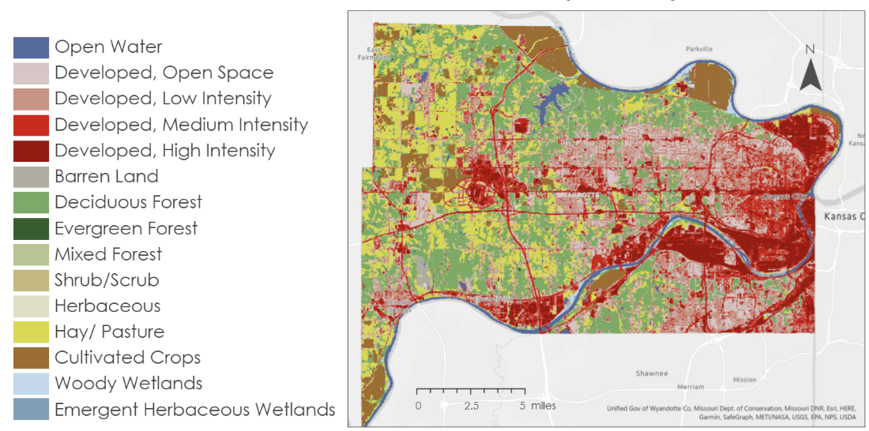
Figure 2. Landcover dataset over Wyandotte county.

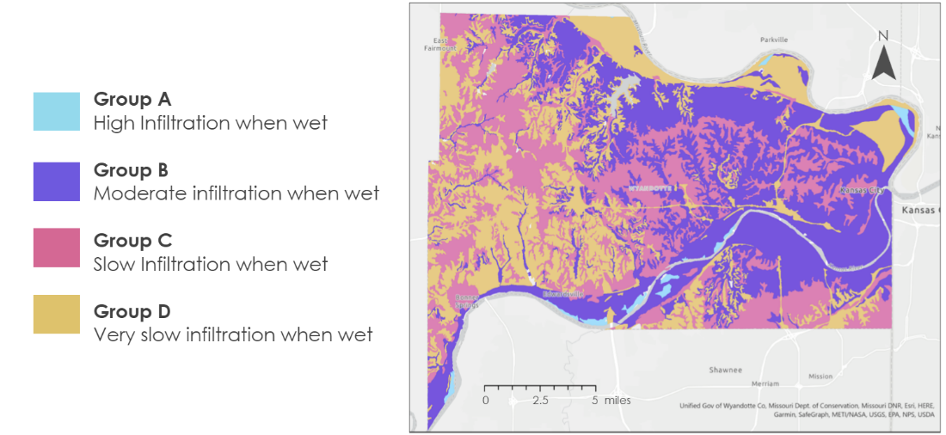
Figure 3. Hydrological Soil Type for Wyandotte County.

3.2.2 InVEST Models Validation
We used Sentinel-1 SAR images for satellite-based flood extent map for cross-comparison with two InVEST model results. After clipping Sentinel-1 SAR images to the AOI, we performed two SAR image pre-processing steps (as seen in Figure 4) before the intensity images could be used for water mapping: Speckle noise filtering and radiometric slope correction. Speckle appears in SAR images as granular noise because of the interference of waves reflected from many out-of-phase elementary scatterers within the same resolution cell. Since SAR images are formed coherently, the out-of-phase weak signals result in granular pixel-to-pixel intensity variation (Lee et al., 1994). Since speckle negatively affects image segmentation and classification accuracy, speckle filtering techniques such as Lee Sigma (Lee et al., 2008) or Gamma Map (Beauchemin et al., 1995) are commonly applied for pre-processing. In addition, due to the side-looking angle of the SAR instrument, geometric distortions such as layover, shadow, and foreshortening often occur in SAR imagery. Therefore, radiometric slope correction using a DEM is also often employed for SAR image pre-processing.

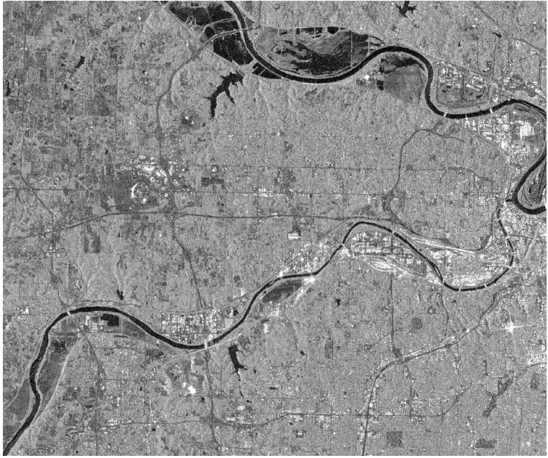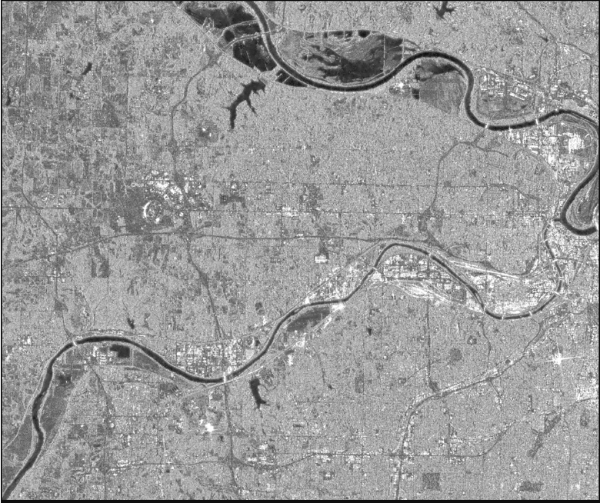
Figure 4. Raw (left) and pre-processed (right) Sentinel-1 SAR intensity images over Wyandotte County.

From the pre-processed SAR images, we initially used the Edge Otsu method (Markert et al., 2020) to derive the water map. The Edge Otsu method uses Canny edge filter to define and buffer the edges (assuming to be water) before sampling the histogram for traditional Otsu thresholding. However, highway and flat land pixels were misclassified as water since they also have similar backscatter intensity as water (Figure 5). Therefore, we employed a change detection method called Z-score water mapping, which calculates how much SAR intensity in the flood image deviates from average SAR intensity during the dry season (DeVries et al., 2020). The Z-score statistics were derived as:
$$\begin{aligned}{\text{Z}}_{{\text{σ}}_{\text{0}}}\text{=}\frac{{\text{σ}}_{\text{0}}\text{- }\overline{{\text{σ}}_{\text{0}}^{\text{Dry}}} }{\text{std(}{\text{σ}}_{\text{0}}^{\text{Dry}}\text{)}}\#\left(\text{1}\right)\end{aligned}$$

with ${\text{σ}}_{\text{0}}$ being the target image intensity value and $\overline{{\text{σ}}_{\text{0}}^{\text{Dry}}}$ and $\text{std}\left({\text{σ}}_{\text{0}}^{\text{Dry}}\right)$ being the mean and standard deviation of dry season intensity images. Similar to DeVries et al (2020), we chose a threshold of -3 as the cutoff of flood water pixels. The water extent map from Z-score change detection is more realistic and therefore will be used for cross-comparison with the InVEST UFRM model’s result. We utilized the NASA SERVIR Hydrologic Remote Sensing Analysis for Floods (HYDRAFloods) Python package to perform speckle noise filtering, Edge Otsu water mapping, and used Google Earth Engine Javascript API for z-score water map derivation.
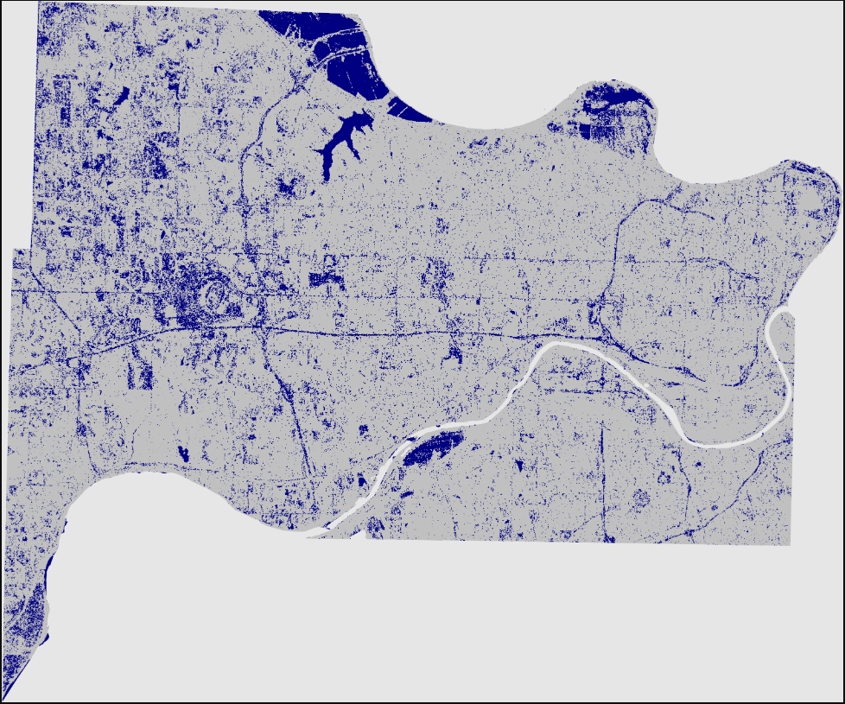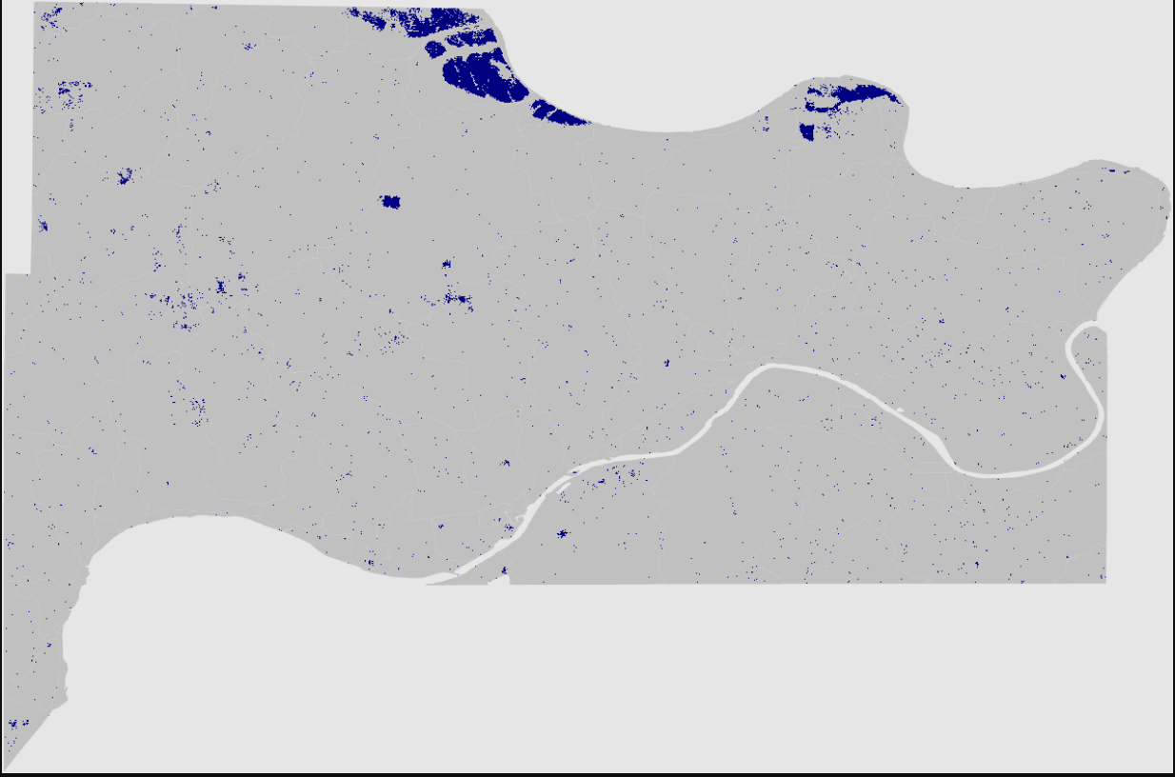
Figure 5. Flood extent map from Edge Otsu method (left) and Z-score change detection method (right).

3.3 Data Analysis
Similar to Quagliolo et al. (2021), we conducted a sensitivity analysis on the original InVEST UFRM model to confirm the sensitivity of model results to rainfall value. Two rainfall depth values with a difference of 50% [20mm and 30mm] were used for the AOI to compare the flood runoff & retention result value. Then, we committed modifications to the original InVEST Python API code to help integrate a rainfall raster into the flood runoff & retention calculation. From the initial InVEST UFRM Python code, we first modified the rainfall input in the user interface from a textbox (number) to directory (raster file). Secondly, the rainfall raster file was aligned and resampled together with LULC and hydrological soil raster datasets. Then for the flood runoff & retention calculation, rainfall data were used as an array with the same dimension and size as other rasters instead of a singular value of all pixels.

Since there was no in-situ flood extent or flood depth gauge data in Wyandotte County, we relied on satellite-based flood map to cross-compare with the results from the InVEST UFRM model. Unfortunately, there was no coincident Sentinel-1 SAR images during the August 2017 flood. We chose SAR images acquired on June 15th, 2019, which had a moderate rainfall rate. We visually compared the flood extent map from Sentinel-1 SAR images with the flood runoff maps from the original and modified InVEST UFRM model.

4. Results & Discussion
4.1 Analysis of Results
The InVEST UFRM model calculates how much stormwater is retained by the soil and hence how much water becomes surface runoff. Two rasters of water retention rate and flood runoff rate can be obtained for the InVEST UFRM model. In each analysis, we evaluated the retention index map (0 to 1, with 0 being all stormwater becomes runoff and 1 being all stormwater gets retained), the flood runoff depth map (in millimeters), and flood volume map of sub-watersheds (in cubic meters).

4.1.1 Sensitivity Analysis
By running a sensitivity analysis, we were able to understand the effects of the change of rainfall input on the model. We ran the original model with 20mm of rainfall and 30mm of rainfall will the rest of the inputs being kept the same to test how sensitive the model is. Since the model gives us various outputs, we looked into the flood volume per sub-watershed (m³), discharge per pixel (mm), and the runoff retention percentage per pixel. With an increase of 50% of rainfall depth, the flood volume increased 231% between the two inputs, and the discharge volume increased by 135%. These results show that the model is sensitive to the rainfall input. Figure 6 below shows the flood volume maps and the changes at the sub-watershed catchment area. Figure 7 shows the increase of discharge from the two inputs whereas Figure 8 shows the runoff retention index.

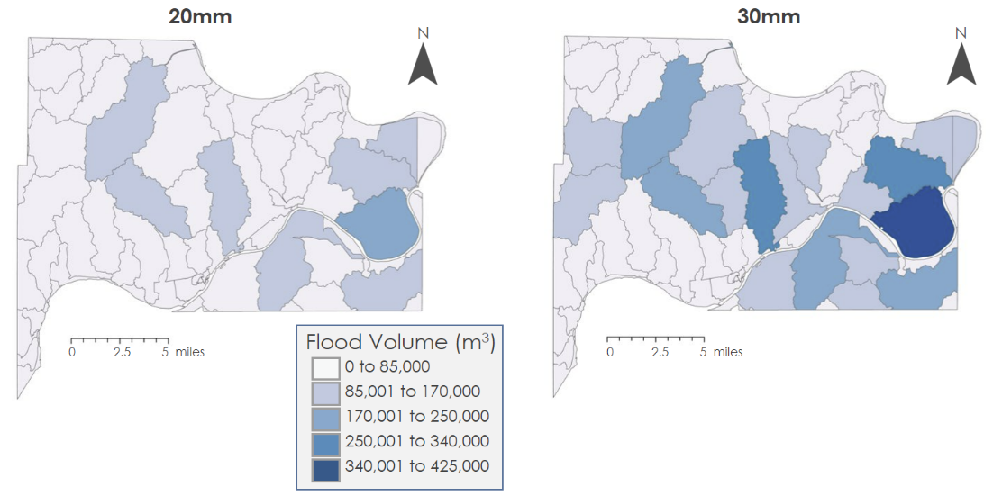
Figure 6. Flood Volume Results from the Sensitivity Analysis.

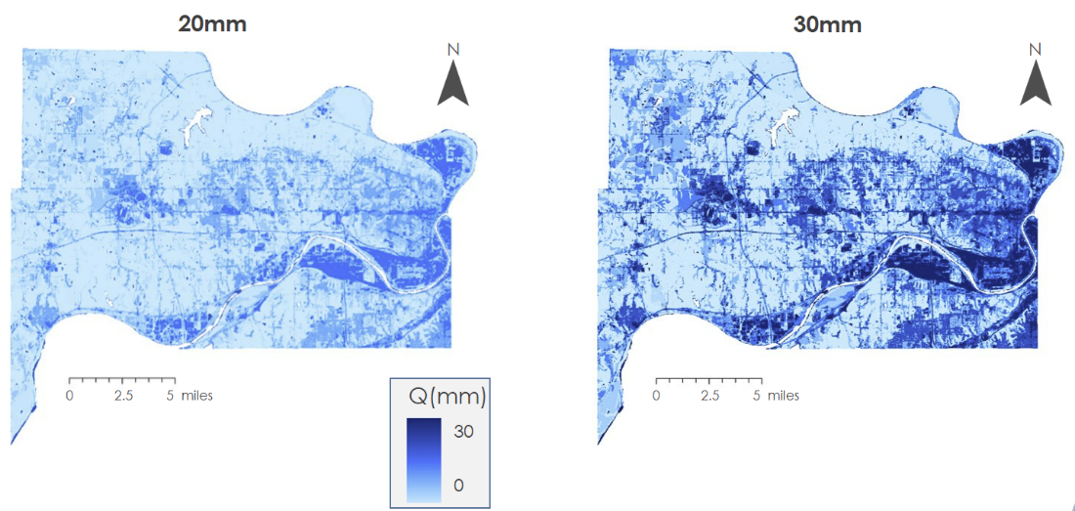
Figure 7. Discharge Results from the Sensitivity Analysis.

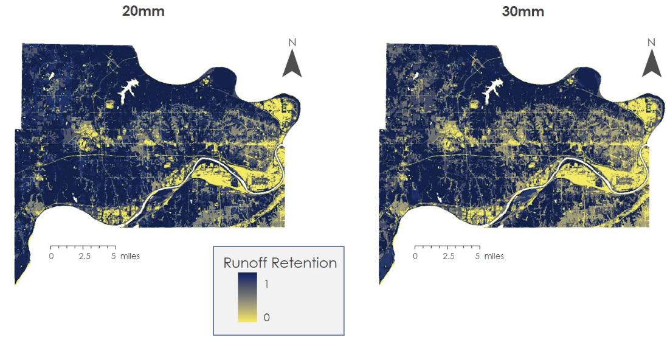
Figure 8. Runoff Retention Results from the Sensitivity Analysis.

This sensitivity analysis shows the importance of accurately inputting the correct amount of rainfall, and with the improved model, we were able to implement the rainfall more accurately with raster datasets, thus providing a more accurate model.

4.1.2 Comparison of two models
In order to compare the models, we generated the flood results of both our modified UFRM model using the GPM raster and the original InVEST UFRM model using one singular rainfall depth value. We ran this test over an AOI of Wyandotte County, Kansas on August 21st and 22nd of 2017. For both days, the original model used maximum precipitation values in the AOI (14.48 millimeters for August 21st and 125.48 millimeters for August 22nd) whereas for the modified model, GPM IMERG daily total precipitation data rasters were used for input. These inputs can be seen in Figures 9 and 10.

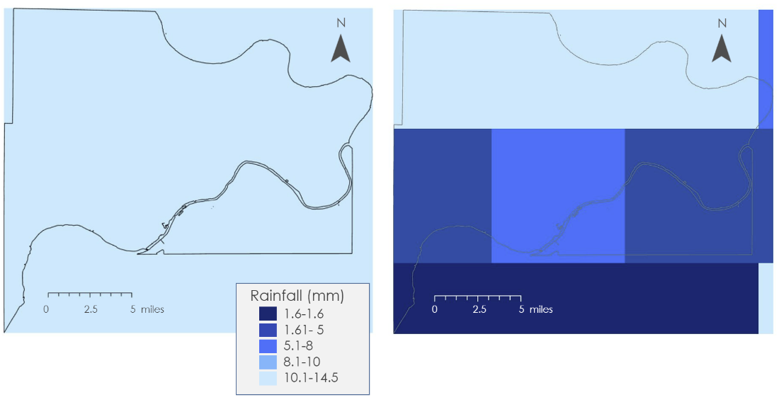
Figure 9. Daily Precipitation for August 21st (left is the original model and right is the improved model) for Wyandotte County.

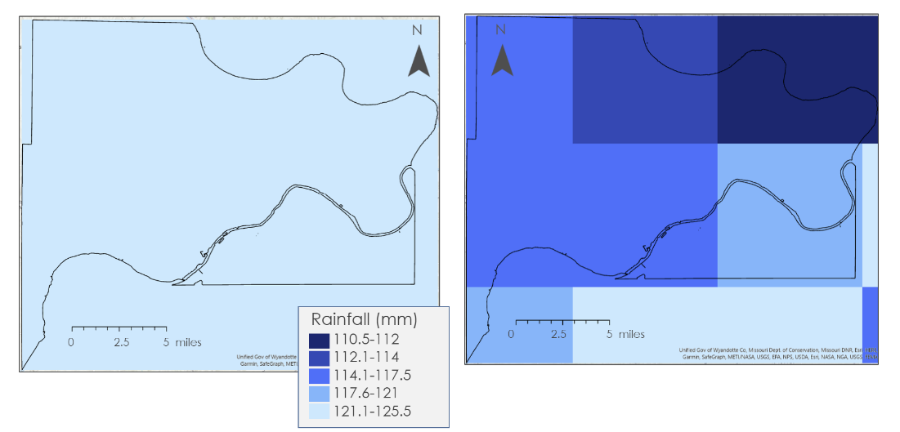
Figure 10. Daily Precipitation for August 22st (left is the original model and right is the improved model) for Wyandotte County.

For August 21st, the rainfall depth contained high spatial variation (Figure 9) in the AOI with the maximum, minimum and mean precipitation value being 14.48, 1.62, and 7.71 millimeters. Therefore, when one single maximum rainfall depth value was used in the original UFRM model, the lower right area of Wyandotte County (near the Kansas River), which in reality received minimal precipitation, would get overestimated flood runoff and retention calculation. The flood runoff map, retention index map, and the sub-watershed flood volume map of two models are shown below in Figures 11, 12, and 13.

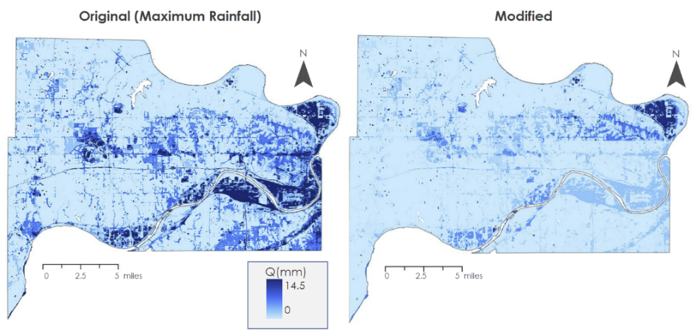
Figure 11. Flood runoff maps for original model (left) and modified model (right) for Wyandotte County on August 21st.

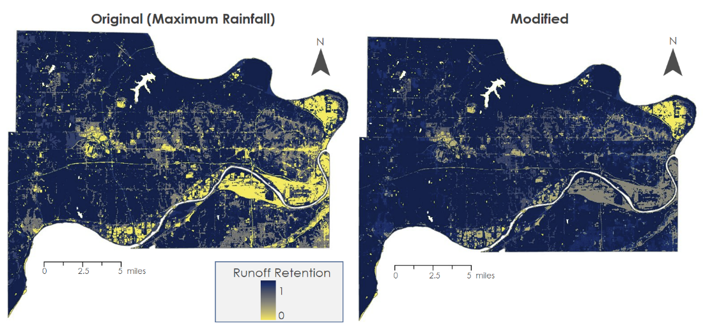
Figure 12. Retention index maps for original model (left) and modified model (right) for Wyandotte County on August 21st.

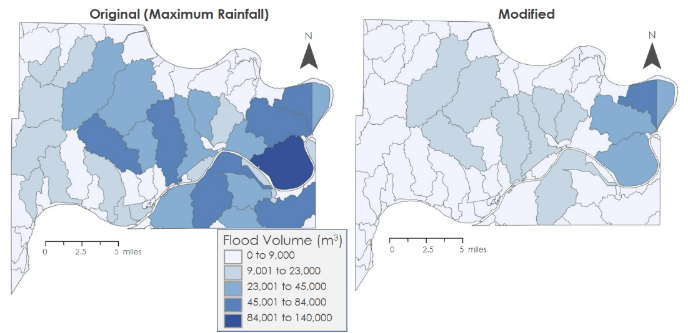
Figure 13. Sub-basin flood volume for original model (left) and modified model (right) for Wyandotte County on August 21st.

For the original model, flood runoff was heavily influenced by the spatial variation of the LULC map (developed land use area is more impervious and therefore results in higher flood runoff and less flood retention). For the modified model, rainfall depth variation was considered, and, as a result, flood runoff was much less than the original model. The biggest difference is seen in the lower right area where less precipitation occurred. While the original model assigned a high value of flood runoff for this area, the modified model showed significantly less runoff. Similar differences could also be seen in the lower left area near Bonner Springs. The retention index map, which is the opposite of the flood runoff map (high retention results in low runoff), presented similar differences. Due to the heavy influence by LULC, all sub-basins with developed land use were predicted to have moderate to high flood volume for the original model. Therefore, with the addition of the rainfall raster input parameter, we achieved less overestimation of flood runoff and volume at low-to-moderate rainfall areas.

For August 22nd, Kansas City and Wyandotte County experienced an extreme flash flood event due to especially heavy rain (up to 125 millimeters) as seen in Figure 10. Compared to August 21st when there were areas with high and low precipitation, extremely high precipitation (above 100 millimeters) occurred across the AOI on August 22nd. Also, high precipitation occurred at the top side of the AOI on August 21st and at the bottom side of the AOI on August 22nd.

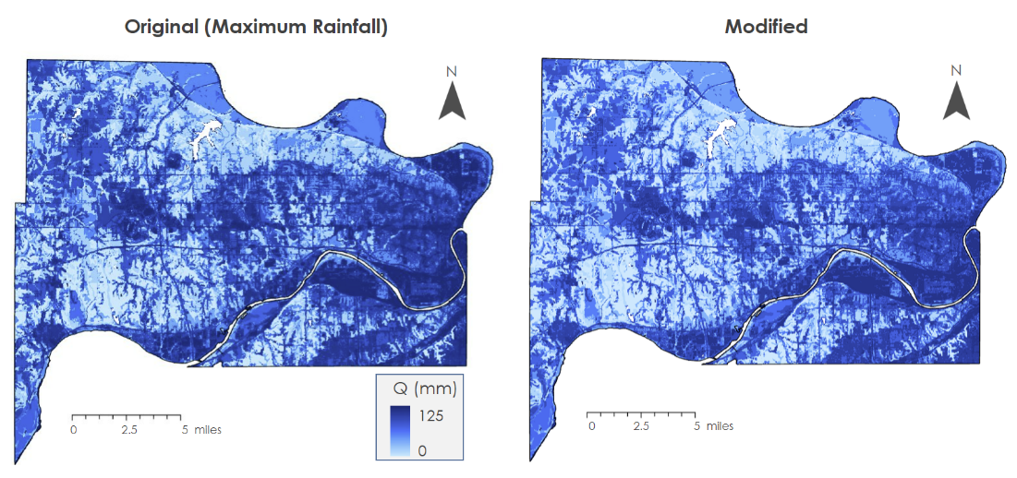
Figure 14. Flood runoff maps for original model (left) and modified model (right) for Wyandotte County on August 22nd.

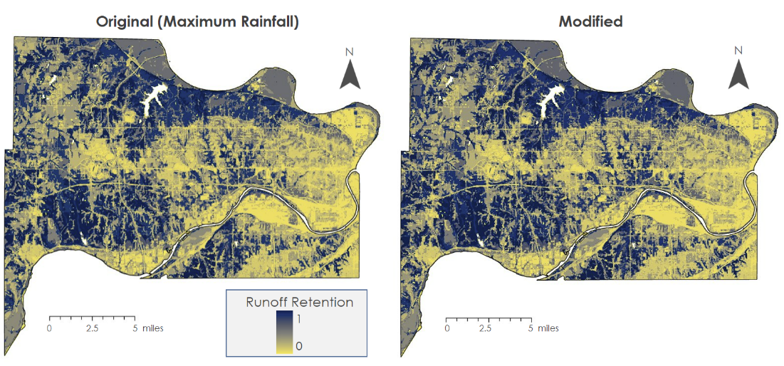
Figure 15. Retention index maps for original model (left) and modified model (right) for Wyandotte County on August 22nd.

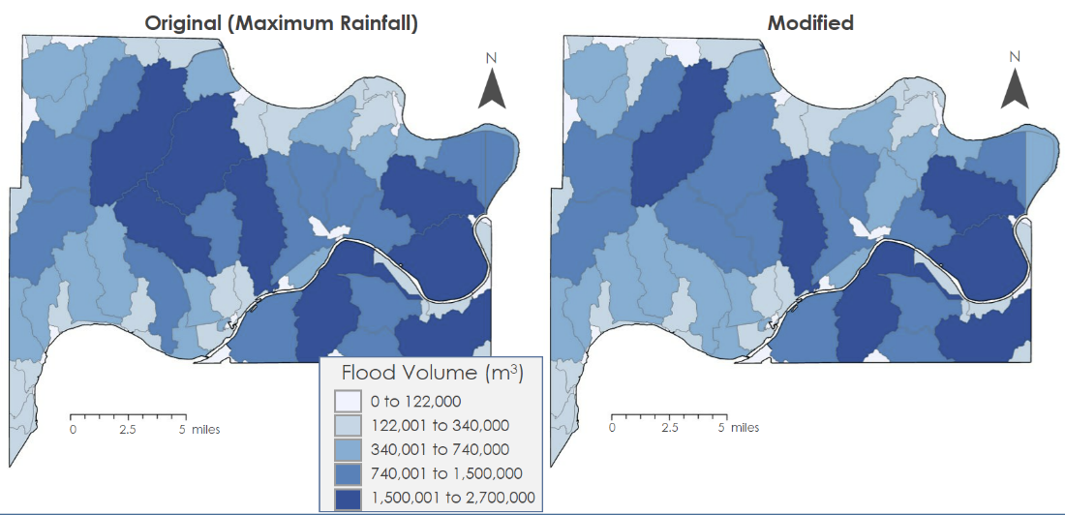
Figure 16. Sub-basin Flood volume for original model (left) and modified model (right) for Wyandotte County on August 22nd.

Compared to the models’ result difference on August 21st, fewer differences were observed for August 22nd for the flood runoff and runoff retention of two models. We observed that the flood runoff at the top side of the county for the modified model was slightly less than that of the original model (since less rainfall occurred there) as seen in Figure 14. However, results from both models were generally similar in spatial variation and magnitude. We speculated that at such a high precipitation event across the AOI, water exceeded the potential maximum retention across the region and therefore resulted in similar results for both models as seen in Figure 15. Similarly, the sub-basin average flood volume maps of both models were similar with the only main differences occurring at the middle section of the AOI as seen in Figure 16.

4.1.3 Validation
Since no coincident Sentinel-1 SAR image during the August 2017 flood was found, we used the SAR images acquired on June 15th, 2019, for cross comparison. It is worth noting that Sentinel-1 SAR flood mapping for urban application images contain many uncertainties due to shadow from buildings and trees as well as surface roughness effect from rain and wind (Zhang et al., 2021). Therefore, the flood extent map from Sentinel-1 SAR image used for cross-comparison in this study is not entirely reliable. Nevertheless, the flood extent map from Sentinel-1 can certainly confirm that the flood overestimation in the original model and that our modified model’s result is more realistic. Figure 17 showed the flood runoff in millimeters from the original and modified models as well as the satellite-based flood extent map.
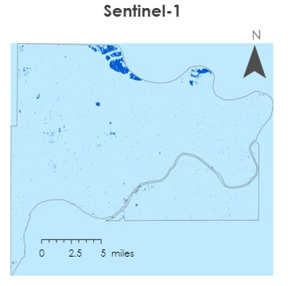
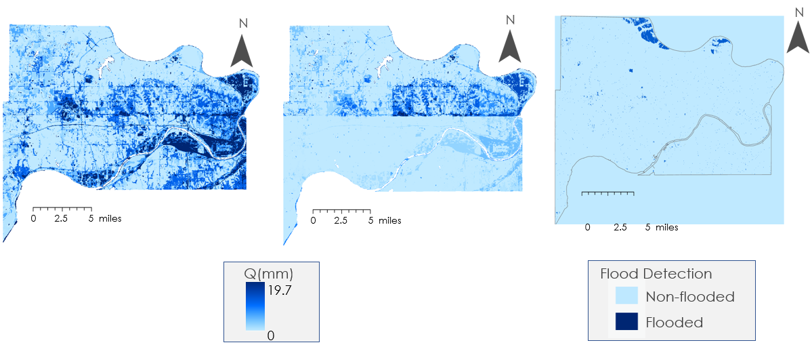
Figure 17. Flood runoff maps of original model (left) and modified model (center) and Sentinel-1 flood extent map (right) for June 15th, 2019.

Similar to the results from the August 2017 flood, the eastern side of the study area was predicted to experience flood due to imperviousness and developed land use. Since the original model only considers land cover and soil group, flood runoff is always predicted to be high in developed areas even if the area experiences minimal rain. From the satellite-based flood extent map, no significant flood was present in the eastern side of Wyandotte County on June 15th, 2019. Though the modified model result is not entirely correct, with the rainfall spatial variability information, modification made to the model helps alleviate the flood overestimation to a large degree.

4.2 Future Work
Moving forward, some improvements can be made to further improve the InVEST UFRM model. We used the GPM IMERG precipitation raster as model input; however, the precipitation product spatial resolution (10 km) is still quite large compared to the other raster input’s resolution (30 m). Since urban flood application requires fine scale resolution and the model is extremely sensitive to precipitation change, it is uncertainly beneficial to test higher resolution precipitation products (i.e., Climate Hazards Group InfraRed Precipitation with Station data (CHIRPS) (5 km) or Gridded Surface Meteorological precipitation (GRIDMET) (4 km)) or to downscale precipitation products before using them as input for the model.
Additionally, to continue improving this model, it is important to add infiltration calculations that will serve as a better estimate for less impervious surfaces and improve the calculations on the discharge. Additionally, downscaling GPM and using higher resolution precipitation data as an input will improve the outputs of the model. Lastly, more in-depth validation efforts on different areas and time periods to improve credibility of the model are needed. Following in line with this project, a subsequent project in other locations that incorporates a downscaled precipitation raster, improved infiltration calculations, and more in-depth validation would serve as an appropriate follow up to this project.

5. Conclusions
Improving the InVEST UFRM proved to better assess urban flooding through a case study in Wyandotte County, KS. By implementing a raster into the model, the precipitation was more accurately accounted for allowing for improved accuracy in the discharge, retention runoff, and flood volume across the AOI. Through the sensitivity analysis, we learned that the increase of rainfall by 50% into the original model increases the discharge by over 200% revealing that the model is very sensitive to the precipitation input. In knowing this, accurately inputting precipitation into the model is of paramount importance. Without more accurately accounting for precipitation, the overestimation of flooding will occur. After modifying the model, the outputs from the modified model for the Wyandotte County flood in August 2017 show a decrease in flooding in comparison to the original model, which uses the maximum rainfall. By having this improved model, local decision makers are able to use this information in urban planning and determining where floods will occur in the future. This information is crucial in making important economic and environmental decisions in urban areas. While the validation efforts proved that the improved model is more accurate at depicting the floods, there are still quantitative efforts in validation that need to be explored.

6. Acknowledgments
We’d like to thank Dr. Venkataraman Lakshmi and Dr. Kenton Ross for their guidance and help throughout this project. This project would not have been possible without the guidance, help, and support of Caroline Williams, our node fellow. We would also like to thank Laramie Plott and Cecil Byles, our PC fellows, for their continuous help with the deliverables throughout the term. We would like to thank the MA Disasters team from whom we gathered data and information regarding the original InVEST model.

This material contains modified Copernicus Sentinel data (2017-2019) processed by ESA.

7. Glossary
AOI – Area of Interest
DEM – Digital elevation model
GPM IMERG – Integrated Multi-satellitE Retrievals for Global Precipitation Measurement
InVEST UFRM – Integrated Valuation of Ecosystem Service and Tradeoffs Urban Flood Risk Mitigation
LULC – Land use and land cover
SAR – Synthetic Aperture Radar
SCS - CN – Soil Conservation Service - Curve Number
USGS – United States Geological Survey

8. References
Beauchemin, M., Thomson, K. P. B., & Edwards, G. (1996). Optimization of the Gamma-Gamma MAP filter for SAR image clutters. International Journal of Remote Sensing, 17(5), 1063–1067. https://doi.org/10.1080/01431169608949067
Castillo, M., Gross, H., Sjostedt, E., & Velez, R. (2022). Assessing Environmental and Socioeconomic Factors of Urban Flood Vulnerability in Kansas City, Kansas [Unpublished manuscript]. NASA DEVELOP National Program, Massachusetts—Boston.
Chen, Y., Zhou, H., Zhang, H., Du, G., & Zhou, J. (2015). Urban flood risk warning under rapid urbanization. Environmental Research, 139, 3–10. https://doi.org/10.1016/j.envres.2015.02.028
DeVries, B., Huang, C., Armston, J., Huang, W., Jones, J. W., & Lang, M. W. (2020). Rapid and robust monitoring of flood events using Sentinel-1 and Landsat data on the Google Earth Engine. Remote Sensing of Environment, 240, 111664. https://doi.org/10.1016/j.rse.2020.111664
Dewitz, J., & U.S. Geological Survey. (2021). National Land Cover Database (NLCD) 2019 Land Cover Conterminous United States (ver. 2.0, June 2021) [Data Set]. U.S Geological Study. https://doi.org/10.5066/P9KZCM54
European Space Agency (ESA). (2014). Sentinel 1 - SAR GRD: C-band Synthetic Aperture Radar Ground Range Detected, log scaling [Dataset]. Earth Engine Data Catalog/European Union/ESA/Copernicus. Retrieved February 14, 2022, from https://developers.google.com/earth-engine/datasets/catalog/COPERNICUS_S1_GRD
Huffman, G.J., Stocker, E.F., Bolvin, D.T., Nelkin, E.J., & Tan, J. (2019). GPM IMERG Final Precipitation L3 1 day 0.1 degree x 0.1 degree V06, Edited by Andrey Savtchenko, Greenbelt, MD, Goddard Earth Sciences Data and Information Services Center (GES DISC), Accessed: 2023-02-14. https://doi.org/10.5067/GPM/IMERGDF/DAY/06
Kadaverugu, A., Nageshwar Rao, C., & Viswanadh, G. K. (2021). Quantification of flood mitigation services by urban green spaces using InVEST model: A case study of Hyderabad city, India. Modeling Earth Systems and Environment, 7(1), 589–602. https://doi.org/10.1007/s40808-020-00937-0
Lee, J. S., Jurkevich, L., Dewaele, P., Wambacq, P., & Oosterlinck, A. (1994). Speckle filtering of synthetic aperture radar images: A review. Remote Sensing Reviews, 8(4), 313–340. https://doi.org/10.1080/02757259409532206
Lee, Jong-sen., Jen-Hung Wen, Ainsworth, T. L., Kun-Shan Chen, & Chen, A. J. (2008). Improved Sigma Filter for Speckle Filtering of SAR Imagery. IEEE Transactions on Geoscience and Remote Sensing, 47(1), 202–213. https://doi.org/10.1109/TGRS.2008.2002881
Luo, P., Luo, M., Li, F., Qi, X., Huo, A., Wang, Z., He, B., Takara, K., Nover, D., & Wang, Y. (2022). Urban flood numerical simulation: Research, methods and future perspectives. Environmental Modelling & Software, 156, 105478. https://doi.org/10.1016/j.envsoft.2022.105478
Markert, K. N., Markert, A. M., Mayer, T., Nauman, C., Haag, A., Poortinga, A., Bhandari, B., Thwal, N. S., Kunlamai, T., Chishtie, F., Kwant, M., Phongsapan, K., Clinton, N., Towashiraporn, P., & Saah, D. (2020). Comparing Sentinel-1 Surface Water Mapping Algorithms and Radiometric Terrain Correction Processing in Southeast Asia Utilizing Google Earth Engine. Remote Sensing, 12(15), 2469. https://doi.org/10.3390/rs12152469
Mignot, E., Li, X., & Dewals, B. (2019). Experimental modelling of urban flooding: A review. Journal of Hydrology, 568, 334–342. https://doi.org/10.1016/j.jhydrol.2018.11.001
National Academies of Sciences, Engineering, and Medicine. (2019). Framing the Challenge of Urban Flooding in the United States. Washington, DC: The National Academies Press. https://10.17226/25381
NRCS-USDA. (2004). Chapter 10. Estimation of Direct Runoff from Storm Rainfall. In United States Department of Agriculture (Ed.), Part 630 Hydrology. National Engineering Handbook. Retrieved from http://www.nrcs.usda.gov/wps/portal/nrcs/detailfull/national/water/?cid=stelprdb1043063
Qi, W., Ma, C., Xu, H., Chen, Z., Zhao, K., & Han, H. (2021). A review on applications of urban flood models in flood mitigation strategies. Natural Hazards, 108(1), 31–62. https://doi.org/10.1007/s11069-021-04715-8
Quagliolo, C., Comino, E., & Pezzoli, A. (2021). Experimental Flash Floods Assessment Through Urban Flood Risk Mitigation (UFRM) Model: The Case Study of Ligurian Coastal Cities. Frontiers in Water, 3, 663378. https://doi.org/10.3389/frwa.2021.663378
Tango, M., Acomb, J., Harrington, A., & Sun, L. (2021). Assessing the Drivers of Urban Flood Vulnerability in Milwaukee using the Integrated Valuation of Ecosystem Services and Tradeoffs Urban Flood Risk Mitigation Model (InVEST) [Unpublished manuscript]. NASA DEVELOP National Program, Virtual Environmental Justices.
Tellman, B., Sullivan, J. A., Kuhn, C., Kettner, A. J., Doyle, C. S., Brakenridge, G. R., Erickson, T. A., & Slayback, D. A. (2021). Satellite imaging reveals increased proportion of population exposed to floods. Nature, 596(7870), 80–86. https://doi.org/10.1038/s41586-021-03695-w
United States Department of Agriculture Soil Survey Staff. (2020). Gridded Soil Survey Geographic (gSSURGO) database for the Conterminous United States [Data Set]. https://catalog.data.gov/dataset/gridded-soil-survey-geographic-gssurgo-30-database-for-the-conterminous-united-states-30-m
United States Geological Survey. (2022). 1/3rd arc-second Digital Elevation Models (DEMs) - USGS National Map 3DEP Downloadable Data Collection [Data Set]. https://data.usgs.gov/datacatalog/data/USGS:3a81321b-c153-416f-98b7-cc8e5f0e17c3
Zhang, H., Qi, Z., Li, X., Chen, Y., Wang, X., & He, Y. (2021). An Urban Flooding Index for Unsupervised Inundated Urban Area Detection Using Sentinel-1 Polarimetric SAR Images. Remote Sensing, 13(22), 4511. https://doi.org/10.3390/rs13224511

