**NASA DEVELOP National Program**



NASA Goddard Space Flight Center

*Summer 2017*

Chesapeake Bay Ecological Forecasting

Utilizing NASA Earth Observations to Monitor Marsh Health in the Chesapeake Bay to Support the Maryland Department of Natural Resources Coastal Resiliency Assessment

**Technical Report**

Final Draft – August 10, 2017

Victor Lenske (Project Lead)

John Fitz

Dr. Sara Lubkin

Sean McCartney

Helen Plattner

Dr. David Lagomasino, NASA Goddard Space Flight Center (Science Advisor)

Jenny Allen, Maryland Department of Natural Resources (Science Advisor)

# **1. Abstract**

Tidal wetlands, such as marshes, are among the Chesapeake Bay’s most protective natural features. Not only do they provide vital ecological services such as breeding grounds and water purification, but wetlands also deliver direct benefits to coastal communities through water absorption, wave attenuation, and sediment stabilization. Thus, marshes can buffer vulnerable communities from erosion, flooding, and storm damage. The Maryland Department of Natural Resources partnered with The Nature Conservancy (TNC) to conduct a Coastal Resiliency Assessment to identify coastal habitats that provide protective benefits to vulnerable coastal communities. While healthy marshes were determined to have high risk-reduction potential, the quality of coastal habitats on the Maryland shoreline is difficult to assess without historical context. The goal of this study was to utilize NASA Earth observations to analyze trends in marsh health on the Maryland coast of the Chesapeake Bay from 1984 to 2017 and to forecast changes in marsh health from 2017 to 2030. Vegetation, soil, and water indices calculated from Landsat and Sentinel-2 imagery were used to detect changes in marsh extent over the past 33 years, as well as current marsh health. The Maryland Department of Natural Resources and The Nature Conservancy will use these results to supplement their Coastal Resiliency Assessment and develop more informed decision-making plans regarding restoration and conservation in the Chesapeake Bay.

**Keywords**

Remote sensing, marsh health, coastal resiliency, Sentinel-2, Landsat, vegetation indices, Chesapeake Bay

# **2. Introduction**

***2.1 Background Information***

Humans have had an impact on Maryland’s marshes since the first European settlement on St. Clement’s Island in 1634. Communities grew near the marshes in order to take advantage of abundant seafood and convenient access to shipping routes. As a result, more than 70% of Maryland’s population lives in coastal areas (NOAA National Coastal Population Report, 2013) and Maryland’s marshes have become an important element of the economy and cultural identity of the state. Marshlands dampen wave energy and bind sediment, creating buffers that protect coastal communities against wave damage, storm surge, and erosion (Duarte et al., 2013). However, in recent decades, the Chesapeake Bay watershed has experienced a significant reduction in and degradation of marsh habitat, particularly in the middle portion of Maryland’s Eastern Shore (Kearney, 2002).

Although national efforts to protect marshes have reduced the rate of coastal wetland loss, 60% of historical marshlands within the Chesapeake Bay no longer exist due to development and agriculture (Stevenson et al., 2002). The remaining marshes have been heavily affected by agricultural and industrial runoff, shellfish and finfish harvesting, groundwater withdrawal and land subsidence, reduction of sediment input, mammal and waterfowl grazing of marsh grasses, burning of marshland, increased salinity, agricultural and industrial runoff, eutrophication, and changes associated with climate change such as sea level rise (Stevenson et al., 2002). The continued degradation of coastal marshes reduces the protective potential of the wetlands and puts coastal communities at risk.

A healthy marsh has few tidal creeks and is devoid of interior ponds. As marsh health deteriorates, the number of tidal creeks increases. Creeks lengthen and widen; small interior ponds form; the marsh soil becomes saturated with water and, in turn, marsh grasses begin to die. The decomposition of vegetation depletes oxygen from the soil and water, leading to anoxic soil conditions (Drake, 1989). As more vegetation is lost, ponds continue to enlarge and coalesce. Over time, marshlands become submerged and extensive coastal erosion occurs (Stevenson et al., 2002).

Satellite imagery provides a valuable tool for monitoring the health of wetlands in a noninvasive manner (Corman, 2008). Landsat has provided continuous coverage of the Earth since 1972, allowing for multi-year comparisons of marsh health and vegetation extent. While several techniques have been developed for evaluating marsh health, most use spectral indices to measure the vegetation, water, and soil components of pixels within the satellite imagery. One example is the Marsh Surface Condition Index (MSCI), which tracks the fractional changes in vegetation, water, and soil over time (Kearney and Rogers, 2010).

The project study area included approximately 78,500 hectares of Maryland marshlands identified and assigned a protection potential score through the Maryland Department of Natural Resources’ Coastal Resiliency Assessment (Fig. A1). The study period ranged from January 1984 to July 2017, with forecasting planned to the year 2030.

***2.2 Project Partners & Objectives***

Project partners included the Maryland Department of Natural Resources (MD DNR) and The Nature Conservancy (TNC). Maryland is a signatory to the 2014 Chesapeake Bay Watershed Agreement, which established a Climate Resiliency Goal and Associated Adaptation Outcome to “continually pursue, design, and construct restoration and protection projects to enhance the resiliency of Bay and aquatic ecosystems from the impacts of coastal erosion, coastal flooding, more intense and more frequent storms, and sea-level rise” (Chesapeake Bay Program, 2014). MD DNR is responsible for scientifically assessing Maryland’s vulnerability to climate change and for developing plans to avert or minimize anticipated effects.

As part of this responsibility, the MD DNR spearheaded a multi-agency Coastal Resiliency Assessment to identify where natural habitats provide the greatest potential risk reduction for coastal communities. The assessment included calculation of indices for shoreline hazard, an estimation of the relative exposure to coastal hazards in Maryland, and identification of coastal community flood risk and priority shoreline areas. The assessment also included the development of the Marsh Protection Potential Index (MPPI) which ranks Maryland’s coastal marshes by their ability to protect vulnerable communities from coastal hazards (Canick et al., 2016). While marsh health is considered important in determining risk reduction potential, MD DNR currently does not have a means to quantify and compare marsh health.

TNC partnered with MD DNR to complete Maryland’s Coastal Resiliency Assessment. TNC is well known for its mission to conserve and protect threatened ecosystems through collaborations that respect the needs of human populations. TNC is actively involved in the protection of marshes and has established more than 30 preserves in the state of Maryland. This assessment of marsh health will allow MD DNR and TNC to better target their marsh restoration and living shoreline projects.

This project addressed NASA’s Ecological Forecasting application area within the Applied Sciences Program by using NASA Earth observations to evaluate and forecast marsh health in the Chesapeake Bay in support of the project partners’ Coastal Resiliency Assessment. The project was guided by the need to incorporate marsh health into MD DNR’s coastal resiliency and protection potential indices. Our first objective was to use remotely sensed data to evaluate changes in marsh health from 1996 to 2017. The second objective was to develop a method to map and measure current marsh health in Maryland’s coastal marshes. The final objective was to forecast changes in marsh health using climate models to 2030. Implementation of a well-calibrated, Earth observation-based methodology at the landscape scale will greatly enhance the ability of MD DNR and TNC to assess marsh health and evaluate the need for marsh restoration efforts.

# **3. Methodology**

***3.1 Data Acquisition***

**3.1.1 Earth Observations**

Earth observation datasets for this project included: Sentinel-2 Multispectral Instrument (MSI), Landsat 5 Thematic Mapper (TM), Landsat 8 Operational Land Imager (OLI), and elevation data from the Shuttle Radar Topography Mission (SRTM). The European Space Agency’s (ESA) Sentinel-2 satellite was launched in June 2015. Sentinel-2’s 10 to 20 m spatial resolution and narrow bands in the red to infrared range makes the imagery ideal for mapping changes in vegetation and can be useful for distinguishing among vegetation types. However, since Sentinel-2 launched recently, imagery from the mission was not available for the entire study period. Thus, Sentinel-2 imagery was primarily used to evaluate marsh health between 2015 and 2017. We downloaded Sentinel-2 Level 1C top-of-atmosphere reflectance tiles for the study area and study period (May through September, 2015-2017) from the USGS EarthExplorer data portal. Three (out of four) cloud-free dates were chosen for analysis: 9-14-2015, 6-20-2016, and 5-16-2017. The other cloud-free date, 6-10-2016, was not used.

We chose Landsat 5 Thematic Mapper (TM) and Landsat 8 Operational Land Imager (OLI) for historical assessment of marshland because 30 m resolution imagery was available for the entire study period of 1984 to 2017. The data were accessed as image collections within the Google Earth Engine (GEE) platform. We chose to use image collections with atmospherically corrected top-of-atmosphere, orthorectified products for Landsat 5 and Landsat 8.

We used 30 m resolution elevation data from the Shuttle Radar Topography Mission (SRTM) version 3, SRTMGL1_003 in the GEE classification scripts. These elevation data were used to mask all areas except low lying marsh as part of the unsupervised classification process. These scripts were then used to create maps of historical marsh extent within the study area. The classification scripts that created marsh extent maps for years 2014 to present, also used the C-band Synthetic Aperture Radar (SAR) from Sentinel-1 to assist in masking coastal areas necessary for classification.

**3.1.2 Ancillary Data**

Ancillary data included land cover classifications and high resolution imagery. Land cover classifications were used to determine transitions in land cover over time while high resolution imagery was used for validation of classifications and index calculations.

NOAA Coastal Change Analysis Program (C-CAP) Regional Land Cover and Change datasets are “nationally standardized, raster-based inventories of land cover for the coastal areas of the United States. Data are derived, through the Coastal Change Analysis Program, from the analysis of multiple dates of remotely sensed [Landsat] imagery. C-CAP data forms the coastal expression of the National Land Cover Database and the A-16 land cover theme of the National Spatial Data Infrastructure.” (National Oceanic and Atmospheric Administration, 2017) Maryland C-CAP data was available for the years of 1992, 1996, 2001, 2006, and 2010. We edited the C-CAP datasets for Maryland in ArcMap before importing the data to TerrSet to determine transitions in land cover between selected years.

USDA National Agricultural Imagery Program (NAIP) high resolution imagery – NAIP aerial 4-band 1 m imagery is collected every three years. NAIP imagery for Maryland was imported into Google Earth Engine scripts to support unsupervised classifications of marsh extent.

***3.2 Data Processing***

We used TerrSet’s (v 18.31) Sentinel module to convert radiance values to surface reflectance values and to provide atmospheric correction using the Cos(t) model for all scenes. The Cos(t) atmospheric correction method accounts for atmospheric gas absorption and scattering in addition to uniform haze effects. We converted the resulting raster files for each band into ENVI IMG files using TerrSet’s ENVIIDRIS module and stacked the bands using ENVI’s Layer Stacking tool to create 11-band composites for each scene. We projected ancillary spatial data in the NAD_1927_UTM_Zone_18N coordinate system to match the Sentinel imagery.

To forecast marsh extent into the future, we used Esri’s ArcMap to edit features of NOAA C-CAP data for streamlined use in TerrSet. C-CAP data is downloaded in packages, with the display data in the form of an IMG file. The C-CAP IMG files were projected to WGS_1984_UTM_Zone_18N to ensure all data would be in the same projection. We deleted and/or reclassified redundant classes to create more general classes that consolidated the number of possible transitions. For example, all classifications for “Estuarine Wetland” were combined into one overarching class of “Estuarine Wetland”, and classes with a value of “0” or “NoData” were removed.

***3.3 Data Analysis***

**3.3.1 Historical Marsh Health**

To assess past trends in marsh health, we used Google Earth Engine (GEE) to create JavaScript tools that were provided to our project partners. The first tool focused on examining change detection using the Normalized Difference Vegetation Index (NDVI) to generate a vegetation anomaly map and statistics for marshes within our study area. The script calculated NDVI mean values during a reference period of 1984 to 1995. The script then determined positive and negative changes from the reference period in vegetation from 1996 to present. The GEE scripting tool also allowed users to select individual points within the study region to examine changes for time series maps, as well as for analysis of change statistics and graphing of values within the selected points.

The second GEE scripting tool performed unsupervised classification and marsh segregation from non-marsh land cover to generate marsh extent maps of the study area for a user-specified year. The script performed unsupervised classification, but also prompted the user to select pixels representing marsh land cover and enter those values into the script by using the inspector tool within the GEE environment. Once those values were entered and the user was satisfied with the resulting map, the file could be exported into the user's assets or Google Drive as a raster data layer. These raster layers could then be incorporated into other GIS platforms for additional analysis or cartography purposes. Two scripts were included in the project partner handoff: one that uses Landsat 5 image collections for determining marsh extent for years 1984 to 2012, and a second script that uses Landsat 8 image collections for years 2012 to present.

The final script imported marsh extent results from the script(s) above for the purposes of generating basic statistics about the marsh extent. The tool calculated basic statistics such as total number of classified marsh pixels and total area of marsh extent in hectares. The script also determined the total area at the county level for each year in square meters. The user has the option of exporting the marsh maps to their Google Drive as a GeoTIFF file.

**3.3.2 Current Marsh Health**

While a healthy marsh is covered with lush vegetation, a degraded marsh is one where vegetation has been replaced with water or mud. Therefore, we chose to follow the established methodology (Kearney & Rogers, 2010) of using spectral indices derived from Sentinel-2 imagery to track changes in the proportion of vegetation, soil, and water in Maryland’s marshes as a measure of marsh health. We used ENVI’s Band Math tool to calculate the Normalized Difference Vegetation index (NDVI), Normalized Difference Water Index (NDWI), and Normalized Difference Soil Index (NDSI).

NDVI = (Band 8 *NIR* - Band 4 *Red* / Band 8 *NIR* + Band 4 *Red* (1)

NDWI = (Band 3 *Green* – Band 8 *NIR*) / (Band 3 *Green* + Band 8 *NIR*) (2)

NDSI = (Band 11 *SWIR* - Band 8 *NIR*) / (Band 11 *SWIR* + Band 8 *NIR*) (3)

The index layers were stacked using ENVI’s Layer Stacking tool to create 3-band false-color composite images in which red represented dense vegetation (NDVI), blue represented high water content (NDWI), and green represented high soil content (NDSI). The scenes were then mosaicked using ENVI’s Seamless Mosaic workflow with no feathering to create one image covering the entire state of Maryland for each date (Appendix B, Fig. B1a).

The team also used the Band Math tool to calculate NDVI - NDWI for each scene (Appendix B, Fig. B2a. This integrated the water body mapping method proposed by Lu et al (2011) to show contrast between small water bodies and the surrounding land. We hoped that it would be equally effective for emphasizing small creeks and ponding in Maryland’s marshlands.

We saved the mosaicked 3-band (NDVI, NDSI, NDWI) images for 9/14/2017, 6/20/2016, and 5/16/2017 as TIFF files, which were exported to ArcMap in order to create maps that could be easily accessed by MD DNR and TNC.

**3.3.3 Forecasting Marsh Cover**

NOAA C-CAP data for 1992 were compared against C-CAP data for 2001 to detect change in land cover using TerrSet’s Land Change Modeler. Once the IMG files for 1992 and 2001 were projected and reclassified in ArcMap, they were imported to TerrSet and combined with a polygon mask of the Chesapeake Bay to exclude land cover classifications outside of the study area. We used TerrSet’s Land Change Modeler to graphically and spatially display the change in land cover between the selected study period.

# **4. Results & Discussion**

***4.1 Analysis of Results***

**4.1.1 Historical Marsh Health**

We observed changes in historical marsh health by examining the output from the NDVI change anomaly GEE script (Appendix C, Fig. C1). We identified changes based on color: loss in vegetation was shown in red, whereas regeneration of vegetation was shown in green. Notably, significant regenerated marsh habitat indicated successful restoration efforts at Poplar Island during the study period. However, regeneration was rare. Loss of vegetation was found throughout the study area; our results indicated a marked decrease within the Blackwater National Wildlife Reserve.

Marsh extent maps for several years were produced from GEE scripts and are shown below for the years 1995, 2000, 2015, and 2017 (Fig. C2). These raster products were exported from GEE scripts after unsupervised classification was conducted and incorporated into ArcMap to create final map products. Subtle changes were observed in the maps, but the general decline was noted throughout the historical timeline. Additional information about the size of marsh extent for selected years are found in Appendix C, Table 1. These results also conform to the declining marsh habitat seen for the entire State of Maryland, as well as for the five Chesapeake Bay counties that contain the most amount of marsh land cover.

**4.1.2 Current Marsh Health**

To determine which map would be most useful for our partners, it was important to measure variability between scenes. We used ENVI’s change detection difference map tool to calculate the percent change in NDVI, NDSI and NDWI from year to year. The percent change was mapped as 41 classes, representing change in 5% increments (0% change, <5% change, 5-10% change, etc.). While NDVI and NDWI remained consistent from year to year (Fig. D1), there were more significant differences in NDSI (Fig. D1). This variation may be due to weather, tides, seasonality and/or the changing nature of marshes. Therefore, it is difficult to pinpoint one date that accurately represented current marsh state. However, any ponding that remains consistent between scenes could be considered a permanent sign of degradation. In the future, change detection in NDVI-NDWI could be used to differentiate between temporary and permanent ponding and seasonal versus permanent degradation in marshes.

**4.1.3 Forecasting Marsh Cover**

We successfully displayed transitions in land cover classifications using TerrSet’s Land Change Modeler. Maryland wetlands experienced net loss in land cover for the period of 1992 to 2001 (Figs. E1 and E2). Almost 1,700 (1,698) hectares of land classified as either estuarine or palustrine wetland were lost over the study period. The majority (286 hectares) of estuarine wetland in 1992 transitioned to open water by 2001, while 69 hectares were converted to agriculture (Fig. E3). The majority (315 hectares) of palustrine wetland in 1992 transitioned to forest by 2001, followed by 219 hectares to scrub/shrub and 189 hectares to agriculture (Fig. E4). Fifty-eight hectares of palustrine wetland transitioned to estuarine wetland over the nine-year period.

Palustrine wetland was the second largest contributor to the gain in estuarine wetland from 1992 to 2001, following land cover classified as grassland/herbaceous (Fig. E3). The grassland/herbaceous class was also the main contributor to gain in palustrine wetland for the study period (Fig. E4), indicating that land cover classified as grassland/herbaceous should be considered when studying general marsh migration. The different transitions displayed through TerrSet’s Land Change Modeler may all be useful for analyzing marsh migration since the gain and loss of marshes over time can be displayed both graphically and spatially. Unfortunately, we were unable to forecast marsh cover into the future based on land cover change without the incorporation of data for the driving factors behind the various transitions.

***4.2 Future Work***

**4.2.1 Mapping Present Day Marsh Health.** Maps of present day (2015-2017) NDVI, NDWI, NDSI and water bodies were generated, but variation among the maps showed that some ponding and vegetation loss in marshes is ephemeral. In the future, change detection workflows could be used to differentiate between temporary and permanent ponding and degradation in marshes and to provide a qualitative scale for degradation.

**4.2.2 Accuracy Assessment**: Accuracy assessment through additional scripting is necessary to examine the validity of the historical marsh extent map results generated in GEE. Random classifier and a confusion matrix function could be created within the Google Earth Engine environment to test the accuracy of the classification. Accuracy assessment is also needed to verify the validity of the NDVI, NDWI, and NDSI composite maps and NDWI - NDVI maps, which provide an estimate of marsh health as a measure of patchiness and ponding. Collection of ground data could be used to generate definitive marsh areas to verify classification pixel identification for recent years and to test and refine index-based health assessments. Ground-based verification would also allow for the differentiation of high and low marsh areas in both the classification and the index-based marsh health analysis. Our current methodology grouped all land cover types classified as marsh; however, an understanding the extent of high and low marsh would provide our project partners with additional information for decision making purposes. Since coastal marshes in the Chesapeake Bay experience the effects of severe storms and semidiurnal tides, referencing tide tables and precipitation data for the dates of selected imagery could be useful in determining accuracy of index-based marsh health assessments.

**4.2.3. Automation and Repetition:**  Although the team used ENVI to generate present-day marsh health maps, much of the work could be automated using ArcGIS tools or Google Earth Engine scripts. Automation should be considered when expanding upon the results of this project. Additionally, to continue efficiently guiding restoration efforts, it is recommended that classifications be repeated on 5-year intervals due to the rapidly changing nature of coastal marshes.

**4.2.3 Forecasting Marsh Cover:** Further work is needed to accurately determine and acquire useful data on the driving factors behind the land cover transitions. Distance to datasets such as current roads, open water, and agriculture should be considered when using transitions to predict change into the future. Current and past elevation, slope, precipitation, and sea-level rise data should also be implemented into future forecasting efforts to ensure forecasting accuracy. Lastly, depending on the user, it may be beneficial to utilize different land classifications and datasets based on the information needed for deeper analyses. Estuarine and palustrine wetland classes could be subdivided and the scrub/shrub classification could be integrated into either wetland class where appropriate.

# **5. Conclusions**

Preliminary historical analysis showed hotspots of both positive and negative NDVI change throughout Maryland’s Chesapeake Bay. Blackwater National Wildlife Refuge, one of the largest contiguous blocks of salt marsh along the Northeast Atlantic Coast, has experienced dramatic loss in vegetation from 1996 to 2017.

Classified marsh extent maps for selected years as well as corresponding marsh area have shown declines in marsh habitat during the project time. Our team successfully created GEE scripting tools to pass off to our project partners that calculated and displayed changes in NDVI over time, as well as marsh extent maps and corresponding statistics.

Sentinel-2 imagery was successfully used to create 10 m resolution baseline maps of Maryland marsh health based on NDVI, NDSI and NDWI. The team was also able to show creek extent and ponding in marshes using NDVI-NDWI. However, this methodology needs to be verified with ground data. If verified, NDVI-NDWI can be combined with change detection to identify permanent damage to marshes and to quantify marsh degradation.

Maryland’s marshes are trending towards degradation and, if all contributing factors persist, will continue to degrade over time. Transitions in land cover were displayed spatially and graphically, but further work needs to occur to determine the driving factors behind those transitions. It is our anticipation that these analyses will successfully assist the Maryland Department of Natural Resources and The Nature Conservancy in identifying and restoring areas of marshland that provide the greatest risk reduction for coastal communities.

# **6. Acknowledgments**

Michelle Canick (The Nature Conservancy)

Nicole Carlozo (Maryland Department of Natural Resources)

Rachel Marks (Maryland Department of Natural Resources)

Dr. John Bolten (NASA Goddard Space Flight Center)

Alison Thieme (NASA DEVELOP National Program)

Any opinions, findings, and conclusions or recommendations expressed in this material are those of the author(s) and do not necessarily reflect the views of the National Aeronautics and Space Administration.

This material is based upon work supported by NASA through contract NNL16AA05C and cooperative agreement NNX14AB60A.

# **7. Glossary**

**Adaptive management –** A method of ecological assessment using Bayesian methods to inform an iterative process focused on reduction of uncertainty to provide feedback and meet managerial objectives

**Anoxic soil** – Soil where the oxygen level consumed by biota is more than the level diffused into the soil

**Coastal resiliency –** The ability of communities located in coastal areas to recover from hazards from such things as storm surge, flooding, and hurricanes

**Earth observations –** Satellites and sensors that collect information about the Earth’s physical, chemical, and biological systems over space and time

**Ecological service –** Benefits derived from the dynamic and complex interrelationships of plants and animals within the environment **Eco-resilience –** The ability of an ecosystem to withstand negative effects or recover after being subject to damage

**Ecosystem** – The complex interdependence of biotic and abiotic characteristics within a location  
**Ecosystem services** – Benefits derived by humans from an ecosystem which can be broken into four service classes: Provisioning (products and derived goods), Regulating (modulation of climate, hazards, water, and waste), Habitat (biosphere), and Cultural (recreation, aesthetics, spiritual connection, intellectual development)

**Erosion –** The transport of weathered material by ice, water, wind, or gravity

**Geographic information systems (GIS)** – A computer system that can store, display, verify, and calculate large and varied types of data that have been defined in space and time for decision support  
**Interior pond** – Small areas of open water that are produced by the combination of low amounts of sediment being deposited during flood events and high rates of coastal submergence resulting in a lack of oxygen in the marsh bed on and from which organisms live and obtain nourishment; these localized regions of substrate devoid of life may start to develop slowly but can rapidly coalesce into large areas leading to high rates of erosion and degradation of the marsh

**InVEST Coastal Vulnerability Model –** The Natural Capital Project’s free, open-source software model which produces a qualitative estimate of such exposure in terms of a Vulnerability Index  
**Landsat –** A joint effort between NASA and the United States Geological Service (USGS) started in 1972 and continuing to provide the longest running record of satellite derived Earth observing data

Landsat mission sensors:

**5:** Thematic Mapper (TM)

**7:** Enhanced Thematic Mapper Plus (ETM+)

**8:** Operational Land Imager (OLI) and Thermal Infrared Sensor (TIRS)

**Living shoreline** – a natural bank stabilization technique which uses structural and organic materials such as wetland plants, submerged aquatic vegetation, oyster reefs, coir fiber logs, sand fill, and stone to provide the shoreline and the surrounding riparian and intertidal environment protection, improve water quality and filtration, and create and maintain valuable aquatic and terrestrial habitat  
**Marsh –** A wetland area that forms the transition between aquatic and terrestrial ecosystems, comprised mostly of herbaceous plants and characterized by deposits of peat

**Marsh Surface Condition Index (MSCI)** – a modelling approach which assesses the fractional changes of vegetation, water, and bare earth percentages as marsh conditions change over time  
**MD DNR –** Maryland Department of Natural Resources  
**Remote sensing –** The gathering of information without direct contact **Restoration –** The recovery and management of an ecosystem to its condition prior to degradation; may be measured by: range of biodiversity, ecological processes and structures, regional and historical context, and sustainable cultural practices

**Risk reduction –** The responsibility for recognizing, identifying, and controlling exposure to hazards through systematic efforts to analyze and reduce causal factors, lessen exposure to hazards, understand vulnerability of people and property, and inform management of land and the environment, while improving preparedness and early warning for adverse events

**Sediment stabilization –** The process of affixing particulate matter from further erosion

**Sentinel-2 –** A European Space Agency (ESA) satellite mission for land monitoring that provides global coverage every 5 days through its constellation of two satellites. Equipped with the Multispectral Imager (MSI) instrument, Sentinel-2 provides high resolution optical imagery and data continuity for the SPOT and Landsat missions

**Shoreline armoring** – The practice of constructing seawalls, jetties, offshore breakwaters and groins intended to hold shorelines in place

**Spectral vegetation index (SVI) –** Simple ratios are created by taking values obtained from two or more spectral bands though simple formulae with results ranging in value from -1 to +1.Vegetation indices solve the problem of quantifying biophysical measurements taken over areas during different solar zeniths and take advantage of the known inverse relationship between red and near infrared (NIR) values to provide an approximation for live, green vegetation

Spectral Wavelengths:

**Infrared –** Invisible region of the electromagnetic spectrum ranging from approx. 350 - 0.7 μm

**Near Infrared (NIR) –** Subset of the Infrared region of the electromagnetic spectrum ranging from approx. 0.7 - 1.4 μm and sensitive to the inner structure of leaves where photosynthesis occurs

**Short Wave Infrared (SWIR) –** Subset of the Infrared region of the electromagnetic spectrum ranging from approx. 0.7 – 2.5 μm

**Red** – Visible section of the electromagnetic spectrum covering approx. 650 nm to 720 nm and sensitive to chlorophyll content

Spectral Vegetation Indices:

**Normalized Difference Water Index (NDWI**):

NDWI = (Red – SWIR1) / (Red + SWIR1)

**Normalized Difference Vegetation index (NDVI)** – large differences with values closer to +1 indicating greater amounts of green vegetation and small difference values around zero indicating bare soil and water values closer to -1

NDVI = (NIR – Red) / (NIR + Red)

**Normalized Difference Soil Index (NDSI)**:

NDSI = (SWIR1 – NIR) / (SWIR1 + NIR)

**Vulnerable populations** – A disadvantaged sub-segment of the community who are particularly vulnerable to disaster and which may contain but is not limited to: children, minors, pregnant women, prisoners, the terminally ill or immunocompromised, and those with physical and intellectual challenges  
**Wave attenuation** – The reduction of energy through the dampening effects of biomass intersecting aquatic habitats subject to waves, tides, and winds  
**Wetlands** – Habitats that are varied in tolerance to salinity and characterized by tidal fluctuations and seasonal flooding such as seagrass beds, low marsh, high marsh, maritime forests, and forested wetlands

# **8. References**

Canick, M.R., Carlozo, N., & Foster, D. (2016). Maryland Coastal Resiliency Assessment.

http://dnr.maryland.gov/ccs/Documents/MARCH-2016_MDCoastalResiliencyAssessment.pdf. Accessed June, 2017.

Drake, B.G. (1989). Photosynthesis of salt marsh species. *Aquatic Botany, 34*,167-180.

Duarte, C. M., Losada, I. J., Hendriks, I. E., Mazarrasa, I., & Marbà, N. (2013). The role of coastal plant communities for climate change mitigation and adaptation. *Nature Climate Change*, *3*(11), 961-968.

EPA. Office of Water. (2006, May) *Economic Benefits of Wetlands* (EPA843-F-06-004). Retrieved from

https://nepis.epa.gov/Exe/ZyPDF.cgi/2000D2PF.PDF?Dockey=2000D2PF.PDF

European Space Agency. (2015). Sentinel-2 Data [Data set]. Geoscience Australia. https://doi.org/10.4225/25/566A407CD2E2B

Google Earth Engine Team. (2015). *Google Earth Engine: A planetary-scale geospatial analysis platform.* Retrieved from https://earthengine.google.com

Kearney, M.S., & Rogers, A.S. (2010). Forecasting sites of future coastal marsh loss using topographical

relationships and logistic regression. *Wetlands Ecology Management*, *18*, 449-461.

Lu, S., Wu, B., Yan, N., & Wang, H. (2011). Water body mapping method with HJ-1A/B satellite imagery. *International Journal of Applied Earth Observation and Geoinformation*, *13*(3), 428-434.

Maryland at a Glance. (2017, March 15). Retrieved June 27, 2017, from

http://msa.maryland.gov/msa/mdmanual/01glance/economy/html/economy.html

MD Coastal Zone | Chesapeake & Coastal Service. (n.d.). Retrieved June 27, 2017, from http://dnr.maryland.gov/ccs/Pages/md-coastal-zone.aspx

Maryland GIS Data Catalog. (2017). Maryland Political Boundaries - County Boundaries. Retrieved from

http://data.imap.maryland.gov/datasets/maryland-political-boundaries-county-boundaries

Maryland GIS Data Catalog. (2017). Maryland Coastal Resiliency Assessment - Marsh Protection Potential Index. Retrieved from http://data.imap.maryland.gov/datasets/maryland-coastal-resiliency-assessment-marsh-protection-potential-index

N. (n.d.). Wetlands - Wetlands. Retrieved June 27, 2017, from https://chesapeakebay.noaa.gov/wetlands/wetlands

NASA EOSDIS Land Processes DAAC, USGS Earth Resources Observation and Science (EROS) Center, Sioux Falls, South Dakota (2013). NASA Shuttle Radar Topography Mission United States 1 arc second, version 3. Accessed: <July 15, 2017> doi:10.5067/MEASURES/SRTM/SRTMUS1.003

National Oceanographic and Atmospheric Administration (NOAA). 2017. Tides and Currents https://tidesandcurrents.noaa.gov/. Accessed 29 June 2017.

National Oceanic and Atmospheric Administration, Office for Coastal Management. “Maryland 1992.” Coastal Change Analysis Program (C-CAP) Regional Land Cover. Charleston, SC: NOAA Office for Coastal Management. Accessed July 2017 at www.coast.noaa.gov/ccapftp

National Oceanic and Atmospheric Administration, Office for Coastal Management. “Maryland 2001.” Coastal Change Analysis Program (C-CAP) Regional Land Cover. Charleston, SC: NOAA Office for Coastal Management. Accessed July 2017 at www.coast.noaa.gov/ccapftp

National Oceanic and Atmospheric Administration, NOAA’s State of the Coast. “National Coastal Population Report: Population Trends from 1970 to 2020.” Accessed July 2017 at https:/aamboceanservice.blob.core.windows.net/oceanservice-prod/facts/coastal-population-report.pdf

Stevenson, J.C., Rooth, J.E., Kearney, M.S., & Sundberg, K.L. (2002). The health and long term stability of

natural and restored marshes in Chesapeake Bay. In Weinstein, M.P. and Kreeger, D.A. (Eds), *Concepts and Controversies in Tidal Marsh Ecology.* Dordrecht, Netherlands. Springer.

The State of Maryland. 2017. Maryland iMap.

http://imap.maryland.gov/Pages/lidar-download.aspx. Accessed 15 June 2017.

U.S. Geological Survey Earth Resources Observation and Science Center. (2012). Provisional Landsat TM Surface Reflectance [Data set]. U.S. Geological Survey. https://doi.org/10.5066/F7KD1VZ9

U.S. Geological Survey Earth Resources Observation and Science Center. (2014). Provisional Landsat OLI Surface Reflectance [Data set]. U.S. Geological Survey. https://doi.org/10.5066/F78S4MZJ

United States Department of Agriculture (USDA). 2017. Geospatial Data Gateway.

https://gdg.sc.egov.usda.gov/. Accessed June, 2017.

# **9. Appendices**

**Appendix A**

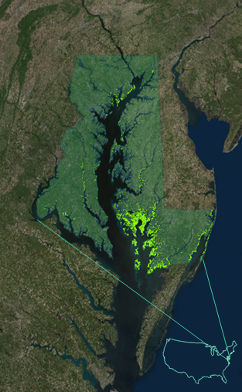

*Figure A1.* Maryland’s 16 counties and Baltimore City encompassing the Chesapeake Bay shown in green with marsh areas highlighted. County boundaries were created using the detailed county boundary layer from Maryland iMap while marsh area was derived from the Marsh Protection Potential Index (MPPI).

**Appendix B**

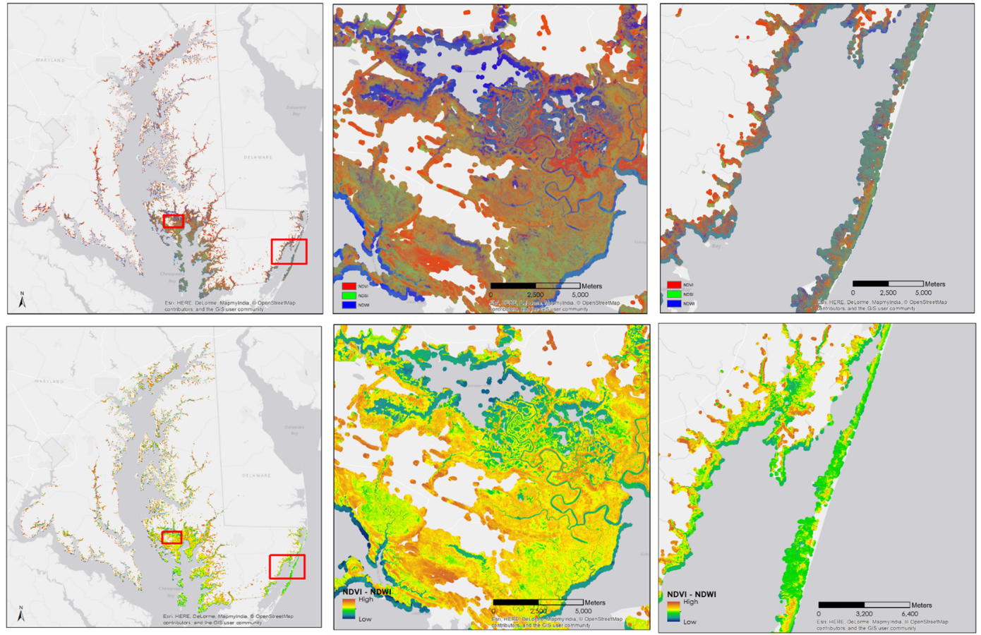

b

a

c

e

d

f

*Figure B (a-f).* Present day marsh health maps: (a) Map based on composite of NDVI, NDSI, and NDWI,(b) Blackwater National Wildlife Refuge, (c) Assateague Island. (d) Map of marsh health based on NDVI – NDWI, which depicts water bodies in blue and green, (e) Blackwater National Wildlife Refuge (f) Assateague Island.

**Appendix C**

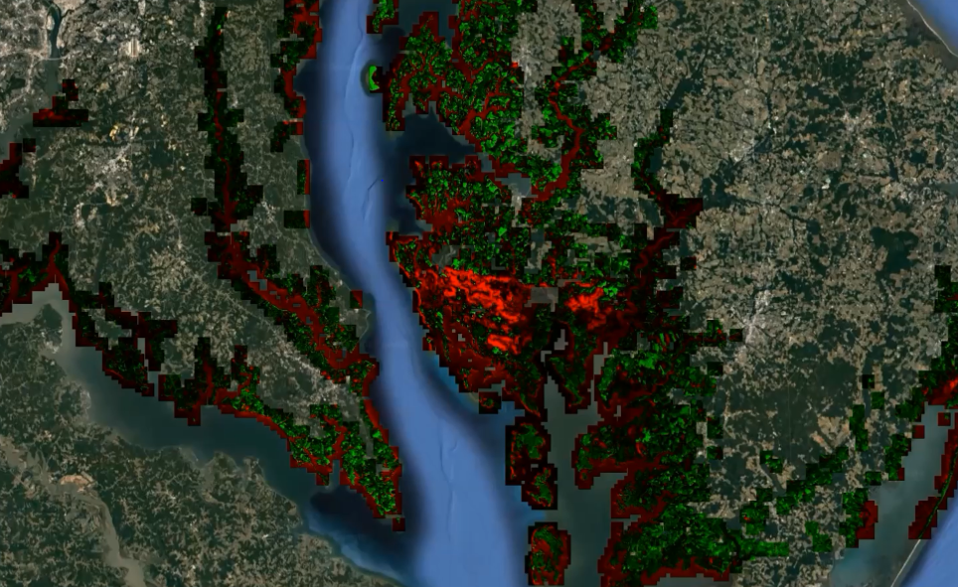

*Figure C1.*NDVI anomaly map results for period of 1996 to present.

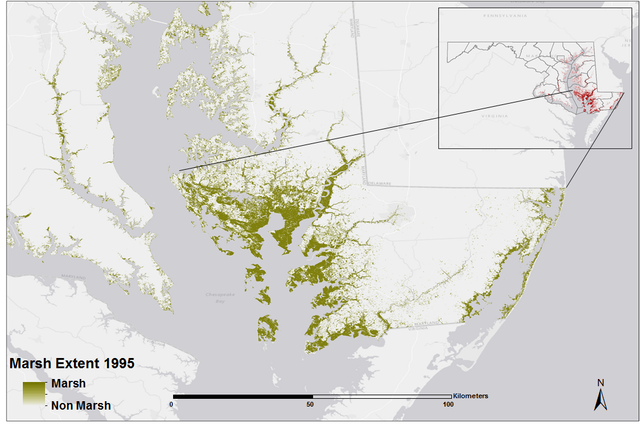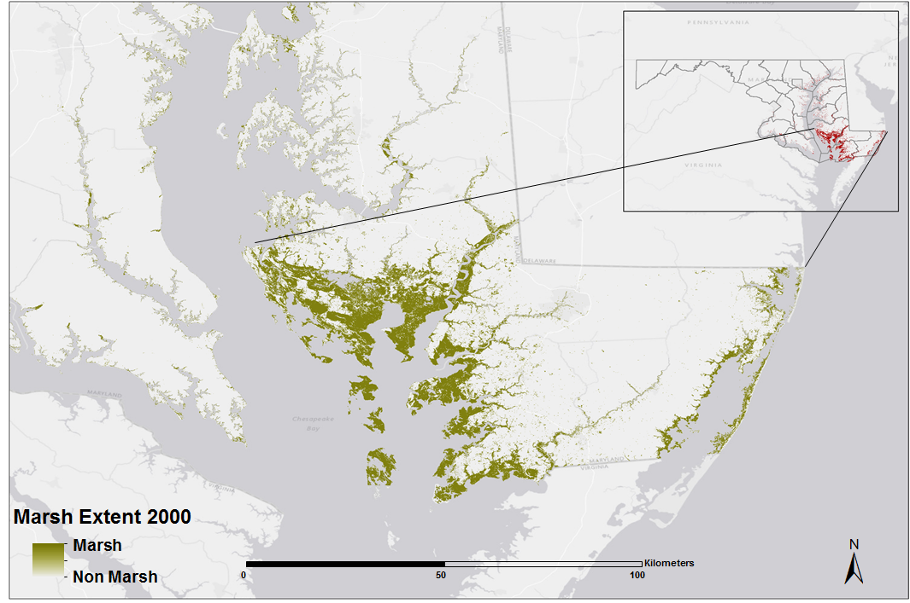

**(a) (b)**

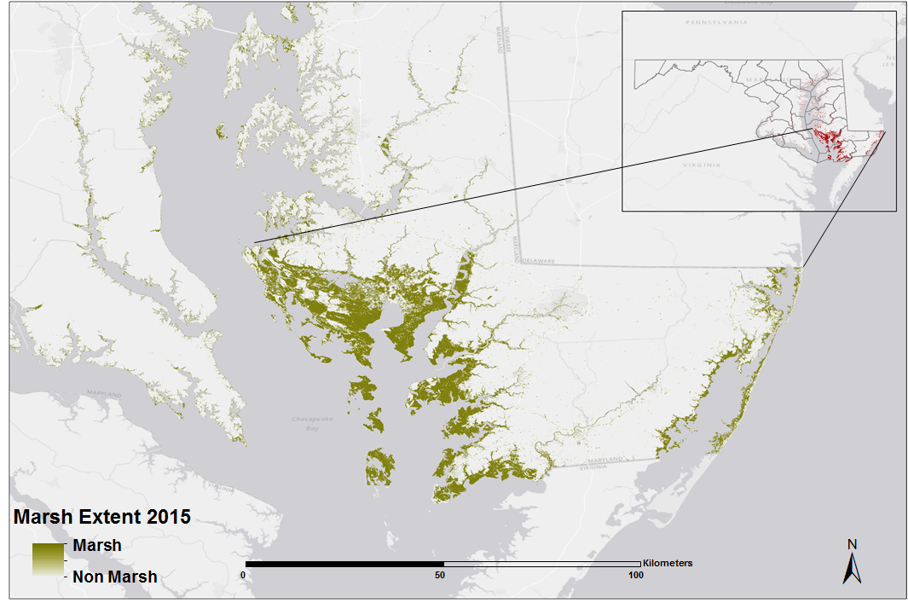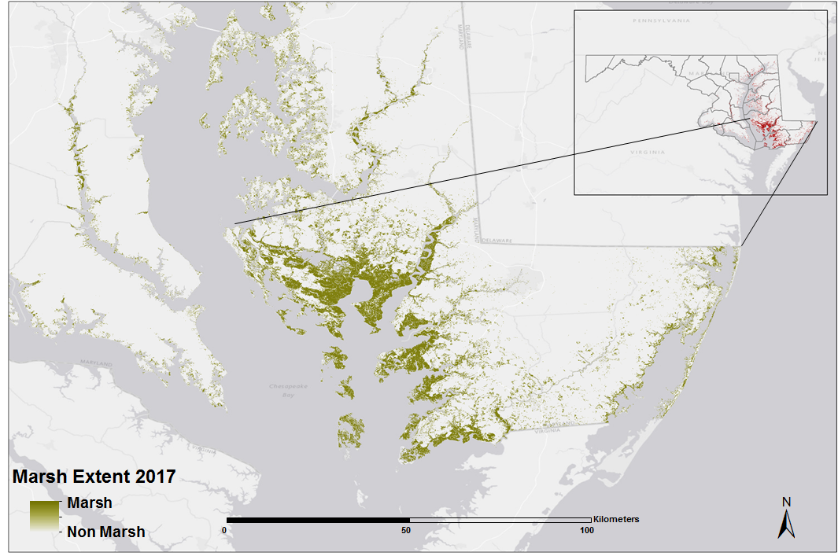

**(c) (d)**

*Figure C2.* Marsh extent maps for years 1995 (a), 2000 (b), 2015 (c), and 2017 (d).

**Table C1**

*Marsh extent land cover results from Google Earth Engine script for selected years from the five Maryland Counties that contain the most coastal marsh land cover.*

|  |  |  |  |  |  |  |
| --- | --- | --- | --- | --- | --- | --- |
| **Year** | **Unsupervised Classification Results for Marsh Extent** | | | | | |
| **All Counties**  **(Ha)** | **Dorchester Co**  **(Ha)** | **Somerset Co**  **(Ha)** | **Worcester Co**  **(Ha)** | **Talbot Co**  **(Ha)** | **Queen Anne’s Co**  **(Ha)** |
| **1995** | **125,395.5** | **44,739.8** | **24,788.4** | **9,376.5** | **7,056.8** | **4,144.8** |
| **2000** | **107,779.9** | **43,454.7** | **26,002.6** | **10,208.7** | **3,001.9** | **2,201.7** |
| **2015** | **106,402.6** | **41,563.8** | **24,217.9** | **9,536.8** | **4,034.9** | **2,756.6** |
| **2017** | **105,484.1** | **37,439.3** | **22,376.6** | **8,430.5** | **7,694.1** | **3,766.2** |

**Appendix D**

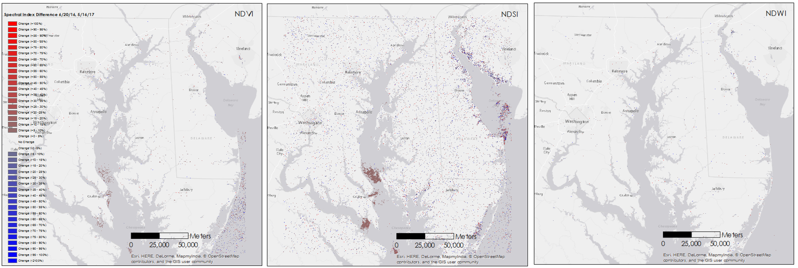

*Figure D.* Change difference maps showing percent difference in NDVI, NDSI and NDWI values between processed Sentinel-2 imagery from 6/20/2016 and 5/16/2017.

**Appendix E**

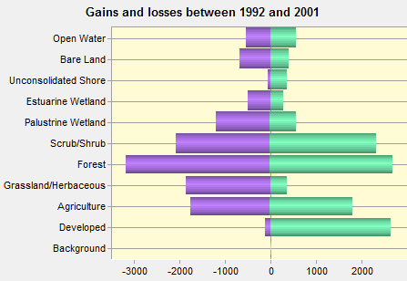

*Figure E1.*Gains and losses between land cover classifications between 1992 and 2001 displayed in hectares.

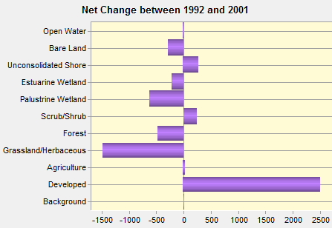

*Figure E2.*Net change between land cover classifications from 1992 to 2001 displayed in hectares.

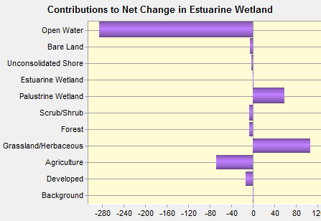

*Figure E3.*Contributions to net change in estuarine wetland classification displayed in hectares. 286 hectares of estuarine wetland transitioned to open water between 1992 and 2001. Palustrine wetland and grassland/herbaceous land cover contributed to over 150 hectares of additional estuarine wetland between the study period.

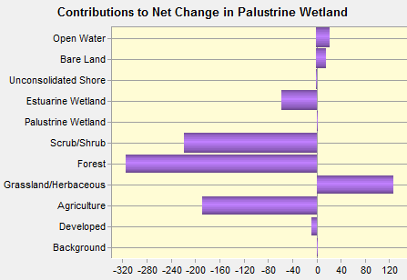

*Figure E4.*Contributions to net change in palustrine wetland classification displayed in hectares. The primary loss of palustrine wetland between 1992 and 2001 is linked to forest, scrub/shrub, and agriculture land classes. Grassland/herbaceous land cover was the primary source of increased palustrine wetland during the study period.