**NASA DEVELOP National Program**

****Langley Research Center

**Spring 2016**

**Short Title: El Salvador Ecological Forecasting II**

**Subtitle:** Utilizing NASA Earth Observations to Predict Deforestation and Forest Degradation in El Salvador

**VPS Title:** El Salvador’s Changing Landscape: Getting to the Ground Truth

**Project Team & Partners**

**Project Team:**

Britta Dosch (Project Lead), britta.c.dosch@nasa.gov

Garrett Kidd

Labreshia Mims

Rebekke Muench

Jacob Patrick

Amy Wolfe

**Advisors & Mentors:**

Dr. Kenton Ross (NASA DEVELOP National Program)

**Past Contributors:**

Courtney Duquette

Clarence Kimbrell

Susannah Miller

Jordan Ped

Stephen Zimmerman

**Partner Organizations:**

Ministerio de Medio Ambiente y Recursos Naturales (MARN) (End-User),

POC: Giovanni Molina

La Mancomunidad La Montañona, Chalatenango (End-User),

POC: Arnulfo Alberto

The Earth Institute, Columbia University, Agroforestry for Biodiversity and Ecosystem Services (ABES) Project (Collaborator),

POC: Dr. Sean Smukler & Sean Kearney

USAID El Salvador Mission (Boundary Organization),

POC: Jason Landrum

**Project Details**

**Applied Sciences National Applications Addressed:** Ecological Forecasting, Agriculture

**Study Area:** La Mancomunidad La Montañona, Chalatenango, El Salvador

**Study Period:** December 1986 – January 2016; 2030

**Earth Observations & Parameters:**

Landsat 4/ 5 (TM) & 8 (OLI/TIRS) - Land Use/Cover; Vegetation

RapidEye Constellation, Jena-Optronik - Land Use/Cover; Vegetation

**Ancillary Datasets Utilized:**

* ABES Field Surveys - Land cover
* NASA Shuttle Radar Topography Mission (SRTM) - Land use/cover; Vegetation

**Models Utilized:**

* ClarkLab’s TerrSet Land Change Modeler

**Software Utilized:**

Google Earth Engine - Land classification of Landsat imagery

ArcGIS - Raster manipulation/analysis, image enhancement, and map creation

JavaScript – Programming language, land classifications, image manipulation

TerrSet- Land change modeler, forecasting

**Project Overview**

**80-100 Word Objectives Overview:**

To develop a methodology for monitoring and forecasting ecological change in La Mancomunidad La Montañona region in El Salvador and identify Land Use/Land Cover (LULC) changes, specifically looking at changes in forest cover. End-users will use this methodology to monitor land change and to anticipate locations at risk of deforestation, helping them to determine where to focus land use management and future REDD+ strategies.

**Abstract:**

Tropical forests are vital ecosystems because of their rich biodiversity and carbon sequestration abilities. Unfortunately, due to a number of factors, these forests are threatened by deforestation and degradation and are in need of comprehensive management strategies. The conservation of forests is not only vital for biodiversity but also for the ecosystem services they provide. The micro-region of La Mancomunidad La Montañona in Chalatenango, El Salvador is a hilly area with a population dependent upon subsistence and livestock farming, often utilizing slash and burn agricultural techniques. Using NASA Earth observations in collaboration with the Ministry of the Environment and Natural Resources (MARN), the Earth Institute at Columbia University, and Agroforestry for Biodiversity and Ecosystem Services (ABES) Project, a methodology was developed for stakeholders and policy makers to monitor long-term changes in forest cover and to predict significant changes in woody forest biomass. A baseline time series showing forest cover and land use land cover (LULC) from December 1986 to January 2016 was used to forecast forest cover change through the year 2030. These predictions will allow stakeholders to identify at-risk regions to focus forest conservation efforts and management strategies.

**Community Concerns:**

* Tropical forests are recognized as essential carbon sinks, vital to maintaining the global carbon budget, and are home to 80% of the world’s terrestrial biodiversity.
* El Salvador is the second most deforested country in Latin America, having lost almost 85% of its forest cover since the 1960’s. It also has the highest population density in Central America. These two factors make forests especially susceptible to deforestation and forest degradation.
* The pine oak forest in La Mancomunidad La Montañona, with both cultural and ecological importance, is threatened by encroachment by the surrounding agricultural and pastoral activities.
* Subsistence farmers rely on forests to provide soil stability, prevent mudslides, and reduce nutrient loss. Today, over half of El Salvador is deemed as unsuitable for cultivation due to severe soil erosion.
* The communities of La Montañona, San Salvador, and other regions downstream, rely on the pine oak forests to maintain local stream and river quality.

**Current Management Practices & Policies**:

El Salvador has few strict environmental policies currently in place. Although the government has designated protected forested areas, forestry laws often go unenforced due to lack of management and funds. There has, however, been a recent push to develop and implement new laws and regulations that would help benefit the environment, especially the forests that have suffered over the last few decades. The Ministry of the Environment and Natural Resources (MARN) is working with the Earth Institute at Columbia University’s ABES Project to determine the best ways to regulate effective payment for ecosystem services (PES) programs and to implement a Reducing Emission from Deforestation and Forest Degradation (REDD+) program per the guidelines set forth by the United Nations Framework Convention on Climate Change (UNFCCC). Efforts include establishing a national forest inventory and identifying priority areas for conservation efforts.

**Decision Support Tools & Benefits:**

|  |  |  |
| --- | --- | --- |
| **End-Product** | **Earth Observations Used** | **Benefit & Impact** |
| Forecasted Land Change Map for 2030 | Landsat 4/ 5 (TM) & 8 (OLI),  RapidEye Constellation, | Allow partners to anticipate and mitigate potential locations at risk for deforestation and incorporate this into REDD+ strategies |
| Land Use, Land Cover (LULC) maps | Landsat 4/ 5 (TM) & 8 (OLI),  RapidEye Constellation | Provide insight into past and current land cover changes. |
| Regional Forest Inventory (1986-2016) | Landsat 4 and 5 (TM) & 8 (OLI), RapidEye | Determine forest extent and composition for current and future monitoring |

**Project Imagery**

**Caption:** The results of a Google Earth Engine random forest classification for the 2015 dry season; a Land Use Land Cover (LULC) map of La Moncomunidad La Montañona with four classes: Water, Urban, Rural Non-forest, and Forest.

Image Credit: El Salvador Ecological Forecasting II Team.

**Image:** (needs legend)

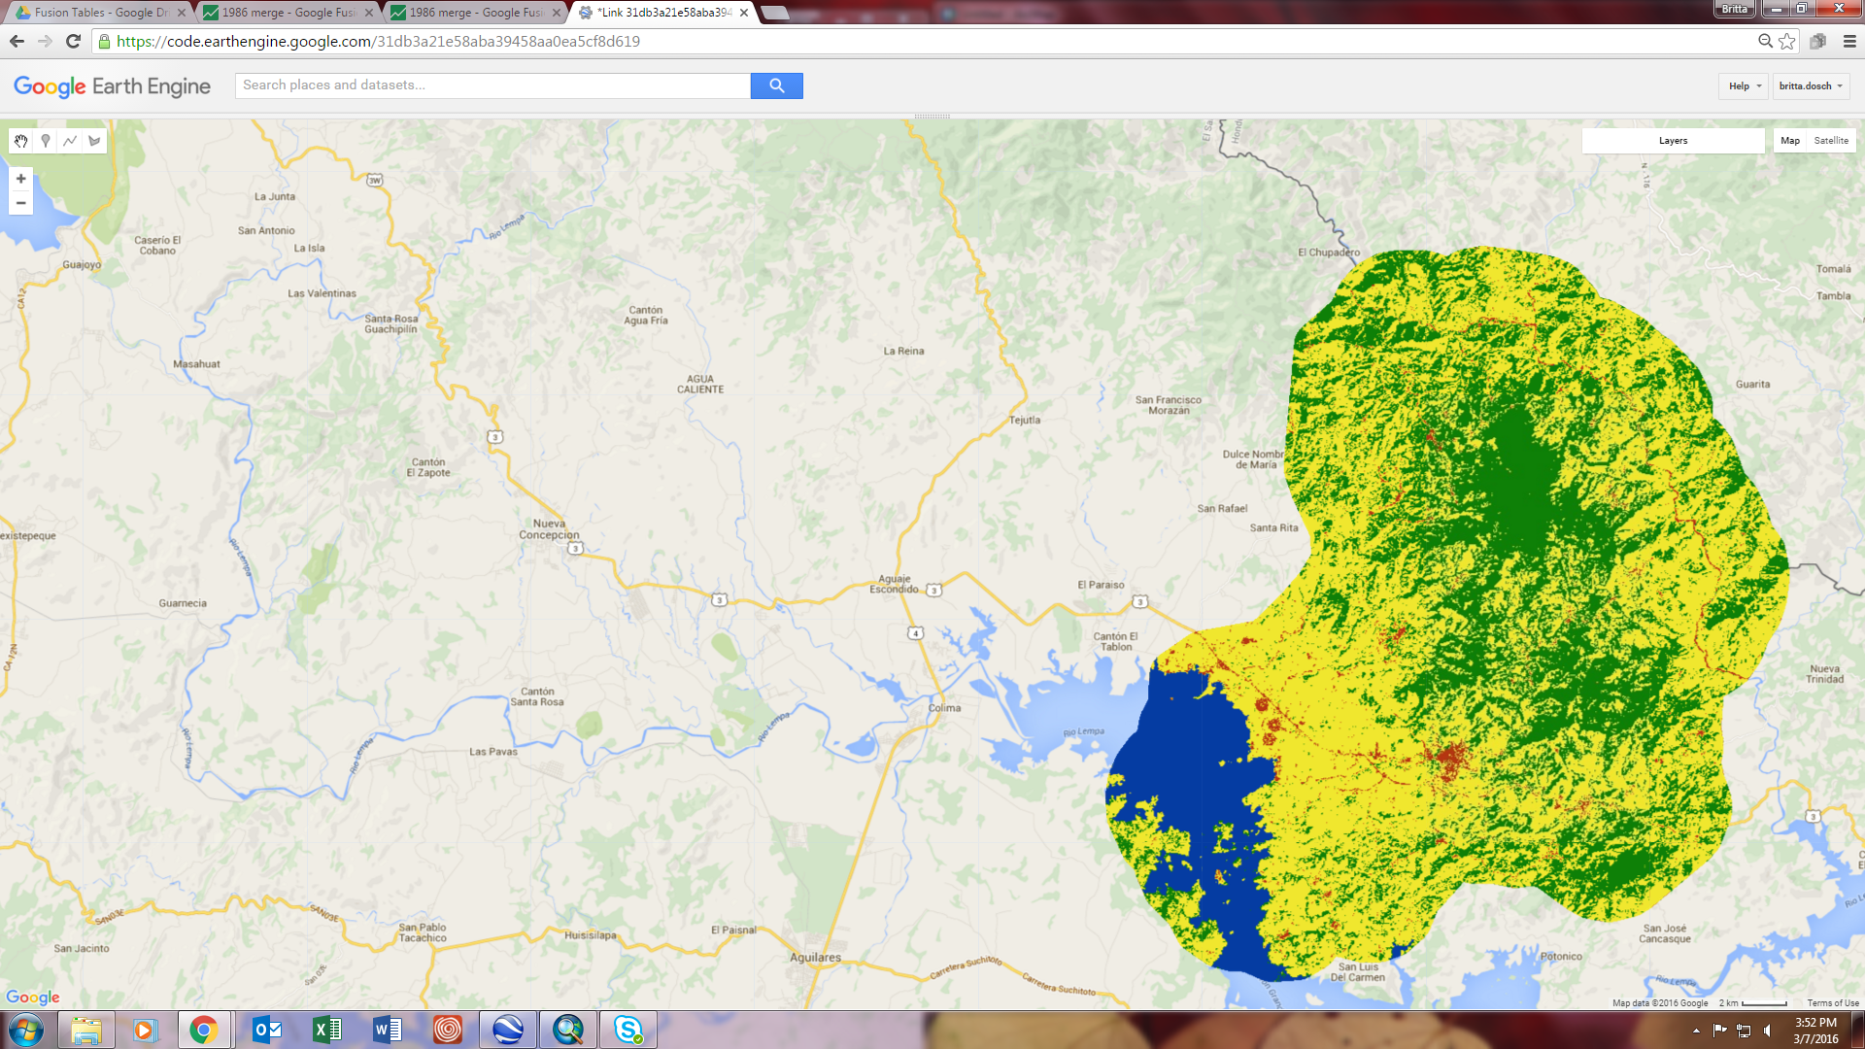

**Software Release Requirements**

Category III

**Software Title:** Classification and Verification Editor

**Software Abbreviation:** CaVE

**Technical Point of Contact:** Amy Wolfe, [ac2kd@virginia.edu](mailto:ac2kd@virginia.edu), Langley Research Center, SSAI

**Brief Description of the Software:** This code improves the efficiency of analyzing multiple classification methods in order to produce the most accuracy classified images for land use and land cover change. Instead of running multiple classifications, validations, and algorithms separately, this is all performed through one script with one condensed output located in the console.

**Type of Code:** Source Code

**Will the software include any embedded computer databases?** Yes

**Does the software use or call any open software or libraries?** Open Source

**List the software or libraries used, under what license they were obtained, and the URL for the license in the table below:**

|  |  |  |
| --- | --- | --- |
| **Name** | **License** | **License URL** |
| Google Earth Engine API | Open Source License | https://earthengine.google.com/ |

**Full Software Description and Plan**

**Introduction/Objective:**

Tropical forests are vital ecosystems because of their rich biodiversity and carbon sequestration abilities. Unfortunately, due to a number of factors, these forests are threatened by deforestation and degradation and are in need of comprehensive management strategies. The conservation of forests is not only vital for biodiversity but also for the ecosystem services they provide to the surrounding communities. The El Salvador Ecological Forecasting II Team at Langley Research Center created a tool to run multiple classifications, validations, and algorithms, such as calculating area, in order to monitor land change. This will allow end users to identify drivers of deforestation and make informed decisions where to focus conservation efforts.

**Applications and Scope:**

This program can be used with future Landsat 8 satellite data to determine future land change in Chalatenango, El Salvador. The results this tool produces will identify land classes and allow data analysis of land change.

**Capabilities:**

The software allows for the addition of images (in particular Landsat and RapidEye) for classification analysis. The classification analyses used are: Maximum Entropy and Random Forest. The classifications cover the seasonal years of 1986, 1996, 2000, 2009, 2014, and 2015. Classified RapidEye imagery is used to validate the stated classifications for the seasonal years 2014 and 2015. Google Earth Engine allows for the use of vector data through kml files and uploaded as a fusion table. These fusion tables contain the training sites that the team has created for classification purpose. Additionally, a polygon shape in kml format is used to clip the area of interest. This code improves the efficiency of analyzing multiple classification methods in order to produce the most accuracy classified images for land use and land cover change. Instead of running multiple classifications, validations, and algorithms separately, this is all performed through one script with one condensed output located in the console. This allows for ease when comparing validation confusion matrices and class changes since it is all located in one area. Additionally, the output maps can all be displayed easily on the interface and each map layer can be toggled on or off for easy comparison. Lastly, using Google Earth Engine has most of the same capabilities as ArcMap, but is open-sourced and thus reduces expense.

**Interfaces:**

The package utilizes JavaScript in Google Earth Engine. The user can use the end products to determine which map has the most accurate classifications and observations of land use changes. This information can use the results for implementing their own policy changes since there will be an increased understanding of their land use and land changes.

**Assumptions, limitations, & Errors:**

Since Google Earth Engine is still in beta, not all options available in ArcMap are offered in Google Earth Engine. However, Google Earth Engine is continually evolving and thus incorporating more and more tools for use.

**Testing:**

Google Earth Engine provides the ability to validate the classifications by using classified ground truth imagery.