**NASA DEVELOP National Program**

Marshall Space Flight Center

**Fall 2013**

**Cumberland Plateau Ecological Forecasting**

Using NASA Earth Observations to Model Representative Species Dispersion in the Cumberland Plateau to Aide in Conservation Efforts

**Team Lead:** Kel Markert (University of Alabama in Huntsville), km0033@uah.edu

**Team Members:**

Amanda Weigel (University of Alabama in Huntsville)

Jean Baptiste Kayitare (California Baptist University)

Timothy Reeves (University of Alabama in Huntsville)

**Advisors & Mentors:**

Dr. Jeff Luvall (NASA, Global Climatology and Hydrology Center)

**Past or Other Contributors:**

Dr. Robert Lawton (University of Alabama in Huntsville)

**Applied Sciences National Applications Addressed:**

Ecological Forecasting

**Study Area:** Cumberland Plateau: Alabama, Tennessee, Kentucky

**Study Period:** August 2012- August 2013.

**Community Concerns**

* The Cumberland Plateau has the highest concentration of endangered species on the continent and is in need of preservation.
* An increase in homes and tourism has led to the fragmentation and degradation of the area’s rich forests and streams.
* Increasing recreational uses has added new pressures to the area.
* Federal government agencies and other non-profit organizations need assistance prioritizing suitable land to purchase for preservation.
* Maps of future species distributions are needed to aid organizations in considering land purchases for preservation.

**80-100 Word Blurb**

The Cumberland Plateau is considered a biodiversity hotspot in North America, rivaling other biodiversity hotspots around the globe. Areas within the Cumberland Plateau are currently being protected by private and government agencies. This study employs a methodology to map the optimal species distribution for White Oak based on current climatic conditions and physical environmental parameters. The White Oak’s optimal distribution was modeled using the Maximum Entropy Species Distribution Model (MaxEnt), with NASA and other ancillary datasets as inputs to the model. The results from this study are used by agencies to prioritize areas for preservation.

**Abstract**

This study examines the spatial distribution of White Oak (*Qeurcus alba)*, a representative species for the Cumberland Plateau area, using different climatic and physical environmental parameters. White Oaks are a major component in mixed mesophytic forest, which comprise a majority of the Cumberland Plateau. The Cumberland Plateau is one of the most biodiverse regions in North America. Government and private agencies such as The Nature Conservancy and the US Fish and Wildlife Service are interested in purchasing land for conservation efforts in the region to support biodiversity. Currently, these agencies are purchasing land and establishing preserves based on land availability and endangered species habitats. White Oak’s potential and optimal distribution was modeled using the Maximum Entropy Species Distribution Model (MaxEnt). Inputs for species distribution modeling included: Terra’s Advanced Spaceborne Thermal Emission and Reflection Radiometer derived Digital Elevation Models, Landsat 8 derived Land Cover, Terra’s Moderate Resolution Imaging Spectroradiometer land surface temperature (LST), and WorldClim bioclimate data. The outputs of this model include an image of the species optimal range and the response this species has to certain environmental parameters. These results provide our partners specific areas in the Cumberland Plateau that are most viable for purchase.

**Partners/Collaborators**

The Nature Conservancy: Steve Northcutt (Director of Protection)

U.S. Fish and Wildlife Service: Oliver van den Ende (Refuge Planner)

U.S. Forest Service: Dr. Callie Schweitzer (Research Forester)

**Current Management Practices & Policies**

The Nature Conservancy and other organizations purchase land and set up forest preserves based on endangered species habitats and land availability. The method used for land purchases and preservation is based on preserving endangered species in habitats that are economically beneficial. The Nature Conservancy does not implement remote sensing to aide in the decision making process.

**Benefit to End-User:**

* Identifying areas that can be used as corridors to connect isolated regions of White Oak.
* Aid in land conservation efforts to preserve the biodiversity of the Cumberland Plateau by purchasing critical areas of land.

**Decision Support Tools**

* Map of projected future White Oak distribution
* Methodology used to aid in future projections of optimal land purchasing
* Optimal locations to purchase for preservation

**Earth Observations & Parameters**

Terra, MODIS-LST - Land Surface Temperature (LST)

Terra, ASTER - Global Digital Elevation Model (GDEM)

Landsat 8, OLI - Current land cover

**NASA Earth Observation useful for future work**

Suomi NPP, VIIRS - Land Surface Temperature

**Models Utilized**

Princeton University, Maximum Entropy Species Habitat Model (MaxEnt)

**Ancillary Datasets Utilized**

Forest Preserve/Land Purchased data provided by The Nature Conservancy

U.S. Forest Service tree plot data, model training data

WorldClim Bioclimatic variables (mean, maximum, and minimum air temperature, annual

Precipitation)

**Software Utilized**

ArcGIS 10.1 - Raster Manipulations/ Analysis, Map Generation

ENVI 5.0 - Raster Processing

**Imagery & Captions**

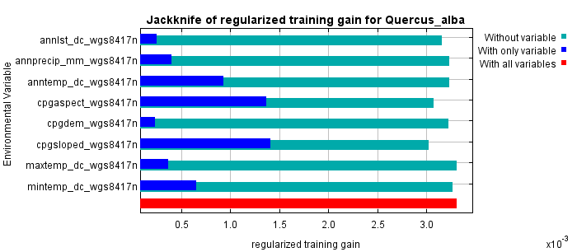

Annual LST

Annual Precipitation

Mean Annual Temp

Aspect

Elevation

Slope

Max Annual Temp

Min Annual Temp

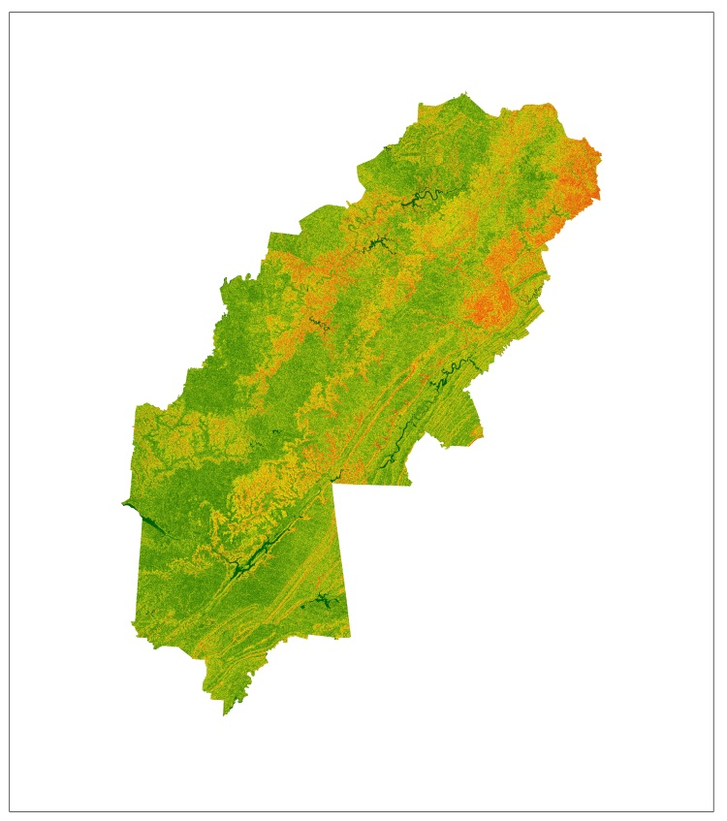

(I)

(II)

Figure A: (I) Output graph from the MaxEnt model. The blue bars symbolize the significance of the environmental parameters in species distribution. Slope was calculated as the most significant variable. (II) Slope for the Cumberland Plateau calculated from ASTER GDEM is shown next to the graph.



Figure B. Output image from the MaxEnt model displaying probability of White Oak distribution based on current climatic conditions and physical environment.