**NASA DEVELOP National Program**



University of Georgia

*Summer 2015*

Costa Rica Water Resources

Utilizing NASA Earth Observations to Develop a Comprehensive Water Budget for the Arenal-Tempisque Watershed of Costa Rica

**Technical Report** 

Final Draft – August 6, 2015

Veronica Fay (Project Lead)

Steve Padgett-Vasquez

Caren Remillard

Eduardo Rendon

Kamala Kanta Sahoo

Xuan Zhang

Dr. Marguerite Madden, University of Georgia (Science Advisor)

Dr. Quint Newcomer, University of Georgia Costa Rica (Science Advisor)

Dr. Adam Milewski, University of Georgia (Science Advisor)

Dr. Kenton Ross, NASA DEVELOP National Program (Science Advisor)

Previous Contributors:

Rachel Will

Benjamin Page

Grant Bloomer

Sarah Medley

# I. Abstract

For the past three years, the Arenal-Tempisque Watershed has experienced drought conditions complicating water management and agricultural production. To facilitate a responsive water management decision-making process, the team collaborated with Costa Rica’s National Service of Underground Water, Irrigation, and Drainage (SENARA), University of Georgia Costa Rica, and the Embassy of Costa Rica in Washington D.C. A model was created in the Soil and Water Assessment Tool (SWAT) modeling software for the Arenal-Tempisque Watershed using NASA Earth observations, ancillary data sources, and *in situ* data. The model’s results were calibrated and validated through the use of the Soil and Water Assessment Tool- Calibration and Uncertainty Procedures (SWAT-CUP) software. The evapotranspiration data (MOD16) from Terra’s Moderate Resolution Imaging Spectroradiometer (MODIS) sensor were used to offer another source of continuous data to supplement the SWAT model’s outputs. Additionally, the project partners were provided with tutorials that will enable the SWAT model’s hydrological outputs to be calibrated and validated for different future scenarios. The results obtained from the SWAT model and the MOD16 data will provide greater insight into the region’s hydrologic processes, which will allow for the development of a water resource inventory for the study area. Upon receiving the hydrological data and tutorials, SENARA will be able to replicate the project’s methods to continuously update their water budget; this will allow them to make a more efficient water management plan, benefitting the local inhabitants and stakeholders.

**Keywords**

Costa Rica, Remote Sensing, Hydrological Processes, SWAT, SWAT-CUP, and MOD 16

**Background**

Costa Rica’s watersheds are important sources of drinking water and many other services related to people’s livelihoods, such as hydroelectricity, agricultural irrigation, eco-tourism, and recreational activities. However, the increasing climate variability in the Arenal-Tempisque watershed has impacted the region’s irrigation capability and hydroelectric potentials; in particular, persisting drought conditions have afflicted this region for the past three years. Competition over water resources for all users is increasing as water accessibility decreases water quality issues arise (Ballestero et al., 2007). Currently, water policy makers do not incorporate geospatial analysis tools or NASA Earth observation datasets in their decision-making processes. By incorporating these data sources and support tools into their policy making procedure, the end-users will have access to updated, continuous hydrological datasets, allowing for more informed and efficient decisions to be made. Therefore, the goal of this project was to provide Servicio Nacional de Aguas Subterráneas, Riego y Avenamiento (SENARA) (Costa Rica’s National Service of Underground Water, Irrigation, and Drainage) with tools and datasets derived from NASA Earth observations, which will assist them with their future water management decisions and policy making.

**Objectives**

The objective of this project was to use datasets derived from NASA Earth Observations to develop tools that would enable project partners to develop a comprehensive water budget for the Arenal-Tempisque Watershed. The Soil and Water Assessment Tool (SWAT) was implemented in ArcGIS and used to simulate the local hydrological processes of this watershed. SWAT- CUP (Soil and Water Assessment Tool- Calibration and Uncertainty Procedures) was used to calibrate and validate the model’s original hydrological outputs. MOD 16 data, derived from Terra’s MODIS sensor, was used to supplement SWAT’s evapotranspiration readings. Tutorials were made for SWAT and SWAT-CUP so end users could replicate our methods, calibrate and validate their models for different future scenarios, and continuously update the water budget.

**Study Area**

The study area was the Arenal-Tempisque Watershed in Guanacaste, Costa Rica (Figure 1). The watershed was located in the northwest region of Costa Rica, and was situated between the Pacific Coast, the Gulf of Nicoya and Lake Arenal. The land use of the watershed can be divided as follows: According to our updated land cover obtained through remote sensing, about 11.6 % was agricultural land, 42.2 % consisted of forests, and 44.0 % was pasture lands. Although only 11.6 % of this watershed’s lands are devoted to farming, the rice, sugarcane, fodder, and farm-raised Tilapia that are produced here make this region one of Costa Rica’s most economically productive. However, the Arenal-Tempisque Watershed has experienced continual drought in the last several years, and these conditions have complicated the management of agricultural practices, as well as environmental services and irrigational procedures. The Arenal-Tempisque Watershed has the largest irrigation district in the country, extending over 28,000 ha (Water resources management in Costa Rica, Wikipedia). Using GIS analysis, it was possible to estimate the total drainage area of the studied watershed which covers about 5,309 km2. Hydroelectricity derived from the region provides roughly a quarter of Costa Rica’s electrical power annually (Amador, Chacon, & Laporte, 2003).

**Study Period**

The study period for this project extended from January 1979 to December 2013. The dates were chosen to allow a sufficient collection of data to simulate and assess hydrological processes in the models.

**National Application Addressed**

The project addresses the “Water Resources” NASA application area, utilizing NASA Earth observations with soil, land cover, climate, and *in situ* data to provide the end-user (SENARA) with datasets and resources to enhance the decision making processes in local water management.

**Project Partners**

The Costa Rica Water Resources team partnered with SENARA’s agronomist for the Arenal-Tempisque Watershed, Javier Artiñano Guzmán. Additional partners included the University of Georgia Costa Rica and the Embassy of Costa Rica in Washington D.C. Due to the continuing drought conditions afflicting the watershed, project partners were interested in incorporating innovative models derived from NASA Earth observations into their decision-making processes as they modified their water resource management plan for this region. Project partners were provided with datasets derived from NASA Earth observations and modeling software tutorials that will allow end users to simulate, calibrate, and validate the hydrologic processes of the Arenal-Tempisque Watershed for future scenarios. The acquisition of these data and tools will allow project partners to update their region’s water budget and increase the efficiency of their water management plan.

# III. Methodology

**Data Acquisition**

This project utilized the SWAT river basin model, which was developed to help evaluate the effects of different water management decisions and alternative land management practices on a large watershed. The datasets acquired for this project affected the hydrological processes of the Arenal-Tempisque Watershed. The SWAT model required two Advanced Spaceborne Thermal Emission and Reflection Radiometer (ASTER) Digital Elevation Models (DEMs) images which were obtained from the United States Geological Survey (USGS). Data from the Landsat 8 Operational Land Imager (OLI) Path: 15 Row: 53, acquired on April 2, 2015 were also obtained from USGS and were utilized to update the land cover data. Weather parameter datasets, including relative humidity, solar radiation, precipitation, temperature, and wind speed data, were obtained from the Climate Forecast Reanalysis (CFSR) site, which was a global weather database preformatted to be compatible with SWAT. Soil inputs were downloaded from the Harmonized World Soil Database’s (HWSD) digital soil map. Costa Rica’s National Service of Underground Water, Irrigation, and Drainage (Servicio Nacional de Aguas Subterráneas Riego y Avenamiento, SENARA) provided land cover data.

The *in situ* stream gage data used to calibrate SWAT’s discharge outputs in SWAT-CUP were acquired from the Global Runoff Data Center (GRDC), which is an international archive of stream discharge data. This gaging station was located on Costa Rica’s Tenorio River.

To compute and map the study area’s evapotranspiration, MOD16 Global, monthly evapotranspiration datasets from 2000 to 2012 were used.

**Data Processing**

Using ancillary agricultural data provided by project partners, the team converted the vector land use data into a raster dataset in ArcGIS. Landsat 8 OLI data were also utilized to create a Normalized Difference Vegetation Index (NDVI) developed by Rouse et al. (1973) and a Normalized Difference Water Index (NDWI) applying Gao’s formula (Gao, 1996).

*NDVI = (NIR – RED) /NIR + RED , NDWI = (NIR – MIR) / NIR + MIR*

These two indexes were used to identify irrigation zones and update the agricultural areas in the land use data. In order to make all raster data consistent in the SWAT model, soil and land use data were resampled to match the spatial resolution of the DEM, which was approximately 30X30 meter resolution. Two updated ASTER DEM images were downloaded and mosaicked to create a continuous elevation model for the entirety of the study area.

The calibration of the SWAT model’s hydrological outputs conducted in SWAT-CUP required a substantial amount of adjusting. Parameters were selected in SWAT-CUP for a sensitivity analysis and these parameters were assigned a numerical range. After running the model, a trend line for simulated values and observed values were produced. A swath depicting a 95% accuracy of all the simulated values was also produced. There were two goals for calibration: to have both the simulated and observed trend lines fall within the 95% accuracy envelope, and to have the two trend lines align. Satisfying both criteria signified that SWAT’s simulated values were credible. The team adjusted the range of these sensitive parameters to find a good fit between the two trend lines.

The monthly global evapotranspiration (MOD16) datasets were taken from the Numerical Terradynamic Simulation Group (NTSG) in as individual raster. The spatial resolution of these images was five kilometers. Consequently, these rasters were re-projected, cropped, and reduced in their grid size so to match the grid size of the DEM which was approximately 30 meters. The evapotranspiration values for each sub-basin (as delineated in SWAT) were calculated using an automated tool developed with ModelBuilder in ArcGIS. The tool processed a large number of global, monthly evapotranspiration raster data and estimated the average evapotranspiration for each respective sub-basin. These evapotranspiration values were then extracted and organized on a spreadsheet for user’s simplification.

**Data Analysis:**

SWAT + SWAT CUP

One of the hydrological principles that SWAT took into consideration was that water flows from a higher elevation to a lower elevation. The study area’s watershed and numerous sub-basins were delineated in SWAT based on this principle and the study area’s DEMs (Figure 2). These sub-basins were further divided into hydrologic response units (HRUs) based on unique combinations of land cover, soil type, and slope within the sub-basins. HRUs are areas that have homogeneous soil types, gradients (slope), and land use (Figure 3). The SWAT model was run using climate data for 35 complete years (i.e. 1979 to 2013), and the hydrological outputs were produced. The output files from SWAT were imported to SWAT-CUP for further calibration and validation. SWAT-CUP contains four uncertainty analysis procedures: SUFI-2, PSO, GLUE, and ParaSol. We used the Sequential Uncertainty Fitting version 2 (SUFI2) and Parameter Solutions (ParaSol) for calibration and validation of the SWAT model (Yang et. al 2008). Thirteen parameters, which were believed to be sensitive and would affect SWAT’s hydrologic outputs, were chosen and thousands of simulations were run. For each simulation, one parameter was altered, and the iteration that best fit the observed data was selected. A 95 % Prediction Uncertainty (95PPU) plot was created after 2,000 thousand iterations were completed in SWAT-CUP, during which the ranges of parameters were adjusted to approach the actual observation values. The summary statistics R2 and NSE were also used to make calibration adjustments in SWAT-CUP. R2, also known as Pearson’s correlation coefficient and coefficient of determination, is a coefficient that indicates how well data fit a statistical model and explains the “proportion of variance in measured data” (Moriasi et al., 2007). This coefficient ranges from 0-1, higher values indicating a better fit. NSE stands for Nash-Sutcliffe Efficiency index; it is a “normalized statistic that determines the relative magnitude of residual variance to the measured data variance” (Morasi et al., 2007). NSE is the best objective function for reflecting the overall fit of a hydrograph. NSE ranges between negative infinity and one. One is considered the optimal value, although values between 0.00 and 1.0 are also considered acceptable levels of performance (Moriasi et.al, 2007).This statistic is widely used in the water resources sector to assess the performance of hydrologic model values.

Other summary statistics included the p-value, which can help identify the most sensitive parameters chosen to calibrate the model. P-values that are less than or equal to 0.1 are considered sensitive parameters. Parameters with higher values can be excluded from the calibration process. Swat-CUP also produces Dotty plots for individual parameters. The trends observed on these plots can help users decide the range of values needed to better adjust their calibration.

# IV. Results & Discussion

The SWAT model results were produced incrementally with the completion of each step. The first step consisted of importing digital elevation models into the SWAT interface. Upon doing so, the watershed and its sub-basins were delineated and the river network and outlets of the watershed were identified. 120 sub-basins were identified based on elevation and roughly 60 river outlets were located. Knowing the boundaries of the of watershed and its sub-basins were important because it ensured that water from outside the desired study area was not considered, which would have created false impressions of the amount of water contained within this region.

The next step in creating the SWAT model was defining the Hydrologic Response Units (HRUs) that share the same type of land use, soil, and gradient (slope). These three properties that compose HRUs dictate how water will interact with the land.

Once the SWAT model was complete, the SWAT model’s simulated hydrological outputs were calibrated with SWAT-CUP using the ParaSol and SUFI2 calibration programs from 1981 to 1991. Due to a lack of calibration data, eight years were used to calibrate the model. Figure 4 shows the result of 2,000 calibration simulations in ParaSol. The black trend line represents the observed *in situ* stream discharge data, while the green trend line represents the iteration that produced the best simulated stream discharge. The shaded swath represents the 95PPU. When the trend lines fall within this swath, the values have a 95 % accuracy. Ideally, the observed and the simulated trend lines should align with one another and fall within the 95PPU envelope, indicating that SWAT’s simulated hydrological outputs are feasible for the study area. However, due to limited and nonconsecutive calibration years, only 48 intermittent months of observed stream discharge for a single sub-basin (sub-basin 43) were used. The overall lack of *in situ* data hindered the calibration efforts, and contributes to the lack of alignment between the observed and simulated trend lines, despite the team’s adjustments of sensitive parameters in SWAT-CUP.

There are hundreds of input variables and model parameters one can use to calibrate the SWAT model, however not all of these parameters are sensitive and will affect the hydrologic processes of a watershed. The team selected 13 important parameters (Table 1), based on previous studies for calibration of the SWAT results (Arnold et al., 2012).

After 2, 000 simulations were completed, the team observed the p-values to determine that only 7 of the 13 input parameters selected for the calibration were sensitive (P-value <0.1) and would influence SWAT outputs, such as stream discharge. After making these adjustments and running 2,000 more simulations, the 95 PPU graph was produced (Figure 4). Some of the trends for the simulated results and the observations were similar, indicated by the R2 value of 0.55. For observed and simulated data on a monthly time scale, values of 0.5 and higher are viewed as acceptable (Moriasi et al., 2007). However, the model was unable to satisfy the acceptable NSE range. The NSE was -0.76, and only a positive NSE is deemed as acceptable (Moriasi et al., 2007). There are several reasons why the simulated and observed trend lines did not match. Firstly, the input data related to land use classifications and soil were generalize and did not reflect all of the characteristics of the study area. Secondly, the observed stream discharge data used for calibration was limited and the calibration years were not consecutive. Lastly, the i*n situ* data were obtained from a stream gage that was not on the watershed’s main confluence, which prevented the team from calibrating the outputs for the entire watershed.

The MODIS global evapotranspiration data (MOD 16 data) was used to calculate evapotranspiration and was compared with SWAT’s evapotranspiration output (Figure 5). Figure 5 illustrates monthly evapotranspiration trends for the years 2000 to 2012. These years were selected to analyze and compare more recent measurements of evapotranspiration for our study area. A general trend can be seen between the values for MODIS and SWAT, however the magnitude of the peaks and troughs differ between the two. The differences in evapotranspiration values might be the result of errors occurring during the simulation and estimation of evapotranspiration from both models. The estimated evapotranspiration values produced by MODIS originally had a very low spatial resolution (5 km2) and it is possible that errors occurred when it was converted to a higher resolution. The MODIS input data may overestimate and underestimate the evapotranspiration values by + -20% (Ruhoff et al. 2013). Possible errors resulting from SWAT could be due to generalized input data, and insufficient *in situ* stream discharge data.

**Errors and Uncertainties**

Several uncertainties existed for the SWAT model. One uncertainty can be attributed to the accessible land use data. Large sections of the study area fell under the classification of “non-forested” land. To account for this generalization, the team cross referenced several Landsat 8 OLI images of the study area to verify and update the current land use of the study area. The team classified it as “pasture” land, but it is possible that other types of land use existed within this area. Different land uses would affect and alter the hydrologic processes of the study area, possibly changing some of the model’s outputs. Although the team lacked access to the study area to account for this possibility, the end-users will be able to easily improve upon the foundations the team has established, as they have personal insight into the region and easier access to their country’s datasets.

Another uncertainty also pertained to the land use classes. SWAT categorizes land use into two main classifications, “Urban” and “Agriculture”. However, we were unable to receive specific crop data, and had to generalize several fields. We classified all crops as “agriculture” in SWAT. This generalization could affect the model’s outputs because different types of vegetation have different amounts of water uptake, and will produce different ET readings.

A major difficulty the team faced was limited calibration data. Because the calibration data only spanned from 1979-1993, the team had to assume that the properties of the watershed, such as land cover, had not changed in the remaining 20 years, which is not the case.

Finally, the location of the *in situ* data stream gage was not ideal. The gage was not located on the watershed’s major confluence, which limited the team’s calibration efforts to a single sub-basin, rather than the entire Arenal-Tempisuqe Watershed.

**Future Work**

ESRI ArcGIS software, which is quite powerful but costly, is not commonly used by many organizations in Costa Rica. To make the project’s products more accessible to the public there and to other countries, we suggest that the project be implemented in QGIS and QSWAT. These programs are free to the public, open source, and have a similar interface to ArcGIS software. An instruction manual or a video could be made for users to follow the steps and apply to their own study area.

The SWAT model requires detailed land use data to simulate different responses in the study area. According to the data we obtained from our end-user and NASA Earth observations, all agricultural areas were grouped into one class. Detailed land use data and crop information could help make the simulation more accurate.

Since this study did not consider physicochemical water quality data, it would be interesting for future researchers to design a monitoring system to measure the quality parameters of water at different levels of the mainstream, with the aim of creating a database for analyzing the variability and changes resulting from watershed management.

# V. Conclusions

Based on available ancillary datasets from our project partners and datasets derived from NASA Earth observations, the team successfully simulated the local hydrological processes of Arenal-Tempisque Watershed through SWAT and GIS software. However, due to limitations presented by the data, the team was only able to calibrate and validate one sub-basin rather than the entire Arenal-Tempisque Watershed. It is important to note that this research was the result of an analysis based on all available information. Although the results cannot currently be used to create a comprehensive water budget for the Arenal- Tempisque watershed, the Spanish tutorials created by the Costa Rica Team for SWAT and SWAT-CUP programs will allow project partners to replicate the methods and develop their own SWAT model. The project partners, who have access to more current and complete datasets, will be able to calibrate and validate their findings for the entire watershed in SWAT-CUP. The tutorials will allow them to simulate hydrological conditions for the watershed for different scenarios, which allows for the development of the best water management plan possible. These tutorials in addition to MOD 16 data will assist project partners in their endeavors to continuously update the region’s water budget for the Arenal-Tempisque Watershed, which will improve future water management policies and decision making.

# VI. Acknowledgments

The Costa Rica Water Resources team would like to extend a special thanks to our project partners, SENARA and the Costa Rica Embassy to the United States. We would like to express our gratitude towards our main contact point at SENARA, Javier Artiñano Guzmán, who provided us with indispensable datasets for our study area. We also appreciate the support of the H.E. Ambassador Roman Macaya and Minister Counselor Alejandra Solano from the Costa Rica Embassy. Thank you to our science advisors Dr. Quint Newcomer, Dr. Marguerite Madden, Dr. Kenton Ross, Dr. Adam Milewski, and Steve Padgett-Vasquez for for their support and guidance. Finally we would like to thank Wondwosen Seyoum, Matt Cahalan, and Mike Durham for technical support and insight. This material is based upon work supported by NASA through contract NNL11AA00B and cooperative agreement NNX14AB60A.

# VII. References

Amador, J. A., Chacón, R. E., & Laporte, S. (2003). Climate and climate variability in the Arenal river basin of Costa Rica. In *Climate and Water* (pp. 317-349). Springer Netherlands.

Arnold, J. G., Moriasi, D. N., Gassman, P. W., Abbaspour, K. C., White, M. J., Srinivasan, R., and Jha, M. K. (2012). SWAT: Model use, calibration, and validation. *Transactions of the ASABE*, *55*(4), 1491-1508.

Ballestero, M., Reyes, V., & Astorga, Y. (2007). Groundwater in Central America: Its importance, development and use, with particular reference to its role in irrigated agriculture. *The Agricultural Revolution: Opportunities and Threats to Development. CAB International, Wallingford*, 100-128.

DEMs, Advanced Spaceborne Thermal Emission and Reflection Radiometer (ASTER), U.S Geological Survey

Gao, B. C. (1996). NDWI—a normalized difference water index for remote sensing of vegetation liquid water from space. *Remote sensing of environment*, *58*(3), 257-266.

Moriasi, D., Arnold, J., Liew, M., Bingner, R., Harmel, R., & Veith, T. (2007). Model Evaluation Guidelines for Systematic Quantification of Accuracy in Watershed Simulations. Transactions of the ASABE, 50, 885-900.

Numerical Terradynamics Simulation Groups (2015). MODIS Global Evapotranspiration Project (MOD16). Retrieved from <http://www.ntsg.umt.edu/project/mod16>.

Rouse Jr, J., Haas, R. H., Schell, J. A., & Deering, D. W. (1974). Monitoring vegetation systems in the Great Plains with ERTS. *NASA special publication*, *351*, 309.

Ruhoff, A. L., Paz, A. R., Aragao, L. E. O. C., Mu, Q., Malhi, Y., Collischonn, W., ... & Running, S. W. (2013). Assessment of the MODIS global evapotranspiration algorithm using eddy covariance measurements and hydrological modelling in the Rio Grande basin. *Hydrological Sciences Journal*, *58*(8), 1658-1676.

Yang, J., Reichert, P., Abbaspour, K., Xia, J., & Yang, H. (2008). Comparing uncertainty analysis techniques for a SWAT application to the Chaohe Basin in China. *Journal of Hydrology,* *358*, 1-23.

# VIII. Content Innovation

Glossary

**Base flow**

That part of streamflow that is sustained primarily by groundwater discharge. It is not attributable to direct runoff from precipitation or melting snow.

**Calibration**

An effort to better parameterize a model to a given set of local conditions, thereby reducing the prediction uncertainty. Model calibration is performed by carefully selecting values for model input parameters by comparing model predictions (output) for a given set of assumed conditions with observed data for the same conditions.

**Evapotranspiration**

Loss of water from a land area through evaporation from the soil and surface-water bodies and transpiration by plants.

**Hydrologic Response Unit (HRU)**

It is the smallest spatial of the model. Each HRU contains the same type of soil, land use, and gradient (slope) within a sub-basin.

**Infiltration**

Movement of water from the land surface into the soil or porous rock.

**Lateral flow**

It is the horizontal movement of water in the unsaturated zone that first returns to the surface or enters a stream prior to becoming groundwater.

**Percolation**

The movement of water through the soil and its layers by gravity and capillary forces.

**Potential evapotranspiration**

The maximum amount evapotranspiration that would occur under natural conditions if unlimited moisture was available.

**Raster data**

Raster data consists of a matrix of cells (or pixels) organized into rows and columns (or a grid) where each cell contains a value representing information, such as temperature.

**Relative humidity**

Relative humidity is the amount of water vapor present in air expressed as a percentage of the amount needed for saturation at the same temperature.

**Stream flow**

The flow of water in a stream channel. Derived from all contributing sources, including base flow, direct runoff, and other sources such as diversions or well discharges.

**Stream gauge**

Stream gauge is an active, continuously functioning measuring device in the field for which a mean daily streamflow is estimated and quality assured for at least 355 days of a water year.

**Surface runoff**

The precipitation that runs directly off the surface into a stream or body of standing water.

**Spatial resolution**

Spatial resolution describes the ability of a sensor to identify the smallest size detail of a pattern on an image. In other words, the distance between distinguishable patterns or objects in an image that can be separated from each other and is often expressed in meters.

**SWAT**

(Soil and Water Assessment Tool) model is a continuous-time, semi-distributed, process-based river basin model. It was developed to evaluate the effects of alternative management decisions on water resources and nonpoint-source pollution in large river basins.

**Validation**

The process of demonstrating that a given site-specific model is capable of making sufficiently accurate simulations, although “sufficiently accurate” can vary based on project goals. Validation involves running a model using parameters that were determined during the calibration process, and comparing the predictions to observed data not used in the calibration.

**Water budget**

P + Qin = ET + ∆S + Qout

where P is precipitation, Qin is water flow into the watershed, ET is evapotranspiration (the sum of evaporation from soils, surface-water bodies, and plants), ∆S is change in water storage, and Qout is water flow out of the watershed.

**Watershed**

The area drained by (or contributing water to) a stream, lake, or other body of water; also drainage basin.

Audio Tutorial

See DEVELOP Exchange

# IV. Appendices

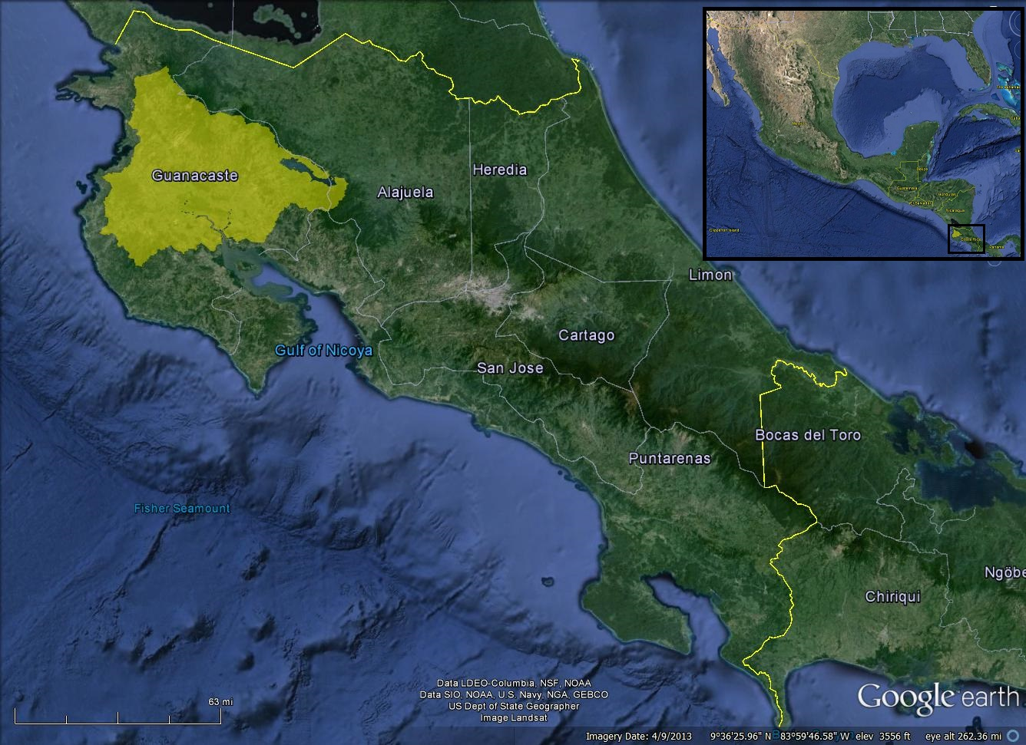

Figure 1: The Arenal-Tempisque watershed showed in bright yellow

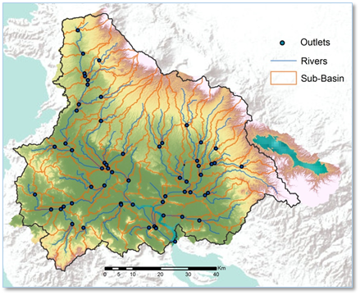  
Figure 2. Delineation of watershed, sub-basins, river network, and river outlets from Digital Elevation Models

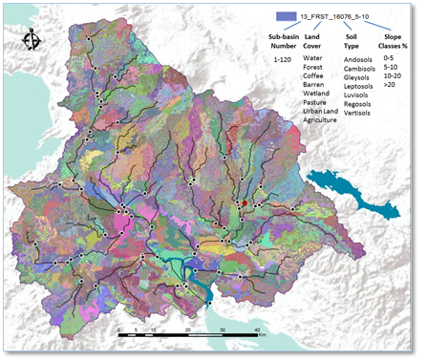

Figure 3. Map displaying the watershed’s 2,551 hydrologic response units

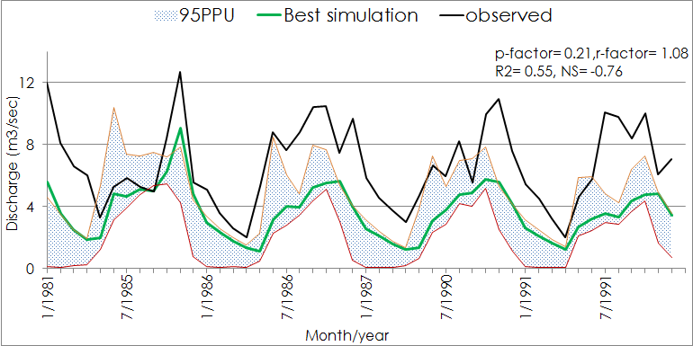

Figure 4: Observed and simulated (with 95 PPU band) monthly streamflow from sub-basin 43 in the Arenal-Tempisque Watershed

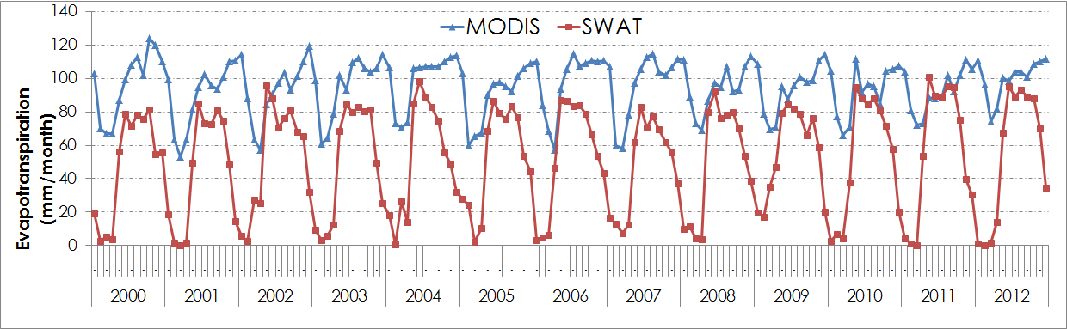

Figure 5: Temporal monthly average evapotranspiration (evapotranspiration) from sub-basin 43 from SWAT and MODIS

|  |  |  |  |
| --- | --- | --- | --- |
| **Parameters name** | **Descriptions** | **Min. Value** | **Max.**  **Value** |
| r__CN2.mgt | Curve number | -0.2 | 0.2 |
| v__GW_DELAY.gw | Groundwater delay time (days) | 30 | 450 |
| v__CH_N2.rte | Manning’s “n” value for the main channel | 0 | 0.3 |
| v__CH_K2.rte | Effective hydraulic conductivity | 5 | 130 |
| v__GW_REVAP.gw | Groundwater “revap” coefficient | 0 | 0.2 |
| v__ALPHA_BNK.rte | Base flow alpha factor for bank storage (days) | 0 | 1 |
| r__SOL_K(1).sol | Soil hydraulic conductivity (mm/h) | -0.8 | 0.8 |
| v__ESCO.hru | Soil evaporation compensation factor | 0.8 | 1 |
| r__SOL_AWC(1).sol | Available water capacity of soil layer (mmH2O/mm soil) | -0.2 | 0.4 |
| r__SOL_BD(1).sol | Moist bulk density (Mg/m3) | -0.5 | 0.6 |
| v__SFTMP.bsn | Snowfall temperature (deg C) | -5 | 5 |
| v__ALPHA_BF.gw | base flow alpha factor (1/day) | 0 | 1 |
| v__GWQMN.gw | Threshold depth of water in the shallow aquifer required for return flow to occur (mm of H2O) | 0 | 2 |

Table 1: Sensitive Parameters used to calibrate SWAT model in SWAT-CUP