**NASA DEVELOP National Program**

****Mobile County Health Department

**Fall 2015**

**Short Title: Natchez Trace Ecological Forecasting and Water Resources**

**Subtitle:** Utilizing NASA Earth Observations to Assess Current and Historic Wetland Extent along the Natchez Trace Parkway

**VPS Title:** Wetlands be Dammed: Mapping Wetlands along the Natchez Trace Parkway

**Project Team & Partners**

**Project Team:**

Jennifer Rackley (Project Lead), rackleyjl87@gmail.com

Ashley Gideon

Tyler Lynn

**Advisors & Mentors:**

Joe Spruce (NASA Stennis Space Center)

Bernard Eichold, M.D., Dr. PH (Mobile County Health Department)

**Partner Organizations:**

National Park Service, Natchez Trace Parkway (End-User), POC: Deanna Boensch

**Project Details**

**Applied Sciences National Applications Addressed:** Ecological Forecasting, Water Resources

**Study Area:** Natchez Trace Parkway, AL, MS, TN

**Study Period:** December 1992 - January 2020

**Earth Observations & Parameters:**

Landsat 5, TM – land cover classification

Landsat 7, ETM+ – land cover classification

Landsat 8, OLI – land cover classification

**Ancillary Datasets Utilized:**

* USDA National Agriculture Imagery Program (NAIP) – high resolution aerial imagery
* USGS National Land Cover Database (NLCD) – Landsat based land cover data for US states, including wetland categories
* Google Earth – high resolution aerial imagery
* National Wetland Inventory (NWI) data

**Models Utilized:**

* TerrSet Land Change Modeler (LCM)

**Software Utilized:**

ERDAS Imagine 2015 - land cover classification of Landsat imagery

ArcGIS 10.3.1 - raster manipulation/analysis and map creation

TerrSet - land modeling and forecasting of wetlands

Python - used for converting Landsat imagery to TOA reflectance

**Project Overview**

**80-100 Word Objectives Overview:**

A project was conducted with the National Park Service to address community concerns regarding the ecological impacts of beaver populations on historic, current, and future wetland extent within the Natchez Trace Parkway. Landsat data from 1992-2015 was classified using ERDAS Imagine 2015 to generate a time series of land use/land cover classification maps of the Natchez Trace Parkway in Mississippi, Alabama, and Tennessee. The TerrSet Land Change Modeler (LCM) was used to predict future wetland extent changes within the parkway for the year 2020.

**Abstract:**

This project partnered with the National Park Service (NPS) to produce needed land cover mapping products for the Natchez Trace Parkway and to address community concerns involving the past, current, and future wetland conditions of this area. The parkway occurs in Mississippi, Alabama, and Tennessee. Beavers have altered current and historic wetland conditions in the study area by changing streamflow along adjacent rivers and tributaries. While the ecological services provided by these beavers can benefit wetland ecosystems, indiscriminate and excessive dam building has caused issues with flooding, property damage, and road maintenance within the parkway. NASA Earth observations – Landsat 5 Thematic Mapper (TM), Landsat 7 Enhanced Thematic Mapper Plus (ETM+), and Landsat 8 Operational Land Imager (OLI) – were used to generate a time series of land use/land cover (LULC) classification maps from December 1992 to January 2015 showing wetland status occurring along the parkway. A projected LULC classification map was also produced using TerrSet Land Change Modeler (LCM) software. This LULC time series and modeled projection will aid the NPS in wetland conservation and beaver management plans throughout the Natchez Trace Parkway.

**Community Concerns:**

* Beaver populations along the Natchez Trace Parkway are affecting the area’s wetlands, causing flooding on the road and private lands.
* A new management strategy is needed for managing these beaver populations, as they are a keystone species within the wetland ecosystems they occupy.
* A historic context for wetland regions along the parkway is needed to determine trends in wetlands habitat type and conditions.

**Current Management Practices & Policies**:

The National Park Service at the Natchez Trace Parkway is in the process of determining best management strategies for beaver dams and populations within the parkway region. Currently, problematic beaver dams are selected based on their obstruction of roads, impacts on parkway maintenance, or complaints from local landowners. When action is needed, multiple options are available for beaver management: 1) leaving the beaver dams in place, which produces the least amount of disturbance, but may increase erosion, cause flooding, or require a rerouting of the parkway; 2) utilization of “levelers”, which involve the installation of pipes below the dams to provide a route for water to avoid excessive flooding; 3) recurring deconstruction and removal of dams, which may encourage beavers to move to a new location; and 4) lethal beaver population removal, including trapping and shooting. The Natchez Trace Parkway management team uses the National Wetlands Inventory to provide a general extent of the parkway’s wetlands for management and conservation purposes.

**Decision Support Tools & Benefits:**

|  |  |  |
| --- | --- | --- |
| **End-Product** | **Earth Observations Used** | **Benefit & Impact** |
| Land use/land cover map time series | Landsat 5 TM, Landsat 7 ETM+, Landsat 8 OLI | Products will provide insight into how wetland extent has changed throughout recent years for current management purposes/adjustments |
| Wetlands extent prediction map | Landsat 5 TM, Landsat 8 OLI | Product will show predicted wetlands extent for future management purposes |

**Project Imagery**

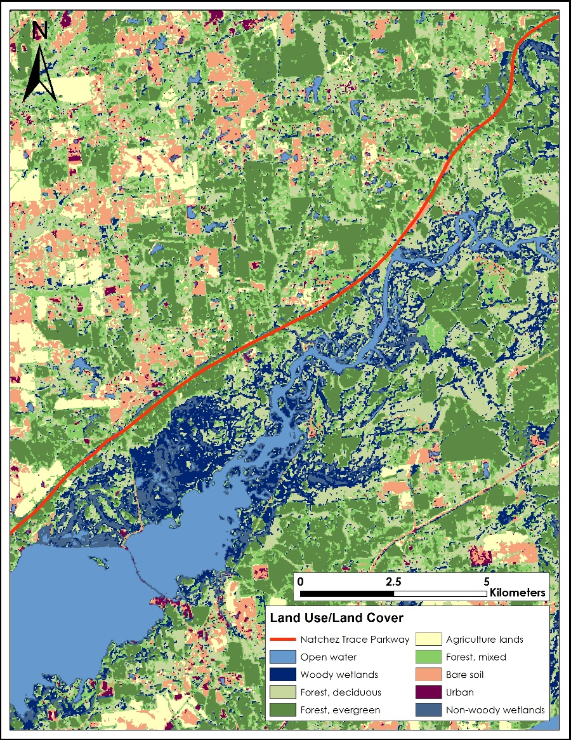

**Caption:** Land cover classification for January 2015 Landsat OLI data showing woody and non-woody wetlands along the Natchez Trace Parkway. Image Credit: Natchez Trace Eco Forecasting Team

**Image:** 2015Fall_MCHD_NatchezTraceEco_FinalImagery

**Software Release Requirements**

Category I