**NASA DEVELOP National Program**



Jet Propulsion Laboratory

*Summer 2014*

Southern California Oceans & Water Resources

Remote Sensing Detection of Wastewater Plumes to Assess Public Water Quality in Los Angeles and Orange Counties

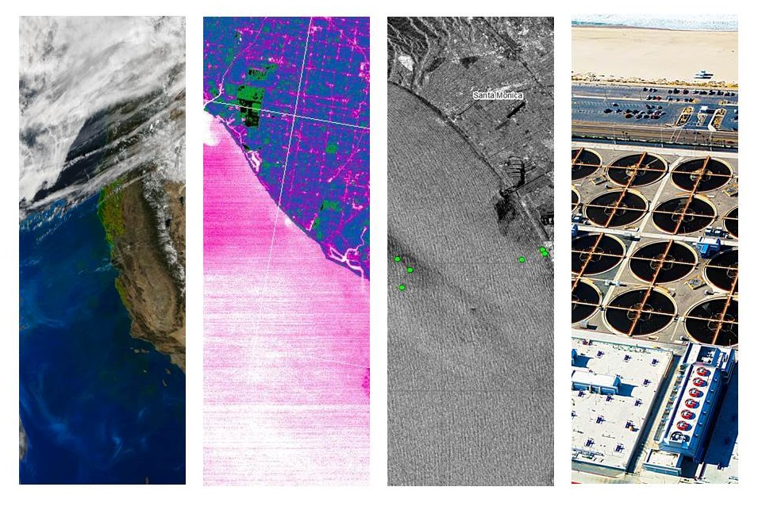

**Cover Art**: (*from left to right*) MODIS-Aqua True Color RGB of the Californian coast (Dec. 4th, 2006); ASTER-Terra SST overlooking Orange County coast (Oct. 8th, 2012); ASAR-Envisat overlooking Los Angeles coast (Dec. 10th, 2006); and City of LA Hyperion Wastewater Treatment Plant, courtesy: Ben Holt (Nov. 29th, 2006).

 **Technical Report**

Boyang “Jack” Pan, Scripps Institution of Oceanography, UCSD (Team Lead)

Christine Rains, California State University, Northridge

Rebecca Trinh, University of California at Berkeley

Benjamin Holt, Jet Propulsion Laboratory (Science Advisor)

Michelle Gierach, Jet Propulsion Laboratory (Science Advisor)

# I. Abstract

As part of their daily operations, the City of Los Angeles Hyperion Wastewater Treatment Plant (HWTP) and the Orange County Sanitation District (OCSD) release treated sewage into the coastal waters of Southern California in the Santa Monica Bay and San Pedro Bay, respectively. Treated sewage is released at depths of approximately 60 m through 5-mile (8.05 km) outfall pipes. Periodically, repair and maintenance services on the outfall pipes require the plants to temporally divert treated sewage to shorter pipes that extend into shallow coastal zones, where buoyant, freshwater plumes may reach the surface. Two such events have taken place: one at the Hyperion Plant in November 2006; and the other from mid-September to the beginning of October, 2012, at OCSD. In both cases, the treated wastewater was diverted to 1-mile (1.6 km) pipes that end at about 20 m depth. Diversion events such as these can potentially impact coastal ecosystems and public health. This study focuses on the 2006 and 2012 diversions and produces an assessment of the plumes’ thermal signature, impact on coastal biogeochemistry, surface roughness, and movement based on analysis of remote sensing data from multiple satellite sensors. The results are synthesized with in situ data and compared with ground truth measurements for validation. These results not only allow a better understanding of the diverted outfall plume, but they also assist the development of a strategy for improved satellite detection during future diversion events.

**Keywords**

Remote sensing, SST, chl-a, SAR, ocean color, coastal ocean, wastewater treatment, freshwater plumes

# II. Introduction

Coastal waters of the Southern California Bight (SCB) are an ecological important marine habitat and a valuable resource in terms of sport and commercial fishing, recreation, and tourism. Pollution management of offshore effluent is necessary to maintain water quality and relies heavily on dispersal and dilution by ocean currents to reduce local concentrations (Uchiyam et al. 2014). Municipal waste water is discharged into the marine environment through outfall pipes located along the steep continental slope. Within the SCB, two major treatment plants, the Hyperion Wastewater Treatment Plant (HWTP) of Los Angeles County and the Orange County Sanitation District (OCSD) Plant No. 2, use these deep ocean outfalls. Discharging effluent at depth at the head of submarine canyons in the SCB allows rapid flushing and mixing with ambient seawater which dilutes the buoyant wastewater plumes before they reach the surface (Washburn et al. 1992).

Located in Playa del Rey, California, the Hyperion Wastewater Treatment Plant is one of the largest wastewater plants on the west coast of the United States (Washburn et al. 1992). It serves 2/3 of Los Angeles County, approximately 4 million people, releasing an average of 360 MGD into coastal waters (Reifel et al. 2013). Effluent from HWTP is primarily discharged from a 3.7 m diameter outfall pipe that terminates 5 miles (8.05 km) offshore near the head of the Santa Monica Marine Canyon at about 57 m depth. The Hyperion plant also has a secondary emergency outfall pipe that terminates 1 mile (1.61 km) from shore at a depth of about 15 m (Reifel et al. 2013). Wastewater from HWTP undergoes two levels of treatment, removing about 85% of suspended solids before being discharged, however, effluent plumes still contain oils, grease, particles, metals, chlorine and other compounds that may have ecological implications and pose a risk to human health (Raco-Rands and Steinberger 2001).

The ocean outfall pipe of OCSD Plant No. 2, lets out into San Pedro Bay. It is the third largest wastewater treatment plant on the west coast of the United States and serves approximately 2.5 million residents. OCSD Plant No. 2 processes an average of about 129 MGD of wastewater. All effluent receives basic treatment and about 50% of it also undergoes a second level of treatment before being discharged from a 3.04 diameter outfall pipe terminating 4.5 miles (7.24 km) offshore at 60 m depth. This plant also has an emergency outfall pipe with a diameter of 1.98 m that terminates 1.37 miles (2.20 km) offshore at a depth of 18 m.

During emergencies or scheduled maintenance, wastewater is diverted from their primary deep ocean pipes to the shallow water pipes. In 2006 the Hyperion Treatment Plant planned a three day diversion from the primary 5 mile outfall pipe to its secondary 1 mile outfall pipe in order to visually inspect the internal structure of the 5 mile pipe. The diversion took place at 03:30 PST on Nov. 28, 2006 and concluded at 05:20 PST on Nov. 30, 2006. Another planned diversion for maintenance occurred in fall 2012 at the Orange County Sanitation District Plant No. 2. Treated wastewater was diverted from the 4.5 mile long pipe, to shorter 1.37 mile pipe from Sep. 11, 2012 to Oct. 4, 2012. HWTP and OCSD effluent wastewater plumes usually remain subsurface, but diversions inject wastewater into the ocean at much shallower depths, allowing them to reach the surface more readily without mixing with ambient seawater. This increases the risk of environmental contamination and contact with humans.

Treatment plants monitoring wastewater outfalls have historically relied on in situ sampling methods. These techniques, however, provide temporally and spatially sparse data due to high costs and lack of sampling stations (Marmorino et al. 2010). Treatment plants need to know the size, duration, and propagation speed and direction of plumes to evaluate their potential impacts. The use of remote sensing techniques, when combined with available in situ data, can yield a more complete description of plume dynamics than in situ data alone. Coastal managers can then use this information to determine the timing and duration of future shallow water diversions (Nezlin and DiGiacomo 2005).

Wastewater plumes discharged from treatment plants contain high concentrations of oils that smooth out surface waters forming slicks (DiGiacomo et al. 2004). This allows plumes to be detected using Synthetic Aperture Radar (SAR), an active satellite sensor that uses radar to determine sea surface roughness. Plumes are also characteristically rich in suspended particles, giving them a unique spectral reflectance. The Moderate-resolution Imaging Spectroradiometer (MODIS) on NASA’s Aqua satellite can detect this signature in ocean-color images. In addition, MODIS’s sensors are able to detect increases in phytoplankton concentrations which may bloom in response to the high nutrient load of the discharged wastewater. These blooms can be used as proxies for tracking the movement of plumes over time. Discharged wastewater plumes may also have distinct thermal signatures when compared to ambient sea water. The thermal signature can be detected by MODIS and the thermal infrared band of the Advanced Spaceborne Thermal Emission and Reflection (ASTER) instrument on Terra.

The objectives of this study were to evaluate the capabilities of satellite data from the aforementioned sensors to detect (1) surface movement and (2) potential ecosystem impacts of wastewater plumes discharged into shallow coastal zones, specifically the 2006 Hyperion Treatment Plant diversion and the 2012 Orange County Sanitation District diversion. Results from this study will help develop an improved remote sensing strategy for monitoring future wastewater diversions, such as the proposed 2015 Hyperion Treatment Plant diversion, by more accurately identifying (1) potential areas of altered water quality and (2) impacts on public health in nearshore environments.

# III. Methodology

***Satellite Remote Sensing and Data Acquisition***

*Surface Roughness – SAR*

Synthetic aperture radar (SAR) is an active sensor capable of obtaining information from planetary surfaces in the presence of cloud cover or even at night. SAR data used in our study were recorded by the SAR sensors on board of Radarsat-1, Advanced SAR (ASAR) on Envisat, and the Phased Array Type L-band SAR (PALSAR) on ALOS. They were retrieved from the Alaska Satellite Facility (ASF). All SAR imageries were level 1 data and were processed in NEST 4C. Level 1 data had significant radiometric bias; each image was radiometrically calibrated by the signal amplitude and was saved in units of dB in order for each pixel value to represent the true backscattering from the surface. Due to the nature of SAR signal, calibrated images can still have high noise which causes rough surfaces to be indistinguishable from the background; A 3 x 3 mean speckle filter was applied to each calibrated image in order to limit this signal noise. All SAR data were also reprojected as WGS 84 to their correct geographic locations for further analysis.

*Sea Surface Temperature – ASTER, MODIS-Aqua, Landsat-8*

Sea surface temperature (SST) measurements were derived from data recorded by ASTER retrieved from the Land Processes Distributed Active Archive Center operated by NASA and USGS (https://lpdaac.usgs.gov/data_access). ASTER records data in 14 bands, including five thermal infrared (TIR) bands which were used for deriving SST data. An algorithm similar to the In-Scene Atmospheric Compensation (ISAC) (Johnson and Young 1998) was applied to the TIR bands for thermal atmospheric correction; this process estimated and removed the atmospheric contributions to the thermal infrared radiance data. The thermal infrared radiation is also a function of the SST and emissivity, so the emissivity needed to be separated to derive the SST. An emissivity normalization technique was applied to the data after the thermal atmospheric correction to create temperature output (Kealy *et al.* 1993; Hook *et al.* 1992). Lastly, the temperature data was converted from units of Kelvin to units of Celsius.

MODIS-derived SST was also used in this study. ASTER-derived SST data has a finer spatial resolution (90m) in comparison to MODIS-derived SST data (250m), but MODIS SST data has a greater temporal and spatial coverage. MODIS level 2P SST data was obtained from NASA’s Physical Oceanography Distributed Active Archive Center (PO.DAAC) at JPL (http://podaac.jpl.nasa.gov/) and through NASA’s OceanColor WEB (http://oceancolor.gsfc.nasa.gov/). Each image was analyzed in a fixed spatial subset in order to focus on this study’s regions of interest (ROIs). The temperature scale was converted from Kelvin to Celsius, while the data were scaled to show 15--20º C to reflect realistic sea surface temperatures.

Although it was not active during the study period, Landsat 8, launched in 2013, has high-resolution thermal imaging capabilities in bands 10 and 11. A scene from the study area was processed as an example for future diversions. A method similar to the one used for ASTER SST processing was applied to the scene. An equation was used to convert pixel values to top of the atmospheric (TOA) spectral radiance:

Lλ = MLQcal + AL

Lλ = TOA spectral radiance (Watts/( m2 * srad * μm))

ML = Band-specific multiplicative rescaling factor from the metadata

AL = Band-specific additive rescaling factor from the metadata

Qcal = Quantized and calibrated standard product pixel values (DN)

TOA spectral radiance was then converted to brightness temperature, hence the temperature at the ocean surface. The equation below was used to derive the temperature in Kelvins

$$T=\frac{K_{2}}{\ln\left(\frac{K_{1}}{L_{λ}}\right)+1} .$$

T = At-satellite brightness temperature (K)

Lλ = TOA spectral radiance (Watts/( m2 * srad * μm))

K1 and K2 = Band-specific thermal conversion constant

The result was then converted from Kelvin to Celsius. Finally, the SST measurements from bands 10 and 11 were averaged.

*Biological Observation through Ocean Color – MODIS-Aqua*

MODIS-Aqua Ocean Color Level 1 (L1) data were obtained through the OceanColor WEB at http://oceancolor.gsfc.nasa.gov/. Ocean color data were processed with SeaDAS, a python-based image analysis package. Level 1A data was processed via SeaDAS to a resolution of 250 m. Atmospheric corrections were automatically applied during the processing.

Each MODIS file was sent through two separate processing algorithms to create two distinct L2 products. One algorithm produced a file with normalized water-leaving radiance, sea surface temperature and generalized chlorophyll-a concentration bands. The chl-a concentration calculated by this algorithm tended to pick up signals from sediment and detritus in addition to chlorophyll-a from phytoplankton. To help separate the effects of each of these contributors, files were processed using a second algorithm. With these two files in hand, it was possible to compare the total chl-a signature with calculated concentrations of the signature’s components.

*In Situ Environmental Data*

In situ data was obtained from multiple institutions that took part in monitoring and studying the 2006 HWTP and 2012 OCSD diversions. HF radar surface current, drifter, CTD (conductivity, temperature, and depth sensors), glider, wind, precipitation, river discharge and tidal data for both ROIs and both years were processed in MatLab, and compared to plume images in satellite data. Areas of low salinity, low temperature, and high chlorophyll fluorescence were noted and the spatial extent of these regions mapped with satellite images. Current, drifter, wind, precipitation, and tidal patterns were correlated with the directionality and position of the plumes in satellite images.

***Hyperion Treatment Plant Diversion: Nov. 28, 2006 – Nov. 30, 2006***

SAR data that concerns the HWTP’s division showed the Santa Monica Bay, and their temporal coverage was as the follows: Radarsat-1 data from during (Nov. 30, 2006) and after (Dec. 1, 2006 – Dec. 8, 2006) the diversion; ASAR data from before (Nov. 27, 2006), during (Nov. 30, 2006), and after (Dec. 8, 2006 – Dec. 10, 2006) the diversion; and PALSAR data from before (Nov. 15, 2006) and after (Dec. 2, 2006 –Dec. 30, 2006) the diversion.

ASTER data temporally covered the period after the diversion (Dec. 1, 2006 – Dec. 10, 2006) showing full or partial views of the Santa Monica Bay. Level 2 MODIS-Aqua and Terra include data coverage on before (Nov. 20, 2006 – Nov. 27, 2006), during (Nov. 28, 2006 – Nov. 30, 2006), and after (Dec. 1, 2006 – Dec. 7, 2006) the divergence.

Through visual inspection of thumbnail images, 12 MODIS scenes relevant to the 2006 Hyperion diversion were identified, with three in the pre-divergence period from Nov. 20th to Nov. 27th, three during the divergence period between Nov. 28--30, and six in the post-divergence period from Dec. 1st to Dec.8th.

Hourly environmental conditions such as wind speed, direction, and precipitation for before (Nov. 23, 2006 – Nov. 27, 2006), during (Nov. 28, 2006 – Nov. 30, 2006), and after (Dec. 1, 2006 – Dec. 8, 2006) were obtained from NOAA’s Quality Controlled Local Climatological Database for their weather station at the Los Angeles International Airport, approximately 2.51 miles away from the Hyperion Treatment Plant. Data was analyzed and plotted to compare with existing imagery data. HF radar surface current data for November – December, 2006 (Hazard, UCSD), surface drifter data for Nov. 27 – Dec. 1, 2006 (Diehl, SCCWRP), and tidal data from Nov. 15 – Dec. 15, 2006 were used to determine the directionality of the surfaced wastewater plume and compared to our resulting satellite images using MatLab. Precipitation data (NOAA) and Ballona Creek discharge data (LA Public Works) were analyzed to distinguish stormwater and Creek discharge plumes from plumes associated with the HWTP wastewater diversion. CTDs deployed by the Hyperion Wastewater Treatment Plant on Nov. 27 – Dec. 1, 2006, as well as on Dec. 4 and Dec. 7, 2006 were used to validate sea surface temperature and chlorophyll satellite measurements. CTDs also provided salinity information, as wastewater plumes are primarily composed of freshwater when compared to ambient seawater. They also provided information in terms of depth profiles of the plume and surrounding waters. A stationary CTD on the Santa Monica Pier (UCLA) for the months of November and December, 2006 yielded additional information to validate the extent of the wastewater plume in comparison to our satellite images.

***Orange County Sanitation District Diversion: Sep. 11, 2012 – Oct. 4, 2012***

Sea surface temperature data from ASTER showing the region of interest, San Pedro Bay, before (Aug. 28, 2012 – Sep. 7, 2012), during (Sep. 23, 2012 – Sep. 28, 2012), and after (Oct. 9, 2012 – Oct. 23, 2012) the Orange county diversion were also obtained, processed and analyzed using previously stated methods.

For the OCSD diversion, 37 MODIS-Aqua files were identified as relevant to our study, including nine from the pre-divergence period of August 26to Sept. 10, nine during the diversion period of Sep. 11 to Oct. 4, and five during the post-divergence period from Oct. 5 to Oct. 19, 2012. These data were processed as for the 2006 Hyperion event, above.

HF radar surface current data from Sep. 11 – Oct. 10, 2012 (UCSD THREDDS) and tidal data (Robertson, OCSD) from September to the end of October 2012 were used to determine the directionality of the surfaced wastewater plume. Wind and precipitation data (NOAA), along with discharge data for the LA River, San Gabriel River, and Santa Ana River (USGS) were analyzed to eliminate non-wastewater plumes seen in our satellite images. Glider data (Seeger, USC) from September 6 and 23, 2012 and October 9, 2012, surface boat measurements of salinity and temperature (Molemaker, UCLA) from Sep. 17-19, 21, 25, and 26, 2012, and CTD data (Caron, USC; Robertson, OCSD) from Sep. 11, 17-19, Oct. 1, and Oct. 3, 2012 were analyzed and mapped in MatLab to determine correlations between in situ temperature, chlorophyll, and salinity of the plume with that seen in our satellite images.

# IV. Results & Discussion

***Hyperion Treatment Plant Diversion: Nov. 28, 2006 – Nov. 30, 2006***

MODIS chl-a data (Figure 1) retrieved from Nov. 21, 2006 before the diversion event did not present any anomaly in phytoplankton growth, except the expected strong signal appearing along the shore. MODIS SST data displayed a colder patch around the 5-mile outfall pipe’s end; however, due to MODIS’s spatial resolution, it remains unknown that if this signal was indeed coming from a surfaced treated wastewater patch.

During the diversion, on Nov. 29, 2006, MODIS SST data indicated an area with low temperature around the 1-mile diversion pipe (Figure 2). MODIS chl-a data also displayed a bloom of chl-a just south of the pipes. When they were compared with in-situ CTD data, there was indeed a small area of distinctively cooler water near the 1-mile diversion pipe, while the chl-a data also presented a similar anomalous feature. However, there was not enough time for phytoplankton to grow in response to the nutrients in the wastewater plume on this date, hence the features observed in the Although it was possible that chlorophyll-bearing phytoplankton from the 15m depth were being brought to the surface, further analysis revealed that the chlor-a feature had strong sediment and detrital components.

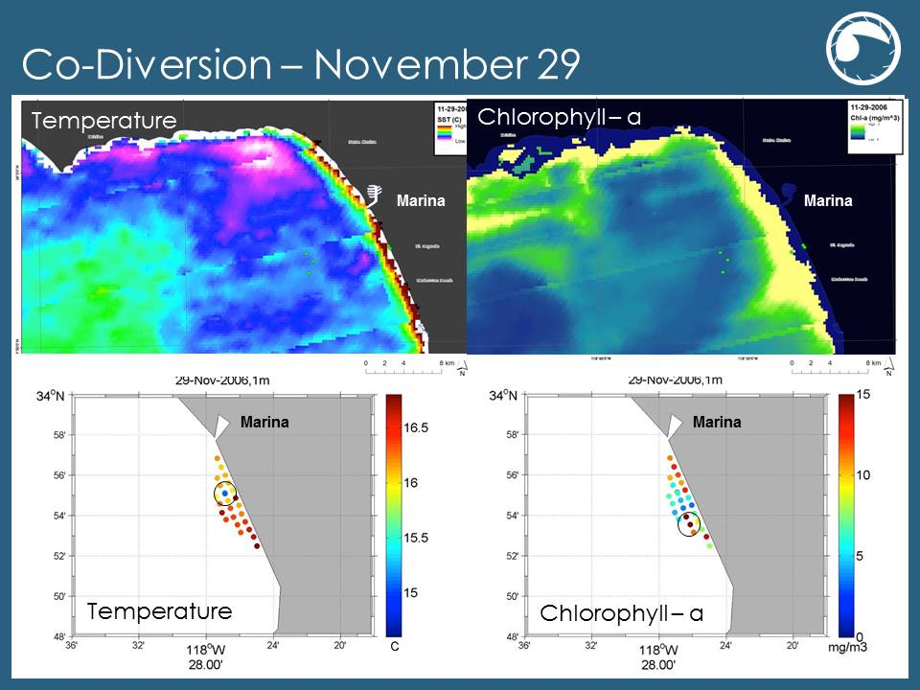**Figure 2:** MODIS SST and Chl-1 from November 29th, 2006 (during the diversion event); results were verified by in-situ measurements.

ASAR data obtained on Nov. 30, 2006 displayed strong radar signal backscattering as dark regions along the shore (Figure 3). A distinct dark slick north of the outfall pipes near the marina has been highlight in figure 3. A plume tracker model produced at UC San Diego displayed a similar shape and position of the plume as the one observed in the ASAR image at about the same time. These results were also correlated with drifter data. Drifters were placed in the water at 7:30 AM on Nov. 29and their positions were marked with “x;” the drifters were retrieved at 8:30 AM on Nov. 30 with their positions marked with “•”. The current pushed the drifter from the 1-mile pipe toward the marina. This indicates the plume observed in the ASAR data is very likely to be surfaced wastewater plume from the 1-mile diversion pipe carrying towards the shore by currents. Other in-situ CTD measurements also correlated well with the ASAR data in figure 3; figure 4 displays a region of low temperature, high chlorophyll, and low salinity on Nov. 30, by the Marina. These signatures are distinct to treated wastewater plumes – cold, fresh water from the deep containing high nutrient concentration which could simulate phytoplankton growth.

On Dec. 1, 2006, the day after HWTP’s diversion concluded, a significantly strong backscattering area around the marina was observed (Figure 5). Drifter data collected from the same date indicates current continues to move north along the shore, hence pushing the surfaced diversion plume towards the marina. CTD data shows a region of low temperature, relatively high chl-a concentration, and relatively low salinity at the mouth and just south of the marina. However, the CTD measurements did not extend north of the marina, where part of the wastewater plume possibly moved to according the ASAR data. Drifter data from the previous day and night also displayed a northward trend in surface ocean currents that may have brought the plume further north past the marina.

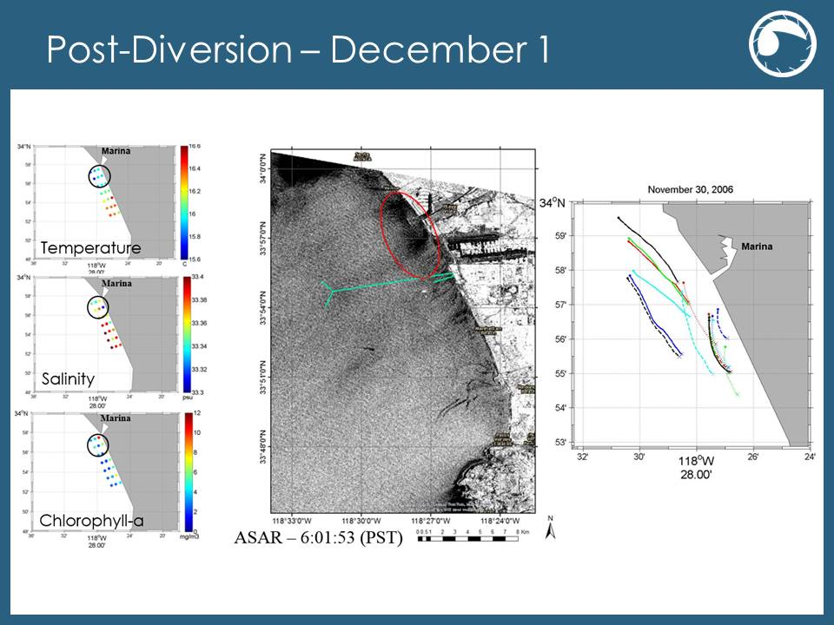

**Figure 5:** In-situ CTD measurements, along with drifter data collected on December 21st, 2006 correlates with ASAR data obtained on the same date.

On Dec. 2, 2006, two days after the diversion event, there were no significant anomalies observed in the MODIS SST and chl-a data (Figure 6); though there was a visible eddy feature present near Malibu. ASTER data did not present any anomalous features regarding the treated wastewater plume, though there was a discharge event from shore near the 1-mile pipe with warm thermal signals.

***Orange County Sanitation District Diversion: Sep. 11, 2012 – Oct. 4, 2012***

Pre-diversion data were examined to establish a baseline for our study. In these images from early September (Figure 7), there was a general temperature gradient across the bay. However, there were no anomalous cool areas or chlorophyll features in the MODIS or ASTER images. Though MODIS and ASTER data were acquired from different dates, they are relatively close temporally, and the difference in spatial resolution was clearly distinguished in figure 7.

MODIS SST data obtained during the diversion event displayed a small cold area near the 1-mile diversion pipe on Sep. 15, 2012 (Figure 8), but the low spatial resolution rendered this feature nearly indistinguishable; MODIS chl-a data from the same date did not display apparent signs of elevated chl-a concentration. On Sep. 17, MODIS SST presented an area with cold temperature near the 1-mile diversion pipe (Figure 9). A few days later, on Sep. 19 (Figure 10), there was a high chl-a concentration feature clustered south of the diversion pipe’s end. By this time, there had been enough time for the nutrient-rich treated wastewater to trigger a phytoplankton bloom with the diversion. Current data indicated that the currents in the area were predominantly southerly on the 18th, indicating that the plume and associated phytoplankton bloom, may have moved south. On Sep. 22, in comparison to figure 8, MODIS SST displayed a much larger area with attenuated temperatures near the diversion pipe (Figure 11).

ASTER SST data from Sep. 23 continued to display a cold plume coming from the 1-mile diversion pipe outside of OCSD (Figure 12); ASTER’s finer 90 m spatial resolution allowed the image to be zoomed in and focused on the 1-mile diversion pipe (Figure 12, *right*): the plume not only displayed thermal gradients, the plume’s tail also indicated the direction of the current flow.

**B**

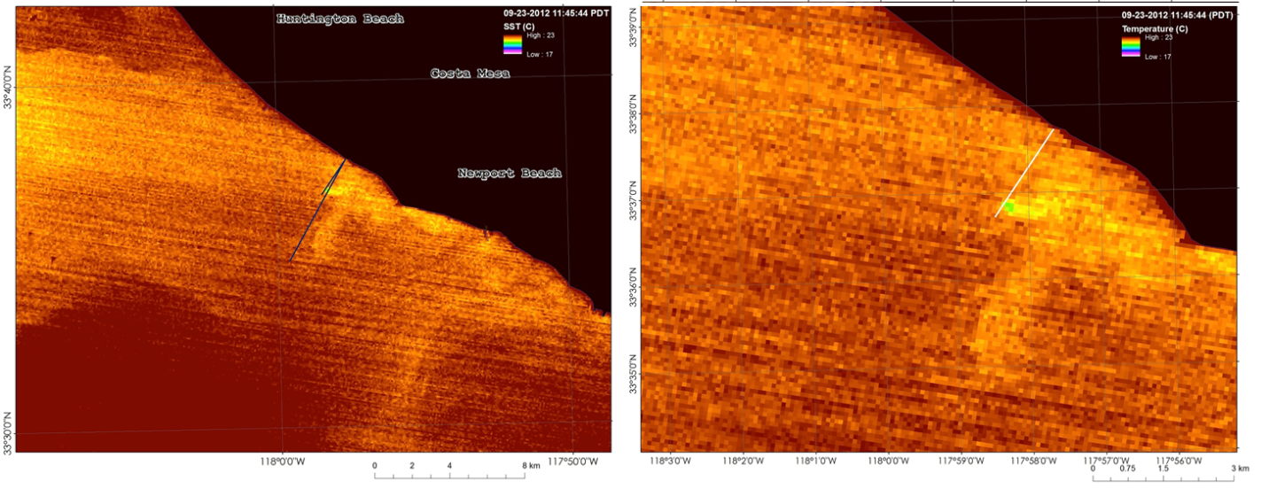**Figure 12:** ASTER SST from September 23, 2012 A) display cold thermal signal from the 1-mile diversion pipe; B) zoomed in to 1-mile pipe.

**A**

On Sep. 26, a very large chl-a appeared in MODIS Chl-a data (Figure 13), and the HF radar data indicates surface current had carried chl-a offshore forming this anomalous feature.

On Oct. 1, MODIS chl-a data displayed a patch with relatively low chl-a concentration appeared among high chl-a concentration (Figure 14); it also appeared that low concentration originated from the 1-mile diversion pipe. CTD data confirmed this chl-a feature with a fresh, cold feature among the saltier, warmer ambient sea water. Further analysis of this chl-a feature showed that it consisted of a few components with their own characteristics (Figure 15): detrital presence showed that most nonliving organic matter was found close to the coast; in contrast, particulate reflectance showed sediment was upwelled by the coast and within the bloom feature, while phytoplankton absorption was minimal along the coast and stronger near the pipe ends. This indicated that the observed low chl-a region has not only chl-a concentration, but also low sediment and detritus content. This was possibly due to the surfacing of the fresh treated wastewater plume pushing away the phytoplankton at the diversion pipe’s end, and strongly diluting the existing surface plumes. Another explanation could be due to chlorine (Cl2) added to the wastewater during the second stage of treatment. Chloring can react with sea water to form hypochlorous acid (HOCl) and hypochlorite ions (OCl-) which both are very effective at terminating bacteria and fungi. During the diversion event, OCSD overestimated how much Cl2 was added, and it was not completely removed during the de-chlorination process. When it was discharged into the ocean, the excess chlorination may not only have removed harmful pathogens but also phytoplankton, resulting in a region of low phytoplankton.

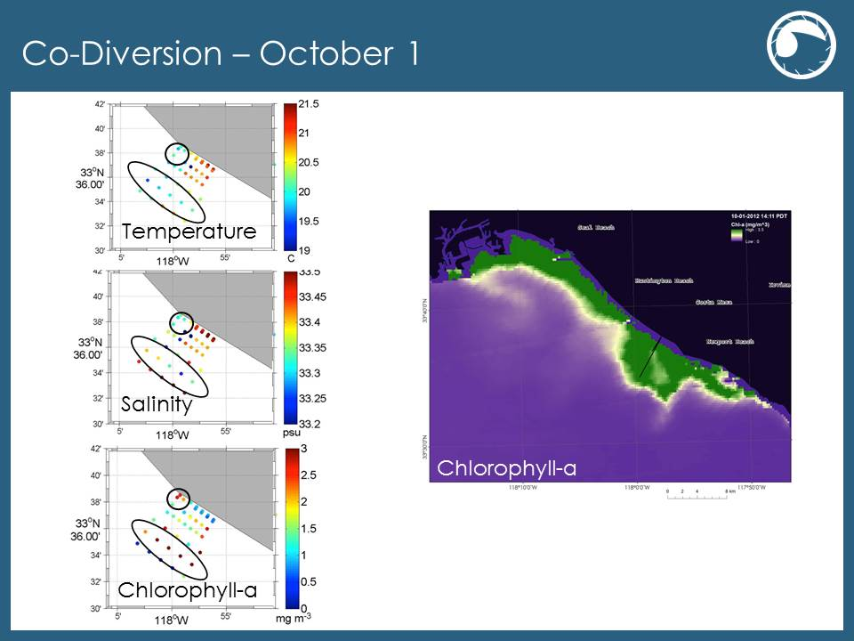

**Figure 14:** MODIS Chl-a from October 1, 2012 displays a relatively lower concentration chl-a feature among high concentrations; in-situ CTD data confirms the physical structure of this feature.

By Oct. 2, 2012 (Figure 16), the patch of high chl-a concentration moved north along the shore and began to display eddy-like physical features; this was also confirmed by HF radar data which shows that the current had moved the plume towards the same direction.

On Oct. 8, 2012, four days after the diversion event ended (Figure 17), ASTER SST data did not display any SST anomalies associated with the pipes. However, there were two warm water discharge events from the local power plant visible in the image.

# V. Conclusions

This study demonstrated that satellite remote sensing is a valuable complement to in situ field sampling during wastewater diversion events in the coastal waters of Southern California. Satellite data containing thermal infrared, optical properties and radar backscattering was converted to observations in SST, marine biogeochemistry, and surface roughness, which were then used to track surfaced wastewater plumes during diversions at the HWTP and OCSD. Though MODIS-Aqua data has a poorer spatial resolution, when combined with data such as ASTER, yields a relevant spatial and temporal data set for tracking these wastewater plumes. Additionally, when verified with available in situ data sources, satellite imagery proved to be consistently reliable in determining plume extent. Future diversion events, such as the scheduled 2015 HWTP diversion, will also be able utilize additional satellite missions, such as Landsat 8 (Figure 18) and PACE, with hyperspectral sensor and finer spatial resolutions, to better assist the efforts in detecting and monitoring treated wastewater plumes.

# VI. Acknowledgments

We would like to thank our science advisors—Ben Holt and Michelle Gierach for data retrieval and assisting us in data analysis. We would also like to acknowledge our project partners: Curtis Cash and Mas Dojiri at the Hyperion Treatment Plant, George Robertson at OCSD, and Meredith Howard at SCCWRP. Their contributions, along with the NASA DEVELOP Program, have made this project possible.

# VII. References

DiGiacomo, P.M., L. Washburn, B. Holt, and B.H. Jones. Coastal pollution hazards in southern California observed by SAR imagery: stormwater plumes, and natural hydrocarbon seeps. Marine Pollution Bulletin, 49, 1013-1024 (2004).

Hook, S. J., A. R. Gabell, A. A. Green, and P. S. Kealy. A comparison of techniques for extracting emissivity information from thermal infrared data for geologic studies. Remote Sensing of Environment, 42, 123-135 (1992).

Johnson, B. R. and S. J. Young. In-Scene Atmospheric Compensation: Application to SEBASS Data Collected at the ARM Site, Technical Report, Space and Environment Technology Center, The Aerospace Corporation (1998).

Kealy, P. S. and S. J. Hook. Separating temperature and emissivity in thermal infrared multispectral scanner data: Implications for recovering land surface temperatures. IEEE Transactions on Geoscience and Remote Sensing, 31(6), 1155-1164 (1993).

Marmorino, G.O., G.B. Smith, W.D. Miller, and J.H. Bowels. Detection of a buoyant coastal wastewater discharge using airborne hyperspectral and infrared imagery. Journal of Applied Remote Sensing, 4, (2010).

Nezlin, N.P. and P.M. DiGiacomo. Satellite ocean color observations of stormwater runoff plumes along the San Pedro Shelf (southern California) during 1997-2003. Continental Shelf Research, 25, 1692-1711 (2005).

Raco-Rands, V.E. and A. Steinberger. Characteristics of effluents from large municipal wastewater treatment facilities in 1997. Southern California Coastal Water Research, 28-44 (2001).

Reifel, K.M., A.A. Corcoran, C. Cash, R. Shipe, and B.H. Jones. Effects of a surfacing effluent plume on coastal phytoplankton community. Continental Shelf Research, 60, 38-50 (2013).

Washburn, L., B.H. Jones, A. Bratkovich, T.D. Dickey, and M. Chen. Mixing, dispersion, and resuspension in vicinity of ocean wastewater plume. J. Hydraul. Eng. 118, 38-58 (1992).

Uchiyama, Y., E.Y. Idica, J.C. McWilliams, and K.D. Stolzenbach. Wastewater effluent dispersal in Southern California Bays. Continental Shelf Research, 76, 36-52 (2014).

# VIII. Appendices

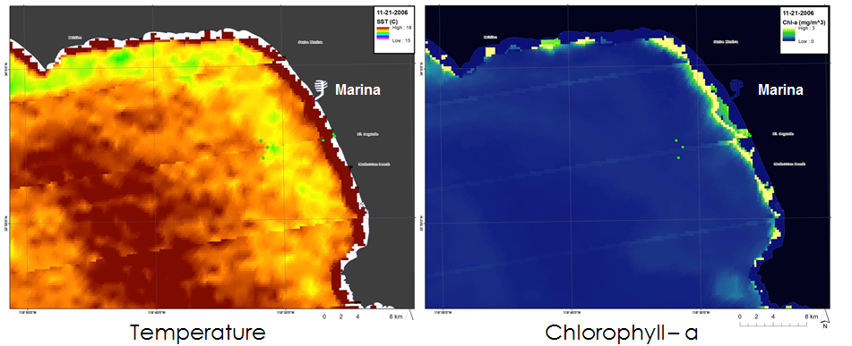

**Figure 1:** MODIS SST and Chl-1 from November 21, 2006 (pre-diversion) overlooking Santa Monica Bay.

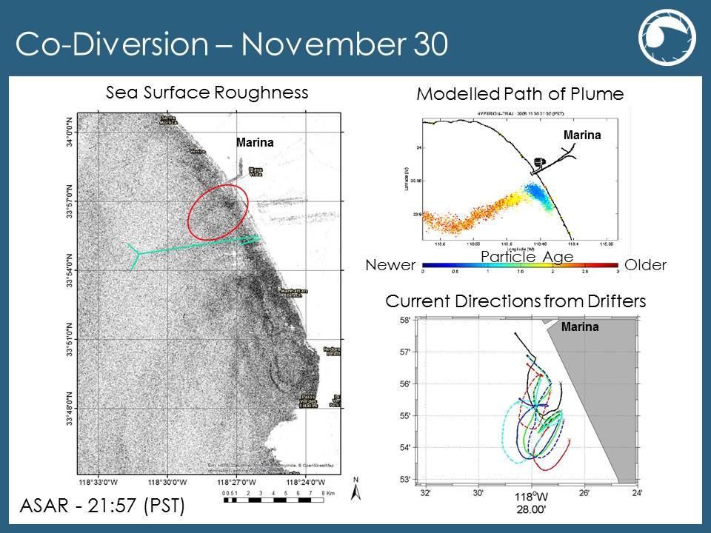

**Figure 3:** ASAR data retrieved from November 30, 2006 during the diversion event; results were compared with plume model simulations and drifter data.

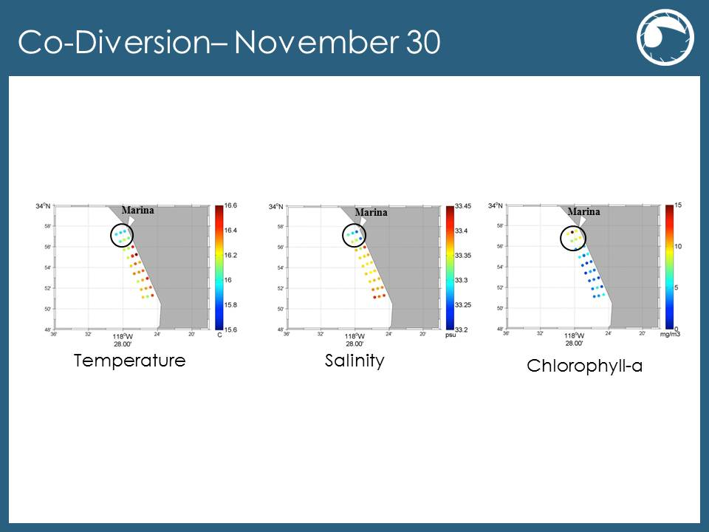**Figure 4:** In-situ CTD measurements collected on Nov. 30, 2006 correlates with ASAR data from Figure 3.

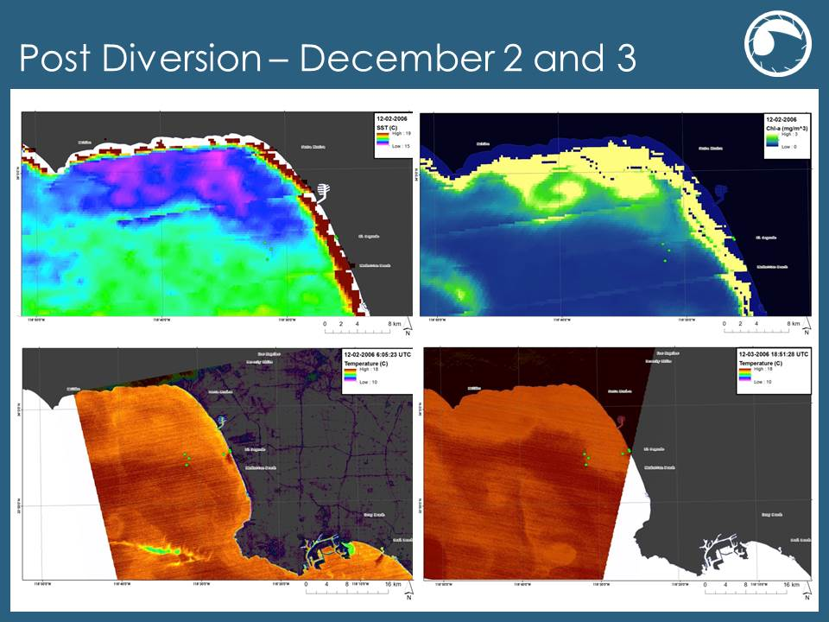

**Figure 6:** (*Top)* MODIS SST and Chl-a data recorded on December 2, 2006; (*Bottom*) ASTER SST data recorded on December 2 and 3, 2006 respectively.

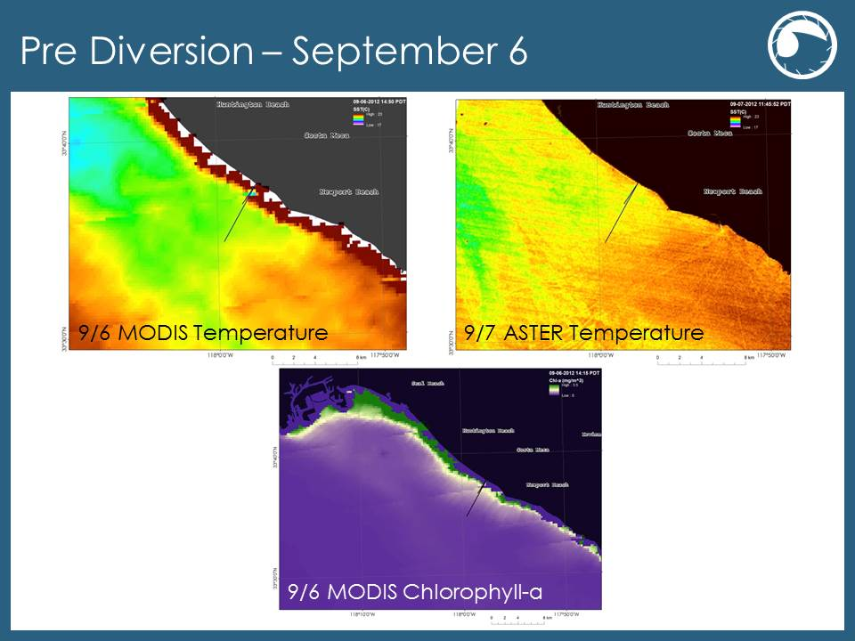

**Figure 7:** MODIS SST and Chl-a data on September 6, 2012; and ASTER SST data on September 7, 2012.

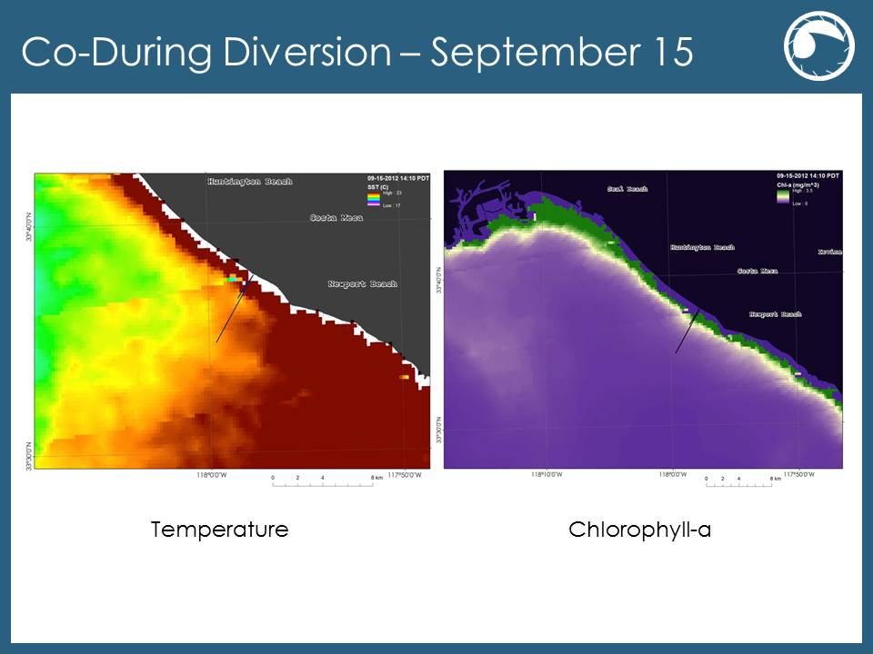

**Figure 8:** MODIS SST (left) and Chl-a (right) data from September 15, 2012.

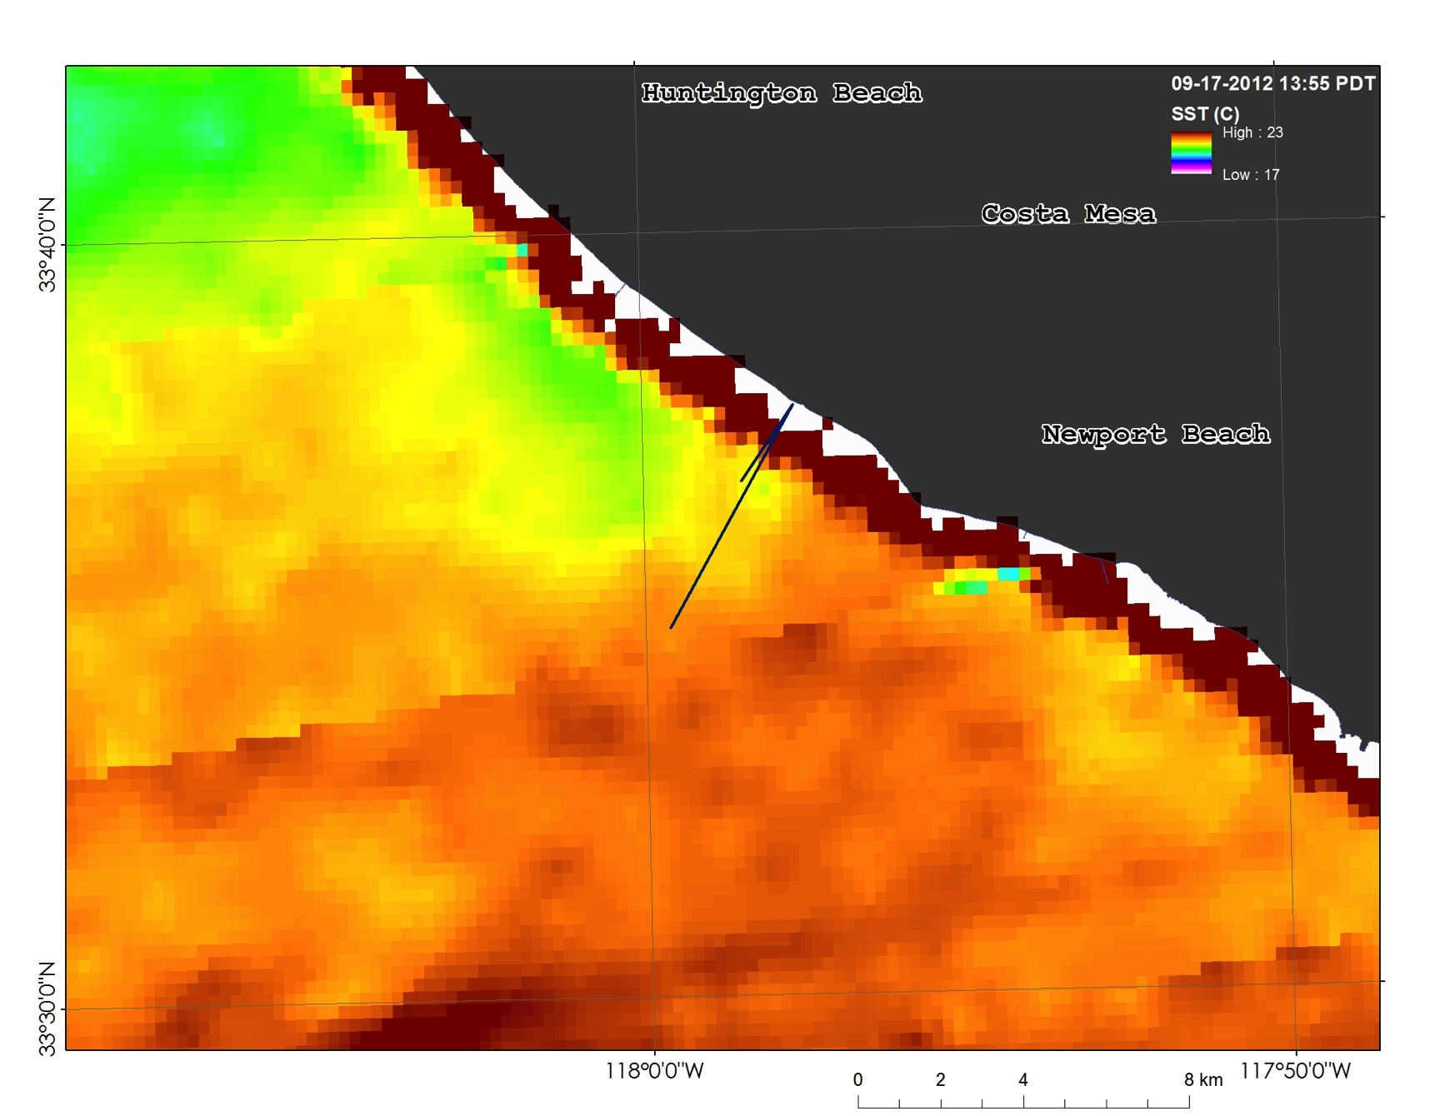

**Figure 9:** MODIS SST from September 17, 2012 overlooking San Pedro Bay.

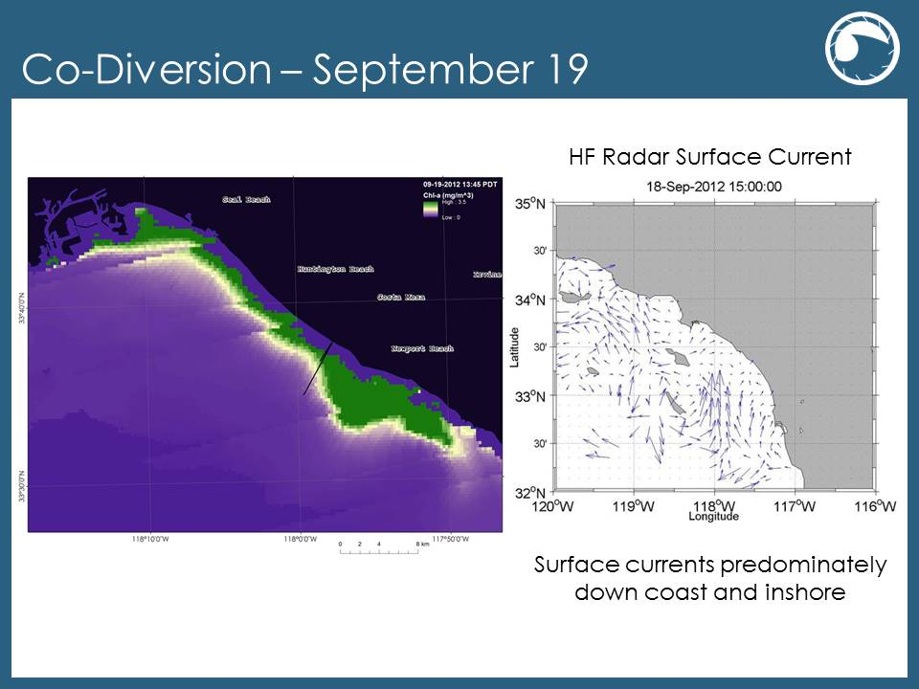

**Figure 10:** (Right) MODIS SST from September 19, 2012 overlooking San Pedro Bay (left); HF Radar detecting surface currents from September 18, 2012.

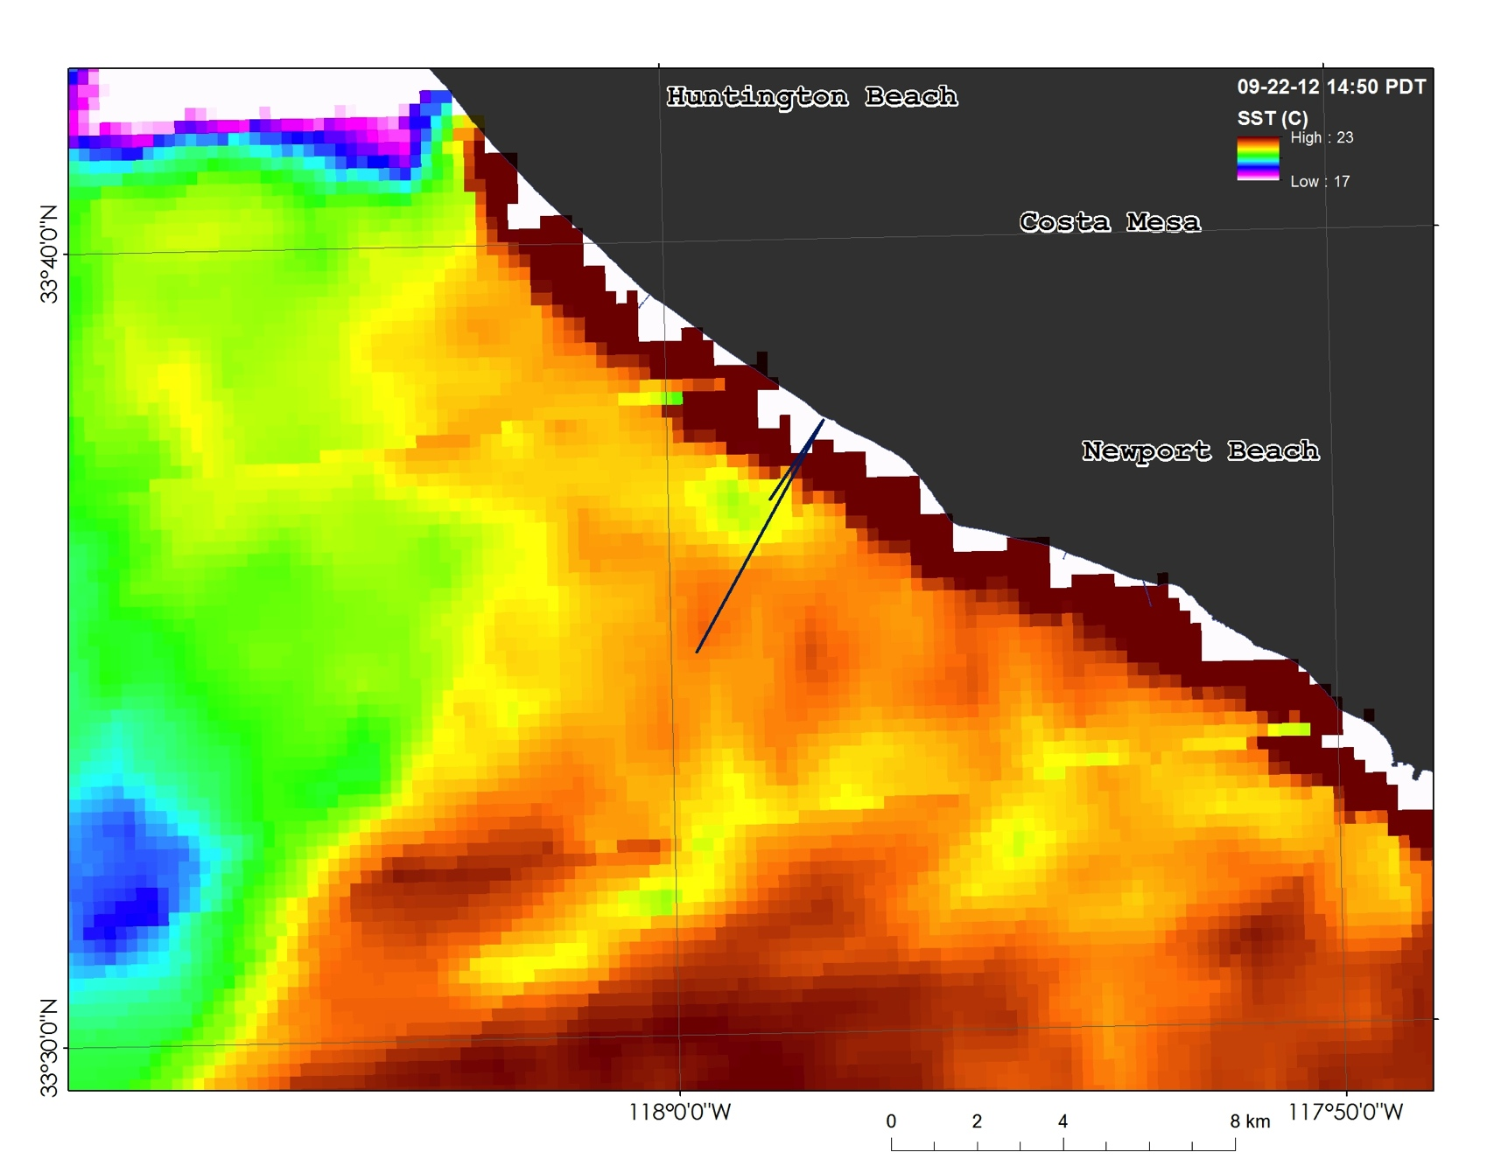

**Figure 11:** MODIS SST from September 22, 2012 overlooking the OCSD’s outfall pipes during the diversion event.

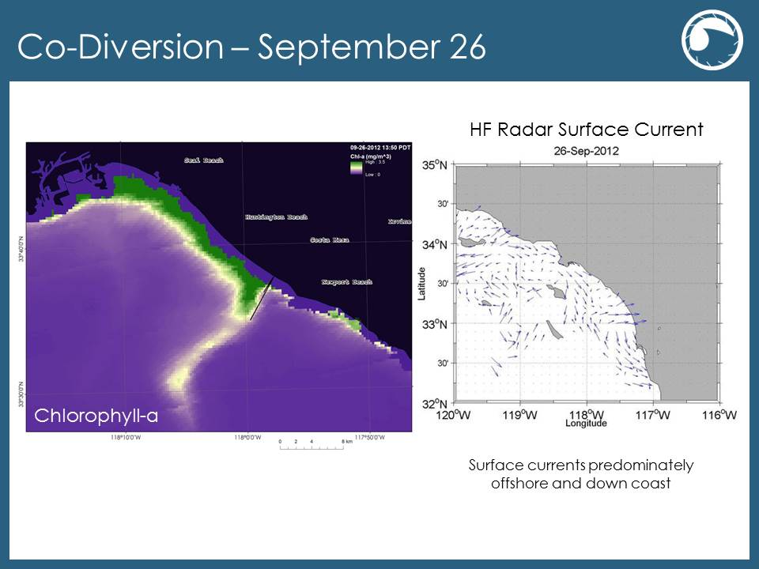

**Figure 13:** MODIS Chl-a from September 26, 2012 displays large chl-a features; while the HF Radar surface current data verifies this feature.

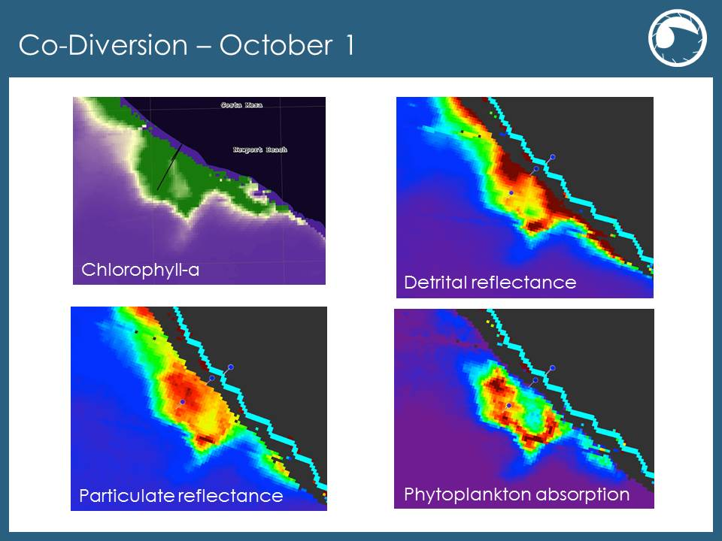

**Figure 15:** MODIS post-processed data from October 1, 2012 displays other optical properties of the observed plume in Figure 14.

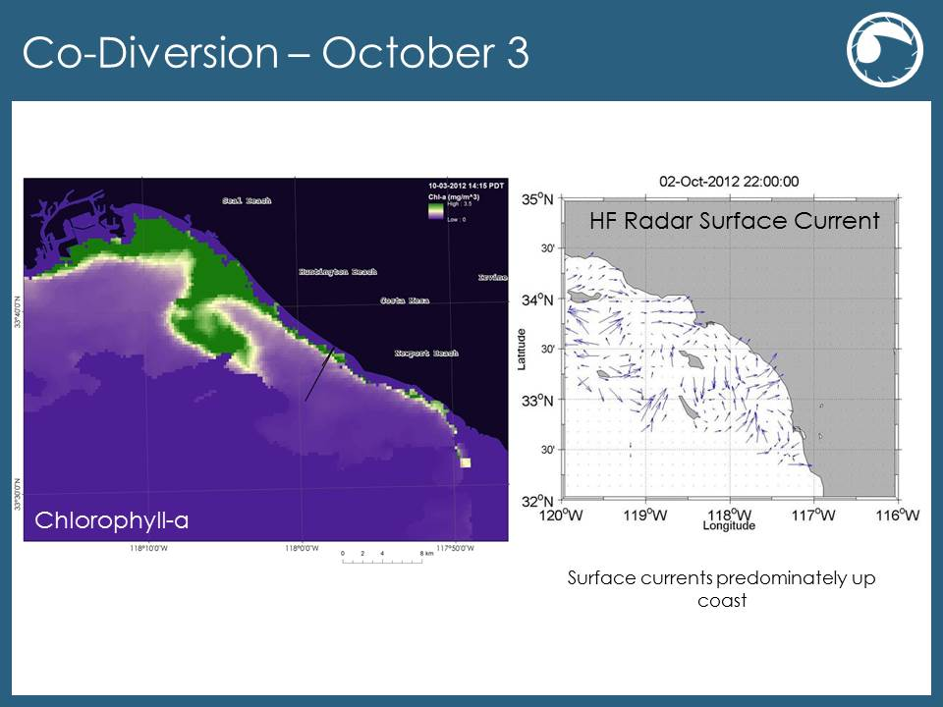

**Figure 16:** MODIS chl-a data from October 2, 2012 displays the movement of high concentration patch when compared with Figure 15; HF Radar surface current data verifies the presence of this feature.

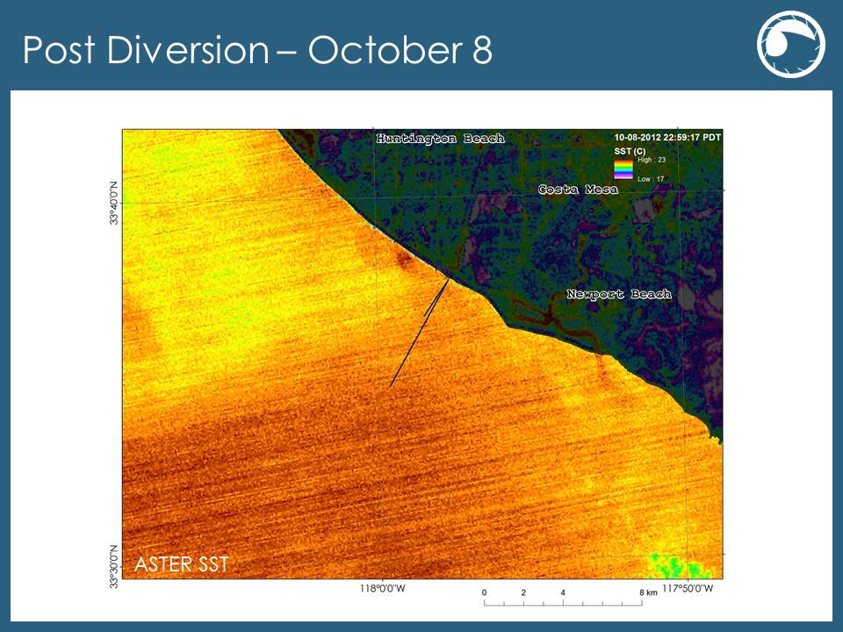’

**Figure 17:** ASTER SST data from October 8, 2012 after the diversion event at OCSD.

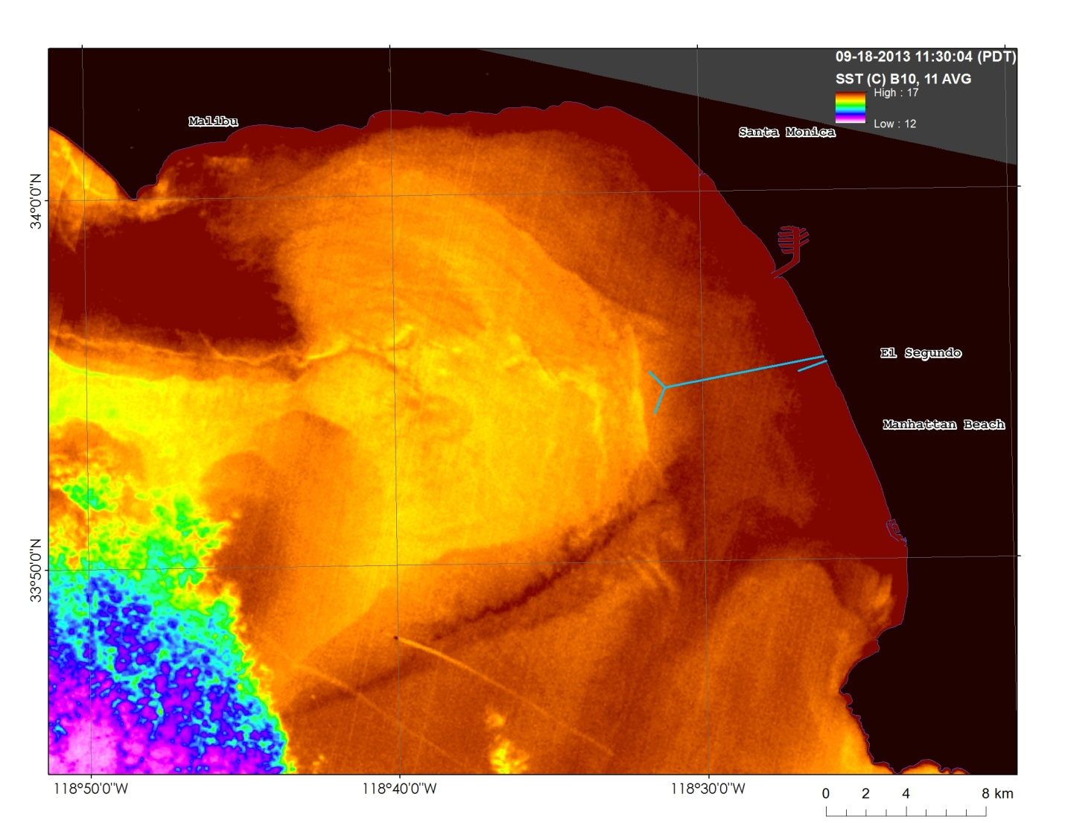

**Figure 18:** Landsat 8 Band 10 and Band 11 average SST data from September 18, 2013 overlooking Santa Monica Bay.