**NASA DEVELOP National Program**



Marshall Space Flight Center

*Spring 2014*

Cumberland Plateau Ecological Forecasting II

Using NASA Earth Observations to Model a Representative Species’ Future Geographic Distribution in the Cumberland Plateau to Aide in Conservation Efforts

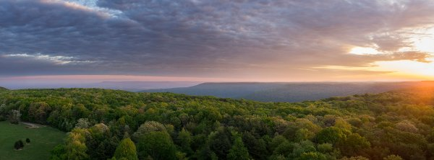

**Technical Report Final Draft**

April 3, 2014

Amanda Weigel, University of Alabama in Huntsville (Project Lead)

Jean Baptiste Kayitare, California Baptist University

Robert Rossell, University of Alabama in Huntsville

Dr. Jeffrey Luvall, NASA Global Climatology and Hydrology Center (Science Advisor)

# I. Abstract

This study examined the spatial distribution of White Oak, a representative species for the Cumberland Plateau area, using future climatic and current physical environmental parameters.  The Cumberland Plateau is one of the most biodiverse regions in North America, therefore, government and private agencies are interested in purchasing land for conservation efforts in years to come. Currently, these lands are purchased without knowledge as to how changes in climate will impact species distributions across the region. Global Digital Elevation Models (GDEM), along with satellite-derived current climate and hydrography data, were used as inputs into the Maximum Entropy Species Distribution Model (MaxEnt). The model outputs weighted environmental parameters indicative of White Oak species distribution. Using MaxEnt output percent contribution of the different environmental layers, a fuzzy logic model was created in ArcGIS and used to map the White Oak’s optimal distribution and habitable range using future climatic projections. For this analysis, we used the National Center for Atmospheric Research (NCAR) Community Climate System Model (CCSM) IPCC Climate Change Commitment Scenario ensemble average to map the future distribution of White Oak in 2020, 2030, 2040, and 2049. The results are used to aid The Nature Conservancy and U.S. Fish and Wildlife Services in determining areas in the Cumberland Plateau that are worth purchasing.

**Keywords**

Cumberland Plateau, White Oak, DEM, Land Cover, Climate, MaxEnt Model, Fuzzy Logic Model

# II. Introduction

*Background Information:*

The Cumberland Plateau is considered a biodiversity hotspot in North America, rivaling that of tropical rainforests. Its diverse ecosystem supports the highest biodiversity in the nation and is under pressure. Currently, the Cumberland Plateau is on the top ten endangered areas list for the southeastern United States (Southern Environmental Law Center, 2011). Many timber companies have used and invested in large amounts of land in the Cumberland Plateau to harvest trees. Moreover, tourism has resulted in an increase in recreational use, which has added to the pressure on the area (Kingsbury, 2012). This activity, along with an increase in homes, has resulted in fragmentation and degradation of the area’s forests and streams. The Cumberland Plateau has the highest concentration of endangered species in North America and is in need of preservation (The Nature Conservancy, 2013).

Vegetation in the Cumberland Plateau consists primarily of mixed-mesophytic, deciduous, hardwood forests. They are predominantly composed of Oak, Maple, Beech, Poplar, Hickory, and Ash trees (A.R. Bhuta et al., 2011). This type of forest is used as a representation of the Cumberland Plateau ecosystem, more precisely White Oak. Previous studies have shown that the plant distribution is being affected and there are isolated regions of White Oak dominant forests on the plateau (C. J. Schweitzer, D. C. Dey, 2011). This break in forested regions can create further pressure on endangered species in the region by limiting range.

Studies have highlighted the economic and the ecological importance of the White Oak, one of the dominant tree species of the Cumberland Plateau. White Oaks are considered one of the best fuel woods, and many trees are cut each year for home heating or for use as chips in industrial or institutional boilers. Smaller Oak logs are used as pulpwood (D. Dickmann & D. Lantagne, 1997). Besides their economic uses, White Oaks are ecologically beneficial. They provide habitat for animal species as well as a food source, via acorns, which are consumed by various animals such as deer, turkeys and squirrels. White Oaks also protect the soil against erosion because of their deep roots and longevity. They provide shade for other trees which grow underneath them such as White Pine, Ash, Sugar Maple and Red Maple (D. Dickmann & D. Lantagne, 1997).

Despite their enormous uses, White Oaks and other types of Oaks are facing different problems in terms of regeneration and reproduction. When cut down for timber products or killed by invasive species, fire or Oak Wilt, the White Oak is unable to naturally reproduce from seeding (Dickmann & D. Lantagne, 1997). Studies conducted within and outside the United States indicate Oaks are experiencing different regeneration problems (H. D. Alexander et al, 2008). Tackling the problems that are faced by endangered species, such as the White Oaks and other species, will economically and ecologically benefit particularly the Cumberland Plateau, and the society in general (The Native Tree Committee of San Luis Obispo County, 2003).

This study employs a methodology to map the optimal species distribution for White Oak based on future climatic conditions and environmental parameters. Data used for this methodology include: Advanced Spaceborne Thermal Emission and Reflection Radiometer (ASTER) Global Digital Elevation Model (GDEM), Landsat 8’s Operational Land Imager (OLI), NCAR Community Climate System Model (CCSM) climate projections, and USGS Hydrography datasets. ASTER GDEM is used to calculate elevation, degrees slope, northness, and eastness of the area. NCAR CCSM climate projections for total monthly precipitation and mean monthly temperature obtained for the study period were used to calculate monthly minimum, maximum, and annual mean values for 2010, 2020, 2030, 2040, and 2049. USGS Hydrographic data was used to analyze the proximity to and density of water bodies within the Cumberland Plateau.

The model used to map current species distribution is the Maximum Entropy Species Distribution Model (MaxEnt) (S.J. Philips, M. Dudik, R.E. Schapire, 2004) produced by Princeton University. MaxEnt is a statistical model utilizing training data to analyze where the species is most likely to occur based on the input variables, and calculates an output of the optimal range in species distribution (S.J. Phillips & M. Dudik, 2005). The model outputs the species response (e.g. how the variable contributes to the species geographic distribution) to each individual variable, making it a useful tool in analyzing how a species responds to different environmental parameters. Using environmental parameters weighted by their corresponding percent contribution output by Maxent, the White Oak’s optimal future distribution was mapped using a fuzzy logic model created in ArcGIS.

*Project Objectives:*

The main objective of this study was to identify areas of the Cumberland Plateau that are more beneficial to conserve based on changes in climate and a representative species distribution. This study aims to optimize the mapping of profitable lands for purchase from the previous DEVELOP Cumberland Plateau Ecological Forecasting project by incorporating future climatic conditions into the decision support tool. The results from this study are used by agencies to prioritize areas for preservation based on future projections of species distribution.

*Study Area:*

The Cumberland Plateau is a geographic feature that stretches from northern Alabama, through Tennessee, into Kentucky (Figure1). This region is known for being one of the most diverse woody plant communities in North America (Ricketts et al., 1999). The Cumberland Plateau contains some of the largest stretches of contiguous forest in eastern North America, approximately 70% of its total area, with over 75% of the forested land consisting of mixed-mesophytic forests (Homer et al., 2004; USDA/FS, 2007). Forest resources, including timber and paper, and forest management are a significant part of the Cumberland Plateau’s economy, particularly in rural regions (Lemke et al., 2011).

*Study Period:*

This projects study period focuses on future climate conditions in the Cumberland Plateau to model the species distribution of White Oak. 2010 data was used to derive the percent contribution climate conditions and physical environmental parameters pose on White Oak habitation. Past conditions were not considered for this study because if used with current tree locations the results would be skewed. The time period of focus extends from January 2010 to December 2049. 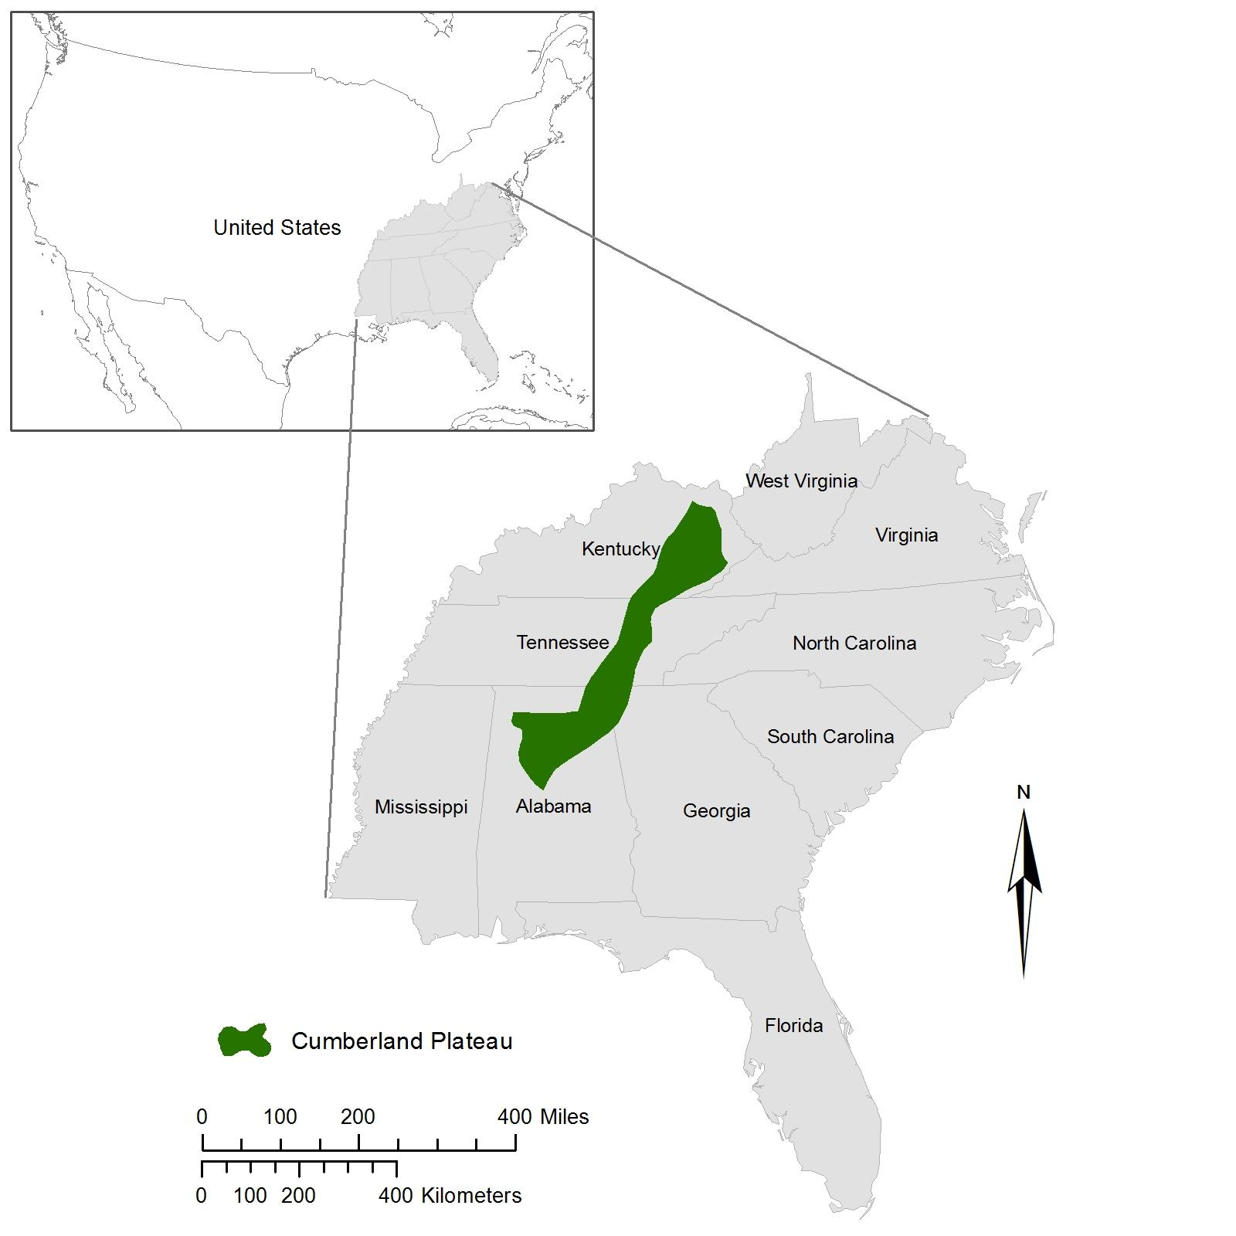

**Figure 1**: The Cumberland Plateau across Kentucky, Tennessee, and Alabama

*National Application Addressed:*

The primary national applications addressed for this project is ecological forecasting. This project’s main focus is to assess the future species distribution of White Oak to understand how the ecology of the land is changing to identify areas worth conserving. This project also falls under the climate national application area where this study aims to support activities associated with environmental health based on climate change.

*Project Partners:*

The project partners for this study are The Nature Conservancy, the U.S. Fish and Wildlife Service (USFWS), and the USDA Forest Service (USFS). The Nature Conservancy is a non-profit organization that focuses on purchasing land for preservation of ecology. The USFWS and USFS are government agencies charged with overseeing the protection and preservation of wildlife throughout the national forests. The Nature Conservancy and USFWS are currently working on establishing preserves within the Cumberland Plateau and are interested in preserving areas that fully embody the plateau. They currently do not implement remote sensing techniques in their decision making process; however, these agencies use endangered species habitats as a proxy for creating preserves. Our partners will benefit from this project’s results by being able to visualize and geographically locate which areas of the Cumberland Plateau are more suitable to protect based on the representative species. This will allow them to establish preserves based on the Cumberland Plateau’s ecological system as a whole.

# III. Methodology

*NCAR Community Climate System Model (CCSM):*

Future climatic conditions were downloaded from the National Center for Atmospheric Research (NCAR) Climate Change Scenarios Portal. Data outputs from the Community Climate System Model (CCSM) were obtained from the Continental U.S. data collection at 4.5 kilometer resolution in gridded point shapefile format. For this study, monthly and annual mean air temperatures and total precipitation were collected using the IPCC Climate Change Commitment Scenario ensemble average. Climate change projection shapefiles were then loaded into ArcGIS 10.2.1 for manipulation. Datasets were trimmed down to five years: 2010, 2020, 2030, 2040, and 2049 then exported into separate shapefiles where minimum, maximum, and annual mean monthly temperature and total precipitation were calculated. Following initial preprocessing, all of the precipitation data was interpolated using the 3D Analyst Kriging tool using the Ordinary Kriging method and exponential semivariogram model, which has been found to be the most accurate interpolation method for precipitation (Earls & Dixon, 2007). Temperature data was interpolated using the 3D Analyst Spine Tool using the tension Spline method found to be the best interpolation method for temperature data (ESRI, 2004). Resulting raster datasets contained the minimum, maximum, and mean annual monthly temperature and total precipitation for each of the five years.

*Terra, ASTER- Global Digital Elevation Model (GDEM):*

ASTER GDEM data was acquired from the USGS using their Earth Explorer online application (USGS, ASTER). The elevation data for the entire study area was mosaicked into a single image. Once mosaicked, the image was imported into ArcGIS 10.2.1, where degrees slope and aspect for the Cumberland Plateau were calculated using the Slope and Aspect tool. Northness and eastness for the Cumberland Plateau were then calculated from aspect using the raster calculator.

*USGS National Hydrography Dataset (NHD):*

The USGS National Hydrography Dataset (NHD) was used to analyze water sources found within the Cumberland Plateau. Three vector files were obtained from the USGS’s high resolution dataset: area, water bodies, and flow line. Each state’s respective data set was merged and clipped to the spatial extent of the study area. Merged files were then manipulated using ArcGIS tools to apply 100 and 500 meter buffers and calculate line density. These files were converted to raster format and reclassified to eliminate overlapping values.

*USFS Species Location Data:*

The species geographic location data was provided by the Forest Inventory and Analysis Spatial Data Services of the USDA Forest Service (USFS, FIA SDS). The data contained a variety of species present in the areas of Alabama, Tennessee, and Kentucky. We extracted the forest plots containing the White Oak information. The plots containing White Oak were found using queries in ArcGIS and the geographic locations for White Oak were then exclusively extracted and saved as a Comma Delimited (CSV) file to be input into the model.

*Modeling Species Distribution:*

Following initial processing, all data was clipped using a shapefile of the study area. All images were required to have the same resolution, spatial extent and projection for input into the model. Image resolution of each file was resampled to 30 meters. The geographic projections were then converted to the World Geographic Coordinate System (WGS) Universal Transverse Mercator (UTM) zone 17 North. The spatial extent for all the raster data was then “snapped” to the extent of the Cumberland Plateau. After processing, the images were converted to ASCII file format for input into the model. All processed data sets were uploaded into the Maximum Entropy Species Distribution Model (MaxEnt) as environmental layers, and categorized as being either continuous or categorical. Once this was completed, the model was run.

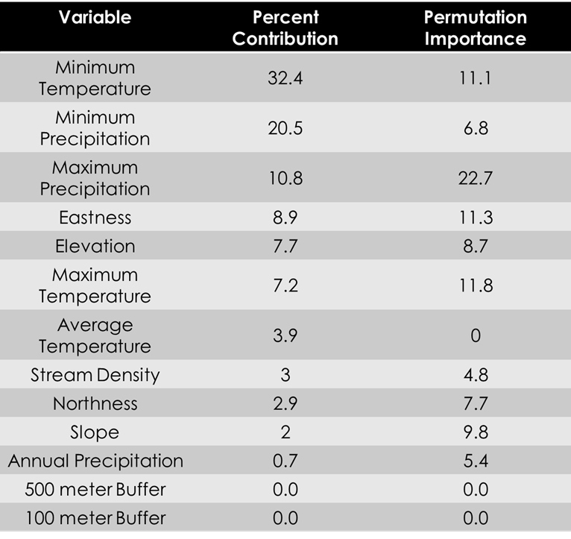

**Figure 2:** MaxEnt Model output percent contribution

*Weighted Fuzzy Logic Model:*

The MaxEnt model outputs the percent contribution (Figure 2) each climatic and physical environmental parameter has on White Oak distribution, along with their associated response curves. Response curves identify values with each data range most probable for White Oak presence. Using these percent contributions in conjunction with NCAR CCSM projections, a weighted fuzzy logic model was developed consisting of two parts: fuzzy membership and a weighted sum. Fuzzy membership was used to apply a line of best fit to each climate projection and physical environmental parameters to highlight optimal values within each dataset indicated by the response curves.

The final portion of this study used resulting fuzzy membership files and MaxEnt output percent contribution to calculate a weighted sum to identify optimal areas for White Oak. The Weighted Sum is an ArcGIS tool used to add multiple raster datasets weighted on a scale of zero to one. For each of the five years covered in the study period, resulting fuzzy membership files were input into the tool and weighted according to their corresponding percent contribution. Pixels with higher values reveal areas likely for White Oak distribution.

# IV. Results & Discussion

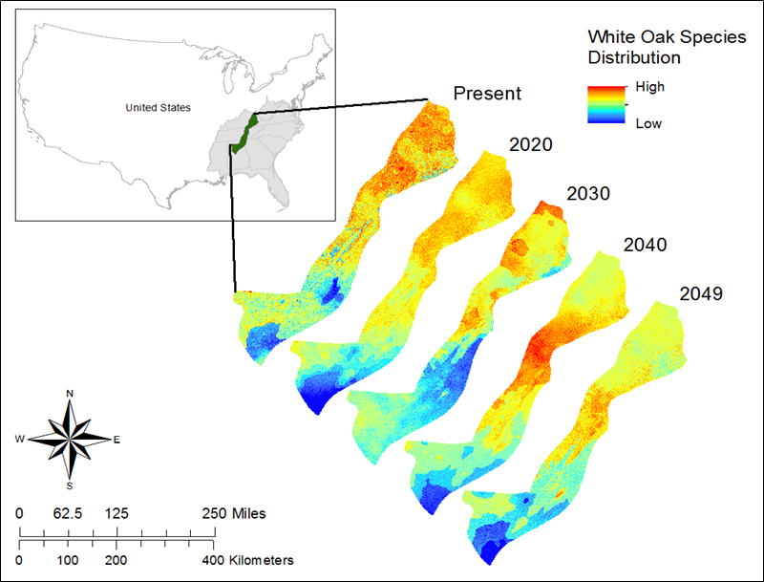

**Figure 3:** Maps of future White Oak distribution

Our analysis found the distribution of White Oak to decrease over time. Figure 3 maps the White Oak distributions’ change over time. Low distributions in the Southern portion of the Cumberland Plateau migrate northwards, while the level of distribution in northern areas appears to decrease and become less concentrated. Decreases in White Oak distribution can be attributed to increases in temperature projected by the NCAR climate model data. Because MaxEnt found White Oak distribution to be most dependent on minimum temperature, future increases in temperature limit the White Oak’s distribution, shifting habitable areas northwards into cooler regions.

Small increases in White Oak distribution in portions of the study area were observed. These increases can be attributed to the species settling into its changing environment. Also note the anomalous high probability area of White Oak distribution for 2040. This concentration of high values is due to a peak in minimum precipitation for that year, which was found to be the second highest contributor to White Oak distribution.

A simple linear regression was run to compare the accuracy of mapping future distribution using fuzzy logic modeling to the Maxent model. The 2010 species distribution was mapped using the weighted fuzzy logic model methodology, and point values at White Oak locations were extracted and compared to those of the Maxent output (Figure 4). Our analysis found a 0.41 correlation between the MaxEnt output and the weighted fuzzy logic model. The fuzzy logic model was found to underestimate the species distribution, which is optimal for ecological forecasting because overestimation is more erroneous.

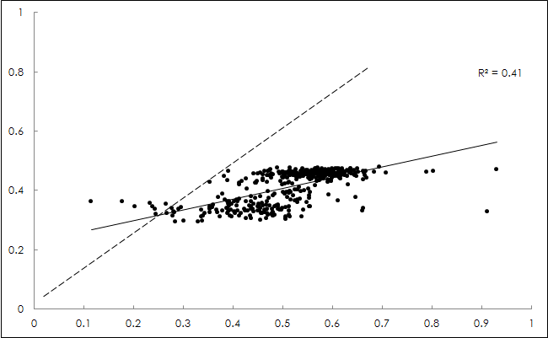

**Figure 4:** Simple linear regression graph correlating MaxEnt with fuzzy logic

*Errors and Uncertainties:*

Errors and uncertainties in our project results can be attributed to a few sources. The results of this study were limited by the Maxent output response curves, whose graphs were difficult to mimic during the fuzzy membership portion of this study. Representation of response curves was also limited by available fuzzy membership functions. Some parameters required multiple steps to manipulate the fuzzy membership functions in order to highlight optimal areas, which can decrease the accuracy of the dataset. Finally, the future distribution was dependent on selected climate model, which will change results depending on the selected climate projections used for future species distribution mapping.

# V. Conclusions

In conclusion, Fuzzy Logic modeling succeeded in mapping the general future distribution of White Oak. Increases in temperature led to a northward transition in White Oak distribution and a decrease in overall distribution with the changing climate parameters. Maps created and analysis results will help end-users prioritize areas in the Cumberland Plateau for future preservation

# VI. Acknowledgments

We would like to thank our science advisor, Dr. Jeffrey Luvall, for his guidance and input on this project and Dr. Robert Lawton from the University of Alabama in Huntsville. We would also like to thank our project partners, specifically Mr. Steve Northcutt with the Nature Conservancy and Dr. Callie Schweitzer with the USFS, for their advisement and support for this project. We also want to thank the USFS for providing tree location data from their Forest Inventory and Analysis Spatial Data Services.

# VII. References

Alexander, H. D., Arthur M. A., Loftis, D. L., & Stephanie, R. G. (2008), Survival and Growth of Upland Oak and Co-occurring Competitor seedlings Following Single and Repeated Prescribed Fires, Forest Ecology and Management 256(2008) 1021-1030

Bhuta, A., Hart, J., Schneider, R. (2011), Forest Vegetation and Development Patterns in Secondary Stands on the Alabama Highland Rim: An Examination of the Largest Landholding in the Region, Natural Areas Journal, 31(3), 256-269, doi: 10.3375/ 043.031.0308

Chandler, W. S., Hoell, J. M., Westberg, D. J., Whitlock, C. H., Whitlock, C. H., & Whitlock, C. H. (2011). *Downscaling nasa climatological data to produce detailed climate zone maps*. (Conference Paper).

Dickmann, D., Lantagne, D. (1997), Planting oaks for Timber and Other Uses, Department of Forestry Michigan State University

Earl, J., Dixon, B. (2007). Proceedings from the 2007 ESRI users group conference.

ESRI. (2004), Interpolating Surfaces in ArcGIS Spatial Analyst. Redlands, CA. Childs, C.

Hattab, T., Ben Rais Lasram, F., Albouy, C., Sammari, C., Romdhane, M., Cury, P., & ... Le Loc’h, F. (2013). The Use of a Predictive Habitat Model and a Fuzzy Logic Approach for Marine Management and Planning. Plos ONE, 8(10), 1-13. doi:10.1371/journal. pone.0076430

Kainz, W. Illustrative Example. Introduction to Fuzzy Logic and Applications in GIS. Department of Geography and Regional Research. University of Vienna, Austria. Retrieved February 20, 2014 from <http://homepage.univie.ac.at/ wolfgang.kainz/Lehrveranstaltungen/ESRI_Fuzzy_ Logic/File_3_Kainz_ Example.pdf>

Kingsbury, P. (2012, September 12), A Big Deal to Connect the Cumberlands. The Nature Conservancy. Retreived September 21, 2013, from http://www.nature .org/ ourinitiatives/regions/northamerica/unitedstates/ tennessee/explore/ tennessee-cumberland-plateau-deal.xml

Lemke, D., Hulme, P. E., Brown, J. A., & Tadesse, W. (2011). Distribution modelling of Japanese honeysuckle *Lonicera japonica* invasion in the Cumberland Plateau and Mountain Region, USA. *Forest Ecology and Management*, *262*(2), 139-149.

NCAR (February 2014). Community Climate System Model. Monthly mean temperature and total precipitation 2010-2049. Climate Change Scenarios Portal. Retrieved from <http://gisclimatechange. ucar.edu/>

Meehl, G. A., Washington, W. M., Santer, B. D., Collins, W. D., Arblaster, J. M., Hu, A., ... & Strand, W. G. (2006). Climate change projections for the twenty-first century and climate change commitment in the CCSM3. *Journal of Climate*, *19*(11).

Oak Woodlands Management Plan. The Native Tree Committee of San Luis Obispo County. Retrieved April 3, 2014, from http://ucanr.edu/sites/oak_ range /files/60623.pdf

Phillips, S. J., Dudík, M., & Schapire, R. E. (2004, July). A maximum entropy approach to species distribution modeling. In *Proceedings of the twenty-first international conference on Machine learning* (p. 83). ACM.

PLANTS Profile for Quercus Alba (white Oak). USDA PLANTS. Retrieved April 15, 2013, from http://plants.usda.gov/java/profile?symbol=qual.

Raines, G. L., Sawatzky, D. L., & Bonham-Carter, G. F. (2010). Incorporating expert knowledge: New fuzzy logic tools in ArcGIS 10. *ArcUser*, *49*, 8-13.

Ricketts, T. H., Dinerstein, E., Olson, D. M., Loucks, C. J., & Eichbaum, W. (1999). Terrestrial Ecoregions of North America: A Conservation Assessment. Washington, D.C.: Island Press.

Schweitzer, C. J., Lesak, A. A., & Wang, Y. (2006). Predicting oak density with ecological, physical, and soil indicators.

Smalley, Glendon W. (1982), Classification and Evaluation of Forest Sites on the Mid-Cumberland Plateau. USDA For. Serv., Gen. Tech. Rep. S0-38. South. For. Exp. Stn., New Orleans, La.

USFS (July 2010). Forest Inventory and Analysis Spatial Data Services DataMart, Retrived October 15, 2013, from http://apps.fs.fed.us/fiadb-downloads/datamart.html

USGS (February 2014) National Hydrography Dataset (NHD), Retrieved Area, Waterbodys, and Flowline data for Kentucky, Tennessee and Alabama, February 5, 2014, from ftp://nhdftp.usgs.gov/DataSets/Staged/States/FileGDB /HighResolution/

USGS (September 2013). Terra, ASTER Global Digital Elevation Model, Retrieved September 25, 2013, from http://earthexplorer.usgs.gov

Top Ten Endangered Areas in the South for 2011. Southern Environmental Law Center. Retrieved April 3, 2014, from <http://stoptitan.org/media/press-releases/2011/SELC%20Top%2010%20Endangered%20Places%20in%20the%20Southeast.pdf>