**Utilizing NASA Earth Observations to Assess Urban Forest as an Adaptation Strategy for Extreme heat in Ajax, ON, Canada**

**Author Names and Affiliations:**

Huntington Keith, NASA DEVELOP

Eleanor Dhuyvetter, NASA DEVELOP

Dean Blumenfeld, NASA DEVELOP

Elizabeth Dyer, NASA DEVELOP

Lance Watkins, NASA DEVELOP

Dr. David Hondula, Arizona State University

Dr. Qunshan Zhao, Arizona State University

a NASA DEVELOP National Program, COOR Hall, Arizona State University, 976 S Forest Mall, Tempe, AZ 85281, U.S.A.

Huntington.Keith@asu.edu

**Corresponding Author:**

Lance Watkins, COOR Hall, Arizona State University, 976 S Forest Mall, Tempe, AZ 85281, U.S.A., [lance.e.watkins@nasa.gov](mailto:lance.e.watkins@nasa.gov)

**Highlights**

* Tree health in a changing climate
* Heat vulnerability analysis using land surface temperatures
* Tree cover percent classification on Landsat 8 imagery using Random Forest methods
* High resolution land use land cover classification using PlanetScope data

**Abstract**

The town of Ajax, Ontario received a report from Specialists in Energy, Nuclear and Environmental Sciences (SENES) Consultants detailing the likely changes in local weather patterns for 2040-2049. The climate model predicts an increase in the frequency and intensity of monthly rainfall, a decrease in annual snowfall, and an increase in average annual temperature of approximately 4 °C. The Town of Ajax, Operations & Environmental Services aims to take early action to mitigate the potential impacts of these changes, such as increased tree fatalities and extreme temperature. In particular, tree fatalities due to increased stress, disease, and infestation are of special concern because trees are an important resource for ameliorating extreme temperatures via shading and evapotranspiration. To create a model for how tree stress varied in conjunction with climate variables, Landsat 5, Landsat 8, and high-resolution imagery from 2000 to 2016 were used to estimate the tree canopy coverage and land cover classes. Combined with meteorological data, these classifications were used to examine the relationship between tree stress and climate variables such as temperature and precipitation. To supplement these results, the group used 2016 Canadian census data and land surface temperature data to create an index of heat vulnerability. The central urban area of Ajax was discovered to have vulnerable populations residing in areas that had warmer surfaces. Fluctuations of previous May rainfall and previous July temperatures were shown to explain 57% of the tree greenness (NDVI) fluctuations of Ajax’s natural cover during the study period. These results will provide city planners with tools needed to plan for the predicted increase in extreme heat events and mitigation of the effects on the community.

**Keywords**

Remote sensing, urban forestry, tree health, social vulnerability, Landsat 8

# 1. Introduction

***1.1 Background information***

Changing climate patterns and extreme weather events are expected to have a significant impact on communities and ecosystems across the globe. One potential area of concern to some local communities is possible threats to effects on their urban forests. Vegetation health is vulnerable to extreme weather events and long-term changes in climate (Kling et al., 2004). Increased carbon dioxide (CO2) can help trees thrive in the short term; however, rising summer temperatures can lead to higher rates of evaporation, resulting in less access to water and lower soil moisture. This stress damages the overall tree health and decreases average tree growth (Nitschke et al., 2017). As global temperatures are predicted to rise, cities may see the health of their urban forests decline, or dominant species may change, based on the temperature ranges in which species thrive.

Low winter temperatures limit the spread of many pathogens, so warmer winters in the future will increase the risk of diseases spreading further poleward. Disease is particularly damaging when combined with drought or the presence of another pest. For example, the aspen forest in northwest Alberta, Canada, was greatly reduced when insects and fungal pathogens took advantage of trees weakened from drought, and conifer trees in southern California were devastated when drought was followed by root disease and infestation by bark beetles. The resulting expanse of dead trees led to a 300,000 ha forest fire. (Hogg et al., 2002, Minnich, 2007).

Another likely change in climatic variables is that the frequency and intensity of extreme storms is predicted to increase. Storms with high winds, hail, or tornadoes and hurricanes, can destroy and damage large swathes of trees (Kling et al., 2004). In response to predicted changing weather patterns, the Town of Ajax Operations & Environmental Services department has created a Climate Action Plan (CAP) that addresses and attempts to mitigate impacts on their community, including to their urban forest. Ajax (population: 120,000) is located on Lake Ontario in Canada, and is a part of the Durham Regional Municipality (Fig. 1). In December 2013, Specialists in Energy, Nuclear and Environmental Sciences (SENES) Consultants provided the Durham Regional Municipality with a climate projection for the region. This forecast included a 5.8 °C increase in average winter temperatures, a 2.6 °C increase in average summer temperatures, and a 16% increase in annual rainfall by 2040-2049 for the Durham area.

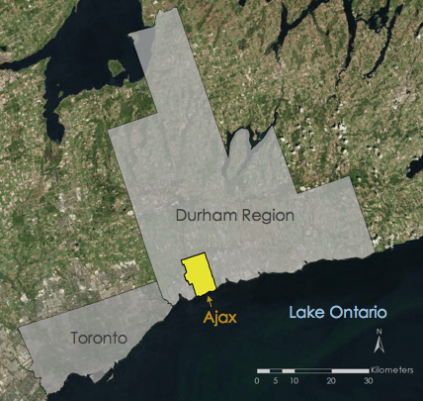Along with other cities within the Durham Municipality, Ajax wished to use the results of this report to adjust their CAP to more effectively prepare for the future. To predict the impact that these significant changes will have on their city, they needed to understand the vulnerability of components like human population and/or forest health. In this context, *vulnerability* is the extent to which these components are susceptible to the effects of the predicted changes and under what conditions they are unable to subsist (Adger, 2006; McCarthy et al., 2001).

Vulnerability Indices are used to measure vulnerability in operational instances and often consists of three constructs: adaptive capacity (ability for a system to adjust to stressors), sensitivity (characteristics that make the system more susceptible to harm), and exposure (the interaction between the system and stressors (e.g. extreme heat). Health outcomes during extreme events are often unevenly distributed among the population in a pattern related to individuals’ social vulnerability. Social vulnerability evaluates susceptibility based on socioeconomic characteristics such as income, age, race, and overall health status (Cutter et al., 2003).

Figure 1 - Ajax, Ontario is located in the Durham Region Municipality.

One type of extreme event predicted to increase that is particularly of concern to the vulnerability of local communities is extreme heat events or heat waves, as they have a large effect on human health and comfort. As there is a relationship between the urban forest and heat experience by the surrounding human population, one method to reduce the effects of extreme heat is to increase the urban forest. Impervious surfaces (ex: asphalt, concrete), which are very common in urban environments, reradiate a significant amount of incoming solar radiation and raise temperatures in the nearby environment. In contrast, trees decrease local temperature by absorbing solar radiation during evapotranspiration and by providing shade (Zhao, 2017). Increased presence of vegetation in cities reduces impervious surfaces and helps to decrease the overall temperature and the impact on community health and comfort.

Urban forests can both be altered by the coming changes and used to mitigate the effects of these changes. Therefore, urban forests are important to consider when trying to understand and plan for the potential impacts to of future climate change on urban environments. Incorporating datasets such as vegetation indices calculated from satellite images, records of climatic variables, and local socioeconomic data, this study used a random forest model to explore methods for determining the sensitivity and vulnerability to changes in climatic variables for different areas within Ajax, and identified locations that may benefit the most from increased urban forest. This will allow municipal foresters, policy planners, and utility operators to prioritize best management practices and to be more effective when implementing future tree cover changes intended to ameliorate the effects of the predicted climatic changes.

# 2. Material and methods

***2.1 Data acquisition***

Landsat 5 Thematic Mapper (TM) and Landsat 8 Operational Land Imager (OLI) and Thermal Infrared Sensor (TIRS) were accessed, manipulated, and downloaded within Google Earth Engine. Landsat 5 provided data from 2002 to 2010, and Landsat 8 provided data from 2013 to 2016. The data from both satellites were processed similarly; visible light (Red, Green, Blue) bands and near infrared bands were used to assess past tree health in Ajax. Landsat 8 TIRS was used to calculate land surface temperature over Ajax for the heat vulnerability analysis.

Oak Ridge National Laboratory Environmental Sciences Division maintains DayMet Version 3 Daily Surface Weather and Climatological Summaries. This dataset uses MODIS 250 MOD44W_v2, weather stations records, and DEMs to calculate gridded daily estimates of climatic variables (maximum and minimum temperature, precipitation, shortwave radiation, vapor pressure, and snow water equivalent) across the continuous North American continent at a 1 km spatial scale. These estimates are validated, and error is calculated by running the model with single weather stations removed and comparing the station data to the estimated data.

Planet Labs is a private company that operates over 130 CubeSat satellites, most of which use four bands (visible light and NIR). High resolution (3 m) PlanetScope imagery from Planet Labs was used to create land cover classification for Ajax in 2017.

Ajax Operations and Environmental Services Department provided the team with aerial orthophotos (resolution: 20 cm) from the Ontario Ministry of Natural Resources for 2002, 2005, 2008, 2010, and 2012 through 2016. These were used for land cover classification.

Using the 2016 Canadian Census, the team aggregated median household income, unemployment, age, immigrants within the past 5 years, and marital status data for each dissemination area, a small region for which all census data are disseminated. Each data set was normalized to the population of the area. These data were used to calculate a social vulnerability index.

***2.2 Data processing***

*2.2.1: Vegetation Indices*

Normalized Difference Vegetation Index (NDVI) can be used as a proxy for vegetation and tree health, while Normalized Difference Moisture Index (NDMI) can be used to detect changes in in the water content of vegetation.Using Google Earth Engine (GEE), NDVI and NDMI were calculated from Landsat 5 and 8 images from 2000-2016 (Eq. 1,2) using standard methods (Tan et al 2017).

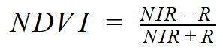

[1]

NIR: Near Infrared Band R: Red Band

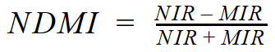

[2]

NIR: Near Infrared Band MIR: Mid Infrared Band

To get an accurate estimate of vegetation distribution and health, data were taken from the peak growing season to maximize the chance of getting an image when vegetation was fully grown. For Ajax, this period was May to September. For each year matching the orthophotos, the median NIR, R, and MIR value for the summer season were used to calculate NDVI and NDMI. The median values were chosen to ensure a cloud free image. A single image was downloaded from each year, which included bands 1-7 for Landsat 5 and bands 1-7, 10, and 11 for Landsat 8.

*2.2.2 Land Surface Temperature*

Land surface temperature (LST) was calculated from summer 2016 median temperature using Landsat 8 TIRS data. These data were processed through Google Earth Engine. To find LST, top of the atmosphere radiance values were converted to top of the atmosphere brightness temperatures (Eq. 3) and then to land surface temperatures (Eq. 4).

[3] $BT=\frac{K_{2}}{\ln\left(\frac{K_{1}}{L_{λ}}+1\right)}-273.15$

*BT* : Brightness Temperature, *K1* : Thermal Conversion Constant

*K2* : Thermal Conversion Constant *Lλ* :Top of Atmosphere Radiance

[4] $LST=\frac{BT}{1+\left(\frac{λBT}{ρ}\right)*ln⁡(ε_{λ})}$

*LST* : Land Surface Temperature *BT* : Brightness Temperature

*ελ* : emissivity *λ:* wavelength

*ρ :* 1.438 x 10-2

*2.2.3 Daymet Climate Variables*

Daily Daymet data were aggregated to the monthly scale within Google Earth Engine. This was done for every month from 2000 to 2016. Eight variables were examined: average maximum temperature, average minimum temperature, number of days below -10°C, number of days above 30°C, total precipitation, and number of days with precipitation above 30 mm. These variables were chosen because they appeared in the SENES report. For temperature variables, the average value for each month was extracted, while for precipitation variables, the monthly sum was used.

*2.2.4 Tree Percent Cover, Broad Land Cover Classification, and Random Forest Models*

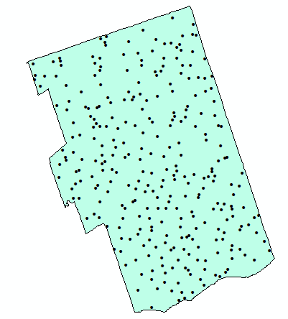To represent the area of Ajax, 300 evenly distributed training pixels were randomly selected (Fig. 2). Each point represented the center of a 30m Landsat pixel. Next, a five by five grid was lain across the pixel and underlain with high resolution ortho-imagery. For each orthophoto pixel, the team visually inspected the grid of 25 squares to estimate tree cover percentage. Tree cover percentage for the 300 pixels was calculated by counting the number of pixels (out of 25) that were at least 75% tree. The overall land cover type within the 25 pixels was also recorded for each of the 300 pixels.

For the next step, the team used a random forest regression model. Random forest models use variables as predictors in a decision tree system. Multiple decision trees are produced by testing various inputs against a known outcome to produce a forest of potential decision trees. When new data are put into the random forest model, the model tests all the trees and averages the results together to produce one output. The team chose to use random forest for this step because of its ability to consider many combinations of variables while formulating an output.

Figure 2 - This is the location of the 300 training pixels that were manually classified from orthophotos and used to estimate the tree cover percentage and land cover classification over all of Ajax.

A random forest regression was run using the percent tree data with the derived NDVI and NDMI as inputs. The result was an interpolation of tree cover percentage over the Landsat pixels within Ajax for each of the 8 years for which orthophoto imagery was available. To verify the model, half the control points were used to train the model, while the other half was used to test the model. The method explained an average of 58.9% of the variance in NDMI and NDVI.

Random forest classification, which differs from random forest regression only in the fact that the method uses the most common result, instead of averaging all results, was used to do a broad landcover classification. The visually determined land cover classification for the 300 points were used as the predictors, while the same Landsat data were used as determinates. The result was a land cover classification over all Landsat pixels in Ajax for each of the eight years that orthophoto imagery was available. Figure 4 shows the change in land cover classification for all of Ajax over the study period.

**Figure 3** - The color gradient shows the tree percentage for 2016. The points on top of the raster overlay the 1,480 pixels that showed no tree cover percentage change 2002-2016.

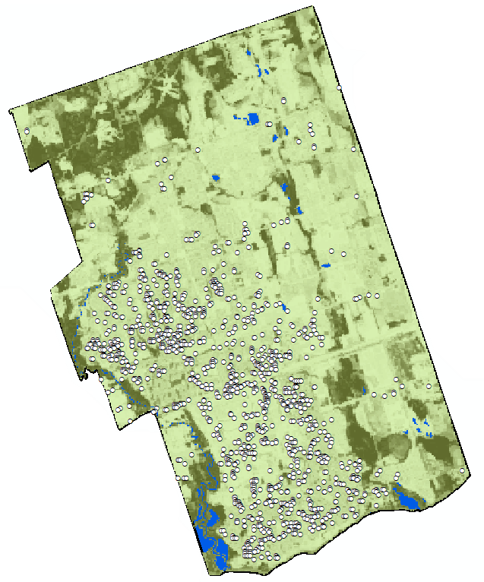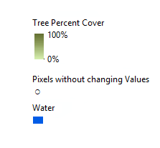

After the tree cover percentage was calculated for all of Ajax, a filtering method was used to remove pixels that changed land cover classification or changed more than 10% in tree cover percentage during the study time period. This meant that any change in NDVI during analysis will be representative of tree health change due to natural phenomena, not from change in the canopy coverage. Out of roughly 98,000 pixels, only 1,480 pixels were found to have not changed over time (Fig. 3).

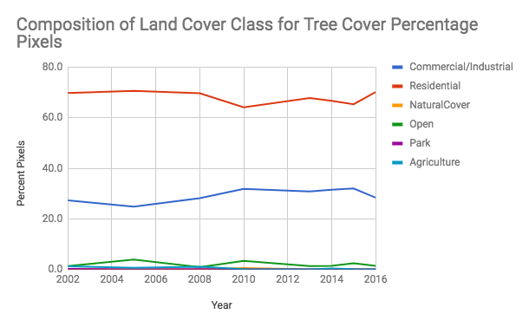*2.2.5 Detailed Land Cover Classification*

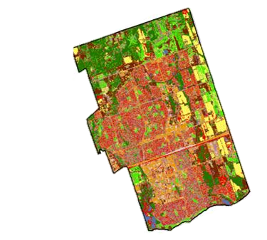A more detailed landcover classification was produced for 2016 using high resolution PlanetScope imagery. A supervised land cover classification was processed in order to understand and visualize the various land areas in Ajax. Eight land cover classes were assigned: water, developed, barren, forest, residential, streets/parking, planted/cultivated (agricultural), and greenspace. In order to assess the accuracy of this map, 504 stratified random points (points that are proportional to the area that the class covers) were generated. These points were then analyzed for their accuracy through ground truthing.

Figure 4- shows composition of landcover classes of filtered pixels

*2.2.6 Social vulnerability Index*

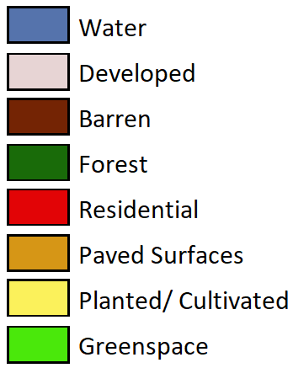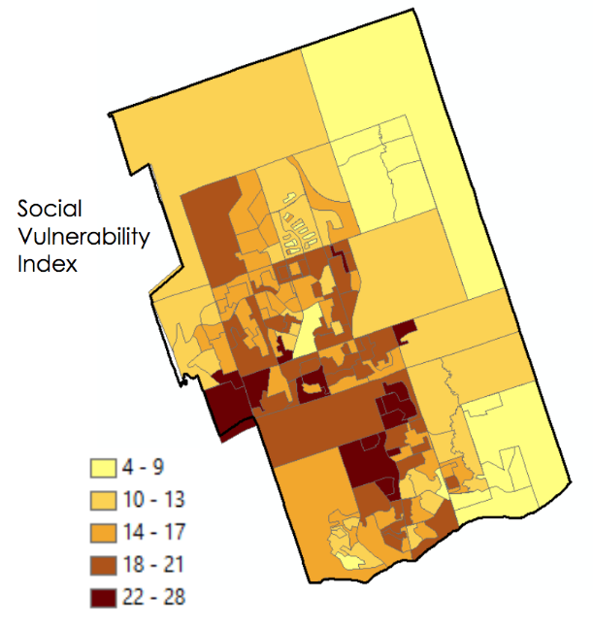Using the 2016 Canadian Census the team generated a social vulnerability index for Ajax. The variables aggregated to calculate this index included median household income, unemployment, age, immigrants with the last 5 years, and marital status data for each ‘dissemination area’. For each variable, every dissemination area was assigned a ‘rank’. The rank was created by sorting the data for that variable in ascending order, dividing it into 20% intervals, and assigning a rank of 1 to 5, where rank 5 indicated highest vulnerability and rank 1 indicated lowest vulnerability. For example, dissemination areas with the highest 20% average household income were assigned a rank of 1 for that variable, whereas areas with the lowest 20% average household income were assigned a rank of 5. On the other hand, areas with the highest unemployment were assigned a rank of 5, while those with lowest unemployment were given a rank of 1. The ranks were then summed over all five variables, and displayed spatially (Fig. 5).

Figure 5 – High resolution Landcover Classification

***2.3 Data analysis***

*2.3.1 Constant Tree Percent Cover Pixel Analysis*

In order to understand how Ajax may be impacted by future climatic changes, the team analyzed the historical relationship between NDVI values and climate variables within Ajax. To determine how the two related, the team tried several methods The first method was analyzing how NDVI changed while tree cover percentage remained constant.

Figure 6- The Social Vulnerability Index within Ajax, ON. The lower the value, the less vulnerable the population

To analyze this relationship using the monthly climate variables mentioned previously (Section 2.2.3), the team compared the median summer NDVI to climate variables from the preceding 16 months at the pixels that did not change in tree percentage or land classification from 2002 to 2016. The purpose behind this decision was to minimize the impact of trees’ input into NDVI, and to keep as many variables constant as possible.

A linear regression was run on the 1480 pixels, creating a model for the relationship between the climate variables and NDVI for each individual pixel. There were 128 individual regressions, one for each climate variable, culminating in over 189,000 total regressions. The result produced by this analysis included an R-squared value for each pixel for each climate variable. The R-squared values were averaged spatially to get one overall R-squared value for each climate variable. This value was used to evaluate which climate variables the model performed best for, and so which climate variables most consistently related to NDVI. The results of this method resulted in very low R-squared values (Table 1), indicating that there was an extremely weak relationship between the variables and NDVI.

Table 1: These are the four variables that had the largest coefficient of determination for the pixels with no change in tree percentage. For example, these results say that the change in number of days below -10°C in the previous year’s December explains 7 percent of the change in NDVI for the time frame.

|  |  |
| --- | --- |
| Variable | R2 |
| Previous December, Number of Days that Minimum Temperature is < -10 °C | 0.07 |
| Previous February, Number of days precipitation was above 30 mm | 0.06 |
| Total Monthly Precipitation of the Previous October | 0.05 |
| Total Monthly Precipitation of the Previous July | 0.05 |

This method produced low R-squared values because a large percent of the pixels that did not change were found in residential areas. Residential areas do not have a high tree cover percentage, making it difficult to observe vegetation using Landsat. Additionally, residential areas manage trees, reducing the impacts of weather. Based on these results, the team chose to try a different method to analyze the correlation between climate and NDVI.

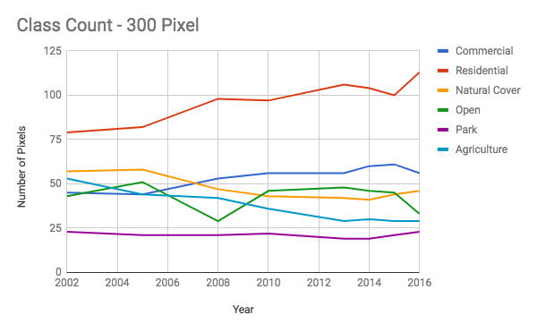*2.3.2 Evenly Distributed Training Pixel Analysis*

The team then chose to return to the 300 training pixels that were evenly but randomly distributed across Ajax (Fig 2). This method provided pixels that were more spatially spread out and belong to a more diverse percentage of land cover types (Fig 7).

Out of the 300 training pixels, the team selected the pixels that had a tree percent greater than zero for all eight years that orthophotos were available for use in the regression. A total of 139 pixels met this criterion.

Figure 7- The count of pixels in each land cover land use class for the study time frame for the 300 training pixels.

The same methods described in the previous section were used except these 139 pixels were used for the analysis. The R-squared values that resulted from this method were much higher, with six climate variables that had R-squared values of 0.40-0.48 (Table 2).

The two variables with the highest R-squared value (precipitation from the previous May and maximum from the previous July) were selected and a multivariate regression was used to examine how well these variables predicted NDVI values. The resulting R-squared values were averaged spatially to get a value of 0.57.

**Table 2:** These are the climatic variables that had an R2 value of .3 or higher for the 139 pixels taken from the training pixels. These are reasonable R2 values for natural systems, particularly the 6 variables that are .4 or higher.

|  |  |  |  |
| --- | --- | --- | --- |
| **Variable** | **Month** | **Year** | **R2** |
| Precipitation (mm) | May | Previous | 0.48 |
| Temperature Maximum (°C) | July | Previous | 0.44 |
| Number days over 30 mm Precipitation | April | Previous | 0.44 |
| Temperature Minimum (°C) | April | Current | 0.41 |
| Temperature Maximum (°C) | April | Current | 0.41 |
| Precipitation (mm) | March | Previous | 0.40 |
| Temperature Maximum (°C) | May | Previous | 0.39 |
| Temperature Minimum (°C) | April | Previous | 0.39 |
| Temperature Minimum (°C) | May | Previous | 0.36 |
| Number of days over 30 °C | July | Previous | 0.35 |
| Temperature Minimum (°C) | July | Previous | 0.31 |
| Temperature Minimum (°C) | June | Previous | 0.30 |
| Temperature Minimum (°C) | November | Previous | 0.30 |
| Temperature Maximum (°C) | March | Current | 0.30 |

# 3. Results and discussion

***3.1 NDVI Sensitivity to Climatic Variables***

*3.1.1 Comparison between the two methods*

A comparison between Figure 2 and Figure 6 clearly shows the difference in land cover type between the two methods. In the pixels used in Method 1, residential land covers70% of the total pixels and commercial/industrial covers 20% of the pixels, which leaves only 10% for the other four land cover types. Residential and commercial/industrial areas inherently generally have lower vegetation (compared land cover categories like forest or grass) and are usually managed by the community. Coarser spatial resolution imagery (Landsat 8) showed that residential and commercial/industrial areas, on average, do have a lower NDVI compared to natural cover, open space, and parks. The vegetation present in residential areas tends to be maintained throughout the year; trees are watered and pruned regularly. In managed areas, resources like water are allocated to urban trees, thus these areas do not show a strong relationship with natural events such as drought. The urban heat island effect is known to keep cities a couple of degrees warmer than surrounding areas during the winter, so urban trees are more resistant to cold winters. This can explain why the model did not show correlation among pixels in the more managed residential/urban areas. The low R-squared values generated by this method (Table 1) did not provide any information about which climate variables are related to NDVI. However, the values do show that vegetation in residential areas is less sensitive to climatic changes.

The pixels used in Method 2 show a more even representation of classes. Residential land accounts for around 33% of pixels and the other classes each account for around 17%. This method means the classes natural cover, open space, agriculture, and parks are much better represented in the regression analysis. The R-squared values generated by the second method are much larger and much more significant (Table 2). The climate variable with the highest R-squared value (0.48) was precipitation from the previous May. Meaning fluctuations in precipitation from the previous May usually result in fluctuations in the NDVI signal the following summer.

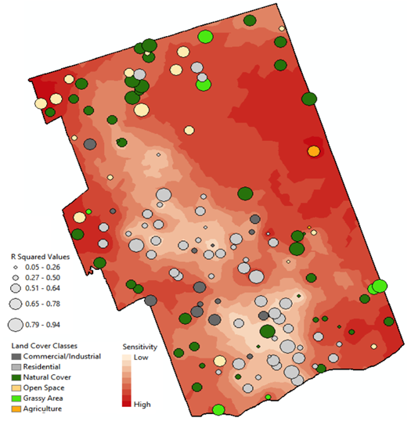*3.1.2 Spatial Analysis*

Of the variables that had an R-squared value of 0.3 or higher, it is clear that the NDVI values were primarily influenced by climatic variables from the previous spring and early summer (Table 2). Previous literature has shown that trees have a delayed response to extreme climate events such as drought, flooding, or a change in predominate wind flow (Hogg et al., 2002, Kling et al., 2004, Nitschke et al., 2017).

The two variables that explained NDVI best were precipitation from the previous May (R2= 0.48) and maximum temperature from the previous July (R2 = 0.44). A high R-squared value indicated that NDVI reliably corresponded to these variables, but not that changes in either variable resulted in large changes to the NDVI. That information can be gained from the correlation coefficient (R). Therefore, in order to understand these relationships in Ajax, the correlation coefficients also needed to be considered. The team examined the distribution of the R-squared values and the correlation coefficients spatially and for each land cover type (Fig 8).

Figure 8 - The gradient underneath represents the sensitivity of NDVI to the change in precipitation of the previous May. This is interpolated from value of the correlation coefficient returned by the model for each pixel. Each dot is for one of the 139 pixels. The size of the dot represents the R-squared value, shows how well the model performed in certain areas of Ajax. The land cover of each pixel is represented by the color of each dot.

Most occurrences of low R-squared values, appeared in either residential or commercial/industrial areas, which supported the earlier observations. Natural cover generally is composed of mostly vegetation and, therefore, has more consistently large R values.

Residential and commercial/industrial pixels also had a low sensitivity. While the sensitivity of other land cover classes is variable, open space was much more likely to have a higher sensitivity than the residential and commercial/industrial pixels.

A negative coefficient indicates a negative correlation, which means as the climatic variable increases, the NDVI decreases. A positive coefficient indicates a positive correlation, which means that as the climatic variable increases the NDVI also increases. The absolute value of the coefficient indicates the degree to which NDVI is sensitive to the climatic variable – the larger the coefficient, the more NDVI changes in response to a change in the climatic variable. Fig. 7 does not identify if the coefficient was negative or positive for the sensitivity analysis, it indicates the absolute value of the correlation.

As the management of vegetation within the downtown and more urban areas seems to work well, a focus in the future may be to develop management plans for trees in the more rural parts of Ajax, as these trees do seem to be impacted by natural climatic factors and could be impacted by future climate change. Significant decrease of the forest in these areas would affect all of Ajax, including the downtown area.

*3.1.2 Vulnerable areas in Ajax, ON*

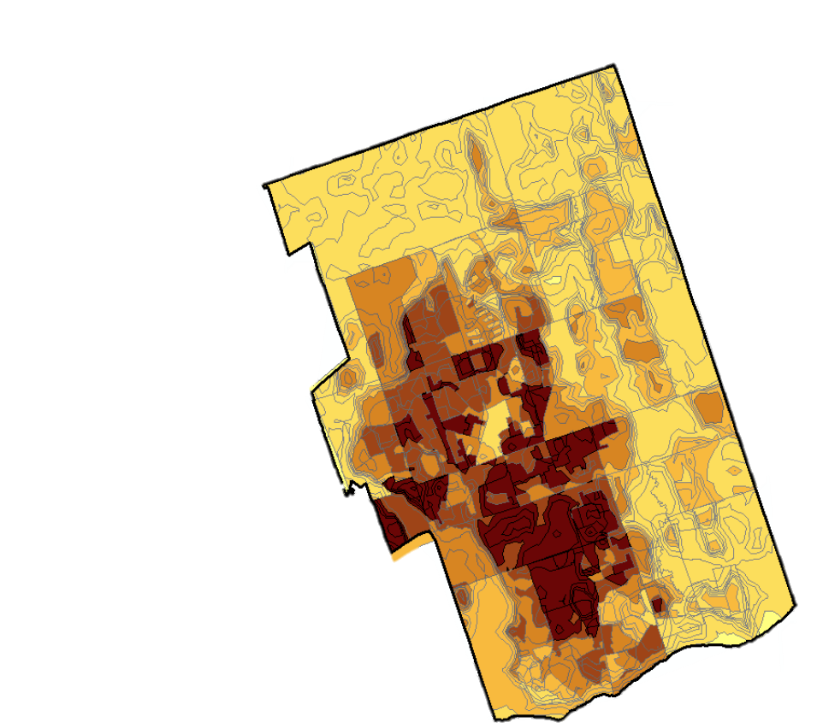In order to highlight areas that are more vulnerable to extreme heat events, the social vulnerability index results were compared with average LST summer values in Ajax (Fig. 8). This was done using ArcMap’s intersect tool.

The contours show that warmer land surface temperatures are found near Ajax’s urban areas, with cooler temperatures to the north of Ajax. Since the most vulnerable populations are often found within urban areas, this map highlights the area that is most vulnerable to future extreme heat events.

These areas are where extreme heat events may have the most impact because of the already high LST and because of the direct effect on human health (ex: heat stroke) of vulnerable populations. In order to mitigate these effects, one of Ajax’s priorities may be to increase urban forest in these downtown areas where possible.

*3.1.3 Potential Errors and Uncertainties*

**Figure 9**- A map of 2016 LST overlain with 2016 Social Vulnerability Index. The darker colors indicate areas where the community and the trees present are more vulnerable, particularly to the effects of extreme heat

The spatial and temporal sample size of this study was rather small. In the second, more successful method, only 139 pixels were used to represent Ajax, ON as a whole. Since only years with corresponding orthophotos were used, only eight years were analyzed. The temporal aspect is not only small, but also not continuous.

Table 2 includes variables tallying the number of days above or below an extreme threshold. These variables were created from variables gathered directly from Daymet, i.e. precipitation, maximum and minimum temperature. Using codependent variables as independent variables in a regression will introduce some error when not quantitatively accounting for variable codependences.

While LST was used for the vulnerable areas map, LST is not the best measure for interpreting human thermal comfort, which is a more important variable to determine heat vulnerability in populations. Air temperature is used in determining thermal comfort. The relationship between surface temperature and air temperature, although not linear and simple, is proportional when synoptic influences are negligent (Shigeto K et. al., 2000). Warmer surfaces will yield, on average, warmer air temperatures. Since the relationship is not quantified in this study, no quantifiable results or conclusions can be made. However, the overall trend should be reliable.

***3.2 Future Work***

# There are many avenues to pursue that would shed further light on this issue. The incorporation of additional climatic variables is one. Vapor pressure would explain soil moisture fluctuations and might be seen in tree health measures. Another possibility would be to incorporate variables that are non-climatic. For example, there may be a relationship between salting of roads in winter and tree health the following summer.

# Imagery with higher spatial resolution would be helpful in a number of ways. Higher resolution imagery could allow distinguishing of different vegetation types in an area. Since NDVI signals are slightly different for different species, this could illuminate any patterns among species. Additional historical imagery with resolution similar to the orthophotos would allow more sample years to be included in the analysis. Overall, it would lead to more accurate results that explain tree health with greater confidence instead of results that are susceptible to the influence of other factors (like species difference). Another benefit of higher spatial resolution would be that our regression could explain more about tree health instead of results that are susceptible to influence of other vegetation signals besides trees. Grass was shown to fluctuate more dramatically and faster than trees. This could have influenced the results from this study.

# In order to improve the temporal resolution issue, sub-pixel analysis could be run on the existing dataset. Picking apart various band ratios within each pixel could identify a certain spectra response that trees emit. Discovering this could lead to a better estimate of percent tree cover that could be used for years without orthophotos.

# 

# To provide Ajax with more detailed advice of tree placement, in which could also be combined with the results of the social vulnerability analysis, a microclimate study of how various spatial arrangements of trees impact air temperature could be an interesting study. This could be done using a microclimate modeling software such as ENVI-MET.

# Since changes in NDVI in residential areas were not explained by climate variables, investigating NDVI fluctuations in residential areas would require data related to human activities for keeping vegetation maintained in an urban landscape. Various motivations are behind keeping a yard healthy or letting it die off, and finding those motivations and relating the fluctuations in those motivations to the fluctuations in NDVI of the residential areas could yield some interesting results.

# 4. Conclusions

# In residential areas, NDVI values did not correlate with climatic variables. This can be attributed to the upkeep of vegetation in residential areas. To investigate the relationship between NDVI and climatic variables, the pixels used in the analysis need to be evenly obtained from all land cover classes. If the pixels are mostly residential or commercial/industrial, any relationship will be obscured.

# In method 2, in which a variety of land cover classes were incorporated, the climate variables that best explained NDVI values tended to be variables from the spring and early summer of the previous year. The two variables with the largest R-squared values were precipitation from May of the previous year and the maximum air temperature from the previous July. Spatially, areas outside of the main urban environment showed higher R-squared values and higher sensitivity.

# After examining factors that included LST and social vulnerability, the most vulnerable areas in Ajax are the center and western part of the downtown urban area. This is where communities composed of more vulnerable people are located. Potential avenues Ajax may want to explore in the future include increasing the amount of trees within the downtown area and looking into management practices that could be extended to keep the trees healthy that are already present in the more rural areas of Ajax.

# Abbreviations

**UHI** - Urban Heat Island

**GLR** - Great Lake Region

# Acknowledgments

The authors would like to thank:

Dr. David Hondula, Arizona State University, DEVELOP Arizona Advisor

Dr. Qunshan Zhao, Arizona State University, DEVELOP Arizona Advisor

Dr. Peter Crank, Arizona State University, Climate Research Center Lead

Dr. Kenton Ross, National Science Advisor, DEVELOP National Project

Office

Lance Watkins, DEVELOP Arizona Center Lead

Any opinions, findings, and conclusions or recommendations expressed in this material are those of the author(s) and do not necessarily reflect the views of the National Aeronautics and Space Administration.

This material is based upon work supported by NASA through contract NNL16AA05C and cooperative agreement NNX14AB60A.

# References

Adger, W.N., 2006. Vulnerability. Global Environmental Change 16, 268-281. Available at <https://doi.org/10.1016/j.gloenvcha.2006.02.006>.

Bonan, G. B., 2008. Forests and climate change: Forcings, feedbacks, and the climate benefits of forests. Science 320, 1444-1449.

Broadmeadow, M.S.J., Jackson, S.B., 2000. Growth responses of *Quercus petraea*, *Fraxinus excelsior* and *Pinus sylvestris* to elevated carbon dioxide, ozone and to elevated carbon dioxide, ozone and water supply. New Phytology 146, 437–451.

Cutter, S. L., Boruff, B. J., Shirley, W. L., 2003. Social Vulnerability to Environmental Hazards. Social Science Quarterly 84, 242–261. Available at <https://doi.org/10.1111/1540-6237.8402002>.

Durham Region Roundtable on Climate Change, 2016. *Towards Resilience: Durham Community Climate Adaptation Plan 2016*. Durham, NC: Durham Region Roundtable on Climate Change.

Eamus, D., Boulain, N., Cleverly, J. and Breshears, D. D., 2013. Global change-type drought-induced tree mortality: Vapor pressure deficit is more important than temperature per se in causing decline in tree health. Ecology and Evolution 3, 2711-2729.

Hogg, E.H., Brandt, J.P. and Kochtubajda, B. (2002). Growth and dieback of Aspen forests in northwestern Alberta, Canada, in relation to climate and insects. Canadian Journal of Forest Research-Revue Canadienne De Recherche Forestiere 32, 823-832.

Kling, G.W., Hayhoe, K., Johnson, L.B., Magnuson, J.J., Polasky, S., Robinson, S.K., Shuter, B.J., Wander, M.M., Wuebbles, D.J., Zak, D.R., Lindroth, R.L., Moser, S.C. and Wilson, M.L., 2003. *Confronting climate change in the Great Lakes region: Impacts on our communities and ecosystems*. Cambridge,MA: Union of Concerned Scientists and Washington, DC: Ecological Society of America.

Minnich, R. A., 2007. Southern California conifer forests. Terrestrial Vegetation of California, 502-538.

Nitschke, C. R., Nichols, S., Allen, K., Dobbs, C., Livesley, S. J., Baker, P. J. and Lynch, Y., 2017. The influence of climate and drought on urban tree growth in southeast Australia and the implications for future growth under climate change. Landscape and Urban Planning 167, 275-287.

Tan, K., Liao, Z., Du, P. and Wu, L., 2017. Land surface temperature retrieval from Landsat 8 data and validation with geosensor network. Frontiers in Earth Science 11,20. Available at <https://doi.org/10.1007/s11707-016-0570-7>.

SENES Consultants, 2014. Durham Region’s Future Climates (2040 – 2049) SUMMARY.

Wilhelmi, O.V. and Hayden M.H., 2010. Connecting people and place: a new framework for reducing urban vulnerability to extreme heat. Environmental Research Letters 5, 014021. Available at <https://doi.org/10.1088/1748-9326/5/1/014021>.

Xiao, Q. and McPherson, E. G., 2005. Tree health mapping with multispectral remote sensing data at UC Davis, California. Urban Ecosystems 8, 349-361.

Zhao, Q., Wentz, E. A. and Murray, A. T., 2017. Tree shade coverage optimization in an urban residential environment. Building and Environment 115, 269–280. Available at <https://doi.org/10.1016/j.buildenv.2017.01.036>.

Zhao, Q. and Wentz, E. A., 2016. A MODIS/ASTER Airborne Simulator (MASTER) Imagery for Urban Heat Island Research. Data 1, 7. Available at <https://doi.org/10.3390/data1010007> .

U.S. Geological Survey Earth Resources Observation and Science Center. 2000-2010. Provisional Landsat TM Surface Reflectance. US Geological Survey. <https://doi.org/10.5066/F7KD1VZ9>

U.S. Geological Survey Earth Resources Observation and Science Center. 2013-2016. Provisional Landsat OLI Surface Reflectance. US Geological Survey. <https://doi.org/10.5066/F7KD1VZ9>