**NASA DEVELOP National Program**



University of Georgia

*Summer 2015*

Ocmulgee Ecological Forecasting II

Utilizing NASA’s Earth Observations for Forecasting Land Use Change and Wildlife Disturbances along the Ocmulgee River Corridor

**Technical Report** 

Final Draft – August 6, 2015

Christopher Cameron (Project Lead)

Andrew Herring

Ayn Remillard

Zhan Shi

Dr. Thomas Jordan, University of Georgia - Center for Geospatial Research (Science Advisor)

Dr. Marguerite Madden, University of Georgia - Center for Geospatial Research (Science Advisor)

Previous Contributors:

Peter Hawman

Gail Miller

Caren Remillard

Simmone Simpson

Steve Padgett-Vasquez

# I. Abstract

The Ocmulgee River corridor is home to unique species such as Atlantic sturgeon, short nosed sturgeon, black bear, and millions of migratory birds. It also holds a rich archeological record of Native American settlement. Over the years, this area has experienced increasing urbanization pressure. The NASA DEVELOP Ocmulgee River Water Resources and Ecological Forecasting team partnered with the Georgia Department of Natural Resources (GA DNR) to conduct a project focused on conserving the Ocmulgee River corridor. The goal of this project was to analyze land cover trends over the past 15 years using National Land Cover Dataset (NLCD) classifications and recent Landsat 8 images to predict future changes within the Ocmulgee River valley. With this goal in mind, a current land cover map was created and the team performed a time-series analysis. Threatened and endangered species habitats and hydrologic characteristics were overlaid with the classification maps to identify areas of concern. Using the results of this project, the GA DNR will be able to prioritize conservation of high risk areas and identify areas of future concern.

**Keywords**

Conservation, Land Cover Change, Ecological Forecasting, Ocmulgee River, Endangered Species

# II. Introduction

**Objectives:**

The objective of this project was to utilize NASA Earth observations to support wildlife resource management with a focus on endangered species and increasing urbanization trends in the Ocmulgee River valley of central Georgia. The team utilized the results of a time series analysis for the years 2001 to 2014 to analyze the effects of changing environmental conditions on wildlife in the Ocmulgee River valley. The time series analysis combined with historic land cover datasets were used to forecast future ecological conditions within the corridor. These ecological forecasts will inform state conservation plans regarding threats to endangered species and at-risk habitats from urban encroachment.

**Background:**

The Ocmulgee River provides services such as ecological habitats, recreational resources, and a supply of fresh water for drinking and irrigation. The Ocmulgee River valley is also home to many historical sites. In the Georgia 2005 Wildlife Action Plan, the Ocmulgee corridor was defined as a high-priority landscape feature. The corridor was also identified as one of six priority land conservation areas by the Department of Natural Resources due to increasing urbanization pressure. The Ocmulgee River corridor consists of bottomland hardwood swamps and other natural communities that support important plant and animal populations. The corridor also serves as an important flyway habitat to millions of migratory birds, is home to the Central Georgia black bear, and contains several archeological sites of pre-contact Native American history.

**Study Area:**

Located in the heart of Georgia’s Coastal Plain region, the head waters of the Ocmulgee River begin near the Lake Jackson reservoir (south of Atlanta). The river flows southeast for nearly 290 kilometers before joining the Oconee River to form the Altamaha River, which feeds directly into the Atlantic Ocean (Figure 1). Macon, located on Georgia’s fall line, is the primary urban center near the Ocmulgee River. This study focused on the portions of the Ocmulgee watershed (as defined by the United States Geological Survey (USGS) Hydrologic Unit Code (HUC) system) which fall within 40 kilometers of the river itself, resulting in a total study area of approximately 11468 km2,with 5444 km2 corresponding to the Upper Ocmulgee and 6024 km2 corresponding to the Lower Ocmulgee.

**Study Period:**

This project used historical data from the National Land Cover Dataset (NLCD) for the years 2001, 2006, and 2011, and data from the United States Department of Agriculture (USDA) CropScape Cropland Data Layer (CDL) service for the years 2008 to 2014. The year 2001 was chosen as the starting date for this project due to the NLCD using a different classification system prior to that time (Homer, 2007). Through the use of recent Landsat 8 imagery, the timeline for this study was extended to 2014.

**National Application Area Addressed:**

This project addressed the Ecological Forecasting and Water Resources application areas. The team’s goal was to provide reliable ecological forecasts that will be used to help decision makers at the Georgia Department of Natural Resources (GA DNR) predict and manage the impacts of environmental change on the Ocmulgee River Valley.

**Project Partners:**

The Ocmulgee Ecological Forecasting team partnered with the Georgia Department of Natural Resources to support their wildlife management and conservation goals. The GA DNR uses numerous decision-making tools to conserve state-owned and operated properties. Some of the GA DNR’s management techniques include the use of statistical and spatial analysis, fish stocking, and prescribed burns. The GA DNR combines field-based assessments with remotely- sensed data to support management decisions. Currently utilized datasets include: *in situ* water quality measurements, rare species inventories, digital aerial photography, Light Detection And Ranging (LiDAR), side imaging SOund Navigation And Ranging (SONAR), and digital elevation models (DEMs). Integrating their current resources with this study’s results served to update and enhance the GA DNR’s assessments of the Ocmulgee region. The GA DNR has personnel trained in GIS and remote sensing who will be able to utilize the tools and products resulting from this DEVELOP project.

# III. Methodology

**Land Cover Classification**

**Data Acquisition:**

Landsat images were acquired from the USGS Global Visualization Viewer website. The 2014 satellite imagery was collected by the Operational Land Imager (OLI) on-board Landsat 8 during April, May, and November. The historical data used for the 2001, 2006, and 2011 NLCD were derived from Landsat 5 Thematic Mapper (TM) and Landsat 7 Enhanced Thematic Mapper Plus (ETM+).

Ancillary datasets used for this project included: United States Department of Agriculture (USDA) CropScape land cover data, Environmental Protection Agency (EPA) 303d for impaired waters, EPA National Pollutant Discharge Elimination System (NPDES) for point-source pollution, GA DNR 2012 Side Scan SONAR for image data and Ocmulgee River substrate layers, GA DNR Index of Biotic Integrity for fish sample data, GA DNR long-term sport fish monitoring data for fish populations, and GA DNR parcel data for land ownership.

**Data Processing:**

Landsat 8 satellite imagery was downloaded as Level 1 GeoTIFF Data Products and was processed using ArcGIS 10.2 and ENVI 5.0. To correct the images for interference from background values, a mask file was created using ArcGIS to eliminate the uneven overlap of bands along the edges of the image. Atmospheric correction of the Landsat 8 imagery was required to accurately extract pixel values and data. The team utilized the ENVI Quick Atmospheric Correction (QUAC) algorithm to process the satellite imagery. QUAC establishes parameters for correction directly from the observed pixel spectra within a scene without ancillary information. QUAC is based on empirical findings that the average reflectance of spectra is not dependent on each individual scene and it works for the visible near-infrared through shortwave infrared (VNIR-SWIR) wavelength range (Bernstein, 2005).

**Data Analysis:**

The 2014 Landsat images were classified using the NLCD’s 2011 land cover criteria. This method of land cover classification and designation is based on the Anderson Land Cover Classification System (Homer, 2012). The following 15 NLCD land cover classes, present in table 1, apply to Central Georgia. The unsupervised classification used in the first term of this project proved too broad for the needs of our project partners, specifically with respect to projecting urban development and encroachment areas. The land cover classification was updated in ENVI 5.0 using a supervised classification method consisting of three main stages: training, classification, and output (Lillesand, 2008, p.547).

The training stage consists of the analyst identifying and defining homogeneous pixels or regions of interest (ROIs) in order to develop a numerical description of the spectral attributes of each land cover type of interest within the scene (Bhaskaran, 2010). Training samples from the same class category may possess different spectral characteristics and it is necessary to sample a wide variety of applicable pixels during the training stage. This project used 30-meter resolution Landsat imagery to develop training sets through visual interpretation of the land use and land cover characteristics. The NLCD maps from 2001, 2006, 2011, and USDA CDL maps from 2014 were used as reference when identifying ROIs to build the training sets.

During the classification stage each pixel in the image data set was categorized based on its comparison to the mean of the signatures derived from the training set. Classification in ENVI is specialized by using one or a combination of the following 4 algorithms: Maximum Likelihood, Minimum Distance, Mahalanobis Distance, and Spectral Angle Mapper (Lillesand, 2008, p.550-557). The Maximum Likelihood (MLC) and Minimum Distance (MDC) algorithms were primarily utilized in this study. Maximum Likelihood is the most widely used algorithm for per-pixel classification with remote sensing data (Harvey, 2002). Maximum Likelihood classification quantitatively evaluates both the variance and covariance of each class’s spectral response patterns. Lillesand notes that MLC assumes that the distribution of the groups of pixels forming the category within the training data is Gaussian (normally distributed). New pixel values are then assigned to the class with the highest probability of generating a given pixel (Lillesand, 2008, p.554-556). The Minimum Distance technique computes the mean pixel vector of the “feature” class, and then assigns new pixels to the “feature” class based on the Euclidean distance from that pixel to the mean (Richards, 1999; ENVI, 2015). For the multiclass case, such as this study, pixels are assigned to the feature whose mean value is the minimum distance from the pixel (Harvey, 2002). The classification results were then mosaicked together in ArcGIS 10.2. A mosaic creates a single raster dataset from multiple raster datasets to optimize final product accuracy and minimize visual inconsistencies.

**Ecological Modeling and Forecasting**

**Data Acquisition:**

The team used the 2014 land cover mosaic and historical NLCD data for 2001, 2006, and 2011. Ancillary data used for ecological modeling and forecasting included, GA DNR plant, animal, and fish survey data for rare and endangered species habitats, and highway and expressways shapefiles for the state of Georgia.

**Data Processing:**

NLD data from 2001, 2006, and 2011 was imported into ArcGIS. The land cover data was aggregated into four broad classes: developed, agriculture, vegetation, and open water. The 2014 mosaic was also aggregated in to the same four classes. Land cover change detection for the aggregated 2001, 2006, 2011, and 2014 data sets was performed using the ArcGIS Combine tool for raster analysis. Land cover changes were organized in time periods, corresponding to source data years, as follows: 2001 to 2006, 2006 to 2011, 2011 to 2014, and 2001 to 2014.

Based on habitat size and ecological observation data provided by GA DNR, the reptile, amphibian, and vascular plant communities appeared to cover the largest portions of the study area. The relation of these three habitats to impacts from urban encroachment was analyzed through distance calculations. Specifically, the team first calculated the impact that highways and expressways had on the ecological communities. This was done in ArcGIS by using the Euclidean Distance tool for the highways and expressways within the Ocmulgee River corridor. The results were clipped to the desired ecological habitats using the Raster Calculator tool within ArcGIS. A second map was generated to show the proximity of developed areas to known rare ecological habitats and existing GA DNR properties. Additionally, the team created a third impact map in ArcGIS showing the ecological habitats present in relation to a reclassified raster of distance from mapped urban areas as well as distance to the GA DNR Wildlife Management Sites. The development risk impact map was created in ArcGIS by using the reclassified raster to calculate the Euclidean distance of ecological habitats to the developed areas, and the GA DNR wildlife management sites were then overlaid on top of the resulting raster.

**Data Analysis:**

Aggregated land cover change trends were quantified to determine the total change in land cover for a given time period. Changes in land cover were further partitioned by land cover class. All land cover changes were converted to percent values in order to rank classes as more or less contributing to observed trends.

# IV. Results & Discussion

**Land Cover Classification:**

The supervised 2014 land cover classification results (Figure 2) indicated several changes in land cover in the Ocmulgee River valley since 2011. The most apparent changes were summarized as area and percent land cover changes (Table 1, 2, and 3). The change in total land cover area and among aggregated land cover classes was summarized as percent values for the entire study area (Figure 7, 8, 9, and 10).

Classification errors occurred from data limitations and possible misinterpretation of the imagery. The 30-meter resolution of the Landsat 8 imagery is coarse enough to represent the heterogeneous land cover, but not detailed enough to capture the desired classification in some areas. Additionally, accurate identification of specific vegetation types and urban intensity through visual and spectral analysis was difficult at this resolution. In both cases (vegetation and urban), overlapping pixel values for land cover classes reduced the overall accuracy of the results. Hand-coding of suitable feature-detection algorithms becomes impractical when pixels and algorithm parameters overlap for multiple classes (Harvey, 2002). Urban land cover is difficult to classify due to the large number of classes present in such a small area (Ridd, 2006).

**Ecological Forecasting:**

The land cover change results (Tables 1, 2, and 3) show that developed areas are increasing in size as of non-agricultural and undeveloped areas are decreasing overall. The results from (Figures 12, 13, 14, and 15) indicate that several GA DNR wildlife management areas fall within the low risk zones. Locations of additional low risk zones occur outside GA DNR’s existing properties, particularly in the Upper Ocmulgee watershed. Additionally, several high-risk areas are located near mapped urban areas and fall well within ecological habitat zones (Figure 12 and 13). Fragmentation of habitats by road networks also reveals that many of the larger ecological habitats are increasingly fragmented in the central portion of the study area (Figure 14 and 15).

# V. Conclusions

The supervised classification proved to have greater accuracy and correct feature detection over the unsupervised classification when compared to historical data. Using multitemporal imagery allowed for better classification of land classes (Yuan et al., 2005). However, the advantage of any technique over another with respect to classification accuracy depends upon the biophysical state of the study area (Eiumnoh, 2000). Several previous studies have confirmed the use of supervised classification by MLC for urban areas as the most appropriate method (Eiumnoh, 2000; Shalaby and Tateishi, 2007; Thapa and Murayama, 2009).

In the future, a combined spectral and spatial approach may be useful to map urban features, particularly those with low spectral distinction (Bhaskaran, 2010). Future work could focus on smaller portions of the study area with higher resolution imagery to get a more accurate classification of urban features. Although project partners provided useful ground truth data for verification, the final classification could benefit from a formal accuracy assessment. It would also be beneficial to GA DNR to consider creating more wildlife management areas within the known ecological habitats present, while avoiding developed areas as well as major highways and expressways.

# VI. Acknowledgments

The Ocmulgee Ecological Forecasting team would like to acknowledge project partners, Thom Litts and Melanie Riley, from the Georgia Department of Natural Resources who provided us with valuable onsite information and ancillary data for our study area. Special thanks to our science advisors Dr. Marguerite Madden, Dr. Thomas Jordan and Dr. David Cotton of The University of Georgia Center for Geospatial Research for their continual guidance, expertise, and support.

This material is based upon work supported by NASA through contract NNL11AA00B and cooperative agreement NNX14AB60A.

# VII. References

Bernstein, L. S., S. M. Adler-Golden, R. L. Sundberg, et al, 2005. *Validation of the QUick Atmospheric Correction (QUAC) algorithm for VNIR-SWIR multi- and hyperspectral imagery*. SPIE Proceedings, Algorithms and Technologies for Multispectral, Hyperspectral, and Ultraspectral Imagery XI. Vol. 5806, pp. 668-678.

Bhaskaran, S., Paramananda, S., & Ramnarayan, M. (2010). Per-pixel and object-oriented classification methods for mapping urban features using Ikonos satellite data. *Applied Geography*, *30*(4), 650-665.

Eiumnoh, A., & Shrestha, R. P. (2000). Application of DEM data to Landsat image classification: evaluation in a tropical wet-dry landscape of Thailand.*Photogrammetric Engineering and Remote Sensing*, *66*(3), 297-304.

Harvey, N. R., Theiler, J., Brumby, S. P., Perkins, S., Szymanski, J. J., Bloch, J., & Galassi, M. (2002). Comparison of GENIE and conventional supervised classifiers for multispectral image feature extraction. *Geoscience and Remote Sensing, IEEE Transactions on*, *40*(2), 393-404.

Homer, C. H., Fry, J. A., & Barnes, C. A. (2012). The national land cover database. *US Geological Survey Fact Sheet*, *3020*(4), 1-4.

Homer, C., Dewitz, J., Fry, J., Coan, M., Hossain, N., Larson, C., & Wickham, J. (2007). Completion of the 2001 national land cover database for the conterminous United States. *Photogrammetric Engineering and Remote Sensing*, *73*(4), 337.

Lillesand, T., Keifer, R., & Chipman, J. (2008). Digital Image Interpretation and Analysis. In Remote Sensing and Image Interpretation (6th ed., p. 756). Hoboken, NJ: John Wiley & Sons.

Richards, J. A., & Jia, X. (1999). Remote sensing digital image analysis: An introduction (3rd ed.). New York, NY: Springer-Verlag

Ridd, M. (2006). Remote Sensing of Human Settlements (3rd ed., Vol. 5, p.752). Bethesda, MD.: American Society for Photogrammetry and Remote Sensing.

Shalaby, A., & Tateishi, R. (2007). Remote sensing and GIS for mapping and monitoring land cover and land-use changes in the Northwestern coastal zone of Egypt. Applied Geography, 27, 28–41.

Thapa, R. B., & Murayama, Y. (2009). Urban mapping, accuracy, & image classification: a comparison of multiple approaches in Tsukuba City. Applied Geography, 29(2009), 135–144.

USGS Global Visualization Viewer. (n.d.). Retrieved August 5, 2015.

Yuan, Fei, Sawaya, Kali E., Loeffelhoz, Brian C., Bauer, Marvin E. (2005). Land cover classification and change analysis of the Twin Cities (Minnesota) Metropolitan Area by multitemporal Landsat remote sensing. *Remote Sensing of Environment*, 98: 317-328.

# VIII. Content Innovation

Interactive Map Viewer: Land cover change maps

AudioSlides: Brief summary of project

# IV. Appendices

A1. Land cover area for all classes in the National Land Cover Dataset since 2001

|  |  |  |  |
| --- | --- | --- | --- |
|  | ***Area (km2)*** | | |
| **Land Cover Class** | **2001** | **2006** | **2011** |
| Barren Land | 54.36 | 44.38 | 47.35 |
| Cultivated Crops | 997.31 | 982.96 | 958.11 |
| Deciduous Forest | 2262.98 | 2250.19 | 2066.55 |
| Developed, High Intensity | 30.02 | 35.36 | 40.44 |
| Developed, Low Intensity | 243.48 | 281.53 | 291.42 |
| Developed, Medium Intensity | 68.01 | 83.76 | 95.26 |
| Developed, Open Space | 694.67 | 764.86 | 771.83 |
| Emergent Herbaceous Wetlands | 81.43 | 74.84 | 97.50 |
| Evergreen Forest | 2828.62 | 2728.67 | 2574.40 |
| Hay/Pasture | 1133.06 | 1096.34 | 1070.86 |
| Herbaceous | 918.91 | 871.44 | 972.12 |
| Mixed Forest | 545.80 | 515.88 | 460.79 |
| Open Water | 132.75 | 134.94 | 139.64 |
| Shrub/Scrub | 180.09 | 309.66 | 598.75 |
| Woody Wetlands | 1288.64 | 1285.32 | 1275.13 |

A2. Changes in class area within the National Land Cover Dataset since 2001

|  |  |  |  |
| --- | --- | --- | --- |
|  | ***Change in Area (km2)*** | | |
| **Land Cover Class** | **2001-06** | **2006-11** | **2001-11** |
| Barren Land | -9.98 | 2.96 | -7.02 |
| Cultivated Crops | -14.35 | -24.85 | -39.20 |
| Deciduous Forest | -12.79 | -183.64 | -196.43 |
| Developed, High Intensity | 5.35 | 5.07 | 10.42 |
| Developed, Low Intensity | 38.05 | 9.89 | 47.94 |
| Developed, Medium Intensity | 15.75 | 11.50 | 27.25 |
| Developed, Open Space | 70.20 | 6.97 | 77.16 |
| Emergent Herbaceous Wetlands | -6.60 | 22.67 | 16.07 |
| Evergreen Forest | -99.95 | -154.27 | -254.22 |
| Hay/Pasture | -36.72 | -25.49 | -62.20 |
| Herbaceous | -47.47 | 100.68 | 53.21 |
| Mixed Forest | -29.92 | -55.09 | -85.01 |
| Open Water | 2.19 | 4.70 | 6.89 |
| Shrub/Scrub | 129.56 | 289.09 | 418.66 |
| Woody Wetlands | -3.32 | -10.20 | -13.52 |

A3. Changes in percent land cover within the National Land Cover Dataset since 2001

|  |  |  |  |
| --- | --- | --- | --- |
|  | ***Land Cover Change (%)*** | | |
| **Land Cover Class** | **2001-06** | **2006-11** | **2001-11** |
| Barren Land | -18.36 | 6.67 | -12.91 |
| Cultivated Crops | -1.44 | -2.53 | -3.93 |
| Deciduous Forest | -0.57 | -8.16 | -8.68 |
| Developed, High Intensity | 17.81 | 14.34 | 34.71 |
| Developed, Low Intensity | 15.63 | 3.51 | 19.69 |
| Developed, Medium Intensity | 23.15 | 13.73 | 40.07 |
| Developed, Open Space | 10.11 | 0.91 | 11.11 |
| Emergent Herbaceous Wetlands | -8.10 | 30.29 | 19.73 |
| Evergreen Forest | -3.53 | -5.65 | -8.99 |
| Hay/Pasture | -3.24 | -2.32 | -5.49 |
| Herbaceous | -5.17 | 11.55 | 5.79 |
| Mixed Forest | -5.48 | -10.68 | -15.57 |
| Open Water | 1.65 | 3.48 | 5.19 |
| Shrub/Scrub | 71.94 | 93.36 | 232.47 |
| Woody Wetlands | -0.26 | -0.79 | -1.05 |

A4. Top 10 Changes in Land Cover Area for the NLCD, 2001 to 2006

|  |  |  |  |
| --- | --- | --- | --- |
| **Land Cover 2001** | **Land Cover 2006** | **Change (km2)** | **Total Cover (%)** |
| Evergreen Forest | Herbaceous | 126.49 | 1.10 |
| Herbaceous | Shrub/Scrub | 88.14 | 0.77 |
| Herbaceous | Evergreen Forest | 67.17 | 0.59 |
| Herbaceous | Deciduous Forest | 35.19 | 0.31 |
| Evergreen Forest | Shrub/Scrub | 30.77 | 0.27 |
| Evergreen Forest | Developed, Open Space | 21.02 | 0.18 |
| Deciduous Forest | Developed, Open Space | 20.36 | 0.18 |
| Deciduous Forest | Herbaceous | 18.12 | 0.16 |
| Mixed Forest | Herbaceous | 17.24 | 0.15 |
| Shrub/Scrub | Evergreen Forest | 13.54 | 0.12 |

A5. Top 10 Changes in Land Cover Area for the NLCD, 2006 to 2011

|  |  |  |  |
| --- | --- | --- | --- |
| **Land Cover 2006** | **Land Cover 2011** | **Change (km2)** | **Total Cover (%)** |
| Evergreen Forest | Herbaceous | 164.29 | 1.43 |
| Evergreen Forest | Shrub/Scrub | 118.85 | 1.04 |
| Herbaceous | Shrub/Scrub | 91.37 | 0.80 |
| Deciduous Forest | Shrub/Scrub | 89.83 | 0.78 |
| Deciduous Forest | Herbaceous | 81.54 | 0.71 |
| Herbaceous | Evergreen Forest | 63.65 | 0.56 |
| Shrub/Scrub | Evergreen Forest | 56.08 | 0.49 |
| Woody Wetlands | Emergent Herbaceous Wetlands | 26.28 | 0.23 |
| Mixed Forest | Shrub/Scrub | 25.81 | 0.23 |
| Mixed Forest | Herbaceous | 23.98 | 0.21 |

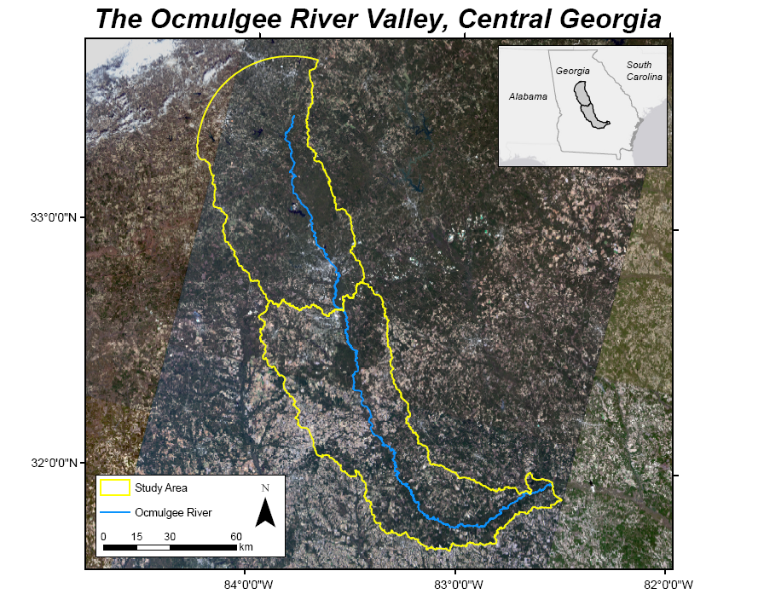

Figure 1: Project Study Area.

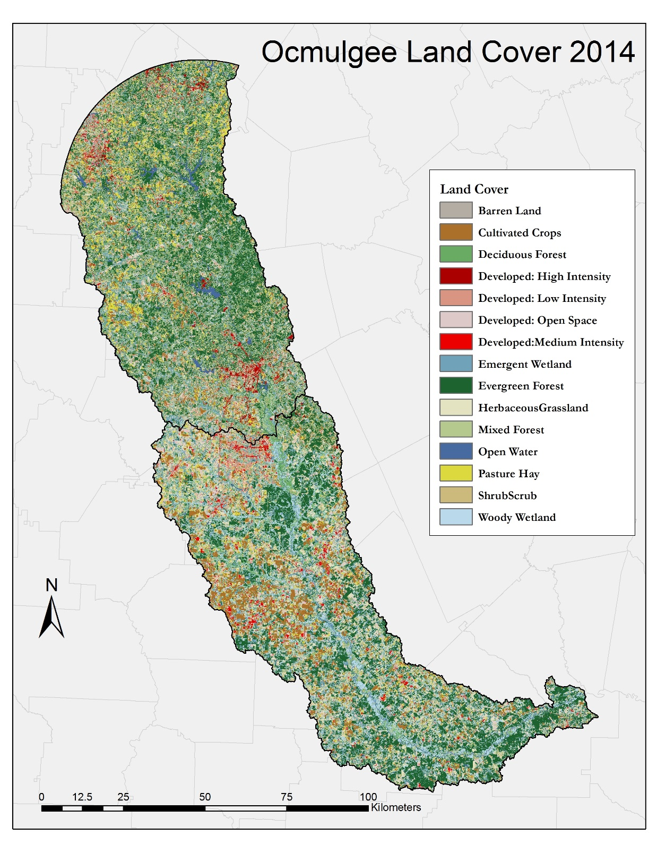

Figure 2: Land cover classification for the year 2014.

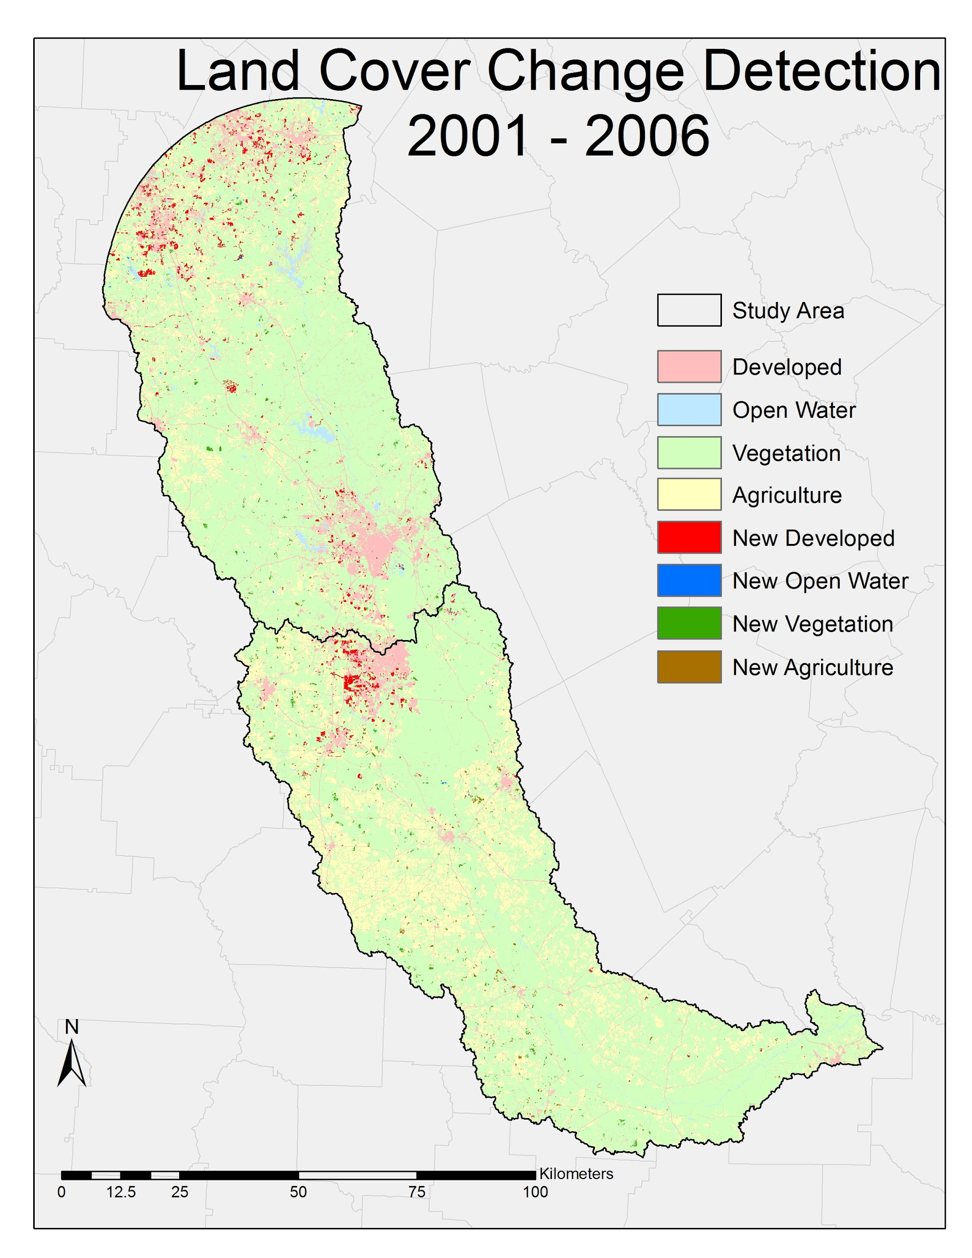

Figure 3: Land cover change detection map of study are from 2001- 2006.

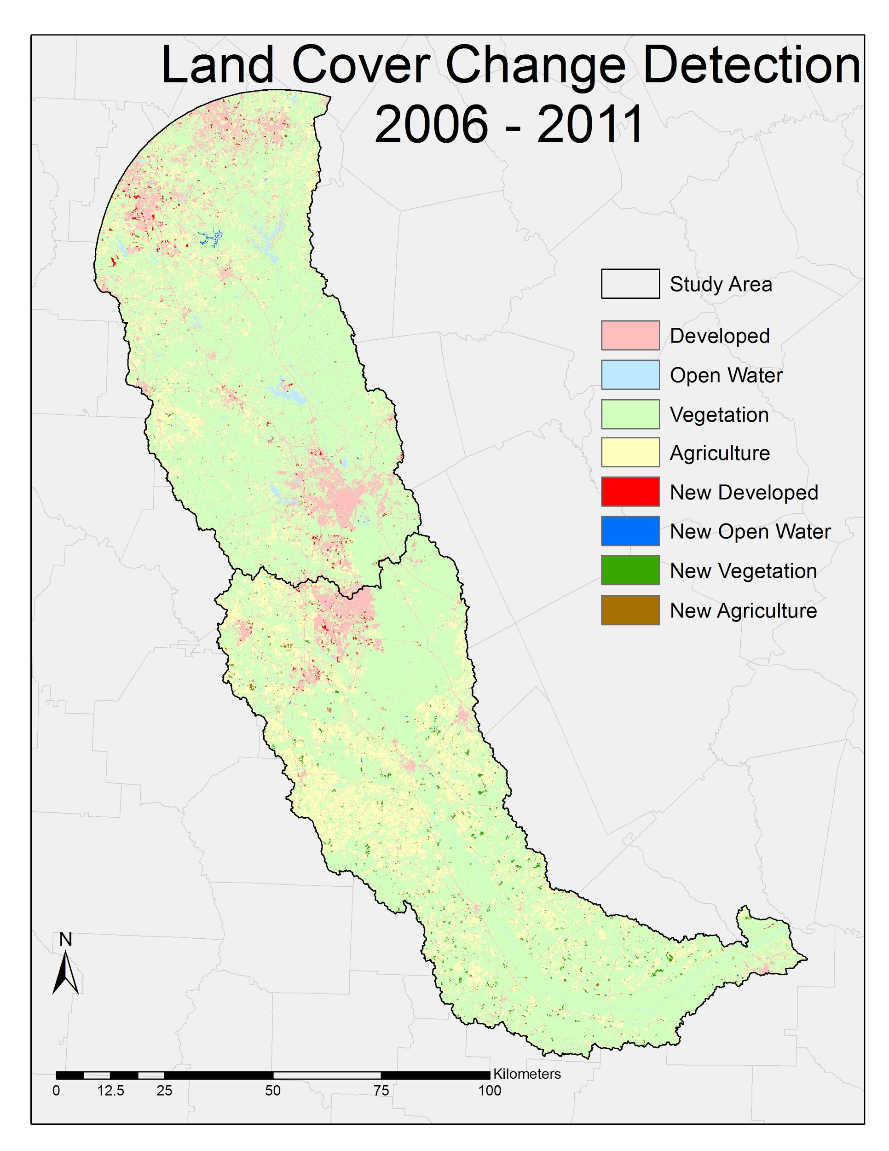

Figure 4: Land cover change detection map of study are from 2006- 2011.

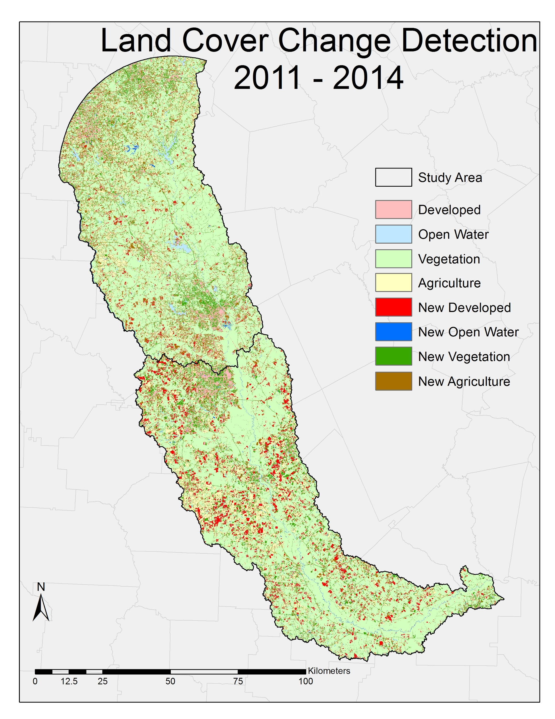

Figure 5: Land cover change detection map of study are from 2011- 2014.

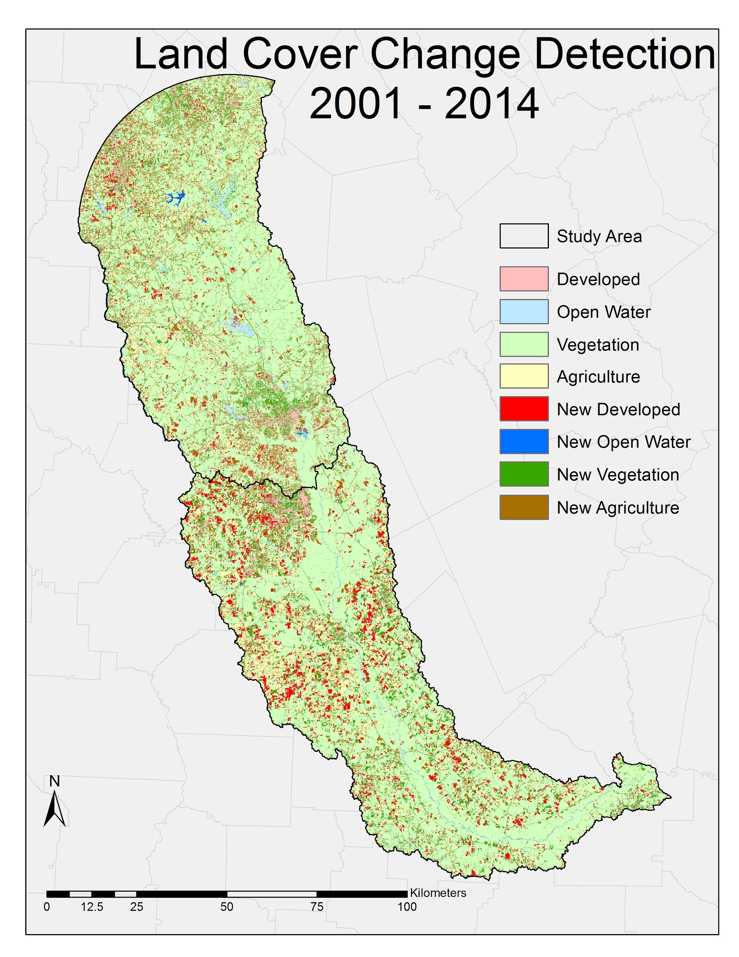

Figure 6: Land cover change detection map of study are from 2001- 2014.

**98.2%**

**10.5%**

**62.7%**

**24.9%**

Percent of Changed Area

Percent of Total Area

Figure 7: Percent land cover change from 2001-2006 (A) Total Area Changes (B) Percent of Changed Area.

**17.3%**

**30.1%**

**48.2%**

Percent of Changed Area

**98.9%**

Percent of Total Area

Figure 8: Percent land cover change from 2006-20011 (A) Total Area Changes (B) Percent of Changed Area.

**78.8%**

**17.2%**

**48.0%**

**31.1%**

Percent of Changed Area

Percent of Total Area

Figure 9: Percent land cover change from 2011-2014 (A) Total Area Changes (B) Percent of Changed Area.

**16.1%**

**47.1%**

**33.0%**

Percent of Total Area

Percent of Changed Area

**77.9%**

Figure 10: Percent land cover change from 2001-2014 (A) Total Area Changes (B) Percent of Changed Area.

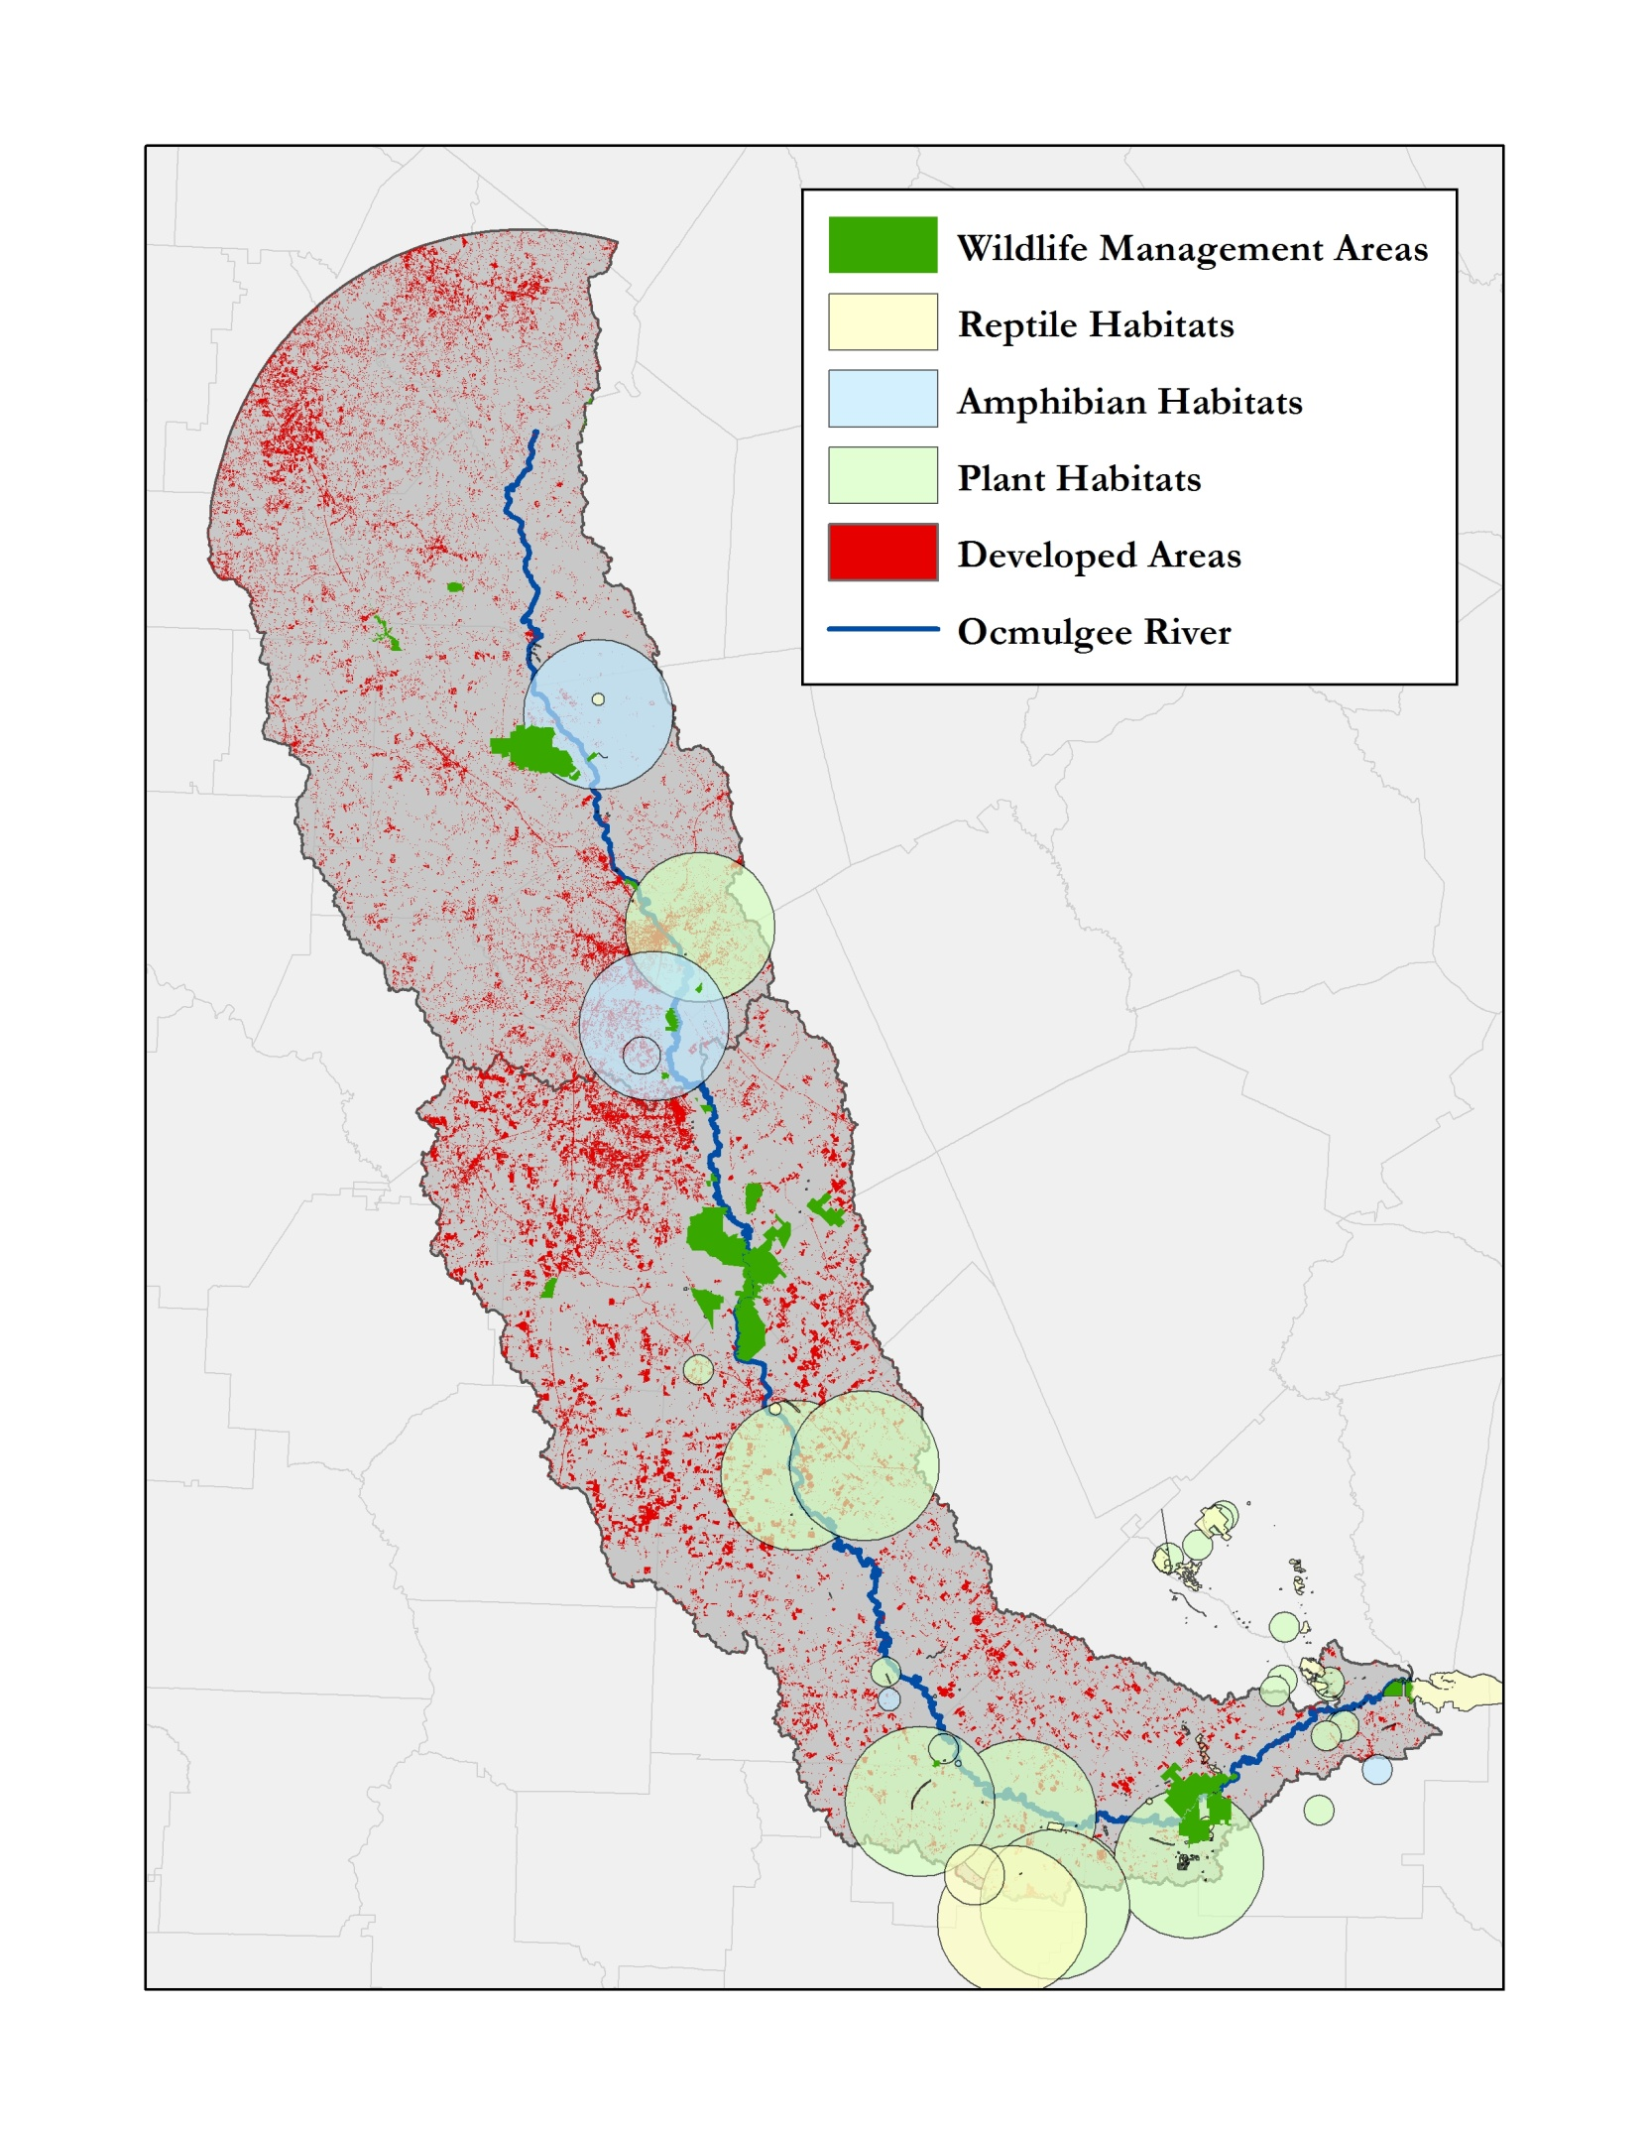

Figure 12: Ecological habitats and Georgia DNR wildlife management in relation to urban areas.

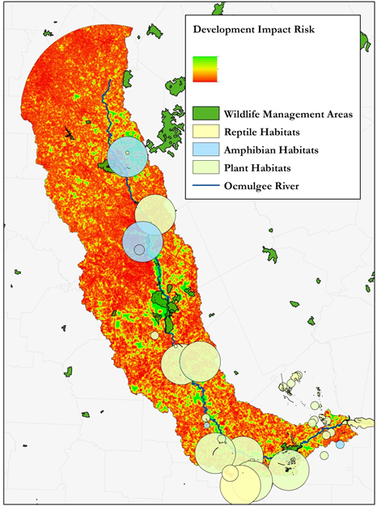

-Low Impact

-High Impact

Figure 13: Ecological habitats and Georgia DNR wildlife management in relation to risk from urban encroachment.

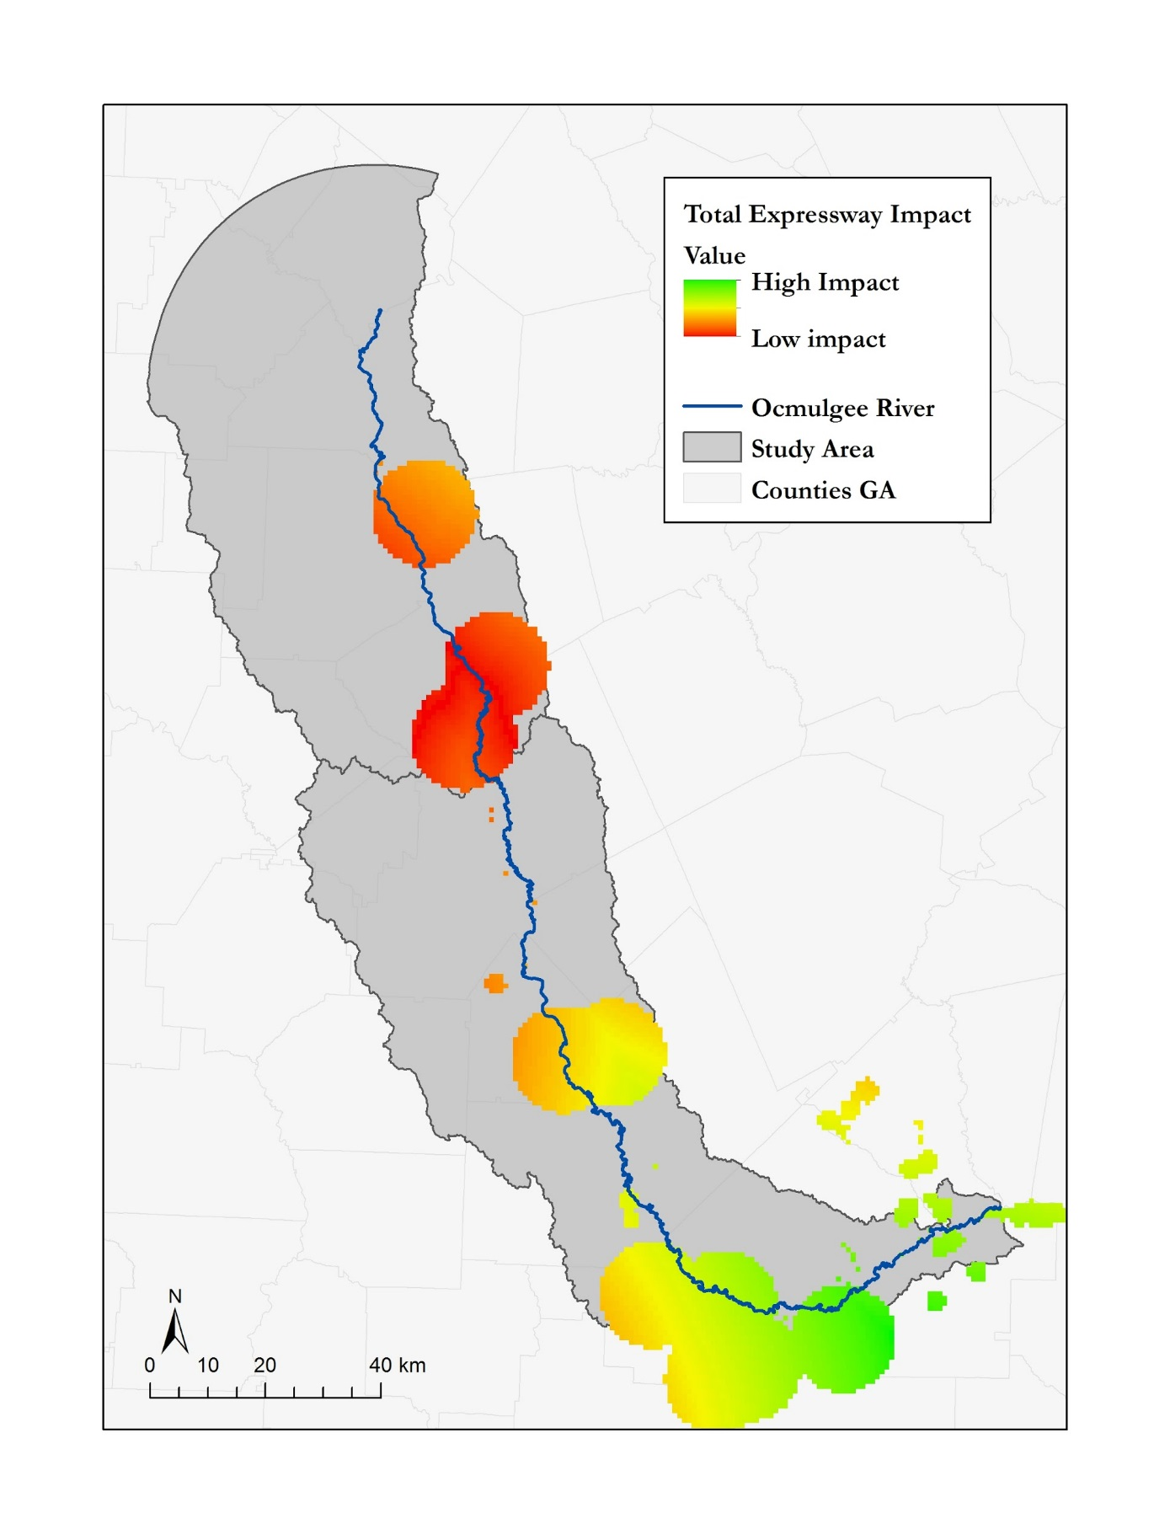

Figure 14: Overall expressway impact on ecological habitats.

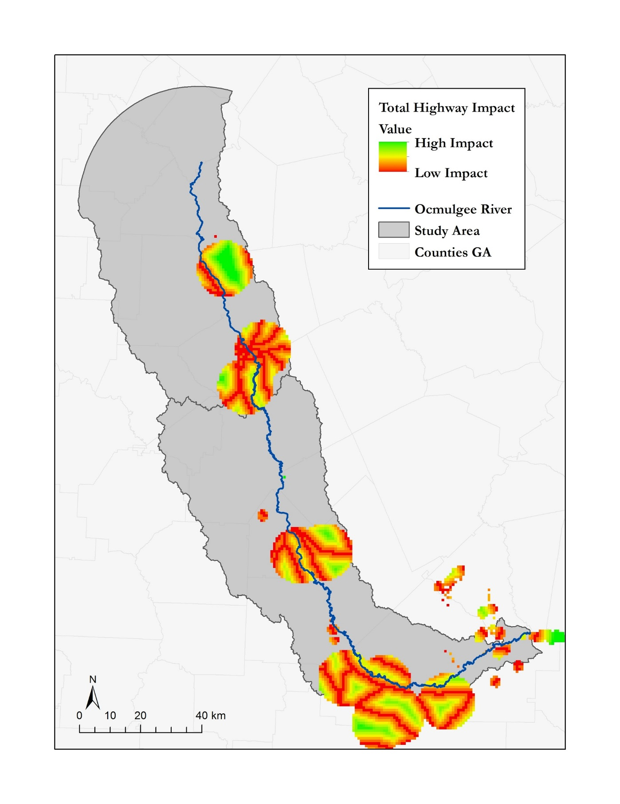

Figure 15: Overall highway impact on ecological habitats

|  |  |  |  |  |
| --- | --- | --- | --- | --- |
|  | **Area (km2)** | | | |
| **Land Cover Type** | **2001** | **2006** | **2011** | **2014** |
| *Barren Land* | 54.36 | 44.38 | 47.35 | 81.21 |
| *Cultivated Crops* | 997.31 | 982.96 | 958.11 | 819.70 |
| *Deciduous Forest* | 2262.98 | 2250.19 | 2066.55 | 888.35 |
| *Developed, High Intensity* | 30.02 | 35.36 | 40.44 | 66.69 |
| *Developed, Low Intensity* | 243.48 | 281.53 | 291.42 | 236.10 |
| *Developed, Medium Intensity* | 68.01 | 83.76 | 95.26 | 639.91 |
| *Developed, Open Space* | 694.67 | 764.86 | 771.83 | 178.37 |
| *Emergent Herbaceous Wetlands* | 81.43 | 74.84 | 97.50 | 1119.53 |
| *Evergreen Forest* | 2828.62 | 2728.67 | 2574.40 | 3046.49 |
| *Hay/Pasture* | 1133.06 | 1096.34 | 1070.86 | 1129.98 |
| *Herbaceous* | 918.91 | 871.44 | 972.12 | 666.98 |
| *Mixed Forest* | 545.80 | 515.88 | 460.79 | 203.04 |
| *Open Water* | 132.75 | 134.94 | 139.64 | 645.68 |
| *Shrub/Scrub* | 180.09 | 309.66 | 598.75 | 765.33 |
| *Woody Wetlands* | 1288.64 | 1285.32 | 1275.13 | 977.92 |

Table 1: Land cover area for study years- adapted from NLCD class names.

|  |  |  |  |  |  |  |
| --- | --- | --- | --- | --- | --- | --- |
|  |  | **Change in Area (km2)** | | | | |
| **Land Cover Type** |  | **2001-06** | **2006-11** | **2011-14** | **2001-11** | **2001-14** |
| *Barren Land* | | -9.98 | 2.96 | 33.87 | -7.02 | 26.85 |
| *Cultivated Crops* | | -14.35 | -24.85 | -138.42 | -39.20 | -177.62 |
| *Deciduous Forest* | | -12.79 | -183.64 | -1178.19 | -196.43 | -1374.62 |
| *Developed, High Intensity* | | 5.35 | 5.07 | 26.25 | 10.42 | 36.67 |
| *Developed, Low Intensity* | | 38.05 | 9.89 | -55.33 | 47.94 | -7.39 |
| *Developed, Medium Intensity* | | 15.75 | 11.50 | 544.65 | 27.25 | 571.90 |
| *Developed, Open Space* | | 70.20 | 6.97 | -593.46 | 77.16 | -516.30 |
| *Emergent Herbaceous Wetlands* | | -6.60 | 22.67 | 1022.03 | 16.07 | 1038.10 |
| *Evergreen Forest* | | -99.95 | -154.27 | 472.09 | -254.22 | 217.86 |
| *Hay/Pasture* | | -36.72 | -25.49 | 59.12 | -62.20 | -3.09 |
| *Herbaceous* | | -47.47 | 100.68 | -305.13 | 53.21 | -251.93 |
| *Mixed Forest* | | -29.92 | -55.09 | -257.75 | -85.01 | -342.76 |
| *Open Water* | | 2.19 | 4.70 | 506.05 | 6.89 | 512.94 |
| *Shrub/Scrub* | | 129.56 | 289.09 | 166.58 | 418.66 | 585.24 |
| *Woody Wetlands* |  | -3.32 | -10.20 | -297.21 | -13.52 | -310.73 |

Table 2: Area changes for study years- adapted from NLCD class names.

|  |  |  |  |  |  |
| --- | --- | --- | --- | --- | --- |
|  | **Land Cover Change (%)** | | | | |
| **Land Cover Type** | **2001-06** | **2006-11** | **2011-14** | **2001-11** | **2001-14** |
| *Barren Land* | -18.36 | 6.67 | 71.53 | -12.91 | 49.39 |
| *Cultivated Crops* | -1.44 | -2.53 | -14.45 | -3.93 | -17.81 |
| *Deciduous Forest* | -0.57 | -8.16 | -57.01 | -8.68 | -60.74 |
| *Developed, High Intensity* | 17.81 | 14.34 | 64.92 | 34.71 | 122.16 |
| *Developed, Low Intensity* | 15.63 | 3.51 | -18.99 | 19.69 | -3.03 |
| *Developed, Medium Intensity* | 23.15 | 13.73 | 571.74 | 40.07 | 840.89 |
| *Developed, Open Space* | 10.11 | 0.91 | -76.89 | 11.11 | -74.32 |
| *Emergent Herbaceous Wetlands* | -8.10 | 30.29 | 1048.21 | 19.73 | 1274.79 |
| *Evergreen Forest* | -3.53 | -5.65 | 18.34 | -8.99 | 7.70 |
| *Hay/Pasture* | -3.24 | -2.32 | 5.52 | -5.49 | -0.27 |
| *Herbaceous* | -5.17 | 11.55 | -31.39 | 5.79 | -27.42 |
| *Mixed Forest* | -5.48 | -10.68 | -55.94 | -15.57 | -62.80 |
| *Open Water* | 1.65 | 3.48 | 362.40 | 5.19 | 386.40 |
| *Shrub/Scrub* | 71.94 | 93.36 | 27.82 | 232.47 | 324.97 |
| *Woody Wetlands* | -0.26 | -0.79 | -23.31 | -1.05 | -24.11 |

Table 3: Percent changes in land cover- adapted from NLCD class names.