**NASA DEVELOP National Program**

****NASA Marshall Space Flight Center

Wise County Clerk of Court’s Office

**Summer 2015**

**Short Title: Thailand Agriculture**

**Subtitle:** Monitoring Food Crop Health and Stress Due to Changing Climate for Enriched Agricultural Land Management

**VPS Title:** My Rice Will Grow On

**Project Team & Partners**

**Project Team:**

Tim Klug (Project Lead), [tim.klug@uah.edu](mailto:tim.klug@uah.edu)

Komsan Rattanakijsuntorn

Arom Boekfah

Chayanit Choomwattana

Watanyoo Suksa-ngiam

Atipat Wattanuntachai

**Advisors & Mentors:**

Dr. Jeffrey Luvall (NASA at National Space Science and Technology Center)

Dr. Robert Griffin (University of Alabama in Huntsville)

**Partner Organizations**

Royal Thai Embassy, Collaborator/Boundary Organization, POC: Gam Raksaphaeng

SERVIR Mekong, Collaborator/Boundary Organization, POCs: Peter Cutter & Bill Crosson

Asian Disaster Preparedness Center (ADPC), Collaborator/Boundary Organization, POC: Peter Cutter

**Project Details**

**Applied Sciences National Applications Addressed:** Agriculture, Climate

**Study Area:** Northeastern Thailand

**Study Period:** Jan 2000 - Present

**Earth Observations & Parameters**

Landsat 5, TM - Spectral Vegetation Indices, Land Cover Classifications, NDVI, NDWI, NMDI

Landsat 7, ETM+ - Spectral Vegetation Indices, Land Cover Classifications, NDVI, NDWI, NMDI

Landsat 8, OLI & TIRS - Spectral Vegetation Indices, Land Cover Classifications, NDVI, NDWI, NMDI

Terra, ASTER - Digital Elevation Model

TRMM, PR - Precipitation Data, SDCI

GPM - Precipitation Data, SDCI

Terra/Aqua, MODIS - Land Surface Temperature MYD11A1 Data, SDCI

Suomi NPP, VIIRS - Land Surface Temperature, SDCI

**Ancillary Datasets Utilized**

* USGS National Land Cover Dataset (NLCD) - Soil data
* NOAA National Centers for Environmental Information (NCEI) - Climate Data
* Geo-Informatics and Space Technology Development Agency (GISTDA) - rice agriculture data

**Models Utilized**

* Maximum Entropy Model (MaxEnt; Jeffry Ely, NASA DEVELOP)
* Coupled Model Intercomparison Project (CMIP5; Jeffry Ely, NASA DEVELOP)
* Landsat Land Surface Temperature Model (LST; Leigh Sinclair, NASA DEVELOP)

**Software Utilized**

ArcGIS - Raster manipulation/analysis, image enhancement & map creation of Landsat TM, ETM+, OLI/TIRS, Terra ASTER, TRMM, GPM, Suomi NPP VIIRS, and Aqua/Terra MODIS imagery

ENVI - Raster processing/manipulation

Python - Spatial Analyst supplement tool for ArcGIS using Arcpy and Dnppy libraries

**Project Overview**

**80-100 Word Objectives Overview**

The economy of Northeastern region of Thailand is vulnerable to climatic variation due to its reliance on rain-fed rice crops. NASA Earth observations were used to quantify the total production and health of agriculture in these regions between 2000 and 2015. Land cover changes over time in prominent rice-growing regions were identified using Landsat imagery. These changes were compared to trends in precipitation surface temperature from TRMM, GPM, and MODIS. These results were compared to local climate, economics, and demographics data to create a model for monitoring the total yield and value of rice crops in Northeastern Thailand.

**Abstract**

Monitoring climate change is crucial for the Thailand agricultural industry. Climate change results in shifting rainfall patterns which in turn affect the management of crop production. Northeastern Thailand grows the majority of the country’s rice, but the rice yield per hectare is relatively low. One primary factor is uncertainty surrounding the ability to monitor and assess climate change. This project aims to assess changing climate patterns to improve the understanding of environmental variables, such as precipitation and temperature, to understand risks and impacts of floods, storms, and drought, and to determine relationships between seasonal rainfall patterns and production areas of rice crop. This study used satellite imagery from Landsat 5 Thematic Mapper (TM), Landsat 7 Enhanced Thematic Mapper Plus (ETM+), and Landsat 8 Operational Land Imager (OLI) and Thermal Infrared Sensor (TIRS). Precipitation data from The Tropical Rainfall Measuring Mission (TRMM) and Global Precipitation Measurement (GPM), land surface temperature data from Moderate Resolution Imaging Spectroradiometer (MODIS), land surface temperature data from Visible Infrared Imaging Radiometer Suite (VIIRS), and a digital elevation model from The Advanced Spaceborne Thermal Emission and Reflection Radiometer (ASTER). The images were analyzed by using land cover classifications, Normalized Difference Vegetation Index (NDVI), Normalized Difference Water Index (NDWI), and/or Normalized Multi-band Drought Index (NMDI). Understanding the changing climate patterns assisted the end-users in initiating the best policies to tackle the challenges of climate change. In addition, the results of this research contributed to the scientific body of knowledge, in particular earth and agricultural sciences.

**Community Concerns**

* Thailand is the world's largest exporter of rice at 8.5 million metric tons in 2014.
* In the northeastern region of Thailand, the rice crop yield is relatively low compared to other regions in the Mekong area.
* Most of the rice grown in North Eastern region of Thailand is rain-fed and depends heavily on the climate.
* In recent years, the climate pattern has begun to change. As a result, farmers will be unable to predict future conditions and may suffer from a dry spell, losing their crops.

**Current Management Practices & Policies**

The Royal Thai Government proposed a rice development strategy focused on developing technologies to increase the production of rice. This was implemented by breeding a variety of rice that was most resistant to pests and could adapt to environmental changes due to climate, and also by developing techniques that reduce the costs associated with planting and harvesting. In 2014, a USAID and NASA-supported program, SERVIR-Mekong, was launched to enhance climate adaptation and landscape management through the applications of geospatial analysis. SERVIR-Mekong will help governments and communities to improve agriculture risk management in the Lower Mekong countries, including Thailand.

**Decision Support Tools & Benefits**

|  |  |  |
| --- | --- | --- |
| **End-Product** | **Earth Observations Used** | **Benefit & Impact** |
| Land Cover Classification | Landsat 5 TM, Landsat 7 ETM+, Landsat 8 OLI & TIRS | Indicates areas where land cover has changed in the study area |
| Normalized Differenced Vegetation/Water Index Catalog | Landsat 5 TM, Landsat 7 ETM+ , Landsat 8 OLI & TIRS, Terra ASTER, TRMM PR, Aqua/Terra MODIS, Suomi NPP VIIRS | Indicates areas of healthy vegetation and photosynthesis and moisture content in soil |

**Project Imagery**

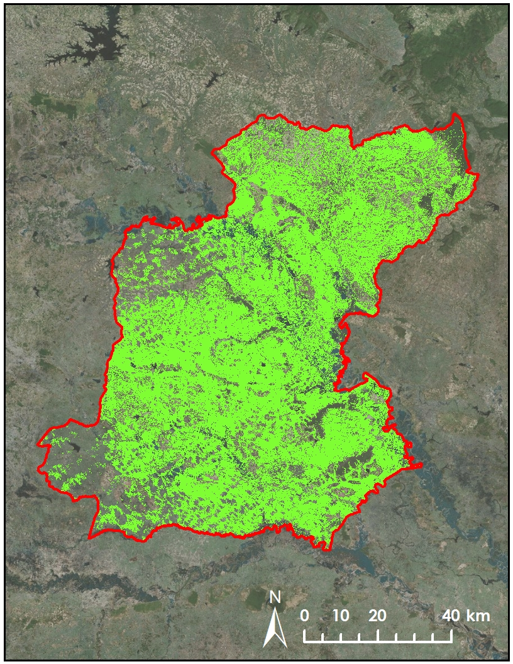



**Caption:** Possible rice paddy land cover in Roi Et province classified from October 2014 Landsat 8 imagery. Image Credit: Thailand Agriculture Team.

**Image:** Roi_Et_2014.jpg