**NASA DEVELOP National Program**

NOAA National Centers for Environmental Information

**Fall 2015**

**Short Title: Missouri River Climate**

**Subtitle:** Using NASA and NOAA Satellite Observations to better understand Runoff in the Missouri River Basin for Improved River System Management and Decision Support.

**VPS Title:** The Run-down on Run-off: Hydrologic Drivers in the Missouri River Basin

**Project Team & Partners**

**Project Team:**

Emily Sturdivant (Project Lead)

Nancy Barnhardt

Alec Courtright

Sam Swanson

**Advisors & Mentors:**

DeWayne Cecil (Global Science & Technology, National Centers for Environmental Information)

**Other Contributors:**

Dennis Todey (South Dakota State University)

**Partner Organizations:**

NOAA Regional Climate Services Director (RCSD) (End-User/Boundary Organization), POC: Doug Kluck

Missouri River Basin Water Management Division (MRBWMD) (End-User), POC: Kevin Grode

**Project Details**

**Applied Sciences National Applications Addressed:** Climate, Water Resources, Agriculture

**Study Area:** Missouri River Basin: MT, ND, SD, WY, NE, KS, MO, CO, IA, MN

**Study Period:** Sep 1979 - Dec 2014

**Earth Observations & Parameters:**

Defense Meteorological Satellite Program (DMSP), sensors SMMR, SSM/I, AMSR-E - ESA GlobSnow Snow Water Equivalent

Geostationary Observational Environmental Satellite (GOES), Thematic Mapper (TM) - Soil moisture, soil temperature

**Ancillary Datasets Utilized:**

* USGS National Land Cover Dataset (NLCD) – Land cover
* NOAA NCEI Global Historical Climatology Network (GHCN) – *In situ* precipitation
* NRCS Soil Climate Analysis Network (SCAN) – *In situ* soil moisture and temperature & snowpack characteristics
* North American Land Data Assimilation System (NLDAS)- soil moisture, soil temperature

**Software Utilized:**

R – Data processing, statistical analysis, graphing

ArcGIS – data visualization, raster manipulation/analysis, image enhancement & map creation of Aqua/Terra MODIS

**Project Overview**

**Objectives Overview:**

This project uses NASA and NOAA satellite and *in situ* data sources to improve the understanding of water supply and runoff in the Northern Plains Region of the Missouri River Basin*.* It describes patterns of soil moisture, snowpack, and soil temperature in the upper basin over a 30 year period.

**Abstract:**

The Missouri River‘s highly variable discharge directly affects livelihoods in six states. The U.S. Army Corps of Engineers manages six main stem dams to mitigate flooding, irrigation and hydropower needs, and other purposes. These decisions impact local residents, businesses, and ecosystems, which rely on accurate forecasting of river flows. However, environmental variables such as soil moisture, snowpack, and soil temperature have an unquantified influence on river run-off. In particular, the Northern Plains Region of the Basin is not adequately covered by on-the-ground monitoring stations, resulting in a data-poor region and an incomplete understanding of the driving variables of run-off. This project used NASA’s Earth Observing System, NOAA Climate Data Records (CDRs), and *in situ* datasets to improve the understanding of water availability and runoff. This project analyzed the soil moisture, snowpack, and soil temperature for the preceding 30+ years (1979­-2015). For each variable, it produced maps of 30-year annual and monthly means, minimums, maximums, and inter-annual linear trends. Grid cells corresponding to NOAA and USGS ground stations were verified with *in situ* observations and qualitatively analyzed for temporal patterns. These results will aid the MRBWM team in their informed water management throughout the basin in future years. The analysis will help them to communicate with residents about the potential causes of run-off in the region.

**Community Concerns**

* The MRBWMD and the U.S. Army Corps of Engineers need to better understand run-off in the basin to make informed water management decisions and potentially improve the quality of flood control, navigation, irrigation, recreation, hydropower generation, and water supply.
* Many endangered species and communities in the Basin depend on the availability of water from the reservoirs.
* The MRBWM’s run-off forecasts are used by basin stakeholders to make business decisions that are affected by reservoir releases. Stakeholders include hydropower providers, fisheries, farmers, and river transportation companies.

**Current Management Practices & Policies**:

Missouri River Basin Water Management operates their reservoir system based on run-off predictions produced by the U.S. Army Corps of Engineers. The Corps produces a monthly forecast of the expected annual run-off each calendar year with improved forecasting updates for remaining months as the year progresses. This forecast takes into account present basin conditions, such as soil moisture and snowpack, as well as historical trends and long-range weather expectations. Each month, these run-off forecast estimates are used as inputs to a 3-week forecast, which forecasts reservoir inflows, releases, storage levels, and hydropower generation, among other things. The Corps has access to a wealth of *in situ* data and utilizes a regression analysis of the past thirty years for mountain snowpack run-off. However, there are several areas within the Upper Missouri River Basin that are relatively data-poor regions. For example, although mountain snowpack run-off is well known, there is little available information for surface water storage and snow water equivalents within the plains region of the basin.

**Decision Support Tools & Benefits:**

|  |  |  |
| --- | --- | --- |
| **End-Product** | **Earth Observations Used** | **Benefit & Impact** |
| Monthly and yearly climatologies, anomalies, and historical trends of requested variables: soil moisture, snow water equivalent, and soil temperature | AMSR-E/SMMR/SSM/I/ GOES | Graphic and tabular conclusions concerning historical normals in the study region provide useful information on little-known variables for future management. |

**Project Imagery**

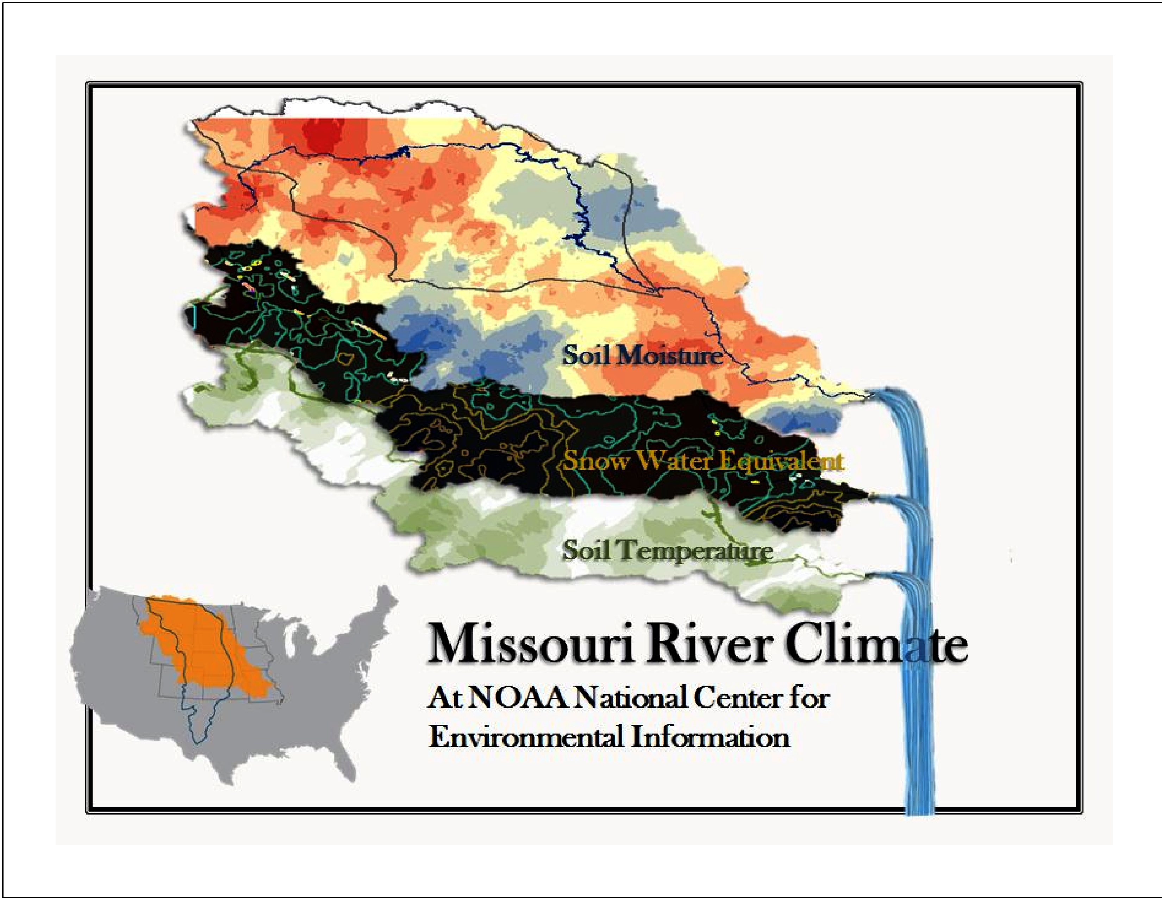

**Caption:** Run-off into the Missouri River is driven by patterns of snow water equivalent, soil temperature, and soil moisture in the Northern Plains. Image Credit: Missouri River Climate Team.

**Image:** 2015Fall_NCEI_MissouriRiverClimate_VPSImage

**Software Release Requirements**

This project’s software tools fall within category I. R, IDL, and ArcGIS codes are being used but only the results are handed-off to end-users.