**NASA DEVELOP National Program**

****International Research Institute for Climate and Society

**Fall 2015**

**Short Title: New Jersey Health & Air Quality**

**Subtitle:** Modeling Near Surface Air Temperature Profile of Complex Urban Systems Based on Land Surface Properties and Correlating On-Site and Satellite Data to Better Understand Temperature Profiles in Urban Microclimates.

**VPS Title:** Forecast Is What You Expect; Near Surface Temp. Is What You Get

**Project Team & Partners**

**Project Team:**

Maryam Karimi (Project Lead), MKarimi@gradcenter.cuny.edu

Jerrod Lessel

**Advisors & Mentors:**

Pietro Ceccato (Research Scientist, Lead Environmental Monitoring Program, The International Research institute for Climate and Society, The Earth Institute, Columbia University)

**Partner Organizations:**

Bureau of Environmental Surveillance and Policy, New York City Department of Health and Mental Hygiene (End User), POC: Thomas Matte

We Act for Environmental Justice (End User), POC: Aurash Khawarzad

Columbia University, Mailman School of Public Health (Collaborator), POC: Patrick Kinney

Consortium for Climate Risk in the Urban Northeast (CCRUN), (Collaborator), POC: Brian Vant-Hull

**Project Details**

**Applied Sciences National Applications Addressed:** Health and Air Quality

**Study Area:** Glassboro, NJ

**Study Period:** May – July 2015

**Earth Observations & Parameters:**

Landsat 7, ETM+ - Land Cover, Land Surface Temperature

Landsat 8, OLI/TIRS – Land cover, Land Surface Temperature

**Ancillary Datasets Utilized:**

* Field Measurement- Vertical temperature probes installed in Rowan University campus in Glassboro, NJ. Temperature data will be used from instrument probes.

**Models Utilized:**

Atmospheric correction models, land surface model

**Software Utilized:**

Excel – statistical analysis of data

ArcGIS – raster manipulation/analysis, map creation of Landsat ETM+/OLI/TIRS

**Project Overview**

**80-100 Word Objectives Overview:**

To improve the understanding of, and mitigate, Urban Heat Island (UHI) effects on humans and to develop a correlation between various surface features and near surface air temperatures to improve urban design and city management.

**Abstract:**

Urbanization has created an increase in what is known as the urban heat island (UHI) effect. The excess heat in these urban environments has led to a rise in heat related illnesses and mortality. There is little understanding of urban microclimate. To better understand the impact of different land surfaces in an urban system a quantitative study was completed, analyzing on-site locations representing varied microclimates and analyzing satellite imagery of Glassboro Township of New Jersey. A correlation is being developed to be able to obtain the surface temperature and near surface air temperature of a microclimate based on the environmental factors. The on-site study revealed that varied environments (grass, water, and concrete) result in different temperature profiles within the range of 0 to 3 meters. Results indicate; grass was the coolest environment, water was the most temperate, and concrete had the highest peak temperatures. The satellite study revealed that increased levels of urbanization, with no methods of heat mitigation, resulted in higher average temperatures. Both the on-site and satellite data confirm that the increased urbanization leads to increased temperatures within microclimates.

**Community Concerns:**

* Urbanization has created an increase in the Urban Heat Island (UHI) effect, which has adverse health effects on both humans and animals within the region.
* Vertical temperature variation at microscale has been a crucial missing part of UHI research.
* Businesses and community leaders can benefit from the understanding of the impact of urban structures on the UHI effect

**Current Management Practices & Policies**:

Current management practices aimed to decrease the UHI effect are cool roof installation, urban forestry, public outreach and education on the impacts of UHI on energy and air quality.

**Decision Support Tools & Benefits:**

|  |  |  |
| --- | --- | --- |
| **End-Product** | **Earth Observations Used** | **Benefit & Impact** |
| True Surface Temperature-Forecasting (TST) model | Landsat 7 ETM+, Landsat 8 OLI/TIRS, Aqua/Terra MODIS | Obtain the true surface temperature and near surface air temperature of a microclimate based on the environmental factors visible via satellite. The TST model can help in predicting actual surface temperature for any surface type at highest resolution. |

**Project Imagery**

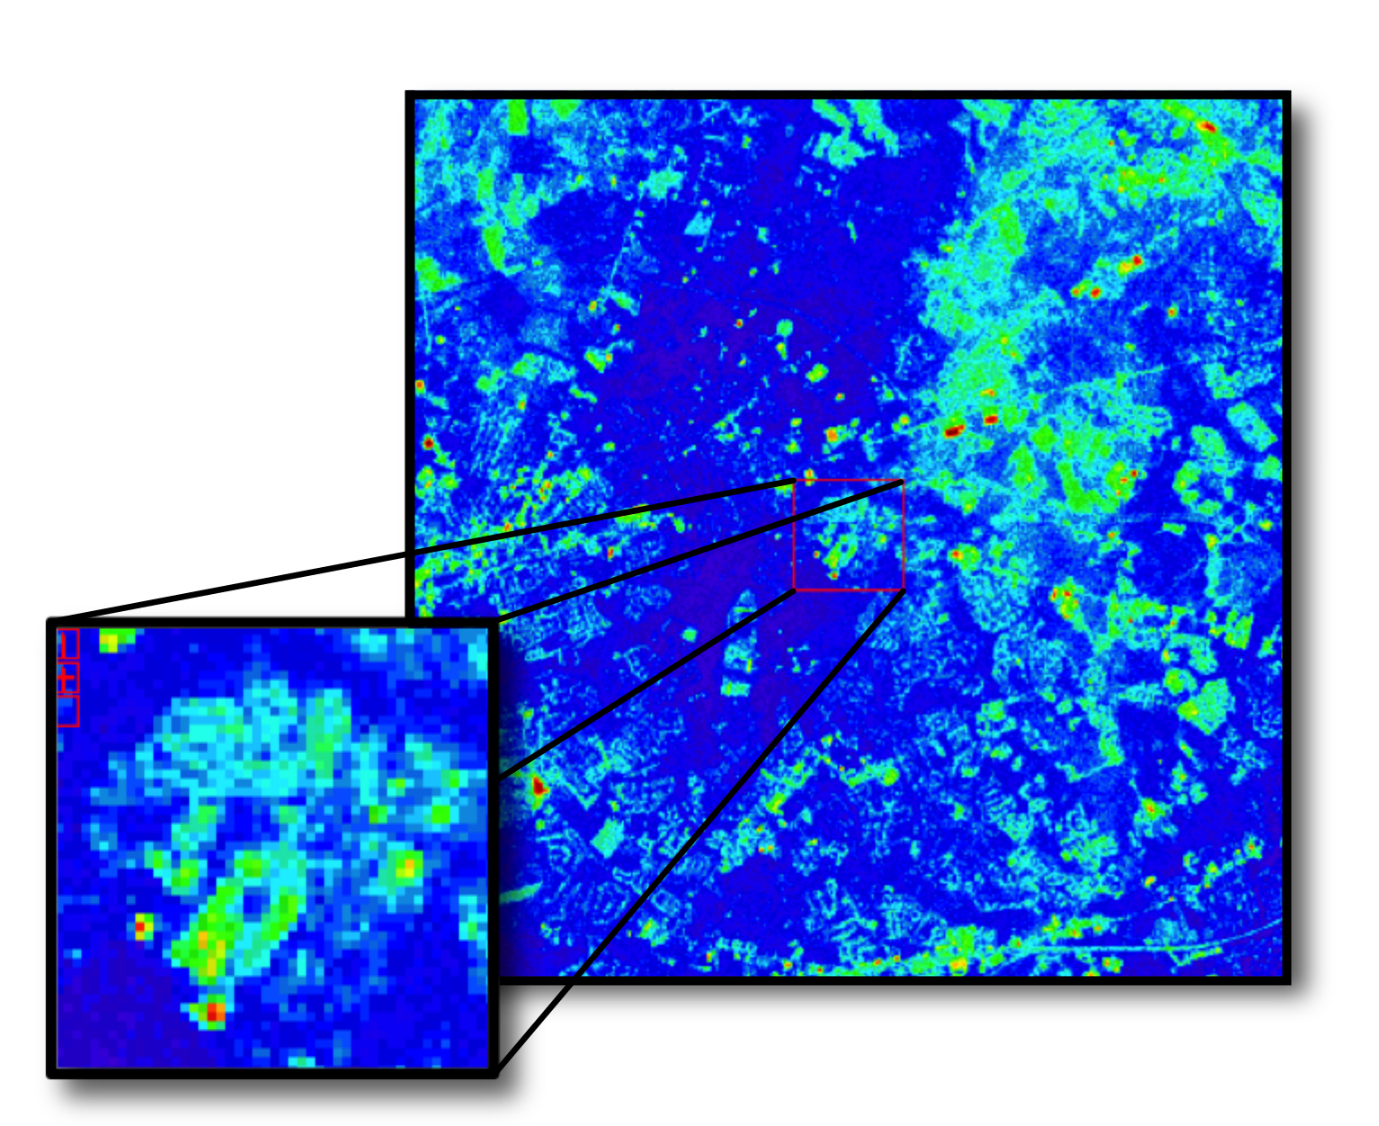

**Caption:** Landsat thermal image showing the study area, Rowan University, in the inset. Image Credit: New Jersey Health and Air Quality Team.

**Image:** LSTimage.jpeg

**Software Release Requirements**

What category do the tools your project is creating fall within? Category I