Delaware Basin Health and Air Quality

Spatiotemporal Analysis of Air Pollutants Collected from Ground and Space Instruments Around the Guadalupe Mountains and

Carlsbad Caverns National Parks

 **Technical Report**

Final Draft – March 31st, 2022

Sean Cusick (Project Lead)

Amber Schlessiger

Billy Henshaw

Perrin Krisko

***Advisors:***

Dr. Laura Judd (NASA Langley Research Center)

Dr. Elizabeth Wiggins (NASA Langley Research Center)

# 1. Abstract

Nitrogen dioxide (NO2) is a precursor for secondary air pollutants, which are associated with decreased visibility, and decreased ecosystem and respiratory health. NO2 is a growing threat to national parks within the Delaware Basin where nearby oil and gas activity contributes to deteriorating park conditions, implying adverse effects on the local tourism economy and public health. To demonstrate spatial and temporal patterns of air pollution in the parks, we examined average monthly, seasonal, and annual tropospheric column concentrations of NO2 in Carlsbad Caverns (CAVE) and Guadalupe Mountain (GUMO) National Parks. We used both the NASA Ozone Monitoring Instrument (OMI) and the European Space Agency (ESA) Tropospheric Monitoring Instrument (TROPOMI) to map NO2 tropospheric column densities. Using ground-based emissions values from the Environmental Protection Agency National Emissions Inventory (NEI) for two nearby natural gas processing plants (Indian Basin Gas Plant, South Carlsbad Plant), we extrapolated monthly trends from these point sources and compared seasonal emissions levels with the measurements recorded by OMI and TROPOMI. The NEI data show an 8% increase in flaring from 2013–2021. OMI measured a 38.3% NO2 increase over the Delaware Basin, 15.29% increase over CAVE, and 4.26% decrease over GUMO from 2011–2018. TROPOMI measured a -1% NO2 change over the Delaware Basin, 3% over CAVE, and 7% over GUMO from 2018–2020. The analysis indicates a positive correlation between emissions from fossil fuel exploration and NO2 concentrations above CAVE and GUMO. This information will inform National Park Service air quality monitoring and policy efforts to ensure compliance with the Clean Air Act.

# 2. Introduction

***2.1 Background Information***

Located near the western Texas and southern New Mexico border, the Delaware Basin is home to both Guadalupe Mountains National Park (GUMO) and Carlsbad Caverns National Park (CAVE) (Figure 1). The Delaware Basin is a part of a larger Permian Basin that is known for its oil and gas deposits (Wright et al., 2011). The Permian Basin continues to be the most productive oil basin, and one of the most productive natural gas basins, in the United States. It produces over five million barrels of oil and over twenty trillion cubic feet of natural gas per day, according to the U.S. Energy Information Administration. Aside from the exceptional case that took place in 2020 during the global COVID-19 pandemic, rig counts have risen in the Permian basin since January 2017, suggesting the attractiveness of this region to oil and gas drillers (“Drilling Productivity Report,” n.d.). The oil and gas extraction process releases air pollutants in many ways. Primarily, the machinery required to run these oil and gas wells emit pollutants. In addition, natural gas leaks combined with the deliberate burning of gases (also known as flaring) are common, emitting additional pollutants (Veloski et al. 2014).

Over the past decade, GUMO and CAVE reported deteriorating visibility and air quality. During this same time, increased oil and gas activity has occurred near the park boundaries. Oil and gas activity emissions often include pollutants such as nitrogen dioxide (NO2). This pollutant can have a myriad of effects on ecosystems and public health, such as decreased visibility, increased water acidity, and altered soil chemistry (Follett et al., 2001). In the short term, people with acute cardiovascular and pulmonary conditions who are exposed to NO2 can experience increased severity of their symptoms. Meanwhile, long-term exposure is linked to the development of respiratory conditions, such as recurring infections and asthma (Latza et al., 2009).

GUMO and CAVE are classified by the Clean Air Act as Class I areas. The Class I indication is the greatest level of air quality protection administered by the NPS and is assigned to national parks that are deemed “sensitive ecosystems” (“National Parks and the Clean Air Act,” n.d.; “NPS Class I Areas,” n.d.). Therefore, the region is the subject of many scientific studies to determine potential causes of reduced visibility and air quality, as well as to map monthly and seasonal trends around both parks.

Previous studies investigating these concerns in the region have included a 2017 study conducted at CAVE, which utilized ground measurements and HYSPLIT trajectories to determine the severity of volatile organic compounds (VOCs) in the park (Benedict et al., 2020). Another study investigated the TROPOMI retrieval accuracy of nitrogen oxides (NOx) in rural areas by comparing satellite reports to nearby emissions reports (Goldberg et al., 2019). Results of that study suggest that TROPOMI is well-suited for estimating NOx emissions for both seasonal and intra-seasonal timeframes. Meteorological variables and their impacts on pollution and visibility in the Permian Basin are well-researched. A two-year study (2018–2020) focused on TROPOMI NO2 and surface wind direction to determine ways in which meteorology in the area affects NO2 transportation. Results of this study showed that due to the short lifetime of NO2, the highest concentrations occur near anthropogenic sources. Winds carried NO2 as far as the western Delaware Basin, with the highest concentrations settling near Carlsbad, New Mexico (NM) and Pecos, Texas (TX) (Crosman, 2021). The methods and findings demonstrated through these studies guided our project and contributed to further understanding of the unique meteorological and geologic issues experienced in GUMO and CAVE during our study period from May 2010 to May 2021.

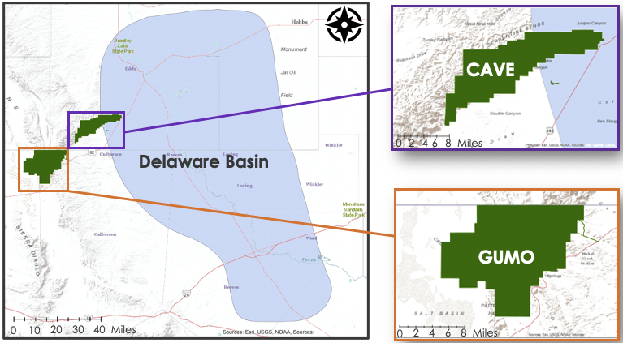

*Figure 1.* The boundaries within our study region, with the orange lines denoting GUMO boundaries, the purple lines denoting CAVE boundaries, and the blue boundary denoting the Delaware Basin.

***2.2 Project Partners & Objectives***

The project partners for this term were the National Park Service (NPS) Intermountain Region, Carlsbad Caverns National Park, and Guadalupe Mountains National Park. The NPS observed a reduction in air quality and visibility over GUMO and CAVE over the last decade. Partners are alarmed about the adverse impacts the deteriorating air quality will have on the pristine environments of the national parks and the local tourism economy. There is concern that oil and gas exploration has exacerbated these issues and the NPS is interested in using satellite data to identify temporal and spatial changes in air pollutants over the Delaware Basin region to aid in their decision-making process. This study set out to evaluate the relationships between pollution sources within CAVE and GUMO by using *in situ* and satellite-based data, as well as to create maps of NO2 around the Delaware Basin to assist with CAVE and GUMO’s park management policies surrounding air quality and visibility.

# 3. Methodology

***3.1 Data Acquisition***

The European Space Agency (ESA) released version 2.2.0 of TROPOMI’s Level 2 NO2 product to address artificially low tropospheric NO2 columns over heavily polluted regions. Then, the need to eliminate discontinuity in NO2 data introduced by processor changes in December 2020 led to further reprocessing and the release of Version 2.3.1 (S5P-PAL Data Portal, n.d. We acquired the TROPOMI Level 2 NO2 product through the creation of a Python script that used the PySTAC package (“PySTAC Documentation – Pystac 1.3.0 Documentation”, n.d.) to automate data download from the S5P-PAL data portal (S5P-PAL Data Portal, n.d.). We set a 6.0 ° x 6.0 ° extent centered at 32.0 °N, -104.0 °W. Our team then ran the script which download all files between May 2018–May 2021 that captured the specified spatial extent.

OMI data from NASA’s Aura satellite was downloaded from NASA Earthdata Search. To configure spatial boundaries for data acquisition, we set a point at 32.20 °N, -102.70 °W to ensure the swath would cover the study area. We then collected records of each satellite flyover time during the study period from 2010–2021 and compiled these into a text file. With the satellite flyover times in this text file, we ran a Unix module to review each point and download the corresponding OMI HE5 file.

We also utilized three non-satellite datasets:

* 1. Annual global flaring dataset from the National Oceanic and Atmospheric Administration (NOAA), Colorado School of Mines, and the World Bank (“NOAA dataset”)
  2. A dataset from the New Mexico State Government’s Oil Conservation Division (OCD, “OCD dataset”)
  3. Ground monitor NO2 data from the Environmental Protection Agency’s AirData site.

The NOAA dataset contains flaring values at the individual well level but only provides annual estimates of flaring. The OCD dataset contains sum-aggregated flaring values at the broader district level but provides monthly estimates of flaring. Ground measures of NO2 were only available from one Environmental Protection Agency (EPA) air monitor in the Delaware Basin region. These data were available for site #350151005 (at 32.38012 °N and -104.263 °W) daily from 2010-2021, which we aggregated into 120 monthly averages using Excel. The below table (Table 1) contains a data dictionary of acquired datasets and their uses.

Table 1

*Data dictionary for datasets used.*

|  |  |  |  |  |  |  |
| --- | --- | --- | --- | --- | --- | --- |
| **Dataset Name** | **Source** | **Product Version/ Level** | **Spatial Resolution** | **Temporal Resolution** | **Temporal Extent** | **Justification** |
| NO2 | TROPOMI | 2.03.01/L2 (S5P-PAL) | 3.5 × 7 km2 | Daily | May 2018 –May 2021 | Evaluation of hyperlocal trends across the Delaware Basin, CAVE, and GUMO |
| NO2 | OMI | 3/L3 | 0.25° × 0.25° | Daily | May 2010 –May 2021 | Evaluation of regional trends around the Delaware Basin |
| Global flaring dataset | NOAA, Colorado School of Mines, World Bank | n/a | Well level | Yearly estimates | 2017 – 2020 | Estimation of emissions from oil and gas wells |
| Monthly production of natural gas and flaring | Oil Conservation Division of New Mexico | n/a | District level | Monthly estimates | 2017 – 2020 | Ground comparison of column NO2 TROPOMI observations with temporally collocated gas well emissions |
| AirData | Environmental Protection Agency | n/a | One point; Carlsbad, New Mexico | Monthly averages | 2010 – 2021 | Ground-based measurement of NO2 to supplement satellite column measures |

***3.2 Data Processing***

We utilized four Interactive Data Language (IDL) scripts to clip TROPOMI and OMI data to the specified extent to reduce computation time and increase the efficiency of our workflow. Two of the scripts re-gridded the data to a 0.01° x 0.01° and a 0.25° x 0.25° resolution, using an oversampling procedure from Goldberg et al., (2021). To complete this procedure, we read the existing NCTROPOMI NetCDF files and OMI HE5 files, defined new variables, and changed NO2 units from moles/m2 to molecules/cm2 by multiplying by Avogadro's Number (6.02214 * 1019), over 104. We then applied a quality assurance value of 0.75 as recommended by our science advisors, which filters cloud radiance fractions greater than 50%. With these changes, we created a new NetCDF file.

Once the TROPOMI data were oversampled and re-gridded, another IDL script was used to make monthly aggregates. We created a total of thirty-five monthly aggregates of TROPOMI data, spanning from May 2018–April 2021. To load these NC files into ArcGIS Pro as raster files, we ran a Python script to rescale, reposition, project, and export the files as TIFs. We then added these TIFs to a mosaic dataset in ArcGIS, and added the time dimension of “Month” to each one using the Make Multidimensional Raster tool.

The OMI data, once re-gridded, was used to create yearly and seasonal aggregates. To do this, we repeated the process used for creating the multidimensional mosaic raster dataset with TROPOMI, with the oversampled and re-gridded OMI dataset. We did not convert NO2 units in the OMI datasets because the HE5 files already defined NO2 as molecules/cm2. The yearly aggregates spanned May 2010–May 2021, with 2010 only encapsulating May–December and the 2021 aggregate covering January–May. We ended with twelve yearly aggregate files of OMI data.

For the OMI seasonal aggregates, we defined the seasons as:

* + Spring: March–May
  + Summer: June–August
  + Fall: September–November
  + Winter: December–February

Specifically, the winter season represents December of the defined year, going into January and February of the next calendar year. For example, winter 2010 is defined as December 2010–February 2011. We excluded the May 2010 data from the seasonal aggregates as it only encompassed one month of spring. For the spring 2021 file, we noted that the months included were March–May 1st. This period did not include the entire month of May but we still included it to view the potential impacts of the COVID-19 pandemic on NO2 production. The total number of OMI seasonal files created was 44.

We then created two Python scripts: one to plot the data, and the other to create a GIF file of each monthly, yearly, or seasonal aggregate. The Python script for plotting defined the color bar limits, which were decided by looking at the TROPOMI monthly files to determine the best fit scale for our area. We decided on a color bar that spanned 0 – 3.5 × 1015 with units of molecules/cm2. For the monthly TROPOMI files, each month from May 2018–April 2021 was plotted and read into the second Python script, creating a GIF file with each image. The OMI yearly files encapsulated 2011–2020 fully, with 2010 and 2021 showing eight months and five months of data, respectively. We exported each of these generated images in to the Python GIF script, creating one GIF showing the yearly progression of NO2 in the region. The OMI seasonal data was plotted starting in summer 2010 and ending in spring 2021. The plots were broken into their respective seasons, and four GIF files were created, representative of spring, summer, fall, and winter. Our team used an Excel file containing the approximate latitude and longitude of Carlsbad, NM and El Paso, TX in the Python plotting script to create geographic points in each image. We did this to create greater spatial awareness within each plotted image.

For flaring data, we downloaded the 2017–2020 annual global flaring estimate data from NOAA, World Bank, and Colorado School of Mines, with which we performed ArcGIS mapping of these flaring points to identify global flaring hotspots near the two parks in New Mexico and Texas. We benchmarked the NOAA annual global flaring data to oil production and flaring data (in units of billion cubic meters) reported by New Mexico’s Energy, Minerals, and Natural Resources department. These data provided by New Mexico (OCD data) were in a monthly format and were not oil- and gas-well specific; instead, the flaring data (in units million cubic feet) were aggregated by district. The monthly flaring data by district were summed on an annual basis and converted to units of billion cubic meters to allow for benchmarking against the NOAA annual global flaring data. Prior to benchmarking, we used GIS to attribute NOAA annual flaring data to New Mexico districts.

Given the strong correlation, we used the OCD monthly dataset to create an estimated monthly view of the NOAA flaring dataset. Our team calculated the percentage share of annual volume for the OCD dataset every month. For example, in January 2017, the state of New Mexico reported 0.0361 billion cubic meters (bcm) of flaring emissions statewide, which is approximately 8% of annual flaring. This value defines the adjustment factor for the annual NOAA flaring dataset for the corresponding month. Multiplying the annual volume by the adjustment factor creates an estimated monthly temporal pattern from the NOAA dataset. Therefore, we multiplied the 2017 NOAA annual NM flaring data (across all flare sites) by 8% to create the January 2017 flaring volume estimate. We repeated this methodology for the years 2017–2020 to create a monthly profile of volumetric flaring in New Mexico and Texas near the study area. To create the estimates for NO2 from the monthly flaring volumetric data produced above, we applied a correlation factor used in a prior study focused on emissions from flaring (Umukoro & Ismail, 2017).

Flaring fires are composed of multiple gases, thus emissions resulting from the burning of flares are never precisely known. According to the Umukoro & Ismail study, the anticipated global gaseous emissions from an annual flaring rate of 126 bcm per year (2000–2011) results in 560 mmt (millions of metric tons) of carbon dioxide (CO2), 48 mmt of carbon monoxide (CO), 91 mmt of nitrogen monoxide (NO), 93 mmt of NO2, and 50 mmt of sulfur dioxide (SO2). Thus, for every billion cubic meters of gases flared during natural gas production, we estimated NO2 emissions to be 0.73 mmt. We applied these ratios to individual wells in the modified NOAA dataset, showing monthly NO2 emissions for individual wells around GUMO and CAVE. We used the resulting dataset for ground validation of TROPOMI and OMI column measurements.

Several assumptions were made here:

1. New Mexico gas production and flaring between 2017–2020 was representative of nearby Texas gas production and flaring during the same period.
2. The monthly flaring at each well site is constant and the volumes of flaring do not deviate strongly from the statewide trends.

***3.3 Data Analysis***

We verified the spatial projection of our TROPOMI maps generated from Python by collecting the latitude and longitude coordinates of Carlsbad, New Mexico and El Paso, Texas. We corresponded these cities with NO2 values by overlaying the geographic coordinates with the TROPOMI map using a scatter plot in Python. To define locations on the map, we specified points of the scatter plot with labels mentioning each city’s name.

We found that the annual reported flaring estimates in the NOAA data were 35% higher than the data reported by the New Mexico government. The annual New Mexico OCD flaring data correlated well with the NOAA annual flaring data, both on a spatial and temporal basis. Spatially, the highest volumes of annual flaring were in districts 1 and 2 in both datasets. Temporally, annual flaring was found to be lowest in 2017 and highest in the years 2018 and 2019. Given the strong correlation, the New Mexico OCD monthly data was used to create an estimated monthly view of the NOAA flaring dataset. Every month, the percentage share of annual volume was calculated for the New Mexico OCD data. For example, in January 2017, the flaring volume that New Mexico reported by the state was 0.0361 bcm, approximately 8% of annual New Mexico flaring. This 8% would then be used to adjust the annual NOAA flaring volumes to create an estimated monthly temporal pattern. For example, to create the January 2017 flaring volume estimate using the NOAA data, the 2017 NOAA annual New Mexico flaring data (across all flare sites) would be multiplied by 8%. This methodology was repeated for the years 2017-2020 in Excel to create a monthly profile of volumetric flaring in New Mexico and Texas near GUMO and CAVE.

Several assumptions are made here:

1. New Mexico gas production and flaring between 2017-2020 was representative of nearby Texas gas production and flaring during the same period.
2. The monthly flaring at each well site is constant and the volumes of flaring do not deviate strongly from the statewide trends.

To create the estimates for NO2 from the monthly flaring volumetric data, a correlation factor was applied based on a prior study focusing on emissions from flaring. Flaring fires are composed of multiple gases, and thus the emissions resulting from the burning of flares are never precisely known. According to the study we based our methodology on, the anticipated global gaseous emissions from an annual flaring rate of 126 bcm per year (between 2000-2011) results in 560 mmt, 48 mmt, 91 mmt, 93 mmt, and 50 mmt for CO2, CO, NO, NO2, and SO2, respectively. As an estimate, for every billion cubic meters of gas flared during natural gas production, 0.73 mmt of NO2 is assumed.

b.

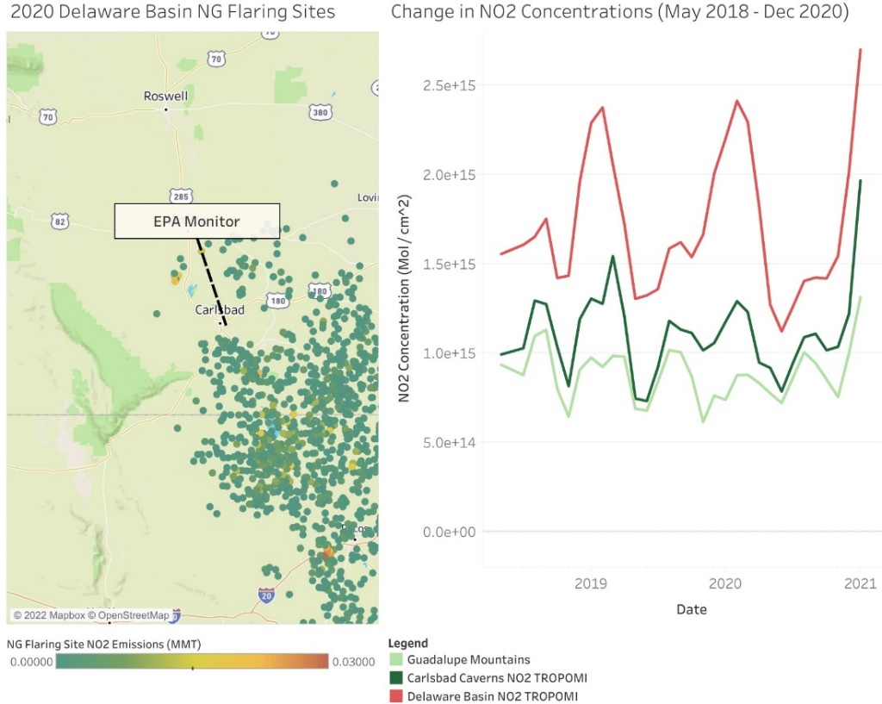

*Figure 2.* Study area with oil and gas flaring sites (a). Monthly average column densities over key points in our study area derived from TROPOMI from May 2018–May 2021 (b).

To statistically evaluate TROPOMI and OCD data, we uploaded shapefile boundaries of GUMO and CAVE National Parks and the Delaware Basin extents to ArcGIS. Because natural gas flaring is most active within the boundaries of the Delaware Basin, we created a shapefile boundary using the Intersect tool to extract the area that is within ten miles of CAVE and inside the Delaware Basin. Our team uploaded the TROPOMI raster files representing monthly NO2 average column densities to ArcGIS. Using the Zonal Statistics to Table tool, we then calculated the average NO2 column densities for each month within each extent of interest (i.e., GUMO, CAVE, Delaware Basin, and the intersection region). The spatial averages for each extent of interest and month were recorded in a separate Excel workbook. TROPOMI seasonal column densities of NO2 at the National Parks were then graphically compared against TROPOMI seasonal column densities of NO2 in the Delaware Basin (Figure 2). Finally, we graphically compared the TROPOMI seasonal column densities of NO2 at the intersection of the CAVE ten-mile buffer zone and the Delaware basin against the TROPOMI seasonal column densities of NO2 in the Delaware Basin (Figure 3).

b.

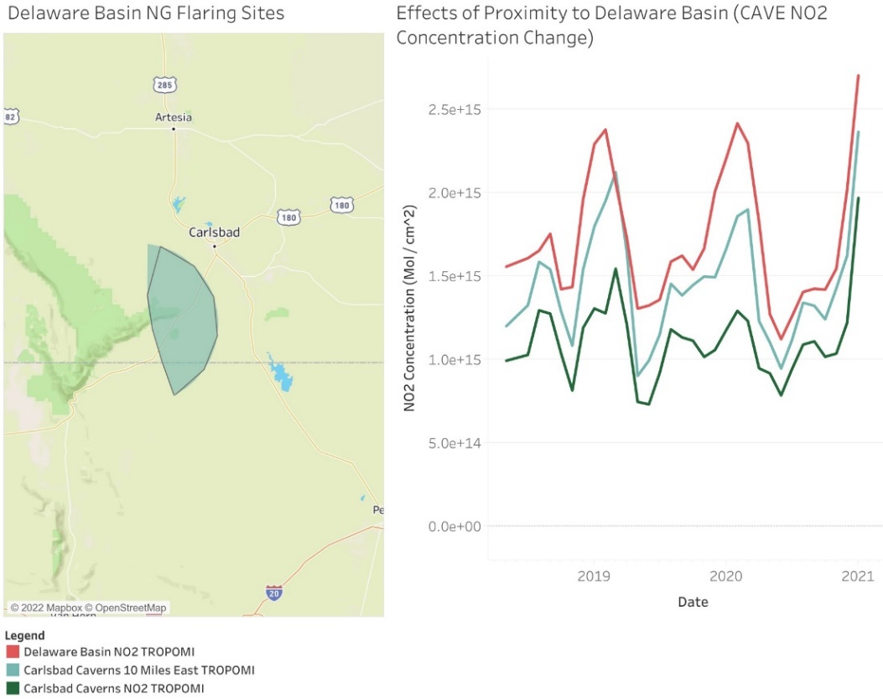

*Figure 3.* Study area with ten-mile intersection area of the Delaware Basin and CAVE (left). Monthly average column densities over areas closest to oil and gas exploration in our study area derived from TROPOMI from May 2018–May 2021 (right).

# 4. Results & Discussion

***4.1 Analysis of Results***

Oil and gas flaring observations have increased steadily since 2010. There were seventeen active oil and gas wells within ten miles of CAVE in 2021. OMI saw a 6.6% annual increase in NO2 from 2010–2018, and TROPOMI showed a 2.5% annual increase from 2018–2021. In addition, ground measurements show an 8% increase in flaring from 2013–2021.

*4.1.1 OMI*

Mean yearly OMI NO2 column densities were graphed in a 6° bounding box surrounding the Delaware Basin, CAVE, and GUMO from May 2010–April 2021, although only 2010–2018 were analyzed with OMI, reserving 2018–2021 for the higher-resolution TROPOMI. The Delaware Basin showed a +38.3% change in NO2 column densities from 2011–2018, with a -1% change from 2018–2020. The partial years of 2010 and 2021 were not included in the annual statistics because the seasonality present in NO2 column densities would inflate the annual mean calculations of these years. See Figure 4 for a visualization of this seasonality.

From the years of 2011–2018, CAVE and GUMO exhibit opposite trends. The percent change in NO2 concentration over CAVE is +15.29 %, while over GUMO, the percent change is -4.26 %. CAVE had a much smaller concentration of NO2 in 2010. The rate of change over CAVE was negative on average until 2015, when a local spike in NO2 column density over the Delaware Basin contributed to a spike in NO2 column density over CAVE. As NO2 column density continued to rise on average over the Delaware Basin after 2015, column densities over CAVE remained relatively constant during the same time interval. NO2 column density measurements over GUMO increased on average through 2015, matching what is found over the Delaware Basin over the same time interval. After 2015, column density decreased, showing an opposite trend to the Delaware Basin over the same time interval.

*Figure 4*. Yearly column densities from the study region from May 2010 – May 2021 derived from OMI observations.

*Figure 5.* Seasonal averages between flaring observations and TROPOMI retrievals (top); seasonal average comparison between EPA ground monitor data and TROPOMI retrievals (bottom).

*4.1.2 TROPOMI*

Statistically driven data were graphed alongside monthly TROPOMI NO2 column densities from the Delaware Basin region, showcasing a seasonal alignment amongst different data sources (Figure 5). This alignment provides confidence that the TROPOMI measurements in the Delaware Basin region are accurate to local monitoring estimates (EPA monitor) and that the seasonal shape of the NO2 column densities is driven in part by the natural gas flaring occurring in the region. We found less alignment between the seasonal NO2 column density patterns in the Delaware Basin and the NO2 concentrations within the boundaries of the national parks, although both CAVE and GUMO still show a seasonal trend (Figure 6). TROPOMI measured a -1 % change over the Delaware Basin, a +3% change over CAVE, and a +7% change over GUMO from 2018-2020. On average, the NO2 column densities within the two national park boundaries were also found to be much lower than in the Delaware Basin. This indicates that on a monthly average basis, the flaring effects from the Delaware Basin are not as apparent within the boundaries of the parks. However, daily NO2 concentrations from natural gas flaring activities can still vary dramatically despite lower average monthly NO2 column densities.

We found stronger alignment between monthly NO2 column density patterns within ten miles east of the CAVE national park and inside CAVE than anywhere else in the Delaware Basin. Figure 3 compares mean monthly NO2 measurements inside CAVE to within ten miles of CAVE. The plot in Figure 7a shows a strong correlation between their measurements, denoted by an R2 value of 0.87. Figure 7b shows an R2 value of 0.65 between NO2 column densities inside CAVE and measurements beyond the ten-mile region closest to CAVE. On average, NO2 column densities within ten miles of CAVE intersecting the Delaware Basin were higher than NO2 column densities within the boundaries of CAVE. This indicates that the NO2 column density effects of natural gas flaring are more apparent directly outside of CAVE. Additionally, this distance relationship between CAVE and the ten-mile zone outside CAVE within the Delaware Basin indicates that NO2 trends within CAVE will likely respond more directly to changes in NO2 activity that occur closer to the park. The column densities found in GUMO do not correlate with the areas within ten miles of CAVE or beyond ten miles of CAVE, showing R2 values of 0.46 and 0.27, respectively (Figures 7c and 7d).

*Figure 6.* Monthly TROPOMI column density observations from May 2018–April 2021 for CAVE, GUMO, and Delaware Basin.

|  |  |
| --- | --- |
|   **(a)** |  |
|   **(c)** |   **(d)** |

*Figure 7*. Scatter plots of average monthly NO2 column densities: (a) within 10 miles of CAVE compared to inside CAVE boundaries, (b) beyond 10 miles of CAVE compared to inside CAVE boundaries, (c) within 10 miles of GUMO compared to inside GUMO boundaries, (d) beyond 10 miles of GUMO compared to inside GUMO boundaries.

***4.2 Future Work***

If this project was given an additional term, an environmental degradation study would be insightful for managing park health and safety. This term measured a rise in NO2 near the study area, but the environmental effects of this change on vegetation, water quality, health, and wildlife still remain unknown. Additionally, this work can be expanded by investigating a larger set of atmospheric pollutants. Data from the Global Gas Flaring Reduction Partnership (GGFR) shows flaring near the park; however, the exact combination of pollutants that are emitted from oil and gas flaring is never precisely known. Identifying the existing combinations can further elucidate specific interventions that need to be taken. Future projects can also build upon our work and supplement our results by incorporating measures from a wider array of ground-based monitors. If the parks or other stakeholders in the region install other NO2 monitors than the ones currently used, ground validation could be improved. Alternatively, the parks recently stationed a network of low-cost PurpleAir monitors, which measure particulate matter. These monitors would be a valuable tool to implement in a future study. Lastly, future work should focus on visibility. Haze during the day obstructs the scenery of the park, while light pollution prevents stargazing at night (“Air Pollution & Visibility,” n.d.), and may also disrupt the migratory and sleeping patterns of local wildlife. The National Parks aim to protect natural resources not only for the protection and preservation of wildlife but also for the promotion of visitor education and experience. Exploring these miscellaneous pollutants and measures can offer critical information to help protect park natural resources and improve the park experience for visitors.

# 5. Conclusions

America’s National Parks were originally designed to preserve areas of natural and historic significance. Today, they are also areas where members of the public can experience and appreciate pristine sites. Since the formation of the NPS, numerous efforts have been enacted to protect park natural resources, including air quality, efforts such as the Clean Air Act and the NPS Night Skies program. This analysis capitalized on OMI and TROPOMI satellite sensing, ground-based monitor measurements, gas and oil flare data, and emissions data. Through this analysis, we were able to demonstrate an increase in NO2 column densities around the Guadalupe Mountains and Carlsbad Caverns National Parks in the past decade. This historical overview offers insight into the spatial and temporal pattern of NO2 precursor pollutants. Spatially, the greatest increases in NO2 column densities around the parks occurred within 10 miles east of Carlsbad Caverns National Park, near the overlap area between the Delaware Basin and the park, closest to oil and gas flaring activity. Temporally, the greatest increases occurred in 2017–2018, and more specifically during the winter seasons. We illustrated these variations using ArcGIS maps, Python plots, and statistical analyses in Excel. These outputs will inform the placement of new air monitoring stations to better inform visitors of air quality and will provide NPS staff with critical data imperative for supporting improved park experience, health, and stewardship. Ecosystem health and visibility in GUMO and CAVE National Parks are vital to maintaining the natural resources and unique biodiversity of these national emblems, and this data will equip partners with insight to assist with park management policy.

# 

# 6. Acknowledgments

We thank our partners with the National Park Service at Carlsbad Caverns and the Guadalupe Mountains: Lisa Devore, Erin Lynch, and Mike Medrano for offering their experience on the ground, which ultimately led to the successful completion of this DEVELOP project. We also thank our science advisors, Dr. Laura Judd, Elizabeth Wiggins, and Dr. Kenneth Ross, whose technical and scientific expertise were instrumental to the team and our methodologies. We want to thank Dr. Daniel Goldberg at George Washington University for his continuous support and guidance, and whose contributions made this project possible and sustainable. Lastly, we would like to thank our node fellow, Adriana Le Compte, for her day-to-day leadership throughout the DEVELOP process.

This material contains modified Copernicus Sentinel data 2018–2021, processed by ESA.

Any opinions, findings, conclusions, or recommendations expressed in this material are those of the author(s) and do not necessarily reflect the views of the National Aeronautics and Space Administration.

This material is based upon work supported by NASA through contract NNL16AA05C.

# 7. Glossary

**bcm** – billions of cubic meters

**CAVE** – Carlsbad Caverns National Park

**ECMWF** – European Centre for Medium-range Weather Forecasts

**EPA** – Environmental Protection Agency

**ESA** – European Space Agency

**GGFR** – Global Gas Flaring Reduction Partnership

**GIS** – Geographic Information System

**GUMO** – Guadalupe Mountain National Park

**IMPROVE** - Interagency Monitoring Protection of Visual Environments

**mmt** – millions of metric tons

**NO2** – Nitrogen dioxide

**NOx** – Nitrogen Oxides are a family of poisonous, highly reactive gases.

**NOAA** – National Oceanographic and Atmospheric Administration

**NPS** – National Park Service

**OCD** – Oil Conservation Division

**OMI** – Ozone Monitoring Instrument

**PySTAC** – Python SpatioTemporal Access Catalog

**S5P-PAL** – Sentinel-5 Precursor Product Algorithm Library

**TROPOMI** – Tropospheric Monitoring Instrument

# 8. References

*Air Pollution & Visibility*. (n.d.).National Park Service. https://www.nps.gov/subjects/air/visibility.htm

*National Parks and the Clean Air Act*. (n.d.). National Park Service. <https://www.nps.gov/subjects/air/cleanairact.htm>

Crossman, E. (2021). Meteorological Drivers of Permian Basin Methane Anomalies Derived from TROPOMI. *Remote Sens*. 13, 896. Retrieved March 31, 2022 from <https://www.mdpi.com/2072-4292/13/5/896/htm>

DeFlorio-Barker, S., Crooks, J., Reyes, J., & Rappold, A. G. (2019). Cardiopulmonary Effects of Fine Particulate Matter Exposure among Older Adults, during Wildfire and Non-Wildfire Periods, in the United States 2008-2010. *Environmental Health Perspectives*, 127(3), 37006. <https://doi-org.libpublic3.library.isu.edu/10.1289/EHP3860>

*Drilling Productivity Report*. (n.d.). U.S. Energy Information Administration (EIA). <https://www.eia.gov/petroleum/drilling/index.php>

Eskes, H., Geffen, J. van, Boersma, F., Eichmann, K.-U., Apituley, A., Pedergnana, M., Sneep, M., Veefkind, J. P., & Loyola, D. (2021). Sentinel-5 precursor/TROPOMI Level 2 Product User Manual Nitrogendioxide. 4.0.2. https://sentinel.esa.int/documents/247904/2474726/Sentinel-5P-Level-2-Product-User-Manual-Nitrogen-Dioxide

Follett, R. F., & Hatfield, J. L. (2001). Nitrogen in the Environment: Sources, Problems, and Management. *The Scientific World Journal*, 1, 920–926. <https://doi.org/10.1100/tsw.2001.269>

Goldberg, D. L., Anenberg, S. C., Kerr, G. H., Mohegh, A., Lu, Z., & Streets, D. G. (2021). TROPOMI NO2 in the United States: A Detailed Look at the Annual Averages, Weekly Cycles, Effects of Temperature, and Correlation with Surface NO2 Concentrations. *Earth’s Future*, 9(4), e2020EF001665. <https://doi.org/10.1029/2020EF001665>

Latza, U., Gerdes, S., & Baur, X. (2009). Effects of nitrogen dioxide on human health: Systematic review of experimental and epidemiological studies conducted between 2002 and 2006. *International Journal of Hygiene and Environmental Health*, 212(3), 271–287. <https://doi.org/10.1016/j.ijheh.2008.06.003>

*NPS Class I Areas*. (n.d.). U.S. National Park Service. https://www.nps.gov/subjects/air/npsclass1.htm

*PySTAC Documentation*. (n.d.). SpatioTemporal Asset Catalog. <https://pystac.readthedocs.io/en/stable/>

S5P-PAL Data portal. (n.d.). Retrieved February 22, 2022, from <https://data-portal.s5p-pal.com/products/no2.html>

Umukoro, G. E., & Ismail, O. S. (2017). Modelling emissions from natural gas flaring. *Journal of King Saud University - Engineering Sciences*, *29*(2), 178–182. <https://doi.org/10.1016/j.jksues.2015.08.001>

Veloski, G., & Pekney, N. J. (2014, February 18). Measurement of atmospheric pollutants associated with oil and natural gas exploration and production activity in Pennsylvania's Allegheny National Forest. Taylor & Francis. Retrieved March 26, 2022, from <https://www.tandfonline.com/doi/full/10.1080/10962247.2014.897270?scroll=top&needAccess=true>

Wright, W. R. (2011). Pennsylvanian paleodepositional evolution of the greater Permian Basin, Texas and New Mexico: Depositional systems and hydrocarbon reservoir analysis. *AAPG Bulletin*, *95*(9), 1525–1555. <https://doi.org/10.1306/01031110127>

Yue, X. & Unger, N. (2018) Fire air pollution reduces global terrestrial productivity. *Nature Communications*, 9(1). https://doi.org/10.1038/s41467-018-07921-4