New Orleans Health and Air Quality

Monitoring the Urban Heat Island Effects on the Health of Residents of New Orleans, Louisiana Metropolitan Area with Landsat Land Surface Temperature Products

 **Technical Report**

Final – November 20th, 2018

Madison Murphy (Project Lead)

Charles Christonikos

Alahna Moore

Ann Rodden

Joe Spruce, Science System & Applications Inc. (Science Advisor)

Dr. Kenton Ross, NASA Langley Research Center (Science Advisor)

Bernard H. Eichold II, M.D., Dr. P.H., Mobile County Health Department (Mentor)

**1. Abstract**

The urban heat island (UHI) effect occurs when non-vegetated surfaces trap heat during daylight hours, increasing the overall temperature of urbanized cities relative to adjacent rural areas. Excessive heat can increase the likelihood of heat stroke or dehydration, especially in vulnerable populations without access to adequate cooling mechanisms and in residents with medical complications that reduce heat endurance. This research used remotely sensed imagery from Landsat 5 Thematic Mapper (TM), Landsat 7 Enhanced Thematic Mapper Plus, Landsat 8 Operational Land Imager (OLI), and Landsat 8 Thermal Infrared Sensor (TIRS) to map land surface temperature (LST) in relation to urban and vegetated surfaces. The team produced a land cover classification of the New Orleans metropolitan area to quantify the extent of gray infrastructure and tree cover canopy. The team then produced snapshot LST datasets to visualize annual heating trends for the summer months of each year between 2000 through 2018. These LST data, overlaid with NDVI and land cover classification maps, identified “hot spot” areas prone to excess heat and calculated their proximity to urban areas and vegetated surfaces. Finally, the team produced a heat vulnerability analysis map that determined spatial relationships between areas prone to severe urban heat and Census Tracts with large populations of residents identified as vulnerable due to income, age, and education. Our project provided the Louisiana Public Health Institute with end products that will be used in combination with clinical health data to improve New Orleans’ heat mitigation strategies and sustainability efforts.

**Keywords**

Urban heat island (UHI), health, extreme heat, land cover classification, Land Surface Temperature (LST), remote sensing, Normalized Difference Vegetation Index (NDVI), social vulnerability index

# 2. Introduction

***2.1 Background Information***

Steadily rising temperatures have resulted in increases in the intensity, frequency, and duration of extreme heat events around the globe. The consequences from rising temperatures will be most acute in urban areas due to a phenomenon known as the urban heat island (UHI) effect, where temperatures in urban areas tend to be warmer than the surrounding countryside (Knight, Price, Bowler, & King, 2016). This excess warming of urban areas is a result of several anthropogenic factors: the presence of materials such as asphalt and concrete with low albedo and high heat absorption capacity; the limited presence of vegetated and permeable surfaces which limit shade and evapotranspiration; and the concentration of heat-trapping greenhouse gases near the ground surface (Wang, Berardi, & Akbari, 2015). Heat is the number one cause of weather-related deaths in the United States and, according to the Centers for Disease Control and Prevention, extreme heat events are projected to become more severe and frequent in the near future. Currently, extreme heat events that previously occurred once every 20 years in U.S. urban areas are now likely to occur every two to four years (Anderson, 2017; U.S. EPA, 2017).

Severe urban heat disproportionately impacts the health of a city’s most vulnerable residents. Table A1 details common impacts on health when a human body is exposed to temperatures exceeding 90° F (Curtis, 1999). Factors that increase one’s risk during an extreme heat episode include being very young or very old, being disabled or homebound, being socially isolated, lacking air conditioning, and/or suffering from psychiatric or cardiopulmonary diseases (Stone, Hess, & Frumkin, 2010). Exposure to extreme heat increases the likelihood of heat stroke and dehydration. Moreover, the warming of the air encourages the formation of ground-level ozone, which can aggravate lung diseases, such as asthma, and increase the risk of premature death from heart or lung disease. With annually increasing temperatures, the atmosphere can hold greater concentrations of moisture and other greenhouse gases, presenting several stressors to the delicate ecology of Southern Louisiana and to the residents of New Orleans, the state’s largest city. Additionally, higher ocean temperatures that result from diverted sediment carried by the Mississippi River contribute to rising sea levels and increase the probability and severity of tropical storm and flooding events in the region; these factors threaten to accelerate the degradation of the Mississippi River Delta and the structural weakening of the levees surrounding New Orleans (Johnson, Fischbach, & Kuhn, 2015).

This study focuses on the greater New Orleans metropolitan area during the months of May through September between 2000 and 2018 (see Figure 1). Protected by levees and floodwalls, New Orleans is a coastal city situated below sea level at a particularly vulnerable point between the Mississippi River and Lake Pontchartrain. It is a sprawling urban area with approximately 1,200,000 residents and relatively little green space. These factors contribute to record-breaking extreme heat trends during the summer months (Fritz, 2016). In July 2017, the City of New Orleans released *Climate Action for a Resilient New Orleans: 50% by 2030*, a climate action strategy that pledges a 50% reduction of New Orleans’ greenhouse gas emissions by modernizing the city’s energy use, encouraging multi-modal transportation, and diverting waste from landfills (City of New Orleans, 2017). A greater understanding of severe heat trends is needed to formulate effective climate mitigation strategies that benefit all New Orleanians moving forward.

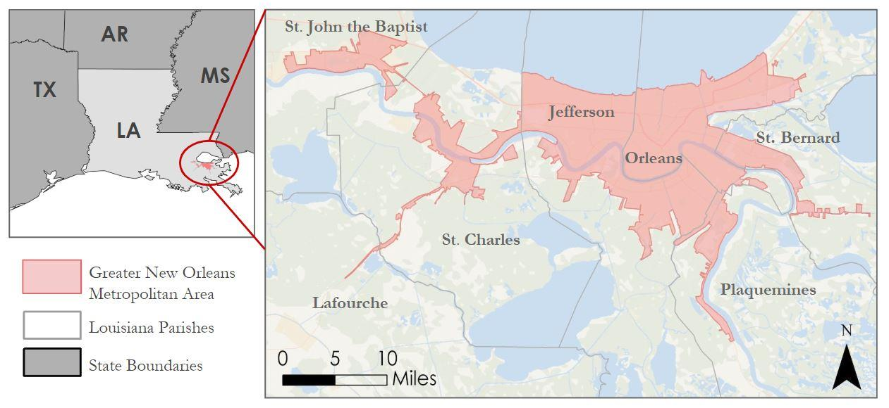  
*Figure 1.* Study area of New Orleans metropolitan area as designated by 2010 U.S. Census data

* 1. ***Project Partners & Objectives***

The Louisiana Public Health Institute (LPHI) examines and analyzes determinants of public health. The organization’s decision making is informed by statistical evidence in conjunction with the lived experiences of impacted communities. The spatial data generated by the New Orleans Health and Air Quality team will be utilized alongside internal medical information and clinical statistics from the LPHI in order to study the relationships between vulnerable populations in New Orleans and areas prone to concentrated severe heat. The team’s deliverables can be used to monitor temporal change in heat concentration in New Orleans over the past two decades by comparing the annual averages of Land Surface Temperature (LST) while also examining seasonal trends and meteorological-related anomalies. This analysis will greatly enhance the capabilities of the LPHI to predict and prevent heat-related illness within the city of New Orleans.

***Project Objectives***

* Visualize patterns of change throughout the study period by compiling a time series analysis of annual LST in New Orleans
* Calculate snapshot Normalized Difference Vegetation Index (NDVI) maps for summer months within the study period
* Create a land cover classification of New Orleans in order to identify municipal zones with higher grey infrastructure density and lower urban tree coverage
* Identify regions experiencing anomalously high temperatures and label them as “hot spots”
* Analyze LST data overlaid with a Social Vulnerability Index (SoVI) map in order to identify areas within New Orleans with higher concentrations of vulnerable citizens at risk of heat-related illness or mortality

**3. Methodology**

***3.1 Data Acquisition***

***3.1.1 Land Surface Temperature***

The team used Landsat 5 Thematic Mapper (TM) and Landsat 8 Operational Land Imager (OLI) and Thermal Infrared Radio Spectrometer (TIRS) Level-1 imagery products to produce a time-series analysis of LST over the course of the designated study period. The team used Landsat 5 TM Level-1 data to obtain imagery for annual analysis for the years 2000 to 2011, and Landsat 8 OLI/TIRS Level-1 data for the years 2013 to 2018 (see Table A2). Neither Landsat 5 TM nor Landsat 8 OLI/TIRS collected any imagery for the year 2012; upon discovering no adequate imagery from Landsat 7 Enhanced Thematic Mapper Plus (ETM+) existed within the study period, the team decided to omit 2012 from all analyses. For each year within the study period, excluding 2012, the team downloaded and processed one image per year between May and September to generate LST map products representative of each year. Overall, the team collected 24 Landsat 5 TM and Landsat 8 OLI/TIRS Level-1 scenes with less than 10% cloud cover downloaded from the U.S. Geological Survey (USGS) Earth Explorer for World Reference System (WRS), path 22 row 39.

Initially, the team sought out to monitor temporal patterns of change in LST throughout the entire study period. As a result of excessive cloud cover obstructing the study area during the summer months, the team collected data from a range of time spanning May 1st to September 30th, a full 5 months. Because the study period defined as “summer months” spanned nearly half of a year, there is great variation in the overall temperatures in the LST products produced by the team. For example, imagery captured in May has extreme values at around 97° F, while imagery captured in August has extreme values around 107° F. While the range of temperatures varies month to month and year to year, the spatial distribution of hot spots is consistent throughout the 18-year study period.

***3.1.2. Land Cover Classification***

The team used Landsat 5 TM and Landsat 8 OLI/TIRS Level-1 imagery products to conduct land cover classifications of select years within the study period (see Table 2). The team used the same Landsat Level-1 products retrieved from USGS Earth Explorer for path 22, row 39 with less than 10% cloud cover for the land cover assessment. The bands from each Landsat sensor used for this analysis all have spatial resolutions of 30 meters. The team used clear, leaf-on imagery collected between the months of May and September in the years 2000, 2006, and 2018. For the purposes of the project, the team decided to only perform classifications for the years 2000, 2006, and 2018. The team determined that three land cover classifications would be adequate to map change from the beginning (2000) to the end (2018) of the study period, as well as in the year following Hurricane Katrina (2006), the most destructive natural disaster to hit New Orleans in the last two decades. The team utilized high-resolution (1 m) National Agricultural Imagery Program (NAIP) imagery from the year 2015 from the National Resource Conservation Service (NRCS) Geospatial Data Gateway (GDG) to improve the accuracy of the unsupervised classifications. Additionally, the team referenced the National Land Cover Dataset (NLCD) from the year 2011 to confirm the validity of the land cover classifications.

***3.1.3. Social Vulnerability Index***  
For the social vulnerability assessment, the team used a SoVI dataset created by the University of New Orleans Center for Hazards Assessment, Response, and Technology (UNO CHART), the Federal Transit Administration, and the City of New Orleans. The UNO CHART team originally created the SoVI for a larger project dedicated to community mapping of vulnerable populations and their ability to evacuate in the event of a disaster (University of New Orleans et al., 2016). Social vulnerability indices are a useful metric to understand the multiple socioeconomic, demographic, and built environment variables that contribute to one’s vulnerability risk such as socioeconomic status, development density, population age, race/ethnicity, and gender (Cutter, 2006).

For this project, the team utilized the SoVI dataset to examine the demographic characteristics that may contribute to a high rate of heat-related illness. The team eventually overlaid and processed these data along with the LST and land cover assessments to arrive at the final product: the Aggregated Heat Vulnerability Assessment. This polygon shapefile divided the metropolitan area into census tracts and then ranked each tract based on the number of individuals residing within that tract that identified themselves in a way that would make them exceptionally vulnerable to the impacts of the UHI effect. High-ranking tracts had a majority population that self-reported as over 65 or under 5 years old, lacking higher education, low income, or linguistically isolated. These socioeconomic factors are considered to increase one’s vulnerability to the negative health impacts caused by extreme heat and disastrous weather events due to a lack of mobility and/or access to resources such as water, shade, and air conditioning.

***3.2 Data Processing***

***3.2.1 Study Area***

The team downloaded the New Orleans city boundary shapefile from the U.S. Census 2010 TIGER/Line (Topologically Integrated Geographic Encoding and Referencing) Urban Area National shapefile system to use as the study area shapefile. The population density of New Orleans in 2010 determined the shapefile (U.S. Census Bureau, 2010). An additional shapefile of the census tracts within Orleans Parish provided by the

UNO CHART SoVI dataset allowed for a more specific analysis of vulnerability. The team projected all shapefile and raster layers to the WGS 1984 UTM Zone 15N coordinate system.

***3.2.2 Land Surface Temperature***

The New Orleans Health and Air Quality team aimed to provide the LPHI with resources to understand the spatial distribution of severe heat within New Orleans over time by generating map products of LST for each year within the study period. The team calculated LST for each scene within the study period by using the LST Single Band method, which involved applying two main inputs: Emissivity (∈) and Top of Atmosphere Brightness Temperature (BT) (Sobrino et al., 2004). An overall workflow for the calculation of the LST outputs for each year from start to finish and a summation of the inputs and outputs is provided in Figure A5 and Table A3, respectively.

First, the team utilized the Semi-automated Classification Plugin (SCP) in QGIS Desktop 2.18.20 to atmospherically correct each of the Landsat 5 TM and Landsat OLI/TIRS Level-1 (30 m) images used in the annual analysis. The plugin converted raw thermal bands from Landsat imagery (Band 6 in Landsat 5, Band 10 in Landsat 8) into Top of Atmosphere (TOA) LST values in Centigrade. The LST values of the processed thermal bands corresponded with brightness temperature values and provided suitable inputs for the team’s LST equation.

Next, the team generated NDVI datasets using the SCP plugin to preprocess the near infrared and visible red bands of Landsat 5 and 8 imagery. Bands 3 and 4 for Landsat 5 and bands 4 and 5 for Landsat 8 represented the red and infrared bands, respectively. To produce NDVI maps from atmospherically corrected infrared and red bands, the team used the raster calculator function to process Equation 1. The Raster Calculator equations for these LST processes can be found in Table A4:

$NDVI= \frac{NIR-R}{NIR+R}$*(1)*

Next, the team obtained the vegetation proportion value using the NDVI Thresholds Method, in which you multiplying the entire image by the midpoint value of the sensor’s range (Sobrino et al., 2004). The Thresholds Method obtains emissivity values from the NDVI considering different cases, where a pixel with an NDVI < 0.2 is considered bare soil while a pixel with an NDVI >0.5 is considered fully vegetated (Carlson & Ripley, 1997). Calculating Equation 2 generated image identifying vegetation proportion (*Pv*):

$Pv= \frac{NDVI-{NDVI}_{min}}{{NDVI}_{max}- {NDVI}_{min}}$*(2)*

With these *Pv* values, the team then applied a Land Surface Emissivity formula based upon typical Emissivity (∈) values for vegetation and soil to arrive at final emissivity values (Sobrino et al., 2004). Emissivity values were calculated using Equation 3:

$∈ =0.004 P_{v}+ 0.986$*(3)*

Finally, the team input the corrected thermal bands and emissivity values for each image into equation 4 to calculate emissivity-corrected LST (*Ts*) (Avdan & Jovanovska, 2015). To automate most of the calculation process, the team used Model Builder in ArcGIS Pro 2.1.0. This workflow is provided in Figure A6. Equation 4 provided an output for LST (*Ts*) by using BT and ∈ as inputs.

$T_{s}= \frac{BT}{\{1+λ\left[\frac{BT}{ρ}\right)ln∈_{λ}]\}}$*(4)*

Each LST output provided temperature values in degrees Celsius. The team converted each image to degrees Fahrenheit and the saved each image as a Tag Image File Format (TIFF) file. Finally, the team loaded each TIFF image into QGIS Desktop 2.18.20 and clipped the image to the study area shapefile to isolate LST values within the area of interest.

***3.2.3 Land Cover Classification***

The team performed land cover classifications for the years 2000, 2006, and 2018. The team used these classified images to quantify the amount of urban land within each census tract and to aid in the interpretation of the LST map products. Land cover datasets illustrated the distribution of open vegetated areas as well as paved, heat-trapping surfaces within the study area. A workflow of the overall land cover classification process is provided in Figure A15.

For the land cover classification products, the team atmospherically corrected Level-1 Landsat 5 and 8 imagery for TOA reflectance using the SCP plugin in QGIS Desktop 2.18.20. The team then used the atmospherically corrected bands of each image to create virtual raster stack images for each year using the SCP plugin. The year 2000 classification used bands 1, 2, 3, 4, 5, and 7 from Landsat 5 to build virtual raster stacks; Landsat 8 captured data for the years 2006 and 2018 and the team used bands 2, 3, 4, 5, 6, 7, and 10 for that satellite. The team clipped each raster stack to the study area shapefile.

On each clipped image, the team ran an unsupervised classification using the Iso-cluster Unsupervised Classification tool in ArcGIS Pro 2.1.0, which grouped pixels into 20 classes. The specifications of the inputs entered into the tool are listed in Table A5. Next, the team masked out water values and ran the Unsupervised Classification tool again, reducing the class number to 13. From these 13 classes, the team created a more refined classification scheme with less than 10 classes distinguishing between urban and vegetated land covers. The maps identified of both intensity developed and vegetated areas by using descriptors such as “Developed, high intensity” and “Densely forested”. Classified maps for the years 2000 and 2018 are Figure A16 and Figure A17, respectively.

Following this secondary classification, the team refined the land cover classification scheme to two classes: vegetated and urban. The team reclassified urban areas as 1, and all vegetated spaces as 0. A breakdown of this classification scheme is seen in Table A6. The team calculated zonal statistics on the simplified Urban and Vegetation land cover classification for 2018 to find the percentage of urban density within each census tract (see Figure A21). The mean of each census tract represented the percentage of urban land cover. A census tract with a value approaching 1 has predominantly urban land cover within that tract.

***3.2.3 Social Vulnerability Index***

By appending demographic data of New Orleans from the 2014 U.S. Census Bureau’s American Community Survey (ACS) along with a TIGER/Line shapefile of census tracts within Orleans Parish (2016), UNO CHART created the SoVI. The team compiled data of 27 socioeconomic variables in Orleans Parish (see Table A7) into a spreadsheet, then joined to each census tract in the TIGER/Line shapefile by unique GEOID IDs using ACS. The team assigned priority rankings of High, Medium, and Low to each of the 27 variables of interest on the basis of priority in relation to evacuation needs; a more specific overview of the factors used to assign priority can be found in Table A8. The team assigned each priority tier a multiplier (High - multiplier of 3, Medium - multiplier of 2, Low - multiplier of 1), producing new weighted values to quantify social vulnerability. These values, or Social Vulnerability Scores, ranged from 1 to 52; tracts with average scores between 1 and 30 indicate lowest levels, those with average scores between 31 and 40 indicate moderate levels, and those with average scores between 41 and 52 indicate highest values of social vulnerability (2016).

***3.2.4 Aggregated Heat Vulnerability Assessment***

The Aggregated Heat Vulnerability Assessment identifies which areas of New Orleans are most vulnerable to the effects of UHIs based on the spatial distribution of heat islands, the composition of vegetation and urban land cover in the city, and demographic factors, such as those found in Table A8, that influence an individual’s risk of experiencing health impacts from severe heat. The Aggregated Heat Vulnerability Assessment utilized three input layers: the mean LST per census tract for July 9, 2018, the percent urban land cover assessment, and the UNO CHART SoVI.

The team reclassified each layer on a scale of 1-5, with 1 being least impactful to heat vulnerability and 5 being most impactful. The reclassified values are listed in Table A9. The land cover and LST assessments utilized a mean of raster values within a census tract polygon. The team brought all three input layers into QGIS Desktop 2.18.20, converted the SoVI into a raster format, and overlaid the three input layers. Using the Raster Calculator function, the team consolidated the three disparate values into a single value for each census tract. Assigning an equal weight of .33 to each input layer allowed for a composite image to be created that represents the Heat Vulnerability score for each census tract as a single value between 1 and 5. The resulting map displayed the census tracts with the highest overall vulnerability scores as dark red (5) and those with the lowest overall vulnerability scores as dark green (1).

***3.3 Data Analysis***

***3.3.1 Land Surface Temperature***

Once the team loaded each LST output image into QGIS Desktop 2.18.20, a custom color ramp allowed for visualization of the spatial distribution of surface temperature. Deep blue represented the lowest relative temperature (70°F) and deep red represented the highest relative temperature (100°F), allowing for the identification of “hot spots” for each image. An example of one of the images with this color ramp applied is provided below in Figure 2.

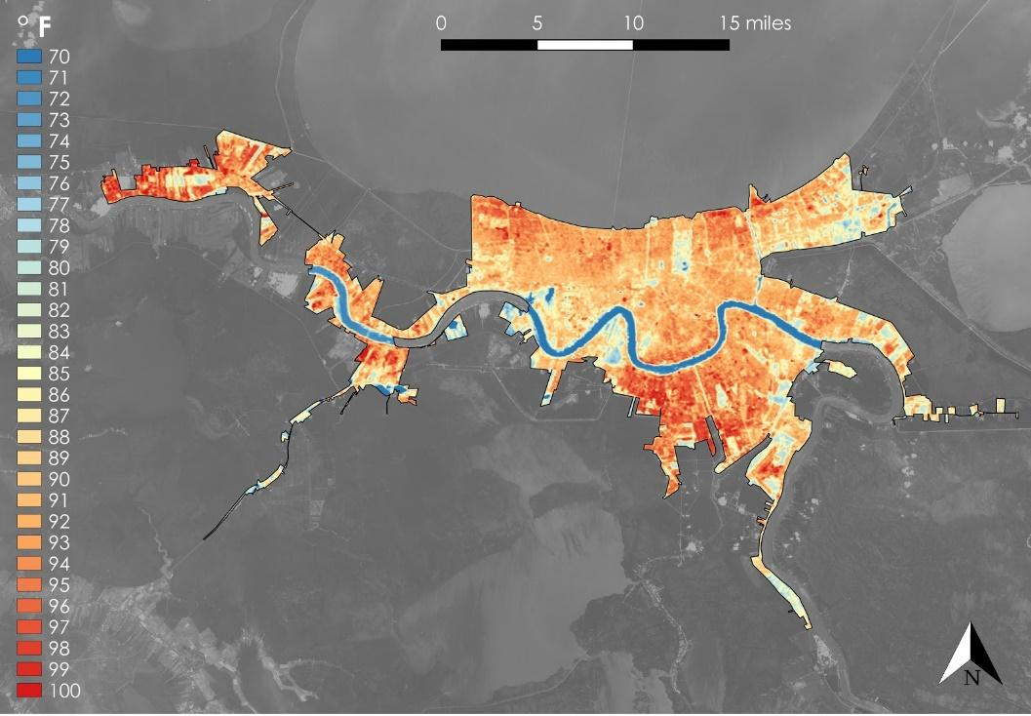

*Figure 2*. Landsat 5 TM imagery indicating LST values for New Orleans New Orleans on June 6, 2006

For statistical analysis of the LST maps, the team used the Zonal Statistics tool in ArcGIS Pro 2.1.0. to calculate the mean temperature for each census tract within Orleans Parish. The team used 90°F as a threshold of what constitutes as a “hot spot” area, as prolonged exposure to apparent temperatures of 90°F and above puts the human body at risk of experiencing heat exhaustion and stroke (Curtis, 1999). The team ranked each census tract between 1-5 based on 5 Fahrenheit degree increments between 75 and 100 andreclassified the output raster with the same values.

***3.3.2. Land Cover Classification***

The team calculated zonal statistics by re-classifying the land cover classification for 2018 so that pixels of vegetated land cover were assigned a value of 0 and pixels of urban land cover a value of 1. Using the Zonal Statistics tool in ArcGIS Pro 2.1.0., the team calculated the percentage of urban land cover for each census tract. This tool ranked each tract with a score between 0 and 1, where a value of 0 denotes an entirely vegetated census tract and a value of 1 denotes an entirely urbanized tract. The team then took these scores and ranked them 1 through 5 as follows: tracts with a score between 0 and 0.2 represented a rank of 1, between 0.2 and 0.4 a rank of 2, between 0.4 and 0.6 a rank of 3, between 0.6 and 0.8 a rank of 4, and between 0.8 and 1 a rank of 5. The resulting map displayed census tracts with the highest percentage of urban cover as dark red (most vulnerable - 5) and those with the lowest percentage of urban cover as dark green (least vulnerable - 1).

***3.3.3 Social Vulnerability Index Assessment***

In order to incorporate the raw data from the UNO CHART’s SoVI, the values ranging from 1-52 needed to be simplified (see Figure A18). To maintain consistency, the team ranked the raw values and reclassified them from 1-5 based on the classes outlined in Table A6. The natural breaks (Jenks) histogram in QGIS influenced the selection of these classes. In addition to numerical consistency, the QGIS rasterize tool allowed the team to convert the SoVI shapefile to a raster from a vector while maintaining the native resolution of the shapefile (see Figure A19). This process prepared the SoVI dataset for incorporation into the final Heat Vulnerability Assessment.

***3.3.4 Aggregated Heat Vulnerability Assessment***

The team created an Aggregated Heat Vulnerability Assessment for the greater New Orleans area by evaluating the spatial patterns of vulnerability based on three contributing factors: social vulnerability, the density of development and gray infrastructure, and LST. The team divided each variable into census tracts and reclassified each tract on a scale from 1-5 in order to create uniformity between disparate datasets. To create a final Heat Vulnerability Assessment, the team utilized Raster Calculator tool in QGIS Desktop 2.18.20 to multiply each raster by .33 (for equal weight) and combine the three raster layers, as seen in Figure A20.

**4. Results & Discussion**

***4.1 Analysis of Results***

***4.1.1 Aggregated Heat Vulnerability Assessment Variables***

To build the Aggregated Heat Vulnerability Assessment, the team compiled data representing three variables contributing to heat vulnerability: social vulnerability, land cover, and LST. In order to make all variables uniform, the team assigned each census tract a ranking, as seen in Table A9. The team reclassified the original SoVI dataset and then performed the Rasterize function within QGIS. The resulting raster variable maps are Figure 3 and Figure 4 below.

***4.1.1 Heat Vulnerability Assessment***

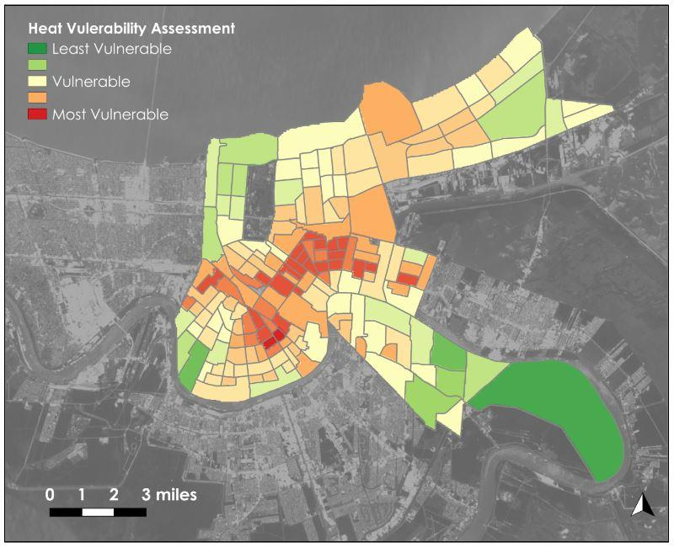

*Figure 3.* Aggregated Heat Vulnerability Assessment using Landsat 8 OLI/TIRS imagery for New Orleans on July 9, 2018

In the final Aggregated Heat Vulnerability Assessment, each census tract is assigned a Heat Vulnerability score between 1 and 5. Tracts with higher scores, such as Census Tracts 31, 75.02, and 92, have large populations of socially vulnerable residents, high-density urban development, and exhibit high LST values (90°-100°F). Comparatively, census tracts such as 76.04, 120, and 142 have higher percentages young, wealthy, and educated residents, with more vegetated land cover, and typically lower LST values (80°-90°F). Census tracts of interest and their respective heat vulnerability scores are provided in Figure A20 and Table A10.

The Aggregated Heat Vulnerability Assessment is a deliverable created to suit the needs of the LPHI. The purpose of this map is to identify areas that are likely to have high rates of heat-related hospitalizations. This data can be used in a variety of applications: to confirm clinical data, to expedite monitoring of hospitalization rates in specific areas, or to improve the distribution of the LPHI’s resources throughout the city. Areas with Heat Vulnerability Scores exceeding 4 are exceptionally likely to have many residents experiencing negative impacts from rising temperatures, and therefore public health can benefit from the addition of shade structures and drinking water access in these areas. Policy decisions made by the LPHI can be informed and improved upon based on this map product.

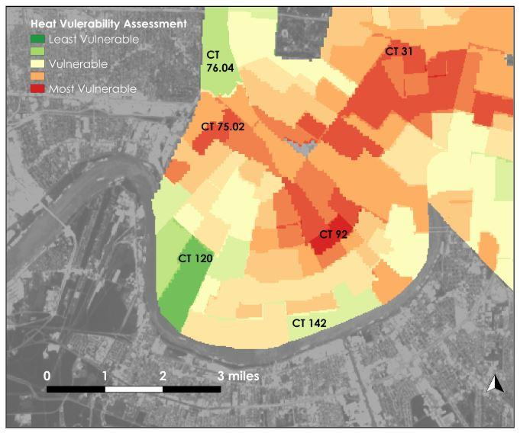  
*Figure 4*. Census tracts ranked in Aggregated Heat Vulnerability Assessment using Landsat 8 OLI/TIRS imagery for New Orleans on July 9, 2018

***4.1.2 Land Surface Temperature***

The LST model produced 24 maps using Landsat imagery. One image represented each year for the study period. Figure 11 shows the LST map of New Orleans for May 23, 2001. Figure A14 depicts the same map with extreme temperature values highlighted. The coolest point in this image is 79°F, located in Audubon Park. Conversely, a hot spot in the Central City neighborhood registered a temperature of 104°F. This image shows temperatures higher than average in late May when the expected high temperature at New Orleans International Airport is 85° (National Weather Service). Based on this image, the range between extreme high and low temperatures for the year 2001 is 25°F.

Compared to May 23, 2001, LST calculations for May 24, 2013, suggested much higher values. Despite a median point, the distribution of high temperatures remained the same. The average high temperature in May is 85°F (National Weather Service). In the maps from 2013, the majority of the city is between 85°-95°F. This LST image clearly depicts cool areas in yellow along major Live Oak tree-lined streets, such as St. Charles, Carrollton, and Esplanade Avenues, surrounded by 90°F urban and residential areas. Hot spots of 92°F and 97°F are present in the Central City neighborhood (92°F) and in the Central Business District (97°F).

Figure A11 shows LST values in the upper 90°-100°F range for August of 2015. According to the National Weather Service, the average high temperature for August at the New Orleans Airport is 91°F, but the values in Figure A12 greatly exceed that temperature. The spread of temperatures between the cool spot of 85°F at Audubon Park and 112°F in Central Business District is 27°F.

Figures A13 and A14 illustrate the LST on July 9, 2018. This specific image clearly depicts that distribution of high temperatures throughout the city on an average day in July. Blues and pale yellows on the map represent temperatures in the upper 70s and low 80s, and these values are often found in regions of vegetated space. This image also highlights densely urbanized regions with values in dark red representing LST values in the upper 90s and 100s. The spread between the coolest space in Audubon Park (79°F) to the concrete and asphalt filled Central Business District (105°F) is 26°F.

The urban heat island effect can be seen in Figures A7-A14 where densely populated areas with large amounts of urban land cover are shown to have higher LST values compared to spaces with vegetated land cover. Throughout the time series, the difference between high and low values of a single image remained between a 20°-30°F spread. It can be deduced that urban density positively relates to higher LST values based on this trend. It is clear within the team’s research that urban spaces with gray infrastructure regularly reach temperatures much higher than the average temperature of the city, while vegetated areas remain approximately 20°F cooler than urban areas. It is shown in Figures A7-A14 that hot spots are located in regions with dense urban infrastructure. With this understanding, it can be said that proximity to dense urban infrastructure causes an increased risk for extreme heat exposure which may lead to heat-related illnesses.

***4.2 Future Work***

The LPHI can use the end products created by the team to highlight areas that are experiencing extreme impacts of UHI effect, and these maps can be compared with the organization’s clinical health data to denote any correlation between heat-related illnesses and corresponding hot spots within the city. It would be beneficial to access health information related to extreme heat illnesses in the city of New Orleans in order to confirm any spatial correlation between areas with significant reporting of heat-related illness to team-identified “hot spots” within the city. Additionally, a corresponding ground truth investigation would be helpful to analyze and validate the air temperature within the city from the LST data. The LST values do not always align with the above ambient temperature with consideration to environmental variables such as wind, the presence of clouds, and precipitation. Thus, an *in situ* measurement for surface air temperatures would be helpful for a more accurate understanding of heat response of varying surfaces within an urban region.  
  
**5. Conclusions**

Through the utilization of NASA Earth observations, the team quantified impacts of the urban heat island effect in New Orleans, Louisiana. The team’s research depicted a positive spatial relationship between areas with dense urban land cover, census tracts with residents who have socioeconomic setbacks, and regions experiencing extreme land surface temperatures. Each of these factors contributes to the intensity of the UHI effect upon human health, and this project identified areas of interest for further research and outreach opportunities. This information will help to lay a foundation by identifying regions in New Orleans that have a higher risk for heat-related illness or mortality due to the UHI effect.

**6. Acknowledgments**

* Joe Spruce, Lead Science Advisor, Science Systems and Applications, Inc.
* Dr. Kenton Ross, Science Advisor, NASA Langley Research Center
* Bernard H. Eichold II, M.D., Dr. P.H., Mentor, Mobile County Health Department
* Dr. Thomas Carton, Chief Business Development Officer, Louisiana Public Health Institute
* Helen Baldwin, Center Lead, NASA DEVELOP Alabama – Mobile and Alabama – Marshall nodes
* Kathrene Garcia, Communications Fellow, NASA DEVELOP Alabama – Marshall

Any opinions, findings, and conclusions or recommendations expressed in this material are those of the author(s) and do not necessarily reflect the views of the National Aeronautics and Space Administration.

This material is based upon work supported by NASA through contract NNL16AA05C.

# 7. Glossary Earth observations – satellites and sensors that collect information about the Earth’s physical, chemical, and biological systems over space and time

**ESA –** European Space Agency

**Hot spot** **–** an area within the urban heat island (i.e. the entire urban area) exhibiting its own distinct heating trends when compared to the urban segments around it

**Land Surface Temperature (LST) –** radiative skin temperature of the land surface estimated from top of atmosphere brightness temperatures from the infrared and thermal bands

**LPHI –** Louisiana Public Health Institute

**Landsat 5 TM** **–** Landsat 5 Thematic Mapper

**Landsat 7 ETM+ –** Landsat 7 Enhanced Thematic Mapper Plus

**Landsat 8 OLI –** Landsat 8 Operational Land Imager

**Landsat 8 TIRS –** Landsat 8 Thermal Infrared Sensor

**Normalized Difference Vegetation Index (NDVI) –** index measuring chlorophyll content by calculating near infrared and red-light reflection

**Semi-Automatic Classification Plugin (SCP) –** a plugin for QGIS that provides tools for the download, preprocessing and processing of remotely sensed images

**Social Vulnerability Index (SoVI) –** anindex created by a research team at the University of New Orleans used to map locations of vulnerable populations and their ability to evacuate in the event of a disaster

**Urban Heat Island (UHI) –** an urban or metropolitan area that is significantly warmer than surrounding rural areas due to the presence of impervious surfaces and other human activities

**USGS –** United States Geological Survey

# 8. References

Anderson, H. et al. (2017, May 27). *Climate and Health Intervention Assessment: Evidence on Public Health Interventions to Prevent the Negative Health Effects of Climate Change.* Retrieved from <https://www.cdc.gov/climateandhealth/>

Carlson, T.N., & Ripley, D.A. (1997). On the relation between NDVI, fractional vegetation cover, and leaf area index. *Remote Sensing of Environment, 62*, 241-252*.*

City of New Orleans. (2017). *Climate Action for a Resilient New Orleans*. Retrieved from https://nola.gov/resilience/climate-action/

Curtis, R. (1999). *The Backpacker’s Field Manual.* Retrieved from https://www.princeton.edu/~oa/safety/heatcold.shtml

Cutter, S., Mitchell, J., & Scott, M. (2000). Revealing the vulnerability of people and places: A case study of Georgetown County, South Carolina. *Annals of the Association of American Geographers, 90(*4), 713-737*.* Retrieved from https://www.tandfonline.com/doi/abs/10.1111/0004-5608.00219

Fritz, A. (2016, September 26). The mind-boggling New Orleans heat record that no one is talking about.    *The Washington Post.* Retrieved from https://www.washingtonpost.com/news/capital-weather-gang/

Johnson, D., Fischbach, J., & Kuhn, K. (2015). Current and Future Flood Risk in Greater New Orleans. *The New Orleans Index at Ten.* Retrieved from https://s3.amazonaws.com/gnocdc/reports/TheDataCenter_CurrentandFutureFloodRisk.pdf

Knight, T., Price, S., Bowler, D., & King, S. (2016). How effective is ‘greening’ of urban areas in reducing human exposure to ground-level ozone concentrations, UV exposure and the ‘urban heat island effect’? A protocol to update a systematic review. *Environmental Evidence, 5*(3), *.* Retrieved from https://environmentalevidencejournal.biomedcentral.com/track/pdf/10.1186/s13750-016-0054-y

Sobrino, J., Jimenez-Muñoz, J., & Paolini, L. (2004). Land Surface Temperature retrieval from LANDSAT 5 TM. *Remote Sensing of Environment, 90*, 434-440*.* Retrieved from https://www.uv.es/ucg/articulos/2005/Publications_2004_10.pdf

Stone, B., Hess, J., & Frumkin, H. (2010). Urban form and extreme heat events: Are sprawling cities more vulnerable to climate change than compact cities? *Environmental Health Perspectives, 118*(10), 1425–1428.

Ugur, A., & Gordana, J. (2015). Algorithm for automated mapping of land surface temperature using Landsat 8 satellite data. *Journal of Sensors*, *2016*, 1480307. https://doi.org/10.1155/2016[/](https://doi.org/10.1155/2016/1480307)1480307

University of New Orleans Center for Hazards Assessment, Response, and Technology (2016). “Community Mapping of Vulnerable Populations near the Evacuspots.” Unpublished manuscript, University of  
 New Orleans, New Orleans, LA.

U.S. Environmental Protection Agency. (2017). Heat Island Effect [Webpage]. Retrieved from <https://www.epa.gov/heat-islands>

US Geological Survey Earth Resources Observation and Science Center. (2015). *Landsat 5 Digital Object Identifier*. [Image collection]. Retrieved from https://doi.org/10.5066/F7N015TQ

US Geological Survey Earth Resources Observation and Science Center. (2015). *Landsat 8 OLI/TIRS Surface Reflectance*. [Image collection]. Retrieved from https://dx.doi.org/10.5066/F78S4MZJ

Wang, Y., Berardi, U., & Akbari, H. (2015). Comparing the effects of Urban Heat Island Mitigation Strategies for Toronto, Canada. Energy and Buildings. Retrieved from https://s3.amazonaws.com/academia.edu.documents

# 9. Appendix A

*Table A1*. Heat impacts from exposure to severe apparent temperatures (Curtis, 1999)

|  |  |
| --- | --- |
| **Apparent Temperature** | **Heat-stress risk with prolonged exposure** |
| 90°-104°F | Heat cramps or heat exhaustion possible |
| 105°-129°F | Heat cramps or heat exhaustion likely, heatstroke possible |
| 130°F+ | Heatstroke very likely |
|  |  |

*Table A2.* Data acquisition dates, product types, uses, and sources

|  |  |  |  |  |
| --- | --- | --- | --- | --- |
| Product | Sensor | Product Level | Date | Source |
| Land Cover Classification, NDVI, LST | Landsat 5 TM | Level-1 | * July 7, 2000 * May 23, 2001 * September 15, 2002 * April 29, 2003 * August 19, 2004 * June 19, 2005 * June 6, 2006 * August 12, 2007 * August 30, 2008 * June 30, 2009 * September 5, 2010 * June 4, 2011 | USGS Earth Explorer |
| Landsat 8 OLI/TIRS | Level-1 | * May 24, 2013 * July 30, 2014 * August 2, 2015 * March 13, 2016 * April 1, 2017 * July 9, 2018 |

**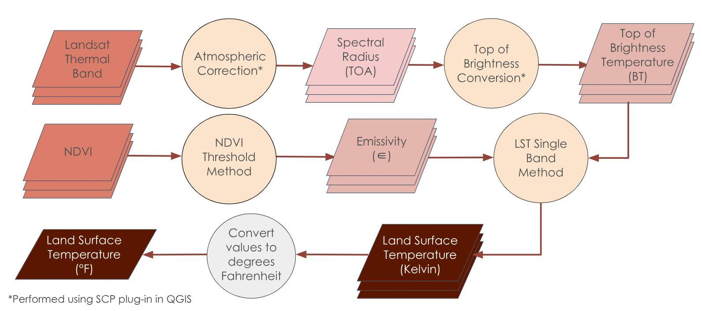***Figure A5.* Flowchart of the methodology used to calculate Land Surface Temperature from raw Landsat data

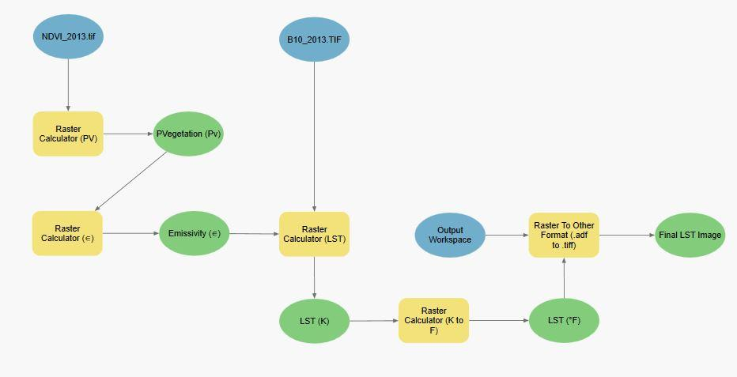

*Figure A6*. Model built in ArcGIS Pro 2.1.0. to automate the Emissivity (∈) and final LST calculations, along with the specific inputs, outputs, and equations used

*Table A3.* Supplementary Information for above LST model

|  |  |
| --- | --- |
| **Inputs** | * NDVI_20XX.TIF * B6_20XX.TIF (for Landsat 5) * B10_20XX.TIF (for Landsat 8) |
| **Outputs** | * Percentage vegetation (Pv) * Emissivity (∈) * Land Surface Temperature (K) * Final Land Surface Temperature (F) |

*Table A4.* Raster Calculator equations for above LST model

|  |  |
| --- | --- |
| **Output** | **Equation** |
| PVegetation (Pv) | Square( (**"%NDVI_20XX.tif%"** - 0.2 ) / ( 0.5 -0.2 ) ) |
| Emissivity (∈) | ( 0.004 * **"%PVegetation (Pv)%"** ) + 0.986 |
| Landsat - Kelvin (LST - K) *[for Landsat 5 data]* | **“%B6_20XX.TIF%”** / ( 1 + ( ( 11.45 * **“%B6_20XX.TIF%”** / 14388 ) * Ln ( **“%Emissivity%”** ) ) ) |
| Landsat  - Kelvin (LST - K) *[for Landsat 8 data]* | **“%B10_20XX.TIF%”** / ( 1 + ( ( 10.895 * **“%B10_20XX.TIF%”** / 14388 ) * Ln ( **“%Emissivity%”** ) ) ) |
| Landsat - degrees Fahrenheit (LST - K to F) | ( **"%LST (K)%"** * ( 9 / 5 ) ) - 459.67 |

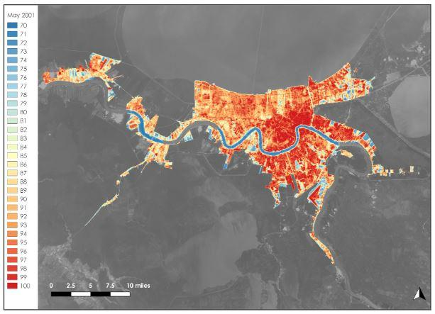  
*Figure A7.* Landsat 5 TM imagery indicating LST values for New Orleans New Orleans on May 23, 2001

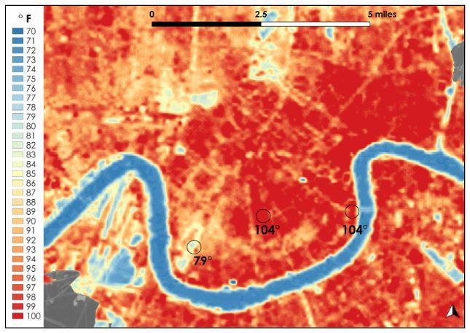  
*Figure A8*. Detailed view of Landsat 5 TM imagery indicating LST values for New Orleans New Orleans on May 23, 2001

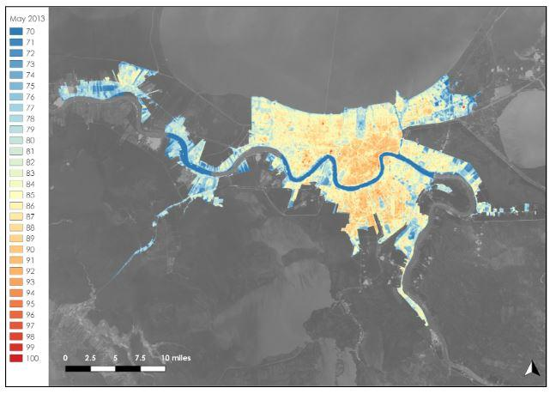  
*Figure A9*. Landsat 8 OLI/TIRS imagery indicating LST values for New Orleans New Orleans on May 24, 2013

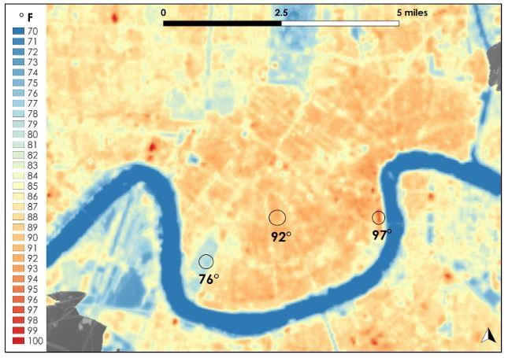

*Figure A10*. Detailed view of Landsat 8 OLI/TIRS imagery indicating LST values for New Orleans New Orleans on May 24, 2013

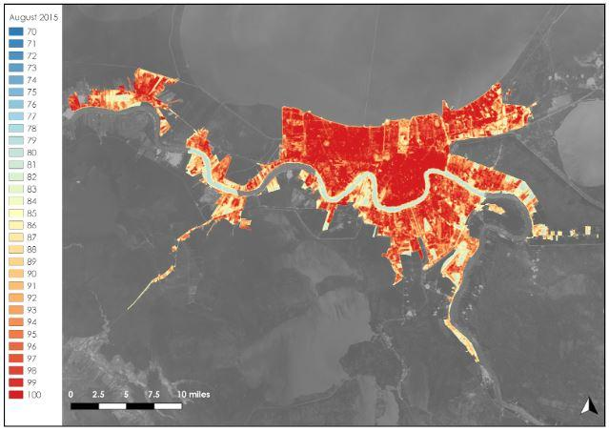

*Figure A11*. Landsat 8 OLI/TIRS imagery indicating LST values for New Orleans New Orleans on

August 2, 2015

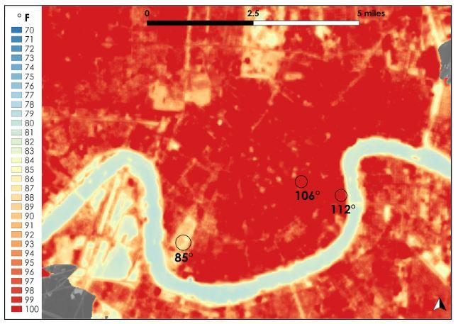

*Figure A12*. Detailed view of Landsat 8 OLI/TIRS imagery indicating LST values for New Orleans New Orleans on August 2, 2015

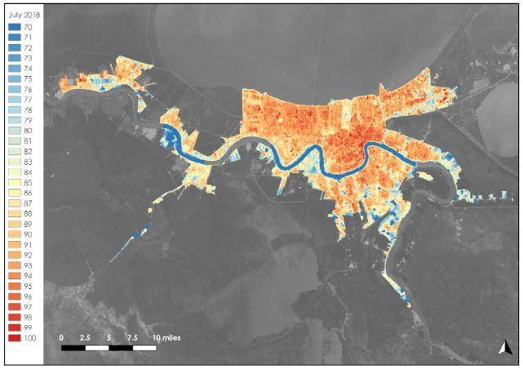

*Figure A13*. Landsat 8 OLI/TIRS imagery indicating LST values for New Orleans New Orleans on July 9, 2018

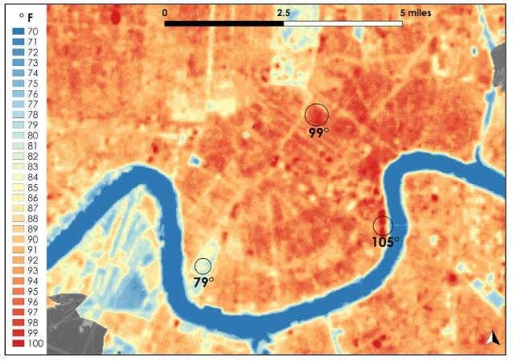

*Figure A14.* Detailed view of Landsat 8 OLI/TIRS imagery indicating LST values for New Orleans New Orleans on July 9, 2018

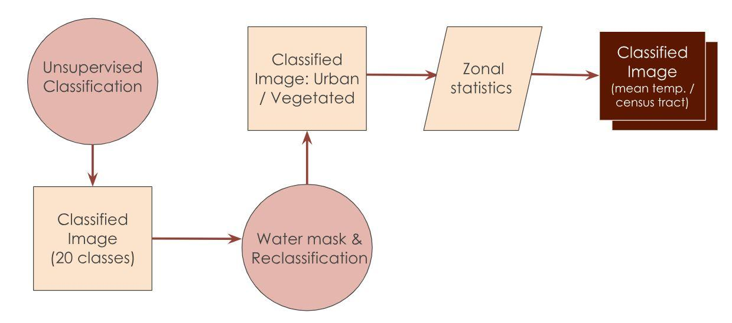

*Figure A15*. Flowchart of the methodology used to classify land cover and produce the Vegetation vs. Urban Cover Assessment

*Table A5*. Input parameters for ISO Unsupervised Classification using ArcGIS Pro 2.1.0.

|  |  |
| --- | --- |
| **Parameter** | **Classification Input** |
| Maximum Number of Classes | 20 |
| Maximum Number of Iterations | 100 |
| Maximum Number of Cluster Merges per Iteration | 5 |
| Maximum Merge Distance | 0.5 |
| Minimum Sampled per Cluster | 100 |
| Skip Factor | 10 |

*Table A6*.  Scheme used for secondary classification of land cover classes

|  |  |
| --- | --- |
| Urban | Vegetated |
| Developed, Open Space | Open Park |
| Developed, Low Intensity | Developed, Vegetated |
| Developed, Medium Intensity | Forested |
| Developed, High Intensity | Woody Wetlands |
|  | Forested, Dense |
|  | Cultivated Crops |
|  | Barren |

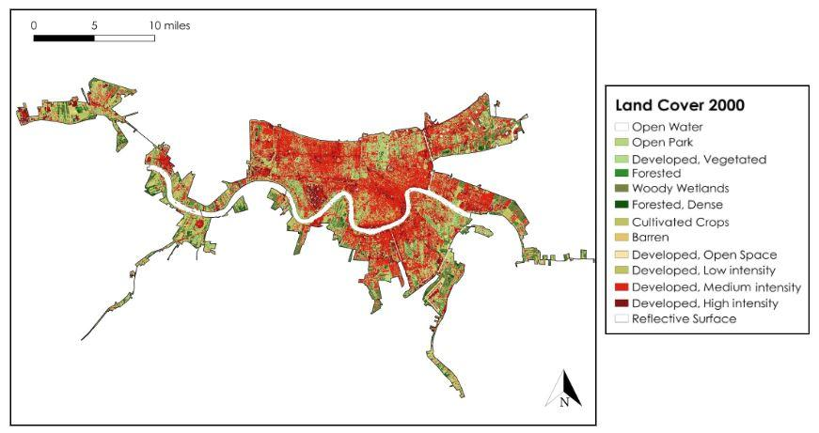

*Figure A16.* Land cover classification derived from Landsat 5 TM image for New Orleans on July 7, 2000

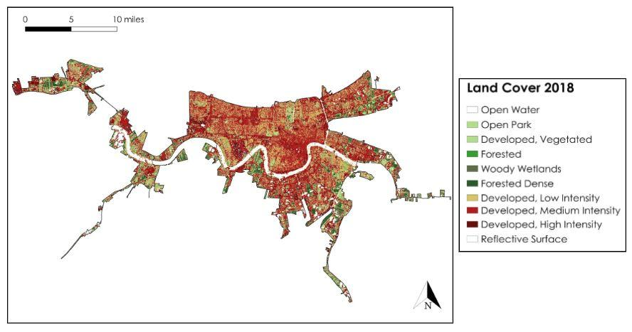

*Figure A17.*Land cover classification derived from Landsat 8 OLI image for New Orleans on

July 9, 2018

*Table 7.* Socioeconomic and Mobility Variables examined in UNO CHART Vulnerability Assessment Total Population

|  |
| --- |
| * Total Population * Grandparents Living with Grandchildren (8 and under) * Grandparent as Guardian * Household with 1 or More Persons Age 60+ * Percentage of Households with 1 or More Persons Age 60+ * Population Age 25+   + Percentage with Less than High School Education * Number of Persons with a Disability * Percentage of Persons with a Disability * Number of Households with no Vehicle * Percentage with No Vehicle * Population Age 5+ * Percentage Speak Language Other Than English * Percentage Speak English Less than Very Well * Percentage Below 100% Poverty Level * Percentage Between 100% to 149% Poverty Level * Percentage at or Above 150% Poverty Level * Percentage of Households with Male Single Parent * Percentage of Households with Female Single Parent * Percentage of Households with Income less than $10,000 * Percentage of Households with Income Between $10,000 and $14,999 * Percentage of Households with Income Between $15,000 and $24,999 * Percentage of Households with Income Between $25,000 and $34,999 * Percentage of Households with Income Between $35,000 and $49,999 * Percentage of Families with Income Below Poverty Line * Percentage of Individuals with Income Below Poverty Line |

*Table A8.* Criteria used to create a three-tier system of Priority for overall SoVI

|  |  |  |
| --- | --- | --- |
| **High Priority**  (Multiplier of Three) | **Medium Priority**  (Multiplier of Two) | **Low Priority**  (Multiplier of One) |
| Disabled | Race | Single Parenthood |
| Elderly | Education (% with < HS degree) | Language |
| Without a car | Income < $25K |  |
|  | Poverty |  |

*Table A9.* Reclassified values and variables used to in assigning values to tracts

|  |  |  |  |
| --- | --- | --- | --- |
| **Ranked classes for Each Variable of Aggregated Heat Vulnerability Assessment** | | | |
| **Reclassified Value** | **Land Surface Temperature** | **Percentage Urban** | **Social Vulnerability Score** |
| 1 | 75° - 80°F | 0 - 20% | 0 - 25 |
| 2 | 80° - 85°F | 20 - 40% | 25 - 32 |
| 3 | 85° - 90°F | 40 - 60% | 32 - 38 |
| 4 | 90° - 95°F | 60 - 80% | 38 - 45 |
| 5 | 95° - 100°F | 80 - 100% | 45 - 52 |

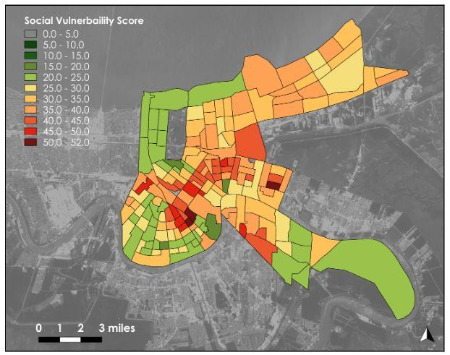

*Figure A18.* UNO CHART SoVI derived from the 2014 American Community Survey data

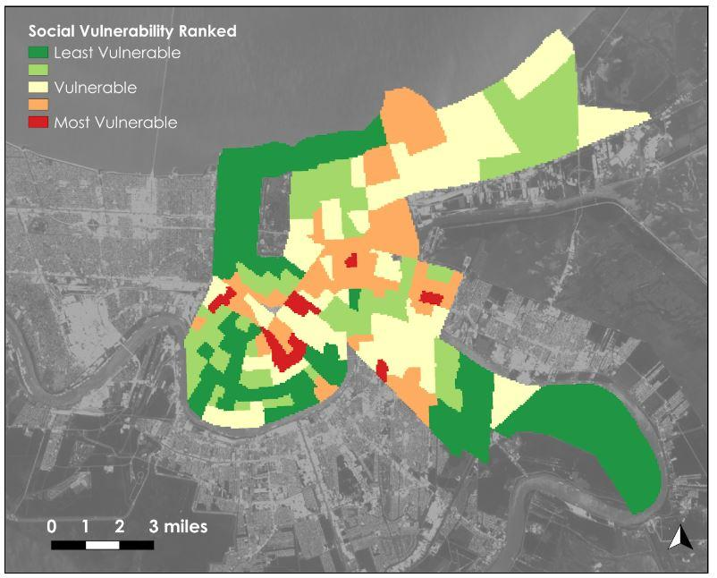

*Figure A19.*Ranked and rasterized SoVI

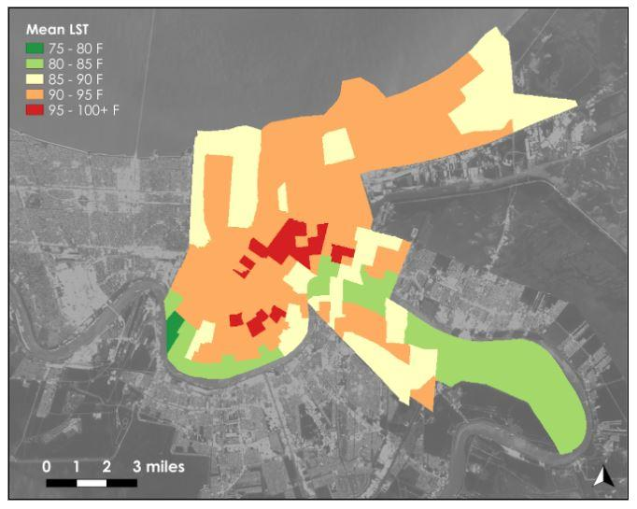

*Figure A20.* Mean LST derived from Landsat 8 OLI/TIRS for Orleans Parish for July 9, 2018, per census tract classified into five categories

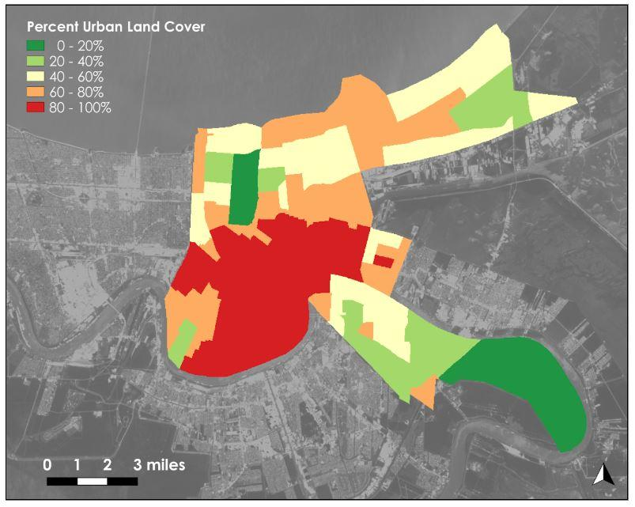

*Figure A21.* Percent urban land cover derived from Landsat 8 OLI for Orleans Parish for July 9, 2018, per census tract

*Table A10*. Census tracts and their respective heat vulnerability scores

|  |  |
| --- | --- |
| **Census Tract** | **Heat Vulnerability Score** |
| 31 | 4.62 |
| 92 | 4.95 |
| 75.02 | 4.62 |
| 76.04 | 2.31 |
| 120 | 1.65 |
| 142 | 2.64 |