**NASA DEVELOP National Program**

****University of Georgia

**Summer 2015**

**Short Title: Ocmulgee Ecological Forecasting II**

**Subtitle:** Utilizing NASA’s Earth Observations for Forecasting Land Use Change and Wildlife Disturbances along the Ocmulgee River Corridor

**VPS Title:** TBD

**Project Team & Partners**

**Project Team:**

Christopher Cameron (Project Lead), cscameron89@gmail.com

Andrew Herring

Ayn Remillard

Zhan Shi

**Advisors & Mentors:**

Dr. Thomas Jordan (University of Georgia, Center for Geospatial Research)

Dr. Marguerite Madden (University of Georgia, Center for Geospatial Research)

**Past or Other Contributors:**

Peter Hawman

Gail Miller

Caren Remillard

Simmone Simpson

Steve Padgett-Vasquez

**Partner Organizations**

Georgia Department of Natural Resources (GA DNR), End-User, POCs: Dan Forester, Thom Litts, and Melanie Riley

**Project Details**

**Applied Sciences National Applications Addressed:**

Ecological Forecasting, Water Resources

**Study Area:** GA: Ocmulgee River, Central Georgia

**Study Period:** January 2001 to present

**Earth Observations & Parameters**

Landsat 8, OLI- Land cover

Terra, ASTER- Land use and digital elevation model (DEM)

**Ancillary Datasets Utilized**

* Environmental Protection Agency (EPA) 303d - Impaired waters
* EPA National Pollutant Discharge Elimination System (NPDES) - Point source pollution
* GA DNR 2012 Side Scan Sound Navigation And Ranging (SONAR) - Image data and Ocmulgee River substrate layers
* GA DNR Index of Biotic Integrity (IBI)- Fish sample data
* GA DNR Long term sport fish monitoring data - Fish populations
* GA DNR Plant / animal / fish survey data - Rare and endangered species distributions
* GA DNR Parcel data - Land ownership and classification
* United States Department of Agriculture (USDA) CropScape - Land cover
* United States Geologic Survey (USGS) National Land Cover Dataset (NLCD) - Land cover

**Models Utilized**: TBD

**Software Utilized**

ENVI - atmospheric corrections of Landsat 8 and ASTER Imagery

ERDAS IMAGINE - land classification of Landsat 8 and ASTER

ArcGIS - raster manipulation/analysis, image enhancement & map creation

Clark Labs Land Change Modeler ArcGIS Extension - land cover forecasting

**Project Overview**

**80-100 Word Objectives Overview**

The goal of this project is to utilize the time series produced during the first term of this project to analyze the effects of changing conditions on the wildlife and fisheries in the Ocmulgee River corridor with a focus on endangered native species. This will provide the partners with information regarding threats to habitat and allow for ecological forecasting. Additionally, the team will explore the use of close-range unmanned aerial systems (UAS) coupled with NASA Earth observations for wildlife management.

**Abstract**

The Ocmulgee River corridor is home to unique species such as Atlantic sturgeon, short nosed sturgeon, black bear, and millions of migratory birds. It also holds a rich archeological record of Native American settlement. Over the years, this area has experienced increasing urbanization pressure. The NASA DEVELOP Ocmulgee River Water Resources and Ecological Forecasting team partnered with the Georgia Department of Natural Resources (GA DNR) to conduct a project focused on conserving the Ocmulgee River corridor. The goal of this project was to analyze land cover trends over the past 15 years using National Land Cover Dataset (NLCD) classifications and recent Landsat 8 images to predict future changes within the Ocmulgee River valley. With this goal in mind, a current land cover map was created and the team performed a time-series analysis. Threatened and endangered species habitats and hydrologic characteristics were overlaid with the classification maps to identify areas of concern. Using the results of this project, the GA DNR will be able to prioritize conservation of high risk areas and identify areas of future concern.

**Community Concerns**

* The Ocmulgee River valley is defined as a high-priority landscape feature in Georgia’s 2005 Wildlife Action Plan and was identified as one of six priority land conservation areas by the Georgia Department of Natural Resources.
* The Ocmulgee River valley is becoming fragmented into isolated ecological patches due to urban sprawl.
* This fragmentation has the potential to threaten populations that have been classified as endangered by federal authorities.

**Current Management Practices & Policies**

The Georgia Department of Natural Resources (GA DNR), Wildlife Resources Division (WRD) is charged with conserving, enhancing and promoting Georgia’s wildlife resources, including game and nongame animals, fish, and protected plants. It is comprised of three sections: Game Management, Fisheries Management, and Nongame Conservation. The GA DNR uses numerous decision and management tools to conserve state-owned and -operated lands. These range from statistical and spatial analysis to fish stocking and prescribed burns. GA DNR currently uses remotely sensed data to support management decisions, including National Agriculture Imagery Program imagery, LiDAR, side imaging sonar, digital elevation models, and products derived from satellite sensors. The GA DNR has personnel trained in GIS and remote sensing and will be able to take ownership and utilize the tools and products resulting from this DEVELOP project.

**Decision Support Tools & Benefits**

|  |  |  |
| --- | --- | --- |
| **End-Product** | **Earth Observations Used** | **Benefit & Impact** |
| Land-use Forecast | Landsat 8 OLI | Predict future land use change for management purposes |
| Threat and Opportunity Assessment | Landsat 8 OLI | Quantitative results can be used to communicate and enhance management and conservation decisions for fisheries and wildlife |

**Project Imagery**

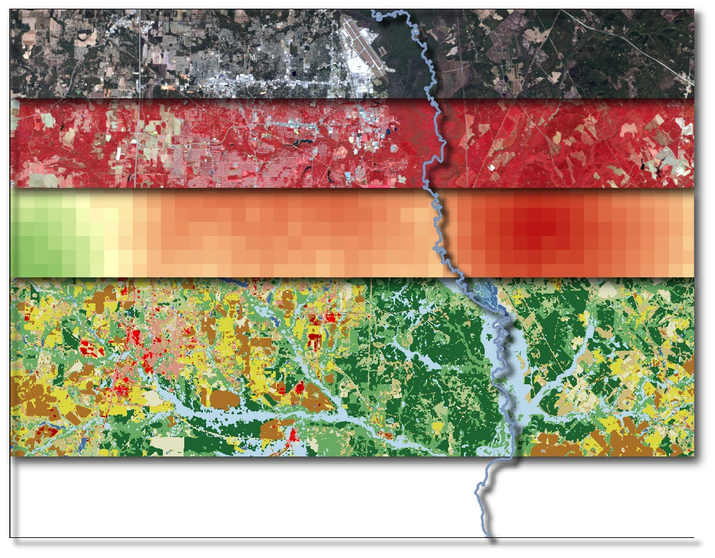

**Caption:** The Ocmulgee River south of Macon as seen across Landsat 8 true color, near infrared, ecological heat map, and 2014 land cover classification. Image Credit: Ocmulgee Ecological Forecasting II Team.

**Image:** 2015Sum_UGA_OcmulgeeEco_ProjectSummaryImage.JPG