**NASA DEVELOP National Program**



Langley Research Center

*Spring 2015*

Northwest US Agriculture II

Evaluating cultivation suitability of apples based on accumulated chill hours and precipitation in Washington State from 2003 – 2065

 **Technical Report**

Rough Draft - Feb 19, 2015

Lydia Cuker (Project Lead)

Laura Lykens

Alyssa Walzak

Tim Stelter

Dr. Kenton Ross, (NASA DEVELOP National Program Science Advisor)

Previous Contributors:

Northwest Agriculture I – LaRC Fall 2014

# I. Abstract

[Placeholder - do not put anything here until the final draft submission. The abstract in the project summary is where the working draft of the abstract should “live”]

**Keywords**

Apples, Washington State, Chill Hours, Precipitation, MODIS, Agriculture, Climate

# II. Introduction

As the leading apple producing state in the United States, Washington produces over half of the nation’s apples (USDA NASS, 2012). Washington built its reputation as a major figure in the apple indusrty with Red Delicious apples and established the state as one with a suitable climate for the crop (Carter, 2007). However, there are concerns in regards to climate change and how that will affect apple production for Washington in the future. Two weather parameters that have an effect on apple growth are rainfall accumulation and minimum overnight temperatures, which affect the number of chill hours. Both factors contribute to the health and success of apple crop production. More specifically, chill hours, which are hours with temperatures between 0 – 7° C, are vital for successful apple tree blossoming in the springtime. Apple trees require 500 – 1000 chill hours per growing season, depending on the apple cultivar, in order to prosper (Carter, 2007).

The purpose of this project is to expand methods to include precipitation and temperature forecasts in order to assess possible locations of change in apple production in the state of Washington. Accumulated chill hours and total precipitation are climatically controlled factors that determine a location’s suitability for growing apples. These factors may be influenced as climate changes; therefore, calculating past totals as well as forecasting these factors into the future will give apple growers a sense of how the suitability of their present lands may alter with coming climate change. Due to requirements for accumulated chill hours, rising temperatures may shift the location of ideal apple growing conditions northward. Additionally, climate change may modify demands for irrigation resources.

Washington, which is located in the Pacific Northwest, has great variance in climate across the state. There are two distinct climate zones: the regions east and west of the Cascades. In the eastern region of Washington, there are warmer summers and cooler winters with frequent precipitation. Western Washington offers cool summers with mild, wet winters. The zone east of the Cascades contains the major apple production regions such as Yakima Valley, North Central (Wenatchee) district, and the Columbia Basin. Due to the differences in climate across Washington, growing conditions vary across the state. Therefore, different apple species are able to thrive in Washington State due to the diverse regions (Smith, 2001).

In Washington, apple orchards are able to flourish in a moderate, marine-influenced, desert climate (Smith, 2001). Furthermore, less effort and expenses are required for the growers due to the dry, warm growing seasons, which prevent disease and pest issues (Schotzko, n.d.). Additionally, the snowmelt in Washington provides ample stream water, which is advantageous for the growers as well (Smith, 2001).

The NASA Applied Sciences Program application areas addressed in this project include agriculture and climate. These will be addressed by focusing on apples, which are a major contributor to the Washington state economy.

One of our project partners is Dr. Michael Glenn from the Appalachian Fruit Research Station. We are also partnering with the United States Department of Agriculture – Agriculture Research Service (USDA-ARS). Through partnering with USDA-ARS, accumulated chill hours and precipitation were identified as key factors contributing to the health and success of apple crops that will change due to climate fluctuations. Thus, understanding how climate change will affect these factors will inform future prediction of this fruit.

The forecasted calculations of both chill hours and accumulated rainfall, in addition to past calculations will provide growers with better comprehension of how climate change will affect apple crop production. The forecasted trends in both chill hours and precipitation will enable apple growers to anticipate climate change and better understand what to expect.

In order to calculate chill hours for Washington State, we are going to utilize the Utah Chill Hours Model. This model assigns different weights to various temperature intervals in order to sum accumulated chill hours (Luedeling, 2009). ***Barely started this; needs to be finished***

Word count should be between 200-1000.

Material to include:

* Background Information: Relevant information to inform the reader of current status, issues, previous studies, etc
* Project Objectives: These should be short decisive action items.
* Study Area: Describe the geographic location of the study
* Study Period: Explain the time period of data you are looking at (years and dates of data)
* National Application(s) Addressed: Explain which NASA national application areas this project addresses and how it contributes to them
* Project Partners: Explain who the project partners are, why they are interested in this project, how they will use it, what decision making they have to do and is being addressed with this research and methodologies, etc. How will they benefit from this project and methodology?

# III. Methodology

This should be concise, yet explanatory, and highlight the NASA Earth observations utilized and its/their capabilities. Include a paragraph or more for each of the following items. No word cap, but be thoughtful.

Data Acquisition: What data did you get, what level products are they, for what dates did you get images, where did you get the images from, etc.

Data Processing: What did you do to the data? Were there conversions needed to be able to analyze it? Did you have to mosaic images? Did you have to normalize anything to fit other datasets? Did you run an NDVI, change detection, etc?

Data Analysis: How did you analyze the data? What methods did you use?

**Data Acquisition:**

Using NASA Earth observations from Aqua and Terra Moderate Resolution Imaging Spectroradiometer (MODIS) and Suomi NPP Visible Infrared Imaging Radiometer Suite (VIIRS), specifically the Land Surface Temperature products from each, chill hour accumulations were calculated from 2003 – 2013, and then forecasted using a future climate model. With local weather station data and the National Oceanic and Atmospheric Administration (NOAA) Multisensor Precipitation Estimator (MPE), precipitation totals were calculated for 2003 – 2013, and then forecasted using a future climate model.

Using MODIS, we obtained the maximum and minimum temperature changes of the land surface of Washington State for the same 10 year period and using the climate model, the forecasted data was found and projected.

**Data Processing:**

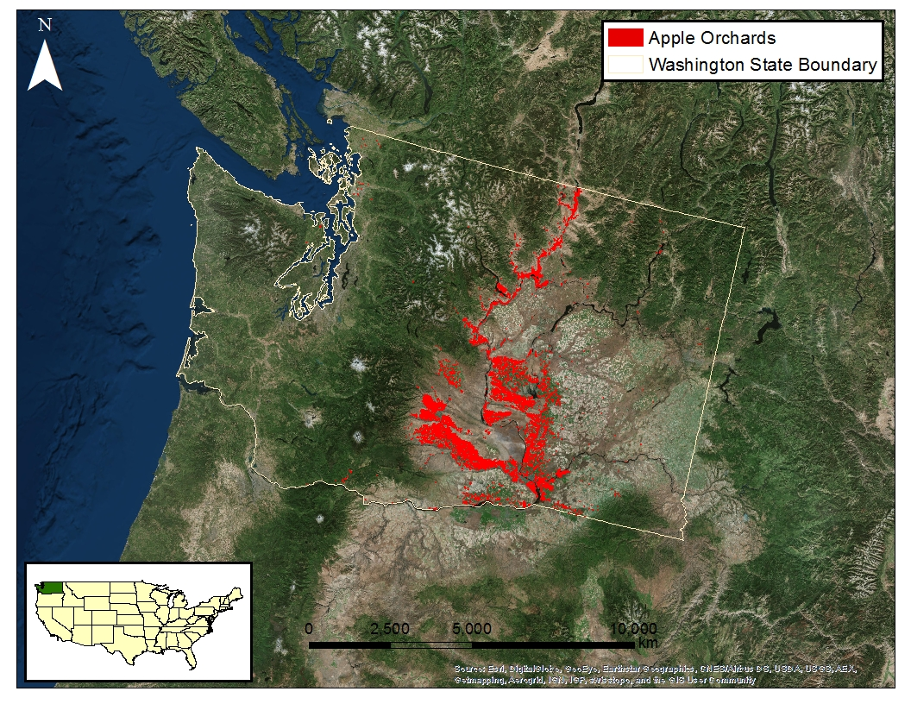

Using Esri’s ArcGIS version 10.2.2, we were able to identify our focus area of apple orchards in the state of Washington for analysis and comparison to temperature changes by using local weather station data and Multisensor Precipitation Estimator (MPE).

To calculate the amount of chill hours between the months of ____________, 2003-2013, the Utah Model was followed to give a sufficient analysis of how the apples were affected during climate changes. The Utah Model was chosen based off its purpose of use in certain climate areas which are similar to the climate of Washington State. The specific equation used in this model was found more accurate and comprehendible to use. Using python, the chill hours were calculated based on the specific temperature ranges of 2.5 to 9.1 degrees Celsius which were the temperature requirements to meet dormancy. Based on the temperature, a chill unit or weight was designated to that specific temperature (Luedeling, 2009). The unit was assigned in Python to give an accurate analysis of the MODIS temperature results.

**Data Analysis:**

The hourly MODIS curve was analyzed for the maximum and minimum land surface temperature to help assign a chill unit to each average temperature reading using this equation:

* T ≤ 1.4°C= 0
* 1.4***°***C  < T ≤ 2.4***°***C = 0.5
* 2.4***°***C < T ≤ 9.1***°***C = 1
* 9.1***°***C < T ≤ 12.4***°***C = 0.5
* 12.4***°***C < T ≤ 15.9***°***C = 0
* 15.9***°***C < T ≤ 18.0***°***C = -0.5
* T ≥ 18.0***°***C = -1

Once the chill units are assigned, the sum of the chill hours can be attained.

# IV. Results & Discussion

Insert images, graphs, maps, charts, etc. here. Choose the most important results to highlight here. Things to discuss:

* Analysis of Results: What can you tell from your graphs, images, etc? What does this mean for your project?
* Errors & Uncertainty: What factors could you not account for, what things didn’t work out like you expected they would, etc
* Future Work: If this project was to be selected for another term, what would be the focus? What other areas would be of interest?

# V. Conclusions

This project’s purpose was to utilize past and forecasted chill hours and accumulated precipitation in order to consider climate change on apple growth. Results show that chill hour temperatures are expected to increase by 2065. This will enable growers to better prepare for the coming climate change. Additionally, they will be able to strategize or use innovative techniques in order to produce healthy and prosperous apples.

Final conclusions. Word count: 200-600.

# VI. Acknowledgments

Dr. Kenton Ross (NASA DEVELOP National Science Advisor)

Jeffry Ely (NASA DEVELOP Geoinformation Scientist)

Dr. Michael Glenn (USDA ARS)

Nathan Owen (NASA DEVELOP Langley Center Lead)

Fall 2014 Northwest US Agriculture Team

This material is based upon work supported by NASA through contract NNL11AA00B and cooperative agreement NNX14AB60A.

# VII. References

Carter, K. (2007). Low-chill apples [On-line serial]. URL http://ucanr.org/sites/urbanhort/files/80158.pdf

Jensen, W. S. (n.d.). Washington’s billion-dollar secret: The tree fruit producers who help grow our economy [WWW page]. URL http://www.wahort.org/images/downloads/issue-brief.pdf

Luedeling, E. et al. (2009). Sensitivity of winter chill models for fruit and nut trees to climatic changes expected in California’s Central Valley. *Agriculture, Ecosystems and Environment, 133,* 23-31.

Schotzko, R. T. (n.d.). A brief look at the Washington apple industry: past and present [WWW page]. URL http://www.agribusiness

-mgmt.wsu.edu/agbusresearch/docs/SES04-05_BRIEF_LOOK_WAFTA.pdf

Smith, T. J. (2001). Crop profile for apples in Washington [WWW page]. URL http://www.ipmcenters.org/cropprofiles/docs/WAApples.pdf

USDA NASS. (2012). 286 Washington 2012 Census of Agriculture - County Data Table 10. *Irrigation: 2012 and 2007* (Vol. 2007, pp. 286–290).

# VIII. Appendices

Insert here