**NASA DEVELOP National Program**



National Centers for Environmental Information (NCEI) -

Asheville, NC

*Spring 2016*

Cascade and Sierra Nevada Mountains

Water Resources

A comparison of remotely-sensed Climate Data Records (CDRs) over the Cascade and Sierra Nevada Mountains for improved climate monitoring by the Western Regional Climate Center (WRCC), and National Weather Service River Forecast Centers (NWS RFCs).



**Technical Report**

Rough Draft – Feb 18, 2016

Sam Swanson (Project Lead)

Kevin Rapa

Jessica Sutton (CL)

Michael Kruk, ERT, Inc. (Science Advisor)

# I. Abstract

[Placeholder - do not put anything here until the final draft submission. The abstract in the project summary is where the working draft of the abstract should “live”]

**Keywords**

Remote Sensing, Water Resources, Drought, Climate Change, Precipitation, Snow Water Equivalent, Cascades, Sierra Nevadas

# II. Introduction

Hydrologic processes in California, Oregon, and Washington are unique among the rest of the United States. Their primary water source for human and ecological use is stored in the natural reservoirs of snowpack at high elevations during the winter and spring (Mote et al 2005; Vicuna and Dracup 2007). Since 1950, studies have shown a decreasing trend in snowpack and snow-water equivalent (SWE) in mountainous areas. This trend has been repeatedly correlated with temperature increases hypothesized to be a result of human-induced climate change (Melillo et al 2014; Vicuna and Dracup 2007; Mote et al 2005). Furthermore, the fraction of precipitation falling as rain has increased at low- to mid-elevations, thus shifting peak snowmelt runoff to occur earlier in the spring (Knowles et al 2007; Stewart et al 2005; Maurer et al 2007). Consequently, less precipitation is stored as snow in the mountains for summer runoff, forcing water managers to reassess their management schemes and limiting water for human and ecological use (Maurer et al 2007). Thus, changes in water supply, demand, and reliability in California, Oregon, and Washington warrant a more accurate monitoring of water availability.

The National Weather Service (NWS) and the Western Regional Climate Center (WRCC) work together to disseminate high quality climate information in their region, which includes Washington, Oregon, Nevada, and California. For their purposes, the gridded dataset PRISM (Parameter Elevation Regression on Independent Slopes Model) is the most widely used tool in estimating precipitation. PRISM extrapolates known precipitation measurements from ground-stations to areas lacking *in situ* measurements. The WRCC also consults the Global Historical Climatology Network (GHCN), an amalgam of many ground-based data collection organizations including Snow Telemetry (SNOTEL), Remote Automated Weather Stations (RAWS), Automated Surface Observing System units (ASOS), and the Cooperative Observer Network (COOP). These ground stations are more limited in their precipitation and snowpack measurements in the Cascade and Sierra Nevada mountain ranges (Nina Oakley, personal communication, February 1, 2016). Previous studies have shown that satellite-derived precipitation estimates, when validated by ground observations, can be useful in monitoring climate indicators in the continental US (Prat and Nelson 2015). However, regions with highly variable geography, like the mountainous northwestern United States, continue to prove difficult for satellite-derived algorithms to accurately measure (Prat and Nelson 2015). These difficulties may be resolved with new satellite-products at higher spatial resolutions (Dr. Olivier Prat, personal communication, February 3, 2016). The purpose of this study was to compare and analyze remotely-sensed and *in situ* precipitation data in the Sierra Nevada and Cascade mountain ranges to gauge the usefulness of satellite data in mountainous regions. This study enhanced the understanding of water availability in mountain snowpack across the western United States, informing both climate monitoring and forecasting efforts.

The 3 objectives of this research were to determine if satellite data are useful in measuring orographic precipitation by comparing satellite climate data records (CDRs) to currently-used ground-station data, to make a suite of map products to enhance the understanding of precipitation, and to further understand snow water equivalent in the study area by comparing NOHRSC satellite data to ground observations from SNOTEL and the California Snow Survey.

# III. Methodology

Inside the methodology, the useful data were identified, processed, visualized, and analyzed before being presented as a final product to the end-users. This process involved an analysis of satellite and ground data differences in precipitation measurements, the creation of anomaly and benefits maps, and determining the usefulness of satellites in measuring SWE.

The first objective required the Climate Prediction Center Morphing Technique (CMORPH) CDRs, the Global Precipitation Measurement (GPM), four GHCN datasets, and the PRISM dataset. The CMORPH dataset is a satellite-derived climate data record (CDR) produced by the National Oceanic and Atmospheric Administration (NOAA). The satellite uses a passive microwave sensing technique to derive global precipitation estimates. Although these estimates are derived, the data are available at high spatial and temporal resolutions of .073° (8 km2 at the equator) from 1998 to 2013, but solely at a 30 minute temporal resolution. These estimates were collected in a numeric weather prediction adjusted format, which corrected biases in original CMORPH data. From the NOAA corrected repository, the global CMORPH dataset was downloaded in the form of compressed .tar files, representing a collection of 30-minute intervals from 1998 to 2013. Being such an enormous dataset, it required much further processing. Using the statistical program R, an un-compression process was automated to expand the CMORPH files into binary .bz2 files. From there, R code looped through each .bz2 file, processing each into a raster and clipping it to the study area. In the interest of the NWS and WRCC, the 30-minute rasters were aggregated into daily sums. This also greatly reduced the size of the dataset. The data was then manipulated and visualized to produce our results and findings.

The second data source, GPM, is a global mission to produce satellite-derived precipitation measurements. This mission, launched by the National Aeronautic Space Administration (NASA) and the Japanese Aerospace Exploration Agency (JAXA) in 2013, is a continuation of the Tropical Rainfall Measuring Mission (TRMM), which collected rainfall estimates at tropical latitudes. GPM now creates a merged product of global precipitation estimates from 60°N to 60°S from March 14, 2014 to the present at a high spatial resolution of 0.1° (11.13 km2 at the equator) and temporal resolution of 30 minutes. These records were collected from the NASA website. This data was subset to our study area before being downloaded, and then downloaded as GeoTiff files at a daily temporal resolution.

The GHCN and PRISM datasets, which the NWS and WRCC currently use, were chosen for the comparison of CMORPH against GPM. Of over twenty sources included in GHCN, four were used in this study: Snow Telemetry (SNOTEL), Remote Automated Weather Stations (RAWS), Automated Surface Observing System units (ASOS), and the Cooperative Observer Network (COOP). These all provide spatially expansive data in the study area and are consulted daily by monitoring organizations. The datasets of the GHCN, however, have fewer estimates at higher elevations, notably in the Sierra Nevada and Cascade mountains. The GHCN datasets were processed from five space-delimited text files. Four of the text files contained only raw precipitation estimates from the four GHCN sources, the date of each record, and the station ID associated with each. The remaining text file contained notably each station's latitude and longitude, plus the respective station ID.

The Parameter Elevation Regressions on Independent Slopes Model (PRISM) was the second ground-based dataset used for comparison against the satellite data. PRISM uses a large collection of station networks, including GHCN, to interpolate measurements at high elevations. PRISM differs from GHCN in that it is a gridded dataset at a .037° resolution (4km at the equator). The WRCC uses this dataset when station data are unavailable. The PRISM dataset was downloaded from the Oregon State University PRISM Climate Group website. The files came compressed in a .zip format, which were uncompressed using R programming. They were then subset to our study area. Since PRISM interpolates from GHCN stations, an extraction technique was used to get the value of each PRISM cell underlying each respective GHCN station. These values were added as new columns in the GHCN attribute tables, and thus could be treated in the same way the GHCN data were.

After the initial processing of the CMORPH, GPM, GHCN, and PRISM datasets was complete, comparisons between satellite and ground-station precipitation measurements were made at each station point using the nearest-lying raster pixel. In order to determine which satellite-raster pixels to extract, each GHCN station was plotted on a map, and their geographic coordinates noted. From under each station point, we extracted the accompanying satellite-raster pixel value and appended it to the station record for each date. At this time, the attribute tables contained station ID fields, elevation fields, and precipitation fields of both ground and satellite datasets for every day. From here, area weighted averages were calculated in the table to account for multiple stations lying in the same raster pixel. Several univariate and bivariate statistical methods were used to visualize and understand the variance in the data. Bivariate analyses consisted of scatterplots between the satellite and ground station precipitation. The plots were split into summer and winter seasons (April 1-October 1 and October 1-April 1) and then further subdivided according to the areas of the Northwest and California/Nevada River Forecast Centers (RFCs).

In addition to a suite of scatter plots for the satellite/ground comparisons, maps comparing satellite and station-derived 15-year seasonal normals to anomalous years were created using ArcMap. In order to visualize the difference, the ground data and satellite data were processed similarly. For each, the anomalous data was subtracted from the 15-year normal data and then divided by the normal data to produce a new feature class for both the raster and point layers. The new ground data was layered on top of the satellite data as shown in figure 3. From these, the anomalies represented in both the ground and satellite datasets could be seen, and their results could be compared against one another.

A benefits map, showing where satellite data could best fill in station data gaps, was also produced using estimates from the remotely-sensed dataset with the highest correlation to GHCN measurements. In knowing the geographic attributes of the locations where satellite and ground station data agreed most, we identified locations with similar geographic attributes and no *in situ* stations. By highlighting these locations, the WRCC, NWS, and River Forecasting Centers learned where their monitoring efforts would benefit the most from the inclusion of remotely-sensed data.

For objective 3, the topic of interest shifted from precipitation to snow water equivalent (SWE), following a similar methodology. Snow water equivalent measures the amount of water stored in snowpack, and thus is an important factor in predicting the timing and amount of snowmelt runoff. NOAA's National Operational Hydrologic Remote Sensing Center (NOHRSC) is currently used by WRCC to monitor SWE. NOHRSC produces high-quality, 1km2 resolution measurements on a daily time-scale. The ability of NOHRSC, a satellite-derived estimate, to measure SWE was evaluated by comparing it to ground-based measurements from SNOTEL and the California Snow Survey. Correlations and disparities using scatter plots were analyzed, maps of SWE normals and anomalies displaying both satellite and *in situ* data were displayed, and a benefits map for the WRCC’s consideration was produced.

# IV. Results & Discussion

**Future Work: If this project was to be selected for another term, what would be the focus? What other areas would be of interest?**

From our results, we hope to show the comparisons of precipitation measurements between satellite and ground station products using statistical graphs and maps created in ArcMap. Our results will emulate the following examples that have been created from similar studies in broader or different study areas.

In our study, we will compare GPM and CMORPH to GHCN stations at a higher resolution than in figure 1. We hope comparing precipitation measurements at up to an 8 km2 resolution will provide a better estimate of precipitation in mountainous areas. Similar to Prat et al. 2015, we will divide our data into winter and summer seasons and compare data by the Northwest RFC and the California-Nevada RFC.

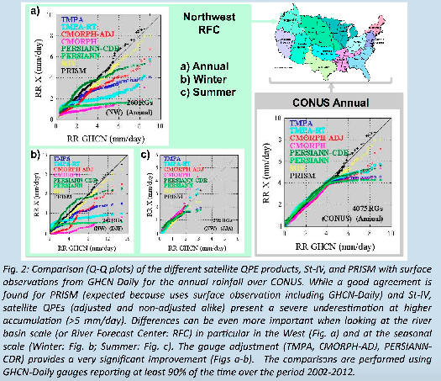

Figure 1. Scatterplots comparing measurements of precipitation via ground-stations (GHCN) to remotely-sensed and gridded datasets. Satellite measurements of the Northwest RFC underestimate precipitation. Source: Prat et al 2015.

Comparisons in Figure 1 will determine which satellite-derived precipitation measurements over the Cascades and Sierra Nevadas are best aligned with the in-situ ground stations. The figure facilitates the preparation of a suite of maps including normal and anomalous seasons, and a benefits map. First, we will create a "precipitation variability” map, which displays average seasonal precipitation (from October 1 to April 1) from the comparative maps above. This will be a map depicting a normal time period, to which anomalous periods can be compared. For example, the anomaly map could show the percent difference from normal of an El Nino year's precipitation measurement. A similar map will be created using PRISM data in order to show similarities or differences, thereby showing product’s power to measure anomalies. Overlain on both maps will be station data, to display anomalous station measurements. These maps will represent the ability of satellite-derived products to measure anomalies as compared to PRISM and ground-station data, like those shown in Figure 2.

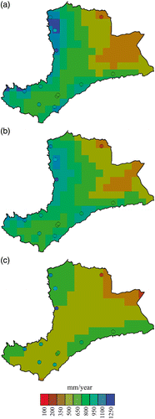

Elevation gradients are important factors in accurately estimating precipitation from satellite-derived algorithms. Figure 3 and 4 show precipitation estimates from several sources, both remotely-sensed and ground-based, according to elevation. Similar results will be shown for CMORPH, GPM, PRISM, and GHCN datasets, highlighting the elevations at which satellites best perform.

Furthermore, deviations from normal are well-shown via histograms, such as those in Figure 5. This visualization would be seasonal (wet-season and dry-season) over our study period. This graphic highlights extreme years by the magnitude of their standard deviations. El Nino/La Nina years may be highlighted.

Figure 2. Comparative maps showing 5-year averages of precipitation from different satellite products: a) TRMM, b) CMORPH, and c) PERSIANN. Overlayed on top of these rasters are points of Ethiopian ground station measurements with the same color scheme for comparison. Source: Herpa et al 2010.

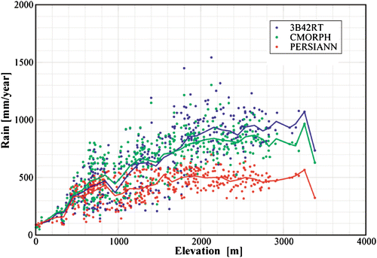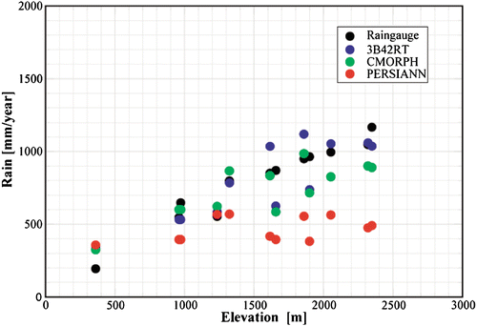

Figures 3 and 4. Precipitation measurements by various products as compared to elevation. Because mountainous regions vary so drastically in elevation over short spaces, it is important to note a satellite’s power in measuring precipitation at certain elevations. Our study will present similar results by drawing elevation data from the GHCN sites, then comparing across GPM, CMORPH, and PRISM. Source: Herpa et al 2010.

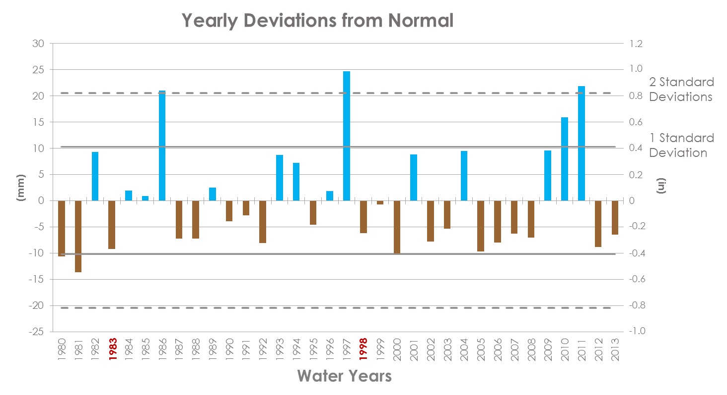

Figure 5. Histogram showing standard deviations from normal by year. Source: Missouri River Climate Team, Fall 2015.

Finally, we plan to create a benefits map, the ultimate product for our end users. Its purpose is to highlight the areas of the Cascade and Sierra Nevada mountains that would most benefit from remotely-sensed data. In order to accomplish this, we will identify the geographic attributes like slope angle, aspect, time of year, but particularly elevation, of each ground station that correlates well with our best satellite product. (ArcMap will be a crucial tool in creating the benefits map.) Then, we will find regions of similar elevation, slope angle, and aspect in our study region where no ground stations exist, and highlight them as areas of probable high satellite-*in situ* correlation without existing *in situ* measurements. This way, the WRCC can best utilize remotely-sensed data in their climate monitoring.

The results described above depict precipitation estimates from satellite, gridded, and ground-based datasets. Our end-user desires a similar comparison of snow water equivalent estimates. Although perhaps better suited for the “Future Work” section of our paper, our team will work hard to compare both types of data - precipitation and snow water equivalent. In this event, we will create similar scatterplots, comparative maps, anomalous maps, time series histograms, and a benefits map for SWE over the Cascade and Sierra Nevada mountain ranges.

# V. Conclusions

N/A

# VI. Acknowledgments

• NCEI, Asheville, NC

• Michael Kruk

• Jessica Sutton

• Emma Baghel

• Dr. Olivier Prat

• Nina Oakley

• Andrea Bair

• Jonathan Brannock

This material is based upon work supported by NASA through contract NNL11AA00B and cooperative agreement NNX14AB60A.

# VII. References

"CPC: Monitoring and Data - Global Precipitation Analyses." *CPC: Monitoring and Data - Global*

*Precipitation Analyses*. National Oceanic and Atmospheric Administration, n.d. Web. 11 Feb. 2016.

Knowles, Noah, Michael D. Dettinger, and Daniel R. Cayan. "Trends in Snowfall versus Rainfall in

the Western United States." *Journal of Climate J. Climate* 19.18 (2006): 4545-559.

Maurer, E. P., I. T. Stewart, C. Bonfils, P. B. Duffy, and D. Cayan. "Detection, Attribution, and

Sensitivity of Trends toward Earlier Streamflow in the Sierra Nevada." *J. Geophys. Res.*

*Journal of Geophysical Research* 112.D11 (2007).

Melillo, Jerry M., Terese (T.C.) Richmond, and Gary W. Yohe, Eds., 2014: Highlights of Climate

Change Impacts in the United States: The Third National Climate Assessment. U.S. Global

Change Research Program, 148 pp.

Milly, P.C.D., Julio Betancourt, Malin Falkenmark, et al. 2008. Stationarity is Dead: Whither Water

Management? Science 319 (5863): 573-574.

Mote, Philip W., Alan F. Hamlet, Martyn P. Clark, and Dennis P. Lettenmaier. "Declining Mountain

Snowpack In Western North America*." *Bull. Amer. Meteor. Soc. Bulletin of the American*

*Meteorological Society* 86.1 (2005): 39-49.

Prat, Olivier P., Brian R. Nelson, Lou Vasquez, Ralph Ferraro, Scott Rudlosky, and Jian-Jian

Wang. *Evaluation of Satellite Based Quantitative Estimates (QPEs) over CONUS (2002-2012): Comparison with Surface and Radar Precipitation Datasets*. Tech. Asheville: NOAA, 2014.

Prat, O. P., and B. R. Nelson. "Evaluation of Precipitation Estimates over CONUS Derived from

Satellite, Radar, and Rain Gauge Data Sets at Daily to Annual Scales (2002–2012)."

*Hydrol. Earth Syst. Sci. Hydrology and Earth System Sciences* 19.4 (2015): 2037-056.

Stewart, Iris T., Daniel R. Cayan, and Michael D. Dettinger. "Changes toward Earlier Streamflow

Timing across Western North America." *Journal of Climate J. Climate* 18.8 (2005): 1136-155.

Vicuna, S., and J. A. Dracup. "The Evolution of Climate Change Impact Studies on Hydrology and

Water Resources in California." *Climatic Change* 82.3-4 (2007): 327-50.

# VIII. Content Innovation

We plan to create a Glossary Viewer, an Interactive Plot Viewer of our scatterplots, and a Data Profile, as the datasets included in this study were drawn from massive data files with some difficulty.

# IV. Appendices

Insert here