**NASA DEVELOP National Program**

NASA Langley Research Center

**Spring 2016**

**Short Title: Texas Water Resources II**

**Subtitle:** Utilizing NASA Earth Observations to Assess Soil Moisture in Texas for Wildfire Mitigation

**VPS Title:** Fire Distinguisher: Using SMAP Data to Improve Wildfire Predictions

**Project Team & Partners**

**Project Team:**

Greg Hoobchaak(Project Lead), gregory.hoobchaak.11@cnu.edu

Jessica Jozwik

Alyx Riebeling

**Advisors & Mentors:**

Dr. Kenton Ross (NASA DEVELOP National Program)

**Past or Other Contributors:**

Megan Buzanowicz

Laura Lykens

Zacary Richards

Jeff Close

**Partner Organizations:**

Texas Forest Service (End-User), POC: Curt Stripling and Tom Spencer

**Project Details**

**Applied Sciences National Applications Addressed:** Water Resources, Disasters

**Study Area:** TX

**Study Period:** April 1, 2015-February 1, 2016

**Earth Observations & Parameters:**

Soil Moisture Active Passive (SMAP) - soil moisture

**Ancillary Datasets Utilized:**

* Soil Climate Analysis Network (SCAN) - precipitation, air temperature, soil moisture
* Texas A&M University (TAMU) Soil Moisture Database - soil moisture

**Software Utilized:**

ArcGIS- Raster manipulation/analysis, image enhancement, and map creation

Python- Programming language, land classifications, image manipulation

**Project Overview**

**80-100 Word Objectives Overview:**

Accurate and real-time soil moisture data can play a crucial role when identifying areas susceptible to wildfires. This project will correlate NASA’s Soil Moisture Active Passive (SMAP) Satellite data with *in situ* data from the Slow Climate Analysis Network (SCAN) and Texas A&M University (TAMU) Soil Moisture Database to provide the Texas Forest Service with a normalized single correction soil moisture model for the state of Texas to assist with their efforts in predicting and preventing wildfires.

For the last fifteen years an average of approximately one hundred firefighters have lost their lives in the line of duty; of those one hundred firefighters, just under twenty percent of those firefighters have been wildland firefighters. This percentage has been on the rise for several years, but with the ability to better predict and prevent wildfires this loss of life and property could be greatly reduced.

**Abstract:**

Each year, Texas experiences severe droughts, making large areas of the state vulnerable to wildfires that damage agriculture, infrastructure, and habitats across Texas. Texas Fire Services stated in their most recent report that just under 18,500 wildland fires occurred in 2014 causing almost two million dollars in damages. The Texas Forest Service utilizes precipitation, temperature, vegetation, and soil moisture data to identify particular areas in danger of wildfires. Several methods exist to monitor soil moisture, but these methods rely on estimates from precipitation and temperature data or from testing specific locations with sensors. By incorporating satellite data into their monitoring practices, the Texas Forest Service can monitor and compare changing soil moisture levels throughout the year. Soil Moisture data obtained from NASA’s Soil Moisture Active Passive (SMAP) satellite was correlated with *in situ* data from the Slow Climate Analysis Network (SCAN) and Texas A&M University (TAMU) Soil Moisture Database. A single correction model for Texas was created from trends identified in the data.

**Community Concerns:**

* In 2011, Texas experienced a record-breaking drought, resulting in $5.2 billion lost in agricultural resources, damaged roads, and infrastructure.
* As a result of the drought, wildfire severity and frequency increased. From November 15, 2010 through September 29, 2011, 23,835 fires burned more than 3.8 million acres and destroyed 2,763 homes.
* 80% of fires occur within two miles of a community, thus threatening life, property, and infrastructure.
* Wildfires also result in soil degradation, soil erosion, loss of biodiversity, and agricultural losses.

**Current Management Practices & Policies**:

The Texas Forest Service utilizes weather patterns, drought severity indices, and assessments of available vegetative fuels to identify areas susceptible to wildfires. Popular drought indices, like the Standard Precipitation Index and the Keetch-Byram Drought Index estimate evapotranspiration, fuel potential, and soil moisture from precipitation and temperature data to quantify severity of drought across varied spatial and temporal scales. The Forest Service then uses these data to justify budget requests, coordinate between agencies across jurisdictions, educate and communicate alerts to the public, and craft response and suppression plans.

**Decision Support Tools & Benefits:**

|  |  |  |
| --- | --- | --- |
| **End-Product** | **Earth Observations Used** | **Benefit & Impact** |
| Soil Moisture Maps | SMAP | Provide an additional tool to TFS to identify areas susceptible to wildfires |

**Project Imagery**

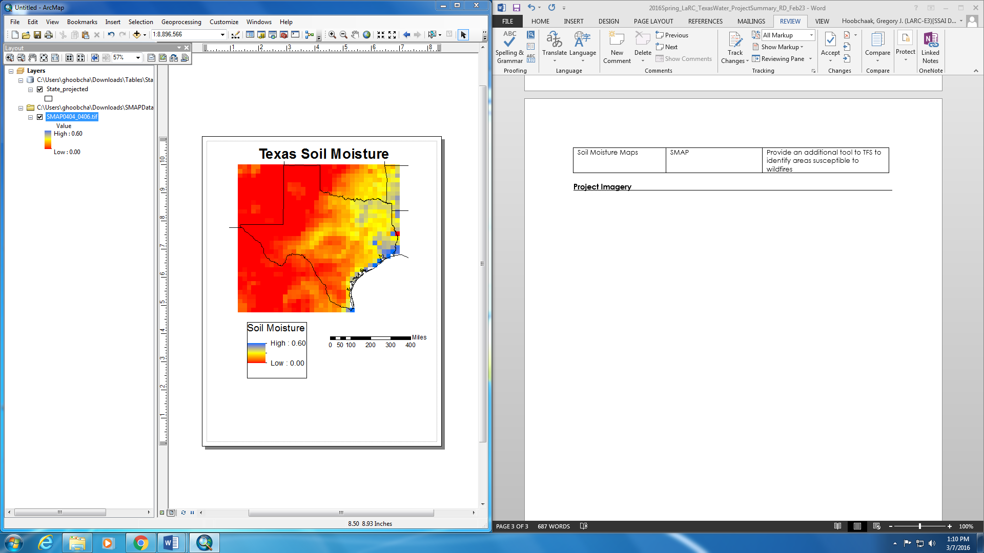**Image:** April 2015 Soil Moisture Active Passive.jpg

**Image Credit:** Texas Water Resources II Team

**Caption:** Soil Moisture Active Passive image of Texas in April 2015. Lower values (red) represent areas with drier soil conditions, while higher values (blue) represent areas with more saturated soils. This map shows that Western Texas has drier soil conditions while East Texas has more saturated soils.