NASA DEVELOP National Program
Langley Research Center
Spring 2015

Coastal Mid-Atlantic Water Resources II
Measuring Evapotranspiration using the METRIC Model in the
Mid-Atlantic Coastal Plain


Technical Report
Rough Draft –February 19, 2015

Kent Sparrow (Project Lead)
Jamie VanderHeiden

Dr. Kenton Ross (Science Advisor)

Previous Contributors:
Coastal Mid-Atlantic Water Resources team I (2014 Summer Term)
Coastal Mid-Atlantic Water Resources Team II (2014 Fall Term)

I. Abstract

Crop irrigation accounts for a considerable amount of water use in the Coastal Mid-Atlantic region. Better understanding of how much water farmers need to irrigate their fields will help decrease both water waste and the economic burden for farmers. The Mapping Evapotranspiration at High Resolution with Internalized Calibration (METRIC) model is a powerful tool that calculates evapotranspiration (ET) based on localized data. Executable from a Python script, the model can be used as a decision support tool that allows farmers to make more-informed decisions about when irrigation is necessary. METRIC estimates ET using a series of equations where local input variables are acquired from Landsat 8 sensors, a United States Geological Survey (USGS) survey-based Digital Elevation Model (DEM), and local weather conditions. While METRIC derived ET estimates are beneficial for irrigation purposes, it can also provide state officials with a useful means of drought monitoring. Utilizing data from NASA Earth observations in the Coastal Mid-Atlantic region will contribute to a large-scale, more-complete, understanding of the water consumption behavior in an area that can be used for both policy and individual agricultural decisions.

Keywords
Coastal Plain, remote Sensing, Landsat 8, METRIC Model, Water Resources, Irrigation Management, Drought Monitoring, Coastal Mid-Atlantic Region

II. Introduction

Background Information
Current Status
Irrigated agriculture accounts for a significant amount of water consumption nationwide and despite technological advances, at least half of U.S. irrigated cropland rely on traditional, low-efficiency irrigation methods (USDA, 2012). Improving irrigation practices will allow farmers to make more-informed decisions about when irrigation is necessary (Evans et al. 1996). Previous research has also indicated that estimating ET rates can provide a useful method for monitoring drought conditions (Narasimhan and Srinivasa, 2005). Drought monitoring is vital to the agricultural industry because the effects of drought cost US farmers billions of dollars in agricultural loss each year (FEMA, 1995). It is likely that future drought monitoring and irrigation management can be improved by the use of the METRIC model (Allen et al., 2007).
Previous Studies
ET is a major component of the hydrologic cycle (Allen et al. 2007; Telis et al., 2007; Papadavid, 2011) and is defined as the combination of evaporation from the ground and transpiration from agriculture (Michigan DEQ, 2010; Hoedjes et al., 2008; Papadavid et al., 2011). The USGS states that ET levels are directly proportional to crop yield, making it useful for assessing crop health and expected production (Verdin & Eilerts, 2013). A low ET rate during the peak of growing season would indicate crop stress while a high ET rate would indicate a healthy, adequately watered, field. Crop health and production are vital to the agricultural industry due to an expansion in population which has heightened demand for food and agricultural resources (Wenda & Hanks, 1981; Turner et al., 2004). Irrigation increases crop yield beyond what is achieved with non-irrigated farming by mitigating the effects of drought during growing seasons (Turner et al. 2004). While irrigation is often necessary for maximum crop production, higher pumping costs have placed pressure on the agricultural industry to update irrigation technology to optimize efficiency (Hornbaker R.H. & H.P. Mapp, 1988; Turner et al., 2004).
ET can be estimated by multiplying reference crop evapotranspiration rate by a dimensionless crop coefficient, determined by crop height, albedo (reflectance), canopy resistance, and evaporation from soil (Allen et al., 1998). Another method is to use in situ ET measurements made at lysimeter stations, which are reliable devices for measuring local ET rates with error as low as 5% (Howell et al., 1991). However, they are ill-suited to represent values for a wide area (Holm et al., 2000). Calculating ET using remotely-sensed data results in higher spatial resolution and coverage than using in situ measurements alone (Bastiaanssen, 1998; Allen et al., 2007).
An early model for assessing evapotranspiration using remote-sensing is the Surface Energy Balance Algorithm for Land (SEBAL), established by Bastiaanssen (1998). SEBAL uses minimal requirements for ground-based weather data, giving it a distinct advantage over models which rely exclusively on ground-based data. While a useful model, SEBAL relies on a fixed evaporative fraction for the entire day, typically resulting in an underestimated ET (Nouri et al., 2013). Allen et al. (2005) adapted SEBAL to create the METRIC model, which derives ET values using digital image data collected by Landsat 7 and meteorological variables recorded at local weather stations in Idaho. ET is estimated as the residual latent energy remaining after subtracting the energy lost to the ground and air in an energy balance equation (Allen et al., 2005). The METRIC model improved the accuracy of ET estimates by incorporating a reference evapotranspiration and internal calibration to eliminate the need for atmospheric correction of reflectance measurements (Morse et al., 2006). The internally calibrated METRIC model is more reliable and less complex than SEBAL since it does not rely on crop classification (Allen et al., 2007).
Since its development, the METRIC model has been a useful tool for long-term resource management in the western US (Allen et al., 2007). While the model was originally developed for Idaho, it has also been used in water management throughout the Imperial Valley of California and the Rio Grande Valley by calculating ET from both irrigated farmland and riparian areas (Allen et al., 2005). Areas in the Coastal Mid-Atlantic region could benefit from similar METRIC model applications by improving resource management practices, reducing irrigation costs, and enhancing crop productivity.
Objective
The current method of using the METRIC model to estimate ET is very complex (Allen et al., 2007). Applications of this model currently require trained experts with a background in energy balance, radiation physics, and knowledge of vegetation characteristics, as well as access to high-quality hourly weather data. The METRIC model was originally designed for use in the western US, but could be adapted to other regions, such as the Coastal Mid-Atlantic. The purpose of this project was to develop a more-accurate method of using the METRIC model to determine evapotranspiration in the Mid-Atlantic coastal plains. The findings from this research will contribute information enabling efficient irrigation in the region.

Study Area
South-Central Idaho was used for testing and validating the current model. Select locations in the Mid-Atlantic coastal plain were studied once the model was validated.

Study Period
Landsat 8 OLI/TIRS data from July 2013 was used exclusively for this project. This date was chosen because it falls within the growing season when the METRIC model would be useful for irrigation planning.

National Application Addressed
This project addressed the NASA Applied Sciences National Application Area of Water Resources and Agriculture.
Project Partners
The partners for this project included members of the Virginia government and Digital Harvest, a private company working with the State of Virginia. Virginia Secretary of Natural Resources Molly Ward, Virginia Secretary of Technology Karen Jackson, and Virginia Secretary of Agriculture and Forestry Todd Haymore, along the with Virginia Department of Environmental Quality Director of Surface and Ground Water Supply Planning, Scott Kudlas, were the project partners in the Virginia state government.

III. Methodology

Data Description
The crop data layer (CDL) used in this study was acquired from the U.S. Department of Agriculture (USDA) to identify land cover types in the southern Idaho and Coastal Mid-Atlantic sample areas. This layer was used specifically to select separate wet (alfalfa fields) and dry (bare agricultural field) reference regions used to internally calibrate the METRIC model. Landsat 8 images were acquired from the USGS Global Visualization viewer. Data from bands 2-7 and 10-11 were used as input to make the METRIC model compatible with Landsat 8 data. Weather data, recorded from automated surface observing system (ASOS) stations, were retrieved from the NOAA National Climate Data Center (NCDC) for local weather inputs. In situ measurements of hourly evapotranspiration rates, used for verification of model output, were based on lysimeter estimates available from AgriMet (http://www.usbr.gov/pn/agrimet/wxdata.html). A DEM with a 30-m resolution was acquired from the USGS Center for Earth Resources Observation and Science (EROS) website.

Basic METRIC Model Equations
The methodology for calculating ET using the METRIC model follows a set of equations (Appendix A) established by Allen et al. (2007). Landsat imagery, a DEM, and in situ weather data are used as inputs for the series of equations in a Python script. ET is first calculated for a sample region in southern Idaho, where the model requires testing and validation. The testing phase of this study is necessary for establishing model accuracy since Allen et al. (2007) designed the METRIC model for specifically calculating ET in the Western US. The model output was displayed using ArcGIS to provide ET maps in specific study areas for end users, such as the DEQ, farmers, and various policy makers. Since ET rates are influenced by radiation, air temperature, humidity, and wind speed, numerous calculations were required to adapt the METRIC model to a specific study area.
The basis of calculating ET using the METRIC model is represented by the following equation:
$$LE=R_{n}-G-H$$
where LE = latent energy consumed by ET, R_{n} = sum of all incoming and outgoing radiation, G = soil heat flux conducted into the ground, and H = sensible heat flux convected into the air. The availability of LE directly relates to the amount of ET that will occur. The first step to deriving LE begins with calculating net radiation flux (R_{n}), using the following surface energy budget equation:
$$R_{n}=R_{S↓}-{∝R}_{S↓}+R_{L↓}-R_{L↑}-\left(1-ε_{0}\right)R_{L↓}$$
In this equation, $R_{S↓}$ = incoming short-wave radiation, $∝$ = surface albedo, $R_{L↓}$ = incoming long-wave radiation $R_{L↑}$ = outgoing-long wave radiation, and $ε_{O}$ = broad-band surface thermal emissivity. R_{n} is largely influenced by the latitude of a study area since incoming solar radiation (insolation) increases as latitude decreases.
After computing net radiation, soil heat flux (G) was calculated to determine the amount of energy stored through the conduction of heat into the soil. G can be influenced by the amount and type of vegetation present, soil moisture content, and surface temperature. This component of LE is calculated using the following equation:
$\frac{G}{R_{n}}=\left(T_{s}-273.15\right)(0.0038+0.0074∝)(1-0.98{NDVI}^{4})$
where T_{S} = surface temperature (K), $∝$ = surface albedo, and NDVI = ratio of differences in reflectivity for the near-infrared band and the red band to their sums. To determine the value of G, each side of the equation was simply multiplied by the R_{n} value calculated in the previous equation.
The final component necessary for determining LE was sensible heat flux (H), which displays a value for energy lost through heat being convected into the air. H is calculated using the following equation:
$$H=ρ_{air}C_{p}\frac{dT}{r_{ah}}$$
where $ρ_{air}$ = density of air (kg m⁻³), C_{p} = specific heat of air at a constant pressure (J kg⁻¹ K⁻¹), and r_{ah} = aerodynamic resistance (s m⁻¹) between two near surface heights , z₁ and z₂.
Using the derived LE value, ET can be computed at instantaneous, daily, and seasonal rates. For this study, instantaneous and daily ET values were calculated and projected onto spatial maps. Instantaneous ET was calculated for each pixel at the instant of the satellite image and is represented by the following equation:
$${ET}_{inst=3600}\frac{LE}{λp_{w}}$$
where ET_{inst} = instantaneous ET (mm h⁻¹), 3600 converts seconds to hours, $p_{w}$ = density of water (~1000kg m⁻³), and $λ$ = latent heat of vaporization (J kg⁻¹). The value for ET_{inst} is important for model validation.

IV. Results & Discussion

Evapotranspiration and the METRIC model
The METRIC model was used to calculate instantaneous ET rates for a sample region in southern Idaho (Figure 1). ET_{inst} values ranged from -.031 - .24mm hr⁻¹, representing the rate of ET occurring during the hour of Landsat acquisition (5:00- 6:00 UTC). The higher ET_{inst} values occurred in areas of higher vapor flux where water and lush vegetation were present. The lower ET_{inst} values occurred over drier areas with little vegetation. In Figure 3, irrigated alfalfa fields are easily depicted as areas of high ET_{inst} in circular shapes due to center-pivot irrigation systems.
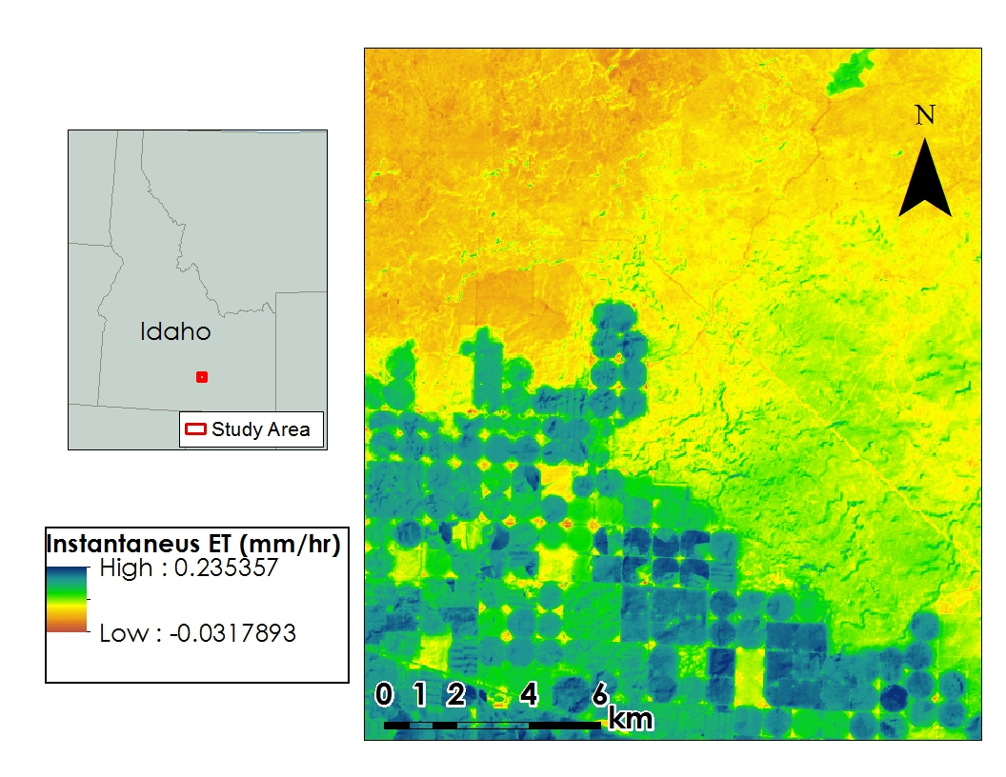
Figure 1: Map of ET_{inst} calculated by the METRIC model for the test and validation study area in southern Idaho. The red square in the state map of Idaho depicts our study area.
ET_{inst} rates were calculated for a sample area in North Carolina around the “fields of interest”, provided by a project partner. ET_{inst} values for this area range from -.0422564 - .36738 mm hr⁻¹. The areas with the highest rates represent recently irrigated cropland at the time of Landsat acquisition, while the lower rates represent areas of drier or barren cropland. Negative ET_{inst} are a result of condensation from clouds appearing in the image. Large differences in ET_{inst} are apparent from in the agricultural fields in this image. This difference is likely due to soil moisture differences in irrigated and non-irrigated fields.
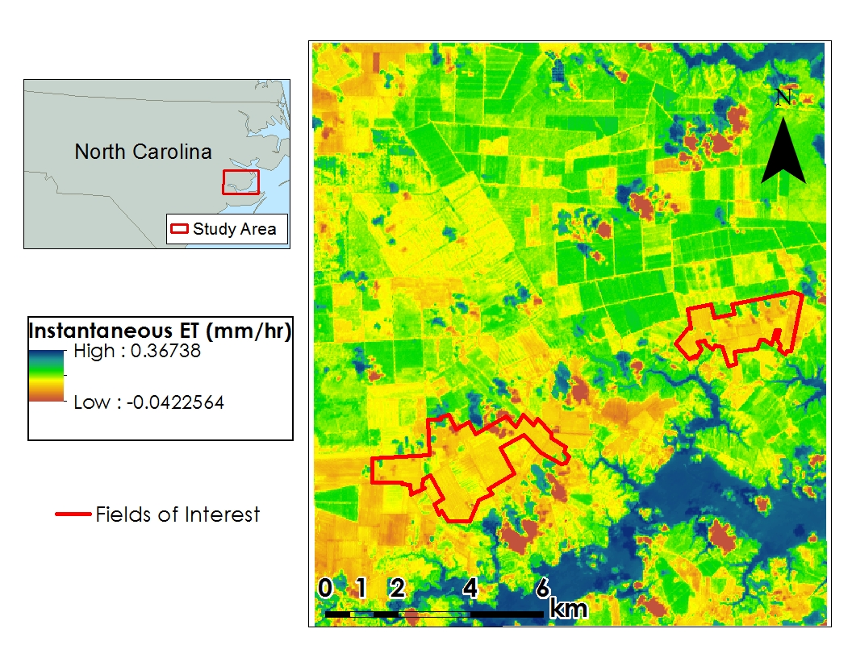
Figure 2: Map of ET_{inst} calculated by the METRIC model for the Mid-Atlantic Coastal Plain. The red square in the North Carolina state map depicts our study area. The outlined fields are the fields of interest for this study.

V. Conclusions

The use of the METRIC model will be beneficial to government officials and private industries involved in the agriculture industry. Better irrigation planning could reduce the events of heat stress on crops, improving productivity. State officials can use the METRIC model as a means of drought monitoring by applying the model to various types of land cover. This application will allow state officials to monitor drought conditions on a larger scale. Private end-users are interested in incorporating weather model data in place of weather station data to predict ET₂₄ rates up to a week in advance. This forecast will give farmers information to predict how much and how often to irrigate in advance.

VII. Acknowledgements

We would like to thank Dr. Kenton Ross, Nathan Owen, Lauren Childs and Jamie Favors for their support and assistance throughout the course of our project. We would also like to thank our project partners at Digital Harvest, Young Kim and Ed Hassell, for their valuable input, suggestions, and data.

This material is based upon work supported by NASA through contract NNL11AA00B and cooperative agreement NNX14AB60A.

VIII. References

Allen, R.G., Pereira, L.S., Raes, D., and Smith, M. (1998). Crop evapotranspiration: Guidelines for computing crop water requirements. Food and Agriculture Organization (FAO) of the United Nations.

Allen, Richard G.; Pereira, Luis S.; Howell, Terry A.; and Jensen, Marvin E., (2011). Evapotranspiration information reporting: I. Factors governing measurement accuracy. Publications from USDA-ARS / UNL Faculty. Paper 829. http://digitalcommons.unl.edu/usdaarsfacpub/829

Allen, R.G., Tasumi, M., Morse, A., and Trezza, R. (2005). Satellite-based evapotranspiration by energy balance for western states water management. Impacts of Global Climate Change, 1-18.

Allen, R.G., Tasumi, M., and Trezza, R. (2007). Satellite-based energy balance for mapping evapotranspiration with internalized calibration (METRIC) – Model. Journal of Irrigation and Drainage Engineering, 133(4), 380-394.

Allen, R.G, et al. (2007). Satellite-Based Energy Balance for Mapping Evapotranspiration with Internalized Calibration METRIC—Applications. Journal of Irrigation and Drainage Engineering, 133(4), 395-406.

Bastiaanssen W.G.M, Menenti, M., Feddes, R.A., and Holtslag, A.A.M. (1998). Remote sensing surface energy balance algorithm for land (SEBAL). J. Hydrol. 212-213(1-4), 198-212.

FEMA (1995). National mitigation strategy: partnerships for building safer communities. Federal Emergency Management Agency, Washington, DC.

Hornbaker R.H., and Harry P. Mapp. (1988). A Dynamic Analysis of Water Savings from Advanced Irrigation. Western Journal of Agricultural Economics, 13(2), 307-315.

Howell, T.A. (2003). Irrigation Efficiency. Encyclopedia of Soil Science. 467-472. Retrieved October 6, 2014 from http://www.cprl.ars.usda.gov/pdfs/Howell-Irrig%20Efficiency-Ency%20Water%20Sci.pdf

Howell, T.A., Schneider, A.D., and Jensen, M.E. (1991). History of lysimeter design and use for evapotranspiration measurements. Lysimeters for Evapotranspiration and Environmental Measurements, 1-9. 14

Irrigation (2012). EPA Ag 101. Retrieved October 6, 2014 from http://www.epa.gov/agriculture/ag101/cropirrigation.htm

Michigan Department of Environmental Quality, Land and Water Management Division. (2010). General Guidelines for Calculating a Water Budget. Retrieved October 6, 2014 from http://www.michigan.gov/documents/deq/lwm-waterbudget_202791_7.pdf

Morse, A., Kramber, W.J., Allen, R.G., Tasumi, M. (2006). Mapping evapotranspiration using Landsat and the METRIC evapotranspiration Model. In Proceedings of the 2006 ASPRS Conference.

Nouri, H., Beecham, S., Kazemi, F., Hassanli, A.M., and Anderson, S. (2013). Remote sensing techniques for predicting evapotranspiration from mixed vegetated surfaces. Hydrologic Earth System Science Discussion, 10, 3897-3925.

Narasimhan, B., & Srinivasan, R. (2005). Development and evaluation of Soil Moisture Deficit Index (SMDI) and Evapotranspiration Deficit Index (ETDI) for agricultural drought monitoring. Agricultural and Forest Meteorology, 133(1), 69-88.

Papadavid G., Hadjimitsis D.G., Perdikou S., Michaelides S., Toulios L., and Seraphides N. (2011). Use of Field Spectroscopy for Exploring the Impact of Atmospheric Effects on Landsat 5 TM / 7 ETM+ Satellite Images Intended for Hydrological Purposes in Cyprus. GIScience and Remote Sensing, 48(2), 280-298.

Telis A. and Koutsogiannis D. 2007. Estimation of Evapotranspiration in Greece. PhD Thesis, Athens.
Tolk, J.A., Howell, T., and Evett, S. (2006). Nighttime Evapotranspiration from Alfalfa and Cotton in a Semiarid Climate. Agronomy Journal, 98, 730-736. Retrieved October 7, 2014 from http://www.cprl.ars.usda.gov/wmru/pdfs/Tolk%20et%20al%202006%20AJ%20730.pdf

Turner, K.,Georgiou, S., Clark, R., Brouwer, R., and Burke, J. (2004). Economic Valuation in Water Resource in Agriculture. Food and Agriculture Organization (FAO) of the United Nations.

Verdin, J., and Eilerts, G. (2013). Remote Sensing of Evapotranspiration: A new tool for early warning of drought and food crises. Forum for Agricultural Risk Management in Development. Retrieved October 6, 2014 from
IX. Appendix
Appendix A
This appendix depicts the flow of equations in the Allen et al. (2007) paper.

A1. Evapotranspiration estimated from Latent Energy

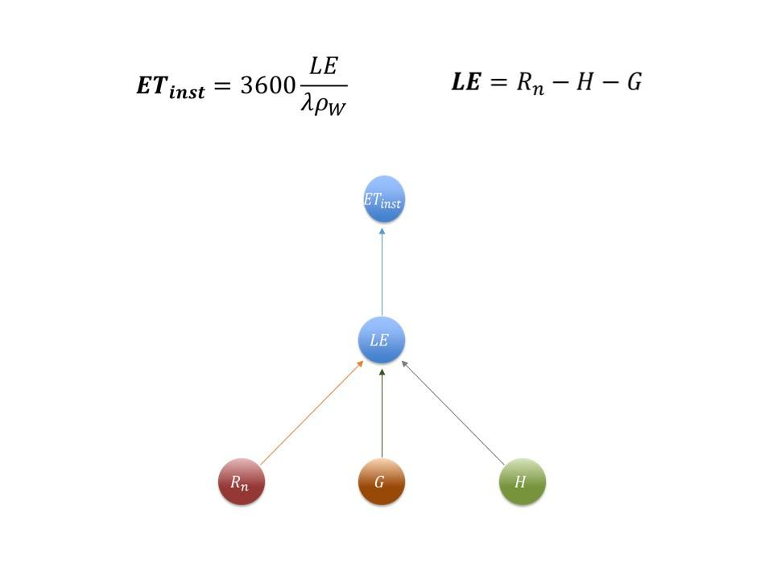

A2. Calculation of net radiation
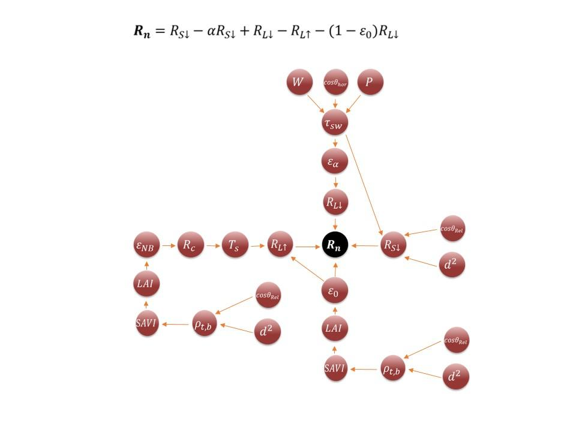

A3. Calculation of soil heat flux
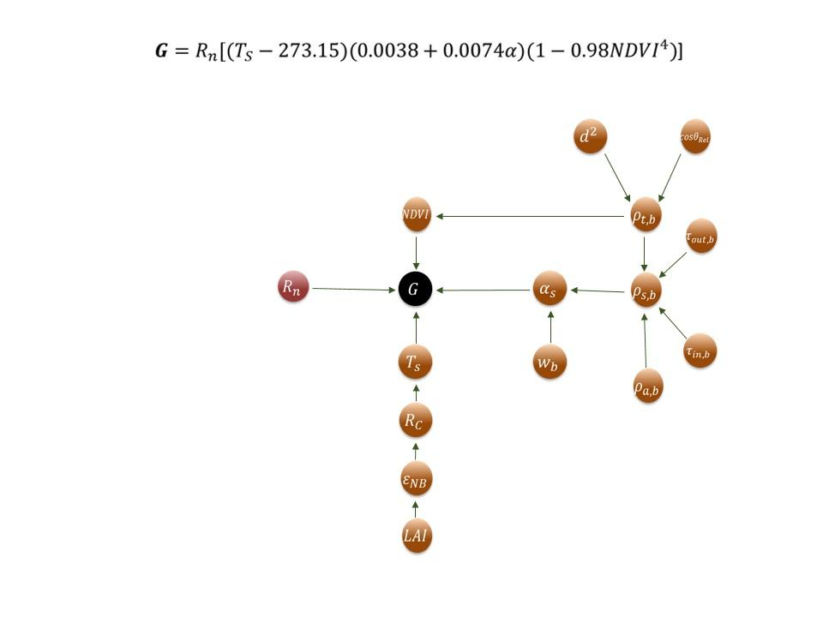

A4. Calculation of sensible heat flux (initial and iterative equations)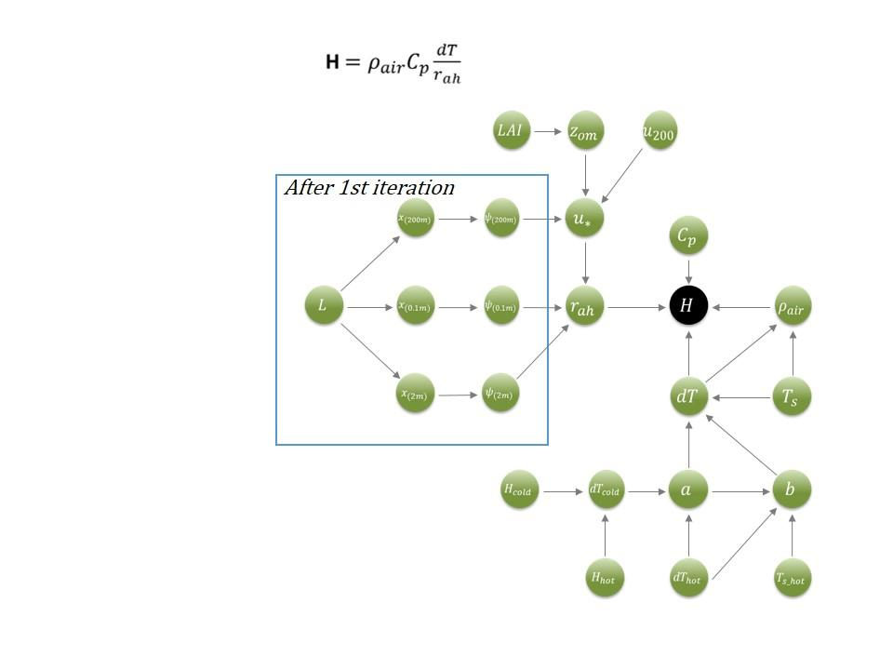

A5. Equation reference numbers from METRIC Model paper by Allen et al., 2007
1. |  | LE | Latent Energy |  | W m⁻²
2. |  | R_{n} | Actual net radiation flux at the |  | W m⁻²
3. |  | R_{s↓} | Incoming short-wave radiation |  | W m⁻²
4. |  | τ_{sw} | Broad-band atmospheric transmissivity |  | -
5. |  | P | Atmospheric pressure |  | kPa
6. |  | W | Water in the atmosphere |  | mm
7. |  | cosθ_{rel} | Solar incidence angle for sloping surfaces |  | Radians
8. |  | cosθ_{hor} | Solar incidence angle for horizontal flat surfaces |  | Radians
9. |  | d² | Square of the relative Earth-Sun distance |  | AU
10. |  | ρ_{t,b} | “At-satellite” or “top of atmosphere” reflectance for band b |  | -
11. |  | ρ_{s,b} | At surface reflectance for band b |  | -
12. |  | τ_{in,b} | Effective narrowband transmittance for incoming solar radiation |  | -
13. |  | τ_{out,b} | Effective narrowband transmittance for shortwave radiation reflected from the surface |  | -
14. |  | ρ_{a,b} | Per band path reflectance |  | -
15. |  | α_{s} | Broad-band surface albedo |  | -
16. |  | R_{s↑} | Outgoing long-wave radiation |  | W m⁻²
17. |  | ε₀ | Broad-band surface emissivity |  | -
18. |  | LAI | Leaf area index; the ratio of the total leaf area for the surface per unit ground area |  | m² m⁻²
19. |  | SAVI | Soil adjusted vegetation index |  | -
20. |  | T_{S} | Surface Temperature |  | K
21. |  | R_{C} | Corrected thermal radiance from the surface |  | W m⁻² sr⁻¹ μm⁻¹
22. |  | ε_{NB} | Narrowband transmissivity |  | -
23. |  | NDVI | Ratio of the differences in reflectivities for the NIR band and Red band to their sum |  | -
24. |  | R_{L↓} | Incoming long-wave radiation |  | W m⁻²
25. |  | ε_{a} | Effective atmospheric emissivity
26. |  | G | Soil heat flux |  | W m⁻²
28. |  | H | Sensible heat flux |  | W m⁻²
29. |  | dT | Temperature gradient |  | K
30. |  | r_{ah} | Aerodynamic transport |  | -
31. |  | u* | Friction velocity |  | m s⁻¹
32. |  | u₂₀₀ | Wind speed at blending height 200m |  | m s⁻¹
33. |  | z_{om} | Momentum roughness length |  | m
40. |  | L | Monin-Obukhov Length |  | m
41. |  | ψ_{(200m)} | Stability Correction for Momentum Transport | at 200m | ____
42. | a) | ψ_{(2m)} |  | at 2m
 | b) | ψ_{(0.1m)} |  | at 0.1m
43. | a) | χ_{(200m)} | Parameters used in associated Stability Correction for Momentum Transport |  | ____
 | b) | χ_{(2m)}
 | c) | χ_{(0.1m)}
46. |  | dT_{hot} | Near-surface temperature gradient over the hot pixel |  | K
47. |  | H_{hot} | Sensible heat flux at the hot pixel |  | W m⁻²
48. |  | H_{cold} | Sensible heat flux at the cold pixel |  | W m⁻²
49. |  | dT_{cold} | Near-surface temperature gradient over the cold pixel |  | K
50. |  | a | Coefficients |  | ___
51. |  | b
52. |  | ET_{inst} | Evapotranspiration at the instant of the satellite image |  | mm h⁻¹
53. |  | λ | Latent heat of vaporization |  | J kg⁻¹
54. |  | ET_{r}F | Reference ET fraction |  | -
55. |  | ET₂₄ | 24hr ET |  | mm day⁻¹
Appendix B:

This appendix depicts intermediate results from the sample region in the Mid-Atlantic coastal plains.
B1. Leaf Area Index (LAI), an index that displays the ratio of leaf area to ground area.

B2. Normalized Differential Vegetation Index (NDVI), an index that represents the amount of green, healthy, vegetation present.

B3. Soil-Adjusted Vegetation Index (SAVI), an index that is derived from NDVI to account for soil brightness. It represents the amount of green, healthy, vegetation present.

Appendix C:
This appendix serves as an end-user guide for operating the METRIC model tool created in this project. This guide describes the files and inputs that are needed in order to run the model and where file paths will need to be modified to fit your machine.

- .py Files needed:
  - MetricModelAtlantic.py
    - This file is the “run script” that calls all of the functions from the module and identifies them to make .tiff outputs. This allows the generation of nice ET maps in ArcMap.
  - Develop_Module_KR_20140731c.py\
    - This file is the “module script” that contains all of the functions required for METRIC calculations.
- Folders to create for model inputs
  - Input/Landsat & Input/Test_Subset/DEM_STUDYAREA_Subset/
    - Within the Input/Landsat directory you need following files in order for your model to successfully run. Some of these files will be created by the model, and some are needed in order for the model to run.
      - Final_clip#.tif
        - This file will contain the clipped sample area, selected in ArcMap, where 24-hour ET rates will be calculated. A shapefile will need to be created for the sample area with all Landsat 8 bands and the DEM mosaicked to the same area. The larger this area is, the longer your model will take to run.
      - Irrigated_cool.shp
        - This small sample area is selected in ArcMap where the the most abundant vegetation and highest likely ET rate is likely located. It is important to use Landsat 8 bands 10 and 11 (thermal bands) when selecting this area. This shapefile is named “irrigated_cool.shp.” in our script since we selected a well irrigated cool region in the thermal bands. Google Earth can be used to identify irrigation systems.
      - Nonirrigated_hot.shp
        - This small sample area is selected over a barren sample region and represents the area with the lowest likely ET rate. The hot and cold regions are involved with model calibration, which sets bounds for the highest and lowest ET rates for the selected area. Like with the cool irrigated pixel, it is important to use Landsat 8 bands 10 and 11 when selecting this hot, nonirrigated area.
      - Hotstats.dbf & Coolstats.dbf
        - These are the information database files for the user selected hot and cold pixel shape files. These files do not need to be created by the user, they are created by the model once submitted to run. The Hotstats.dbf file is the information associated with the nonirrigated_hot pixel and the Coolstats.dbf file is the information associated with the irrigated_cool pixel.
      - Final_MidAtl files
        - This is the intermediate output file that is used for model inputs file in the run script. It contains intermediate calculations, such LAI, NDVI, and SAVI. This file is created by the model and does not need to be created by the user.
      - NC_metadata
        - This file contains the metadata from the Landsat 8 bands and is imported into the run script with the Landsat 8 files. To initially run the script, a blank text file can be used. The run script will write in the data needed. When resubmitting the run script, this file does not need to be changed or deleted because its contents will be overwritten for each submission.
    - Within the Test_Subset/DEM_STUDYAREA_Subset/ you need the Study area files
      - Download DEM files from USGS- the higher resolution the better
  - Output
    - This is the output file where all of your METRIC results will be stored
  - Wx_data
    - Contains your weather data (month_year). The weather data will need to be from local Automated Surface Observing System or Automated Weather Observing System stations. The weather files can be ordered by going to the following link and completing the steps below. Once the data is ordered, download the file and input it into this directory.
    - http://www.ncdc.noaa.gov/cdo-web/datatools/findstation
    - After following the link,
      - Under “Enter Location” - enter the location of the weather data needed
      - Under the “Select Dataset” option select “Normals hourly”. This option includes the input variables required by the model.
      - Under “Select Data Range” select the data range needed.
- The following lines are the directory paths in MetricModelAtlantic that will need to modified to match those on your machine:
  - Line 21: outdir = user_account + “\\Output\\DIRECTORY\\PATH”
  - Line 26: landsat_dir = user_account + “\\Input\\Landsat\\DATA\\PATH”
  - Line 63: dem_file = user_account + “\\Input\\Test_Subset\\DEM_AREA_Subset\\PATH”
  - Line 67: wx_file = user_account + “\\YOUR\\wx_data\\PATH”
  - Line 70: reference_pixel_directory = user_account + “\\Input\\Landsat\\DATA\\PATH “
    - Make sure files found on line 71, 72, 75, 76 are found within the Input/Landsat directory
  - Make directories found in line 79 in code (C:\\arcgis\\scratch\\scratch.mdb)
    - Need to create scratch.mdb file in arcmap. This is a personal geodatabase file that can be created in ArcCatalog.
    - As the model runs, all the intermediate calculations and results are inputting into this scratch file. Once the model is complete, this scratch file is emptied and all the final results are located in the output directory.

- If using different Landsat data, need to change the following
  - In MetricModelAtlantic:
    - line 26 depending on folder name is necessary
    - Line 28-37: the f_band names if necessary
    - Line 877 & 878: the reflectance_bands[i] depending on which band needed
      - Band #: reflectance_bands[#-2]
      - Band 2: reflectance_bands[0]
      - Band 3: reflectance_bands[1]
      - Band 4: reflectance_bands[2]
    - Landsat Thermal Band 10 & 11: lines 272-323

