**NASA DEVELOP National Program**



NASA Langley Research Center & Wise County and City of Norton Clerk of Court's Office

*Summer 2016*

Appalachian Trail Health & Air Quality

Monitoring Ozone in the Troposphere to Help Regulate Point Source Emissions and to Improve Ozone Advisory Messages by the National Park Service

**Technical Report** 

August 11, 2016

Amy Wolfe (Project Lead)

Amber Showers   
Emily Beyer  
Eric White  
Tyler Rhodes

Dr. Travis Knepp, NASA Langley Research Center - SSAI (Science Advisor)

Dr. Kenton Ross, NASA DEVELOP National Program (Science Advisor)

# 1. Abstract

Ozone (O3) in the stratosphere serves as a boundary that absorbs harmful ultraviolet radiation from the sun. Ozone in the troposphere is hazardous to both human and plant health. Anthropogenic activities, such as fossil fuel combustion, are the main catalysts for high levels of tropospheric ozone, nitrogen oxides, and sulfur oxides. The warmer months, from May to September, typically display higher levels of tropospheric ozone located near urban areas with large populations. Tropospheric ozone forms from nitrogen oxides and volatile organic compounds (VOCs) reacting with sunlight, and fluctuates throughout the day displaying its peak concentration during mid-to-late afternoon. Lower concentrations occur during the early morning when the planetary boundary layer (PBL) is lowest and ozone molecules have not formed from the nitrogen oxide and VOCs reacting. NASA Earth observations can be used to monitor these atmospheric constituents. This project used Aura’s Ozone Monitoring Instrument (OMI) and Microwave Limb Sounder (MLS) to look at tropospheric ozone, nitrogen dioxide, and sulfur dioxide. The analysis and mapping of these atmospheric constituents provided data to compare to the National Park Service’s ground-level air quality stations. This project determined whether OMI and MLS are effective sensors for observing air pollutants in the troposphere and create visual aids of correlations and general trends.

**Keywords**

Remote Sensing, VOC, OMI, MLS, Ozone, Air Pollution

# 2. Introduction

* 1. ***Background Information***

Ozone (O3), commonly referred to as smog, is a colorless, odorless reactive gas comprised of three oxygen atoms. Ozone occurs throughout the upper and lower atmosphere, but the location and origin determines whether the effects of the ozone are beneficial or harmful (Ozone Basics, 2016). The troposphere, the lowest layer of the atmosphere, stretches from the surface of the Earth to approximately 10-15 km in altitude. The next layer, the stratosphere, is located approximately 10-50 km above Earth’s surface and contains the “ozone layer”. This layer resides between the stratosphere and the troposphere, extending from about 15-30 km in altitude (Basic Ozone Layer Science, 2016), and acts as a thin sheet protecting the Earth’s surface from harmful ultraviolet radiation emitted by the Sun (Ozone Basics, 2016). Ozone occurs naturally in the stratosphere and is beneficial for humans and the environment because it blocks ultraviolet radiation known to causes skin cancer and harm marine and plant life (Basic Ozone Layer Science, 2016). Significant depletion of stratospheric ozone has been observed near the South Pole driven primarily through the increase of anthropogenic chemicals such as chlorofluorocarbons (CFCs), commonly used in vehicle air conditioners, and have a long life expectancy within the troposphere (What is the Ozone Hole?, 2013). Commonly known as the “Ozone Hole”, this gap develops within the stratospheric layer by the chemical reactions between the pollutants and ozone (Basic Ozone Layer Science, 2016).

Ground-level or tropospheric ozone is a “criteria air pollutant” that poses significant health risks to plants and humans (Criteria Air Pollutants, 2016). It is formed through a chemical reaction of nitrogen oxides and volatile organic compounds (VOCs) in the presence of sunlight (Krotkov, 2016). Ground level ozone has been increasing as a result of more fossil fuel combustion. According to the California Air Resources Board, exposure to high ozone levels irritates the respiratory system can worsen asthma symptoms and may cause permanent lung damage. The United States Department of Agriculture (USDA) states that tropospheric ozone causes more damage to plant life than all other atmospheric pollutants combined (Effects of Ozone Air Pollution on Plants, 2005). Tropospheric ozone damages forests in many ways, including foliar damage, which decreases photosynthesis and increases leaf senescence. These effects increase the vegetation’s susceptibility to drought, invasive species infestation, and wildfire. Understanding tropospheric ozone is important for the NPS, as it has the responsibility to protect natural resources affected by air pollution and deliver high ozone advisories to the public.

Under the Clean Air Act amendments of 1977, national parks greater than 6,000 acres and wilderness areas larger than 5,000 acres are protected as Mandatory Class I lands. This Class I establishment requires the monitoring and regulation of air polluting emissions in these areas to prevent and remedy any existing visibility impairment caused by anthropogenic air pollution. According to the Air Quality Index, there is a scale to determine the ranges of acceptable ozone. The scale ranges from 0 to 500 parts per billion (ppb) with a healthy range being 0 to 50 ppb (Air Quality Index, 2016). However, the Environmental Protection Agency (EPA) recently changed the NPS ozone standards to a daily level of 70 ppb (Ozone Standard, 2016). In order to implement the visibility regulations, the EPA created Interagency Monitoring of Protected Visual Environments (IMPROVE) that is essentially a long-term monitoring program to establish the current visibility conditions, track changes, and identify visibility impairment causation and sources (Mikel, 2002). The NPS has the responsibility of monitoring visibility and particulate concentrations in the air. The NPS Air Resources Division contains the Gaseous Pollutant Monitoring Program (GPMP), which measures the primary air pollutants and compares them to the standards set by the EPA (Ray, 2009). In 1987, the EPA and National Oceanic Atmospheric Administration (NOAA) agreed to create a national monitoring network, Clean Air Status and Trends Network (CASTNET), in order to provide data on dry deposition and other atmospheric pollutants such as sulfur dioxide, ammonium, and ground-level ozone. CASTNET determines trends in air pollutant emissions and helps assess the effectiveness of national control programs.

Ground-level ozone is very difficult to measure and various methods have been established in order to accomplish accurate measurements using satellite sensors. A common method is to use one of NASA’s Earth observations, Aura, and subtract the stratospheric ozone gathered from its sensor, the Microwave Limb Sounder (MLS), from the total column ozone measured by a different sensor, the Ozone Monitoring Instrument (OMI) (Fishman, 2010). Ground monitoring of ozone provides an accurate measurement near the surface for that specific region; however, the stations extrapolate the value over large distances. The confidence in the extrapolation decreases as the distance from the monitoring station increases. Incorporating satellite instruments with the monitoring stations’ measurements could provide supplementary information of the distribution and changes of ozone over large areas with little to no surface measurements (Ray, 2004).

The Appalachian Trail spans 2,189 miles traversing 14 states along the east side of the United States. Started in 1921 by private citizens, the Appalachian Trail was completed in 1937 and is managed today by many federal agencies such as the National Park Service and the US Forest Service, along with state agencies and local volunteers (United States, n.d.). This project studied the entirety of the Appalachian Trail from 2012 to 2015 during the months of May to September (see Appendix A). Specifically, the study focused on the hourly measurements made by the Shenandoah ground monitoring station, Big Meadows, the Great Smoky Mountain monitoring station, Cove Mountain, measurements from OMI, and MLS to compare and validate the effectiveness of using these sensors to measure air pollutants in the troposphere.

* 1. ***Project Partners & Objectives***

This project addressed NASA’s Applied Sciences Program Health & Air Quality application area. The objective for this project is directed to enhance current research and monitoring practices of ozone. Currently, monitoring stations are the main source of data collection for pollutants in the troposphere. OMI and MLS were used congruently as an additional way to capture air quality information in the total-column troposphere and provide data in areas with few monitoring stations. This project established the effectiveness and usefulness of incorporating remotely sensed data with the National Park Service’s monitoring stations.

# 3. Methodology

***3.1 Data Acquisition***

NASA Goddard’s Giovanni website was used to download the total column ozone data using the OMI Level-3 Total Column Ozone Data Product in 0.25 degree Lat/Long grid in NetCDF file format. Stratospheric ozone datasets were acquired from Goddard Earth Sciences Data and Information Services Center for the MLS Level-2 Ozone Mixing Ratio in HDF5 file format. These sensors are located on the Aura satellite, launched on July 15, 2014, with the purpose of long-term measurements of trace gases in the atmosphere. The Appalachian Trail Centerline and States shapefiles were obtained from the ArcGIS Online feature service. Hourly measurements of surface ozone, barometric pressure, and ambient temperature for the study period were downloaded for the Big Meadows monitoring station at Shenandoah National Park and Cove Mountain monitoring station in the Great Smoky Mountains National Park from the NPS.

***3.2 Data Processing***

Diurnal ascending MLS stratospheric ozone measurements, latitude, and longitude were copied from the HDF5 files for each day and placed into a text file. The text files were then easily converted to shapefiles using the iteration tool within Model Builder for use in ArcMap. Iteration was also used on the OMI images in order to convert to raster datasets within ArcMap. All data were projected to Mercator Auxiliary Sphere with WGS 1984 geographic coordinate system. A polygon shapefile was created that extended across the area of interest, which extends from Maine to the upper portion of Florida along the east coast. Rasters and shapefiles were clipped to this newly created shapefile for analysis. Invalidated hourly data were removed from the Big Meadows and Cove Mountain text files. Daily measurements were then averaged and converted to point shapefiles.

***3.3 Data Analysis***

Due to multiple row anomalies that have occurred since 2007, the OMI Level-3 images contained large areas of missing data displaying a north-south gap. In order to compensate for this, a geostatistical autocorrelation method called Empirical Bayesian Kriging was performed to fill in the missing areas. The points where the two sensors’ data overlapped were combined using the Extract Values to Points tool within ArcMap. The stratospheric ozone and the total column ozone measurements were then subtracted using the field calculator to estimate the Tropospheric Ozone Residual (TOR). Empirical Bayesian Kriging was used again on these newly created points to produce averaged seasonal maps for the months of May - September for 2012 - 2015.

The OMI images’ spatial resolution, 0.25 degree (25 km) pixels, was used as a grid to compare ozone surface measurements of the Big Meadows monitoring station, Cove Mountain monitoring station, and the calculated TOR. Having a spatial discrepancy between the pixel size and the monitoring station point, an assumption was made that the surface ozone measurements are representative of the entire grid cell. Since the surface level measurements were in units of parts per billion (ppb), the TOR was converted from Dobson Units (DU) to ppb. However, this conversion is not straightforward and assumptions were made during the following calculations:

1 DU = (2.67E16 molecules/cm2)

ozone molecules/cm3 = (2.67E16 molecules/cm2)/height of the troposphere (assumed 12 km = 1.2 x 106 cm)

In order to identify how many air molecules are within the cubic centimeter, the ideal gas law was used. It is assumed that the volume (V) is 1 cm3, pressure (P) is the barometric pressure from the monitoring station in atm, and temperature is the average ambient temperature from the monitoring station in K, and solve for moles of air (n)

Pressure (atm) * 1E-3 L = n * 0.082 L*atm/(mol * K) * Temperature (K)

Moles is then converted to molecules of air per 1 cm3 of volume where we use Avogadro’s Number, 6.02 x 1023 molecules/mole:

air molecules/cm3 = Moles x (6.02 x 1023 molecules/mole)

The average mixing ratio is derived using the air molecules/cm3 and the average molecules/cm3:

ppb = (( ozone molecules/cm3)/(air molecules/cm3)) x (1 x 109)

The newly calculated mixing ratio was then compared to the measurements taken by two monitoring stations to identify the accuracy of the monthly average TOR calculations.

***3.4 Appalachian Trail Analysis***

Segmented analyses of the Appalachian Trail maps were performed by sectioning the trail along ecological regions and airshed associations. These segments were selected where the trail aligns with the national parks with monitoring stations to be of use for the NPS. Zonal Statistics were used to identify the minimum, maximum, and average tropospheric ozone residual within each zone.

# 4. Results & Discussion

***4.1 Analysis of Results***

TOR was calculated for the months of May to September for four consecutive years from 2012 to 2015 to observe the change in ozone during peak months and also the differences between years. Visually, the months of June and July regularly have high ozone over the entire study area with June 2015 displaying very high ozone (Figure 1, see Appendix B). Also observed was a tapering off of ozone from August to September (See Appendix B).

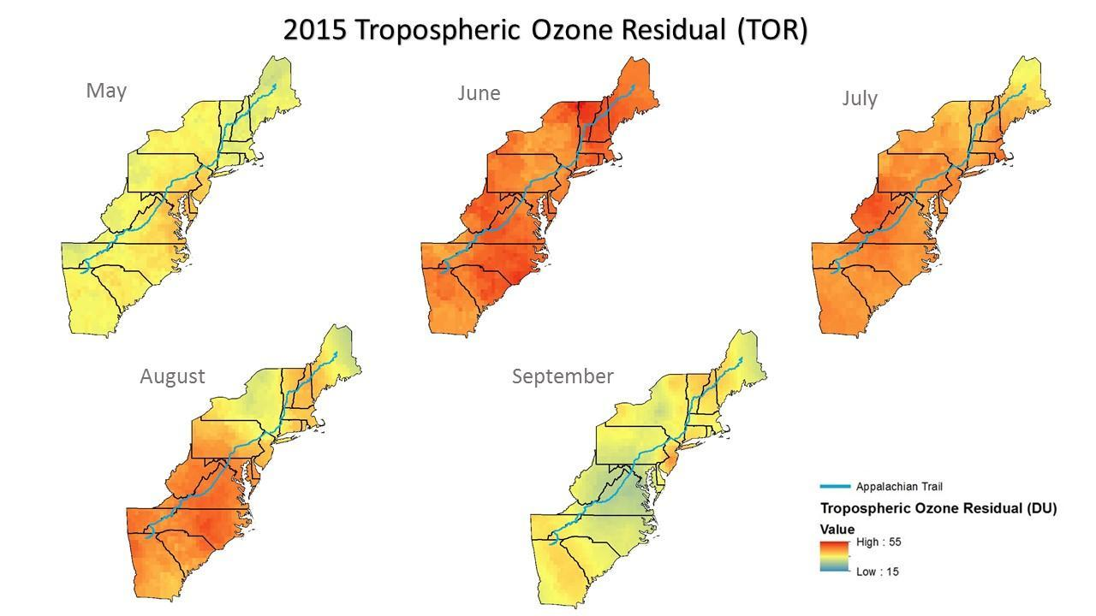

Figure 1. Monthly tropospheric ozone residual (TOR) for 2015.

A segmented analysis of the Appalachian Trail was performed based on Bailey’s ecoregions and the Hydrologic Unit Code (HUC) 10 Shell. For the Central Appalachian (N), Blue Ridge (N) and the Central Ridge and Valley, Central Appalachian (S), Blue Ridge (S) sections similar trends were observed with the summer months of 2015 displaying higher ozone levels than the previous years. The Hudson, Lower New England section displayed unique results. Generally, the trend for each month’s TOR does not change drastically over the study period. For example, June had a distinctly high level of ozone for all of the years and 2013 had the highest and lowest ozone levels in May and September respectively. In the Adirondack East section, 2014 and 2015 do not follow the trend observed for the previous two years. In 2014, September showed an abnormally high level of ozone while in 2015, this large spike was observed in June. Lastly in the Adirondack West region, high levels of ozone were observed during June for every year with ozone reaching a peak level of 49 DU in 2015 (See Appendix D, Figures 11-15).

In addition to the monthly ozone maps created, graphs were created to display the comparison between the surface ozone from the two stations with the calculated TOR from the Aura satellite. For the year 2012, our results revealed the monitoring stations’ measurements were consistently higher compared to the estimated TOR (Figures 2 & 3). However, overall, both the ground monitoring stations and TOR calculations showed similar trends with slight differences. The largest differences occurred during the months of May and September, but the differences were small. The largest difference between the ground monitoring stations and TOR was approximately 15 ppb while the smallest separation was 1 ppb.

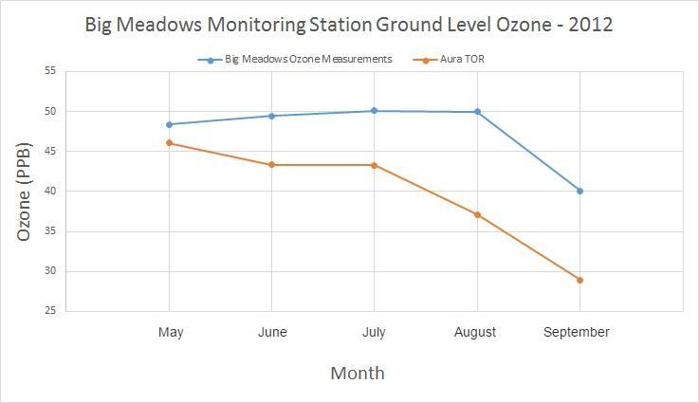

Figure 2. Monthly comparison of the Big Meadows ground monitoring station and the calculated Aura TOR for the year 2012.

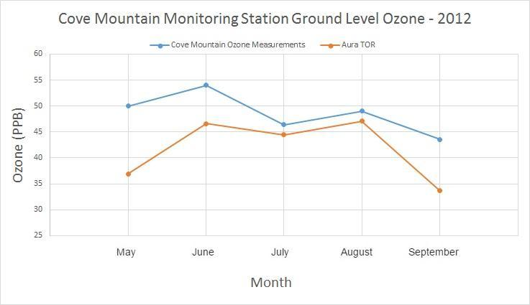

Figure 3. Monthly comparison of the Cove Mountain ground monitoring station and the calculated Aura TOR for the year 2012.

***4.2 Limitations, Errors, and Uncertainties***

The largest areas of uncertainty were caused by the row anomaly issue that resulted in large areas of missing data in the OMI images, MLS point data versus OMI raster data, and DU to ppb conversion. Due to the numerous row anomalies, the daily OMI data contained missing swaths of data across the study area. In order to compensate, the data were interpolated to fill in the missing area. The MLS data were presented as point data while the OMI data were in raster format. A limitation occurred when observing daily measurements as only a few number of point data from the MLS sensor overlapped the OMI data covering the study area. As a result, diurnal TOR calculations were not feasible. Assumptions were made for the conversion from DU to ppb with the largest being a constant tropopause height of 12 km. Other conjectures were that the barometric pressures and the ambient temperatures were representative of the entire pixel.

***4.3 Future Work***

For future studies, the TOR calculation could incorporate more variables such as incorporating the changing tropopause height, which is known to naturally fluctuate from the equator to the poles. Also, more advanced satellites could be utilized to monitor air pollutants such as Tropospheric Emissions: Monitoring of Pollution (TEMPO). TEMPO is planned to be completed mid-2017, and launched at the earliest date possible. This instrument will be in a geostationary Earth orbit (GEO) about 22,000 miles above Earth's equator. The TEMPO instrument is sensitive to ultraviolet and visible wavelengths of light, and will maintain a constant view of North America. This will allow the instrument’s light collecting mirror to face Earth and make scans every hour during the day from the East Coast to the West Coast. The pixels will be a few square miles, unlike the current sensors which are around 100 square miles. This will allow for tracking at a much smaller scale, and could help the NPS track pollutant movements across each individual park.

While this project’s objective originally included nitrogen and sulfur dioxide analyses, due to time constraints this was not feasible. Further research to include these pollutants would benefit the NPS, specifically Shenandoah National Park where its foliage and its aquatic life are damaged from acid rain. Along with including more atmospheric species, studying visibility and the relationship with different aerosols in the atmosphere would be beneficial for the NPS. Visibility is one of the key focuses of the Clean Air Act and is a major aesthetic component for visitors to the parks.

# 5. Conclusions

The methodology used to calculate TOR proved to provide a satisfactory estimation of the monthly trends in ground-level ozone. Differences were observed and found to be greatest for the months of May and September. Reasons for the differences could be a result of random variability, scaling, changing tropopause height, or other secondary variables such as plant activity. For example, in May there is an increase in biogenic emissions from plants coming into bloom while the opposite effect occurs in September when many plants die and decompose. Ozone is released during both of these natural cycles. Increases in ozone for the months of June and July are possibly the result of more anthropogenic activities, such as traveling, contributing to higher automobile emissions. In 2012, an increased level of ozone was observed throughout the Appalachian Trail. This could be a result of 2012 experiencing record warm temperatures across the nation paired with dryness causing an unusually high amount of wildfires across the western portion of the United States (Wildfires - Annual 2012, 2013). Wildfires contribute to the release of nitrogen oxides in the atmosphere. The westerly winds likely transported a portion of the smoke and gases towards the Appalachian Trail contributing to the formation of tropospheric ozone.

This project can be useful for the National Park Service to monitor ozone trends in areas in which parks do not currently monitor ozone with ground stations. In addition, satellite data could help supplement the ground monitors to obtain a more accurate measurement of ozone across large areas. The methodology can be used to track long-term changes in ozone to see whether ozone is increasing, decreasing, or remaining constant. TOR derived from the satellite instruments could provide a better understanding of the ozone trends across the Appalachian Trail to help the National Park Service provide better policies for clean air to protect the park’s natural resources and visitors.

# 6. Acknowledgments

# The Appalachian Trail Health and Air Quality team would like to acknowledge Dr. Travis Knepp from Science Systems and Applications, Incorporated at NASA Langley Research Center and Dr. Kenton Ross from NASA DEVELOP for their scientific advising on the project. We also offer thanks to the Center management, Tyler Rhodes, Emily Gotschalk, Carrie Kelley, and Kathleen Moore for their help, support, and facilitation throughout the project lifecycle. We would also like to thank Jalyn Cummings, Shenandoah National Park Air and Water Quality Program Manager, for her partnership with the project along with Fred Dieffenbach, the Environmental Monitoring Coordinator for the Northeast Temperate Network, and Liz Garcia, Physical Science Technician at the National Park Service, who have provided useful map boundary information and data for the project.

# Any opinions, findings, and conclusions or recommendations expressed in this material are those of the author(s) and do not necessarily reflect the views of the National Aeronautics and Space Administration.

# This material is based upon work supported by NASA through contract NNL11AA00B and cooperative agreement NNX14AB60A.

# 7. References

Air Quality Basics. (2013, January 10). Retrieved July 25, 2016, from http://www.nature.nps.gov/air/aqbasics/index.cfm

Air Quality Index (AQI) Basics. (2016, July 22). Retrieved August 04, 2016, from https://www.airnow.gov/index.cfm?action=aqibasics.aqi

Basic Ozone Layer Science. (2016, January 14). Retrieved June 28, 2016, from https://www.epa.gov/ozone-layer-protection/basic-ozone-layer-science

Clean Air Act Text. (2016, March 30). Retrieved June 28, 2016, from https://www.epa.gov/clean-air-act-overview/clean-air-act-text

Criteria Air Pollutants. (2016, June 16). Retrieved June 28, 2016, from https://www.epa.gov/criteria-air-pollutants

Effects of Ozone Air Pollution on Plants. (2005, August 25). Retrieved August 08, 2016, from https://www.ars.usda.gov/Research/docs.htm?docid=8453

Fishman, J., Creilson, J. K., Parker, P. A., Ainsworth, E. A., Vining, G. G., Szarka, J., Booker, F., Xu, X. (2010). An investigation of widespread ozone damage to the soybean crop in the upper Midwest determined from ground-based and satellite measurements. *Atmospheric Environment, 44*, 2248-2256.

Krotkov, N. A., McLinden, C. A., Li, C., Lamsal, L. N., Celarier, E. A., Marchenko, S. V.,...Streets, D. G. (2016). Aura OMI observations of regional SO2 and NO2 pollution changes from 2005 to 2015. *Atmospheric Chemistry and Physics, 16*, 4605-4629.

Lamsal, L. N., Krotkov, N. A., Celarier, E. A., Swartz, W. H., Pickering, K. E., Bucsela, E. J.,...Knepp, T. N. (2014). Evaluation of OMI operational standard NO2 column retrievals using in situ and surface-based NO2 observations. *Atmospheric Chemistry and Physics, 14*, 11587-11609.

Mikel, D., Pitchford, M., Scruggs, M., Maxwell, D., Dietrich, D., Mercer, G., Eldred, R. (2002). Interagency Monitoring of Protected Visual Environments. *Quality Management Plam*, 1-57.

Montreal protocol on substances that deplete the ozone layer: Message from the President of the United States transmitting the Montreal protocol on substances that deplete the ozone layer, done at Montreal on September 16, 1987, to the Vienna Convention for the Protection of the Ozone Layer. (1987). Washington: U.S. G.P.O.

NAAQS Table. (2016, March 29). Retrieved June 28, 2016, from https://www.epa.gov/criteria-air-pollutants/naaqs-table

Ozone Basics. (2016, May 16). Retrieved June 28, 2016, from https://www.epa.gov/ozone-pollution/ozone-basics#what where how

Ozone Standard Exceedances in National Parks. (2016, July 8). Retrieved August 04, 2016, from http://www.nature.nps.gov/air/Monitoring/exceed.cfm

Ray, J. D. (2009). Annual Data Summary 2009 Gaseous Pollutant Monitoring Program. Retrieved June 28, 2016, from http://science.nature.nps.gov/im/units/cakn/Documents/airQuality/ozone%20monitoring/ozone%20and%20meteorology%20annual%20report%202009.pdf

Ray, J.D. (2004). Ozone Monitoring Protocol for the National Park Service. *National Park Service U.S. Department of the Interior*, 1-24.

Spruce, J. P. (2007) Use of AIRS, OMI, MLS, and TES Data in Assessing Forest Ecosystem Exposure to Ozone. Solutions Network Formulation Report, 1-6.

United States. National Park Service. (n.d.). Appalachian National Scenic Trail (U.S. National Park Service). Retrieved August 08, 2016, from https://www.nps.gov/appa/index.htm

United States. National Park Service. (n.d.). Gaseous Pollutants, Ozone, and Smog. Retrieved June 28, 2016, from https://www.nps.gov/shen/learn/nature/gaseous_pollutants.htm

What is the Ozone Hole? (2013, September 25). Retrieved June 28, 2016, from http://ozonewatch.gsfc.nasa.gov/facts/hole_SH.

Wildfires - Annual 2012. (2013, January 07). Retrieved August 09, 2016, from https://www.ncdc.noaa.gov/sotc/fire/201213.

# 8. Content Innovation

**Content Innovation #1**

Audio Slides

Emailed to [Lauren.M.Childs@nasa.gov](mailto:Lauren.M.Childs@nasa.gov) with filename 2016Summer_LaRC_AppalachianTrailHealthAQ_TechPaper_AudioSlides

**OR** shared through Google Drive at: <https://goo.gl/u49jps>

**Content Innovation #2**

Glossary Viewer

Emailed to [Lauren.M.Childs@nasa.gov](mailto:Lauren.M.Childs@nasa.gov) with filename

2016Summer_LaRC_AppalachianTrailHealthAQ_InnovativeContent_glossary

**Content Innovation #3**

Inline Supplementary Material

* Figure 1
* Figure 2
* Figure 3
* Appendices A - C

**Content Innovation #4**

Interactive Map Viewer

Emailed to [Lauren.M.Childs@nasa.gov](mailto:Lauren.M.Childs@nasa.gov) with filename

2016Summer_LaRC_AppalachianTrailHealthAQ_InnovativeContent_InteractiveMapViewer

**Content Innovation #5**

Featured Multimedia for this Article

Emailed to [Lauren.M.Childs@nasa.gov](mailto:Lauren.M.Childs@nasa.gov) and Mark.A.Barker@jpl.nasa.gov with filename

VPS_Video

# 9. Appendix A

**Study Area**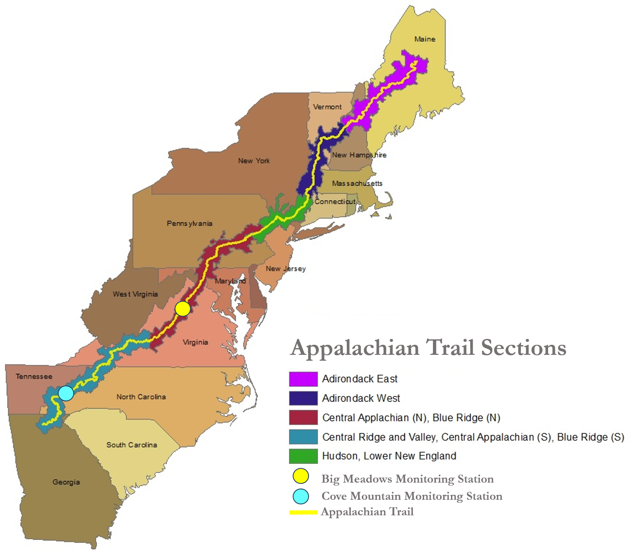

Figure 1. Map of the study area along with the location of the two ground monitoring stations.

# Appendix B

**Calculated Tropospheric Ozone Residual (TOR)**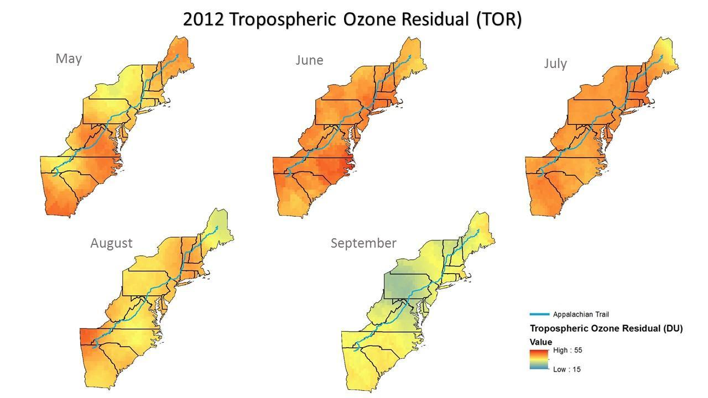

Figure 2. Monthly tropospheric ozone residual (TOR) for 2012.

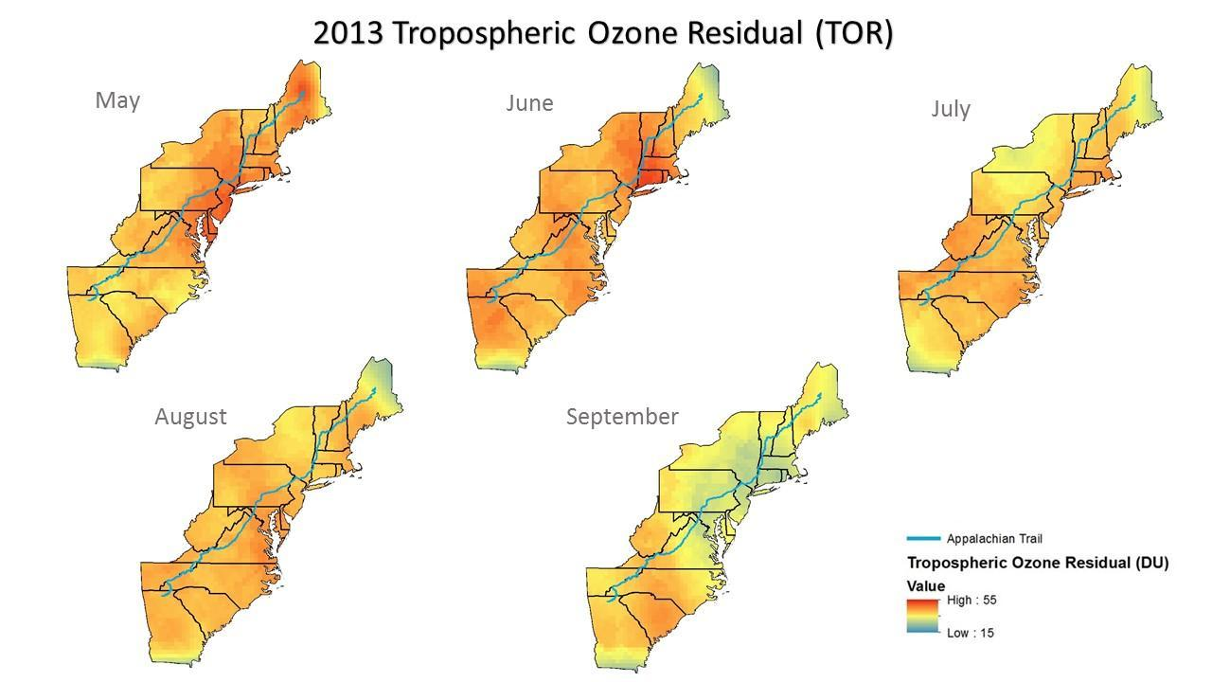

Figure 3. Monthly tropospheric ozone residual (TOR) for 2013.

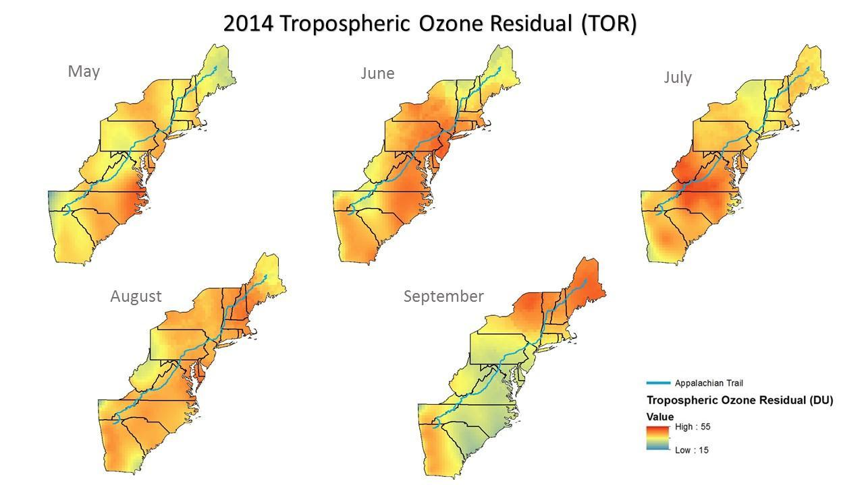

Figure 4. Monthly tropospheric ozone residual (TOR) for 2014.

# Appendix C

**Validation through the Monitoring Stations of the Accuracy of the Tropospheric Ozone Residual**

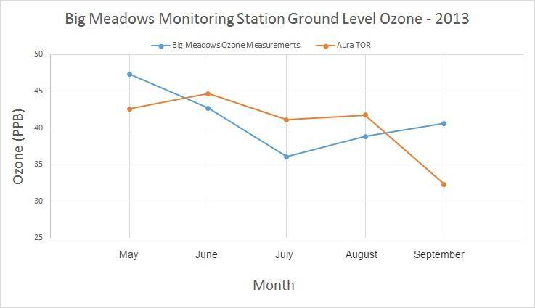

Figure 5. Monthly comparison of the Big Meadows ground monitoring station and the calculated Aura TOR for the year 2013.

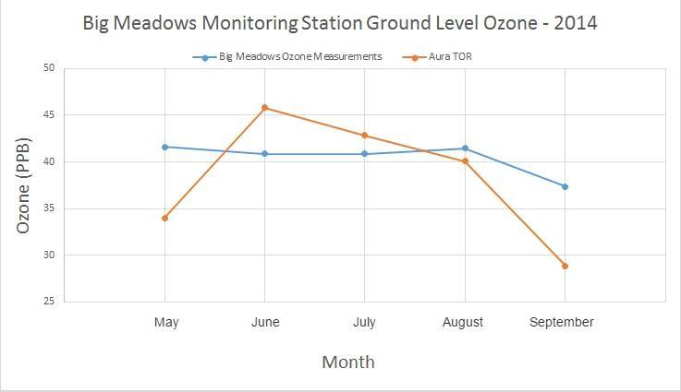

Figure 6. Monthly comparison of the Big Meadows ground monitoring station and the calculated Aura TOR for the year 2014.

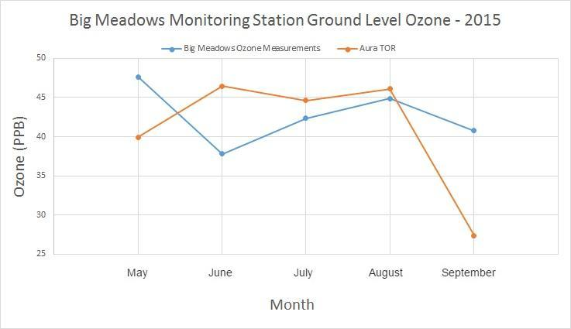

Figure 7. Monthly comparison of the Big Meadows ground monitoring station and the calculated Aura TOR for the year 2015.

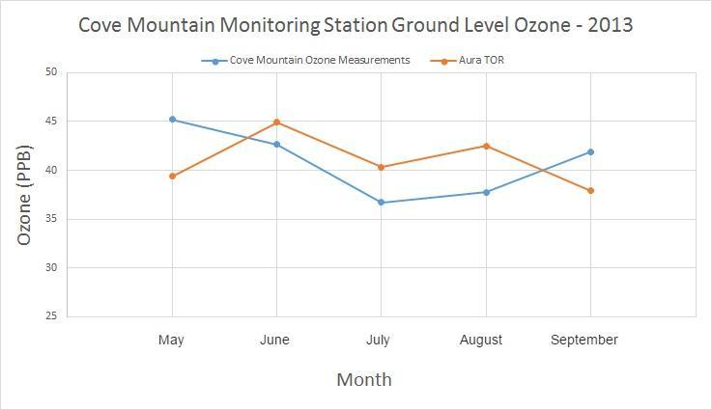

Figure 8. Monthly comparison of the Cove Mountain ground monitoring station and the calculated Aura TOR for the year 2013.

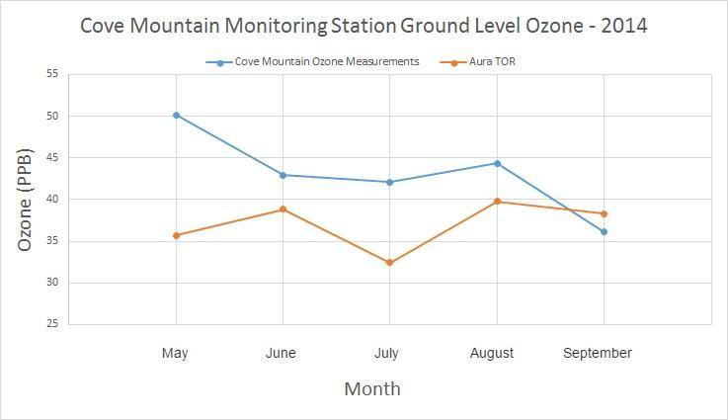

Figure 9. Monthly comparison of the Cove Mountain ground monitoring station and the calculated Aura TOR for the year 2014.

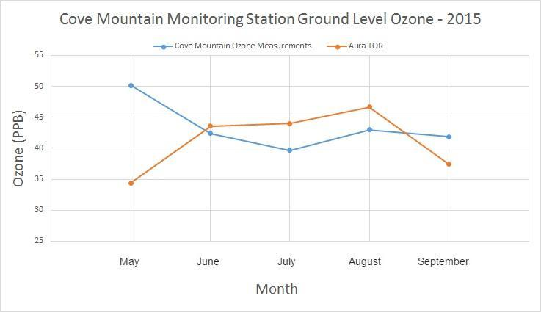

Figure 10. Monthly comparison of the Cove Mountain ground monitoring station and the calculated Aura TOR for the year 2015.

# Appendix D

**Tropospheric Ozone Residual Measurement for Each Section of the Appalachian Trail**

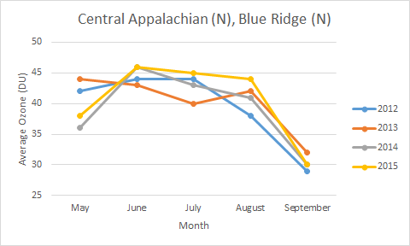

Figure 11. Average ozone (DU) for the Central Appalachian (N), Blue Ridge (N) Appalachian Trail Section.

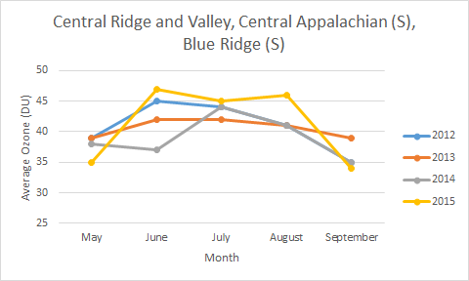

Figure 12. Average ozone (DU) for the Central Ridge and Valley, Central Appalachian (S), Blue Ridge (S) Appalachian Trail Section.

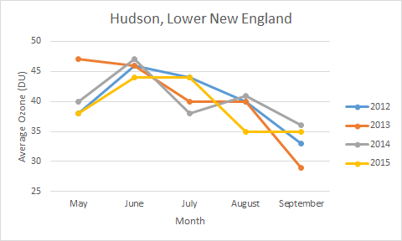

Figure 13. Average ozone (DU) for the Hudson, Lower New England Appalachian Trail Section.

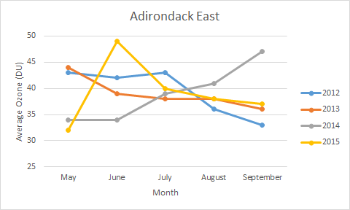

Figure 14. Average ozone (DU) for the Adirondack East Appalachian Trail Section.

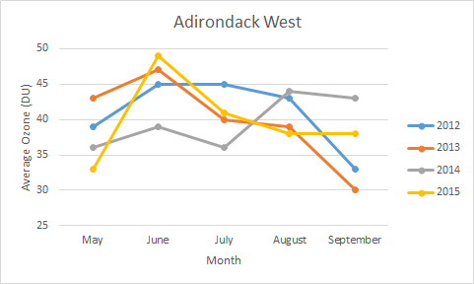

Figure 15. Average ozone (DU) for the Adirondack West Appalachian Trail Section.

**Table 1. Ozone estimates at each Appalachian Trail Ecoregion/Airshed Association for 2012.**

|  |  |  |  |
| --- | --- | --- | --- |
| **May 2012** | | | |
| **Appalachian Trail Ecoregion/Airshed Association** | **Min Ozone (DU)** | **Max Ozone (DU)** | **Average Ozone (DU)** |
| Central Appalachian (N), Blue Ridge (N) | 36 | 42 | 42 |
| Hudson, Lower New England | 38 | 39 | 38 |
| Adirondack West | 37 | 41 | 39 |
| Adirondack East | 40 | 45 | 43 |
| Central Ridge and Valley, Central Appalachian (S), Blue Ridge (S) | 36 | 46 | 39 |
| **June 2012** | | | |
| Central Appalachian (N), Blue Ridge (N) | 42 | 46 | 44 |
| **Table 1 (contd.).** | | | |
| Hudson, Lower New England | 43 | 48 | 46 |
| Adirondack West | 43 | 48 | 45 |
| Adirondack East | 40 | 46 | 42 |
| Central Ridge and Valley, Central Appalachian (S), Blue Ridge (S) | 44 | 47 | 45 |
| **July 2012** | | | |
| Central Appalachian (N), Blue Ridge (N) | 42 | 45 | 44 |
| Hudson, Lower New England | 43 | 45 | 44 |
| Adirondack West | 45 | 47 | 45 |
| Adirondack East | 38 | 46 | 43 |
| Central Ridge and Valley, Central Appalachian (S), Blue Ridge (S) | 42 | 46 | 44 |
| **August 2012** | | | |
| Central Appalachian (N), Blue Ridge (N) | 35 | 40 | 38 |
| Hudson, Lower New England | 39 | 42 | 40 |
| Adirondack West | 41 | 44 | 43 |
| Adirondack East | 31 | 42 | 36 |
| Central Ridge and Valley, Central Appalachian (S), Blue Ridge (S) | 36 | 47 | 41 |
| **August 2012** | | | |
| **Table 1 (contd.).** | | | |
| Central Appalachian (N), Blue Ridge (N) | 25 | 35 | 29 |
| Hudson, Lower New England | 30 | 36 | 33 |
| Adirondack West | 30 | 35 | 33 |
| Adirondack East | 29 | 37 | 33 |
| Central Ridge and Valley, Central Appalachian (S), Blue Ridge (S) | 33 | 37 | 35 |

**Table 2. Ozone estimates at each Appalachian Trail Ecoregion/Airshed Association for 2013.**

|  |  |  |  |
| --- | --- | --- | --- |
| **May 2013** | | | |
| **Appalachian Trail Ecoregion/Airshed Association** | **Min Ozone (DU)** | **Max Ozone (DU)** | **Average Ozone (DU)** |
| Central Appalachian (N), Blue Ridge (N) | 41 | 48 | 44 |
| Hudson, Lower New England | 43 | 48 | 47 |
| Adirondack West | 40 | 46 | 43 |
| Adirondack East | 38 | 41 | 44 |
| Central Ridge and Valley, Central Appalachian (S), Blue Ridge (S) | 36 | 44 | 39 |
| **June 2013** | | | |
| Central Appalachian (N), Blue Ridge (N) | 40 | 46 | 43 |
| Hudson, Lower New England | 43 | 51 | 46 |
| Adirondack West | 43 | 51 | 47 |
| Adirondack East | 34 | 43 | 39 |
| Central Ridge and Valley, Central Appalachian (S), Blue Ridge (S) | 40 | 45 | 42 |
| **July 2013** | | | |
| **Table 2 (contd.).** | | | |
| Central Appalachian (N), Blue Ridge (N) | 37 | 42 | 40 |
| Hudson, Lower New England | 38 | 43 | 40 |
| Adirondack West | 38 | 43 | 40 |
| Adirondack East | 34 | 41 | 38 |
| Central Ridge and Valley, Central Appalachian (S), Blue Ridge (S) | 39 | 45 | 42 |
| **August 2013** | | | |
| Central Appalachian (N), Blue Ridge (N) | 40 | 44 | 42 |
| Hudson, Lower New England | 38 | 42 | 40 |
| Adirondack West | 38 | 40 | 39 |
| Adirondack East | 31 | 42 | 38 |
| Central Ridge and Valley, Central Appalachian (S), Blue Ridge (S) | 40 | 43 | 41 |
| **September 2013** | | | |
| Central Appalachian (N), Blue Ridge (N) | 28 | 40 | 32 |
| Hudson, Lower New England | 27 | 32 | 29 |
| Adirondack West | 27 | 35 | 30 |
| Adirondack East | 33 | 37 | 36 |
| Central Ridge and Valley, Central Appalachian (S), Blue Ridge (S) | 37 | 42 | 39 |

**Table 3. Ozone estimates at each Appalachian Trail Ecoregion/Airshed Association for 2014.**

|  |  |  |  |
| --- | --- | --- | --- |
| **May 2014** | | | |
| **Appalachian Trail Ecoregion/Airshed Association** | **Min Ozone (DU)** | **Max Ozone (DU)** | **Average Ozone (DU)** |
| Central Appalachian (N), Blue Ridge (N) | 33 | 41 | 36 |
| **Table 3 (contd.).** | | | |
| Hudson, Lower New England | 38 | 42 | 40 |
| Adirondack West | 35 | 39 | 36 |
| Adirondack East | 29 | 39 | 34 |
| Central Ridge and Valley, Central Appalachian (S), Blue Ridge (S) | 35 | 41 | 38 |
| **June 2014** | | | |
| Central Appalachian (N), Blue Ridge (N) | 43 | 49 | 46 |
| Hudson, Lower New England | 45 | 49 | 47 |
| Adirondack West | 35 | 45 | 39 |
| Adirondack East | 31 | 38 | 34 |
| Central Ridge and Valley, Central Appalachian (S), Blue Ridge (S) | 31 | 43 | 37 |
| **July 2014** | | | |
| Central Appalachian (N), Blue Ridge (N) | 39 | 50 | 43 |
| Hudson, Lower New England | 36 | 41 | 38 |
| Adirondack West | 33 | 38 | 36 |
| Adirondack East | 36 | 41 | 39 |
| Central Ridge and Valley, Central Appalachian (S), Blue Ridge (S) | 39 | 52 | 44 |
| **August 2014** | | | |
| Central Appalachian (N), Blue Ridge (N) | 40 | 43 | 41 |
| Hudson, Lower New England | 40 | 43 | 41 |
| Adirondack West | 42 | 47 | 44 |
| Adirondack East | 33 | 47 | 41 |
| Central Ridge and Valley, Central Appalachian (S), Blue Ridge (S) | 39 | 43 | 41 |
| **Table 3 (contd.).** | | | |
| **September 2014** | | | |
| Central Appalachian (N), Blue Ridge (N) | 29 | 34 | 30 |
| Hudson, Lower New England | 32 | 38 | 36 |
| Adirondack West | 39 | 46 | 43 |
| Adirondack East | 44 | 49 | 47 |
| Central Ridge and Valley, Central Appalachian (S), Blue Ridge (S) | 32 | 42 | 35 |

**Table 4. Ozone estimates at each Appalachian Trail Ecoregion/Airshed Association for 2015.**

|  |  |  |  |
| --- | --- | --- | --- |
| **May 2015** | | | |
| **Appalachian Trail Ecoregion/Airshed Association** | **Min Ozone (DU)** | **Max Ozone (DU)** | **Average Ozone (DU)** |
| Central Appalachian (N), Blue Ridge (N) | 34 | 42 | 38 |
| Hudson, Lower New England | 33 | 41 | 38 |
| Adirondack West | 31 | 34 | 33 |
| Adirondack East | 29 | 35 | 32 |
| Central Ridge and Valley, Central Appalachian (S), Blue Ridge (S) | 32 | 37 | 35 |
| **June 2015** | | | |
| Central Appalachian (N), Blue Ridge (N) | 43 | 50 | 46 |
| Hudson, Lower New England | 43 | 48 | 44 |
| Adirondack West | 45 | 53 | 49 |
| Adirondack East | 45 | 52 | 49 |
| Central Ridge and Valley, Central Appalachian (S), Blue Ridge (S) | 42 | 51 | 45 |
| **July 2015** | | | |
| Central Appalachian (N), Blue Ridge (N) | 42 | 47 | 45 |
| **Table 4 (contd.).** | | | |
| Hudson, Lower New England | 42 | 46 | 44 |
| Adirondack West | 40 | 43 | 41 |
| Adirondack East | 34 | 44 | 40 |
| Central Ridge and Valley, Central Appalachian (S), Blue Ridge (S) | 43 | 48 | 45 |
| **August 2015** | | | |
| Central Appalachian (N), Blue Ridge (N) | 35 | 49 | 44 |
| Hudson, Lower New England | 33 | 39 | 35 |
| Adirondack West | 35 | 41 | 38 |
| Adirondack East | 31 | 42 | 38 |
| Central Ridge and Valley, Central Appalachian (S), Blue Ridge (S) | 43 | 49 | 46 |
| **September 2015** | | | |
| Central Appalachian (N), Blue Ridge (N) | 27 | 35 | 30 |
| Hudson, Lower New England | 33 | 37 | 35 |
| Adirondack West | 35 | 39 | 37 |
| Adirondack East | 32 | 40 | 37 |
| Central Ridge and Valley, Central Appalachian (S), Blue Ridge (S) | 27 | 38 | 34 |