**NASA DEVELOP National Program**

****Mobile County Health Department

**Fall 2013**

**Gulf Coast Health and Air Quality**

*Utilizing NASA Earth Observing Resources to Initialize an Environmental Suitability Model to Ascertain Transmission Risk of Chagas Disease along the Gulf Coast*

**Team Lead:** Walt Clark (University of South Alabama), waltclark4@gmail.com

**Team Members:**

Sid King (University of South Alabama)

Shikher Mishra (University of South Alabama)

James Pickett (University of South Alabama)

**Advisors & Mentors:**

Dr. Bernard Eichold, M.D., Dr.P.H.

Mr. Joe Spruce (Computer Sciences Corporation)

Dr. Kenton Ross (NASA Langley Research Center)

**Applied Sciences National Applications Addressed:**

Health and Air Quality, Ecological Forecasting

**Study Area:** Central Gulf Coast Region: Louisiana, Mississippi, Alabama, Florida, Texas

**Study Period:** Prognostic Modeling; data taken as current as possible.

**Community Concerns**

* Chagas Disease initially manifests itself with flu like symptoms in the acute phase, but lack of treatment leads to a chronic phase where the pathogenic protozoa, *Trypanosoma cruzi*, multiplies in soft tissues, causing irreparable damage to the heart and intestines.
* Chagas has long been an affliction of Central and South America, but it is estimated that roughly 300,000 people living in the United States have chronic Chagas Disease.
* The CDC has named Chagas Disease one of the five national neglected parasitic infections due to continued expansion of urban areas into formerly rural, wooded areas, the presence of vector and host reservoirs in the United States, and the high cost burden of Chagas cases.

**80-100 Word Blurb**

This project aims to initiate the GARP (Genetic Algorithm for Rule set Production) environmental suitability model using data from NASA Earth observing systems, and ancillary species data to determine optimum habitats for specific *Triatominae*. The end results support collection and testing efforts in order to determine Chagas transmission risk for populations in suburban and rural areas within the southeastern United States.

**Abstract**

Chagas Disease is a chronic infection caused by the *Trypanosoma cruzi* protozoa that is transmitted by the *Triatominae* subfamily of the *Reduviidae* family of true insects. These insects seek blood meals, often from humans, where they transmit the disease through defecation soon after feeding. The insect displays a preference for the face which offers ample infection routes through the eyes or mouth. The disease initially manifests itself with symptoms similar to the flu, but a lack of treatment leads to a chronic phase in which the transmitted protozoa multiplies in soft tissues causing irreparable damage to the heart and intestines. Presently, little attention is given to Chagas Disease in the United States despite the presence of vectors and a large reservoir population. Although it is hypothesized that better housing within the U.S. prevents rampant transmission, increases in the wild urban interface and climate change may open up new habitats for *Triatominae* and transmission potential for Chagas by extension. Thus, the objective of this project was to determine the risk of contracting Chagas Disease in the rural southeastern United States, and more specifically Alabama. Considering the insect has specific environmental needs, this study focused on the species, *Triatoma sanguisuga.* Environmental suitability modeling was performed using spatial data with Stockwell and Peters’ Genetic Algorithm for Rule Set Production (GARP) to create species location maps. From this, project partners will collect as many specimens of *T. sanguisuga* as possible from Mobile county and neighboring regions, and will test the insect vectors for the disease causing protozoa. Although research of this nature has been performed before in Florida and Louisiana, no collected specimens have been tested in Alabama.

Shuttle Radar Topography Mission (SRTM) data were used for elevation and slope, and Moderate Resolution Imaging Spectroradiometer (MODIS) data were used to calculate Normalized Difference Vegetation and Water Indices (NDVI, NDWI), and to discriminate between deciduous and evergreen vegetation, as *T. sanguisuga* has a specific affinity for elm, oak, and hickory groves. Total Rainfall Measuring Mission (TRMM) data were used to calculate rainfall accumulations on a seasonal basis. These data and other parameters that are identified in literature specific to triatomines were created, formatted, and implemented in the GARP environmental niche model to predict optimal habitats of endemic triatomine species. Finally, the species location maps derived from GARP results were used with TIGER files to determine transmission risk.

**Partners/Collaborators**

Partner 1: University of South Alabama, Earth Sciences (Dr. Frances Mujica) and Biology (Dr. John McCreadie)

Partner 2: Mobile County Health Department, Vector Control (Jerry Folse) and Epidemiology (Dr. Monica Knight)

**Current Management Practices & Policies**

Chagas Disease is a prevalent issue in Latin America, which has led to intensive vector control and mandatory blood screenings for the disease prior to transfusions. Presently, little attention is given to Chagas Disease in the United States despite the presence of vectors and a large reservoir population. The triatomine vectors were last sampled in Alabama in 1964, and were subsequently not tested for the protozoa *T. cruzi*. There are no management practices or policies in place locally for the issue.

**Decision Support Tools**

* Species Location Maps
* Transmission Risk Maps

**Benefit to End-User:**

* University of South Alabama researchers Dr. Francis Mujica and Dr. John McCreadie will use the specific *Triatominae* location maps to better allocate resources for trapping *T. sanguisuga* and testing them for the *T. cruzi* protozoa.
* Knowing the probable location of the triatomine will enable vector control to optimize resource distribution, and place CO2 emitter traps more strategically.

**Earth Observations & Parameters**

Aqua/Terra, MODIS/ASTER - Land Cover, NDVI, NDWI, LST, Topography

TRMM, PR/TMU - Rainfall

Shuttle, SRTM - Topography

Landsat 8, OLI - LST, Land Cover

**Future Applicable NASA Missions**

HyspIRI – Vegetation identification

**Models Used**

Genetic Algorithm for Rule Set Production: Stockwell and Peters

**Ancillary Datasets Used**

Global Biodiversity Information Facility coordinates of specimens of *T. sanguisuga*

Louisiana State Arthropod Museum coordinates of specimens of *T. sanguisuga*

**Software Used**

ERDAS Imagine - land classification of Landsat imagery

ArcGIS - Raster Manipulation/Analysis, Image Enhancement & Map Creation of Landsat ETM+, NPP VIIRS, Aqua/Terra MODIS

**Image**

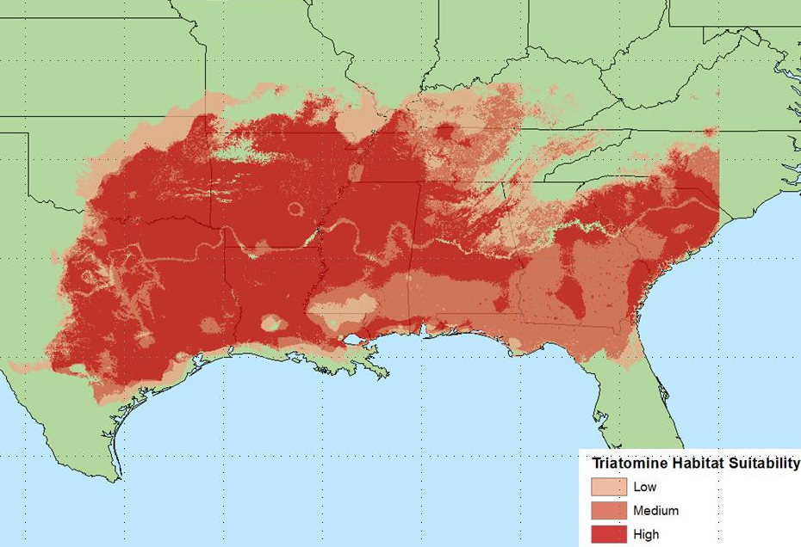

An ecological niche risk map for *T. sanguisuga* centered on the Southeast United States, 1 km resolution