Pacific Northwest Health & Air Quality

*Utilizing NASA Earth Observations to Analyze Air Quality Impacts from Wildfires in the Pacific Northwest*

 **Technical Report**

Final Draft – August 6th, 2020

Ani Matevosian (Project Lead)

Taylor Orcutt

Danielle Ruffe

Liana Solis

***Advisors***

Dr. Juan Torres-Pérez, Bay Area Environmental Research Institute, NASA Ames Center

Dr. Kenton Ross, NASA Langley Research Center

Abigail Nastan, M.S., NASA Jet Propulsion Lab

# 1. Abstract

The Pacific Northwest region of the United States and Canada has become more vulnerable to intense wildfire regimes due to years of fire suppression and climatic changes. Smoke from fires exposes communities to hazardous aerosols and pollutants known to trigger asthma symptoms and exacerbate other respiratory and cardiovascular diseases. In partnership with The Nature Conservancy’s Washington Chapter and the Puget Sound Clean Air Agency, NASA DEVELOP investigated the impacts of wildfire smoke on air quality from 2008 to 2020 using NASA Earth observations. To explore the various dimensions of smoke and its relation to air quality, the team looked at the vertical extent of smoke plumes and the resulting changes in air quality. The team evaluated the potential relationship between plume height of wildfire smoke and fire radiative power (FRP) using data from the Moderate Resolution Imaging Spectroradiometer (MODIS) aboard the Aqua and Terra satellites and data products retrieved from Terra’s Multi-angle Imaging SpectroRadiometer (MISR) using the MISR INteractive eXplorer (MINX). The team determined that there was no regional relationship between FRP and smoke plume height. To investigate changes in air quality resulting from wildfire smoke, the team utilized data from NASA’s Fire Information for Resource Management System, from the European Space Agency’s Sentinel-5P Tropospheric Monitoring Instrument (TROPOMI), and true color imagery from Landsat 8 Operational Land Imager (OLI). The team created a Google Earth Engine-based (GEE) web tool to visualize changes in atmospheric pollutants and aerosol optical depth. Results of case study fires showed varying increases in pollutant concentrations when compared to a baseline map. The end products provided the partners with tools to quantify plume height using MINX and to visualize recent air quality patterns relating to variations in wildfire extent and severity in the Pacific Northwest.

**Key Terms**

remote sensing, Google Earth Engine, aerosol optical depth, smoke plume height, MINX, MISR, MODIS, TROPOMI

# 2. Introduction

* 1. ***Background Information***

Since 2010, there have been an average of 64,100 wildfires annually across the United States (Hoover & Hanson, 2020). Wildfires produce aerosols and trace gases that can travel across large geographic regions after entering the atmosphere (Gonzalez-Alonso et al., 2019; Hung et al., 2020; Marlier et al., 2019; Mirzaei et al., 2018). Resulting smoke from wildfires contains pollutants such as fine particulate matter, black carbon, carbon monoxide, nitrogen oxides, ozone, benzene, and trace pollutants (Gupta et al., 2018; Hung et al., 2020; Marlier et al., 2019; Mirzaei et al., 2018). Exposure to fine particulate matter from wildfires has been associated with adverse health effects, in particular cardiorespiratory symptoms and premature death (Gupta et al., 2018; Marlier et al., 2019). Poorer air quality leads to increased health effects and subsequent hospitalizations, which poses a financial burden for communities. Research has been doneto highlight the long-term economic impacts of wildland fire-attributable premature deaths and cardiorespiratory hospital admissions. Fann et al. (2018) estimated for 2008-2012, the hospital admissions cost was between $76 and $130 billion per year, using the 2010-dollar value. To better understand wildfire smoke associated health risk effects, it is vital to identify where wildfire smoke exposure occurs and the behavior of seasonal wildfire regimes.

Climate change is projected to cause a longer, hotter, and drier fire season, leading to an overall increase in wildfires (Wimberly & Liu, 2014). Wildfires are a natural and important factor in forest health and diversity. However, historical fire regimes in the Pacific Northwest – a region of the United States and Canada that includes Oregon, Washington, and Southern British Columbia (*Figure 1*) – have been altered by fire suppression, timber harvesting, and forest management practices (Mirzaei et al., 2018; Wimberly & Liu, 2014). In addition to the frequency of wildfires, the altitude at which smoke is injected into the atmosphere affects how communities are exposed to wildfire smoke. The altitude also determines the lifetime of pollutants and influences how widely pollutants can be transported over large geographical areas (Gonzalez-Alonso et al., 2019). Although studies have covered vertical smoke profiles over the Alaska-Yukon region, the Amazon Region, New York State, and Bitterroot Valley Montana, the Pacific Northwest remains underrepresented in vertical smoke plume studies (Gonzalez-Alonso et al., 2019; Hung et al., 2020; Kahn et al., 2008; Kovalev et al., 2014).

The Summer 2020 DEVELOP Pacific Northwest Health & Air Quality team explored the utility of NASA Earth observations to analyze and quantify wildfire smoke effects on air quality in the Pacific Northwest. Identifying areas of hazardous air quality conditions caused by wildfire pollutants is vital for public health, but most air quality measurements are reliant on ground-based air quality monitors (Gupta et al., 2018; Hung et al., 2020; van Donkelaar et al., 2011). These ground-based networks are often sparse throughout the affected region and offer limited temporal coverage (Gupta et al., 2018; van Donkelaar et al., 2011). The team analyzed smoke plume heights with NASA’s Multi-angle Imaging SpectroRadiometer (MISR) and developed a plume digitization methodology tailored to end users. In addition, the team created a GEE web-based tool to visualize smoke and air quality changes in the study area, providing coverage over regions that lack ground-based monitors.

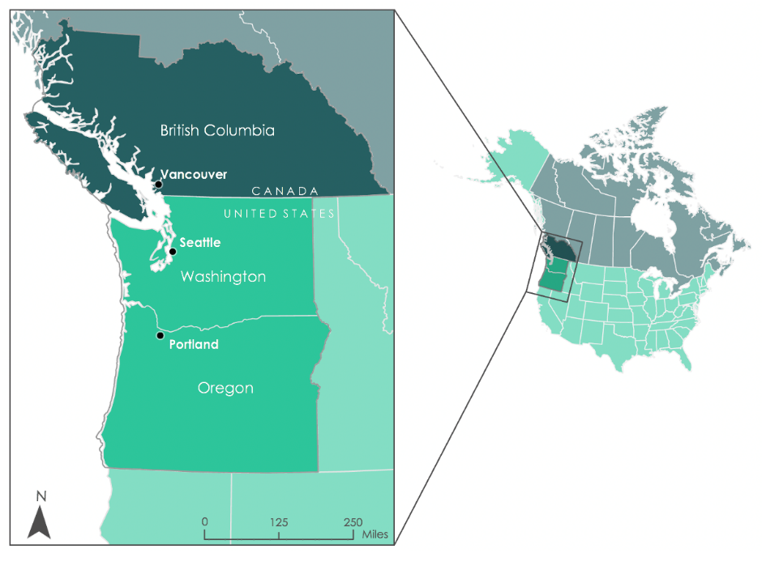

*Figure 1.* The project study area includes Oregon, Washington, and southern British Columbia.

* 1. ***Project Partners & Objectives***

The Nature Conservancy, Washington Chapter (TNC-W) seeks science-based solutions that integrate multi-scale agencies and organizations to conserve land and natural resources as well as improve local communities and conserve wildlife habitat. Under the Central Cascades Management Plan, TNC-W engages in forest restoration practices, such as fire-wise thinning, prescribed burning, management of forest fuels, and planting species to diversify the forest. TNC-W also conducts outreach to engage community stakeholders to create a shared vision for the land.

The Puget Sound Clean Air Agency (PSCAA) is a special purpose regional government agency that works to improve air quality in counties around the Seattle metropolitan area. The PSCAA aims to reduce the area’s contribution to climate change by monitoring air pollution, enforcing air quality regulations mandated by both the federal Clean Air Act and the Washington Clean Air Act, and educating the public on clean-air and climate-friendly choices. The PSCAA works with the Washington State Department of Ecology to operate the Puget Sound region's monitoring network which is composed of meteorological and pollutant-specific equipment to identify and monitor air quality trends.

The team evaluated how wildfire smoke impacts air quality in the Pacific Northwest through the creation of a web-based tool in GEE to identify wildfire smoke and associated changes in pollutants. The tool provided the partners with air quality and wildfire smoke data for areas with limited access to ground-based air quality sensors (*Figure 2*). Additionally, the team developed a methodology and tutorial for quantifying smoke plume height in the MISR INteractive eXplorer (MINX) developed by NASA Jet Propulsion Laboratory. The team applied this methodology to specific fire events of interest to the partners to demonstrate its use, empowering the partner to utilize MINX for their own plume research. The team also analyzed the relationship between fire radiative power (FRP) and plume height. This relationship may inform TNC-W’s air quality impacts from prescribed burns and the PSCAA in preparing for air quality hazards within their jurisdiction.

*Figure 2.* Air quality monitoring stations in the study area*.*

# 3. Methodology

***3.1 Smoke Plume Height***

*3.1.1 Remote Sensing Data*

The team evaluated smoke plume height with data from MISR and the Moderate Resolution Imaging Spectrometer (MODIS) instruments aboard Terra. To locate the data files needed for each fire event, the location and date were input into the MISR Browse Tool which provided the orbit and block number(s) necessary to order the imagery. In the MISR Order and Customization Tool, the team selected the data files required for input into MINX: MISR level 1B2 Terrain Data (MI1B2T), MISR Geometric Parameters (MIBGEOP), MISR Ancillary Geographic Product (MIANCAGP), and optional MISR Level 2 Aerosol Parameter (MIL2ASAE) (Table 1). After the data file types were selected, the team input the orbit numbers associated with the defined fire events and ordered the data for all nine of MISR’s cameras. For fire pixel data, the team downloaded Terra MODIS Thermal Anomalies Fire 5-Min L2 Swath 1km V006 (MOD14.006) data for each fire event and processed the fire pixels with MINX (Table 1).

The team analyzed over 200 fire events in the Pacific Northwest to showcase MISR data utility. For regional plume analysis, the team acquired MINX preprocessed plumes from the MISR Plume Height Project 2. The MISR Plume Height Project 2 is a project that was initiated by NASA Jet Propulsion Laboratory (JPL) scientists David Nelson, Sebastian Val, Ralph Kahn, Ernest Koeberlein, Mika Tosca, David Diner, and Cecelia Lawshe. Each summer, JPL interns manually digitize plumes worldwide. The team analyzed these preprocessed plumes in search of a regional correlation between FRP and maximum plume height. All available plumes that were in the MISR Plume Height Project 2 were filtered by the study area and fire season (July to September) from 2008 to 2018. The data collected from the MISR Plume Height Project 2 has temporal gaps and is missing data from the entirety of 2012 to 2016, July 2009, July 2011, August 2011, and September 2018. The data compiled from the MISR Plume Height Project 2 totaled 223 fire events within our study area.

*Table 1*

Remote sensing data products used for the smoke plume height analysis in MINX.

|  |  |  |  |
| --- | --- | --- | --- |
| **Platform and Sensor** | **Data Products** | **Dates** | **Acquisition Method** |
| Terra MISR | Level 1B2 Terrain Data (MI1B2T)  MISR Geometric Parameters (MIBGEOP)  MISR Ancillary Geographic Product (MIANCAGP)  (optional) MISR level 2 Aerosol parameter (MIL2ASAE) and MISR Level 2 TOA/Cloud Classifier parameter (MILTCCL) | 2008 to 2020 | NASA Langley’s Atmospheric Data Center (ASDC) MISR Order and Customization Tool |
| Terra MODIS | Terra Thermal Anomalies Fire 5-Min L2 Swath 1km V006 (MOD14.006) | 2008 to 2020 | EARTHDATA |

*3.1.2 Data Processing*

MISR satellite images containing wildfire smoke plumes were individually input into the MINX software and manually digitized. The team input the smoke plumes by selecting the “Animate Cameras” option from the MINX main menu. The MISR Level 1B2 Terrain data were selected and refined to include only the relevant block locations of the fire event. In “Animate Cameras”, the imagery from MISR’s nine cameras can be viewed. Before digitizing, “Tasks/Correct Misregistration/Warp Orbit 1 Cameras for Plumes” was used until the Root Mean Square (RMS) corrections for all cameras were less than 0.2. If the misregistration was applied three times and the RMS corrections were still greater than 0.2, the files were discarded as the analysis did not meet the data validation threshold for the MINX program. If the data validation failed, a new set of MISR files for the smoke plume would need to be selected.

Once the files successfully underwent misregistration correction, the nine images from MISR were aligned and prepared for digitizing. The team digitized plumes by manually drawing a polygon with a wide buffer around the smoke plume (Abigail Nastan, M.S., personal communication, June 25, 2020). Since the plume could only be digitized from the nadir camera view (“An” camera on MISR), the buffer area was drawn to incorporate all nine cameras of MISR data. The cameras on MISR capture the plume at different angles, so the polygon must incorporate the smoke between all nine cameras to get an assessment of the entire plume. After the polygon was created, the wind direction was estimated by drawing a wind direction vector. Once the wind direction vector was complete, right clicking prompted the processing. The MISR Geometric Parameters (MIBGEOP), MISR Ancillary Geographic Product (MIANCAGP), and MISR level 2 Aerosol Parameter (MIL2ASAE) data files were selected and MINX generated the results with graphs, raw data text file, and supporting imagery populated in the data folder.

To collect the data from the MISR Plume Height Project 2, an advanced search was done to meet the temporal and spatial criteria for fire season in the study area. The search results were saved to an Excel file and an R script condensed the data into a single .csv file with only the necessary information. Since the MISR Plume Height Project 2 advanced search can only filter the area of interest by a rectangle, the .csv file was then input into ArcGIS Pro to ensure that all the data points fell within the study area. Any points that were not within the study area were clipped out and deleted. In ArcGIS Pro, a new field was added to the attribute table indicating what state or province the data point was located (British Columbia, Washington, or Oregon). The data was then exported and used in a second R script to extract the median height from the MISR Plume Height Project 2 database a parameter found in the detailed .txt file associated with each plume. The resulting table contained fields for longitude, latitude, MISR orbit, MISR block, biome classification, FRP calculated in megawatts (MW), maximum plume height (m), median plume height (m), retrieval quality, retrieval band (red or blue), an indicator if the plume FRP was above a user defined threshold, the date, and location (state or province).

***3.2 GEE Tool: PHOENIX (Plume Hazards and Observations of Emissions by Navigating an Interactive eXplorer)***

*3.2.1 Remote Sensing Data*

Due to the sheer volume of imagery, the team acquired a variety of datasets via the GEE catalog, forming the foundation of the team’s wildfire smoke and pollutant assessment tool, PHOENIX (see Table 2 for Earth Observations used). The team imported Level 2 Aerosol Optical Depth (AOD) Daily 1km measurements using the Multi-angle Implementation of Atmospheric Correction (MAIAC) product from the MODIS sensor aboard Terra and Aqua from July 2018 to July 2020. The team utilized the “Optical_Depth_047” band for unitless AOD values. These data were combined with the European Space Agency’s Sentinel-5P TROPOspheric Monitoring Instrument (TROPOMI) data capturing carbon monoxide (CO), nitrogen dioxide (NO2), and formaldehyde (HCHO) atmospheric levels in units of mol/meters2. The team acquired the offline versions of these Sentinel-5P datasets that cover July 2018 and are consistently updating to the current date. All TROPOMI data were Level 3 measuring the total vertically integrated “column number density” of carbon monoxide and nitrogen dioxide, and the tropospheric “column number density” of formaldehyde due to limited data availability. For fire visualization, the team imported the Fire Information Resource and Management System (FIRMS) in the Google Earth Engine Catalog; this dataset is derived from the near real-time (NRT) MODIS Thermal Anomaly MOD14/MYD14 product provided by the Land, Atmosphere Near real-time Capability for Earth Observing System (LANCE). This enabled a layer of fire locations from July 2018 to 2020. Lastly, the team imported Landsat 8 Operational Land Imager (OLI) surface reflectance for true color imagery visualization in the tool.

*Table 2*

Remote sensing data products used for the wildfire smoke and pollutant assessment tool in GEE, All data acquired through GEE database.

|  |  |  |
| --- | --- | --- |
| **Platform and Sensor** | **Data Products** | **Dates** |
| Terra MODIS MAIAC | Land Aerosol Optical Depth Daily 1km (MCD19A2.006) | 2018 to 2020 |
| Aqua MODIS MAIAC | Land Aerosol Optical Depth Daily 1km (MCD19A2.006) | 2018 to 2020 |
| Copernicus Sentinel-5P TROPOMI | Offline Formaldehyde  (S5P OFFL HCHO)  Offline Carbon Monoxide  (S5P OFFL CO)  Offline Nitrogen Dioxide  (S5P OFFL NO2) | 2018-10-02 to 2020  2018-06-28 to 2020  2018-06-28 to 2020 |
| Landsat 8 OLI | Surface Reflectance | 2018-07-01 to 2020 |

*3.2.2 PHOENIX Data Processing and Functionality*

The team programmed a variety of features using the GEE Code Editor JavaScript API. Because the MAIAC AOD dataset was Level 2 and Sentinel-5P datasets were Level 3, further processing was not required. Landsat 8 OLI surface reflectance imagery visualized in true color was processed to select the least cloudy image for the filtered date range. FIRMS data visualization was altered slightly to display the fires as one color (instead of the default multi-color scale based on fire intensity) to avoid confusion with the display of the air quality parameters on the map. Separately, 2-year average baseline GeoTIFFs were created for the parameters of AOD, carbon monoxide, formaldehyde, and nitrogen dioxide; these maps were single images representing the averaged values of each parameter, which varied across the study area, for July 2018 to July 2020 to ultimately represent “typical” conditions.

The tool clips and filters all raster datasets to the study area shapefile of the Pacific Northwest. The code generates a graphical user interface that allows the user to select a custom date or a fire from the drop down, which automates a 7-day average. Then, the user selects one or multiple parameters (AOD, CO, HCHO, and/or NO2), which calculates a raster difference between the parameter(s) and the aforementioned baseline maps. This differencing operation was performed to see the change in pollutant levels for the date range, as compared to the baseline maps. Next, the user can toggle the map layers to display true color imagery (for plume visualization), fire location data from FIRMS, the differenced layers, and the original values from the selected date range. Then, the user can export the desired layers as TIFFs directly to their Google Drive. Lastly, the user may select a year (for the fire season months of July to November), a pollutant, and a point around which a 500-meter buffer is created to generate a graph.

# 4. Results & Discussion

Using the MISR Plume Project 2, the team used a linear regression analysis on plume height data and conducted a case study analysis using PHOENIX and MINX. There was no regional correlation between MOD14 FRP and maximum plume height derived from MINX (*Figure 3*). Only plumes from 2008 to 2018 during the regional fire season, July to September, were selected for the analysis.

All Plumes

Figure 3. The team found no statistical correlation between FRP and maximum plume height. The data points are color-coded by location: British Columbia (Blue), Oregon (Teal), Washington (Red), and All (Purple).

The team used the Cougar Creek Fire as a case study to evaluate how PHOENIX and MINX can produce data that are complementary of each other. The Cougar Creek Fire began on July 29, 2018 in Chelan County, Washington, and lasted until August 24, 2018 (Erik Saganić, personal communication, 2020, July 24). The team selected August 19, 2018 as the date for the Cougar Creek case study because this date was within the fire event and there was cloud-free MISR data available.

The Cougar Creek Fire smoke plume had a maximum height of 3,947 m and a median height of 3,021 m on August 19, 2018 (*Figures 4*, *5*, and Appendix A). The target pollutants (AOD, CO, and NO2) all increased in concentration compared to the two-year baseline (*Figure 5*). Formaldehyde concentrations could not be determined because the Cougar Creek Fire occurred before TROPOMI formaldehyde data was available on GEE. The pollutant concentration time-series graph for the location of the Cougar Creek Fire (Lat: -120.50, Long: 47.81) showed a local maximum for AOD on August 19, 2018 (*Figure 6*), while CO concentrations were slightly below the local maximum (*Figure 7*). See Appendix A (*Figures A3-A5*) for additional time-series graphs for pollutants such as NO2, as well as the original PHOENIX outputs. See Appendix B for another case study using PHOENIX and MINX for a fire in British Columbia.

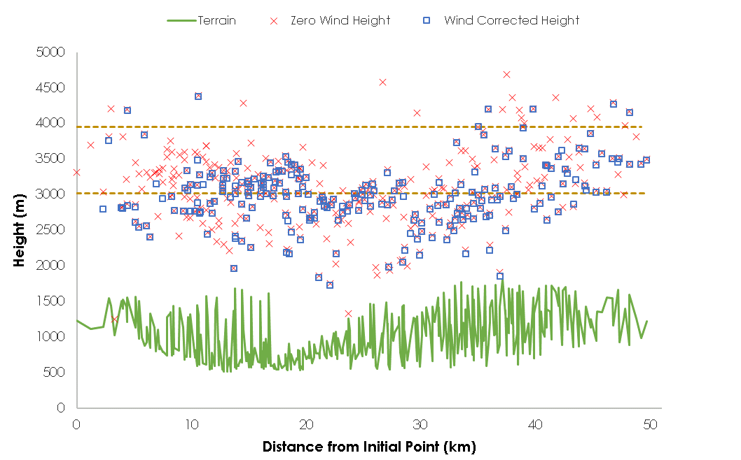

**Maximum Top Height**

**Median Top Height**

*Figure 4*. The Cougar Creek Fire as seen from MINX plume height results, with no-wind and wind corrected heights above terrain. The initial point is the downwind extent of the fire.

*Figure 5*. The Cougar Creek Fire in Chelan County, Washington on August 19, 2018 observed in MINX and PHOENIX. Pollutant concentrations increase in areas where the smoke plume is located.

Figure 6. A time-series graph generated in PHOENIX for the 2018 fire season (here, July to November) for Aerosol Optical Depth (AOD), at the location of the Cougar Creek Fire in Central Washington. An increased level of AOD is present throughout the Cougar Creek Fire event (July 29 to August 24), with AOD at a local maximum on August 19, 2018.

Figure 7. A time-series graph generated in PHOENIX for the 2018 fire season (here, July to November) for Carbon Monoxide (CO) levels at the location of the Cougar Creek Fire in Central Washington. An increased level of CO is present throughout the Cougar Creek Fire event (July 29 to August 24), with CO slightly below the local maximum on August 19, 2018.

***4.1 Analysis of Results***:

*4.1.2 Preprocessed Plume Analysis*

The team analyzed the data collected from the MISR Plume Project 2 to discern a regional relationship between FRP (or fire intensity) and maximum plume height. The team postulated there would be a strong positive correlation between fire power and plume height as the more intense heat producing fires would generate larger plumes. The R-squared values of each correlation are low, with the highest value at 0.51 (*Figure 3*). These values are not strong enough to show a statistically significant correlation in the trend. The results from the fire analysis do showcase a positive correlation between the two values, but with the low R-squared values these results are only slightly better than random. Therefore, there is no evidence of a statistical correlation between FRP and historical plume data from the database.

*4.1.3 Cougar Creek Fire Case Study Analysis*

Although the team retrieved the maximum and median height of the Cougar Creek smoke plume, these values may not be representative of the plume’s true maximum and median heights because Terra’s overpass occurs in the late morning, so data is collected before the typical late-afternoon peak of fire intensity (Gonzalez-Alonso et al., 2019). The plume height with wind direction and speed determines the extent the smoke will travel and the regions in which the air quality will be affected by smoke. MINX requires a user input of wind direction, therefore the user may make an error or a slight misrepresentation of the wind direction which can skew the results. The MINX tool specializes in determining plume height for air quality impact analysis models, but does not show pollutant compositions.

The composition of smoke is shown in the PHOENIX results. The graphs from PHOENIX display changes in concentrations of the target pollutants (AOD, carbon monoxide, formaldehyde, and nitrogen dioxide) due to wildfire events. The pollutant concentration at the tropospheric level would be more beneficial to understanding the impact on communities’ air quality rather than the total column concentrations that PHOENIX produces (for all parameters except formaldehyde). The PHOENIX results show FIRMS fire locations did correlate with areas with high pollutant concentrations from the baseline, visually on the map and numerically by pollutant values. Fire locations geographically overlapped with the locations of increased aerosols and pollutants. This demonstrates the utility of the tool and shows the satellite sensors were able to successfully detect changes in air quality surrounding a fire (*Figure 5*).

***4.2 Validation Efforts***

Ceilometers, lidar ground instruments that measure cloud or aerosol height from the ground, are limited in the study area and the data is not available for public use. In previous studies, researchers have used NASA’s Multi-angle Implementation of Atmospheric Correction (MAIAC) dataset, which has a sensor reading for injection height, to verify the MISR smoke plume height results (Nelson et al., 2008). Since MAIAC is also based on satellite sensor data, a MINX and MAIAC validation has inherent limitations because there is no ground-truth data. For this reason, the team decided against MAIAC validation and sought alternative means through ground lidar instruments outside of the region.

The team attempted to verify MINX height outputs in a proof-of-concept case study. However, future work to improve upon and focus on an appropriate methodology will be needed to successfully support the height analyses done in MINX. The team selected a plume that had its height verified by a ground-based lidar in a study by Kovalev et al. (2009). This lidar plume height data was from the Montana I-90 Fire at 11:37 a.m. on August 9, 2005. However, MISR data was not available until August 10, 2005. Parts of the plume were obstructed by clouds, but the maximum height determined by MINX for the area of the plume not blocked by cloud cover was 2.871 km which is within the lidar maximum height estimate of 2.800 – 3.100 km (Kovalev et al. 2009).

Ground verification data was limited from air quality ground sensors in the study area. Due to technical issues with the Washington air quality monitoring station website and limited time, the team was not able to validate the Sentinel-5P TROPOMI pollutant and aerosol measurements. However, for aerosol validation, previous DEVELOP projects have completed analyses that support using AOD as a proxy for particulate matter 2.5 (PM2.5), validated with in-situ PM2.5 measurements (Kalra et al., 2020). Other limitations for PHOENIX include spatial gaps in AOD data due to calibration artifacts in the data set and a coarse pixel size for formaldehyde.

***4.3 Future Work***

Future work should incorporate data and findings from the upcoming MultiAngle Imager for Aerosols (MAIA) mission set to launch in 2022. This instrument will measure aerosols to derive near-surface particulate matter concentrations and focus research on the public health impact. In addition, the team would like to validate the satellite-derived pollutant measurements with in-situ ground-based air monitors and ceilometer data for validating plume heights from MISR in MINX. The team was interested in incorporating lidar data from CALIPSO on the Cloud-Aerosol Lidar and Infrared Pathfinder (CALIOP) satellite to complement the MISR data and provide the partners with additional information on the vertical profile of the atmosphere. It is difficult to consistently collect MISR and CALIPSO data for the same fire event because of the satellites’ differing swaths and temporal resolution, but future work may focus on case studies with the two satellites. Future work may also include an impact analysis, incorporating demographic data and respiratory-related hospitalization rates to investigate relationships between pollutant distributions, impacted communities, and socioeconomic status.

# 

# 5. Conclusions

This project shows the success and feasibility of utilizing satellite data to detect air quality changes from wildfires and measure plume height in the study area. The MINX methodology and the PHOENIX tool provide both partners with a way to visualize and analyze smoke impacts across a broader geographic region; the partners currently rely solely on the ground-based air quality monitoring network for measuring pollutants in the atmosphere. This network is sparse over rural parts of the state, namely eastern Washington where the project partners at TNC-W are located (*Figure 2*). Therefore, the project will aid community decision making and engagement with Earth observations by demonstrating the application and benefit of satellite data for examining air quality in the Pacific Northwest.

The team’s additional analysis on the relationship between maximum plume height and FRP for the Pacific Northwest region resulted in no statistical correlation. This relationship and question have been previously investigated, but at a global scale. Therefore, the analysis conducted by this project provides a novel case study on the relationship for plume height and fire intensity for a specific region. There are many other factors that contribute to plume height than fire intensity alone, including meteorological and ambient atmospheric conditions, which may explain the lack of statistical correlation between these two variables. Nonetheless, the analyses and results provide the partners with an increased understanding of regional wildfire smoke.

By delivering a web-based tool and a methodology on digitizing and quantifying plume height, the team enhanced the partners’ capacity to study both historic and future smoke impacts in a more comprehensive way. MINX provides vertical smoke extent via plume height estimations, while PHOENIX provides geographic extent of smoke and changes in the smoke-emitted pollutants. Together, these tools will allow the partners to pursue a multi-dimensional investigation on wildfire smoke and its impacts on surrounding air quality. The PSCAA can incorporate MISR data and follow the MINX methodology developed by the team to include plume heights in their smoke transport modelling efforts. The MINX methodology also provides the partner with information on other factors that can be explored in MINX, including FRP, terrain height, and biome classifications for further analyses. TNC-W, which focuses greatly on wildfires and forest health management, may use PHOENIX to study the air quality patterns attributed to local and remote fires as well as actively apply the tool to research and land management practices. The PSCAA and TNC-W can utilize these results from PHOENIX to understand the magnitude of wildfire smoke impact on air quality and pollutant concentrations over time. These resources will extend beyond the ten-week DEVELOP term, as the PHOENIX code updates to the most present date, so it is sustainable for future use by the end-users.

# 

# 6. Acknowledgments

The DEVELOP Pacific Northwest Health & Air Quality Team would like to thank their partners, Erik Saganić of the Puget Sound Clean Air Agency and Brian Straniti at The Nature Conservancy, Washington Chapter for their collaboration and engagement throughout the project. The team would like to recognize the support from their science advisors, Dr. Juan Torres-Pérez, Dr. Kenton Ross, and Abigail Nastan. The team also thanks Madison Broddle, Danielle Groenen, and Sanjana Paul of the Atmospheric Science Data Center for their guidance and offering of resources related to the project. Additionally, the team thanks Dr. Ralph Kahn for connecting them to Abigail Nastan of the NASA Jet Propulsion Lab, whose expertise in using MISR and MINX was especially informative and beneficial. Furthermore, the team thanks Britnay Beaudry and John Dilger for their assistance with the development of the PHOENIX tool. Lastly, the team would like to thank their Fellows, Gina Cova and Zachary Bengtsson, for their incredible guidance, leadership, and consistent support throughout the term.

This material contains modified Copernicus Sentinel data (2018-2020), processed by ESA.

Any opinions, findings, and conclusions or recommendations expressed in this material are those of the author(s) and do not necessarily reflect the views of the National Aeronautics and Space Administration.

This material is based upon work supported by NASA through contract NNL16AA05C.

# 7. Glossary

**AOD** – Aerosol Optical Depth, a measure of the extinction of electromagnetic radiation due to available aerosol in the atmosphere

**Earth observations** – Satellites and sensors that collect information about the Earth’s physical, chemical, and biological systems over space and time

**MODIS** – MODerate resolution Imaging Spectroradiometer

**MISR** – Multi-angle Imaging SpectroRadiometer, a sensor aboard Terra that uses cameras pointed at nine different angles to collect data in blue, green, red, and near-infrared bands

**MINX** – MISR INteractive eXplorer, an interactive visualization and analysis program for MISR data to retrieve heights and motion of aerosol plumes and clouds using stereoscopic methods

**Plume** – optically significant smoke

# 8. References

Copernicus Sentinel Data [2018-2019]. Retrieved from Google Earth Engine [3 March 2020], processed by ESA.

Diner, D. (2000). MISR Ancillary Geographic Product HDF-EOS File - Version 1 [Data set]. NASA Langley Atmospheric Science Data Center DAAC. https://doi.org/10.5067/TERRA/MISR/MIANCAGP_ANCILLARY.001

Diner, D. (2009). MISR Geometric Parameters HDF-EOS File - Version 2 [Data set]. NASA Langley Atmospheric Science Data Center DAAC. <https://doi.org/10.5067/TERRA/MISR/MIB2GEOP_L1.002>

Diner, D. (2019). MISR Level 2 Aerosol Parameters HDF-EOS File - Version3 [Data set]. NASA Langley Atmospheric Science Data Center DAAC. <https://doi.org/10.5067/TERRA/MISR/MIL2ASAE_L2.003-23>

Diner, D. (2009). MISR Level 1B2 Terrain Data HDF-EOS File - Version 3 [Data set]. NASA Langley Atmospheric Science Data Center DAAC. <https://doi.org/10.5067/TERRA/MISR/MI1B2T_L1.003>

ESA Copernicus Sentinel-5P TROPOMI. (2018). *Sentinel-5P Offline Carbon Monoxide Level 3* [Dataset]*.* Accessed 1 July 2020 from <https://developers.google.com/earth-engine/datasets/catalog/COPERNICUS_S5P_OFFL_L3_CO?hl=en#terms-of-use>

ESA Copernicus Sentinel-5P. (2019). *Sentinel-5P Offline Nitrogen Dioxide Level 3.* [Dataset]. Accessed 1 July 2020 from <https://developers.google.com/earth-engine/datasets/catalog/COPERNICUS_S5P_OFFL_L3_NO2>

ESA Copernicus Sentinel-5P. (2018). *Sentinel-5P Offline Ozone Level 3.* [Dataset]. Accessed 1 July 2020 from <https://developers.google.com/earth-engine/datasets/catalog/COPERNICUS_S5P_OFFL_L3_O3?hl=tr>

ESA Copernicus Sentinel-5P. (2018). *Sentinel-5P Offline Formaldehyde Level 3.* [Dataset]. Accessed 1 July 2020 <https://developers.google.com/earth-engine/datasets/catalog/COPERNICUS_S5P_OFFL_L3_HCHO>

Fann, N., Alman, B., Broome, R. A., Morgan, G. G., Johnston, F. H., Pouliot, G., & Rappold, A. G. (2018). The health impacts and economic value of wildland fire episodes in the U.S.: 2008–2012. *Science of The Total Environment*, *610–611*, 802–809. https://doi.org/10.1016/j.scitotenv.2017.08.024

Gonzalez-Alonso, L., Val Martin, M., & Kahn, R. A. (2019). Biomass-burning smoke heights over the Amazon observed from space. *Atmospheric Chemistry and Physics*, *19*(3), 1685–1702. https://doi.org/10.5194/acp-19-1685-2019

Gupta, P., Christopher, S. A., Wang, J., Gehrig, R., Lee, Y., and N. Kumar. (2006). Satellite remote sensing of particulate matter and air quality assessment over global cities. *Atmospheric Environment*, *40*(30), 5880-5892. <https://doi.org/10.1016/j.atmosenv.2006.03.016>

Hoover, K. & L. Hanson (2020, August 3). *Wildfire statistics.* Congressional Research Service.https://fas.org/sgp/crs/misc/IF10244.pdf

Hung, W.-T., Lu, C.-H. (Sarah), Shrestha, B., Lin, H.-C., Lin, C.-A., Grogan, D., Hong, J., Ahmadov, R., James, E., & Joseph, E. (2020). The impacts of transported wildfire smoke aerosols on surface air quality in New York State: A case study in summer 2018. *Atmospheric Environment*, *227*, 117415. https://doi.org/10.1016/j.atmosenv.2020.117415

Kahn, R. A., Chen, Y., Nelson, D. L., Leung, F.-Y., Li, Q., Diner, D. J., & Logan, J. A. (2008). Wildfire smoke injection heights: Two perspectives from space. *Geophysical Research Letters*, *35*(4), L04809. <https://doi.org/10.1029/2007GL032165>

Kalra, A., Deninger, R., Earwood, R., Murray, R. (2020). Washington Health & Air Quality: Quantifying Air Quality Parameters and Validating Air Pollution Sources Impacting the Health of Puget Sound Residents Through the Use of NASA and ESA Remote Sensing Data. Unpublished manuscript, NASA DEVELOP.

Kovalev, V., Petkov, A., Wold, C., Urbanski, S., & Hao, W. (2009). Determination of smoke plume and layer heights using scanning lidar data. Applied Optics, 48, 5287–5294. <https://doi.org/10.1364/AO.48.005287>Kovalev, V., Urbanski, S., Petkov, A., Scalise, A., Wold, C., & Hao, W. M. (2014). Validation of smoke plume rise models using ground-based Lidar (C. M. U. Neale & A. Maltese, Eds.; p. 92391S). <https://doi.org/10.1117/12.2066895>

Giglio, L., Justice, C. (2015). *MOD14 MODIS/Terra Thermal Anomalies/Fire 5-Min L2 Swath 1km V006* [Data set]. NASA EOSDIS Land Processes DAAC. Doi: 10.5067/MODIS/MOD14.006

Giglio, L. and NASA Land, Atmosphere Near real-time Capability for EOS Fire Information For Resource Management System. (2016). *MODIS Aqua & Terra 1km Thermal Anomalies and Fire Locations V006*. doi: 10.5067/FIRMS/MODIS/MCD14DL.NRT.006

Lyupastin, A., Wang, Y., & NASA Land Processes Distributed Active Archive Center. (2018). *MCD19A2.006: Terra & Aqua MAIAC Land Aerosol Optical Depth Daily 1km.* [Dataset]. Accessed 1 July 2020 from <https://developers.google.com/earth-engine/datasets/catalog/MODIS_006_MCD19A2_GRANULES>. doi: 10.5067/MODIS/MCD19A2.006

Marlier, M. E., Liu, T., Yu, K., Buonocore, J. J., Koplitz, S. N., DeFries, R. S., Mickley, L. J., Jacob, D. J., Schwartz, J., Wardhana, B. S., & Myers, S. S. (2019). Fires, Smoke Exposure, and Public Health: An Integrative Framework to Maximize Health Benefits from Peatland Restoration. *GeoHealth*. https://doi.org/10.1029/2019GH000191

Mirzaei, M., Bertazzon, S., & Couloigner, I. (2018). Modeling Wildfire Smoke Pollution by Integrating Land Use Regression and Remote Sensing Data: Regional Multi-Temporal Estimates for Public Health and Exposure Models. *Atmosphere*, 9(9), 335. https://doi.org/10.3390/atmos9090335

Nelson, D. L., Chen, Y., Kahn, R. A., Diner, D. J., & Mazzoni, D. (2008, August). Example applications of the MISR INteractive eXplorer (MINX) software tool to wildfire smoke plume analyses. In Remote sensing of fire: science and application (Vol. 7089, p. 708909). International Society for Optics and Photonics.

U.S. Geological Survey. (2013). Landsat-8 OLI (Operational Land Imager) and TIRS (Thermal Infrared Sensor) Level-1 Tier 1 Surface Reflectance [Dataset]. Accessed 30 June 2020 from <https://developers.google.com/earth-engine/datasets/catalog/LANDSAT_LC08_C01_T1_SR>. [doi.org/10.5066/F78S4MZJ](https://doi.org/10.5066/F78S4MZJ)

van Donkelaar, A., Martin, R. V., Levy, R. C., da Silva, A. M., Krzyzanowski, M., Chubarova, N. E., Semutnikova, E., & Cohen, A. J. (2011). Satellite-based estimates of ground-level fine particulate matter during extreme events: A case study of the Moscow fires in 2010. *Atmospheric Environment*, 45(34), 6225–6232. https://doi.org/10.1016/j.atmosenv.2011.07.068

Wimberly, M. C., & Liu, Z. (2014). Interactions of climate, fire, and management in future forests of the Pacific Northwest. *Forest Ecology and Management*, 327, 270–279. https://doi.org/10.1016/j.foreco.2013.09.043

# 9. Appendices

**Appendix A**

Figure A1. The original AOD time-series graph output from PHOENIX for the Cougar Creek Fire on August 19, 2018.

Figure A2. The original CO time-series graph output from PHOENIX for the Cougar Creek Fire on August 19, 2018.

Figure A3. The original NO2 time-series graph output from PHOENIX.

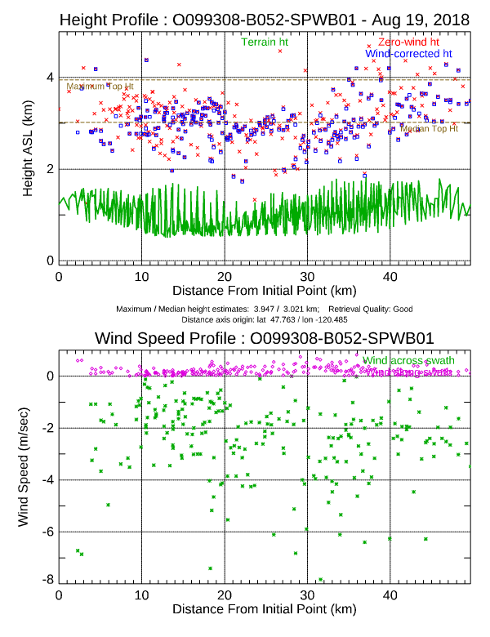

*Figure A4*. Raw MINX output of height profiles graphs for the Cougar Creek Fire.

**Appendix B**

*Figure B1.* A second case study on an unnamed fire in British Columbia on August 6th, 2018. Plume heights are derived from MINX, while CO and AOD concentrations are found in PHOENIX.