**NASA DEVELOP National Program**

****Goddard Space Flight Center

**Fall 2013**

**Myanmar Ecological Forecasting**

*Utilizing NASA Earth Observations to Monitor, Map and Analyze Mangrove Forests in Myanmar for Enhanced Conservation*

**Team Lead:** Sam Weber (Virginia Tech), Samuel.J.Weber@nasa.gov

**Team Members:**

Louis Keddell (University of Maryland)

Mohammed Kemal (University of Maryland)

**Advisors & Mentors:**

Dr. Temilola Fatoyinbo (NASA, Goddard Space Flight Center)

Fritz Policelli (NASA, Goddard Space Flight Center)

**Past or Other Contributors:**

DEVELOP Myanmar Ecological Forecasting team, Langley Summer 2013

**Applied Sciences National Applications Addressed:**

Ecological Forecasting

**Study Area:** Ayeyarwardy Delta, and the Rakhine and Tanintharyi regions’ coastlines

**Study Period:** Dry Season, 2000 and 2013 for the Ayeyarwardy and Rakhine region, 2000 and 2009 for the Tanintharyi region

**Community Concerns**

* Mangroves are an invaluable natural resource that provides Myanmar’s citizens with timber, firewood, charcoal, construction materials, and food
* Exploding population, expanding urban infrastructure, and poorly planned agriculture are depleting mangroves at unsustainable rates
* Receding mangroves threaten rich biodiversity and habitats for 1,300 species, many of which are vital to Myanmar’s economy
* One third of Myanmar’s GDP stems from their agricultural sector, creating a delicate balance between a thriving environment and a blooming economy
* Destroying mangroves exposes fragile shoreline ecosystems to consistent, unprotected punishment from waves, wind, and tropical cyclones
* Lush forests serve as an important carbon sink to offset excess emissions
* Mangroves help moderate water quality
* Of the 6,900 square kilometers of mangroves worldwide, 70% are already considered degraded or very degraded, and they are disappearing at the rate of 1% per year

**80-100 Word Blurb**

Myanmar’s mangroves are increasingly threatened by expanding human activity, resulting in an urgent need for sustainable management. The NASA Goddard DEVELOP team developed a series of products to assist in this effort, including a land change map from 2000 to 2013 (Ayeyarwardy and Rakhine) or 2000 to 2009 (Tanintharyi), a risk map forecasting to 2030, and a biomass map derived from Terra Advanced Spaceborne Thermal Emission and Reflection Radiometer (ASTER) elevation data. Landsat 5, Landsat 7 and Landsat 8 imagery were utilized to map the mangroves along the coast of Myanmar, with a particular focus on the mangroves located in the Rakhine, Ayeyarwady, and Tanintharyi regions.

**Abstract**

Mangroves supply many essential environmental amenities, such as soil erosion protection, water filtration, and shoreline protection from harmful waves, floods, storms, and winds. The Mangroves in Myanmar not only provide citizens with a food source, but they also offer firewood, charcoal, and construction materials. The depletion of mangroves is threatening more than the biodiversity, however; Myanmar’s fiscal livelihood is also in harm’s way. Mangroves are valued at $100,000 to $277,000 per square kilometer and, if managed in a sustainable fashion, can infuse constant income to the emerging Myanmarese economy. This study analyzed three coastline regions, the Ayeyarwady Delta, Rakhine, and Tanintharyi, and mapped the spatial extent of mangrove forest during the dry season in 2000 to 2013 (Ayeyarwardy and Rakhine) or 2000 to 2009 (Tanintharyi). The classifications were derived from Landsat 5 Thematic Mapper (TM), Landsat 7 Enhanced Thematic Mapper Plus (ETM+) and Landsat 8 Operational Land Imager (OLI) imagery, as well as the ASTER digital elevation model information. This data was mosaicked, masked, and classified in ENVI, then run through ArcGIS to create final imagery. Forest degradation information collected from 2000 and 2009 or 2013 was later used to forecast the density and health of Mangroves in the year 2030. These results were presented to project partners Dr. Peter Leimgruber and Ellen Aiken at the Smithsonian Conservation Biology Institute (SCBI) in Front Royal, VA. The SCBI partners then formally passed the results to the Myanmar Ministry of Environment, Conservation and Forestry for policy makers and forest managers to utilize and determine proper policy changes in order to enhance protection of the Myanmar mangrove ecosystems while sustaining a healthy economy.

**Partners/Collaborators**

Smithsonian Conservation Biology Institute: Dr. Peter Leimgruber and Ellen Aiken

Myanmar Ministry of Environment, Conservation and Forestry

**Current Management Practices & Policies**

The Forest Department of Myanmar oversees Myanmar’s forests through the provision of several laws and policies, including the 1992 Forest Law, the 1994 Protection of Wildlife and Protected Areas Law, and the 1995 Myanmar Forest Policy. In addition to legislation, the government has facilitated the protection of mangrove forests through the establishment of community forest plantations and programs designed to encourage more local participation in forest management and conservation in order to ensure the sustainable use of forest resources.

Reporting on mangrove status is conducted by local authorities, but the Forest Department of Myanmar does utilize GIS and remote sensing to monitor forests and land use throughout the country. Much of the training, financial, and technical assistance has come from international collaborations with various agencies and organizations such as UNDP/FAO, several space and research agencies from Japan (JICA, JAFTA, NASDA, JAXA), Economic and Social Commission for Asia and the Pacific (ESCAP), International Centre for Integrated Mountain Development (ICIMOD), and other countries within the region such as Thailand and India. Although these technologies and collaborations exist, much could still be contributed towards the conservation and management of Myanmar’s mangroves.

**Benefit to End-User:**

* Low-cost monitoring of land change, including mangrove extent and health
* Monitor complete sections of mangroves and coastal environments rather than invasive, spotty in-situ measurement and observation sites
* Assess the success of past and current environmental legislature by examining mangrove range over a given time period
* Conservation resources can be prioritized towards identified high risk regions
* Highlighting degraded areas could unearth the causes of the deforestation and raise awareness on potentially harmful anthropogenic activity

**Decision Support Tools**

* Accurately classify mangrove ecosystems and health during the study period
* Create change detection maps to identify areas of deforestation and afforestation
* Approximate mangrove canopy heights using digital elevation models
* Translate canopy heights into biomass estimations to gauge mangrove vigor and spatial boundaries
* Predict future mangrove deforestation

**Earth Observations & Parameters**

Landsat 5 TM, Landsat 7 ETM+ and Landsat 8 OLI - mangrove classification and land cover change

Terra, ASTER - Digital Elevation Model to estimate mangrove canopy height

SRTM Water Body Data - water boundaries to aid in classification masking

**Models Utilized**

Canopy height estimation algorithm (Fatoyinbo et al., 2008)

Global Mangrove Height-Biomass Relationship algorithm (Saenger and Snedaker)

Irdisi Land Change Modeler

**Ancillary Datasets Utilized**

AsiaPop- Population Map

**Software Utilized**

ENVI - Mosaic, mask, and classify images

ArcGIS - Create final imagery

Idrisi- Land Change Modeler

**Imagery & Captions (only to be included in the final draft, not rough draft)**

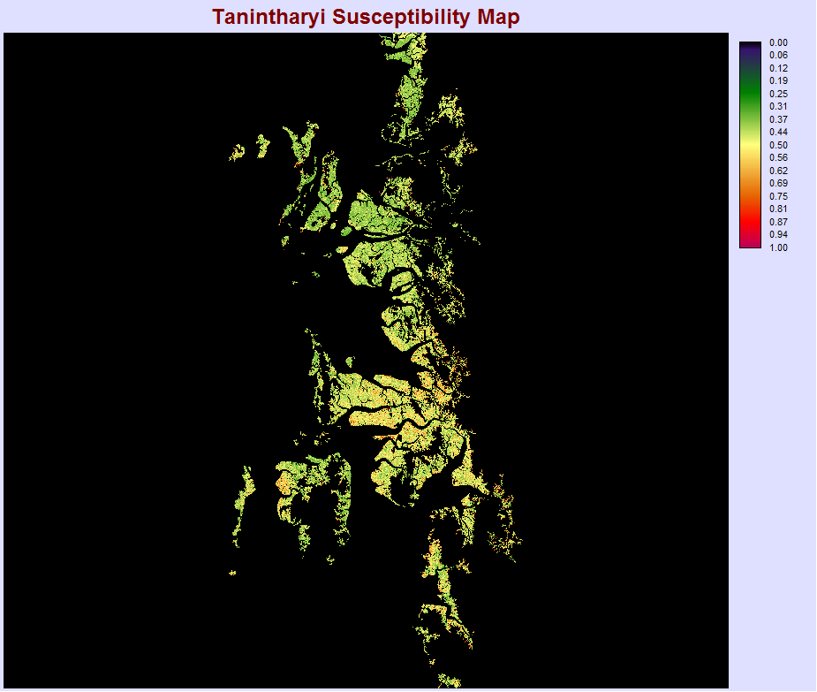

This map shows land susceptibility in the Tanintharyi region for mangroves to become deforested (0 being no risk and 1 being extreme risk). As whole the area is not in eminent danger, but there are pockets of mangroves that are at an elevated risk for deforestation. This region is on the southern coast of Myanmar and was created using the Idrisi Land Change Modeler.