**NASA DEVELOP National Program**



NASA Goddard Space Flight Center

*Spring 2016*

Gulf of Mexico Health & Air Quality

Utilizing NASA Earth Observations to Manage Air Quality and Pollutants over the Gulf of Mexico

 **Technical Report**

Final Draft – March 31, 2016

Amanda Clayton (Project Lead)

Lori Mandable

Dr. Robert Levy, NASA GSFC (Science Advisor)

Dr. Pawan Gupta, GESTAR/USRA, NASA GSFC (Science Advisor)

# I. Abstract

The Outer Continental Shelf (OCS) of the Gulf of Mexico houses over 3,000 offshore oil and gas production facilities. These facilities emit criteria pollutants that are known to have both human health and environmental impacts. The Bureau of Ocean Energy Management (BOEM) is tasked with monitoring the onshore impacts of these emissions under federal regulations. Current practice requires that facility operators collect monthly emissions inventory data that is used to model air quality. NASA Earth observations were utilized to a produce long-term, regional study in the Gulf of Mexico to monitor changes in air quality. Terra Moderate Resolution Imaging Spectroradiometer (MODIS) and Aura Ozone Monitoring Instrument (OMI) data were used to create emissions profiles for PM2.5 and nitrogen dioxide for the Gulf of Mexico. Time series and time-averaged maps were created to illustrate emissions over the 2000-2015 timeframe. Lastly, satellite data were extracted and correlated with data provided by BOEM’s platform sites to identify areas where emissions levels exceeded average annual thresholds. The project methodology allows BOEM to incorporate satellite data for monitoring atmospheric plumes associated with offshore drilling by oil and natural gas platforms to address future environmental concerns in the Gulf of Mexico.

**Keywords**

Remote Sensing, Gulf of Mexico, Air Quality, Particulate Matter, Nitrogen Dioxide, MODIS, OMI

# II. Introduction

**Background**

Aerosols and trace gas emissions are primarily responsible for polluting air quality within the lower troposphere of Earth. Aerosols, also known as particulate matter (PM), are collections of particles within air or a gas as defined by the United States National Aeronautics and Space Administration (NASA, 1996). These aerosols are produced by a variety of activities such as dust blowing off of desert areas, salt evaporites, volcanic eruptions, and through anthropogenic burning of fossil fuels and forested areas (Kaufman et al., 2002; NASA, 1996). The net effect of aerosols is to cool the Earth’s surface by reflecting solar radiation and changing cloud properties (Allen, 1996; Kaufman et al., 2002). Such cooling occurs on a regional basis due to the short lifetime of particulate matter settling and trace gases recombining within the lower troposphere to form secondary particulate matter (Kaufman et al., 2002). Particulate matter is further classified by the size of the particle, with PM10 indicating the mass concentration of particles of size less than 10 micrometers and PM2.5 indicating the mass concentration of particles of size less than 2.5 micrometers. Anthropogenic aerosols emitted from urban and industrial regional pollution are a source of large concentrations of PM2.5, or “fine”, aerosols (Kaufman et al., 2002; Shepherd, 2004). Particulate matter air pollution can have negative cardiovascular and respiratory health effects along with environmental impacts (Anderson et al., 2012; Shepherd, 2004).

Trace gases such as nitrogen dioxide (NO2) are produced primarily by anthropogenic sources such as combustion engines, coal burning electrical utilities, and industrial boilers (United States Environmental Protection Agency, 1995; Wisconsin Department of Health Services, 2015).  The emissions of trace gases contribute to air pollution as a primary source and as a secondary source when they react with other particulate matter in the troposphere, producing nitrate products (Shepherd, 2004). Table 1 (see Appendix) outlines air quality thresholds not to be exceeded for PM2.5 and NO2 as determined by the United States Environmental Protection Agency (Protection of Environment, 2011).

As of 2009, Hoff and Christopher found that no satellite measurements had been used to quantitatively address the EPA’s National Ambient Air Quality Standards (NAAQS). Many of NASA’s Earth observing satellites have instruments capable of measuring atmospheric aerosol and greenhouse gas concentrations. These satellite instruments include the Ozone Monitoring Instrument (OMI), Moderate Resolution Imaging Spectroradiometer (MODIS), Cloud-Aerosol Lidar with Orthogonal Polarization (CALIOP), Ozone Mapping Profiler Suite (OMPS), and Measurements of Pollution In The Troposphere (MOPITT). Because utilizing satellite data requires technical skills involved with accessing, processing, and interpreting satellite data, it was not often used by end-users for air quality applications, who relied on point data sources in determining pollution products (Duncan et al., 2014). However, satellite data has the benefit of regional to global coverage, enabling end-users to analyze larger scale patterns present in air quality assessment (Lamsal et al., 2015).

**Project Partners and Objectives**

The Bureau of Ocean Energy Management (BOEM) assesses the potential onshore air quality impacts from petroleum resources in the Outer Continental Shelf of the Gulf of Mexico (GOM). To make a decision regarding air quality, offshore facility operators must include air emission information when they submit exploratory, development, and production plans. BOEM applies laws presented in the 30 Code for Federal Regulations 550.302 through 304, and generally follows the NAAQS defined by U.S. EPA. While BOEM is able to monitor air quality through their monthly inventories of platform and non-platform emissions, this type of data is cost prohibitive in producing long-term, regionally scaled studies. Satellite data will allow BOEM to track pollutant plumes, determine exceptional events, and evaluate air quality models based on emissions inventory data.

The objectives of this project were to map and analyze airborne pollutant concentrations of PM2.5 aerosol and nitrogen dioxide (NO2) using remotely sensed data from NASA’s Terra MODIS and Aura OMI satellite instruments. Pollutant data was compared to *in situ* data collected by the Bureau of Ocean Energy Management and the EPA to determine if correlations existed between these pollutants and primary emission sources.

**Study Area and Study Period**

The study area for this project encompasses the Outer Continental Shelf (OCS) of the Gulf of Mexico (GOM) including onshore areas of Texas, Louisiana, Mississippi, and Alabama. The bounding coordinates for the study area (-100.0, 24.0, -84.0, 32.0) include all active oil and gas facilities in the GOM under BOEM monitoring along with onshore areas with EPA monitoring stations. Figure 1 displays BOEM monitored facilities within the GOM.  BOEM created a baseline emissions inventory in 2000 and produced subsequent inventories in the years 2005, 2008, and 2011. Satellite data provides coverage and long-term record of metrics related to air quality throughout the GOM. This study produced a monthly and annual regional analysis for a fifteen-year period from 2000 to 2015, focusing on the years corresponding with BOEM’s previous emissions inventories.

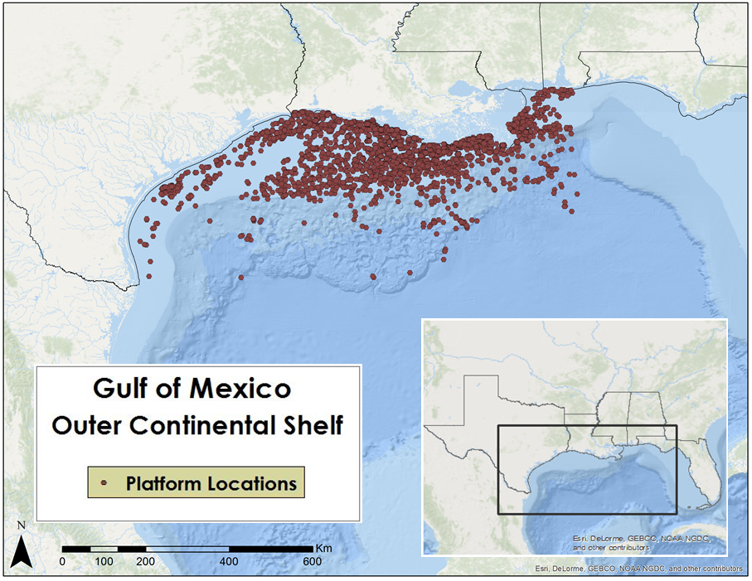

Figure 1. Study area of the Outer Continental Shelf of the Gulf of Mexico

**National Application Addressed**:

This project addressed the Health & Air Quality NASA National Application Area. NASA Earth observations provided satellite retrievals of PM2.5 and NO2 emission concentrations for regional and long-term analysis over the Gulf of Mexico. Our end-users at BOEM can apply the methodology developed in this project to other criteria pollutants (e.g., CO, CH4, VOCs) measured by facility operators included in the Gulfwide Emissions Inventory reports.

# III. Methodology

**Level 3 data**

Level 3 (L3) satellite data is easy to analyze and can be used for regional air quality applications (Duncan et al., 2014). Geospatial Interactive Online Visualization and Analysis Infrastructure (GIOVANNI) was used to examine L3 data for aerosol optical depth and NO2 satellite retrievals for preliminary analysis.

For determining ground-based PM2.5, Aerosol Optical Depth (AOD), or Aerosol Optical Thickness (AOT) is used as a proxy, which is available as a product in GIOVANNI for the Terra MODIS satellite instrument. Specifically, Terra MODIS data for AOD at 550 nm (Dark Target) with 1° spatial resolution were plotted. Data were available at a monthly temporal resolution from March 2000 - December 2015. AOD is a unitless quantity.GIOVANNI was also used to visualize the AURA OMI Level 3 Global Gridded (0.25° latitude x 0.25° longitude) nitrogen dioxide data product. These data were available as NO2 Tropospheric Column (30% cloud screened) in molecules/cm2. Data were available at a daily temporal resolution from October 2004 - December 2015.

Time averaged maps and area-averaged time series were created annually and for the entire study period, as data were available. These allowed us to easily identify time frames in which levels exceeded average pollutant concentration. With the timeframe parameter known, GIOVANNI could then be queried to display the area in which the gas level exceeded average thresholds to provide the coordinates needed for a Level 2 data query.

**Level 2 data**

Level 2 satellite data are original geolocated observations that can be used to analyze point sources (Duncan, 2014). A Terra MODIS monthly averaged and gridded AOD Level 2 data product was obtained at a 0.1 degree spatial resolution for the study area for the years 2002 to 2014. Monthly data were then aggregated to annual AOD averages in ArcGIS and rasterized to produce map composites and time series graphs of average annual emissions for the time period 2002-2014.  The resulting raster files were classified according to manual AOD values of 0-0.15 (very low, blue), 0.15-0.30 (low, green), 0.30-0.45 (medium, yellow), 0.45-0.6 (high, orange) and 0.60-1.728 (very high, red) to reveal areas of significantly higher AOD concentration (See Appendix B).

Monthly gridded Level 2 data for Aura OMI NO2 at a 0.1 degree by 0.1 degree spatial resolution were acquired from NASA Goddard’s Aura Validation Data Center for the years 2005, 2008 and 2011 to correspond with BOEM’s Emission Inventory data. Annual gridded Level 2 data from Aura OMI NO2 at the same 0.1 degree by 0.1 degree spatial resolution were also acquired from NASA Goddard’s Aura Validation Data Center for the years 2005-2015. These data were imported into ArcGIS, where they were projected into the GCS_North_American_1983 geographic coordinate system to match Terra MODIS and BOEM *in situ* datasets. After reprojection, the datasets were clipped to analyze the area between 24.0oN and 32.0oN latitude and 84.0oW and 100.0oW longitude. Annual NO2 average rasters were used to produce map composites and time series graphs of average annual emissions for the time period 2005-2015. The resulting raster files were classified in Dobson Units as 0-0.4 (very low, blue), 0.4-0.7 (low, green), 0.7-0.10 (medium, yellow), 0.10-0.14 (high, orange) and 0.14-0.26 (very high, red) (See Appendix B).

***In situ* data**

*In situ* emissions data were obtained from BOEM’s Gulfwide Emissions Inventories. BOEM emissions inventories include monthly emissions data collected from OCS oil and gas production platform (e.g. diesel and natural gas engines, flares, drilling equipment, etc.) and non-platform (e.g. drilling rigs, pipe laying vessels, helicopters, etc.) sources for multiple criteria pollutants and greenhouse gasses for the years 2000, 2005, 2008, and 2011. Data were obtained in Microsoft Access format, where data were then filtered and joined together to identify emissions for the pollutants of concern for this study. Data provided by these inventories reported in the units of pounds or tons per year and was then exported into Microsoft Excel for upload into ArcGIS.

BOEM gulfwide inventory data from the years 2005, 2008, and 2011 were analyzed to correspond with the availability of MODIS and OMI satellite retrievals. Data from the year 2000 study was excluded due to lack of corresponding satellite data. Platform and non-platform data were combined in Microsoft Excel, then run through IDL code to create gridded datasets to match the 0.1 degree by 0.1 degree spatial resolution of the satellite products. These files were then imported into ArcGIS to create point shapefiles, and rasterized matching the 0.1 degree spatial extent of the Level 2 data products for comparison and correlation. Hot spots of pixels with high emissions measurements were determined by statistical natural breaks that corresponded to the five lowest points of the histogram troughs, which were automatically calculated in ArcGIS.

Once BOEM emissions inventory data and satellite retrievals for AOD and NO2 were processed, pollutant values at common pixels for 2005, 2008, and 2011 were extracted and correlated examine the relationship between the different data sources.  This was done for both the entire study area extent and at specific areas previously identified as hotspots of high measured emissions from BOEM data. Colocated BOEM and satellite data were displayed on scatter plots and through covariance/correlation matrices using the Band Collection Statistics tool in ArcGIS to show possible correlations.

# IV. Results & Discussion

**Level 3 Data**

GIOVANNI produced area-averaged time series and time-averaged maps for AOD (Figure 2) and NO2 (Figure 3) to capture regional and long-term trends in emissions measured by Earth observing satellites.

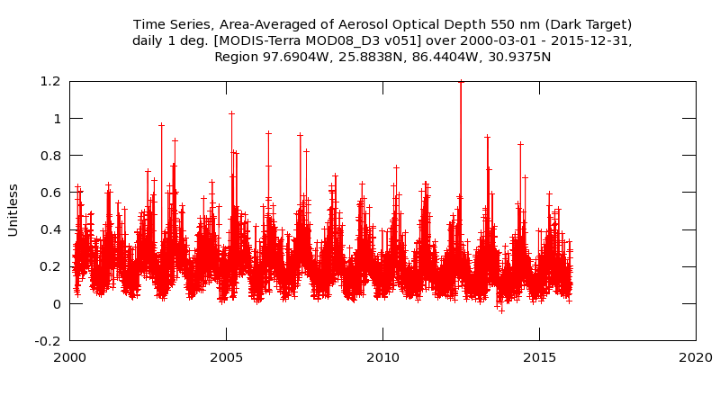

Figure 2.GIOVANNI area-averaged time series of the Level-3 AOD data product from March 2000 - December 2015.

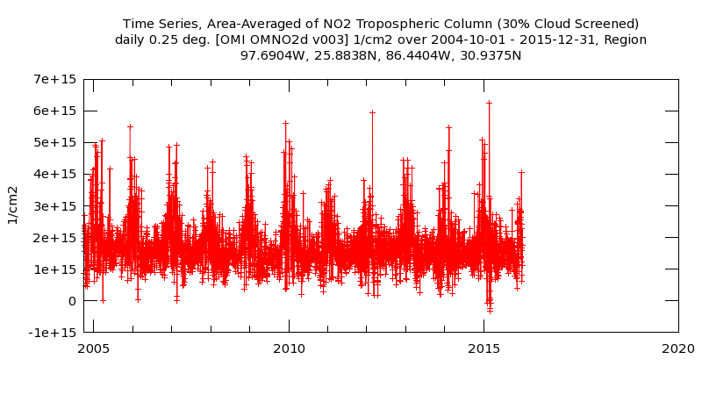

Figure 3. GIOVANNI area-averaged time series of the Level-3 NO2 data product from October 2004 - December 2015.

**Level 2 Data**

*Particulate Matter2.5 - Aerosol Optical Depth*

For Aerosol Optical Depth obtained from Terra’s MODIS instrument, there was an overall decline in AOD from 2002 to 2014, with the years 2002, 2007 and 2011 showing particularly higher than average amounts and the years 2010 and 2014 showing lower than average amounts for the study area, which is reflected in Figure 4 below.

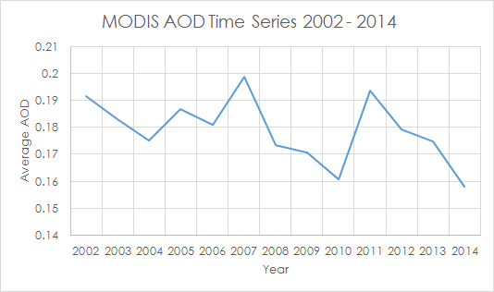

Figure 4. Time series of the annual averages of aerosol optical depth for the study area retrieved from Terra MODIS, 2002 - 2014.

When Terra MODIS Level 2 data was correlated with BOEM Emission Inventories from 2005, 2008 and 2011 (See Appendix B, Figures 12-17), no significant correlation was observed as illustrated by Figures 5, 6 and 7 below. The resulting trendline for 2005 showed an extremely slight positive correlation between the data, whereas the trendlines for 2008 showed extremely slight negative correlations. Additionally, monthly data from BOEM and MODIS were analyzed for a single coordinate (28.2°N, 88.5°W) in 2008 to examine the relationship between emissions measurements at a smaller scale (Appendix C, Figure 24). The 2008 annual time series showed correlated measurements for one month, June, with varying degrees of correlations for the rest of the year.

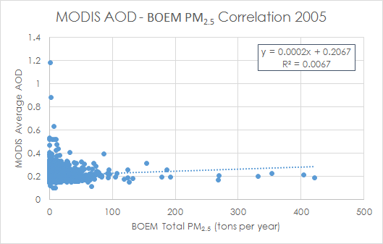

Figure 5. Scatter plot and correlation of BOEM PM2.5 and MODIS AOD data for 2005.

# https://lh6.googleusercontent.com/tGAjPMiou3O-Lx6DQMPTXA3Wsn2Et4jyHe7KLxQz6De7cyW2ihNHVH-9UQ5MIsCKTkATCtlXwAy7jhtbIqoD5m5Oz458J6KpeytlCnRrg_287p_s7jqbaw0NB-aQD-CIaJoHmEqf

Figure 6. Scatter plot and correlation of BOEM PM2.5 and MODIS AOD data for 2008.

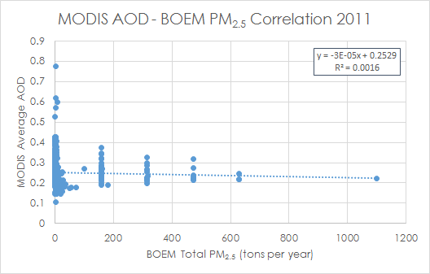

Figure 7. Scatter plot and correlation of BOEM PM2.5 and MODIS AOD data for 2008.

*Nitrogen Oxides - Nitrogen Dioxide*

For nitrogen dioxide obtained from Aura’s OMI instrument, there was an overall decline in concentration from 2005 to 2015, with the years 2005 and 2012 showing increased concentration and the years 2007, 2010 and 2014 showing decreased concentration for the study area, which is reflected in Figure 8 below.

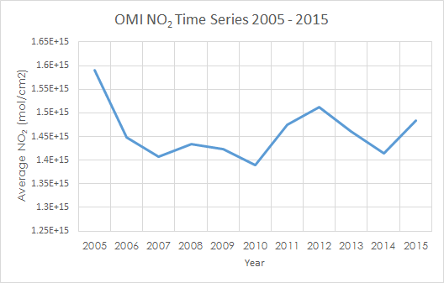

Figure 8. Time series of the annual averages of nitrogen dioxide for the study area retrieved from Aura OMI, 2005 - 2015.

When Aura OMI Level 2 data was correlated with BOEM Emission Inventories from 2005, 2008 and 2011(See Appendix B, Figures 18-23), no significant correlation was observed as illustrated by Figures 9, 10 and 11 below. The resulting trendlines for 2005 and 2008 showed an extremely slight positive correlation between the data, whereas the trendline for 2011 showed extremely slight negative correlation. These data were better correlated than the BOEM/MODIS AOD correlations but again showed no significant correlation. Coordinate 28.2°N, 88.5°W was also identified as a hot spot for NOx in 2008 and was further analyzed with monthly data(Appendix C, Figure 25). As shown for the analysis of BOEM PM2.5/MODIS AOD at the same coordinate, emissions measurements for June 2008 were the most strongly correlated while other monthly values showed greater variation between ground and satellite measurements.

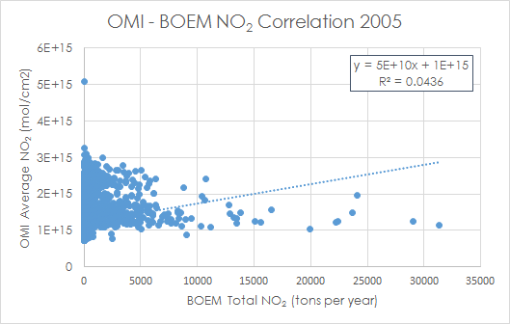

Figure 9. Scatter plot and correlation of BOEM NO2 and OMI NO2 data for 2005.

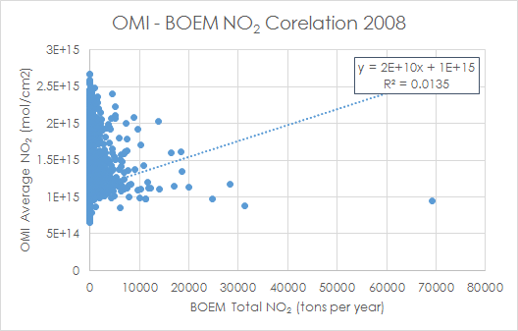

Figure 10. Scatter plot and correlation of BOEM NO2 and OMI NO2 data for 2008.

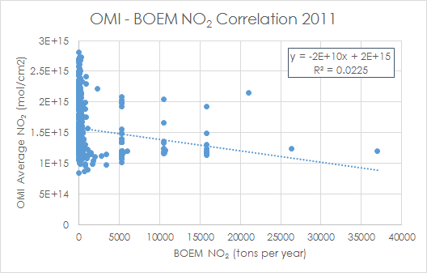

Figure 11. Scatterplot and correlation of BOEM NO2 and OMI NO2 data for 2011.

The availability of long term (10+ years) data, ease of accessibility and global coverage at fine spatial resolution make Terra MODIS and Aura OMI data ideally suited to perform regional analysis of emission patterns. When combined with point-source data from BOEM’s Emission Inventories of 2005, 2008 and 2011, stronger correlation was anticipated. The lack of correlation can best be explained by several factors. First, satellite instrumentation provides data for the total tropospheric column whereas point-sourced data only records surface level activity. It is highly likely that the point-sourced data was not strong enough to be detected by the satellites without interference. Secondly, BOEM’s emission inventories evolved from 2000-2008 to become a standardized triennial product. Emissions recorded in the 2000 and 2005 inventories were not consistently provided as monthly data for non-platform sources making it possible to analyze at an annual scale instead of a monthly scale.

To alleviate these issues, it is recommended that additional satellite data from CALIPSO’s CALIOP lidar instrument be integrated, which will provide the vertical pollutant distribution and allow for a stronger comparison between point-sourced surface data and lower tropospheric emissions. Additionally, it is recommended that the BOEM 2014 Emissions Inventory is integrated into this study when becomes available in the summer of 2016 to provide an additional year of data comparison and better correlation. Lastly, additional pollutants were suggested in the original study proposal that could not be integrated into this study due to time constraints. Future work in this area on other pollutants such as sulfur dioxide, methane, carbon monoxide and volatile organic compounds could yield stronger correlations as additional satellite data is incorporated in the study.

# V. Conclusions

The overall objectives of the 2016 Gulf of Mexico Health and Air Quality Team were to map and analyze airborne pollutant concentrations of PM2.5 and NO2 using NASA Earth observations, determine if correlations existed between pollutants remotely sensed by satellites and primary emission sources in the Gulf of Mexico and to develop a methodology for emissions monitoring. The data from Terra’s MODIS and Aura’s OMI instruments successfully illustrated the ability of satellites to provide over a decade of data that can be used to analyze emission patterns on a regional scale. The team did not find significant correlation between BOEM’s Emission Inventory data for the years 2005, 2008 and 2011 and corresponding satellite data for AOD and NO2 emissions, which was due to a variety of factors. From 2000 to 2008, BOEM’s Emission Inventory structure evolved from recording data in pounds or tons per month for platform sources or tons per year for non-platform sources into a standardized format of tons per month for both sources. Additionally, Terra’s MODIS and Aura’s OMI instruments provide total columnar measurements of tropospheric pollutants, while BOEM Emission Inventories provide a mass amount per point source, which do not easily correlate. To aid in resolving these issues, it would be worthwhile to examine the use of CALIPSO’s CALIOP lidar instrument to augment MODIS AOD data and utilize the United States’ Environmental Protection Agency’s land sensors for additional ground-based data. Despite the lack of correlation, further investigation of other pollutants such as sulfur dioxide, methane, carbon monoxide and volatile organic compounds could potentially yield a stronger correlation between the BOEM Emissions Inventory data and satellite products. BOEM’s 2014 Emissions Inventory is scheduled for release in the summer of 2016, which could also provide the additional data needed to support a stronger correlation. Procedures outlining the team’s methodology are presented in the Methodology section above, which can also be applied to other pollutants for future emissions monitoring.

# VI. Acknowledgments

* Dr. Robert Levy
* Dr. Pawan Gupta
* Dr. Bryan Duncan
* Dr. Lok Lamsal
* Dr. Nickolay Krotkov

Any opinions, findings, and conclusions or recommendations expressed in this material are those of the author(s) and do not necessarily reflect the views of the National Aeronautics and Space Administration.

This material is based upon work supported by NASA through contract NNL11AA00B and cooperative agreement NNX14AB60A.

# VII. References

# Acker, J. G., and Leptoukh, G. (2007). Online analysis enhances use of NASA Earth science data. *Eos, Transactions American Geophysical Union, 88*(2), 14 and 17. http://dx.doi.org/10.1029/2007EO020003

# Anderson, J.O., Thundiyil, J.G., and Stolbach, A. (2012). Clearing the air: A review of the effects of particulate matter air pollution on human health. *Journal of Medical Toxicology, 8*(2), 166-175. http://dx.doi.org/10.1007/s13181-011-0203-1

# Duncan, B.N., Prados, A.I., Lamsal, L.N., Liu, Y, Streets, D.G., Gupta, P., … Ziemba, L.D. (2014). Satellite data of atmospheric pollution for U.S. air quality applications: Examples of applications, summary of data end-user resources, answers to FAQs, and common mistakes to avoid. *Atmospheric Environment (94)*, 647-662. http://dx.doi.org/10.1016/j.atmosenv.2014.05.061

# Hoff, R.M., and Christopher, S.A. (2009). Remote sensing of particulate pollution from space: Have we reached the promised land? *Journal of the Air and Waste Management* *Association 59*, 645-675. http://dx.doi.org/10.3155/1047-3289.59.10.1130

# Kaufman, Y.J., Tanré, D., and Boucher, O. (2012). A satellite view of aerosols in the climate system. *Nature 419*(6903), 215-223. http://dx.doi.org/10.1038/nature01091

NASA. (1996, August 1). *Atmospheric Aerosols: What Are They, and Why Are They So Important?* (B. Allen, Editor) Retrieved from NASA: https://www.nasa.gov/centers/langley/news/factsheets/Aerosols.html

# Protection of Environment, 40 C.F.R § 50 (2011).

Shepherd, M. (2004). Chapter 1: Perspective for managing PM. In P.H. McMurry, M. Shepherd, and J.S. Vickery (Eds.), *Particulate matter science for policy makers: a NARSTO assessment* (1-16). Cambridge, England: Cambridge University Press.

United States Environmental Protection Agency. (1995). 1995 *National air quality and emissions trends report*. Washington, DC: Office of Air Quality Planning and Standards.

Wisconsin Department of Health Services. (2015). *Wisconsin Department of Health Services*. Retrieved from: https://www.dhs.wisconsin.gov/chemical/sulfurdioxide.htm

# VIII. Content Innovation

Interactive Map Viewer KML files available at: <https://drive.google.com/file/d/0B0LdRdEHs-ExNzNUbTdPdFNtMk0/view?usp=sharing>

<https://drive.google.com/file/d/0B0LdRdEHs-ExajlldFNCb0hJdTA/view?usp=sharing>

Data Profile available at:

<https://drive.google.com/file/d/0B0LdRdEHs-ExN2R4UlVWemZFUXM/view?usp=sharing>

# IV. Appendices

**Appendix A: National Ambient Air Quality Standards**

|  |  |  |  |  |
| --- | --- | --- | --- | --- |
| Pollutant | Primary/Secondary | Averaging Time | Level | Form |
| Particulate Matter (PM2.5) | Primary | 1 year | 12.0 µg/m3 | Annual Mean, averaged over 3 years |
| Secondary | 1 year | 15.0 µg/m3 | Annual Mean, averaged over 3 years |
| Primary and Secondary | 24 hours | 35.0 µg/m3 | 98th percentile, averaged over 3 years |
| Nitrogen Dioxide (NO2) | Primary | 1 hour | 100 ppb | 98th percentile of 1-hour daily maximum concentrations, averaged over 3 years |
| Primary and Secondary | 1 year | 53 ppb | Annual Mean |
| Sulfur Dioxide (SO2) | Primary | 1 hour | 75 ppb | 99th percentile of 1-hour daily maximum concentrations, averaged over 3 years |
| Secondary | 3 hours | 0.5 ppm | Not to be exceeded more than once per year |

Table 1. EPA National Ambient Air Quality Standards (Protection of Environment, 2011). Primary standards provide public health protection and secondary standards provide welfare protection (e.g. damage to animals, crops, buildings). Units of measure for the standards are micrograms per cubic meter of air (µg/m3), parts per billion (ppb) by volume, and parts per million (ppm) by volume.

**Appendix B: BOEM and satellite raster images for correlations**

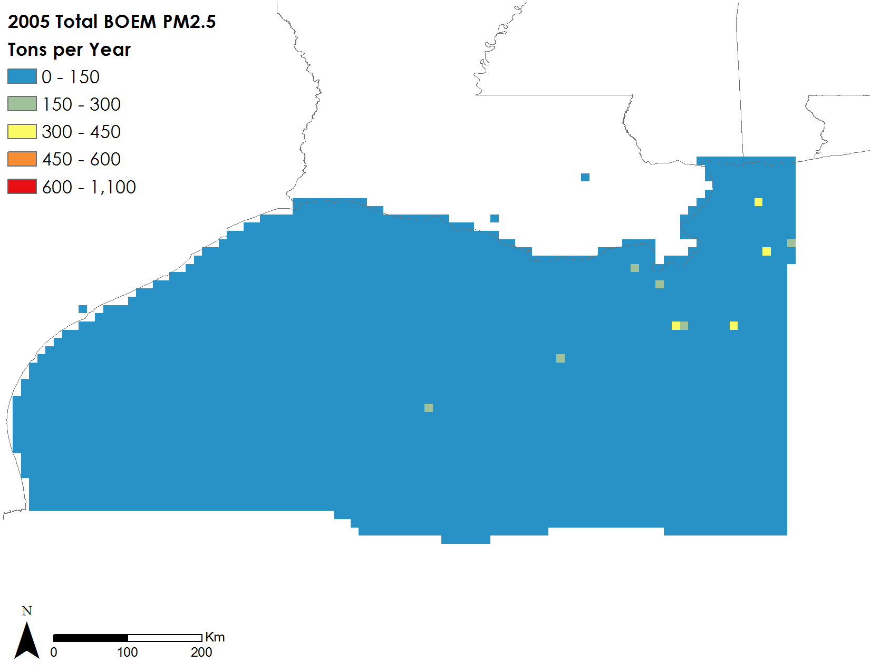

Figure 12. Total BOEM Platform and non-platform PM2.5 emission measurement data for the year 2005 at 0.1 degree spatial resolution.

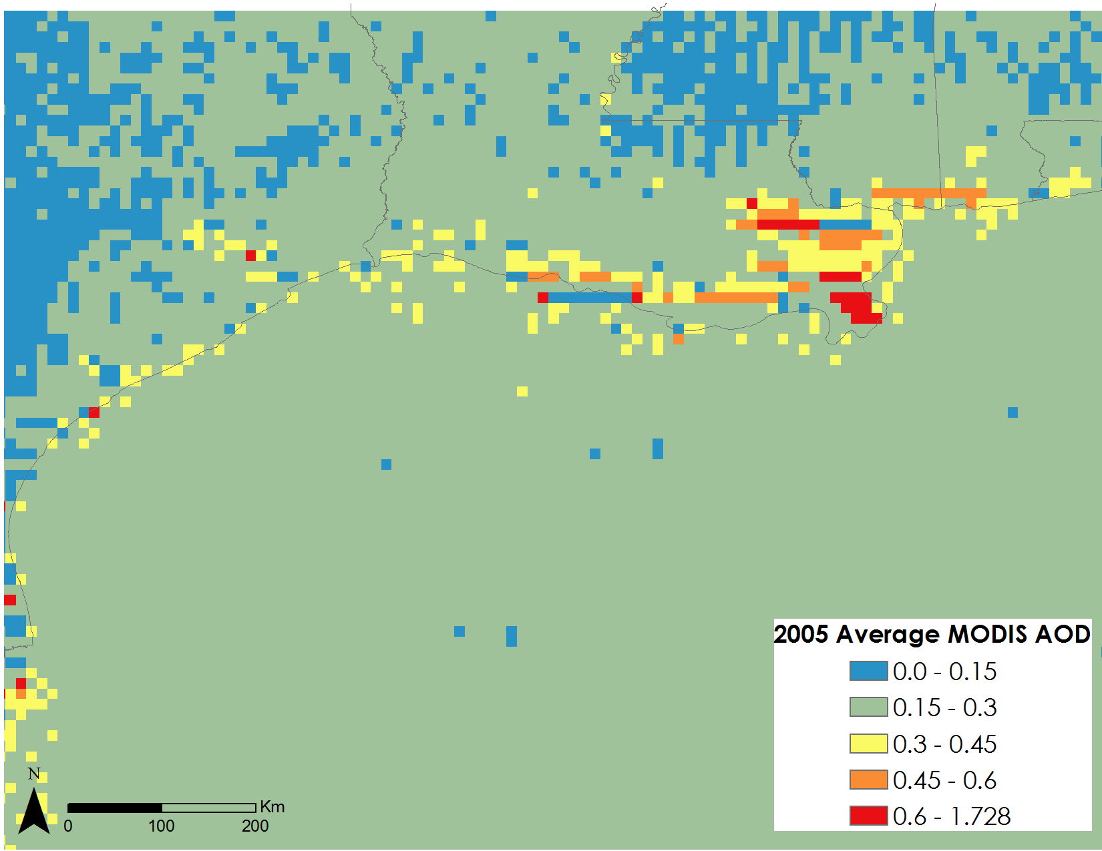

Figure 13. Average MODIS aerosol optical depth at 550nm for the year 2005 at 0.1 degree spatial resolution.

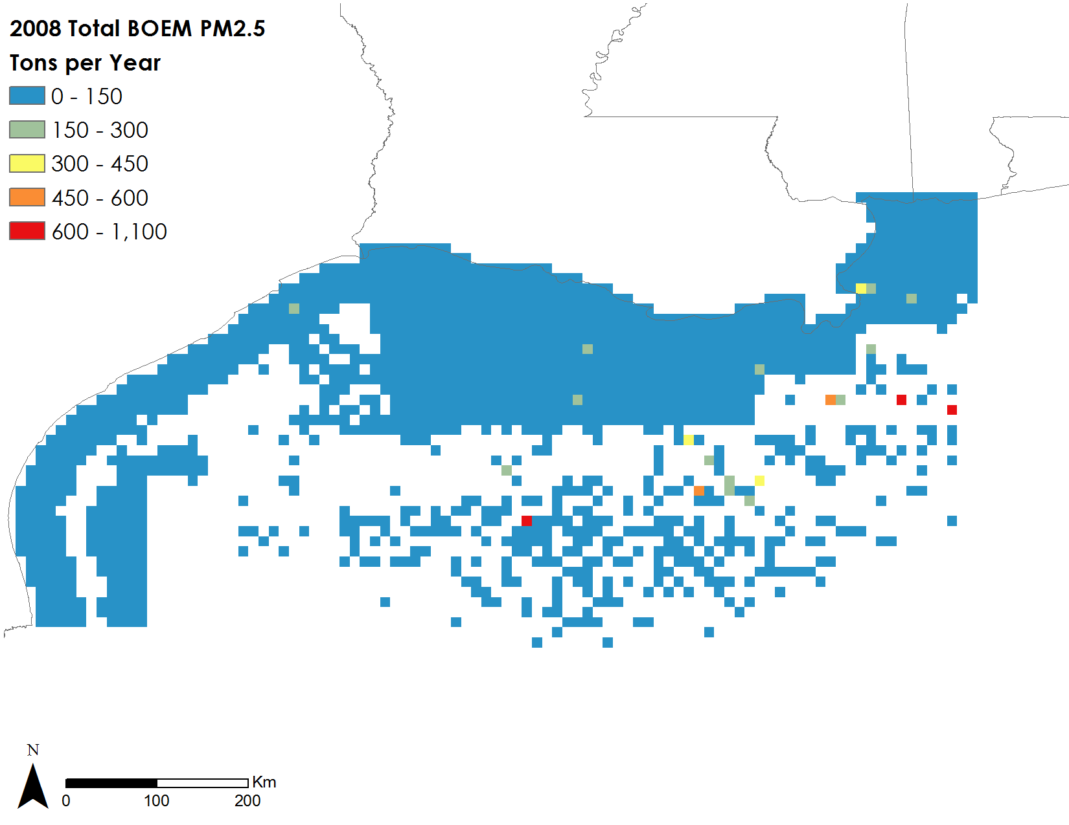

Figure 14. Total BOEM Platform and non-platform PM2.5 emission measurement data for the year 2008 at 0.1 degree spatial resolution.

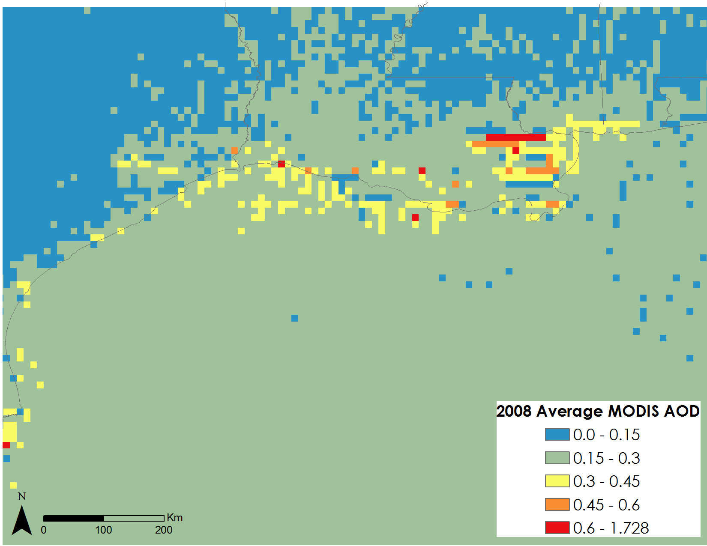

Figure 14. Average MODIS aerosol optical depth at 550nm for the year 2008 at 0.1 degree spatial resolution.

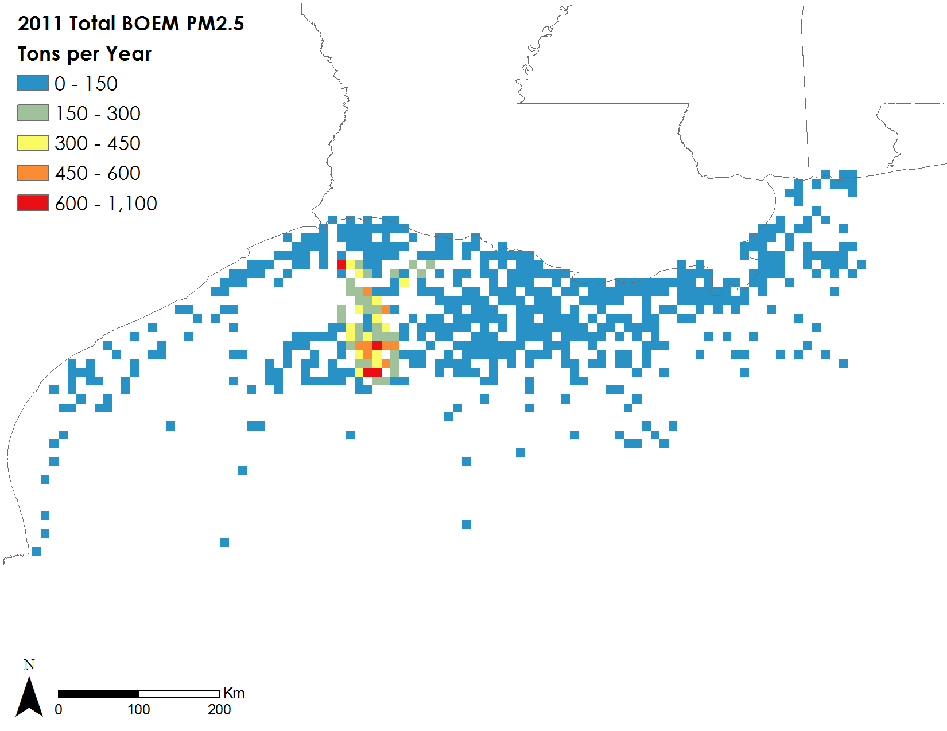

Figure 16. BOEM Platform and non-platform PM2.5 emission measurement data from 2011 at 0.1 degree spatial resolution.

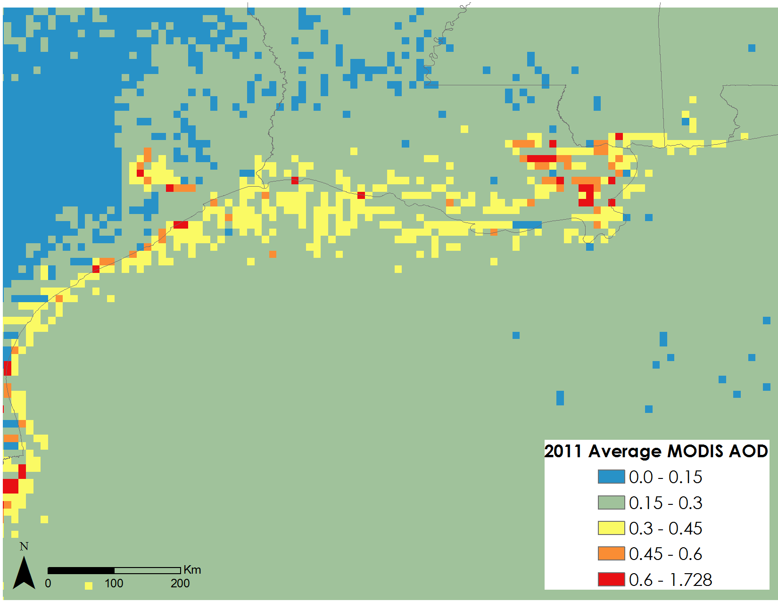

Figure 17. Average MODIS aerosol optical depth at 550nm for the year 2011 at 0.1 degree spatial resolution.

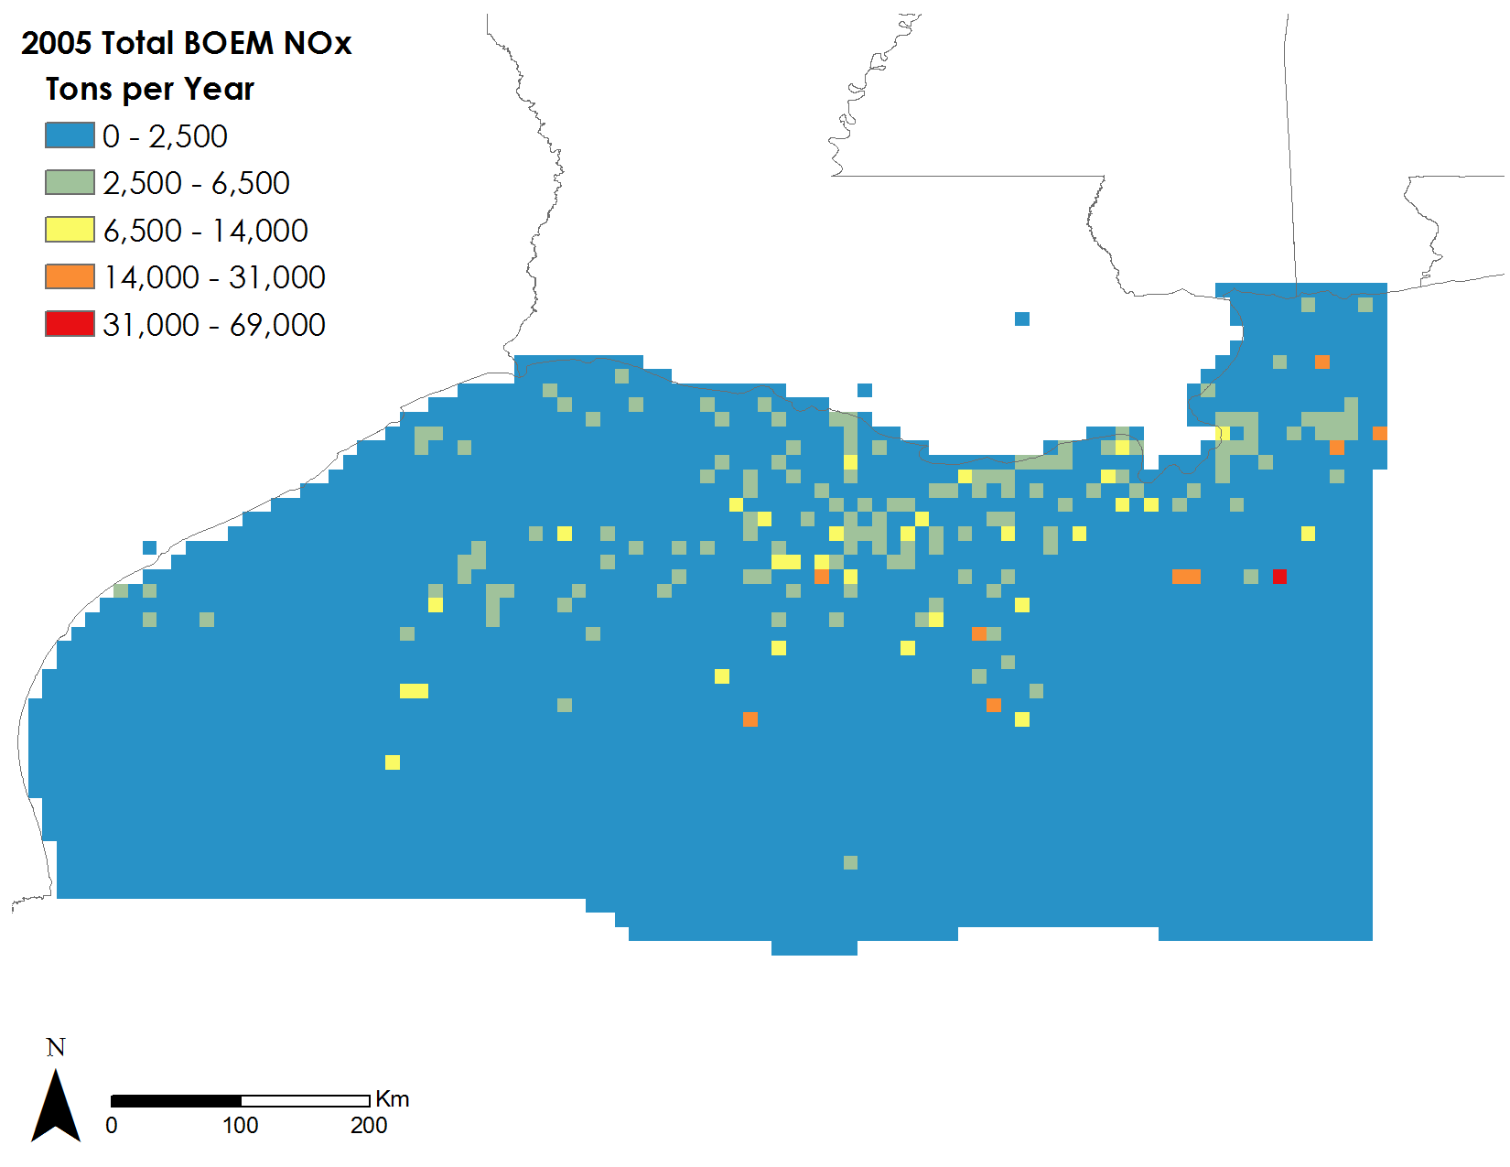

Figure 18. Total BOEM Platform and non-platform NOx emission measurement data for the year 2005 at 0.1 degree spatial resolution.

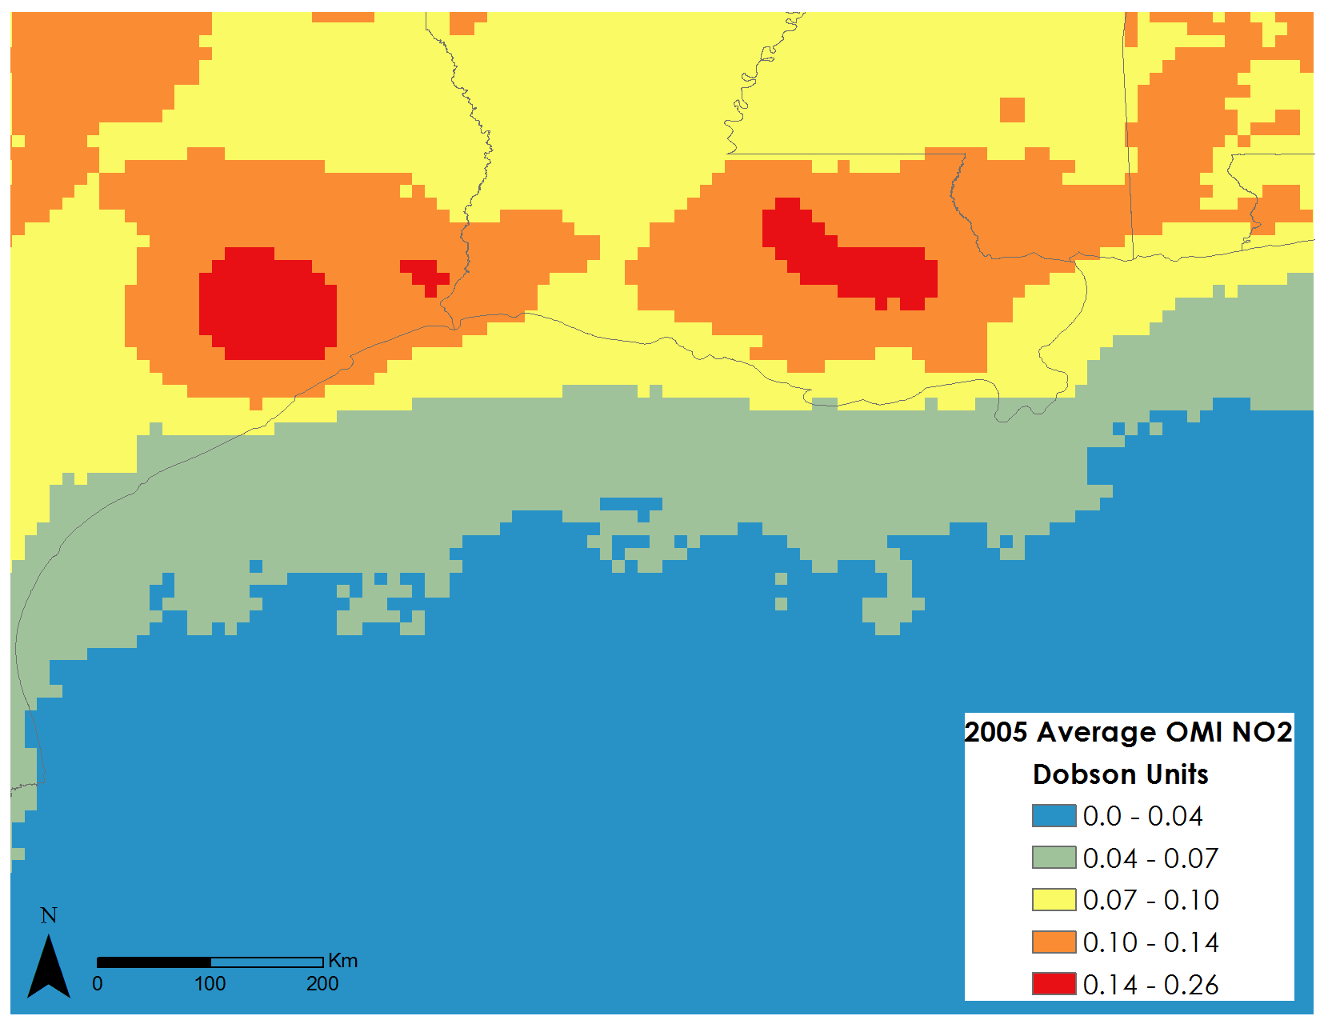

Figure 19. Average column OMI NO2 for the year 2005 at 0.1 degree spatial resolution.

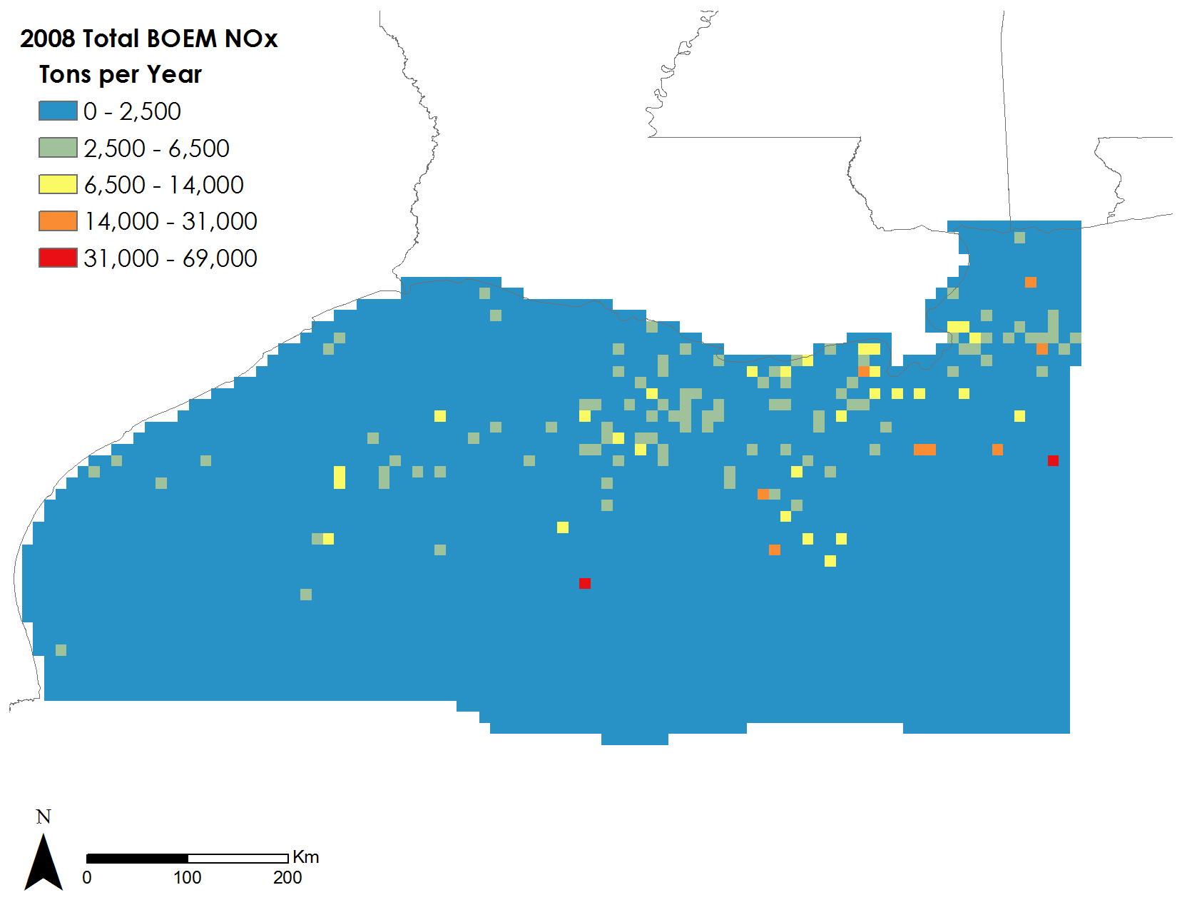

Figure 20. Total BOEM Platform and non-platform PM2.5 emission measurement data for the year 2008 at 0.1 degree spatial resolution.

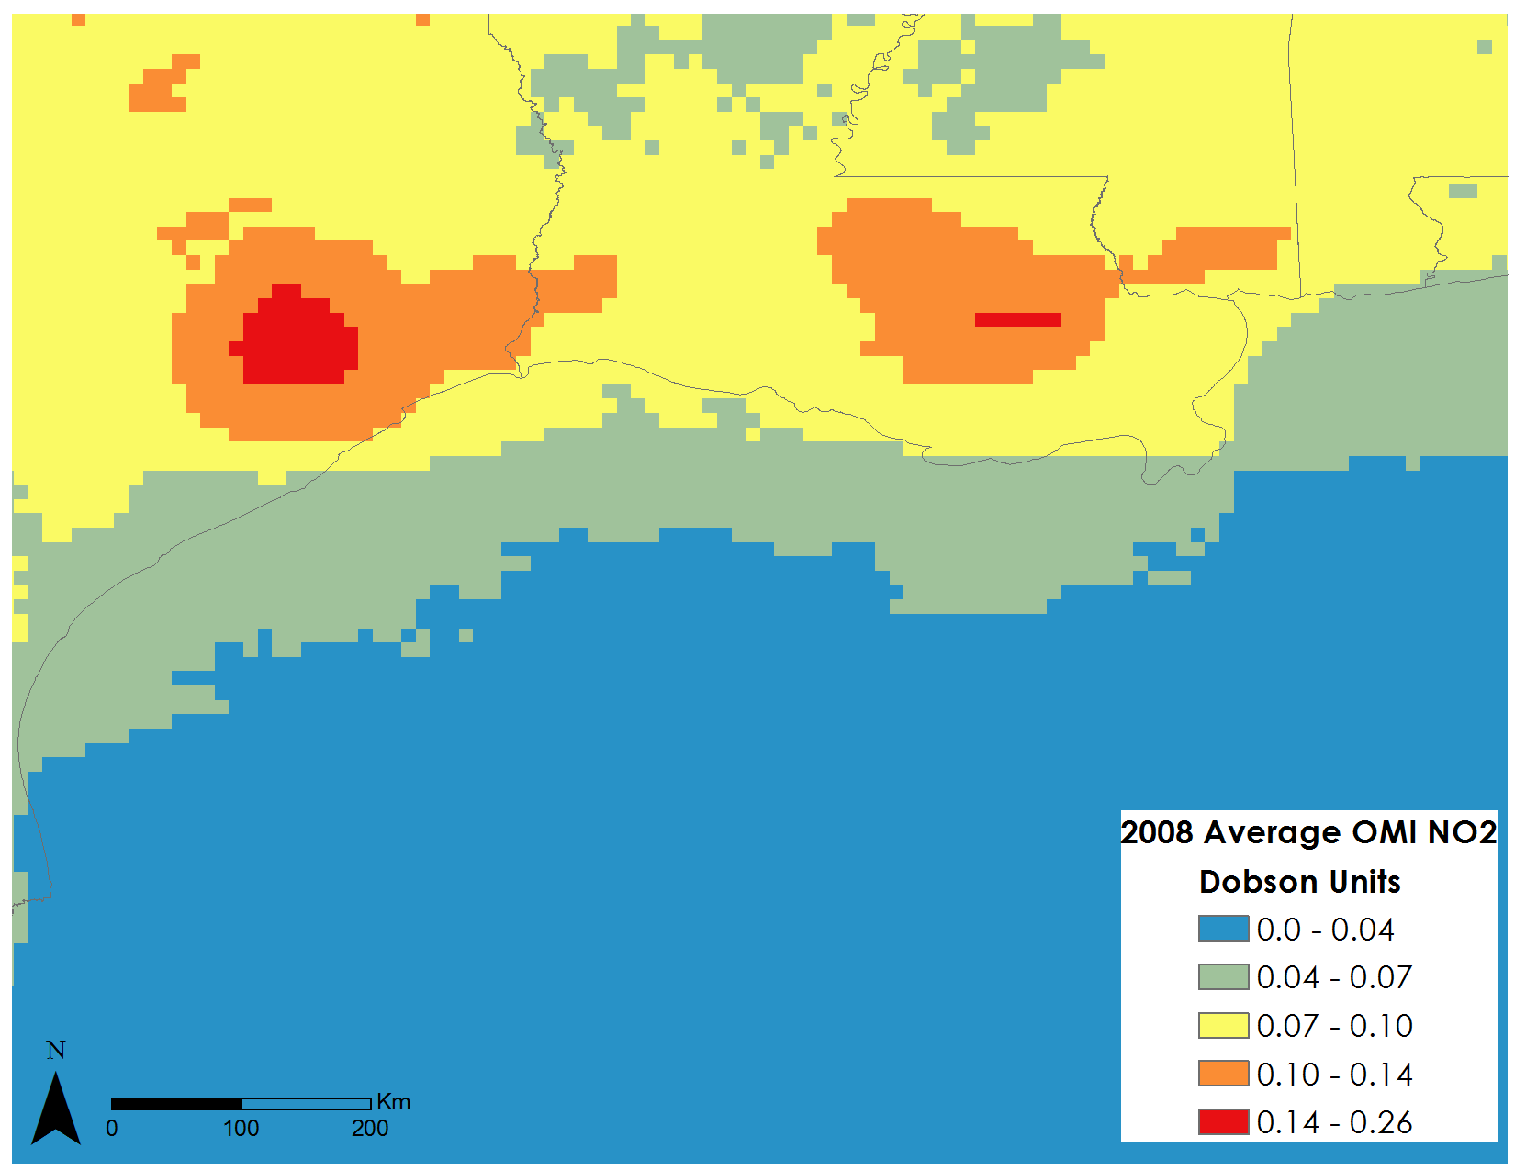

Figure 21. Average column OMI NO2 for the year 2008 at 0.1 degree spatial resolution.

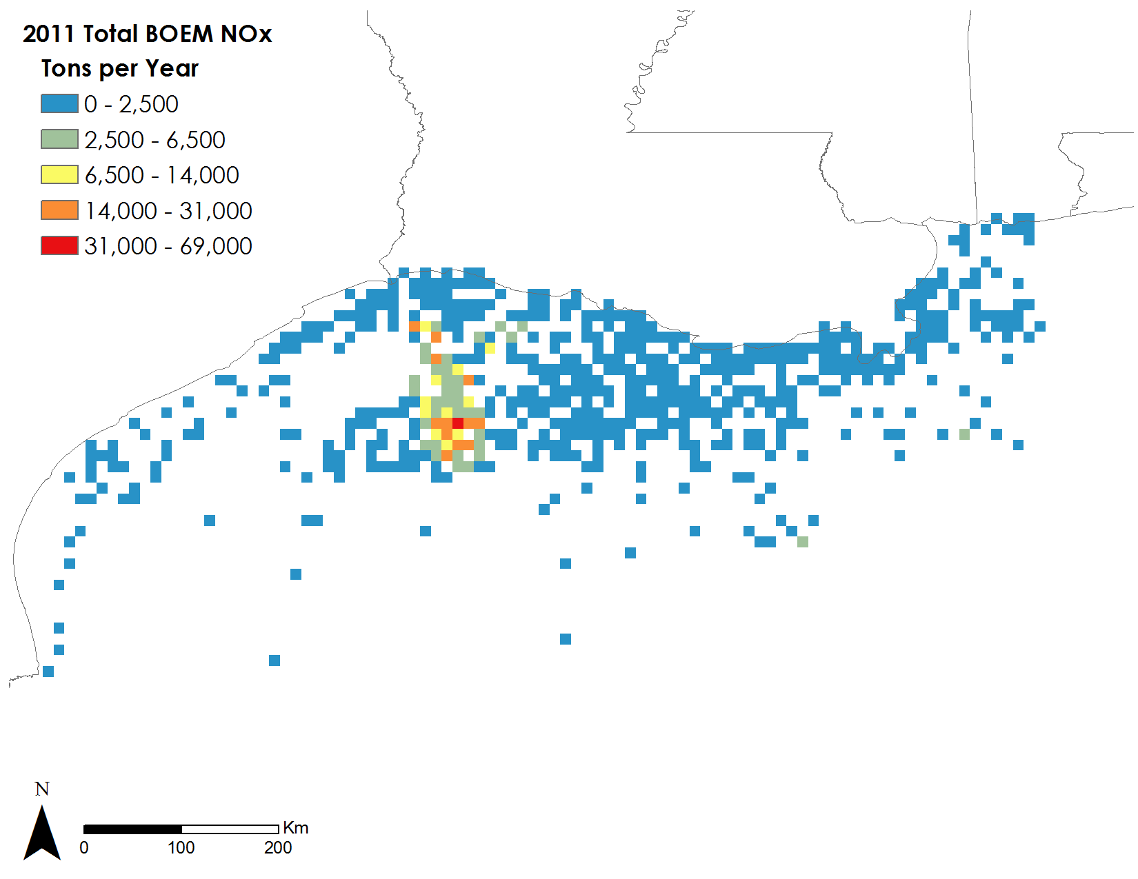

Figure 22. Total BOEM Platform and non-platform PM2.5 emission measurement data for the year 2011 at 0.1 degree spatial resolution.

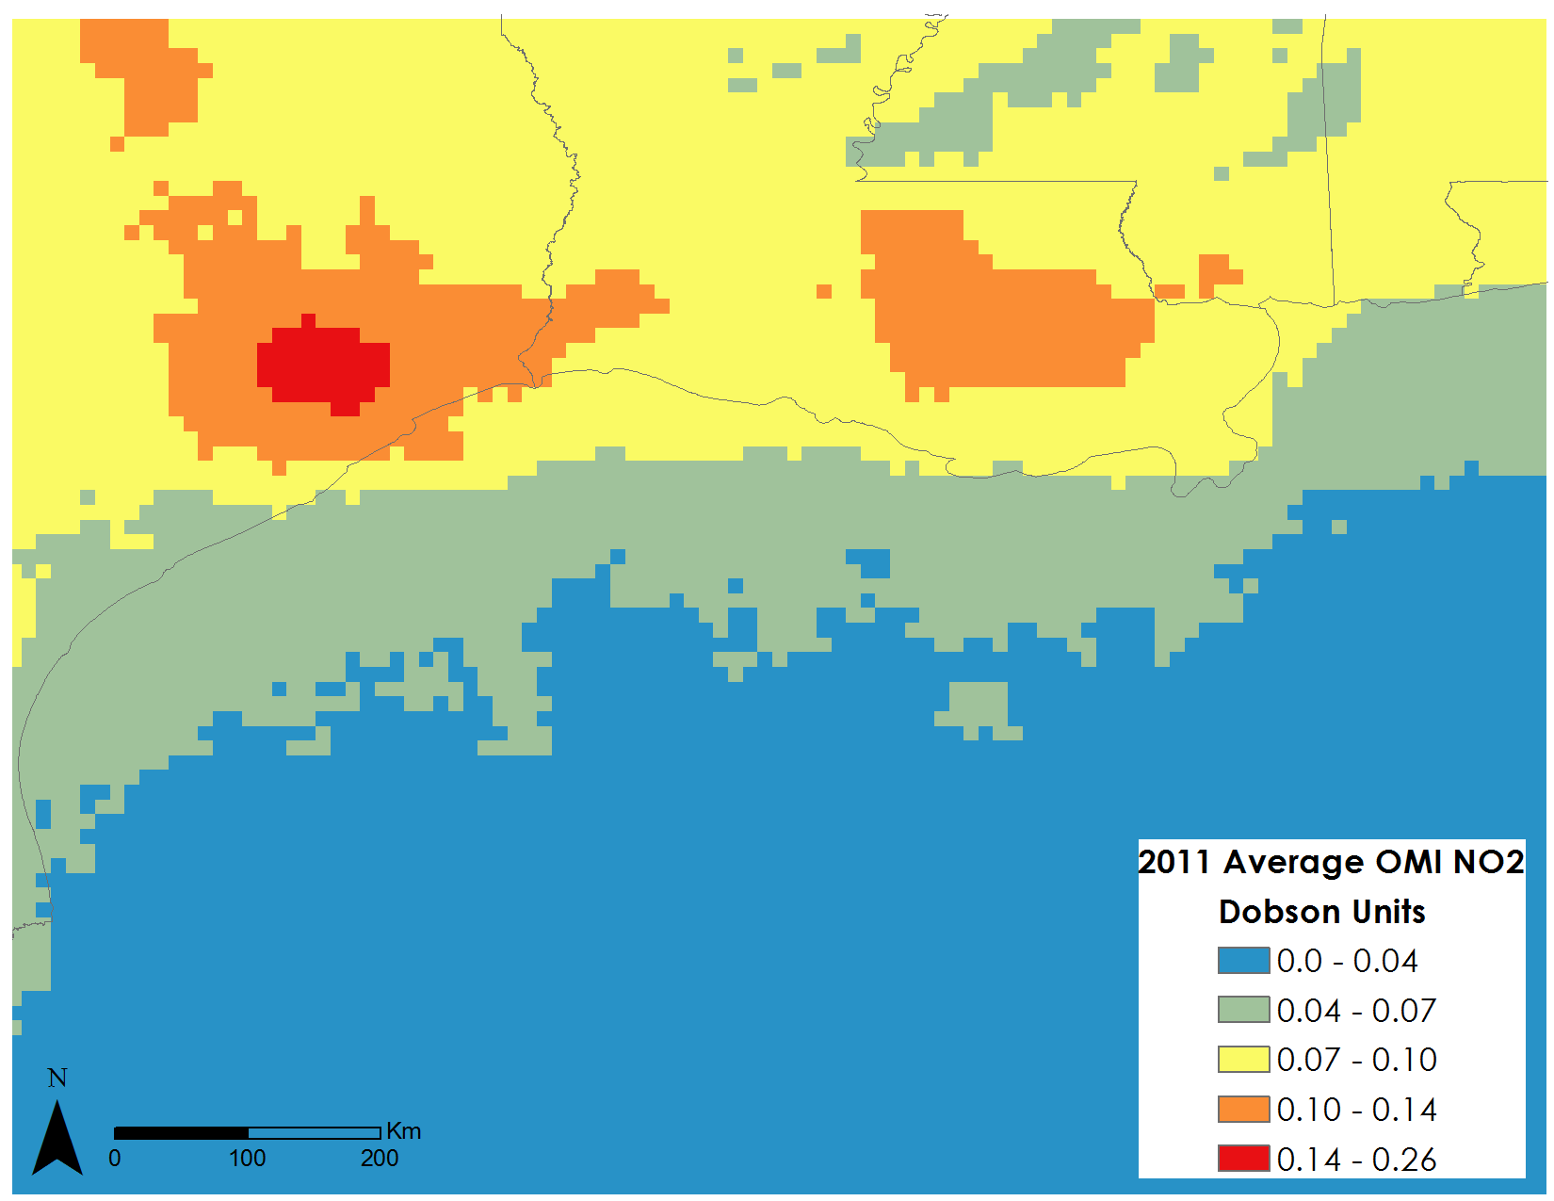

Figure 23. Average column OMI NO2 for the year 2011 at 0.1 degree spatial resolution.

**Appendix C. Correlation analysis at hot spot 28.2°N, 88.5°W**

Figure 24. Correlation between BOEM Total PM2.5 and MODIS Average AOD at coordinate28.2°N, 88.5°W

Figure 25. Correlation between BOEM Total NOx and OMI Average NO2 at coordinate28.2°N, 88.5°W