Rocky Mountain Water Resources II

Employing NASA and ESA Earth Observations to Monitor Alpine Lake Algal Productivity in Rocky Mountain National Park

**Technical Report**

Final Draft – August 8th, 2019

Anastasia Kunz (Project Lead)

Genevieve Clow

Natalie Schmer

Sarah Wingard

Dr. Paul Evangelista, Colorado State University, Natural Resource Ecology Laboratory (Science Advisor)

Dr. Catherine Jarnevich, United States Geological Survey, Fort Collins Science Center (Science Advisor)

Nicholas Young, Colorado State University, Natural Resource Ecology Laboratory (Science Advisor)

Peder Engelstad, Colorado State University, Natural Resource Ecology Laboratory (Science Advisor)

Tony Vorster, Colorado State University, Natural Resource Ecology Laboratory (Science Advisor)

Previous Contributors:

Emily Campbell

Benjamin Ignac

Muthukumaran Sampath

Amy Stuyvesant

# 1. Abstract

Alpine lakes in Rocky Mountain National Park (RMNP) serve as important habitats and water sources for wildlife and contribute to the overall aesthetic value of the park. However, since the 1960s, alpine lakes within RMNP have experienced intensified algal productivity as a result of rising temperatures and increased nitrogen and phosphorus deposition. This increased algal productivity may have negative impacts on water quality, ecological function, and park aesthetic. Due to the remote location of many of these lakes, continuous monitoring of algal productivity is difficult. In order to assist in the surveillance of these lakes, the Rocky Mountain Water Resources II team partnered with the United States Geological Survey’s Fort Collins Science Center and the National Park Service at RMNP to develop a methodology integrating satellite imagery for monitoring chlorophyll-a concentration as a proxy for algal productivity. In 2016, DEVELOP’s Rocky Mountain Climate team utilized Landsat 8 Operational Land Imager (OLI) to predict chlorophyll-a levels, but they were limited by the spatial and temporal resolution of the data. This feasibility analysis compared the efficacy of integrating higher resolution Sentinel-2 Multispectral Instrument (MSI) data with Landsat 8 OLI indices in detecting chlorophyll-a at two RMNP focal lakes, Sky Pond and The Loch. An increased understanding of the algal productivity of these lakes will allow our partners to promote best management practices in maintaining the resilience and preserve the beauty of these fragile ecosystems.

**Keywords**

remote sensing, Sentinel-2 MSI, Landsat 8 OLI, chlorophyll-a, algal blooms, eutrophication, water quality, ecological function

# 2. Introduction

* 1. ***Background Information***

Within Colorado’s Rocky Mountain National Park (RMNP), 147 alpine and subalpine lakes provide vital freshwater sources and habitat for wildlife. Headwater streams in the Rocky Mountains feed into the Colorado River, which provides water to much of the western United States. Additionally, these lakes contribute to the aesthetic value of RMNP for millions of visitors each year. In 2018, RMNP had 4,590,493 visitors, generating $306 million in revenue for the park and the surrounding region (National Park Service, 2018; National Park Service, 2019). While these alpine lakes are renowned as pristine environments, there is recent evidence suggesting that anthropogenic forces, such as increased nutrient loading to the lakes and rising temperatures, are significantly impacting the park (Baron, 2006).

Due to population growth in the Colorado Front Range, atmospheric nitrogen concentrations have increased significantly since the 1950s (Baron, 2006; Mast et al., 2014). Transportation, power generation, and agriculture emit reactive nitrogen, such as ammonia and nitrogen oxides, into the atmosphere (Baron, 2006). This atmospheric nitrogen is then deposited through precipitation in the Rocky Mountains, increasing the amount of available nitrogen in the ecosystem. Algae thrive under these high nutrient conditions, and as a result, alpine lakes have seen a shift in trophic status from oligotrophic to meso-eutrophic, marked by changes in lake algae and diatom community compositions (Baron, 2006). Previously present in low amounts, green filamentous algae now dominates the lake beds, indicating increased nutrient load and impaired water quality. As the algae decompose, they produce unpleasant odors and unsightly appearances. Additionally, there is an opening in the ecosystem for cyanobacteria (blue-green algae) to establish, which can be toxic to wildlife and people when present in high concentrations. Therefore, threats to ecosystem and human health warrant close monitoring of these lakes in response to human activity.

***2.2 Project Partners & Previous Work***

Beginning in 1983, the Loch Vale watershed in RMNP has been the subject of long-term ecological research and monitoring. Field data, including water samples and sediment cores, are currently collected on a weekly basis by the United States Geological Survey (USGS), the National Park Service (NPS), and researchers at Colorado State University (CSU). The scope of this long-term study is to monitor the hydrology, water chemistry, climate, aquatic biota, and ecological responses to changing environmental conditions and human disturbances.

The Class I designation of RMNP under the Clean Air Act requires that the park limit human impact on the landscape and protect the airshed from air pollution. To address this issue, the NPS released a plan to reduce nitrogen levels by 50% or 1.5 kg/ha/yr by 2032 (National Park Service, Environmental Protection Agency, Colorado Department of Public Health & Environment, 2010). Although nitrogen emissions from transportation and coal combustion have decreased over time, agriculture remains a source of elevated nitrogen inputs (Colorado Department of Public Health and Environment, 2008). While the NPS and USGS do not have the ability to create policies relating to nitrogen emissions outside of the park, they do have the ability to heavily influence other political agencies such as the Environmental Protection Agency and the Colorado Department of Public Health and Environment, which may lead to stricter environmental regulations to protect these crucial ecosystems.

The previous Rocky Mountain DEVELOP team partnered with the NPS and USGS to assess the feasibility of using Landsat 8 Operational Land Imager (OLI) to monitor algal productivity in alpine lakes. They tested several chlorophyll-a spectral indices as a proxy for algae and found that the NIR/Red band ratio was moderately successful (R2 = 0.22) at predicting chlorophyll-a when compared with *in situ* data. However, this study had several limitations, including the availability of cloud-free Landsat 8 OLI imagery, mixed pixels from shoreline vegetation, limited *in situ* data, and the coarse 30 m resolution of Landsat imagery.

***2.3 Scientific Basis***

To address the issue of low spatial resolution, this project built upon the previous term’s methodology by incorporating imagery from Sentinel-2 MultiSpectral Instrument (MSI), which has a finer spatial resolution of 10 m. The reflectance peak between 700 nm and 720 nm has been commonly used to detect chlorophyll-a due to its absorption of these wavelengths (Ansper & Alikas, 2018; Toming et al., 2016). This wavelength range corresponds with the vegetation red edge band from Sentinel-2 MSI (705 nm, Band 5). Therefore, the red edge bands are commonly used in remote sensing of chlorophyll-a. Landsat 8 OLI lacks the vegetation red edge bands, but previous studies have reported success monitoring lake water quality parameters with Landsat 8 OLI (Barrett & Frazier, 2016; Boucher et al., 2018).

Several studies have attempted to develop indices for monitoring water quality using Sentinel-2 with varying success (Ansper & Alikas 2018; Beck et al., 2016; Bresciani et al., 2018; Delegido et al., 2011; Ha et al., 2017; Toming et al., 2016). However, to our knowledge, no previous peer-reviewed studies have applied remote sensing to monitoring small alpine lakes such as those within the Rocky Mountains, which are often less than 0.05 square kilometers. Previous studies have primarily investigated highly eutrophic lakes, with chlorophyll-a concentration values typically ranging from 30-80+ μg/L (Beck et al., 2015; Mishra & Mishra, 2012). Most research has centered around monitoring water quality of highly eutrophic lakes because they are at higher risk of experiencing harmful algal blooms (Beck et al., 2016). Studying alpine lakes presents new challenges due to extremely low algal productivity. Alpine lakes, historically considered naturally oligotrophic (typically < ~2.6 μg/L, Trophic State Index) seem to be moving towards a eutrophic state with even slightly elevated levels of chlorophyll-a observed (Table 1). Comparatively, these ranges represent relatively low concentrations of chlorophyll-a, and the spectral signature may be difficult to detect remotely.

***2.3. Objectives***

The primary objective of this project was to integrate Sentinel-2 MSI, Landsat 8 OLI, and *in situ* field data to monitor algal productivity in two focal lakes, Sky Pond and The Loch. To do this, the team (1) assessed the feasibility of utilizing Sentinel-2 and Landsat 8 for remote algae monitoring by correlating several chlorophyll-a indices with *in situ* data, (2) determined the most effective indices, and (3) developed an automated ArcGIS Tool to correlate field observed algal biomass with remotely sensed data and produce chlorophyll-a output maps. Our partners at the USGS and the NPS will be able to use this monitoring tool to continue this research as more data become available.

# 3. Methodology

***3.1 Study Area and Period***

The study area for this project is Rocky Mountain National Park, located in the northern front range of Colorado. The park area encompasses 1,075.67 km2 of land, including 4.66 km2 of lakes. The maximum elevation of the park is Longs Peak at 4,346 m. Per partner interest, this project focused on two specific lakes within the Loch Vale Watershed, The Loch and Sky Pond (Figure 1). The study period includes the ice-free season (June to September) from 2015 through 2018. This study is part of a larger lake monitoring effort that has been ongoing since 1982.

|  |  |  |  |  |  |
| --- | --- | --- | --- | --- | --- |
| **Lake** | **Surface Area** | **Average Depth** | **Elevation** | **Trophic Status** | **Chlorophyll-a Range** |
| The Loch | 0.0547043 km² | 1.5 m | 3105.91 m | Oligotrophic | 0.3 - 9.8 𝜇g/L |
| Sky Pond | 0.0434516 km² | 4.5 m | 3322.32 m | Oligotrophic | 0.3 - 11.9𝜇g/L |

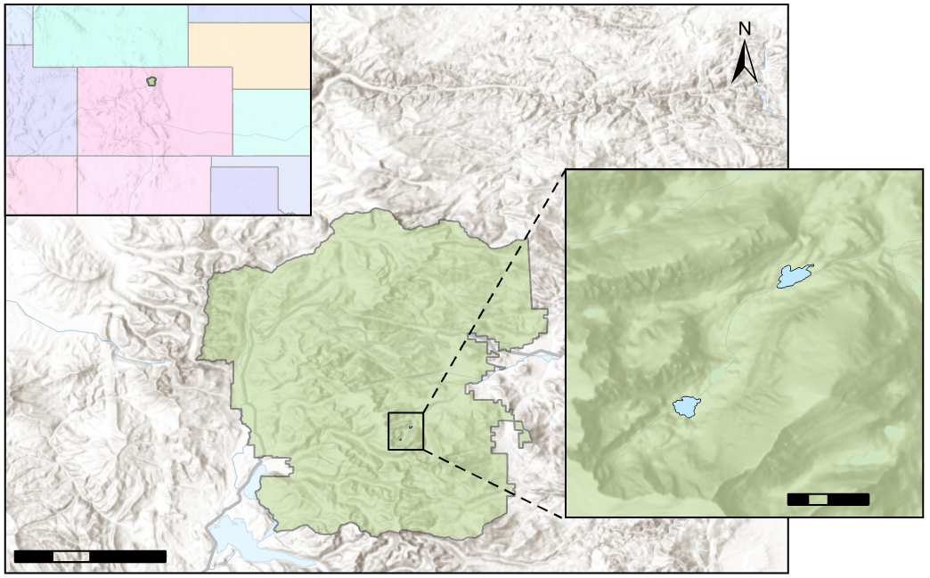

**Sky Pond**

**The Loch**

**COLORADO**

Rocky Mountain National Park

1 km

0

20 km

0

10

5

*Figure 1.* Study area extent, falling within Sentinel-2 Tile 13TDE, focused on The Loch and Sky Pond lakes in Rocky Mountain National Park.

***3.2 Data Acquisition***

Partners at the USGS provided our team with *in situ* pelagic chlorophyll-a concentration data for both The Loch and Sky Pond between May and September from 2015 to 2018. These data included measurements from the surface and bottom of the lake. We downloaded Landsat 8 OLI (Path 34/Row 32) and Sentinel-2 MSI (Tile 13TDE) imagery from USGS Earth Explorer that corresponded with in-field collection dates and had good visibility for The Loch and Sky Pond (Appendix 1). Data from the previous term included a shapefile delineating lake boundaries within RMNP.

***3.3 Data Processing***

To compare the effects of atmospheric correction on Sentinel-2 MSI imagery, we incorporated both products at Level 1C Processing (top of atmosphere) and Level 2A Processing (bottom of atmosphere) over the study area. We processed Sentinel-2 MSI imagery using ACOLITE software (The Royal Belgian Institute of Natural Sciences, 2014) to perform atmospheric corrections. ACOLITE was chosen because it has been used in similar studies and was designed to work for small inland waters (Ansper & Alikas, 2018). Landsat 8 OLI surface reflectance imagery was downloaded from USGS Earth Explorer for the study area and period, so no atmospheric correction was necessary. We then calculated 11 indices for both Level 1C Processing and Level 2A Processing for Sentinel-2 and 7 indices for Landsat 8 (Appendix 2). In Esri ArcMap, the indices were calculated in Raster Calculator. The resulting raster layers were clipped to The Loch and Sky Pond lake boundaries.

The previous term found that averaging the field measurements through the water column had a higher correlation to remotely sensed chlorophyll-a values. We replicated their method to determine which index had higher correlations with the field data in each lake individually and combined. The previous team also found that averaging the pixel values within a 30 m buffer had a higher correlation with *in situ* data than values at individual intersecting pixels. Our team created a 20 m buffer around our field data points corresponding to the higher resolution Sentinel-2 imagery (10 to 20 m). In ArcMap, the raster values were extracted for both the intersecting pixel and the average of pixels within the 20 m buffer in order to validate the previous team’s findings.

***3.4 Data Analysis***

The remotely sensed data were correlated to the *in situ* measurements using R (Version 3.5.1). A Spearman’s (Spearman, 1904) Correlation Coefficient (rho, ρ) was calculated for each index using the ltm package in RStudio (Rizopolous, 2006). Using the same method, we also correlated indices with each other. For any indices with ρ > 0.7 to each other, the index with the lower correlation to the *in situ* data was removed. From the indices with the three highest correlations, we created spatial maps and assessed them qualitatively to confirm their ecological validity based on our knowledge of seasonal and spatial algal production within lake systems. It was expected that more algae would be present along the lake boundaries, where more light can reach the substrate. To further explore the relationship between field observations and spectral reflectance, we also split the data by lake and reduced the number of days between fly-over and field data collection to 3 for Sentinel and 5 for Landsat and recalculated the correlations.

# 4. Results & Discussion

***4.1 Highest Performing Indices***

We found that 6.922 - 5.758 * (ln(Blue) / ln(Red)) from Landsat 8 imagery had the highest correlation with field collected chlorophyll-a measurements (ρ = -0.585) (Table 1)(Appendix 3). The second highest correlation was Red Edge 1/Red from Level 2A Processing Sentinel-2 imagery (ρ = -0.548). The highest performing index for Level 1C Processing Sentinel-2 imagery was e(Green/Red) (ρ = -0.515). The red edge band was included in two of the three highest correlated indices for Sentinel-2, for both Level 1C and Level 2A Processing data. The red edge band was expected to be a good indicator of algae due to the absorption of chlorophyll-a in the red edge region. The ratio of the red and red edge has previously been shown to have strong correlations with chlorophyll-a in water (Matthews et al., 2011). Although Landsat 8 does not have the red edge bands, it demonstrated comparable results to Sentinel-2. The red band was included in the top three highest correlated indices, which is commonly used for remote sensing of green vegetation. The index that repeatedly performed well between both sensors was (Blue-Red)/Green. This finding is consistent with Matthews et al. (2011), which found this to be the most effective algorithm for chlorophyll-a concentrations below 20 mg/m3. The blue band is used due to the absorption of blue in chlorophyll-a. Additionally, subtracting red from blue removes the scattering effects from inorganic suspended solids, which absorb red, and is normalized using reflectance of the green band (Matthews et al., 2011).

|  |  |  |
| --- | --- | --- |
| **Landsat 8** | **Sentinel-2 Level 2A** | **Sentinel-2 Level 1C** |
| **Buffered (20 meters)** | | |
| 6.923 - 5.758 * (ln(Blue)/ln(Red))  **ρ = -0.585** | Red Edge 1/ Red  **ρ = -0.548** | e(Green/Red)  **ρ = -0.515** |
| (NIR - Red)/(NIR +Red)  **ρ = 0.544** | e(Green/Red)  **ρ = -0.366** | (1/Red) - (1/Red Edge 1) * Red Edge 4  **ρ = -0.473** |
| (Blue-Red)/Green  **ρ = 0.142** | (Red Edge 3 - Red)/ (Red Edge 3 + Red)  **ρ = -0.358** | (Red Edge 1 - Red) - 0.389(Red Edge 2 - Red)  **ρ = -0.233** |
| **Intersecting Points** | | |
| (Blue-Red)/Green  **ρ = 0.391** | (Blue-Red)/Green  **ρ =0.437** | e(Green/Red)  **ρ = -0.503** |
| Green/Blue  **ρ = -0.378** | NIR/Red  **ρ = -0.271** | (Red Edge 3 - Red)/(Red Edge 3 + Red)  **ρ = 0.270** |
| 6.92274 - 5.7581 * (ln(Blue)/ln(Red))  **ρ = -0.361** | (1/Red) - (1/Red Edge 1) * Red Edge 4  **ρ = 0.242** | (Blue-Red)/Green  **ρ = -0.215** |

*Table 1*. Three highest correlated indices for Sentinel-2 (Level 1C and 2A Processing) and Landsat 8. Higher ρ values (absolute values) indicate stronger correlations with field data, with ρ = ±1 indicating perfect correlation and ρ = 0 indicating no correlation.

Reducing the elapsed days between field collection and flyover dates from 10 days to a maximum of 5 days for Landsat and 3 days for Sentinel resulted in higher correlations. The number of maximum days was increased to 5 rather than 3 days for Landsat due to the longer revisit time of 16 days, compared to a revisit time of 5 days for Sentinel-2. Following this adjustment in date range, the highest performing index for Sentinel-2 Level 2A Processing (Red Edge 1/ Red) increased from ρ = -0.447 to ρ= -0.548. Algal production can vary rapidly, producing blooms within a few days making the time between field collection and flyover date a critical component of this study (Gardner et al., 2008).

In addition to Spearman’s Correlation Coefficient, a linear regression was also calculated. Even for the highest correlated indices, the R2 values were very low (Appendix 4), and show comparable results to the previous term’s findings. This may indicate that the relationship is not linear, and future research could benefit from exploring other ways to relate field measurements to remotely sensed data.

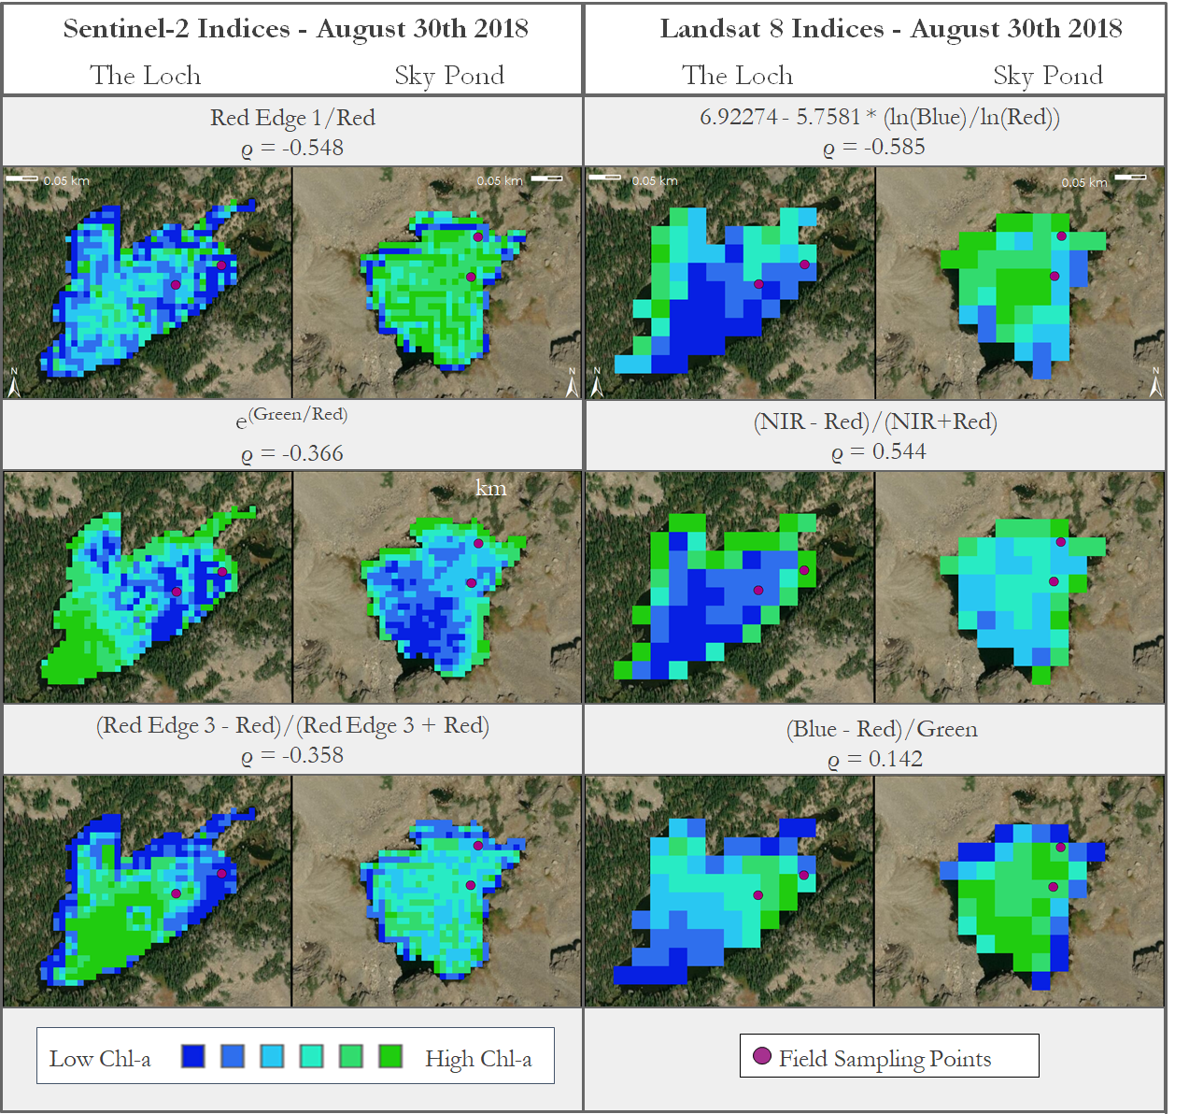

*Figure 2*. Comparison of Sentinel-2 (Level 2A) and Landsat 8 imagery from August 30th, showing the top three indices.

***4.2 Atmospheric Correction***

There is some discrepancy in the literature as to whether atmospheric correction is a beneficial step in detecting chlorophyll-a concentrations through remote sensing. Toming et al. (2016) found that their correlations decreased when using Sentinel-2 imagery processed with the atmospheric correction software, Sen2Cor. However, Ansper & Alikas (2018) found that while atmospheric correction was necessary, applicable software is dependent on the type of lake. Similarly, we found that our top performing index correlations changed when we atmospherically corrected our imagery. The atmospherically corrected imagery had a marginally higher correlation for the top performing index. The correlation for one index, e(Green/Red), decreased with atmospheric correction from ρ = -0.515 to ρ = -0.366. This may be in part due to the fact that we are looking to detect very low levels of chlorophyll-a. Atmospheric correction may diminish the marginal signal of the chlorophyll-a, making it more difficult to detect the already weak signal of the algae. However, our correlations overall improved with atmospheric correction, indicating that this may be an important step for future research.

***4.3 Effects of Buffering***

Consistent with the previous term’s findings, this study found that using the mean pixel value within a 20 m buffer yielded higher correlations with the *in situ* data for Landsat 8 and both 1C and 2A Sentinel-2 imagery. The inclusion of a buffer may improve correlations by removing the effect of outliers, as well as account for the variation in pixel values throughout the lake, compared to only using a single intersecting point. However, the correlations with individual pixels also showed some comparable correlations. For example, the e(Green/Red) index calculated from Sentinel-2 Level 1C data had a correlation of ρ = -0.503 with intersecting pixels and ρ = -0.515 with the buffered values.

***4.4 Highest Correlations for Individual Lakes***

Due to ecological variations between alpine lakes, we also identified the highest correlated indices for each individual lake. The highest correlated index for The Loch was 6.92274 - 5.7581 x (ln(Blue)/ln(Red)) with ρ = -0.633, calculated with Landsat 8 and buffered data. Interestingly, (Red-1 - Red Edge 1 -1) / (Red Edge 2-1 - Red Edge 1-1) from Sentinel-2 had the highest correlation to Sky Pond (ρ = 0.618). However, when this index was compared to The Loch, it showed a moderate negative correlation (ρ = -0.481). We found a similar trend with the (Red Edge 1 - Red) / (Red Edge 1 + Red) index, which had a greater negative correlation to The Loch (ρ= -0.570) and a low correlation with Sky Pond (ρ = 0.200). A similar trend was found by Mishra & Mishra (2012) in which another index utilizing the red edge band, (Red Edge 1 - Red) / (Red Edge 1 + Red), showed a negative correlation, with very low levels of chlorophyll-a, and positive relationships at higher concentrations of chlorophyll-a. Sky Pond has higher rates of algal productivity than The Loch according to field measurements, which aligns with our findings (Appendix 5). This explains why this index has a weaker correlation across both indices, but higher correlation coefficients when analyzed separately (Figure 3). It was noted by Matsushita et al. (2015) that indices involving different combinations of bands perform very differently across trophic states, and an index applicable to very low chlorophyll-a concentrations will not be as effective in monitoring lakes with higher algal productivity. It is therefore important to compare the ecology of each focal lake before calculating correlations across both lakes together.

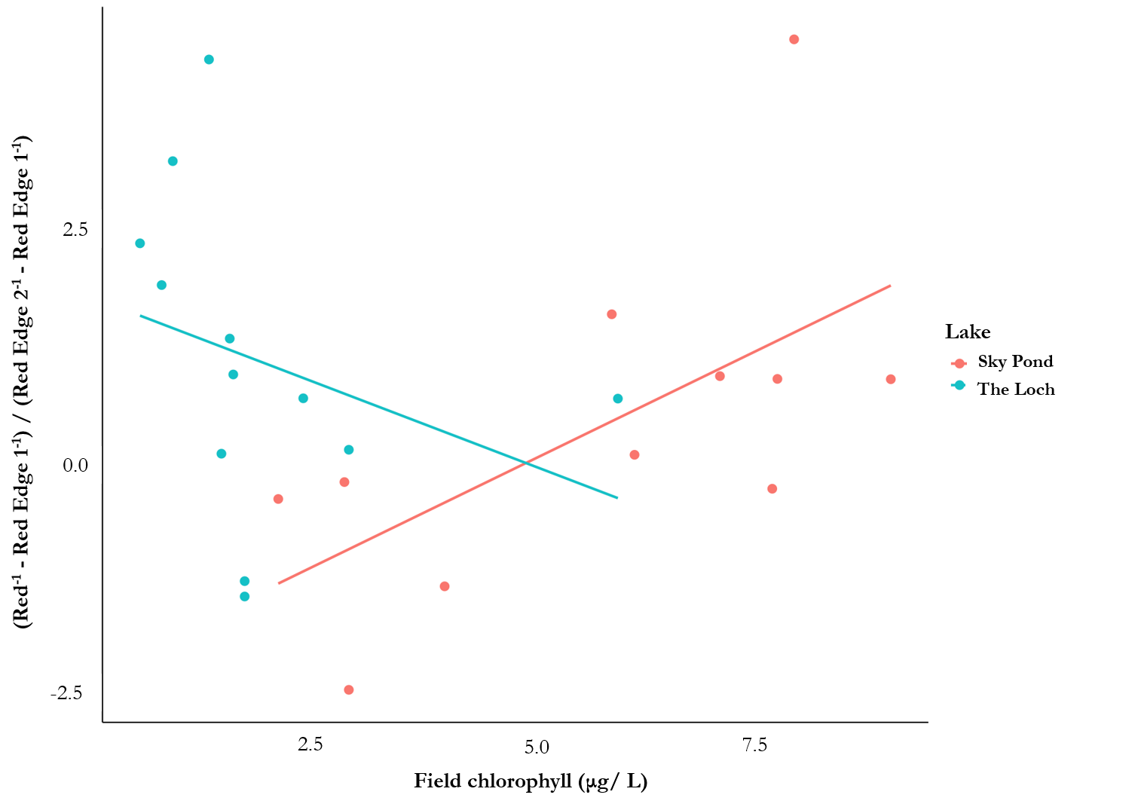

*Figure 3*. Sentinel-2 derived index, (Red-1 - Red Edge 1 -1)/(Red Edge 2-1 - Red Edge 1-1), and its correlations with The Loch and Sky Pond separately. Sky Pond shows a positive correlation, while The Loch is negative.

***4.5 Limitations & Future Work***

What we found to work best for the RMNP lakes may not necessarily work for other lakes if this method is applied on a global scale. The nutrient levels for these alpine and subalpine ecosystems may be historically high, but algal productivity in these systems is considered relatively low in comparison to other eutrophic lakes. Additionally, these alpine lakes are very small (0.04 - 0.06 km²), and related studies have focused on much larger focal lakes with higher algal productivity that may be easier to detect with satellite imagery (Appendix 6). Additional complications of this analysis include the spectral effects at the lake edge, where pixels along the lake boundary may experience interference from vegetation along the shoreline. This is particularly noticeable at The Loch where there is more vegetation surrounding the lake (Figure 3). Sky Pond has rockier terrain along the shoreline, but may still experience edge effects given the lower indicated values in these areas. The previous team removed pixels along the edge of the focal lakes to counter this effect. However, higher benthic algal production is known to occur in these locations, particularly along the rocks close to the shoreline. Removing these pixels neglects these highly productive regions from analysis. Spectral unmixing may provide a solution for this issue in future studies.

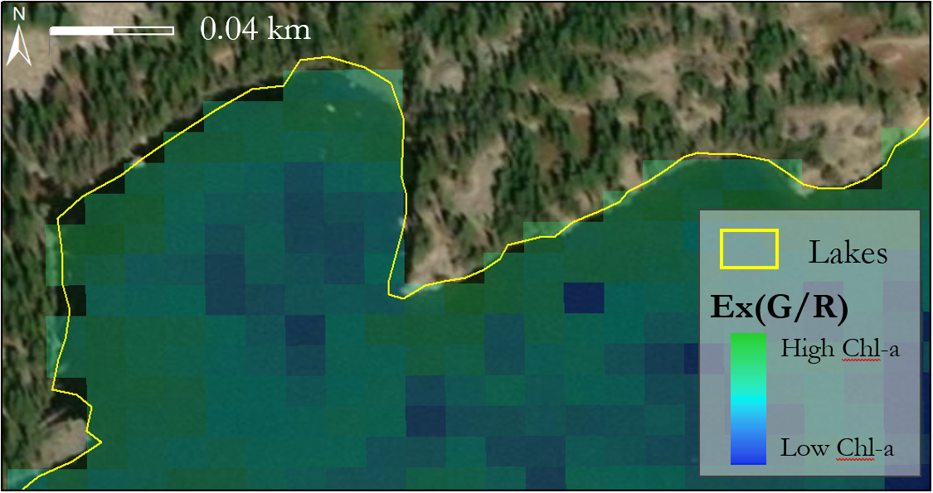

*Figure 4*. Map of The Loch showing e(Green/Red) index overlayed with the lake boundary shapefile used for clipping the rasters. Some pixels along the lake edge contain spectral information from land, which may impact chlorophyll-a (Chl-a) values. This map also shows that there is some inaccuracy in the lakes shapefile.

Our results emphasize the importance of matching flyover dates closely with field collection dates to produce the most accurate representation of chlorophyll-a concentration at the time of collection. However, it is important to note that this eliminates a large portion of available data. After limiting the elapsed time between flyovers and field collection to a 5 day maximum, our data was restricted to only 25 data points. We correlated our field data to The Loch and Sky Pond individually as well as both lakes together, which further limited our *in situ* data availability (The Loch n = 14, Sky Pond n = 11). Additionally, we separated the data by month to see how the algal production varies over a season and were severely limited by the amount of data points for each lake per month (1-5 data points per month).

Although field monitoring of these lakes extends back to the 1980s and chlorophyll-a concentration data was provided extending back into 2015, Sentinel-2 was not launched until 2016, rendering nearly half of the field data unusable. Additional field data and satellite imagery is needed to provide more comprehensive results. Future work continuing this study for another year would provide additional *in situ* measurements to potentially create more robust correlations between Sentinel-2 indices and field data. Our partners are now aligning their field collection dates with the day of Sentinel- 2 flyover to collect more consistent data that will be primed for remote sensing analysis. This study was similarly limited by the amount of field collection dates that correspond with cloud-free flyover dates from both Landsat 8 and Sentinel-2. It is also important to note that Sentinel-2 passes over The Loch and Sky Pond at 5:49 pm. During the summer months, the Rocky Mountains often experience afternoon thundershowers, causing significant cloud cover over this study area. For example, in July of 2018 there are only two cloud-free images. This makes understanding the relationship between field collected values and index values difficult during an important period of algal production. Future studies should investigate possible strategies to incorporate different methods of remote sensing such as active or aerial remote sensing during this period to remove the limitation of cloud cover.

This project focused on detecting pelagic algae because of the available field data. However, our partners are currently compiling field collected benthic algae data. Benthic algae may provide a stronger correlation with index values because of the depth and clarity of the lakes. Pelagic algae, while an important parameter of water quality, may not provide enough of a stable reflectance, which can be remedied by the incorporation of benthic data.

We created an automated ArcGIS tool to assist researchers with replicating this methodology in future work. This tool incorporates the ability to add satellite and field data as they become available and calculate Spearman’s Correlation Coefficient with additional data points. The tool was designed for Sentinel-2 data because our partners are currently collecting field data on days that align with Sentinel-2 flyovers. This tool has the capability of automatically calculating the indices and producing maps, which can be used for time series analysis to increase understanding of how algal productivity has changed over time. Researchers can also use this tool to test additional indices that were not included in this study.

# 5. Conclusions

Landsat 8 and Sentinel-2 Level 2A Processing indices showed comparable results in detection capability of chlorophyll-a. The highest performing indices were Red Edge 1/ Red for Sentinel-2 Level 2A Processing, and 6.923 - 5.758 x (ln(Blue)/ln(Red)) for Landsat 8. Some indices improved performance after atmospheric correction, while some displayed lower correlations following this processing step. Overall, a greater number of selected Sentinel-2 indices displayed higher correlations to field data with atmospheric correction. Our findings may support the idea that atmospheric correction may be dependent on the type of lake among other ecological factors. Additionally, the inclusion of the 20 m buffer improved correlations for indices derived from Landsat 8 as well as Sentinel-2 Level 1C Processing and Level 2A Processing. Correlations were also improved by looking at lakes individually and within 5 days of field collection for Landsat 8, and 3 days for Sentinel-2. This highlights the importance of understanding the ecological context when applying remote sensing strategies to algal productivity studies. The rapid shifts in algal production necessitates a limited number of elapsed days between field collection and flyover date to produce higher correlations. Although correlations improved with these adjustments, the low chlorophyll-a concentrations and small surface area of the lakes in our study area remained a limitation. These findings support the development of an index which can be applied to other alpine lakes, and can assist our partners in understanding patterns of eutrophication across Rocky Mountain National Park.

# 6. Acknowledgments

The Rocky Mountain Water Resources II Team would like to thank our partners at the USGS and NPS for engaging with NASA DEVELOP to make this research possible. We would also like to give a special thanks to Kristen Dennis (Colorado – Fort Collins and Idaho – Pocatello DEVELOP Nodes Center Lead), Peder Engelstad (Science Advisor), and Dr. Jill Baron (USGS) for working closely with our team throughout this research project.

This material contains modified Copernicus Sentinel data (2017-2018), processed by ESA.

Any opinions, findings, and conclusions or recommendations expressed in this material are those of the authors and do not necessarily reflect the views of the National Aeronautics and Space Administration.

This material is based upon work supported by NASA through contract NNL16AA05C.

# 7. Glossary

**Alpine** – Relating to a high elevation mountain ecosystem

**Chlorophyll-a** – Pigment used as a proxy for algal biomass

**Earth observations** – Satellites and sensors that collect information about the Earth’s physical, chemical, and biological systems over space and time

**Eutrophic** – Trophic status, in this case referring to lakes rich in nutrients from natural or anthropogenic sources that can support excessive algal production

**Landsat 8** - Satellite, operated by NASA and the USGS

**OLI** – Operational Land Imager on-board Landsat 8 for measuring Earth’s reflected radiance

**Level 1C Processing** – Per-pixel radiometric measurements are provided in Top Of Atmosphere (TOA) reflectances

**Level 2A Processing** – Measurements are provided in Bottom of Atmosphere (BOA) reflectances

**Meso-eutrophic** – Trophic status, in this case referring to lakes with intermediate nutrient concentrations that can support submerged vegetation

**NPS** – National Park Service

**Oligotrophic** – Trophic status, in this case, referring to lakes with low nutrient concentrations that supports little vegetation

**Sentinel-2** - Satellite operated by the European Space Agency

**MSI** – MultiSpectral Instrument on-board Sentinel-2 for measuring Earth’s reflected radiance

**Subalpine** – Relating to an ecosystem situated on the higher slopes of mountains, just below the timberline

**USGS** – United States Geological Survey

# 8. References

Ansper, A., & Alikas, K. (2018). Retrieval of Chlorophyll *a* from Sentinel-2 MSI data for the European Union Water Framework Directive Reporting Purposes. *Remote Sensing, 11*(1), 64. <https://doi.org/10.3390/rs11010064>

Baron, J. S. (2006). Hindcasting Nitrogen Deposition To Determine An Ecological Critical Load. *Ecological Applications, 16*(2), 433-439. [https://doi.org/10.1890/1051-0761(2006)016[0433:HNDTDA]2.0.CO;2](https://doi.org/10.1890/1051-0761(2006)016%5B0433:HNDTDA%5D2.0.CO;2)

Barrett, D. C., & Frazier, A. E. (2016). Automated Method for Monitoring Water Quality Using Landsat Imagery. *Water*, *8*(6), 257. https://doi.org/10.3390/w8060257

Beck, R., Zhan, S., Liu, H., Tong, S., Yang, B., Xu, M., … Su, H. (2016). Comparison of satellite reflectance algorithms for estimating chlorophyll-*a* in a temperate reservoir using coincident hyperspectral aircraft imagery and dense coincident surface observations. *Remote Sensing of Environment*, *178* (15-30). <https://doi.org/10.1016/j.rse.2016.03.002>

Boucher, J., Weathers, K. C., Norouzi, H. & Steele, B. (2018). Assessing the effectiveness of Landsat 8 chlorophyll *a* retrieval algorithms for regional freshwater monitoring. *Ecological Applications*, *28*, 1044-1054. doi:[10.1002/eap.1708](https://doi.org/10.1002/eap.1708)

Bresciani, M., Cazzaniga, I., Austoni, M., Sforzi, T., Buzzi, F., Morabito, G., & Giardino, C. (2018). Mapping phytoplankton blooms in deep subalpine lakes from Sentinel-2A and Landsat-8. *Hydrobiologia*, *824*(1), 197–214. <https://doi.org/10.1007/s10750-017-3462-2>

Colorado Department of Public Health and Environment. (2008). *Colorado 2008 Air Quality Data Report.* Retrieved June 24, 2019 from <https://www.colorado.gov/airquality/tech_doc_repository.aspx?action=open&file=2008AnnualDataReport.pdf>

Copernicus Sentinel Data [2016-2018]. Retrieved from United States Geological Survey Earth Explorer [14 June 2019], processed by ESA

Delegido, J., Verrelst, J., Alonso, L., & Moreno, J. (2011). Evaluation of Sentinel-2 Red-Edge Bands for Empirical Estimation of Green LAI and Chlorophyll Content. *Sensors, 11*(7), 7063-7081. https://doi:10.3390/s110707063

Gardner, E., McKnight, D., Lewis, W., & Miller, M. (2008). Effects of Nutrient Enrichment on Phytoplankton in an Alpine Lake, Colorado, U.S.A. *Arctic, Antarctic, and Alpine Research, 40*(1),55–64. https://doi:10.1657/1523-0430(07-002)[GARDNER]2.0.CO;2

Ha, N. T., Thao, N. P., Koike, K., & Nhuan, M. T. (2017). Selecting the Best Band Ratio to Estimate Chlorophyll-a Concentration in a Tropical Freshwater Lake Using Sentinel-2A Images from a Case Study of Lake Ba Be (Northern Vietnam). *ISPRS International Journal of Geo-Information, 6*(9), 290. <https://doi.org/10.3390/ijgi6090290>

Mast, M. A., Clow, D. W., Baron, J. S., & Wetherbee, G. A. (2014). Links between N deposition and Nitrate Export from a High-Elevation Watershed in the Colorado Front Range. *Environmental Science and Technology,* *48*(24) 14258-14265. <https://doi.org/10.1021/es502461k>

National Park Service. (2019). *Park Statistics.* Retrieved June 12, 2019, from <https://www.nps.gov/romo/learn/management/statistics.htm>

National Park Service, Environmental Protection Agency, Colorado Department of Public Health & Environment. (2010). *Rocky Mountain National Park Initiative Nitrogen Deposition*

*Reduction Contingency Plan.* Retrieved from

<https://environmentalrecords.colorado.gov/HPRMWebDrawer/RecordView/1281849>

National Park Service. (2018). *Visitor Spending Effects – Economic Contributions of National Park Visitor Spending.* Retrieved June 12, 2019, from <https://www.nps.gov/subjects/socialscience/vse.htm>

Trophic State Index. (n.d.). Retrieved July 29, 2019 from https://www.rmbel.info/primer/lake-trophic-states/

Toming, K., Kutser, T., Laas, A., Sepp, M., Paavel, B., & Nõges, T. (2016). First Experiences in Mapping Lake Water Quality Parameters with Sentinel-2 MSI Imagery. *Remote Sensing, 8*(8), 640. https://doi:10.3390/rs8080640

U.S. Geological Survey Earth Resources Observation and Science Center. (2014). Landsat 8 OLI Level-2 Surface Reflectance (SR) Science Product [Data set]. U.S. Geological Survey. https://doi.org/10.5066/f78s4mzj

# 9. Appendices

Appendix 1: Table of images downloaded for analysis

|  |  |  |
| --- | --- | --- |
| **Year** | **Sentinel-2** | **Landsat 8** |
| 2015 |  | 07/05/2015, 07/21/2015, 08/06/2015, 08/22/2015, 06/05/2016 |
| 2016 |  | 06/21/2016, 07/07/2016, 07/23/16, 08/08/2016, 9/24/2016 |
| 2017 | 06/01/2017, 06/212017, 07/012017, 07/16/2017, 07/312017, 08/20/2017, 09/09/2017, 09/29/2017 | 05/07/2017, 06/08/2017, 06/24/2017, 06/24/2017, 06/24/2017, 07/26/2017, 08/27/2017, 09/12/2017, 09/28/2017 |
| 2018 | 06/01/2018, 06/06/2018, 06/11/2018, 06/21/2018, 06/26/2018, 07/01/2018, 07/21/2018, 08/05/2018, 08/10/2018, 08/15/2018, 08/20/2018, 08/25/2018, 08/30/2018, 09/14/2018, 09/29/2018 | 05/26/2018, 05/26/2018, 06/11/2018, 06/27/2018, 07/13/2018, 07/29/2018, 07/29/2018,0 8/30/2018, 8/30/2018, 09/15/2018, 10/01/2018 |

Appendix 2: Chlorophyll-a Indices

|  |  |
| --- | --- |
| **Sentinel-2 (10 to 20 m) Index** | **Landsat 8 (30 m) Index** |
| 1 | 6 |
| 1  *Red Edge 1 - Red - .389(Red Edge 2 - Red)* | 7 |
| 1 | 8 |
| 1 | 9 |
| 2 | *10*  *1.67 - 3.94 * ln(Green) + 3.78l * ln(Red)* |
| 2 | 10 |
| 2 | 5 |
| 3  *e* |  |
| 4 |  |
| 5 |  |
| 5 |  |

1. Ansper & Alikas, (2018) 2. Beck et al., (2016), Mishra et al., (2014) 3. Ha et al., (2017) 4. Delegido et al., (2011) 5. Matthews et al. (2011) 6. Alawadi (2010), referenced in Boucher et al., (2018) 7. Brivio et al., (2001) in Boucher et al., (2018) 8. Dall'Olmo & Gitelson (2016) in Boucher et al., (2018) 9. Mishra & Mishra (2012) in Boucher et al., (2018) 10. Kabbara et al., (2008) in Boucher et al., (2018)

Appendix 3: Scatter plot of top performing indices and field data

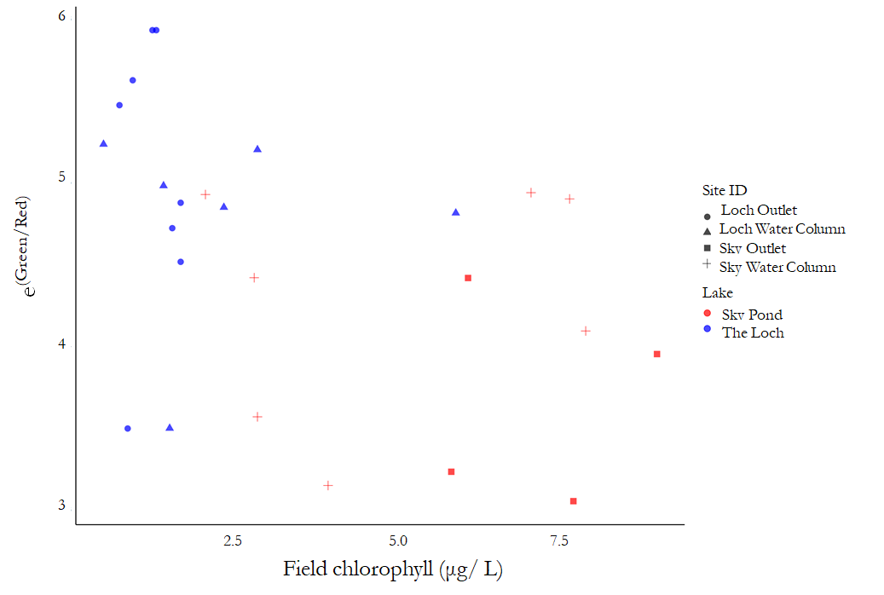

Sentinel-2 1C level processing data, 20 m buffered field points

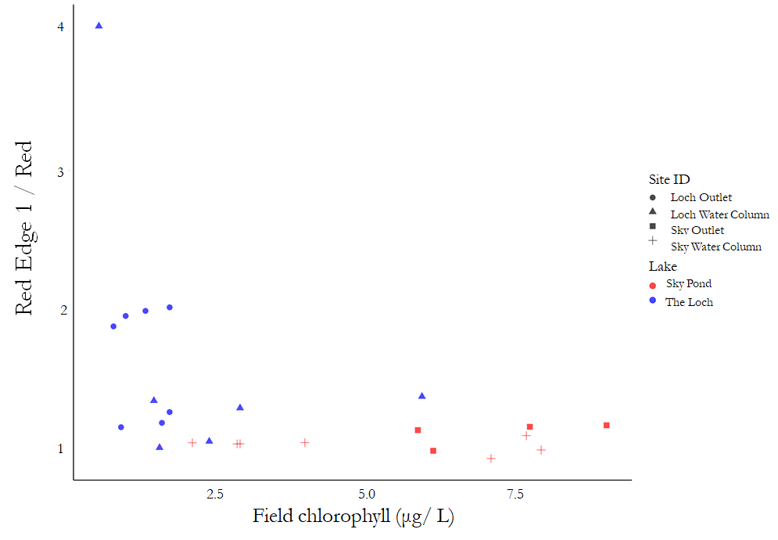

Sentinel-2 2A level processing data, 20 m buffered field points.

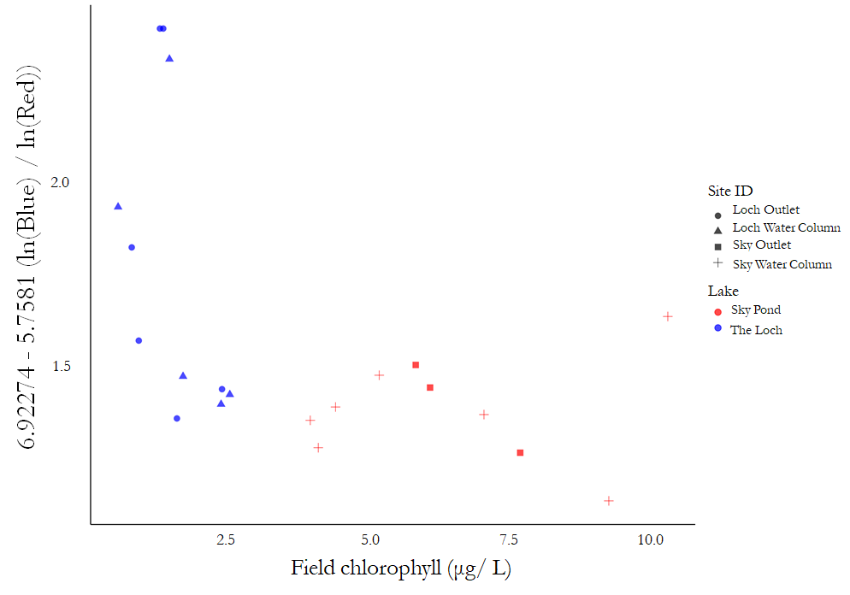

Landsat 8 data, 20 m buffered field points.

Appendix 4. Linear correlations for top performing indices

|  |  |  |
| --- | --- | --- |
| **Landsat 8** | **Sentinel-2 Level 2A** | **Sentinel-2 Level 1C** |
| **Buffered (20 meters)** | | |
| 6.923 - 5.758 * (ln(Blue)/ln(Red))  **R2 = 0.2607** | Red Edge 1/ Red  **R2 = 0.1938** | e(Green/Red)  **R2 = 0.173** |
| **Intersecting Points** | | |
| (Blue-Red)/Green  **R2 = 0.09714** | (Blue-Red)/Green  **R2 = 0.04** | e(Green/Red)  **R2 = 0.1887** |

Appendix 5. Ecological Trends of Chlorophyll-a Over Time.

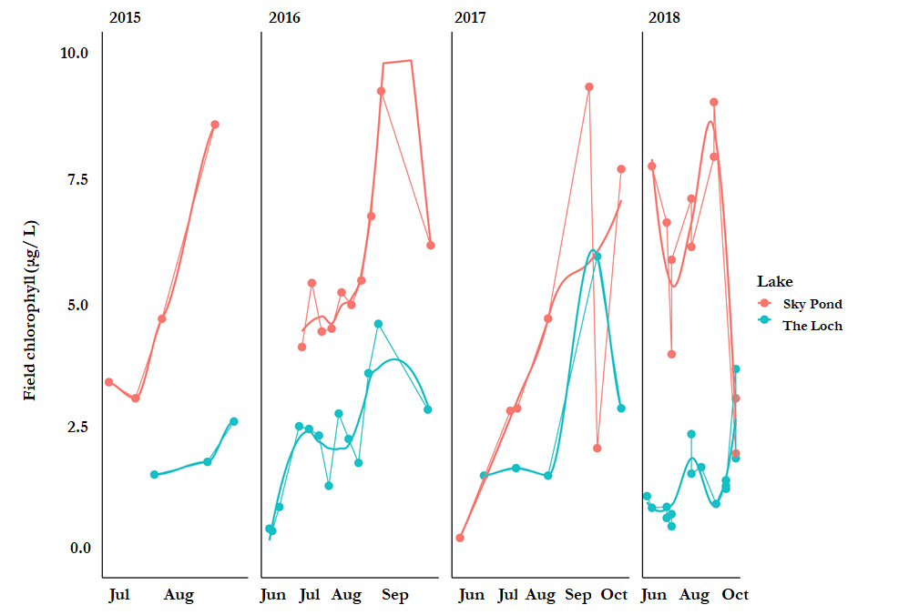

Appendix 6. *In situ* Chlorophyll-a Ranges in Previous Studies

|  |  |
| --- | --- |
| Reference | Chl-a Range |
| Toming et al., 2016 | 3.70 μg/L - 72.9 μg/L |
| Mishra & Mishra, 2012 | <7.5 μg/L - 105 μg/L |
| Boucher et al., 2018 | 0 μg/L - 65 μg/L |
| Malahlela et al., 2018 | 2.5 μg/L - 1219 μg/L |
| Ansper et al., 2018 | 5 μg/L - 30 μg/L |