**NASA DEVELOP National Program**



NASA Ames Research Center

*Spring 2016*

Puerto Rico Health & Air Quality II

A Geospatial Assessment of Environmental Variability in Puerto Rico and its Relation to Confirmed Dengue Fever Cases

 **Technical Report**

Final Draft – April 6, 2016

Andrew Nguyen (Project Lead)

Martha Sayre

Dr. Juan Torres-Pérez, Bay Area Environmental Research Institute (Science Advisor)

Previous Contributors:

Alannah Johansen

# 

# **I. Abstract**

Vector-borne diseases such as dengue fever, chikungunya, and Zika pose a major threat to the health of Caribbean communities. *Aedes aegypti (A. aegypti),* the primary vector of these viruses, is dependent on humans for reproduction, and has been detected in populated areas within Puerto Rico. The vector’s lifecycle and its transmission of dengue in Puerto Rico have been connected to specific environmental conditions. This study examined environmental conditions related to Confirmed Dengue Fever Cases (CDFC) for Puerto Rico from January 2009 - December 2013 to model the distribution of dengue-infected *A. aegypti* and its relationship to these conditions. This project used monthly NASA Terra/ Aqua Moderate Resolution Imaging Spectroradiometer (MODIS) Normalized Difference Water Index (NDWI), along with day and night land surface temperature (DLST / NLST) products, Geostationary Operational Environmental Satellite system Puerto Rico Water Energy Balance (GOES-PRWEB) relative humidity (RH), Climate Hazards Group InfraRed Precipitation with Stations (CHIRPS) total precipitation (TP) modeled data, and Population Density data from WorldPop. A Maximum Entropy Species Distribution Model and Earth Trends Modeler within Clark Labs’ TerrSet were used to spatially delineate monthly *A. aegypti* habitat suitability, determine the permutation importance of the environmental conditions, and quantify island-wide environmental trends. Population density and elevation had the highest mean relative importance above all other variables, which supports our background knowledge. TP had the highest mean relative importance of the dynamic environmental variables, while CDFC seasonality and environmental conditions moderately coincide with one another in the more recent years of the project time period. This agrees with several studies that climatic environmental conditions play a significant role in disease transmission.

**Keywords**

Remote Sensing, Dengue, MaxEnt, MODIS, *Aedes aegypti*

**II. Introduction**

**2.1 Background**

Dengue fever (DF), chikungunya, and Zika viruses are debilitating and potentially fatal mosquito-borne illnesses that are endemic in tropical and sub-tropical regions [CDC, 2014a]. The Centers for Disease Control and Prevention (CDC) estimated that over 400 million people are infected globally each year by any one of four different serotypes, or variations, of the dengue virus (DENV) [CDC, 2014b]. Prior to 2013, chikungunya and Zika viruses had been reported in most equatorial countries, but these viruses are now reported in Caribbean countries, including Puerto Rico [Barrera et al., 2011].

Globally, DENV is spread by multiple species of mosquito within the genus, *Aedes*. The main vectors worldwide are *Aedes aegypti (A. aegypti) and Aedes albopictus,* with the primary vector in Puerto Rico being *A. aegypti* [Cox et al., 2007]. *A. aegypti* is a domestic mosquito that lives and breeds near or within human-occupied structures [CDC, 2014a]. Thus, the majority of these mosquitoes exist in developed urban regions with large populations, such as San Juan and Bayamon [Barrera et al., 2011]. This species lays its eggs in a variety of water containers such as rain barrels, abandoned tires, plastic jugs, or pot holes on roads that are in close proximity to humans [CDC, 2014a; Barrera et al., 2011].

To better understand the spread of DENV, an awareness of the habitat suitability of thevector is needed. This study used Confirmed Dengue Fever Cases (CDFC) in Puerto Rico as a proxy for *A. aegypti* locations, due to the lack of island-wide *in situ* *A. aegypti* presence data. There are multiple contributing environmental conditions that have been implicated in the spread and density of this vector, including increases in precipitation, ambient temperature, relative humidity (RH), and vegetation water content [Johansson et al., 2009; Mendez-Lazaro et al., 2014; Patz et al., 1998; Barrera et al., 2011, Estallo et al., 2011]. Increases in precipitation and temperature can result in the proliferation of *A. aegypti* by providing suitable breeding habitat and by hastening their development and reproductive cycles [Johansson et al., 2009]. Increases in temperature can also shorten the incubation period required for *A. aegypti* to become infectious after a virus-infected blood meal, which leads to an increase in the proportion of vectors after a warming period [Johansson et al., 2009; Patz et al., 1998]. Also, increases in RH have been shown to result in increased oviposition and hatching rates in *A. aegypti*, leading to increases in mosquito population density [Arruda Pedrosa de Almeida Costa et al., 2010]. Vegetation water content has been shown to act as a proxy for soil moisture content, precipitation [Breshears et al. 1997, Jackson et al., 2004], and water amount status in specific areas from field ecologists [Estallo et al., 2011]. These factors create conditions for mosquito proliferation.

In order to study the relationship between favorable environmental conditions and increases in CDFC (See section 3.1.1), this study utilized remotely-sensed products to determine habitat suitability for *A. aegypti* and quantify the contribution of environmental factors to DF epidemic and non-epidemic periods on the island of Puerto Rico from 2009 to 2013. To do this, the number of CDFC were analyzed from a continuous environmental geospatial modeling perspective.

**2.2 Project Objectives**

The primary objective of the first phase of this project was to produce island-wide risk assessment maps of potential CDFC. The secondary objective was to perform a Time Series Frequency Analysis to explore the relationship between Sea Surface Temperature (SST) and CDFC, as well as the relationships between each of the chosen environmental variables. Project results provided a geospatial overview of both DF risk and the factors contributing to DF incidence in Puerto Rico from 2009-2013.

The objectives of the second phase were to include additional variables in a Maximum Entropy Species Distribution Model (MaxEnt) and examine trends in environmental conditions to assess inter-annual and seasonal changes in order to identify the changes in the environmental conditions that relate to CDFC seasonality.

**2.3 Study Area**

Analyses were performed within the political boundaries of the Commonwealth of Puerto Rico. The island is an unincorporated United States territory located in the Caribbean Sea with general coordinates of 18°15'N latitude and 66°30'W longitude (Figure 1, App. A). Puerto Rico is a small, densely-populated island with a total area of 9,104 km2 and a population of over 3.5 million. The climate is tropical, with annual average temperatures between 21°C and 27°C, and a rainy season from April to November. Climate varies along the length of the island, with the drier regions predominantly occurring in the south.

**2.4 Study Period**

The project examined the months from January 2009 through December 2013 (Figure 2). This date range coincides with the most recent dengue outbreak years (2010, 2012, and 2013) according to CDFC *in situ* data (See 3.1 Data).

**2.5 National Application Area Addressed**

This project addressed the Health and Air Quality Application Area within NASA’s Applied Sciences Program. By using Earth Observing Systems (EOS) data, as well as modeled data products, this project focused on human welfare through the use of a Maximum Entropy Species Distribution Model. MaxEnt was used to produce monthly dengue-infected *A. aegypti* habitat suitability maps and to determine the contribution of environmental variables to the species’ habitat suitability in epidemic and non-epidemic periods in Puerto Rico. Inter-annual and seasonal trends analyses will look more closely at the changes over time in the environmental conditions that contribute to the seasonality of DF epidemics. Model outputs will be used by public health administrations to help mitigate DF outbreaks in the future.

**2.6 Project Partners**

Currently, the project end users, who include the Center for Disease Control (CDC)-Dengue Branch, University of Puerto Rico-Medical Sciences Department, and the Puerto Rico Department of Public Health, use quantitative research on vector-borne diseases and outbreaks to inform public policy on vector control measures that can be implemented to prevent the spread of diseases such as DF.

The Puerto Rico Department of Health provides citizen services and public health announcements, and conducts health assessments pertaining to dengue awareness on the island. The agency reports on recent statistics and information regarding mosquito vector habitats, and publishes scientific literature related to various illnesses in Puerto Rico. The Dengue Branch of the CDC, located in San Juan, Puerto Rico, is dedicated to dengue research and health outreach. The agency advocates public health practices, and disseminates educational information on how to reduce the risk of household spread of dengue. They also conduct diagnostic testing, molecular research, and field investigations regarding dengue contraction and control. The results of this study will be able to inform both agencies on the contribution of environmental factors to DF outbreaks, allowing them to improve dengue prevention protocols.

**III. Methodology**

**3.1** **Data**

All data collected were obtained or downloaded in monthly time steps from January 2009 to December 2013. The data are divided into two categories: point *in situ* data and raster environmental data.

**3.1.1 *In Situ* Data**

***2000-2015 Confirmed Dengue Fever Cases (CDFC)***

A dataset of daily CDFC from January 2000 to August 2015 was obtained from the CDC, with a total of 44,338 CDFC. The CDC Dengue Branch tracks and monitors reported dengue cases and confirms these cases through laboratory testing. A vast majority of the data contain addresses, country name, zip code, and latitude/longitude coordinates. Cases without latitude/longitude coordinates or data that did not occur within the study period were excluded. This study used a total of 29,575 CDFC points within Puerto Rico. Increases, peaks, and decreases of CDFC during this time period generally follow a seasonal time frame from May to November/December timeframe (Figure 3 and 4, App. A).

**Hydrologic Units**

Four Hydrologic Unit Code 8 (HUC-8) shapefiles for Puerto Rico (Figure 5, App. B) were downloaded from the Watershed Boundary Dataset within the USGS Geospatial Data Gateway. These hydrologic units break up the island into western, southern, northeastern, and northern watersheds and were used within our methodology to derive seasonal trends for each environmental variable. This delineation enables a better understanding of the differences in environmental trends between the watersheds, acting as a proxy for ecological regions, due to highly variable island weather patterns and terrain [Pablo Méndez Lázaro, personal communication, February 10th 2016].

**3.1.2 Raster Environmental Data**

***2009-2013 Terra/ Aqua Moderate Resolution Imaging Spectroradiometer (MODIS)***

Two sets of MODISdata were downloaded to produce (1) Land Surface Temperature (LST) and (2) Normalized Difference Water Index (NDWI).

1. MOD11C3v5, a MODIS level 3 data product, provided monthly Daytime LST (DLST) and Night LST (NLST) (Kelvin) at .05º resolution. LST data were downloaded for the h11v07 tile, which covers the Puerto Rico region, using Reverb, through the Land Process Distributed Active Archive Center (LP DAAC) website [LP DAAC, 2000].
2. MOD09A1 level 3, 500m data products are 8-day averages of Surface Reflectance. One image was downloaded with the least cloud cover for every month during the study period. The NDWI equation (B2-B5/ B2+B5) was then applied to derive vegetation water content values for each image.

***Climate Hazard Group InfraRed Precipitation with Stations (CHIRPS)***

Total precipitation (TP)data (mm/month) at .05º resolution, from the Climate Hazard Group InfraRed Precipitation with Stations (CHIRPS) archive were downloaded from the University of California, Santa Barbara’s Climate Hazards Group website for each month of interest [CHG, 2015]. CHIRPS is a precipitation product from a combination of satellite and *in situ* station data; it monitors drought and other environmental issues. The inputs to CHIRPS include modeled and Earth-observed precipitation data from the Climate Hazard Group’s Precipitation Climatology model, infrared satellite data from NOAA, Tropical Rainfall Measuring Mission (TRMM) data from NASA, NOAA Climate Forecast System data, and *in situ* precipitation measurements [Funk et al., 2014].

***Geostationary Operational Environmental Satellite system Puerto Rico Water Energy Balance (GOES-PRWEB)***

Relative humidity (RH) data were obtained from Geostationary Operational Environmental Satellite system Puerto Rico Water Energy Balance (GOES-PRWEB), which provides several island-scale estimated and modeled environmental datasets for Puerto Rico [GOES-PRWEB, 2009]. Incident radiation data derived from GOES were used to estimate net radiation, which was then used to further derive Photosynthetically Active Radiation (PAR). Additionally, solar radiation data from GOES were used to predict daily reference evapotranspiration along with an array of other important environmental conditions, including soil moisture. Precipitation data were sourced from NOAA’s Advanced Hydrologic Prediction Service (AHPS) to produce runoff and several other hydrological variables. All these data variables were used to produce modeled RH in Puerto Rico.

***World Pop Population Density Data***

Population density data were calculated in people per pixel, which was obtained through World Pop via Nirav Nikunj Patel. The approach detailed in Stevens et al. (2015) was utilized to produce the population distribution grids at 100 meter by 100 meter grid resolution. The approach allows for incorporating global, large scale data sets of both continuous and discrete covariates, which is useful when fine scale data do not exist. A dasymetric redistribution approach was utilized by using population counts from census data and a weighting scheme which is based on a nonparametric predictive model ("Random Forest"). This modeling framework is flexible enough to allow easy incorporation of remotely sensed and geospatial data from differing scales into the weighted result of the dasymetric model. The most accurate ancillary data benefits this approach the most on the non-parametric statistical predictions, and also allows for those predictions to be anchored across space to the most accurate administrative-boundary linked geospatial data that is available.

Additionally, to make the population distribution grids more current, a custom urban extraction methodology that was detailed in Trianni et al. (2015) leverages supervised classification of multispectral data in the Google Earth Engine environment. The cloud computing environment allows for consistent scaling over large geographic areas, which is computationally intensive. By utilizing the extensive record of NASA/USGS Landsat data available on this platform, custom urban extents for Puerto Rico were extracted for 2009, 2010, 2011, 2012 and 2013, and integrated with the existing land cover that was available to make the resulting population distribution grids more relevant, as demonstrated in Patel et al. (2015). Population density data was included in the model because *A. aegypti* is an urban mosquito. Studies have shown that human density relates positively to *A. aegypti* presence and density around households, especially female *A. aegypti,* which increases the possibility of DENV transmission (Rodrigues et al., 2015).

***USGS Elevation***

The USGS 3D Elevation Program (3DEP) Digital Elevation Model (DEM), with a resolution of ⅓ arc second, was used for elevation data. These LiDAR-based images were sourced from the USGS National Map Database [USGS, 2015]. Elevation can contribute to the suitable habitat for *A. aegypti* in a location due to the species’ climatic preferences [Lozano-Fuentes et al., 2012]. Geospatial results and model outputs that incorporate elevation data will help link the role of elevation to occurrences of CDFC.

**3.2 Data Processing**

All 2009-2013 CDFC, population density, DLST, NLST, NDWI, RH and TP data were processed in order to conform to the data prerequisites of the MaxEnt Species Distribution Model within TerrSet; all of the monthly datasets were re-projected to the World Geodetic System (WGS) 1984 coordinate system.

***Environmental Variables***

Processing of DLST, NLST, NDWI, RH, and TP were conducted using a combination of ArcGIS 10.3 Model Builder, ArcPy, and R-commander; this expedited the task of processing five years of monthly data for each variable.

All products were converted from their original forms into TIFFs and re-projected to the WGS 1984 coordinate system. The 3DEP DEM tiles containing parts of Puerto Rico were then mosaicked together and clipped to the boundary shapefile of the island. All other products were subsequently resampled bi-linearly to the ⅓ arc second DEM, which had the finest resolution among the variables, and clipped to the boundary shapefile of Puerto Rico. DLST and NLST were further processed to correct for a scale factor of .02, using the raster calculator tool in ArcGIS 10.3. All of the products’ ‘no-data values’ were defined after processing (back to their originals). The resultant TIFF files were then converted to RST format and further processed using TerrSet software. Finally, all files were resampled to a uniform extent, and several parameters within the metadata were updated. These include the addition of value units, as well as the classification of ‘no-data values’ as background.

**3.3 Analysis**

Analyses were conducted to determine habitat suitability for *A. aegypti* usingCDFC as proxy presence points. Further analysis was done to analyze environmental variables that are known to contribute to vector proliferation.

**3.3.1 Maximum Entropy (MaxEnt) Species Distribution Model**

MaxEnt Species Distribution modeling was conducted for every month of case data from June 2009 to December 2013 for the main island of Puerto Rico using Clark Labs’ TerrSet 1.0. TerrSet is a software system that incorporates IDRISI GIS Analysis, image processing tools, and several modeling approaches for analysis of geospatial data [Clark University, 2015].

Due to the presence-only nature of the CDFC data, MaxEnt, an option for species distribution modeling within TerrSet’s Habitat and Biodiversity Modeler, was chosen to model the geographic suitability of *A. aegypti* suitability related to DF incidence in all of Puerto Rico. MaxEnt is a machine-learning model that used the principle of maximum entropy to assign a predicted probability of suitable conditions for *A. aegypti* occurrences at each pixel location. The model accomplished this by starting with a uniform distribution, randomly assigning 75% of the presence points to be used for training, and then successively using each point to improve the fit of the model to the presence data [Phillips, 2006]. The remaining 25% of the data points were then used to test the accuracy of the predictions.

Model runs were performed in monthly time-steps from 2009-2013 to produce dengue-infected *A. aegypti* habitat suitability maps based on the probability distribution of CDFC. In addition, the MaxEnt model gave estimates of the relative contributions of each environmental variable to the final model output in the form of permutation importance values. First, MaxEnt estimates these values by tracking which variables most contribute to the overall fit of the model at each training step, and then by measuring the decrease in fit when the values of each of the variables are randomly rearranged. The advantage of this estimation method is that it gives values of relative importance that are independent of the path used to calculate them [Phillips, 2006].

***Application of Time Lags to MaxEnt Model***

Once environmental conditions become favorable, time is required for mosquito populations to proliferate and for mosquitoes to become infectious after an infected blood meal. After an onset of symptoms begin to appear in infected people, cases can be diagnosed and confirmed through laboratory testing. Due to these delays between changes in the environment and the increase in DF incidence, it was necessary to apply a time lag for each environmental variable to the MaxEnt model runs. The lengths of the time lags were chosen for each variable based on previous studies. For DLST and NLST, a time lag of three months was chosen based on the work of Keating [2000], who showed that the increase in DF cases in Puerto Rico occurred three months following the peak in ambient temperature. A two month time lag was chosen for TP based on work by Moore et al. [1978], whose results indicated that peak DF incidence in Southwestern Puerto Rico occurs six to eight weeks after peak rainfall. A two month time lag was also chosen for RH following the work of Gharbi et al. [2011], who used a Seasonal Autoregressive Integrated Moving Average model to determine that the strongest correlation between RH and dengue incidence in Guadeloupe, French West Indies, occurred at a time lag of seven weeks. Therefore, a two month estimate of RH time lag was based on this study, since no studies were found that determined the time lag between RH and DF incidence specifically in Puerto Rico. Lastly, a five month lag was applied to NDWI, taking into account the findings of Estallo et al. [2011] and the time period for maturation, disease transmission, and the DF case to be confirmed [Roberto Barrera, personal communication, October 28th 2015].

***Analysis of Model Outputs***

Mean monthly permutation importance values for population density, Elevation, DLST, NLST, NDWI, RH, and TP were calculated for all years, as well as both epidemic and non-epidemic years. These values were compared to each other and to the mean monthly number of training cases in order to determine trends in the factors that are contributing to *A. aegypti* habitat suitability and relating DF outbreaks.

MaxEnt also gives estimates of the predictive ability of the output for each model run. It calculates the area under the curve for both training and testing curves on a sensitivity vs. 1-specificity graph [Phillips et al., 2006]. Mean monthly Area under the curve for training and testing were compared graphically for the study’s time period.

**3.3.2 Earth Trends Modeler (ETM) Analyses**

In addition to Habitat and Biodiversity Modeler, Clark Labs’ TerrSet also contains the Earth Trends Modeler module which enables the user to examine environmental variability based on user-defined time periods and time steps. This study used two tools within Earth Trends Modeler to statistically analyze trends of inter-annual anomalies and to explore the changes of seasonality according to environmental conditions and to examine these conditions leading up to CDFC seasons, most notably during the last two subsequent epidemics in 2012 and 2013.

To better examine results and partition island-wide environmental conditions, the main island was segmented into four HUC-8 regions within Puerto Rico for this analysis (See Hydrological Units Section). These regions included the west, north, south, and south-east sections of the island.

**Inter-annual Trends**

To examine inter-annual trends, all environmental conditions data were analyzed for anomalies through a de-seasoning process within the module. The module also enabled the application of several statistical analyses that output geospatial representations of Thiel-Sen slope coefficient (r) and Mann-Kendall Monotonic Trends (Z-score) significance tests. These tests identify areas of related (scores closer to 0) or increasing/ decreasing (+/- scores) trends, according to our time period.

**Seasonal Trends Analysis**

TerrSet Earth Trends Modeler Seasonal Trend Analysis tool was used for all environmental conditions. Seasonal Trend Analysis conducts a harmonic regression of a time series for a variable being examined, and delineates annual and semi-annual cycles based on phases and amplitudes. Seasonal Trend Analysis then conducts a Thiel-Sen trend analysis to smooth the regression line, which de-noises the data and allows for a 29% outlier error. This is especially useful for shorter time series (Eastman et al. 2015). The resulting graph and seasonal onset and offset trends reflect changes in seasonality for a particular time period

**IV. Results & Discussion**

**4.1 Maximum Entropy Species Distribution Model**

Mean permutation importance results from MaxEnt, for the entire time period, indicate that population density had the greatest relative contribution to the model for *A. aegypti* habitat suitability (71.9 ± 15.1), followed by elevation (10.5 ± 9.9) (Table 1; Figure 8, App. A). In epidemic periods, the relative importance of population density rose slightly (74.8 ± 13.9) and decreased for elevation (8.7 ± 7.6), while the reverse was observed in non-epidemic periods (66.3 ± 16.0, 13.9 ± 12.7) (Table 2; Figures 9 & 10, App. A).

The environmental conditions (TP, DLST, NLST, RH and NDWI) all had low mean relative importance values, which remained relatively consistent between epidemic and non-epidemic years, with a slight decrease in the importance of TP in non-epidemic years, and a slight increase in the importance of DLST and RH in non-epidemic years (Tables 1 and 2, Figures 8, 9, and 10, App. A).

Overall, there were not any distinct patterns of seasonality for the changes in the permutation importance of the environmental conditions relating to habitat suitability (Figure 7). However, all of the environmental conditions, with the exception of RH, were at their highest mean permutation importance for runs with 100 to 500 training samples when the mean relative importance of population density decreased. This could indicate that periods that are leading up to epidemics, which are characterized by case numbers within the 100 – 500 range, have an increased relative importance for the environmental variables. However, the series from 2009 – 2013 for permutation importance percentages does not indicate this distinctly (Figure 7, App. A), and the standard deviations are relatively large (Figure 13, App. A).

The visual results of the *A. aegypti* habitat suitability maps indicate higher suitability in densely populated areas at low elevations (Figure 5, App. A). In August 2010, at the peak of the 2010 epidemic, it was evident that areas with the highest concentrated suitability for *A. aegypti* were in the San Juan Metropolitan area and the nearby cities of Bayamón, Carolina, and Caguas (Figure 5 and 6). The coastal cities with higher population density and lower elevation had moderate to high suitability, while the inland areas with lower population density and elevation had moderate suitability (Figure 5). The higher elevation areas with low population density had very low *A. aegypti* habitat suitability (Figure 5, App. A).

|  |  |
| --- | --- |
| **Variables** | **Mean Permutation Importance [All Years] (%)** |
| Population Density | 71.9 ± 15.1 |
| Elevation | 10.5 ± 9.9 |
| TP | 5.4 ± 5.9 |
| DLST | 3.9 ± 4.2 |
| NLST | 3.3 ± 3.7 |
| RH | 3.9 ± 5.5 |
| NDWI | 1.3 ± 1.2 |

*Table 1:* Mean permutation importance of environmental variables to the model for *A. aegypti* habitat suitability from 2009 - 2013.

|  |  |  |
| --- | --- | --- |
| **Variables** | **Mean Permutation Importance Values [Epidemic Years] (%)** | **Mean Permutation Importance Values [Non-Epidemic Years] (%)** |
| Population Density | 74.8 ± 13.9 | 66.3 ± 16.0 |
| Elevation | 8.7 ± 7.6 | 13.9 ± 12.7 |
| TP | 5.5 ± 5.4 | 5.0 ± 7.0 |
| DLST | 3.0 ± 3.2 | 5.5 ± 5.4 |
| NLST | 3.4 ± 3.7 | 3.1 ± 3.6 |
| RH | 3.4 ± 4.7 | 4.8 ± 6.7 |
| NDWI | 1.3 ± 1.1 | 1.3 ± 1.3 |

*Table 2:* Mean permutation importance values of the environmental variables to the model for *A. aegypti* habitat suitability compared between epidemic (2010, 2012, & 2013) and non-epidemic years (2009 & 2011).

|  |  |  |  |
| --- | --- | --- | --- |
| **Variables** | **Mean Permutation Importance [for runs with TS<100] (%)** | **Mean Permutation Importance [for runs with 100≤TS<500] (%)** | **Mean Permutation Importance [for runs with TS≥500] (%)** |
| Population Density | 75.9 ± 15.5 | 67.3 ± 14.3 | 76.1 ± 14.6 |
| Elevation | 10.1 ± 11.7 | 12.1 ± 10.8 | 8.0 ± 4.8 |
| TP | 5.0 ± 7.7 | 5.7 ± 5.8 | 5.1 ± 4.1 |
| DLST | 2.8 ± 3.8 | 5.1 ± 4.8 | 2.7 ± 2.8 |
| NLST | 1.2 ± 2.1 | 4.3 ± 4.2 | 3.6 ± 3.0 |
| RH | 4.4 ± 7.4 | 3.7 ± 4.5 | 3.7 ± 5.0 |
| NDWI | .53 ± .93 | 1.8 ± 1.2 | 1.0 ± .7 |

*Table 3*: Mean permutation importance values for each environmental variable, to the model for *A. aegypti* habitat suitability, in groups delineated by training sample numbers from 2009 – 2013.

Errors and limitations were introduced into the MaxEnt models through the presence points as well as the variables. CDFCs were collected by the CDC, but not all people with DF symptoms report them or get tested, as they are restrained by monetary funds or by access to a testing location. This introduces a sample bias into the presence points, possibly causing a bias towards large populations that are within the vicinity of hospitals and clinics. Limitations were introduced by the variables, which limited the use of presence points, due to a lack of data in the southwest and southeast coastal region for MODIS products (DLST, NLST, and NDWI). Furthermore, the presence points being used in the model were not for *A. aegypti* explicitly. By using CDFC, this report cannot guarantee that where the case was reported was where the transmission took place, which adds error into the model. However, regional understanding of suitability was the objective to this study.

**4.2 Inter-annual Trends**

*DLST*

Slightly positive and negative trends were seen from DLST according to the Thiel-Sen analysis, with values ranging from 0.0146 to -0.0179. The Mann- Kendall monotonic trends analysis showed an increase of DLST in the far southwest and northwest regions of the island, while decreases in the northeast sections of the island ranging from 1.7284 to-1.8242. Southwest and western sections contain less canopy cover and are characterized by grassy rolling hills, while the north and northeast of the island contain heavy vegetation with more canopy cover to encourage cooling and evapotranspiration (Figure 1, App. B).

*NLST*

Weak positive and moderate negative trends were observed for NLST according to the Thiel-Sen outputs, with values ranging from 0.1977 to -0.4671. A majority of the western sections of the island are experiencing inversely similar NLST, while the far coastal eastern sections are experiencing weakly positive relationships. The Mann- Kendall monotonic trends analysis showed an increase of NLST for most of the west and south side, with decreases in the far coastal east and southeast regions of the island, ranging from 3.3598 to-0.9568. Again, southwest and western sections contain less canopy cover and are characterized by grassy rolling hills that enable more retention of heat during the daytime. On the contrary, the north and northeast of the island contain more canopy cover to reflect temperatures during the daytime (Figure 2, App. B).

*TP*

Moderate positive and strong negative trends for TP according to the Thiel-Sen outputs, resulted in values ranging from 8.4108 to -25.7432. A majority of the western and southern sections of the island are experiencing positive similar TP, indicating subtle changes in rain amount, while the far eastern sections are experiencing strong inverse relationships, indicating highly variable patterns of rainfall. The Mann- Kendall monotonic trends analysis showed slight increases of TP for most of the east and northeast sections, with slight decreases concentrated in the middle south and coastal west regions of the island, ranging from 1.1799 to-1.6391. These findings suggest increasing and highly variable rainfall in the northeast, with decreasing and less variable rainfall in the south and west regions (Figure 3, App. B).

*RH*

Weak positive to zero trends for RH pixel values were shown according to the Thiel-Sen analysis, with values ranging from 2.1501 to 0. All the coastal regions and deeper valleys of the island are experiencing the most amount of positive variability. As the elevation increases, RH variability begins to decrease, with little to no variability occurring in the upper reaches of the inter mountains. The Mann- Kendall monotonic trends analysis showed no increases of RH for most coastal regions, and slight decreases with increased elevation ranging from 0 to -2.5575. These results suggest decreasing RH values, with little to no variability as elevation increases. They also indicate fairly stable RH for lower elevation and coastal sections of the island, suggesting that *A. aegypti* proliferation may be more prone to breed in lower elevations. Therefore, habitats may be decreasing along with elevation from our time period (Figure 4, App. B).

*NDWI*

Slight positive and weak negative trends between NDWI were observed to the Thiel-Sen outputs, with values ranging from 0.2173 to -0.0787. Several sections of prominent coastal and nearshore features exhibit slightly variable positive values of vegetation water content. Negative values can be found in heterogeneous patches around the island, suggesting overall consistent negative vegetation water content. The Mann- Kendall monotonic trends analysis showed little increases of RH for middle northern and southern sections, with moderate decreases in the far eastern and far southwest, ranging from 3.4505 to -6.4163. These results suggest slightly consistent occurrences of less water retention from vegetation, potentially leading to more evapotranspiration, and leading to increases in humidly in the far eastern regions. Regions such as the middle north are experiencing more consistent increases of water retention, indicating potentially less evapotranspiration, and therefore less humid environments (Figure 5, App. B).

**4.3 Seasonal Trends Analysis**

*DLST*

Island-wide, recent trends show more intensely increasing values of DLST compared to earlier trends. These increases are apparent in the onset (green up) of the spring season. The southern, western, and northern sections are also experiencing earlier onsets of approximately one month, indicating longer seasons of DLST, while the north east is experiencing a shift forward in DLST seasonality. These findings suggest that overall DLST seasons are getting longer, warmer, and earlier than they were in 2009. The more recent green up periods occur during late January to early February. When applied with a three month lag, this seasonality coincides with CDFC seasonality during May. This suggests a potential seasonal relationship between DLST and CDFC (Figure 7, App. B).

*NLST*

Recent trends show more intense, earlier, and increasing values of onset NLST compared to earlier trends. Additionally, NLST values are increasing throughout the rest of the season. These findings suggest an overall shift forward in NLST seasonality by approximately one month. The more recent green up periods occur during late March. When applied with a three month lag, this seasonality coincides with the peak of the last two subsequent (2012 and 2013) CDFC epidemics during July. This suggests a moderate potential seasonal relationship between NLST and CDFC (Figure 8, App. B).

*TP*

Differences in the four regions are highly apparent for TP. The north and northeast regions are experiencing slightly later and increasingly intense onsets of the rainy season. Both regions are also showing increased, more intense, and later offset (green down). This suggests an almost one month longer season in the more recent years. The west and south regions display approximately normal onset and offset, however the west is experiencing significant decreases during the summer. These findings suggest wetter years for the north and northeast, and less wet years for the west and south regions of the island. The more recent green up periods occur during late March to early April. When applied with a two month lag, this seasonality coincides with CDFC seasonality during May. This suggests a potential seasonal relationship between TP and CDFC (Figure 9, App. B).

*RH*

Throughout the island, RH green up is occurring approximately 53 days later in the more recent years than it was earlier in the study period. Green up has also significantly decreased and ended slightly earlier. This indicates less RH values island-wide. There is little difference shown for RH when examining a partition of the island based on HUC-8. Therefore, examining the island RH based on elevation gradients may yield more conclusive results (Figure 10, App. B).

*NDWI*

For the north and northeast regions, NDWI green ups are about normal with significant value decreases compared to earlier years of the study period. However, values rise more intensely during the summer. For the west and south regions, NDWI green up and green down values are similar, yet values are higher during the summer. These findings suggest overall more rapid decreases of vegetation water content during late December, which may be contributing to a rapid increase of evapotranspiration and more humid environments during this time of the year. When applied with a five month time lag, the more recent offset of NDWI coincides with CDFC seasonality during May. This suggests a potential seasonal relationship between NDWI offset and CDFC onset. NDWI may be related to the more recent and subsequent epidemics in 2012 and 2013 (Figure 11, App. B).

**V. Conclusions**

This project is the development of an approach in better understanding *A. aegypti* proliferation and its relation to seasonal and environmental conditions from a remote sensing and geospatial perspective. Population density, elevation, and TP are the highest importance of *A. aegypti* suitability according to this study’s modeling approach. According to the Seasonal Trend Analysis results, recent island-wide TP, DLST, NLST, and NDWI seasonal onsets are moderately related to CDFC seasonal onset, with proper lag times applied. This could be connected to the more recent and subsequent epidemics towards the last two years of the time period. A combined assessment of Earth Trends Modeler results suggests wetter and warmer conditions in the northeast and several areas around the northern regions, with drier and warmer conditions in the west and south regions of the island. The southern and northern sections have the least amount of population density, which could explain fewer CDFCs when compared to the San Juan Metropolitan region. However, if population levels remain consistent into the future, and our results from Earth Trends Modeler remain consistent, we conclude that due to the increased drying of west and south regions, CDFC occurrence may decrease. Additionally CDFC occurrences may begin to increase in the north and north east regions of the island, due to more intense rainy seasons and increasing warmer temperatures.

It is recommended that further research is catered to extending the study time period, and sourcing specifically *A. aegypti insitu* data to refine this approach of better understanding mosquito behavior and suitable breeding grounds in Puerto Rico.

This study produced results that agree with much of the literature, however it provides a methodology and unique approach on assessing *A. aegypti* suitability in large scale regions, such as the mainland of Puerto Rico. Additionally, data used for thus study are freely available and these methods are portable to other regions experiencing dengue fever, chikungunya, and Zika. These remote sensing techniques are paramount for planning mitigation practices in any areas with little research capacity. Thus, this study also presents an economic approach to better understand *A. aegypti* suitability in other areas, while integrating common knowledge of vector behavior and patterns.

**VI. Acknowledgments**

Many thanks to Alannah Johansen who worked tirelessly on the first term of this project, and has continued to be a great help through its second term.

We would like to acknowledge Dr. Pablo M*é*ndez-L*á*zaro from Medical Sciences Campus of the University of Puerto Rico, and Dr. Roberto Barrera from the U.S. Centers for Disease Control and Prevention (CDC) Dengue Branch for project advisement and data sources.

We would also like to thank Jessica Cabrera from the Puerto Rico Department of Health for her overall support of the project. Also, Nirav Nikunj Patel from WorldPop, who provided us with vital data. Lastly, we would like to thank Chippie Kislik and Victoria Ly for their support and supervision throughout the project as the DEVELOP management team at NASA Ames Research Center.

Any opinions, findings, and conclusions or recommendations expressed in this material are those of the author(s) and do not necessarily reflect the views of the National Aeronautics and Space Administration.

This material is based upon work supported by NASA through contract NNL11AA00B and cooperative agreement NNX14AB60A.

# **VII. References**

Arruda Pedrosa de Almeida Costa, E., E. Maria de Mendonça Santos, J. Cavalcanti Correia, and C. Maria Ribeiro de Albuquerque (2010), Impact of small variations in temperature and humidity on the reproductive activity and survival of *Aedes aegypti* (Diptera, Culicidae), *Rev. Bras. Entomol., 54*(3), 488-493.

Barrera, R., M. Amador, and J. MacKay (2011), Population Dynamics of *Aedes aegypti* and Dengue as Influenced by Weather and Human Behavior in San Juan, Puerto Rico, *PLOS Neglected Tropical Diseases*, 5(12), e1378.

Box, G. E. P., and G. M. Jenkins (1976), *Time series analysis: forecasting and control*, Holden-Day, Oakland, California.

Brown, O. B., P. J. Minnett, R. Evans, E. Kearns, K. Kilpatrick, A. Kumar, R. Sikorski, and A. Závody (1999), MODIS Infrared Sea Surface Temperature Algorithm Algorithm Theoretical Basis Document Version 2.0, *University of Miami*, 33149–1098.

Climate Hazard Group (CHG) (2015), Climate Hazards Group InfraRed Precipitation with Station data (CHIRPS) Version 2, January 2009 to December 2013, University of California, Santa Barbara. Available from: ftp://[chg-ftpout.geog.ucsb.edu/pub/org/chg/products/CHIRPS-2.0/global_monthly/tifs/](http://chg-ftpout.geog.ucsb.edu/pub/org/chg/products/CHIRPS-2.0/global_monthly/tifs/) (last acessed 5 October 2015).

Centers for Disease Control and Prevention (2014), Dengue and the *Aedes aegypt*i mosquito, <http://www.cdc.gov/dengue/resources/30Jan2012/aegyptifactsheet.pdf> (last acessed 11 November 2015).

Centers for Disease Control and Prevention (2014), Dengue Epidemiology,<http://www.cdc.gov/Dengue/epidemiology/index.html> (last accessed 5 October 2015).

Centers for Disease Control and Prevention (CDC) National Environmental Public Health (NCEH) Tracking Program (2005), A geoprimer: Environmental public health tracking, Version 1.0,<http://www.cdc.gov/nceh/tracking/pdfs/geoprimer.pdf> (last acessed 11 November 2015).

Cox, J., M. E. Grillet, O. M. Ramos, M. Amador, and R. Barrera (2007), Habitat segregation of Dengue vectors along an urban environmental gradient, *Am. J. Trop. Med. Hyg.*, 76(5), 820–826.

Clark Labs (2015), Clark University. [https://clarklabs.org/products/.](https://clarklabs.org/products/)

Eastman, J.R., Sangermano, F., Ghimire, B., Zhu, H., Chen, H., Neeti, N., Machado, E.A., and Crema, S.C. 2009. Seasonal Trend Analysis of Image Series. International Journal of Remote Sensing 30(10): 2721-2726.

Eisen, L., and S. Lozano-Fuentes (2009), Use of Mapping and Spatial and Space-Time Modeling Approaches in Operational Control of Aedes aegypti and Dengue, edited by A. J. Tatem, *PLoS Neglected Tropical Diseases*, *3*(4), e411, doi:10.1371/journal.pntd.0000411.

Focks, D. A., and R. Barrera (2006), Dengue transmission dynamics: Assessment and implications for control. *WHO Report of the Scientific Working Group meeting on Dengue, Geneva, 01/2006*.

Funk, C. et al. (2014), A Quasi-Gloabal Precipitation Time Series for Drought Monitoring, US Geological Survey, 1-5.

Gubler, DJ (2002), Epidemic dengue/dengue hemorrhagic fever as a public health, social and economic problem in the 21st century. *Trends Microbiol* 10: 100–103.

GOES-PRWEB (2009), Relative Humidity,<http://academic.uprm.edu/hdc/GOES-PRWEB_RESULTS/> (Updated Daily).

Harrington, L. C., T. W. Scott, K Lerdthusnee, T. C. Coleman, A. Costero, G. G. Clark, J. J. Jones, S. Kitthawee, P. Kittayapong, R. Sithiprasasna, and J. D. Edman (2005), Dispersal of the Dengue vector Aedes aegypti within and between rural communities, *Am. J. Trop. Med. Hyg.*, 72(2), 209–220.

Helsel, D. R., and R. M. Hirsch (1993), *Statistical Methods in Water Resources*, Elsevier.

Hurtado-Díaz, M., H. Riojas-Rodríguez, S. J. Rothenberg, H. Gomez-Dantés, and E. Cifuentes (2007), Short communication: Impact of climate variability on the incidence of dengue in Mexico, *Tropical Medicine & International Health*, *12*(11), 1327–1337, doi:10.1111/j.1365-3156.2007.01930.x.

Johansson, M. A., F. Dominici, and G. E. Glass (2009), Local and Global Effects of Climate on Dengue Transmission in Puerto Rico, edited by E. Massad, *PLoS Neglected Tropical Diseases*, *3*(2), e382, doi:10.1371/journal.pntd.0000382.

Land Processes Distributed Active Archive Center (LP DAAC) (2000), MODIS 11C3

Land Surface Temperature and Emissivity Monthly L3 Global 0.05Deg CMG, Version 5, January 2009 to December 2013, https://lpdaac.usgs.gov/dataset_discovery/modis/modis_products_table/mod11c3, NASA EOSDIS Land Processes DAAC, USGS Earth Resources Observation and Science (EROS) Center, Sioux Falls, South Dakota.

Little, E., R. Barrera, K. C. Seto, and M. Diuk-Wasser (2011), Co-occurrence Patterns of the Dengue Vector Aedes aegypti and Aedes mediovitattus, a Dengue Competent Mosquito in Puerto Rico, *EcoHealth*, *8*(3), 365–375, doi:10.1007/s10393-011-0708-8.

Lozano-Fuentes, S. C., Welsh-Rodriguez, A. J. Monaghan, D. F. Steinhoff, C. Ochoa-Martinez, B. Tapia-Santos, M. H. Hayden, and L Eisen (2014), Intra-annual changes in abundance of *Aedes (Stegomyia) aegypti* and *Aedes (Ochlerotatus) epactius* (Diptera: Culicidae) in high-elevation communities in Mexico, *J. Med. Entomol*., 51(4), 742-751.

Lozano-Fuentes, S. C., M. H. Hayden, C. Welsh-Rodriguez, C. Ochoa-Martinez, B. Tapia-Santos, K. C. Kobylinski, C. K. Uejio, E. Zielinski-Gutierrez, L. Delle Monache, A. J. Monaghan, D. F. Steinhoff, and L Eisen (2014), The dengue virus mosquito vector *Aedes aegypti* at high elevation in Mexico, *Am. J. Trop. Med. Hyg*., 87(5), 902-909.

Méndez-Lázaro, P., F. E. Muller-Karger, D. Otis. M. J. McCarthy, and M. Peña-Orellana (2014), Assessing climate variability effects on Dengue incidence in San Juan, Puerto Rico, *Int. J. Environ. Res. Public Health*, 11, 9409-9428.

Moore, C. G., B. L. Cline, E. Ruiz-Tiben, D. Lee, H. Romney-Joseph, and E. Rivera-Correa (1978), *Aedes aegypti* in Puerto Rico: Environmental determinants of larval abundance and relation to dengue virus transmission, *Am J Trop Med Hyg*, 27, 1225-1231.

Multi-Resolution Land Characteristics Consortium (MRLC) (2001), National Land Cover Database Puerto Rico Version 1,<http://www.mrlc.gov/nlcd01_data.php>, U.S. Geological Survey, Earth Resources Observation and Science (EROS) Center, MRLC Project, Sioux Falls, SD.

Patel, N.N., E. Angiuli, P. Gamba, A.E. Gaughan, G. Lisini, F.R. Stevens, A. Tatem, and G. Trianni (2015), Multitemporal settlement and population mapping from Landsat using Google Earth Engine, *International Journal of Applied Earth Observation and Geoinformation*, 35, 199-208. doi: 10.1016/j.jag.2014.09.005

Patz, J. A., Martens, W. J., Focks, D. A., and T. H. Jetten (1998), Dengue fever epidemic potential as projected by general circulation models of global climate change, *Environmental Health Perspectives*, *106*(3), 147.

Phillips, S. (2006), A brief tutorial on Maxent. *AT & T Research*, http://www.cs.princeton.edu/~schapire/maxent/tutorial/tutorial.doc.

Phillips, S., R.P. Anderson, and R.E Schapire (2006), Maximum entropy modelling of species geographic distributions, *Ecological Modelling*, *190*, 231–259.

Ramos, M. M. et al. (2008), Epidemic dengue and dengue hemorrhagic fever at the Texas–Mexico border: results of a household-based seroepidemiologic survey, December 2005, *The American journal of tropical medicine and hygiene*, *78*(3), 364–369.

Reiter, P., M. A. Amador, R. A. Anderson, and G. G. Clark (1995), Short report: Dispersal of Aedes aegypti in an urban area after blood feeding as demonstrated by rubidium-marked eggs, *Am. J. Trop. Med. Hyg., 52*(2), 177-179.

Rodrigues, M. de M., Marques, G. R. A. M., Serpa, L. L. N., Arduino, M. de B., Voltolini, J. C., Barbosa, G. L., de Lima, V. L. C. (2015), Density of *Aedes aegypti* and *Aedes albopictus* and its association with number of residents and meteorological variables in the home environment of dengue endemic area, São Paulo, Brazil. *Parasites & Vectors*, *8*, 115. http://doi.org/10.1186/s13071-015-0703-y

Sharp, T. M., E. Hunsperger, G. A. Santiago, J. L. Muñoz-Jordan, L. M. Santiago, A. Rivera, R. L. Rodriguez-Acosta, L. Gonzalez Feliciano, H. S. Margolis, and K. M. Tomashek (2013), Virus-Specific Differences in Rates of Disease during the 2010 Dengue Epidemic in Puerto Rico, *PLOS Neglected Tropical Diseases*, 7(4), e2159.

Spence, J. M., M. A. Taylor, and A. A. Chen (2004), The effect of concurrent sea-surface temperature anomalies in the tropical Pacific and Atlantic on Caribbean rainfall, *International Journal of Climatology*, *24*(12), 1531–1541, doi:10.1002/joc.1068.

Stevens F.R., Gaughan A.E., Linard C., Tatem A.J. (2015), Disaggregating Census Data for Population Mapping Using Random Forests with Remotely-Sensed and Ancillary Data, PLoS ONE 10(2): e0107042. doi: 10.1371/journal.pone.0107042

Trianni G., Lisini G., Angiuli E., Moreno E.A., Dondi P., Gaggia A., Gamba P. (2015), Scaling up to National/Regional Urban Extent Mapping Using Landsat Data, in *IEEE Journal of Selected Topics in Applied Earth Observations and Remote Sensing*, vol. 8, no. 7, pp. 3710-3719. doi: 10.1109/JSTARS.2015.2398032

US Census Bureau (USCB) (2015), Commuting (Journey to Work) Main, http://www.census.gov/hhes/commuting.

US Geological Survey (USGS) The National Map (TNM) (2015), 3D Elevation Program (3DEP),<http://nationalmap.gov/3DEP/index.html>.

**Appendix A: MaxEnt Figures**

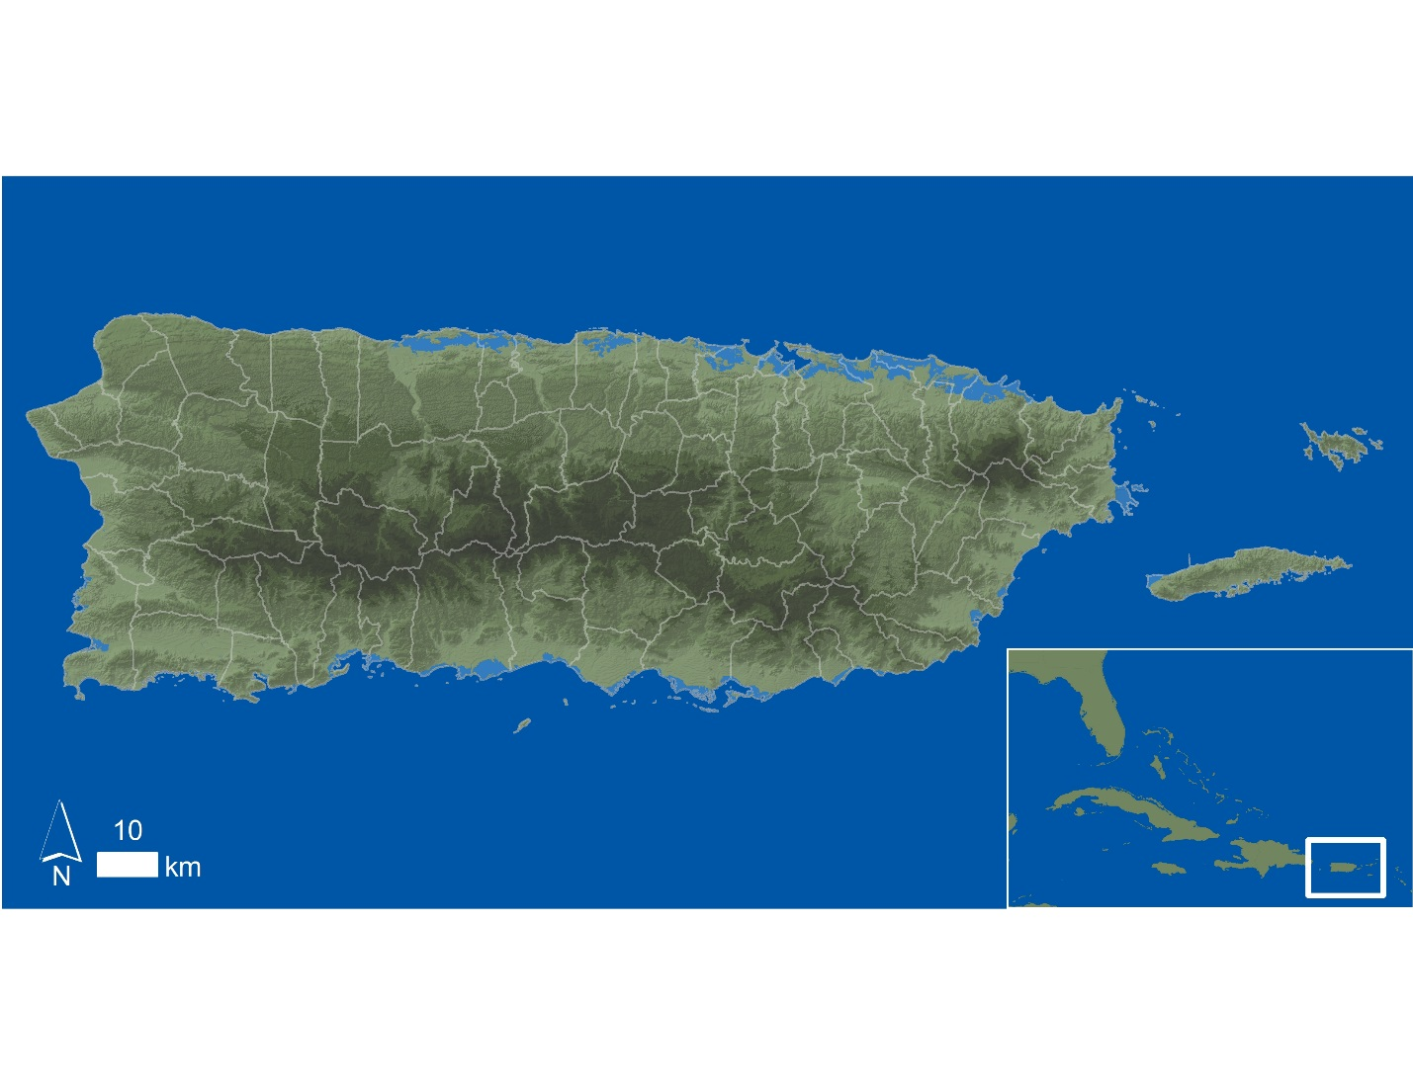

*Figure 1*: Study area 1: Analyses using the MaxEnt model were conducted within the political boundaries of the Commonwealth of Puerto Rico for the main island.

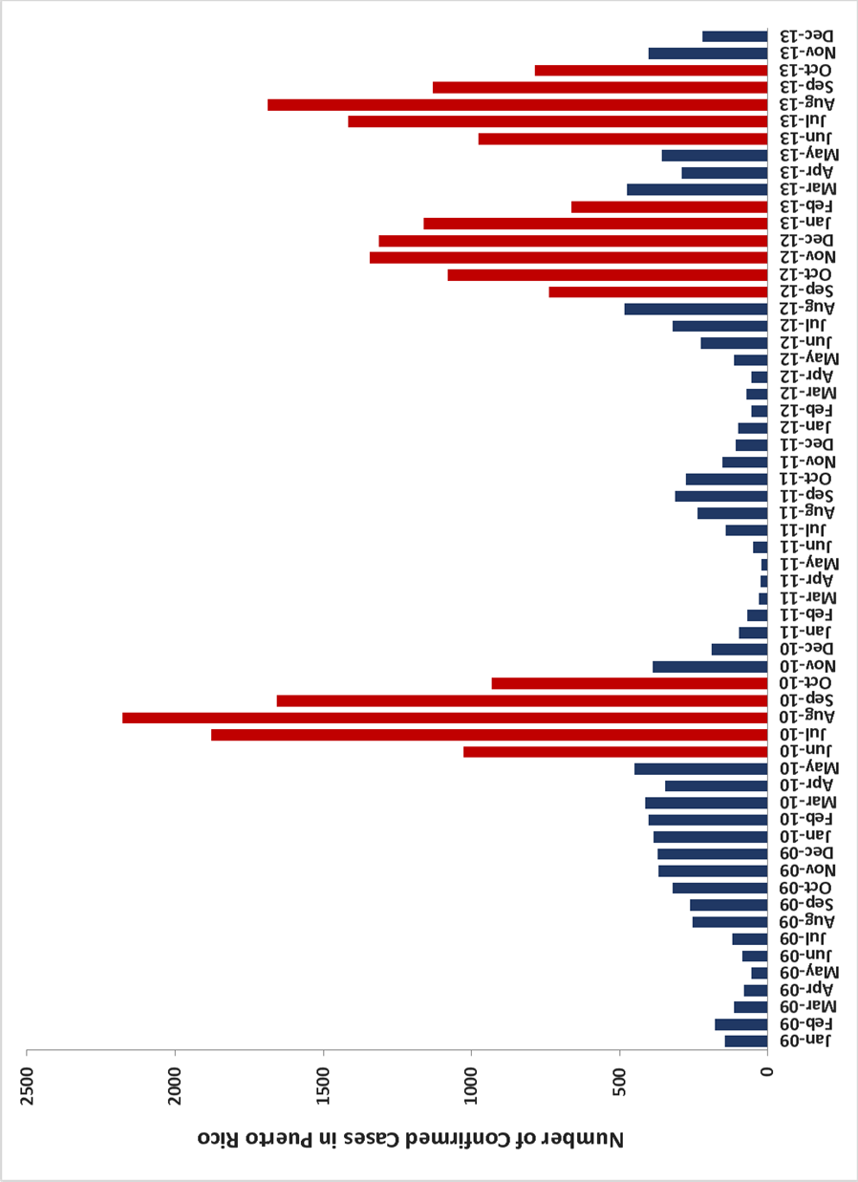

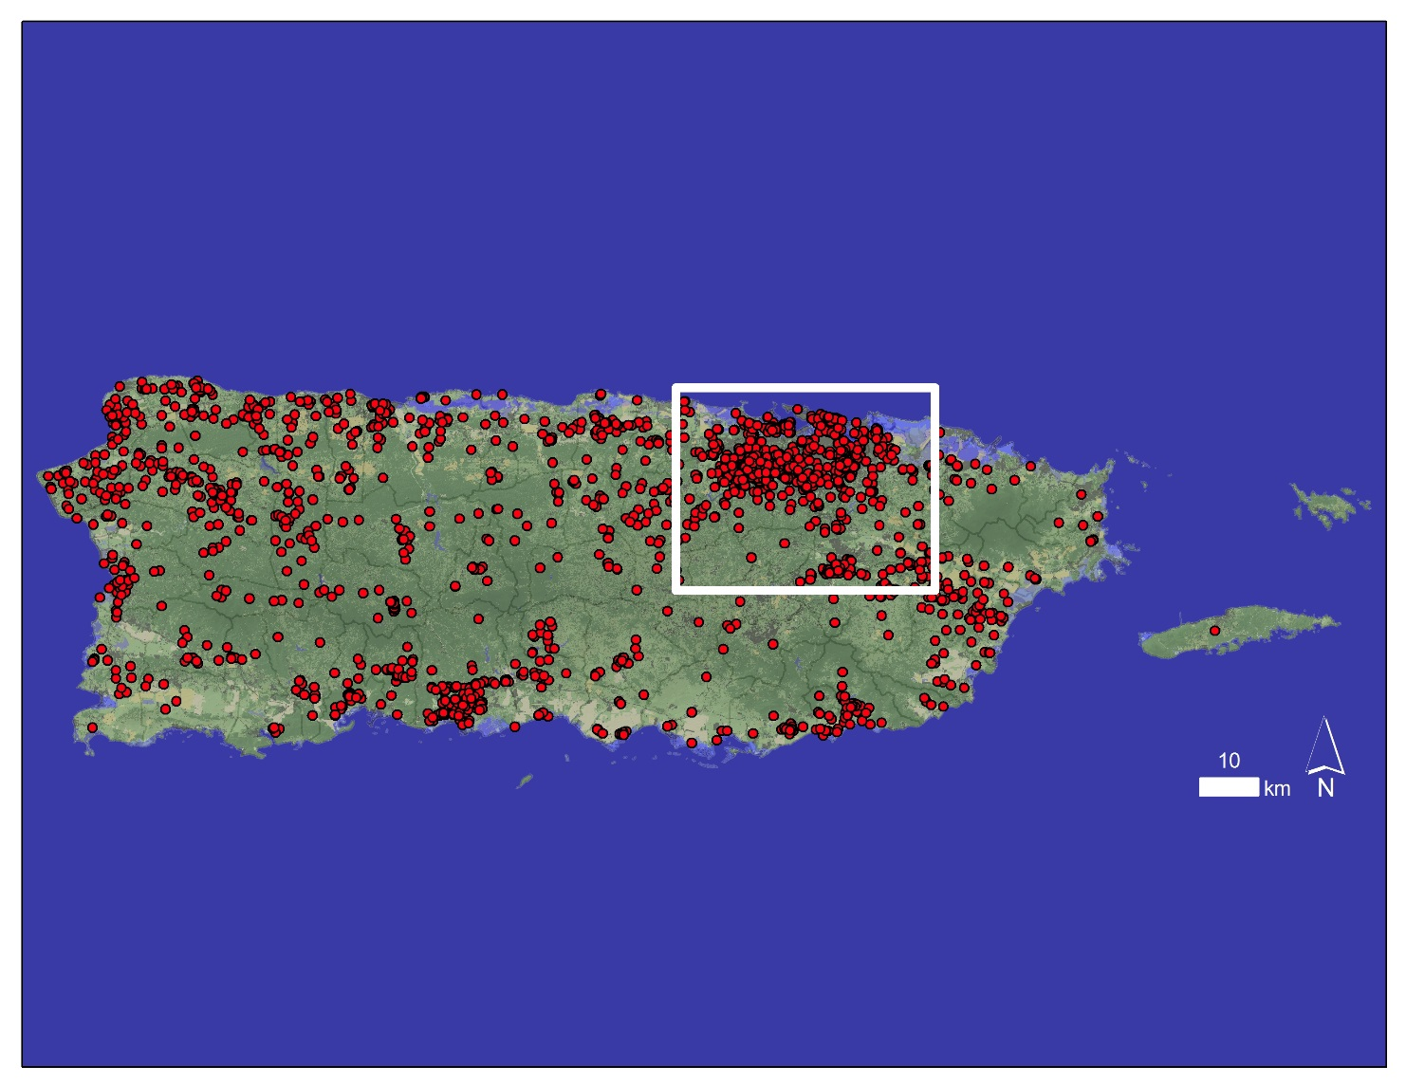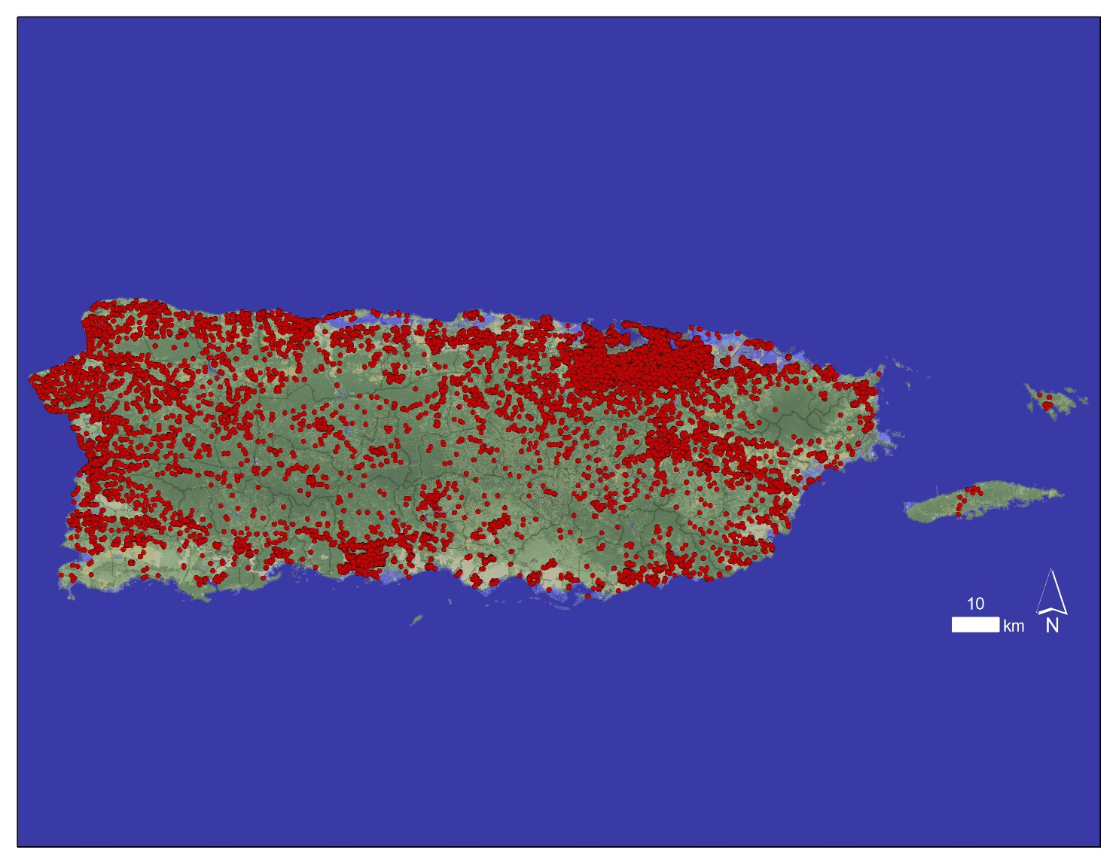

*Figure 4*: Map showing the locations all CDFC that occurred during August 2010, the month with the highest number of CDFC during the study period. The San Juan metropolitan area is highlighted.

*Figure 3*: Map showing the locations all CDFC that occurred in Puerto Rico from January 2009 – December 2013.

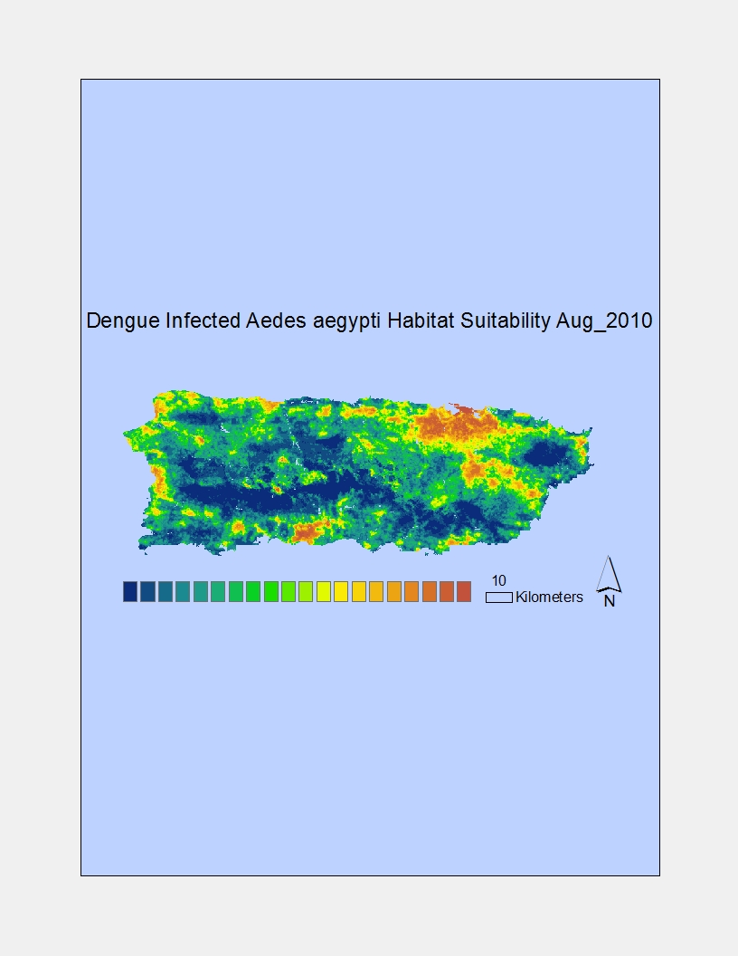

*Figure 5*: DF infected *A. aegypti* habitat suitability map produced by the MaxEnt model for August 2010, the month with the highest number of CDFC during the study period. Warmer colors represent regions of higher habitat suitability. The San Juan metropolitan area is highlighted.

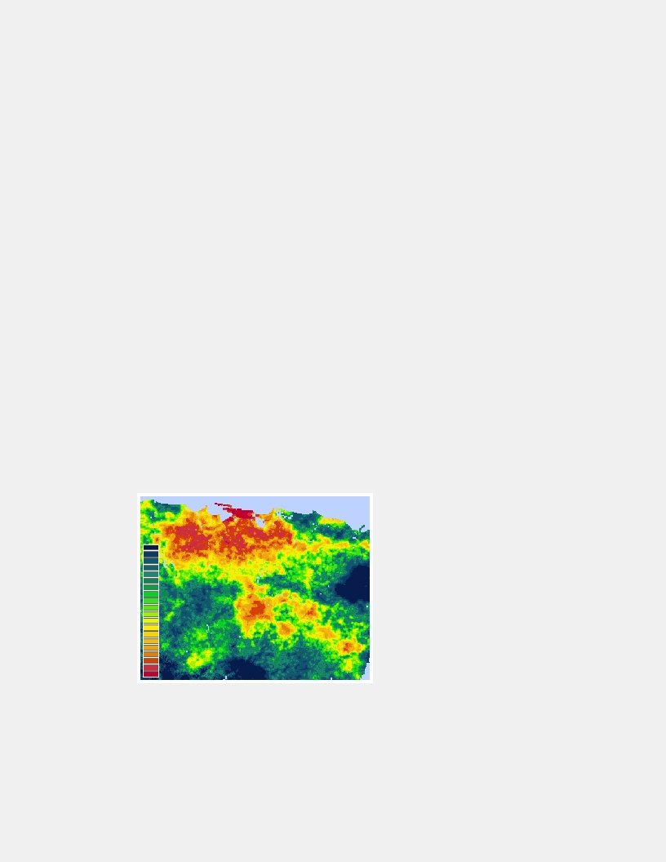

*Figure 6*: Close up view of the San Juan metropolitan area from the August 2010 *A. aegypti* habitat suitability map produced by the MaxEnt model. Warmer colors represent regions of higher *A. aegypti* suitability.

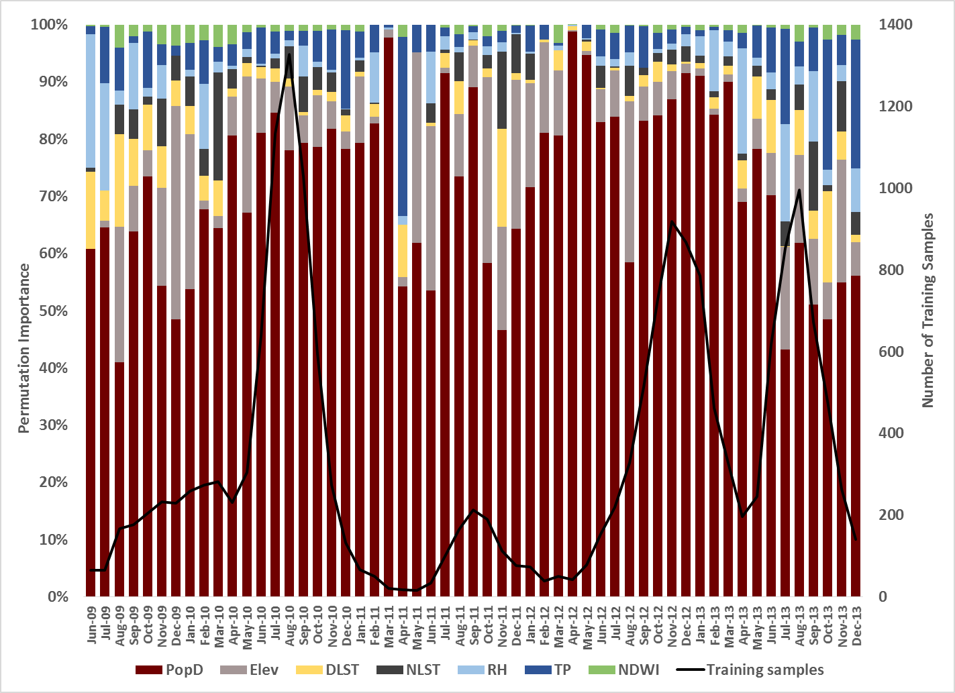

*Figure 7*: Timeline of MaxEnt output of permutation importance values for all environmental variables in Puerto Rico from June 2009 – December 2013.

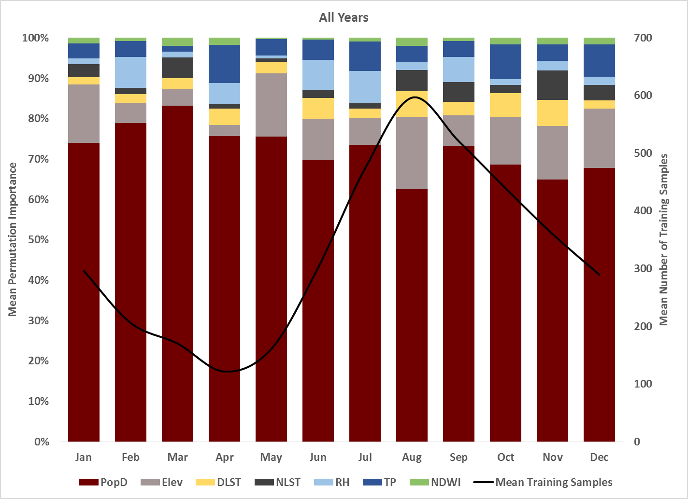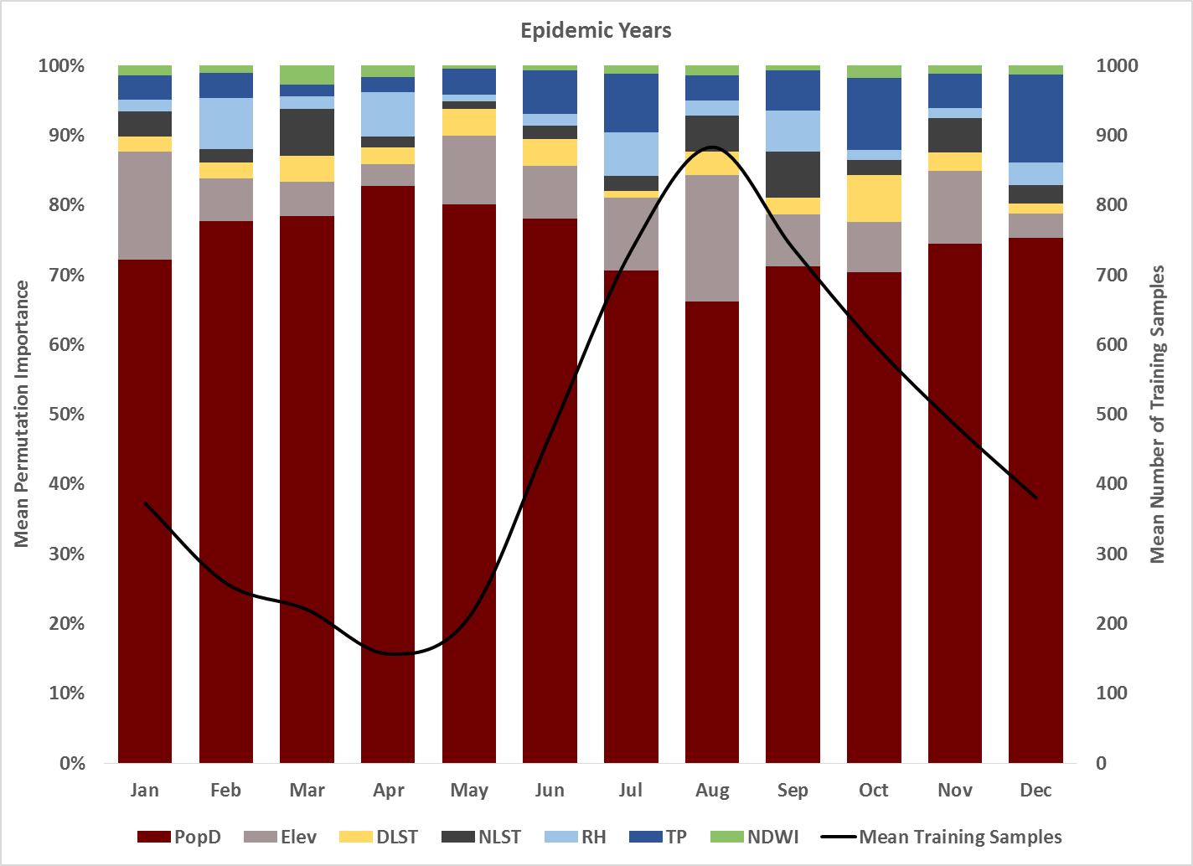

*Figure 8*: Timeline of MaxEnt output of mean monthly permutation importance values for all environmental variables in Puerto Rico from June 2009 – December 2013.

*Figure 11*: Timeline of MaxEnt output of mean monthly permutation importance values for all environmental variables in Puerto Rico from June 2009 – December 2013.

*Figure 11*: Timeline of MaxEnt output of mean monthly permutation importance values for all environmental variables in Puerto Rico from January 2009 – December 2013.

*Figure 9*: Timeline of MaxEnt output of mean monthly permutation importance values for all environmental variables in Puerto Rico during the epidemic years of 2010, 2012, and 2013.

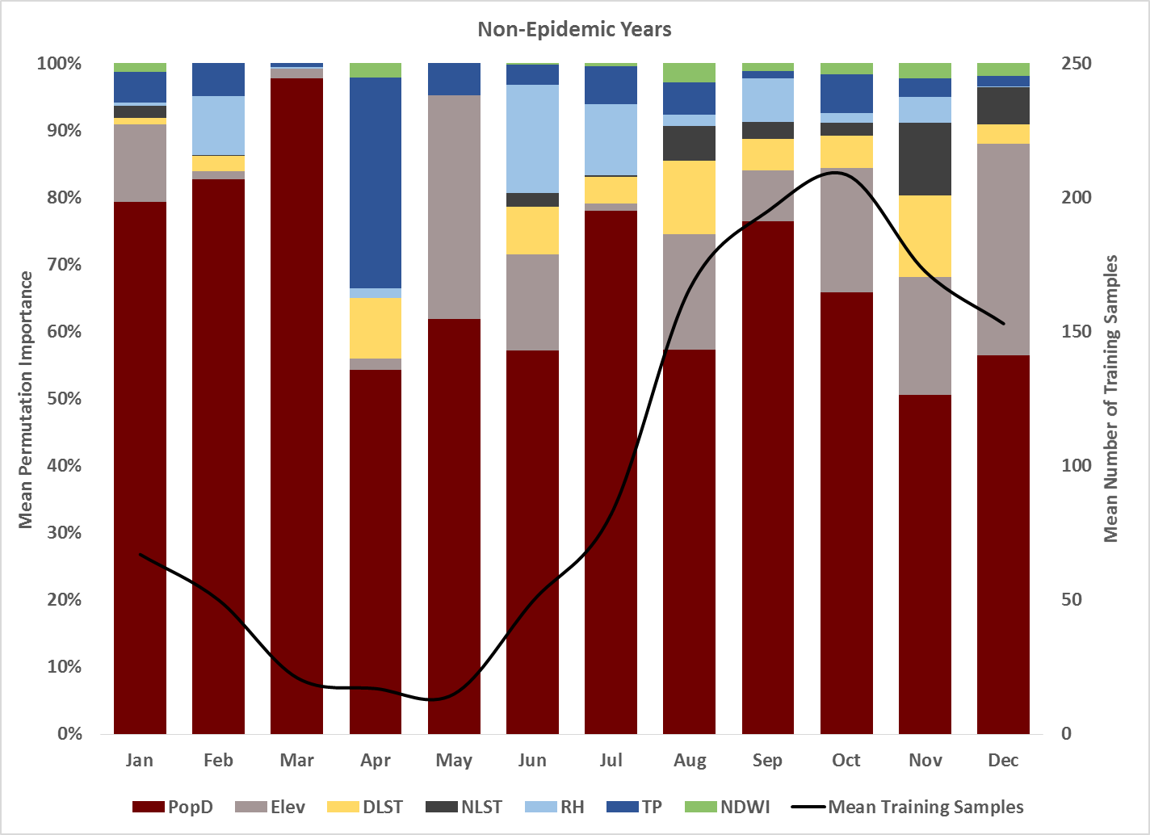

*Figure 10*: Timeline of MaxEnt output of mean monthly permutation importance values for all environmental variables in Puerto Rico during the non-epidemic years of 2009 and 2011.

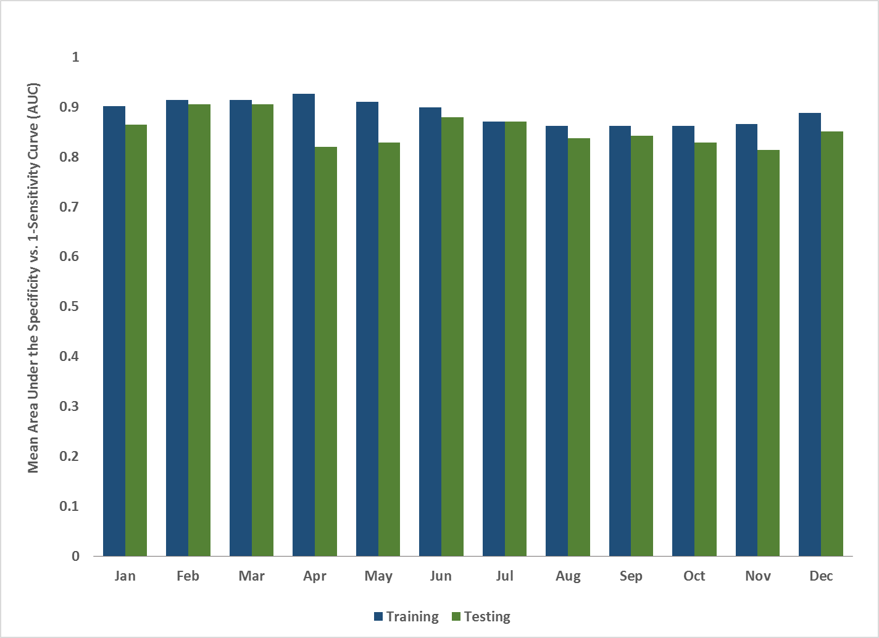

*Figure 11*: Comparison of mean monthly training vs. testing AUC values determined from the Specificity vs. 1-Sensitivity Curve.

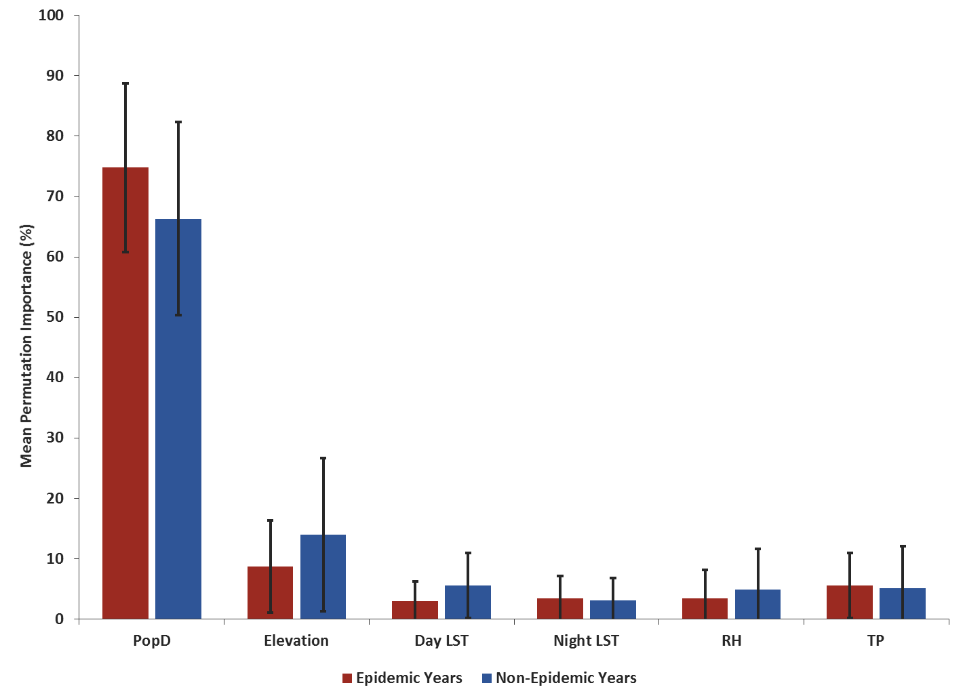

*Figure 12*: Comparison of mean permutation importance values for MaxEnt model runs in epidemic and non-epidemic years.

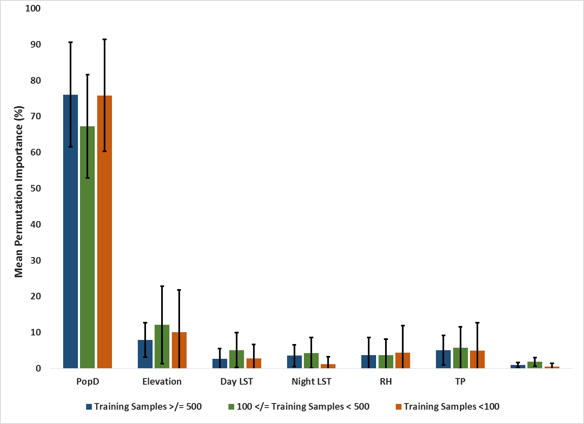**Appendix B: ETM Figures**

*Figure 13*: Comparison of mean permutation importance values for MaxEnt model runs with the number of training samples < 100, 100≤TS<500, and ≥ 500.

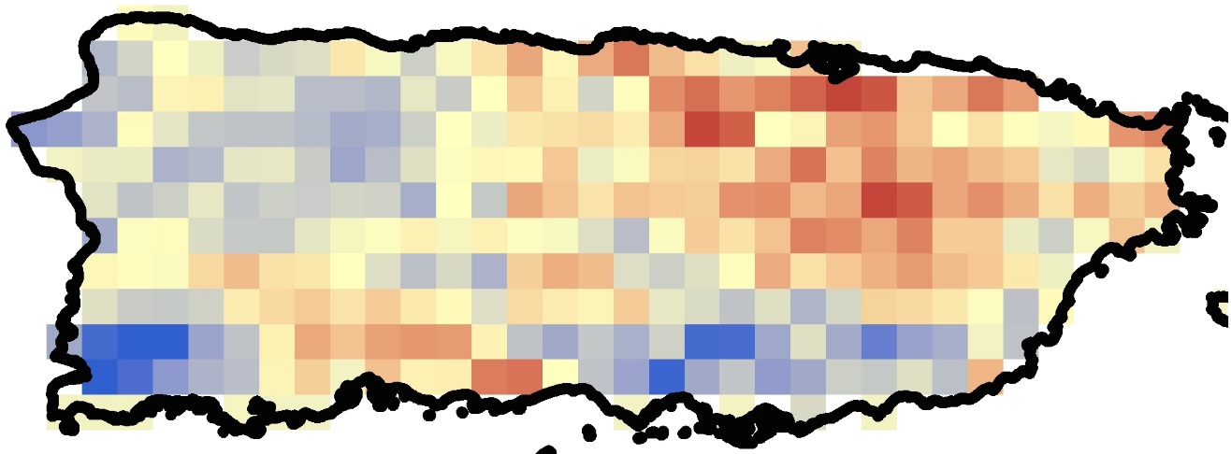

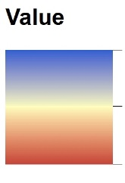

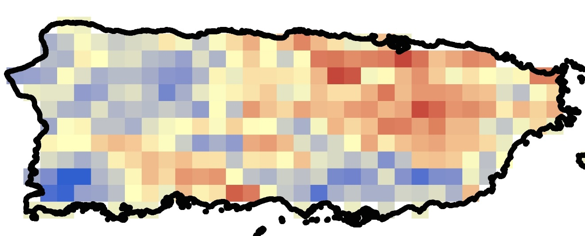

*Figure 1: DLST Theil-Sen Median (upper) and Monotonic (lower) Trends from January 2009 to December 2013. Darker shades of blue indicate positive/increasing values, while shades of red indicate negative/ decreasing values. Theil-Sen Median values range 0.0146 to -0.0179 and Monotonic values range 1.7284 to -1.8242.*

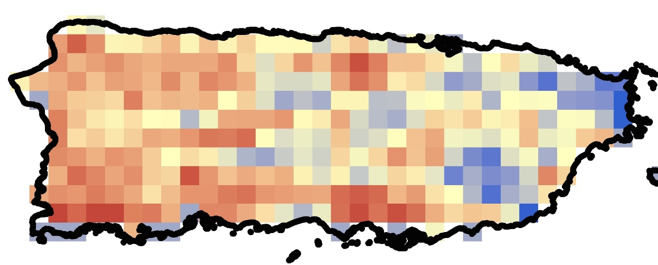

**

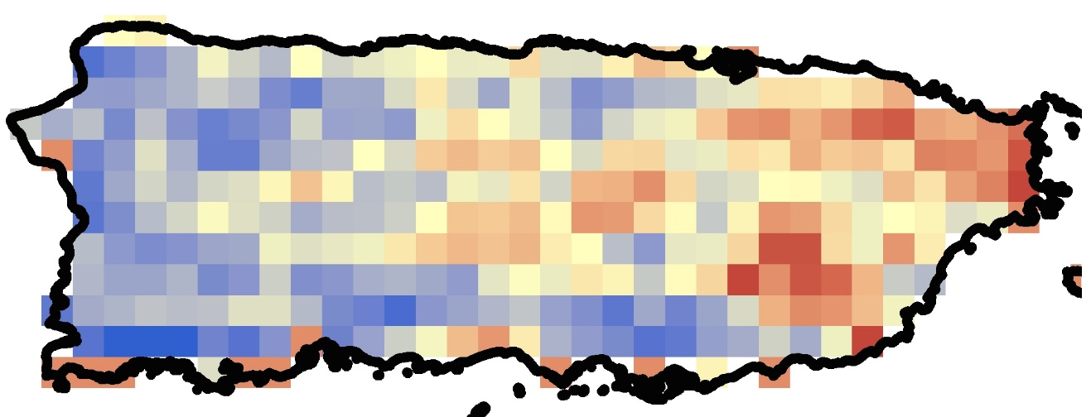

*Figure 2: NLST Theil-Sen Median (upper) and Monotonic (lower) Trends from January 2009 to December 2013. Darker shades of blue indicate positive/increasing values, while shades of red indicate negative/ decreasing values. Theil-Sen Median values range 0.1977 to -0.4670 and Monotonic values range 3.5398 to -0.9588.*

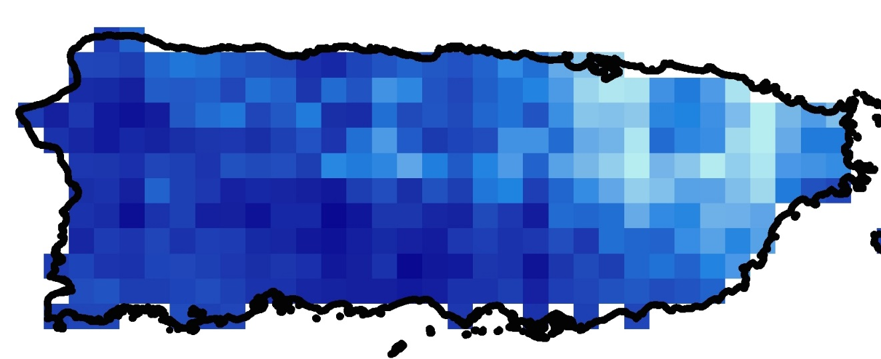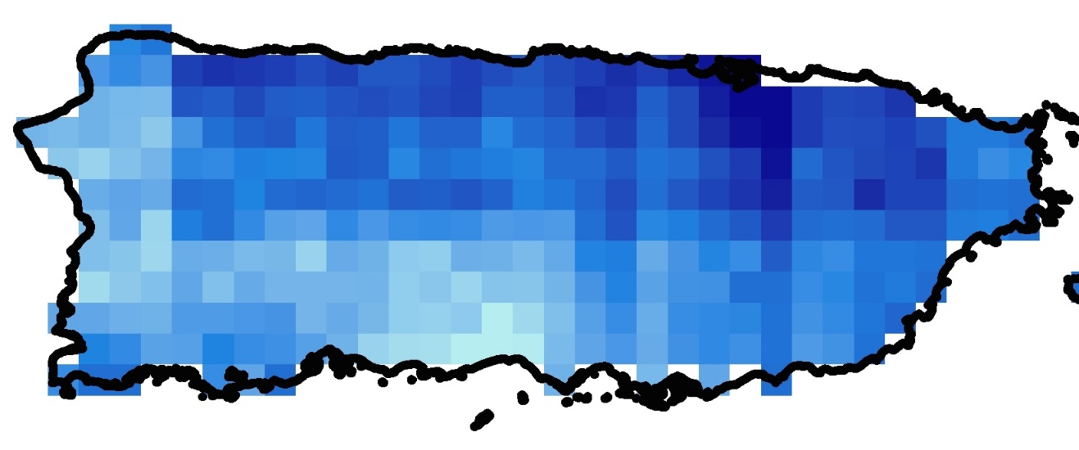

*Figure 3: TP Theil-Sen Median (upper) and Monotonic (lower) Trends from January 2009 to December 2013. Darker shades of blue indicate positive/increasing values, while lighter shades of blue indicate negative/ decreasing values. Theil-Sen Median values range 8.4108 to -25.7432 and Monotonic values range 1.1799 to -1.6391.*

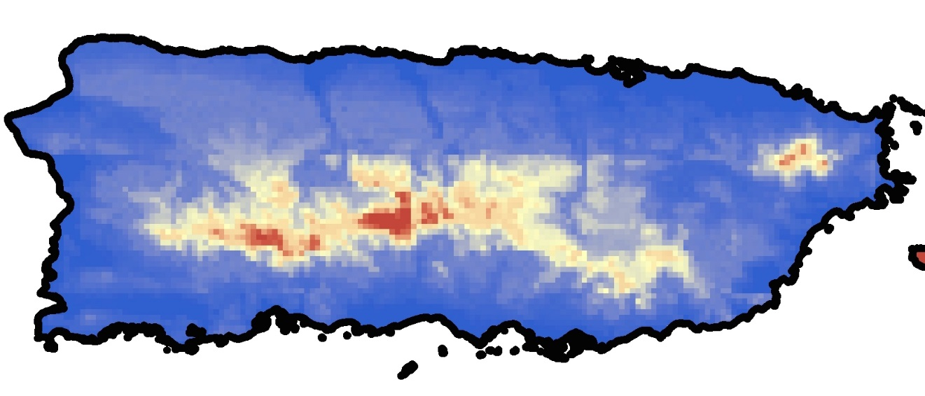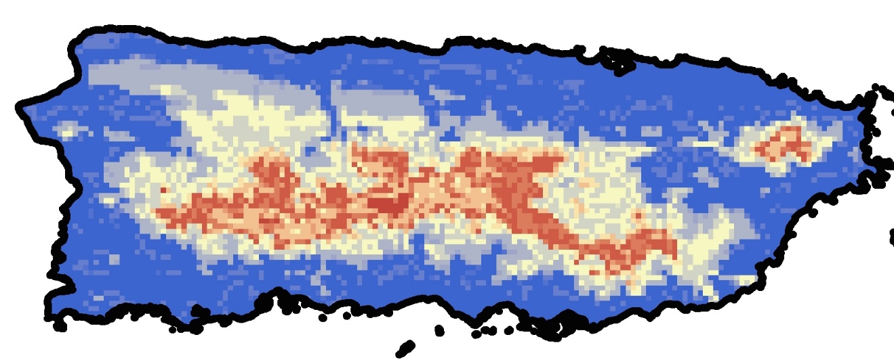

*Figure 4: RH Theil-Sen Median (upper) and Monotonic (lower) Trends from January 2009 to December 2013. Darker shades of blue indicate positive/increasing values, while shades of red indicate negative/ decreasing values. Theil-Sen Median values range -2.1501 to 0 and Monotonic values range 0 to -2.5576.*

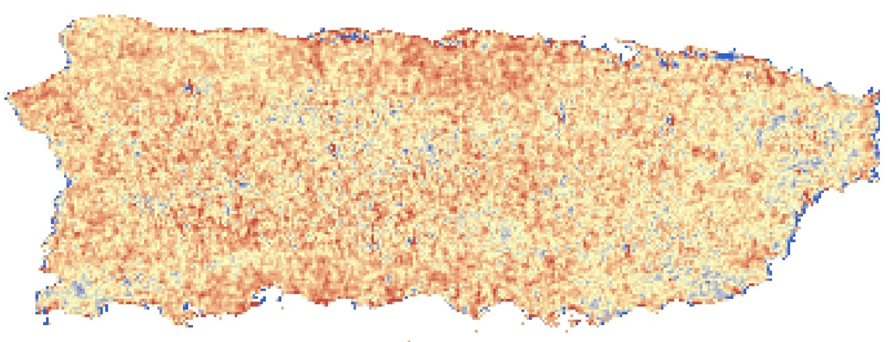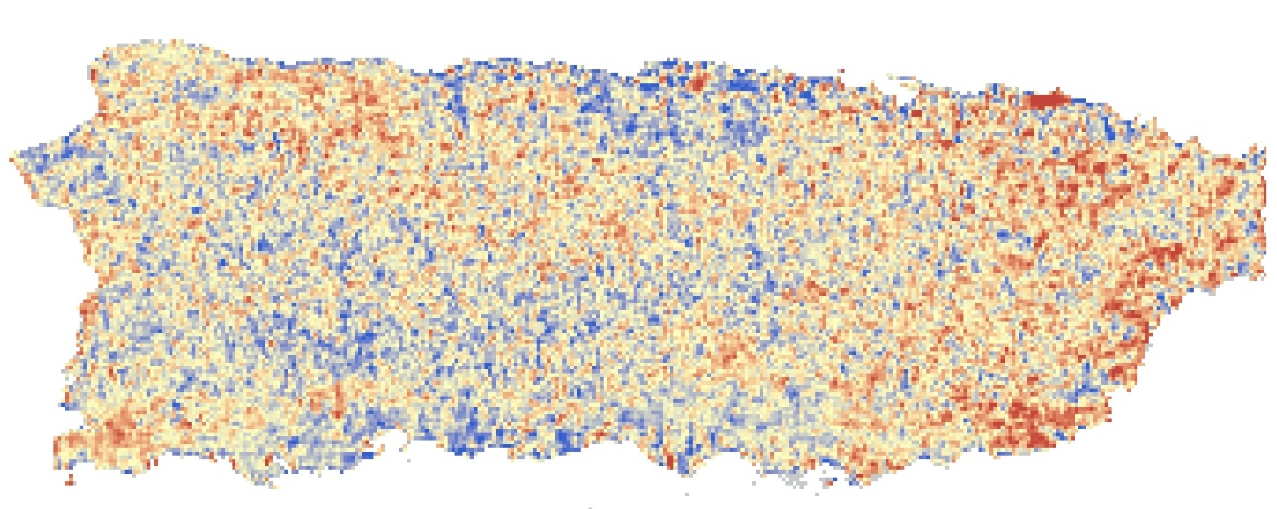

*Figure 5: NDWI Theil-Sen Median (upper) and Monotonic (lower) Trends from January 2009 to December 2013. Darker shades of blue indicate positive/increasing values, while shades of red indicate negative/ decreasing values. Theil-Sen Median values range 0.2174 to -0.0787 and Monotonic values range 3.4504 to -6.4163.*

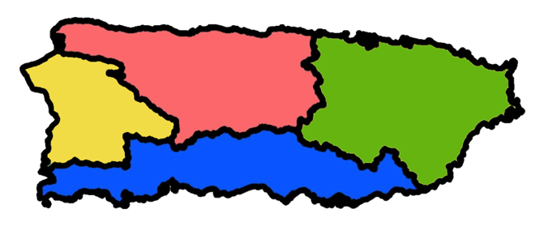

*Figure 6: HUC-8 for the mainland of Puerto Rico. The island was separated into these regions to isolate seasonal trends due to Puerto Rico’s high variable water patterns and terrain.*

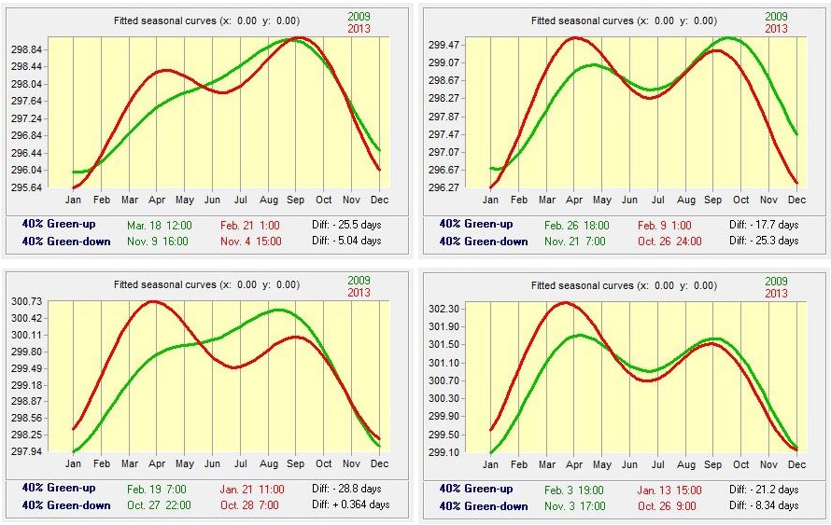

*Figure 7: DLST STA results for HUC-8 regions. The seasonal trend graphs for the north (upper left), northeast (upper right), west (lower left), and south (lower right) delineate seasonal changes from the beginning of 2009 (green line) to the end of 2013 (red line). Green up and green down dates indicate the approximate onset and offset of the season.*

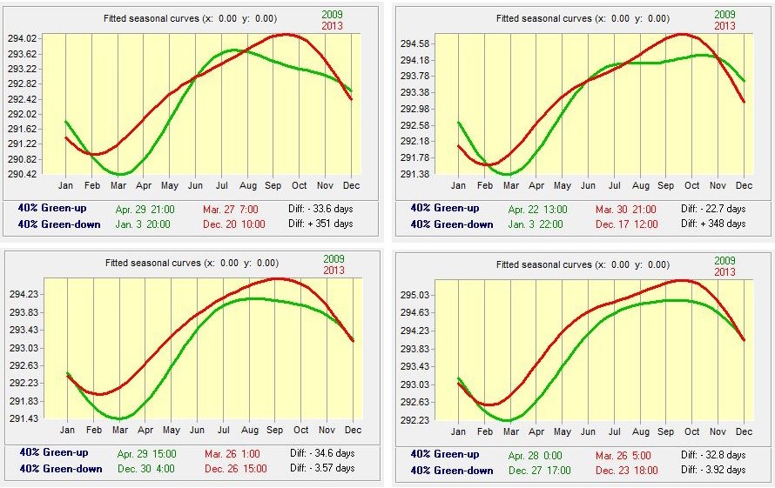

*Figure 8: NLST STA results for HUC-8 regions. The seasonal trend graphs for the north (upper left), northeast (upper right), west (lower left), and south (lower right) delineate seasonal changes from the beginning of 2009 (green line) to the end of 2013 (red line). Green up and green down dates indicate the approximate onset and offset of the season.*

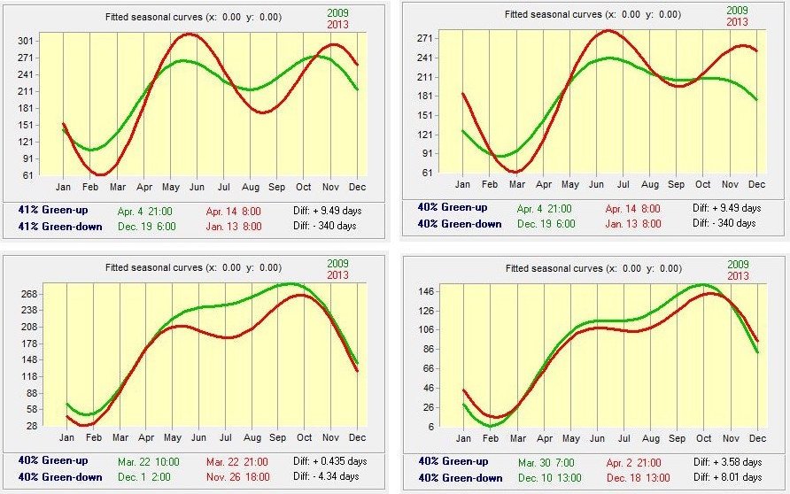

*Figure 9: TP STA results for HUC-8 regions. The seasonal trend graphs for the north (upper left), northeast (upper right), west (lower left), and south (lower right) delineate seasonal changes from the beginning of 2009 (green line) to the end of 2013 (red line). Green up and green down dates indicate the approximate onset and offset of the season.*

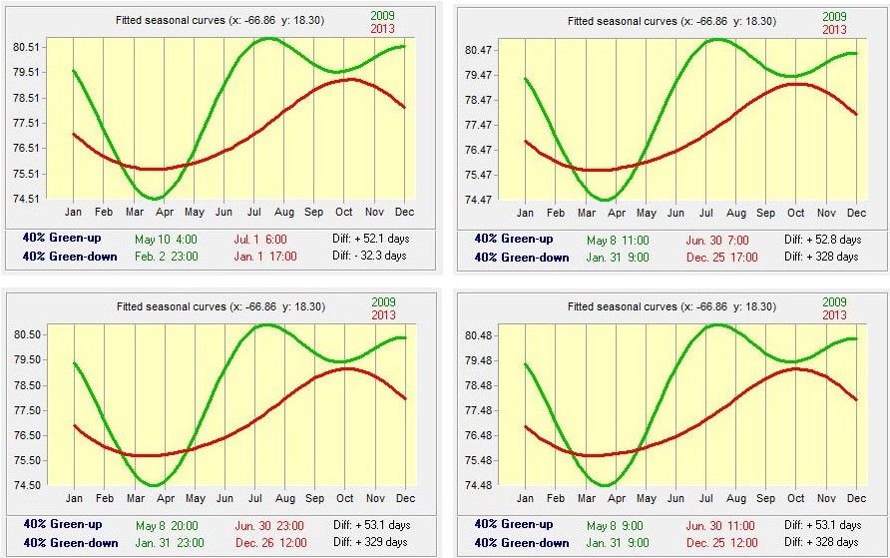

*Figure 10: RH STA results for HUC-8 regions. The seasonal trend graphs for the north (upper left), northeast (upper right), west (lower left), and south (lower right) delineate seasonal changes from the beginning of 2009 (green line) to the end of 2013 (red line). Green up and green down dates indicate the approximate onset and offset of the season.*

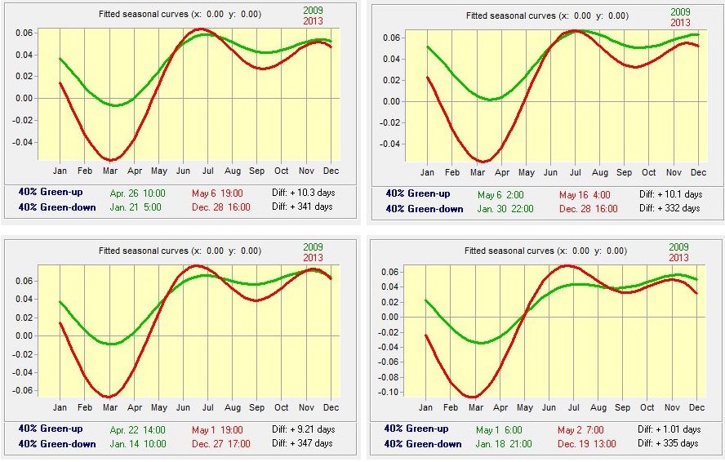

*Figure 11: NDWI STA results for HUC-8 regions. The seasonal trend graphs for the north (upper left), northeast (upper right), west (lower left), and south (lower right) delineate seasonal changes from the beginning of 2009 (green line) to the end of 2013 (red line). Green up and green down dates indicate the approximate onset and offset of the season.*