**NASA DEVELOP National Program**

NASA Langley Research Center

**Fall 2015**

**Short Title:** **El Salvador Ecological Forecasting**

**Subtitle:** Utilizing NASA Earth Observations to Predict Deforestation and Degradation in El Salvador

**VPS Title:** The Time to Act is Now! Forecasting Change in El Salvador’s Pine-Oak Forests

**Project Team & Partners**

**Project Team:**

Jordan Ped (Project Lead), jordan.w.ped@nasa.gov

Courtney Duquette

Clarence Kimbrell

Susannah Miller

Stephen Zimmerman

**Advisors & Mentors:**

Dr. Kenton Ross (NASA DEVELOP National Program)

**Partner Organizations:**

La Mancomunidad La Montañona, Chalatenango (End-User),

POC: Arnulfo Alberto

Ministerio de Medio Ambiente y Recursos Naturales (MARN) (End-User),

POC: Giovanni Molina

The Earth Institute, Columbia University, Agroforestry for Biodiversity and Ecosystem Services (ABES) Project (Collaborator),

POC: Dr. Sean Smukler & Sean Kearney

**Project Details**

**Applied Sciences National Applications Addressed:** Ecological Forecasting, Agriculture

**Study Area:** La Mancomunidad La Montañona, Chalatenango, El Salvador

**Study Period:** December 1986 – January 2015

**Earth Observations & Parameters:**

Landsat 4 and 5 (TM) & 8 (OLI/TIRS) - Land Use/Cover; Vegetation

RapidEye Constellation, Jena-Optronik - Land Use/Cover; Vegetation

QuickBird, BGIS 2000 - Land Use/Cover; Vegetation

**Ancillary Datasets Utilized:**

* ABES Field surveys (2012 ground observations of forest patches .01 hectares to 1 hectare)
* Hansen et. al. Global Forest Cover Dataset (2000 and 2014 classification of forest cover)
* Shuttle Radar Topography Mission (SRTM) – Land use/Cover; Vegetation

**Models Utilized:**

* Clark Lab’s TerrSet Land Change Modeler

**Software Utilized:**

Google Earth Engine - Land classifications

ArcGIS - Raster manipulation/analysis, image enhancement & map creation

Multispec– Land cover classifications

Python - Programming language, land classifications, image manipulation

**Project Overview**

**80-100 Word Objectives Overview:**

The overall objective of the project is to develop a methodology for monitoring and forecasting ecological change in La Mancomunidad La Montañona region in El Salavdor. Ministerio de Medio Ambiente y Recursos Naturales (MARN) and other El Salvadorian end-users will use this methodology to determine at-risk areas and implement effective policy. The long-term changes in the extent of the region's pine-oak forests and agricultural land use were identified in order to determine indicators of deforestation and degradation. This information will develop baseline trajectories against which future monitoring and modeling of forest change can be compared.

**Abstract:**

Tropical rainforests have been recognized as a major contributor to maintaining the global carbon budget and contain a significant portion of the world's biodiversity. However, these ecosystems are threatened by deforestation and forest degradation and require careful management to retain their ecosystem services. La Mancomunidad La Montañona in Chalatenango, El Salvador is home to the critical Rio Lempa watershed where small scale farmers and pastoralists commonly practice slash and burn agriculture. Using NASA Earth observations in collaboration with Ministerio de Medio Ambiente y Recursos Naturales (MARN) and the Earth Institute of Columbia University, Agroforestry for Biodiversity and Ecosystem Services (ABES) Project, a methodology was developed for stakeholders and policy makers to monitor long-term changes in forest cover and identify indicators of forest degradation. A baseline time series showing forest cover and land-use, land-cover from December 1986 to January 2015 was used to forecast forest cover change. These predictions and tools will help assess priority areas for conservation and development of sustainable agricultural practices.

**Community Concerns:**

* Rainforests have been recognized as a significant contributor to maintaining the global carbon budget and are home to 80% of the world’s terrestrial biodiversity.
* El Salvador has the least forest cover (121,000 hectares) and the highest population density (300 people/km2) of the seven countries in Central America leaving this area extremely vulnerable to forest degradation and deforestation.
* The forests of La Montañona are critical to maintaining springs and rivers from which many communities rely on as their only source of fresh water.
* The forests in these mountainous region support soil stability, preventing mudslides and excessive loss of soil fertility, which subsistence farmers rely on.

**Current Management Practices & Policies**:

In El Salvador, management policies and practices are not strictly enforced. The governing bodies in this region are working with the Earth Institute at Columbia University’s ABES Project to determine the best ways to regulate effective payment for ecosystem services (PES) programs and implement Reducing Emission from Deforestation and Degradation (REDD+) guidelines set forth by the United Nations at the United Nations Framework Convention on Climate Change (UNFCCC). These include obtaining a national forest inventory and working with all levels of government to institute different policies that will prioritize areas for conservation.

**Decision Support Tools & Benefits:**

|  |  |  |
| --- | --- | --- |
| **End-Product** | **Earth Observations Used** | **Benefit & Impact** |
| Regional Forest Inventory (1986-2015) | Landsat 4 and 5 (TM) & 8 (OLI), QuickBird, RapidEye | Determine forest extent and composition for current and future monitoring |
| Land Use/Land Cover (1986-2015) | Landsat 4 and 5 (TM) & 8 (OLI), QuickBird, RapidEye | Analyze land cover change patterns and current land use practices for comparison and risk assessment |
| Forecasting Model for Forest Cover | Landsat 4 and 5 (TM) & 8 (OLI), Quickbird, RapidEye | Prioritize conservation zones and identity high risk deforestation and degradation areas |

**Project Imagery**

**Image:**

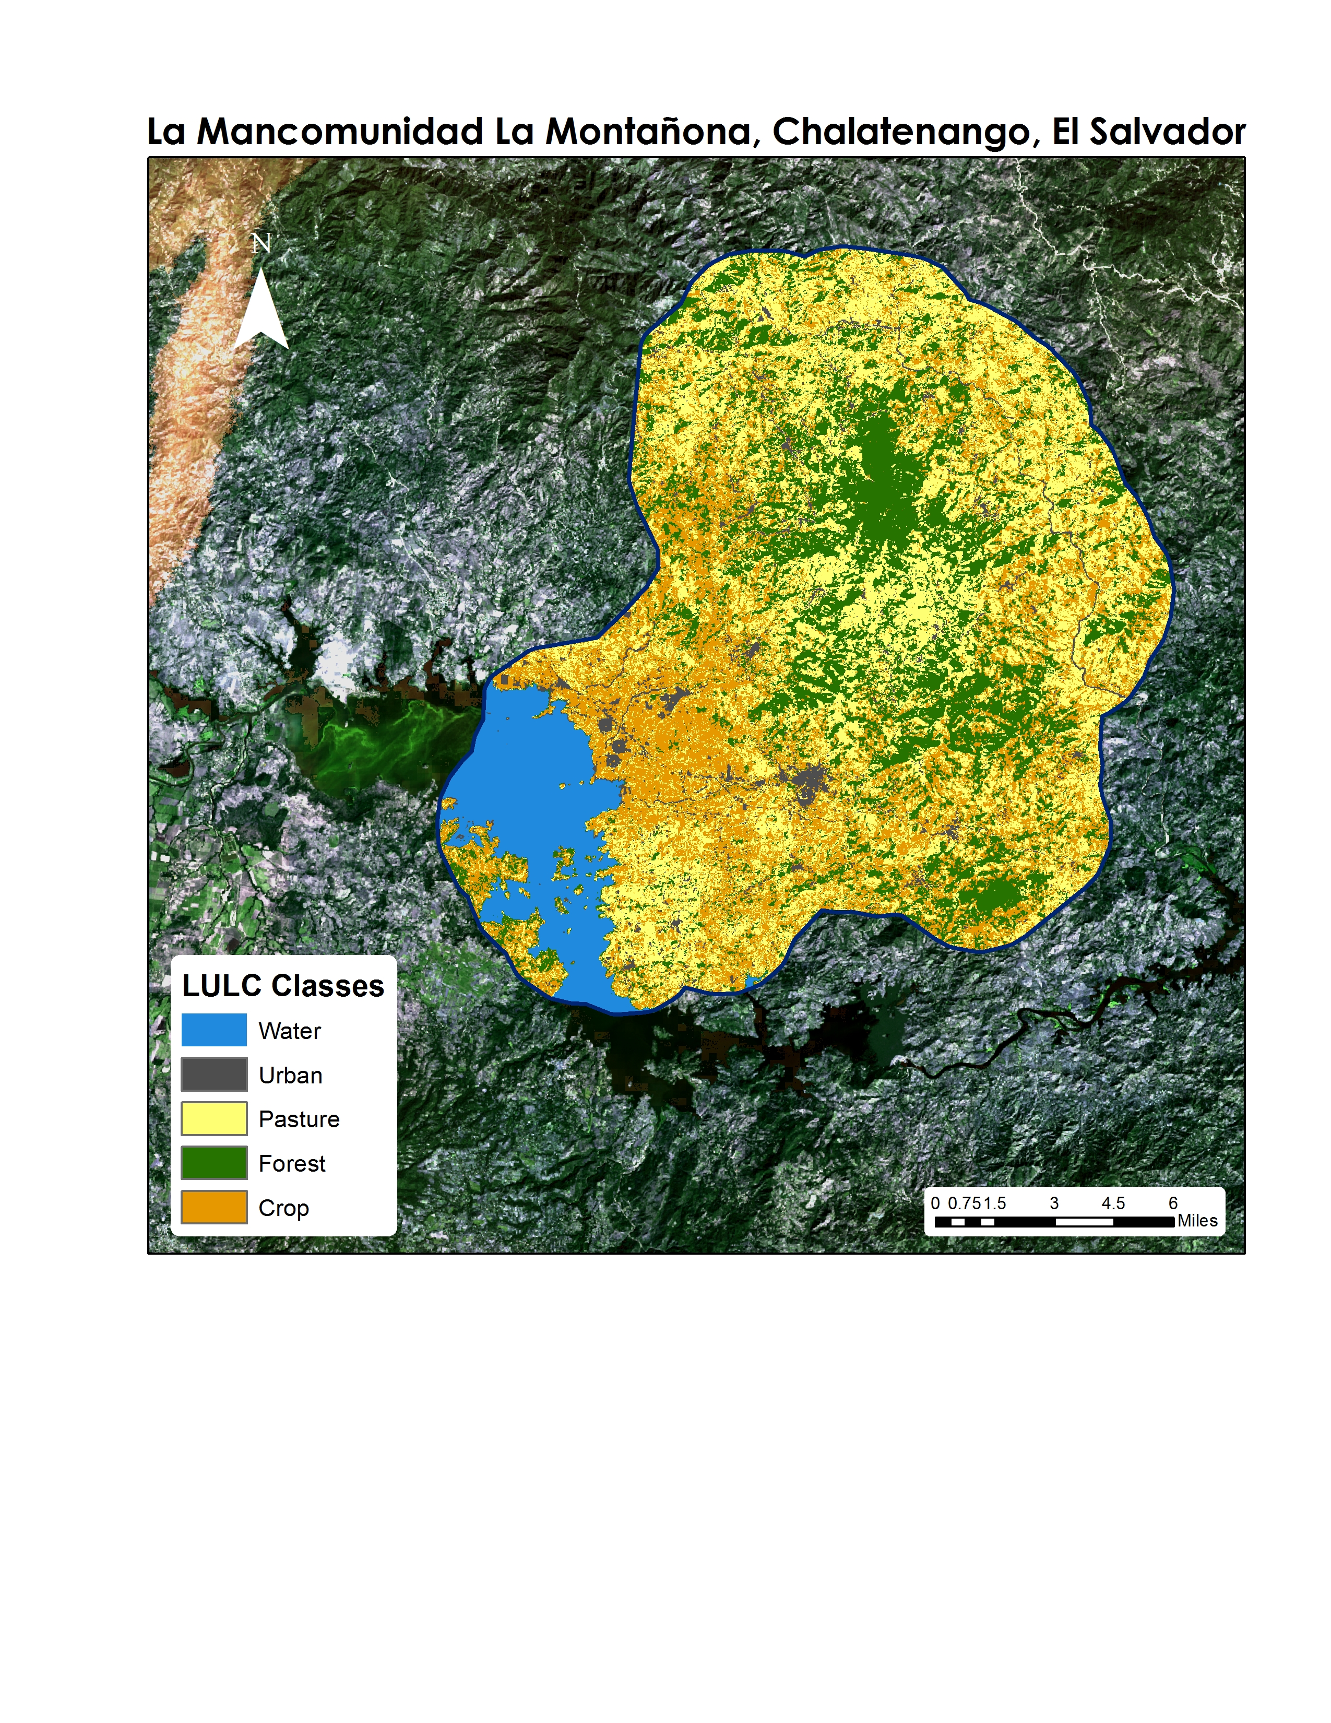

**Caption:** The results of an ArcGIS maximum likelihood classification; a Land Use Land Cover (LULC) map of La Moncomunidad La Montañona with five classes: Water, Urban, Pasture, Forest, & Crop. Image Credit: El Salvador Ecological Forecasting Team.

**Software Release Requirements**

Category I