**NASA DEVELOP National Program**



NASA Langley Research Center

**Summer 2016**

**Short Title: Middle East Water Resources**

**Subtitle:** Utilizing NASA Earth Observations to Create a Precipitation Climatology of Jordan, Israel, and the West Bank to Identify Optimal Rainwater Harvesting Locations for Underserved Schools

**VPS Title:** Make it Rain: The Water Cycle from Precipitation to Sanitation

**Project Team & Partners**

**Project Team:**

Hannah Rosenblum (Project Lead), hannah.s.rosenblum@nasa.gov

Vishal Arya

Michael Sclater

Raghda El-Behaedi

Brad Schroeder

Labreshia Mims

**Advisors & Mentors:**

Dr. Kenton Ross (NASA DEVELOP National Program)

**Partner Organizations:**

|  |  |  |  |
| --- | --- | --- | --- |
| **Organization** | **POC (Name, Position/Title)** | **Partner Type** | **Boundary Org?** |
| Water Resources Action Project, Inc. (WRAP) | Brendan McGinnis, Executive Director | End-User | No |

**Project Details**

**Applied Sciences National Applications Addressed:** Water Resources, Climate

**Study Area:** Jordan, Israel, West Bank

**Study Period:** January 2005 - June 2016

**Earth Observations & Parameters:**

Tropical Rainfall Measuring Mission (TRMM), Precipitation Radar (PR) – precipitation measurements

Global Precipitation Mission (GPM), Dual Frequency Precipitation Radar (DPR) – precipitation measurements

NASA Shuttle Radar Topography Mission (SRTM), SIR-C/X-SAR radar – Digital Elevation Model

Gravity Recovery and Climate Experiment (GRACE) – groundwater

**Ancillary Datasets Utilized:**

* NOAA Global Summary of the Day (GSOD) – precipitation measurements
* Climate Hazards Group CHIRPS – precipitation measurements

**Software Utilized:**

* Python – batch downloading, batch processing
* Google Earth Engine – data visualization
* ESRI ArcGIS – raster manipulation/analysis, image enhancement, and map creation
* QGIS – data visualization and interface creation

**Project Overview**

**Objectives Overview:**   
Population growth and urbanization, coupled with water scarcity, will force Jordan, Israel, and the West Bank to employ alternative strategies to augment their water supplies. The objective of this project is to create a precipitation climatology, using TRMM and GPM data from the last decade, to quantify and visualize monthly precipitation rates. The results will aid the Water Resources Action Project, Inc. (WRAP) in decision-making by identifying regions most suitable for low-cost, low-tech, rainwater harvesting alternatives, which the organization implements in local schools.

**Abstract:**

Water resources are declining in the Middle East as a result of the combination of diminished supply from overexploitation and drought, increased demand due to growing populations, and inadequate infrastructure. Water shortages have led to sanitation issues in schools and, in severe cases, even school closures. Rainwater harvesting is an eco-friendly, low-tech, and cost effective method of collecting and storing water for local use. The Water Resources Action Project, Inc. (WRAP) provides rain barrels and cisterns to underserved schools in the region to increase their water resources for sanitation purposes. This study used data from Tropical Rainfall Measurement Mission (TRMM), Global Precipitation Measurement (GPM), and other NASA Earth observations to quantify and visualize precipitation to identify locations most suitable for rainwater harvesting. Results indicate that precipitation is greatest in the north, nearest to the Mediterranean Sea, and along the Jordan Rift Valley. The team created a climatology which characterizes the precipitation regime of the region, as well as an interactive interface to help WRAP determine which schools would benefit most from their assistance. The interface will be shared with the schools to which WRAP provides rainwater harvesting systems as an educational tool that can be used to improve students’ understanding of the region’s precipitation and climate as well as Geographic Information Systems and other monitoring and analysis technologies.

**Keywords:**

QGIS, Google Earth Engine, Water Resources Action Project, Inc. (WRAP), data visualization tools, Python, JavaScript

**Community Concerns:**

* Jordan, Israel, and the West Bank have an arid climate with low to intermittent rainfall.
* The main sources of water in this region are surface and groundwater reservoirs; however, the majority of water sources that still exist are polluted and deteriorating as the demand for water rises.
* Some schools in the region have been forced to close due to insufficient water for sanitation, which accounts for about 85% of a school’s total water usage.
* Predicted changes in precipitation and temperature will exacerbate the strain on water resources.
* Current geopolitical relations within the region have resulted in increased refugee populations as well as demands for water resources.

**Current Management Practices & Policies**:

WRAP uses data from the Food and Agricultural Organization of the United Nations (FAO) and the World Bank to understand rainfall and population patterns. The non-profit uses the information to select future sites for rainwater collection programs for schools based on rainwater availability and the number of people impacted by the collection program.

**Decision Support Tools & Benefits:**

|  |  |  |  |
| --- | --- | --- | --- |
| **End-Product** | **Earth Observations Used** | **Benefit & Impact** | **Software**  **Release** |
| Precipitation Maps | TRMM and GPM precipitation data | Precipitation maps will provide visualizations of both historical trends and current conditions. | N/A |
| Groundwater Maps | GRACE groundwater data | Groundwater maps will provide visualizations of existing groundwater | N/A |
| Graphs of seasonal rainfall averages | TRMM and GPM precipitation data | Seasonal rainfall averages will improve understanding of both historical trends and current conditions. | N/A |
| Interactive Interface | TRMM, GPM, SRTM | Allows the partner, and the schools they work with, to (1) better understand the data and (2) learn about NASA Earth observations and GIS | 3 |

**Project VPS/Booklet Imagery**

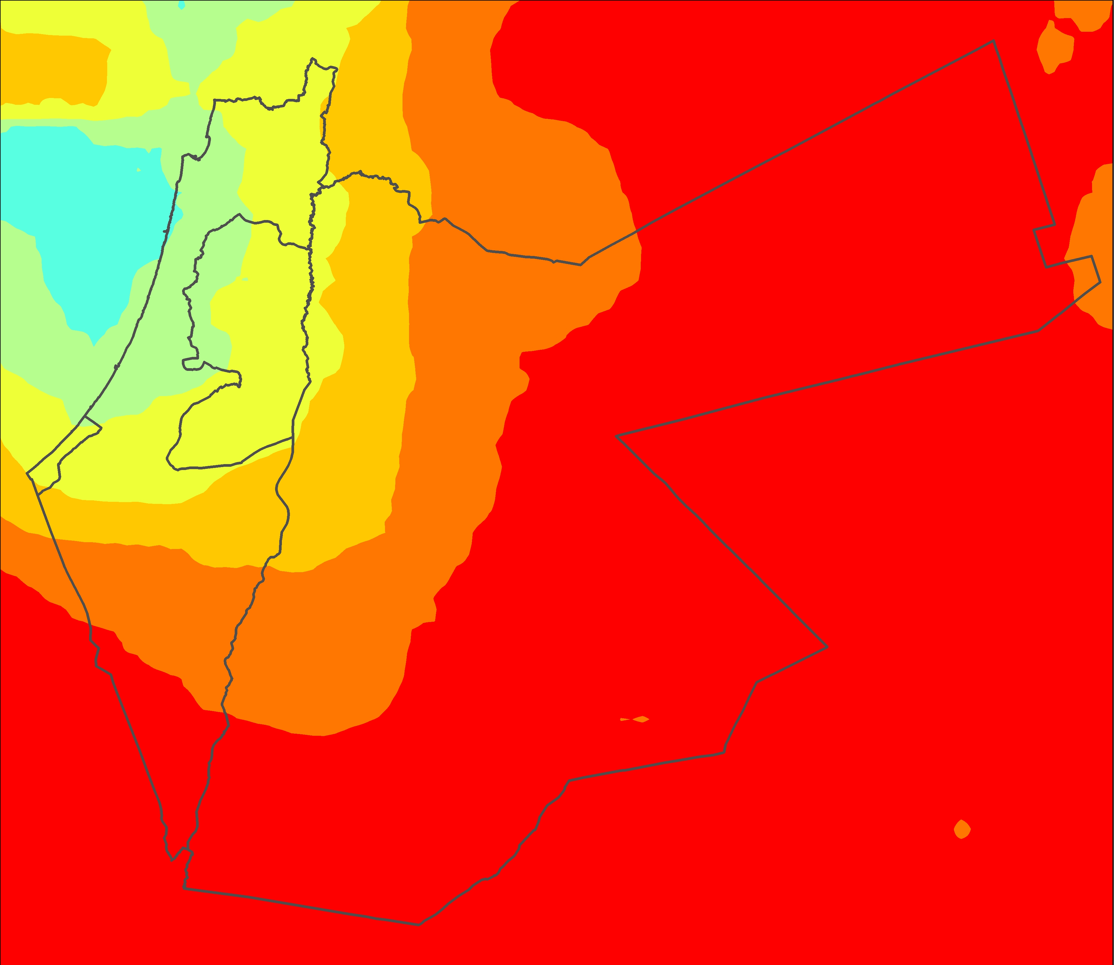

**Caption:** Average precipitation from all available GPM images for the region (March 2014 through January 2016), interpolated using the inverse distance weighted (IDW) interpolation technique. Image Credit: Middle East Water Resources Team.

**Image:** 2016Sum_LaRC_MiddleEastWater_VPSimage