**NASA DEVELOP National Program**



Mobile County Health Department

*Fall 2016*

Southeastern Arizona Water Resources

Using NASA Earth Observations to Assist the National Park Service in Assessing Snow Cover Distribution and Persistence Changes in the Sky Islands

**Technical Report** 

Final Draft – November 17, 2016

Saranee Dutta (Project Lead)

Farnaz Bayat

Elaina Gonsoroski

Katie Harville

Tyler Lynn

Advisors and Mentors:

Dr. Bernard Eichold, M.D., Dr. PH, Mobile County Health Department (Mentor)

Joseph Spruce (NASA Langley Research Center) – Main Science Advisor

Dr. Kenton Ross (NASA Langley Research Center) – DEVELOP National Science Advisor

# 1. Abstract

Saguaro National Park in southeastern Arizona occupies one of several unique mountain ranges known collectively as the Sky Islands or the Madrean Archipelago. The Sky Islands are biodiversity hotspots and host different ecosystems, ranging from arid deserts to temperate forests. Snowmelt provides a source of water during the dry season for the various flora and fauna that inhabit the Sky Islands. However, climate change and its effect on snow cover is of growing concern. Currently, the National Park Service (NPS) monitors water presence, but a more synoptic record of snow presence does not exist due to the remote and rugged topography of the region. As a result, it is difficult to study how climate change has affected water resources in the Sky Islands and what effect this has on wildlife and vegetation. This project used NASA Earth observations to aid the NPS in understanding the role of snow cover in the Sky Islands. Historical snow cover maps were created to address the current gap in information regarding snow presence. With a more complete understanding of the impact of snow cover, the NPS will be able to analyze past snow cover changes to improve future land management decisions.

**Keywords**

Biodiversity hotspot, climate change, hydrology, Madrean Archipelago, remote sensing, Saguaro National Park, Sky Islands, stream gage, watershed

# 2. Introduction

* 1. ***Background Information***

**Background** - Saguaro National Park in southeastern Arizona is partially located on an assemblage of mountains known together as the Sky Islands. This region includes more than forty Sky Islands collectively referred to as the Madrean Archipelago, a stepping stone sequence of valleys and mountains located between the Rocky Mountains and the Sierra Madre Occidental region. The Sky Island’s system of mountains and valleys results in stacked biological communities and isolated evolutionary habitats that include biodiversity hotspots. The latter consist of montane forests at the higher altitudes surrounded by lower elevation arid desert scrub or grasslands (Warshall 1986). The Sky Islands’ ecosystem has a unique relationship to the water resources available in the region because it is only there that, as a long-term average, precipitation input exceeds evapotranspiration to the extent that forest vegetation can survive (Brown et al, 2007). Due to the arid climate of this region, runoff from melting snowpack provides a critical source of water during the dry summer season (Gottfried and Ffolliott 2011; Ffolliott et al. 1996). Without the contributions from snowmelt runoff, the many streams, springs, and seeps located throughout the Sky Islands would exhibit extremely low water levels at an earlier time of year and, in some cases, dry out completely or more quickly relative to historic records. A lack of available water due to a dwindling annual snowpack would seriously endanger the flora and fauna that inhabit the Sky Island region.

Given the significant ecological role of snow in the region, how climate change has and will continue to affect snow cover extent and persistence is of growing concern to the region’s natural resource managers. Noted climate change effects in the Southwestern United States include significant increases in temperature across the region. Warming temperatures cause shifts in winter precipitation patterns, e.g. precipitation is falling as rain rather than snow (Misztal et al, 2013; Robles and Enquist 2010). This will reduce the volume of water that soaks into the ground as snow melts. A shift from a snow regime towards a rain regime leads to changes in the year distribution of mean stream flow (Stewart et al, 2005; Regonda et al, 2005) which can cause significant impacts on human freshwater resources (Barnett et al, 2005) and disruptions of ecosystem functioning (Bunn & Arthington 2002; Cayan et al, 2001).

**Community Concerns** -Snowmelt recharges the region’s groundwater reserves and provides a source of water during the dry season for the flora and fauna that inhabit the sky islands. Reduced annual snowpack has potential to negatively impact an ecosystem at every level. Consequently, changes in water resources could have a negative effect on riparian habitats. Additionally, many visitors to the backcountry rely on water from streams and other natural sources. Understanding changes in water resources can aid the park managers to plan and manage for visitors.

**Current Management Practices & Policies** -Currently, resource managers at Saguaro National Park and the National Park Service (NPS) use empirical field data on stream water flow collected manually or electronically from remote sites located within the park. To date, the inclusion or consideration of remote sensing data is rare. However, the NPS does not have a method to consistently collect snow cover data in a synoptically and temporally effective manner, resulting in a major gap in spatio-temporal hydrologic information needed by resource managers. This project aimed to fill gaps in the information which is currently missing such as snow persistence, cover and depth. With such additional data, the NPS can better assess potential changes in the hydrology of the park due to climate change and make informed decisions such as when to implement prescribed burns. In addition, it would help resource managers better understand which aquatic species may become threatened due to hydrological changes, and if riparian habitats and stream flow will become threatened by changes in snowpack. With such information, the NPS should also be able to improve their understanding of how backcountry visitors will be affected by changing water resources and if supplementary water supplies should be considered. The Southeastern Arizona Water Resources team collaborated with partners from the NPS, Intermountain Region and Saguaro National Park and used NASA Earth observations to model the impact of climate change on water resources in the sky islands.

**Study Area** - The overall study area consisted of the Sky Islands located in southeastern Arizona and portions of Mexico covering roughly 45,156 sq. km in area. This term the team focused on the sky islands and watersheds within the high elevations of Saguaro National Park (Figure 1).

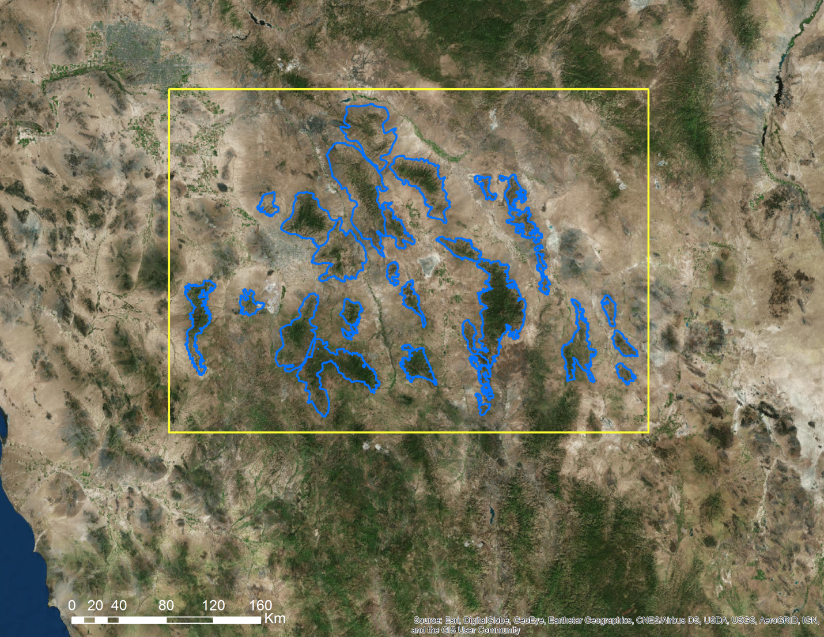

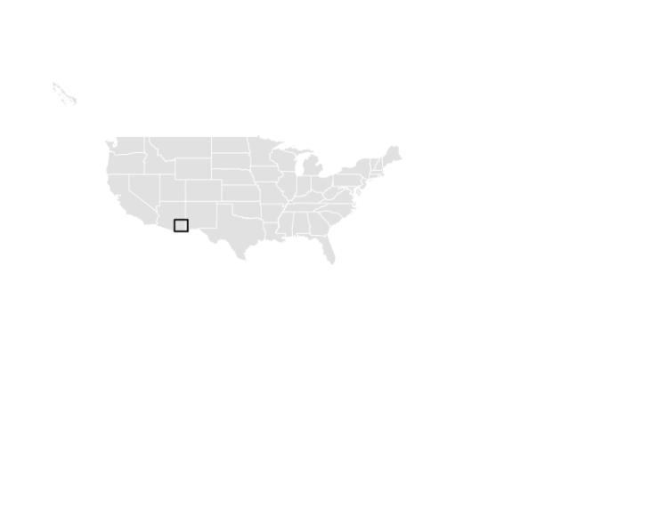

Figure 1: Study area

**Study Period** - The study period for this project ranged from 1985 to 2016. This time period was influenced by the availability of Landsat and Aqua and Terra Moderate Resolution Imaging Spectroradiometer (MODIS) data collected from 2000 to present. Landsat data collected from 1985 to present provides a higher spatial resolution (30m) than MODIS (500m). MODIS was selected due to its higher temporal resolution with two images collected every day whereas Landsat collects only 1 wall to wall image every 16 days.

* 1. ***Project Partners & Objectives***

**National Application Addressed** - This project addressed NASA’s Climate and Water Resources application areas by using NASA Earth observations to understand the impact of climate on water resources in the sky island regions.

**Project Partners** - Partners for this project include the National Park Service, Intermountain Region and the National Park Service, Saguaro National Park.

**Objectives** - The goal of this project is to compute snow maps and to assess snow cover distribution in the Sky Island regions, using NASA Earth observations (MODIS and Landsat) data. In doing so, the team conducted a historical assessment of snow distribution from 1985 to present in addition to analyzing recent trends in snow cover. Also, snow cover data from satellite sources were compared to stream discharge to assess the effects of snow on water flow.

3. **Methodology**

***3.1 Data Acquisition***

Aqua and Terra MODIS standard snow cover products horizontal tile number 08 and vertical tile number 05 were obtained from NASA’s Land Processes Distributed Active Archive Center (LP DAAC) for the years 2002 through 2016. Data from Landsat 5 Thematic Mapper (TM), Landsat 7 Enhanced Thematic Mapper Plus (ETM+), and Landsat 8 Operational Land Imager (OLI) were obtained through the United States Geological Survey’s EarthExplorer from 1985 to 2016 for all dates containing <30% cloud cover from October through April of the following year . The team acquired data for Landsat row 38, path 36 which covered the Rincon Mountains and Saguaro National Park East, the focus area for the first term of the project. Stream gauge data was downloaded from the USGS website for streams of interest in the Rincon Mountains.

***3.2 Data Processing***

***3.2.1 MODIS data processing***

The ArcGIS model builder was used to process the Aqua and Terra MODIS snow cover products. The NDSI subdataset from the MODIS standard snow cover products were used to identify pixels likely to be snow within the study area using a ratio between the visible green reflectance and the Short Wave Infrared (SWIR) reflectance (Table 1). The standard snow cover products were inserted into model builder and iterated in order to extract, clip, and reproject all MODIS NDSI rasters to the study area. (Figure A-1). In total, 2534 Aqua MODIS and 2896 Terra MODIS files were processed.

***3.2.2 Landsat data Processing***

Landsat 5 TM, Landsat 7 ETM+ and Landsat 8 OLI data were scaled to Top of Atmosphere (TOA) reflectance. Atmospheric corrections were applied using a TOA reflectance script in the DEVELOP National Program Python Package (dnppy). Next, the team created a script in Python to iterate through files which had been scaled to TOA reflectance and calculate the NDSI from these files. To do this, the green and short wave infrared (SWIR) bands (Table 1) were used in a band ratio (1):

$NDSI=\frac{Green-SWIR}{Green+SWIR}$ (1)

where values greater than 0.4 were more likely to be snow (Dozier and Painter 2004). Next, the data was reclassified into categories of values which were indicated as snow or another spectral value. These processes were completed for 430 Landsat dates (i.e. data sets) in total. This provided the team with raster data to compare between years for analyses alongside data from stream gauges.

**Table 1:** MODIS and Landsat band wavelengths used to calculate the NDSI.

|  |  |  |
| --- | --- | --- |
|  | **Green Band (Wavelength)** | **SWIR Band (Wavelength)** |
| **Landsat 5 TM** | Band 2 (0.52 – 0.60 µm) | Band 5 (1.55 – 1.75 µm) |
| **Landsat 7 ETM+** | Band 2 (0.52 – 0.60 µm) | Band 5 (1.55 – 1.75 µm) |
| **Landsat 8 OLI** | Band 3 (0.53 – 0.59 µm) | Band 6 (1.57 – 1.65 µm) |
| **MODIS** | Band 4 (0.545 – 0.565 µm) | Band 6 (1.628 – 1.652 µm) |

***3.3 Data Analysis***

The MODIS NDSI product identified reflectance values likely to be snow using a ratio between the visible green reflectance and the Short Wave Infrared (SWIR) reflectance. Digital values of pixels ranging between 0 and 100 were classified as snow in regards to each MODIS NDSI data input (Rigs and Hall 2015). However, the resolution of MODIS NDSI data was 500m. Consequently, the amount of snow cover visibly differed from Landsat NDSI-based snow maps in part due to differences in spatial resolution between MODIS and Landsat data (Figure 2).

Using ArcMap 10.4.1, the snow percent for each watershed within the Rincon mountain boundary was calculated for all data acquired from Landsat 5 TM (1985-2011) and Landsat 8 (2013-2016). The NDSI data for each year was classified to show the snow presence (with values over 0.4). Then the Zonal Histogram tool from the Spatial Analyst toolbox was used to create an image showing the number of pixels within the different land type categories. The percent of the total area covered by snow was calculated using this data after the data were exported to an excel sheet, allowing for comparison between and study of the snow percent fluctuations for the Rincon Mountain watersheds.

Preliminary analysis was performed to understand the historical snow cover in the study area. The zonal histogram tool was used to calculate frequency distribution of snow pixel for all Landsat data to show pixels as snow or other. A pixel was classified as snow if the NDSI reflectance value for that pixel was greater than 0.4. (Figure A-2). Remaining pixels were classified as other. The watershed boundaries located on the Rincon Mountain were used as a zone to extract NDSI. The data were exported in Excel to create a database for graphical analysis.

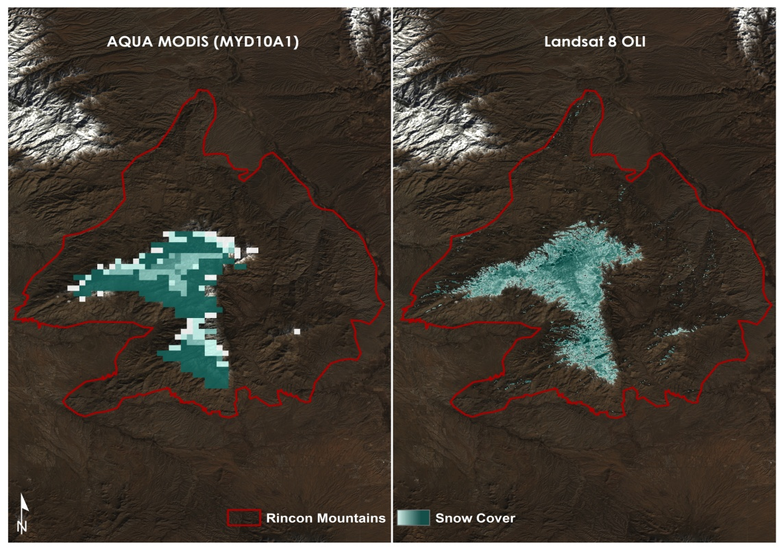

Figure 2: A side by side visual comparison between Aqua MODIS NDSI data (left) and Landsat 8 OLI NDSI data (right). Here the difference in resolution can easily be seen.

# 4. Results & Discussion

***4.1 Analysis of Results***

The stream gauge data was obtained by the team from the United States Geological Survey (USGS) (Figure 3). For this term the team specifically focused on the Rincon Creek stream gauge data and watersheds located on the Rincon Mountain as this is where the eastern portion Saguaro National Park is located. The stream gauge data was compared to NDSI data from Landsat in order to gain an understanding of how snow may affect water resources in the park. Average maximum stream discharge was observed for the year 1995. The large peak observed during January - February and November - December are probably the result of melting snow (Figure 4). A downward trend was observed from April - September when average stream discharge is lower than usual. Runoff from snowmelt varies not only by season but also by year (Dettinger and Cayan, 1995). We observed high peaks of streamflow for the year 1992 with a much smaller stream flow for 1996. This is most likely due to the severe 1996 drought in Arizona (Goodrich and Ellis, 2006). The winter and spring of 1995-1996 was one of the driest on record in the southwestern United States (NOAA, June 1996).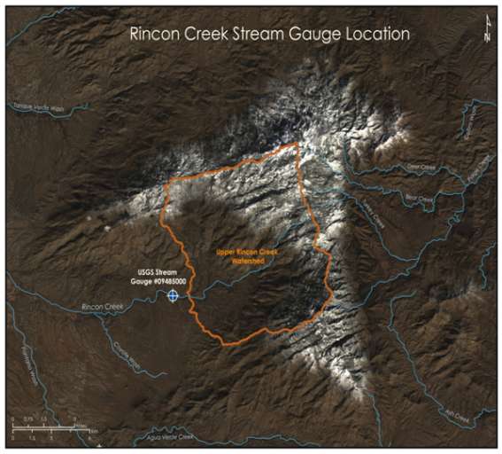

Figure 3: The Rincon Creek stream gauge shown in relation to the Upper Rincon Creek watershed.

Figure 4: Graph showing the stream discharge for each year.

Snow is a major component in the hydrological cycle in this region and a primary source of water to natural ecosystems and human populations in the western United States. Runoff from snowmelt recharges groundwater aquifers and reservoirs located downstream. The USGS estimates as much as 75% of water supplies in the western US are derived from snow melt (Dettinger, 2005).

The Landsat NDSI data for the Rincon Mountain was used when the data was cloud free over the mountain. The snow cover area was calculated by reclassifying rasters in ArcMap to show pixels as either snow or other. Landsat data was used to identify percent snow cover area for Upper Rincon Creek watershed (Figure A-3). Percent snow cover was compared with average monthly streamflow to understand the contribution of snowmelt in stream flow in order to gain a better understanding of how snow is impacting water resources in the Sky Island region (Figure 5). Percentage of snow cover within each watershed was estimated using Landsat data.

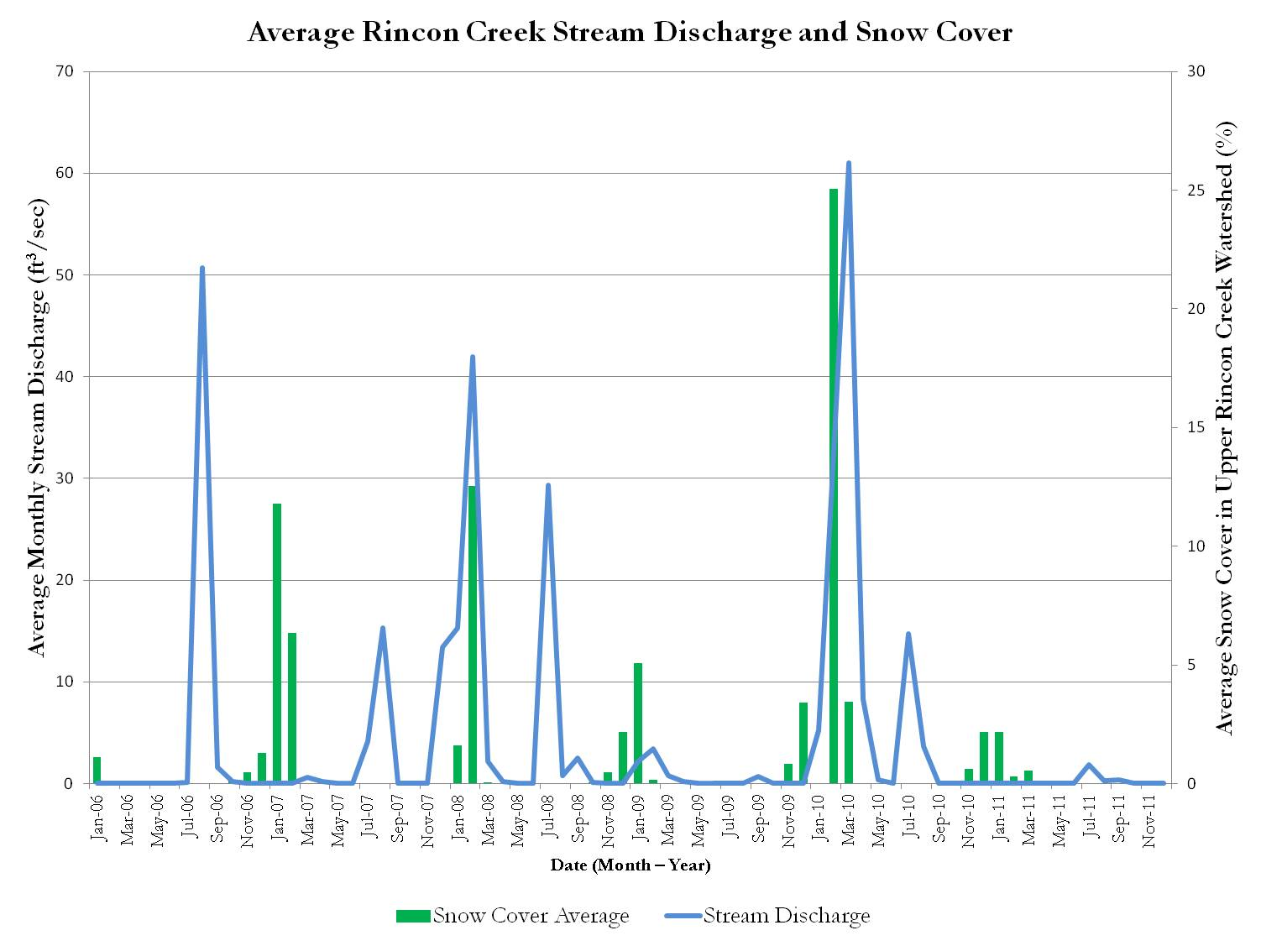

Figure 5: Graphical depiction of the average monthly snow cover as a percent of the total area of the watershed (green) and the average monthly stream discharge (blue).

***4.2 Errors & Uncertainty***

Pixel values falling within the range of snow values (>0.4) for NDSI may have been falsely categorized as snow due to factors such as atmospheric contamination, topographic shadow, or mixed pixels. Atmospheric contamination inhibits the number of pixels that may be observed in the study area. Topographic shadow may have also inaccurately given pixel values a higher or lower pixel value, potentially resulting in that pixel’s value falling below the threshold of values typically identified as snow. Additionally, geologic landforms within our study area may have exhibited similar spectral signatures to that of snow and thus resulted in the overestimation of snow cover area for that date. Another uncertainty in the project may have resulted through the use of mixed pixels in the estimation of snow cover area. Mixed pixels may have over or underestimated the snow cover area as an entire pixel may entirely consist of a singular land cover type such as snow. Clouds and cloud shadows also represent a source of error. The ability to mask out the clouds and cloud shadows is imperfect. In some cases, too little atmospheric contamination can be removed. In other cases, too much atmospheric contamination is removed with omission of real snow covered areas as a result. Alternative data processing may help reduce snow classification errors due to mixed pixel and residual, unmasked atmospheric contamination effects.

***4.3 Future Work***

In the following term, the team will include additional spectral indices such as the Normalized Difference Vegetation Index or Normalized Difference Water Index in order to hopefully improve snow classifications from Landsat and MODIS data. These indices will be used in conjunction with the NDSI to more accurately identify areas of snow cover for the entire Sky Island region. Future work will also include applying additional corrections to the NDSI data to more accurately classify snow cover in areas where cloud cover, topographic shadows, or water may not be accurately identified as snow. Additionally, the team will expand in-depth watershed analyses to include all of the Sky Islands in the study area. The inclusion of additional data such as precipitation and temperature will be used in the future to help provide a better understanding of the impact of multiple factors on water resources within the Sky Islands region.

# 5. Conclusions

The team was able to do a preliminary analysis of snow cover and its effect on water resources by focusing on just the Upper Rincon Creek watershed and the Rincon Creek stream gauge for the first term of the project. The NDSI values above 0.4 for Landsat data were categorized as snow. The months chosen for study in the Upper Rincon Creek watershed ranged from October through April due to the higher likelihood of snow presence during these months. For the period of 1985 to 2016, the areal percentage of snow cover within the Upper Rincon Creek watershed was never higher than 30% of the watershed area on the Landsat data collection date except for February 28, 1987 where the percentage of snow cover was approximately 68%. While no other long term trends have been identified, preliminary analyses identified a lag between snow presence and higher volumes of stream discharge due to the delay in snowmelt runoff. More analyses to identify other factors which contribute to the length of this lag time will continue.

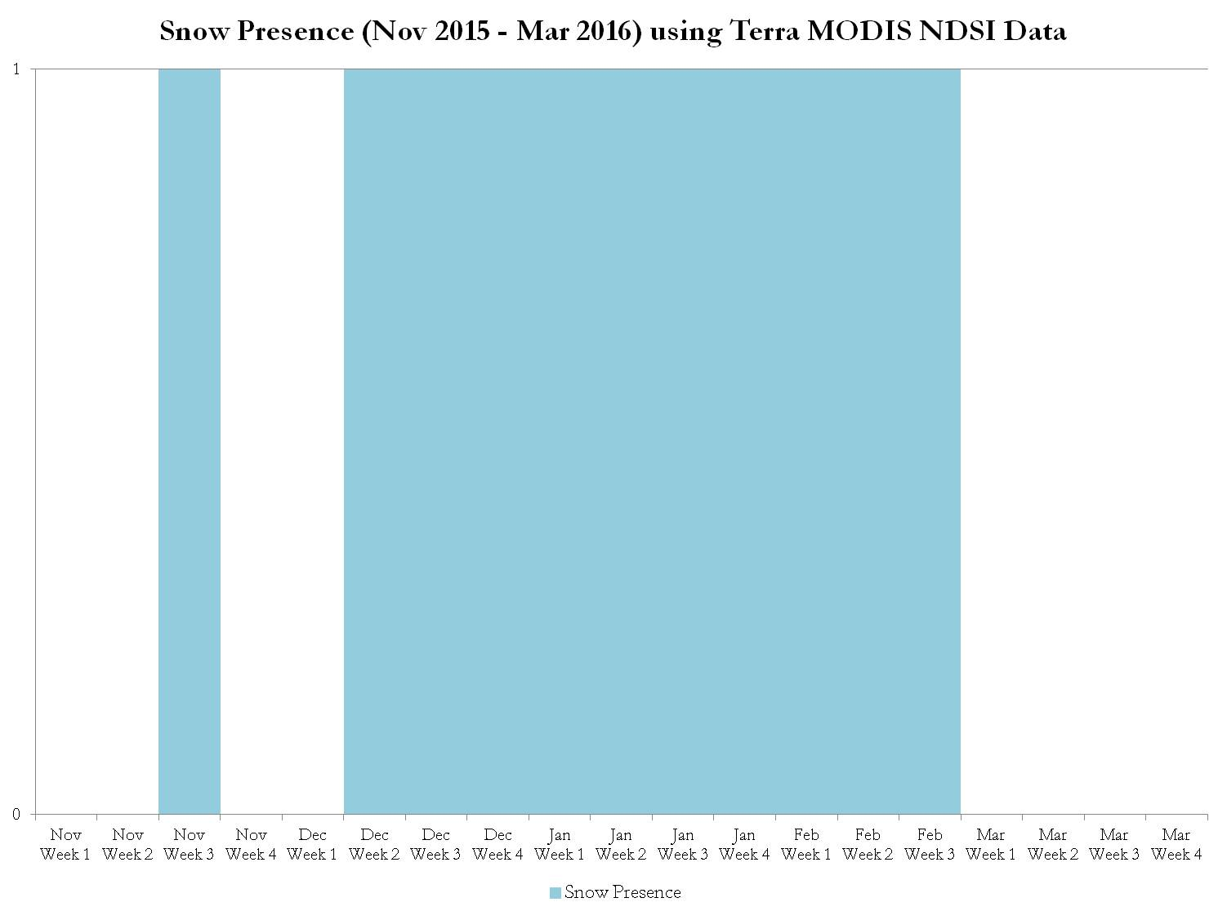

Figure 6: Shown here is a graphical representation of snow presence by week for one season (November 2015 - March 2016) using Terra MODIS NDSI data. A value of 1 indicates that snow was present and a value of 0 indicates there was no snow present during that week.

Although Landsat data offered a higher spatial resolution, the added temporal resolution of MODIS could aid when examining the factors which contribute to the duration of snow presence in the Sky Islands (Figure 6) and what affect this timing has on water resources. The project’s first term resulted in time series of MODIS and Landsat-based snow distribution maps. It allowed initial exploratory analyses of the satellite-based snow maps and sets the stage for a follow-on project to be done in the spring of 2017. Continued analyses will provide a more complete understanding of the impact of snow cover. With this information the NPS will be able to analyze past snow cover changes, and establish well-informed water resource management strategies that can be adapted to the southeastern Arizona Sky Islands region.

# 

# 6. Acknowledgments

The Southeastern Arizona Water Resources team would like to thank the following for their assistance and support in the completion of this project:

* **Colleen Filippone**, National Park Service, Intermountain Region (Project Partner)
* **Don Swann**, National Park Service, Saguaro National Park (Project Partner)
* **Bernard Eichold**, M.D., Dr. PH, Mobile County Health Department (Mentor)
* **Joseph Spruce**, NASA Langley Research Center (Science Advisor)
* **Kenton Ross**, PhD, NASA Langley Research Center (Science Advisor)

Any opinions, findings, and conclusions or recommendations expressed in this material are those of the author(s) and do not necessarily reflect the views of the National Aeronautics and Space Administration.

This material is based upon work supported by NASA through contract NNL11AA00B and cooperative agreement NNX14AB60A.

# 7. References

Barnett, T. P., Adam, J. C., & Lettenmaier, D. P. (2005). Potential impacts of a warming climate on water availability in snow-dominated regions. *Nature*, 438(7066), 303-309.

Brown-Mitic, C., Shuttleworth, W. J., Harlow, R. C., Petti, J., Burke, E., & Bales, R. (2007). Seasonal water dynamics of a sky island subalpine forest in semi-arid southwestern United States. *Journal of arid environments*, *69*(2), 237-258.

Bunn, S. E., & Arthington, A. H. (2002). Basic principles and ecological consequences of altered flow regimes for aquatic biodiversity. *Environmental management*, *30*(4), 492-507.

Cayan, D. R., Dettinger, M. D., Kammerdiener, S. A., Caprio, J. M., & Peterson, D. H. (2001). Changes in the onset of spring in the western United States. *Bulletin of the American Meteorological Society*, *82*(3), 399-415.

Dettinger, M. (2005). *Changes in streamflow timing in the western United States in recent decades... from the National Streamflow Information Program* (No. 2005-3018). Geological Survey (US).

Dettinger, M. D., & Cayan, D. R. (1995). Large-scale atmospheric forcing of recent trends toward early snowmelt runoff in California. *Journal of Climate*, *8*(3), 606-623.

Dozier, Jeff, & Painter, Thomas H. (2004). Multispectral and Hyperspectral Remote Sensing of Alpine Snow Properties. *Annual Review of Earth and Planetary Sciences,* 32, 465-94.

Ffolliott, P. F., Gottfried, G. J., & Baker Jr, M. B. (1996). The Role of Snow in the Hydrology of the Madrean Province in Southeastern Arizona. *Hydrology and Water Resources in Arizona and the Southwest*. Arizona-Nevada Academy of Science.

Goodrich, G. B., & Ellis, A. W. (2006). Climatological drought in Arizona: An analysis of indicators for guiding the governor's drought task force. *The Professional Geographer*, *58*(4), 460-469.

Gottfried, G. J., & Ffolliottz, P. F. (2011). Contributions of Snowmelt to Streamflow in Southeastern Arizona: A Case Study from the Santa Catalina Mountains. *Hydrology and Water Resources in Arizona and the Southwest,* 47.

Misztal, L. W., Garfin, G., & Hansen, L. (2013). Responding to climate change impacts in the Sky Island Region: From planning to action. In: Gottfried, Gerald J.; Ffolliott, Peter F.; Gebow, Brooke S.; Eskew, Lane G.; Collins, Loa C. Merging science and management in a rapidly changing world: Biodiversity and management of the Madrean Archipelago III and 7th Conference on Research and Resource Management in the Southwestern Deserts; 2012 May 1-5; Tucson, AZ. Proceedings. RMRS-P-67. Fort Collins, CO: U.S. Department of Agriculture, Forest Service, Rocky Mountain Research Station, 60-66.

NOAA, June 1996. Special climate summary 96/2: Drought in the Southern Plains and the Southwest.

Regonda, S. K., Rajagopalan, B., Clark, M., & Pitlick, J. (2005). Seasonal cycle shifts in hydroclimatology over the western United States. *Journal of Climate*, *18*(2), 372-384.

Riggs, George A., & Hall, Dorothy K. 2015. MODIS Snow Products Collection 6 User Guide.

Robles, M. D., and C. E. F. Enquist. 2010. Managing changing landscapes in the southwestern United States. A report of the Southwest Climate Change Initiative. The Nature Conservancy, Tucson, AZ. 26 pp.

Stewart, I. T., Cayan, D. R., & Dettinger, M. D. (2005). Changes toward earlier streamflow timing across western North America. *Journal of climate*, 18(8), 1136-1155.

Warshall, P. (1995). The Madrean sky island archipelago: a planetary overview. *Biodiversity and management of the Madrean Archipelago: the sky islands of southwestern United States and northwestern Mexico*, 6-18.

# 8. Content Innovation

**Content Innovation #1**

Featured Multimedia: VPS, 2016Fall_MCHD_SoutheasternAzWater_VPS-final.mp4

**Content Innovation #2**

Glossary Viewer

Arid – Extremely dry with little to no vegetation

Biodiversity – The biological diversity of plants and animal species in an environment

Biodiversity Hotspot – An extremely diverse biogeographic region that also supports high diversity of endemic species and also is threatened with destruction

Ecosystem – A natural system consisting plants, animals and other microorganism communities and how they interact with their nonliving environment as a functional unit

Hydrology – Study of water including distribution, movement, conservation and properties of water on the earth

Madrean Archipelago – Stepping stone chain of isolated mountains between the Rocky Mountains and the Sierra Madre Mountains

NASA’s Earth Observing Systems - Series of satellites designed for long term global observation of the land surface, atmosphere, biosphere and oceans to monitor environmental changes

Normalized Difference Snow Index – A band ratio that uses reflectance off of the earth’s surface to identify snow from other surface features

Remote Sensing – the process of gathering information about an object or phenomena without making physical contact with the subject

Sky Islands – Isolated, high elevation, forested mountains that are separated by low desert scrubland

Stream Gauge – Location of a gauging station that collects volume and movement of water in a stream

Temperate Forest – A forested area characterized by moderate climate, exhibits four seasons and contain variety of deciduous trees

Watershed – A drainage basin that receives waters flowing from upland rivers, streams and drains into river systems or other water bodies such as wetlands and estuaries

**Content Innovation #3**

Interactive Map Viewer: Fall2016_MCHD_SoutheasternAZWater_InteractiveMapViewer.kmz

**9. Appendices**



Figure A- 1: Model using geoprocessing functions to extract, clip, and project MODIS data.



Figure A- 2: Zonal histogram calculates frequency distribution of pixels in each class for Upper Rincon Creek Watershed for January 11, 2016.

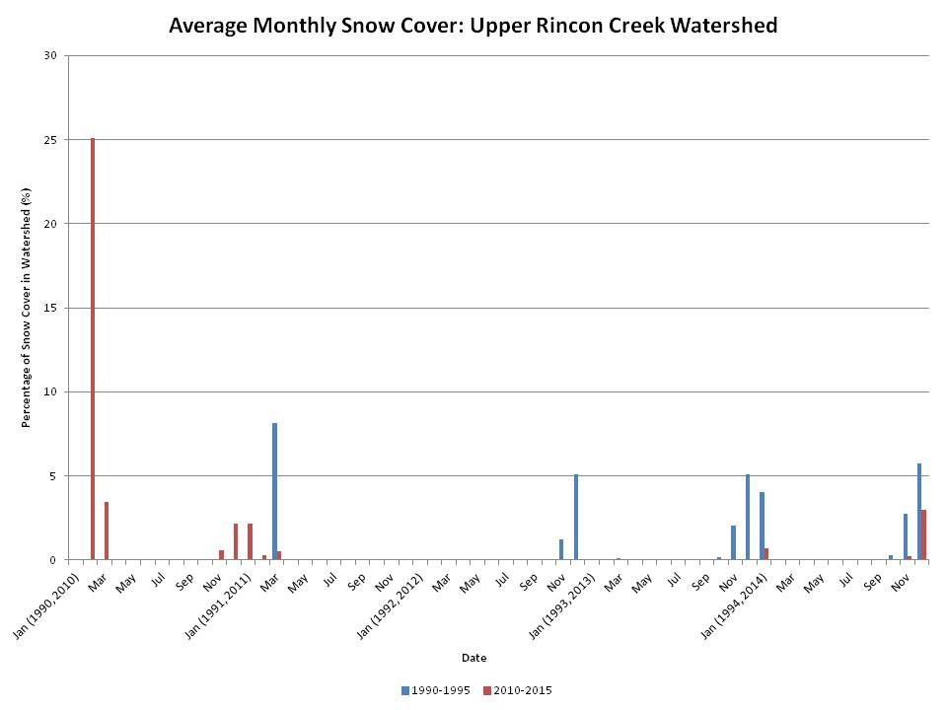

Figure A- 3: Average snow cover in the Upper Rincon Creek watershed as a percent of the total area. Graph shows data for the years 1990-1995 and 2010-2015.