**NASA DEVELOP National Program**

****Mobile County Health Department

**Fall 2016**

**Short Title: Southeastern Arizona Water Resources**

**Subtitle:** Using NASA Earth Observations to Assist the National Park Service in Assessing Snow Cover Distribution and Persistence Changes in the Sky Islands

**VPS Title:** The Final Meltdown

**Project Team & Partners**

**Project Team:**

Saranee Dutta (Project Lead), saranee.dutta@gmail.com

Farnaz Bayat

Elaina Gonsoroski

Katie Harville

Tyler Lynn

**Advisors & Mentors:**

Bernard Eichold, M.D., Dr. PH (Mobile County Health Department)

Joseph Spruce (NASA Langley Research Center)

**Partner Organizations:**

|  |  |  |  |
| --- | --- | --- | --- |
| **Organization** | **POC (Name, Position/Title)** | **Partner Type** | **Boundary Org?** |
| National Park Service, Intermountain Region | Colleen Filippone, Intermountain Region Hydrologist | End-User | No |
| National Park Service, Saguaro National Park | Don Swann, Biologist | End-User | No |

**Project Details**

**Applied Sciences National Applications Addressed:** Water Resources, Climate

**Study Area:** Southeastern Arizona, AZ

**Study Period:** January 1984 – October 2016

**Earth Observations & Parameters:**

Aqua and Terra, Moderate Resolution Imaging Spectroradiometer (MODIS) – standard and value added snow cover products

Landsat 5, Thematic Mapper (TM) – snow cover

Landsat 7, Enhanced Thematic Mapper Plus (ETM+) – snow cover

Landsat 8, Operational Land Imager (OLI) – snow cover

**Ancillary Datasets Utilized:**

* NPS Historical Water Presence Data – water presence
* USDA Natural Resource Conservation Service (NRCS) Snow Telemetry Dataset (SNOTEL)– snow presence
* USGS Stream Gauge Data – stream flow

**Software Utilized:**

* ESRI ArcGIS - raster manipulation and map production
* ERDAS Imagine – image data analysis
* Google Earth Engine – processing of MODIS and Landsat time series data

**Project Overview**

**80-100 Word Objectives Overview:**

Arizona’s Sky Island mountain ranges are among the most diverse ecosystems in the world and snow is a fundamental resource supporting the biodiversity of these mountain ecosystems. The goal of this project was to create an overall assessment of snow cover distribution in the Sky Island regions using NASA Earth observations (MODIS and Landsat) data products. These data produced historical and current snow cover maps across the study area, which will assist our partner organization, the National Park Service, to better understand the impact of climate change on the vegetation and wildlife distributions in the Sky Island region.

**Abstract:**

Saguaro National Park in southeastern Arizona occupies one of several unique mountain ranges known collectively as the Sky Islands or the Madrean Archipelago. The Sky Islands are biodiversity hotspots and host different ecosystems, ranging from arid deserts to temperate forests. Snowmelt provides a source of water during the dry season for the various flora and fauna that inhabit the Sky Islands. However, climate change and its effect on snow cover is of growing concern. Currently, the National Park Service (NPS) monitors water presence, but a synoptic record of snow presence does not exist due to the remote and rugged topography of the region. As a result, it is difficult to study how climate change has affected water resources in the Sky Islands and what effect this has on wildlife and vegetation. This project used NASA Earth observations to aid the NPS in understanding the role of snow cover in the Sky Islands. Historical snow cover maps were created to address the current gap in information regarding snow presence. With a more complete understanding of the impact of snow cover, the NPS will be able to analyze past snow cover changes to improve future land management decisions.

**Keywords:**

Biodiversity Hotspot, climate change, hydrology, Madrean Archipelago, remote sensing, Saguaro National Park, Sky Islands, watershed

**Community Concerns**

* The Southwestern United States is experiencing significant increases in temperature across the region due to climate change.
* Effects associated with warming climate include shifts in the hydrological cycle, decreased winter precipitation, shifting precipitation patterns towards rain rather than snow, and earlier yearly snowmelt in the Sky Island region.
* Snowmelt feeds streams and water bodies, providing water resources to wildlife and vegetation even during the dry season. Loss of snowpack and increased aridity will have negative impacts on ecosystems at every level and the flora and fauna that inhabit the Sky Islands.

**Current Management Practices & Policies**:

When creating management strategies, resource managers at Saguaro National Park and the National Park Service currently use empirical field data collected by hand or electronically from remote stations located throughout the Arizona portion of the Madrean Sky Island Archipelago. Inclusion of remote sensing data is rare. At the federal level, NPS resource management is guided by Director’s order #12 of the National Environmental Policy Act, and Arizona Title 49 at the state level. Research and management cooperatives, such as the Desert Landscape Conservation Co-op and the Sky Island Alliance, also play a role in resource conservation throughout the study area.

**Decision Support Tools & Benefits:**

|  |  |  |  |
| --- | --- | --- | --- |
| **End-Product** | **Earth Observations Used** | **Benefit & Impact** | **Software**  **Release** |
| Historical Snow Cover Maps | Aqua/Terra MODIS, Landsat 5 TM, Landsat 7 ETM+, Landsat 8 OLI | Establish baseline conditions and methodology for researching snow cover variation | N/A |

**Project VPS/Booklet Imagery**

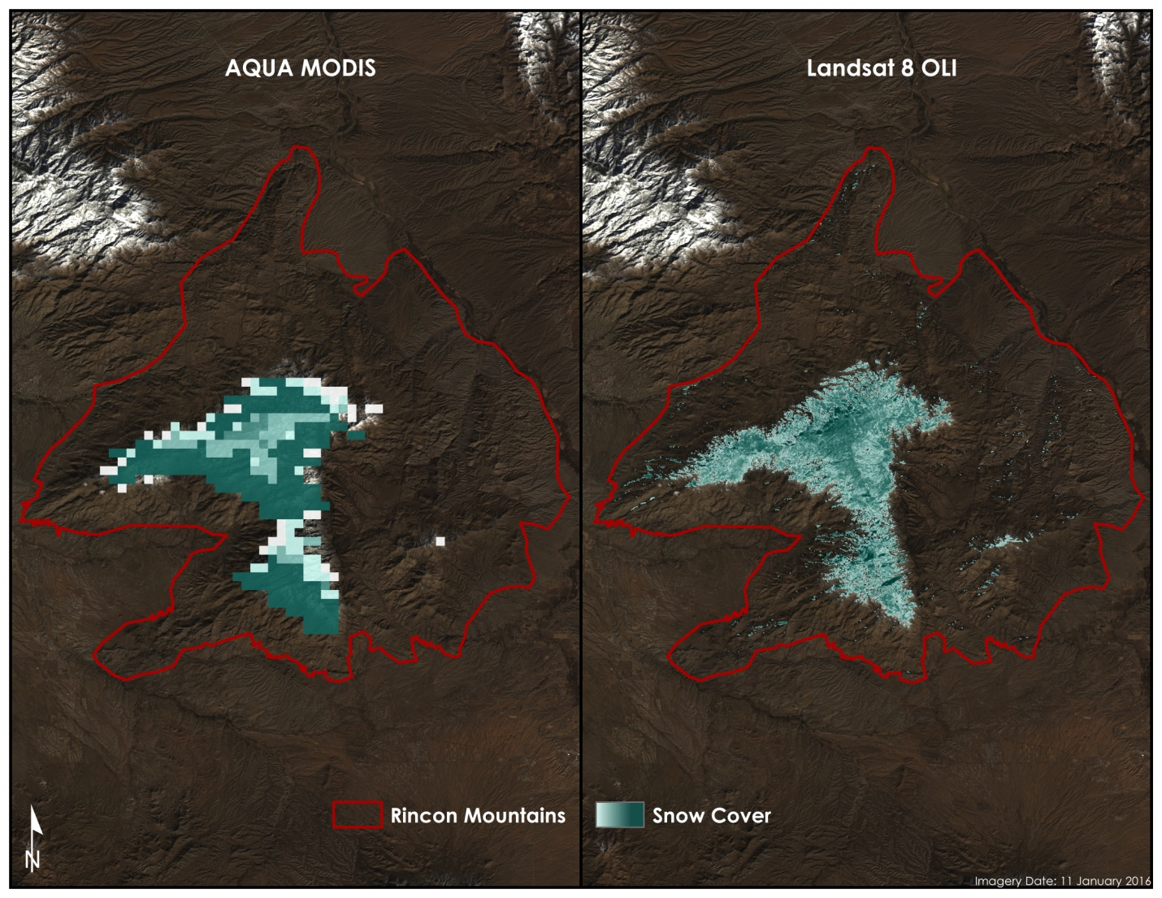

**Caption:** Image of calculated Normalized Difference Snow Index on the Rincon Mountain, Arizona. Image Credit: Southeastern Arizona Water Resources Team.

**Image:** 2016Fall_MCHD_SoutheasternAZWater_VPS.jpeg