NASA DEVELOP National Program
NASA Ames Research Center
Fall 2016

Short Title: Navajo Nation Climate III
Subtitle: Spatial and Inter-annual Variability of Drivers of Drought in the Navajo Nation
VPS Title: Beyond a Shadow of a Drought III
Project Team & Partners
Project Team:
Lauryn Gutowski, Lauryn.D.Gutowski@nasa.gov
Madison Davis
Christina Zapata

Advisors & Mentors:
Ms. Vickie Ly (Bay Area Environmental Research Institute)
Dr. Juan Torres-Pérez (Bay Area Environmental Research Institute)
Dr. Venkat Lakshmi (University of South Carolina)
Dr. Cindy Schmidt (Bay Area Environmental Research Institute)

Past or Other Contributors:
Amber Brooks
Cheryl Cary
Michael Gao
Vickie Ly
Clayton Sodergren
Anton Surunis
Sophie Turnbull-Appell
Mariah Ashley

Partner Organizations:
Organization | POC (Name, Position/Title) | Partner Type | Boundary Org?
Navajo Nation Department of Water Resources (NNDWR), Water Management Branch | Carl McClellan, Senior Hydrologist; Teresa Showa, Principal Hydrologist; Robert Kirk, Principal Hydrologist; Maurice Upshaw, Tech. Support; Jason John, Branch Manager | End-User | Yes
USDA Natural Resource Conservation Services (NRCS) | Brian Domonkos, Colorado Snow Survey Supervisor | Collaborator | No

Project Details
Applied Sciences National Applications Addressed: Climate, Water Resources

Study Area: The Navajo Nation, located at the intersection of Arizona (AZ), New Mexico (NM), and Utah (UT)

Study Period: June 1981 to August 2016

Earth Observations & Parameters:
- Gravity Recovery and Climate Experiment (GRACE) (April 2002 - July 2016) – Root Zone Soil Moisture, Assimilation outputs using the Catchment Fortuna-2.5 land surface model
- Terra Moderate Resolution Imaging Spectroradiometer (MODIS) (March 2003 – September 2016) – Land Surface Temperature

Ancillary Datasets Utilized:
- University of California Santa Barbara, Climate Hazards Group InfraRed Precipitation with Station data (CHIRPS) – precipitation rate (January 1981 – August 2016)
- National Weather Service's National Operational Hydrologic Remote Sensing (NOHRSC) SNOw Data Assimilation System (SNODAS) – snow water equivalent (SWE) (October 2003 - August 2016)NNDWR shapefiles – infrastructure (roads, irrigation areas, dams, political boundaries), lakes, rivers, wells, springs, dams, snowpack, precipitation, streamflow
- NNDWR in situ rain gauge data
- Environmental Protection Agency (EPA) Ecoregions Level III & IV shapefiles

Software Utilized:
- Esri ArcGIS 10.4.1 – Spatial Analysis Toolbox, CHIRPS raster analysis
- Python – Data processing
- Microsoft Excel – Statistical analysis
- R – Calculation of SPI values with SPI package utilizing CHIRPS data, web app development using R Shiny

Project Overview
80-100 Word Objectives Overview:
Severe drought in the arid southwest of the Navajo Nation exacerbates water scarcity and vulnerability. Standardized Precipitation Index (SPI) calculations in DSAT 2.0 derived from CHIRPS satellite data, snow water equivalent (SWE) from SNODAS, land surface temperature (LST) from Terra MODIS, and root zone soil moisture (RZSM) from Assimilated GRACE can provide a more comprehensive picture of statistically significant drought trends where there is spatial and temporal uncertainty. This project’s analysis of SPI and SWE provided early warning indications of drought extent, likelihood, intensity, and recovery as decision makers allocate scarce funding to reservation regions in most need of water.

Abstract:
The Navajo Nation (NN) is a 65,700 km² Native American territory located in the southwestern US that has been experiencing increasing seasonal dust storms, declining in rangeland, and shifting of plant ranges caused by severe drought. Drought exacerbates water resource availability, where one-third live without potable water in homes and resort to hauling water.
Currently, monthly drought monitoring status report summaries issued by the Navajo Nation Water Management Branch (NNWMB) are published by piecing together regional and national hydroclimatic variables such as Standardized Precipitation Index (SPI) to drought classifications. The DEVELOP Ames Navajo Nation Climate I and II teams created a decision support tool called the Drought Severity Assessment Tool 2.0 (DSAT 2.0) to improve visualization of user-specified zonal SPI statistics using the Climate Hazards Group InfraRed Precipitation with Station data (CHIRPS). High annual and seasonal variation make it difficult to assess whether increasing drought trends are significant. This term, the Navajo Nation Climate III team aims to determine whether there are significant temporal and spatial trends of SPI from DSAT2.0, in addition to other drought indicators such as snow water equivalent (SWE) from NOAA's Snow Data Assimilation System (SNODAS), land surface temperature (LST) from Terra MODIS, and root zone soil moisture (RZSM) from Assimilated GRACE. Precipitation, SWE, RZSM, LST were analyzed for statistical anomalies, as well as spatial and temporal trends, to enable enhanced decision-making capacity regarding imminent economic and agricultural impacts from water resources in the NN.

Keywords:
Remote Sensing, Drought, Standardized Precipitation Index (SPI), Water Management, Snow Water Equivalent (SWE), root zone soil moisture (RZSM), land surface temperature (LST), Navajo Nation

Community Concerns:
- 70,000 people (~1/3rd) in the Navajo Nation are without direct access to public water systems, and rely heavily on groundwater sources, which are failing to recharge due to prolonged drought.
- Climate change is projected to continue to decrease precipitation, increase temperatures and aridity, and exacerbate drought in the Navajo Nation.
- The Navajo Nation currently relies on an SPI calculation from the Western Regional Climate Center (WRCC) to monitor drought, however, these values are not provided at a spatial resolution fine enough to examine differences in drought severity across the entire Nation.
- Drought has lead to many impacts including rapid decline in range conditions, poorer crop yield, and shifting of plant ranges used for ceremonial and medicinal plants, seasonal dust storms creating infrastructure damage,
- Seasonal dust storms
- Severe economic challenges will require that short-term water resource funds be allocated cautiously for anticipated and on-going long-term drought issues.

Current Management Practices & Policies:
The Navajo Nation Department of Water Resources (NNDWR) currently monitors water conditions using a network of 85 rain gauges, 9 stream gages, 12 weather stations, and 9 snow courses as of November 2010 (NNDWR, 2011). However, limited government funding, as well as staff and infrastructural constraints, have made it difficult to consistently collect these data and maintain an accurate record of rainfall and snow pack across the Navajo Nation. To determine the Navajo Nation’s drought status, the NNDWR uses the Standardized Precipitation Index (SPI), an internationally used probability-based indicator of abnormally wet or dry time periods. The NN currently relies on SPI values that are calculated by the Western Regional Climate Center (WRCC). However, these SPI values represent the region in three large footprints, lacking the spatial resolution needed to provide a detailed understanding of the drought regime within the Nation’s regional boundaries. The NN does not currently calculate the SPI for its specific region, and does not collect or process any remotely sensed data for management purposes (personal communication, Feb. 11, 2015). Previously, the NASA DEVELOP Navajo Nation Climate Team II at Ames Research Center created Drought Severity Assessment Tool (DSAT) 2.0. DSAT 2.0 served as a decision support tool created for the Navajo Nation to allow water managers to use satellite data to calculate and visualize Standardized Precipitation Index (SPI) values specific to chosen boundaries within the reservation. Currently, snow water equivalent (SWE) is estimated at 9 ground level snow courses and 2 SNOTEL sites, where it is collected and distributed to USDA NRCS and later used to calculate early onset of drought (personal communication, Sept. 20, 2016). However, the snow survey sites are currently spatially limited to the Chuska Mountain range, with no SWE estimates in other reservation areas that receive snowpack. Neither land surface temperature nor root zone soil moisture is measured or monitored by the Navajo Nation. Soil moisture was considered by the NNDWR but devices were not implemented.

Decision Support Tools & Benefits:
End-Product | Earth Observations Used | Benefit & Impact | Software  Release
Validation for DSAT 2.0 : in-situ data comparison | CHIRPS | Validating the DSAT 2.0 model and identifying discrepancies between CHIRPS and in-situ rain gauge data will allow the NNDWR to assess the accuracy of the remotely derived SPI values and implement the DSAT model. | N/A
Analysis of inter-annual and seasonal SPI anomalies and major drought events | CHIRPS | The NNDWR will be able to use these graphs and visualizations to illustrate the use of DSAT in their drought management decisions, reports, and papers. | N/A
Time series analysis of Snow Water Equivalent (SWE)  2003-2016 | SNODAS | The NNDWR will be able to visualize spatial and temporal changes of Snow Water Equivalent for the Navajo Nation political boundaries and the minimum bounding rectangle of the HUC-8 watersheds encompassing the NN. This end-product will help the NNDWR better understand and estimate snow pack, summer stream flow, and reservoir. | N/A
Comparison of SPI drought trends and SWE trends | SNODAS | An analysis of SPI and SWE trends provides the NNDWR with a more comprehensive picture of drought regimes and the impact of drought on water availability in the Navajo Nation. | N/A
Time series of LST and RZSM and spatial comparison to other variables | TerraMODIS, GRACE | The NNDWR will be able to use these graphs and visualizations to better understand different symptoms and drivers of drought in the Navajo Nation. | N/A

Project VPS/Booklet Imagery
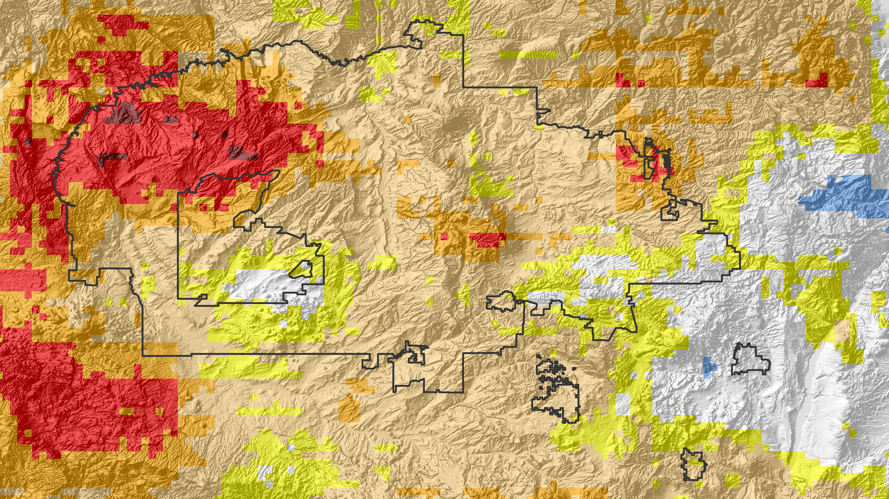

Caption: Standardized Precipitation Index classifications using the US Drought Monitor SPI categories, in July 2014 over the Navajo Nation and surrounding areas.
Image Credit: Navajo Nation Climate III Team.
Image: 2016Fall_ARC_NavajoNationClimateIII_VPSImage.png

