Milwaukee Urban Development
Assessing Climate Vulnerability through the InVEST Model on Urban Cooling in Milwaukee Using NASA Earth Observations


Technical Report
Final – November 17th, 2022

Nash Keyes (Project Lead)
Caleigh McLaren
Nati Phan
Dalia Vazquez

Advisors:
Lauren Childs-Gleason, NASA Langley Research Center (Science Advisor)
Dr. Kenton Ross, NASA Langley Research Center (Science Advisor)

Previous Contributors:
Madeleine Tango (Project Lead)
Jack Acomb
Annika Harrington
Lisa Sun
Marco Vallejos (Fellow)
Remi Work (Assistant Fellow)

Fellow:
Julianne Liu (Virtual Environmental Justice Node)

1. Abstract
Milwaukee’s neighborhoods experience increased social, health, and ecological stress from the Urban Heat Island (UHI) effect due to changing land cover and climate. Extreme urban heat disproportionately affects Black and Latine communities due to systematic disinvestment in infrastructure and lack of resources to cope with heat. Our partner, Groundwork Milwaukee, supports Environmental Justice organizing around urban heat in historically redlined neighborhoods. This study explores heat mitigation in Metcalfe Park, one such neighborhood that is a focus area for our partner, as well as across the city and county of Milwaukee. Our team utilized the Natural Capital Project’s Integrated Valuation of Ecosystem Services and Tradeoffs (InVEST) Model for urban cooling to model heat mitigation scenarios for Milwaukee in support of Groundwork’s climate resilience and heat mitigation work. The data inputs used in our analysis were Land Use Land Cover (LULC), evapotranspiration, and surface temperature derived from NASA Earth observations, as well as a biophysical table containing land cover class attributes. We developed a heat vulnerability index from American Community Survey datasets and satellite imagery to identify areas in most need of heat mitigation intervention. We found that central and northwest city areas, home to a majority of Milwaukee’s Black and Latine population, have low heat mitigation and high vulnerability to heat impacts compared to the rest of the county. We also found that tree canopy increases across scales are effective in promoting heat mitigation. Our results and end products will bolster the efforts of our partners to make decisions on heat mitigation strategies, build community resilience, and reverse legacies of environmental racism in the face of extreme heat and climate change.

Key Terms: urban heat island, urban cooling, InVEST, Environmental Justice, Climate Safe Neighborhoods, environmental vulnerability, systemic racism, redlining

2. Introduction

2.1 Study Area
Milwaukee County is located in southeastern Wisconsin on Lake Michigan, as illustrated in Figure A1. Within lies the city of Milwaukee. The city experiences climate change impacts, such as flood-induced heavy rain and temperature increases. In the coming decades, the region will experience more frequent extreme heat events, which is a public health concern for residents in urban areas.

Milwaukee is the most segregated city in the US, with a population that is 32% White, 38% Black, and 20% Hispanic/Latino (Frey, 2018; US Census Bureau, 2020). The majority of the Black population resides in North and North Central Milwaukee, while the Hispanic/Latino population resides on the central and south sides of the city. Additionally, 24.6% of the population lives below the poverty level as of 2020 (US Census Bureau, 2016-2020).

2.2 Urban Heat Island (UHI) Effect
More impervious land cover in cities causes higher heat retention compared to less developed areas with more vegetation, a phenomenon known as the Urban Heat Island (UHI) effect (Ziter et al., 2019). Milwaukee experiences both urban flooding and urban heat, but focus has remained on flooding because the city is perceived to be cool, making heat a less pressing issue. However, as land cover and the climate changes, UHIs are an increasingly urgent concern for the city.

UHIs have negative implications for human, economic, and environmental well-being, causing dehydration, heat stress, mortality, and exacerbation of preexisting health conditions (Elmes et al., 2020). UHIs increase electricity usage through air conditioning, which exacerbates the utility costs burden for low-income communities, risk of electrical blackouts, and air pollution. Additionally, increased temperatures from UHIs impact water quality and aquatic biodiversity (US EPA, 2014). UHIs can be mitigated through green infrastructure, including Urban Tree Cover (UTC; Elmes et al., 2017).

2.3 Redlining & Environmental Justice
The impacts of UHI disproportionately affect marginalized and low-income communities. This environmental injustice is a result of structural racism, defined as the “ways in which society maintains discriminatory practices that mutually reinforce inequitable systems across a variety of sectors” (Bikomeye et al., 2021, p. 2). These longstanding practices maintain oppression against Black individuals, Indigenous peoples, and People of Color (BIPOC; Bikomeye et al., 2021).

Redlining is a major manifestation of structural racism leading to the inequitable distribution UHI impacts. In the 1930s, the Home Owners’ Loan Corporation (HOLC) created maps of cities in the United States (US) rating neighborhoods on their value for investments. Largely based on racial demographics, these maps gave minority neighborhoods lower grades, which reduced access to credit and affected ability to get property loans for BIPOC city residents (Hoffman et al., 2020). Such neighborhoods have continued to be underfunded, causing increased segregation, lower property values, and disinvestment in environmental resources. Aaronson et al., (2021) found the difference in mean home values between neighborhoods in the highest and lowest HOLC grade ranged from $96,916 to $207,109 between 1930 and 2010, illustrating the lasting impacts of disinvestment. Wealthy, white homeowners could lobby for more trees and parks, while landlords in lower income BIPOC neighborhoods seldom invested in greenspace. Redlined neighborhoods became hubs for industrial development due to cheap land, bringing more impervious surfaces and less vegetation (Plumer & Popovich, 2020). Redlining and ongoing neglect have left urban areas occupied by BIPOC with the highest temperatures and the least resources to cope (Hoffman et al., 2020).

2.4 Term I Results
In the first term of this project, the team analyzed the connections between flood risk and social and environmental spatial data by leveraging the Natural Capital Project’s InVEST urban flooding model. Results showed flood risk was highest in redlined neighborhoods, majority Black and Latine census block groups, areas lacking green space, and low community resilience areas. Additionally, the central downtown area of Milwaukee had poorer runoff retention contributing to greater flood risk associated with increased socioeconomic vulnerability.

2.5 Project Partners
This project was conducted by the DEVELOP Term II Milwaukee team in partnership with Groundwork USA and Groundwork Milwaukee. Groundwork USA is a national network of local trusts across the country that help communities organize around Environmental Justice, influence city-wide decision-making, and build collaborations to address environmental issues. Groundwork and their local partners will use this project’s conclusions and deliverables to provide evidence for policymakers on environmental injustice, promote community education, and inform environmentally-just green infrastructure interventions in the community.

2.6 Project Objectives
Our project applied the InVEST urban cooling model, which estimates urban area’s capacity to mitigate heat. Our team analyzed results obtained from the InVEST model to gain more insight into the relationship between UHI effects, demographics, and historical redlining, as well as to assess the effectiveness of a range of mitigation scenarios. We also developed an urban heat vulnerability index (HVI) to illustrate the drivers and unequal distribution of urban heat and identify vulnerable communities in Milwaukee. The products derived from these results will build Groundwork Milwaukee’s capacity to advocate for more mitigation strategies and will help educate residents on environmental risks in their communities.

3. Methodology

3.1 Environmental Justice
Throughout this project, our team prioritized Environmental Justice and its relationship to structural racism. We chose to adhere to the definition of Environmental Justice by Charles Lee, which has been revised from the 1992 EPA definition. Lee (2021) defines Environmental Justice as “the fair treatment and meaningful involvement of all people regardless of race, color, national origin, or income with respect to the development, implementation, and enforcement of laws, regulations, and policies that affect the environment and/or public health” (p.336). Lee (2021) further notes that Environmental Justice must strive to ensure the equitable distribution of resources, prioritize the most vulnerable communities, prevent and mitigate environmental hazards, identify unjust policies and practices, and address systemic barriers to achieving healthy and sustainable communities.

Since our analysis was focused on the spatial distribution and drivers of urban heat, heat mitigation capacity, and heat vulnerability, we strove to incorporate community perspectives through an Environmental Justice lens into every aspect of our work to the best of our ability. We discussed the connections between social factors, redlining, and heat mitigation capacity, as well as heat vulnerability. Our team also investigated mitigation strategies that were in alignment with current community goals. Throughout our project, we strived to uphold the principles of equity and Environmental Justice.

3.2 Data Acquisition
We accessed and processed a combination of NASA satellite observations and auxiliary datasets in order to run the InVEST urban cooling model and analyze the UHI effect’s relationship with sociodemographic factors. The NASA Earth observation inputs are listed in Table B1, while auxiliary datasets are listed in Table B2. Our team used Collection-2 Landsat 8 Operational Land Imager (OLI) and Thermal Infrared Sensor (TIRS) Level-1 data products to obtain albedo and Land Surface Temperature (LST) values for the InVEST model, and the ECOSTRESS Evapotranspiration PT-JPL Daily L3 Global 70 m V001 and LST and Emissivity Daily L2 Global 70 m V001 data products to obtain evapotranspiration and nighttime LST. We used the Milwaukee County boundary shapefile from the county’s Land Information Office to set InVEST’s area of interest, tree canopy data from the Wisconsin Department of Natural Resources to calculate shade for the biophysical table, land use data from USGS’s National Land Cover Dataset (NLCD) to define land cover classes in the model, and a building height layer from the county’s Land Information Office. In addition, we analyzed a variety of auxiliary datasets from the American Community Survey and beyond to create a HVI.

3.3 Data Processing

3.3.1 Daytime LST
Our team used Landsat 8 TIRS Level 2, Collection 2, Tier 1 analysis-ready data from the Google Earth Engine Catalog to calculate daytime LST for the study area. Using Google Earth Engine, we applied a cloud mask and selected images with less than 20% cloud cover. We rescaled the surface temperature from band 10 and filtered dates for the months of June through September, in the years 2016 through 2021, to represent the hot months in Milwaukee. We then clipped the raster file to our study area before moving to ArcGIS Pro for further analysis.

3.3.2 Nighttime LST
Our team examined the average sunrise and sunset times for the city of Milwaukee during the summer months to inform our nighttime LST data processing. We concluded that nighttime LST data would be collected during 20:20 – 05:10 Central Daylight Time (CDT). Our team requested a collection of processed LST images from ECOSTRESS during the select times between the dates of June 1, 2019 through September 30, 2021. In order to filter images collected during specific nighttime hours, we imported the LST and cloud mask CSV file to JupyterLab and filtered the file by nighttime hours using Python. Once both lists are retrieved, those specific files were uploaded to a geodatabase in ArcGIS Pro. We created a loop that ran through both geodatabases using this function CON(cloud_mask == 1, (LST raster list)) to extract cloud pixels from the raster image. We then imported the loop outputs into a Composite Band Tool, then ran that layer through Cell Statistics to obtain a median raster image. Finally, we converted the median raster image values to Celsius and filled in no data values using the Raster Calculator.

3.3.3 Reference Temperature & UHI Magnitude
In order to calibrate its representation of the UHI effect, InVEST requires a reference temperature, which is the average LST of a region near the study area that is outside the area of influence of the city’s UHI effect. We chose reference areas by identifying regions relatively close to Milwaukee that are unaffected by the city’s urban heat island and are relatively undeveloped. We selected areas within one degree of latitude and longitude of the city center and are, on average, equally close to Lake Michigan as the city. We chose areas north and south of the city and averaged temperature across them, as shown in Fig. A2. We used Zonal Statistics in ArcGIS on the LST raster to average the temperature over these selected areas and found the reference temperature to input into InVEST.

InVEST also needs a UHI magnitude value, which we estimated by finding the highest temperature within the Milwaukee city limits. We used Zonal Statistics on our LST raster to find this maximum temperature. The maximum temperature value is the largest temperature average over the months June to September of the years 2016 to 2021 for a single pixel within Milwaukee. The averaging of temperature throughout time means the UHI value is representative climatologically of Milwaukee’s extreme summer heat, rather than a potential outlier based on a shorter-timescale weather anomaly.

3.3.4 Evapotranspiration
We created an Evapotranspiration GeoTIFF image using ECOSTRESS’s instantaneous evapotranspiration for the timeframe June 1, 2019 through September 30, 2022. In order to create the composite image, 155 GeoTIFF files downloaded from AppEEARS were imported into ArcGIS Pro. We then used the Composite Bands and Cell Statistics tool to obtain the mean of the data values. To meet the input unit requirements for the InVEST model, we used a raster calculator function in ArcGIS Pro to convert the units from Daily ET in W/m² to mm/day². Water body pixels were replaced with 1.3 mm/day², since InVEST requires raster data that is completely filled. The Evapotranspiration GeoTIFF file was exported and put into InVEST. In the InVEST model, the ECOSTRESS file was resampled from 70 m resolution to 30 m to match the resolution of the land cover raster. Lastly, we clipped the raster to the Milwaukee County boundary.

3.3.5 Land Use / Land Cover
We accessed our land cover layer from the USGS NLCD’s 2019 land cover dataset, which has a 30 m resolution. No additional processing was needed in order to use this raster except for clipping to the Milwaukee County area. We then filled in the LULC Code column of the InVEST biophysical table by matching the land cover types with their corresponding raster values in the NLCD dataset, based on the accompanying dataset information.

3.3.6 Tree Shade
To compute shade fractions for each land cover class, we analyzed data from the Wisconsin Community Tree Cover map. We reclassified the map so that any pixel with trees was assigned a value of 1, while all other pixels were 0. Then, we performed Zonal Statistics to find the mean of this reclassified raster for each LULC class, with the resulting values being the fraction of each LULC class shaded by trees. These values filled in the shade column of the InVEST biophysical table.

3.3.7 Albedo
Our approach to obtaining albedo was similar to the approach for shade. We computed the mean albedo within each LULC class using Zonal Statistics. We then used these as the inputs to the albedo column of the InVEST biophysical table.

3.3.8 Building Intensity
Building intensity is defined as the ratio of building floor area to total land area within a study area. We clipped the LiDAR (Light Detection and Ranging) DSM (Digital Surface Model) layer to the building footprint polygons and set non-building areas to 0. We then converted building height to number of floors by dividing by 14 feet, a common estimate of story height for most buildings (Setting Floor Heights, 2017). Lastly, we used Zonal Statistics to find the average of the resulting layer within each LULC class, which gives the building intensity that is input to the InVEST biophysical table’s corresponding column.

3.3.9 Model Constants
There were several values held constant during all modeling runs of the InVEST model, including maximum cooling radius, air blending distance, and crop coefficient. Maximum cooling distance is defined as the distance over which larger green areas (2 hectares or larger) have a cooling effect. We used a value of 450 m, as directed by the InVEST user guide. The air blending distance is the defining radius used for averaging temperatures in order to model air mixing. The user guide suggested a range of 500 – 600 m, and we used a value of 500. These two values were input directly into InVEST. The crop coefficient (kc) is a value within the biophysical table defined as the ratio of actual and reference crop evapotranspiration (Li et al., 2013). We applied a kc value of 1 for all lucodes in the biophysical table because the ECOSTRESS output gives the actual evapotranspiration. A lucode is an integer that corresponds to landcover codes in a raster.

3.3.10 Census Data
For our heat vulnerability analysis, we accessed block group level data from 2020 5-Year American Community Survey (ACS) via the tidycensus package in R. As shown in Table B3(a), we used a range of datasets to incorporate diverse metrics of heat exposure, sensitivity, and adaptive capacity. For each variable, we calculated percentages by dividing the population of interest by the total population surveyed for that question. We also found it helpful to classify the variables by type of influence on the experience and impact of heat, into the categories – exposure, sensitivity, and adaptive capacity, as shown in the relevant tables. Additionally, we noted that many datasets were missing data in two particular block groups. One of these is the recreation area on the waterfront downtown–unsurprisingly, there is no housing in that area. The other is the Milwaukee County "House of Correction” in the southwest of the county. A limitation of the census data is that incarcerated people were not included and thus were not able to be represented by the findings.

3.3.11 Health & Energy Data
In addition to census data, our team incorporated data from our partners on heat-related illnesses and energy burden, as shown in Table B3(b). We included rates of asthma and chronic obstructive pulmonary disease (COPD), two common heat-related illnesses. Energy burden data included percent of household income spent on electricity, since electricity costs for running air conditioning would be a higher burden for households affected by UHI. Energy burden datasets contained data at the block group resolution which matched the ACS data geography. The illness and energy burden datasets merged four pairs of block groups that the ACS and our census block group shapefile marked as separate. We duplicated each block group’s existing entry and relabeled the two copies to their correct block group ID’s so that this dataset would exactly match that of the ACS geography.

3.3.12 Environmental Census Block Group Data
Our goal was to merge environmental data with census block data. We used processed satellite data and InVEST model outputs to incorporate exposure to heat, as shown in Table B3(c). We created these datasets by computing the mean value, by block group, for each variable’s raster using the Zonal Statistics as Table tool.

3.4 Data Analysis

3.4.1: InVEST Model
We utilized the Natural Capital Project’s InVEST model for urban cooling to model heat mitigation scenarios for Milwaukee in support of Groundwork’s climate resilience and heat mitigation work. InVEST requires Evapotranspiration and Land Use Land Cover rasters with the same extent and resolution, as well as an accompanying biophysical table with the following fields: lucode, kc, green area, shade, and albedo. The main outputs from InVEST are a heat mitigation index raster and an air temperature estimate raster.

3.4.2: Mitigation Scenarios
We ran four different heat mitigation scenarios using the InVEST urban cooling model. The first model measured heat mitigation at the city scale with an increase in canopy cover of 30% and 40%. The second model measured heat mitigation at the county scale with an increase in canopy cover of 30% and 40%. The third model measured heat mitigation at the Metcalfe Park neighborhood scale with an increase in canopy cover of 30% and 40%. The fourth model measured heat mitigation in vacant lots and parks with an increase in canopy cover by 75%.

We created these mitigation scenarios by altering the input LULC rasters. We used the Raster Calculator tool to combine the original NLCD LULC data with different Boolean rasters representing the areas of interest, i.e., city versus county or park area versus non-park area. This enabled us to create new LULC classes for the areas of interest only, whose biophysical table attributes we altered to implement the mitigation scenarios.

3.4.3: Heat Vulnerability Index
Our team constructed an HVI for Milwaukee County in order to incorporate the community Environmental Justice implications of heat exposure and impacts. Following the methodology of previous DEVELOP projects and heat vulnerability studies utilizing the UHEAT 1.0 tool, we used principal component analysis (PCA) and combined a range of variables, as described in Sections 3.3.10-12 and shown in Table B3, into one unified index. Principal component analysis reduces the dimensionality of large datasets by finding combinations of variables that explain the most variability in the data.
We ran an initial PCA using the psych package’s principal function on our full set of variables. This resulted in a set of components ranked from least to most important. We used the Kaiser criterion and 70% variance accounting methods to select the number of components to retain in our index. We then re-ran PCA imposing that only the number of components to be retained should be computed to explain variance in the data. We also imposed the varimax rotation in order to most clearly group variables onto the resulting components. To create the unified HVI, we added up all of these final components’ values within each census block group.

4. Results and Discussion

4.1 Analysis of Results

4.1.1 InVEST Outputs
We first modeled heat mitigation at the current 26% city-wide canopy cover using InVEST. Figure C1 showed a heat mitigation index (HMI) for baseline current daytime and nighttime scenarios. The index ranged from zero to one, with values in red representing low heat mitigation and values in blue representing high heat mitigation. The HMI corresponded to an area’s ability to cool down due to trees, water, or other factors. The mean HMI value for the current daytime run was 0.28 at the county scale, and the average air temperature was 99.41 °F. The first noticeable pattern in this map is that the surrounding rural areas are generally cooler than the city. Central Milwaukee, especially the easternmost side of the city’s center, was the hottest area on this map, which suggests a need for green infrastructure measures here. This hot area corresponded spatially to the HOLC grade D, or historically redlined areas of Milwaukee. We then modeled the same scenario at the current 26% city-wide canopy cover for nighttime. Central Milwaukee again displayed low HMI values in bright red indicating an inability to cool off at night. This finding may highlight possible implications for heat-related illness including respiratory issues, heat cramps, heat exhaustion, non-fatal heat stroke, and even heat-related deaths, which are exacerbated when residents are unable to escape the heat at night (Heat Island Impacts, 2022).

One of the City of Milwaukee’s goals, outlined in the ReFresh Milwaukee Sustainability Plan for 2013 – 2023, was to expand tree cover to 40%, which is an American Forests benchmark (Leahy, 2017; Environmental Collaboration Office, 2013). We modeled 30% and 40% canopy cover to reflect the city’s goals. The first mitigation scenario we modeled shows a canopy cover increase to 30% and 40% at the city-scale (Figure C2). There was slightly more cooling throughout the city with the 30% scenario, evidenced by the shift in the mean HMI value to 0.29. The most cooling occurred in the hottest parts of central Milwaukee represented by the transition of these areas to a lighter shade of orange (Figure C2). The percent change for this scenario, compared to the current baseline, was 3.3% and resulted in an air temperature difference of 0.133 °F. In the 40% canopy cover city-scale scenario, there was a pronounced increase in cooling in these same vulnerable areas of central Milwaukee, as well as the rest of the city. Lighter orange and yellow colors, in comparison to the 30% city-wide and current 26% scenarios, denoted this difference (Figure C2). This mitigation scenario derived a percent change of 11.5%, and an air temperature difference of 0.47 °F. The mean value also improved to 0.31.

We then modeled heat mitigation for 30% and 40% canopy cover in the entire county, shown in Figure C3. Although we applied the increase in tree cover to both the city and rural areas, the 30% county canopy cover scenario showed most of the cooling happened in central Milwaukee, again represented by lighter shades of orange as compared to the baseline (Figure C3). With this scenario, the mean value increased to 0.30. The percent change value was 7.4%, and the air temperature decreased by 0.30 °F. The 40% county-wide canopy cover scenario, demonstrates the most cooling thus far with a substantive shift throughout the city and county. The mean value increased to 0.36 with this scenario. A stark difference in the typically hot center of Milwaukee was evident as these once dark orange areas shifted to light orange and yellow alongside the increase in trees (Figure C3). The percent change was 26.8%, and the air temperature difference was 1.09 °F when compared to the baseline. Figure C4 further illustrated the relationship between trees and heat in our modeled scenarios. The results confirmed that county, rather than city-scale, and 40% canopy cover, rather than 30%, prove to be most effective in cooling.

A 2018 progress report flagged Milwaukee’s 40% canopy cover goal as unrealistic for the entire city, so we modeled a canopy cover increase for just Metcalfe Park to see if localized mitigation tactics would affect heat by increasing canopy cover to 40% in the Metcalfe Park Neighborhood (Environmental Collaboration Office, 2018). In Figure C5, the leftmost map showed heat mitigation at the current 26% canopy cover, and the top inset map zoomed in on Metcalfe Park for this scenario. This map visually illustrated our finding that Metcalfe Park is the 18th hottest neighborhood in Milwaukee. The middle and bottom inset maps modeled 30% and 40% canopy cover in Metcalfe Park. In the 30% and 40% scenarios, the colors within the neighborhood faded to light orange with the additional trees, denoting a decrease in heat within the neighborhood. The localized mean, percent change, and air temperature change were calculated for the neighborhood only, as compared to the previous scenarios that reported the overall change at the county level. The localized mean value improved from 0.18 with the baseline canopy cover to 0.24 with 30% canopy cover and 0.30 with 40% canopy cover. The localized percent change for the 30% modeled scenario compared to the baseline was 48.5%, and the localized air temperature difference was 1.15 °F. For the 40% modeled scenario, the localized percent change value was 85.3%, and the air temperature difference was 1.84 °F. We also note that even with this increase in canopy cover, Metcalfe Park’s HMI value only barely exceeds the city’s average, indicating the need for this and other mitigation tactics and EJ interventions in the neighborhood.

Figure C6 showed the HMI in which canopy cover in vacant lots and parks increases to 75% throughout the city. For the vacant lots run, differences in the map were difficult to detect, but the light green dots indicated vacant lot locations where tree cover increased. The localized mean value for this scenario increased to 0.46. The localized percent change compared to the baseline value was 100%, and the localized air temperature change was 0.37 °F. Similarly, the parks mitigation scenario yielded light green patches of cooling where the tree increase occurred. The localized mean value increased to 0.40, the localized percent change was 28.5%, and the localized air temperature change was 1.28 °F.

4.1.2 Vulnerability Analysis
For our initial PCA run, we applied the Kaiser criterion and variance accounting methods to choose how many principal components to retain, and both methods indicated that we should retain the five most important components to construct our HVI (Figure D1). We then re-ran our PCA with 5 components and the varimax rotation, and we obtained an output table of components and how the variables were weighted on those components (Table C4).
We assigned Table C4 to Component 1 health, race, and income variables, which are linked to each other through healthcare prices, medical discrimination, and employment discrimination. Component 2 comprised temperature, shade, and heat mitigation variables, which relate to how hot a city area becomes and how easily it can cool off. Component 3 was composed of language, citizenship, and education variables, which can increase language and social barriers to accessing cooling resources. Component 4 contains computer access and the number of people who live alone, which can relate to resource access abilities. Lastly, Component 5 was made up of car use, albedo, and evapotranspiration variables, which relate to the presence of pavement versus vegetation. Our PCA output largely made sense given the social and environmental context of the variables used. The output’s ranking of the components’ importance also helps us pick out which factors require the most attention and indicating that the interwoven factors of heat-related illness, racial discrimination, income inequality, and poverty could be important variables to consider in directing heat mitigation efforts.

We mapped each of the five components’ distributions across the county of Milwaukee to see how they contribute geographically to our HVI (Figure D2). Component 1 shows high vulnerability in low-income and majority-Black communities in Central and Northwest Milwaukee, following the known pattern of extreme segregation in the city. Component 2 has a distribution very similar to our current-day heat mitigation map, showing higher vulnerability in the central and northwestern parts of the county that experience more heat and are less good at cooling. Component 3’s high vulnerability is concentrated on the south side of the city, which is home to significant Latine and immigrant communities. Component 4’s distribution has a less clear pattern, which is likely because important components are more likely to be noise. Component 5 interestingly shows most vulnerability on the east side of the city, a clear pattern without an obvious explanation that is worthy of future exploration – see our Limitations section for further detail.

As shown in Figure D3, we mapped the final HVI, which sums up all five components across the county’s census blocks. However, we had reason to exclude component 4 based on its lack of clear pattern and accompanying higher likelihood to be noise, as well as component 5. To account for the noise, we made an HVI without Components 4 and 5 (Figure D3). Both maps show similar patterns of high heat vulnerability concentrated within the city limits of Milwaukee and lower in the rest of the county. In comparison of the component maps, we can see that Component 1 (health/race/income) establishes the central and northwest spread of higher vulnerability, while components 2 and 3 (heat/mitigation and language/citizenship/education) further focus the highest vulnerability around downtown. Lastly, Components 4 and 5 have fewer clear contributions. We also compared our index to Groundwork Milwaukee’s index and observed that the overall geographic distributions were similar (Figure D3). The Groundwork Milwaukee focus area is the 49th most vulnerable per our HVI containing all five components, placing it at around the 75th percentile of vulnerability in the city.

4.1.3 HVI, HMI, & Redlining Comparison
This final HVI output was overlaid with the current 26% canopy cover HMI InVEST output to create a bivariate map shown in Figure D4. Areas with low heat mitigation and high heat vulnerability are of the most concern, shown in pink and concentrated in the central Milwaukee downtown area (Figure D4). As vulnerable areas corresponded to historically redlined neighborhoods, urban heat can be considered a potential remnant of HOLC policies.

Finally, to show the environmentally unjust disparities in heat mitigation and vulnerability, we created box plots of our InVEST heat mitigation output and HVI by HOLC class, showing the quartiles of the variables’ distributions in each HOLC class (Figure D5). Clearly and unsurprisingly, heat mitigation uniformly decreases in order of HOLC grade, while heat vulnerability increases. This is a stark visualization of the enduring impacts of redlining and racist disinvestment on neighborhoods’ ability to withstand and adapt to both current and increasing extreme urban heat.

4.2 Limitations & Uncertainties
Ultimately, our results were limited to the quality and availability of data and community input accessible to our team during the DEVELOP term including the InVEST model itself. The InVEST model was designed to increase tree canopy for the entire study area, rather than localized interventions. Our LULC alterations results were limited to the quality and availability of data and community input accessible to our team during the DEVELOP term. The ACS data used for vulnerability calculations were estimates with an expected margin of error, particularly with smaller spatial scales, and may not accurately represent all populations, leading to bias. Furthermore, although we incorporated as many relevant variables into our HVI as possible, our results are limited to only the variables included. As the InVEST model uses LST, we note this is an imperfect approximation of the air temperature people experience in Milwaukee. When averaging composite images for nighttime LST, the cloud masking function applied caused a lot of imagery loss. We resorted to taking the median of the image, instead of the preferred mean, to prevent any major imagery loss. This enabled us to run mitigation scenarios using InVEST, but the model was not originally built to run locally, so there may be unaccounted errors resulting from this approach. Also, we attempted running InVEST with LULC rasters of different resolutions and noted that changing the resolution changed the output. InVEST may exhibit errors when trying to compare across data resolutions.

PCA is limited in its reliance on linear correlation and multiple steps of user decision-making such as component selection and sign determination. One issue we encountered in sign determination is that our fifth component, made up of albedo, car use, and evapotranspiration variables, is not as clear as the others in whether its sign should be changed. Higher albedo seems to indicate lower vulnerability, but so does higher evapotranspiration; yet their signs in the original component loading are opposite, so these cannot both be true. On the advice of one of our collaborators we did flip the sign so that higher albedo does increase vulnerability, but this means that higher evapotranspiration also increases vulnerability. However, the opposite choice may be more correct given that our partners commented that the fifth component’s distribution seems opposite of what it should be, with higher rather than lower vulnerability in areas nearer the lake with more greenspace. Refraining from inverting the sign is a good future avenue of exploration. We confirmed that water pixels were not included in zonal averaging of satellite data used in the HVI, so that is not the source of the problem. This issue requires further investigation. The fifth component is the least important and has the smallest impact on the results, but we also note that we followed UHEAT 1.0’s methodology and summed the principal components in an unweighted fashion. Weighted summation, by component eigenvalue or variance explained, is recommended for future work. However, we included an HVI made up of only components 1, 2, and 3, so that these more interpretable components could be considered separately from components 4 and 5. Lastly, we did not have time to include an error analysis in our use of PCA, which is an important step that future analysis could pursue.

4.3 Future Work
Future work on this topic should firstly include integration of Term I’s findings from the InVEST Urban Flood Risk mitigation model and Term II’s findings from the InVEST urban cooling model to better understand climate resiliency in Milwaukee. Additionally, it would be beneficial to model other mitigation scenarios, such as white roof treatments and green roof installations, as these are two other strategies that could contribute to urban cooling in Milwaukee. This work may be furthered by a spatial analysis of cooling center locations, in relation to our HVI, to identify areas in need of more cooling centers or which cooling centers are underutilized. Impacts of our work may also be expanded by an investigation into the impacts of urban heat on Environmental Justice and health in the Milwaukee community. Our partner has also expressed interest in quantifying energy savings in the city following various mitigation scenarios. This is a possible output for the InVEST model, if given energy consumption data for the city. Lastly, this work may be incorporated into education and empowerment of the community to combat the unequal impacts of climate change and further the fight for Environmental Justice.

5. Conclusions
Through our investigation of urban cooling in Milwaukee, we found that the city’s current heat mitigation capacity was low when compared to the county. The central city area showed the lowest heat mitigation scores. The central city area also showed low nighttime heat mitigation, meaning residents in these areas have a low ability to cool off at night and receive little relief from the heat. Groundwork Milwaukee’s focus area of Metcalfe Park ranked 18th lowest heat mitigation out of 190 neighborhoods. The unequal distribution of heat mitigation capacity and vulnerability throughout Milwaukee aligns with our hypothesis, considering the unequal distribution of drivers of urban heat.

After consideration of community goals, we analyzed various urban cooling mitigation scenarios in Milwaukee. In exploring tree canopy increase at the county and city level for Milwaukee, we found that increasing tree canopy coverage to 40% at the county level yielded the greatest change in both the HMI and temperature in the area. We considered the feasibility and practicality of these possible mitigation scenarios, along with community input, which prompted our team to examine smaller mitigation scenarios in neighborhoods, parks, and vacant lots. The localized tree canopy increase in the Metcalfe Park area yielded a stronger improvement in heat mitigation, as well as a considerable temperature decrease. However, even with the tree canopy increase to 40%, Metcalfe Park’s mitigation score was still lower than the city’s average, indicating room for further intervention. Our tree canopy increase in the vacant lots and parks surrounding Metcalfe Park also produced substantial impacts on the heat mitigation and temperature of the area, with the vacant lots scenario providing a much stronger effect in the localized region. Quantifying the impacts of mitigation scenarios of interest will be a valuable asset to our partners and their decision-making process regarding mitigation strategies.

Our vulnerability maps confirmed that urban heat and vulnerability were unequally distributed throughout Milwaukee city and county, demonstrating an ongoing need for heat mitigation interventions in vulnerable communities. In conducting our PCA, we found the most important component to be a combination of health, race, and income, which are known to be intertwined and connected to both discrimination and lack of access to resources. We found high vulnerability in Central and Northwest Milwaukee, which was expected given the patterns of segregation in the city. The final HVI maps, both with and without components 4 and 5, illustrated high heat vulnerability in the city, concentrated in Milwaukee’s center. The HVI containing all components ranked Metcalfe Park as 49th most vulnerable to heat among the city’s neighborhoods. Comparing the HVI map to our individual principal component maps allows us to see which components contribute to areas of high vulnerability, providing another useful insight to our partners. Also, the comparison with Groundwork Milwaukee’s previous index indicates that adding more variables does not necessarily change the overall trend in vulnerability, but our index may be able to provide more detail to inform partner and community decision-making. Our heat mitigation and heat vulnerability results, by HOLC class, displayed an anticipated trend of lower heat mitigation and higher heat vulnerability by decreasing HOLC grade. Also, our bivariate map of HMI and HVI gives insight into how heat mitigation and vulnerability interact, with highest vulnerability along both axes again concentrated within the central city area. This further confirms that the impacts of redlining and structural racism continue to influence communities’ resilience against extreme heat.

Building this understanding of the current spatial distribution and drivers of urban heat, heat mitigation capacity, and vulnerability, as well as the impacts of various mitigation scenarios in Milwaukee, will provide our partners with the knowledge needed to direct mitigation efforts, combat the inequitable impacts of climate change, and progress the fight for equity and Environmental Justice.

6. Acknowledgments
We would like to acknowledge that we, the researchers, met and worked throughout this project on Indigenous lands. Our study area, what is now known as Milwaukee County, encompasses land originally occupied by the Menominee, Ojibwe, Potawatomi, and Ho-Chunk peoples. Additionally, we would like to acknowledge the Indigenous lands from which our team members worked:
- Myaamia, Shawnee, Delaware, Wyandot, Kaskaskia, and Erie (Columbus, OH)
- Nipmuc and Agawam (Worcester, MA)
- Bulbancha: Choctaw, Houma, Chitimacha, and Biloxi Lands (New Orleans, LA)
- Tonkawa, Lipan-Apache, Karankawa, Comanche, and Coahuiltecan (Austin, TX)
Thanks to our Fellow and Science Advisors for their direction and support:
- Julianne Liu (Virtual Environmental Justice Fellow)
- Dr. Kenton Ross (NASA Langley Research Center)
- Lauren Childs-Gleason (NASA Langley Research Center)

And to our wonderful project partners at Groundwork USA & Groundwork Milwaukee:
- Lawrence Hoffman, Deputy Director of GIS
- John Valinch, Manager of Equity and Resilience Programs

As well as to Milwaukee Urban Development I for their previous contributions:
- Team Members: Madeleine Tango (Project Lead), Jack Acomb, Annika Harrington, & Lisa Sun
- Fellows: Marco Vallejos (Fellow) & Remi Work (Assistant Fellow)

Additionally, our thanks to the following past DEVELOPers for their help with our InVEST and HVI methodologies: Lance Watkins, Christina Dennis, & Akshay Agrawal.

Maps throughout this work were created using ArcGIS® software by Esri. ArcGIS® and ArcMap™ are the intellectual property of Esri and are used herein under license. All rights reserved.

Any opinions, findings, and conclusions or recommendations expressed in this material are those of the author(s) and do not necessarily reflect the views of the National Aeronautics and Space Administration.

This material is based upon work supported by NASA through contract NNL16AA05C.

7. Glossary
Albedo – Proportion of radiation reflected, as opposed to absorbed, by a surface as compared to the total incident radiation
Application for Extracting and Exploring Analysis Ready Samples (AppEEARS) – NASA tool to access Earth observations from federal data collections
Cooling Centers – Community or city centers that offer an air-conditioned space to the public
Environmental Justice – Lee (2021) defines Environmental Justice as “The fair treatment and meaningful involvement of all people regardless of race, color, national origin, or income with respect to the development, implementation, and enforcement of laws, regulations and policies that affect the environment and/or public health. Environmental justice strives to ensure the equitable and just distribution of resources and benefits in a manner that prioritizes communities experiencing the greatest inequities, disproportionate impacts, and unmet needs. It also strives to prevent and mitigate environmental harms and burdens, identify and address policies and practices contributing to disproportionate impacts, and eliminate systemic barriers to the achievement of healthy and sustainable communities for all people.” (p.336)
Earth Observations – Satellites and sensors that collect information about the Earth’s physical, chemical, and biological systems over space and time
ECOsystem Spaceborne Thermal Radiometer Experiment on Space Station (ECOSTRESS) – NASA sensor on the International Space Station that monitors factors such as evapotranspiration
Evapotranspiration – Processes by which plants transfer water from land to atmosphere via evaporation and transpiration
Heat Mitigation Index (HMI) – Output layer from the InVEST model that measures the capacity of land area to mitigate extreme heat and accounts for the cooling effect of green spaces
Heat Vulnerability Index (HVI) – Summarizes sociodemographic and environmental attributes that make people vulnerable to extreme heat events and their impacts. This data helps identify the areas where heat is unevenly distributed based on location and social vulnerability in relation to extreme heat events
Integrated Valuation of Ecosystem Services and Tradeoffs (InVEST) – Suite of models used to map and value the goods and services from nature that sustain and fulfill human life
Land Processes Distributed Active Archive Center (LP DAAC) – Data center that is part of the NASA EOSDIS (NASA Earth Observing System Data and Information System) that archives, processes, and distributes land data products
Landsat 8 – Earth imaging satellite that has collected data from 2013 to present
Land Surface Temperature (LST) – The temperature of the Earth’s surface
Operational Land Imager (OLI) – Landsat 8 sensor that measures surface reflectance
Thermal Infrared Sensor (TIRS) – Landsat 8 sensor that measures land surface temperature

8. References
Aaronson, D., Hartley, D., and Mazumder, B. (2021). "The Effects of the 1930s HOLC "Redlining" Maps." American Economic Journal: Economic Policy, 13 (4): 355-92. https://doi.org/10.1257/pol.20190414
Applying the InVEST Model. (2021, September 2). ArcGIS StoryMaps. https://storymaps.arcgis.com/stories/55c6a84db09749fd98f00600e8a1fc3e
Bikomeye, J. C., Namin, S., Anyanwu, C., Rublee, C. S., Ferschinger, J., Leinbach, K., Lindquist, P., Hoppe, A., Hoffman, L., Hegarty, J., Sperber, D., & Beyer, K. M. M. (2021). Resilience and Equity in a Time of Crises: Investing in Public Urban Greenspace Is Now More Essential Than Ever in the US and Beyond. International Journal of Environmental Research and Public Health, 18(16), Article 16. https://doi.org/10.3390/ijerph18168420
Christenson, M. L., Moran, C. E., Grant, B. S., Tomaro, N. C., & Meiman, J. G. (2021). Community Assessment of Extreme Heat Preparedness in Milwaukee, Wisconsin. WMJ: official publication of the State Medical Society of Wisconsin, 120(3), 222–225.
Dewitz, J., and U.S. Geological Survey, (2021). National Land Cover Database (NLCD) 2019 Products (ver. 2.0, June 2021). U.S. Geological Survey data release, https://doi.org/10.5066/P9KZCM54
Earth Resources Observation and Science (EROS) Center. (2013). Collection-2 Landsat 8-9 OLI (Operational Land Imager) and TIRS (Thermal Infrared Sensor) Level-1 Data Products [Other]. U.S. Geological Survey. https://doi.org/10.5066/P975CC9B
Elmes, A., Rogan, J., Williams, C., Ratick, S., Nowak, D., & Martin, D. (2017). Effects of urban tree canopy loss on land surface temperature magnitude and timing. ISPRS Journal of Photogrammetry and Remote Sensing, 128, 338–353. https://doi.org/10.1016/j.isprsjprs.2017.04.011
Elmes, A., Healy, M., Geron, N., Andrews, M. M., Rogan, J., Martin, D. G., Sangermano, F., Williams, C. A., & Weil, B. (2020). Mapping spatiotemporal variability of the urban heat island across an urban gradient in Worcester, Massachusetts using in-situ Thermochrons and Landsat-8 Thermal Infrared Sensor (TIRS) data. GIScience & Remote Sensing, 57(7), 845–864. https://doi.org/10.1080/15481603.2020.1818950
Environmental Collaboration Office. (2018). ReFresh Milwaukee: City of Milwaukee Sustainability Plan: 2018 Progress Report. https://city.milwaukee.gov/ImageLibrary/Groups/cityGreenTeam/documents/2018/ReFresh2018ProgressReport.pdf
Environmental Collaboration Office. (2013, July). ReFresh Milwaukee: City of Milwaukee Sustainability Plan. https://city.milwaukee.gov/ReFreshMKE_PlanFinal_Web.pdf
Foltman, L. (2019, February 28). How redlining continues to shape racial segregation in Milwaukee. Translational Applied Demography. https://apl.wisc.edu/shared/tad/redlining-milwaukee
Frey, W. H. (2018, December 17). Black-white segregation edges downward since 2000, census shows. Brookings. https://www.brookings.edu/blog/the-avenue/2018/12/17/black-white-segregation-edges-downward-since-2000-census-shows/
Haven, L. H., Mingoya, C., Valinch, J., & Haven, J. (2022, May 12). Climate Safe Neighborhoods. ArcGIS StoryMaps. https://storymaps.arcgis.com/stories/25e047d8917744c8acfb72ec65b845de
Heat Island Impacts. (2022, September 2). EPA. https://www.epa.gov/heatislands/heat-island-impacts
Heat Watch Mapping Campaign. (n.d.). Groundwork Milwaukee. https://www.groundworkmke.org/all-events/2022/6/7/heat-watch-mapping-campaign
Hoffman, J. S., Shandas, V., & Pendleton, N. (2020). The Effects of Historical Housing Policies on Resident Exposure to Intra-Urban Heat: A Study of 108 US Urban Areas. Climate, 8(1), Article 1. https://doi.org/10.3390/cli8010012
Hook, S., Fisher, J. (2019). ECOSTRESS Evapotranspiration PT-JPL Daily L3 Global 70 m V001 [Data set]. NASA EOSDIS Land Processes DAAC. Accessed 2022-11-18 from https://doi.org/10.5067/ECOSTRESS/ECO3ETPTJPL.001
Hook, S., Hulley, G. (2019). ECOSTRESS Land Surface Temperature and Emissivity Daily L2 Global 70 m V001 [Data set]. NASA EOSDIS Land Processes DAAC. Accessed 2022-11-18 from https://doi.org/10.5067/ECOSTRESS/ECO2LSTE.001
Leahy, I. (2017, January 12). Why we no longer recommend a 40 percent urban tree canopy goal. American Forests. https://www.americanforests.org/article/why-we-no-longer-recommend-a-40-percent-urban-tree-canopy-goal/
Lee, C. (2021). Evaluating Environmental Protection Agency's Definition of Environmental Justice. Environmental Justice, 14(5), 332–337. http://doi.org/10.1089/env.2021.0007
Li, L., Zhang, L., Zhang, F. (2013) Crop Mixtures and the Mechanisms of Overyielding. Encyclopedia of Biodiversity, 2, 382–295. https://www.sciencedirect.com/science/article/pii/B9780123847195003634
Madrigano, J., Shih, R. A., Izenberg, M., Fischbach, J. R., & Preston, B. L. (2021). Science Policy to Advance a Climate Change and Health Research Agenda in the United States. International Journal of Environmental Research and Public Health, 18(15), Article 15. https://doi.org/10.3390/ijerph18157868
Milwaukee County Land Information Office. (2018). Milwaukee County Boundary. Milwaukee County GIS and Land Information. https://gis-mclio.opendata.arcgis.com/datasets/MCLIO::county-boundary/explore?location=43.016862%2C-87.942900%2C11.42
NASA-DEVELOP/UHEAT. (2022). NASA-DEVELOP. https://github.com/NASA-DEVELOP/UHEAT (Original work published 2022)
NOAA’s National Weather Service. (n.d.-a). July 12-15, 1995 Deadly Heat Wave. Weather. https://www.weather.gov/mkx/1995_heat-wave
NOAA’s National Weather Service. (n.d.-b). Weather Related Fatality and Injury Statistics. Weather. https://www.weather.gov/hazstat/
Patz, J. A., Gibbs, H. K., Foley, J. A., Rogers, J. V., & Smith, K. R. (2007). Climate Change and Global Health: Quantifying a Growing Ethical Crisis. EcoHealth, 4(4), 397–405. https://doi.org/10.1007/s10393-007-0141-1
Plumer, B. & Popovich, N. (2020, August 24). How Decades of Racist Housing Policy Left Neighborhoods Sweltering. The New York Times. https://www.nytimes.com/interactive/2020/08/24/climate/racism-redlining-cities-global-warming.html
Schneider, S. H., Semenov, S., Patwardhan, A., Burton, I., Magadza, C. H. D., Oppenheimer, M., Pittock, A. B., Rahman, A., Smith, J. B., Suarez, A., Yamin, F., Corfee-Morlot, J., Finkel, A., Füssel, H.-M., Keller, K., MacMynowski, D., Mastrandrea, M. D., Todorov, A., Sukumar, R., … Zillman, J. (n.d.). Assessing key vulnerabilities and the risk from climate change. 32.
Setting Floor Heights. (2017, May 7). Architekwiki. http://www.architekwiki.com/1/post/2017/05/4-things-to-remember-when-setting-floor-heights.html
Trehan, A. (2021, April 8). Energy Burden in Milwaukee: Study Reveals Major Disparities & Links to Redlined Areas. Sierra Club. https://www.sierraclub.org/sites/default/files/sce-authors/u560/2392%20MilwaukeeEnergy_Report_06_high%20%281%29.pdf
Urban Cooling Model—InVEST documentation. (n.d.). https://invest-userguide.readthedocs.io/en/latest/urban_cooling_model.html
US Census Bureau. (2016-2020). American Community Survey 5-Year Estimates: S1701 Poverty Status in the last 12 months. https://data.census.gov/table?q=Milwaukee+City,+Wisconsin+poverty&tid=ACSST5Y2020.S1701.
US Census Bureau. (2020). 2020: DEC Redistricting Data (PL 94-171), P2 / Hispanic or Latino and Not Hispanic or Latino by race. https://data.census.gov/table?q=Milwaukee+City,+Wisconsin+race&tid=DECENNIALPL2020.P2
US Environmental Protection Agency. (2014, June 17). Heat Island Impacts [Overviews and Factsheets]. https://www.epa.gov/heatislands/heat-island-impacts
US Geological Survey. (2013). Landsat 8 Level 2, Collection 2, Tier 1. Google Earth Engine Data Catalog. https://developers.google.com/earth-engine/datasets/catalog/LANDSAT_LC08_C02_T1_L2
Wisconsin Urban Forest Assessment Program. (2013). Wisconsin Community Canopy Cover. Wisconsin Department of Natural Resources. https://dnr.wisconsin.gov/topic/urbanforests/ufia/landcover
World Health Organization. (2021, October 30). Climate change and health. WHO. https://www.who.int/news-room/fact-sheets/detail/climate-change-and-health
Zaks, I. (2019, April 1). InVEST. Natural Capital Project. https://naturalcapitalproject.stanford.edu/software/invest
Ziter, C. D., Pedersen, E. J., Kucharik, C. J., & Turner, M. G. (2019). Scale-dependent interactions between tree canopy cover and impervious surfaces reduce daytime urban heat during summer. Proceedings of the National Academy of Sciences, 116(15), 7575–7580. https://doi.org/10.1073/pnas.1817561116
Zorn, A. M. (2022, September 15). When Heat Waves Slam Summer. Milwaukee Magazine. https://www.milwaukeemag.com/warnings-and-wet-bulb-temperature-when-heat-waves-slam-summer/

9. Appendices

Appendix A: Study & Reference Areas
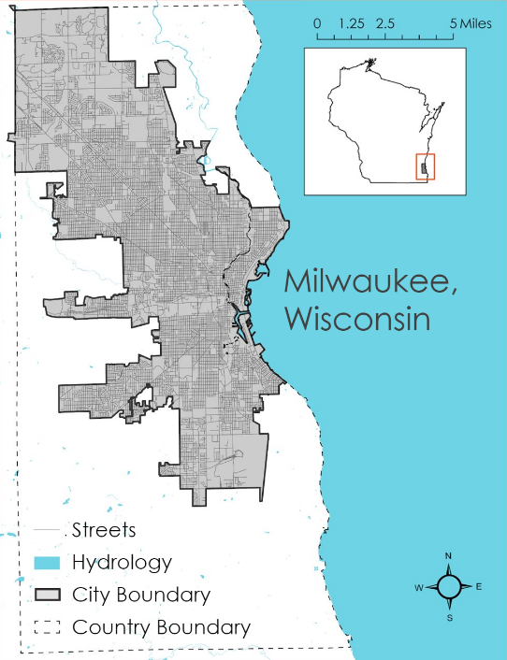
Figure A1: Map of the Milwaukee City and County study area, with inset of the State of Wisconsin

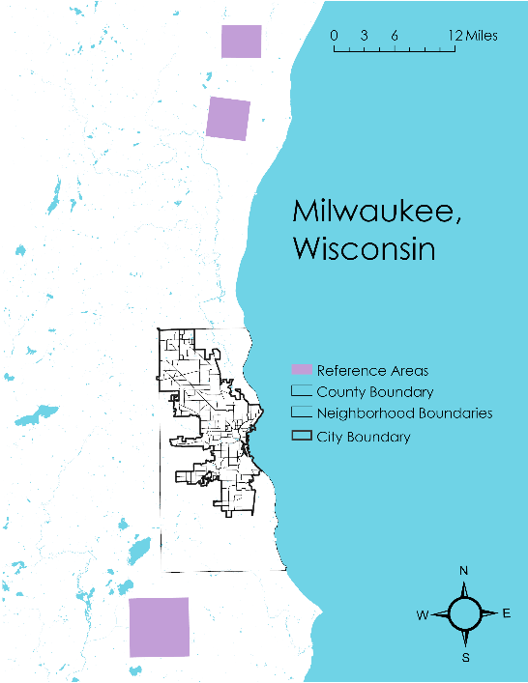
Figure A2: Reference areas used to compute reference temperature and UHI magnitude inputs to the InVEST model

Appendix B: Datasets

Table B1
NASA Earth observation datasets
Satellite | Sensor | Product ID | Purpose | Dates Used | Acquisition Method | Spatial Resolution
Landsat 8 | Operational Land Imager (OLI) | LANDSAT/LC08 /C02/T1_L2 | Calculate albedo input for InVEST biophysical table | June 1 – September 30 of 2013 – 2021 | Google Earth Engine (GEE) Catalog | 30-meter
Landsat 8 | Thermal Infrared Sensor (TIRS) | LANDSAT/LC08 /C02/T1_L2 | Calculate land surface temperature constants for InVEST model input | June 1 – September 30 of 2016 – 2021 | GEE Catalog | 30-meter
ISS | ECOsystem Spaceborne Thermal Radiometer Experiment on Space Station (ECOSTRESS) | ECO2LSTE.001, ECO3ETPTJPL.001 | Calculate mean of nighttime temperature and evapotranspira-tion for InVEST model input | June 1 – September 30 of 2019 – 2021 | Application for Extracting and Exploring Analysis Ready Samples (AppEEARS) | 70-meter

Table B2
Auxiliary datasets
Parameter | Source | Purpose | Dates Used | Resolution
Study area | Milwaukee County Land Information Office (MKE CLIO) | Set InVEST study area | 2018 | n/a
Land cover | USGS National Land Cover Dataset (NLCD) | InVEST land use/land cover (LULC) input raster | 2019 | 30-meter
Tree canopy | Wisconsin Department of Natural Resources Community Canopy Map | Calculate InVEST biophysical table shade input | 2013 | 1-meter
Building height | MKE CLIO LIDAR (Light Detection and Ranging) Digital Surface Model (DSM) | Calculate InVEST biophysical table building intensity input | 2010 | 5-meter
Census block groups | MKE CLIO | Heat vulnerability index geographic unit | 2018 | n/a
Sociodemo-graphic data | American Community Survey | Heat vulnerability index factors | 2021 | Census Block Group

Tables B3
Datasets gathered for use in constructing the HVI
B3(a): American Community Survey datasets
Name | Variable | Type | ACS Data Codes  (pop. of interest / pop. total)
Income | % in poverty | Adaptive capacity | B17021_002 / B17021_001
Unemployment | % unemployed | Adaptive capacity | B23025_005 / B23025_003
Computers | % without computer access at home | Adaptive capacity | B28010_007 / B28010_001
Living Alone | % living alone | Adaptive capacity | B09021_002 / B09021_001
Car Use | % who drive cars to work | Adaptive capacity | B08301_002 / B08301_001
Education | % without high school diploma | Adaptive capacity | B28006_002 / B01003_001
Language | % non-English speakers | Adaptive capacity | B06007_005, B06007_008/ B06007_001
Citizenship | % non-citizen | Adaptive capacity | B05001_006 / B05001_001
Race | % non-white (1 - % white) | Sensitivity* | B02001_002 / B02001_001
Age | % over 65 | Sensitivity | B09021_022 / B09021_001
* Race is harder to categorize, as it is not as directly a source of sensitivity in itself.

B3(b): Health datasets from Groundwork Milwaukee
Name | Variable | Type | Source
Asthma | % with asthma | Sensitivity | Heat Illnesses dataset
COPD | % with COPD | Sensitivity | Heat Illnesses dataset
Energy burden | % household income spent on electricity | Adaptive capacity | Energy Burden dataset

B3(c): Satellite and InVEST environmental datasets
Name | Type | Source
Albedo | Exposure | Landsat 8 OLI
Shade | Exposure | Wisconsin Community Canopy
Daytime LST | Exposure | Landsat 8 TIRS
Nighttime LST | Exposure | ISS ECOSTRESS
Evapotranspiration | Exposure | ISS ECOSTRESS
Heat Mitigation | Exposure | InVEST model output

Appendix C: InVEST Outputs

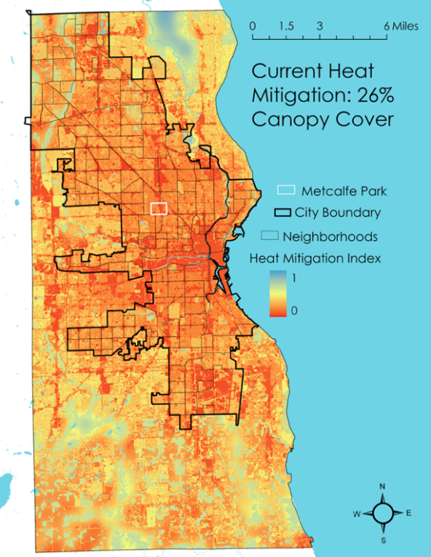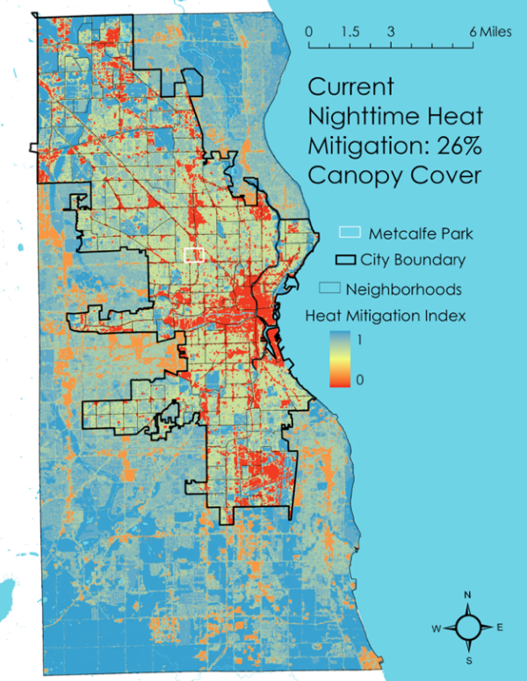

Figure C1: InVEST HMI outputs for current 26% canopy cover for daytime (left) and nighttime (right). Cooler colors indicate more heat mitigation and warmer colors indicate less heat mitigation.

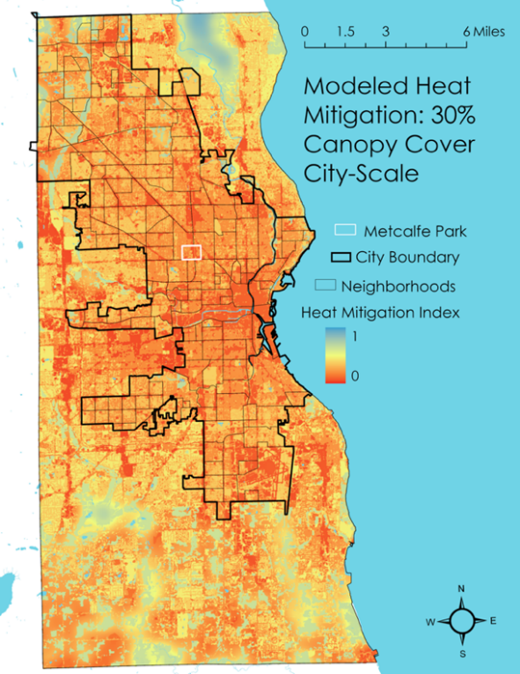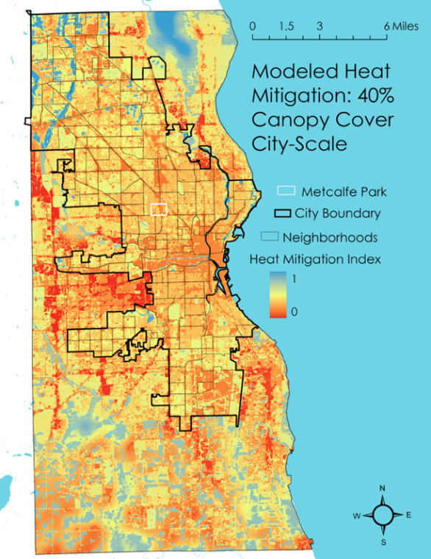

Figure C2: InVEST HMI outputs for modeled 30% (left) and 40% (right) canopy cover city-wide. Cooler colors indicate more heat mitigation and warmer colors indicate less heat mitigation.

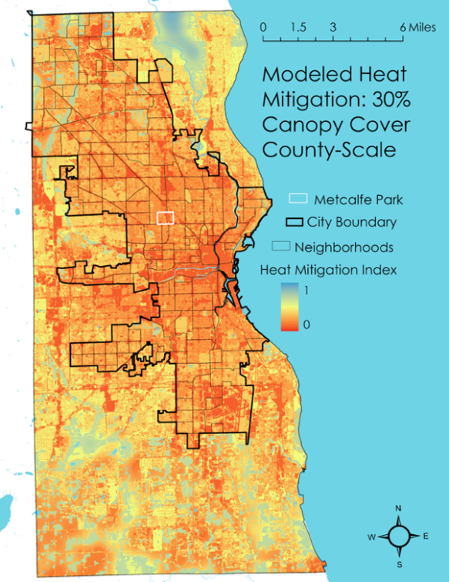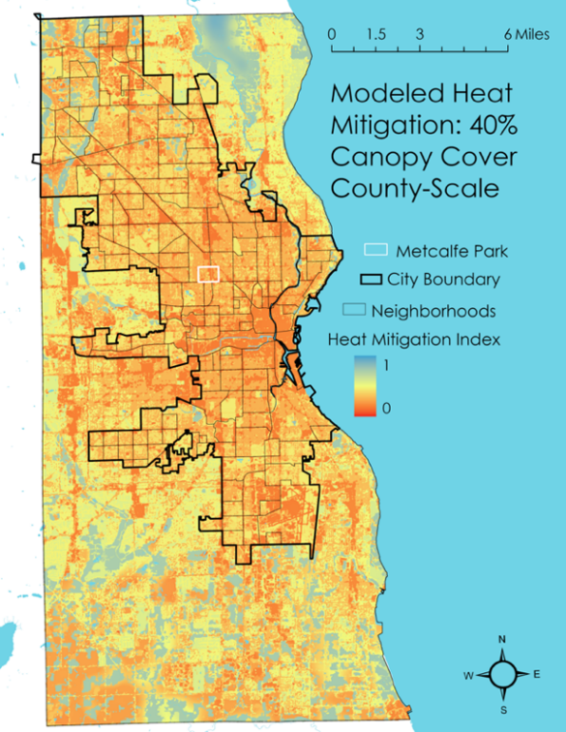

Figure C3: InVEST HMI outputs for modeled 30% (left) and 40% (right) canopy cover county-wide. Cooler colors indicate more heat mitigation and warmer colors indicate less heat mitigation.

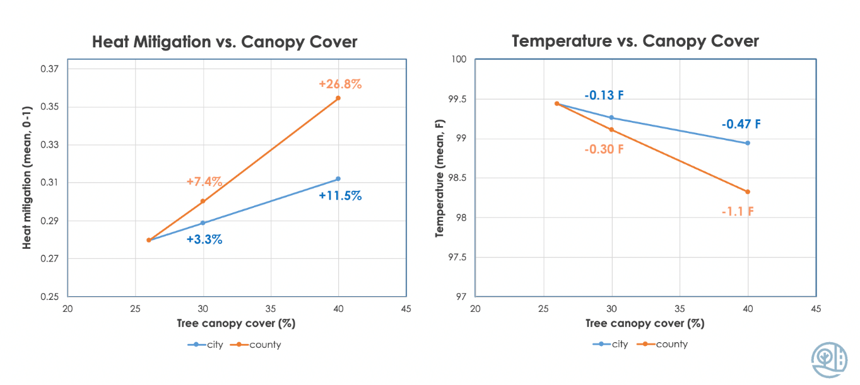
Figure C4: Plots showing the city and county modeled HMI percent changes and temperature changes as compared to the baseline current 26% canopy cover scenario

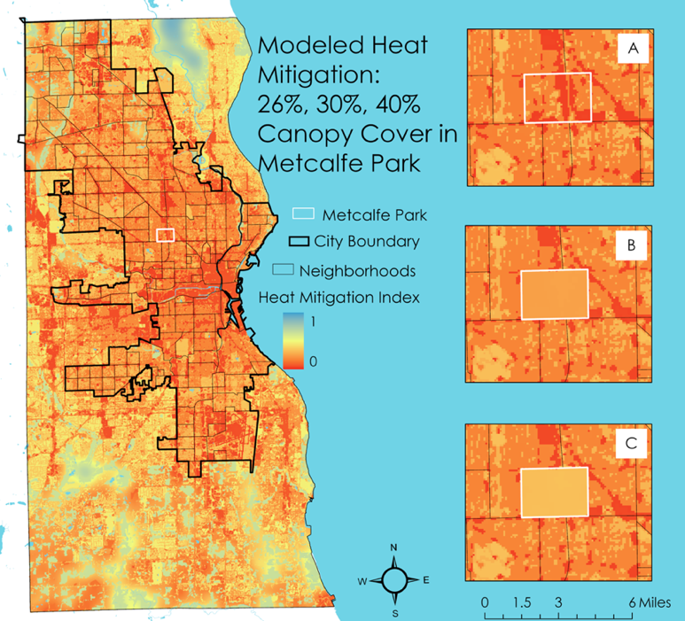
Figure C5: InVEST HMI outputs for neighborhood mitigation scenarios, with inset maps showing (A) current 26% canopy, (B) 30% canopy cover mitigation, and (C) 40% canopy cover mitigation scenario HMIs. Cooler colors indicate more heat mitigation and warmer colors indicate less heat mitigation.

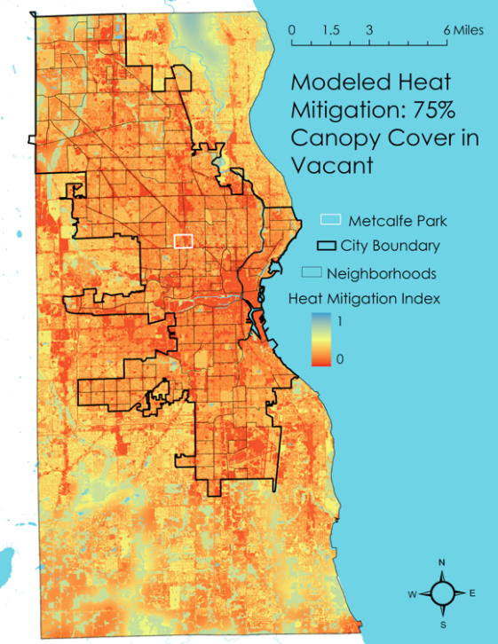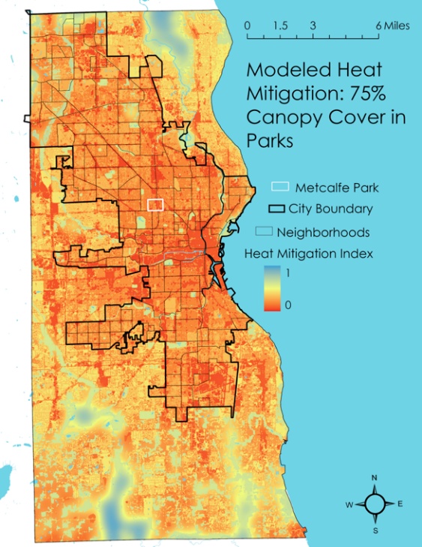
Figure C6: InVEST HMI outputs for modeled 75% canopy cover for vacant lots (left) and parks (right). Cooler colors indicate more heat mitigation and warmer colors indicate less heat mitigation.

Appendix D: HVI Analysis Outputs
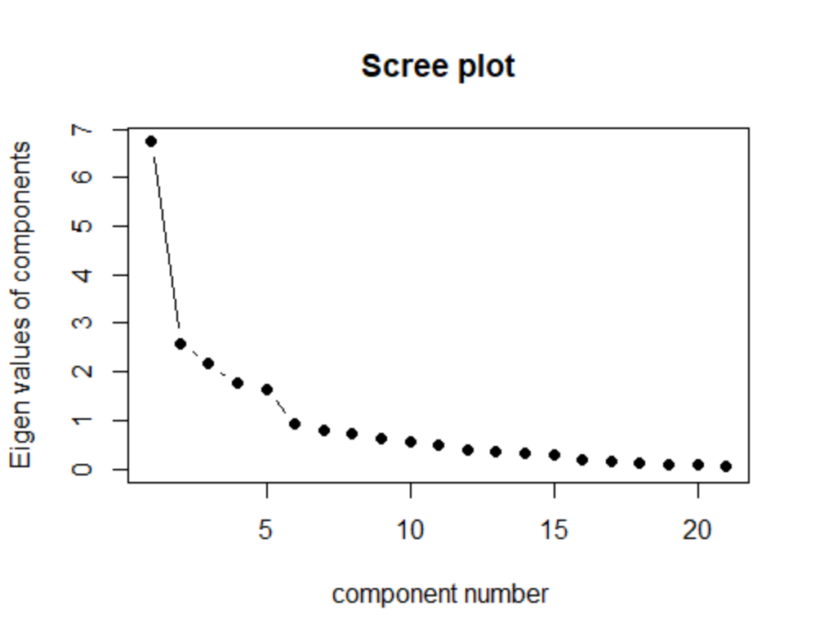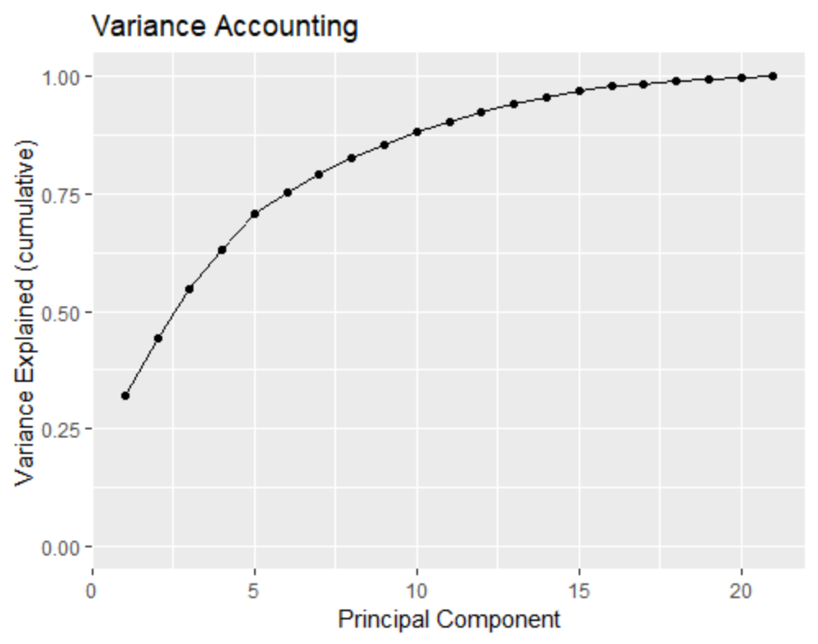
Figure D1: PCA component selection plots - Kaiser criterion plot of component eigenvalues shown with threshold of 1 (left), variance accounting plot of cumulative data variance explained by components with a threshold of 75% (right).

Table D1
HVI component weights. Note that only variables with component weights over 0.5 were included, but some values (e.g., the starred value of 0.49 for Elderly [% over 65]) are very close to that and could be included if desired by changing the cutoff threshold.
 | PC 1 | PC 2 | PC 3 | PC 4 | PC 5
Albedo |  |  |  |  | 0.53
Shade |  | -0.83
Daytime LST |  | 0.88
Nighttime LST |  | 0.76
Evapotranspiration |  |  |  |  | -0.79
Heat Mitigation |  | -0.86
Energy Burden | 0.88
Asthma | 0.94
COPD | 0.79
People of color | 0.86
Poverty | 0.71
Vacancy | 0.64
Unemployment | 0.56
No Computer |  |  |  | 0.58
Living Alone |  |  |  | 0.84
Elderly* |  |  |  | 0.49*
Elderly Living Alone |  |  |  | 0.71
Car Use |  |  |  |  | 0.65
No HS Diploma |  |  | 0.70
Non-English Speaking |  |  | 0.92
Non-Citizen |  |  | 0.90

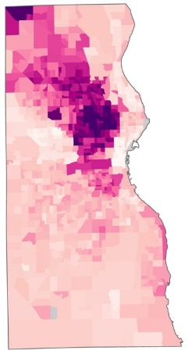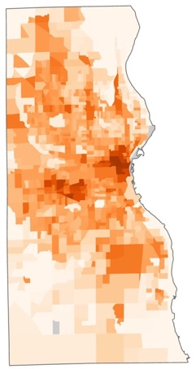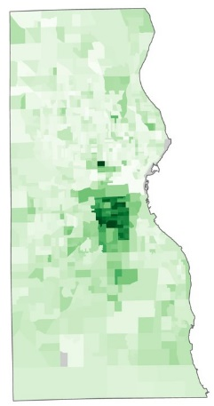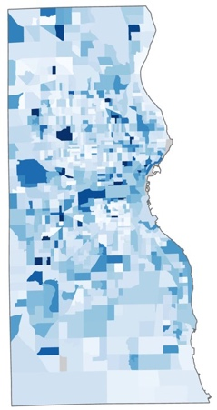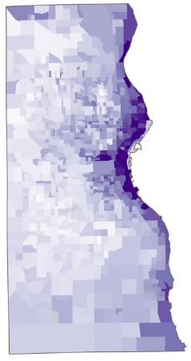
Figure D2: Maps of each of the five principal components resulting from the PCA analysis. Note that the fifth component (farthest right) is symbolized with the sign inversion discussed in the Limitations section, and the opposite choice would flip the vulnerability color bar on this map.

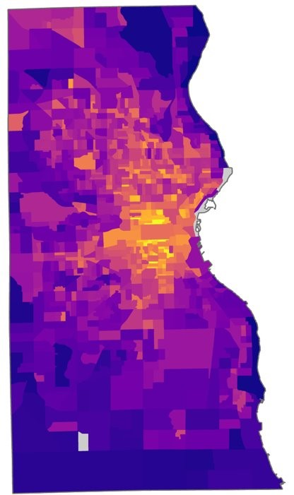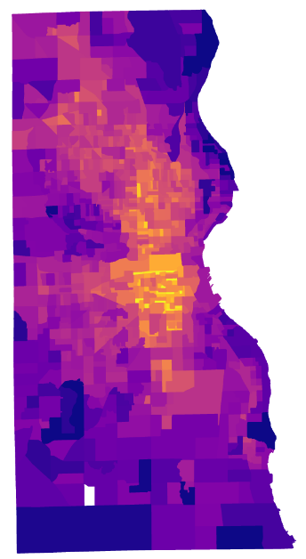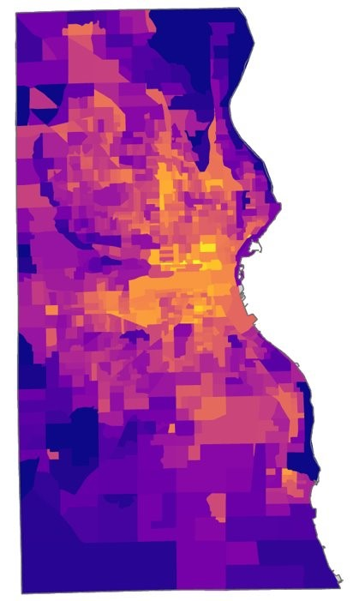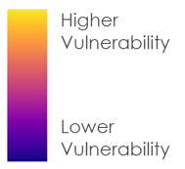

Figure D3: DEVELOP HVI with all components (left), DEVELOP HVI with first three components only (middle), compared with Groundwork HVI (right).

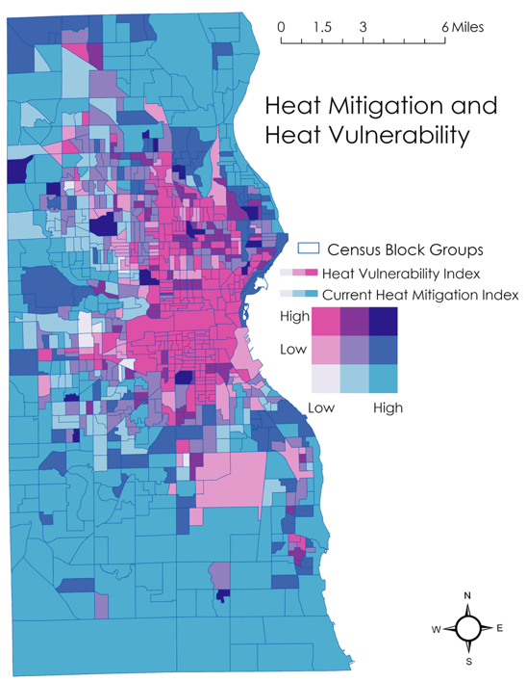
Figure D4: Bivariate plot of current-day HMI and HVI. High HMI represents more cooling. High HVI represents high vulnerability. Pink areas represent highest heat exposure and vulnerability.

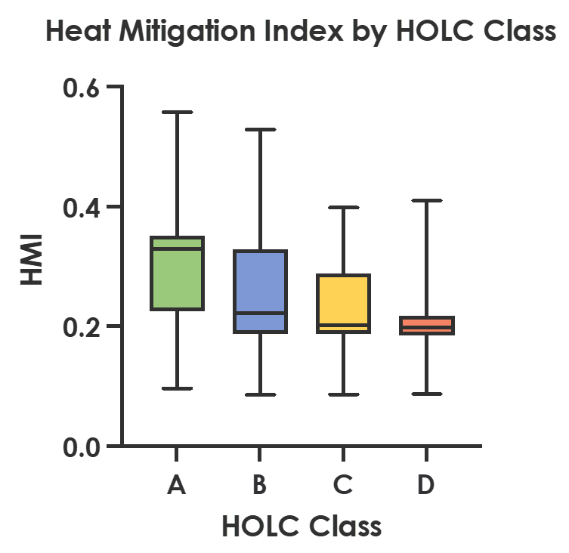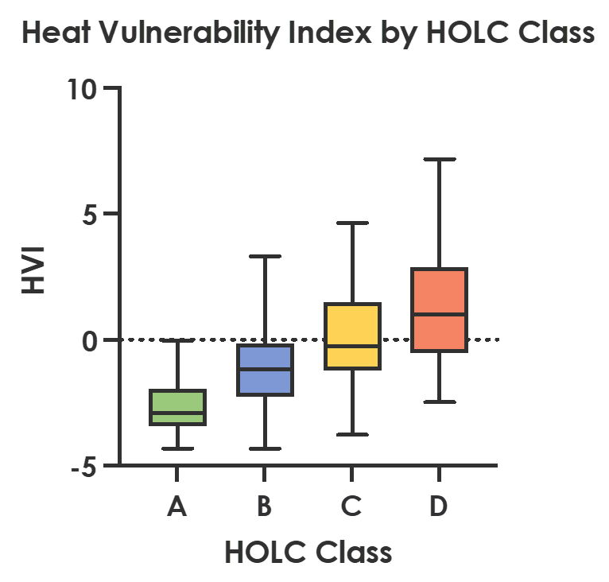
Figure D5: HMI (left) and HVI (right) by HOLC class.

