**NASA DEVELOP National Program**

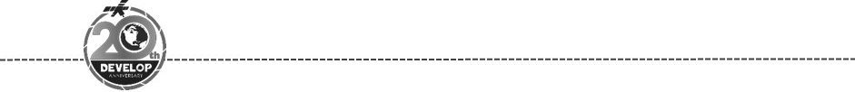California – Ames

*Spring 2018*

California Health and Air Quality

Measuring California Air Quality through the Use of NASA Earth Observations to Identify Spatial, Temporal, and Social Disparities in Particulate Matter Pollution

 **Technical Report**

Final Draft – March 29, 2018

Amanda Wasserman (Project Lead)

Megan Seeley

Ariana Nickmeyer

Dr. Juan Torres-Pérez, Bay Area Environmental Research Institute, NASA Ames Research Center (Science Advisor)

# 1. Abstract

Thirty-five million California residents live in counties where they are more susceptible to contracting an air quality-related health ailment. Particulate matter less than 2.5 µm in size (PM2.5) is an important metric of air quality and can cause significant health problems. Despite California’s policies targeted at reducing PM2.5 and other air pollutants, three major cities experienced increasing levels of PM2.5 from 2013 to 2015. California’s rapid population growth compounds these air quality problems and stresses the need for air pollution reduction policies. Current air quality remediation and regulations are based off in situ air quality monitors; however, these methods do not provide optimal spatial coverage. The NASA DEVELOP project team investigated the advantages of using PM2.5 data derived from remote sensing imagery taken from Moderate Resolution Imaging Spectroradiometer (MODIS), Multi-angle Imaging Spectroradiometer (MISR), Cloud-Aerosol Lidar and Infrared Pathfinder Satellite Observation (CALIPSO), and Sea-Viewing Wide Field-of-View Sensor (SeaWiFS), to study PM2.5 in California from 1998 to 2016. We analyzed trends in PM2.5 concentrations over time as well as the spatial distribution of PM2.5 relative to socioeconomic factors. With the results of these analyses, the California Air Resources Board (CARB) will gain a clearer understanding of the spatial and temporal distribution of particulate matter pollution in the state, and which communities are more likely to face heightened health risks from air pollution.

**Keywords**

PM2.5, remote sensing, MODIS, MISR, SeaWiFS, CALIPSO, environmental justice

# 2. Introduction

* 1. ***Background Information***

The Earth’s atmosphere is omnipresent and essential; its composition, especially at the surface, affects our health, the climate, and all other organisms (American Lung Association, 2017; Grantz et al., 2003; Kaufman et al., 2002). Solid and liquid particles, or particulate matter (PM), naturally become suspended in the atmosphere through sources such as dust, sea spray, and volcanic ash, or through anthropogenic sources, primarily combustion (Environmental Protection Agency, n.d.). PM is classified based on size; when less than 2.5 µm, PM can enter the lungs and circulatory system, consequently endangering human health. Known as PM2.5, this pollutant is associated with a heightened risk of health disorders (Ren & Tong, 2006) such as cardiovascular disease (., 2014), autism (Raz et al., 2015), and asthma (Maantay, 2007), as well as early mortality (Jerrett et al., 2017) and substantial economic losses (Lu et al., 2017; Xie et al., 2016). Furthermore, communities of low socioeconomic status tend to be disproportionately burdened by these negative effects (Kioumourtzoglou et al., 2016).

In recognition of the existence of such disparities, the Environmental Protection Agency (EPA) has defined environmental justice to be “the fair treatment and meaningful involvement of all people regardless of race, color, national origin, or income, with respect to the development, implementation, and enforcement of environmental laws, regulations, and policies.”. Environmental justice issues are pervasive across the United States, but are of particular concern with regards to air quality in California, as the state is ranked both high in racial diversity and low in air quality relative to the rest of the country (American Lung Association, 2017). Several studies have identified air quality-related environmental justice issues in California. For instance, Cushing et al. (2016) found that neighborhoods within the San Joaquin Valley, San Francisco Bay Area, and southern California with higher proportions of impoverished residents and residents of color were more likely to have a greenhouse-gas-emitting facility nearby. In southern California, minority and impoverished neighborhoods were exposed to higher traffic density, placing residents at greater risk of exposure to vehicle-related air pollutants (Houston, Wu, Ong, & Winer, 2004). Systematic identification of these at-risk areas across California is necessary for targeted remediation.

To combat increasing air pollution from sources such as industry, population growth, and traffic, California has several air quality policies in place, which have set standards for the entire country (Collantes & Sperling, 2008; EPA, n.d.). The first air pollution control program was initiated in Los Angeles in 1945. Fifty-three years later, California drafted legislation mandating research to reduce the pollution burden on communities of low socioeconomic status (Legal Counsel State of California, 2000). In 2006, the California Global Warming Solutions Act (Assembly Bill No. 32) was passed with the goal to significantly reduce greenhouse gas emissions in the state. This law requires state facilities to report their emissions to the California Air Resources Board (CARB) and mandated that they assemble an Environmental Justice Advisory Committee (AB 32, 2006). Policies addressing air quality like those formerly mentioned have historically reduced PM2.5 (Rao et al., 2016; Carle, 2006) and have the potential to significantly improve air quality projections (Levy II, 2009; Tagaris et al., 2007).

Continued improvements to air quality policy, regulation, and monitoring techniques can improve the lives of many Californians. Enhancing our methods of air pollution detection to target communities where efforts should be directed is necessary to ameliorate California’s air quality problems. Through the use of satellite-derived PM2.5 data across a study period of 1998 to 2016, we seek to provide an improved method of visualizing patterns of air pollution throughout the study area, the state of California (Figure 1). In doing so, we intend to assist CARB in examining spatial and temporal PM2.5 trends in California and in identifying communities heavily burdened by air pollution.

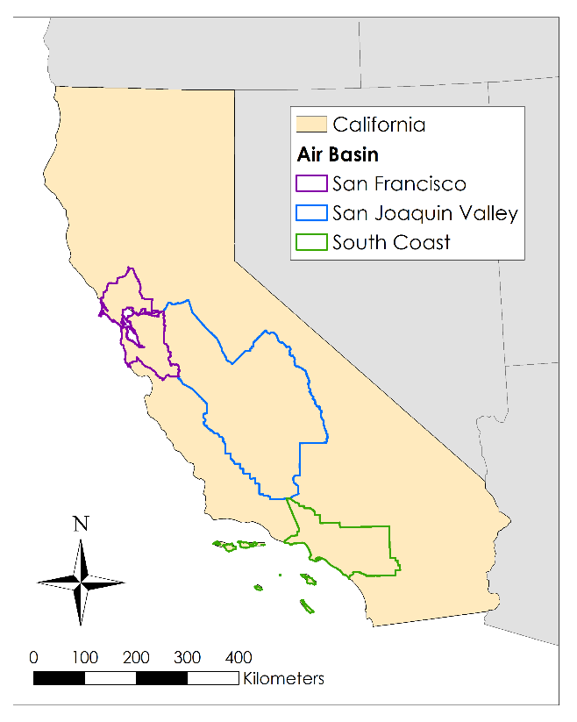

Figure 1: Study area (state of California) with three air basins of interest (San Francisco, San Joaquin Valley, South Coast).

* 1. ***Project Partners & Objectives***

This project’s partners are CARB and the University of California, Los Angeles, Institute of Transportation Studies. Our primary partner, CARB, is a government organization dedicated to improving air quality in California through monitoring, research, and enforcement of policy. Currently, CARB’s PM2.5 monitoring is carried out through the deployment of permanent and temporary ground monitors. These *in situ* measurements are analyzed *post hoc* to inform policy and management decisions; however, spatial coverage across California may not be adequate to identify pollution hotspots, and spatially-averaged data can contain errors (Gupta et al., 2006).

Remote sensing can be a valuable means of monitoring air quality over large spatial extents (West et al., 2016). The objectives of this project were to determine the feasibility of using a satellite-derived dataset to represent PM2.5 in California, examine statewide spatial and temporal trends in PM2.5 concentration, and evaluate the correlation between satellite-derived PM2.5 and socioeconomic factors. Dr. Hyung Joo Lee, a research scientist at CARB, seeks to use our results to supplement his work relating to air quality and environmental justice issues.

# 3. Methodology

***3.1 Data Acquisition***

We acquired all raster data on ground-level PM2.5 concentrations from the Dalhousie University Atmospheric Composition Analysis Group (ACAG). These publicly available data represent global PM2.5 annual averages for the years 1998 to 2016 at a spatial resolution of 1 km (Van Donkelaar, 2016). ACAG researchers modeled PM2.5 concentrations by applying a Geographically Weighted Regression to aerosol optical depth retrievals from Terra MODIS, Terra MISR, Aqua MODIS, CALIPSO, and SeaWiFS, the GEOS-Chem (Goddard Earth Observation System) chemical transport model, and observations from Aerosol Robotic Network (AERONET) ground-based monitors (van Donkelaar et al., 2016).

We acquired ancillary data representing socioeconomic factors, ground-based measurements of PM2.5, and potential sources of or factors relating to PM2.5 that were necessary to support our analyses (Table 1).



Table 1: All ancillary data used in the project, including years obtained (if applicable) and sources.

***3.2 Data Processing***

ACAG PM2.5 data products were clipped to California and the San Francisco, San Joaquin Valley, and South Coast air basins. To compare the ACAG product PM2.5 and the CARB ground-based monitor PM2.5 data, we extracted PM2.5 values from the ACAG product within 1-km of each CARB monitor from 1999 to 2016. This section of our analysis excludes 1998 because there was insufficient ground monitor data. To both assess PM2.5 trends over time and how evenly CARB monitors represent PM2.5diversity across California, we extracted PM2.5values from all ACAG data product cells between 1998 and 2016 for the entire state and each air basin.

We geocoded self-reported emissions data using Google Earth Pro (Google Inc., 2018) to determine geographic coordinates (latitude and longitude) of all reporting state facilities. Self-reported data are recorded as tonnage, precluding comparisons with CARB ground monitors and the AGAC PM2.5 data product, which report PM2.5 as a volume. In lieu of comparing these data, we used facility location to examine the spatial distribution of PM2.5 represented by the ACAG data product by extracting geographically-weighted PM2.5 data from within 1-km, 2-km excluding the inner 1-km, 5-km excluding the inner 2-km, and 10-km excluding the inner 5-km, of each facility, controlling for extraction area, from 2008 to 2016 using the *raster* package in R (Hijmans, 2016). PM2.5values for locations within 1-km of interstate and U.S. roads were likewise extracted from the ACAG data product and divided by the extraction area. Lastly, we identified all CARB ground monitors within 2-km of state facilities.

For both the 2000 and 2010 demographic data, we calculated the percent of the population in each census block group representing each socioeconomic factor (Table 2), except housing value, which was represented as a median. Factors included in this analysis are common metrics in environmental justice analyses (Kioumourtzoglou et al., 2016; Office of Environmental Health Hazard Assessment, 2017) and include percent of the population that is white, percent of the population that is Latino/Hispanic, percent of the population with no high school degree, median rent (renter-occupied), median house value (owner-occupied), and percent of the population that is under the poverty line. We reprojected all socioeconomic data to the WGS 1984 datum and onto the same 1-km grid as the ACAG PM2.5 data product using the *raster* packages in R (R Core Team, 2017).

Table 2: Socioeconomic data (represented as a percent of population) derived from IPUMS.

|  |  |
| --- | --- |
| **Race** | · White Alone |
|  | · Black Alone |
|  | · Two or More Races |
| **Ethnicity** | · Hispanic or Latino |
| **Education** | · No High School Degree |
|  | · College Degree (Associates, Bachelors, Masters, PhD) |
|  | · Females with College Degree |
| **Poverty** | · Below Poverty Line |
|  | · Income-to-Poverty Ratio >2.0 |
| **Housing Value** | · Median Gross Rent (Renter-occupied) |
|  | · Median House Value (Owner-occupied) |

The monthly cumulative precipitation .bil files from PRISM were converted to .tif format, reprojected into GCS_WGS_1984, and clipped to California using Esri ArcMap. The monthly data were summed for each year then averaged across the entire state to calculate mean cumulative precipitation.

***3.3 Data Analysis***

Data analysis focused on three objectives: 1) determine the feasibility of using a satellite-derived dataset (ACAG PM2.5 data product) to represent PM2.5 in California, 2) evaluate spatial and temporal trends in PM2.5 concentration, and 3) evaluate the correlation between satellite-derived PM2.5 and socioeconomic factors.

To address our first objective, we regressed CARB ground monitor data against PM2.5 data extracted from the ACAG data product within a 1-km radius of each CARB ground monitor between 1999 and 2016. Data were analyzed across all locations both for the entire study period and separately for each year. Trends in model performance, measured by R2, root mean square error (RMSE), percent RMSE, and slope, controlling for the intercept, were assessed. Model performance near a stationary pollution source was assessed by performing this ground assessment while including only CARB monitors within 2 km of state facilities, as determined by the geocoded CEIDARS data.

To investigate potential expansions of using satellite data to monitor PM2.5, we examined the representation of PM2.5 by current CARB monitoring sites. As all models calculating PM2.5 from aerosol optical depth use ground-based measurements in their calibrations, representation of all geographic regions, land-use types, ecosystems, and PM2.5 by monitoring sites would lend itself to more accurately modeled PM2.5. The scope of this project allowed only an investigation of CARB representation of PM2.5 levels. To accomplish this, we created quartiles of PM2.5 based on the 2010 ACAG data product. We counted all CARB ground monitors reporting a mean annual PM2.5 within each quartile in 2010 and performed a chi squared goodness of fit.

Next, we examined spatial and temporal PM2.5 trends in California. Our accuracy analysis, described above, revealed a divergence in the slope of the relationship between the ACAG PM2.5 data and CARB ground monitors when the intercept was forced to zero in 2015 and 2016. Since we cannot verify the accuracy of the ACAG PM2.5 data product for these years, we excluded them from further analyses, though they were included in our visualizations.

We assessed changes in PM2.5 between 1998 and 2014 by performing a Mann-Kendall Test on mean PM2.5for the entire state of California and each air basin of interest. PM2.5 temporal trends were further examined by plotting mean PM2.5 for the state and each air basin across time (including 2015 and 2016) along with total vehicle miles traveled (VMT). Inter-annual variability in PM2.5 was visually represented as anomalies in the mean PM2.5 for each year. Annual deviation from the mean of the entire study period (1998-2016) was graphed along with the mean cumulative annual precipitation and the total area burned per year.

We examined the relative contribution of the major sources of pollution (point source vs. non-point source) using PM2.5 data extracted from 1-km buffers around major California roads and state facilities. We compared the average PM2.5, controlling for area, associated with major California roads and state facility with a Wilcoxon Rank-Sum test. We further examined PM2.5 surrounding these facilities by performing a pairwise t‑test on mean PM2.5 values extracted from the 1, 2, 5, and 10 km buffers around each facility, controlling for area.

To assess how community socioeconomic status relates to PM2.5 levels in California, we performed regression analyses between the 2000 and 2010 census data and three-year PM2.5 averages (1999-2001 and 2009-2011, respectively). To determine which socioeconomic indicators to use in the linear regression analyses, we assessed collinearity between the socioeconomic variable dataset (Table 2) using the *corrplot* package in R (Wei & Simko, 2016). Variables representing the five socioeconomic categories—race, ethnicity, education, housing value, and income—in the linear regressions were selected to reduce redundancy and correlation within the socioeconomic dataset while providing insight into whether communities of low socioeconomic status are disproportionately impacted by PM2.5. The refined socioeconomic dataset included percent of the population that is white, percent of the population that is black, percent of the population that is Hispanic or Latino, percent of the population with no high school degree, percent of the population under the poverty line, and median housing value. These analyses allowed us to assess how the correlation between PM2.5 and each socioeconomic variable varies throughout our air basins of interest and across California, as well as how the relationship changes through the study period.

# 4. Results & Discussion

***4.1 Analysis of Results***

*4.1.1 Satellite representation of PM2.5 in California*

Linear regressions between ACAG-derived PM2.5 and CARB ground monitor data revealed a temporal trend in the relationship (Figure 2). The overall R2 for the entire study period was 0.4, but when we analyzed the data by year, the R2 ranged between 0.2 in 2008 and 2013, and 0.9 in 1999. The RMSE increased from 1.6 in 1999 to 3.9 in 2016, indicating that the unexplained variance increased over time. An examination of the slope, with the intercept set to zero, revealed a slightly different trend. The mean slope between 1999 and 2014 was 0.99±0.07. In 2014 and 2015, the slope increased to 1.37 and 1.51, respectively. The slope of the yearly regressions indicates that the ACAG data prior to 2014 are representative of surface-level PM2.5 in California.

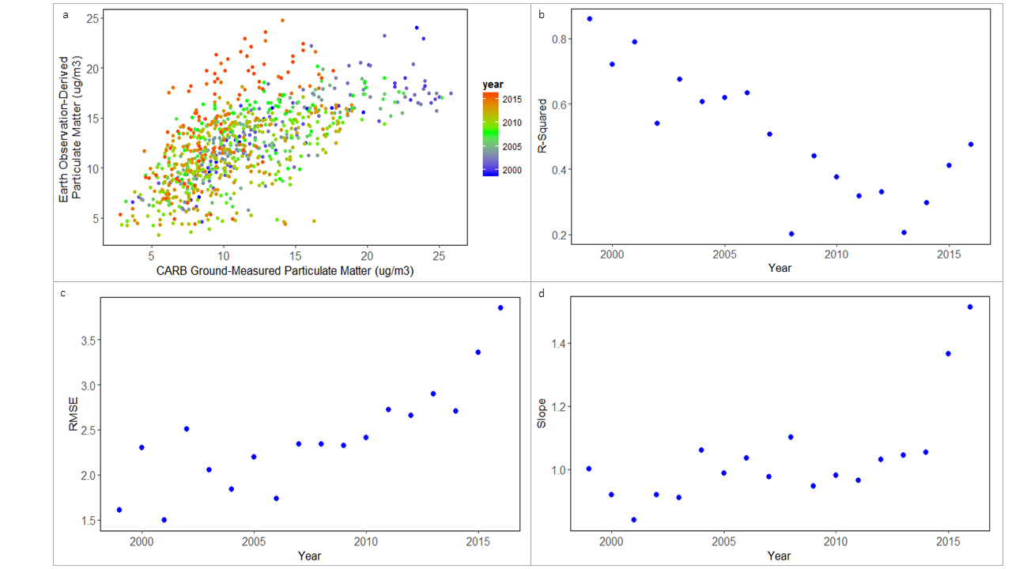

Figure 2: Relationship between ACAG PM2.5 and CARB ground-monitor PM2.5. From top left to bottom right: regression, R2, RMSE, and slope of their relationship from 1999 to 2016.

We investigated potential biases in the ACAG data product that relate to point-source emissions. CARB and ACAG data since 2008 result in an RMSE of 3.43 for all monitors and 3.23 for monitors within 2 km of state facilities. Plotting the points revealed no trend based on proximity to facilities (Appendix A). Further analysis of the relationship between ACAG-derived PM2.5 and CARB ground monitors may reveal how future satellite-derived data products can more accurately represent California surface-level PM2.5. The scope of this project was too narrow to include further investigation.

Potential reasons for the changes in the relationship between ACAG-derived PM2.5 and CARB ground monitor data include, but are not limited to: the increased use of Beta Attenuation Monitors (BAMs) in addition to the Federal Reference Method monitors in 2008; meteorological limitations of Earth observations; a smoothing function applied to the ACAG data product; timing of data acquisition (ground monitors represent continuous data while Earth observations collect one or two observations per day); changing conditions in California not captured in this global dataset; changes in PM2.5 composition affecting its ability to absorb water; a lack of ACAG model calibration in recent years; and changes in biomass burning activities. Legislative changes in California diesel fuel composition may also result in decreased accuracy of BAMs.

To provide a preliminary investigation on this subject, we investigated the bias in CARB ground monitor placement. We performed a chi squared analysis on the 2010 data to determine the representation of PM2.5 by CARB monitors in comparison to the representation of the ACAG product. The *p*-value from this analysis was <0.001, indicating that the CARB monitors do not represent the variation in PM2.5 across California; higher PM2.5 were overrepresented while lower PM2.5 concentrations were underrepresented. This result is expected because CARB monitors areas of high PM2.5 to determine compliance with policies; including monitors that represent lower PM2.5 levels will help build models simulating PM2.5 from satellites and improve air quality monitoring across the state.

*4.1.2 Spatial and temporal PM2.5 trends*

The Mann-Kendall Test indicated a significant decreasing trend in PM2.5 in the San Joaquin Valley, South Coast, and San Francisco air basins from 1998 to 2014 (α= 0.05; Figure 3). *P*-values for these air basins were 0.009 for San Joaquin Valley and South Coast air basins and 0.036 for San Francisco. Changes in PM2.5 in California as a whole during this time period were not significant (*p* = 0.064).

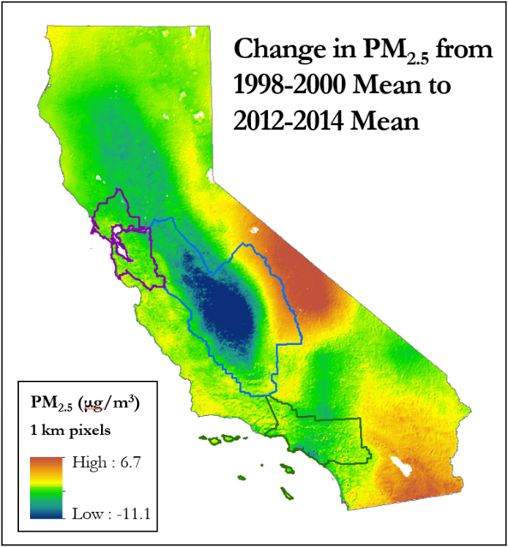

Figure 3: Change over time in PM2.5, calculated as the difference between the mean of 2012 to 2014 and the mean of 1998 to 2000. San Francisco air basin is in purple, San Joaquin Valley air basin in blue, and South Coast air basin in green.

Prior to 2004, VMT does not appear to follow mean PM2.5 trends (Figure 4); following this year, however, VMT tracks well with PM2.5. This trend may reflect an increasing importance in VMT relative to other factors, such as smoke and precipitation, or changes in gasoline and diesel legislation throughout this period. With further investigation, we may better understand this relationship.

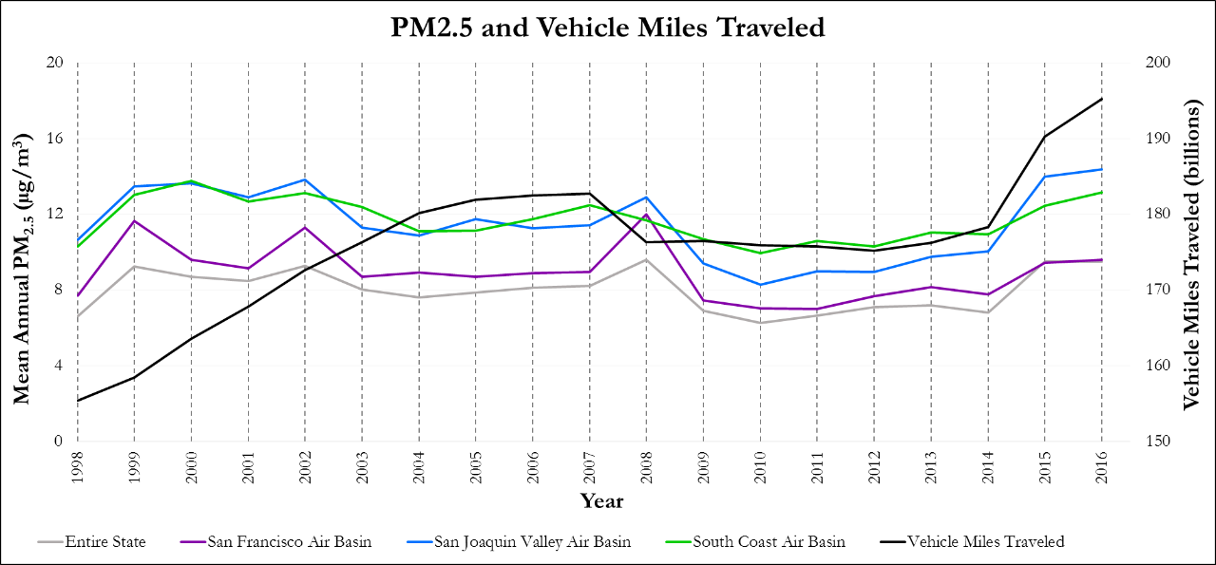

Figure 4: Mean annual PM2.5 values for California and the three air basins. Vehicle miles traveled are in billions and are an estimate of the number of miles traveled on California State Highways by motorists each year.

The mean PM2.5 in the San Joaquin Valley and South Coast air basins was generally greater than that in the San Francisco air basin. Mean PM2.5 concentrations were lower across the entire state of California than in the individual air basins. To investigate the difference between stationary and mobile PM2.5 sources, we performed a Wilcoxon Rank-Sum test between PM2.5 concentrations within 1 km of state facilities and those within 1-km of interstates and U.S. highways. Due to time and processing power limitations, this test was only performed on the San Francisco air basin. It revealed that, controlling for area, regions around the stationary sources had higher PM2.5 levels than those around mobile sources (*p* < 0.001). The effect of stationary sources was assessed further by looking at how distance from each state facility affects PM2.5 levels. We found that locations 5 to 10 km from state facilities had lower PM2.5 levels than locations within 2 km (*p* = 0.0121). PM2.5 levels within 1 km of state facilities were greater than those between 2 and 5 km away (*p* = 0.0016). This investigation indicates that spatial trends exist in relation to major roads and state facilities in the San Francisco Bay Area in 2010. For example, PM2.5 was greater on a per area basis within 1 km of state facilities than major roads. We also found a radial decrease in PM2.5 as the distance from state facilities increased. These spatial PM2.5 trends confirm prior studies and logical reasoning concerning PM2.5 in these areas. As a result, we conclude that the ACAG data product modeled the expected PM2.5 spatial trends in this air basin in 2010.

Inter-annual variation in PM2.5, as represented by the deviation from the mean, tended to track with annual acreage burned and mirror cumulative precipitation (Figure 5). As smoke is a form of particulate matter and precipitation indirectly influences fire and dust, we expect PM2.5 to respond to both these variables. As expected, we found a precipitation trend that mirrored PM2.5 and a trend in acres burned that tracked PM2.5.

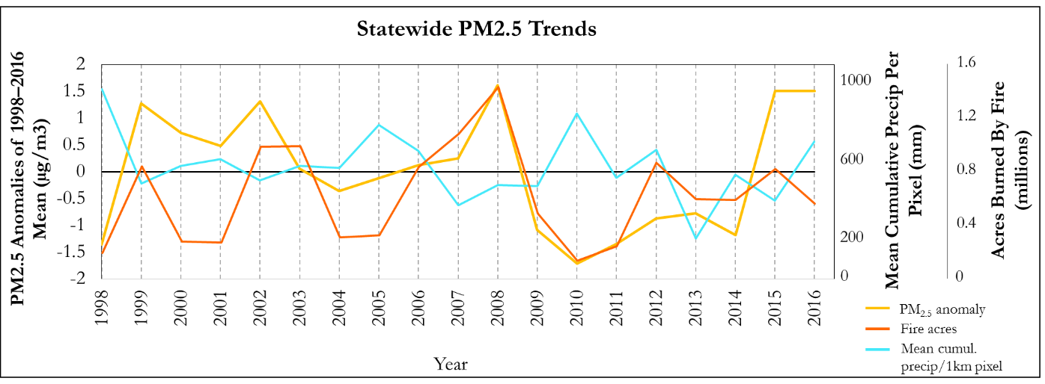

Figure 5: Inter-annual trends in PM2.5 as compared with the number of acres burned by fire, which tracks PM2.5, and cumulative precipitation, which mirrors the PM2.5 levels.

*4.1.3. Correlation between PM2.5 and socioeconomic factors*

The final set of analyses examined the correlation between PM2.5 and various socioeconomic variables. Linear regressions indicate a significant correlation between all variables and PM2.5, with the exception of PM2.5 and percent of the population that is Latino or Hispanic in the San Francisco air basin in 2010 (Figure 6). As the percentage of population that is white increases, PM2.5 in that area tends to decrease. The opposite trend occurs as the percentage of the population that is Latino or Hispanic and percentage of the population that is black increases.

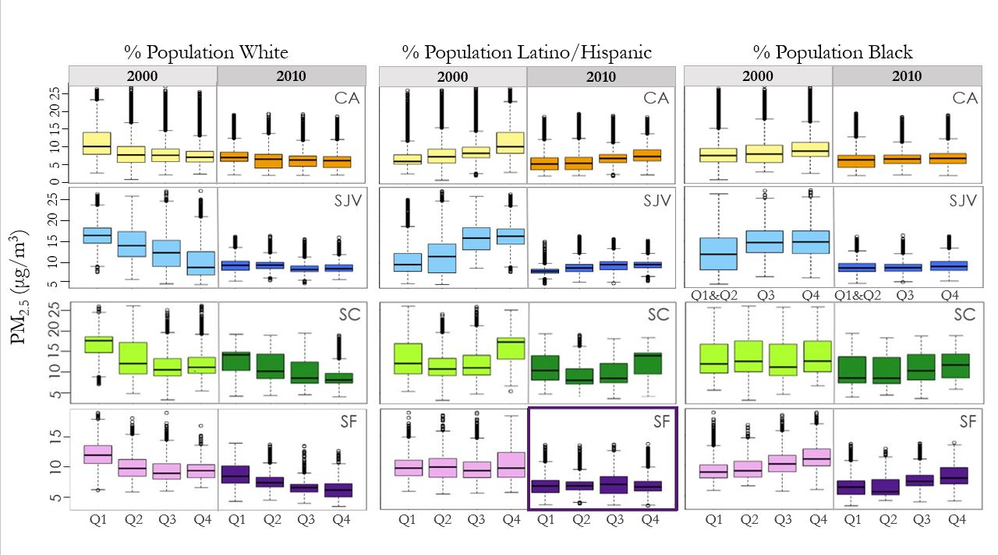

*Figure 6:* Relationship between PM2.5 and race and ethnicity, with socioeconomic values divided into quartiles along x-axis. Y-axis represents PM2.5 in ug/m3. Rows represent different geographic regions. From top to bottom: California, San Joaquin Valley, San Francisco, and South Coast air basins. Across all regions there are similar trends between the racial and ethnic makeup of communities and PM2.5. Only insignificant relationship is outlined with a bold purple box.

From 2000 to 2010, the slope for the relationship between community composition and PM2.5 decreases, and in San Francisco, the correlation is no longer significant when considering ethnicity. These results indicate that although PM2.5 is disproportionately distributed across communities based on race and ethnicity, that relationship tends to weaken over the course of the decade. The same weakening from 2000 to 2010 exists in the relationship between PM2.5 and income, education, and housing value (Appendix B). Within the San Joaquin Valley air basin and the Los Angeles metropolitan area, significant relationships between each socioeconomic variable and PM2.5 still exist in 2010, but the slope is closer to zero. The spatial distribution of each socioeconomic variable remained fairly stable from 2000 to 2010. Over the same decade, however, the change in PM2.5 in the San Joaquin Valley displays a strong spatial pattern (Appendix B), implying that change in PM2.5 concentration itself is likely driving the shift in these relationships within the San Joaquin Valley.

***4.2 Future Work***

Air quality continues to be an important environmental justice issue in California, though great improvements have already been realized. Some suggestions for future improvements in air quality monitoring include reporting CEIDARS data as a volume to directly compare these data with satellite-derived PM2.5 data or ground-based monitor data and better monitor human health impacts. A transition to a volumetric unit of measurement that allows for better analyses and a direct comparison between industry emissions data and other forms of PM2.5 monitoring in the state could further elucidate the efficacy of air pollution reduction policies.

Future studies could further investigate the 2015/2016 slope anomalies by assessing whether the growing difference between satellite-derived and *in situ* PM2.5 observations is related to the ground monitors or the ACAG data product. Comparing the relationship between the ACAG data product and various types of ground monitors such as BAM and FRM may indicate if the monitor type changes the accuracy. Another important investigation would be to address when the CARB ground monitors and the Earth observations are missing PM2.5 data. This could be achieved through a variety of ways, including analyzing subsets of ground monitors over time in relation to the satellite-derived data to see if discrepancy varies regionally. Technical difficulties and maintenance issues could create gaps in the CARB monitor data while cloud coverage could reduce satellite data recordings; a non-overlap of data from these different sources could additionally create a difference in PM2.5. Knowing the percentage of the data product that is missing each year due to cloud cover or model limitations could help us better understand some of the trends we have observed.

While the ACAG data product proved useful for looking at long-term patterns in PM2.5 distribution, future studies would be strengthened by the addition of data with finer temporal resolution, e.g., seasonal, monthly, or weekly. Even short-term exposure to high PM2.5 concentrations can negatively impact human health, but annual averages smooth out any spikes in PM2.5 that might occur. Our analyses of various socioeconomic factors and particulate matter pollution showed some correlation; however, we believe that these relationships would be more apparent with data of finer temporal resolution. Studies that incorporated such data would be valuable in identifying hotspots of particulate matter pollution across California.

# 5. Conclusions

While the ACAG PM2.5 data product adequately represents long-term exposure and large-scale spatial processes, the dataset’s coarse annual average temporal resolution may fail to capture all PM2.5-related health risks. Satellite data are a valuable augmentation to *in situ* particulate matter measurements, but regional and temporal nuances are difficult to pinpoint and encapsulate without finer resolution datasets.

Although it is difficult to parse the impacts of any one California air quality regulation, the combined effects of recent policies over the previous two decades likely contribute to overall declines in PM2.5. Precipitation, fire, and transportation patterns may contribute to the inter-annual variability in the San Francisco, San Joaquin Valley, and South Coast air basins.

While the socioeconomic makeup of California communities has not seriously changed from 2000 to 2010, PM2.5 concentrations have shown significant fluctuations. In the present study, low income communities, especially those with higher percentages of minority populations, were more likely to experience greater annual mean PM2.5 concentrations.

# 6. Acknowledgments

* Dr. Hyung Joo Lee (California Air Resources Board)
* Madeline Brozen (University of California, Los Angeles, Institute of Transportation Studies)
* Dr. Juan Torres-Pérez (Bay Area Environmental Research Institute, NASA Ames Research Center)
* Jenna Williams (NASA DEVELOP, NASA Ames Research Center)
* John Dilger (NASA DEVELOP, NASA Ames Research Center)
* Dr. Cindy Schmidt (Bay Area Environmental Research Institute)
* Dr. Robert Chatfield (NASA Ames Research Center)
* Dr. Anthony Strawa (NASA Ames Research Center)
* Dr. Meytar Sorek-Hamer (Universities Space Research Association, NASA Ames Research Center)
* Dr. Caroline Parworth (Universities Space Research Association, NASA Ames Research Center)

Any opinions, findings, and conclusions or recommendations expressed in this material are those of the author(s) and do not necessarily reflect the views of the National Aeronautics and Space Administration.

This material is based upon work supported by NASA through contract NNL16AA05C and cooperative agreement NNX14AB60A.

# 7. Glossary

**AERONET** – Aerosol Robotic Network

**ACAG** – Atmospheric Composition Analysis Group

**CALIOP** – Cloud-Aerosol Lidar with Orthogonal Polarization

**CALIPSO** – Cloud-Aerosol Lidar and Infrared Pathfinder Satellite Observation

**CARB** – California Air Resources Board

**CEIDARS** – California Emission Inventory Development and Reporting System

**Earth observations** – Satellites and sensors that collect information about the Earth’s physical, chemical, and biological systems over space and time

**Environmental justice** – The fair treatment of all people regardless of race, color, national origin, or income, with respect to the development and enforcement of environmental laws and regulations

**GEOS-Chem** – Goddard Earth Observation System chemical transport model

**IPUMS** – Integrated Public Use Microdata Series

**MAIAC** – Multi-Angle Implementation of Atmospheric Correction

**MISR** – Multi-Angle Imaging Spectroradiometer

**MODIS** – Moderate Resolution Imaging Spectroradiometer

**PM2.5** – Particulate matter less than 2.5 µm in size

**PRISM** – Parameter-elevation Regressions on Independent Slopes Model

**SeaWiFS** – Sea-Viewing Wide Field-of-View Sensor

**VMT** – Estimate of the number of vehicle miles that motorists travel on California State Highways per year

# 8. References

American Lung Association. (2017). State of the air 2017. Retrieved from

<http://www.lung.org/assets/documents/healthy-air/state-of-the-air/state-of-the-air-2017.pdf>

Assembly Bill No. 32.

<http://www.leginfo.ca.gov/pub/05-06/bill/asm/ab_0001-0050/ab_32_bill_20060927_chaptered.pdf> (2006)

California Air Resources Board. CARB Pollution Mapping Tool. Sacramento, CA: California Environmental

Protection Agency; 2018.

Carle, D. (2006). *Introduction to Air in California*. University of California Press. Retrieved from

<http://www.jstor.org/stable/10.1525/j.ctt1pns9c>

Collantes, G., & Sperling, D. (2008). The origin of California’s zero emission vehicle mandate. *Transportation*

*Research Part A: Policy and Practice*, *42*(10), 1302–1313.

Cushing, L. J., Wander, M., Morello-Frosch, R., Pastor, M., Zhu, A., & Sadd, J. (2016, September). *A*

*preliminary environmental equity assessment of California’s cap-and-trade program* (Research brief). Retrieved from <https://dornsife.usc.edu/PERE/enviro-equity-CA-cap-trade>

Environmental Protection Agency. (n.d.) *History of reducing air pollution from transportation in the United States*

*(U.S.).* Retrieved from <https://www.epa.gov/air-pollution-transportation/accomplishments-and-success-air-pollution-transportation>

Google Inc. (2018). Google Earth Pro (Version 7.3.1) [Software]. Available from

<https://www.google.com/earth/desktop/>

Grantz, D. A., Garner, J. H. B., & Johnson, D. W. (2003). Ecological effects of particulate matter. *Environment*

*International*, *29*(2-3), 213–239.

Gupta, P., Christopher, S. A., Wang, J., Gehrig, R., Lee, Y. C., & Kumar, N. (2006). Satellite remote sensing

of particulate matter and air quality assessment over global cities. *Atmospheric Environment*, *40*(30), 5880-5892.

Hijmans, R. J. (2016). raster: Geographic Data Analysis and

 Modeling. R package version 2.5-8. https://CRAN.R-project.org/package=raster

Houston, D., Wu, J., Ong, P., & Winer, A. (2004). Structural disparities of urban traffic in Southern

California: Implications for vehicle-related air polexposure in minority and high-poverty neighborhoods. *Journal of Urban Affairs*, *26*, 565–592.

Jerrett, M., Turner, M. C., Beckerman, B. S., Pope III, C. A., van Donkelaar, A., Martin, R. V., ... & Diver, W.

R. (2017). Comparing the health effects of ambient particulate matter estimated using ground-based versus remote sensing exposure estimates. *Environmental Health Perspectives*, *125*(4), 552–559.

Kaufman, Y. J., Tanré, D., & Boucher, O. (2002). A satellite view of aerosols in the climate system. *Nature*,

*419*(6903), 215.

Kioumourtzoglou, M. A., Schwartz, J., James, P., Dominici, F., & Zanobetti, A. (2016). PM2.5 and mortality

in 207 US cities: Modification by temperature and city characteristics. *Epidemiology*, *27*(2), 221–227.

Legal Counsel State of California. (2000). "Bill Number: SB 115."

www.leginfo.ca.gov/pub/99-00/bill/sen/sb_0101- 0150/sb_115_bill_19991010_chaptered.html Accessed: March 2004.

Levy II, H. (Ed.). (2009). *Climate projections based on emissions scenarios for long-lived and short-lived radiatively active*

*gases and aerosols*. DIANE Publishing.

Lu, X., Lin, C., Li, Y., Yao, T., Fung, J. C., & Lau, A. K. (2017). Assessment of health burden caused by

particulate matter in southern China using high-resolution satellite observation. *Environment International, 98*, 160-170.

Ma, Z., Hu, X., Huang, L., Bi, J., & Liu, Y. (2014). Estimating ground-level PM2. 5 in China using satellite

remote sensing. *Environmental Science & Technology*, *48*(13), 7436-7444.

Maantay, J. (2007). Asthma and air pollution in the Bronx: methodological and data considerations in using

GIS for environmental justice and health research. *Health & Place*, *13*(1), 32-56.

Office of Environmental Health Hazard Assessment. California Communities Environmental Health

Screening Tool, Version 3.0 (CalEnviroScreen 3.0): Guidance and Screening Tool. Sacramento, CA:

California Environmental Protection Agency; 2017.

PRISM Climate Group, Oregon State University. (2017). Retrieved from <http://prism.oregonstate.edu>

R Core Team. (2017). R: A language and environment for statistical computing [Software]. R Foundation for

Statistical Computing, Vienna, Austria. Available from [https://www.R-project.org/](https://www.r-project.org/)

Rao, S., Klimont, Z., Leitao, J., Riahi, K., Van Dingenen, R., Reis, L. A., ... & Harmsen, M. (2016). A

multi-model assessment of the co-benefits of climate mitigation for global air quality. *Environmental Research Letters*, *11*(12), 124013.

Raz, R., Roberts, A. L., Lyall, K., Hart, J. E., Just, A. C., Laden, F., & Weisskopf, M. G. (2015). Autism

spectrum disorder and particulate matter air pollution before, during, and after pregnancy: A nested case-control analysis within the Nurses’ Health Study II cohort. *Environmental Health Perspectives, 123*(3), 264–270.

Ren, C., & Tong, S. (2006). Temperature modifies the health effects of particulate matter in Brisbane,

Australia. *International Journal of Biometeorology*, *51*(2), 87-96.

Ruggles, S., Genadek, K., Goeken, R.,Grover, J., & Sobek, M. *Integrated Public Use Microdata*

*Series: Version 7.0* [dataset]. Minneapolis: University of Minnesota, 2017. <https://doi.org/10.18128/D010.V7.0>.

Tagaris, E., Manomaiphiboon, K., Liao, K. J., Leung, L. R., Woo, J. H., He, S., ... & Russell, A. G. (2007).

Impacts of global climate change and emissions on regional ozone and fine particulate matter concentrations over the United States. *Journal of Geophysical Research: Atmospheres*, *112*(D14).

Van Donkelaar, A., Martin, R. V., Brauer, M., Hsu, N. C., Kahn, R. A., Levy, R. C., … Winker, D. M. (2016).

Global estimates of fine particulate matter using a combined geophysical-statistical method with information from satellites, models, and monitors. *Environmental Science & Technology*, *50*(7), 3762–3772.<https://doi.org/10.1021/acs.est.5b05833>

Wei, T. & Simko, V. (2016). corrplot: Visualization of a Correlation Matrix. R package version 0.77.

https://CRAN.R-project.org/package=corrplot

West, J. J., Cohen, A., Dentener, F., Brunekreef, B., Zhu, T., Armstrong, B., ... & Dockery, D. W. (2016).

What we breathe impacts our health: improving understanding of the link between air pollution and health. <http://pubs.acs.org/doi/pdf/10.1021/acs.est.5b03827>

Xie, Y., Dai, H., Dong, H., Hanaoka, T., & Masui, T. (2016). Economic impacts from PM2.5

pollution-related health effects in China: a provincial-level analysis. *Environmental Science & Technology*, *50*(9), 4836-4843.

# 9. Appendices

Appendix A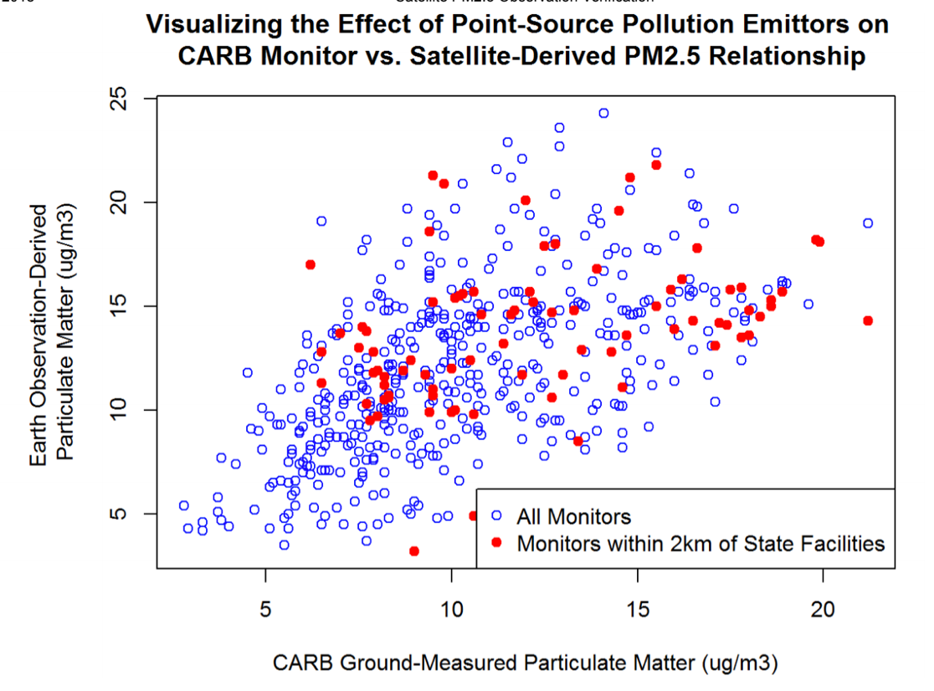

Figure A1: Plotting the points revealed no trend based on proximity to facilities.

Appendix B

Socioeconomic values and PM2.5 in the San Joaquin Valley air basin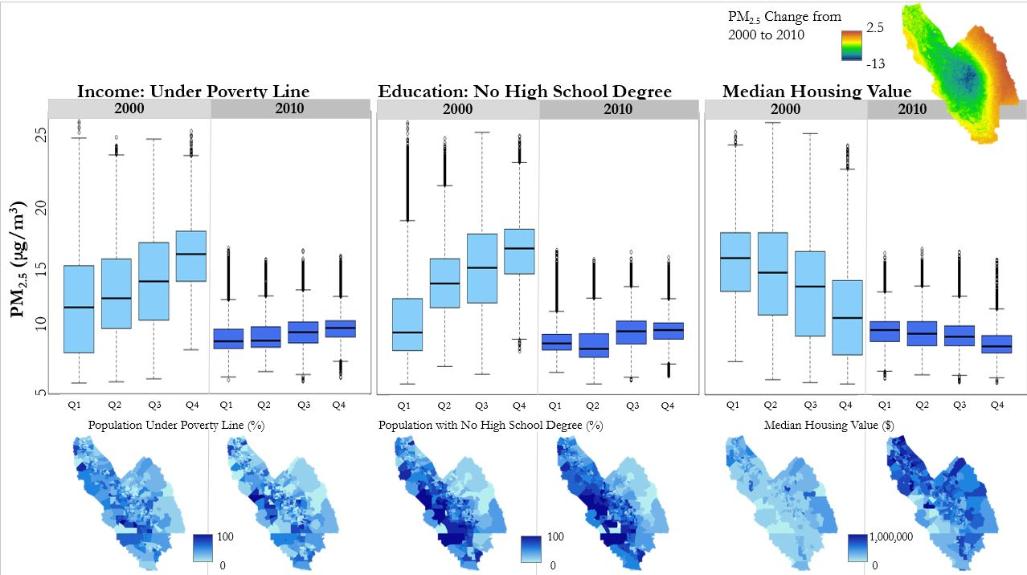

Figure B1: Relationships weaken from 2000 to 2010. Spatial distribution of socioeconomic variables does not change much while PM2.5 concentration does in a clear spatial pattern.