Lake Michigan Water Resources II

Utilizing Multispectral Satellite Imagery to Monitor and Predict the Displacement of *Cladophora* Along the Milwaukee County Shoreline

 **Technical Report**

Final Draft – October 4th, 2018

Jashvina Devadoss (Project Lead)

Catherine Breen

Genevieve Clow

Elizabeth Looby

Dr. Juan Torres-Perez, Bay Area Environmental Research Institute, NASA Ames Research Center (Science Advisor)

Dr. Sherry Palacios, Bay Area Environmental Research Institute, NASA Ames Research Center (Science Advisor)

Previous Contributors:

Jerrold Acdan

Steven Chao

Lawrence Fujiwara

Ella Golovey

# 1. Abstract

Changing lake conditions, such as rising temperatures and phosphorus cycling by invasive Dreissenid mussels, have made washup of the green macroalgae *Cladophora glomerata* a consistent problem on beaches in Milwaukee County, presenting a threat to both wildlife and the local economy. Groundwork Milwaukee (GWMKE), a nonprofit organization, seeks to remove *Cladophora* from beaches along the Milwaukee County shoreline. To aid GWMKE’s cleanup planning efforts, the previous NASA DEVELOP Lake Michigan Water Resources Team created a habitat suitability map for *Cladophora* and utilized bathymetry, nearshore structures, and population density to create a predictive washup map. Our team continued their work by creating a user-friendly ArcGIS tool that predicts where *Cladophora* is most likely to wash ashore. The new tool utilized chlorophyll-a spectral signatures as proxies for *Cladophora* detection from Landsat 8 Operational Land Imager (OLI). Sentinel-2 MultiSpectral Instrument (MSI) data was also investigated for this purpose, however, the results from Landsat 8 more closely matched *in situ* chlorophyll-a measurements for Lake Michigan. Surface water currents were incorporated to predict *Cladophora* transport. The tool processed data for the study period of June to September, 2016 to 2018, and the outputs were compared with *in situ* data of *Cladophora* washup. With the assistance of the Predictive Washup Tool, GWMKE will be able to more accurately predict the location of *Cladophora* washup and effectively manage their future cleanup efforts, making the beaches safer and more enjoyable for the community.

**Keywords**

*Cladophora*, Groundwork Milwaukee, chlorophyll-a, remote sensing, Landsat 8 OLI, Sentinel-2 MSI, surface water currents

# 2. Introduction

* 1. ***Background Information***

*Cladophora* *(Cladophora glomerata)* is a green macroalgae that grows on hard substrates in Lake Michigan (Auer et al., 2010). Nitrogen, phosphorous, temperature, and irradiance are found to influence *Cladophora* growth (Herbst, 1969). High nearshore concentrations of phosphorus, which is linked to phosphorus cycling by introduced Dreissenid mussels, have contributed to a recent surge in *Cladophora* growth (Hecky et al., 2004; Higgins et al., 2008). *Cladophora* grows at depths up to 10 meters, but increased light from water filtration by Dreissenid mussels can promote *Cladophora* growth at greater depths (Auer et al., 2010; Higgins, 2005).

Wind and water currents can lead to onshore deposition of *Cladophora* mats (Nevers et al., 2014). The heaviest deposition occurs in late summer and early fall, during *Cladophora* sloughing season (Higgins et al., 2008). A study by Riley et al. (2015) suggests that nearshore structures, high population density, and shallow waters increase *Cladophora* washup. Though many factors contributing to *Cladophora* displacement are known, determining precise locations of *Cladophora* washup requires monitoring and fine-scale models (Bootsma et al., 2015).

Nuisance *Cladophora* levels were recorded starting in the 1970s, but it diminished due to a reduction in human-caused phosphorus loading in the 1980s (Auer et al., 2010). However, a recent resurgence in *Cladophora* threatens wildlife and the local economy (Auer et al., 2010). The decay of large malodorous mats deters visitors and lowers property values along the shores (Nevers et al., 2014). *Cladophora* decay also promotes the growth of bacteria toxic to humans and wildlife, such as *Escherichia coli* (*E. coli*) and *Clostridium botulinum* (Chun et al., 2013; Englebert et al., 2008; Whitman et al., 2003)*.*

* 1. ***Project Partners & Objectives***

*2.2.1. Project Partner*

The Lake Michigan Water Resources II team partnered with Groundwork Milwaukee (GWMKE), a nonprofit organization, to address the challenges of monitoring and predicting *Cladophora* washup locations. GWMKE uses community-based efforts, such as volunteer days and educational programs, to promote environmental, economic, and social well-being within the Milwaukee area (Groundwork Milwaukee, 2018). GWMKE seeks to earn a contract with the City of Milwaukee to organize *Cladophora* clean-up days. The cleanup process is labor intensive; to direct the location of cleanup efforts, GWMKE must visit each beach, often below steep bluffs, and visually inspect whether *Cladophora* has washed ashore. After identifying washup locations, cleanup teams must rake the algae from the beaches, haul it out in garbage bins, and transport it to the local landfill. GWMKE seeks to simplify the process of identifying sites for cleanup, allowing them to focus efforts on beaches with the most *Cladophora*. Additionally, an enhanced ability to detect *Cladophora* washup will demonstrate GWMKE’s commitment to a healthier community, increasing their chances of earning the City’s contract in future years. Increased funding will enable GWMKE to hire youth to assist with the cleanup and compost the algae instead of transporting it to the landfill (D. Powell & L. Hoffman, personal communication, June 13, 2018).

*2.2.2 Prior Term’s Findings*

This project is a continuation of the summer 2018 NASA DEVELOP Lake Michigan Water Resources team’s project conducted at NASA Ames Research Center. Phase 1 created habitat suitability and predictive washup maps to identify areas suitable for *Cladophora* growth and washup. Inputs into these maps included multi-criteria evaluations of bathymetry, mussel distribution, substrate, turbidity, and water temperature for the months of June to September in 2016 and 2017 (Acdan et al., 2018). Surface water currents were overlaid as a map layer, but they were not factored into the predictive values because Riley et al. (2015) suggest that surface water currents have a minimal effect on *Cladophora* deposition. However, other studies suggest that currents are a substantial factor in the displacement of algae (Filipkowska et al., 2009; Son et al., 2015).

*2.2.3 Objectives*

Continuing with the goal to support GWMKE by predicting *Cladophora* washup, the objective of Phase 2 was to directly detect the location of floating *Cladophora* and compare the results with the outputs for Phase 1. The team created a Predictive Washup Tool, which uses chlorophyll-a as a proxy to detect floating *Cladophora* from satellite imagery and predicts how the algae will move over time by incorporating the National Ocean and Atmospheric Administration (NOAA) surface water current data. The tool was tested with Sentinel-2 Multispectral Instrument (MSI) and Landsat 8 Operational Land Imager (OLI) imagery and water current data for the study period of June to September 2016 through 2018 from western Lake Michigan (Figure 1). Going forward, GWMKE will run the tool with updated Lake Michigan satellite imagery and NOAA surface water current data to predict *Cladophora* washup for the sloughing season. The tool will provide decision-support for GWMKE to improve their remediation process by removing the time-consuming step of visually inspecting beaches and, instead, allow them to dedicate cleanup efforts to beaches with the highest density of *Cladophora*.

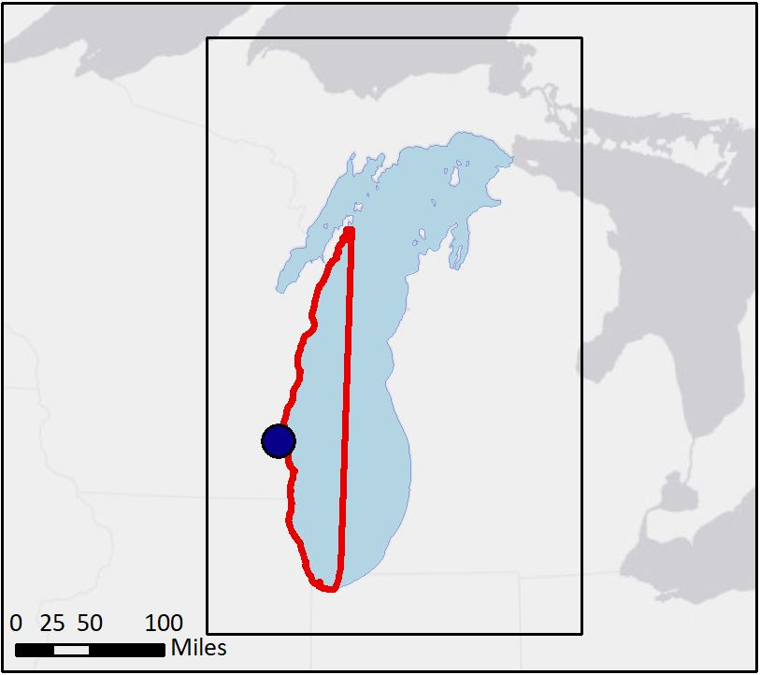

**N**

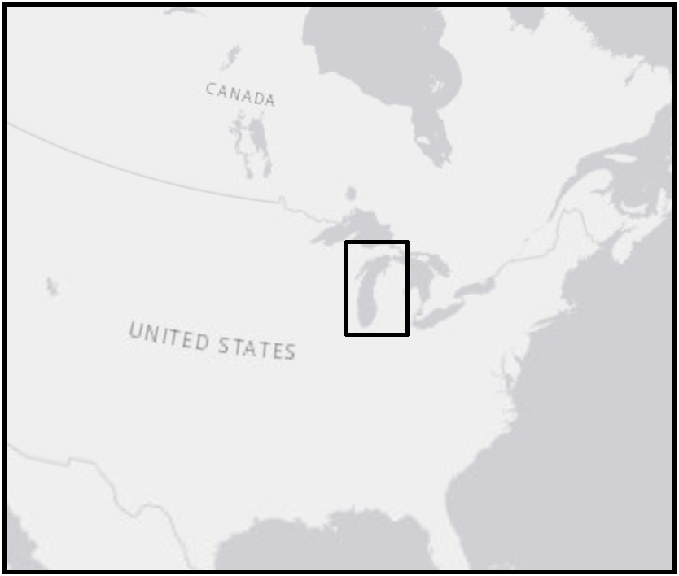

**Milwaukee**



Study Area

Lake Michigan

*Figure 1.* The study area, the western shore of Lake Michigan.

(Lake Michigan Water Resources Team II, ESRI).

# 3. Methodology

The team created a *Cladophora* detection and monitoring tool in ArcGIS Pro (2.2.0) and tested the tool by creating a predictive washup map using data from June to September for the years 2016 through 2018 (ESRI, 2018). In these four months of the year, *Cladophora* detaches from hard substrata and washes up on shores, a process known as “sloughing” (Bellis & McLarty, 1967; Canale & Auer, 1982; Malkin et al., 2008). Crucial factors in the predictive model include chlorophyll-a spectral signatures and surface water current data. Landsat 8 OLI and Sentinel-2 MSI imagery were used to detect chlorophyll-a in *Cladophora*. Chlorophyll-a was chosen as a proxy for *Cladophora* because ithashigh chlorophyll-a content and is the dominant algae in Lake Michigan (Dere et al., 1998; Greb et al., 2004). The red-edge spectral range available with Sentinel-2 MSI was utilized in the chlorophyll analysis as it is an established method to monitor vegetation and detect chlorophyll-a content (Frampton et al., 2013; Vanhellemont & Ruddick, 2016). Sentinel-2 MSI was also chosen for its high spatial and temporal resolution. Landsat 8 OLI has been used in previous studies for algae detection with reasonable accuracy, but higher resolution data are still desirable for more accurate detection (Malahlela et al., 2018; Shuchman et al., 2013). The visual bands of Landsat 8 OLI have 30 m spatial resolution, while Sentinel-2 MSI has 10 m resolution visual bands and 20 m red-edge band resolutions. We have compared data from both satellites to investigate the effects of spatial resolution and the use of the red-edge bands on *Cladophora* detection. Modeled surface water current data from NOAA predicted the trajectory of the algal mats once they were detected and were incorporated based upon the findings of Filipkowska et al. (2009) about the role of currents in algal displacement. *In situ* observations from GWMKE along the Milwaukee County shoreline were compared to the output of the predictive washup tool.

***3.1 Data Acquisition***

Earth observations and other ancillary data were acquired as detailed in Tables 1 and 2 below.

*Table 1.* NASA and ESA satellite data used in this project.

|  |  |  |  |
| --- | --- | --- | --- |
| **Earth Observation Data** | | | |
| **Product Title** | **Specifications** | **Image Dates** | **Source** |
| Landsat 8 Operational Land Imager Level-2 | Path 23, Rows 28 - 31 | June 24, 2016  July 26, 2016  August 11, 2016  September 12, 2016  June 27, 2017  July 29, 2017  August 30, 2017  September 17, 2017  May 29, 2018  June 30, 2018  July 16, 2018  August 1, 2018  September 2, 2018 | [EarthExplorer - USGS](https://earthexplorer.usgs.gov/) |
| Sentinel-2 Multispectral Instrument Level-1C | Tiles:  16TDQ  16TDP  16TDN  16TDM | June 15, 2016  July 25, 2016  August 14, 2016  September 3, 2016  June 10, 2017  July 25, 2017  August 29, 2017  September 23, 2017  June 30, 2018  July 10, 2018  August 19, 2018  September 23, 2018 | [ESA Copernicus Open Access Hub](https://scihub.copernicus.eu/dhus/#/home) |

*Table 2.* Ancillary Data acquired used in this project.

|  |  |  |  |
| --- | --- | --- | --- |
| **Ancillary Data** | | | |
| **Data Type** | **Specifications** | **Dates** | **Source** |
| Great Lakes Coastal Forecasting System Model outputs | netCDF | June to September, 2016 - 2018 | [NOAA Great Lakes Environmental Research Laboratory](https://www.glerl.noaa.gov/)  POC: Gregory Lang, gregory.lang@noaa.gov |
| *In situ Cladophora* washup data | GPS Points | June to September, 2018 | Groundwork Milwaukee  POC: Lawrence Hoffman, lawrence@groundworkmke.org |
| NOAA Continuously Updated Shoreline Product | Shapefile | 2018 | <https://www.ngs.noaa.gov/CUSP/> |

***3.2 Data Processing & Analysis***



Study Area

Lake Michigan

*3.2.1 Data Acquisition and Pre-processing*

One scene was selected from each month from June to September of 2016, 2017, and 2018 for both Landsat 8 OLI and Sentinel-2 MSI to inform the predictive model. Atmospherically corrected Level-2 Landsat 8 scenes were downloaded from the United States Geological Survey’s Earth Explorer. Level-1C Sentinel-2 scenes were downloaded from the European Space Agency’s (ESA) Open Access Hub and were atmospherically corrected using Sen2Cor in that Sentinel Application Platform (ESA, 2018). Within the Sen2Cor parameters, the resolution was set to “ALL”, the Aerosol was set to “MARITIME”, and the default settings were used with the remaining parameters. Since multiple Landsat 8 and Sentinel-2 scenes were needed for each date to cover the region, they were mosaicked into a single scene and clipped to fit the study area.

Scenes with more than 20% cloud cover were more likely to have clouds covering the shoreline and about 36% of all scenes from both Landsat 8 and Sentinel-2 were above that threshold. Clouds were removed from all scenes in order to increase the accuracy of the analysis. For Landsat 8 scenes, cloud masking was incorporated into the Predictive Washup Tool by excluding areas where pixel values in the Quality Assessment Band corresponded to “cloud shadow”, “cloud”, “high confidence cloud”, or “high confidence cirrus” (“Landsat Surface Reflectance Quality Assessment”, 2018). For Sentinel-2 scenes, areas that intersected with the ESA vector cloud mask layer were excluded.

*3.2.2 Chlorophyll-a Detection*

To best detect chlorophyll-a in the Landsat 8 scenes, the O’Reilly band ratio Chl_OC2 algorithm (Equation 1) was applied (O'Reilly et al., 1998)*.* This algorithm is a modified cubic polynomial where we have applied updated Landsat 8 specific coefficients from Werdell (2014) that help fit the ratio of blue and green bands to the curve of an observed chlorophyll-a dataset. The 4th coefficient, $a_{4}$, is needed to detect lower concentrations of chlorophyll-a while not significantly tampering with the fit of the curve at higher detected levels (O’Reilly et al., 1998). For chlorophyll-a detection with Sentinel-2 scenes, the Moses 3-band red-edge algorithm, as shown in Equation 2, was applied due to its use of Sentinel-2 MSI’s vegetation-sensitive red-edge bands (Moses et al., 2012). The published coefficients were used; simulations have shown the outcomes to be satisfactory for Sentinel-2 MSI even though they were not modified for this specific sensor (Q. Vanhellemont, personal communication, October 11, 2018). The Landsat 8 OLI and Sentinel-2 MSI data with the respective chlorophyll-a algorithms applied were imported into ArcGIS Pro as rasters. Chlorophyll-a values in the 99.95 percentile were extracted from the raster to be converted to points in order to reduce the number of input points into the Particle Track tool. The smallest value for the lower limit of the 99.95 percentile was 1.7 μg/L, which is twice the measured mean chlorophyll-a concentration for the 0-30m bathymetry zone of Lake Michigan for the years 2010 to 2013 (Fahnenstiel et al., 2016).

$\log_{10}\left(chlor_a\right)=a_{0}+\sum_{i=1}^{4}{a_{i}}{\left(\log_{10}\left(\frac{R_{rs}(λblue)}{R_{rs}(λgreen)}\right)\right)}^{i}$ (1)

$Chl_a=232.29\left[\left(R_{644}^{-1}-R_{704}^{-1}\right)×R_{780}\right]+23.174$ (2)

To measure the performance of the chlorophyll-a detection algorithms used here, we compared chlorophyll-a results for each sensor to results from the Floating Algae Index shown in Equation 3, an algorithm designed for MODIS that targets algae floating on the water’s surface (Hu, 2009).

$FAI=R_{NIR}-\left[R_{RED}+\left(R_{SWIR}-R_{RED}\right)×\left(λ_{NIR}-λ_{RED}\right)/\left(λ_{SWIR}-λ_{RED}\right)\right]$ (3)

*3.2.3 Water Currents*

NOAA Great Lakes Environmental Research Laboratory provided the team with 50-day Network Common Data Form (NetCDF) files containing hourly outputs from the Great Lakes Coastal Forecasting System model during our study period of June through September 2016 to 2018. Ten-day averages of surface water current variables, u (eastward velocity) and v (northward velocity), were calculated using NetCDF Operator (NCO). To obtain the desired 10-day averages, the team averaged five 10-day ranges within each 50-day file. We divided the 50-day file into five consecutive 10-day averages so that current information would more closely reflect the variability in currents throughout the summer season. The NetCDFs were converted to points in ArcGIS Pro using the Make NetCDF Feature Layer tool, and vector math was used to convert the northward and eastward velocities into rasters with 2 km spatial resolution representing direction and magnitude of the surface water currents. The direction and magnitude rasters were used as inputs for the Particle Track Tool in ArcGIS Pro, which calculates the projected path of a point until it reaches the raster boundary. At the 2 m bathymetry line, waves on Lake Michigan begin to break and apply forward motion on floating objects, so it was assumed that algae close to shore will likely wash up on the nearest beach because wave movement exerts more control over direction than currents at shallow depths (Brown et al., 1989). These points close to the shoreline were excluded from the Particle Track Tool to improve the accuracy because the tool only calculates movement from surface water currents. However, the points located close to shore were still included in the Predictive Washup Map.

*3.2.4 Predictive Washup Tool*

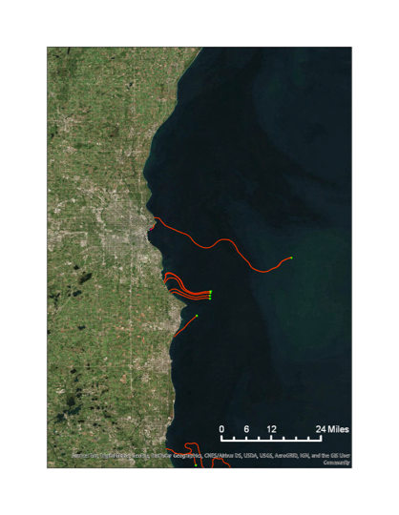

**Predictive Washup Tool**

Initial *Cladophora* locations

*Cladophora* Trajectory

*Figure 2.* The trajectory of chlorophyll-a point movement with surface water currents using the Particle Track Tool in ArcGIS, Landsat 8 OLI, 2016

Due to processing limitations in ArcGIS Pro, it was necessary to reduce the number of points used as inputs in the Particle Track Tool. Therefore, the points representing the highest 99.95% chlorophyll-a values were clustered into groups using the Density-based Clustering tool in ArcGIS Pro. The Mean Center tool was then used to calculate the average x and y coordinates of the cluster. The coordinates of each point were input into the Particle Track Tool along with the surface water currents data from the corresponding time period. The Particle Track Tool generates polyline features representing the path taken by each particle over time (Figure 2). These lines were simplified with the Unsplit Lines ArcGIS Pro tool and merged into a single feature class, which contained the last timestamp in seconds for each line. The time unit was converted from seconds to days so that the tool user can estimate how long it takes for the algae to wash ashore. Figure 3 shows an overview of the Predictive Washup Tool.

The predictive map was made by running the tool with Landsat 8 images and surface water current data from 2016 and 2017 in order to avoid incorporating cloud noise that resulted in high outlier chlorophyll-a values for July and September of 2018. In order to create a Predictive Washup Map, we counted intersections between chlorophyll-a points within the 2 m bathymetry line, predicted paths of *Cladophora* movement, and Milwaukee County beaches. The total number of modeled intersections were used as a metric for washup likelihood. The modeled washup output generated by the Predictive Washup Tool was compared to the Predictive Washup Map generated by the previous Lake Michigan Water Resources team and the *Cladophora* location points collected by GWMKE with the ArcGIS Collector application.

NASA Earth Observations: Landsat 8 OLI

ESA Earth Observations:

Sentinel-2 MSI

NOAA Modeled Surface Current Data

Floating Algae Location

Direction and Magnitude of Surface Currents

Predictive Washup Map

**Inputs**

**Automated Steps in ArcGIS Pro**

**Output**

Chlorophyll-a Algorithms

# 

# *Figure 3.* Factors incorporated into the Predictive Washup Tool.

# 4. Results & Discussion

***4.1 Cladophora* Detection**

The coarse spatial and temporal resolution of the Earth observations from Landsat 8 OLI hindered the algae detection results for the previous Lake Michigan Water Resources team’s study. To improve resolution to 20 m, our team used data from Sentinel-2 MSI in addition to Landsat 8 OLI for chlorophyll-a detection. Our original hypothesis was that because the results from the red-edge algorithm used with Sentinel-2 MSI would have a finer spatial and temporal resolution, the incorporation of this data would allow for a more accurate result than that of the chlorophyll-a indices of Landsat 8 OLI. However, while the results of the O’Reilly algorithm for Landsat 8 were within the expected range of chlorophyll-a values for Lake Michigan and showed high values in the nearshore zone where *Cladophora* grows, the values from the Moses 3-band ratio for Sentinel-2 varied from the expected range by two orders of magnitude and showed a mix of high and low values throughout the lake (Figure 4). Correlation analysis for the chlorophyll-a outputs between one coinciding date for each study year between Landsat 8 and Sentinel-2 was done for comparison. Landsat 8 and Sentinel-2 image dates differed by one day for two of these comparison dates. The resulting r values were insignificant for each of the three pairs, potentially due to the issue with the Sentinel-2 chlorophyll-a values, or, in the case of the two pairs collected in staggered days, partially attributable to actual differences in chlorophyll-a levels. Due to the lower quality of results from Sentinel-2, only the output from Landsat 8 was used as an input for the Predictive Washup Tool.

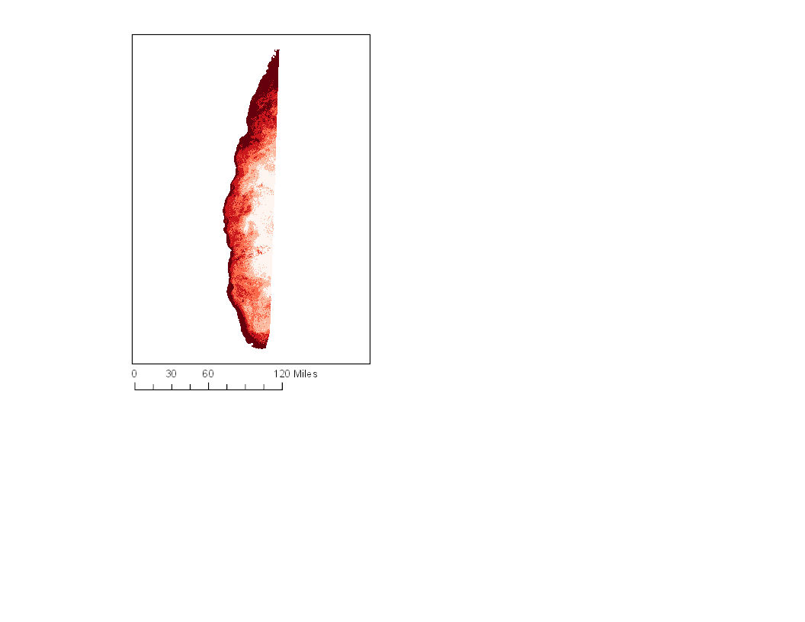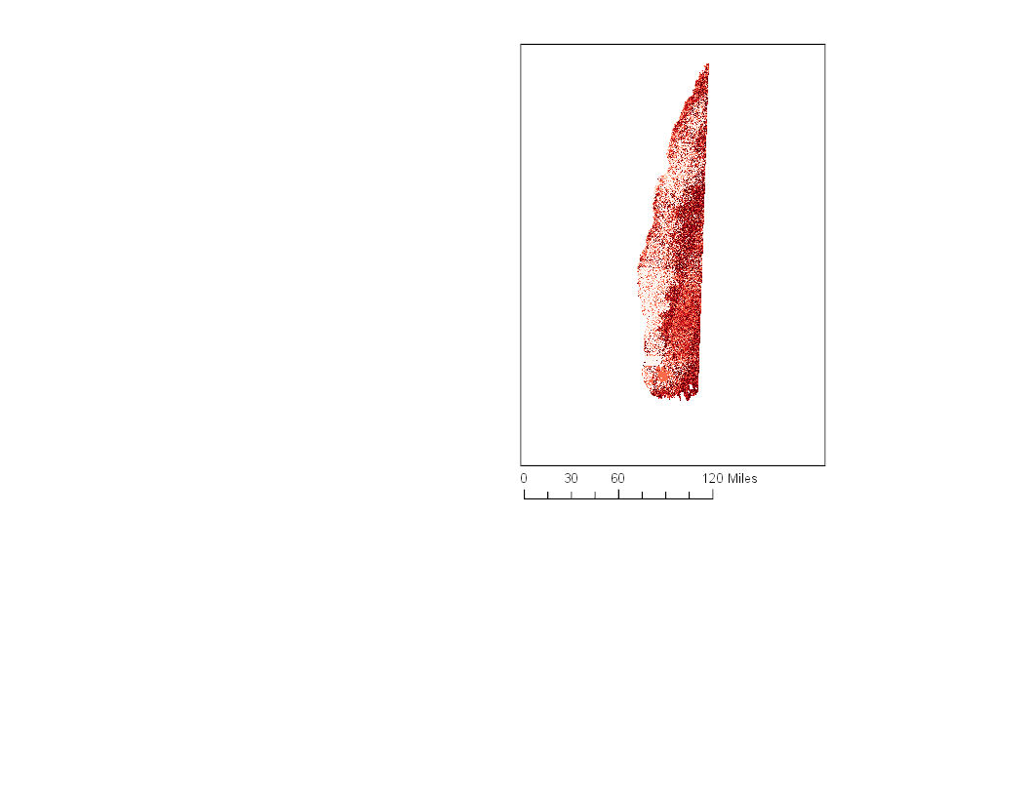

N

N

N

**Chlorophyll-a by Percentile**

≤ 100%

≤ 80%

≤ 60%

≤ 40%

≤ 20%

**Landsat 8**

**Sentinel-2**

*Figure 4.* Chlorophyll-a algorithms applied to a Landsat 8 OLI scene (right) from July 26, 2016, and Sentinel-2 MSI (left) from July 25, 2016.

In comparing the results of the algorithms for chlorophyll-a detection to that of the FAI for both Landsat 8 and Sentinel-2, we have found a low correlation (r = -0.0001 for Landsat 8; r = 0.0599 for Sentinel-2). A possible explanation for the lack of correlation between FAI and each of the chlorophyll-a algorithms is that FAI is specifically designed to pick up algae floating on the water’s surface, whereas chlorophyll-a values are measured for the water column and could include suspended phytoplankton. Figure 5 shows the output of our FAI algorithm, which does not show the expected distribution of floating algae in the lake. Therefore, we used chlorophyll-a for our Predictive Washup Map.

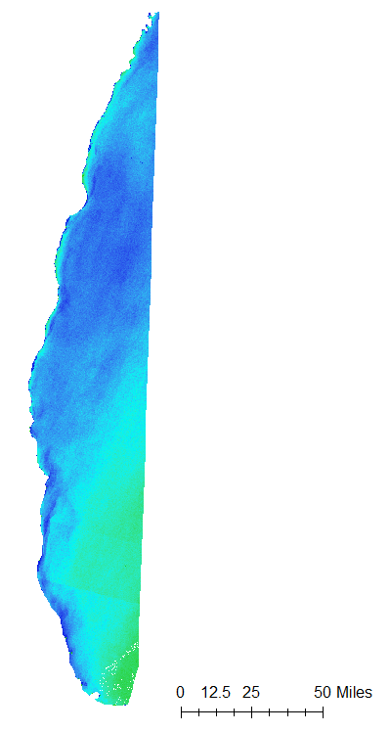



High: 4715

Low: -1459

*Figure 5.* FAI applied to a Landsat 8 scene from September 17, 2017.

While processing our data, we found that there were high outlier values in 2018 due to noise from clouds that were not eliminated by the cloud mask. We updated the tool to reclassify each raster to eliminate pixels above 20 or below 0 in order to capture the full range of potential chlorophyll-a values in the lake while eliminating any remaining noise due to clouds. Because of the reduction in points allowed by this change, we were able to generate predictions for chlorophyll-a values in the 99.5 percentile in the tool given to our partner organization.

***4.2* Surface Water Currents**

Due to the complexity and variability of the currents in Lake Michigan, accurately predicting *Cladophora* washup using modeled surface water current data is a significant challenge. The surface water current data used represents a highly simplified model. This simplification is necessary in order to incorporate the current data into ArcGIS Pro. The team found that the ArcGIS Pro platform is lacking a more robust particle tracking tool, and other modeling software lack formats that can be easily incorporated into GIS. The Particle Track Tool can only input a static raster representing direction and magnitude of the surface currents, which made it necessary to take the average of the currents rather than incorporating all modeled data into a more dynamic tool that accounts for changing daily and hourly currents. Our original idea had been to create a general seasonal model, but this would have introduced error into the tool because it was found that there is wide variability in currents depending on the year. A more accurate Predictive Washup Tool could be created using software designed for current modeling, but the goal of this project was to create a simple tool that can easily be used in ArcGIS by our partner organization. The Particle Tracking Tool in ArcGIS Pro is adequate for performing simple mathematical calculations, but it does not capture the complexity of the water currents.

***4.3* Predictive Washup Tool**

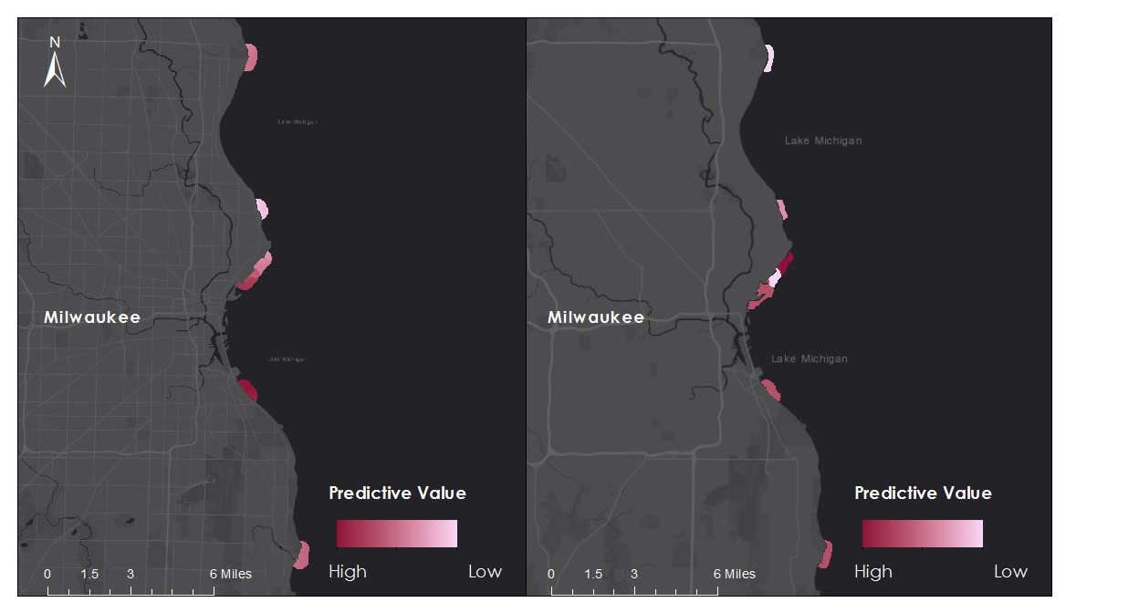

**Phase 1**

**Phase 2**

**Doctors Park**

**Doctors Park**

**Atwater Beach**

**Atwater Beach**

**Bradford Beach**

**Bradford Beach**

**McKinley Beach**

**McKinley Beach**

**Veterans Park**

**Veterans Park**

**South Shore Beach**

**South Shore Beach**

**Grant Park Beach**

**Grant Park Beach**

*Figure 6*. A comparison of outputs of the Predictive Washup Tool modeled for 2016 - 2017 (Phase 2) to the previous term’s Washup Predictive Map (Phase 1).

In Phase 2, currents were incorporated into the Predictive Washup Tool based upon studies suggesting that currents play a role in algal movement (Filipkowska et al., 2009; Son et al., 2015). For this reason, incorporating surface current data into the particle tracking tool in ArcGIS Pro may give a more accurate representation of algal mat movement than solely using shoreline curvature and the number of structures, factors considered by Phase 1 of this project. When compared to the Washup Predictive Map from Acdan et al. (2018), the predictions of the two methods differ most notably on Bradford Beach where Phase 1 predicted moderate likelihood of washup and Phase 2 predicted highest, on South Shore Beach (Phase 1, highest; Phase2, moderate), and on Doctors Park where Phase 1 predicted moderate likelihood and Phase 2 predicted low (Figure 6).

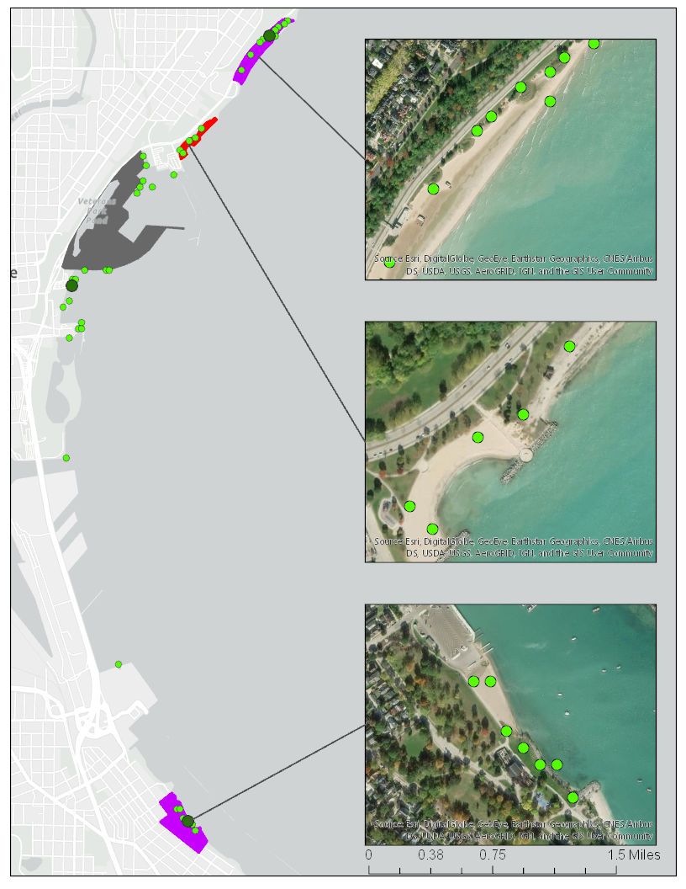

Bradford Beach

McKinley Beach

South Shore Beach

N

Highest chlorophyll-a values

No *Cladophora* observed

*Cladophora* observed

No data

***In Situ* Observations**

**Tool Outputs**

Clustered points

***4.2 Future Work***

*Figure 7.* Comparison of the Predictive Washup Tool to *in situ* observations for June 30, 2018.

We compared our model outputs with *in situ* data collected by GWMKE. Figure 7 shows our comparison between predicted and observed *Cladophora* washup locations for June 30, 2018. The inset maps show that some points detected as *Cladophora* in our model may have been vegetation on land. We clipped our input chlorophyll-a rasters to the lake based upon NOAA Continually Updated Shoreline measurements of the extent of Lake Michigan, but the extent predicted by NOAA may not have been accurate in all locations.

***4.2 Future Work***

Future efforts to predict *Cladophora* movement would benefit from incorporating *in situ* measurements for floating *Cladophora* in Lake Michigan, which could be used as parameters or validation for remote sensing analyses. Because chlorophyll-a can detect other phytoplankton, it could be useful to incorporate hyperspectral imagery in order to detect spectral signatures more specific to *Cladophora*. More field measurements of *Cladophora* washup along the shores of Lake Michigan could improve our understanding of the factors affecting *Cladophora* deposition, calibrate predictions about its movement, and help determine which factors contribute most to washup. Higher resolution imagery would also aid efforts to detect *Cladophora* because mats could be smaller than the 30 square meter resolution of Landsat 8 imagery. This may require adaptations to the Moses three-band red-edge algorithm for Sentinel-2 and Lake Michigan. The Predictive Washup Tool could be made more accurate by using software designed for water current modeling that would incorporate the complex, dynamic movement of surface water currents and waves.

**5. Conclusions**

# The team successfully generated new insights about *Cladophora* washup, expanding upon the previous Lake Michigan Water Resources team’s findings by incorporating chlorophyll-a and surface water currents into the predictive model. The three-band red-edge algorithm used with Sentinel-2 MSI proved to be problematic in detecting *Cladophora* in the lake and along the beach shores, but Landsat 8 OLI with the O’Reilly band ratio algorithm gave satisfactory results. Chlorophyll-a patterns detected in Landsat 8 imagery followed *Cladophora* washup behavior, suggesting that what was detected could likely be *Cladophora*. With an enhanced Predictive Washup Tool, GWMKE will be able to make better decisions related to *Cladophora* washup management and conserve more resources during cleanup efforts.

# 6. Acknowledgments

The Lake Michigan Water Resources II team would like to thank the mentors and partners who dedicated their time and assistance to this project. Without them, this project would not have been possible.

We appreciate the cooperation and help from our project partners at Groundwork Milwaukee:

* Deneine Christa Powell, Executive Director
* Lawrence Hoffman, GIS Program Manager

Mentors/Science Advisors:

* Dr. Juan Torres-Pérez, Science Advisor (Bay Area Environmental Research Institute, NASA Ames Research Center)
* Dr. Sherry Palacios, Science Advisor (Bay Area Environmental Research Institute, NASA Ames Research Center)
* Dr. Kenton Ross, Science Advisor (NASA Langley Research Center)
* Joe Spruce, Science Advisor (Science Systems & Applications, Inc)
* Farnaz Bayat, DEVELOP Center Lead (NASA Ames Research Center)
* Jerrold Acdan, DEVELOP Project Coordination Fellow (NASA Ames Research Center)

This material contains modified Copernicus Sentinel data (2016-2018), processed by ESA.

Any opinions, findings, and conclusions or recommendations expressed in this material are those of the author(s) and do not necessarily reflect the views of the National Aeronautics and Space Administration.

This material is based upon work supported by NASA through contract NNL16AA05C.

# 7. Glossary

***Cladophora*** –Genus of the filamentous green algae *Cladophora glomerata* found naturally in the Great Lakes

**Earth Observations** – Satellites and sensors that collect information about the Earth’s physical, chemical, and biological systems over space and time

**GWMKE** – Groundwork Milwaukee, a nonprofit organization that works with the local community to create positive socioeconomic and environmental change

# 9. References

Acdan, J., Chao, S., Fujiwara, L., & Golovey, E. (2018, August 09). Lake Michigan Water Resources: Utilizing NASA Earth Observations and Community Science to Detect and Map the Displacement of *Cladophora* along the Milwaukee County Shoreline. Retrieved September 20, 2018, from http://www.devpedia.developexchange.com/dp/index.php?title=Lake_Michigan_Water_Resources_ARC_Summer_2018

Auer, M. T., Tomlinson, L. M., Higgins, S. N., Malkin, S. Y., Howell, E. T., & Bootsma, H. A. (2010). Great Lakes *Cladophora* in the 21st Century: Same algae—Different ecosystem. *Journal of Great Lakes* *Research,* *36*(2), 248-255. doi:10.1016/j.jglr.2010.03.001

Bellis, V. J., & Mclarty, D. A. (1967). Ecology Of *Cladophora* Glomerata (L.) Kütz in Southern Ontario. *Journal of Phycology,* *3*(2), 57-63. doi:10.1111/j.1529-8817.1967.tb04631.x

Bootsma, H. A., Rowe, M. D., Brooks, C. N., Vanderploeg, H. A. (2015). Commentary: The need for model development related to *Cladophora* and nutrient management in Lake Michigan. *Journal of Great Lakes* *Research*, *41(3),* 7-15. doi:10.1016/j.jglr.2015.03.023

Brown, J., Colling, A., Park, D., Phillips, J., Rothery, D., & Wright, J. (1989). Waves. In *Waves, Tides, and Shallow-Water Processes* (Vol. 4, Oceanography, pp. 27-33). Milton Keynes, UK: The Open University in association with Pergamon.

Canale, R. P., & Auer, M. T. (1982). Ecological studies and mathematical modeling of *Cladophora* in Lake Huron: 7. Model verification and system response. *Journal of Great Lakes Research,* *8*(1), 134-143. doi:10.1016/s0380-1330(82)71951-3

Chun, C. L., Ochsner, U., Byappanahalli, M. N., Whitman, R. L., Tepp, W. H., Lin, G., . . . Sadowsky, M. J. (2013). Association of toxin-producing *Clostridium botulinum* with the macroalga *Cladophora* in the Great Lakes. *Environmental Science & Technology,* *47*(6), 2587-2594. doi:10.1021/es304743m

Dere, Ş., Günes, T., & Sivaci, R. (1998). Spectrophotometric determination of chlorophyll - A, B, and total carotenoid contents of some algae species using different solvents. *Turkish Journal of Botany, 22*(1)*,* 13-17. Retrieved from https://journals.tubitak.gov.tr/botany/issue.htm?id=145

Englebert, T.E., McDermott, C., & Kleinheinz, G.T. (2008). Effects of the nuisance algae, *Cladophora*, on *Escherichia coli* at recreational beaches in Wisconsin. *Science of the Total Environment, 404*(1)*,* 10-17. doi:10.1016/j.scitotenv.2008.05.025

ESA (2018). Sentinel Application Platform (6.0) [Computer Software]. Retrieved from <http://step.esa.int>

ESRI (2018). ArcGIS Pro (2.2.4) [Computer Software]. Retrieved from <https://pro.arcgis.com/en/pro-app/>

Fahnenstiel, G.L., Sayers, M.J., Shuchman, R.A., Yousef, F., & Pothoven S.A. (2016). Lake-wide phytoplankton production and abundance in the upper great lakes: 2010-2013. *Journal of Great Lakes Research, 42,* 619-629. <https://doi.org/10.1016/j.jglr.2016.02.004>

Filipkowska, A., Lubecki, L., Szymcczak-Zyla, M., Lotocka, M., & Kowalewska, G. (2009). Factors affecting the occurrence of algae on the Sopot Beach (Baltic Sea). *Oceanologia*, *51*(2), 233-262. <http://www.iopan.gda.pl/oceanologia>

Frampton, W. J., Dash, J., Watmough, G., & Milton, E. J. (2013). Evaluating the capabilities of Sentinel-2 for quantitative estimation of biophysical variables in vegetation. *ISPRS Journal of Photogrammetry and Remote Sensing,* *82*, 83-92. doi:10.1016/j.isprsjprs.2013.04.007

Greb, S., Garrison P., & Pfeiffer, S. (2004). *Cladophora* and water quality of Lake Michigan: A systematic survey of Wisconsin nearshore areas. *Cladophora Research and Management in the Great Lakes, Proceedings of a workshop held at the Great Lakes WATER Institute*, 73-80*.* Retrieved from <http://seagrant.wisc.edu/home/Portals/0/Files/Water%20Quality/Dec_05_Cladophora_Research_Workshop_Proceedings_2.pdf>

Hecky, R.E., Smith, R.E.H., Barton, D.R., Guildford, S.J., Taylor, W.D., & Charlton, M.N. (2004). The near shore phosphorous shunt: a consequence of ecosystem engineering by Dreissenids in the Laurentian Great Lakes. *Canadian Journal of Fisheries and Aquatic Sciences, 61*(7), 1285-1293. doi:10.1139/F04-065

Herbst, R.P. (1969). Ecological factors and the distribution of *Cladophora glomerata* in the Great Lakes. *The* *American Midland Naturalist*, *82*(1), 90-98. doi:10.2307/2423819

Higgins, S. N., Hecky, R. E., & Guildford, S. J. (2005). Modeling the growth, biomass, and tissue phosphorus concentration of *Cladophora glomerata* in Eastern Lake Erie: Model description and field testing. *Journal of Great Lakes Research,* *31*(4), 439-455. doi:10.1016/s0380-1330(05)70275-6

Higgins, S. N., Malkin, S. Y., Howell, E. T., Guildford, S. J., Campbell, L., Hiriart-Baer, V., & Hecky, R. E. (2008). An Ecological review of *Cladophora glomerata* (Chlorophyta) in the Laurentian Great Lakes. *Journal of Phycology,* *44*(4), 839-854. doi:10.1111/j.1529-8817.2008.00538.x

Hu, C. (2009). A novel ocean color index to detect floating algae in the global oceans. *Remote Sensing of Environment,* *113*(10), 2118-2129. doi:10.1016/j.rse.2009.05.012

Kautz, S. (2018). Landsat 8 OLI (Operational Land Imager) and TIRS (Thermal Infrared Sensor) [Dataset]. U.S. Geological Survey, accessed October 4, 2018. <https://doi.org/10.5066/f71835s6>

Landsat Surface Reflectance Quality Assessment. (2018, October 18). Retrieved from <https://landsat.usgs.gov/landsat-surface-reflectance-quality-assessment>

Malahlela, O. E., Oliphant, T., Tsoeleng, L. T., & Mhangara, P. (2018). Mapping Chlorophyll-a concentrations in a cyanobacteria- and algae-impacted Vaal Dam using Landsat 8 OLI data. *South African Journal of Science,* *114*(9/10). doi:10.17159/sajs.2018/4841

Malkin, S.Y., Sorichetti R.J., Wiklund, J.A., Hecky, R.E. (2008). Seasonal abundance, community composition, and silica content of diatoms epiphytic on *Cladophora glomerata*. *Journal of Great Lakes Research*, *35*, 199-205. doi:10.1016/j.jglr.2008.12.008

Moses, W. J., Gitelson, A. A., Berdnikov, S., Saprygin, V., & Povazhnyi, V. (2012). Operational MERIS-based NIR-red algorithms for estimating chlorophyll-a concentrations in coastal waters — The Azov Sea case study. *Remote Sensing of Environment,* *121*, 118-124. doi:10.1016/j.rse.2012.01.024

Nevers, M. B., Byappanahalli, M. N., Edge, T. A., & Whitman, R. L. (2014). Beach science in the Great Lakes. *Journal of Great Lakes Research,* *40*(1), 1-14. doi:10.1016/j.jglr.2013.12.011

O'Reilly, J. E., Maritorena, S., Mitchell, B. G., Siegel, D. A., Carder, K. L., Garver, S. A., . . . Mcclain, C. (1998). Ocean color chlorophyll algorithms for SeaWiFS. *Journal of Geophysical Research: Oceans,* *103*(C11), 24937-24953. doi:10.1029/98jc02160

Riley, S.C., Tucker, T.R., Adams, J.V., Fogarty, L.R., Mroaska Lafrancois, B. (2015). Factors associated with the deposition of *Cladophora* on Lake Michigan beaches in 2012. *Journal of Great Lakes Research, 41(4)*, 1094-1105. doi:10.1016/j.jglr.2015.09.008

Shuchman, R.A., Sayers, M.J., & Brooks, C.N. (2013) Mapping and monitoring the extent of submerged aquatic vegetation in the laurentian great lakes with multi-scale satellite remote sensing. *Journal of Great Lakes Research*, *39*, 78-89. https://doi.org/10.1016/j.jglr.2013.05.006.

Son, Y. B., Choi, B., Kim, Y. H., & Park, Y. (2015). Tracing floating green algae blooms in the Yellow Sea and the East China Sea using GOCI satellite data and lagrangian transport simulations. *Remote Sensing of Environment,* *156*, 21-33. doi:10.1016/j.rse.2014.09.024

Vanhellemont, Q., & Ruddick, K. (2016). ACOLITE for Sentinel-2: Aquatic applications of MSI imagery. *Living Planet Symposium,* *740*, ESA Special Publication. Retrieved October 1, 2018.

Werdell, J. (2014). Chlorophyll a (chlor_a). Retrieved October 2, 2018, from<https://oceancolor.gsfc.nasa.gov/atbd/chlor_a/>

What We Do. (2018, November). *Groundwork Milwaukee.* Retrieved from <http://www.groundworkmke.org/mission/>

Whitman, R.L., Shively, D.A., Pawlik, H., Nevers, M.B., & Byappanahalli, M.N. (2003). Occurrence of *Escherichia coli* and Enterococci in *Cladophora* (Chlorophyta) in nearshore water and beach sand of Lake Michigan. *Applied and Environmental Microbiology*, *69*(8), 4714-4719. doi:10.1128/AEM.69.8.4714-4719.2003