**NASA DEVELOP National Program**

****University of Georgia

**Summer 2016**

**Short Title: Southeast U.S. Ecological Forecasting III**

**Subtitle:** Utilizing NASA Earth Observations and Proximal Remote Sensing for Mapping the Spatio-Temporal Distribution of *Hydrilla verticillata*

**VPS Title:** Hydrilla Hype: Mapping an Invasive Weed in Two Georgia Reservoirs

**Project Team & Partners**

**Project Team:**

Shuvankar Ghosh (Project Co-Lead), sghosh.21011984@gmail.com

Austin Haney (Project Co-Lead), austinh@uga.edu

Frank Braun

Zachary Conner

Christopher Cooper

Abhishek Kumar

**Advisors & Mentors:**

Dr. Deepak Mishra (University of Georgia, Department of Geography)

Dr. Susan Wilde (University of Georgia, Warnell School of Forestry and Natural Resources)

**Past or Other Contributors:**

Wuyang Cai

Pradeep Kumar Ragu Chanthar

Elizabeth Dyer

Peter Hawman

Brandon Hays

Benjamin Page

Linli Zhu

**Partner Organizations:**

|  |  |  |  |
| --- | --- | --- | --- |
| **Organization** | **POC (Name, Position/Title)** | **Partner Type** | **Boundary Org?** |
| US Army Corps of Engineers, J. Strom Thurmond Project | Kenneth Boyd, Conservation Biologist | End-User | No |
| Henry County Water Authority, Cubihatchi Outdoor Education | Kenneth Presley, Assistant Reservoir Manager | End-User | No |

**Project Details**

**Applied Sciences National Applications Addressed:** Ecological Forecasting, Water Resources

**Study Area:** Lake Thurmond, GA/SC and Long Branch Reservoir, Henry County, GA

**Study Period:** Jun 2016 - Aug2016; forecast yearly growth cycle

**Earth Observations & Parameters:**

Landsat 8, Operational Land Imager (OLI) – *Hydrilla*distribution and vegetation indices

**Ancillary Datasets Utilized:**

* UGA *in situ* data – hyperspectral spectroradiometer showing above and below water canopy reflectance for *Hydrilla* presence, Secchi Disk showing *Hydrilla* depth & Vertical diffuse attenuation coefficients
* Field data collected by the team – Total Suspended solids (organic + inorganic) concentration, turbidity, and GPS locations

**Models Utilized:**

* The University of Georgia Benthic Habitat Radiative Transfer Model
* SAV Light Requirement Model

**Software Utilized:**

* MatLab – Atmospheric correction of Landsat 8 imagery
* ArcGIS – Raster manipulation and mapping using a multi-platform approach to find spatial and temporal distribution patterns of *Hydrilla verticillata*
* ERDAS Imagine 2013 – Raster manipulation of Landsat 8 Imagery
* ENVI 5.0 – Raster manipulation of Landsat 8 Imagery

**Project Overview**

**80-100 Word Objectives Overview:**

*Hydrilla verticillata* is an invasive aquatic plant which has contaminated numerous freshwater lakes and rivers throughout the Southeastern US, displacing native fauna and flora while also costing millions of dollars in damage and removal efforts. This NASA DEVELOP project uses Landsat 8 OLI data to create a model for mapping the current distribution of *Hydrilla* to be used later for predicting future growth. The goal of this work is to generate a useful, rapid assessment tool that will aid control efforts targeting *Hydrilla* in local reservoirs.

**Abstract:**

*Hydrilla verticillata* is an invasive aquatic plant which has rapidly spread through many inland water-bodies across the Southeastern United States (SEUS) mainly through inadvertent transfer. Once in a water body, this invasive species generally out-competes native aquatic plants and becomes established as the most dominant vegetative species. Consumption of water for drinking, power generation, and recreational use of lakes has been threatened by the spread of *Hydrilla.* In recent years it was discovered that *Hydrilla* serves as a host for an epiphytic, toxic cyanobacteria (*Aetokthonos hydrillicola*) in some water bodies. *Aetokthonos hydrillicola* is now known to be the causative agent of the neurodegenerative disease avian vacuolar myelinopathy (AVM), which affects waterfowl, raptors, and amphibians. Using Landsat 8 Operational Land Imager (OLI) imagery, a rapid assessment tool was developed to accurately map the extent of *Hydrilla* on Lake Thurmond (GA/SC) and Long Branch reservoir in Henry County, Georgia. This tool will act as the foundation for later models intending to predict future locations in need of *Hydrilla* management.

**Keywords:**

Landsat 8 OLI, biovolume, Invasive aquatic plants

**Community Concerns:**

* *Hydrilla verticillata* outcompetes native plants and forms surface canopies that block sunlight in turn intensifying lake stratification and causing anoxic conditions.
* In some water bodies, *Hydrilla* harbors toxic epiphytic cyanobacteria that affect the food chain causing wildlife fatalities.
* *Hydrilla* mats clog boat motors disrupting transportation and recreation as well as causing hazardous swimming conditions.
* *Hydrilla* obstructs water withdrawal for drinking water, irrigation, and power generation.

**Current Management Practices & Policies**:

Local management agencies use visual analysis, rake collection, and sonar analysis to monitor the spread of *Hydrilla*. Herbicides are often used to manage *Hydrilla verticillata*, including chelated copper, diguat, endothall, and fluridone, but applying these chemicals can have adverse effects on lake ecosystems. As a lower-impact strategy, managers have introduced triploid grass carp (*Ctenopharyngodon idella*), a species of fish which consumes aquatic plant material including *Hydrilla*. Because triploid grass carp are sterile, they cannot reproduce or become established within water bodies in which they are implemented.

**Decision Support Tools & Benefits:**

|  |  |  |  |
| --- | --- | --- | --- |
| **End-Product** | **Earth Observations Used** | **Benefit & Impact** | **Software**  **Release** |
| Landsat 8 Benthic Model for *Hydrilla* sp. Mapping | Landsat 8 OLI | Detecting the spatial distribution of *Hydrilla* sp. to support preemptive planning efforts | N/A |
| *Hydrilla* Distribution Maps | Landsat 8 OLI | Lake managers can use these map products to target mitigation and restoration efforts | N/A |
| *Hydrilla* Biomass Forecast Model | Landsat 8 OLI | Biomass forecast model can be used by the end-users to approximate the standing biomass of *Hydrilla* in the lakes from satellite data and forecast their growth cycle for the year. | N/A |

**Project VPS/Booklet Imagery**

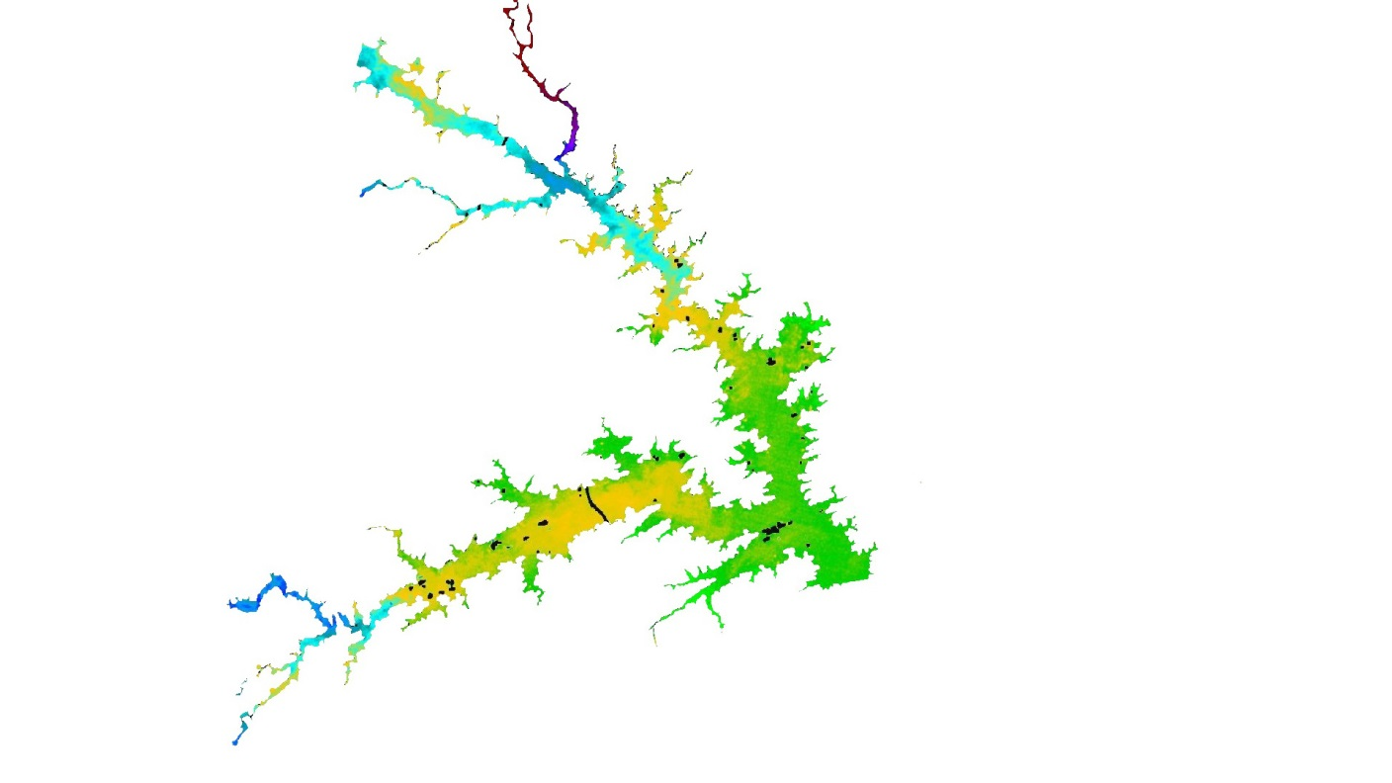

**Caption:** *Hydrilla* distribution prediction in Lake J. Strom Thurmond based on Secchi disk depth, October 2015. Image Credit: Southeast Ecological Forecasting III Team.

**Image:** 2016Sum_UGA_SoutheastUSEcoIII_VPSImage.jpg