**NASA DEVELOP National Program**

****NASA Jet Propulsion Laboratory

**Spring 2016**

**Short Title: Bolsa Chica Ecological Forecasting**

**Subtitle:** Analyzing the Success of the Bolsa Chica Wetland Restoration Using Multi-spectral NASA Earth Observations

**VPS Title:** Where’s a Bird to Go? Mapping Wetland Restoration on the Pacific Flyway

**Project Team & Partners**

**Project Team:**

Christine Elowitt (Project Lead), Christine.E.Elowitt@jpl.nasa.gov

Nick Rousseau

Steven Kerns

**Advisors & Mentors:**

Cedric Fichot (NASA Jet Propulsion Laboratory)

Benjamin Holt (NASA Jet Propulsion Laboratory)

**Past or Other Contributors:**

Gwen Miller

**Partner Organizations:**

Amigos de Bolsa Chica (End-User), POC: Joana Tavares-Reager; Boundary Organization

**Project Details**

**Applied Sciences National Application Addressed:** Ecological Forecasting

**Study Area:** Bolsa Chica Ecological Reserve, Huntington Beach, CA

**Study Period:** August 2002- August 2014

**Earth Observations & Parameters:**

Landsat 7, ETM+ – land cover, vegetation and water indices

Landsat 8, OLI – land cover, vegetation and water indices

**Ancillary Datasets Utilized:**

* NOAA Coastal Change Analysis Program (C-CAP) – land cover data
* USDA National Agriculture Imagery Program (NAIP) – aerial imagery
* USGS Digital Orthographic Quadrangles (DOQ) – aerial imagery
* USGS High Resolution Orthoimagery (HRO) – aerial imagery

**Software Utilized:**

ArcGIS – Creation of vector layers representing different land cover types, map layouts

QGIS – Index calculation for Landsat Imagery

**Project Overview**

**80-100 Word Objectives Overview:**

The objective of this project is to conduct a change detection analysis using NASA Earth observations to show a time series of maps depicting the extent of vegetation and water before and after key restoration events in the Bolsa Chica Ecological Reserve. Over the course of the past century, development and urbanization have greatly affected Southern California’s natural coastal environment. Since the state acquired rights to this reserve in 1997, it has been working to restore it to historical conditions. The research conducted here will help guide coastal managers in their decision making while assessing the effectiveness of past and current management practices.

**Abstract:**

The Bolsa Chica Ecological Reserve in Huntington Beach, California, consists of 1550 acres of undeveloped coastal wetland and is home to several endangered species, including *Rallus longirostris levipes* and *Sterna antillarum browni,* which fly along the Pacific flyway. Since the 1800’s, farming, land subsidence, resource extraction, and land development have impacted these wetlands, affecting the habitat’s biodiversity. The Amigos de Bolsa Chica advocacy group has made a 40-year effort to preserve, restore, and maintain the wetlands through volunteer work and public outreach, impacting public policy and management practices. However, there has been no previous attempt to assess the success of the restoration using aerial imagery. This project utilized NASA Earth observations, National Agriculture Imagery Program (NAIP) imagery, USGS High Resolution Orthoimagery and Digital Orthographic Quadrangles, and field surveys to highlight the changes in habitat and tidal water extent from 2002 to 2014, with a particular focus on the changes that ensued from the opening of a channel connecting the site to the ocean in 2006. Using a before and after time series based off of our analysis and vegetation maps of the current site, the Amigos de Bolsa Chica will be able to: enhance their education and outreach, create more effective tools to engage the community, strengthen their management of the wetlands and better prioritize areas of future concern.

**Community Concerns:**

* The landscape of the wetlands has been impacted by past human activity, including farming and oil extraction.
* In the past two decades, state agencies have been attempting to restore tidal flow and vegetation to their more natural state to provide habitat for endangered species and other wildlife with few other nesting site options along the Southern California coast.
* No analysis has been done comparing the site’s current state to what it was before restoration efforts began to gauge the success of the restoration.
* Since the reserve belongs to California residents, it’s important to educate them on the importance of this restoration effort as well as show them how effective their tax dollars have been thus far.

**Current Management Practices & Policies**:

The Bolsa Chica Ecological Reserve is managed by the California Department of Fish and Wildlife, while the California Coastal Commission regulates any development within the site. The Amigos De Bolsa Chica is one of two non-profit groups that are affiliated with the site. Both groups are stakeholders and give their input and feedback at regulatory and decision-making meetings. The Amigos’ efforts lay primarily within the realm of community involvement and education through activism and advocacy. They have created the Follow and Learn about the Ocean Wetlands (FLOW) program to monitor water quality and create a citizens scientist corp. Given that they are a non-profit volunteer organization, wetland surveys rely on volunteers of various skill levels who monitor the wetlands to determine its state of health.

**Decision Support Tools & Benefits:**

|  |  |  |
| --- | --- | --- |
| **End-Product** | **Earth Observations Used** | **Benefit & Impact** |
| Time-Series of Satellite Images and Vegetation/Water Indices | Landsat 8 OLI  Landsat 7 ETM+ | A series of satellite images from 2002 and 2014, along with indices calculated from the images’ bands, will show the changes in vegetation and water extent that the site has undergone since it was reopened to tidal influences in 2006, allowing analysis of the restoration effort’s success. |
| Before and After Land Cover Maps | Landsat 8 OLI  Landsat 7 ETM+ | These maps will show land cover in the Bolsa Chica Ecological Preserve in 2002 and 2014. Many parts of the wetland are not accessible on foot, so groups affiliated with the wetlands have not been able to fully study the extent of these habitats, many of which provide shelter to endangered species. These images can be easily understood by the general public, and will be in a format that can be utilized on the website and brochures of the Amigos de Bolsa Chica. |

**Project Imagery**

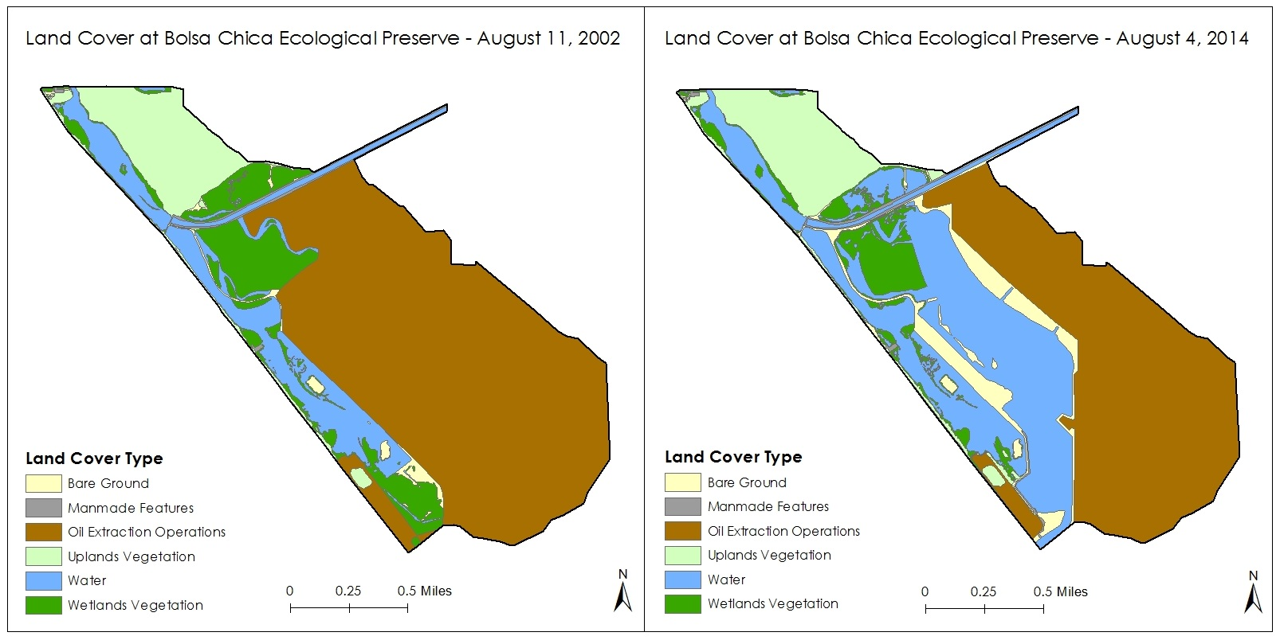

**Caption:** Land cover maps showing the changes that have happened at the Bolsa Chica Ecological Preserve before and after the restoration efforts re-opened the site to direct tidal influences in 2006. Image Credit: Bolsa Chica Ecological Forecasting Team.

**Image:** 2016Spring_JPL_BolsaChicaEco_VPSImage