NASA DEVELOP National Program
NASA Langley Research Center
Summer 2015

Northwest U.S. Agriculture III
Applying Future Climate Patterns to Apple Orchards
in Washington State


Technical Report
Final Draft – July 29, 2015

Madeline Ruid (Project Lead)
Teresa Fenn
Matthew Mullen
Sarah Philbrick
James Hendrickson (USAF)

Dr. Kenton Ross, NASA DEVELOP National Program (Science Advisor)
Dr. Noel Baker, NASA Postdoctoral Fellow (Science Advisor)

Previous Contributors:
Lauren Makely
Idamis Del Valle-Martinez
Clarence Kimbrell
Zachariah Long
Chad Smith
Matthew Smith
Lydia Cuker
Laura Lykens
Alyssa Walzak
Timothy Stelter

I. Abstract
Washington State produces 65% of the nation’s apples, adding 2.2 billion dollars to the nation’s economy. Washington’s warm, dry summers and cool, wet winters provide excellent conditions for apple growth. However, there is a strong likelihood that Washington’s suitability for apple orchards could be altered by current and future climate change. Currently, the USDA determines which plant species will thrive in a particular location based on their Plant Hardiness Zone (PHZ) Map. Apples grow best when climate conditions match zones 5, 6, or 7. By creating maps of current and projected PHZs, apple growers will be able to decide both if it would be beneficial to move apple orchards in the upcoming decades and where the most suitable conditions will be located. Using Aqua MODIS Land Surface Temperature (LST) from 2002 to 2015, minimum temperatures per day and month were extracted to create a present-day PHZ map. Additionally, future climate model air temperature forecasts from the NASA Earth Exchange Downscaled Climate Projections (NEX-DCP30) dataset for 2040 to 2100 were used to determine future PHZs. Growing Degree Days (GDD) were also calculated to create orchard suitability maps. Since the ability of apple trees to thrive is dependent on GDDs, PHZs, and average growing season temperature, these maps provide further insight into which regions of Washington State may be suitable for apple orchards in the future. Final current and forecasted PHZ and suitability maps will allow stakeholders to identify regions that are currently optimal for apple production, and see how those regions may move with forecasted climate change.

Keywords
Remote Sensing, Climate Change, Agriculture, Apples, MODIS, Washington State, Plant Hardiness Zones, Growing Degree Days

II. Introduction
Washington State’s warm, dry summers and cool, wet winters provide excellent conditions for apple growth. As a result, Washington produces 65% of the nation’s apples, adding 2.2 billion dollars to the nation’s economy (NASS 2015, Washington State Dept. of Agriculture). A majority of the apple orchards in Washington are located in the valleys and basins to the east of the Cascade Mountains (Smith 2001). The primary apple growing counties are Chelan, Yakima and Grant (Figure 1). These counties have a relatively temperate, dry climate coupled with an abundant irrigation source of rivers and streams that are fed by snow melt, creating ideal conditions for producing apples (Smith 2001).

In 2014, Washington produced an unprecedented 7.3 billion pounds of apples, which was a 24% increase from the previous year’s harvest (NASS 2015). The record yield was the result of a warm spring and expansions of high density orchards (NASS 2015). As seen through recently collected data, Washington’s conditions have been ideal for producing high apple yields; however, there is a strong likelihood that Washington’s suitability for apple farming could be impacted by future climate change. The most recent report from the Intergovernmental Panel on Climate Change (IPCC) projects the global mean surface temperature to increase 1-2 °C by 2065 and 1-3.7 °C by 2100 (2013). Downscaled regional predictions show that Washington State could see even more severe temperature changes. The IPCC climate models use Representative Concentration Pathways (RCPs) to model different possible emissions scenarios in regards to climate change. The RCP 8.5 scenario – which is currently the worst-case scenario – predicts that Washington could see up to a 4-5 °C increase in temperature by 2100 (IPCC 2013). The RCP8.5 scenario projects temperatures using the trend of annual CO2 emissions steadily rising that results in an atmospheric CO2 concentration of 936 ppm by 2100. The more moderate RCP4.5 scenario projects annual carbon emissions to level off and then begin declining by the middle to late part of this century, resulting in 538 ppm by 2100 (IPCC 2013).
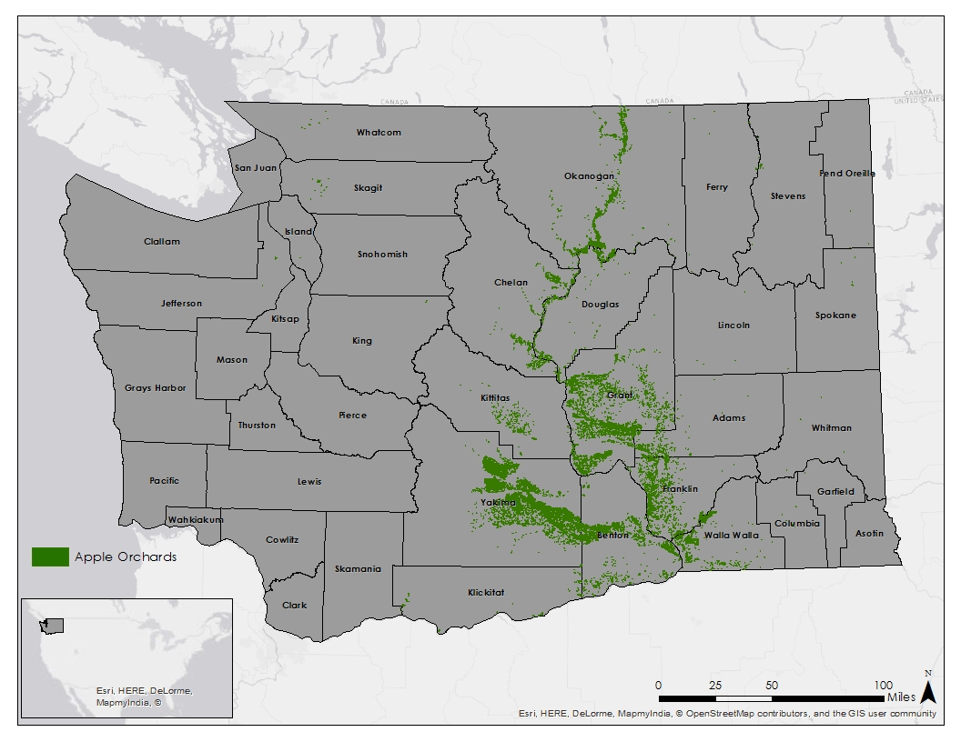
Figure 1: Current Apple Orchard Locations within Washington State

The United States Department of Agriculture’s (USDA) Plant Hardiness Zone (PHZ) maps are a good way to identify areas that are well suited for apple growth. PHZ maps are created by classifying average annual minimum temperatures into 10 °F zones, and are used to determine which plants will thrive in a particular location (Daly 2012). Minimum temperature is useful when determining locations for orchards because extreme cold temperatures can cause winter injury, leading to poor production and even tree death (Quamme 2010). According to Dr. Michael Glenn from the USDA Agricultural Research Service (ARS), apples grow best in PHZs 5, 6, and 7, where minimum temperatures are between -28.9 °C and -12.2 °C. The PHZ map is helpful when making present-day decisions, but there are currently no projected PHZ maps that take into account future climate change.

The objective of the project was to create current and forecasted PHZ maps specific to Washington State for 2045, 2065, and 2095 in order to determine which areas will be most suitable for apple orchards. The current PHZ map was created using MODIS LST data for the period of Jan 1, 2002 to June 1, 2015. In addition to the PHZ maps, current and future orchard suitability maps that combine annual minimum temperature, growing degree days for Codling Moths, and average temperature for the growing season were created for the same time periods.

The project addressed the agriculture application area by using observations from the MODIS sensor on the NASA satellite Aqua to create PHZ maps, which will help inform current and future decisions by the USDA and farmers concerning apple production over the 21st century. The climate application area was also addressed because climate models are utilized to demonstrate how climate change will affect the growing conditions for apples through the year 2100.

By creating current and future PHZ and suitability maps, growers can better prepare for the predicted effects of climate change. These maps will be shared with the USDA’s Agricultural Research Service. By understanding the effect that climate change will have on suitable growing areas in Washington, growers have more information for their own decision-making processes.

III. Methodology
Data Acquisition
Level three Aqua MODIS data (MYD11A1) was acquired from the Land Processes Distributed Active Archive Center (LP DAAC) for January 2002 through June 2015 for the state of Washington, consisting of tiles h9v04 and h10v04. The PRISM data, used to validate our MODIS data, was acquired from the PRISM Climate Group for January 2002 through June 2015 for the state of Washington.

Future temperature forecasts were obtained using Coupled Model Intercomparison Project Phase 5 (CMIP5) based NASA Earth Exchange - Downscaled Climate Projection 30 (NEX-DCP30) data, an ensemble dataset comprised of 33 models. Two scenarios from the climate model were used. The moderate scenario was RCP 4.5, where radiative forcing was 4.5 W/m² greater in 2100 relative to 1750. The extreme scenario was RCP 8.5, where radiative forcing was 8.5 W/m² greater in 2100 relative to 1750 (IPCC 2013). Weather station data for Yakima, Grant, and Chelan for 2002- 2015 was downloaded from National Oceanic and Atmospheric Administration’s National Climatic Data Center.

Data Processing
The MODIS LST data were processed in Python in order to convert the raw MODIS files from Hierarchical Data Format (HDF) to tiff files. The data were then mosaicked together, projected to the North American Datum 1983 High Accuracy Reference Network State Plane Washington South projection, and clipped to the state of Washington. The temperature values were converted from Kelvin to degrees Celsius, and land surface temperatures were converted to estimated air temperatures using a linear transformation obtained by plotting data from the eleven weather stations that overlapped the apple orchards against MODIS LST data. Using the equation of this line, we derived a transformation equation to be applied to both nighttime and daytime data (Table 1).

Dataset | Equation
Day | y = 0.66x + 2.78
Night | y = 0.828x + 1.725
Table 1: Linear Regression Equations for LST to Air Temperature Conversion

The data were then processed to remove any outliers which may include pixels tainted by cloud cover or other atmospheric conditions. All cloud cover previously detected by the MODIS satellite was given a null value. Other outliers were defined as being more than three standard deviations from the mean.

In order to calculate current growing degree days, MODIS data was averaged using a five day rolling average technique, where each pixel was averaged with the data taken within two days of its acquisition date. The data was then averaged from the same day over multiple years.

Average growing season temperature was created by averaging the maximum and minimum temperatures for each month in the growing season. The monthly averages were then combined into a yearly average and then a decadal average.
The NEX-DCP30 dataset and PRISM dataset were clipped and projected to match the MODIS dataset extent and projection. The NEX-DCP30 dataset was converted from degrees Kelvin to degrees Celsius.

Data Analysis
To create PHZ maps and orchard suitability maps, daily minimum and maximum temperatures were estimated using the air temperatures that were converted from the MODIS Land Surface Temperatures (LST). PHZ maps were created by classifying the average minimum yearly temperature for each pixel into 5°F zones. The USDA used PRISM data from 1976-2005 to create their current PHZ map, so PRISM data from 2002-2015 was used to create a comparative PHZ map that aligns with the MODIS time period in order to compare the two methods. Suitability maps were created by combining Growing Degree Days (GDD), PHZs, and average growing season temperature. All parameters were scaled from 0-100 and given equal weights in the final suitability maps.

GDD were scaled based on the number of Codling Moth generations that would be able to hatch in a year (Table 2). If a generation of Codling Moths does not hatch completely, the species will die off for that year. Therefore, areas with GDD less than 1175, producing less than one full generation of Codling Moths, were given a score of 100. Areas where one full generation would hatch were given a score of 80, two generations were given a score of 60, three generations 40, and four generations 20. The thresholds for moth development were taken from Tree Fruit Research & Extension Center which lists the GDD thresholds for first and second generation development (2015). Third and fourth generation development was assumed to be similar to the average of two.

Growing Degree Days | Score
0 -1175 | 100
1175 - 2295 | 80
2295 - 3442 | 60
3442 - 4589 | 40
4589 - 5736 | 20
Table 2: Suitability Scores for GDDs

Plant Hardiness Zones were classified based on apple tree growing data obtained from the Arbor Day Foundation (2015). Eleven species of apples were considered, and the percentage of trees that were able to grow in each plant hardiness zone determined the score of that zone. Zones 5 through 7 could support all eleven apple varieties, and received a score of 100 (Table 3).

Plant Hardiness Zone | Score
5-7 | 100
8 | 64
4 | 55
9 | 45
10 | 18
<5 or >10 | 0
Table 3: Suitability Scores for PHZs

Average growing season temperature was scaled based on the current average growing season temperatures for areas of current apple growth. The growing season was defined as May 1st through September 30th. USDA Cropscape data was used to mask areas of apple growth, and the average growing season temperature was taken for the area. The same technique was used to find average growing season temperatures for PHZs 5 through 7. Temperatures within two standard deviations from the mean growing season temperature of apple growing areas were given a suitability score of 100. Temperatures within two standard deviations from mean of areas with PHZ 5-7 and not included in the previous category were given a score of 80. Temperatures that fell within two and three standard deviations from the means were given a score of 60, and temperatures that fell within negative two and negative three standard deviations from the mean were given a score of 30 (Table 4). The temperature ranges were scored based on anecdotal information from the project partner Dr. Glenn.

Temperature Range (°C) | Score
15.37-19.97 | 100
9.23-15.37 or 19.97-21.48 | 80
21.48-24.53 | 60
6.16-9.22 | 30
<6.16 or >24.53 | 0
Table 4: Suitability Scores for Average Growing Season Temperature

Results & Discussion
Comparing MODIS LSTs to NOAA weather station air temperatures shows that there is a relatively high correlation between the two. Daytime temperatures have an r² value of 0.75, while nighttime temperatures have a value of 0.77. Figure 2 shows the spread of temperatures in relation to the line of best fit (grey line) and one-to-one line (black line), where r² would equal 1. Comparing the plots for daytime and nighttime temperatures reveals that nighttime MODIS temperatures are more closely correlated to weather station data, as indicated by the closer clustering of dots around the black one-to-one line. In addition, the line of best fit closely follows the one-to-one line. In contrast, the daytime data shows greater spread from the black one-to-one line. Even with this variation, both the daytime and nighttime temperatures have a high enough correlation that the MODIS LST data can be corrected using linear regression equations taken from the line of best fit (found in Table 1, above). These corrected air temperature values can then be used to extract plant hardiness zones, growing degree days, and average growing season temperature.
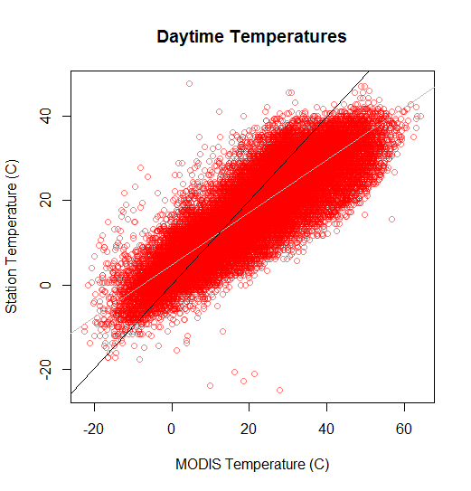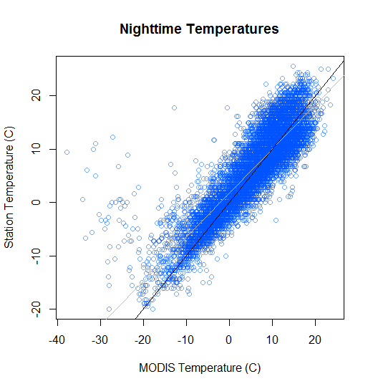
Figure 2: Correlation between MODIS LST and Weather Station Air Temperatures for daytime (left) and nighttime (right) temperatures

Currently, all apple orchards in Washington State are found in zones 6b - 8a, with the cooler zones in the north of the state. The majority of the orchards are in the ideal range of 5-7 (Figure 3). However, both scenarios predict that by 2045 both zones 6 and 7 will have disappeared completely from Washington state, zones 9a and 9b will expand to cover most of the apple region, and zone 10a appears in the south. There is little difference between the scenarios until 2095, when the PHZs in the extreme scenario are one half-zone above those in the moderate scenario. The extreme scenario in 2095 predicts that almost all the current apple orchards will be within zones 10a and 10b, while the moderate scenario shows that zone 9a is the coolest zone where apples will be found. Both are well above the ideal range of 5 to 7 (see Table 3). Larger versions of the PHZ maps can be found in Appendix A.

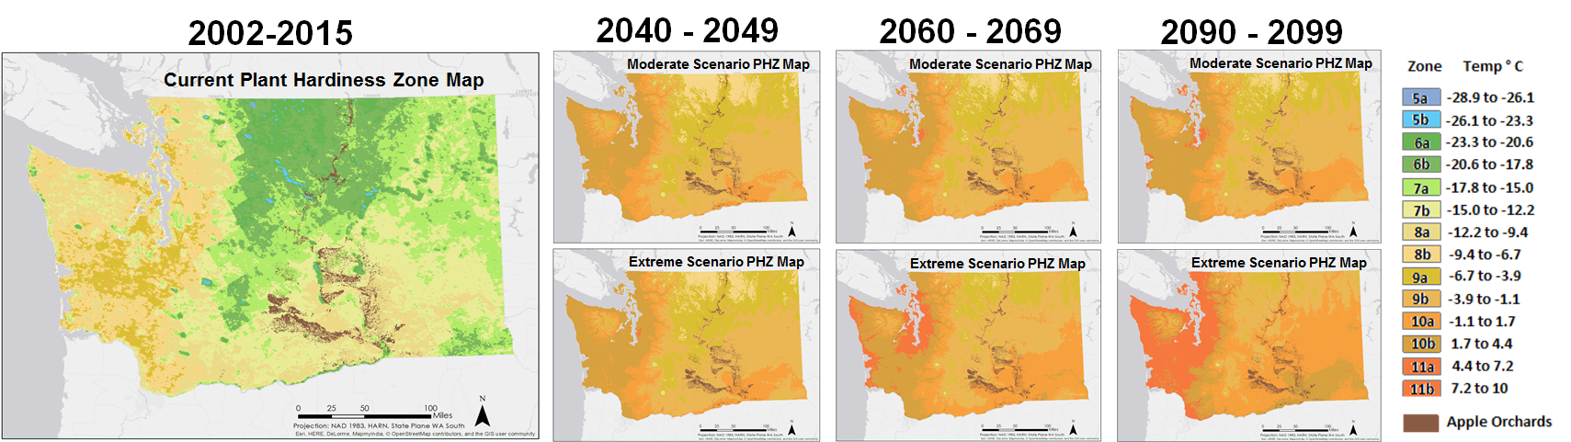
Figure 3: Current and Future PHZ Map.
RCP4.5 (top), RCP8.5 (bottom)

The present day suitability of Washington State for apple production is very high, especially in the north of the state; however, the suitability is predicted to decrease in the coming century. Like the PHZ maps, there is little difference between the moderate and extreme scenarios until 2095. The moderate scenario predicts that conditions will be unsuitable in the south, and only marginally suitable in the north by 2095. The extreme scenario predicts severely unsuitable conditions in the south, and even the northern orchards will no longer be in suitable conditions (Figure 4). Appendix B contains larger suitability maps.

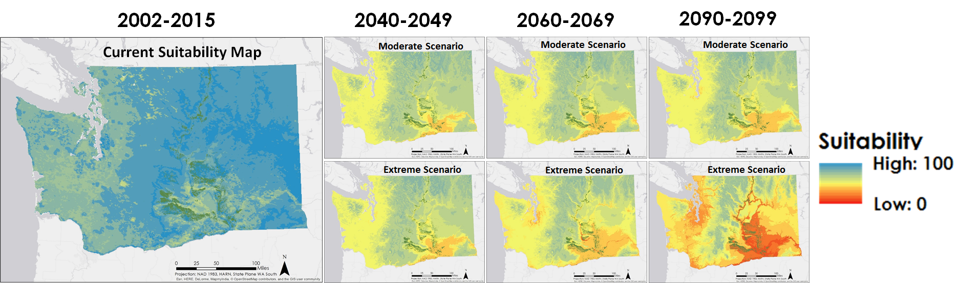
4: Current and Future Suitability Map.
RCP4.5 (top), RCP8.5 (bottom)

Figure 5 shows the percent area of Washington that is predicted to experience an increase of 4, 5, and 6 PHZ steps between 2045 and the present, where each step is half of a plant hardiness zone. The steps are cumulative, meaning that areas undergoing increases of four or more are included in the category of four step increases. In the RCP4.5 scenario, 78% of the area of Washington State will have experienced a PHZ increase of four or more steps. Specifically, 42% of the area will have moved up four steps, 27% of the area will have moved up five steps, 7% of the area will have moved up six steps, and 2% will have moved more than six steps. Similarly, for RCP8.5, 81% of the area will have experienced at least a four step increase in PHZ. Specifically, 41% will have moved up four steps, 30% of the area will have moved up five steps, 8% will have moved up six steps, and 2% will have moved more than six steps.

In 2095, however, the results are bleaker. For RCP4.5, the area experiencing an increase of at least four steps is 85%; which breaks down to 37% moving up four steps, 33% moving five steps, 12% moving six steps, and 3% moving more than six steps. For RCP8.5, 98% increases by four or more steps. Only 16% will have moved up four steps, 38% moved up five steps, 31% moved up six steps, and 13% will have moved more than six steps (Figure 5).
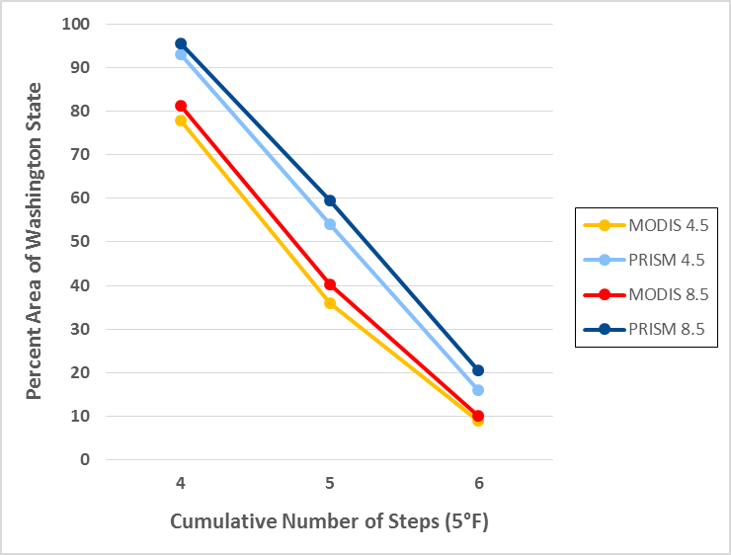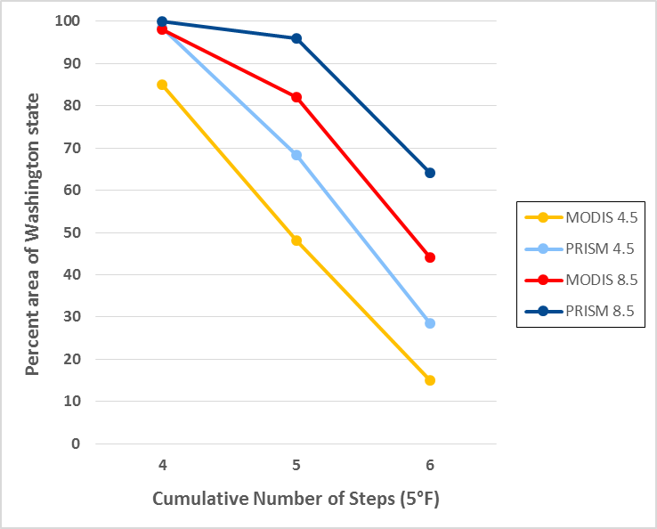
Figure 5: Cumulative Changes in Zones;
Present Day - 2045 (left), Present Day - 2095 (right)

Figure 6 shows the change in apple suitability scores for areas currently covered with apple orchards. Areas of apple orchards were classified using the USDA’s Cropscape dataset. By 2045 there are no regions with a suitability score over 70, and most regions have a score between 61-70 in both climate scenarios. In 2095 the majority of apple orchards will have a suitability score between 41-50 using the RCP4.5 scenario and 11-20 in the RCP8.5 scenario. Currently, there are no orchards in areas with a suitability of below 68. To better understand where apple growers may want to move within the state, areas with a suitability of over 65 were extracted from our results. The map of current data shows the lowest score of a pixel in the apple growing region is 68 and 99.97% of the pixels in the state have a suitability score above 65. In 2045 54% of the pixels in the state have a suitability score above 65 in the RCP4.5 scenario and 47% in the RCP8.5 scenario. In 2095 only 42% of the pixels in the state have a suitability score above 65 in the RCP4.5 scenario and 15% in the RCP8.5 scenario. Using the USDA’s Cropscape data as a current land cover classification map showed that most of these future suitable areas are currently evergreen forest or shrubland for all years in both scenarios.

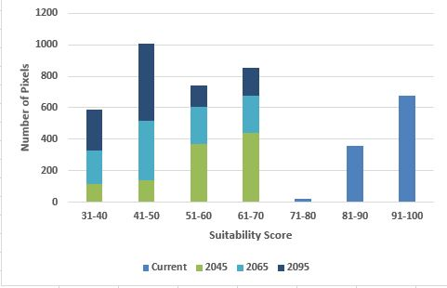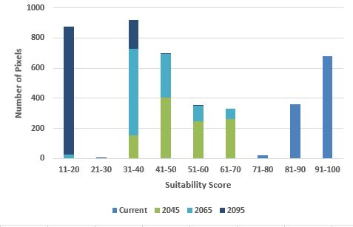
Figure 6: Suitability of Apple Growing Regions; RCP4.5 (left), RCP8.5 (right)

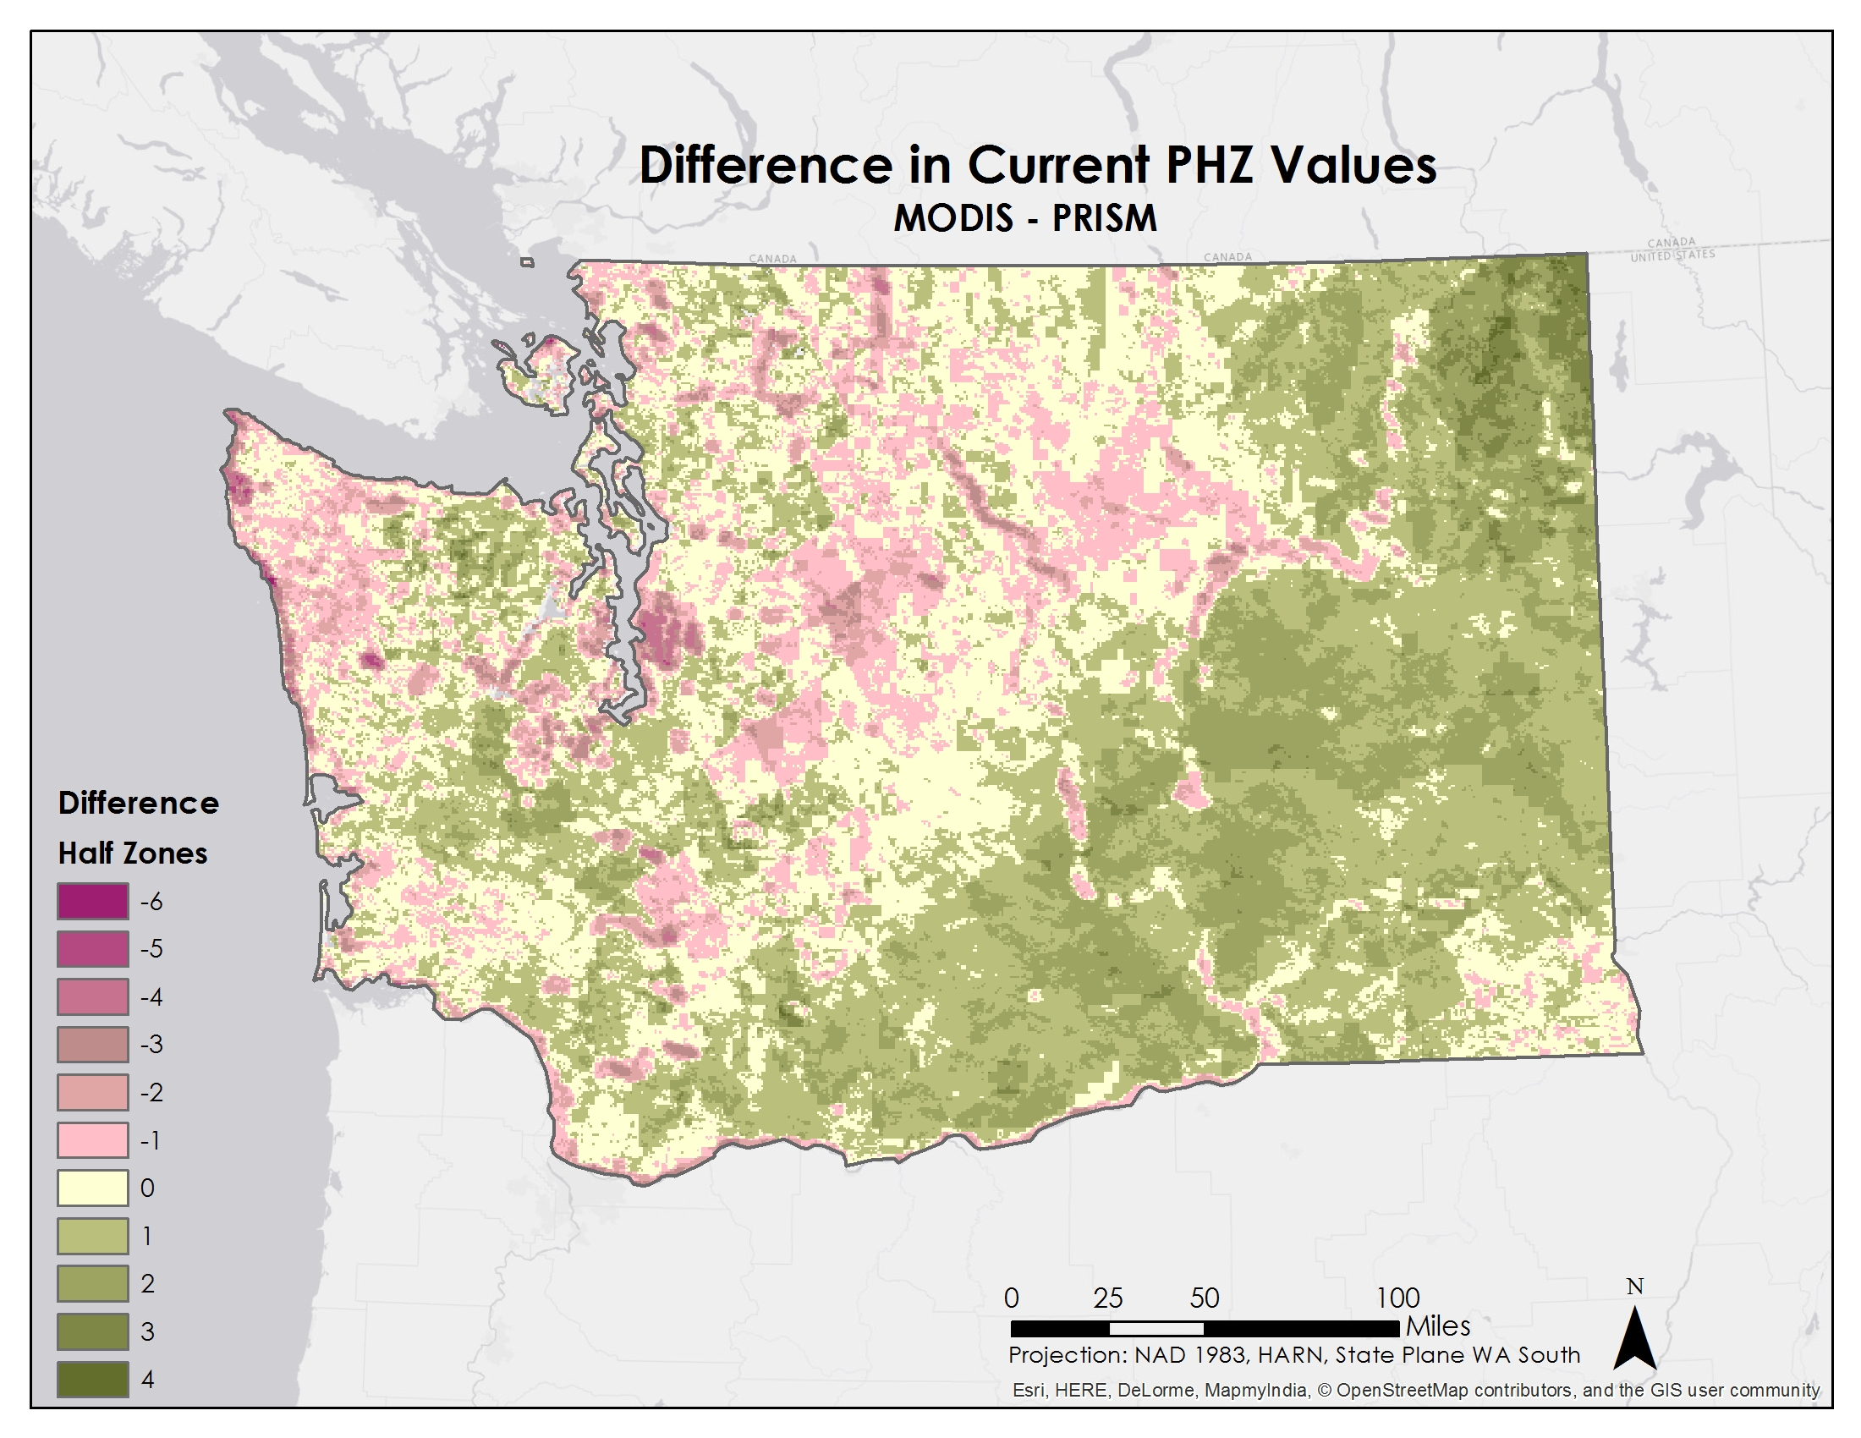
Figure 7: The difference between PHZs created with MODIS data
and PRISM data from 2002-2015

The PHZ map that was created with the PRISM data from 2002-2015 depicts clear differences from the MODIS-derived map. Figure 7 indicates that the primary apple-growing regions in Southern Washington are a half to one zone higher with the MODIS data. Figure 8 reveals that MODIS extracts zones 7b and 8a in areas where the PRISM PHZ map mainly plots zone 7a. In addition to the new PRISM-derived map, the current USDA PHZ map that was created with PRISM data from 1986-2005 (Appendix C) also shows 7a dominating the southern apple-growing region. This analysis reveals that MODIS may be over-predicting air temperatures in this region, but other regions in Washington, including the apple growing region in the North produce the same zone. Even with this discrepancy, using MODIS data to create PHZ maps may be a more robust method. With the MODIS dataset, each pixel is a recorded observation from the satellite. In comparison, the PRISM dataset was created by interpolating temperature values from observed weather station data. Improving the conversion from MODIS land surface temperatures to air temperatures could improve the overall accuracy of the zones.
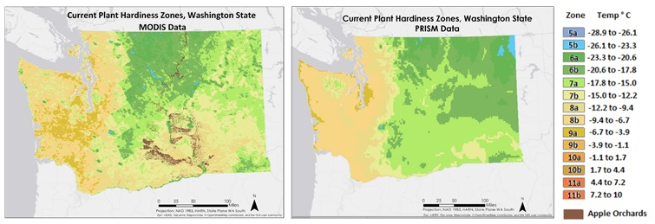
Figure 8: PHZ Maps derived from MODIS data (left)
and PRISM data (right) from 2002-2015

The previous Northwest U.S. Agriculture groups had to rely on their MODIS-derived maps to project their variables into future climate scenarios because the climate model resolutions were very coarse. By using NASA’s high resolution NEX-DCP30 dataset, the future suitability and PHZ maps were not derived from the change between MODIS and the scenarios, so they are completely independent of the uncertainty surrounding MODIS air temperatures. The NEX-DCP30 dataset is an ensemble that averages 33 climate models together, which greatly increases the confidence in these future projections. For suitability maps, possible sources of error include the weights and scaling of the three factors. Other environmental factors that affect apple growth such as soil, pH, precipitation and wind were not taken into account when measuring apple suitability.

In the future, other researchers could create an interactive program that would allow temperature data to be used to create suitability maps for different crops and/or locations. Our suitability model could also be modified to include precipitation data, wind, soil type, and soil moisture data from the Soil Moisture Active Passive (SMAP) satellite as it becomes available.

V. Conclusions
The PHZ map and suitability map show that Washington State is well suited to growing apples at present. However, the moderate and extreme scenarios of the climate model predict that this will not be the case in the coming decades. In 2045, the ideal zones 5-7 will be absent from Washington State, and over half the area in Washington State will have experienced an increase of at least four steps. In 2095, over 70% of Washington will experience an increase of at least four steps, and the PHZ map will resemble that of south Florida today. The moderate scenario predicts that the temperature regime in Washington State will become unacceptable for orchards in the south, and only marginally acceptable in the north. The extreme scenario shows conditions drastically worsening, until the area currently taken up by apple orchards becomes completely unfit in 2095. In each scenario and decade, northern Washington is more suitable than southern Washington, since the temperature increases in the south of the state before the north. The temperature regimes of the Cascade Mountain Range in central Washington and the Columbia Mountain Range of northern Washington remain marginally suitable through 2095; however, the soil in these regions will not support apple orchards, and they can be discounted as potential locations for apple production.

VI. Acknowledgments
We would like to thank our science advisors, Dr. Kenton Ross and Dr. Noelle Baker, and
Jeff Ely - the NASA DEVELOP Geoinformation Scientist - for assisting us with the coding for the project. We would also like to thank our project partner, Dr. Michael Glenn; as well as the previous NW US Agriculture Teams from the fall of 2014 and the spring of 2015 for laying a foundation we could build on.

This material is based upon work supported by NASA through contract NNL11AA00B and cooperative agreement NNX14AB60A.

VII. References
Arbor Day Foundation. “The Tree Guide.” Arbor Day Foundation. Arbor Day, 2015. Web. 21 July 2015.
Daly, Christopher, et al. "Development of a new USDA plant hardiness zone map for the United States." Journal of Applied Meteorology and Climatology 51.2 (2012): 242-264.
IPCC, 2013: Summary for Policymakers. In: Climate Change 2013: The Physical Science Basis. Contribution of Working Group I to the Fifth Assessment Report of the Intergovernmental Panel on Climate Change [Stocker,T.F., D. Qin, G.-K. Plattner, M. Tignor, S.K. Allen, J. Boschung, A. Nauels, Y. Xia, V. Bex and P.M. Midgley (eds.)]. Cambridge University Press, Cambridge, United Kingdom and New York, NY, USA.
Quamme, H. A., et al. "The potential impact of climate change on the occurrence of winter freeze events in six fruit crops grown in the Okanagan Valley." Canadian Journal of Plant Science 90.1 (2010): 85-93.
Smith, T. J. "Overview of tree fruit production in the Pacific Northwest United States of America and southern British Columbia, Canada." ACTA Horticulture (2001): 25-30.
Tree Fruit Research & Extension Center. “Apple IPM Transition Project: Degree-Day Development Table for Codling Moth.” Washington State University, 2015. Web. 21 July 2015. http://pmtp.wsu.edu/CM-DD.html
USDA, National Agricultural Statistics Service (NASS). Washington Apple and Grape Crops Set Record Highs in 2014, 26 Jan. 2015. NASS. Web. 16 June 2015.
Washington State Department of Agriculture. Agriculture- A Cornerstone of Washington’s Economy, 2013. Department of Agriculture. Web 16 June 2015.

VIII. Content Innovation
Some options include:
AudioSlides - added as attachment--
Glossary Viewer - included in this document
Interactive Map Viewer- KMZ on drive

Glossary terms
Plant Hardiness Zones (PHZs): Zones used to determine an area’s suitability for different species of plants. The zones are created by classifying average annual minimum temperatures into 10 °F zones. More recently in the United States zones have been divided into half zones (a and b) which represent 5 °F groups (Daly 2012).
MODIS: (Moderate Resolution Imaging Spectroradiometer) is a key instrument aboard the Terra and Aqua satellites. MODIS acquires data in 36 spectral bands.
Growing Degree Days (GDD): Growing degree day accumulations involve the amount of accumulated heat required for insects and their host plants to flourish. Growing degree days are calculated using the formula GDD= (Tmax - Tmin)/2 - threshold temp. In the case of the Codling Moth, the threshold temperature is 10°C and Tmax cannot exceed 32°C.
Codling Moth: Cydia pomonella is a major pest to apples and other pome fruit which can devastate apple production. This moth is a nocturnal insect that feeds on apples and other crops. Once a grub hatches, it burrows into the apple where it feeds until metamorphosis.
Representative Concentration Pathway (RCP): Scenarios used to model various levels of greenhouse gas emissions which are used in creating climate models. RCP4.5 represents a moderate level of greenhouse gas emissions in the future with 538 ppm of atmospheric CO2 by 2100, while RCP8.5 is a more extreme scenario with 936 ppm of atmospheric CO2 by 2100. The numbers 4.5 and 8.5 refer to radiative forcings, or the change in the energy in the atmosphere due to greenhouse gas emissions, and are expressed in Watts per square meter (W/m2).
NEX-DCP30: The NASA Earth Exchange Downscaled Climate Projections (NEX-DCP30) Dataset has an 800m spatial resolution and includes an ensemble average of the 33 models from CMIP5. The high spatial resolution and ensemble average is useful for conducting local and regional-scale climate change projects.
CMIP5: The Coupled Model Intercomparison Project 5 (CMIP5) brought together climate modeling groups from around the globe to create a standard set of model simulations in order to evaluate how well the models recreate the recent past and how they differ in future scenarios. The 33+ models involved in CMIP5 were included in the analyses and most recent report from the International Governmental Panel on Climate Change (IPCC).
PRISM: The PRISM Climate Group at Oregon State creates climate datasets by advanced interpolation methods applied to weather station observations throughout Washington State. PRISM data from 1976-2005 is currently used by the USDA to create their PHZ maps

IX. Appendix A

Current Plant Hardiness Zones

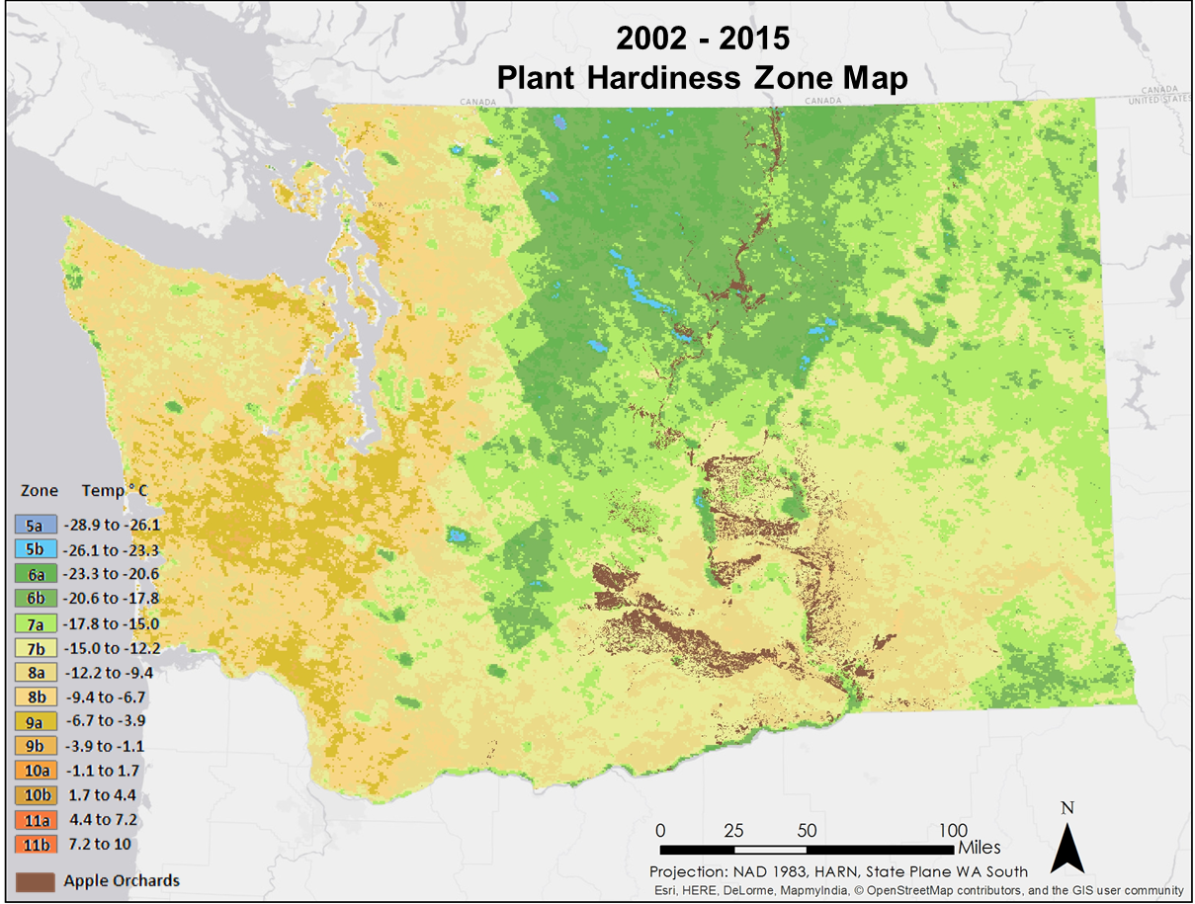

2045 Plant Hardiness Zones
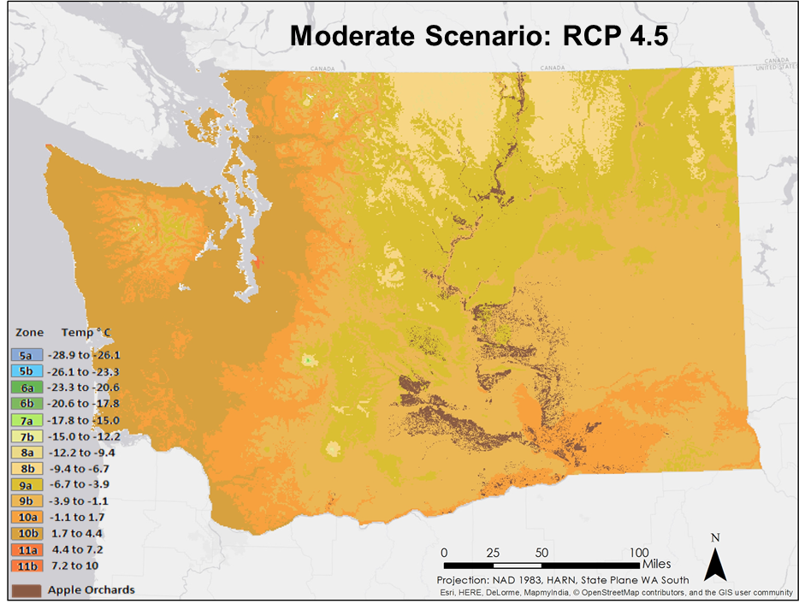
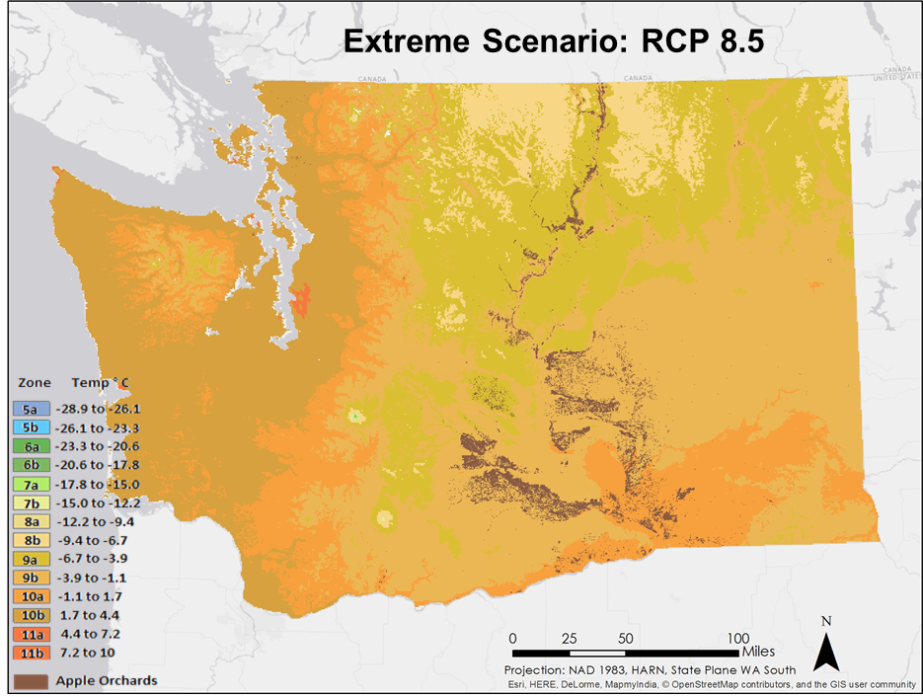
2065 Plant Hardiness Zones
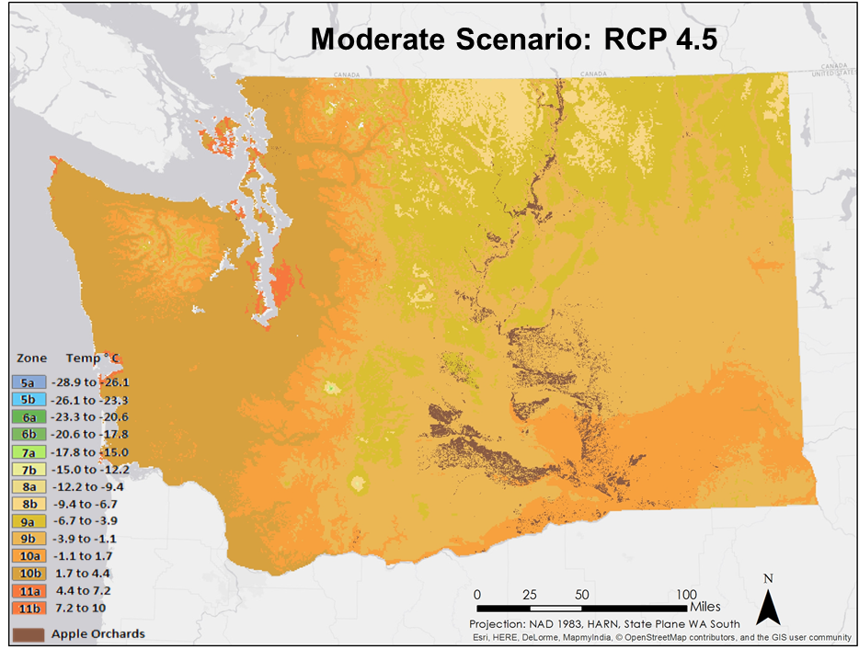
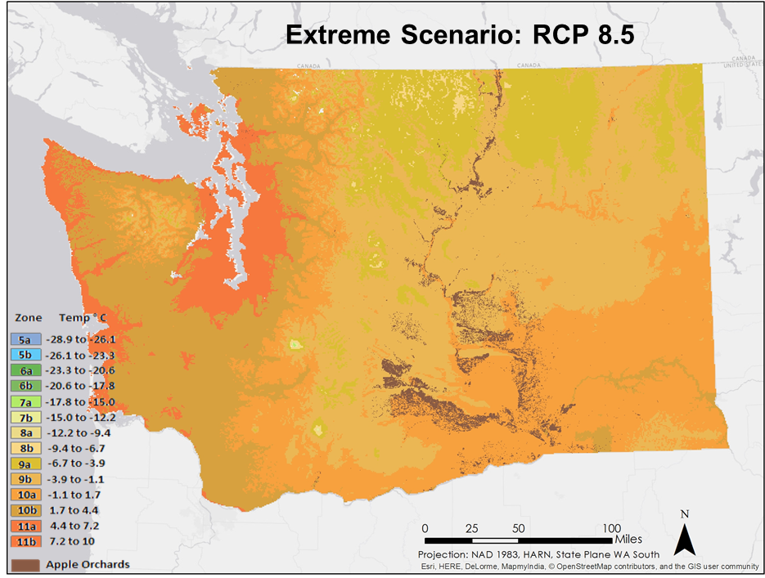
2095 Plant Hardiness Zones
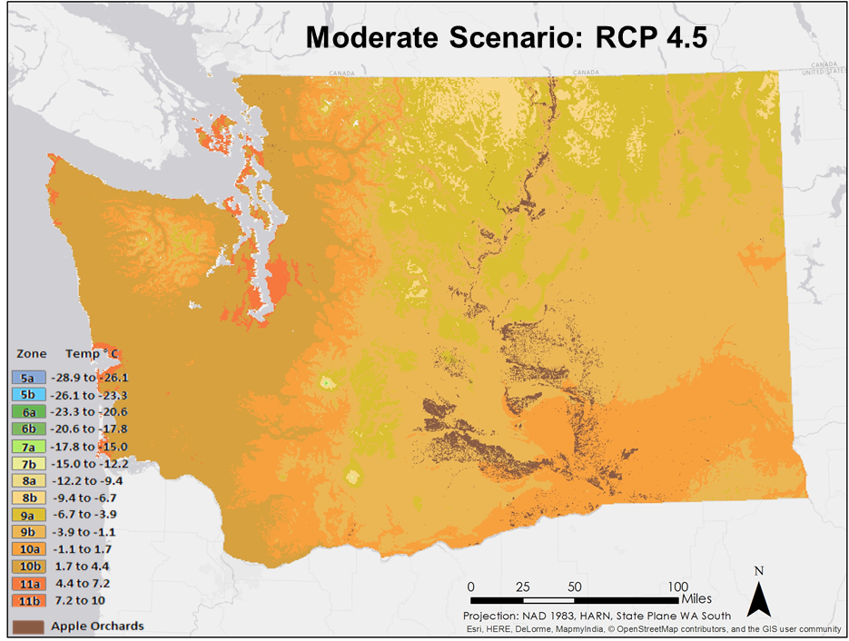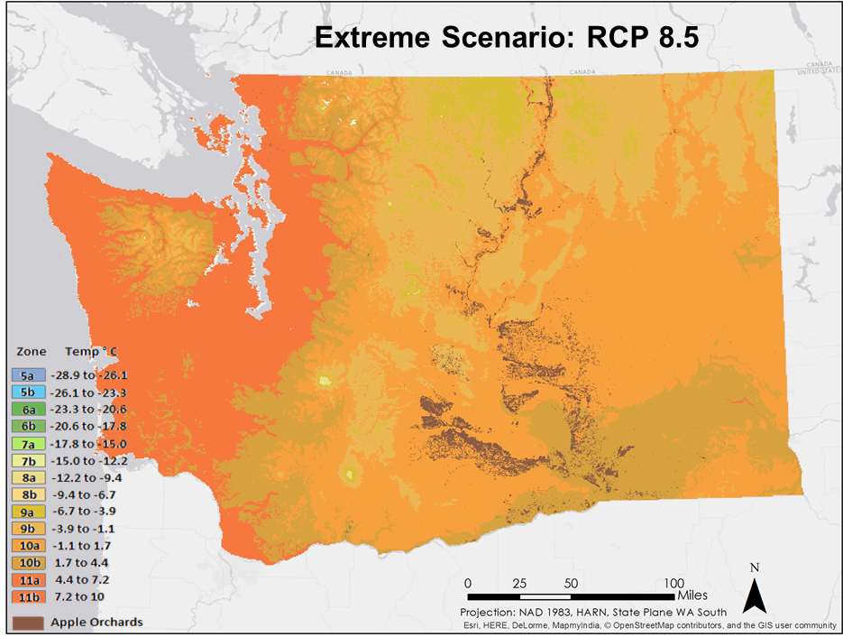

X. Appendix B

Current Suitability Map

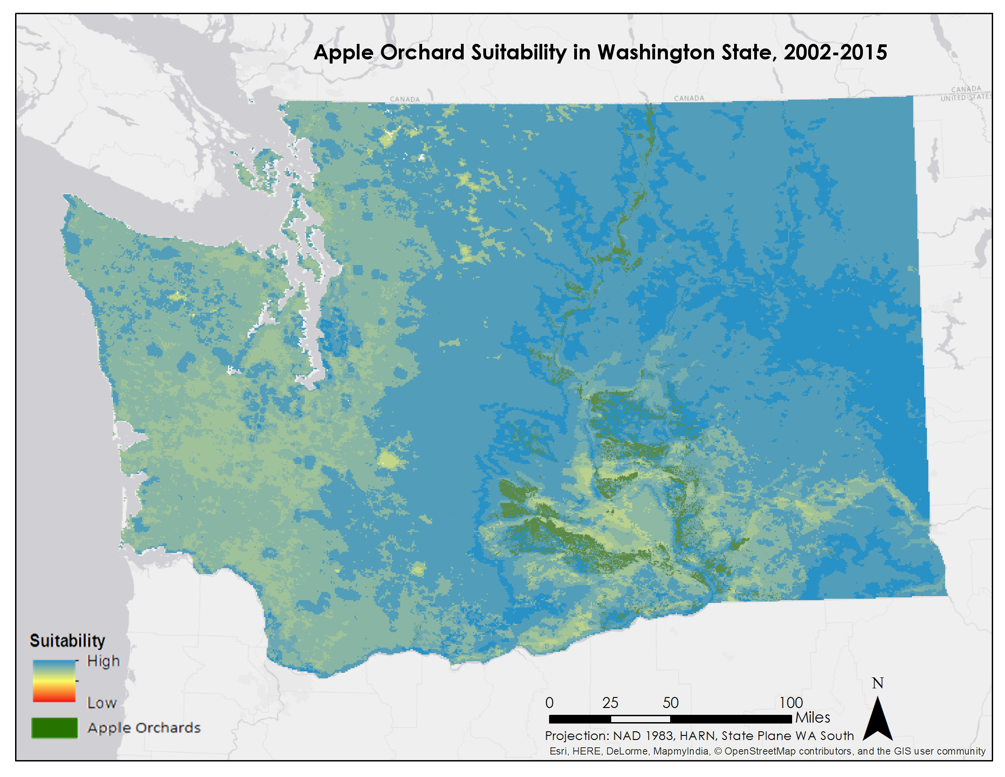

2045 Suitability Maps
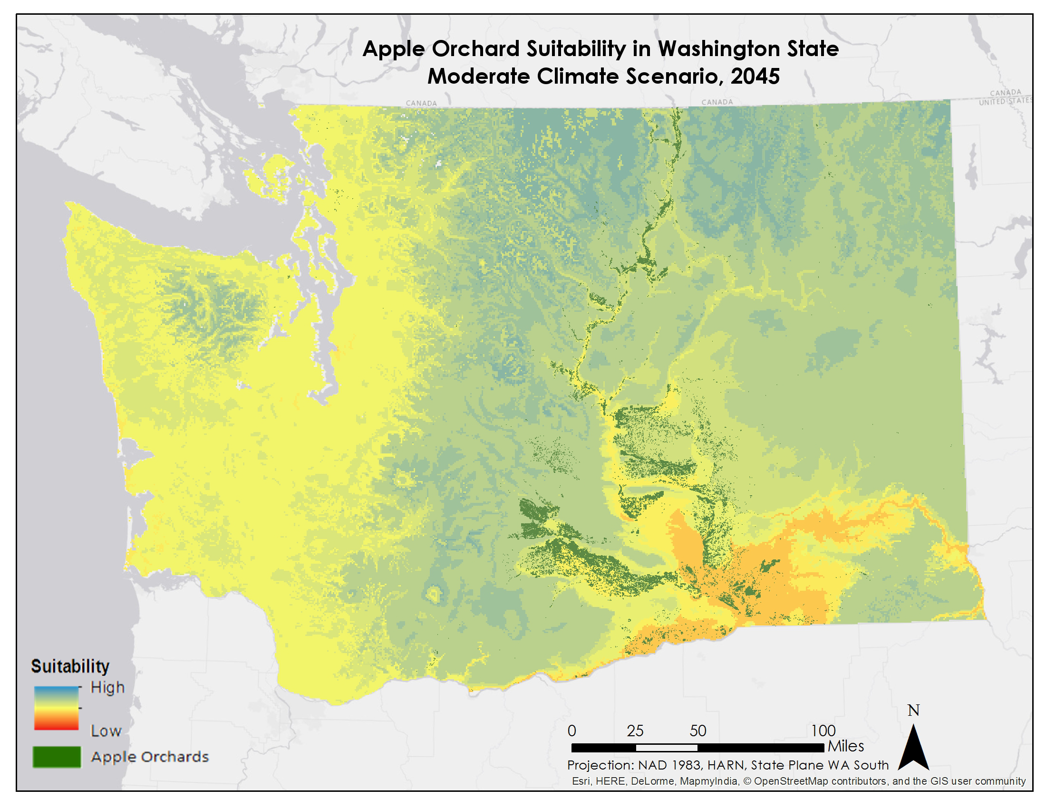
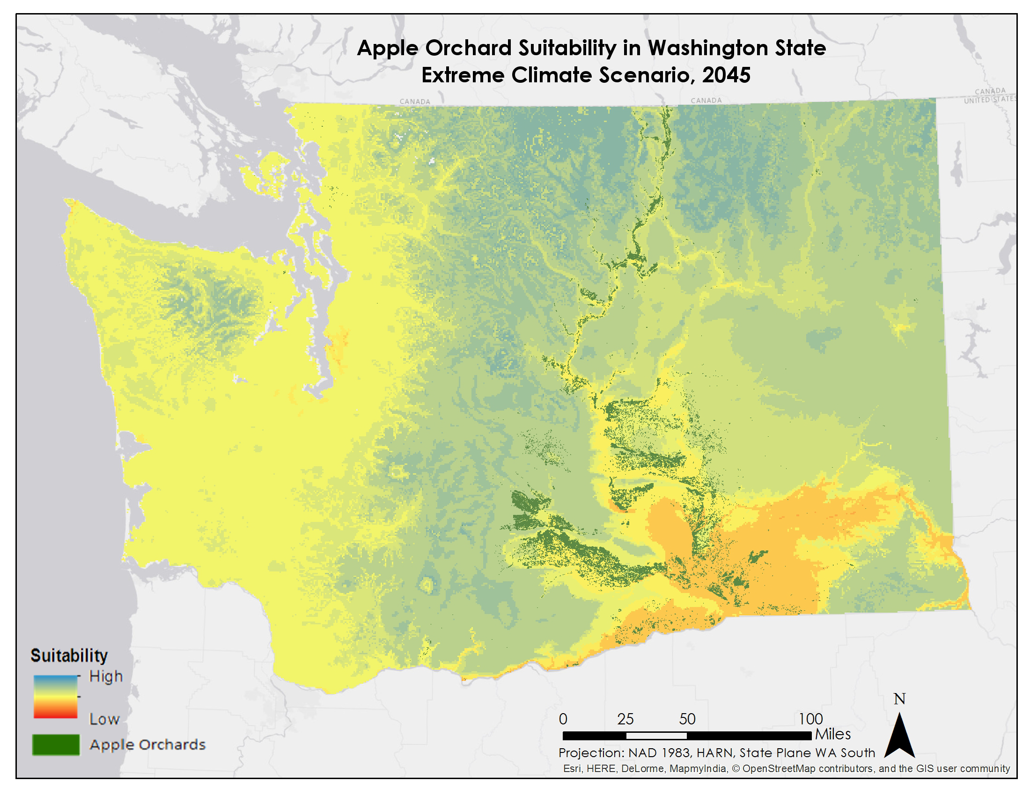
2065 Suitability Maps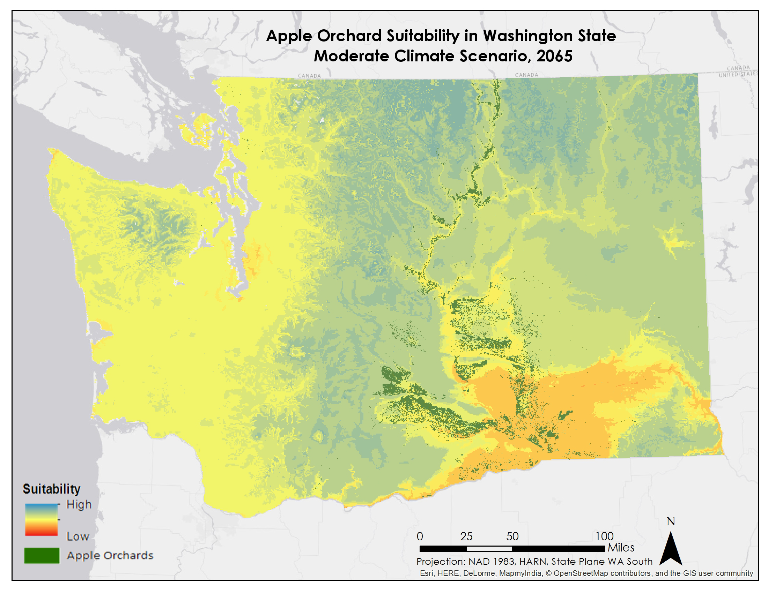
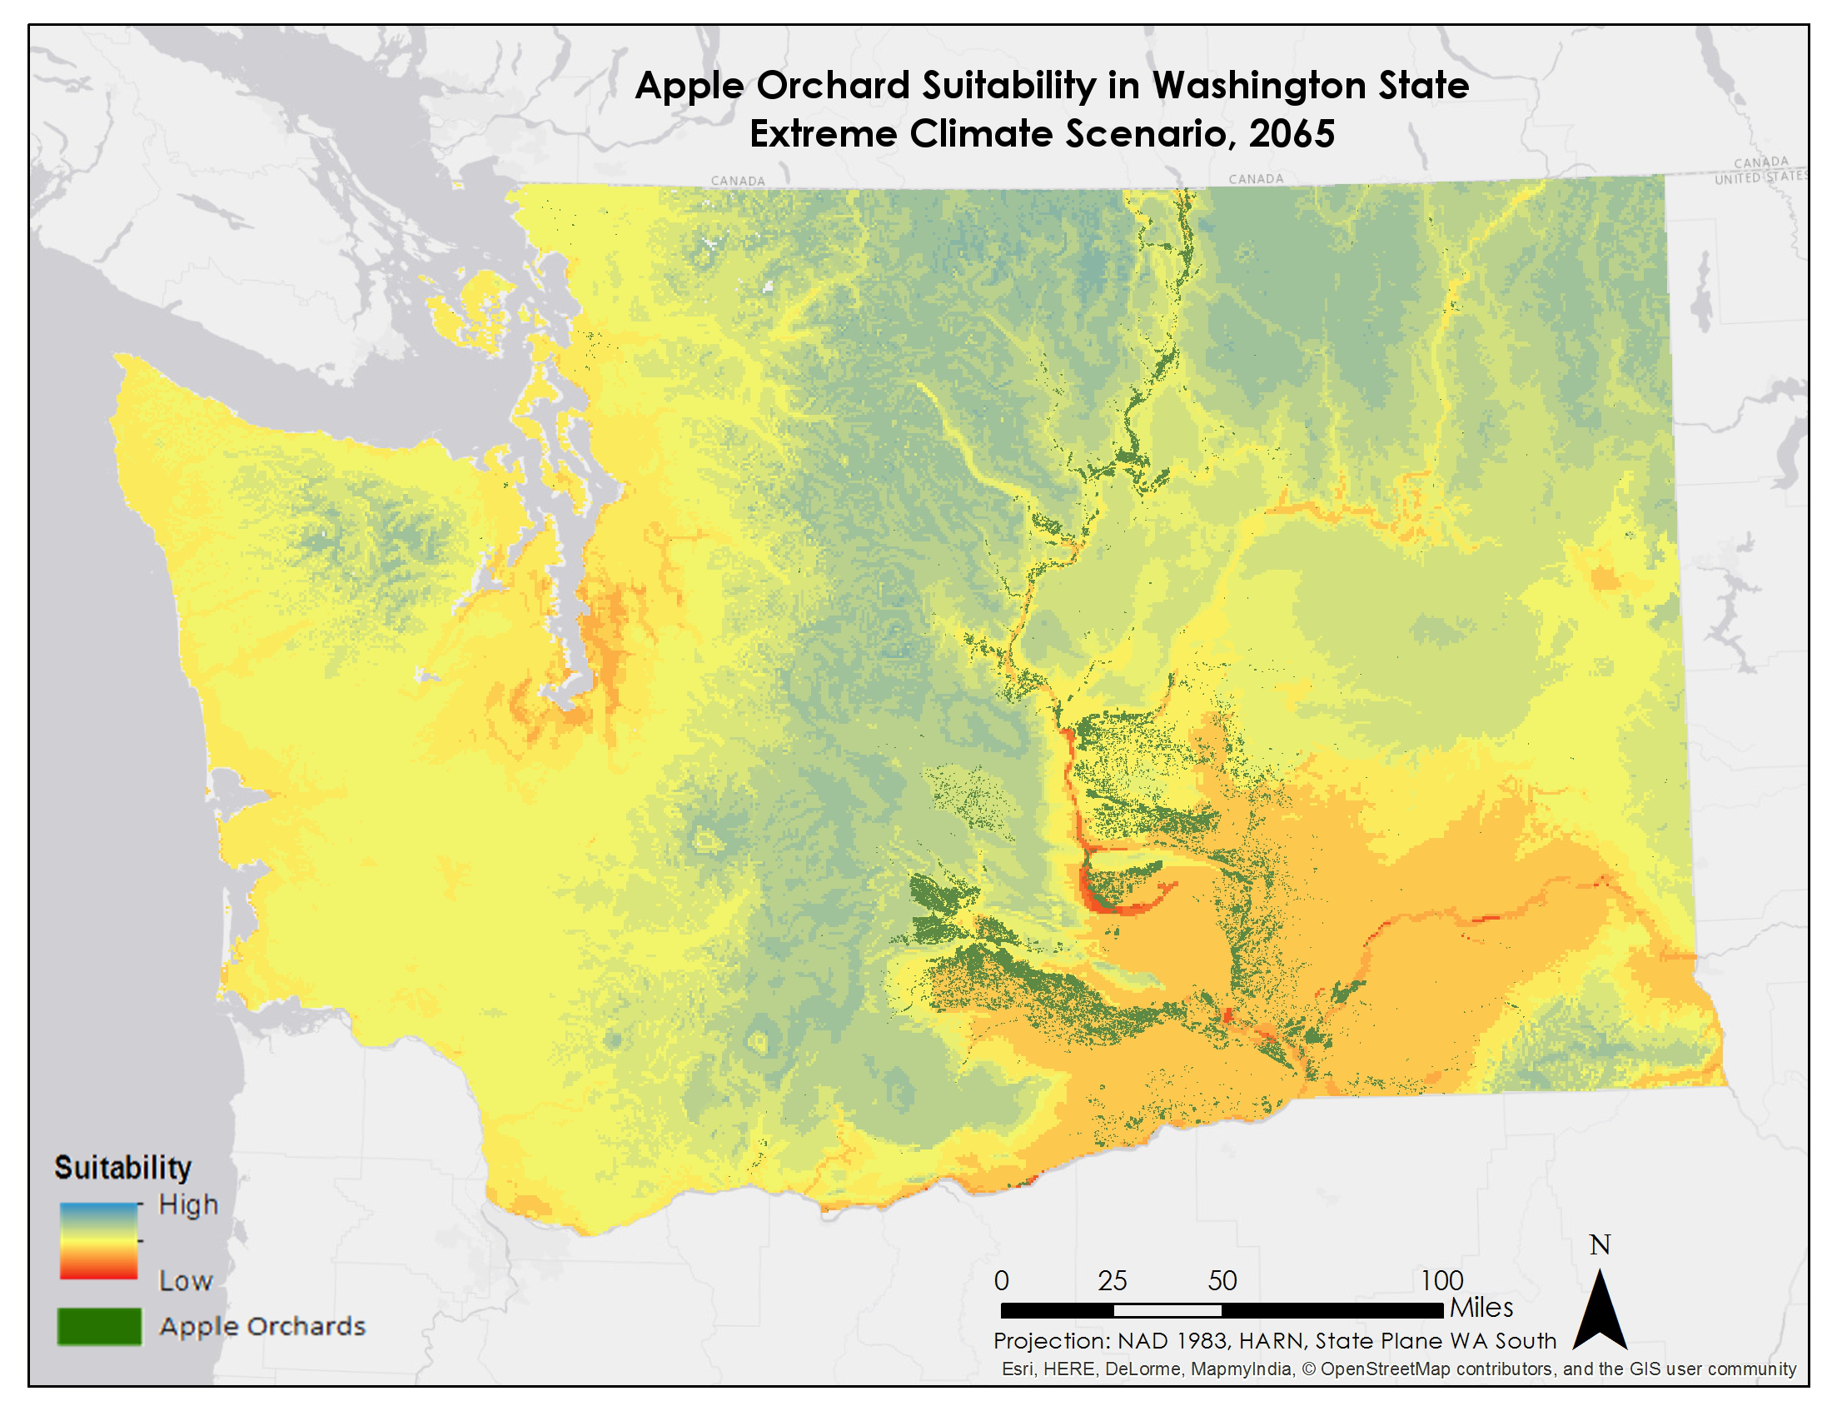
2095 Suitability Maps
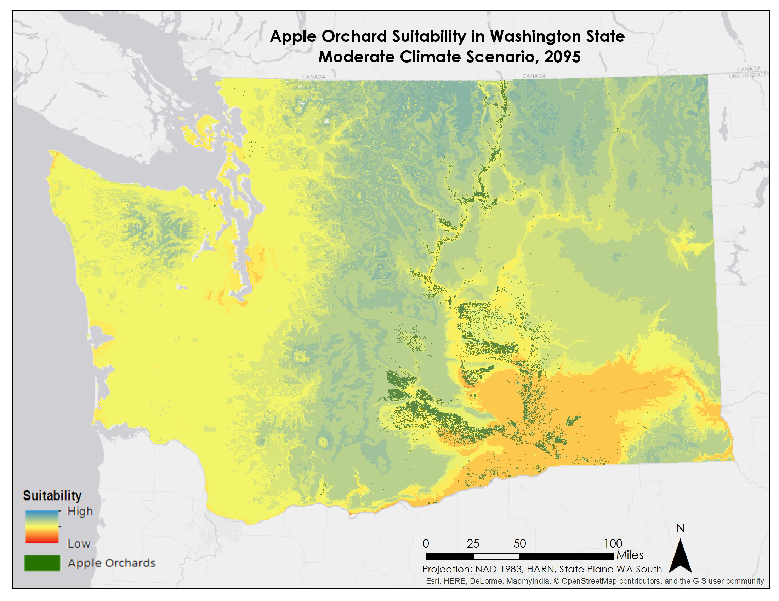
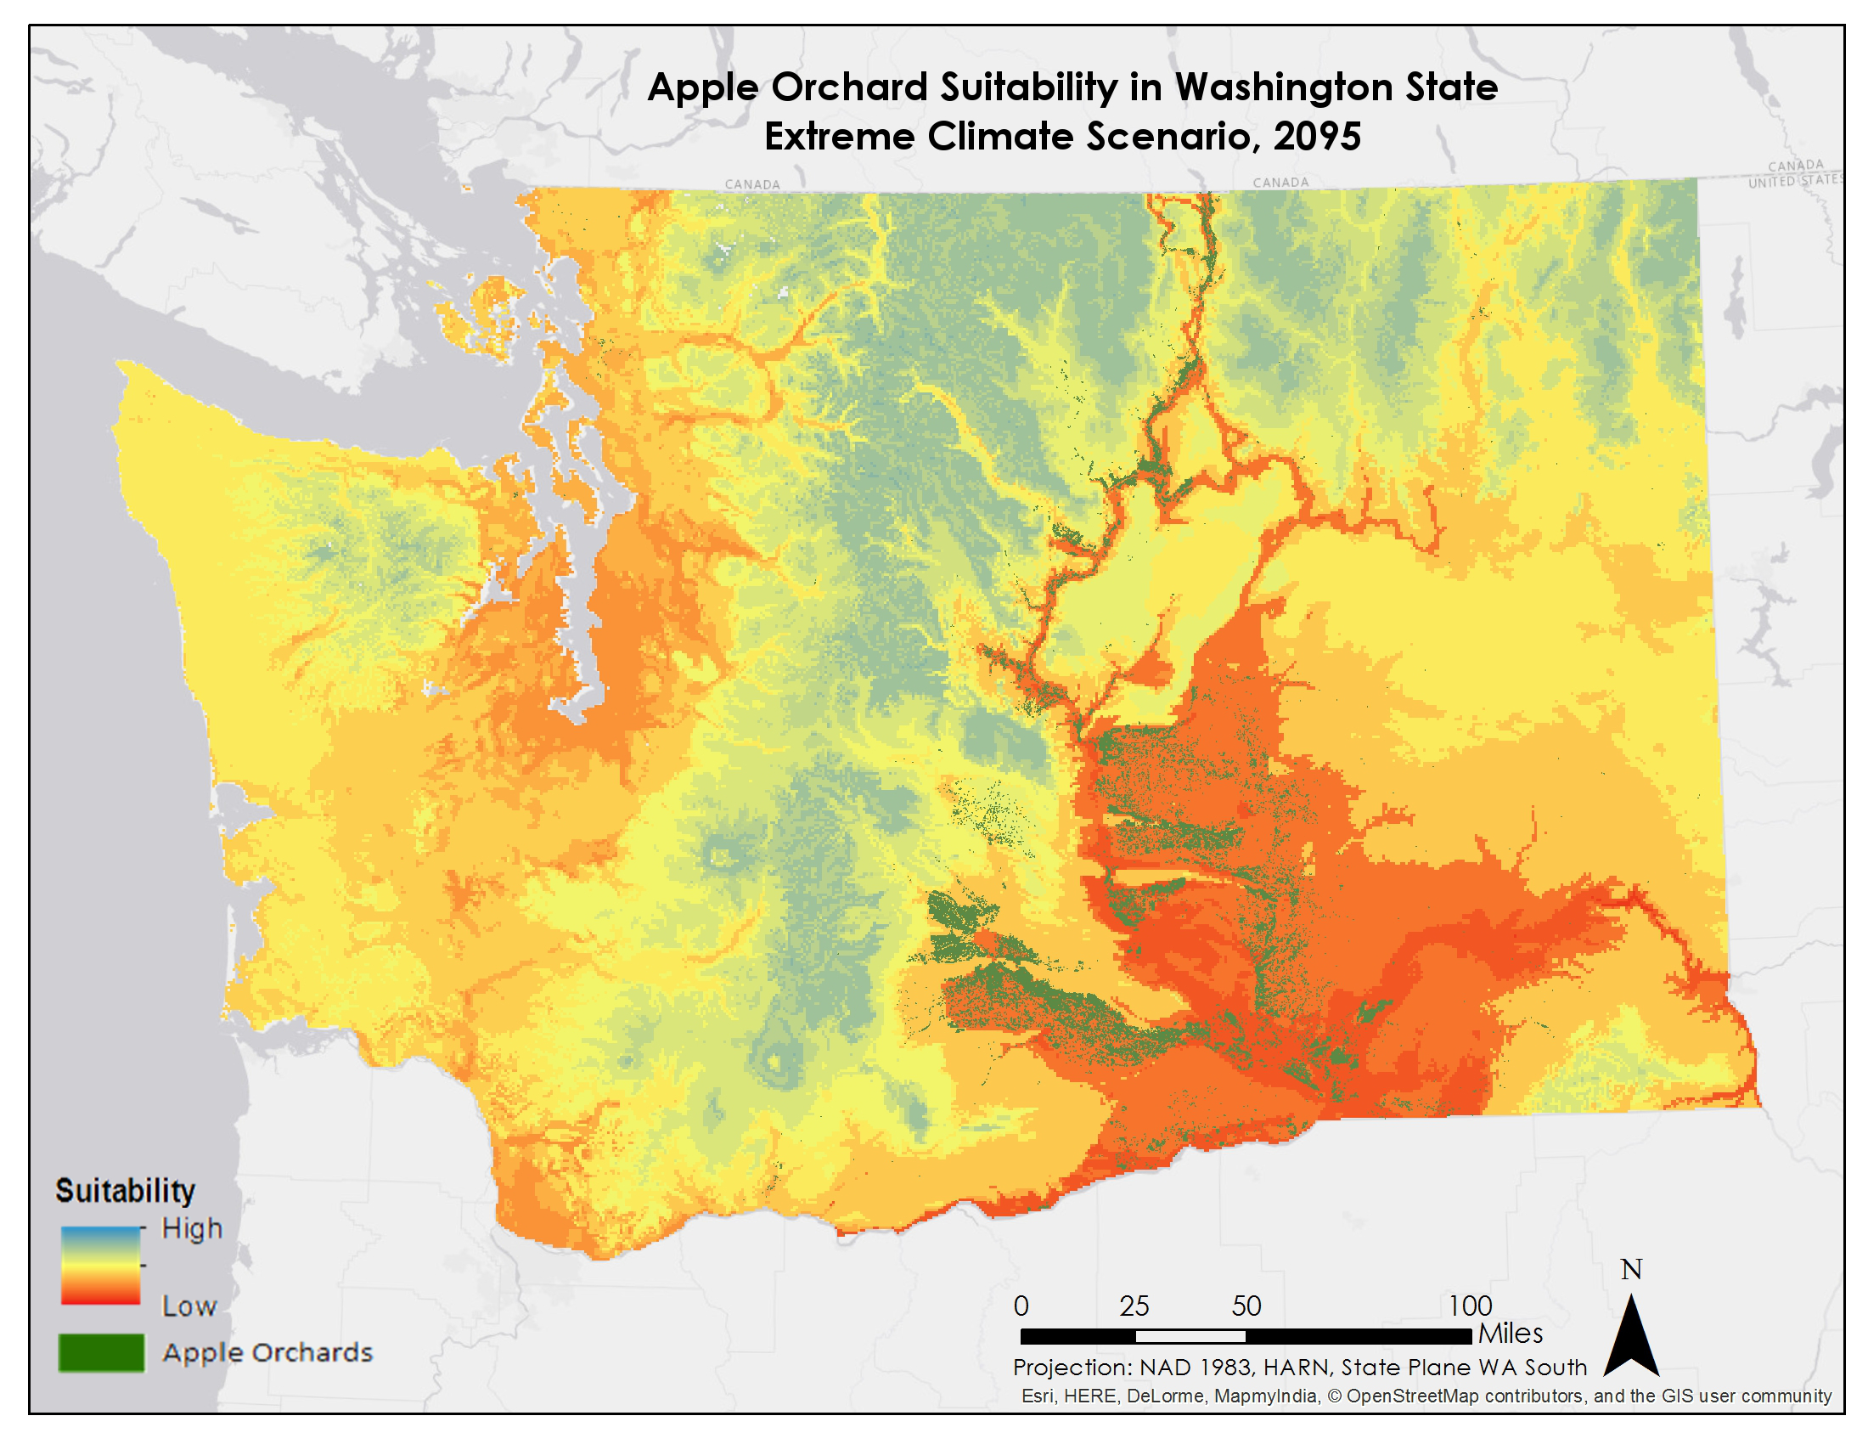
XI. Appendix C

The USDA’s current PHZ map that was created using PRISM data from 1976-2005.
