**NASA DEVELOP National Program**

****NASA Langley Research Center

**Summer 2015**

**Short Title: CALIPSO Cross-Cutting II**

**Subtitle:** Interfacing CALISPO Data through a Graphical User Interface

**VPS Title:** Catching the Black Smoke: Visualizing Aerosols with CALIPSO

**Project Team & Partners**

**Project Team:**

Grant Mercer (Project Lead), grant.a.mercer@nasa.gov

Nathan Qian

**Advisors & Mentors:**

Jeffry Ely (NASA DEVELOP National Program)

Dr. Kenton Ross (NASA DEVELOP National Program)

**Past or Other Contributors:**

Jordan Vaa

Courtney Duquette

Ashna Aggarwal

**Partner Organizations**

CALIPSO Science Team, End-User, POC: Dr. Charles Trepte and Dr. Amber Soja

**Project Details**

**Applied Sciences National Applications Addressed:**

Cross-Cutting

**Study Area:** Global

**Study Period:** May 2006 - Current

**Earth Observations & Parameters**

CALIPSO, CALIOP – Vertical Profile of Aerosols

**Software Utilized**

Python 2.7, sqlite3, CALIPSO L1 and L2 data products

**Project Overview**

The CALIPSO satellite's goal is to provide new insight into the role that clouds and atmospheric aerosols play in regulating Earth weather, climate, and air quality. VOCAL is a visualization that offers an easy to use GUI interface that allows users to visualize CALIPSO data. Users can then use a number of tools to select areas of the plot by drawing 'shapes' around those areas, and label shapes with attributes and notes. Shapes can be exported to a backend database which can serve as a centralized point for researchers to share data and help track and identify aerosols in the atmosphere.

**Abstract**

The Cloud-Aerosol Lidar and Infrared Pathfinder Satellite Observation (CALIPSO) satellite is a NASA Earth observation that analyzes aerosol particles suspended in the Earth’s atmosphere. Researchers use visualized CALIPSO data to track the global distribution, dispersion, and source of aerosols. However, the current visualization tool for displaying CALIPSO data does not support needed features for tracking aerosols such as selecting areas of data and sharing those selected sections, making tracking specific airborne objects difficult for researchers. Adding these necessary features to the current CALIPSO visualization tool is difficult, as the tool is written in Interactive Data Language (IDL), a proprietary and obscure language, and writing additional features for the tool would require a specialized development team. For the 2015 summer term, our team was focused on the development of the *Visualization of CALIPSO* (VOCAL) Python program. VOCAL will serve as the successor to the current visualization tool for CALIPSO data. We built off a previous DEVELOP team’s work and implemented a number of new features and offer new functionalities to Earth scientists to more easily identify the sources of aerosols and their impact on Earth’s climate.

**Community Concerns**

* Aerosols have a major impact on Earth’s climate and human health
* CALIPSO helps researchers better predict the effect aerosols have on climate and health
* The current CALIPSO visualization tool is not easily configurable or adaptable
* The CALIPSO science team lacks a method for storing and sharing specific features of CALIPSO imagery

**Current Management Practices & Policies**

The tool currently used to visualize CALIPSO data is written in IDL, a proprietary language which lacks many features and hinders open source updates. Currently, the tool lacks any means to share results between researchers electronically. Any kind of collaboration between Earth scientists needs to be done in person.

**Decision Support Tools & Benefits**

|  |  |  |
| --- | --- | --- |
| **End-Product** | **Earth Observations Used** | **Benefit & Impact** |
| New CALIPSO Data Visualization Tool | CALIPSO | Our end users will have an open source, low maintenance program that can intuitively display and manipulate CALIPSO data. |

**Project Imagery**

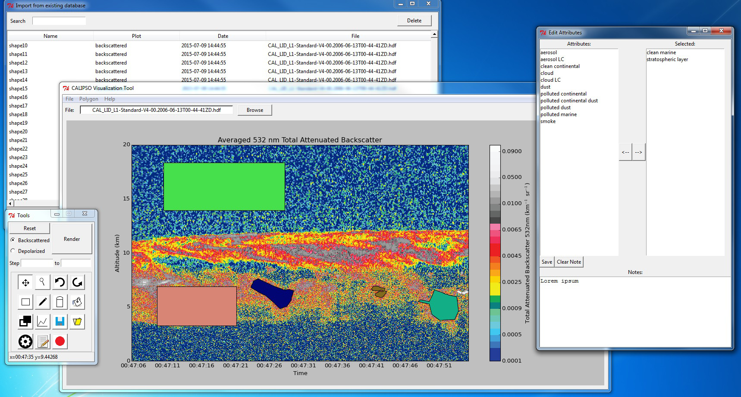

**Caption:** A shot of the Visualization Tool demonstrating the various functionalities of the tool. (In clockwise order) Database dialog, attributes dialog, main window, and toolbar window. The shapes displayed in the main window are for demonstration purposes only.

**Image:** final_image_300.jpeg