**NASA DEVELOP National Program**



NASA Marshall Space Flight Center

*Summer 2017*

Thailand Cross-Cutting

Utilizing Suomi NPP’s Day-Night Band to Assess Energy Consumption and Assess Its Suitability as a Proxy for Poverty in Thailand

 **Technical Report**

Final Draft – August 10, 2017

Helen Baldwin (Project Co-Lead)

Maggi Klug (Project Co-Lead)

Krisda Tapracharoen

Chayanan Nan Visudchindaporn

Dr. Jeffrey Luvall, NASA Marshall Space Flight Center at NSSTC (Science Advisor)

Dr. Robert Griffin, University of Alabama in Huntsville (Science Advisor)

Eric Anderson, NASA SERVIR Coordination Office (Science Advisor)

Leigh Sinclair, University of Alabama in Huntsville/Information Technology and Systems Center (Mentor)

# 1. Abstract

While poverty in Thailand has decreased from 67% in 1986 to 13% in 2012, 6.7 million people were still living within 20% of the poverty line in 2014. Economic uncertainty caused by recurring droughts and decreasing agricultural prices puts this vulnerable part of the population at risk of dropping below the national poverty line in the future. In order to address this issue, the DEVELOP team worked with the Office of Science and Technology (OSTC) at the Royal Thai Embassy, Asian Disaster Preparedness Center (ADPC), and the NASA SERVIR Coordination Office to formulate a new method of analyzing poverty within Thailand. This project utilized the monthly composite product for 2012-2015 produced by the Earth Observations Group (EOG) at National Oceanic and Atmospheric Administration (NOAA) and National Geophysical Data Center (NGDC). Additionally, this project incorporated socio-economic data from Thailand’s Ministry of Information and Communication Technology’s National Statistical Office and Ministry of Education’s National Education Information System to create an enhanced poverty index. This new poverty index will provide the Thai government a cost-effective way to analyze changes of poverty within the nation and inform policy making.

**Keywords**

Night-time Lights, Poverty, Suomi, Remote Sensing, Visible Infrared Imaging Radiometer Suite (VIIRS), Energy Consumption, Light Emission, Thailand

# 2. Introduction

* 1. ***Background Information***

In Thailand, 6.7 million people live within 20% above the national poverty line and are at risk of becoming impoverished if the economy slows (The World Bank). According to Thailand 4.0, the latest economic model promoted by the Royal Thai Government, Thailand is trapped as a middle income nation. This means Thailand must overcome several economic challenges, such as the decrease of the economic growth rate and economic inequality (Languepin, 2017). To have sustainable growth and development, it is key that the Royal Thai Government identifies poverty levels in order to create effective strategies and prevention plans during policy making. Previously, most studies of poverty in Thailand were conducted by deriving poverty indicators from statistical data and surveys. These have inaccuracies and are costly in terms of time and budget due to the nature of door-to-door surveys. This project introduced the use of night-time lights (NTL) from Suomi National Polar-Orbiting Visible Infrared Imaging Radiometer Suite’s Day Night Band (Suomi NPP VIIRS DNB) over the 2012 to 2015 study period in order to analyze poverty. Studies measuring light emissions at night to use as a proxy for poverty indicators have been conducted in Africa (Noor, 2008) and China (Wang, 2012); however, it has never been done in Thailand. The analyses performed during this project included an exploration of how distance from a city or major highway and seasonality affect NTL.

* 1. ***Project Partners & Objectives***

The Thailand Cross-Cutting team worked with the Office of Science and Technology (OSTC) at the Royal Thai Embassy, Asian Disaster Preparedness Center (ADPC), and NASA SERVIR Coordination Office to formulate a new method of analyzing poverty within Thailand. With this method, this project aims to identify where poverty is occurring and what groups of the population are at risk. Additionally, the project explores how NTL intensity varies depending on factors, such as seasons, distance from roads, distance from cities, and type of land cover. This project utilized statistics from Thailand’s Ministry of Information and Communication Technology’s National Statistical Office and Ministry of Education’s National Education Information System. In addition, a monthly composite product for 2012 to 2015 produced by the Earth Observations Group (EOG) at National Oceanic and Atmospheric Administration (NOAA) and National Centers for Environmental Information (NCEI) created from satellite imagery from Suomi NPP VIIRS DNB was used. Together these data were used to create an enhanced poverty index. The final products of this project can serve as a basis for the future research of poverty analysis throughout surrounding Asian countries in addition to helping to inform and support poverty reduction and aid efforts.

# 3. Methodology

***3.1 Data Acquisition***

The EOG at NOAA/NCEI generated cloud free composites of monthly average radiance products from Suomi NPP VIIRS DNB data. These monthly composites consisted of the average of NTL, which Suomi NPP VIIRS DNB recorded between wavelengths 0.5 to 0.9 μm at a spatial resolution of 750 m and daily temporal resolution. Cloud cover, lightning, and lunar illumination were excluded from the composites. This project utilized 75N/060E tiles from January 2013 through December 2015 downloaded through EOG’s website.

In this project, socio-economic data relating to poverty in Thailand were collected at the provincial level from various organizations. These datasets and their sources can be found in Appendix A. These data were downloaded in their respective file formats and provincial datasets were combined together following a data merging script (de Bruin, 2008).

Shapefiles detailing the road and railroad systems in Thailand were procured from DIVA-Geographic Information System (GIS), based on the 1992 Digital Chart of the World, as well as from the Humanitarian Data Exchange (HDX) as provided by the United Nations Office for the Coordination of Humanitarian Affairs (OCHA), based on 2005 data from Thailand’s Geo-Informatics and Space Technology Development Agency (GISTDA). Administrative areas of Thailand, including national, provincial, and district levels, were also retrieved from the DIVA-GIS website. These were based on the November 2015 version of the GADM (Global Administrative Areas) database. The MCD12Q1 Global Land Cover Facility (GLCF) based on data from MODerate resolution Imaging Spectroradiometer (MODIS) in 2012 was retrieved from the Global Land Cover Facility website.

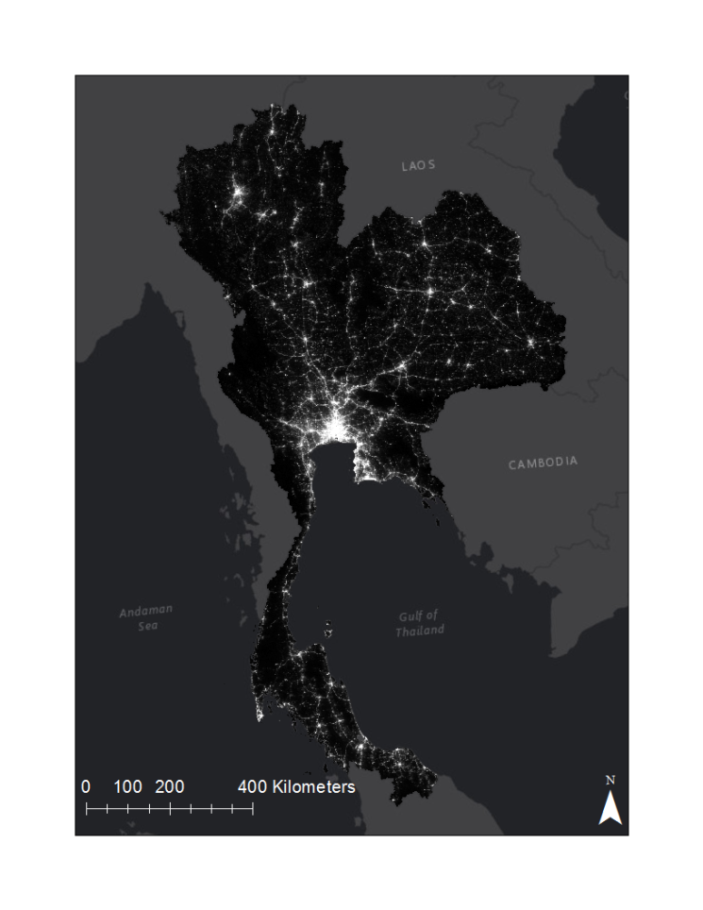

High: 565.334

Low: 0

Night-time light intensity

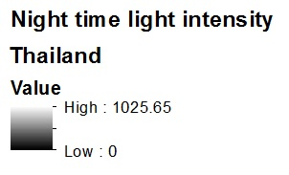

*Figure 1.* Night-time light image clipped to the study boundary of Thailand (from Suomi NPP VIIRS DNB, 2015).

***3.2 Data Processing***

In order to investigate NTL as a proxy for indicating poverty, NTL images had to be processed. The monthly average radiance composite images generated by EOG at NOAA/NCEI were pre-processed to remove data impacted by clouds, stray light, lunar illumination, and lightning. The pixel value of this product represents radiance in nW/cm2/sr (Earth Observation Group, 2017). First, the radiance tiles for each month, January 2013 through December 2015, were clipped to the study area. Then, the clipped tiles were projected to Asia South Lambert Conformal Conic. In addition, the ancillary tiles representing the number of observations included in the average for each pixel in the monthly composite were also clipped to the study area and projected. Additionally, the GLCF raster was clipped to the study area and converted from a raster to a shapefile. The roads and railroad shapefiles were also projected using the same projection.

Although the images from Suomi NPP VIIRS DNB were pre-processed, the ranges of intensity value from each satellite images were inconsistent. The ranges varied for each image that was analyzed due to other factors, such as noise from the effect of lunar phase cycle (Miller, 2009; Roman, 2015). The goal of this project was to develop a poverty index based on night-time light. Therefore, it is important to make images consistent and comparable. To make each image comparable, the intensity distribution must be statistically the same. Z-score was introduced to solve this problem. Z-score is a statistical tool for analyzing data from different sample spaces. Z-score technique can only be used for normally distributed data. As shown in figure 2, the left-hand image shows that the intensity distribution of the satellite image was not normally distributed and was also highly skewed. Hence, transformation played a role in this process. The log transformation was appropriate for a highly skewed distribution (Feng, 2014) as it can make the pattern in the data more interpretable. After transformation, a Z-score can be calculated from the following formula.

$Z=\frac{(X-μ)}{σ}$ (1)

Where Z is the z-score, X is data, $μ$ is the mean, and $σ$ is the standard deviation. Z-score works only with normally distributed data. The distribution plots before and after using z-score are shown in Figure 2 and the satellite image before and after z-score transformation can be seen in Appendix B.



*Figure 2.* Intensity distribution of satellite image without processing on the left and intensity distribution of satellite image after transformation using z-score on the right (from Suomi NPP VIIRS DNB, January 2013).

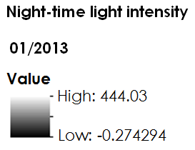

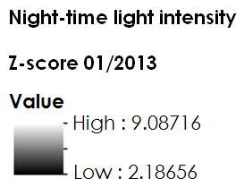

Annual averages for 2013, 2014, and 2015 were made from the monthly composites with the Raster Calculator tool in Esri’s ArcMap 10.4.1 in order to compare the NTL data with the socioeconomic data, which is available annually. These two sets of data covered roughly the same period; therefore, a weighted arithmetic mean was performed to average the intensity value of every pixel from each month. In this case, the weight is the number of observations with good quality data in each month. Good quality data means that there was no cloud-cover, lunar illumination, or stray light affecting the data. The weighted arithmetic mean for the annual composite was determined following Equation (2):

$I_{A}=\frac{\sum_{n=1}^{k}{I_{n}N_{n}}}{\sum_{n=1}^{k}{N_{n}}}$ (2)

Where $I_{A}$ is the average intensity value, $I_{n}$ is the monthly intensity value, k is the number of images being averaged, which was twelve in the case of annual intensity, and $N_{n}$ is the number of good quality observations.

Furthermore, the NTL in Thailand were assessed in terms of seasonality, land cover type, distance to city centers, and distance to city centers. In order to conduct a seasonality analysis on NTL in Thailand, a time series was created. To accomplish this, the months for each year 2013, 2014, and 2015 were averaged using the weighted average technique described above for making the annual average. In this case, the value of *k* was three as each composite was being created from the three monthly average images. This resulted in a weighted average tile for each month that included 2013, 2014, and 2015 data. Then averages were made for each season: winter, fall, spring, and summer. Seasons were defined as meteorological seasons where spring included April, May, and June; summer included July, August, and September; fall included October, November, and December; and winter included January, February, and March.

Land cover data were converted to a vector file using the Raster to Polygon Conversion tool in order to clip the NTL data to the new land cover class polygons using the Clip Data Management tool. The average pixel value was calculated for all land cover classes to determine which classes experience the highest NTL emissions.

In order to understand energy consumption patterns in populated areas, the average light emissions at certain distances from city centers were calculated. To provide representative sampling of cities in Thailand, two sets of 20 cities were chosen according to the highest population and highest population density in 2014. The city center was defined as the pixel with the highest intensity within each city’s boundary. This was found using the Zonal Statistics and Raster Calculator Spatial Analyst tools. This definition was used with the assumption that the brightest point is where the greatest human activity is occurring and is therefore the center of the city. Then, 15 one-mile buffers were created around both sets of city center points using the Multiple Ring Buffer Analysis tool. The average light emission values for each buffer were calculated using the Zonal Statistics tool and the weighted annual composite created for 2014. Thus, the average decrease in light emissions as one moves away from city centers was analyzed.

In addition, the change of NTL as one moves away from roads was studied. A shape file covering 0.5 miles from roads with 0.1 mile increments were created by using the Multiple Ring Buffer tool. The Zonal Statistics as Table tool was used to calculate the sum of NTL in each buffer.

***3.3 Data Analysis***

The assumption behind using NTL is that the brighter the light, the less poverty. Two NTL indicators were used throughout this project: Total Night-time light (TN) and Night-time light index (NLI). TN is calculated by the summation of the intensity value of each pixel in each area of interest. In this case, each area of interest is a province. NLI is the ratio between TN and the number of population ($N_{p}$). These indicators can be written in the equation form:

$TN=\sum_{i=1}^{n}{I_{i}}$ (3)

$NLI=\frac{TN}{N_{p}}$ (4)

Where $I_{i}$ is the intensity value of pixel number I; n is the number of pixels in each province. *TN* and $NLI$ were calculated for each province.

The second analysis involved the various socioeconomic datasets regarding poverty in Thailand. Socioeconomic data can be specified in many ways (Cavatassi, 2004; Yu, 2015; Wang, 2012) based on the availability of the data. These data can be categorized into four main aspects: education, health & welfare, economics, and living necessities. The socioeconomic variables for Thailand according to these four aspects and availability of the data are shown in Table 1. Sources for each variable can be found in Appendix A.

*Table 1:* Socioeconomic Variables Used for Thailand’s Poverty Index

|  |  |
| --- | --- |
| **Aspect** | **Variables** |
| Education | Number of students |
| Health & Welfare | Daily minimum wage in Thailand  Unemployment rate  Number of patients |
| Economics | Average Monthly Expenditure Per Household  Average Monthly Income Per Household  Gross provincial product (GPP) |
| Living necessities | Electricity usage  Water usage  Minimum level of income needed to secure the necessities of life (Poverty line) |

The current poverty index from the National Statistical Office in Thailand is from survey data. It is calculated from incomes and expenditures of a group of people to represent the whole province. These survey data accessed only the economic aspect (Jitsuchon, 2007). Therefore, this project defined a comprehensive poverty index (CPI) in order to take into account all four aspects that affect poverty.

Principal components analysis (PCA) is a factor analysis that reduces the dimensionality of large data sets based on statistics (Jolliffe, 2002). PCA transforms a number of variables to a set of uncorrelated variables, called principal components (PCs), each of which contains a linear combination of variables.

According to Table 2, the first 3 PCs accounted for most of the variance of the variables; approximately 75%. Poverty levels were determined by a number of socio-economic variables (Cavatassi, 2004) revealed that the first PC, a linear combination of socioeconomic variables combined the largest variation amongst the other PCs. In this study we used the following 11 socio-economic variables to extract a comprehensive poverty index (CPI).

The KMO and Bartlett’s test results show that the P value was approximately 0, indicating strong relationships amongst the variables. The KMO sampling adequacy was 0.786, showing that the PCA method was suitable for this study.

*Table 2:* Total Variance of 11 socio-economic variables explained by the first 3 components

|  |  |  |  |  |  |
| --- | --- | --- | --- | --- | --- |
| Components |  | Extraction Sums of Squared Loadings | | |  |
|  | Total | % of Variance | Cumulative % |  |
| 1 |  | 5.552 | 50.473 | 50.473 |  |
| 2 |  | 1.717 | 15.613 | 66.086 |  |
| 3 |  | 1.026 | 9.328 | 75.414 |  |

The component score coefficient matrix of the PCA results are given in Table 3. The eigenvectors of the 11 variables in the matrix can be used to express each of the components. Eigenvectors are the new lines of axis from which the eigenvalues are determined. Eigenvalues are the variences of the PCs. The PCs can be expressed by the following:

$Z_{1}$ = $0.322x_{1}-0.244x_{2}+0.041x_{3}+0.218x_{4}-0.070x_{5}-0.021x_{6}-0.008x_{7}+{0.273x}_{8}+0.239x_{9}$ (5)

$$+0.004x_{10}-0.095x_{11}$$

$Z_{2 }$ = $0.181x_{1}+0.326x_{2}+0.079x_{3}-0.016x_{4}+0.144x_{5}+0.274x_{6}+0.264x_{7}-0.092x_{8}+0.035x_{9}$ (6)

$$+0.189x_{10}+0.317x_{11}$$

$Z_{3 }$ = $-0.069x_{1}+0.030x_{2}-0.663x_{3}-0.053x_{4}+0.644x_{5}-0.104x_{6}-0.098x_{7}-{0.002x}_{8}$ (7)

$$+0.159x_{10}+0.104x_{11}$$

where $x_{i}$ are the 3 year averages of socioeconomic variables between 2013 and 2015 used in this study and the weights of each variable are the eigenvectors of the PCA result.

*Table 3:* Components Score Coefficient Matrix

|  |  |  |  |  |  |
| --- | --- | --- | --- | --- | --- |
| Variable |  | Variable name | Principal Components (PCs) | | |
| 1 | 2 | 3 |
| X1 |  | Number of students | 0.322 | 0.181 | -0.069 |
| X2 |  | Fatal Occupational Injuries Rate | -0.244 | 0.326 | 0.030 |
| X3 |  | Unemployment rate | 0.041 | 0.079 | -0.663 |
| X4 |  | Population density | 0.218 | -0.016 | -0.053 |
| X5 |  | Medical service rate | -0.070 | 0.144 | 0.644 |
| X6 |  | Average Monthly expenditure per household | -0.021 | 0.274 | -0.104 |
| X7 |  | Average Monthly income per household | -0.008 | 0.264 | -0.098 |
| X8 |  | Gross provincial product (GPP) | 0.273 | -0.092 | -0.002 |
| X9 |  | Energy sales Kilowatt-hours (kWh) | 0.239 | 0.035 | 0.000 |
| X10 |  | Water usage | 0.004 | 0.189 | 0.159 |
| X11 |  | Poverty line | -0.095 | 0.317 | 0.104 |

By combining the above 3 PCs and the eigenvectors ( $λ_{1}$ = 5.552, $λ_{2}$ = 1.717 and $λ_{3}$ =1.026) from Table 1, an comprehensive poverty index (CPI) that best represents the 11 socio-economic variables can be defined as:

$IPI=0.6693Z_{1}+0.2070Z_{2}+0.1237Z_{3}$ (8)

The ultimate goal for this research was to utilize the data from NLI to access the poverty indicator. Once the CPIs were calculated, an equation was formed using linear regression. In other words, the Enhanced Poverty Index (EPI) was a function of NLI which can represent the poverty based on ANI:

$EPI=f(ANI)$ (9)

In summary, CPI was calculated by PCA using socioeconomic variables and then CPI was used to form the regression equation between EPI and NLI. In order to calculate EPI in the future, the user must input NLI to get the poverty index of the specific area.

# 4. Results & Discussion

***4.1 Analysis of Results***

This section includes the results of CPIs of 77 provinces in Thailand, the EPI showed the relationship between NLI and CPI, and a comparison between NLI and CPI.

***4.1.1 Comprehensive poverty indices (CPIs) of 77 provinces in Thailand***

The CPIs calculated from Equation 8 were classified into five classes by K-means clustering, as shown in Table 4. The range of CPIs in each class 1, 2, 3, 4, and 5 represented most poverty, more poverty, poverty, less poverty, and least poverty respectively.

*Table 4:* The Range of CPIs in five classes

|  |  |  |  |
| --- | --- | --- | --- |
| No. | Class of CPIs |  | Range of CPIs |
| 1 | Very Low |  | -0.6 ≤ Most Poverty < -0.46 |
| 2 | Low |  | -0.46 ≤ More Poverty ≤ -0.11 |
| 3 | Medium |  | -0.11 ≤ Poverty < 0.15 |
| 4 | High |  | 0.15 ≤ Less Poverty ≤ 1 |
| 5 | Very High |  | 1 < Least Poverty ≤ 5.6 |

To illustrate, the poverty map using comprehensive poverty index is shown in Figure 3, Bangkok, the capital city of Thailand, is the only province in the least impoverished class. Bangkok has much higher values than other provinces because it is the center of finance, commerce, fashion, technology, and culture (“Bangkok Population”, 2017). Due to these advantages, population density is very high. Most other provinces with high CPIs are in the eastern part of Thailand where people earn income from industrial section. Most of the provinces with medium CPIs are in the southern part of Thailand, and the ones with lower CPIs are mainly in the western region.

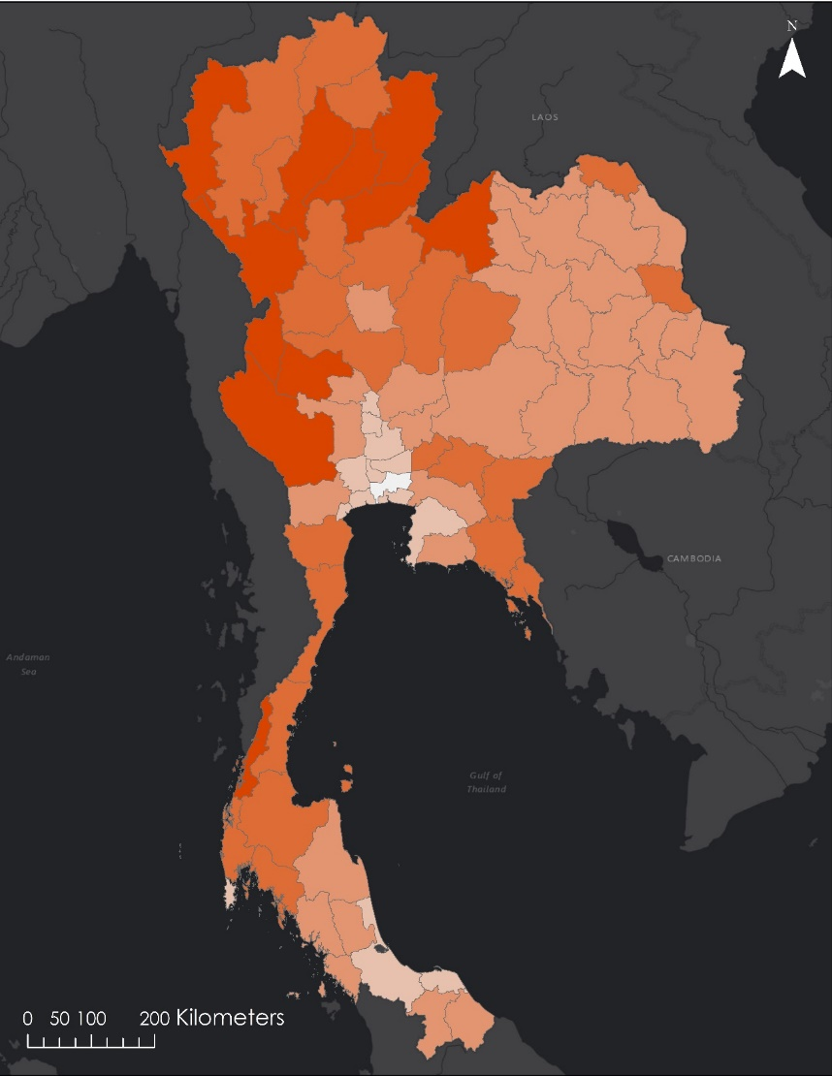

5 – Most Poverty

**Poverty Rank**

1- Least Poverty

2

3

4



*Figure 3.* Poverty Map Using Comprehensive Poverty Index (from Suomi NPP VIIRS DNB, 2013-2015).

***4.1.2 Relationship between NTL and IPI***

To explore the relationship between NLI and IPI, a regression analysis was applied. As shown in Figure 3, a positive linear relationship between the inverse of average night-time light index and integrated poverty index was found with the coefficient of determination $R^{2}$*=* 0.8277. The linear regression can be expressed as:

$Y=0.0265X-0.389$ (10)

When X is the inverse of the average NLI for 2013-2015 and Y is comprehensive poverty index for 2013-2015. This indicates that NLI can provide a good estimate of the economic situation and poverty levels which is very efficient when compared to costly and time-consuming socio-economic statistic data.

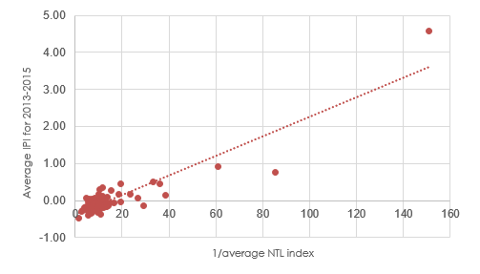

Average CPI for 2013-2015

1/average NLI

*Figure 3.* Relationship between the inverse of average NLIs and CPIs

***4.1.3 Comparison between NLI and CPI***

The NLIs were grouped into the following five classes by K-means clustering, as shown in Table 5. The Poverty Map Using Night-Time Light in Figure 4, illustrates the predicted poverty on the provincial level. The rank of most impoverished to least impoverished was determined using the intensity of night-time light emissions and population within each province. The night-time light analyzed in this map is a weighted average covering all months in the study period.

*Table 5:* The Range of NTLs in five classes

|  |  |  |  |
| --- | --- | --- | --- |
| No. | Class of NLIs |  | Range of NLIs |
| 1 | Very Low |  | 1.5 < Most Poverty <5.5 |
| 2 | Low |  | 5.5 ≤ More Poverty ≤ 9.26 |
| 3 | Medium |  | 9.26 < Poverty ≤ 15.15 |
| 4 | High |  | 15.15 < Less Poverty < 120 |
| 5 | Very High |  | Least Poverty ≥ 120 |

The comparison map shown in Figure 4explores the difference of using night-time light as a proxy for poverty on the provincial level. It illustrates the absolute difference between the poverty rank as defined by socio-economic factors and the poverty rank as predicted by night-time light emissions during the study period. The class ranks of the two indices show similar trends. They were identical in the majority of the regions (39 provinces, or 50%). In other words, different night-time average light index levels can well reflect different poverty levels of these regions. 33 provinces had a difference of ±1 rank (42%). Only 5 provinces displayed differences larger than 1. They are Ang Thong, Pattani, Ranong, Sing Buri, and Surat Thani. Amongst them, 2 provinces, namely Ang Thong and Sing Buri, have secondary industries that account for 20% and 31% of their regional GPP in 2015 (Gross Provincial Product Chain Volume Measures, 2017), however, their tertiary industries are not very active which results in relatively low NLI class ranks in these regions. Minor class rank differences (equal to 1 or -1) between CPIs and NLIs are seen in 33 provinces.

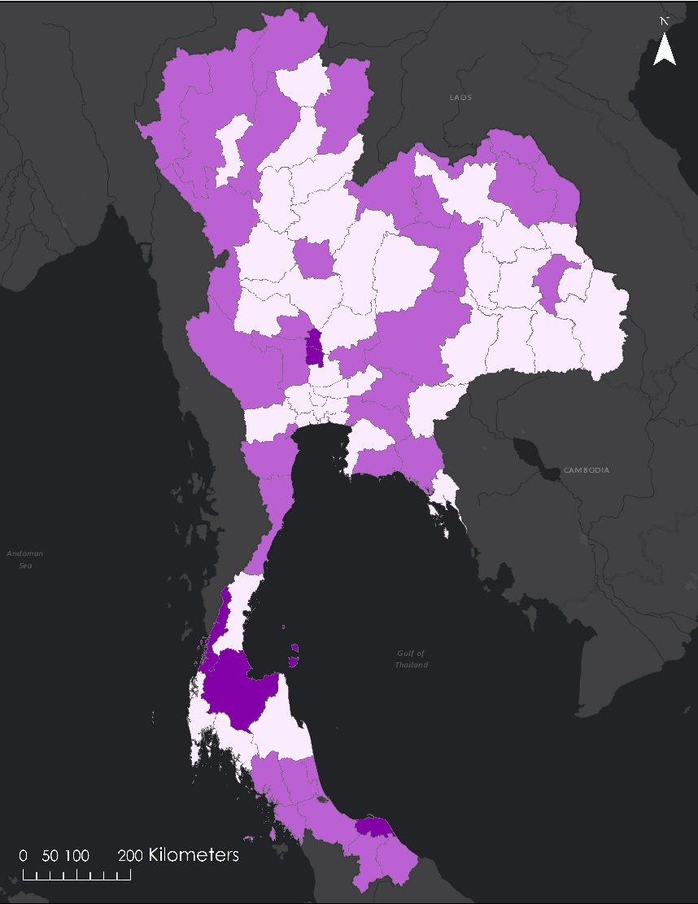



0

1

2

Difference

*Figure 4.* Comparison map between the average NLI and CPI

***4.1.4 Results from Explorations***

For the seasonality component of the explorations, summer was determined to have the highest average NTL intensity while winter had the lowest. This can aid in the understanding of limitations using NTL. Average NTL intensity throughout the four seasons over the three-year study period can be observed in Figure 5.

.

Average Night-Time Light Intensity

Meteorological Seasons

*Figure 5.* Average NTL intensity based on land cover class as identified by GLCF.

Furthermore, a land cover analysis was completed to show the variation of NTL over different land types. It was determined that urban areas experience the highest light emissions and forest experiences the least.

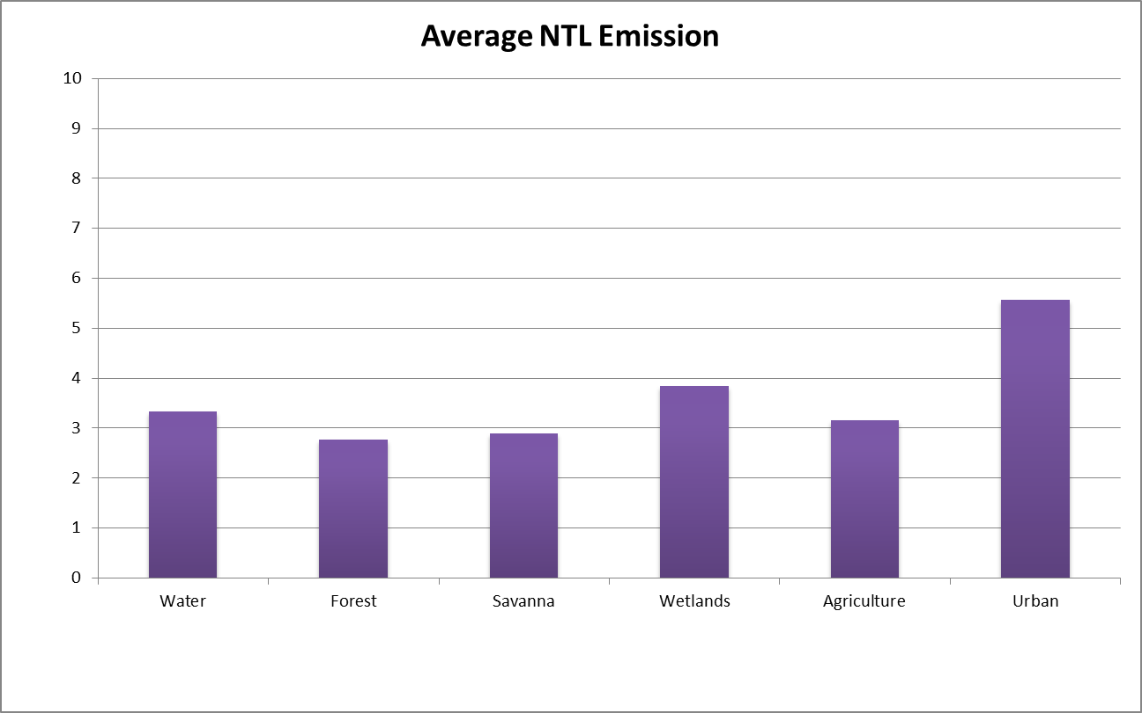

**NTL Emission**

**Land Cover Type**

*Figure 6.* Average NTL intensity based on land cover class as identified by GLCF.

Both sets of 20 cities chosen by total population and population density had a high correlation between distance from the city center and decrease of NTL intensity. Cities chosen by density had a slightly higher correlation with an r2 of 0.9152. Cities chosen by total population had an r2 of 0.8869. Similarly, in the roads exploration, as distance from roads increased, the NTL decreased.

***4.2 Future Work***

Due to differences in average light intensity between provincial and district levels, future work could include analysis using socioeconomic data at a higher resolution. This may also increase the NTL index’s sensitivity to year to year change. Specifically, looking at a particular district or sub-district that has socio-economic data available on a higher resolution would increase the usefulness of this project. In addition, adding additional socio-economic variables would improve the IPI.

The explorations conducted on seasonality, land cover class, and distance from city centers and roads could be a basis for future works using NTL. Validation of the CPI can be conducted as socio-economic data becomes available for 2016. This would allow for a comparison between the poverty level predicted by NTL and the IPI as determined by socio-economic factors.

# 5. Conclusions

Night-time light is suitable as a proxy indicator for poverty. The correlation coefficient between the poverty index and the night-time light index is 0.8277. The NLI can be used to identify different levels of wealth within provinces in Thailand. The methodology used in this project to create a NTL index as a proxy indicator for poverty can be repeated for other countries or for different administrative levels within Thailand. Some caution should be exercised when using the equation created by this project when looking at year to year change as the equation has been shown to be less sensitive to change in poverty levels then the socio-economic factors describing poverty.

Explorations can be used as a basis for further work as well as looking at limitations of our project. As for seasonality, summer has the highest average night-time light intensity, while winter has the lowest. Urban is the land cover class with the highest average NTL intensity. Average NTL intensity also decreases as distance from a city center or road increases.

# 6. Acknowledgments

The Thailand Cross-Cutting team would like to thank the following mentors and project partners without whom this project would not have been possible:

* Dr. Jeffrey Luvall (NASA at NSSTC)
* Dr. Robert Griffin (University of Alabama Huntsville)
* Eric Anderson (NASA SERVIR Coordination Office)
* Leigh Sinclair (University of Alabama Huntsville/Information Technology & Systems Center)
* Kel Markert (NASA SERVIR Coordination Office)
* Petter Cutter (Asian Disaster Preparedness Center)
* Peeranan Towashiraporn (Asian Disaster Preparedness Center)
* Gam Bunyakiat (Royal Thai Embassy)
* Dashiell Cruz (NASA DEVELOP at MSFC)
* Dan Irwin (NASA SERVIR)

Any opinions, findings, and conclusions or recommendations expressed in this material are those of the author(s) and do not necessarily reflect the views of the National Aeronautics and Space Administration.

This material is based upon work supported by NASA through contract NNL16AA05C and cooperative agreement NNX14AB60A.

# 7. Glossary

**ADPC** – Asia Disaster Preparedness Center: organization that works to improve disaster resilience in the Asia-Pacific Region

**CPI** – Comprehensive Poverty Index: poverty index that includes economic, health & wellness, education and living necessities aspects

**EPI** – Enhanced poverty index: poverty index formed from regression between integrated poverty index and night-time light indicator.

**MODIS** – MODerate resolution Imaging Spectroradiometer

**NLI** – Night-time light index: the ratio between TN and the number of population

**NTL** – Night-time Light: light emissions at night recorded by satellites

**PCA** – Principal component analysis: factor analysis that reduces the dimensionality of a large data set based on statistics

**Suomi NPP VIIRS DNB** – Suomi National Polar-orbiting Partnership Visible Infrared Imaging Radiometer Suite Day/Night Band

**TN** – Total night-light: summation of intensity value of each pixel in the area of interest

# 8. References

Cavatassi, R., Davis, B., & Lipper, L. (2004, November). Estimating poverty over time and space: construction of time-variant poverty index for Costa-Rica. *ESA Working paper no. 04-24.*

De Bruin, Ron, Rice, F. (2008). Merging Data from Multiple Workbooks into a Summary Workbook in Excel. Retrieved June 29, 2017 from https://msdn.microsoft.com/en-us/library/cc837974(v=office.12).aspx

Earth Observations Group (2017, May). Retrieved June 26, 2017 from https://www.ngdc.noaa.gov/eog/viirs/download_dnb_composites.html

Elividge, D. C., Sutton, C. P., Ghosh, T., Tuttle, T. B., Baugh, E. K., Bhaduri, B., & Bright, E. (2009, January). A global poverty map derived from satellite data. *Computers & Geosciences,* 35, 1652-1660.

Esri (2017). Data classification methods. Retrieved June 26, 2017 from: http://pro.arcgis.com/en/pro-app/help/mapping/symbols-and-styles/data-classification-methods.htm

Feng, C., Wang, H., Lu, N., Chen, T., He, H., Lu, Y., Tu, M. X. (2014, April). Log-transformation and its implication for data analysis. *Shanghai Arch Psychiatry,* 26(2), 105-109.

Jitsuchon, S., & Richter, K. (2007). Thailand’s Poverty Maps from Construction to Application. World Bank Institute.

Jolliffe, I.T. (2002). *Principal Component Analysis*. Aberdeen, NY: Springer.

Khandker, S. (2005, August). Introduction to poverty analysis. *World Bank Institute.* Retrieved June 28, 2017 from: http://siteresources.worldbank.org/PGLP/Resources/PovertyManual.pdf

Languepin, O. (2017, April 25). Thailand 4.0, what does it mean and what you need to know? Retrieved June 26, 2017, from https://www.thailand-business-news.com/economics/54286-thailand-4-0-need-know.html

Noor, M. A., Alegana, A. V., Gething, W. P., Tatem, J. A., & Snow, W. R. (2008, October). Using remotely sensed night-time light as a proxy for poverty in Africa. Population Health Metrics. 6:5.

Miller, D. S., Turner, E. R. (2009, July). A Dynamic Lunar Spectral Irradiance Data Set for NPOESS/VIIRS Day/Night Band Nighttime Environmental Applications. [*IEEE Transactions on Geoscience and Remote Sensing*](http://ieeexplore.ieee.org/xpl/RecentIssue.jsp?punumber=36)*,* Volume. 47, Issue 7, 2316-2329

Roman, O. M., Stokes, C. E. (2015, June). Holidays in lights: Tracking cultural patterns in demand for energy services. *Earth’s Future,* Volume. 3, issue 6, 182-205

The World Bank (n.d.). Thailand Overview. Countries- Thailand. Retrieved June 26, 2017 from http://www.worldbank.org/en/country/thailand/overview

Wang, W., Cheng, H., & Zhang, Li. (2012, February). Poverty assessment using DMSP/OLS night-time light satellite imagery at a provincial scale in China. *Advances in Space Research*. Volume 49, Issue 8, Pages 1253-1264.

Yu, B., Shi, K.,Huang, C., Chen, Z., & Wu, J. (2015, March). Poverty evaluation using NPP-VIIRS nighttime light composite data at the country level in China. *Journal of selected topics in applied earth observation and remote sensing, vol. 8, No. 3.*

# 9. Appendices

**Appendix A.**

List of socio-economic factors incorporated into the poverty index and their sources.

|  |  |  |
| --- | --- | --- |
| Socio-economic Variable | Description | Source |
| Number of Students | Number of students per educational level on the provincial level in 2013 and 2015. | Ministry of Education’s National Education Information System |
| Fatal Occupational Injuries | Number of occupational injuries on the provincial level from 2013 to 2015. | Ministry of Labour’s Labour Welfare Fund Office |
| Unemployment Rate | Unemployment rate for 2007 through 2016 on the provincial level, Bueng Kan Province is excluded before March 23, 2011. | Ministry of Information and Communication Technology’s National Statistical Office’s Labor Force Survey |
| Population Density | Population density on the provincial level for 2006 to 2015. | Ministry of Interior’s Department of Provincial Administration |
| Medical Service Rate | Number of times each person visits a doctor each year through the social security system on the provincial level from 2013 to 2015. | Ministry of Information and Communication Technology’s National Statistical Office’s Economic Survey |
| Average Monthly Expenditure | Average monthly expenditure per household on the provincial level for alternate years from 1998 to 2015. | Ministry of Information and Communication Technology’s National Statistical Office’s Socio-Economic Survey |
| Average Monthly Income | Average monthly income per household on the provincial level from 2006 to 2015. Bueng Kan Province is excluded before March 23, 2011. | Ministry of Information and Communication Technology’s National Statistical Office’s Socio-Economic Survey |
| Gross Provincial Product (GPP) | Gross provincial product on the provincial level from 2005 to 2015. Bueng Kan Province is excluded before March 23, 2011. | Office of the Prime Minister’s Office of the National Economic and Social Development Board |
| Electricity Usage | Electricity usage on the provincial level from 2006 to 2015. MEA provides electricity usage data for Bangkok, while PEA provides data for all other provinces. Bueng Kan Province is excluded before March 23, 2011. | Metropolitan Electricity Authority (MEA) & Provincial Electricity Authority (PEA)for all other provinces |
| Water Usage | Metropolitan Waterworks Authority & Provincial Waterworks Authority | Water usage on the provincial level from 2006 to 2015. The Metropolitan Waterworks Authority provides water usage data for Bangkok, Samut Prakan and Nonthaburi, while the Provincial Waterworks Authority provides data for all other provinces. Bueng Kan Province is excluded before March 23, 2011. |
| Poverty Line | Minimum level of income determined necessary to secure the necessities of life on the provincial level from 2000 to 2015. Bueng Kan Province is excluded before March 23, 2011. | Office of the Prime Minister’s Office of the National Economic and Social Development Board |

**Appendix B.**

Top: Satellite image without processing (from Suomi NPP VIIRS DNB, January 2013). Bottom: Satellite image after transformation using z-score (from Suomi NPP VIIRS DNB, January 2013).

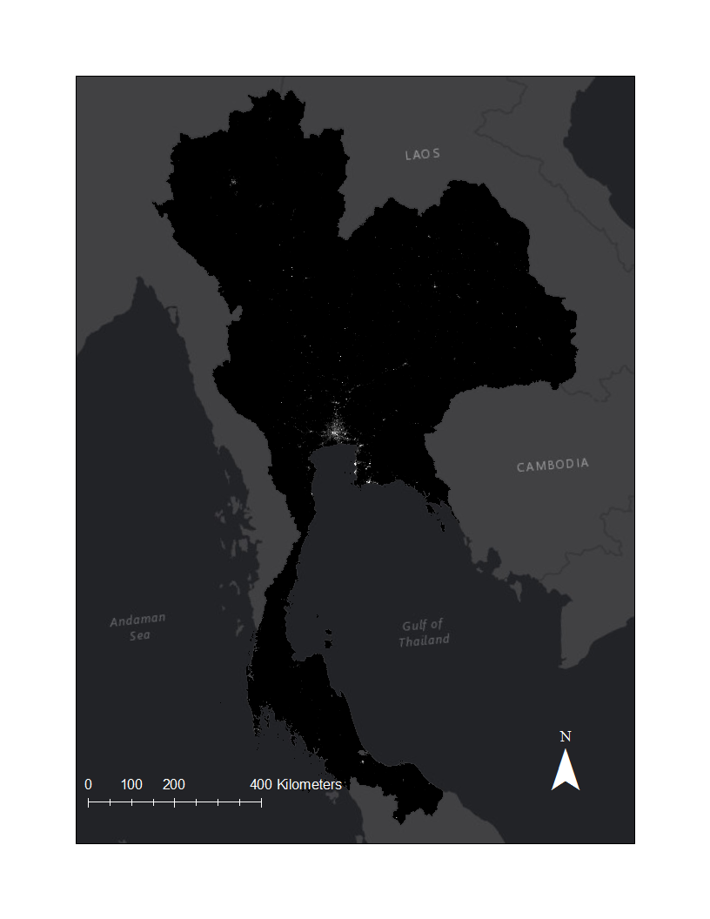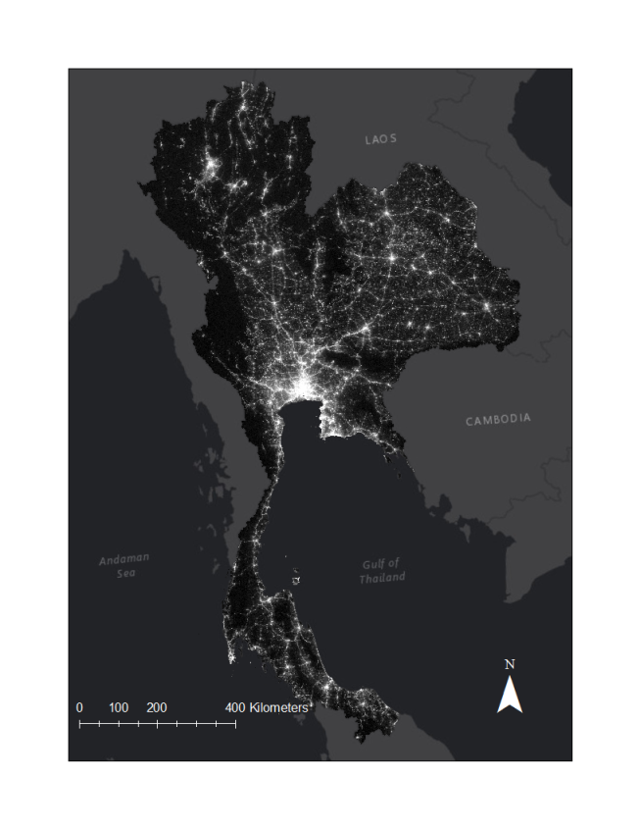

**Poverty Rank**