Coastal California Water Resources II

Utilizing NASA Earth Observations to Detect and Assess the Impacts of Estuarine Breach Events for Improved Coastal Wetland Monitoring and Management

 **Technical Report**

Final – August 12th, 2021

Sarah Payne (Project Lead)

Karina Alvarez

Rachel Darling

Alexander Gunnerson

Sophia Stonebrook

***Advisors:***

Benjamin Holt (NASA Jet Propulsion Laboratory)

Dr. Christine Lee (NASA Jet Propulsion Laboratory)

Dr. Bruce Chapman (NASA Jet Propulsion Laboratory)

***Previous Contributors:***

Molly Bruce

Roger Ly

# 1. Abstract

Estuaries are dynamic environments that provide a host of vital ecosystem services. California’s Marine Life Protection Act protects such ecosystems by creating Marine Protected Areas. California has approximately 440,000 acres of estuarine habitats as well as 23 Estuarine Marine Protected Areas (EMPAs); thus, in situ data collection is often difficult due to time and resource constraints. This project used remote sensing to gather data that examined the health and dynamics of California EMPAs in order to supplement ground-based field measurements. Through the use of Landsat 8 Operational Land Imager (OLI) and Thermal Infrared Sensor (TIRS), Sentinel-2 Multispectral Instrument (MSI) and Sentinel-1 C-band Synthetic Aperture Radar (C-SAR), this project assessed mouth state, inundation extent, turbidity, temperature, and tidal measurements for observable estuaries. The Normalized Water Difference Index from Sentinel-2 MSI captured estuary mouth state and inundation extent. Landsat 8 OLI and Sentinel-2 MSI detected differences in water quality metrics that correlated to changes in estuary mouth state (i.e., open or closed). The team’s California Estuary Assessment (CEA) tool in Google Earth Engine was successful in analyzing estuary mouth state, inundation, and water quality. It was most effective when breach events were larger than 10 meters in resolution, water surface was smooth, and imagery was unimpeded by algae or sun glint. The CEA tool will allow the partners, the Ocean Protection Council, Central Coast Wetlands Group, Southern California Coastal Water Research Project, and University of California Los Angeles (UCLA) and Davis (UCD), to better understand estuary dynamics and more effectively conduct in situ estuary monitoring.

**Key Terms**

Marine Protected Area, NDWI, Turbidity, Water Temperature, Google Earth Engine, Landsat 8, Sentinel-2, ECOSTRESS

# 2. Introduction

***2.1 Background Information***

An estuary is a wetland ecosystem at a river mouth where freshwater mixes with seawater. Bar-built estuaries (BBE) have a sand bar at the mouth that undergoes frequent and rapid changes. BBEs comprise approximately half of California’s 577 coastal confluences (Clark & O’Connor, 2019). They receive extremely variable seasonal water discharge and are found on beaches that are exposed to high wave energy (Harris et al., 2002). River discharge can often open, or breach, these sand bars, while high wave energy can close the estuary mouth through the formation of sand bars (Rich & Keller, 2013). BBE closures allow the estuary to receive only freshwater input except during large wave events and bidirectional seepage through the sand bar; meanwhile, during a breach event, the estuary is subject to tidal influences (Clark & O’Connor, 2019).

The dynamic nature of these breach events results in variable levels of turbidity and sea surface temperature (SST). Turbidity levels inside BBEs usually increase with increased streamflow, which carries sediment downstream. During a breach event, BBEs release sediment into the ocean, resulting in increased turbidity outside the estuary mouth. During a closed mouth state, SST within the estuary generally increases. Table A1 summarizes some of the observed relationships between these metrics and estuary mouth state (Largier et al., 2019).

BBEs create robust and diverse habitats that arise from sand bar formation and failure (Clark & O’Connor, 2019). BBEs also provide numerous important ecological functions that include: filtering pollutants out of the water, providing a protective habitat for endangered and threatened species, and acting as nurseries for fish and invertebrates (Barbier et al., 2011). However, anthropogenic activities like land development, approved flood management breaches, and unapproved recreational breaches disrupt important natural cycles, timing, magnitude, and duration of estuarine processes (Dahl, 1990; Heady et al., 2015, Largier et al., 2019).

California legislators enacted the Marine Life Protection Act (MLPA) in 1999 to protect estuaries and estuarine ecosystem services such as: estuary function, structure, diversity, cultural value, and educational value. The MLPA requires consistent monitoring of the networks of California’s Marine Protected Areas (MPAs). However, in situ data monitoring of these dynamic ecosystems is time intensive, difficult, and expensive. While many MPAs are heavily monitored, there is a deficiency of robust, sequential data for California’s resource managers ability to protect, monitor, and measure anthropogenic impacts on estuaries.

Publicly available, remotely sensed data can provide a more cost and time effective way to gather information on Californian estuary metrics, especially when field-based monitoring cannot be conducted. This allows managers to complete long-term analyses at a higher temporal resolution. Past studies used multi-source, remotely sensed data to monitor wetland ecosystems (Guo et al., 2017). For example, studies have utilized Earth observations (EO) to detect nearshore bars (Román-Rivera & Ellis, 2019) and assess inundation over time (Eid et al., 2020). This project uses satellite EOs to assess the health of five California estuaries (*Figure 1*) from December 2018 to July 2021.

*Figure 1*. Five team-selected estuary study sites.

The sites were chosen based on partner input and feasibility parameters to test the California Estuary Assessment (CEA) tool, such as size variability. Testing larger and smaller sites allowed the team to determine the spatial resolution limits of the CEA tool. Additionally, all sites are BBEs and located along the California coast, which allowed the team to study a wide range of these ecosystems.

The previous term found that Sentinel-2 Multispectral Imager (MSI) best visualized estuaries of all sizes while Landsat 8 Operational Land Imager (OLI) best observed larger estuaries. Last term also found that Sentinel-2 MSI imagery captured estuary mouth state and Sentinel-1 C-SAR could potentially supplement optical imagery when cloud cover was present. Furthermore, they found assessing color dissolved organic matter and chlorophyll-a using Google Earth Engine’s (GEE) currently available image collections challenging and assessing turbidity more feasible.

***2.2 Project Partners & Objectives***

The team worked with the Ocean Protection Council (OPC), Southern California Coastal Water Resources Project (SCCWRP), Moss Landing Marine Laboratories (MLML), Central Coast Wetlands Group (CCWG), the University of California, Los Angeles (UCLA), and the University of California Davis (UCD) to create a GEE tool that monitors and assesses estuaries. By including analysis of remotely sensed data in decision making, OPC will be able to provide technical support and funding to other state-level agencies. The CEA tool produced in this project analyzes estuary mouth state, inundation, SST, and turbidity. The objectives were to refine and validate the CEA tool as well as generate time series to compare: estuary mouth state, Sentinel-2 MSI derived inundation extent, Sentinel-1 C-SAR derived inundation, turbidity, and SST during the study period for the five sites. The team created a user-friendly GUI to display and export results. The CEA tool will provide a more efficient workflow for state-agencies interested in EMPA monitoring.

# 3. Methodology

***3.1 Data Acquisition***

The team acquired Landsat 8 OLI/TIRS (Thermal Infrared Sensor), Sentinel-2 MSI, and Sentinel-1 C-SAR imagery through GEE (Table 1). Ancillary datasets include United States Fish and Wildlife Service (USFWS) National Wetlands Inventory accessed through the USFWS Wetlands Mapper, United States Geological Survey (USGS) 3D Elevation Project (USGS 3DEP) 1m DEMs obtained through the USGS 3DEP LidarExplorer, and Coastal National Elevation Database (CoNED) 1 m DEMS acquired through NOAA Data Access Viewer. The team used these datasets to designate the five estuary study sites used in the CEA tool. Additional in situ data used for validation include water level and below-surface temperature data for the Navarro River estuary from CCWG, water level data for the Carmel River estuary from the Monterey Peninsula Water Management District, water level and below-surface temperature data for Malibu Lagoon from The Bay Foundation, tide data for all sites from NOAA Tides and Currents, and daily streamflow data for all sites from the USGS. For tide and streamflow data, the team identified stations closest to each estuary and downloaded this data, when available.

Table 1

*EO data acquired for this project.*

|  |  |  |  |  |
| --- | --- | --- | --- | --- |
| **Platform & Sensor** | **Processing Level** | **Resolution** | **Date Range of Available Data** | **Data Provider** |
| Landsat 8 OLI/TIRS | Level 2 Surface Reflectance Level 2 Collection 2 Tier 1 | 30 m, 16 day revisit | June 2013 to Present | USGS |
| Sentinel-2 MSI | Level 2A Surface Reflectance | 10-20 m, ~ 5 day revisit | December 2018 to Present | European Space Agency (ESA) Copernicus Open Access Hub |
| Sentinel-1 C-SAR | Level 1 GRD | 10 m, ~ 2-3 day revisit | April 2014 to Present | ESA Copernicus Open Access Hub |
| PlanetScope | Level 3A | 3 m, ~1 – 2 day revisit | June 2016 to Present | Planet Labs |

***3.2 Data Processing***

The team primarily used GEE to process data and generate products in this study. To ensure clear optical imagery, the team first applied cloud filters and cloud masks to parse GEE image collections. The cloud filters and masks for each tool varied slightly and are described in the subsections below.

*3.2.1 Study Area Shapefiles*

This project generated three shapefiles specifically suited to each line of inquiry: estuary mouth state detection, inundation, and water quality. For creating the estuary mouth state shapefile, the CEA tool used a point at the center of each estuary mouth for the five selected sites. The team then created a 500 m buffer around this point for all sites with the exception of Malibu Lagoon (250 m buffer). Malibu Lagoon had a smaller buffer due to its small size and unique mouth opening. The buffer was intersected with the inundation shapefile to exclude land from the estuary mouth state analysis. To study inundation extent, the team used USFWS National Wetlands Inventory (NWI) as a baseline designation of estuary extent. The team extended polygons with either USGS 3DEP 1m DEM or USGS CoNED 1 m Topobathymetric models to determine areas of potential inundation up to 5 m. The team then clipped inundation shapefile to ensure only the landward side of the estuary was included. Finally, the team created a shapefile for water quality. A large area of interest approximately 4 km away from the center of the estuary mouth captured water quality metrics like turbidity and temperature plumes.

*3.2.2 Estuary Mouth State Detection*

The team detected estuary mouth state using Sentinel-2 imagery by assessing the continuity of water pixels between the estuary body and the open ocean. To do this, the team applied two cloud filters to ensure clear images. The first filter removed any image with greater than 20% cloud cover in the entire Sentinel-2 image based on the metadata (‘CLOUDY_PIXEL_PERCENTAGE’ attribute). The team applied a second filter based on the QA60 quality assurance band. If the QA60 band detected any clouds in the estuary mouth state shapefile, those images were excluded from the analysis. Two cloud filters were used because both methods did not sufficiently identify and exclude cloudy images. More cloudy images were excluded from analysis when using two filters that assessed different areas and different image properties.

After applying both cloud filters, the team then calculated the Normalized Difference Water Index (NDWI, Equation 1) (Gao, 1996) and the modified Normalized Difference Water Index (mNDWI, Equation 2) (Xu, 2007) using Sentinel-2 MSI imagery.

(1)

m (2)

In Equation 1, Rrs(559) represents reflectance values at 559 nm and refers to the green band, while Rrs(864) represents reflectance values at 864 nm and refers to the near-infrared (NIR) band. On a scale of approximately -0.8 to 0.8, high positive values indicate water, low negative values indicate vegetation, and values near 0 indicate non-vegetated areas. In Equation 2, Rrs(559) refers again to the green band, while Rrs(1610) represents reflectance values at 1610 nm and refers to the shortwave infrared (SWIR) band. On a scale of -1 to 1, high positive values indicate water, low negative values indicate vegetation, and values near 0 indicate non-vegetated areas. The team investigated mNDWI because it enhances open water features and diminishes unvegetated areas that are often correlated with open water in NDWI.

The team investigated NDWI and mNDWI thresholds at 0.0, 0.5, 0.1, and 0.15, and then chose which threshold produced the highest accuracy for the estuary mouth state analysis when compared to visual inspection. A water/non-water binary was then created. The team then used an object-based analysis to determine if the estuary mouth was open (i.e., water pixels were connected from the interior of the estuary to the ocean) or closed (i.e., water pixels were not connected). If water pixels were connected, the analysis would return a single object. If the water pixels were not connected, the analysis returned two objects. Small vestigial clusters of less than 100 pixels, due to waves and rocks, were filtered out from the estuary mouth state analysis.

To generate a time series of estuary mouth state values, the team created a band for each image that designated estuary mouth state as open or closed. The team then converted the object(s) into a vector(s), counted the vectors, and assigned the band a value of 1 or 2. Finally, the team generated a time series chart from this band using a mean reducer. In this instance, a mean reducer can be used in GEE because all the pixels in in a single image were assigned the value of 1 or 2.

*3.2.3 Inundation*

In order to calculatethe total area of inundation, the team used the inundation shapefile. For Sentinel-2 MSI imagery, the team applied the same two cloud filters used for the estuary mouth state analysis. One method that was tested for identifying areas of inundation was calculating NDWI (Equation 1) and applying the same threshold for each site that was used for the mouth state analysis to create a water/non-water binary.

The team used Sentinel-1 C-SAR imagery to complement the NDWI measurement of inundation. In order to prepare the Sentinel-1 C-SAR imagery for analysis, the team applied multiple preprocessing techniques. First, the team converted the data from decibels (dB) to natural values. Next, the team employed the Refined Lee Filter technique to reduce speckle, a phenomenon present in SAR data where non-target backscatter distorts image interpretation. The Refined Lee Filter is a recognized and respected speckle reduction technique that “select[s] similar pixels to reinforce homogeneity according to eight non-square windows as the templates” (Xing et al., 2017). The team experimented with the usage of another speckle reduction technique suggested by one of the team’s science advisors, Dr. Bruce Chapman, where a function is applied to the imagery’s Vertical Transmit-Horizontal Receive Polarization (VH) and Vertical Transmit-Vertical Receive Polarization (VV) bands of “VV + 2VH”. The team found the Refined Lee Filter to be effective in reducing speckle and the VV + 2VH method to be inconsequential in improving image interpretation.

Having reduced speckle, the team reduced noise in the data by segmenting the Sentinel-1 C-SAR imagery by incidence angle and sensor. The team first separated Sentinel-1A and Sentinel-1B imagery due to minor calibration differences (Schmidt et al., 2020). Then, the team separated the imagery into the near or far range based on the location of the study site within the swath. After accounting for noise reduction, the team found that the VV band in the near range was the most successful at discerning sand from water at estuary mouths compared to the far range and both iterations of the VH band. Similar to the Sentinel-2 MSI image processing, the team applied a threshold of 0.02 to the Sentinel-1B imagery and a threshold of 0.025 to the Sentinel-1A imagery in order to distinguish water pixels from non-water pixels. The team selected this threshold after iterating through a range of threshold values across several study sites and several dates as a means of discerning which threshold performed best at identifying estuary features compared to true color Sentinel-2 MSI imagery. Having completed preprocessing, the team interleaved the Sentinel-1 C-SAR imagery into a single time series and generated a water/non-water binary using the same thresholds.

After creating image collections of binary water/non-water rasters for both Sentinel-2 MSI and Sentinel-1 C-SAR, the team determined the total number of water pixels per image by applying a water pixel count function. With the number of water pixels for each binary created, the team multiplied this number by 100 (Sentinel-1 and Sentinel-2 have a resolution of 10 m by 10 m per pixel) to get the area of water in square meters and added this value as a band to the image. The team applied this function to each image collection and then calculated a running two-week average for the area values to reduce noise and generate a smoother visualization. The team visually inspected the imagery and noted dates with sudden drops in the area of inundation as potential trendmarkers. With the advice of the partners, the team monitored trends of how changes in estuary mouth state might correspond with inundation levels (Table A1).

*3.2.4 Water Quality Metrics*

For water quality analyses, the team used Sentinel-2 MSI and Landsat 8 OLI/TIRS imagery for turbidity and SST, respectively. The team first filtered both collections to the study area and study period, then applied cloud masks and water quality algorithms for each metric to the relevant collection.

For turbidity, the team first acquired and processed Sentinel-2 MSI Level-1C top of atmosphere reflectance images using the Modified Atmospheric correction for Inland waters (MAIN) algorithm as a form of atmospheric correction that is applicable for water quality analyses (Page et al., 2019). This algorithm includes a cloud and cloud shadows mask. The team then generated turbidity images from the atmospherically corrected Sentinel-2 MSI collection using an algorithm in GEE initially developed by Sol Kim, Rafael Grillo Avila, and Xiaowei Wang at University of California, Berkeley with the guidance of Dr. Christine Lee. Their algorithm adapted another algorithm which utilized surface reflectance in the red and near-infrared range of the spectrum (Nechad, Ruddick, & Neukermans, 2009). Formazin is a uniformly-sized, insoluble, light scattering polymer that imitates suspended particles that cause turbidity in natural water systems and serves as the calibration standard for turbidity quantification (Rice, 1976). The turbidity layer produced Formazin Nephelometric Units (FNUs) based on surface reflectance products (Equation 3). In this function, AT and C are wavelength-dependent calibration coefficients (366.14 and 0.19563, respectively), while ρW is the reflectance value measured over water in the red band (645.5nm). The team applied this function to Sentinel-2 MSI data to derive turbidity values for each dataset. Finally, the team applied a land mask using a SWIR threshold of 0.0215, where anything above this value was assumed to be land and was excluded from analysis.

(3)

For SST, the team acquired and processed Landsat 8 Collection 2 Level 2 collection imagery. After filtering, the team applied a cloud mask using the quality insurance band of the collection. The team then imported SST values from band 10 of the collection and converted values from Kelvin (K) to Celsius (C) (Equation 4). In equation 4, T represents the Landsat integer value which is a scaled version of a surface temperature estimate. The constant *m* is a scale factor (0.00341802), while the constant *a* is an offset value (149) that is added to adjust values to Kelvin. After applying this algorithm, a land mask was then applied using a SWIR threshold of 0.0215, where anything above this value was assumed to be land and was excluded from analysis. Once unwanted the water quality algorithms and land masks were applied, the team calculated mean values of turbidity inside the estuary, turbidity outside the estuary mouth, and SST inside the estuary.

(4)

***3.3 Data Analysis***

For each estuary attribute assessed—mouth state, inundation extent, turbidity, and SST—the team generated time series charts of estuary mouth state as open or closed, inundation extent, and mean water quality metric values, respectively. To analyze the effectiveness of the CEA tool’s estuary mouth state detection script, the team visually inspected imagery to compare outputs with the imagery from which outputs were generated at each of the five study sites. Every available Sentinel-2 MSI image was recorded in one of four categories: cloudy, open mouth state, closed mouth state, or uncertain mouth state. The team designated an image as uncertain when the mouth state was difficult to discern due to the imagery’s resolution of 10 m. The team then investigated Sentinel-2 images that were deemed uncertain by comparing them to higher resolution (3 m) Planet imagery taken on the same day, if available. If a Planet image on the same date was available, the team changed the uncertain designation to open or closed based on visual inspection of the higher resolution imagery. If Planet imagery was not available, the team left the designation as uncertain. In addition to validating the CEA mouth state detection output with visually inspected imagery, the team compared these results to InletTracker. InletTracker is a GEE-enabled Python software package that assesses if an estuary mouth (also called an inlet) is open or closed using a least-cost pathfinding approach (Heimhuber et al., 2021). InletTracker uses CoastSat, a custom GEE-enabled Python package, to preprocess images, allowing for a comparison of the team’s cloud filter approach and estuary mouth state detection methodology.

The team evaluated the CEA tool’s inundation outputs by comparing the Sentinel-2 MSI water/non-water binary to the associated true color composite. The team filtered out low values which indicated that clouds, which have an NDWI value close to that of land, were not correctly filtered out of images and were interfering with analysis. Sentinel-2 MSI and Sentinel-1 C-SAR water/non-water binaries were compared to one another along with the true color composite on days when there was available imagery from both sensors to assess differences between the two inundation extent outputs.

The team then compared inundation extent and water quality metrics to available in situ data. The team matched remotely-sensed observations with in situ observations by generating time stamps of imagery in GEE time series and for in situ data (in UTC time) and matching the data such that in situ data was as closely tied to the time of image capture as possible. Sentinel-1 and Sentinel-2 inundation data was compared to water level data, where available. Because estuary turbidity data was available for any of the sites, Sentinel-2 turbidity data were instead validated at a stream gage upstream of the Russian River estuary against in situ turbidity and stream discharge data from this gage. Additionally, this in situ data were compared to Sentinel-2 turbidity data retrieved from the Russian River estuary itself. Landsat 8 SST was validated by comparing it to in situ water level data at the Navarro River estuary. The team also visually compared water level data with inundation and water quality data, in addition to running both Pearson’s and Spearman’s correlation tests on associated variables.

# 4. Results & Discussion

***4.1 Analysis of Results***

*4.1.1 Estuary Mouth State*

The success of the CEA tool’s estuary mouth state analysis function relied on the filtering of Sentinel-2 image collections for clouds. The double cloud filter (first filtered on Sentinel-2 metadata for the entire image and then the QA60 band for the estuary study area) ranged in effectiveness between sites. The CEA tool’s cloud filter accuracy ranged from 70% to 83% when compared to visual inspection of the entire Sentinel-2 image collection. The team found that the CEA tool’s cloud filter often over-filtered — that is, it skipped over images the estuary mouth state analysis that the CEA tool could have run on as deemed by visual inspection of the imagery. This error of omission decreased the temporal resolution of the estuary mouth state analysis time series. The team compared the CEA tool cloud filter to Inlet Tracker’s and found that Inlet Tracker’s cloud filter was more accurate, ranging from 88% to 91% across the five study sites. This is most likely because Inlet Tracker’s utilization of CoastSat provides additional functions for image pre-processing and creates a more robust cloud filter (Table A2).

The accuracy of estuary mouth state analysis also heavily relies on the NDWI threshold used to determine the water/non-water binary. The team found that generally for the estuary mouth state analysis NDWI performed better than mNDWI when compared to visually inspected imagery. Each site had different NDWI thresholds that increased the accuracy of estuary mouth state analysis. For NDWI, previous studies have used a threshold of 0.1 to extract water from Sentinel-2 derived NDWI (Kaplan & Avdan, 2017). The team found that a NDWI threshold of 0.10 for Russian River, 0.05 for Navarro, Carmel, and Malibu, and 0.0 for Carmel increased the estuary mouth state analysis accuracy.

The accuracy of the CEA tool’s estuary mouth state analysis function compared to visual inspection of the imagery also varied among sites. Russian River had the highest accuracy of a proper open or closed designation at 83% (*Figure 2*), Navarro at 80%, Carmel at 75%, Malibu at 70%, and Ventura at 60% (Table A2). The primary source of error in the CEA tool was designating an open mouth state, as deemed by visual inspection, as closed. Often, a perched mouth state with a small stream connecting the estuary interior to the ocean was not captured by the CEA tool. Rather, the team found the tool would more often correctly identify full breaches with wide streams. The most probable reason for this is that the 10 m spatial resolution of the imagery did not detect smaller streams. Furthermore, smaller study sites with less inundation in the interior of the estuary were more difficult to capture, especially if there were multiple water ways. This is evident when visually inspecting Carmel and Ventura.

*Figure 2.* Estuary mouth state analysis for Russian River, CEA tool output.

The team compared the CEA tool estuary mouth state analysis to InletTracker’s. The team found that when running InletTracker with NIR and NDWI and minimum requirements for training, the CEA tool outperformed InletTracker for our five study sites. InletTracker’s accuracy compared to visual inspection was Navarro at 52%, Russian at 44%, Carmel at 70%, Malibu at 68%, and Ventura at 24% (Table A2). Inlet Tracker did run on more images since their cloud filter did not over filter as much as the CEA tool. While the CEA tool had higher accuracy in this context for the sites examined, InletTracker has the capacity to be refined by changing the type of analysis (NIR and NDWI to SWIR and mNDWI) and incorporating a check of visual inspection within the tool itself. For the sake of comparing methodology, these adjustments to Inlet Tracker were not investigated. If the end user has coding experience, InletTracker could be a compliment to the CEA tool.

*4.1.2 Inundation*  
This project found that Sentinel-2 MSI inundation was most accurate when the water was clearly identifiable and did not have sun glint or algae present. Sentinel-1 C-SAR was most accurate for larger estuaries when the water was smoother. Upon completing the visual inspection of the Sentinel-2 MSI and Sentinel-1 C-SAR water/non-water binaries compared to the true color composite, the team found similar trends between Navarro and Russian River, the larger sites which we studied. The team found that Sentinel-2 MSI captured inundation more accurately in most instances. When algae were present in the water or clouds were covering part of the estuary, SAR captured the inundation more accurately. However, there were still instances where not all areas of water were identified as water by the binary. There were also instances when the Sentinel-1 C-SAR binary identified the sand bar as inundated. The team generated charts using the CEA Tool that show the area inundated using Sentinel-2 MSI, Sentinel-1 C-SAR, and the combination of both with a two-week running average applied (*Figure 3*).

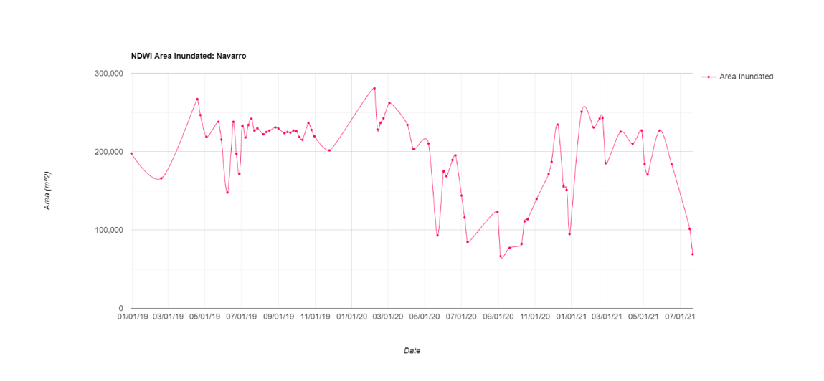

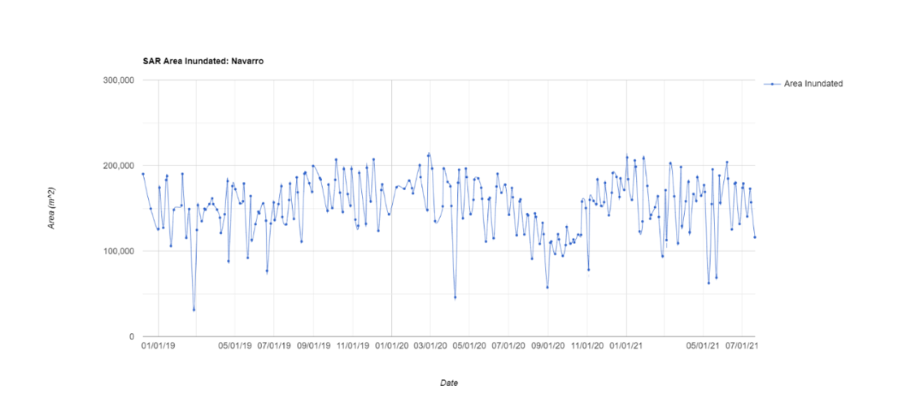

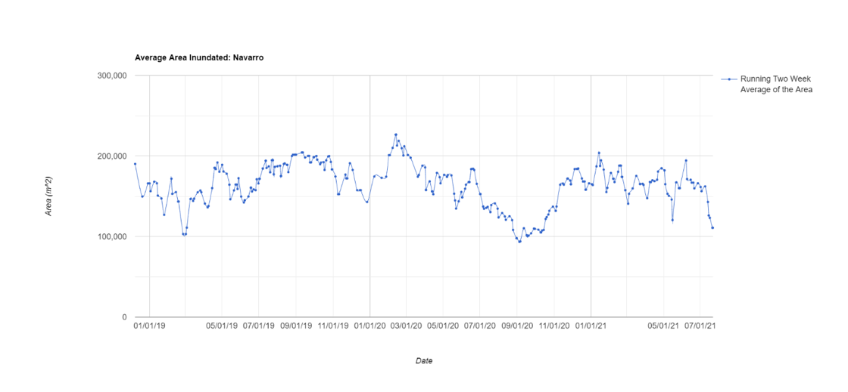

*Figure 3.* Inundation Chart Outputs for Navarro in the California Estuary Assessment Tool for the entire study period, December 2018 to present. The top chart is area inundated from Sentinel-2 MSI imagery. The middle chart is area inundated from Sentinel-1 C-SAR imagery. The bottom chart is a two-week running average of area inundated from Sentinel-1 C-SAR and Sentinel-2 MSI.

The team found that after completing visual inspection of the Sentinel-2 MSI and Sentinel-1 C-SAR water/non-water binaries compared to the true color composite, the inundated area of smaller sites like Malibu, Ventura, and Carmel were not entirely being captured. In many instances the Sentinel-2 MSI binary did not capture all of the water, and the Sentinel-1 C-SAR would identify areas sand pixels as water. Similar to the estuary mouth state analysis, the small size of these estuaries most likely meant that the spatial resolution of the Sentinel-2 MSI and Sentinel-1 C-SAR water/non-water binaries were too coarse to effectively detect the true area of inundation for each estuary. Sentinel-1 C-SAR-derived inundation extent correlated more strongly with in situ water level data (Pearson’s Correlation, R2=0.23) than Sentinel-2 MSI-derived inundation extent did (Pearson’s Correlation, R2=0.07).

*4.1.3 Water Quality*

The turbidity validation conducted at a Russian River stream gage found that turbidity values measured by Sentinel-2 MSI were much lower than turbidity values measured in situ (*Figure A1*). While Sentinel-2 captured some of the variation exhibited by in situ turbidity data, it did miss some peaks. For example, it captured a peak in February 2019 but missed a peak in January 2020. In this validation analysis, Sentinel-2 turbidity exhibited a moderate correlation with in situ data (Pearson’s R2=0.65, Spearman’s R2=0.08).

In the comparison of Sentinel-2 turbidity data at the Russian River gage with stream discharge data, the team found a similarly moderate correlation (Pearson’s R2=0.62, Spearman’s R2=0.07). Sentinel-2 turbidity mirrored the most extreme peaks exhibited by stream discharge data, unlike it did for in situ turbidity data. This suggests that in the absence of turbidity data, stream discharge data may be a suitable alternative for comparing with remotely-sensed turbidity. However, more definitive statements about the accuracy of Sentinel-2 turbidity data are difficult to make without more in situ turbidity data.

Additionally, the team found that Sentinel-2 turbidity outside the estuary positively correlated with upstream discharge (Pearson’s Correlation, R2=0.44, Spearman’s R2=0.02) and with upstream turbidity (Pearson’s R2=0.22, Spearman’s R2=0.24), although the strength of the correlation varied by test. Following the Russian River turbidity comparisons, Sentinel-2 turbidity values from the interior and exterior of the estuary were both compared to in situ discharge values for all sites (Table A3). Generally, interior estuary turbidity was more closely correlated with upstream discharge than exterior estuary turbidity was correlated with upstream discharge.

The SST validation analysis at the Navarro River Estuary found that Landsat 8 SST inside the estuary correlated strongly in situ water temperature (Pearson’s R2=0.78, Spearman’s R2=0.82). The values of Landsat 8 SST were slightly higher than that of in situ data, which further validated the product, as the water surface (SST) is warmer than below the water surface (in situ data). SST at all sites exhibited strong seasonality, where highest temperatures occurred in mid- to late summer and lowest temperatures occurred in mid to late winter. *Figure A2* shows the time series output of internal estuary turbidity from Sentinel-2, external estuary turbidity from Sentinel-2, and SST from Landsat 8 for the Carmel River estuary.

*4.1.4 Cross-Comparison of Parameters*

The graphical user interface (GUI) of this project utilizes GEE to portray estuary mouth state, inundation, and water quality metrics in tandem. Users have the ability to upload their own asset or select a pre-defined area, select which metrics they want to generate, the date range, and utilize the on click function to display images for a selected date. The graphical user interface requires no coding ability to operate (*Figure B1*). Additionally, the GUI allows for easy downloading of data for comparison and analysis outside of GEE.

End users have the ability to look at different metrics in tandem within the GUI, to better understand whether there were trends present between mouth state and water quality metrics. The on click function allows users to visually inspect the true color composite and analyzed images to better understand and verify the trends that were observed in the given time series (*Figure 5*). End users also have the ability to export the time series plots created in the GUI (*Figure 2, Figure 3, Figure 4*) as a CSV to be opened in Excel and have the option to use available in situ data to perform their own further analysis of the data.

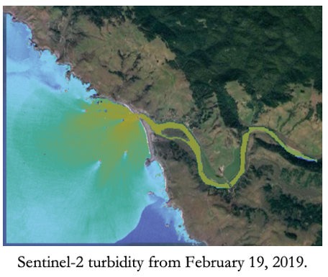 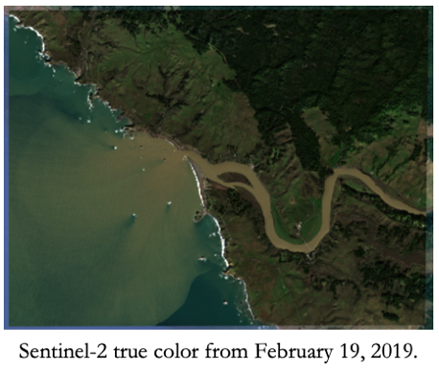

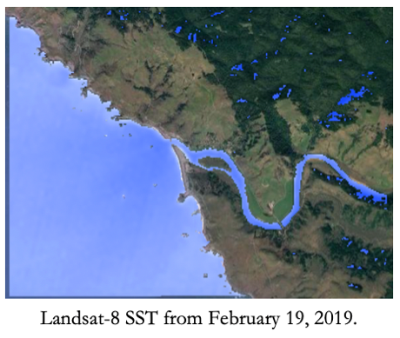 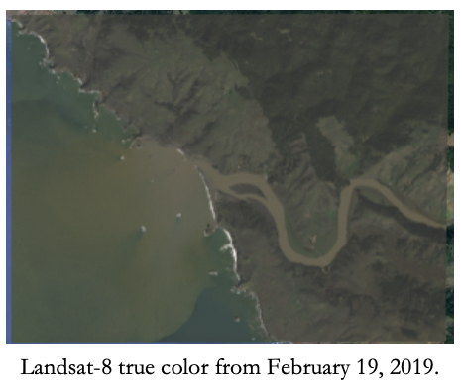

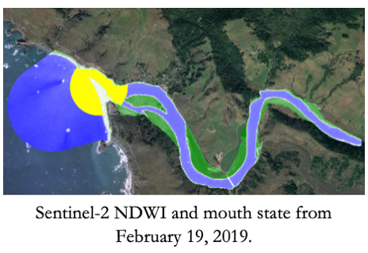 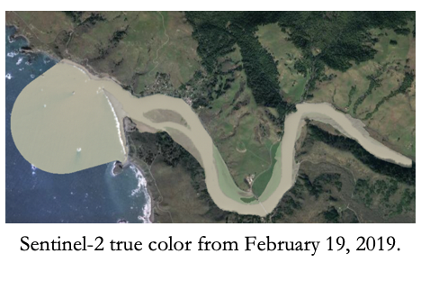

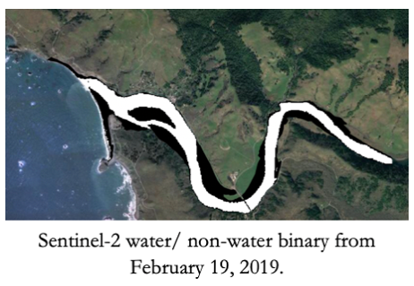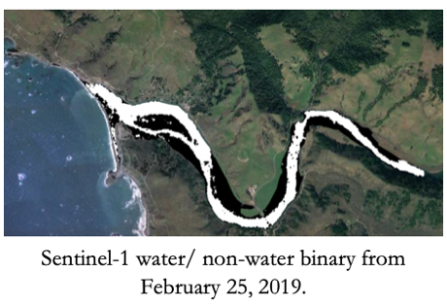

*Figure 5*. Options of on-click outputs in the California Estuary Assessment Tool. All images are from Russian River during February 2019.

This project found that estuary mouth state impacted all other remotely-sensed estuary parameters measured in this project. As freshwater inputs accumulated, the team observed increased inundation extents in winter months and an increase in turbidity. Breach events and open mouth states then resulted in a visible decrease in turbidity inside the estuary, increase in turbidity outside the mouth, increase in SST inside the estuary, and decrease in inundation extent inside the estuary.

Although Sentinel-1 C-SAR and Sentinel-2 MSI results differed from each other, the time series of both exhibited similar dips and peaks at each site, suggesting that these sensors were accurately capturing trends of inundation extent. Trends for all metrics were the clearest for larger estuary sites. Challenges such as minimum pixel number, low water levels, and insufficient resolution resulted in less consistent patterns at smaller estuaries.

***4.2 Future Work***

The CEA tool’s cloud filter could be updated to increase the temporal resolution and accuracy. Analysis run on optical imagery could be improved through a more stringent cloud filter and/or masking cloudy pixels. Other cloud filtering software packages, such as one employed by InletTracker called CoastSat, should be investigated to pre-process and filter imagery.

Future work should focus on expanding water quality metrics. Due to limited time, this term focused primarily on turbidity and SST. Partners showed interest in other water quality metrics such as suspended aquatic vegetation (SAV), colored dissolved organic matter (CDOM), chlorophyll-a, and transmissivity. More time would allow for the opportunity to refine and validate extended water quality metrics.

Along with expanding water quality metrics, future work should also focus on expanding to more sites. Expansion to other sites would allow for the ability to continue to validate the accuracy of the tool in detecting breach events, as well as different water quality metrics. Additional in situ data, specifically water level, temperature, and turbidity, would also facilitate the expansion and validation to other sites.

Another potential source of future work includes the exploration of other Sentinel-1 C-SAR preprocessing techniques. Other methodologies (Mullissa et. al, 2021) have been used to great effect to process Sentinel-1 C-SAR imagery and the comparison with this term’s results may prove fruitful. Additionally, due to the time constraints of the term, the team was not able to correct for Sentinel-1 C-SAR’s consistent misidentification of sand as water. Future work could include utilizing Sentinel-2 MSI imagery to identify areas of sand and systematically correct Sentinel-1 C-SAR’s limitations.

The team explored using a supervised CART classification for mapping inundation extent this term, but due to limited time this method was not a part of the final product. Future work should focus on a method that would allow the user to build their own training datasets for specific sites. Specific training datasets for each site would allow for more accurate reflectance's to be input into the classifier that would run on each site. Future work should also test which classification method would provide the most accurate classification of water and non-water areas.

# 5. Conclusions

The Coastal California Water Resources team successfully created the California Estuary Assessment (CEA) tool. The tool contains a graphical user interface composed of Google Earth Engine scripts that generates series charts of estuary mouth state, inundation extent, turbidity, and SST for the study area. This tool allows users to observe estuary metrics relative to one another, select their own area of analysis, and adjust date ranges.

Overall, this project demonstrated that the EO used were better suited to observe larger estuaries, such as Navarro and Russian River, than smaller estuaries, such as Malibu, Ventura, and Carmel. The team found that Sentinel-2 MSI was capable of properly detecting estuary mouth state. Furthermore, this project found that Sentinel-2 MSI and Sentinel-1 C-SAR regularly detected greater inundation extents preceding a breach event and lower inundation extents immediately following a breach event. Sentinel-1 C-SAR correlated more strongly with in situ water level data, although the relationship between inundation extent and water level is not linear and can vary drastically site to site. The project also found that turbidity increased inside the estuary preceding a breach and decreased following a breach event. In contrast, turbidity outside the estuary increased immediately following a breach event in the form of a plume as sediments were released to the ocean. Upstream discharge also largely impacted fluctuations in interior and exterior estuary turbidity. SST exhibited seasonal trends across all sites, with highest temperatures in mid to late summer and lowest temperatures in winter, coinciding with seasonality of mouth opening and closure.

Further interpretation of this data and remotely-sensed data for other sites across California will heavily depend on in situ data availability. Although this tool can supplement in situ data collection, it must be robustly validated by data collected for the interior of the estuary, especially for sites not included in this feasibility study. This project was able to compare satellite data to some in situ data inside the estuary and upstream of the estuary, but identified some data gaps such as water level data for only some estuaries, lack of estuary turbidity data, and lack of estuary temperature data.

The project goal was to improve California estuary monitoring by visualizing dynamic estuarine processes over time. The CEA tool created in this project provides increased spatial and temporal coverage of estuaries compared to field-based surveys and supplements resource-intensive in situ data collection. The GEE platform supports efficient processing of large datasets such as image collections and allows users to easily access satellite imagery and share tools with other collaborators. Additionally, the GEE platform automatically updates to include the most recently available Earth observations, allowing users to perform timely analyses of estuarine processes. Compared to other GEE-enabled tools for estuary monitoring, the CEA tool proved more accurate than existing tools and successfully assesses novel estuary metrics. Additionally, the graphical user interface created by this project facilitates effective utilization of the CEA tool by end users and collaborators, eliminating the need for coding knowledge to operate the tool.

This project’s products will allow project partners to better understand and monitor estuarine processes over time, especially for the study locations statewide. By supporting improved and coordinated monitoring of California estuaries, the CEA tool provides the OPC additional information to consider as they seek to effectively allocate resources to agencies and estuaries. Furthermore, the development of the tool and associated deliverables builds capacity in partner organizations to further apply Earth observations to estuary monitoring and management.

# 6. Acknowledgments

The Coastal California Water Resources II team would like to thank our project partners and contributors from the OPC, SCCWRP, MLML, CCWG, UCLA, UCD, and The Bay Foundation. Their field perspective, expertise, and encouragement were essential to ensure the CEA tool could be utilized for improved wetland monitoring and management. Thank you also to this project’s science advisors from the NASA Jet Propulsion Laboratory: Benjamin Holt, Dr. Christine Lee, Dr. Bruce Chapman. Their constructive feedback helped guide and refine the team’s lines of inquiry and their enthusiasm for the project made for robust and lively discussions. Finally, the team would like to thank Erica Carcelén for her support and encouragement throughout the DEVELOP term. Thank you all!

This material contains modified Copernicus Sentinel data (2018-2021), processed by ESA.

Any opinions, findings, and conclusions or recommendations expressed in this material are those of the author(s) and do not necessarily reflect the views of the National Aeronautics and Space Administration.

This material is based upon work supported by NASA through contract NNL16AA05C.

# 

# 7. Glossary

**BBE** – Bar-built estuary

**Breach** – A break in the sand barrier at the estuary mouth. A breach may occur naturally or through human intervention.

**Earth observations** – Satellites and sensors that collect information about the Earth’s physical, chemical, and biological systems over space and time

**EMPA** – Estuarine Marine Protected Area

**GEE** – Google Earth Engine

**GUI** – Graphical User Interface

**MLPA** – Marine Life Protection Act

**MPA** – Marine Protected Area

**MSI** – MultiSpectral Instrument

**NDWI** – Normalized Difference Water Index

**OLI** – Operational Land Imager

**SAR** – Synthetic Aperture Radar

**SST** – Sea Surface Temperature

**TIRS** – Thermal Infrared Sensor

**Turbidity** – A measure of water clarity in which high turbidity corresponds to a large presence of suspended matter

# 8. References

Barbier, E. B., Hacker, S. D., Kennedy, C., Koch, E. W., Stier, A. C., & Silliman, B. R. (2011). The value of estuarine and coastal ecosystem services. *Ecological Monographs*, *81*(2), 169–193. https://doi.org/10.1890/10-1510.1

Cao, F., Tzortziou, M., Hu, C., Mannino, A., Fichot, C. G., Del Vecchio, R., Najjar, R. G., & Novak, M. (2018). Remote sensing retrievals of colored dissolved organic matter and dissolved organic carbon dynamics in North American estuaries and their margins. *Remote Sensing of Environment*, *205*, 151–165. https://doi.org/10.1016/j.rse.2017.11.014

Clark, R., & O’Connor, K. (2019). A systematic survey of bar-built estuaries along the California coast.

Estuarine, *Coastal and Shelf Science*, *226*, 106285. https://doi.org/10.1016/j.ecss.2019.106285

Copernicus Sentinel-1 C-SAR Level 1 Data. [2014-2021]. Retrieved from Google Earth Engine, processed by ESA.

Copernicus Sentinel-2 MSI Level-1C Data. [2015-2021]. Retrieved from Google Earth Engine, processed by ESA. https://doi.org/10.5066/F76W992G

Copernicus Sentinel-2 MSI Level-2A Data. [2017-2021]. Retrieved from Google Earth Engine, processed by ESA. https://doi.org/10.5066/F76W992G

Dahl, T. E. 1990. Wetlands losses in the United States 1780’s to 1980’s. U.S. Department of the Interior, Fish and Wildlife Service, Washington, D.C. 21 pp.

Eid, A. N. M., Olatubara, C. O., Ewemoje, T. A., El-Hennawy, M. T., & Farouk, H. (2020). Inland wetland time-series digital change detection based on SAVI and NDWI indecies: Wadi El-Rayan lakes, Egypt. *Remote Sensing Applications: Society and Environment*, *19*, 100347. https://doi.org/10.1016/j.rsase.2020.100347

Eid, A. N. M., Olatubara, C. O., Ewemoje, T. A., El-Hennawy, M. T., & Farouk, H. (2020). Inland wetland time-series digital change detection based on SAVI and NDWI indices: Wadi El-Rayan lakes, Egypt. *Remote Sensing Applications: Society and Environment*, *19*, 100347. https://doi.org/10.1016/j.rsase.2020.100347

Gao, B. (1996). NDWI—A normalized difference water index for remote sensing of vegetation   
liquid water from space. Remote Sensing of Environment, 58(3), 257–266. <https://doi.org/10.1016/S0034-4257(96)00067-3>

Gitelson, A. A., Schalles, J. F., & Hladik, C. M. (2007). Remote chlorophyll-a retrieval in turbid, productive estuaries: Chesapeake Bay case study. *Remote Sensing of Environment*, *109*(4), 464–472. https://doi.org/10.1016/j.rse.2007.01.016

Guo, M., Li, J., Sheng, C., Xu, J., & Wu, L. (2017). A Review of Wetland Remote Sensing. *Sensors*, *17*(4), 777. https://doi.org/10.3390/s17040777

Harris, P. T., Heap, A. D., Bryce, S. M., Porter-Smith, R., Ryan, D. A., & Heggie, D. T. (2002). Classification of Australian Clastic Coastal Depositional Environments Based Upon a Quantitative Analysis of Wave, Tidal, and River Power. *Journal of Sedimentary Research*, *72*(6), 858–870. https://doi.org/10.1306/040902720858

Heady, W. N., Clark, R. P., O’Connor, K., Clark, C., Endris, C., Ryan, S., & Stoner-Duncan, S. (2015). Assessing California’s bar-built estuaries using the California Rapid Assessment Method. *Ecological Indicators*, *58*, 300–310. https://doi.org/10.1016/j.ecolind.2015.05.062

Heimhuber, V., Vos, K., Fu, W., & Glamore, W. (2021). InletTracker: An open-source Python toolkit for historic and near real-time monitoring of coastal inlets from Landsat and Sentinel-2. *Geomorphology*, 107830. https://doi.org/10.1016/j.geomorph.2021.107830

Landsat 8 OLI/TIRS Collection 2, Level-2 Data. [2018-2021]. Retrieved from Google Earth Engine, processed by USGS. https://doi.org/10.5066/P9OGBGM6

Largier, J., O’Connor, K., & Clark, R. (2019). Considerations for Management of the Mouth State of California’s Bar-built Estuaries: Final Report to the Pacific States Marine Fisheries Commission and NOAA (NA14NMF437012). 57.

Markert, K.N., Chishtie, F., Anderson, E.R., Saah, D., & Griffin, R.E. (2018). On the merging of optical and SAR satellite imagery for surface water mapping applications. *Results in Physics,* *9,* 275-277. <https://doi.org/10.1016/j.rinp.2018.02.054>

Mullissa, A., Vollrath, A., Odongo-Braun, C., Slagter, B., Balling, J., Gou, Y., Gorelick, N., Reiche, J. (2021). Sentinel-1 SAR Backscatter Analysis-Ready-Data Preparation in Google Earth Engine. *Remote Sensing*, *13*, 1954. https://doi.org/ 10.3390/rs13101954

Page, B.P., Olmanson, L.G., & Mishra, D.R. (2019). A harmonized image processing workflow using

Sentinel-2/MSI and Landsat-8/OLI for mapping water clarity in optically variable lake systems. *Remote Sensing of Environment, 231,* 111284. https://doi.org/10.1016/j.rse.2019.111284

Rich, A., & Keller, E. A. (2013). A hydrologic and geomorphic model of estuary breaching and closure. *Geomorphology*, *191*, 64–74. https://doi.org/10.1016/j.geomorph.2013.03.003

Román-Rivera, M. A., & Ellis, J. T. (2019). A synthetic review of remote sensing applications to detect nearshore bars. *Marine Geology*, *408*, 144–153. <https://doi.org/10.1016/j.margeo.2018.12.003>

Schmidt, K., Schwerdt, M., Miranda, N., Reimann, J. (2020) Radiometric Comparison within the Sentinel-1 SAR Constellation over a Wide Backscatter Range. Remote Sensing, 12(5), 854. <https://doi.org/10.3390/rs12050854>

Xing, X., Chen, Q., Yang, S., & Liu, X. (2017) Feature-based nonlocal polarimetric SAR filtering. Remote Sensing, 9(1043), 1–19, https://doi.org/10.3390/rs9101043

Xu, H., 2007. Modification of normalised difference water index (NDWI) to enhance open water features in remotely sensed imagery 1161. https://doi.org/10.1080/01431160600589179

# 9. Appendices

**Appendix A**

Table A1

*Changes in water quality metrics associated with estuary mouth state change. A triangle pointed upward indicates an increase while a triangle pointed downward indicates a decrease.*

|  |  |  |  |
| --- | --- | --- | --- |
|  | **Inundation** | **Sea Surface Temperature (SST)** | **Turbidity** |
| Closed Mouth State | Play with solid fill | Play with solid fill | Play with solid fill |
| Open Mouth State | Play with solid fill | Play with solid fill | Play with solid fill |

When the mouth is closed, inundation extent is expected to rise within the estuary. Additionally, when the estuary is not flowing into the ocean, it does not cause sedimentation turbidity. When the mouth is open, inundation extent is expected to be smaller within the estuary as water flows into the ocean. As water flows into the ocean causing sedimentation, turbidity levels will increase.

Table A2

*Every site accuracy of CEA tool and Inlet Tracker’s cloud filter and estuary mouth state analysis when compared to visual inspection of the sentinel-2 image collection from December 2018 to July 2021.*

|  |  |  |  |  |  |
| --- | --- | --- | --- | --- | --- |
|  | Accuracy of  **Cloud Filter** Compared to  Visual Inspection | | Accuracy of  **Mouth Analysis** Compared to  Visual Inspection | | CEA & Inlet Tracker  Agree |
|  | **CEA Tool** | **Inlet Tracker** | **CEA Tool** | **Inlet Tracker** |  |
| Navarro | 88 % | 89 % | 80 % | 52 % | 60 % |
| Russian | 82 % | 91 % | 83 % | 44 % | 57 % |
| Carmel | 70 % | 89 % | 75 % | 70 % | 66 % |
| Malibu | 81 % | 91 % | 70 % | 68 % | 75 % |
| Ventura | 84 % | 88 % | 60 % | 24 % | 29 % |

*Figure A1.* Top: Time series of Sentinel-2 derived turbidity at a stream gage compared with in situ turbidity data measured by the gage. Bottom: Time series of Sentinel-2 derived turbidity at a stream gage compared with in situ stream discharge data measured by the gage.

*Figure A2*. Top: Interior estuary turbidity from Sentinel-2. Middle: external estuary turbidity from Sentinel-2. Bottom: SST from Landsat 8 for Carmel River. The y-axis displays turbidity (FNU) for turbidity graphs and temperature (ºC) for SST.

Table A3

*Correlations of in situ upstream discharge with Sentinel-2 derived turbidity from both the interior and exterior of the estuary. Discharge data was not available for Malibu because there was no stream gage located upstream.*

|  |  |  |  |  |
| --- | --- | --- | --- | --- |
|  | Upstream Discharge and Interior Turbidity | | Upstream Discharge and Exterior Turbidity | |
|  | **Pearson’s R2** | **Spearman’s R2** | **Pearson’s R2** | **Spearman’s R2** |
| Navarro | 0.82 | 0.32 | 0.20 | 0.16 |
| Russian | 0.81 | 0.29 | 0.44 | 0.24 |
| Carmel | 0.46 | 0.31 | 0.00 | 0.00 |
| Malibu |  |  |  |  |
| Ventura | 0.63 | 0.33 | 0.24 | 0.13 |

**Appendix B**

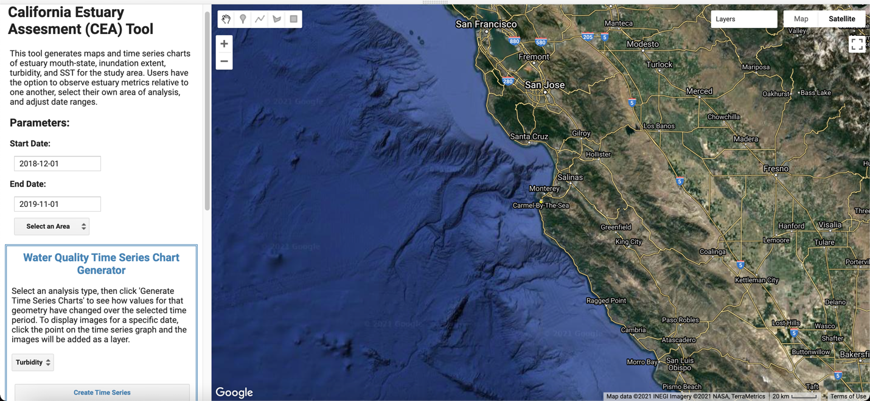

*Figure B1*. The layout of the graphical user interface that was created this term. Users had the ability to adjust the date range, select a study area, and select which metric they would like to investigate.