Patuxent Water Resources

Assessing Land Cover and Land Use Change to Inform Watershed Resource Management

 **Technical Report**

Final Draft – April 4th, 2019

Stephanie Rockwood (Project Lead)

Shaifali Prajapati

Connor Holzmann

Kyung “Robin” Kim

Dr. Kenton Ross, NASA Langley Research Center (Science Advisor)

# 1. Abstract

The Patuxent Reservoirs Watershed, in Howard, Montgomery, and Prince George’s Counties in Maryland, is a significant source of water supply for the greater Washington, D.C., metropolitan area. The Patuxent Reservoirs Watershed Protection Group Technical Advisory Committee (PRWPG TAC) monitors water quality and releases annual reports in order to provide management recommendations to policymakers for reducing pollutant loads. However, more comprehensive data is needed to understand the relationship between water quality and land use change, as inconsistent data availability across the municipal boundaries of the watershed inhibits a holistic land use and land cover (LULC) assessment. To address this concern, the team created synthesized LULC raster datasets by aggregating data from the United States Geologic Survey (USGS) National Land Cover Database (NLCD), the National Oceanic and Atmospheric Administration (NOAA) Coastal Change Analysis Program (C-CAP), the United States Department of Agriculture (USDA) Cropland Data Layer (CDL), and NASA Earth observations. The team calculated annual LULC classification trends from 2008 to 2018 and mapped LULC change on five-year intervals from 1996 to 2016 to analyze overall spatiotemporal trends for the watershed. Team members also compared the synthetic LULC dataset to independently generated LULC maps provided by the PRWPG TAC for 2002 and 2010. The new synthetic raster provides greater specificity in terms of agricultural, wetland, and urban land cover classes. The maps allow the PRWPG TAC to assess the relationship between LULC changes and water quality. In addition, this method of map synthesis gives an easy and economical method for creating LULC datasets in the future.

**Keywords**

water quality, watershed, land cover change, land use change, change analysis, agricultural runoff

# 2. Introduction

* 1. ***Background Information***

The Patuxent River Watershed is about 1,400 square miles and is one of the six major river basins that drain into the Chesapeake Bay. The ecological degradation in the Piedmont and Coastal Plains regions is historically well documented; despite moderate progress since the passage of the Patuxent River Watershed Act in 1980, significant challenges remain unresolved. For example, further work needs to be done in order to meet the Total Maximum Daily Load (TMDL) goals set in 2008 by the Environmental Protection Agency (Dauer, Ranasinghe, & Weisberg, 2000; Jordan, Weller, & Pelc, 2018; Maryland Department of State Planning [MDSP], 1984; United States Environmental Protection Agency [US EPA], 2010). Phosphorus and sediment runoff are especially a concern in the upper portion of the watershed, where the Triadelphia and Rocky Gorge Reservoirs supply drinking water to about 650,000 residents in the greater Washington, D.C., area (Patuxent Reservoirs Watershed Protection Group [PRWPG], 2017). The Washington Suburban Sanitary Commission (WSSC) has been monitoring reservoir water quality for 27 years in order to provide data to support the protection of the reservoirs and drinking water supply. Elevated nutrient inputs to the river induce eutrophication, which in turn depletes dissolved oxygen levels and reduces overall water quality (Dauer et al., 2000). In recent decades, non-point source discharges of such runoff have been identified as the primary contributors to poor water quality (Jordan, Weller, & Correll, 2003; Weller, Jordan, Correll, & Liu, 2003). Because trends in urban and agricultural land use may be used to predict nitrogen, phosphorus, and sediment inputs to a watershed, accurate land use and land cover (LULC) data may help local governments implement wiser management practices (Jordan et al., 2003; Smith & Wilcock 2015; Weller et al., 2003).

Among agricultural land uses, corn, wheat, and soybean fields are the most likely culprits of non-point source nutrient discharge in the Chesapeake Bay region (Staver & Brinsfield, 2001). Corn is particularly notorious for consuming the most phosphorus of any crop, and also receives the highest rate of phosphorus input per unit area, followed by cotton, soybeans, and wheat (National Research Council [NRC], 1993). Furthermore, previous research has determined that phosphorus concentrations in the Patuxent Watershed are highly dependent on temporal factors, implying the significance of planting and harvesting periods (Weller et al., 2003).

The 132 square mile study area lies within the Upper Patuxent Watershed, which contains both reservoirs and is bound by three Maryland counties: Montgomery, Howard, and Prince George’s (*Figure 1*). A detailed, unified LULC map and database are absent for the Upper Patuxent Watershed for years outside of 1973, 2002, and 2010 (Maryland Department of Planning [MDP], 2010). While each county has its own set of vector data, derived from high-resolution aerial photographs from the National Agriculture Imagery Program (NAIP) and commissioned by the MDP, future analyses that require LULC data are limited to those three years (MDP, 2010). Thus, remotely sensed data derived from NASA Earth observations (EO) could offer a more efficient method of supplementing the LULC data already available for the Upper Patuxent River Watershed. The Cropland Data Layer (CDL) from the US Department of Agriculture (USDA), the Coastal Change Analysis Program (C-CAP) from the National Oceanic and Atmospheric Administration (NOAA), and the National Land Cover Database (NLCD) from the US Geological Survey (USGS) all incorporate observations using Landsat imagery between 1992 and 2018. The CDL and C-CAP data sets are especially well-calibrated for agricultural and wetland LULC classification, respectively, due to the available ground truth data to which each agency has access (Boryan, Yang, Mueller, & Craig, 2011; Dobson et. al, 1995; USDA, 2019; Yang et al., 2018).

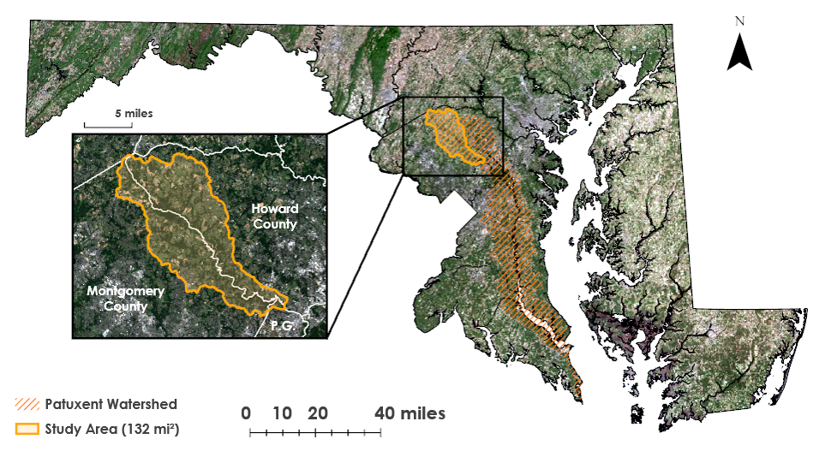

*Figure 1.* Maryland iMAP (2018) land use land cover boundaries on ArcGIS Pro World Imagery basemap, with Upper Patuxent Watershed study area highlighted. An additional inset using Landsat 8 imagery shows Maryland county boundaries. The county boundaries are delineated in white on the inset image.

* 1. ***Project Partners & Objectives***

The Patuxent Water Resources team worked in close cooperation with the PRWPG Technical Advisory Committee (PRWPG TAC), a multi-jurisdictional body including representatives from Prince George’s County, Howard County, Montgomery County, and the Washington Suburban Sanitary Commission. The PRWPG TAC releases annual reports on the state of the watershed and recommends high priority objectives needed to safeguard drinking water in the area. The current focus of the committee lies in the reduction of pollutant loads entering the reservoirs. Additional issues include the preservation of open spaces, the effects of road salts, sustaining biological integrity, invasive plant removal, public outreach, and best management practices as they relate to agriculture (PRWPG, 2017).

This project sought to produce a comprehensive series of LULC maps that draw on the strengths of multiple public datasets and incorporate them into the partner’s established mapping procedures. The provision of a more holistic analysis will better equip the PRWPG TAC to preserve the Upper Patuxent Watershed and prepare for future improvements to the watershed. Detailed analysis of LULC and change detection will enable the TAC to determine which areas of the watershed are at the greatest risk of contamination so the organization can work to maintain safe drinking water in at-risk areas. In addition, the reproducible nature of the project will facilitate further in-house research conducted by participating members of the PRWPG TAC for the future.

# 3. Methodology

***3.1 Data Acquisition***

The team acquired ancillary land use datasets and NASA EO data, as detailed in Table 1. The primary NASA EO used was Landsat 5 Thematic Mapper (TM). The CDL, C-CAP, and NLCD datasets were all created by their respective organizations using Landsat imagery, supplemented with other medium resolution satellite imagery and *in situ* data. The team also acquired a vector-based land use database, which had been created in collaboration between the PRWPG TAC and a private consultant.

The CDL dataset for the study area has been released for 2002, and annually from 2008 to 2018 (Dahal, Wylie, & Howard, 2018). The CDL provides a detailed classification of crops, therefore useful for mapping high input areas based on crop type for the counties inside the Upper Patuxent Watershed (Leslie, Serbina, & Miller, 2017). The C-CAP has been released on an approximate 5-year cycle, available as early as 1992. The wetlands layer for C-CAP was used due to the dataset having the highest accuracy and detail for any water body. Wetlands in the study area have been generally consistent over the project study period (Tiner & Burke, 1995), so, unlike the CDL, continuous annual change was not a factor. The NLCD dataset was incorporated to capture the forested and urban land use areas in fine detail.

Table 1

*Ancillary datasets and NASA EO acquired by the Patuxent Water Resources team.*

|  |  |  |  |
| --- | --- | --- | --- |
| **Ancillary Dataset** | **Description** | **Years Acquired** | **Source** |
| CDL | Crop-specific land cover data layer | 2008-2018 | USDA |
| C-CAP | Coastal area coverage, with high detail for all wetland-related data | 1996, 2001, 2006, 2010, 2016* | NOAA |
| NLCD | Comprehensive, national land cover data product.  Classifies in most detail the forested and urban land use areas | 2001, 2006, 2011, 2016* | USGS |
| Patuxent Reservoirs Database | Created by external environmental consultant. Contained *in situ* water quality measurements, disparate fine resolution commercial remote sensing data, and vector-based LULC maps | 2002, 2010 | PRWPG TAC |
| **NASA EO Data** | **Description** | **Years Acquired** | **Source** |
| Landsat 5 TM | 50 percent Cloud Cover limit; path 15, row 33  Utilized for crop-level classification | 1996, 2001 | USGS EarthExplorer |

*\*The 2016 C-CAP and 2016 NLCD were not available during the project term, and are scheduled to be released early 2019.*

***3.2 Data Processing***

The team used Esri ArcGIS 10.6.1 to compile and process all datasets. The data were reprojected to World Geodetic System 1984 and clipped to the Upper Patuxent Watershed boundary using the 8-digit Hydrologic Unit Code for the Rocky Gorge Dam and Brighton Dam (Triadelphia Reservoir) sub-basins. The State of Maryland most commonly uses the 8-digit scale for watershed management and development of TMDLs (Maryland Department of the Environment, n.d.).

*3.2.1 Supervised Classifications of Land Use*

The 1996 and 2001 Landsat 5 TM scenes were composited into multi-spectral images for each image date available with cloud cover of 50 percent or less. This prepared Landsat imagery for a supervised classification of land uses, which focused on specific crops such as corn, soy, and winter wheat, but also included forest, water, developed areas, and hay and grass areas such as pasture. All spectral bands were available for the classification but narrower, three-band combinations were utilized to visually distinguish crops and to allow for better crop distinction. A false-color combination of short-wave infrared (SWIR), near-infrared (NIR), and visible red generally gave a distinction across different band combinations and provided recognizable color groups (USGS, 2018). The majority of the growing seasons were captured in two Landsat scenes by using a mid-spring image and a late summer image. C-CAP from the respective years, more current releases of the CDL, and crop planting calendars (USDA NASS, 2010) were used as references in the pursuit to capture seasonal change based on crop type.

The team created at least 50 training samples for each of the cover classes, repeated for each season in each year for a total of four separate classified images. April and July were the best available scenes for 1996, and March and August were the best available for 2001. Training samples used for water, forest, developed areas, and non-agriculture fields were shared between growing seasons, but not between years. The April 1996 and March 2001 scenes were used to train samples for winter cropping, which mainly targeted winter wheat. The July 1996 and August 2001 images were used to create samples for corn and soybean fields. While corn and soybeans are both summer crops, they have different planting and harvesting dates (USDA NASS, 2010), and were therefore distinguishable in the same Landsat scene. After evaluating the training samples and making any necessary edits for accuracy, the team split the samples for each Landsat scene, with two-thirds of each land cover class used to classify the image and the other third reserved to use as ground truth. The team then applied classification to all four scenes using the Train Random Trees Classifier tool and classified each raster. A classification was also applied using the ground truth data to create a dataset used in accuracy assessments.

Since classifications were assigned to more than one season in a given year, the two seasons were combined to create single datasets for both 1996 and 2001. The team first extracted crop cover classes, and then used the Raster Calculator tool to add values where there were any overlapping pixel values. The locations where “winter crop” and “soybeans” overlapped, the pixel values were reclassified to be “double crop”, and all other overlapped pixels remained their original value from the classified summer image. The team made this decision due to the greatest likelihood of double cropping being a combination of winter wheat and soybeans, based on better aligned growing seasons. The new crop classes were mosaicked to the originally classified summer image. This whole process prepared a substitute cropland data layer used to create a synthetic raster LULC dataset for 1996 and 2001.

*3.2.2 Creating a Synthetic Raster Dataset*

The next step in processing focused on aggregating the key components of each of the datasets in order to build a series of detailed synthetic LULC maps (Table 2). The time frame ranged from 1996 to 2016, with five-year intervals at 1996, 2001, 2006, 2011, and 2016. Datasets were layered and mosaicked based on the importance of particular attributes, which was decided in order of pixels to be classified in the final synthetic product. The urban layer, which encapsulated all developed areas based on intensity level, was set as the first in importance. Since its coverage often coincided with other layers, features such as roads would often be cut out, which required the layer to be set on top. The urban layer was provided by the NLCD for all map years except 1996 due to its unavailability before 2001, subsequently replacing urban areas from C-CAP for that year. The wetlands layer was derived from C-CAP for all years represented, applied second in order of importance. While most of its coverage does not overlap with the urban layer, some of the water bodies do cover certain roads vital to mapping developed areas. The detailed wetlands layer may allow more insight into the influence of different land cover types on water quality. The agricultural layer derived was applied third in importance. Specific crop varieties and pastoral lands from 2008 onwards were derived from the CDL dataset, however, lack of sufficient agricultural data for 1996 and 2001 required the team to perform supervised land use classifications in order to fill data gaps. Any areas classified as forest, barren land, or other non-urban land cover type were set as the base layer to fill in the empty areas not covered by pixels in the top three layers. The base layers were supplied by the NLCD, with the exception of 1996 where C-CAP functioned as the base layer as well as the urban and wetlands layers.

Table 2

*Dataset combinations used to create synthetic raster LULC datasets.*

| **Map Year** | **Dataset** | **Land Cover Classes** |
| --- | --- | --- |
| 1996 | 1996 C-CAP | Wetlands/Water  Forest/Other  Developed/ Urban Land Use |
| 1996 Team Classified Landsat 5 | Agriculture |
| 2001 | 2001 C-CAP | Wetlands/Water |
| 2001 NLCD | Forest/Other  Developed/ Urban Land Use |
| 2001 Team Classified Landsat 5 | Agriculture |
| 2006 | 2006 C-CAP | Wetlands/Water |
| 2006 NLCD | Forest/Other  Developed/ Urban Land Use |
| 2008 CDL | Agriculture |
| 2011 | 2010 C-CAP | Wetlands/Water |
| 2011 NLCD | Forest/Other  Developed/ Urban Land Use |
| 2010 CDL | Agriculture |
| 2016 | 2010 C-CAP | Wetlands/Water |
| 2011 NLCD | Forest/Other  Developed/ Urban Land Use |
| 2016 CDL | Agriculture |

*3.2.3 Processing Patuxent Reservoirs Database*

The PRWPG TAC provided a Microsoft Access Database containing water quality data, information on sediment loads, and LULC shapefiles for 2002 and 2010. These vector-based shapefiles were imported into ArcMap and converted to raster for ease of comparison. The team then compared this LULC information to the synthetic raster products. The 2001 and 2011 maps were chosen for their proximity in time. In order to keep the comparison as uniform as possible, land cover types were matched to the six broadest possible categories: forest, agriculture, urban, water, wetlands, and barren land.

***3.3 Data Analysis***

*3.3.1 Accuracy Assessment for Supervised Classifications*

The team used ArcGIS accuracy assessment tools to validate the supervised classification products for 1996 and 2001, using the images created prior to crop reclassification. Accuracy assessment points were created using the images classified with two-thirds of the training samples. The points were then updated using the ground truth data. Lastly, the Compute Confusion Matrix tool was utilized to calculate the accuracy of the classifications, with a goal of an 80 percent estimated accuracy.

*3.3.2 Assessing Change in Synthetic Raster LULC Maps*

The land cover classification trends were assessed in tabular and geospatial formats for every five years from 1996 to 2016 to provide overall temporal trends for the watershed. Since there were twenty to over forty classes depending on the year for each dataset, the color map was set to simplify land cover types to nine classes. While each of the attributes within the dataset still kept their unique values, the classes were simplified for analysis in both the tables and maps. Changes from 1996 to 2016 were compared through pixel count to calculate the total acreage of each land cover type. Overlapping areas between datasets within a given year were also calculated using the Tabulate Area tool.

*3.3.3 Comparing to Patuxent Reservoirs Database*

The synthetic LULC dataset was compared to the Patuxent Reservoirs Database through a simple raster calculation. By subtracting the newly rasterized TAC data from the most closely dated synthetic map, change maps were generated. These maps showed the nature of change between classes and were used to calculate the percentage of pixels that were defined as having no change between the two different data sources.

# 

# 4. Results & Discussion

***4.1 Analysis of Results***

*4.1.1 Supervised Classifications*

Crop-specific supervised classifications were difficult, especially with the need to capture multiple growing seasons. However, the team was successful in attaining their overall land classification accuracy goal (Tables A1-A6), even with the lack of *in situ* data. There were variations in accuracy among individual crop classes, with winter crops the most challenging to capture accurately due to varying phenologies observed in the spring season Landsat scenes. Therefore, the team was not as confident as hoped for their 1996 and 2001 winter wheat and double crop classifications. Nevertheless, according to available statistical data provided by the USDA-NASS Maryland Field Office (USDA NASS, 2017; Figure A7), the team’s supervised classification methods confirmed the decreasing trend across cultivated crops in the Patuxent Watershed region.

*4.1.2 Synthetic Raster LULC Maps*

The synthetic maps exhibited distinct LULC change through time. Agricultural land use, primarily composed of corn, soybeans, and wheat, decreased the most in acreage, while urban and forest land covers increased the most over the 20-year study period (*Figure 2*; Figure B4). There was a minor gain in the acreage of wetlands as well. These results imply that water quality, with respect to nutrient load, has likely improved over the years with the simultaneous decrease in cultivated crops and an increase in forest cover. Additionally, the rise in wetlands cover near the mouth of the Triadelphia Reservoir also suggests that sedimentation has been a persistent concern in the watershed, confirming the TAC’s need for monitoring sediment load (*Figure 3A*; *Figure 3B*).

A change matrix between the 1996 and 2016 results depicts which “from-to” transitions occurred across the broader nine classifications. It confirms the significant transfer in agricultural land, whether it is corn, soybean, or winter wheat, to either urban or forest cover and vice versa (Table B3).

*Figure 2.* 20-year LULC change based on acres calculated from the synthetic maps. The most visible net change occurred between agriculture, urban, and forest covers.

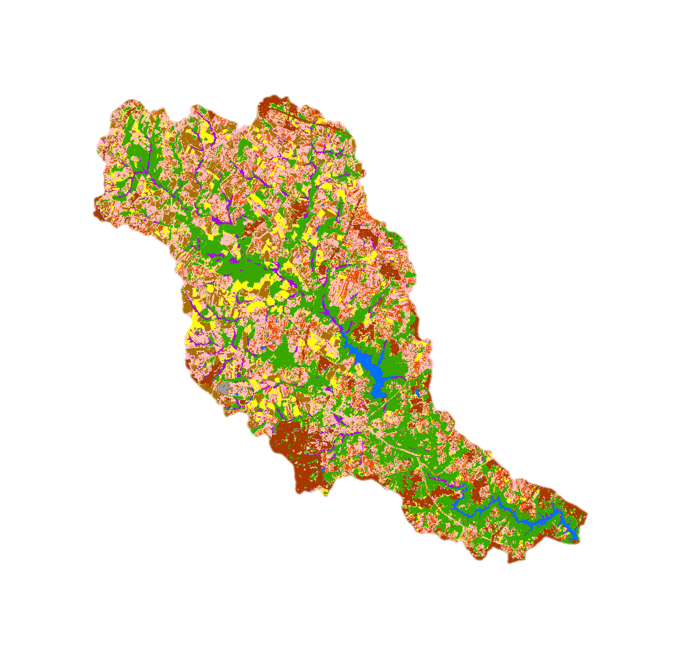

Corn

Soybeans

Winter Wheat

Other Agriculture

Forest

Urban

Wetlands

Barren

Water

*Figure 3A.* 1996 Synthetic Raster Dataset with nine reclassified land cover types, covering the Upper Patuxent Watershed.

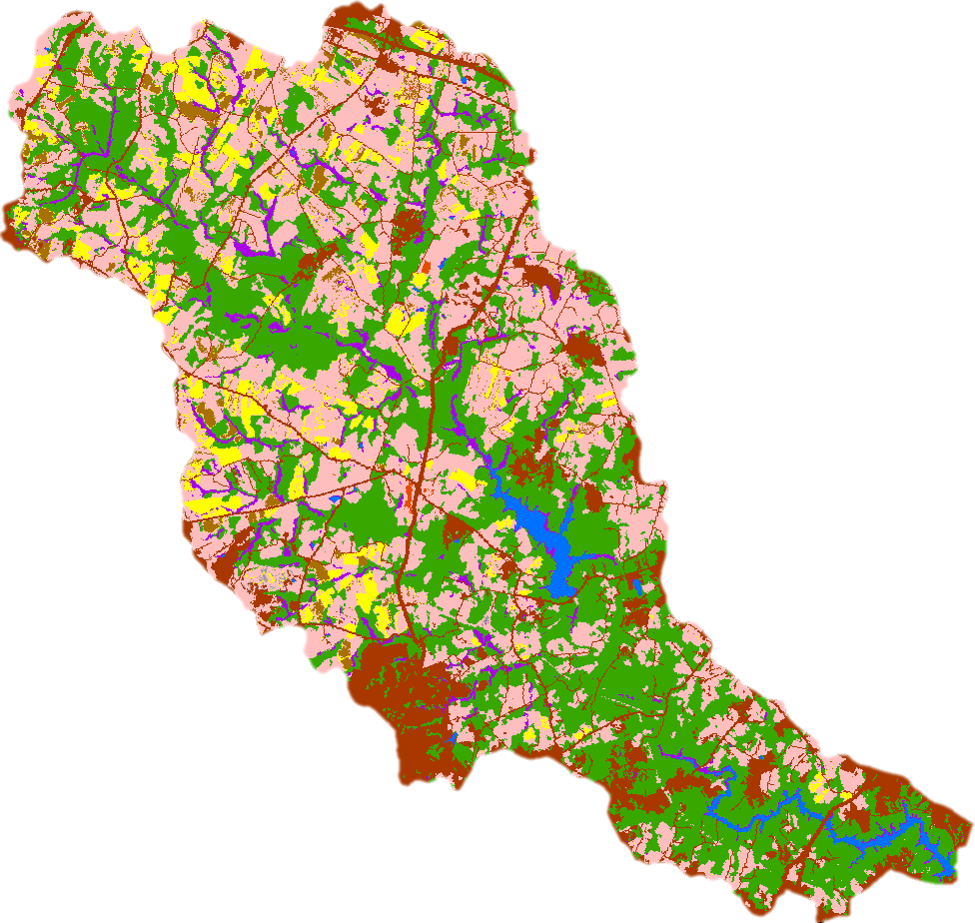

Soybeans

Winter Wheat

Other Agriculture

Forest

Urban

Wetlands

Barren

Water

Corn

*Figure 3B.* 2016 Synthetic Raster Dataset with nine reclassified land cover types, covering the Upper Patuxent Watershed.

*4.1.3 Comparing to Patuxent Reservoirs Database*

The 2002 and 2010 vector LULC maps used by the TAC matched at a rate of about 67 percent with the team’s closest synthetic LULC maps (*Figure 4*). Most discrepancies occurred amongst and between the three most prolific classes: agriculture, urban, and forest. The team’s synthetic maps provided significantly more wetland information based on the incorporation of NOAA data, while the urban classes differed entirely in their original makeup. Urban cover types from the synthetic maps were defined through development intensity (low, medium, and high), whereas the TAC database defined them on specific land use (commercial, institutional, industrial, etc.) These factors helped to explain the margin of error between the two maps.

While not as precise, the team’s methods of incorporating data based on 30 m resolution Landsat imagery appear to classify the Upper Patuxent Watershed region as well as the methods implemented by the analysts responsible for creating the TAC’s vector-based maps. In the future, the TAC may be able to obtain time-relevant data more efficiently using the team’s data synthesizing methodology.

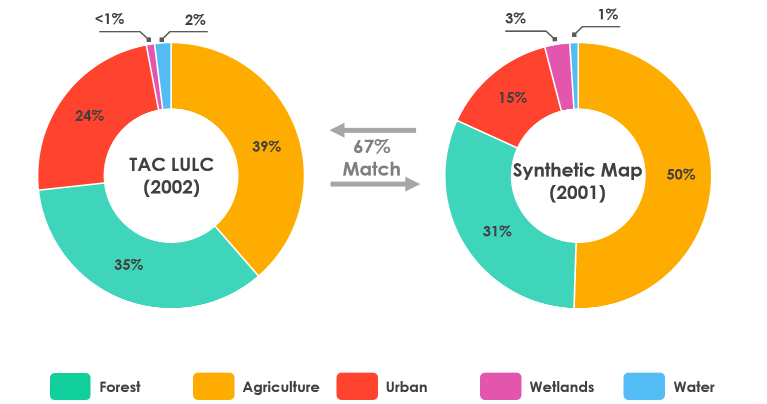

*Figure 4.* Comparison between 2001 team-produced synthetic land use land cover map and 2002 map provided by the PRWPG TAC.

***4.2 Future Work***

Future work could expand the study area to include other points of interest within the greater Patuxent Watershed. The importance of watershed protection increases as urban and suburban areas grow in size. This would require partnerships with other watershed-focused protection groups in addition to the PRWPG. To do this, a team would need to acquire real ground truth data and higher resolution imagery from the region, and then create additional training samples for more precise supervised classifications and potentially improve the accuracy of the product.

Furthermore, with a comprehensive set of LULC maps now available for the Upper Patuxent Watershed, options for hydrological modeling are viable. Using the various water quality measurements obtained from the WSSC, ArcGIS-based programs such as ArcHydro and SWAT may help relate the LULC changes of the region and assist the TAC in managing its ecosystems and reservoirs.

# 5. Conclusions

This project resulted in several important conclusions. The production of synthetic maps could be an efficient alternative for the TAC as they continue to monitor land use change in their area. The team’s historical crop classifications also provide a more comprehensive understanding of how the watershed’s LULC has changed over time, allowing for smarter management practices. Overall, shifts from agricultural land use to forested and urban land cover suggest a decline in nutrient runoff to the watershed. This is believed to lead to an increase in water quality within the watershed if the trends continue.

# 

# 6. Acknowledgments

The Patuxent Water Resources Team would like to extend much gratitude to our project science advisor, Dr. Kenton Ross, and our Center Lead at LaRC, Patrick Frier, for their guidance throughout the development of this project. We also extend thanks to our Patuxent Reservoirs Watershed Protection Group partners on this project: Susan Overstreet from Howard County, Maryland; Jean Kapusnick from Montgomery County, Maryland; and Steven Nelson from the Washington Suburban Sanitary Commission.

Any opinions, findings, and conclusions or recommendations expressed in this material are those of the author(s) and do not necessarily reflect the views of the National Aeronautics and Space Administration.

This material is based upon work supported by NASA through contract NNL16AA05C.

# 

# 7. Glossary

**C-CAP –** Coastal Change Analysis Program, a nationally standardized land cover and land change data product for the coastal regions of the US, developed and maintained by NOAA

**CDL –** Cropland Data Layer, hosted on USDA-NASS CropScape; provides a raster, geo-referenced, crop-specific land cover map for the contiguous US

**EO** **–** Earth observations; Satellites and sensors that collect information about the Earth’s physical, chemical, and biological systems over space and time

**EPA –** Environmental Protection Agency, a US government agency

**Landsat (5 and 8)** **–** Satellites from NASA EOs, equipped with 7 and 11 bands respectively whose various combinations provide information on land cover types beyond the visible spectrum.

**LULC –** Land use/land cover, data files that describe vegetation, water, natural surface, and cultural features on the land surface

**MAST –** Maryland Assessment and Scenario Tool, a web-based watershed modeling tool that allows users to develop a plan for meeting a nitrogen, phosphorus, or sediment load allocation using the most cost-effective strategy

**NAIP –** National Agriculture Imagery Program, a program to acquire peak growing season imagery and deliver this imagery to USDA County Service Centers, in order to maintain the common land unit (CLU) boundaries and assist with farm programs

**NASA –** National Aeronautics and Space Administration, a US government agency

**NLCD –** National Land Cover Database, a comprehensive land cover product based on decadal Landsat imagery and other supplementary datasets, available from the Multi-Resolution Land Cover Characteristics (MRLC) Consortium

**NOAA –** National Oceanic and Atmospheric Administration, a US government agency

**OLI –** Operational Land Imager, a multispectral sensor aboard the Landsat 8 satellite

**TM –** Thematic Mapper, a multispectral sensor aboard the Landsat 5 satellite

**USDA-NASS** –United States Department of Agriculture National Agricultural Statistics Service, a branch of a US government agency

**USGS –** United States Geological Survey, a US government agency

**WSSC** **–** Washington Suburban Sanitary Commission, a large water and wastewater utility company serving Prince George’s and Montgomery Counties, Maryland.

# 8. References

Boryan, C., Yang, Z., Mueller, R., & Craig, M. (2011). Monitoring US agriculture: the US Department of Agriculture, National Agricultural Statistics Service, Cropland Data Layer Program. *Geocarto International, 26*(5), 341-358. https://doi.org/10.1080/10106049.2011.562309

Dahal, D., Wylie, B., & Howard, D. (2018). Rapid crop cover mapping for the conterminous United States. *Scientific Reports, 8*, 1-12. <https://doi.org/10.1038/s41598-018-26284-w>

Dauer, D. M., Ranasinghe, J. A., & Weisberg, S. B. (2000). Relationships between benthic community condition, water quality, sediment quality, nutrient loads, and land use patterns in Chesapeake Bay. *Estuaries, 23*(1), 80-96. https://doi.org/10.2307/1353227

Dobson, J. E., Bright, E. A., Ferguson, R. L., Field, D. W., Wood, L. L., Haddad, K. D., …& Thomas, J. P. (1995). *NOAA Coastal Change Analysis Program (C-CAP): guidance for regional implementation* (NOAA Technical Report NMFS 123 Department of Commerce). Retrieved February 5, 2019, from https://coast.noaa.gov/data/digitalcoast/pdf/ccap-regional-guidance.pdf

Jordan, T. E., Weller, D. E., & Correll, D. L. (2003). Sources of nutrient inputs to the Patuxent River Estuary. *Estuaries, 26*(2), 226-243. https://doi.org/10.1007/BF02695964

Jordan, T. E., Weller, D. E., & Pelc, C. E. (2018). Effects of local watershed land use on water quality in

Mid-Atlantic coastal bays and subestuaries of the Chesapeake Bay. *Estuaries and Coasts, 41*(Suppl 1),

38-53. https://doi.org/10.1007/s12237-017-0303-5

Leslie, C.R., Serbina, L.O., & Miller, H.M. (2017). *Landsat and agriculture—Case studies on the uses and*

*benefits of Landsat imagery in agricultural monitoring and production* (U.S. Geological Survey

Open-File Report 2017–1034). Reston, VA. https://doi.org/10.3133/ofr20171034

Maryland Department of the Environment. (n.d.). [Maryland watershed interactive mapper]. *Map of Maryland’s 8-digit watersheds.* Retrieved February 5, 2019, from https://mde.state.md.us/programs/Water/TMDL/DataCenter/Pages/8DigitWatershed.aspx

Maryland Department of Planning. (2010). 2010 Land Use/Land Cover Update. Retrieved February 20, 2019, from https://planning.maryland.gov/Documents/OurProducts/landuse/Methodology_MappingProcess.pdf

Maryland Department of State Planning. (1984). Patuxent River policy plan: A land management strategy (Department of State Planning Publication No. 83-21). Retrieved February 20, 2019, from https://planning.maryland.gov/Documents/OurWork/PRC/OriginalPolicyPlan.pdf

Multi-Resolution Land Characteristics Consortium. (2011). [Land cover interactive mapper] *National land cover dataset (NLCD).* Retrieved February 6, 2019, from https://www.mrlc.gov/viewer/

National Oceanic and Atmospheric Administration, Office for Coastal Management. (1996-2010). Coastal Change Analysis Program Regional Land Cover. [Data set]. Retrieved February 6, 2019, from https://www.coast.noaa.gov/ccapatlas/#

National Research Council. (1993). 7 Phosphorus in the Soil-Crop System. *Soil and Water Quality: An Agenda for Agriculture*. Washington, D.C. The National Academies Press. doi: 10.17226/2132.

Patuxent Reservoirs Watershed Protection Group. (2017). Annual Report of the Technical Advisory Committee. Retrieved February 6, 2019 from https://www.howardcountymd.gov/LinkClick.aspx?fileticket=pbdIZMKErP0%3d

Patuxent Reservoirs Watershed Protection Group. (2019). Patuxent Reservoirs Database. [Data Set]. Washington Suburban Sanitary Commission.

Smith, S. M. C., & Wilcock, P. R. (2015). Upland sediment supply and its relation to watershed sediment delivery in the contemporary mid-Atlantic Piedmont (U.S.A.), *Geomorphology, 232*, 33-46. http://dx.doi.org/10.1016/j.geomorph.2014.12.036

Staver, K. W., & Brinsfield R. B. (2001). Agriculture and water quality on the Maryland Eastern Shore: where do we go from here?: Long-term solutions to accelerated eutrophication must provide mechanisms for redistributing nutrients flowing into concentrated animal-producing regions. *BioScience*, *51*(10), 859–868.

Retrieved April 2,2019, from https://academic.oup.com/bioscience/article/51/10/859/245249

Tiner, R. W., & D.G. Burke. (1995). *Wetlands of Maryland*. (United States Fish and Wildlife Service, Ecological Services, Region 5, Hadley, MA, and Maryland Department of Natural Resources Annapolis, MD.

Cooperative publication).

United States Department of Agriculture, National Agricultural Statistics Service. (2010). Field Crops - Usual planting dates and harvesting dates. Available from https://usda.library.cornell.edu/concern/publications/vm40xr56k

United States Department of Agriculture, National Agricultural Statistics Service, Maryland Field Office. (1990-2017). *Quick Stats – Acres Planted for Montgomery, Howard, and Prince George’s Counties*. [Data Set]. Retrieved February 28, 2019 from https://quickstats.nass.usda.gov/.

United States Department of Agriculture, National Agricultural Statistics Service Cropland Data Layer. (2008-2018). *Published crop-specific data layer*. [Data Set]. Retrieved on February 6, 2019, from https://nassgeodata.gmu.edu/CropScape/

United States Department of Agriculture. (2019). CropScape and Cropland Data Layers - FAQs. Retrieved February 20, 2019 from https://www.nass.usda.gov/Research_and_Science/Cropland/sarsfaqs2.php

United States Environmental Protection Agency. (2010). Chesapeake Bay total maximum daily load for nitrogen, phosphorus, and sediment. Retrieved February 20, 2019 from https://www.epa.gov/sites/production/files/2014-12/documents/cbay_final_tmdl_exec_sum_section_1_through_3_final_0.pdf

United States Geological Survey Earth Resources Observation and Science Center. (2012). *Provisional Landsat TM Surface Reflectance* [Data set]. https://doi.org/10.5066/f7kd1vz9

United States Geological Survey Earth Resources Observation and Science Center. (2014). *Provisional Landsat OLI Surface Reflectance* [Data set]. https://doi.org/10.5066/f78s4mzj

United States Geological Survey. (2018). What are the best Landsat spectral bands to use for my

study? Retrieved from <https://www.usgs.gov/faqs/what-are-best-landsat-spectral-bands-use-my-study?qt-news_science_products=7#qt-news_science_products>

Weller, D. E., Jordan, T. E., Correll, D. I., & Liu, Z. (2003). Effects of land-use change on nutrient discharges from the Patuxent River watershed. *Estuaries, 26*(2), 244-266. https://doi.org/10.1007/BF02695965

Yang, L., Jin, S., Danielson, P., Homer, C., Gass, L., Bender, S. M.,… & Xian, G. (2018). A new generation of the United States National Land Cover Database: Requirements research priorities, design, and implementation strategies. *ISRPS Journal of Photogrammetry and Remote Sensing, 146*, 108-123. https://doi.org/10.1016/j.isprsjprs.2018.09.006

**Appendix A**

Table A1

*Confusion matrix for accuracy assessment of classified April 1996 Landsat image.*

|  |  |  |  |  |  |  |  |  |
| --- | --- | --- | --- | --- | --- | --- | --- | --- |
|  | Urban | Water | Forest | Hay/ Grass | Winter Crop | Total | User Accuracy | Kappa |
| Urban | 89 | 0 | 5 | 9 | 1 | 104 | **0.86** |  |
| Water | 1 | 9 | 0 | 0 | 0 | 10 | **0.90** |  |
| Forest | 0 | 3 | 125 | 11 | 3 | 142 | **0.88** |  |
| Hay/Grass | 23 | 0 | 17 | 117 | 31 | 188 | **0.62** |  |
| Winter Crop | 4 | 0 | 0 | 9 | 46 | 59 | **0.78** |  |
| Total | 117 | 12 | 147 | 146 | 81 | 503 |  |  |
| Producer Accuracy | **0.76** | **0.75** | **0.85** | **0.80** | **0.57** |  | **0.77** |  |
| Kappa |  |  |  |  |  |  |  | ***0.69*** |

|  |  |  |  |  |  |  |  |  |  |
| --- | --- | --- | --- | --- | --- | --- | --- | --- | --- |
|  | Urban | Water | Forest | Soybean | Corn | Hay/ Grass | Total | User Accuracy | Kappa |
| Urban | 101 | 4 | 1 | 3 | 0 | 5 | 114 | **0.89** |  |
| Water | 0 | 10 | 0 | 0 | 0 | 2 | 12 | **0.83** |  |
| Forest | 0 | 0 | 110 | 0 | 3 | 5 | 118 | **0.93** |  |
| Soybean | 3 | 0 | 0 | 56 | 0 | 8 | 67 | **0.84** |  |
| Corn | 0 | 0 | 3 | 0 | 29 | 5 | 37 | **0.78** |  |
| Hay/Grass | 18 | 3 | 10 | 14 | 6 | 101 | 152 | **0.66** |  |
| Total | 122 | 17 | 124 | 73 | 38 | 126 | 500 |  |  |
| Producer Accuracy | **0.83** | **0.59** | **0.89** | **0.77** | **0.76** | **0.80** |  | **0.81** |  |
| Kappa |  |  |  |  |  |  |  |  | ***0.76*** |

Table A2

*Confusion matrix for accuracy assessment of classified July 1996 Landsat image.*

Table A3

*Confusion matrix for accuracy assessment of classified March 2001 Landsat image.*

|  |  |  |  |  |  |  |  |  |  |  |
| --- | --- | --- | --- | --- | --- | --- | --- | --- | --- | --- |
|  | Urban | | Water | | Forest | Hay/Grass | Winter Crop | Total | User Accuracy | Kappa |
| Urban | 101 | 0 | | 4 | | 7 | 5 | 117 | **0.86** |  |
| Water | 3 | 5 | | 3 | | 0 | 0 | 11 | **0.45** |  |
| Forest | 5 | 0 | | 180 | | 8 | 6 | 199 | **0.90** |  |
| Hay/Grass | 5 | 0 | | 8 | | 134 | 4 | 151 | **0.89** |  |
| Winter Crop | 3 | 0 | | 0 | | 5 | 14 | 22 | **0.64** |  |
| Total | 117 | 5 | | 195 | | 154 | 29 | 500 |  |  |
| Producer Accuracy | **0.86** | **1.00** | | **0.92** | | **0.87** | **0.48** |  | **0.87** |  |
| Kappa |  |  | |  | |  |  |  |  | ***0.81*** |

Table A4

*Confusion matrix for accuracy assessment of classified August 2001 Landsat image.*

|  |  |  |  |  |  |  |  |  |  |
| --- | --- | --- | --- | --- | --- | --- | --- | --- | --- |
|  | Urban | Water | Forest | Soybean | Corn | Hay/ Grass | Total | User Accuracy | Kappa |
| Urban | 116 | 0 | 0 | 1 | 0 | 4 | 121 | **0.96** |  |
| Water | 0 | 10 | 0 | 0 | 0 | 0 | 10 | **1.00** |  |
| Forest | 13 | 6 | 126 | 0 | 16 | 4 | 165 | **0.76** |  |
| Soybean | 5 | 0 | 0 | 16 | 0 | 1 | 22 | **0.73** |  |
| Corn | 1 | 0 | 1 | 1 | 46 | 9 | 58 | **0.79** |  |
| Hay/Grass | 7 | 0 | 0 | 5 | 6 | 108 | 126 | **0.86** |  |
| Total | 142 | 16 | 127 | 23 | 68 | 126 | 502 |  |  |
| Producer Accuracy | **0.82** | **0.63** | **0.99** | **0.70** | **0.68** | **0.86** |  | **0.84** |  |
| Kappa |  |  |  |  |  |  |  |  | ***0.79*** |

Table A5

*Confusion matrix for accuracy assessment of classified July 1996 Landsat image, showing all crops as one class.*

|  |  |  |  |  |  |  |  |  |
| --- | --- | --- | --- | --- | --- | --- | --- | --- |
|  | Urban | Water | Forest | Crops | Hay/ Grass | Total | User Accuracy | Kappa |
| Urban | 101 | 4 | 1 | 3 | 5 | 114 | **0.89** |  |
| Water | 0 | 10 | 0 | 0 | 2 | 12 | **0.83** |  |
| Forest | 0 | 0 | 110 | 3 | 5 | 118 | **0.93** |  |
| Crops | 3 | 0 | 3 | 85 | 13 | 104 | **0.82** |  |
| Hay/Grass | 18 | 3 | 10 | 20 | 101 | 152 | **0.66** |  |
| Total | 122 | 17 | 124 | 111 | 126 | 500 |  |  |
| Producer Accuracy | **0.83** | **0.59** | **0.89** | **0.77** | **0.80** |  | **0.81** |  |
| Kappa |  |  |  |  |  |  |  | ***0.76*** |

Table A6

*Confusion matrix for accuracy assessment of classified August 2001 Landsat image, showing all crops as one class.*

|  |  |  |  |  |  |  |  |  |  |
| --- | --- | --- | --- | --- | --- | --- | --- | --- | --- |
|  | Urban | Water | | Forest | Crops | Hay/ Grass | Total | User Accuracy | Kappa |
| Urban | 116 | 0 | 0 | | 1 | 4 | 121 | **0.96** |  |
| Water | 0 | 10 | 0 | | 0 | 0 | 10 | **1.00** |  |
| Forest | 13 | 6 | 126 | | 16 | 4 | 165 | **0.76** |  |
| Crops | 6 | 0 | 1 | | 63 | 10 | 80 | **0.79** |  |
| Hay/Grass | 7 | 0 | 0 | | 11 | 108 | 126 | **0.86** |  |
| Total | 142 | 16 | 127 | | 91 | 126 | 502 |  |  |
| Producer Accuracy | **0.82** | **0.63** | **0.99** | | **0.69** | **0.86** |  | **0.84** |  |
| Kappa |  |  |  | |  |  |  |  | ***0.79*** |

*Figure A1.*Plot of acres of corn, soybeans, and wheat planted in Howard, Montgomery, and Prince George’s Counties. Data obtained from https://quickstats.nass.usda.gov/.

**Appendix B**

Table B1

*Table of acres of each major LULC through the past two decades.*

|  |  |  |  |  |  |  |
| --- | --- | --- | --- | --- | --- | --- |
|  | Agriculture | Forest | Urban | Water | Wetland | Barren Land |
| 1996 | 43733 | 24355 | 7952 | 1229 | 2757 | 121 |
| 2001 | 42257 | 26225 | 12139 | 1215 | 2747 | 19 |
| 2006 | 37721 | 29194 | 12473 | 1300 | 3058 | 23 |
| 2011 | 44598 | 25737 | 12580 | 1248 | 2952 | 17 |
| 2016 | 34004 | 30793 | 12661 | 1241 | 2931 | 51 |
| Net Change | -9729 | 6438 | 4708 | 13 | 174 | -70 |

Table B2

*Table of acres of each major agricultural LULC through the past two decades.*

|  |  |  |  |  |
| --- | --- | --- | --- | --- |
|  | Corn | Soybeans | Winter Wheat | Other Agriculture |
| 1996 | 7576 | 10160 | 5318 | 20679 |
| 2001 | 10816 | 5213 | 2323 | 23905 |
| 2006 | 6762 | 981 | 4011 | 25966 |
| 2011 | 8219 | 482 | 3659 | 32238 |
| 2016 | 4760 | 100 | 1949 | 27195 |
| Net Change | -2816 | -10060 | -3370 | 6517 |

Table B3

*Change matrix “from 1996 to 2016” created using the Tabulate Area tool (in acres).*

|  |  |  |  |  |  |  |  |  |  |  |  |
| --- | --- | --- | --- | --- | --- | --- | --- | --- | --- | --- | --- |
| 1996 |  | 2016 | | | | | | | | | |
| **Agriculture** | **Barren Land** | **Forest** | **Urban** | **Water** | **Wetland** | **Corn** | **Soybean** | **Winter Wheat** | **Total** |
| **Agriculture** | **15575** | 15 | 4576 | 2511 | 21 | 187 | 1803 | 765 | 30 | 25483 |
| **Barren Land** | 65 | **39** | 0 | 9 | 0 | 0 | 12 | 0 | 0 | 125 |
| **Forest** | 473 | 0 | **22189** | 1211 | 71 | 318 | 45 | 24 | 0 | 24331 |
| **Urban** | 393 | 3 | 494 | **6995** | 6 | 15 | 21 | 12 | 0 | 7938 |
| **Water** | 15 | 0 | 54 | 21 | **1083** | 62 | 0 | 0 | 0 | 1235 |
| **Wetland** | 92 | 0 | 300 | 101 | 65 | **2202** | 6 | 9 | 0 | 2776 |
| **Corn** | 3329 | 3 | 2109 | 479 | 3 | 110 | **940** | 452 | 48 | 7474 |
| **Soybean** | 6795 | 6 | 533 | 628 | 0 | 36 | 1571 | **544** | 21 | 10134 |
| **Winter Wheat** | 3734 | 0 | 610 | 488 | 0 | 12 | 271 | 131 | **6** | 5251 |
| **Total** | 30472 | 65 | 30865 | 12442 | 1250 | 2942 | 4668 | 1937 | 104 | **84746** |

*Figure B1.* Land use and land cover change in the Patuxent Reservoirs Watershed from 1996 to 2016, analyzed in 5-year increments across nine broad land cover classes.