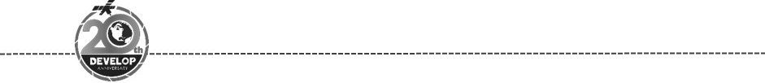**NASA DEVELOP National Program**

**Virginia – Wise**

*Summer 2018*

Louisiana Ecological Forecasting

Using Landsat to Monitor and Predict Roseau Cane Die-offs Caused by The Invasive Roseau Cane Scale & Other Contributing Factors in the Mississippi River Delta

 **Technical Report**

Final Draft – August 8th, 2018

Jen Schellman (Project Lead)

Michael Brooke

Beck Saults

Joseph Spruce, Science Systems & Applications, Inc.

Dr. L. DeWayne Cecil, NOAA National Center for Environmental Information, Global Science & Technology, Inc.

Dr. Marguerite Madden, The University of Georgia

Dr. Kenton Ross, NASA Langley Research Center

Bob VanGundy, The University of Virginia’s College at Wise

# 1. Abstract

The Roseau cane mealy bug (*Nipponaclerda biwakoensis*) is an invasive scale insect discovered in the United States during the 2016-2017 die-offs of Roseau cane (*Phragmites australis)* in the Mississippi River Delta, Plaquemines Parish, LA. Roseau cane stabilize sediment, protect against wave-action and storm surge, and provide critical habitat to wildlife. Roseau cane is the dominant vegetation type in the Mississippi River Delta and its loss will affect coastal marsh extent, shipping interests in the Mississippi River, and property owners along the lower Mississippi River Delta. The NASA DEVELOP Louisiana Ecological Forecasting team partnered with the National Wildlife Federation to use NASA Earth observations, Landsat 5 Thematic Mapper (TM) and Landsat 8 Operational Land Imager (OLI), to monitor and assess the history of Roseau cane die-offs. These data, along with *in situ* observations from the Coastwide Reference Monitoring System (CRMS) stations and the National Agricultural Imagery Program (NAIP) imagery, were input into the Software for Assisted Habitat Modeling (SAHM) model to forecast and predict the vegetative health of the marsh out to 2030. The NDVI maps created assessed yearly changes and overall trends throughout the study period to identify areas of the marsh most impacted by major disturbance events (e.g. hurricanes) elucidating critical areas of interest for mitigation and restoration planning. Modeling with SAHM indicated a continued threat to Roseau cane stands through 2030 as overall marsh health continues to decline and relative sea-level rise (RSLR) coupled with subsidence continues to raise water levels and increase saline conditions for marsh plants.

**Keywords**

*Nipponaclerda biwakoensis,* Roseau cane, *Phragmites*, SAHM, Landsat, NDVI, remote sensing, CRMS

# 2. Introduction

* 1. ***Background Information***

With an average rate of wetland loss at 42.9 km2/y, Louisiana is currently experiencing more wetland loss than all other states in the contiguous United States combined (Couvillion et al., 2011). The loss is attributed to natural and anthropogenic causes that are behind primarily land subsidence averaging about 1.016 cm/y coinciding with a sea-level rise now at 0.254 cm/y, both contributing to coastal inundation (Olea & Coleman, 2014). Disturbances related to cane die-offs range from the anthropogenic-creation of levees and channelization of rivers to biotic & abiotic factors such as relative sea-level rise (RSLR), subsidence and insect infestations. Reed die-back has been a phenomenon of great scientific interest and concern to conservationists worldwide and intensively studied by field ecologists (Stratoulias et al., 2015).

The Roseau cane mealy bug (*Nipponaclerda biwakoensis*) is an invasive scale insect that is a threat to more than 100,000 acres of Roseau cane (*Phragmites australis*) in the lower Mississippi River Delta (MRD) (Louisiana Wildlife & Fisheries, 2017). The insect, native to China and Japan, was first identified in the MRD, 2016 during a Louisiana State University (LSU) survey (Louisiana State University Agriculture Center, 2018). LSU entomologist Lind Hooper-Bui’s research suggests, the scale is attracted to stressed cane via a pheromone given off by weakened stands due to a combination of factors – especially, persistent storms and flooding resulting from the Gulf of Mexico Loop Current pinching off eddy’s that hit the coast repeatedly. The scale infection is decreasing the chances of cane regrowth by consuming too many nutrients for rhizhomal regeneration thus creating more spaces of open water and less protection from inland inundation (FOX 8, 2018).

Roseau cane provides viable habitat and erosion control in the marshes of Louisiana (Tilley & St. John, 2012). The common reed protects marsh soils from wave-action/storm surges (Knight et al., 2018). Phragmites sequesters nutrients, heavy metals and carbon, builds and stabilizes soils, and creates self-maintaining vegetation in urban and industrial areas where many plants do not thrive. These nonhabitat ecosystem services are proportional to biomass and productivity (Kiviat, 2013). *Phragmites* is of keystone importance to the fragile marsh ecosystem. Loss of Roseau cane could lead to more rapid land-loss in the delta, turning marsh into open water (Louisiana Wildlife & Fisheries, 2017).

Roseau cane maximizes the extension of its rhizomes in relation to spatial differences in water depth; this may limit its ability to tolerate sudden temporal increases in water depth or eutrophication (Weisner & Strand, 1996). The elevation of a wetland relative to Mean Water Level (MWL) is considered to be one of the most important factors influencing the productivity, stability and resilience of coastal wetlands (Fragoso & Spencer, 2008). A 2008 study using the Coastal Reference Monitoring System (CRMS) focused on marsh collapse thresholds for coastal Louisiana found a threshold of occurrence in terms of elevation relative to MWL is evident in all marsh types (Couvillion & Beck, 2013).

To better comprehend the mechanisms behind large-scale cane die-offs and the phenology of the invasive insect in the MRD, our study utilized NASA Earth observations (EO) of southern Plaquemines Parish from 2005-2017 (Figure 1). By measuring changes in vegetative health using annual NDVI comparisons, the Software for Assisted Habitat Modeling (SAHM) can predict Roseau cane locations in 2030 and how changing climatic factors (e.g. RSLR) will contribute to affecting overall marsh health.

**Bird’s Foot Delta**

A picture containing text, map

Description generated with very high confidence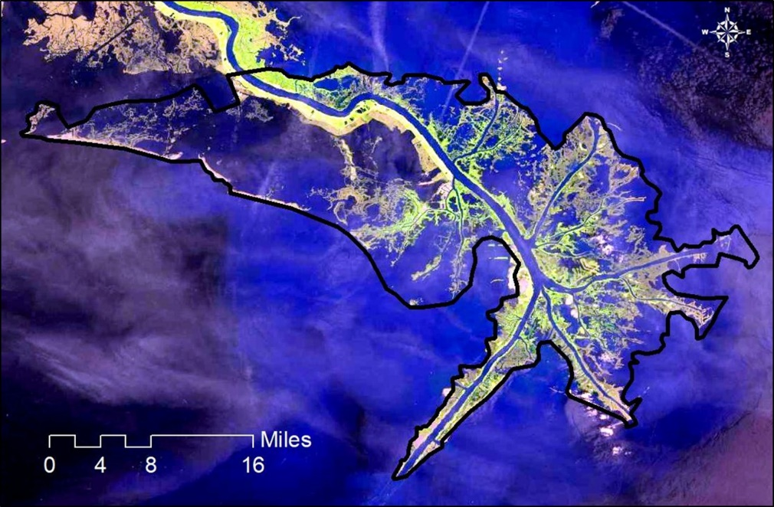

**Louisiana**

Southern Plaquemines Parish, LA

Southern

Plaquemines

Parish

*Figure 1.* Study areamap and inset depicting the extent of southern Plaquemines Parish, LA, USA and the state of Louisiana.

* 1. ***Project Partners & Objectives***

The Louisiana Ecological Forecasting team partnered withDr. Alisha Renfro of The National Wildlife Federation (NWF) to identify areas of habitat disturbance caused by the Roseau cane scale and other contributing factors. The NWF strives to use science-based solutions to identify areas for restoration and mitigation planning within the MRD. With the help of this project, the NWF received NDVI maps, SAHM model and statistical analysis assessing yearly historic changes and forecasted future changes so to identify parts of the marsh most impacted by major disturbance events, to best inform restoration efforts and allocation of resources in the lower MRD. The NWF also seeks to adapt their restoration strategies to anticipate the impacts of the mealy bug on Roseau cane within the MRD.

In order to support the NWF in their ecosystem management, the primary project objectives were to utilize NASA EO’s to: (1) Generate NDVI maps to monitor marsh health (i.e. greenness) between 2005-2017, (2) Assess land cover change in the study area over the study period, (3) Compute annual NDVI change maps and study period change maps for 2005-2017, (4) Forecast locations of Roseau cane dominated marsh using SAHM to 2030, (5) Conduct statistical analysis on Roseau cane die-off locations, and (6) Determine areas of high vulnerability and resilience to major disturbances.

# 3. Methodology

***3.1 Data Acquisition***

The team accessed Landsat 5 TM and Landsat 8 OLI for the study period through Google Earth Engine’s (GEE) Integrated Development Environment (IDE). Collection 1, Tier 1, top-of-atmosphere (TOA) reflectance Landsat 5 TM and Landsat 8 OLI data were used throughout the study. The team used Landsat 5 TM data for 2006-2011 and Landsat 8 OLI data for 2013-2017.

Elevation data were acquired through from the United States Geological Survey (USGS) Earth Explorer platform. The Coastal National Elevation Database (CoNED) Project is a collaboration between the US Geological Survey (USGS) Coastal and Marine Geology Program (CMGP), the National Geospatial Program (NGP), and the NOAA National Geophysical Data Center (NGDC). This coastal elevation database integrates LiDAR and bathymetric data sources into common databases aligned both vertically and horizontally to common reference systems. This data source provided seamless coverage of the study area at 3 m resolution.

Within the study area, monthly summaries of average temperature (TAVG) and monthly precipitation (PRCP) are available. The team used Oregon State University’s PRISM Climate Group 30-year average data downloaded directly from the PRISM web portal. Climate projections, also including temperature and precipitation, from the NASA Earth Exchange Global Daily Downscaled Projections (NEX-GDDP) dataset at 25 km resolution were accessed and downloaded from Google Earth Engine.

Several ancillary datasets were also used for this project. The United States Department of Agriculture (USDA) National Agriculture Imagery Program (NAIP) imagery from 2011 and CRMS vegetation type data was utilized along with Landsat 5, 2011 imagery to create a land cover type distribution map of marsh vegetation. CRMS data undergo quality assurance control procedures and are approved and accepted into the Louisiana Coastal Protection and Restoration Authority’s (CPRA) Coastal Information Management System (CIMS) database. CRMS data were sourced from lacoast.gov, which aggregate data collected by ground stations and the USGS. Aerial photos utilized from the CRMS that overlapped with CRMS *in-situ* stations where Roseau cane was observed, along with points derived from Dr. Madden’s classification were used as an input into the SAHM model in addition to PRISM temperature & precipitation data, CoNED digital elevation data and NEX-GDDP climate projections.

***3.2 Data Processing***

Within the GEE IDE, the team compiled a code that created a single composite, cloud-free image for each year of imagery using the “greenest pixel” method. One way to minimize clouds is to set pixel values in the composite from roughly the same phenological stage, for example the time of maximum greenness of plants (when the leaves are on and photosynthetically active). Max greenness was defined by the maximum NDVI, allowing the team to use qualityMosaic() to make a composite in which each pixel contains the maximum NDVI pixel from the collection. This code then added an NDVI band (Equation 1) to each image, clipped it to the study area, and exported the file in GeoTiff format for further analysis.

$\text{NDVI=}\frac{\text{Red-NIR}}{\text{Red+NIR}}$ (1)

Further data processing was performed using QGIS. Annual NDVI change was computed for consecutive years for the study period (2005-2017).

Using the QGIS Raster Calculator:

Isolating Annual NDVIs for study period: 2005-2011 (change year for each computation)

input

"l5TF_2005_clipped_composite_mask@9"

output

annual_ndvi_2005.tif

Isolating Annual NDVIs for study period: 2013-2017 (change year for each computation)

input

"l5TF_2013_clipped_composite_mask@11"

output

annual_ndvi_2013.tif

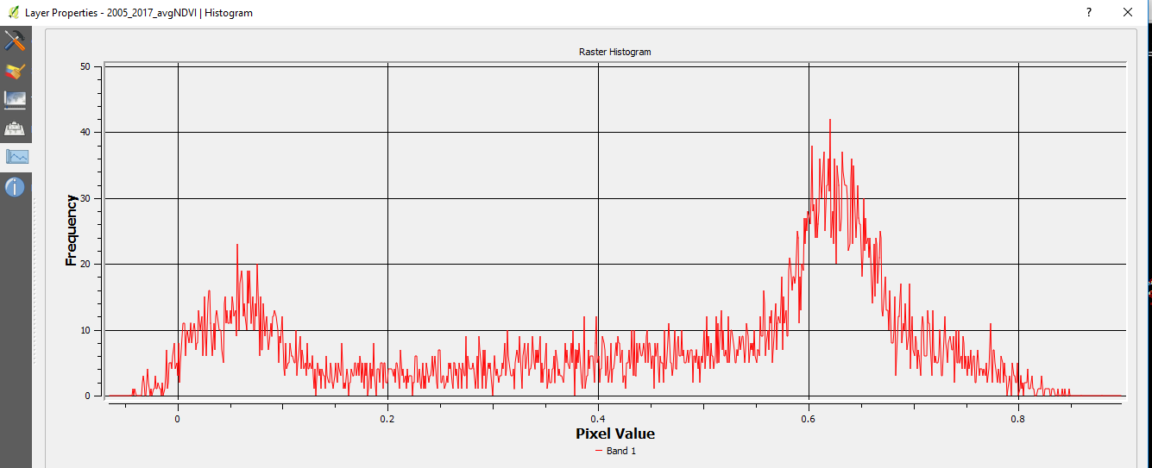

*Figure 2.* Histogram of calculated mean avg. annual NDVI for study period: 2005-2017 to compare against each year.

Calculating Annual NDVI vs Mean Average Annual NDVI for study period: 2005-2017 (change first year for each computation)

input

(( ( "annual_ndvi_2005@1" - "2005_2017_avgNDVI@1")/"2005_2017_avgNDVI@1") * 100)

output

ndvi_change_2005_vs_mean_2005-2017.tif

Calculating Annual NDVI vs Annual NDVI for whole study period: 2017 vs 2005 & specific years following major disturbance events (e.g. Hurricane Katrina – 2006 vs 2005, BP oil spill – 2011 vs 2010, Roseau cane scale insect infestation – 2017 vs 2016)

input

(( ( "annual_ndvi_2017@1" - "annual_ndvi_2005@1")/"annual_ndvi_2005@1" )* 100)

output

ndvi_change_2017_vs_2005.tif

STACK-Raster-Build virtual Raster- Average Annual NDVI for study period (RED) - Year image to stack (blue + green) (change last year for each computation)

input

2005_2017_avgNDVI, annual_ndvi_2005

output

annual_ndvi_2005_2005-2017.vrt

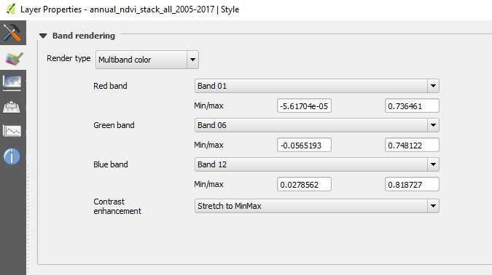*Figure 3.* Virtually Stacking 3 years - Band 01 annual NDVI for 2005, Band 06 annual NDVI for 2011 and Band 12 annual NDVI for 2017.

***3.3 Data Analysis***

The main products were assessed by comparison with available ground reference data that includes high resolution satellite, aerial, and *in situ* data on the location of healthy and declining Roseau cane. Points derived from CRMS *in situ* data, the Center for Geospatial Research (CGR) Director, Dr. Marguerite Madden’s randomly distributed presence/absence points, and our own extrapolation were used as an input into the SAHM model along with PRISM temperature & precipitation data, CoNED digital elevation data and NASA climate change data, forecasting marsh health to 2030.

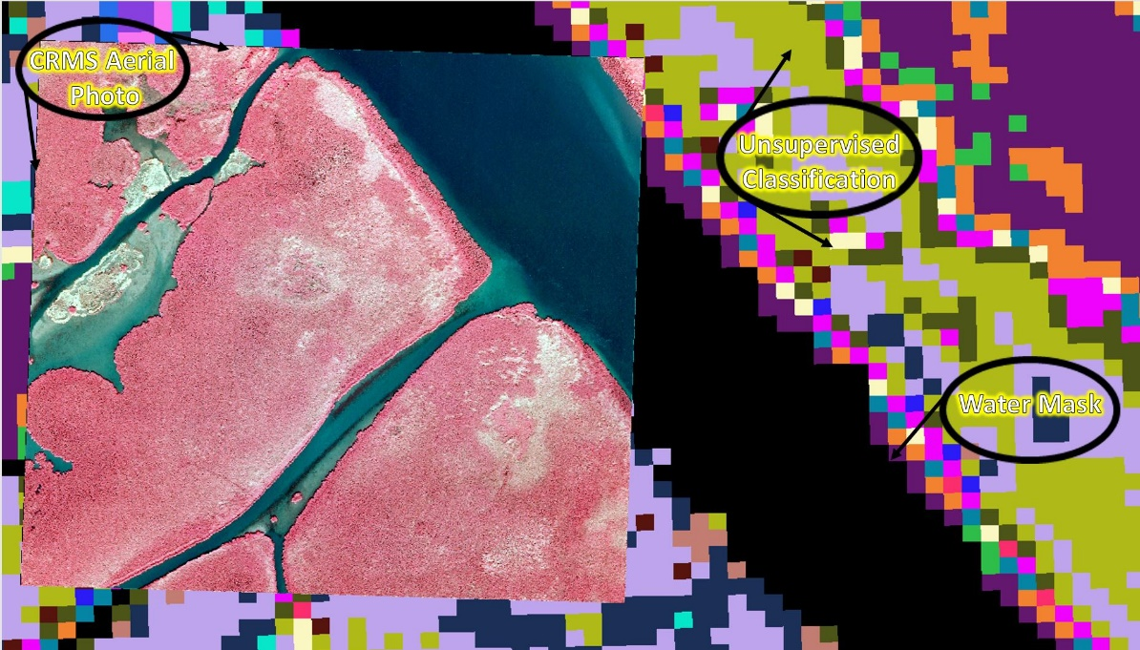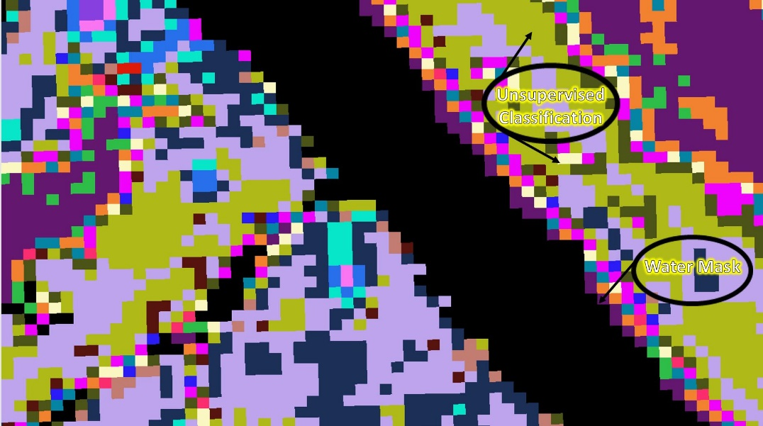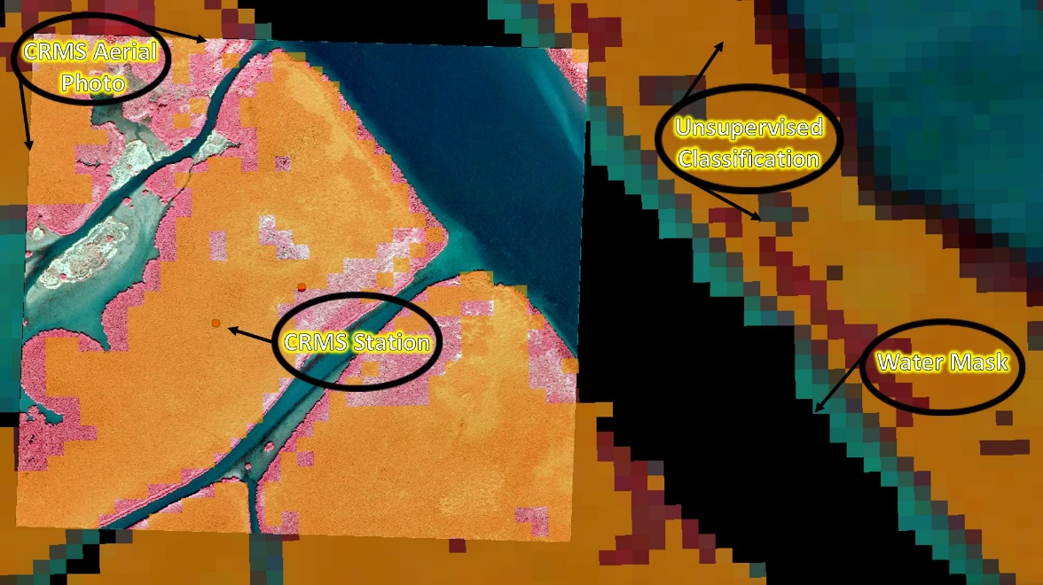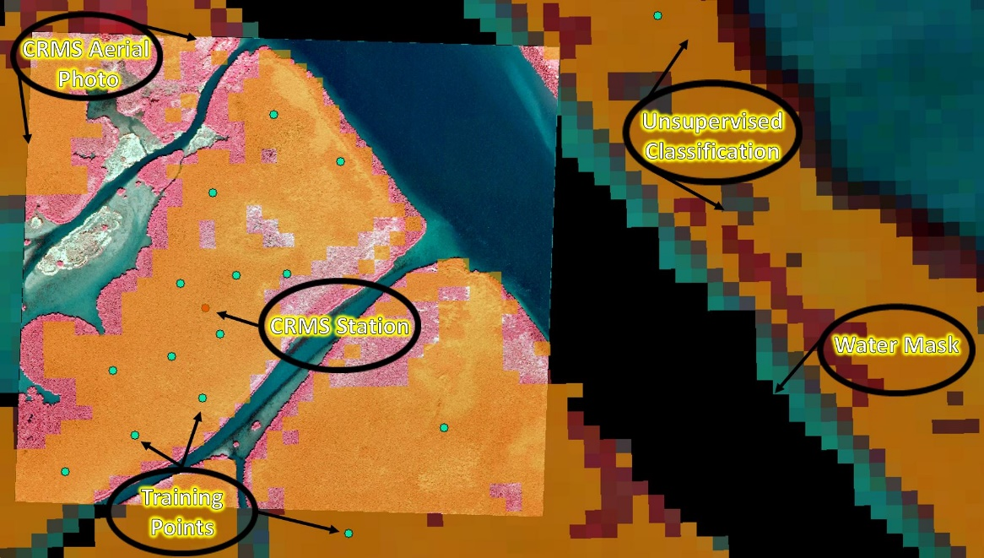

A

B

C

D

*Figure 4.* Training the classifier: (A) unsupervised classification generated from 2011 Landsat 5 TM imagery and the application of a water mask. (B) CRMS aerial photo of Roseau cane overlaid on unsupervised classification. (C) CRMS *in situ* stations overlaid where cane was observed. (D) Green training points generated and randomly distributed for the SAHM model.

A close up of a tree

Description generated with high confidence

*Figure 5.* Classified species distribution map depicting the Bird’s Foot Delta. Classification generated from 2011 Landsat 5 TM imagery based on *in situ* CRMS point data/aerial photographs, CGR classification & NAIP imagery.

The classified species distribution map was created using CRMS data, NAIP imagery along with expert opinion (Dr. Madden) in the mapping of *Phragmites* and other non-target species.

***3.4 Modelling***

SAHM was used to generate images and statistical probabilities of the spread of the Roseau cane scale. Inputs for SAHM included a set of species presence/absence data in .csv format. These data included an observation date and coordinates in decimal degrees.

SAHM requires a template raster file with a defined projection and datum to which all the other data are fit. The team used the March 2017 Landsat 8 OLI NDVI GeoTiff image projected in UTM Zone 15 North on the WGS 84 datum and clipped to the study area. Other inputs included the CoNED topobathymetry DEM, a Modified Normalized Difference Water Index (MNDWI) raster image (Equation 2).

$\text{MNDWI=}\frac{\text{Green-MIR}}{\text{Green+MIR}}$ (2)

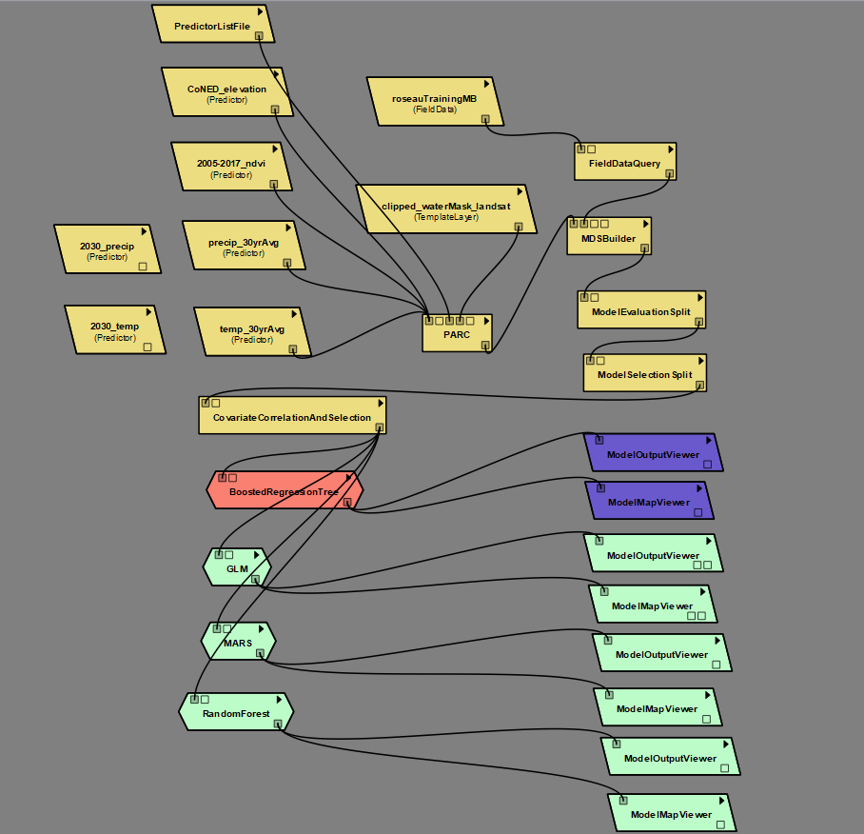

*Figure 6.* SAHM workflow includes input data, preliminary model analysis, correlative models and output routines.

SAHM accepts climate inputs included precipitation and temperature data. Thirty-year average precipitation and temperature data from the University of Oregon’s PRISM climate dataset provided baseline climate data at 800 m resolution. The NASA Earth Exchange Global Daily Downscaled Projections (NEX-GDDP) provided projected temperature and precipitation data at 25 km resolution. Models were run with both 30-year and 2030 projected climate data.

Data processing steps within SAHM modules clip and re-project data to the desired cell-size as defined by a template raster, and values from each predictor layer are extracted and assigned to the corresponding absence or presence point. SAHM allows for initial model evaluation by displaying results from a univariate model fit with each individual predictor and a covariate correlation between predictors. When two predictors had a correlation coefficient of |r| > 0.70, one of the two was eliminated as highly correlated predictors can create “unstable model fits” (Morisette et al., 2013).

Within the SAHM workflow, the team ran five models in parallel. Multivariate adaptive regression splines (MARS), Boosted Regression Trees (BRT), Random Forest, Generalized Linear Model (GLM), and Maximum Entropy (MAXENT) all produced an output. Each model run produced a TIFF image and contains an output text file with common evaluation statistics like sensitivity and AUC, and generates both a spreadsheet and image file comparing performance across all runs. In addition to running the individual models, SAHM also created a composite model of all five model runs.

**4. Results & Discussion**

***4.1 Analysis of Results***

Using Google Earth Engine’s “greenest pixel” method the team calculated annual NDVI change. In order to monitor changes in marsh health, change in annual NDVI was compared for the study period. Major disturbance events impacting marsh health such as the invasive mealy bug outbreak in 2016-2017, the BP oil spill in 2010 and Hurricane Katrina in 2005 were of particular interest in comparing annual NDVI change over time. The annual NDVI from 2005 was compared to all other years within the study period and layered in a multiple year analysis. NDVI change map virtually stacking years: 2005, 2011 & 2017, derived from Landsat 5 TM & 8 OLI (*Figure 4)* compared NDVI change relative to the first date (2005). NDVI change displayed as red (lower on last two dates), cyan (higher on last two dates), green (higher on middle date), and blue (higher on last date). Areas in red appear to be most vulnerable to disturbance events over time, while areas in blue show more resilience (*Figure 6.*).

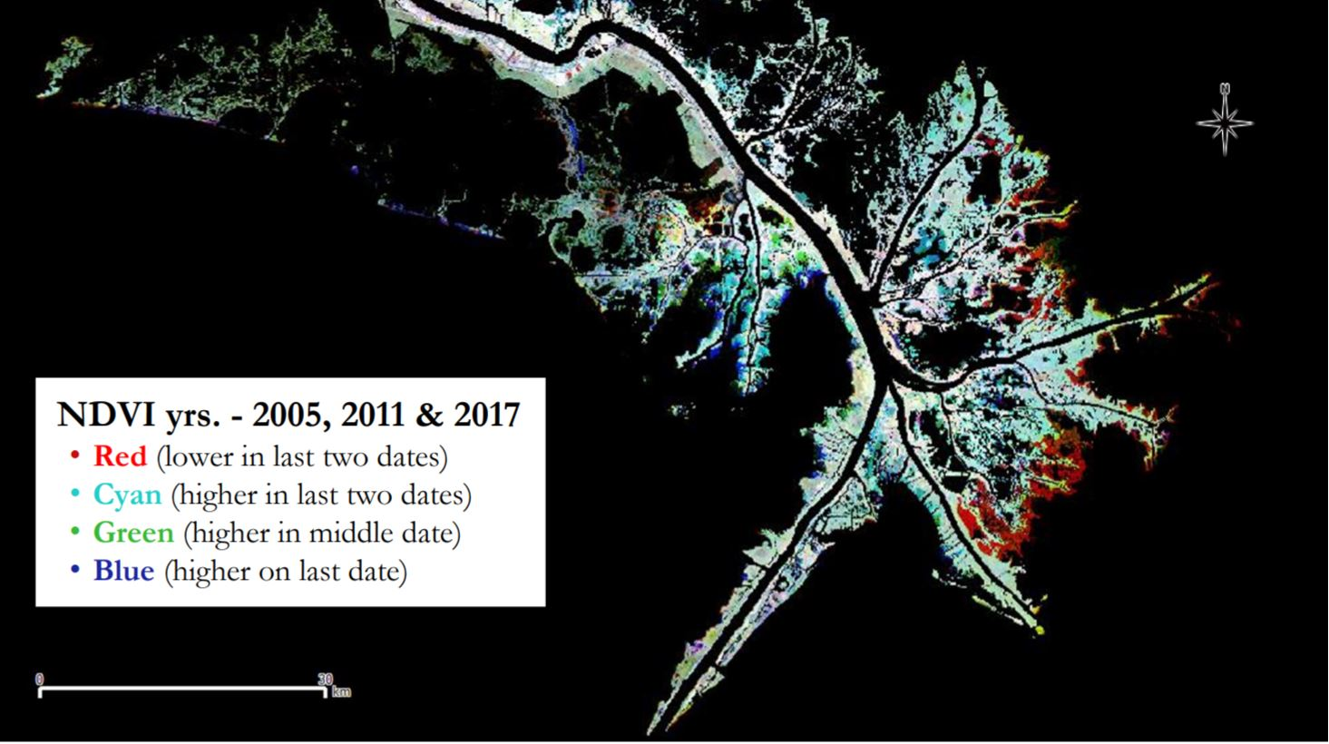

*Figure 6.* NDVI change of Bird’s Foot Delta over time, virtually stacking years-2005/2011/2017, from-Landsat 5-TM & 8-OLI. NDVI change relative to 2005 display red-lower in 2011/2017, cyan-higher in 2011/2017, green-higher in 2011, blue-higher on 2017.

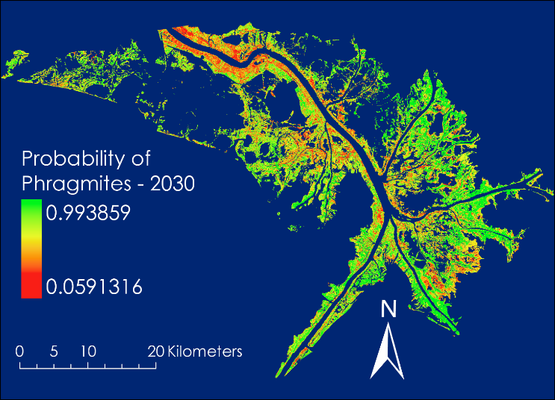

*Figure 7.* Probability maps of the Bird’s Foot Delta show the probability of phragmites-30 year average (left) and the probability of phragmites-2030 (right).

SAHM output several parameters for each model run, including a .tiff image of probability of phragmites. The team ran two different climate scenarios, one based on 30-year average climatology of precipitation and temperature from PRISM, and one based on projected climate data for the year 2030 from NEX-GDDP (*Figure 7*). The ensemble of MARS, MAXENT, BRT, RF, and GLM indicated a decrease in the probability of phragmites in 2030 compared to the 30-year climate average. This can clearly be seen by subtracting the 2030 image from the 30-year average image, yielding a change in probability image (*Figure 8*). Areas shown in red had the largest decrease in probability while areas in green had in increase in probability. The decreasing probability of phragmites were most pronounced in sensitive, low-lying areas immediately along the coast.

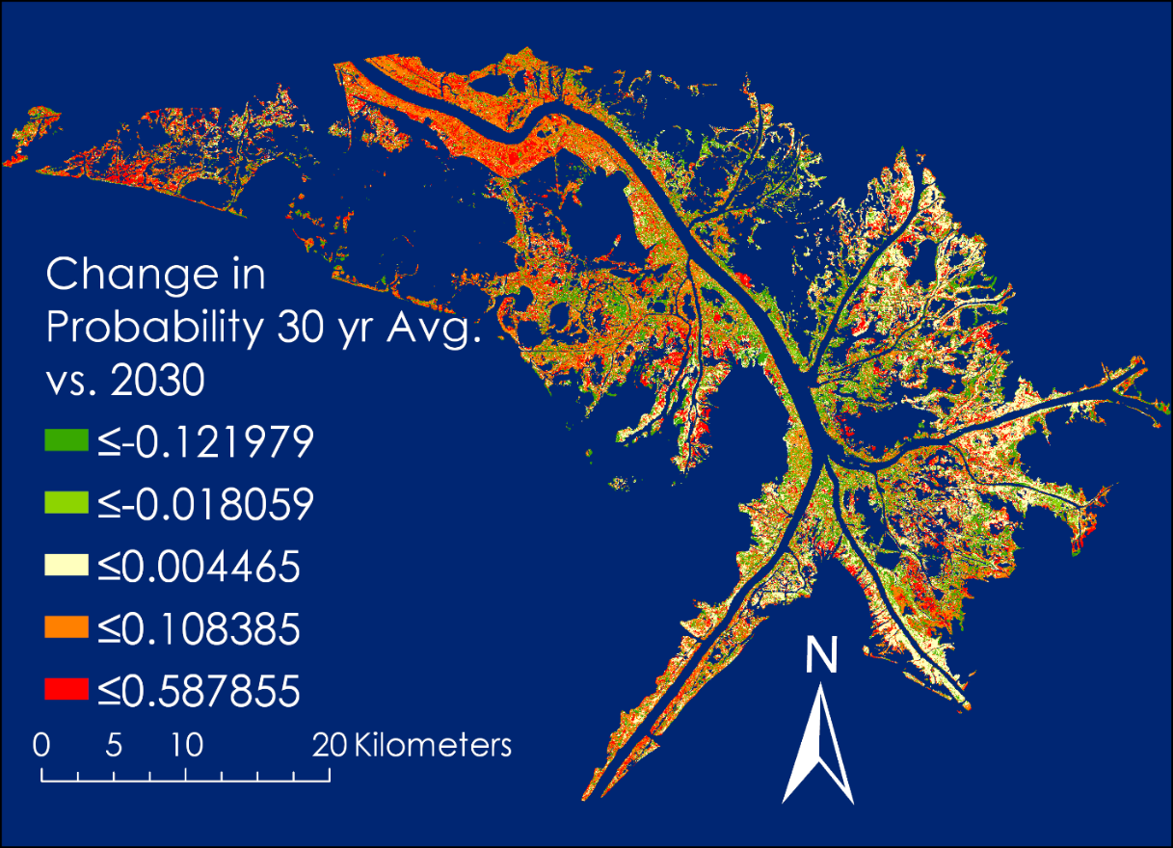

*Figure 8.* Probability of change in phragmites presence 30-year average vs 2030.

Along the west bank of the South Pass of the Mississippi River (*Figure 9*), the ensemble model indicated a decrease in the probability of phragmites. As of 2017, the stands of phragmites were among the healthiest in the Mississippi river delta according to CRMS data as well as ground truth from the project partners. A decrease in phragmites in this area will lead to continued erosion from storm events and possible loss of the channel.

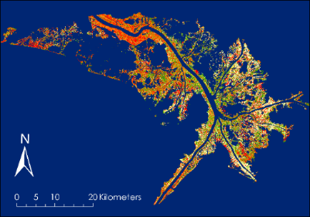

*Figure 9.* Probability of change in *Phragmites* presence 30-year average vs 2030, South Pass MRD.

Along the East Pass of the Mississippi river delta (*Figure 10*), the change in probability of phragmites between 30-year climate average and 2030 projected climate data remains neutral overall. However, within certain areas directly along the coast the probability in 2030 is largely reduced compared to 30-year climate averages. Loss of a healthy marsh along the East Pass of the Mississippi river increases the risk of further land loss.

The West Pass of the Mississippi River is a major pass for the Gulf of Mexico oil and gas industry (*Figure 11*). This area is a mixture of dredge spoil and loosely-consolidated sediment and has been maintained as a major shipping corridor. There is an overall decrease in the probability of phragmites in this area. The oil and gas infrastructure in this area includes pipelines and other platforms which rely on a healthy, stable marsh for protection from hurricanes.

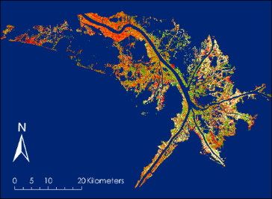

*Figure 10.* Probability of change in *Phragmites* presence 30-year average vs 2030, East Pass MRD.

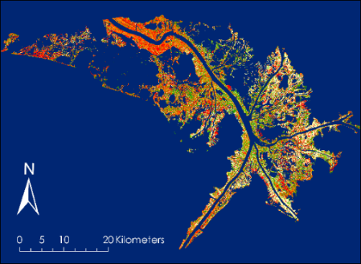

*Figure 11.* Probability of change in *Phragmites* presence 30-year average vs 2030, West Pass MRD.

Project sources of error include: a gap year for 2012 (no cloud-free images for annual NDVI composite), image resolution, limited ground truth, “greenest pixel” bias, and other unaccounted factors (i.e. damage agents). Additional errors could result from hurricane/storm-related disturbances skewing data, Roseau cane mealy bug’s ill-defined (absent) phenology, the issue that reed die-back syndrome is not well understood although well documented internationally. There are confounding biotic/abiotic variables contributing to marsh decline, all of which aren’t known and finally, ecosystem dynamics are in constant flux (always changing)-so, it’s hard to track/measure and elucidate patterns accurately or quickly.

***4.2 Future Work***

Although little is known about the scale insect, understanding invasive species distributions and potential invasions often require broad-scale information on the environmental tolerances of the species (Jarnevich et al., 2018). Future work should conduct in-depth statistical analysis of SAHM model results, multivariate analysis of synergistic effects causing reed die-back as well as an analysis of data from various contributing pollutants effecting vegetative health (e.g. point & non-point source pollutants) and an investigation into marsh lag-time effects & thresholds. Different types of land use show different patterns of total suspended solids in water clarity; thus, there may be more important legacy effects of land-use, which influence water quality over relatively longer time periods following a major disturbance (Kaushal et al., 2017). The loss of wetland structure, function, and services are due in large part to a complex interaction of spatial and temporal factors, including reduced riverine inputs, flood control measures, altered wetland hydrology, saltwater intrusion, subsidence, wave erosion, reduced river sediment load and sea-level rise (Day et al., 2000). Future models accessing vegetative health out to 2050 and 2100 should include more climatic variables (e.g. RSLR, subsidence rates) for the region. Investigation into the effects of restoration projects where Roseau cane planting have had on areas of interest and overall marsh health and higher resolution maps of within the lower Mississippi River Delta for restoration planning.

**5. Conclusions**

Roseau cane is considered vital to the fragile marsh's durability because the root system binds the weak soil in place (Louisiana State University Agriculture Center, 2018). It tolerates salinities up approximately 20 ppt (Achenbach et al., 2013; Pagter et al., 2009); hence it is common in the upper delta plain of estuaries and in coastal wetlands. Annual NDVI’s compared over the study period indicate areas on the eastside of the Delta appear to be more adversely affected by disturbances than the westside. Historic trends and patterns emergent from the data show years following major disturbances (e.g., BP oil spill, Hurricane Katrina, El Niño yrs., Roseau cane scale infestation) had lower than avg. NDVI’s, but more recently, peak NDVI’s increased slightly, suggesting there’s resilience within the marsh (lag-time effects and thresholds should be further investigated). SAHM model results show locations of Roseau cane out to 2030, which will remain under threat to increasing the land-loss, subsidence and relative sea-level rise. The growth of *Phragmites* is suppressed during unfavorable conditions, such as high salinity, unsuitable temperatures in some tropical regions (Clapham et al., 1987), and prolonged flooding (Ostendorp, 1991).

Changes in RSLR often lead to landward migration of coastal wetlands. In coastal Louisiana, landward migration of marsh is often obstructed by anthropogenic barriers to migration (e.g. levees). This situation leads to the logical conclusion that future wetland loss is probable if RSLR continues and/or accelerates at rates that exceed the wetland’s capacity to maintain its elevation relative to water levels (Couvillion & Beck, 2013). SAHM model results show locations of Roseau cane out to 2030, which will remain under threat due to increasing land-loss, subsidence and relative sea-level rise.

Overall decrease in the probability of *Phragmites* presence within the study area. Large scale decrease in sensitive areas – especially along shoreline. South and East Pass show signs of resilience – healthiest stands. West Pass shows an overall decrease, may be more vulnerable. The role of ecosystem changes, such as wetland loss and canalization of rivers was evident during the 2005 hurricane in New Orleans, USA; the capacity of ecosystems to mitigate natural hazards such as floods, droughts, storms and tsunamis appears to be decreasing, although there is considerable variability among regions (Carpenter & Folk, 2006). The NDVI maps and SAHM model created assessed yearly historic changes and forecasted future changes so to identify parts of the marsh most impacted by major disturbance events, elucidating areas of interest for mitigation and restoration; visualizing areas that are most vulnerable and areas of greater resilience will enhance decision making for our partner.

**6. Acknowledgments**

* Joseph Spruce (Science Systems & Applications, Inc.)
* Dr. L. DeWayne Cecil (NOAA National Center for Environmental Information, Global Science & Technology, Inc.)
* Dr. Marguerite Madden (The University of Georgia)
* Dr. Kenton Ross (NASA Langley Research Center)
* Bob VanGundy (The University of Virginia’s College at Wise)
* Brooke Colley (Virginia – Wise Center Lead)
* Eric White (Former Virginia – Wise Center Lead)

Any opinions, findings, and conclusions or recommendations expressed in this material are those of the author(s) and do not necessarily reflect the views of the National Aeronautics and Space Administration.

This material is based upon work supported by NASA through contract NNL16AA05C and cooperative agreement NNX14AB60A.

# 7. Glossary

**NWF – National Wildlife Federation**

**LWF – Louisiana Wildlife & Fisheries**

**LSU – Louisiana State University**

**Earth observations –** Satellites and sensors that collect information about the Earth’s physical, chemical, and biological systems over space and time

**MRD – Mississippi River Delta**

**RSLR – Relative Sea Level Rise**

**Subsidence –** the motion of a surface (usually, the earth's surface) as it shifts downward relative to a datum such as sea level

**CRMS – Coastal Reference Monitoring System**

**MWL – Mean Water Level**

**USGS – United States Geological Survey**

**CoNED – Coastal National Elevation Dataset**

**TM – Thematic Mapper**

**OLI – Optical Land Imager**

**MSI – Multispectral Instrument**

**NDVI – Normalized Difference Vegetative Index**

**NIR – Near Infrared**

**SWIR – Short Wave Infrared**

**SAHM – Software for Assisted Habitat Modelling**

**GEE – Google Earth Engine**

**IDE – Integrated Development Environment**

**NAIP – National Agriculture Imagery Program**

# 8. References

Achenbach, L., Eller, F., Nguyen, L. X., & Brix, H. (2013). Differences in salinity tolerance of genetically distinct Phragmites australis clones. *AoB Plants,* *5*.

Carpenter, S. R., & Folke, C. S. (2006). Ecology for transformation. *Trends in Ecology & Evolution,* *21*(6), 309-315.

Clapham, A. R., Tutin, T. G., & Moore, D. M. (1987). *Flora of the British Isles Cambridge*. UK: Cambridge.

Couvillion, B. R., & Beck, H. (2013). Marsh collapse thresholds for coastal Louisiana estimated using elevation and vegetation index data. *Journal of Coastal Research,* (63), 58-67.

Couvillion, B. R., Barras, J. A., Steyer, G. D., Sleavin, W., Fischer, M., Beck, H., . . . Heckman, D. (2011). *Land area change in coastal Louisiana from 1932 to 2010* [Pamphlet]. U.S. Geological Survey Scientific Investigations.Map 3164, scale 1:265,000, 12 p.

Day, J. W., Britsch, L. D., Hawes, S. R., Shaffer, G. P., Reed, D. J., & Cahoon, D. (2000). Pattern and process of land loss in the Mississippi Delta: A Spatial and temporal analysis of wetland habitat change [Abstract]. *Pattern and Process of Land Loss in the Mississippi Delta: A Spatial and Temporal Analysis of Wetland Habitat Change,* *23*(4), 425-438. Retrieved from https://doi.org/10.2307/1353136

FOX8. *New research shows bugs not culprit in killing off Louisiana coastline*. (2018, March 30). Retrieved from http://www.fox8live.com/story/38312481/new-research-shows-bugs-not-culprit-in-killing-off-louisiana-coastline

Fragoso, G. & Spencer, T. (2008). Physiographic control on the development of Spartina marshes. *Science*, *322*(5904), 1064.

Jarnevich, C.S., Young, N.E., Talbert, M., & Talbert, C. (2018). Forecasting an invasive species’ distribution data, local data, and physiological information. Retrieved from <https://pubs.er.usgs.gov/publication/70197428>

Kaushal, S. S., Gold, A. J., & Mayer, P. M. (2017). Land Use, Climate, and Water Resources—Global Stages of Interaction. [Abstract]. *Water,* *9*(10). Retrieved from https://doi.org/10.3390/w9100815.

Kiviat, E. (2013). Ecosystem services of Phragmites in North America with emphasis on habitat functions. *AoB PLANTS,* *5*. Retrieved from https://doi.org/10.1093/aobpla/plt008.

Knight, I. A., Wilson, B. E., Gill, M., Aviles, L., Cronin, J. T., Nyman, J. A., . . . Diaz, R. (2018). Invasion of *Nipponaclerda biwakoensis* (Hemiptera: Aclerdidae) and *Phragmites australis* die-back in southern Louisiana, USA [Abstract]. *Biological Invasions,* 1-6. Retrieved from https://doi.org/10.1007/s10530-018-1749-5.

Louisiana State University Agriculture Center (2018). Roseau Cane Die-off Issue. Retrieved from http://www.lsuagcenter.com/topics/environment/invasive%20species/roseau%20cane%20die-off/issue

Louisiana Wildlife & Fisheries. (2017). Roseau Cane Mealy Bug continues destructive path through southern Plaquemines Parish. Retrieved from http://www.wlf.louisiana.gov/news/41260

Morisette, J. T., Jarnevich, C. S., Holcombe, T. R., Talbert, C. B., Ignizio, D., Talbert, M.K., …Young, N. E. (2013). VisTrails SAHM: Visualization and workflow management for species habitat modeling. *Ecography*, *36*(2), 129-135. http://doi.org/10.1111/j.1600-0587.2012.07815.x

Olea, R.A. and Coleman Jr, J.L. (2014). A synoptic examination of causes of land loss in southern Louisiana as related to the exploitation of subsurface geologic resources. *Journal of Coastal Research*, *30*(5), 1025–1044. Coconut Creek (Florida), ISSN 0749-0208.

Ostendorp, W., (1991). Damage by episodic flooding to *Phragmites* reeds in a prealpine lake: Proposal of a model. Oecologia 86, 119–124.

Pagter, M., Bragato, C., Malagoli, M., Brix, H., (2009). Osmotic and ionic effects of NaCl and Na2SO4 salinity on *Phragmites australis*. *Aquatic Botany, 90*, 43–51.

Peterson, A. Townsend. *Ecological niches and geographic distributions (MPB-49)*. No. 49. Princeton University Press, 2011.

Stratoulias, D., Balzter, H., Zlinszky, A., Tóth, VR, (2015). [Assessment of ecophysiology of lake shore reed vegetation based on chlorophyll fluorescence, field spectroscopy and hyperspectral airborne imagery](https://scholar.google.com/scholar?oi=bibs&cluster=15792360823668349132&btnI=1&hl=en)-*Remote Sensing of Environment, 157*, 72-84.

The National Wildlife Federation. (2018). Invasive Species. Retrieved from <https://www.nwf.org/Educational-Resources/Wildlife-Guide/Threats-to-Wildlife/Invasive-Species>

Tilley, D.J., & St. John, L. (2012). Plant Guide for common reed (Phragmites australis.) USDA-Natural Resources Conservation Service, Aberdeen, ID Plant Materials Center. 83210-0296. Retrieved from <https://plants.usda.gov/plantguide/pdf/pg_phau7.pdf>

U.S. Geological Survey Earth Resources Observation and Science Center. (2005-2011). Provisional Landsat TM Surface Reflectance [Data set]. US Geological Survey. https://doi.org/10.5066/f7kd1vz9

U.S. Geological Survey Earth Resources Observation and Science Center. (2013-2017). Provisional Landsat OLI Surface Reflectance [Data set]. US Geological Survey. https://doi.org/10.5066/f78s4mzj

Weisner, S.E.B., & Strand, J. A. (1996). Rhizome architecture in Phragmites australis in relation to water depth: Implications for within-plant oxygen transport distances [Abstract]. *Springer Netherlands,* *31*(1), 91-97. Retrieved from https://doi.org/10.1007/BF02803998

# 9. Appendices

**Appendix A**

**Table A1. Data sources**

|  |  |  |
| --- | --- | --- |
| **Platform & Sensor** | **Parameter** | **Use** |
| **CoNED** | Digital Elevation Model | USGS CoNED provides elevation values and bathymetry throughout the study area. Eco-forecasting models take this elevation into account when producing risk maps. |
| **Landsat 5 TM** | Surface Reflectance | NDVI band combination utilized to detect vegetation health at 30 m pixel resolution. This provides imagery up to 2013. |
| **Landsat 8 OLI** | Surface Reflectance | NDVI band combination utilized to detect vegetation health at 30 m pixel resolution. This provides imagery from 2014 to 2017. |
| **PRISM** | Monthly Precipitation | PRISM temperature and precipitation data used to help identify the metrological and climatic conditions that affect Roseau cane health. |

**Appendix B**

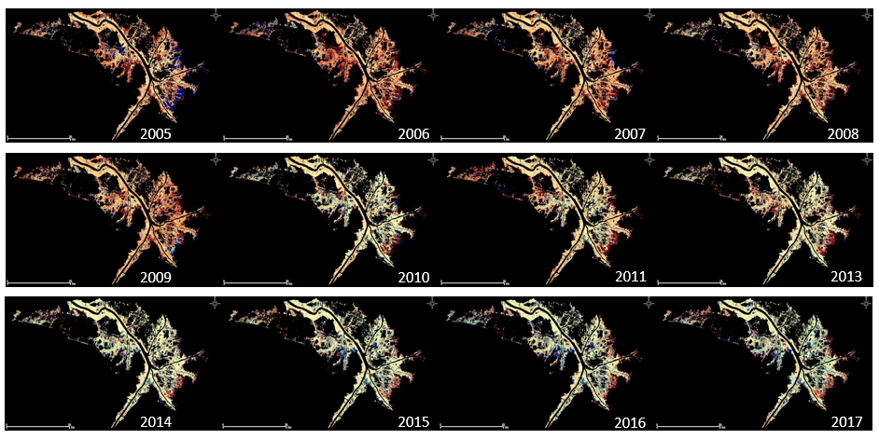**Figure B1. Annual NDVI Change vs Mean of All Years (2005-2017)**

**Figure B2. Annual NDVI Change Maps of Major Disturbance Events (e.g. 2005 – Hurricane Katrina, 2010 – BP Oil Spill, 2016 – Roseau cane scale outbreak) vs Following Yr. After Disturbance NDVI increase/decrease** 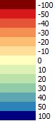

QGIS Calculated Annual NDVI Change vs Mean of All Years for study period: 2005-2017 (gap year: 2012 – no cloud free data).

Decreasing NDVI (orange-red) Increasing NDVI (green-blue)

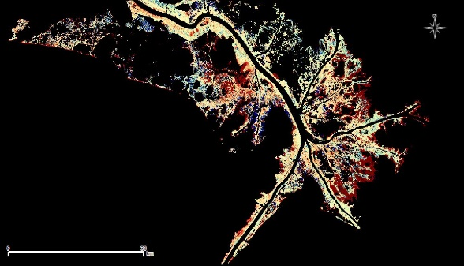

2006 vs 2005

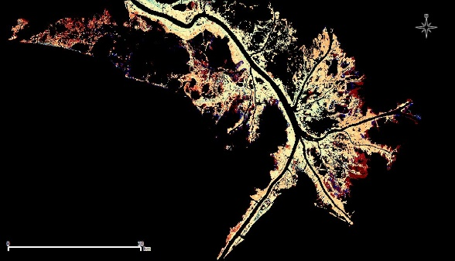

2011 vs 2010

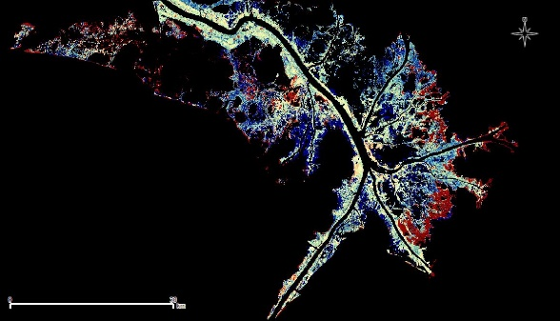

2017 vs 2016