**DEVELOP National Program**

2014 Fall Term

**Virtual Poster Session Wave 1 Submission**

**DEVELOP short title for reference:** DEVELOPedia: DEVELOP’s New Wiki

**Project Lead email:** Logan.J.Kendle@nasa.gov

**VPS Title:** Refurbishing the DEVELOPedia Wiki for National Use in summer 2015

**Team Location:** Langley Research Center – Hampton, Virginia

**Authors List:**

Logan Kendle

Adam White

Carolyn Lynch

Gennifer Anderson

Luke Thompson

Rick Farmer

Timothy Stelter

**Mentors/Advisors:**

Mike Bender (NASA DEVELOP National Technical Lead)

**Past/Other Contributors:**

Lauren Childs-Gleason (NASA DEVELOP National Operations Lead)

DEVELOPedia Tech Team LaRC Fall 2013

DEVELOPedia Tech Team LaRC Spring 2014

DEVELOPedia Tech Team LaRC Summer 2014

**Abstract:**

At the conclusion of the summer 2014 term, DEVELOPedia was still in a beta stage and in need of updates to finalize the functionality and prepare it for operational use. This involved using the current Langley participants to gauge the site’s popularity throughout the fall term to prepare for a limited live spring launch and a full live national launch in summer 2015. The DEVELOPedia site will allow users to complete a multitude of functions not available on the DEVELOP Exchange including: being able to look up keywords in old projects, search previous end users and partners, research the projects completed under each application area, view current list of proposals both approved and not approved, and allow real time editing of all of the features. DEVELOPedia is also accessible to participants once they leave the program giving them permanent access to their old projects and future DEVELOP projects.

**Image:** Main Page Screen Snip.png ; I have attempted to convert the file in a multitude of ways but it always turns out poorly. I have included it as an attachment.

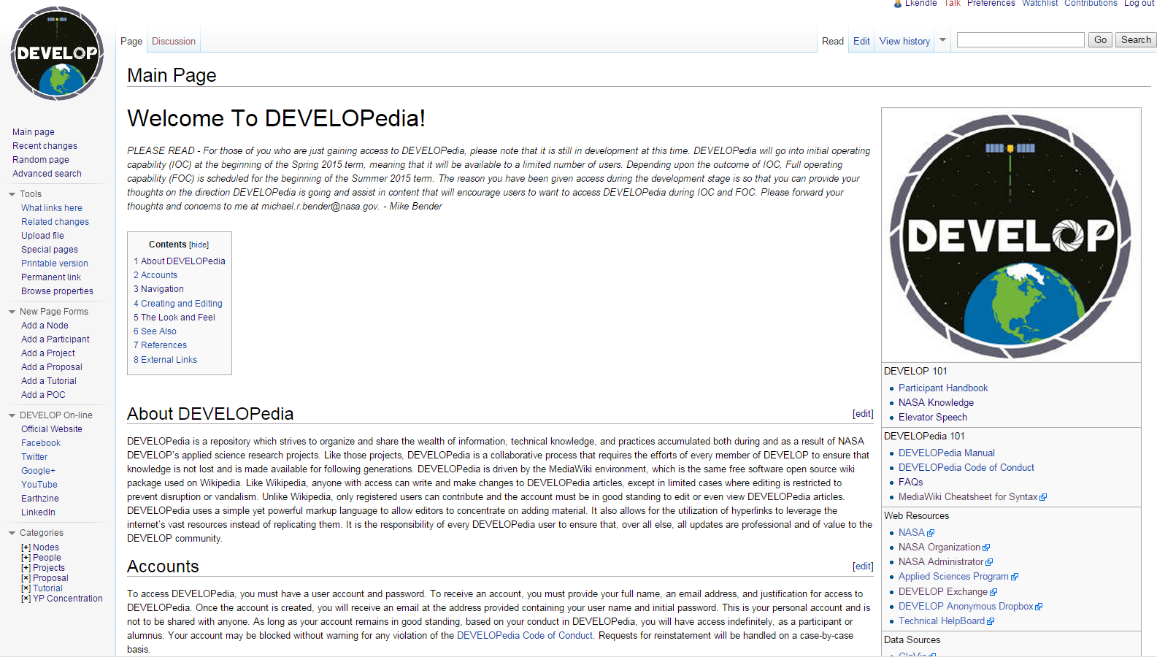

**Caption:** Caption. **Max of 25 words.**

*The DEVELOPedia Main Page is home to all of DEVELOP’s new wiki function. File storage, lookup, upload, and editing as well as Participant, Point of Contact, Proposal, and Tutorials editing can be found here.*

*-- For use in social media promotion and on website if a winning project --*

**Squib:** The DEVELOPedia site was created to replace the DEVELOP exchange with new user-friendly functionality which strives to organize and share the wealth of information, technical knowledge, and practices accumulated both during and as a result of NASA DEVELOP’s applied science research projects.

***Federal Video Resources***

NASA Scientific Visualization Studio: <http://svs.gsfc.nasa.gov/>

USGS B-Roll Gallery: <http://gallery.usgs.gov/video_sets/B-Roll>

**Additional resources available at:** <https://docs.google.com/spreadsheets/d/1e2mQXg4wcYsubINUA6RNQdLwa3udqczxGx-RbD2xSeI/edit?usp=sharing>

Anyone with the link can edit this document, so please add any other federal resources you find!

**Video Style:** We will start out with attention grabbing concern of the lack of user friendliness and organization in DEVELOPedia and DEVELOP Exchange. Then using a screen recording software we’ll add in the rest of the footage covering the Main Page and how to search. From there how to add new Participant Pages and Project Pages. This will serve as overview for new participants even before their term starts. From here we will dive into the naming system for adding projects, images, and files. After this a brief overview of using the categories to find pages and where to find the tutorials and Point of Contacts database. Then end the video with a link to the new DEVELOPedia user manual for Dummies.

1. Hopefully a DEVELOPedia Logo to open the video
2. Intro to problems being solved
3. Cut to screen recordings.
   1. New Participants Page
   2. New Projects Page
   3. How to add and name files
4. Categories and Searching
5. How to find the tutorials and POC’s to help with projects
6. DP User manual
7. Credits and Acknowledgements
8. DEVELOP Logo

**Things to include in the video, other than the lead in and closing clips, the order of inclusion is entirely up to the team:**

Mandatory Lead in: DEVELOP Intro clip (available on the Exchange at: Start > Earthzine – Virtual Poster Sessions > Video Opening & Closing Clips)

Video Opening: Hopefully a DEVELOPedia Logo to open the video

Community Concerns:

* Intro to problems being solved
* Currently the DEVELOP Exchange being used is slow and has limited features.
* The Exchange has no way to search among the documents
* The new site will feature forms and templates to easily add projects, participants, proposals, and tutorials to create easy editing and viewing
* Previous versions were not user friendly and difficult to populate and navigate.

Collaborators & End-Users:

* This project is for you….The DEVELOPer (said in video)
* We have created a monster

How will Participants be introduced: Cut to onscreen recording

* New Participants Page
* New Projects Page
* How to add and name files
* Using Categories and searching
* How to find tutorials and using the POC’s to help with projects

Data Usage:

* The data will be populated from the DEVELOP Exchange and current project deliverables

Results:

* Talk briefly about the DEVELOPedia Admin manual to scare people
* Then talk about how we have created a simpler DEVELOPedia regular user manual

Benefits:

* This will be great for all DEVELOPers for the future.

Mandatory Video Closing: DEVELOP closing clip (available on the Exchange at: Start > Earthzine – Virtual Poster Sessions > Video Opening & Closing Clips)