Kankakee Water Resources

Monitoring Temperature and Vegetation to Detect River Flow Impediments at Energy Intake Structures

**Technical Report**

August 11th, 2023

Marisa Smedsrud (Project Lead)

Hayden Hoffmeister

Oluwatosin Orimolade

Barira Rashid

***Advisors:***

Dr. Austin Madson, University of Wyoming

***Fellow:***  
Caroline Williams (Pop-Up Project)

# 1. Abstract

In recent years, unpredictable grassing events have occurred at the Dresden Generating Station, located on the Kankakee River in northern Illinois. Grassing events are characterized by large mats of aquatic vegetation that accumulate downstream, resulting in the clogging of water intake structures and leading to major disruptions in power generation. Currently, employees at the Dresden Generating Station are responsible for reactively responding to each grassing event individually. This project, in partnership with Constellation Nuclear and the United States Geological Survey (USGS), assessed the feasibility of using Earth observations (Landsat 9 OLI-2, Landsat 8 OLI, Sentinel-2 MSI, DOVE PlanetScope, WorldView-3, and GPM IMERG) to detect floating aquatic vegetation within the Kankakee River and identify predictive factors that trigger grassing events, as doing so will provide the Dresden Generating Station the ability to anticipate future grassing events and enhance general hydrologic modeling efforts held by the USGS. The results of this study illustrated that, while aquatic vegetation can be detected by satellites with up to moderate spatial resolution (30 m), temporal resolution is a major limiting factor for tracking movements in floating aquatic vegetation and identifying predictive measures for these events. In addition, correlation results suggest a possible negative relationship between grassing events and river discharge (-0.875 correlation coefficient). In the future, pairing these results with ground control surveys and sensors with higher temporal capabilities would allow our project partners to predict and proactively address future grassing events, ensuring the reliable operation of the Dresden Generating Station.

**Key Terms**

Landsat, Sentinel, PlanetScope, WorldView, floating aquatic vegetation, remote sensing, environmental trend analysis, cold-water intake.

# 2. Introduction

***2.1 Background Information***

During the summer of 2022, in late July, a significant grassing event occurred in the Kankakee River in northeast Illinois. The rapid growth and release of submerged aquatic vegetation (SAV), via a mechanism that is unknown, led to a large amount of floating aquatic vegetation (FAV) being washed downstream where the Dresden Generating Station sits. This nuclear generating station utilizes the Kankakee River water for cooling two nuclear reactors and their cold-water intake structure is located directly upstream of the confluence between the Kankakee River and the Des Plaines River. During this 2022 grassing event, FAV clogged the station’s intake structure, resulting in a major operational disruption. Being a nuclear energy facility, the Dresden Generating Station is considered a highly reliable energy source and generates the equivalent of 1.4 million homes worth of power (Constellation Nuclear, 2023). However, the impeded operation of the station due to grassing events puts this reliability at risk. Therefore, predicting future grassing events is critical for proactively monitoring the intake when it is at risk of clogging.

Recent studies show the feasibility of detecting and monitoring aquatic vegetation by employing vegetation indices generated from remote sensing imagery (Al-lami et al., 2021; Tan et al., 2020; and Dogliotti et al., 2018). These studies emphasized that vegetation indices, including Green Chlorophyll Index (GCI), Normalized Difference Vegetation Index (NDVI); Enhanced Vegetation Index (EVI), and Soil-Adjusted Vegetation Index (SAVI), are the most accurate indicators for the identification of aquatic vegetation. Some researchers commended the use of NDVI to accurately estimate seagrass biomass (Costa et al., 2021). Additionally, previous research consistently found that precipitation, temperature, and water depth are key in controlling the growth of aquatic vegetation (Garcia-Giron, et al., 2018; Tan, et al., 2020). Establishing environmental metrics that serve as predictors for major grassing events in the Kankakee River will not only provide a broader understanding of its hydrology, but also aid in proactive monitoring of the intake at the Dresden Generating Station.

The study area for analysis is defined as a reach of the Kankakee River between an upstream and downstream boundary (Figure 1). The downstream boundary is the confluence of the Des Plaines River and the Kankakee River. Beyond this point, the existence of FAV is hypothesized to have minimal effect on the station’s operation. However, a portion of the confluence was included to incorporate the effects of backflow from the Des Plains River during periods of low discharge in the Kankakee River. The upstream boundary was determined by the location of the Wilmington Dam—a small check dam that we assumed would catch the majority of FAV originating upstream. A geologic survey of the river showed that sediment and nutrient composition is consistent throughout the river (Gross & Berg, 1981); thus, limiting the study area did not impact the ability to draw conclusions about the impact of the grassing events.

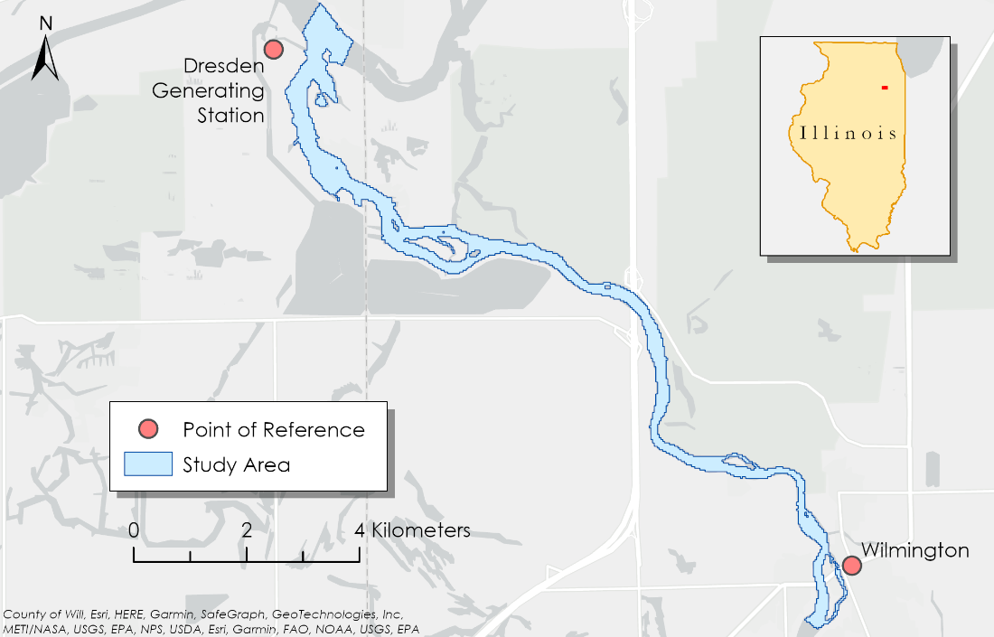

*Figure 1.* Map of the extent of the Kankakee River that was studied. The study area included the river extent from the Wilmington Dam to the intake at Dresden Generating Station.

***2.2 Project Partners & Objectives***

For this project, we partnered with Constellation Nuclear, the energy company that manages the Dresden Generating Station, in collaboration with the USGS Central Midwest Water Science Center. Constellation Nuclear’s main interest in this project is developing predictive capabilities to anticipate grassing events that can clog the intake at the Dresden Generating Station. Prior to the project, Constellation Nuclear was reactively responding to grassing events, with operators manually assessing floating vegetation, and removing it on a case-by-case basis. However, as of summer 2023, they began employing contractors specializing in Unmanned Aerial Vehicles (UAV) to assist in vegetation detection and removal within the Kankakee River near the intake.

Three main objectives were derived for this project based on our partners’ concerns. The first objective was to assess the feasibility of using Earth observations (EO) to detect FAV. To assess the feasibility, a portion of the project consisted of an initial case study comparing the performance of various EO along with various indices to determine the extent to which remote sensing can be used for this application. Second, we aimed to analyze environmental trends to identify predictive measures for anticipating future grassing events in the Kankakee River. Finally, the third objective was to develop a reproducible workflow and tutorial for future partner use. By establishing these objectives, this project aimed to strengthen the predictive capabilities surrounding large grassing events, thus allowing for more reliability in the operation of the Dresden Generating Station and provide a deeper insight into the hydrography of the Kankakee River. The results of these objectives will include static maps that locate FAV and quantitative relationships pertaining to environmental trends that will aid Constellation Nuclear in discerning where aquatic grasses are originating and what triggers their upheaval.

# 3. Methodology

***3.1 Data Acquisition***

For this project, we acquired imagery scenes from multiple EO and a variety of sources (Table 1) to determine which could best detect FAV in the Kankakee River. Each EO has its own respective strengths and weaknesses based on spatial, temporal, and spectral resolution. Due to the needs of our partners, we also took availability into consideration when testing EO. Scenes from NASA’s Landsat satellites and the European Space Agency (ESA)’s Sentinel satellite are free to acquire and easy to use, while commercial satellite data such as Planet’s Super Dove images and Maxar’s WorldView-3 images are housed behind a paywall and require additional acquisition steps. This meant that each EO required an independent acquisition workflow, and furthermore, each workflow was weighed along with the results in our analysis when assessing feasibility.

We acquired Landsat 9 OLI-2, Landsat 8 OLI, Sentinel-2 MSI, DOVE PlanetScope, and WorldView-3 imagery between May 1, 2022, and September 30, 2022, from USGS EarthExplorer, ESA Copernicus, Planet Explorer, and through a data request with Maxar, respectively (Table 1). We obtained surface reflectance scenes containing blue, green, red, and NIR spectral bands. Additionally, we initially only excluded images that contained 100% cloud cover over the entire scene because we intended to visually assess the cloud cover extent within the study area to avoid excluding scenes in which the small study area extent was clear.

For the environmental parameters, we acquired data from USGS and NASA. We selected daily water data from the USGS Water Data portal, between May 1, 2022, and Sept 30, 2022, that included gage height, river discharge, and water temperature. The tab-separated output format was collated and exported into an Excel worksheet. The daily precipitation data from GPM IMERG were downloaded from the Goddard Earth Science Data and Information Service Center (GES DISC). The data contained a raster of daily average precipitation accumulation for each day during the study period. The data was averaged over the study area for each day, and appended to a list that was then exported as a Comma Separated Values (CSV) file. This file represented the daily average precipitation accumulation over the study area for each day of the study period. This dataset was then utilized in the environmental trends analysis to compare precipitation to detected aquatic vegetation. Finally, MODIS-derived daily cloud cover fraction data for the study area was acquired through NASA Earth observations (NEO), which was similarly averaged over the study area and exported as a CSV.

Table 1.

*Description of Earth observations and ancillary data sets used. Spatial resolution, revisit time, and a brief description of use are included for each Earth observation.*

|  |  |  |  |  |
| --- | --- | --- | --- | --- |
| **Data Set** | **Spatial Resolution** | **Revisit Time** | **Description** | **Source** |
| Landsat 9/8 OLI-2/OLI | 30 m | 8 days | Surface reflectance: used to detect FAV. | USGS EarthExplorer |
| Sentinel-2 MSI | 10 m | 5 days | Surface reflectance: used to detect FAV. | ESA Copernicus |
| PlanetScope | 3 m | 1 day | Surface reflectance: used to detect FAV. | Planet Explorer |
| WorldView-3 | 1 m | 1 day | Surface reflectance: used to visually inspect patches of aquatic vegetation at a high spatial resolution. | Maxar |
| GPM IMERG | 10 km | 30 minutes | Precipitation data: used to study spatiotemporal trends. | GES DISC |
| USGS Gage Data | N/A | N/A | Water data: used to study spatiotemporal trends. | USGS Water Data |
| MODIS-Derived Cloud Cover Fraction | 10 km | 1 day | Percent cloud penetration data: used to study spatiotemporal trends. | NEO |

***3.2 Data Processing***

Prior to data analysis, the main data processing steps included further cloud cover assessment as well as river delineation. After acquiring the data, we assessed each scene for cloud cover and subsequently excluded scenes exceeding 5% cloud cover from the analysis within the study area, which, in some cases, largely limited the number of scenes available for analysis. We also determined that the WorldView-3 scenes were too unreliable for analysis due to high cloud cover and most scenes cutting off the study area due to the swathe extent. Some WorldView-3 scenes were utilized for qualitative identification of FAV and comparison to other EO, but none were formally used in the final analysis.

Dissimilarly to assessing cloud cover, delineating the river boundary was a difficult task due to FAV’s spectral similarity to riparian vegetation, leading to some stretches of the river to be incorrectly classified as land area in initial methods where high amounts of aquatic vegetation were present. Therefore, we developed an algorithm to iterate through all scenes within the study area and period, classifying land pixels as those that were consistently above an NDVI threshold of 0.1 for the entire study period. The NDVI threshold was determined via a visual exploration of a cell value histogram created from NDVI processed Landsat 8/9 scenes in ArcGIS Pro and it is important to note that this threshold could vary depending on the time period and EO of interest. If a cell at a certain location within the study area shifted below the threshold at any time during the study period or vice versa, we considered this cell to be within the water boundary and potentially carrying FAV at certain time steps. Before we applied the masking algorithm to each scene to delineate the river boundary, each scene was clipped to a polygon that roughly outlined the study area (Figure 2).

*Figure 2.* A comparison between the initial rough study area polygon extent and the final land mask using a Landsat scene from June 9th, 2022.

***3.3 Data Analysis***

To understand the feasibility of using EO to detect FAV associated with grassing events in the Kankakee River, we first conducted a case study of the July 2022 grassing event that led to major disruptions in power generation for the Dresden Generating Station. The purpose of this initial case study was to identify which EO was feasible for use in this application of FAV by calculating multiple remote sensing indices designed to detect vegetation and comparing the results for each EO. We calculated the vegetation indices for all scenes from each EO using a variety of Python 3 libraries including NumPy and Rasterio. For each index, the Python script iterated through all EO images in the dataset and generated a new raster containing the index value at each cell location using the relevant index formula (Table 2). NDVI is used to quantify vegetation greenness and is useful in understanding vegetation density and assessing changes in plant health (Al-lami et al., 2021). EVI is useful in high leaf area index (LAI) regions where NDVI may saturate (Costa et al., 2021). SAVI is used to correct Normalized Difference Vegetation Index (NDVI) for the influence of soil brightness in areas where vegetative cover is low (Costa et al., 2021). GCI is used to estimate leaf chlorophyll content across different plant species (Al-lami et al., 2021).

We determined the optimal index for this application out of the four tested from the generated collection of index-processed raster images by comparing the histograms of values for each index to understand how many pixels of aquatic vegetation were detected by each EO and index combination. Each histogram was assessed based on its shape and how normally distributed it was to determine how well it could distinguish pixels of water from pixels of vegetation. Based on the resulting histograms, a threshold was derived for each index that could be used to classify water pixels and aquatic vegetation cells within the satellite imagery. A qualitative assessment comparing patches of vegetation identified through false color infrared composite images to the vegetation classified by the threshold was done to determine how accurate each threshold was for classifying cells.

Table 2.

*Description of vegetation indices used in this study.*

|  |  |
| --- | --- |
| **Index** | **Formula** |
| Normalized Difference Vegetation Index (NDVI) | $$((NIR-Red))/((NIR+Red))$$ |
| Enhanced Vegetation Index (EVI) | $$2.5⋅((NIR-Red))/((NIR+2.4⋅Red+1))$$ |
| Soil-Adjusted Vegetation Index (SAVI) | $$((NIR-Red)/(NIR+Red+L))⋅(1+L)$$ where L = 0.5 |
| Green Chlorophyll Index (GCI) | $$((NIR/Green)-1)$$ |

Another part of this project aimed to identify various environmental trends associated with grassing events that impeded the intake at the Dresden Generating Station. Following the case study, we analyzed environmental factors that are mostly associated with grassing events. Through visual qualitative assessment of each EO, we found Landsat to be feasible for detecting aquatic vegetation based on its ability to resolve vegetation patches, despite a moderate spatial resolution, and therefore solely used Landsat for the environmental trends analysis. We first plotted FAV presence together with each environmental metric to visually identify potential patterns in the data. Then, we calculated correlation coefficients (Appendix C) to quantify the strength of the relationship between each environmental metric and FAV presence generated from each vegetation index. Upon these results, we were able to investigate potential hypotheses related to grassing events by pairing evidence from the correlation coefficients as well as time-series visualizations of the environmental metrics. Finally, it is important to note that since all vegetation indices performed similarly to one another, we decided to investigate hypotheses surrounding mechanisms for grassing events solely with NDVI cell counts, as this index is the most universally known to the remote sensing community.

# 4. Results & Discussion

***4.1 Analysis of Case Study Results***

After a preliminary analysis, positive and negative attributes were determined for each EO based on a qualitative assessment of false color infrared images compiled from various scenes across the EO. Each scene was assessed for its ability to resolve patches of aquatic vegetation, and the assessments were compared across EO to determine if different spatial resolutions led to more or less accurate vegetation detection for this application. We considered Landsat 8 and Landsat 9 to be the most ideal satellites for multiple reasons. First, despite concerns about the lower spatial resolution, similar vegetation patches were identified compared to the higher resolution EO (Figure 3). Second, the Landsat program has a long historical archive, allowing for an expanded study period in future partner work. And finally, Landsat data is free and easy to acquire using USGS EarthExplorer. With that said, there are some disadvantageous aspects of using Landsat. The moderate temporal resolution that it provides results in a small number of total scenes within the study period to analyze (six in total for the summer of 2022). Additionally, the 30 m spatial resolution resulted in inaccuracies at the river boundary via spectral mixing of land and water area, potentially reducing the overall precision in the environmental trends analysis results.

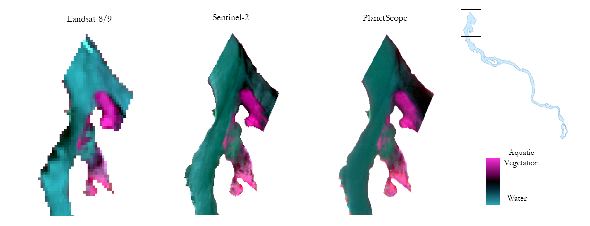*Figure 3.* Comparison between false color infrared images from various EO at the confluence of the Kankakee, Illinois, and Des Plaines Rivers. Includes copyrighted material of Planet Labs PBC. All rights reserved.

For Sentinel-2 and PlanetScope, the list of positive and negative attributes largely differed from that of Landsat 8 and Landsat 9. With Sentinel-2, the spatial resolution is higher than Landsat and closer to PlanetScope, providing more detail in quantifying the presence of aquatic vegetation. Similar to Landsat, Sentinel-2 data is available at no cost through the ESA’s Copernicus program. However, despite the accessibility of the data, it was determined that the availability for Sentinel-2 data was relatively poor over the study period due to cloud cover filtering restrictions when requesting data, resulting in an even smaller number of scenes for the summer of 2022 compared to Landsat. As for PlanetScope, the high spatial and temporal resolution provided increased precision, but PlanetScope data is costly to acquire and only contains four bands—visible blue, green, red, and near infrared—giving it much lower spectral flexibility than the other EO. By comparing the positive and negative attributes of each EO, it was determined that Landsat 8 OLI and Landsat 9 OLI-2 were the most ideal for this project. This determination was based heavily on partner needs, which emphasized historical data availability and data accessibility. Furthermore, Landsat scenes were determined to be feasible in detecting aquatic vegetation within the study area and there were enough scenes available over the study period to provide data points to support preliminary results from the environmental trends analysis.

Once Landsat was deemed feasible for identifying patches of aquatic vegetation, we proceeded with determining which vegetation index would be best at quantifying the extent within the Kankakee River (Appendix A). Through visual inspection of various histograms of values generated from each index over all Landsat scenes (Figure 4), we looked for areas of the histogram that separate water and vegetation cells. Qualitative assessment suggested that NDVI is most likely to accurately classify pixels into the aforementioned categories, while the scenes calculated using GCI produced the least accurate threshold due to heavy left skewing, resulting in over classifying water cells. Therefore, we moved forward with NDVI vegetation detections for the environmental trends analysis.

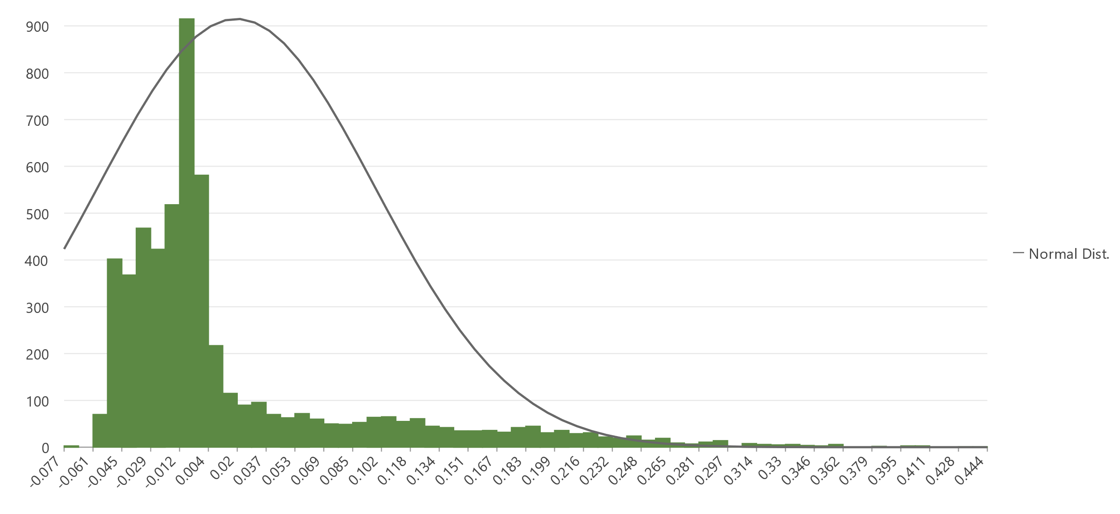

*Figure 4.* Histogram of cell values for NDVI image derived from a Landsat scene taken on June 9th, 2022.

From NDVI processed Landsat imagery within the Kankakee River boundary, general areas of aquatic vegetation were visualized (Figure 5). We found large swaths of aquatic vegetation congregating in the pond across from the Dresden Generating Station and on the bank of the Des Plaines River near its confluence with the Kankakee River. Several other areas of vegetation are shown upstream from the intake; however, they occur close to river boundaries, so it is difficult to confirm that these areas of vegetation should be considered aquatic as opposed to riparian.

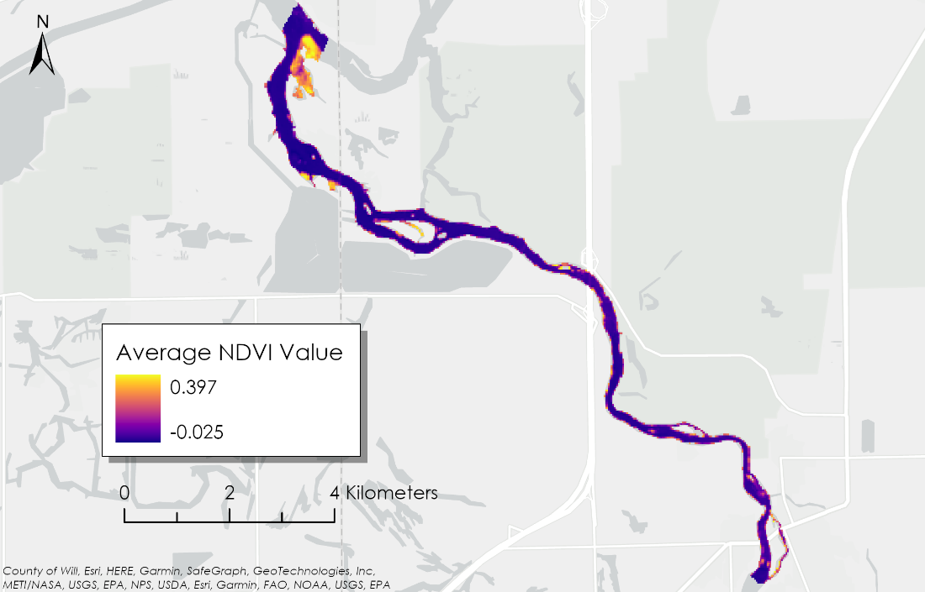

*Figure 5*. A map showing a raster of the average NDVI value of each cell over the study period and the study area where one equals fully vegetated and negative one equals no vegetation detected.

***4.2 Analysis of Environmental Trends Results***

Informed by results of the case study analysis, the environmental trends analysis was conducted using cell counts of detected aquatic vegetation from the Landsat scenes over the study period. Visual assessment of the initial time series produced by comparing vegetation cell count and several environmental factors suggested a variety of preliminary ideas (Appendix B). First, no visual correlation could be identified between cell count and water temperature, precipitation, or cloud cover. There was a discernible correlation between precipitation and cloud cover, which was expected, but among water temperature, precipitation, and cloud cover, it was unclear through a visual assessment of the data if any potential patterns were present between these metrics and the presence of aquatic vegetation. However, we noticed a potential negative relationship between cell count and discharge which was later confirmed through our correlation analysis (Figure 6). Furthermore, an extended period of abnormally low flow, when compared to other summers, was observed prior to the grassing event (sub-2,000 cubic feet per second [cfs] for 30 days).

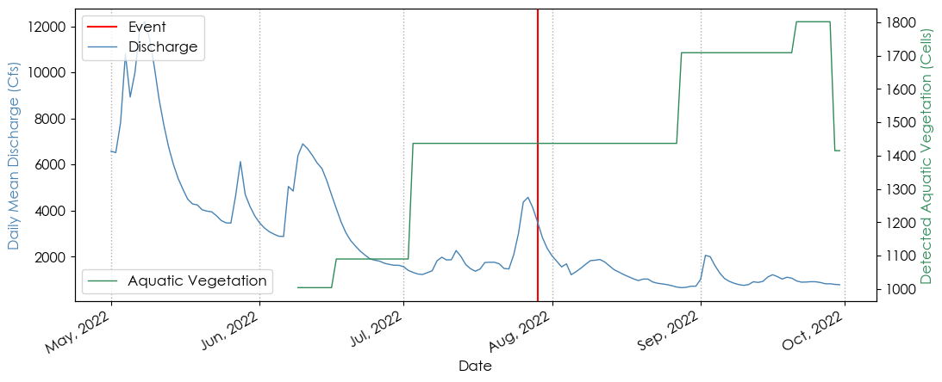

*Figure 6*. A time series graph comparing daily mean discharge to the count of pixels detected as aquatic vegetation using Landsat scenes and NDVI over the study period.

To statistically analyze the environmental factors and their relationship to FAV, a correlation coefficient (Appendix C) was calculated between each factor and the cell count of detected aquatic vegetation for each index over the study period (Table 3). Of the factors that a coefficient was calculated for, gage height and water temperature both had weak correlations across the board. Precipitation and cloud cover had similar coefficients to one another due to the expected correlation between them, and they both had moderate positive correlations with cell count. With that said, cloud cover and GCI cell count had the lowest coefficient among precipitation and cloud cover at 0.374. The strongest correlation coefficient observed was between discharge and EVI cell count, which had a coefficient of –0.881. Across all indices, discharge had a strong negative correlation of at least –0.85 for the summer of 2022. This confirms the aforementioned observed negative relationship between discharge and detected aquatic vegetation.

Table 3

*Correlation coefficients calculated between cell count of aquatic vegetation detected using Landsat data and environmental trends over the study period divided by index.*

|  |  |  |  |  |
| --- | --- | --- | --- | --- |
|  | **NDVI** | **EVI** | **GCI** | **SAVI** |
| **Discharge** | -0.875 | -0.881 | -0.855 | -0.876 |
| **Water Temperature** | 0.291 | 0.287 | 0.272 | 0.291 |
| **Cloud Cover** | 0.449 | 0.403 | 0.374 | 0.443 |
| **Precipitation** | 0.513 | 0.493 | 0.445 | 0.514 |
| **Gage Height** | -0.276 | -0.224 | -0.175 | -0.270 |

Multiple potential hypotheses can be theorized regarding the negative relationship between river discharge and aquatic vegetation detection. First, it could be that grassing events are caused by an extended period (30 days) of low discharge that is sub-2,000 cfs, leading to grasses being released prematurely from the riverbed in large quantities, compared to natural lifecycles of the plant, and accumulating downstream at the Dresden Generating Station's intake. Alternatively, when the river experiences low discharge, vegetation that is rooted in place which is usually submerged may be exposed, thus leading to more overall aquatic vegetation being detected within the scene. If this is the case, it may be hypothesized that there is no systematic environmental cause of large-scale grassing events in the Kankakee River and rather they are occurring at a local scale due to other factors such as backflow, boating wakes, built infrastructure, or other hydrologic mechanics. Due to the limitations inherent to the methods, it is difficult to definitively support one hypothesis over another.

***4.3 Feasibility Assessment***

While it was determined that it was feasible to detect aquatic vegetation using Landsat scenes and NDVI overall, there are several limitations that are relevant to our partner’s needs. First, due to the low temporal resolution of Landsat, it was difficult to track the precise movements in detected aquatic vegetation. This means that it is difficult to identify origins of FAV simply due to the inability to discern between FAV that contributes to grassing events and submerged vegetation that remains held in place. This poses a major challenge for Constellation Nuclear going forward in their attempts to predict future grassing events that halt the water intake at the Dresden Generating Station.

Similarly, spectral similarities in vegetation on the ground led to an inability to resolutely differentiate between aquatic and riparian vegetation, limiting our accuracy in definitively delineating the river boundary. The classification algorithm that we created paired with manual editing in ArcGIS Pro obtained a river boundary to a level of accuracy that we were comfortable with in moving forward with the analysis. Pixels containing riparian vegetation or small-scale islands within the river could have been incorrectly classified as water pixels due to fluctuations in water levels. This limitation would be difficult to overcome with just the use of EO, as there is only so much information that can be discerned from satellite imagery. Without proper ground control to refine methods in river delineation, the reliability of the analysis comes into question especially when the partners want to consider longer reaches of the river and therefore automated methods are ideal.

Finally, due to low temporal resolution over the study period because of Landsat’s low revisit period and high cloud cover in the area, the amount of data points available to support the environmental trends analysis was limited. With limited data points, the conclusions drawn from this analysis should be taken with caution and may not provide adequate significance regarding the causes of grassing events. Another limitation that arose due to the low temporal resolution was the inability to detect vegetation movement between pixels in the results. Without being able to determine whether vegetation was moving spatially and temporally, it cannot be concluded that the detected aquatic vegetation is the same vegetation blocking the intake at the Dresden Generating Station.

Despite limitations of the methods that preclude definitive conclusions from being drawn regarding the partner objectives, the results presented in this paper demonstrate a feasibility for the use of EO and remote sensing for this application if these limitations can be addressed in future work. Furthermore, the end users can utilize methods presented here and expand on them to address their needs as these methods provide the groundwork necessary for further investigation into potential mechanisms surrounding grassing events in the Kankakee River.

***4.4 Future Work***

Based on the results presented, and the limitations discussed, several future directions were determined for this specific topic. Recreating the analysis with similar parameters and methods, but higher temporal resolution could provide more concrete results. This could be achieved by combining EO or using an EO with a high revisit period. More temporally resolute data would allow for more concrete conclusions to be drawn about the relationships between environmental factors and the aquatic vegetation detected from the EOs providing Constellation Nuclear more insight into the mechanisms causing these grassing events. For example, applying various time shifts to the data when calculating the correlation coefficient could allow partners to obtain an optimal cross-correlation and therefore identify proper time-lags between environmental changes and grassing events. Additionally, data with higher temporal resolution would lead to a greater ability to track the movement of aquatic vegetation and locate spatial origins of FAV.

Future research into the topic of grassing events in the Kankakee River can also be conducted in the form of localized tools providing ground truth and in-situ observations. The continued utilization of UAVs to provide a more accurate spatial assessment of where grasses are located could be highly beneficial to partners. Field surveys of grasses to build a more complete profile of the ecological system could provide background insight to support conclusions made by the environmental trends analysis. Finally, in-situ water quality monitoring may be able to further explain why grassing events occur. Pairing observations made through in-person research with the methods utilizing remote sensing and EO outlined in this paper could provide the partners at Constellation Nuclear and the USGS Central Midwest Water Science Center with a more holistic understanding of the problem.

# 5. Conclusions

The detection of floating aquatic vegetation using Earth observations and remote sensing indices could be a crucial method in the toolbox used to address problems faced by the Dresden Generating Station. The project partners at Constellation Nuclear and USGS Central Midwest Water Science Center could expand on the methods discussed to support efforts in resolving operational challenges that grassing events pose towards the station. This paper posits that it is feasible to utilize Landsat 8 OLI and Landsat 9 OLI-2 Earth observations in combination with NDVI calculations to detect aquatic vegetation in the Kankakee River. Furthermore, the results suggest that the SAVI and EVI perform similarly in detecting aquatic vegetation. The use of other EO such as ESA’s Sentinel-2 and commercial satellites like PlanetScope DOVE and WorldView-3 was explored for this application, but further research would need to be done to confirm their capacity to support an environmental trends analysis.

The environmental trends analysis was conducted using Landsat scenes and NDVI images along with GPM IMERG precipitation data and in-situ hydrology data from the USGS. The results of this analysis showed a negative correlation between detected vegetation and discharge, along with a moderate positive correlation between precipitation and cloud cover and detected vegetation. Multiple hypotheses could be used to explain these correlations, but due to limitations inherent to the methods used, no definitive conclusions can be made. Future work done by the project partners utilizing the methods outlined in this paper that incorporates data with higher temporal resolution and ground truthing is strongly encouraged to continue supporting the problem-solving initiatives at the Dresden Generating Station

# 

# 6. Acknowledgements

The Kankakee Water Resources team would like to thank our partners from Constellation Nuclear and USGS Central Midwest Water Science Center. We also would like to thank our science advisor Dr. Austin Madson, for providing research and methods support throughout the duration of the project, as well as our DEVELOP Fellow Caroline Williams who provided a massive amount of support across all facets of the project. Thank you to Cecil Byles and the other DEVELOP Fellows who provided feedback throughout the duration of this project.

This material contains modified Copernicus Sentinel data 2022, processed by ESA.

This work utilized data made available through the NASA Commercial Smallsat Data Acquisition (CSDA) program.

DigitalGlobe/Maxar data were provided by NASA’s Commercial Archive Data for NASA investigators (cad4nasa.gsfc.nasa.gov) under the National Geospatial-Intelligence Agency’s NextView license agreement.

Includes copyrighted material of Planet Labs PBC. All rights reserved.

Any opinions, findings, and conclusions or recommendations expressed in this material are those of the author(s) and do not necessarily reflect the views of the National Aeronautics and Space Administration.

This material is based upon work supported by NASA through contract NNL16AA05C.

# 

# 7. Glossary

**Cold-Water Intake** –The part of a water-cooling system that intakes the cold water, usually from a river or large body of water.

**Confluence** –Where two or more streams of water come together to form a single stream.

**Correlation Coefficient** – A numerical value that represents how closely related two variables are. The closer to one a coefficient is, the more strongly positively correlated the two variables are; the closer to negative one a coefficient is, the more strongly negatively correlated the two variables are; zero represents no correlation.

**EVI** – Enhanced vegetation index; a remote sensing index that is useful for quantifying vegetation greenness.

**Earth observations** – Satellites and sensors that collect information about the Earth’s physical, chemical, and biological systems over space and time.

**False Color Infrared** –An image composed of green, red, and near infrared bands in a given scene that distinctly visualizes vegetation.

**Floating Aquatic Vegetation (FAV)** –Aquatic vegetation that has grown to the surface of a body of water or been released from its rhizome, floating on the surface, thus primarily reflecting electromagnetic waves (as opposed to water reflecting the waves).

**GCI** –Green chlorophyll index; a remote sensing index that is useful for detecting the presence of chlorophyll within a particular cell.

**Grassing Event** –The rapid growth, die-off/release, or both, of aquatic vegetation at seasonally abnormal times.

**MODIS** – Moderate Resolution Imaging Spectroradiometer.

**NDVI** –Normalized difference vegetation index; a remote sensing index that is useful for classifying vegetation and evaluating vegetation health.

**Near Infrared (NIR)** –The portion of the electromagnetic spectrum that directly follows visible light (780 nm to 2500 nm). NIR waves are generally reflected by healthy vegetation.

**River Delineation** –The process of determining where the boundary between land and water is along a stream. Can be done using remote sensing techniques or through in-situ observation.

**SAVI** –Soil adjusted vegetation index; similar to NDVI but is adjusted for areas where vegetation cover is lower.

**Spatial Resolution** –The real-world equivalent areal size of a cell of a given Earth observation. Typically expressed in the length of one side of a cell.

**Spectral Resolution** –The amount of the electromagnetic spectrum that is captured in a scene of a given Earth observation.

**Submerged Aquatic Vegetation (SAV)** –Aquatic vegetation that grows out of rhizomes buried in the sediment of a body of water but does not reach the surface of the water. May partially reflect electromagnetic waves.

**Temporal Resolution** –The number of scenes over time a given Earth observation can produce. Often dictated by the revisit period of a satellite constellation, as well as cloud penetration and correction capabilities, and data processing and publishing turn-around.

# 8. References

Al-lami, A. K., Abbood, R. A., Al Maliki, A. A., & Al-Ansari, N. (2021). Using vegetation indices for monitoring the spread of Nile Rose plant in the Tigris River within Wasit province, Iraq*. Remote Sensing Applications: Society and Environment, 22*, 100471. https://doi.org/10.1016/j.rsase.2021.100471.

Constellation. (2023). Dresden Generating Station [Fact sheet]. https://www.constellationenergy.com/content/dam/constellationenergy/images/location-sites/nuclear/Dresden%20Generating%20Station_Fact%20Sheet.pdf.

Costa, V.; Serôdio, J.; Lillebø, A.I.; Sousa, A.I. (2021). Use of hyperspectral reflectance to non‐destructively estimate seagrass Zostera noltei biomass. *Ecol. Indic.* 121, https://doi.org/10.1016/j.ecolind.2020.107018.

Dogliotti, A. I., Gossn, J. I., Vanhellemont, Q., & Ruddick, K. G. (2018). Detecting and quantifying a massive invasion of floating aquatic plants in the Río de la Plata turbid waters using high spatial resolution ocean color imagery. *Remote Sensing, 10(7),* 1140. https://doi.org/10.3390/rs10071140.

European Space Agency. (2021). *Copernicus Sentinel-2 pre-Collection-1 MSI Level-2A* (03.01). [Data set]. Copernicus Sentinel-2 (processed by ESA). Retrieved June 26, 2023. https://doi.org/10.5270/S2_-6eb6imz.

Espel, D., Courty, S., Auda, Y., Sheeren, D., & Elger, A. (2020). Submerged macrophyte assessment in rivers: An automatic mapping method using Pléiades imagery. *Water Research*, *186*, 116353. https://doi.org/10.1016/j.watres.2020.116353.

García-Girón, J., Fernández-Aláez, C., Fernández-Aláez, M, and Nistal-García, A. (2018). Changes in Climate, Land use and Local Conditions Drive Macrophyte Assemblages in a Mediterranean Shallow Lake. *Limnetica, 37 (1)*, 159-172. https://doi.org/10.23818/limn.37.13.

Gross, D., Berg, R. (1981). Geology of the Kankakee river system in Kankakee County, Illinois. *ISGS, Environmental Geology Notes 92*.

Huffman, G. J., Stocker, E. F., Bolvin, D. T., Nelkin, E. J., Tan, J. (2019). *GPM IMERG Late Precipitation L3 1 day 0.1 degree x 0.1 degree* (06) [Data Set]. Goddard Earth Sciences Data and Information Services Center. Retrieved June 26, 2023. https://doi.org/10.5067/GPM/IMERGDL/DAY/06.

Lacoul, P., & Freedman, B. (2006). Relationships between aquatic plants and environmental factors along a steep Himalayan altitudinal gradient. *Aquatic Botany, 84*, 3– 16. https://doi.org/10.1016/j.aquabot.2005.06.011.

Planet. (2018). *Planet Application Program Interface: In space for Life on Earth*. [Data set]. Planet Explorer. Retrieved June 26, 2023. https://api.plnaet.com.

Tan, W., Xing, J., Yang, S., Yu, G., Sun, P., & Jiang, Y. (2020). Long term aquatic vegetation dynamics in Longgan Lake using Landsat time series and their responses to water level fluctuation. *Water, 12(8),* 2178. https://doi.org/10.3390/w12082178.

U.S. Geologic Survey. (2020). *Landsat 8-9 OLI/TIRS Collection 2 Level-2 Science Products*. [Data set]. Earth Resources Observation and Science Center. Retrieved June 26, 2023. https://doi.org/10.5066/P9OGBGM6.

Ward, K. (2023). *Cloud Fraction (1 day – Terra/MODIS)*. [Data set]. NASA Earth Observations (comp.). Retrieved July 17, 2023. http://neo.gsfc.nasa.gov/view.php?datasetId=MODAL2_D_CLD_FR.

# 9. Appendices

**Appendix A:** *Index Histograms*

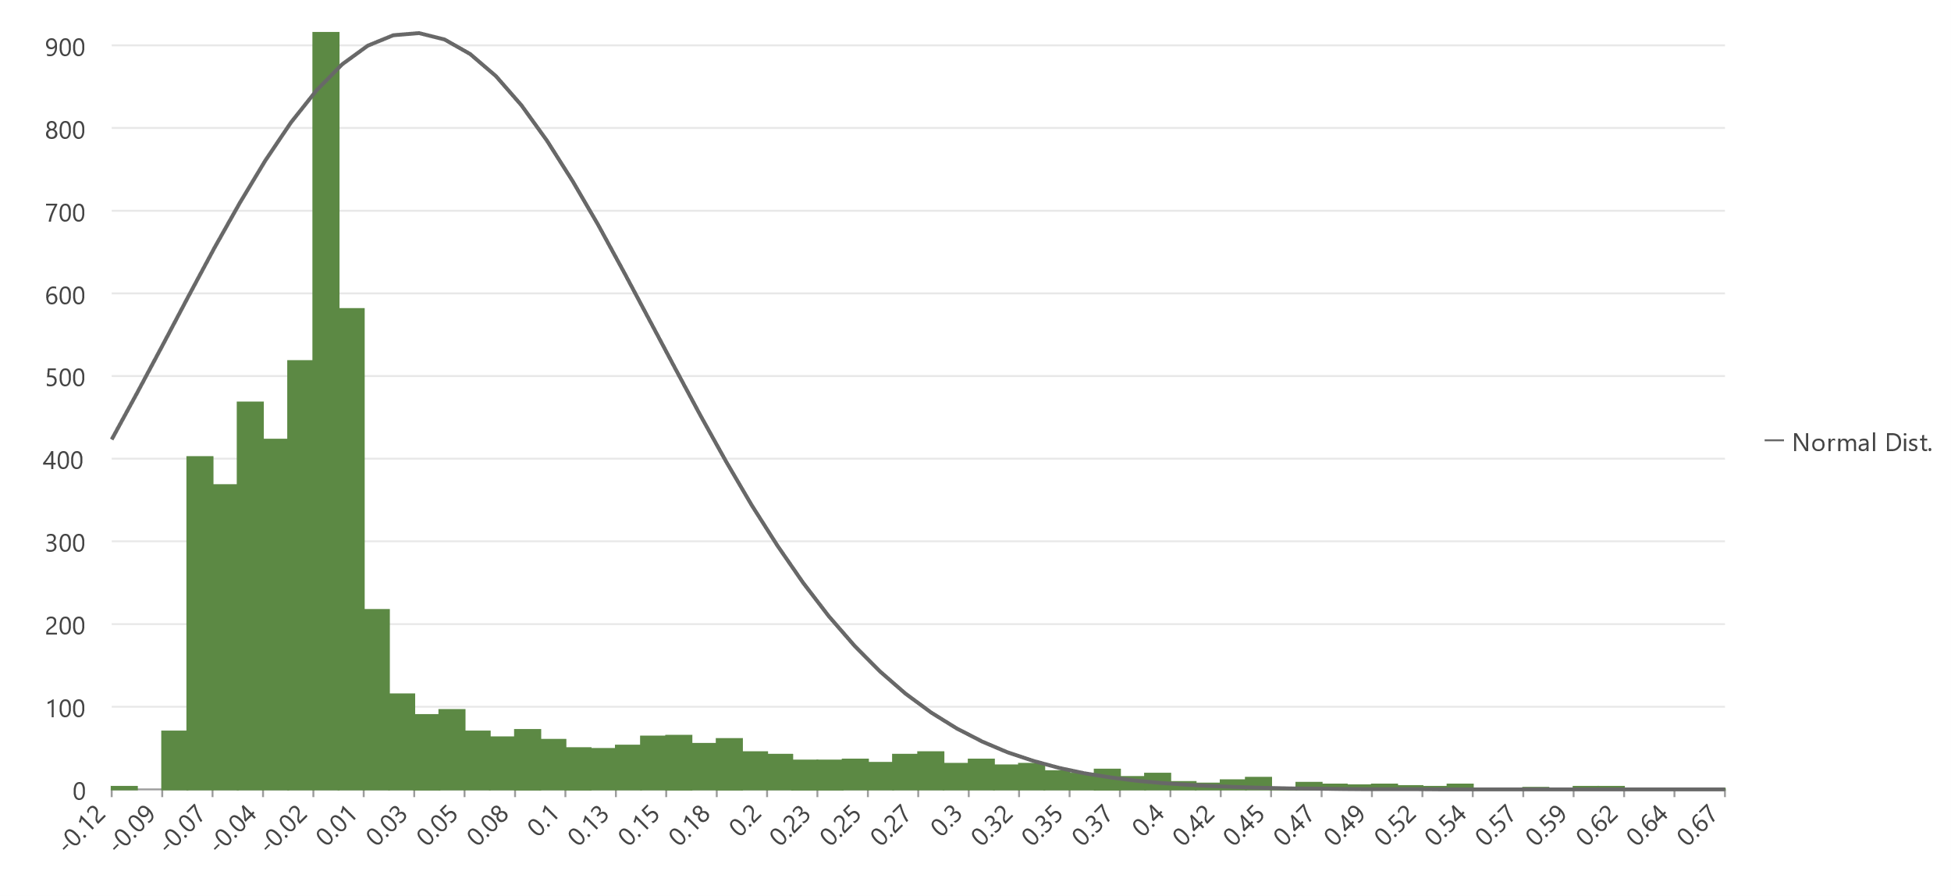

*Figure A1.* A histogram showing the distribution of cell values of a SAVI image calculated from a Landsat scene taken on June 9th, 2022.

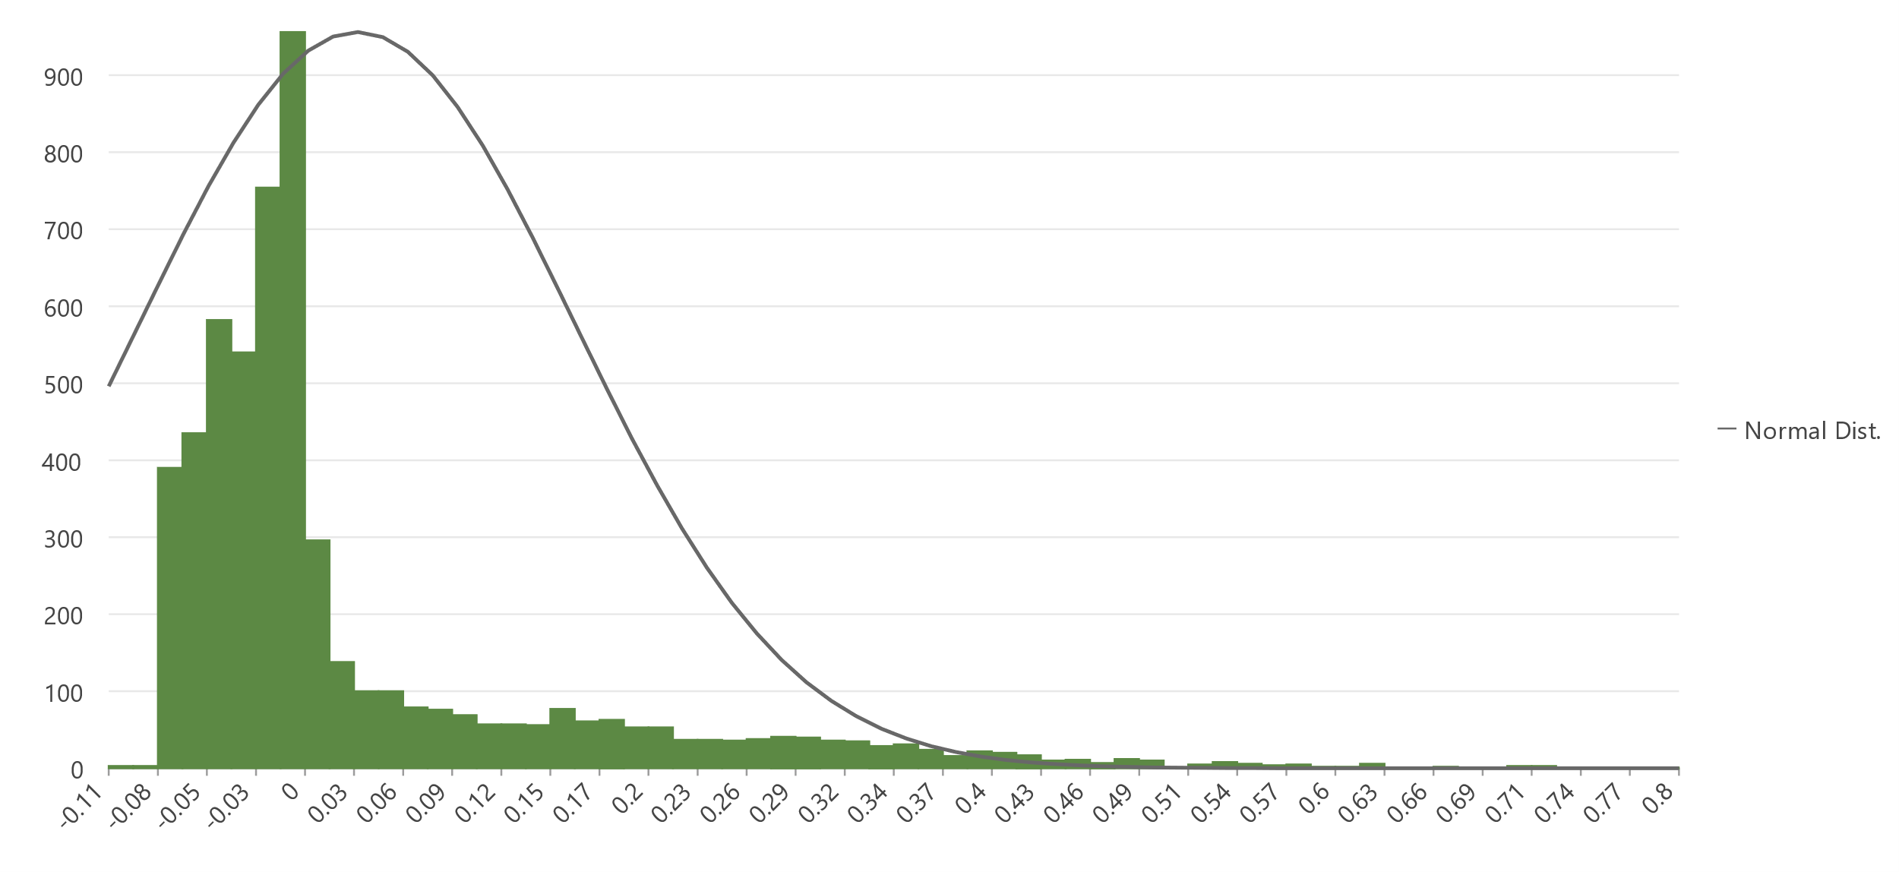

*Figure A2.* A histogram showing the distribution of cell values of an EVI image calculated from a Landsat scene taken on June 9th, 2022.

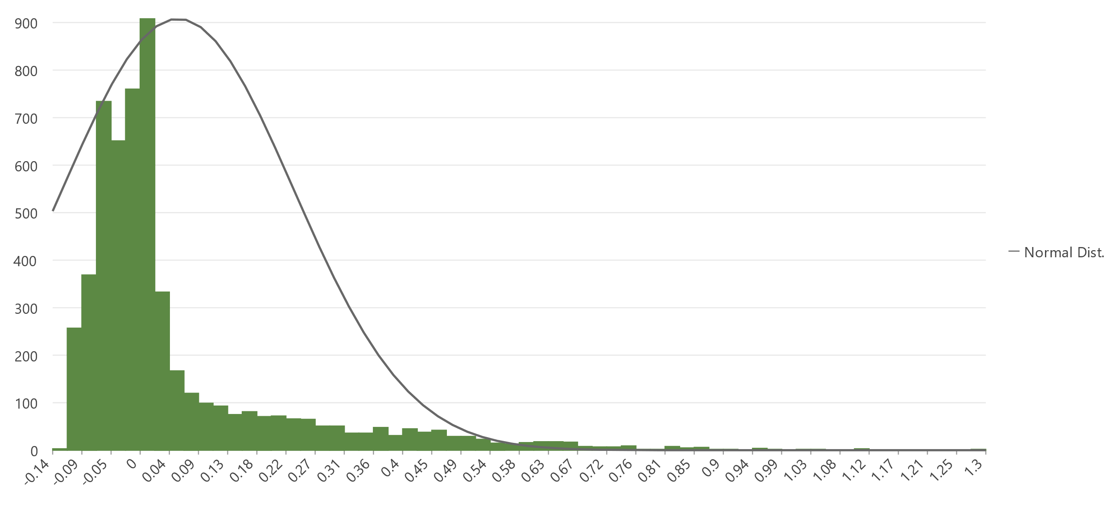

*Figure A3.* A histogram showing the distribution of cell values of a GCI image calculated from a Landsat scene taken on June 9th, 2022.

**Appendix B:** *Environmental Trends Analysis Time Series Graphs*

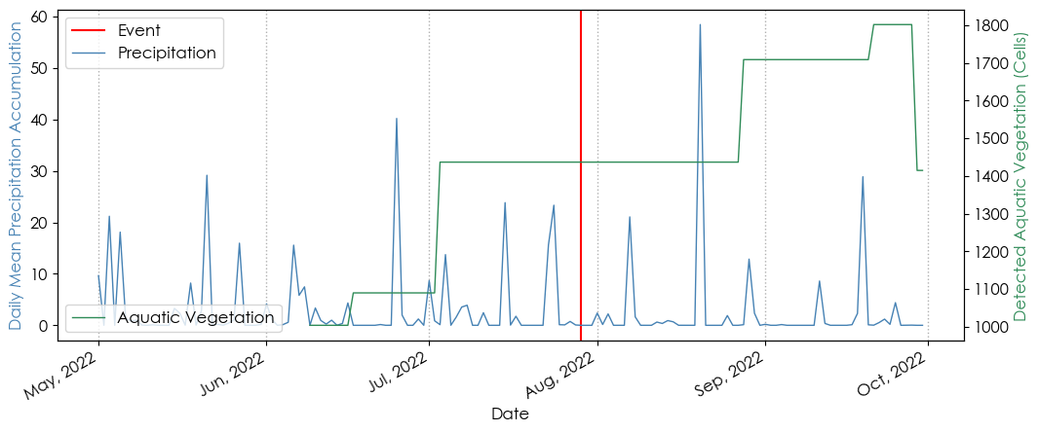

*Figure B1.* A time series graph comparing daily mean precipitation accumulation over the study period to the count of pixels detected as aquatic vegetation using Landsat scenes and NDVI over the study period.

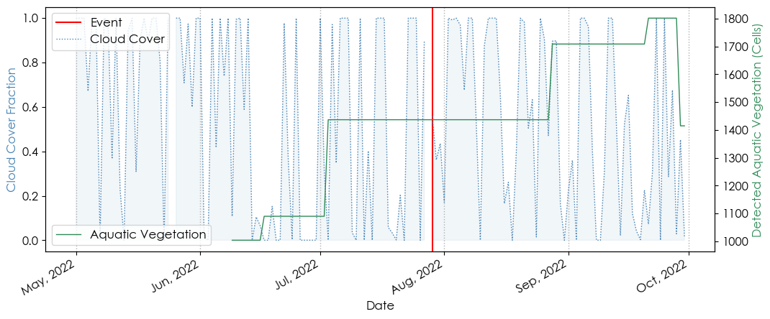

*Figure B2.* A time series graph comparing cloud cover fraction (range representing light being blocked by clouds, where 1 equates to completely blocked, and 0 equates to no light being blocked) to the count of pixels detected as aquatic vegetation using Landsat scenes and NDVI over the study period.

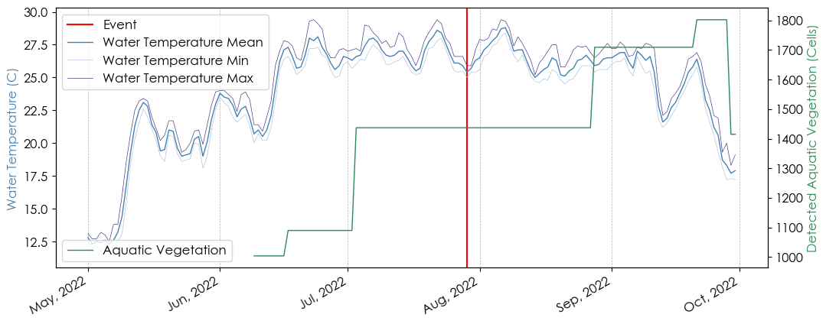

*Figure B3.* A time series graph comparing daily mean, maximum, and minimum water temperature to the count of pixels detected as aquatic vegetation using Landsat scenes and NDVI over the study period.

**Appendix C:** *Statistical Analysis Formulas*

$$r =\frac{{cov}_{x,y}}{σ_{x}σ_{y}}$$

*Equation C1*. The formula for the correlation coefficient that was used to determine the strength of the relationship between detected aquatic vegetation and each environmental parameter, where r equals the correlation coefficient, covx,y is equal to the covariance (Equation C2), sigma x is equal to the standard deviation of an environmental trend time series and sigma y is equal to the standard deviation of a detected aquatic vegetation time series.

$${cov}_{x,y} =\frac{1}{n}\sum{}(x-\underline{x})(y-\underline{y})$$

*Equation C2.* The formula for the covariance of two variables that is used as an input in the formula for the correlation coefficients (Equation C1), where n is equal to the sample size, x is equal to an environmental trend time series, y is equal to a detected aquatic vegetation time series, and the bar variables are equal to the mean of each respective data set.