**NASA DEVELOP National Program**

****NASA John C. Stennis Space Center

**Fall 2015**

**Short Title: Southern Rockies Ecological Forecasting**

**Subtitle:** Using NASA Earth Observations to Identify and Predict Suitable Mule Deer Habitats

**VPS Title:** Helping Wildlife Managers Assess Mule Deer Habitat Quality

**Project Team & Partners**

**Project Team:**

Ross Reahard (Project Lead), ross.r.reahard@nasa.gov

Teresa Fenn

Jeri Wisman

**Advisors & Mentors:**

Joseph Spruce (NASA Stennis Space Center)

Dr. Kenton Ross (NASA Langley Research Center)

**Partner Organizations:**

Southern Rockies Landscape Conservation Cooperative (End-User), POC: John Rice

Western Association of Fish and Wildlife Agencies (WAFWA) Mule Deer Working Group (End-User) POC: Jim Heffelfinger

**Project Details**

**Applied Sciences National Application Addressed:** Ecological Forecasting

**Study Area:** Mule Deer Winter Range within the Southern Rockies Landscape Conservation Cooperative (ID, WY, UT, CO, AZ, NM)

**Study Period:** 2005 - 2014

**Earth Observations & Parameters:**

Aqua and Terra, MODIS – Phenology products, vegetation indices

Landsat 5, TM – Land cover classification, vegetation indices

Landsat 8, OLI – Land cover classification, vegetation indices

SRTM and ASTER – elevation data

Terra, ASTER – Global elevation datasets, phenology products, vegetation indices

**Ancillary Datasets Utilized:**

* NRCS 2011 NLCD – Land cover
* ForWarn System – MODIS phenology
* Monitoring Trends in Burn Severity (MTBS) – Fire perimeters
* Utah State University’s RS/ GIS Lab – Mule deer habitat maps

**Models Utilized:**

* Lifemapper Species Distribution Modeling (LmSDM)

**Software Utilized:**

ERDAS IMAGINE – raster data analysis, image enhancement and land cover classification of multispectral data from Landsat and MODIS

ArcGIS – raster manipulation/analysis, image enhancement & map creation of Landsat ETM+, NPP VIIRS, Aqua/Terra MODIS

**Project Overview**

**80-100 Word Objectives Overview:**

Mule deer numbers are declining in the Southwestern US and this decline is related to decrease in habitat quality. With ever-increasing amounts of habitat loss and degradation due to anthropogenic activities among ungulate habitats, wildlife managers are concerned about the availability of future mule deer habitats, especially wintering habitat. In response, this project was conducted to aid assessment of mule deer habitat in the Southern Rocky Mountains, using NASA Earth. Project products will include a predictive geospatial habitat quality model will assist end-users in prioritizing habitats for conservation and restoration. The impact of fire disturbances on habitat quality was also explored using land cover and phenology products.

**Abstract:**

Mule deer, *Odocoileus heminonus*, is a migratory ungulate species found in the western region of the US. Mule deer play a major role in ecosystem processes of the region and serve as an important indicator of ecological integrity. With increasing impacts from anthropogenic activities, changes in mule deer populations reflect changes can be related to habitat change that in turn can affect a broad range of wildlife species. Improved mule deer habitat maps provide more insights into the current and future habitat availability that resource managers can use in management and planning. The quantification of mule deer habitat quality remains a key information gap. . In response, this project used NASA Earth observations to characterize the land utilized by the deer during the winter months. Project end-users indicated that recently burned habitats may provide improved high quality mule deer habitat. However, there is a question as to how much of wintering range has been burned and what is the condition of this burned habitats; Consequently, MODIS NDVI phenology data from the ForWarn System was used to burned habitat within the study area. SRTM and ASTER digital elevation model datasets were used to characterize the elevation of the winter range. Landsat 5 TM and Landsat 8 OLI land cover datasets provided current and historical land cover to describe the forage within the habitats. PRISM datasets were used to describe the monthly precipitation amounts and temperature. MODIS snow data was also considered. By correlating these NASA Earth observations, this project developed a habitat suitability model to determine characteristics of mule deer winter range habitats. The products will enable resource decision-makers to determine appropriate areas for conservation and restoration.

**Community Concerns:**

* John Rice, the Science Coordinator of the Southern Rockies LCC, expressed a need for the development of remotely sensed data utilization that will aid decision-makers in characterizing and managing habitat quality.
* Mule deer populations are declining yet play a vital role in the processes of their ecosystems and are an important ecosystem indicator species.
* Increased levels of human development in mule deer habitats have demonstrated behavioral changes in deer habitat use.
* Fires can provide either negative or positive effects on mule deer habitat. Conservationists would like to determine how fire disturbances have provided quality habitats in order to develop better prescribed burn plans.

**Current Management Practices & Policies**:

Currently, land managers use ground surveys to identify suitable habitats. This is limiting because the information used does not provide a comprehensive understanding regarding how and when the mule deer are using different habitat patches. John Rice expressed the need for a landscape-scale solution that will allow for the development of a predictive habitat model based on historic and recent mule deer migrations.

**Decision Support Tools & Benefits:**

|  |  |  |
| --- | --- | --- |
| **End-Product** | **Earth Observations Used** | **Benefit & Impact** |
| Seasonal Vegetation Phenology | Aqua MODIS  Terra ASTER & MODIS  Landsat 8 OLI  Landsat 5 TM | Prioritization of mule deer land areas to be conserved or restored |
| Foraging Habitat Type and Condition Maps | Aqua MODIS  Terra ASTER & MODIS  Landsat 8 OLI  Landsat 5 TM  ASTER and SRTM DEMs | Prioritization of mule deer land areas to be conserved or restored |
| Mule Deer Range Maps | Aqua MODIS  Terra ASTER & MODIS  Landsat 8 OLI  Landsat 5 TM  ASTER and SRTM DEMs | Prioritization of mule deer land areas to be conserved or restored |
| Species Distribution Model Outputs | Aqua MODIS  Terra ASTER & MODIS  Landsat 8 OLI  Landsat 5 TM  ASTER and SRTM DEMs | Prioritization of mule deer land areas to be conserved or restored |

**Project Imagery**

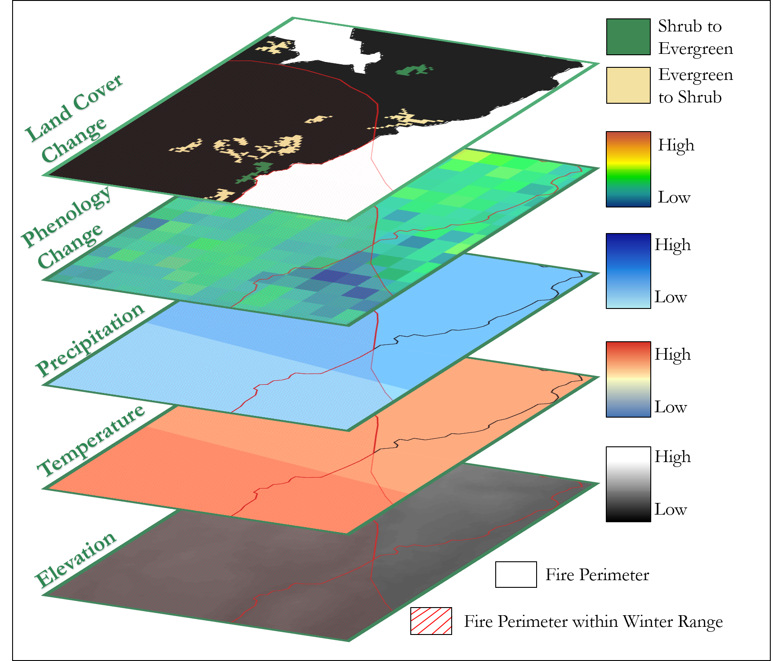

**Caption:** Image showing overlaid layers for this project. Image Credit: Southern Rockies Ecological Forecasting Team.

**Image:** File Name 2015Fall_SSC_SouthernRockiesEco_VPSImage.jpeg

**Software Release Requirements**

Category I