Southern Maine Health & Air Quality

Examining Tick-Borne Illness Risk by Evaluating Land Cover and Tick Habitat Suitability in Southern Maine

 **Technical Report**

Final Draft – August 8th, 2019

Celeste Gambino (Project Lead)

Britnay Beaudry

Madison Berman

Monica Colmenares

Dr. Cedric Fichot, Boston University (Science Advisor)

Dr. Valerie Pasquarella, Boston University (Science Advisor)

Tess McCabe, Boston University (Science Advisor)

John Foster, Boston University (Science Advisor)

# 1. Abstract

Tick-borne diseases are a public health issue in southern Maine, and recent estimates completed by the State of Maine suggest that as little as 1 in 10 cases of Lyme disease are actually reported. There are three tick-borne diseases known to occur in Maine that can be transmitted by the deer tick (*Ixodes scapularis*). Due to the higher prevalence and attention from Maine public health institutions, Lyme disease was the predominant focus in this study. The Massachusetts – Boston NASA DEVELOP team partnered with the Maine Medical Center Research Institute, Lyme & Vector-Borne Disease Laboratory; Maine Vector-Borne Disease Working Group; and Bigelow Laboratory for Ocean Sciences to assist with Maine’s tick-borne disease mitigation efforts. The team utilized NASA data from Landsat 8 Operational Land Imager (OLI), Terra and Aqua Moderate Resolution Imaging Spectroradiometer (MODIS), as well as ancillary datasets, from January 2008 to June 2019. Accurate land cover and tick-borne disease risk maps were created for Cumberland County, Maine. The land cover maps allow for improved public awareness of areas conducive to tick encounter. The risk maps illustrate how variations in temperature and humidity contribute to the spatial distribution of tick-borne illness risk and determine the estimated number of actual Lyme disease incidents per year in every town. In addition, the team created a time series analysis that informs the end user’s research related to the impact of environmental parameters on tick distribution.

**Keywords**

remote sensing, ticks, vector-borne illnesses, land cover, MODIS, Landsat

# 2. Introduction

* 1. ***Background Information***

As the climate continues to change, allowing ticks to thrive in new habitats, communities are becoming increasingly concerned by the spread of tick-borne illnesses. Lyme disease (LD) is the most common tick-borne disease in temperate zones of the Northern Hemisphere. The most common agent known to cause LD in North America is *Borrelia burgdorferi*, which is transmitted from mammal to mammal by ticks of the species *Ixodes scapularis* and *Ixodes pacificus*, more commonly known as the deer tick and the western-blacklegged tick (Ozdenerol, 2015). Ticks live through a three-stage life cycle over two years: larva, nymph, and adult. When ticks are in the nymph stage, they can transmit infection when they feed. Most humans are infected through their bites, usually during the months of May through July (Pepin et al., 2012).

The US Centers for Disease Control and Prevention (CDC) states that once infected, typical symptoms of LD include fever, headache, fatigue, and a skin rash. If left untreated, the infection can spread to the joints, heart, and nervous system (Centers for Disease Control and Prevention, 2019a). The rising number of annual reported human cases of LD calls for a deeper understanding of the relationship between tick-borne illness risk and the surrounding environment to help issue earlier warnings and prevent risks to the population (Alonso-Carné, García-Martín, & Estrada-Peña, 2016; Ozdenerol, 2015). Although the CDC has had systematic surveillance for LD in place since 1982, the impact on personal health is critical and the direct medical costs associated with LD is estimated at 2.5 billion dollars annually (Centers for Disease Control and Prevention, 2019b). In addition, there is currently no vaccine available for human use (Ozdernol, 2015).

Previous projects have looked into the idea that climate conditions can regulate the development of a tick’s life cycle. In a study done by Diuk-Wasser et al. (2010), the density of nymphal deer ticksin the eastern United States was predicted using vapor pressure deficit (VPD), and researchers also found that temperature and relative humidity can regulate the activity of these ticks (Kalluri, Gilruth, Rogers, & Szczur, 2007). Another study examined the distribution ofdeer ticks in the upper Midwest in relation to environmental factors using satellite, climatological, and ecological data to determine tick habitats. They concluded that land cover was a dominant contributor to tick presence and constructed risk maps indicating the suitable habitats already claimed by deer ticks (Guerra et al., 2002). Other studies have applied approaches that combine spatial modeling using GIS and remote sensing, which allows for identification of tick habitats from multispectral imagery and can provide large-scale data with adequate spatial and temporal resolution (Ozdenerol, 2015). A study conducted in 2010 found that the Normalized Difference Vegetation Index (NDVI) used to predict habitats of the deer tick was the “most consistently significant variable for predicting tick distributions,” as it informs us of the availability of moisture for free-living ticks (correlated to tick mortality rates) (Berger, Wang, & Mather, 2013; Diuk-Wasser et al., 2010; Kalluri et al., 2007).

Similarly, it has been found that the risk of coming in contact with ticks increases where two different habitats meet. For example, the fragmentation of continuous woodland creates an ‘edge’ habitat, which can be more structurally complex and species rich. This means that the edge habitat is attractive not only to mice, but also to a wide array of vertebrate species including deer, chipmunks, and raccoons, all known to serve as hosts for immature deer ticks *(*Frank, Fish, & Moy, 1998*)*. Landscapes with abundant edges might attract both heavy human use and pose high entomological risk, becoming an ideal target for mitigation (Horobik, Keesing, & Ostfeld, 2006).

Studies have also used supervised and unsupervised classification (using *a priori* knowledge of the land cover classes) of tick habitats to get a sense of the relationship between tick distributions and environmental characteristics (Ozdenerol, 2015). A study done by Eisen, Eisen, & Lane (2006) mapped the high-risk areas of human exposure to LD, then used a supervised classification model based on seasonal Landsat 5 Thematic Mapper (TM) images to identify the key habitat of western-blacklegged ticknymphs. Similarly, Poortinga et al. (2019) made a training dataset in Google Earth Engine that can create probability layers for imagery taken from Landsat 8, Sentinel-1, and Sentinel-2. Using these layers, they created land cover maps for each land cover class. This method of classification was found to be 84% accurate, and after including additional validation points, their final accuracy was 91%.

Our team conducted this study in collaboration with southern Maine communities located in and around Cumberland County, Maine (*Figure 1*).  Data for this project were acquired from January 1, 2008, to June 20, 2019. This time period was chosen based on satellite data availability and to ensure that the most recent data were taken into account.

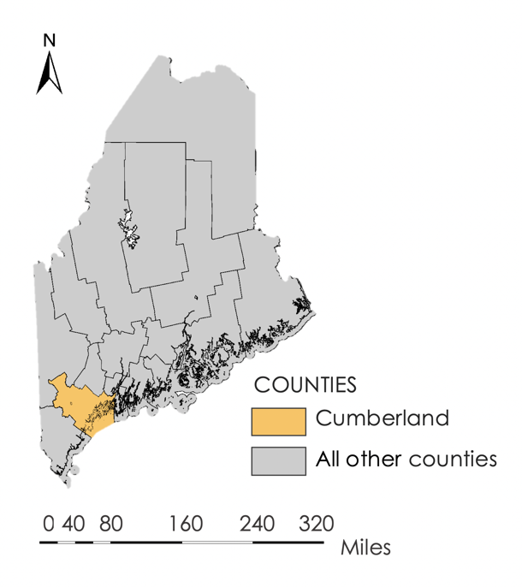

*Figure 1*. Shown above is a map of Maine highlighting Cumberland County.

* 1. ***Project Partners & Objectives***

The NASA DEVELOP Southern Maine Health & Air Quality team partnered with the Maine Medical Center Research Institute (MMCRI) Lyme & Vector-Borne Disease Laboratory, the Maine Vector-Borne Disease Working Group (the Working Group), and Bigelow Laboratory for Ocean Sciences. As a collaborator, Bigelow Laboratory for Ocean Sciences assisted in data assessment and interpretation. During the term MMCRI and the Working Group, the primary end users of this project, focused on risks of tick-borne illness, mitigation efforts, and public outreach to communicate these risks.

This project is beneficial to partners as it provides remotely sensed data about the spatial distribution of tick-borne illness risk. MMCRI and the Working Group do not currently use remote sensing data to collect information about tick-borne illness risk, making this project particularly useful for decision-making by extending their resources beyond *in situ* data. A modeled map displaying tick-borne illness risk in Cumberland County, created using disease incidence and environmental parameter influence, will be beneficial for both MMCRI and the Working Group. By leveraging their resources to more holistically examine tick-borne illness in Maine, this project will help support increased mitigation and public awareness in high-risk areas.

The objectives of this project included creating a detailed land cover map as well as adaptable code to be utilized by MMCRI, the Working Group, and Maine communities for continuous land cover assessment. This project also focused on illustrating how different environmental factors specific to Cumberland County, such as land cover, temperature, and humidity, affect the distribution of local tick-borne illness risk. This information can then be utilized by MMCRI and the Working Group for informed and targeted outreach. This approach was employed with the aim of providing Southern Maine communities with meaningful data and tools to impact future research.

# 3. Methodology

***3.1 Data Acquisition for Land Cover Analysis***

The team used Google Earth Engine (GEE) to analyze surface reflectance remote sensing imagery in order to create a land cover map for Cumberland County, Maine. GEE is a free, cloud-based geospatial research service. GEE houses a variety of datasets, raw imagery collections, and pre-processed imagery collections from NASA and European Space Agency (ESA) sensors. Cloud-based services, like GEE, eliminate hardware requirements, such as storage limits and processing power.

The team acquired Landsat 8 Operational Land Imager (OLI) Level-1 data from GEE. Landsat images were viewed and selected using USGS Earth Explorer, an online database of Landsat and other remotely sensed images. The dates of July 12th, 19th, and 28th, 2018, were chosen as they were the clearest images available over the study area for the summer of 2018 with less than 10% cloud cover. These dates were then imported into GEE for processing.

***3.2 Data Processing and Analysis for Land Cover Analysis***

DEVELOP participants used two different approaches for data processing to create land cover maps in GEE: supervised classification and unsupervised classification. For both processes, Landsat 8 OLI images of Maine were loaded directly into GEE. As there was not a single Landsat 8 OLI image that entirely covered Cumberland County, three tiles, Path-Row 11-29, 11-30, and 12-30, within GEE were merged to create a single mosaic image that contained the entire study area. The team then used the classification to create an edge map that illustrates the locations where land cover classes touch or overlap.

To perform the supervised classification, the team defined a list of land cover classes to be identified from the image. Nine classes were ultimately selected: low density development, mid density development, high density development, coniferous trees, deciduous trees, mixed trees, cultivated, water, and barren. For the three densities of developed land, a layer of percent impervious surface was added from the National Land Cover Database (NLCD). The percent imperviousness range for each developed classification was separated at the upper threshold of 22%, 56%, and 100%, respectively. The cultivated land cover class includes agricultural areas, open fields, and non-forest vegetated areas influenced by human actions. For each of the other classes, a set of training data were manually input and processed in GEE. Based on the given data, GEE subsequently produced a land cover map of Cumberland County including the nine assigned classes.

An unsupervised classification methodology was also initially performed. The team used a random set of pixels from the Landsat 8 image to create training data for GEE to use in assigning land cover classifications. These training data were then applied to the whole image and the code was specified to produce four output classes. GEE then produced a map with four classes, based on randomized training data from the image that the team then classified manually as water, urban, vegetation, and agriculture.

After exploring both supervised and unsupervised classification techniques, supervised was found to be better suited for the study area and partners. Therefore, all ensuing land cover analysis and discussion was solely based on supervised classification methods. The team traveled to Cumberland County, Maine to perform ground truthing validation of 18 latitude/longitude training points. Ground truthing provided visual confirmation of whether each location had been correctly or incorrectly classified within the original land cover map. Additionally, a confusion matrix was included within the supervised classification script to assess the accuracy of how well the classifier was able to correctly label training data.

The DEVELOP team then used the information gathered in the land cover map to create an edge map of Cumberland County. Based on the supervised classification, three land cover types (forest cover, urban cover, and cultivated) were selected to help in finding the edge habitat. Each layer throughout this process is masked to 0’s and 1’s to aid in mapping.

Once the forest cover layer was introduced from the land cover map, the distance to the edge of the forest cover (within 30 meters) was found by generating a distance kernel based on Euclidean distance, then computing the distance using that kernel. With this distance layer, a buffer was found along the edge of the forest cover using its focalmax. These steps were repeated for the urban cover. To create the edge map, the locations where the forest and urban buffers touched or overlapped were isolated, as they are considered the ‘forest-urban edge’.

Code was also created to calculate the percentage of edge in a certain location. By computing the total number of pixels in the original forest, urban, and agriculture covers, then calculating the number of pixels in the edge layer, it is possible to calculate what percentage of the land cover is considered to be edge area. This calculation can be done for all of Cumberland County, or can be limited to specified towns.

***3.3 Data Acquisition for Time Series Tool***

This time series tool is a modified version of the Hydrologic Inputs Tool (HIT) that was created by the NASA DEVELOP Niagara Falls Disasters team during the spring 2019 term. The tool was subsequently modified to include data from Terra Moderate Resolution Imaging Spectroradiometer (MODIS), the Gridded Surface Meteorological (gridMET) dataset, and the Parameter-elevation Regressions on Independent Slopes Model (PRISM) dataset. The team acquired data from GEE to incorporate NDVI, land surface temperature (LST), humidity, VPD, and precipitation into a user interface that allows users to visualize data during available years (Table 1).

Table 1

*Shown are the datasets included in the Time Series Tool, with GEE Image Collection ID and time range.*

|  |  |  |  |
| --- | --- | --- | --- |
| **Dataset** | **GEE ID** | **Use** | **Time Range** |
| Terra MODIS | MODIS/006/MOD11A1 | Land Surface Temperature | January 1, 2010 – June 20, 2019 |
| Terra MODIS | MODIS/006/MOD13Q1 | NDVI | January 1, 2008 – June 20, 2019 |
| gridMET | IDAHO_EPSCOR/GRIDMET | Humidity, VPD | January 1, 2010 – June 20, 2019 |
| PRISM | OREGONSTATE/PRISM/AN81d | Precipitation | January 1, 2008 – June 20, 2019 |

***3.4 Data Analysis for Time Series Tool***

Upon launching the user interface panel, users can select a latitude/longitude point within the study area. This automatically generates time series for NDVI, LST, humidity, VPD, and precipitation for that location. Each parameter is aggregated down to the town level for each town in Cumberland County at the best temporal resolution available for each sensor. All time series are then available for export out of GEE as either a CSV, PNG, or SVG.

***3.5 Data Acquisition, Processing, and Analysis for Risk Mapping***

Environmental parameter data from the time series tool, specifically Terra MODIS LST and gridMET humidity data, were exported from GEE and ingested into R for processing. Additionally, LST data from Aqua MODIS were also exported from GEE and run through R. Maine CDC tick-borne disease incidence data were downloaded from the CDC and were also ingested into R for processing. Data were processed in R using Just Another Gibbs Sampler (JAGS), a package that implements Bayesian statistics in R.

Data processing for risk mapping end products was conducted by science advisors John Foster and Tess McCabe at Boston University. The science advisors aggregated each environmental parameter based on co-variate type down to yearly temporal resolution to match the CDC yearly tick-borne incidence data. Aggregation methods centered the data on their respective means.

The science advising team used state-space Bayesian models to combine parameters and analyze the data. State-space models allow for modeling a latent variable that is never directly observed; in this case, the latent variable was the “true” number of tick-borne disease cases, or an estimate of the tick-borne disease cases taking into account observational error. In each model, it was assumed that the reported number of tick-borne disease cases is an underestimation of the true value. Each simple state-space model included a data model and a process model. The process model is a statement of how the specified environmental conditions drive LD cases. The data model is a statement about how each dataset informs the latent variable. Multiple datasets were used for temperature in order to better constrain the process model.

Three simple Bayesian models were created: one null model incorporating both LD incidence and population, one model further driven by temperature, and one model driven by humidity. Each model was fit to all individual towns in Cumberland County. The years 2009 to 2016 were used to fit and build the models, while 2017 and 2018 were used for validation. Model performance in the two validation years was measured by a comparison of observed values to predicted values.

# 4. Results & Discussion

***4.1 Analysis of Results***

The supervised classification land cover map was successful in classifying forest into deciduous, mixed and coniferous covers and classifying urban into low, medium, and high density development categories (in addition to the cultivated, water, and barren categories) (*Figure 2)*. The ground truthing visual accuracy assessment resulted in a land cover map accuracy of 86%, which was subsequently refined to improve misclassifications. From the incorporated confusion matrix, the training accuracy for the data was found to be 96.9%.

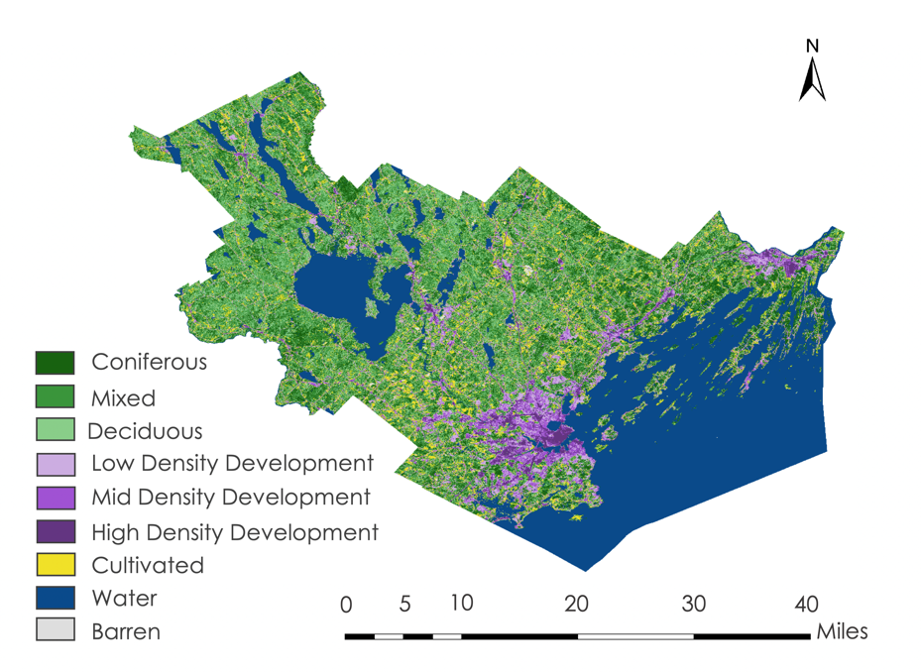

*Figure 2.* Above is the supervised land cover classification map for Cumberland County, Maine.

The classified land cover types were able to be incorporated into two edge maps. One map displays the land cover classes (the forest cover and the urban cover) overlaid by the forest-urban edge layer (*Figure A1*). The map also displays the forest and urban buffers used to find the combined edge. The second map illustrates the final forest-urban edge layer; the locations where the buffers touch or overlap is highlighted in blue (*Figure 3*).

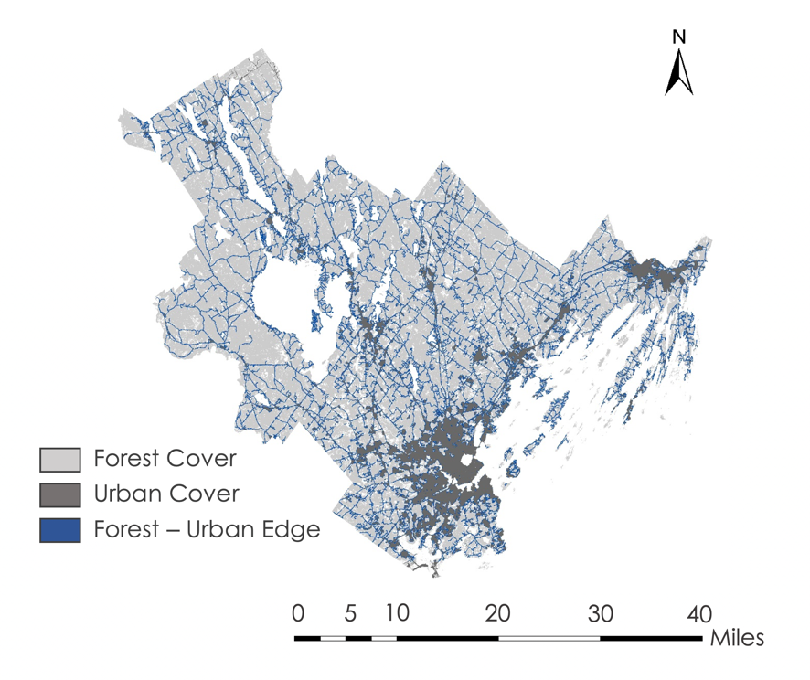

*Figure 3.* Shown above is a map of Cumberland County, Maine with the forest-urban edge feature highlighted in blue.

The creation of this edge map allowed for an analysis of the percentage of edge habitat in Cumberland County (*Figure 4*). For all of Cumberland County (forest, urban, and agriculture covers combined), 19.887% of the land is considered to be edge habitat. When this is subdivided by town, Frye Island, Chebeague Island, and Long Island have the highest percentage of edge features, calculated at 63.21%, 37.89%, and 39.079% respectively (Table A1). This is notable as these areas are small islands that aren’t as populated as cities such as Portland. These small areas that are not dominated by any one land cover type provide many opportunities for humans to come in contact with ticks, as they contain more edge habitat where increased species diversity is followed by increased tick presence. Comparatively, towns such as Baldwin, Sebago, and Pownal have much smaller percentages of edge: 11.82%, 11.89%, and 12.54% (Table A1). These towns tend to have one dominating land cover class, resulting in less edge habitat and thus a smaller edge-related risk of encountering ticks.

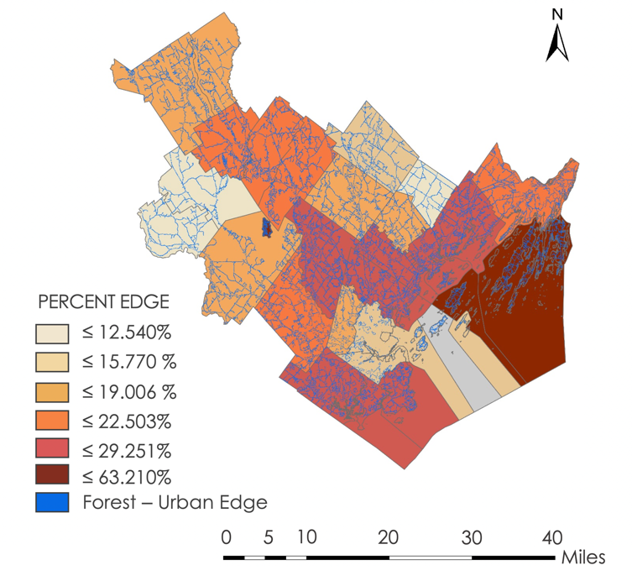

*Figure 4.* Above is a Cumberland County, Maine displaying the percentages of forest-urban edge area by town. The forest-urban edge layer is highlighted in blue.

For the risk and environmental parameter relationship analyses, a choropleth map was made to display the risk of contracting LD; in this case, risk is defined as the probability of acquiring LD per person at town-level spatial resolution for Cumberland County, as estimated by disease incidence and yearly population in the null model (*Figure 5*). New Gloucester, North Yarmouth, and Cumberland were found to have the highest modeled LD risk per person in Cumberland County, with probability means of 0.389%, 0.382%, and 0.375% respectively (Table B1). Baldwin, Sebago, Chebeague Island, Long Island, and Pownal had high probabilities between 23% and 50%, however, these values are unreliable due to a high standard deviation combined with suppressed data.Portland, South Portland, and Westbrook had the lowest modeled tick-borne LD risk with probability means of 0.050%, 0.045%, and 0.056% respectively.Omitted towns were not included as the probability of infection and probability of detection were too difficult to separate and the number of model iterations were considered too large in R; so the models did not converge. This could be due to two possible factors: 1) the model was not informative enough, 2) the data used to fit the model did not provide enough constraint (population, observed tick cases, priors, etc.). An uninformative prior was put on the probability of infection as this was an exploratory analysis. A tighter prior for the probability of infection from an expert in the field would likely help model convergence moving forward. Additionally, the null model estimated the latent variable, the “true” number of tick-borne disease cases, for each year per town (Table B2 and B2.1).

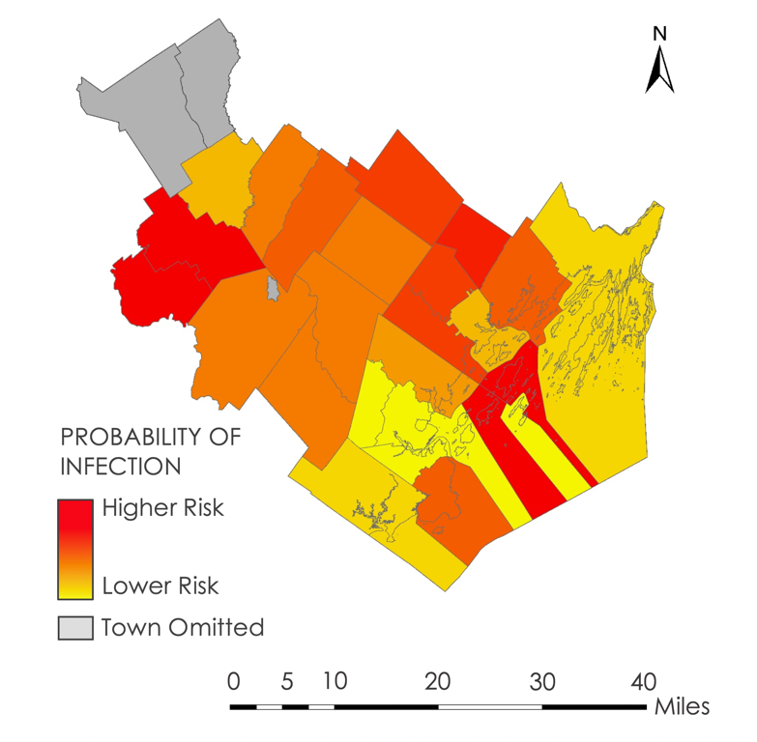

*Figure 5.* This map of Cumberland County, Maine illustrates the probability of acquiring LD per person at town-level spatial resolution, as estimated by disease incidence and population.

Results from the two parameter driven models showed differing strength of parameter effect on increased disease incidence. The estimated effect of humidity on disease incidence in the 22 successfully processed towns was negligible, with the effect being indistinguishable between either increasing or suppressing LD cases (Table B3). These results indicate that humidity may not strongly drive changes in LD incidence in Cumberland County towns. Theses results may also be due to the aggregation method or model structure.

The estimated relative effect of temperature on LD incidence in Cumberland towns was more substantial than humidity’s influence, with smaller associated error (*Figure 6)* (Table B4). Raymond, Westbrook, and Cape Elizabeth were found to have the most negative influence, at -0.427, -0.391, and -0.291 respectively, suggesting that as temperature increases LD incidence in these towns is suppressed. Standish, South Portland, and Harpswell were found to have the most positive influence, at 0.404, 0.355, and 0.301 respectively, suggesting that as temperature increases LD incidence in these towns is increased. Long Island had the overall highest influence at 1.896; however, Long Island’s associated error is notably much larger than the other listed towns, making this result less reliable. Many of the towns had a 95% confidence interval that contained 0, suggesting that the direction of the effect could change. Interestingly, Standish, South Portland, and Harpswell are all located adjacent to large bodies of water, potentially influencing this relationship.

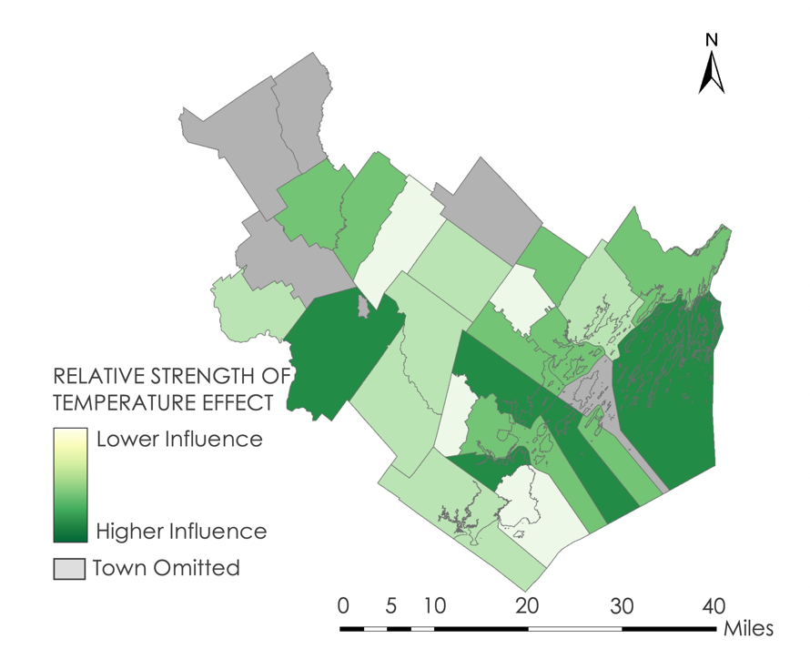

*Figure 6.* This map illustrates the relative comparative effect of LST on LD incidence in Cumberland County towns. While the overall magnitude of temperature’s effect is small, the magnitude of effect varies when comparing Cumberland towns to each other.

As both Terra and Aqua MODIS LST data were aggregated together for this model and each sensor is assumed to have some degree of associated error in their respective measurements, the model calculated the mean error per town for both Aqua and Terra MODIS LST (Table B5). On average, across the 22 successfully processed towns, Terra MODIS’s associated error was over twice as large as Aqua MODIS’s associated error. Though it should be noted that the standard deviation for Terra MODIS’s associated error also tended to be larger across the towns.

The temperature data model combined Aqua and Terra MODIS accounting for their respective errors and produced an estimated underlying LST measurement per town for 2009 to 2018. Additionally, the latent number of LD cases was calculated per year per town. Data was not analyzed due to time constraints of the term, but is available upon request.

***4.2 Possible Errors and Limitations***

Over the course of this project, there were multiple potential errors and limitations presented in data collection and analyses. While collecting ground truthing data points, the number of points collected was limited due to time constraints and the overall size of our study area. There were also issues in confirming the ground truthing points that were collected, further limiting the verification of our land cover map through ground truthing.

The models created for this project were aggregated to annual temporal resolution using methods as descriptive as possible. However, this may not be as descriptive as is needed. These models also work under the assumption that the relationship between climate variables and tick prevalence is the same as the relationship between tick-borne illnesses and these climate variables, which might not be accurate.

The data were modeled at town-level spatial resolution based on where tick-borne illnesses were reported. This is limiting as the town in which the incidence is reported is not necessarily the town where the initial contact with a tick occurred. To get the most accurate representation of which towns provide the highest risk of tick-borne illnesses, it would be beneficial to have data on where tick encounters occur rather than where tick-borne illnesses are reported.

In the creation of the disease risk map, the probability of contracting Lyme was calculated for every town using previous years’ data and Bayesian models. As previously mentioned, some towns, namely Baldwin, Sebago, Chebeague Island, Long Island, and Pownal, had high probabilities between 23% and 50%. These values are unreliable due to a high standard deviation combined with suppressed data.

The spatial resolution of the Landsat 8 data proved to be limiting in classifications for the land cover map. The 30 m spatial resolution made it difficult to differentiate between and determine vegetation types. This makes differentiation between coniferous, deciduous, mixed, and invasive species less reliable and limits the ability to denote invasive species that ticks frequently use for habitat.

***4.3 Future Work***

Possibilities for further research into this subject stem from mitigating initial limitations. Because the resolution of the supervised land cover classification and the edge map was 30 m, the precision of classification and identification of vegetation were limited to that resolution. If the resolution could be improved to a smaller scale, such as 1-5 m, the possibility of distinguishing between species could help better identify areas of high tick encounter risk.

Additionally, a higher spatial resolution would serve to better understand the relationship between high levels of LD among transportation workers and their proximity to forest-urban edges. Transportation workers are at a higher risk of coming in contact with ticks because they work along roads and areas that tend to coincide with the ‘edge’ between land classified as forest and urban. It would be beneficial to compare edge habitats with tick encounter locations, instead of the locations of reports, to see if there is a higher correlation between edge areas and tick encounter locations. In addition, if improved spatial resolution were available, it would be easier to identify the vegetation that ticks prefer in the edge map.

Currently, the model may not be as informative as possible. Possible future work should include additional covariates. Tighter priors could also provide more specific and accurate outputs for prediction of tick-borne illness risk. Future work could also model more accurate risk maps of tick-borne illnesses by generating or collecting data on where tick encounters occur rather than where tick-borne illnesses are reported.

# 5. Conclusions

The supervised classification land cover map indicates that classification on a county level is effective at identifying land cover types predisposed to tick encounters. Categorizing the land cover types into cultivated, three tree cover types, and three development types allowed for a more informed understanding of tick habitat in Southern Maine. Furthermore, the map also illustrated that tree cover classes were more mixed than expected and impervious surface was a subjective proxy for urbanization.

The edge map is an effective way to represent Cumberland County towns that have a high percentage of edge habitat. The towns with the lowest percent edge are Baldwin, Sebago, and Pownal, while the towns with the highest percent edge are Frye Island, Chebeague Island, and Long Island. High percentage areas are more likely to both collect wildlife that serve as hosts for deer ticks and attract heavy human use; this may impact how much contact humans have with deer ticks and thus with LD. These areas should be targeted for increased mitigation and public awareness.

Based on the risk map created using disease incidence and population, New Gloucester, North Yarmouth, and Cumberland have the highest probability of acquiring LD per person in Cumberland County (this probability being based on the reports of confirmed LD cases). Comparatively, people in Portland, South Portland, and Westbrook have the lowest probability of acquiring LD per person.

Environmental parameter driven models show varying levels of parameter influence on disease incidence. Humidity’s strength of effect on LD incidence in Cumberland County towns was negligible, suggesting that humidity is not highly predictive of tick encounter cases. The effect of temperature on LD incidence was relatively stronger in certain towns, though overall magnitude of effect is still small.

Overall, this project was successful in applying land cover classifications and remotely-sensed environmental data to preliminary tick-borne illness risk assessment efforts. Future research should focus on the simultaneous implementation of structural land cover characteristics and environmental covariates within a single model. Further efforts should also focus on examining the utility of satellite remote sensing at a community and local level.

# 6. Acknowledgments

The Massachusetts – Boston NASA DEVELOP team would like to thank the partners and advisors who provided their time and support to make this project possible.

Specifically, the team would like to thank project partners from the Maine Medical Center Research Institute, Lyme & Vector-Borne Disease Laboratory and the Maine Vector-Borne Disease Working Group.

* Dr. Susan Elias, Research Associate
* Chuck Lubelczyk, Field Biologist
* Dr. Rob Smith, Director and Co-Founder

And our project partner from Bigelow Laboratory for Ocean Sciences:

* Dr. Nick Record, Senior Research Scientist

We would also like to thank our Science Advisor and Mentors:

* Dr. Cedric Fichot (Boston University)
* Dr. Valerie Pasquarella (Boston University)
* Tess McCabe (Boston University)
* John Foster (Boston University)
* Zachary Bengtsson (DEVELOP Massachusetts – Boston Node)

Any opinions, findings, and conclusions or recommendations expressed in this material are those of the author(s) and do not necessarily reflect the views of the National Aeronautics and Space Administration.

This material is based upon work supported by NASA through contract NNL16AA05C.

# 

# 7. Glossary

**Earth observations** – Satellites and sensors that collect information about the Earth’s physical, chemical, and biological systems over space and time

**GridMET** - Gridded Surface Meteorological dataset provided daily humidity and vapor pressure deficit data

**MODIS** – MODerate resolution Imaging Spectroradiometer sensor aboard Terra and Aqua used for acquiring land surface temperature data

**OLI** – Operational Land Imager sensor aboard Landsat 8

**PRISM** – Parameter-elevation Regressions on Independent Slopes Model daily dataset used for acquiring precipitation data

**GEE** – Google Earth Engine, a free, cloud-based geospatial research service used for land cover and edge mapping

**GeoTIFF** - Georeferenced Tagged Image File Format, used in exporting images from

# 8. References

Abatzoglou J. T. (2012) Development of gridded surface meteorological data for ecological

applications and modelling [Data set]. International Journal of Climatology. doi: https://doi.org/10.1002/joc.3413.

Alonso-Carné, J., García-Martín, A., & Estrada-Peña, A. (2016). Modelling the phenological

relationships of questing immature Ixodes ricinus (Ixodidae) using temperature and NDVI data. *Zoonoses and Public Health, 63*, 40-52. doi:10.1111/zph.12203

Berger, K. A., Wang, Y., & Mather, T. N. (2013). MODIS-derived land surface moisture conditions

for monitoring blacklegged tick habitat in southern New England. *International Journal of Remote Sensing,* *34*(1), 73-85. doi:10.1080/01431161.2012.705447

Centers for Disease Control and Prevention (CDC). (2019a). *Lyme disease*. Retrieved June 17, 2019,

from <https://www.cdc.gov/lyme/>

Centers for Disease Control and Prevention (CDC). (2019b). *Symptoms of tickborne illness*. Retrieved

June 17, 2019, from <https://www.cdc.gov/ticks/symptoms.html>

Diuk‐Wasser, M. A., Vourc'h, G., Cislo, P., Hoen, A. G., Melton, F., Hamer, S. A., … Fish, D.

(2010). Field and climate‐based model for predicting the density of host‐seeking nymphal Ixodes scapularis, an important vector of tick‐borne disease agents in the eastern United States. *Global Ecology and Biogeography, 19*(4), 504-14. doi:10.1111/j.1466-8238.2010.00526.x

Eisen, R. J., Eisen, L., & Lane, R. S. (2006). Predicting density of Ixodes pacificus nymphs in dense

woodlands in Mendocino County, California, based on geographic information systems and remote sensing versus field-derived data. *The American Journal of Tropical Medicine and Hygiene, 74*(4), 632-40. doi:10.4269/ajtmh.2006.74.632

Frank, D. H., Fish, D., Moy, F. H. (1998). Landscape features associated with lyme disease risk in a

suburban residential environment. *Landscape Ecology*, *13,* 27-36. https://doi.org/10.1023/A:1007965600166

Guerra, M., Walker, E., Jones, C., Paskewitz, S., Cortinas, M. R., Stancil, A., … Kitron, U. (2002).

Predicting the risk of Lyme disease: habitat suitability for Ixodes scapularis in the north central United States. *Emerging Infectious Diseases, 8*(3), 289-297. doi:10.3201/eid0803.010166

Horobik, V., Keesing, F., Ostfeld, R.S. (2006). Abundance and Borrelia burgdorferi-infection

prevalence of nymphal Ixodes scapularis ticks along forest-field edges. *Ecohealth*. *3*(4), 262-68. https://doi.org/10.1007/s10393-006-0065-1

Kalluri, S., Gilruth, P., Rogers, D., & Szczur, M. (2007). Surveillance of arthropod vector-borne

infectious diseases using remote sensing techniques: a review. *PLoS Pathogens, 3*(10), e116. doi:10.1371/journal.ppat.0030116

Ozdenerol, E. (2015). GIS and remote sensing use in the exploration of lyme disease epidemiology.

*International Journal of Environmental Research and Public Health, 12*(12), 15182-15203. doi:10.3390/ijerph121214971

Pepin, K. M., Eisen, R. J., Mead, P. S., Piesman, J., Fish, D., Hoen, A. G., … Diuk-Wasser, M. A.

(2012). Geographic variation in the relationship between human Lyme disease incidence and density of infected host-seeking Ixodes scapularis nymphs in the Eastern United States. *The American Journal of Tropical Medicine and Hygiene, 86*(6), 1062-1071. doi:10.4269/ajtmh.2012.11-0630

Poortinga, A., Tenneson, K., Shapiro, A., Nquyen, Q., Aung, K. S., Chishtie, F., & Saah, D. (2019.)

Mapping plantations in Myanmar by fusing Landsat-8, Sentinel-2 and Sentinel-1 data along with systematic error quantification. *Remote Sensing, 11*(7), 831. doi:10.3390/rs11070831

US Geological Survey Earth Resources Observation and Science Center. (2014). Provisional Landsat

OLI Surface Reflectance [Data set]. US Geological Survey. https://dx.doi.org/10.5066/F78S4MZJ.

Wan, Z., Hook, S., Hulley, G. (2015). MOD11A1 MODIS/Terra Land Surface

Temperature/Emissivity Daily L3 Global 1km SIN Grid V006 [Data set]. NASA EOSDIS Land Processes DAAC. doi: 10.5067/MODIS/MOD11A1.006.

Wan, Z., Hook, S., Hulley, G. (2015). MYD11A1 MODIS/Aqua Land Surface

Temperature/Emissivity Daily L3 Global 1km SIN Grid V006 [Data set]. NASA EOSDIS Land Processes DAAC. doi: 10.5067/MODIS/MYD11A1.006.

# 9. Appendices

**Appendix A.** Edge Results

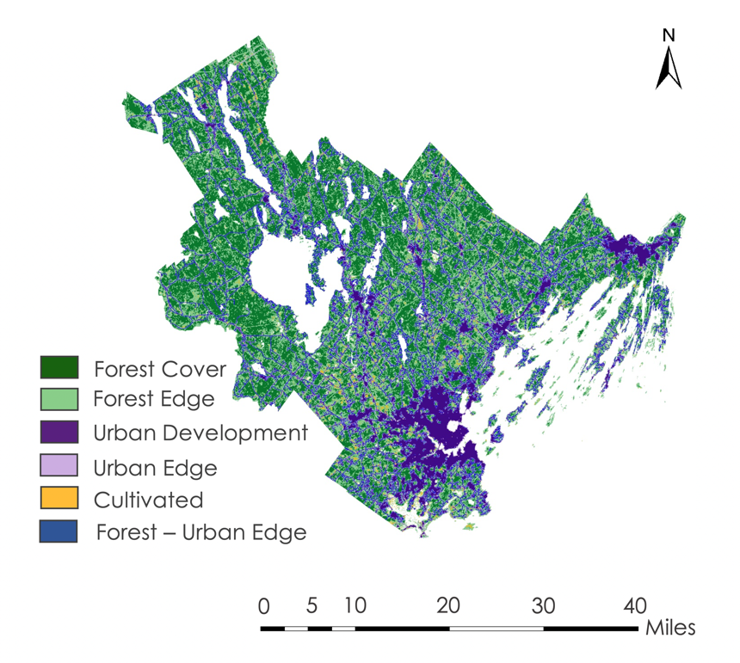

*Figure A1.* Edge map showing the forest, urban, and cultivated land covers. It also displays the lighter-colored buffers along the edge of those land covers. In blue are the areas where forest and urban cover touch or overlap.

Table A1

*Percent values of the Forest - Urban edge area from Cumberland County, Maine, calculated by town.*

|  |  |
| --- | --- |
| **Town** | **Edge (%)** |
| Baldwin | 11.815 |
| Bridgton | 17.397 |
| Brunswick | 20.490 |
| Cape Elizabeth | 29.251 |
| Casco | 19.426 |
| Chebeague Island | 37.890 |
| Cumberland | 26.604 |
| Falmouth | 26.319 |
| Freeport | 23.706 |
| Frye Island | 63.210 |
| Gorham | 19.916 |
| Gray | 18.401 |
| Harpswell | 33.852 |
| Harrison | 16.573 |
| Long Island | 39.079 |
| Naples | 21.025 |
| New Gloucester | 15.770 |
| North Yarmouth | 18.519 |
| Portland | 14.147 |
| Pownal | 12.540 |
| Raymond | 22.503 |
| Scarborough | 24.534 |
| Sebago | 11.888 |
| South Portland | 13.983 |
| Standish | 16.999 |
| Westbrook | 19.006 |
| Windham | 23.720 |
| Yarmouth | 29.118 |

**Appendix B.** Modeling Results

Table B1

*Results from the binomial null model.*

|  |  |  |  |  |
| --- | --- | --- | --- | --- |
| **Location** | **Detection Probability Mean** | **Detection Probability Standard Deviation** | **Infection Probability Mean** | **Infection Probability Standard Deviation** |
| Baldwin | 0.605874723 | 0.374036303 | 0.49994972 | 0.288673596 |
| Brunswick | 0.97666108 | 0.044495586 | 0.001120118 | 0.00010816 |
| Cumberland | 0.506452061 | 0.150055619 | 0.003751516 | 0.001230174 |
| Falmouth | 0.94212722 | 0.090761453 | 0.001502214 | 0.000239234 |
| Freeport | 0.876372844 | 0.145565562 | 0.002040402 | 0.000507602 |
| Gorham | 0.792182201 | 0.166189026 | 0.001838152 | 0.000479835 |
| Gray | 0.930561525 | 0.111478678 | 0.001893862 | 0.000393861 |
| Harpswell | 0.976768932 | 0.047182043 | 0.001185559 | 0.000205592 |
| Naples | 0.947665438 | 0.098092896 | 0.001321252 | 0.000333623 |
| North Yarmouth | 0.868701044 | 0.151675327 | 0.003818367 | 0.001013149 |
| Scarborough | 0.520357919 | 0.196663148 | 0.001145249 | 0.000502936 |
| Sebago | 0.045157257 | 0.176066885 | 0.302379025 | 0.299095519 |
| South Portland | 0.848956953 | 0.174682157 | 0.000446506 | 0.00015042 |
| Standish | 0.829726196 | 0.181251541 | 0.001781934 | 0.000591378 |
| Westbrook | 0.962299143 | 0.068617875 | 0.000555248 | 8.61E-05 |
| Windham | 0.966350413 | 0.059044848 | 0.001655922 | 0.000171756 |
| Yarmouth | 0.954978027 | 0.079704583 | 0.001300423 | 0.000214048 |
| Chebeague Island | 0.091215239 | 0.24264839 | 0.287404593 | 0.294102796 |
| Long Island | 0.106856406 | 0.259699474 | 0.286503423 | 0.294118445 |
| Pownal | 0.260735337 | 0.358046587 | 0.239248208 | 0.27827976 |
| Cape Elizabeth | 0.65783984 | 0.221402831 | 0.00212062 | 0.000915922 |
| Casco | 0.927787163 | 0.121833758 | 0.00173603 | 0.000490939 |
| New Gloucester | 0.596533571 | 0.281835282 | 0.003889403 | 0.003265275 |
| Portland | 0.828980282 | 0.168389608 | 0.000501971 | 0.000138502 |
| Raymond | 0.948718318 | 0.095748799 | 0.002067742 | 0.00043104 |

Table B2

*Results from the null model for estimated latent variable.*

|  |  |  |  |  |  |
| --- | --- | --- | --- | --- | --- |
| **Location** | **2009 Mean** | **2010 Mean** | **2011 Mean** | **2012 Mean** | **2013 Mean** |
| Baldwin | 0.393980096 | 762.4188218 | 760.4251452 | 759.922494 | 771.4219124 |
| Brunswick | 27.46666554 | 15.58453732 | 25.58845083 | 19.59198867 | 25.59085236 |
| Cumberland | 28.31264191 | 24.50062767 | 27.77672325 | 23.83567476 | 29.88550683 |
| Falmouth | 20.09975284 | 9.163430477 | 20.16601623 | 23.15924891 | 13.18197707 |
| Freeport | 18.47262481 | 11.49879937 | 11.50169814 | 19.48138448 | 14.52251784 |
| Gorham | 27.23518292 | 31.45538269 | 33.51933805 | 31.5478527 | 31.64122467 |
| Gray | 10.62460011 | 12.30428581 | 9.319835945 | 9.321613139 | 21.33080709 |
| Harpswell | 11.04643225 | 3.146541845 | 6.146328642 | 6.145129952 | 5.144162299 |
| Naples | 5.052349192 | 2.351413056 | 4.352008483 | 4.354460244 | 7.357451565 |
| North Yarmouth | 17.49465857 | 7.267216096 | 14.27513918 | 10.28345029 | 19.30140014 |
| Scarborough | 18.11379786 | 16.94997803 | 19.00562933 | 21.96595211 | 21.95901614 |
| Sebago | 5.001452459 | 519.5907858 | 521.3106766 | 525.5386011 | 529.8695752 |
| South Portland | 11.96361627 | 5.254637822 | 11.25764721 | 13.29279 | 15.31805628 |
| Standish | 13.55440088 | 11.94343476 | 21.96874708 | 18.01554169 | 30.0237047 |
| Westbrook | 15.41486671 | 6.427390573 | 10.42663281 | 6.428996753 | 19.43217331 |
| Windham | 28.84086857 | 13.07157866 | 26.0818059 | 26.08498566 | 35.09533321 |
| Yarmouth | 13.45030657 | 4.585970524 | 7.581084059 | 12.58264991 | 13.58809356 |
| Chebeague Island | 104.3300185 | 101.4535891 | 97.79338988 | 100.01711 | 99.44344114 |
| Long Island | 55.29496394 | 61.88414037 | 65.67939633 | 66.46889143 | 66.18209188 |
| Pownal | 399.0586875 | 362.6797055 | 352.6448285 | 351.4550245 | 352.8858524 |
| Cape Elizabeth | 14.47239665 | 17.13012063 | 17.09881868 | 19.04821968 | 19.15322347 |
| Casco | 6.288193182 | 5.638775468 | 3.647225401 | 8.654995019 | 6.65137617 |
| New Gloucester | 7.227282883 | 17.49406249 | 23.53937351 | 16.64893208 | 28.79663384 |
| Portland | 19.76255038 | 27.10529372 | 29.11263295 | 30.16009243 | 37.15769102 |
| Raymond | 5.051346738 | 7.607393459 | 9.611820154 | 6.621011774 | 12.61955557 |

Table B2 (Continued)

|  |  |  |  |  |  |
| --- | --- | --- | --- | --- | --- |
| **Location** | **2014 Mean** | **2015 Mean** | **2016 Mean** | **2017 Mean** | **2018 Mean** |
| Baldwin | 780.4186461 | 783.4189248 | 794.9178299 | 794.9150093 | 794.9227166 |
| Brunswick | 28.59357492 | 18.59687462 | 26.60024381 | 23.3284977 | 23.32827883 |
| Cumberland | 31.16561644 | 30.38931781 | 27.49771174 | 28.91660802 | 28.91713333 |
| Falmouth | 24.19863463 | 10.20148632 | 18.18033012 | 17.06175851 | 17.06362974 |
| Freeport | 21.55829632 | 17.5335275 | 16.5598014 | 16.47823086 | 16.47905253 |
| Gorham | 35.71553879 | 24.83126017 | 26.93636151 | 32.04084321 | 32.04059542 |
| Gray | 17.34370031 | 15.3580474 | 19.36501401 | 15.3993311 | 15.39942848 |
| Harpswell | 4.147286398 | 3.143780142 | 10.14347446 | 5.51169937 | 5.511000247 |
| Naples | 5.360938804 | 6.36290907 | 5.366551516 | 5.338212976 | 5.337870372 |
| North Yarmouth | 17.33131689 | 14.33496603 | 13.36036337 | 14.18815859 | 14.1901118 |
| Scarborough | 26.18086238 | 20.50115834 | 26.24326283 | 22.21061799 | 22.20946567 |
| Sebago | 535.5037484 | 538.2387237 | 543.9738257 | 543.9825849 | 543.9788579 |
| South Portland | 8.305549214 | 14.39288618 | 11.37048624 | 11.73717351 | 11.73758701 |
| Standish | 16.03423694 | 12.13283652 | 15.17427651 | 18.62699641 | 18.62606456 |
| Westbrook | 9.436303432 | 7.44176445 | 8.445172312 | 10.11030991 | 10.11037223 |
| Windham | 35.10568526 | 28.12886096 | 38.14054407 | 30.00594795 | 30.00586375 |
| Yarmouth | 12.59096862 | 8.581259633 | 15.59160205 | 10.98076104 | 10.97902211 |
| Chebeague Island | 99.15569591 | 99.8012724 | 99.72809446 | 100.8790879 | 100.8790714 |
| Long Island | 65.60888544 | 64.53688807 | 64.74795364 | 65.60967225 | 65.60944972 |
| Pownal | 356.5326676 | 359.468343 | 361.7586346 | 367.7985046 | 366.2906284 |
| Cape Elizabeth | 25.18823352 | 19.16684885 | 16.15259657 | 19.16598352 | 19.16744195 |
| Casco | 7.659284828 | 6.656455144 | 6.666099454 | 6.78618264 | 6.785788057 |
| New Gloucester | 22.78535009 | 21.04558403 | 23.15538256 | 22.70872892 | 22.71179521 |
| Portland | 36.22039512 | 37.23477554 | 37.34811188 | 34.34943715 | 34.34599309 |
| Raymond | 14.62068817 | 7.619317963 | 5.615278703 | 9.313396804 | 9.311849721 |

Table B2.1

*Standard deviation of the results from the null model for estimated latent variable.*

|  |  |  |  |  |  |
| --- | --- | --- | --- | --- | --- |
| **Location** | **2009 Standard Deviation** | **2010 Standard Deviation** | **2011 Standard Deviation** | **2012 Standard Deviation** | **2013 Standard Deviation** |
| Baldwin | 0.393980096 | 440.5135211 | 439.3629831 | 439.0765635 | 445.7117809 |
| Brunswick | 27.46666554 | 1.454235425 | 1.462416575 | 1.470147204 | 1.468004891 |
| Cumberland | 28.31264191 | 9.353930606 | 9.517532695 | 9.552691594 | 9.581538617 |
| Falmouth | 20.09975284 | 2.409439594 | 2.414018778 | 2.401792392 | 2.444252278 |
| Freeport | 18.47262481 | 3.985402534 | 3.989001046 | 3.959508566 | 4.019336527 |
| Gorham | 27.23518292 | 8.000760991 | 8.066143838 | 8.0956156 | 8.189012644 |
| Gray | 10.62460011 | 2.902808586 | 2.934993205 | 2.938814351 | 2.958054289 |
| Harpswell | 11.04643225 | 0.516366693 | 0.515762527 | 0.512998357 | 0.510659539 |
| Naples | 5.052349192 | 1.120611978 | 1.122707231 | 1.129461506 | 1.137519399 |
| North Yarmouth | 17.49465857 | 3.623055866 | 3.634444799 | 3.647062539 | 3.672601717 |
| Scarborough | 18.11379786 | 9.888733193 | 9.933878484 | 9.900600667 | 9.895732402 |
| Sebago | 5.001452459 | 514.4379542 | 515.8525463 | 520.0279863 | 524.608183 |
| South Portland | 11.96361627 | 3.813317737 | 3.817129983 | 3.872182177 | 3.913419197 |
| Standish | 13.55440088 | 5.921748779 | 5.957199886 | 6.02313025 | 6.03573426 |
| Westbrook | 15.41486671 | 1.126801473 | 1.125119705 | 1.131014635 | 1.138240447 |
| Windham | 28.84086857 | 2.357266983 | 2.377058992 | 2.383041863 | 2.403701195 |
| Yarmouth | 13.45030657 | 1.4674061 | 1.456895308 | 1.460392193 | 1.472327138 |
| Chebeague Island | 104.3300185 | 104.020299 | 100.5818568 | 102.5474267 | 101.9610309 |
| Long Island | 55.29496394 | 63.7291495 | 67.94132149 | 68.43670354 | 68.1411858 |
| Pownal | 399.0586875 | 423.1538086 | 410.3680305 | 408.9800564 | 410.6454679 |
| Cape Elizabeth | 14.47239665 | 8.512231826 | 8.485575896 | 8.42707113 | 8.541956829 |
| Casco | 6.288193182 | 1.73880252 | 1.760740717 | 1.779654522 | 1.770525533 |
| New Gloucester | 7.227282883 | 18.31329181 | 18.38619084 | 18.54061616 | 18.74980614 |
| Portland | 19.76255038 | 9.242004932 | 9.249305352 | 9.308094217 | 9.305315319 |
| Raymond | 5.051346738 | 1.705012418 | 1.719262969 | 1.742458602 | 1.736750102 |

Table B2.1 (Continued)

|  |  |  |  |  |  |
| --- | --- | --- | --- | --- | --- |
| **Location** | **2014 Standard Deviation** | **2015 Standard Deviation** | **2016 Standard Deviation** | **2017 Standard Deviation** | **2018 Standard Deviation** |
| Baldwin | 450.9087016 | 452.6392934 | 459.2760362 | 459.2806766 | 459.2795252 |
| Brunswick | 1.474017401 | 1.480285906 | 1.487901441 | 5.327283521 | 5.326638602 |
| Cumberland | 9.746936732 | 9.87958526 | 9.944463669 | 10.89559757 | 10.89715763 |
| Falmouth | 2.474992628 | 2.48065787 | 2.441658004 | 4.941200134 | 4.942160741 |
| Freeport | 4.072909582 | 4.036351094 | 4.074988314 | 5.767256481 | 5.766668285 |
| Gorham | 8.263075933 | 8.381951722 | 8.486806171 | 10.09866574 | 10.09594643 |
| Gray | 2.983736011 | 3.013762775 | 3.027412542 | 5.062843384 | 5.062689088 |
| Harpswell | 0.518044118 | 0.509210432 | 0.508674037 | 2.533549291 | 2.532886108 |
| Naples | 1.147348417 | 1.152727884 | 1.161775761 | 2.673491139 | 2.673947234 |
| North Yarmouth | 3.716810932 | 3.722393801 | 3.75906316 | 5.319905437 | 5.320325765 |
| Scarborough | 10.07044401 | 10.31826149 | 10.11784778 | 10.83070021 | 10.82913145 |
| Sebago | 529.8973674 | 532.5994447 | 538.2700095 | 538.2762781 | 538.2851149 |
| South Portland | 3.892469946 | 4.028608088 | 3.994074129 | 5.230122453 | 5.230914133 |
| Standish | 6.050794946 | 6.190659206 | 6.249144767 | 7.537258367 | 7.536749738 |
| Westbrook | 1.146845141 | 1.158544418 | 1.166323224 | 3.544272652 | 3.544694744 |
| Windham | 2.425092424 | 2.470725275 | 2.493733086 | 6.29664227 | 6.295816763 |
| Yarmouth | 1.478454493 | 1.457096676 | 1.480206643 | 3.773081995 | 3.771514283 |
| Chebeague Island | 101.6668364 | 102.6420721 | 102.253967 | 103.4316611 | 103.4310465 |
| Long Island | 67.55365179 | 66.76284029 | 66.67145637 | 67.55334537 | 67.55459005 |
| Pownal | 417.0027762 | 418.1218501 | 420.9507168 | 425.6693657 | 426.2346434 |
| Cape Elizabeth | 8.57001252 | 8.549658014 | 8.540981191 | 9.355369465 | 9.36554 |
| Casco | 1.792499535 | 1.783283911 | 1.804068013 | 3.234187947 | 3.23321945 |
| New Gloucester | 18.74213911 | 19.10020932 | 19.28098409 | 19.65093235 | 19.65401946 |
| Portland | 9.386377438 | 9.39508387 | 9.543544895 | 11.13713688 | 11.13748345 |
| Raymond | 1.742783249 | 1.73603222 | 1.726927913 | 3.611310416 | 3.613371798 |

Table B3

*Results of the humidity analysis.*

|  |  |  |
| --- | --- | --- |
| **Location** | **Relative Strength of Effect** | **Standard Deviation** |
| Baldwin | 0.003421053 | 5.001809274 |
| Cape Elizabeth | -0.039372562 | 5.002408929 |
| Casco | -0.00971758 | 5.000609367 |
| Freeport | -0.027872382 | 5.000881566 |
| Gray | -0.07453723 | 5.00127215 |
| Harpswell | 0.016741887 | 5.000077974 |
| Naples | -0.016942001 | 5.000337831 |
| Raymond | -0.036443912 | 5.000122829 |
| Westbrook | -0.082017723 | 5.000350843 |
| Windham | -0.101199441 | 5.002016852 |
| Yarmouth | -0.023450972 | 5.002189155 |
| Bridgton | -0.000422876 | 5.000387907 |
| Long Island | -0.000022966 | 4.999766392 |
| New Gloucester | -0.03816488 | 5.000742487 |
| Brunswick | -0.044734055 | 4.995204943 |
| Cumberland | -0.028826165 | 4.987499329 |
| Falmouth | -0.005485654 | 5.001950408 |
| Portland | -0.018212802 | 4.92650453 |
| Pownal | 0.009377804 | 5.001646337 |
| Scarborough | -0.032707221 | 4.999564708 |
| South Portland | -0.018831587 | 5.005093628 |
| Standish | -0.069878732 | 4.99817189 |

Table B4

*Results of the temperature analysis.*

|  |  |  |
| --- | --- | --- |
| **Location** | **Relative Strength of Effect** | **Standard Deviation** |
| Baldwin | 0.001299798 | 5.001798179 |
| Cape Elizabeth | -0.290545388 | 0.307872795 |
| Casco | 0.099343287 | 0.198470198 |
| Freeport | -0.135524567 | 0.194537668 |
| Gray | -0.020435169 | 0.172556048 |
| North Yarmouth | -0.276334672 | 0.170671858 |
| Pownal | 0.174865681 | 0.538011209 |
| Raymond | -0.427356017 | 0.18833614 |
| Scarborough | -0.062151475 | 0.226783656 |
| Westbrook | -0.391350598 | 0.201725887 |
| Windham | -0.029081823 | 0.106259718 |
| Yarmouth | 0.106681105 | 0.35534615 |
| Brunswick | 0.100923011 | 0.079735306 |
| Cumberland | 0.091201005 | 0.132200613 |
| Falmouth | 0.296530388 | 0.15548892 |
| Gorham | -0.028141831 | 0.082819125 |
| Harpswell | 0.301069089 | 0.270665001 |
| Long Island | 1.896178873 | 4.188726116 |
| Naples | 0.199464176 | 0.198548276 |
| Portland | 0.078942231 | 0.085139394 |
| South Portland | 0.355729628 | 0.186868626 |
| Standish | 0.403709189 | 0.151351395 |