Gulf of Mexico Health and Air Quality
Using NASA Earth Observations to Identify Potential Methane Sources for Improved Monitoring of Offshore Oil & Gas Activity in the Gulf of Mexico


Technical Report
Final – March 31st, 2022

Kate Howell (Project Lead)
Ashley Fernando
Ephrata Yohannes
J. Kyle Bergerson

Advisors:
Daniel Cusworth, University of Arizona, CarbonMapper
Ben Holt, Jet Propulsion Laboratory, California Institute of Technology

1. Abstract
The extraction, production, and transportation of oil and gas is a leading contributor to anthropogenic methane emissions via activities such as flaring and venting. The Bureau of Ocean and Energy Management (BOEM) has air quality jurisdiction offshore in the Gulf of Mexico and drafts regulations for criteria pollutants, while the Bureau of Safety and Environmental Enforcement (BSEE) enforces these regulations. Additionally, the non-profit organization SkyTruth monitors natural resources, including methane. BOEM, BSEE, and SkyTruth have partnered with NASA DEVELOP to use Earth observations to identify potential offshore methane sources in the Gulf of Mexico and to validate reported flaring activity. This information will allow BOEM and BSEE to make informed regulations regarding air pollution. Here, we cross-referenced BOEM infrastructure data with Suomi National Polar-orbiting Partnership (NPP) Visible Infrared Radiometer Suite (VIIRS) Nightfire data to validate operator-reported flaring. Sentinel-5p TROPOspheric Monitoring Instrument (TROPOMI) pollutant concentrations were used to validate VIIRS-detected flaring outside of the Gulf of Mexico where operator-reported data is unavailable. Using these methods, we identified the locations of offshore oil and gas infrastructure with known episodic flaring and venting in 2017 in the Gulf of Mexico, as well as offshore of South America and West Africa in 2021. Drawing upon retrieval methods used to detect onshore methane emissions, we proposed an analogous method utilizing sunglint to illuminate methane plumes over the ocean using Sentinel-2 Multispectral Imager (MSI) imagery. We detected two potential methane plumes – one at the Constitution complex in the Gulf of Mexico in July 2017 and one off the Coast of Lagos, West Africa, in July 2021.

Key Terms
flaring, venting, VIIRS Nightfire, sunglint, NO₂:SO₂ ratios

2. Introduction
2.1 Background Information
The first offshore oil well in the U.S was drilled off the coast of Summerland, CA, in 1896, where the water was less than 300 feet deep (NOAA, 2019). Today, offshore rigs are installed in depths over 10,000 feet. In April of 2010, a natural gas surge burst through a concrete well seal on the Deepwater Horizon oil rig in the Gulf of Mexico, carrying airborne particles from evaporating and burning surface oil to onshore communities (Smithsonian, 2021). Although such disasters are uncommon, ongoing extraction operations contribute to air pollution and climate change.

Flaring and venting are processes used by oil and gas (OG) facilities to dispel extraneous associated gas, mainly comprised of methane (CH₄). Flaring is the process of burning this gas which releases CO₂, NO₂, and H₂O into the atmosphere. Venting is the direct release of methane. Gas may undergo inefficient flaring, in which case methane is only partially combusted – causing unintentional venting. OG companies flare as a safety precaution to avoid major incidents like the Deepwater Horizon explosion. However, technical solutions exist to replace flaring and reduce greenhouse gas (GHG) emissions while simultaneously ensuring safe repurposing of gas. To the detriment of the environment in many cases, required infrastructure for such solutions is not installed because it is determined to be more cost-beneficial for OG companies to flare or vent excess gas rather than to transport and sell it (Brandt, 2020).

Satellite instruments, such as the Visible Infrared Imaging Radiometer Suite (VIIRS), can detect abnormally high temperatures from space and thus identify offshore flaring. Franklin et al. (2019) developed a regression approach to compute flared gas volume from flare temperature and source area. Using this approach to identify flare clusters, the authors cross-validated top-down flared volume estimates from VIIRS with reported venting activity from the Railroad Commission of Texas (Franklin et al., 2019). According to Brandt (2020), the VIIRS Nightfire (VNF) analysis accurately estimates flare volumes - with accuracy increasing as flare volume increases. Other flaring detection methods have used NO₂:SO₂ column density ratios to rule out other types of offshore emission scenarios, thus indicating flaring (Zhang et al., 2019).

Vented methane is detected from short-wave infrared (SWIR) absorption features (Cusworth et al., 2019). Past studies that explore remote methane retrieval assert that success hinges on characteristics of both the instrument and the scene. Homogeneous scenes have greater reflectance and generally lack other features that absorb SWIR wavelengths. Past studies showed that such features could be misclassififed as due to presence of methane plumes (Ayasse et al., 2018; Cusworth et al., 2019). Finally, scenes with moderate to high albedo, especially water scenes with sunglint, have shown higher retrieval accuracy than those with low radiance (Ayasse et al., 2018).

The study area encompasses U.S. Federal waters in the Gulf of Mexico (Figure 1a). Due to a lack of offshore OG regulation, as well as locations favorable for sunglint, the west African coast (Figure 1b) and the Venezuelan coast are also included (Figure 1c). We assessed 2017 data for the Gulf of Mexico and 2021 data for our supplementary areas of interest (AOI). The study periods we selected reflect data availability.

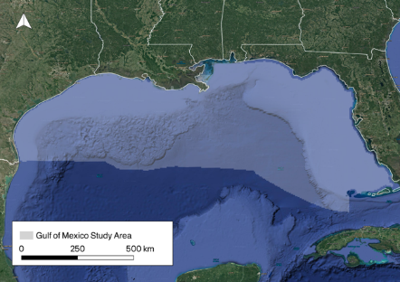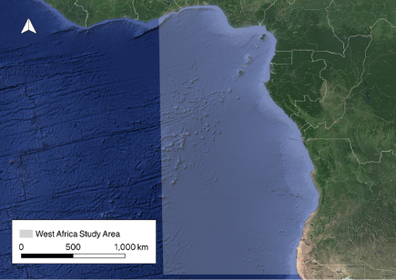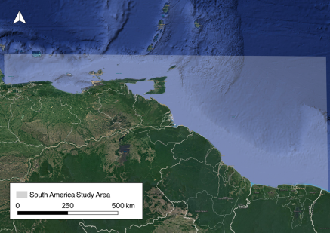
(a) (b) (c)

Figure 1. The three study areas: U.S. Federal waters in the Gulf of Mexico (1a), the coast of Angola, Nigeria, The Republic of the Congo, and Ghana (1b), and the coast of Venezuela, Guyana, and Suriname (1c).

2.2 Project Partners & Objectives
In response to the Deepwater Horizon incident, The Bureau of Ocean Management (BOEM) and the Bureau of Safety and Environmental Enforcement (BSEE) were created. BOEM is responsible for offshore air quality rulemaking. Every three years, the agency conducts an emissions inventory which includes estimates for GHGs (BOEM, n.d.). BOEM does not have the authority to regulate gas emissions, but by increasing their monitoring capacity through remote sensing, they may be able to enact GHG regulations in the future (BSEE, n.d.). BSEE, BOEM’s sister agency, enforces BOEM’s air quality rules in addition to regulating venting and flaring. They currently use infrared cameras to identify fugitive emissions during inspections, but cannot determine the emission volume nor pinpoint the duration of time for which gas was released. When preparing Environmental Assessments to comply with the National Environmental Policy Act, BOEM and BSEE rely on operator-reported emission estimates, released by venting and flaring (BSEE, n.d.). To support our partners, our objectives include mapping potential sources of fugitive emissions. We aim to validate operator-reported flare and vent volumes in the Gulf using VNF data. This research will give BOEM and BSEE a more robust understanding of OG climate impacts in the Gulf. We identified active OG facilities using VNF data, operator reported activity, and NO₂:SO₂ ratios, to select locations for sunglint investigation of methane plumes.

3. Methodology
3.1 Data Acquisition
We obtained VNF data from the Earth Observation Group via our collaborators at Skytruth (Elvidge et al., 2013). All Tropospheric Monitoring Instrument (TROPOMI) data products were downloaded via NASA Earthdata, and Sentinel-2 Multispectral Imager (MSI) imagery was accessed through Google Earth Engine. We also obtained ancillary data from the Real Time Mesoscale Analysis (RTMA). Data product details, such as platform and sensor, product title, and parameters are listed in Table 1.

Table 1. This table highlights the instruments used throughout this term along with their capabilities and products.
Platform & Sensor or Dataset Name | Data Products | Parameters
Suomi NPP VIIRS | VNF_npp_noaa_V21 | Radiative heat and temperature
Sentinel-5P TROPOMI | Tropospheric NO₂ 1-Orbit L2 5.5km x 3.5km V2  Sulphur Dioxide SO₂ 1-Orbit L2 5.5km x 3.5km V2 | NO₂ tropospheric column concentration  SO₂ vertical column concentration
Sentinel-2 MSI | Level-1C | Red, Green, Blue bands  Cloudy pixel percentage  QA60 cloud mask  Bands 11 and 12
Real Time Mesoscale Analysis | RTMA 2.5km | U component of wind  V component of wind

In order to compare reported flaring with VNF data, we used the 2017 operator-reported monthly flared gas volumes dataset from BOEM. To identify flares that were outside of 1km from a platform, we used the non-platform emissions database. BOEM uses the words platform and facility interchangeably. Herein we refer to these as ‘non-facility flares’. Lastly, to compare flaring and venting activities, as well as determine target locations for methane plumes, we used the BOEM operator-reported monthly cold vent gas volumes. All three ancillary datasets were downloaded from the Outer Continental Shelf Air Quality System (OCS AQS) portal. We also used BOEM’s Gulf of Mexico infrastructure GIS layers, downloaded from the online BOEM Data Center, for general mapping purposes.

3.2 Data Processing
In order to compare BOEM reported flaring estimates with VNF flaring events, we spatially and temporally collocated all VIIRS flaring events that occurred nearby BOEM facilities for validation. First, we identified all facilities within 1km of each flaring event. We chose this radius based on the spatial resolution of VIIRS and feedback from advisors and partners. Facility group IDs (a-h) were assigned to all flares in the instance a flare radius intersected multiple facilities. In this case, these facilities received the same group ID and were aggregated together throughout the study period. For each unique facility or facility group, we summed the temperature, radiant heat, and radiant output parameters to arrive at monthly aggregations. We then categorized BOEM flaring volumes by facility or facility group when applicable. Lastly, we compared VIIRS monthly aggregated flare volumes with BOEM flaring volumes by facility and facility group.

In order to determine the locations of active offshore OG facilities in our supplementary AOIs where operator-reported flaring and venting data were not available, we analyzed NO₂:SO₂ ratios because low ratios serve as a flaring signature (Zhang et al., 2019). First, TROPOMI NO₂ and SO₂ column densities were cloud masked prior to downloading, so additional preprocessing was not necessary. Both datasets were clipped to match our areas of interest. We filtered negative fill values from the datasets, and then calculated NO_{2:}SO₂ ratios from these column densities for validating detected VIIRS events.

Next, we processed Sentinel-2 imagery prior to our sunglint methane analysis. We removed images with a cloudy pixel percentage higher than 15%, as per Varon et al., 2021, and further removed individual cloudy pixels using the QA60 cloud mask. In order to select sunglint images we created a mask indicating if band 11 (SWIR) reflectance was greater than 0.11. This threshold was determined based on visual inspection of images with sunglint present. Using this reflectance mask, we then calculated the percentage of sunglint pixels in a given image. Only images with a sunglint percentage greater than 30% were selected for further analysis.

3.3 Data Analysis
3.3.1 Comparison of BOEM Flared Volume by Facility with VIIRS Flaring Events
We compared collocated monthly operator reported estimates with aggregated monthly VIIRS events by facility, then generated a scatter plot of monthly VIIRS radiant heat (RH) vs. reported flare volume. According to literature from similar studies onshore, there is a linear relationship between radiant heat of a flare and the flared gas volume (Schade, 2020). Additionally, we selected the facilities with the operator reporting no flaring but which had with flares detected by VIIRS. Flaring events that occurred more than 1km from a facility were mapped and further investigated alongside monthly reported activities for that given lease block. Bottom-up venting monthly estimates from BOEM were also visualized by facility. Reported vent volumes were compared with reported flare volumes in an attempt to identify any trends that could be leveraged when selecting locations for sunglint investigation.

3.3.2 NO₂:SO₂ Ratios
By visually locating persistent hotspots of low-value NO₂:SO₂ ratios that overlap with clusters of VIIRS events, we aimed to estimate the locations of offshore oil and gas facilities with persistent flaring activity. Since inefficient flaring can lead to venting, we assumed active flaring facilities may also vent. These facilities served as candidates for methane plume detection via sunglint-configured imagery.

3.3.3 Sunglint Investigation
We selected platforms with potentially detectable venting events. Since BOEM reports venting estimates monthly by platform, we calculated conservative estimates for hourly methane emission rates. By making the assumption that facilities are venting continuously throughout the month, we arrived at a lower bound on methane emitted per hour. Varon et al. (2021) conducted methane retrievals using Sentinel-2, setting 10⁴ - 10⁵ kg CH₄/hr as the detectable range for such a retrieval. Following this limit, we selected all BOEM reported venting events with estimated hourly emission rates above 3,000 kg/hr. For each of these detectable events, we selected a 10 km x 10 km bounding box to surround the platform.

Varon et al. (2021) used the Multi Band Single Pass (MBSP) method, in which SWIR bands 11 and 12 are compared to reveal a methane enhanced image from OG sites. For a given image, a linear regression is fit between R11 and R12. The variable c refers to the resulting coefficient, which is specific to a given image. The equation from Varon et al. (2021) used in this study is below, where R12 and R11 correspond with the SWIR bands:

$∆R=\frac{(c*R12-R11)}{R11}$ Equation 1

We calculated $∆R$ for each 10km x 10km area described above. We then visualized this value, and flagged images with potential plume like structures. When determining if a plume was present, we compared the $∆R$ image to its visible image. If there was an artifact in both the visible and $∆R$image, it was ruled out as a plume.

4. Results & Discussion
4.1 Analysis of Results
4.1.1 BOEM Flare Volume and VIIRS Comparison
After collocation with facility locations, we classified VIIRS flaring events into three categories: unreported by facility, reported by facility, and non-facility flares (Figure 2). Unlike unreported flares, where their location in the Gulf has no significant pattern, reported flares mostly congregate 175km directly south of the Cajun County coast. Non-facility flares congregate 150km southeast of the Mississippi Delta.

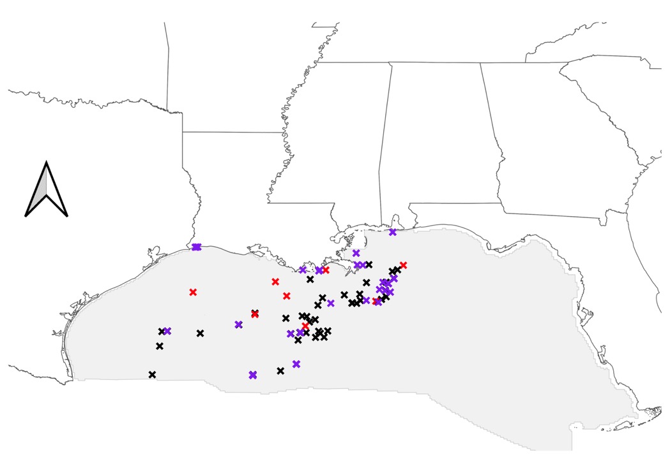
Figure 2. Facilities with VIIRS detected flaring in 2017. Reported flaring is in black, unreported flaring is in red and non-facility flaring is in purple.
Our partners have expressed interest in determining what vessels can be responsible for these non-facility flares as BOEM only has emission volume data from facility operators. BOEM, however, does have a database detailing what non-facility vessel types are present in a specific lease block. Lease blocks are designated 4.8km x 4.8km offshore areas leased by BOEM to oil and energy developers (BSEE, n.d.). We identified 16 lease blocks home to non-facility flaring detected by VIIRS (Figure A1). Since BOEM only has jurisdiction over federal waters, the eight unreported flares along the coastline are omitted from the figure. Out of the 16 lease blocks, we analyzed two which represent contrasting monthly flare frequencies. Lease block MC127 reports flares only in the month of May (Figure 3a) whereas a majority of flares in WR551 (Figure 3b) occur periodically throughout the year.

Table A3 discloses possible vessel types responsible for the non-facility flares within these lease blocks. While the vessel database does not specify which vessel type produced a specific flare on a specific day, it offers a summary of all the vessels active in a given month where a flare is present. In essence, these results highlight a plethora of non-facility units potentially responsible for flares - an entire class of pollution of which BOEM has no documentation.

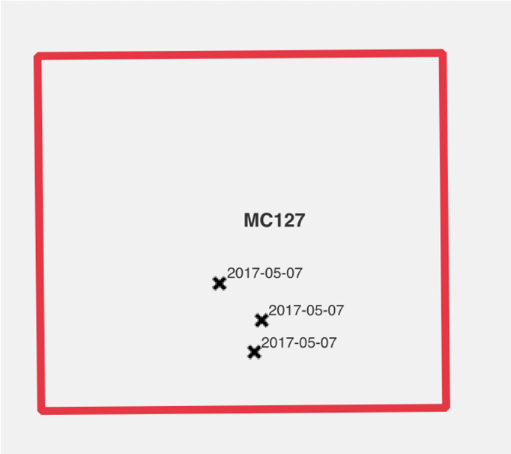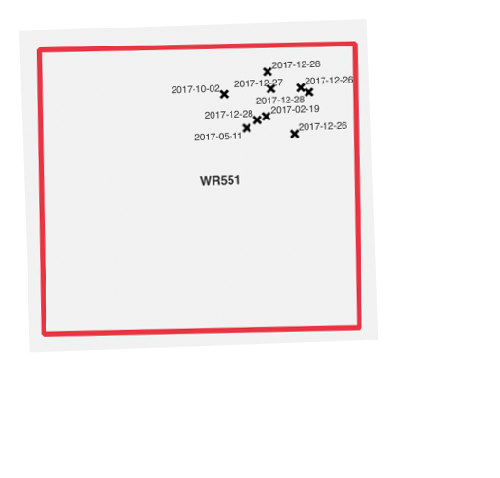
(a) (b)
Figure 3. Sample lease blocks with non-platform flaring in 2017: MC127 (a) and WR551 (b).
The majority of lower annual venting volumes are clustered near- and onshore (Figure 4). These locations likely include smaller, more shallow water facilities that may not have flare booms. The dark red points indicate greater venting volumes – which are readily seen off the Mississippi delta and amorphously scattered further out into the Gulf. Figure A4 classifies the top 10 platforms with the most recorded venting (in thousands of standard cubic feet). Among those platforms, we have isolated two that undergo drastic venting during certain months. According to partner feedback, deep-water facilities that vent high amounts of gas more infrequently could be due to malfunctions with infrastructure meant to transport, flare, or capture excess gas (Figure 5). Facility 33032-1 demonstrates a clear case of this.
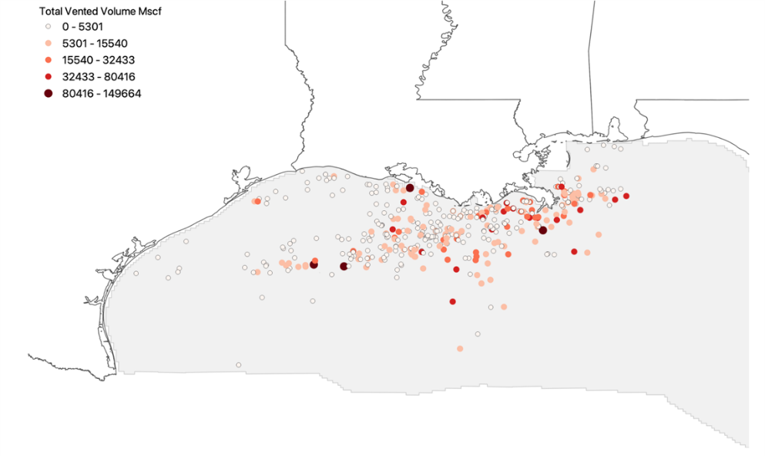
Figure 4. Vented volume by platform in 2017.

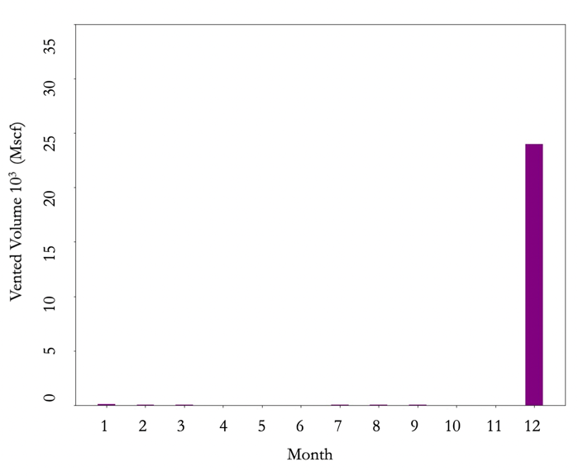 (a) | 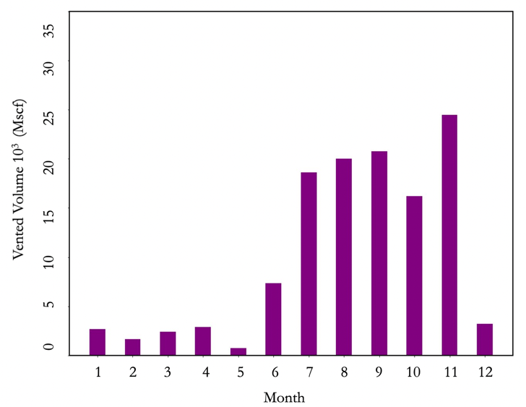  (b)
Figure 5. Two high venting facilities by month in 2017, 33032-1 (a) and 90028-1 (b).
We expected a tight linear relationship between VIIRS radiative heat (RH) and operator reported flared gas volume. General agreement between RH and flared gas volume is observed at facility 1819-1 (Figure 6a). However, there are some instances where VIIRS estimates are significantly lower than what has been reported, as shown in Figure 6b. This is likely due to the fact that VIIRS passes over a given facility exactly twice per day – thus missing flaring events throughout the rest of the day. 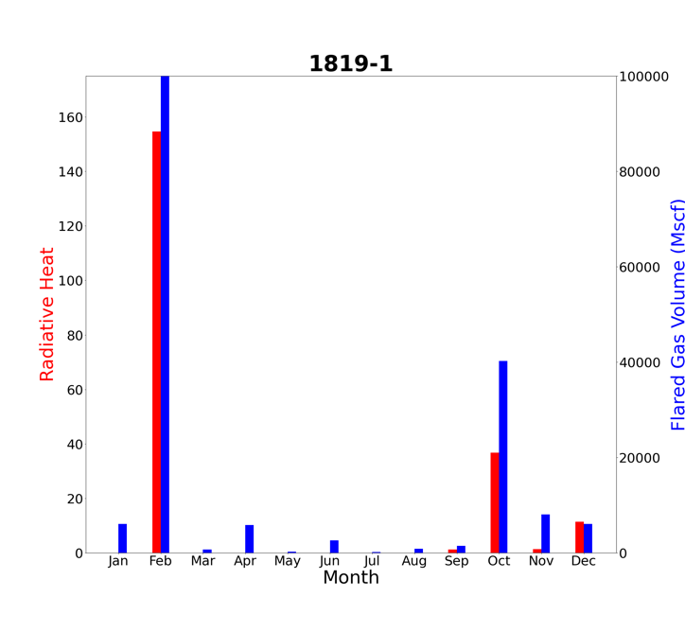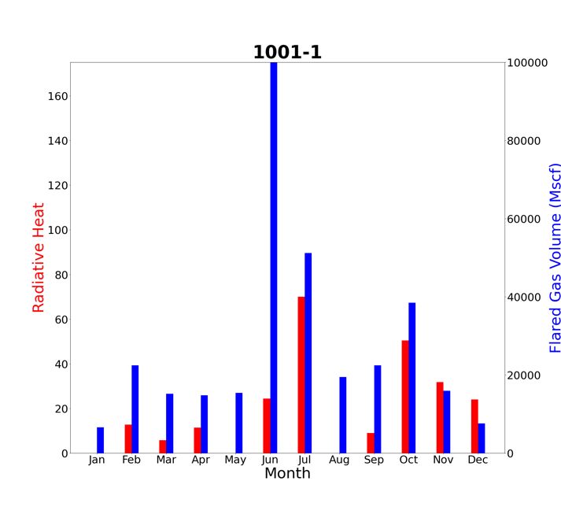
(a) (b)
Figure 6. Monthly BOEM reported flare volume vs. VIIRS radiative heat (RH) seen at Facility ID 1819-1 (a) and 1001-1 (b).

While our comparative analysis between VIIRS detected flares and Gulf of Mexico operator reported flare volumes demonstrate qualitative agreement at certain facilities, we do not observe an overall trend between radiant heat detected by VIIRS and reported flare volume (Figure 7). This likely occurs because gas flared by facilities at any other time of the day beyond VIIRS’ overpass times will be missed by VIIRS. On the other hand, it is not likely that VIIRS misses flares in scenes over the ocean, since VIIRS detects flares based on anomalous heat in the atmosphere, and extremely hot detections could only be coming from combusted gas.

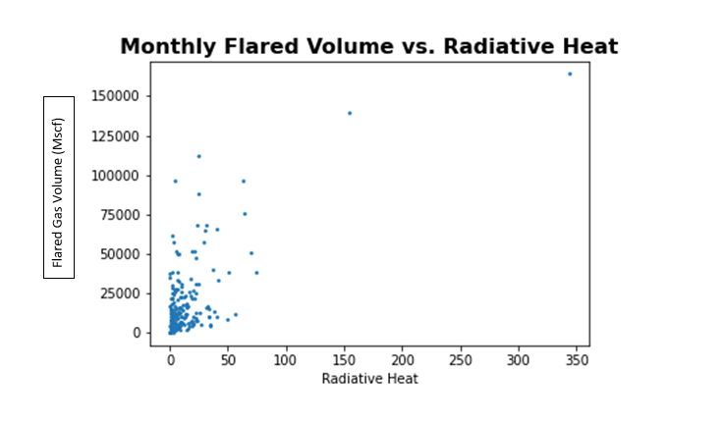
Figure 7. Monthly VIIRS estimates vs monthly reported gas volume for every facility in the Gulf of Mexico in 2017.

4.1.2 VIIRS Flaring Activity vs. NO₂:SO₂
The figure below showcases VIIRS flare points and low NO₂:SO₂ ratio points off the South American coast. While we see some clustering of low ratios near VIIRS flaring events in Lecheria and near Trinidad and Tobago, there is a high degree of noise present in the figure (Figure 8). Similar results for the Gulf of Mexico and our west Africa AOI present even less ratio clustering (Figures B1-B3).

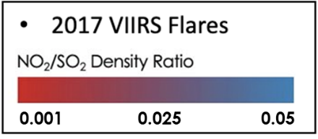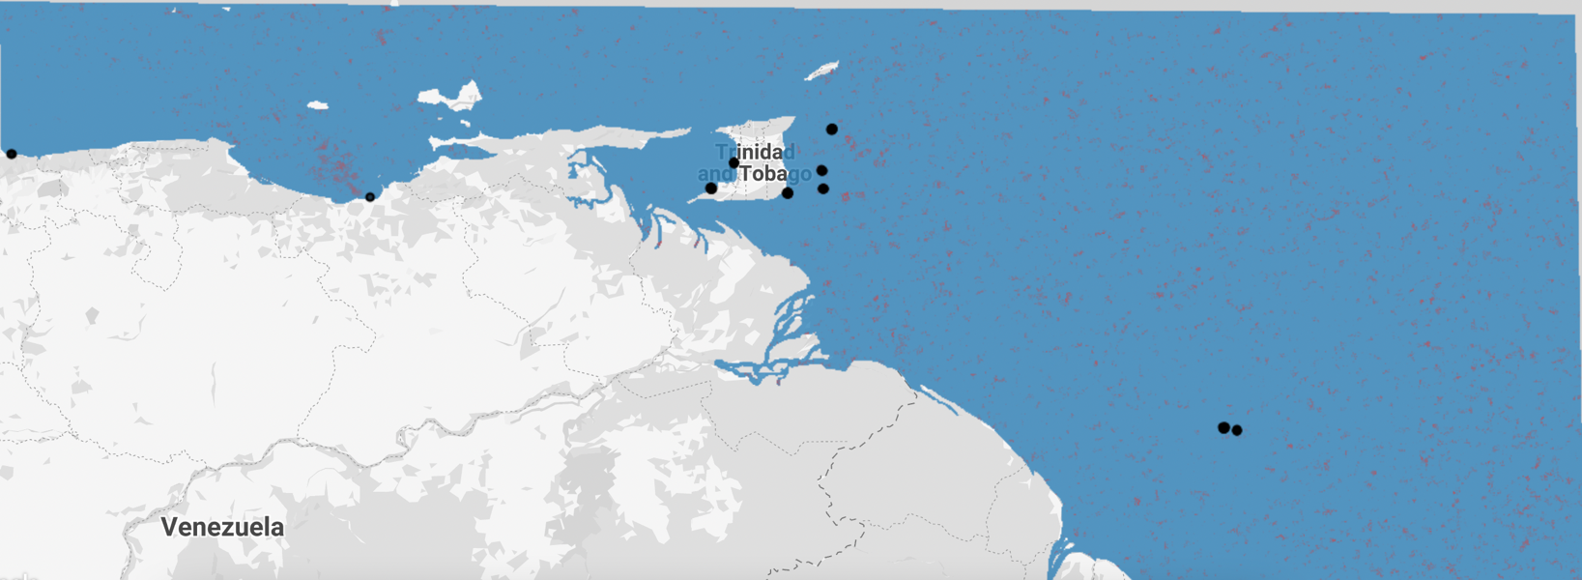
Venezuelan Coast, September 2021
Figure 8. VIIRS flare points and low NO₂:SO₂ ratios off the South American coast in September, 2021.

4.1.3 Sunglint Investigation
According to reports, there were 128 detectable emission months, coming from 38 unique facilities in the Gulf of Mexico in 2017 (Figure A2). Of these events, one potential plume was detected on July 5, 2017, coming off of the Constitution Deepwater complex (1665-1) in the Gulf of Mexico (Figure 9). The scene is relatively homogenous, with a couple of artifacts seen in both the ΔR image and in the visible image. However, on the left, there is a plume-like structure in red that is not seen in the visible image to the right. We looked at baseline images and were able to confidently rule out the scenario that the suspected plume is a recurring artifact occurring near this complex. Confirming that the wind direction is parallel to the plume feature offered additional reassurance. In July of 2017, operators of the 1665-1 facility reported around 3.14 * 10⁵ kg of vented methane. At the time of this image acquisition the wind was blowing from the southeast, directly parallel to the potential plume (Figure C1). This strengthens the case that this diagonal structure is in fact a methane plume, and not an image artifact or physical feature. Additional potential plumes were identified in July of 2021 off the coast of Lagos, Nigeria and Pointe-Noire, The Republic of the Congo (Figures C2 and C3).

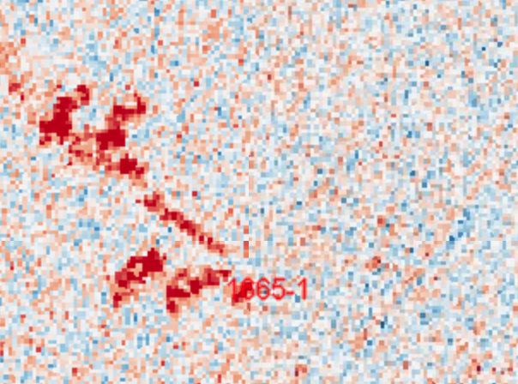 | 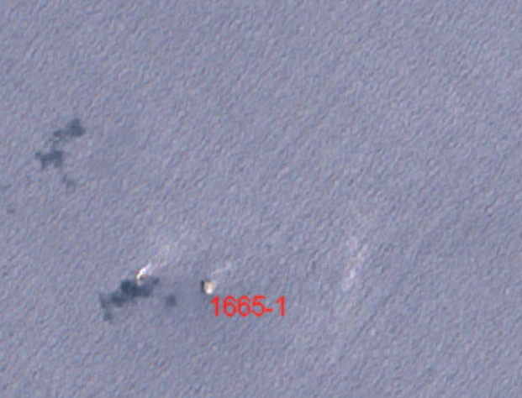
(a) | (b)
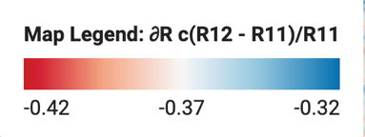
Figure 9. Potential plume in MBSP (a) and visible image (b)
on 7/5/17 at 16:43.

We discovered an unexpected flaring signature when looking for methane plumes (Figure 10). In the visible image on the right, we see an orange dot signifying a flare coming off a facility in west Africa. In the infrared comparison image on the left, there is a star-like artifact centered around the flare. This is likely occurring because the signal from the flare in the infrared bands is so saturated that it creates this visual effect. This is a potentially useful result, as Sentinel-2 has much higher resolution than VIIRS, and if utilized, this could give our partners flare detection results at high spatial resolution.

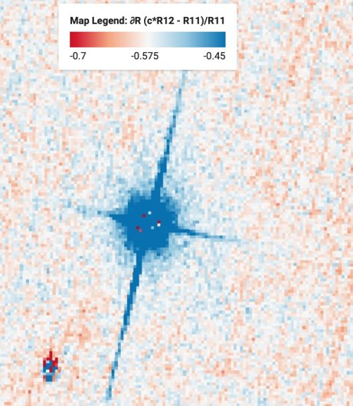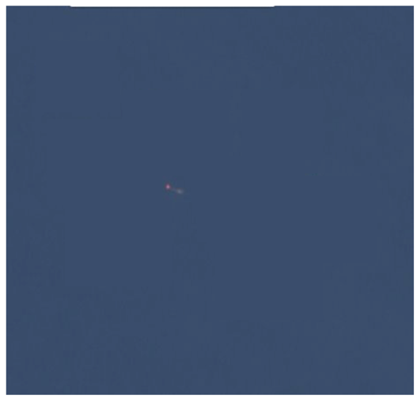
(a) (b)
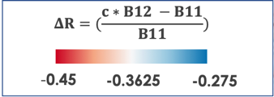
Figure 10. Flaring Signature Surrounding Offshore Flare
MBSP (a), Visible Image (b).

4.2 Future Work
The future team could remove noise from our NO₂:SO₂ ratio analysis to strengthen our sunglint-configured plume detection, use additional datasets to validate operator-reported data and identify glint scenes, and investigate other methods of flare detection.
First, the NO₂:SO₂ ratio map could be improved by incorporating a wind model, accounting for the effects of wind direction, speed and atmospheric transport. Accounting for the variability of the wind would boost the signal from persistent flaring and remove noise. This would allow the team to definitively pinpoint the locations of low ratio hotspots and infer which areas flare frequently. For our plume detection analysis, removing background noise from methane plume images by averaging baseline images of the same scene and then emulating the background estimation and removal methods of Ehret and Varon (Ehret, 2021; Varon, 2021), would improve plume images necessary for quantifying released methane volume.
While our term only had access to VIIRS onboard Suomi-NPP to validate BOEM’s 2017 data, the 2nd term will have the added benefit of utilizing NOAA-20 which launched after 2018 and can be used alongside Suomi-NPP to validate BOEM’s 2021 emissions inventory - publicly accessible in mid-2022. With the 2nd term using VIIRS onboard two satellites, VIIRS now detects heat four times a day. Thus, we anticipate a decrease in the number of missed flares by VIIRS. The 2nd term will be able to accurately identify facilities in the Gulf with the highest flaring and venting volumes, targeting them for methane retrieval. The addition of near-shore Landsat 8 and Landsat 9 sunglint-configured imagery would efficiently identify more relevant and usable glint scenes. We recommend that the future team leverage sensors aboard PRecursore IperSpettrale della Missione AMissioneva (PRISMA), which can target specific coordinates and be tilted to maximize sunglint, providing imagery with high spectral and spatial resolution that is optimal for methane retrieval.
Finally, the future team can expand upon our identification of flares by visualizing ΔR values through the MBSP method (Figure 9). This method may provide additional validation for VIIRS-detected flares since these signatures were detected using Sentinel-2 imagery, which has higher spatial resolution than VIIRS. The team could also use this method to investigate the impact of flare temperature on the shape of its signature in the SWIR.

5. Conclusions
The work conducted throughout this term offers insight into offshore venting and flaring activities, as well as a method to detect offshore methane plumes from OG facilities. Given the non-linear relationship discussed between VIIRs and reported flared volume, daily activity reports - rather than monthly - would allow our partners to better quantify this relationship, thus improving the capability to use VIIRS for validation and to investigate inefficient flaring. While this relationship is not infallible, our investigation did identify non-compliant facilities - facilities with nearby VIIRS detections - that did not report any flaring in 2017. Our partners can use this result to investigate these non-compliant facilities, which will in turn incentivize operators to be more vigilant with reporting. This could influence impact assessments for their National Environmental Policy Act (NEPA) documents.

Our results confirm a surprising level of frequent non-facility flaring. Since BOEM only has operator-reported data from facility flares and not from non-facilities, BOEM does not have an accurate portrayal of offshore flaring. Accounting for emissions coming from non-facility vessels can provide our partners with a more comprehensive view of emissions in the Gulf of Mexio and better inform venting and flaring regulation.

Our analysis of venting in the Gulf of Mexico indicates that larger deep-water facilities have fewer venting episodes overall – but might exhibit periodic venting due to malfunctions. On the other hand, many shallow water platforms frequently vent small amounts and rarely flare. Given these distributions, it is important to incentivize smaller platforms to invest in flaring infrastructure despite installation and operation costs. In addition, while these figures are illustrative of venting activity, daily activity reports would also improve Earth observation methane retrieval methods.

Overall, we did not see high correspondence between VIIRS flaring clusters and hotspots of low NO₂:SO₂ ratios. Without accounting for transport and wind direction, as in Zhang et al. (2019), we are unable to sufficiently remove noise from our visualizations. Wind rotations as well as increasing the averaging window would boost the signal from flaring events, offering validation to VIIRS, as well as identifying other persistence flaring hotspots that might be missed by VIIRS due to the revisit time. Future work that utilizes a combination of VIIRS and TROPOMI data will allow for a more robust detection of active offshore OG platforms, in areas around the world where operator reported data is not available.

Lastly, this paper illustrates a novel use for Sentinel-2 SWIR imagery. By drawing upon existing methane retrieval methods from Ehret et al. (2021) and Varon et al. (2021), and leveraging naturally occurring sunglint, we have illustrated the possibility of offshore methane retrievals. Methane plumes identified in this paper are preliminary, yet they indicate the potential for monitoring offshore methane emissions in a more routine fashion. Further, these methods – if validated and expanded – could aid scientists and decision makers in quantifying offshore OG to the global methane budget; fundamental for informing climate agreements and curbing the consequences that anthropogenic emission activities have on our planet.

6. Acknowledgments

Advisors: Daniel Cusworth (University of Arizona), Benjamin Holt (NASA Jet Propulsion Laboratory, California Institute of Technology)
DEVELOP Fellow: Erica Carcelén
Partners:
- U.S. Department of the Interior, Bureau of Safety and Environmental Enforcement: Jay Cho, Program Manager, Engineer; Ramona Sanders, Senior Environmental Stewardship Coordinator; Jarvis B. Abbott, SPEAR Program Coordinator
- U.S. Department of the Interior, Bureau of Ocean Energy Management: Holli D. Ensz, Physical Scientist; Cholena Ren, Physical Scientist; Thomas Kilpatrick, Ocean and Atmospheric Scientist
- Skytruth: John Amos, President; Dan Cogswell, Software Developer; Brendan Jarrell, Geospatial Analyst

This product was made utilizing VIIRS Nightfire (VNF) nightly data produced by the Earth Observation Group, Payne Institute for Public Policy, and the Colorado School of Mines.

This material contains modified Copernicus Sentinel data (2017, 2021) processed by ESA.

Any opinions, findings, and conclusions or recommendations expressed in this material are those of the author(s) and do not necessarily reflect the views of the National Aeronautics and Space Administration.

This material is based upon work supported by NASA through contract NNL16AA05C.

7. Glossary
Define field-specific terms and acronyms. The goal of this section is to help the reader better understand the work presented in the paper. Include vocabulary that the reader may not be familiar with, in addition to defining the acronyms in your paper.
EO – Earth Observations Satellites and sensors that collect information about the Earth’s physical, chemical, and biological systems over space and time
MODIS – Moderate Resolution Imaging Spectroradiometer
Venting – Direct release of methane into the atmosphere
Flaring – Process of burning this gas which releases CO₂, NO₂, and water vapor into the atmosphere.
VIIRS – Visible Infrared Imaging Radiometer Suite
FPSO – Floating Production Storage Offloading (vessel)
SWIR – Short-wave infrared
RGB – Red, Green, Blue used to view satellite imagery in true color
NEPA – National Environmental Policy Act
Lease Block – Designated blocks that BOEM leases out to operators, 4.8km x 4.8km in size

8. References

Ayasse, A. K., Thorpe, A. K., Roberts, D. A., Funk, C. C., Dennison, P. E., Frankenberg, C., Steffke, A., & Aubrey, A. D. (2018, June 27). Evaluating the effects of surface properties on methane retrievals using a synthetic airborne visible/Infrared Imaging Spectrometer Next Generation (aviris-NG) image. Remote Sensing of Environment, 215, 386-397. https://doi.org/10.1016/j.rse.2018.06.018
BOEM (n.d.). Bureau of Ocean Energy Management. Retrieved April 1, 2022, from https://www.boem.gov/
Brandt, A. R. (2020). Accuracy of satellite-derived estimates of flaring volume for offshore oil and gas operations in nine countries. Environmental Research Communications, 2(5). https://doi.org/10.1088/2515-7620/ab8e17
BSEE. (n.d.). Bureau of Safety and Environmental Enforcement. Bureau of Safety and Environmental Enforcement. Retrieved March 31, 2022, from https://www.bsee.gov/
Copernicus Sentinel data processed by ESA, Koninklijk Nederlands Meteorologisch Instituut (KNMI) (2021), Sentinel-5P TROPOMI Tropospheric NO2 1-Orbit L2 5.5km x 3.5km, Greenbelt, MD, USA, Goddard Earth Sciences Data and Information Services Center (GES DISC), Accessed: March 5 2022, https://doi.org/10.5270/S5P-9bnp8q8
Copernicus Sentinel data processed by ESA, German Aerospace Center (DLR) (2020), Sentinel-5P TROPOMI Sulphur Dioxide SO2 1-Orbit L2 5.5km x 3.5km, Greenbelt, MD, USA, Goddard Earth Sciences Data and Information Services Center (GES DISC), Accessed: March 5 2022, https://doi.org/10.5270/S5P-74eidii
Copernicus Sentinel data (2022), Sentinel-2 MSI: Multispectral Instrument Level 1-C. Accessed: March 5 2022, developers.google.com/earth-engine/datasets/catalog/COPERNICUS_S2_HARMONIZED?hl=en
Cusworth, D. H., Jacob, D. J., Varon, D. J., Chan Miller, C., Liu, X., Chance, K., Thorpe, A. K., Duren, R. M., Miller, C. E., Thompson, D. R., Frankenberg, C., Guanter, L., & Randles, C. A. (2019). Potential of next-generation imaging spectrometers to detect and quantify methane point sources from space. Atmospheric Measurement Techniques, 12(10), 5655–5668. https://doi.org/10.5194/amt-12-5655-2019
Ehret, T., De Truchis, A., Mazzolini, M., Morel, J.-M., d’Aspremont, A., Lauvaux, T., Duren, R., Cusworth, D., & Facciolo, G. (2021). Global Tracking and Quantification of Oil and Gas Methane Emissions from Recurrent Sentinel-2 Imagery. 1–27. http://arxiv.org/abs/2110.11832
Elvidge, C.D.; Zhizhin, M.; Hsu, F.-C.; Baugh, K.E. (2013). VIIRS Nightfire: Satellite pyrometry at night. Remote Sensing, 5, 4423-4449. https://doi.org/10.3390/rs5094423
Franklin, M., Chau, K., Cushing L. J., Johnston, J. E. (2019). Characterizing flaring from unconventional oil and gas operations in South Texas using satellite observations. Environmental Science & Technology, 53(4). https://doi.org/10.1021/acs.est.8b05355
National Oceanic and Atmospheric Administration data. (2017). RTMA: Real-time mesoscale analysis . Google. Retrieved April 1, 2022, from https://developers.google.com/earth-engine/datasets/catalog/NOAA_NWS_RTMA
NOAA. (2019, February 26). Oil Spills, Seeps, and the Early Days of Drilling Oil Along California's Coast. Office of Response and Restoration. Retrieved February 23, 2022, from https://response.restoration.noaa.gov/about/media/oil-spills-seeps-and-early-days-drilling-oil-along-californias-coast.html#:~:text=The%20first%20offshore%20wells%20in,were%20built%20in%20the%20region.
Schade, G. W. (2020). The Problem With Natural Gas Flaring. Retrieved February 10, 2022, from https://today.tamu.edu/2020/08/03/the-problem-with-natural-gas-flaring/
Smithsonian. (2021, August 12). Gulf Oil Spill. Smithsonian Ocean. Retrieved March 31, 2022, from https://ocean.si.edu/conservation/pollution/gulf-oil-spill#:~:text=Oil%20is%20composed%20of%20flammable,was%20removed%20by%20controlled%20burning.
The World Bank Group. (n.d.). About the ZRF. World Bank. Retrieved February 24, 2022, from https://www.worldbank.org/en/programs/zero-routine-flaring-by-2030/about
Varon, D. J., Jervis, D., McKeever, J., Spence, I., Gains, D., & Jacob, D. J. (2021). High-frequency monitoring of anomalous methane point sources with multispectral Sentinel-2 satellite observations. Atmospheric Measurement Techniques, 14(4), 2771–2785. https://doi.org/10.5194/amt-14-2771-2021
Zhang, Y., Gautam, R., Zavala‐Araiza, D., Jacob D. J., Zhang, R., Sheng, J. Scarpetti, T. (2019). Satellite-observed changes in Mexico’s offshore gas flaring activity to oil/gas regulations. Geophysical Research Letters, 46(3), 1879-1885. https://doi.org/10.1029/2018GL081145

9. Appendices

Appendix A

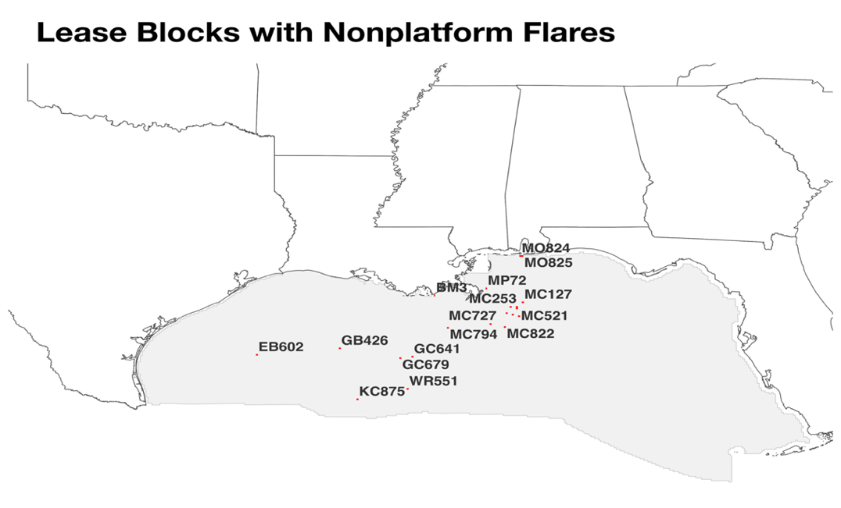
Figure A1. Lease blocks in which non-facility flaring occur more than 1km away from a flare in 2017.

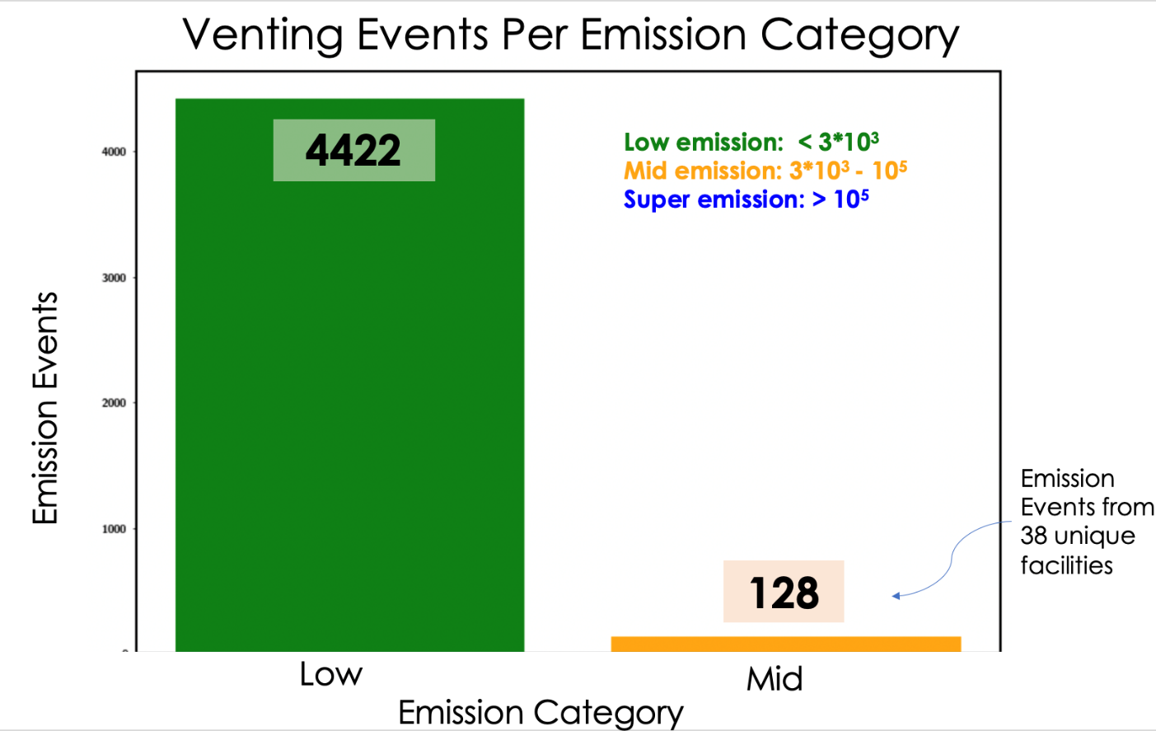
Figure A2. This chart classifies the number of emission events according to its emission level: low, mid or super emitter.

Lease Block AC_LAB | Month | Figure | Vessel Type
MC127 | May | 4a | Bulk Carrier, Drilling, General Cargo, Misc, Offshore Oil and Gas Support, Survey, Tug, Unknown, Coast Guard, Biogenic/Geogenic, Helicopters
WR551 | December | 4b | Crude Oil Tanker, Offshore Oil and Gas Support, Coast Guard, Helicopters
Table A3. Reported vessel types by lease block and month.

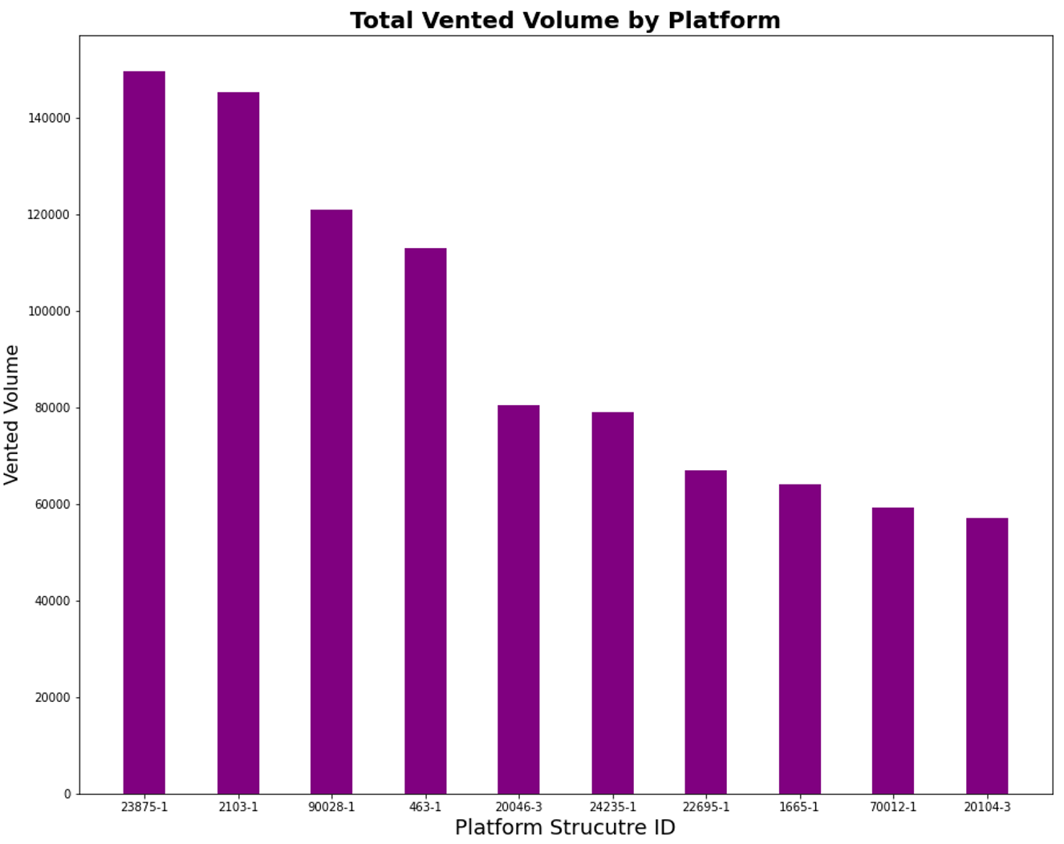 Figure A4. Total vented volume at top platforms, 2017.

Appendix B
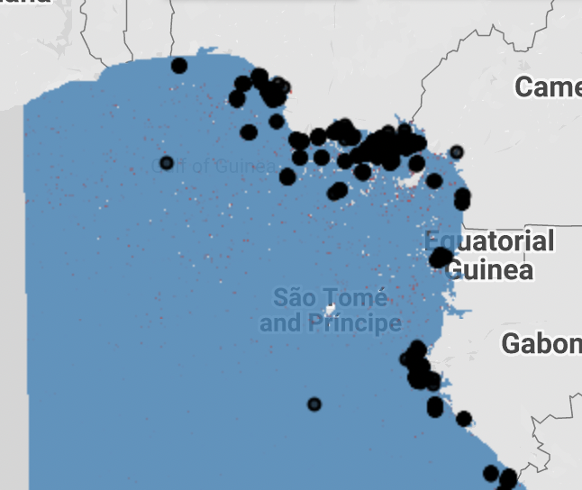
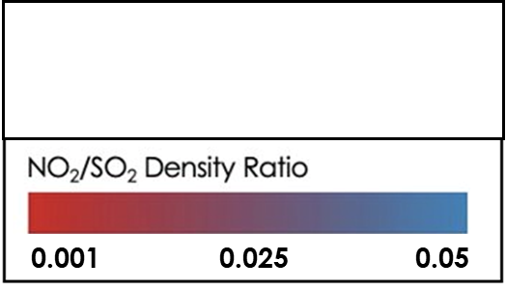
Figure B1. VIIRS flare points and low NO₂:SO₂ ratios off the West African coast in January, 2021.

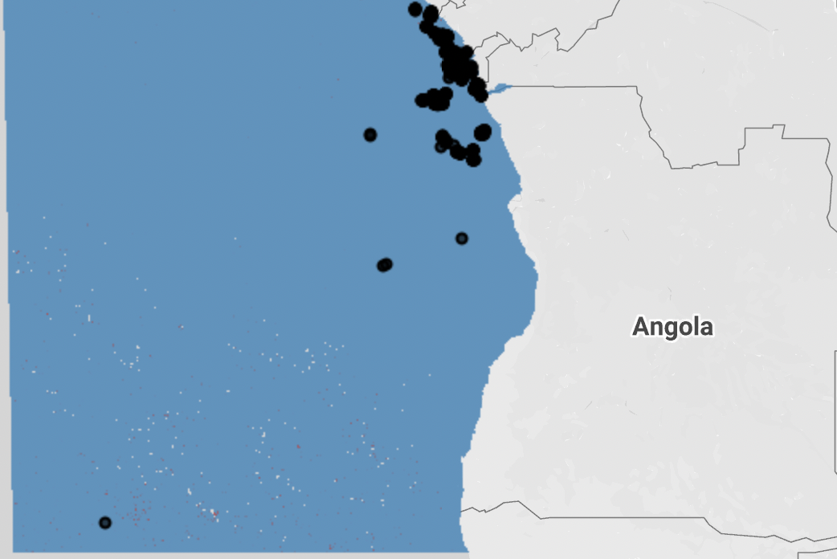
Figure B2. VIIRS flare points and low NO₂:SO₂ ratios off the Southwestern African coast in January, 2021.

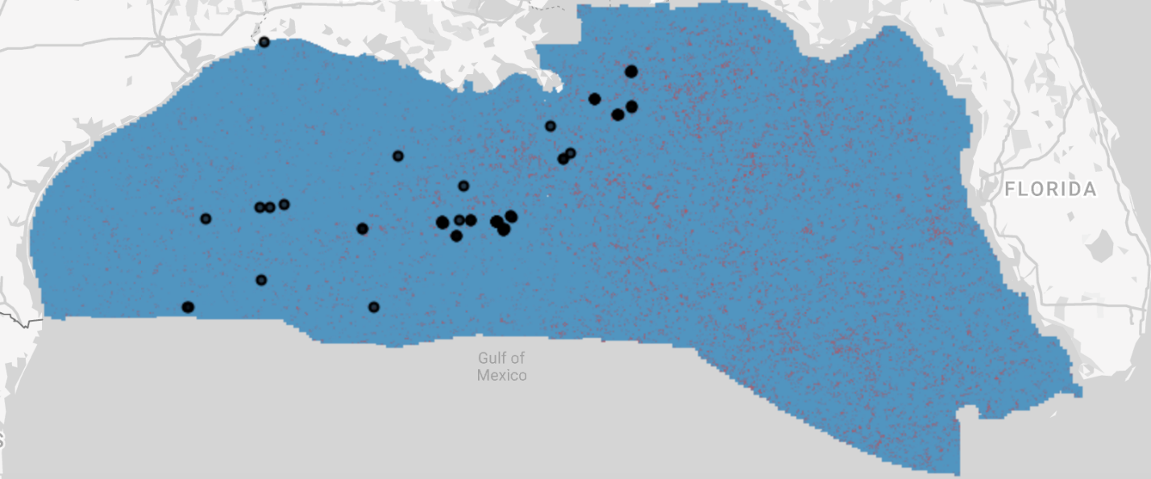
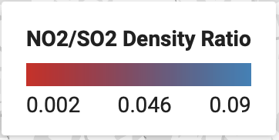
Figure B3. VIIRS flare points and low NO₂:SO₂ ratios off the Gulf of Mexico in January, 2021.

Appendix C

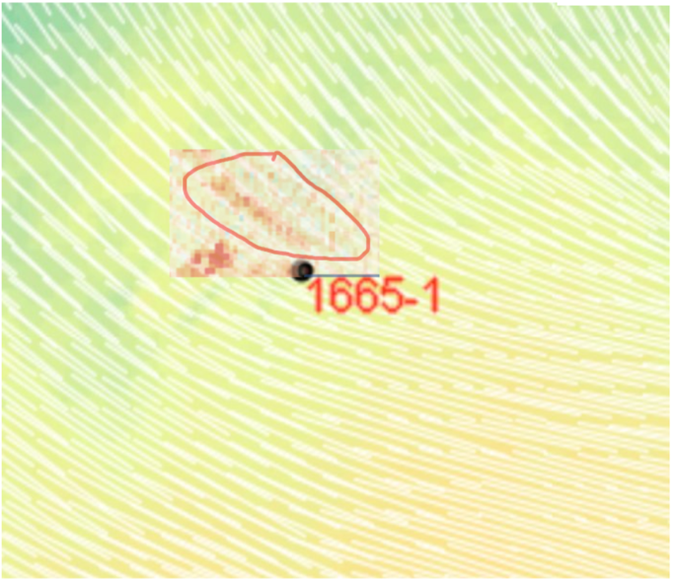 | 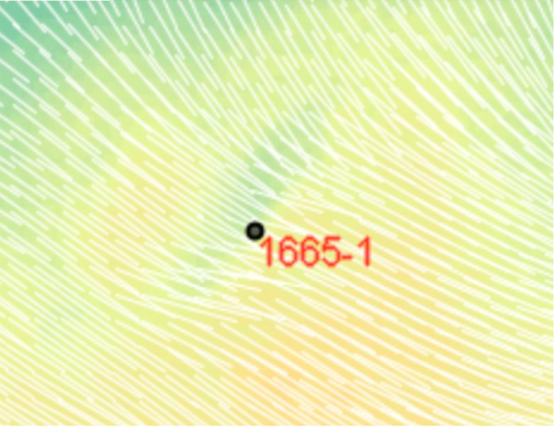

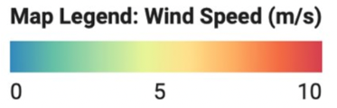
Figure C1. Wind Vector Map Around Constitution Plume (1665-1) using RTMA. (a) 7/5/17 at 16:00, (b) 7/5/17 at 17:00.

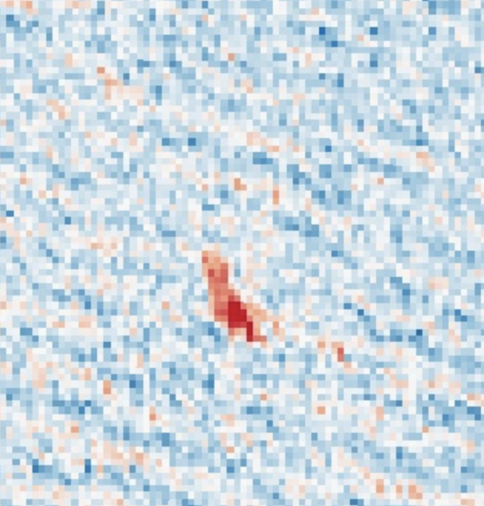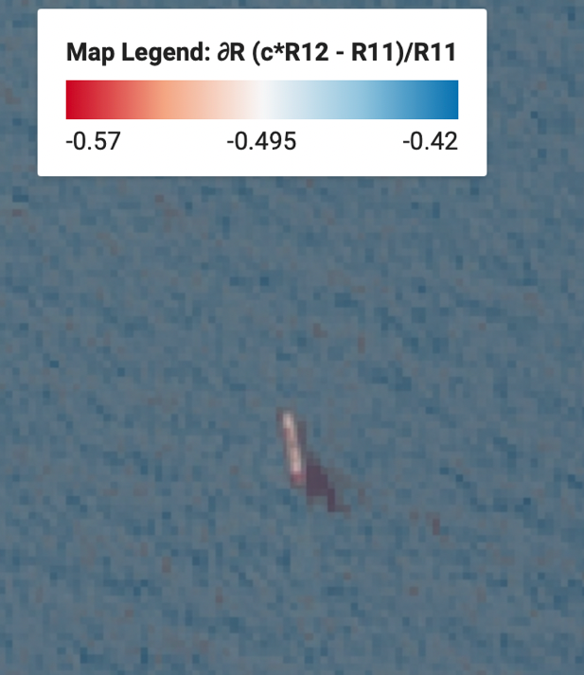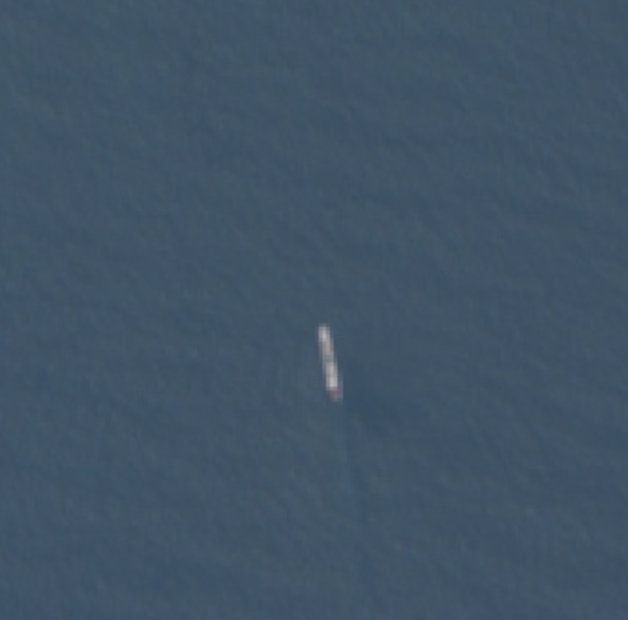
(a) (b) (c)
Figure C2. Potential Plume on 7/29/21 off Lagos, Nigeria, MBSP (a) MBSP overlayed on visible image (b) and visible image (c).

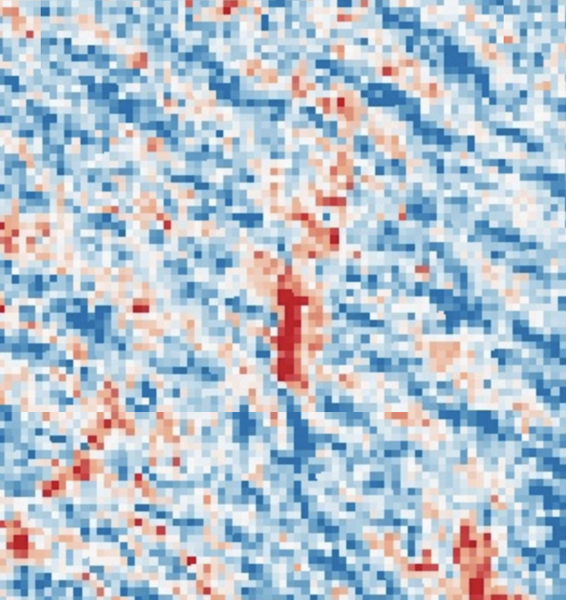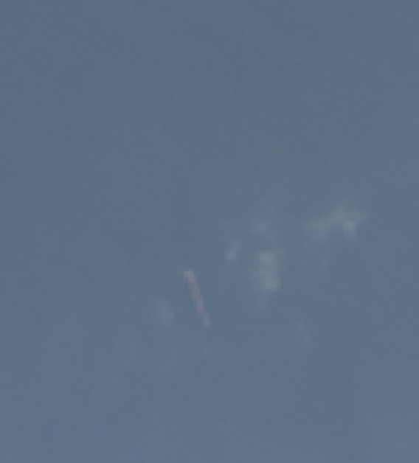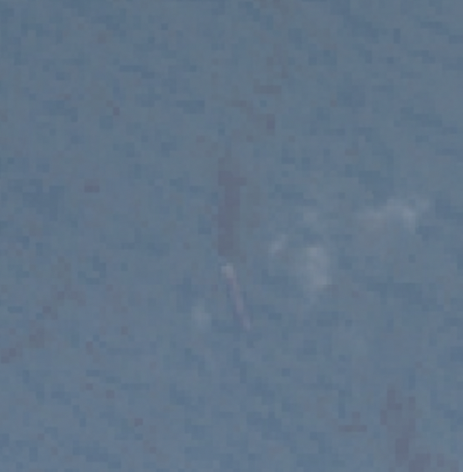
Figure C3. Potential Plume on 7/22/21 off Pointe-Noire, Congo MBSP (a) MBSP overlayed on visible image (b) and visible image (c).

